PHYTOCHEMICAL SCREENING AND IN-VITRO ANTIBACTERIAL ASSESSMENT OF AQUEOUS LEAF EXTRACTS OF Vernonia amygdalina (Asteraceae) and Ocimum gratissimum (Lamiaceae) ON MOXIFLOXACIN RESISTANT Escherichia coli ISOLATED FROM CLINICAL AND ENVIRONMENTAL SAMPLES.

¹*Akinjogunla, O. J., ¹Ekoi, O. H. and ²Odeyemi, A.T.

¹Department of Microbiology, Faculty of Science, University of Uyo, P.M.B.1017, Uyo, Akwa-Ibom State.
²Department of Microbiology, Faculty of Science, University of Ado-Ekiti, P.M.B.5363, Ado-Ekiti, Ekiti State
*Corresponding Author: Akinjogunla Olajide Joseph.
E–mail: papajyde2000@yahoo.com; Tel No: +2348064069404; +2348057125622

Abstract: The aim of this study was to determine the preliminary phytochemistry and antibacterial effectiveness of aqueous leaf extracts of Vernonia amygdalina and Ocimum gratissimum on moxifloxacin resistant Escherichia coli isolated from clinical and environmental samples using standard microbiological and agar disc diffusion techniques. The phytochemical analysis of the aqueous leaf extracts of Ocimum gratissimum and Vernonia amygdalina revealed the presence of phyto-constituents such as alkaloids, saponins, tannins, flavonoids, phlobatanins, anthraquinones, terpenes, deoxy-sugar and cardiac glycosides. The results also showed that moxifloxacin resistant Escherichia coli isolated from clinical and environmental were susceptible to aqueous leaf extracts of Vernonia amygdalina (decoction) and Ocimum gratissimum (decoction) and combination of equal ratio (1:1) by volume of Ocimum gratissimum and Vernonia amygdalina (concoction) at different graded concentrations (6.25mg/ml, 12.5mg/ml and 25.0 mg/ml). The discs containing 25.0mg/ml of aqueous leaf extracts showed the highest Mean ± SD zones of inhibition against both clinical and environmental moxifloxacin resistant E coli, while the discs containing 6.25mg/ml showed the lowest inhibitory zones. The concoctions of the aqueous leaf extracts of O. gratissimum and V. amygdalina exert a much higher activities on moxifloxacin resistant E. coli than decoction of Ocimum gratissimum and decoction of Vernonia amygdalina. The results obtained in this research imply that aqueous leaf extracts of O. gratissimum and Vernonia amygdalina as decoctions and concoctions could be useful in the treatment of infections/diseases caused by Escherichia coli.
[Akinjogunla, O. J., Ekoi, O. H. and Odeyemi, A.T. Phytochemical Screening and In-vitro Antibacterial Assessment of Aqueous Leaf Extracts of Vernonia amygdalina and Ocimum gratissimum on Moxifloxacin Resistant Escherichia coli Isolated from Clinical and Environmental Samples. Nature and Science 2011;9(7):42-52]. (ISSN: 1545-0740). http://www.sciencepub.net.

Key Words: Vernonia amygdalina, Ocimum gratissimum, Phytochemical, Decoction, E. coli Moxifloxacin, Concoction

INTRODUCTION:
The World Health Organization (WHO) estimates that approximately 80% of the world’s inhabitants rely on traditional or herbal medicines for their primary health care and plants have long formed the basis of sophisticated traditional medicine systems and purportedly provide excellent leads for new drug developments (Sofowora, 1993; Pravi, 2006; WHO, 2008; Akinjogunla et al., 2009). Herbal medicine is the oldest form of healthcare known to mankind and over 50% of all modern clinical drugs are of natural products origin and natural products play important roles in drug development in the pharmaceutical industry (Preethi et al., 2010). The rediscovery of the connection between plants and health is responsible for the launching of a new generation of multi-component botanical drugs, dietary supplements and plant-produced recombinant proteins (Raskin et al., 2002; Akinjogunla et al., 2011). However, the increasing problems of multi-drug resistant (MDR) bacteria is of great concern to both the clinicians and pharmaceutical industries and this has made it significant to search for newer drugs that are highly effective, affordable, acceptable and available (Martino et al., 2002; Akinjogunla et al.. 2010). Ocimum gratissimum also known as “alfavaca” is an aromatic medicinal plant belonging to the family Lamiaceae. It is an important herbal medicine found in the tropical and warm regions such as India and sub-Sahara Africa especially in Kenya and Nigeria (Lexa et al., 1997; Aguiyi et al. 2000; Okigbo and Ogbonnaya, 2006). In Nigeria, O. gratissimum is called “Efinrin” in Yoruba; “Ncho-anwu” or “Ahuji” in Igbo; “Aramogbo” in Edo and “Daidoya” in Hausa (Effraim et al., 2000). It is naturally used in the treatment of different diseases / infections such as upper respiratory tract infections, diarrhoea, conjunctivitis, skin disease and pneumonia (Onajobi, 1986; Ilori et al., 1996; Nwinyi et al., 2009). O. gratissimum decoction is used for treatment of gonorrheal infection and mental illness in Congo (Abdulrahma, 1992). This plant contains ocimum oil which is active against both Gram positive bacteria (Staphylococcus aureus, Listeria monocytogenes) and Gram negative bacteria (Escherichia coli, Shigella spp., Salmonella spp. and Proteus spp.). Antifungal activities of ocimum oil on Trichophyton rubrum, T. mentagrophytes, Cryptococcus neoformans, Penicillium spp. and Candida albicans have also been reported (Nwosu and Okafor 1995; Akinyemi et al., 2004; Lopez et al., 2005). O. gratissimum has proved to be useful in the medication for people living with Human Immuno deficiency Virus (HIV) and Acquired Immuno Deficiency Syndrome virus AIDs (Elujoba,2000) Vernonia amygdalina, a species in the family Asteraceae, is a tropical shrub with height of 1-3mm, petiole leaf of about 6mm in diameter (Igile et al, 1995). V. amygdalina is indigenous to tropical Africa and cultivated all over sub-Saharan Africa (Bosch et al., 2005). Vernonia amygdalina commonly called bitter leaf in English, “oriwo” in Edo, “ewuro” in Yoruba, “shikawa” in Hausa, and “olubu” in Igbo (Oboh and Masodje, 2009). The leaves are consumed as vegetable and condiments, after macerating and washing thoroughly to remove the bitterness (Mayhew and Penny, 1998). The bitter V. amygdalina is due to anti-nutritional factors such as alkaloids, saponins, tannins and glycosides. Antihelmitic, antimalarial, antitumourigenic, hypoglycemic and hypolipidaemic properties of Vernonia amygdalina have been reported (Akah and Okafor, 1992; Abosi and Raserika, 2003; Izevbigie et al, 2004). Both the roots and leaves are used in phyto-medicine to treat fever, hiccups, kidney disease and stomach discomfort (Gill, 1992; Hamoiona and Saffaf,1994) Considering the vast potentiality of these plants as source of therapeutic agents, studies were therefore conducted to test the efficacy of aqueous leaf extracts of Vernonia amygdalina and Ocimum gratissimum against moxifloxacin resistant Escherichia coli isolated from clinical and environmental samples with a view to ascertaining their medicinal values.

MATERIALS AND METHODS:
SOURCE OF ORGANISMS
Escherichia coli that were freshly isolated from both clinical samples (stool, urine and wound) and environmental samples (sewage and soil) were used. They were obtained from the Department of Microbiology, University of Uyo, Akwa Ibom State, Nigeria. The bacterial stock cultures were maintained on nutrient agar (Oxoid, UK) slants at 4ºC until needed.

STERILIZATION OF MATERIALS
All the glasswares used for this research work were thoroughly washed with detergent and rinsed with distilled water. The glasswares such as Petri dishes, test tubes and pipettes were wrapped with aluminium foil and appropriately sterilized in the hot air oven at 180°C for 2hrs.. The culture media such as nutrient agar and nutrient broth were sterilized in an autoclaved at 121°C for 15mins. Inoculating wire loop and forceps were sterilized by dipping in 70% ethanol and then flamed in Bunsen flame. Inoculating loop was heat flamed to redness before and after each use.

ANTIBIOTIC SENSITIVITY TESTING
The sensitivity of E coli isolated from clinical and environmental samples to moxifloxacin was performed by disk diffusion method (DDM) on Muller-Hinton agar plates as described by the National Committee for Clinical Laboratory Standards. 1 ml of each E .coli isolates was seeded into each of the Petri dishes containing Mueller-Hinton agar and were allowed to stand for 30 mins to enable the pre-diffusion of the inoculated organisms. The commercially disc containing Moxifloxacin (Mox,5ug) (Oxoid, UK) was aseptically placed on the surfaces of the Muller-Hinton agar plates with a sterile forceps and gently pressed to enable even contact and these were then incubated for 18 - 24hrs at 37°C. Zones of inhibition after incubation were observed and the diameters of inhibition zones were measured in millimeters. The interpretation of the measurement as sensitive (Inhibitory zones ≥ 17) and resistant (Inhibitory zones ≤ 14) was made according to the manufacturer’s standard zone size interpretive manual.

SOURCES OF MEDICINAL PLANTS:
The medicinal plants used in this research (Vernonia amygdalina / Ocimum gratissimum) were obtained from their natural habitats in Uyo (Figures 1 and 2). Identification of plants was done and confirmed at the herbarium unit, Department of Botany and Ecological Studies, University of Uyo, Nigeria. The leaves of these plants were dried at room temperature for one month. The dried plant parts were pulverized and stored in polythene bag until required and later transferred to Pharmacognosy Laboratory, Faculty of Pharmacy, University of Uyo, for processing.

PREPARATION AND CONCENTRATION OF AQUEOUS EXTRACTS
A sample (50g) of the shade-dried powdered leaves of (Vernonia amygdalina / Ocimum gratissimum) was soaked in aqueous for three days. At the end of the extraction, the extracts were filtered using Whatman No.1filter paper. The filtrate was concentrated in vacuum at 30ºC. After complete evaporation, the extract was weighed and preserved aseptically at 4ºC. Three (3) different graded concentrations (6.25mg/ml, 12.5 mg/ml and 25.0 mg/ml) of the extracts were aseptically prepared using distilled water and then subjected to antibacterial activity assays.

ASSESSMENT OF ANTIBACTERIAL ACTIVITY
The decoctions and concoctions of the aqueous extracts were tested for antibacterial activity by the disc diffusion method (NCCLS, 2004; Nair et al., 2005). Mueller – Hinton agar (MHA) was sterilized in flasks cooled to 45 – 50ºC and then poured into sterilized Petri dishes. Sterile filter paper discs of 6 mm diameter were impregnated with the decoction of each aqueous extracts solution of graded concentrations (6.25mg/ml, 12.5mg/ml and 25.0 mg/ml) and then placed on to agar plates which had previously been inoculated with the moxifloxacin resistant E. coli (from overnight agar plate adjusted to 0.5Mcfarland Standard) using sterilized forcep. Also sterile filter paper discs of 6 mm diameter were impregnated with the two extracts concoction (Vernonia amygdalina / Ocimum gratissimum) of graded concentrations (6.25mg/ml, 12.5mg/ml and 25.0 mg/ml) prepared in 1:1 ratio by volume and then placed on to agar plates which had previously been inoculated with moxifloxacin resistant E. coli using sterilized forcep. Control experiments comprising iminipen (10ug) and water were set up. The plates were then incubated at 37ºC for 24 hrs. The diameters of the inhibition zones were measured in millimeters.

DETERMINATION OF ACTIVITY INDEX (A.I)
Activity Index (AI) was calculated as the mean inhibition zone of sample divided by the mean inhibition zone of the standard drug used (iminipen).
Activity Index = Mean inhibition zone of sample
Mean inhibition zone of the standard drug

DETERMINATION OF MINIMUM INHIBITORY CONCENTRATION (MIC) AND MINIMUM BACTERICIDAL CONCENTRATION (MBC)
The Minimum Inhibitory Concentration (MIC) of the extracts was determined for each of the test organisms in test tubes according to macro broth dilution techniques (Akinyemi et al., 2005). To 0.5 ml of varying concentrations of the extracts (5, 10, 15, 20, 25, 30 and 40) mg/ml in test tubes, nutrient broth (2 ml) was added and then a loopful of the moxifloxacin resistant E. coli. The culture tubes were then incubated at 37ºC for 24 hrs. After incubation the tubes were then examined for microbial growth by observing for turbidity. The MIC was read as the least concentration that inhibited the growth of the test organism. To determine the MBC, for each set of test tubes in the MIC determination, a loopful of broth was collected from those tubes that did not show any growth and inoculated onto sterile nutrient agar by streaking. Nutrient agar plates were also streaked with the respective test organisms to serve as controls. All the plates were then incubated at 37ºC for 24 hrs. After incubation, the concentration that yielded no visible growth was considered as the Minimum Bactericidal Concentration (MBC). (Akinjogunla et al., 2009)

PHYTOCHEMICAL SCREENING
The phytochemical components of the powdered plant leaves were analyzed according to the method described by Trease and Evans (1989).

TEST FOR SAPONINS: About 0.5g of the filtered plant extract was put in a test tube and 2ml of distilled water added and shaken vigorously. Formation of frothing or foam which persisted on warming was taken as preliminary evidence for the presence of saponins

TEST FOR TANNINS: About 0.5g of the filtered plant extract was put in a test tube and 9ml of distilled water added. Decolouration was observed upon addition of bromine water which indicated the positive test for tannins.

TEST FOR PHLOBATANINS: About 0.5g of the plant extract was added with 3 drops of 40% formaldehyde, 6 drops of diluted hydrochloric acid (HCl) is also added to boiling and cool. A precipitate was formed, if positive and washed with hot water; this leaves a colourless residue after washing indicating the presence of phlobatanins.

TEST FOR CARDIAC GLYCOSIDE: About 0.5g of the plant extract was dissolved in 2ml of Chloroform concentrated Sulphuric acid (H₂SO₄) was carefully added to form a lower layer. A reddish-brown colour at the interface indicated a positive test.

TEST FOR ANTHRAQUINONES: About 0.5g of the plant extract was boiled with 5mls of 10% sulphuric acid (H₂SO₄₎ and filtered. The filtrate was cooled in ice and shaken with 2.5mls benzene, the benzene layer separates and half its own volume of 10% ammonium hydroxide (NH₄OH) was added. The development of pink, red or violet coloration in ammonia (lower) phase indicated a positive test.

TEST FOR FLAVONOIDS: Few pieces of magnesium metal strip were added to 5mls of the filtrate plant extract with concentrated hydrochloric acid (5ml). The formation of orange, red, crimson or magenta was taken as a positive test.

TEST FOR TERPENE: About 0.5g of the plant extract was dissolved in 3mls of Chloroform and filtered. 10 drops of acetic anhydride were added to the filtrate with 2 drops of concentrated Sulphuric acid (H₂SO₄) pink colour at the interphase was taken as the positive test.

TEST FOR DEOXY-SUGAR: About 0.5g of the filtered plant extract was dissolved in 2mls of glacial acetic acid containing one drop of ferric chloride. It was then underplayed with 1ml of concentrated sulphuric acid (H₂SO₄).Violet ring observed which settled after few minutes was an indication of a positive test.

TEST FOR ALKALOIDS: About 0.5g of the plant extract was added with a few drops of picric acid reagent. A white or yellow precipitate indicated a positive test.

DETERMINATION OF pH VALUES OF DIFFERENT GRADED CONCENTRATIONS OF THE EXTRACTS.
The pH values of different graded concentrations of the aqueous leaf extracts were determined using the Fisher accument model pH-meter.

STATISTICAL ANALYSIS: The results are expressed as Mean ± SD. Difference in means were also determined by Duncan’s multiple range test (P<0.05).

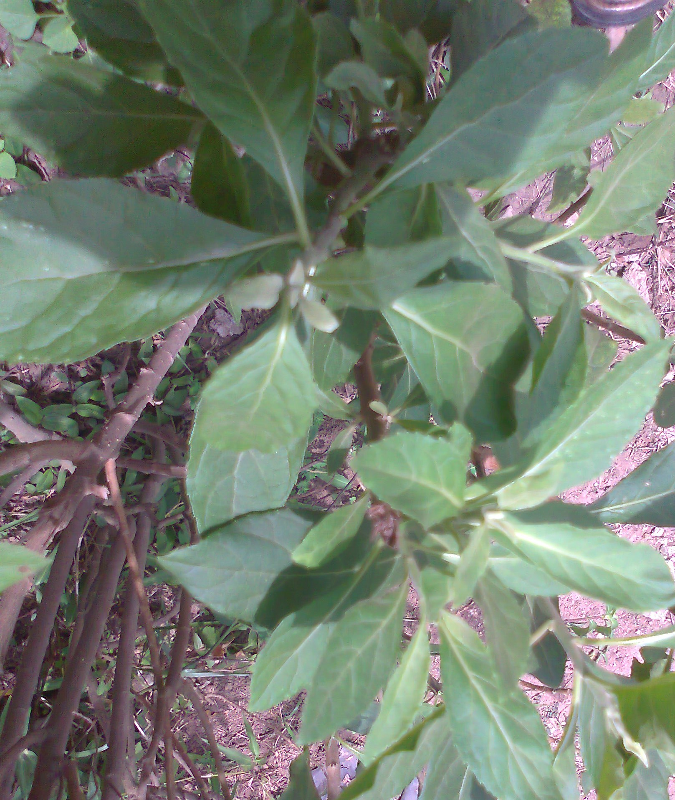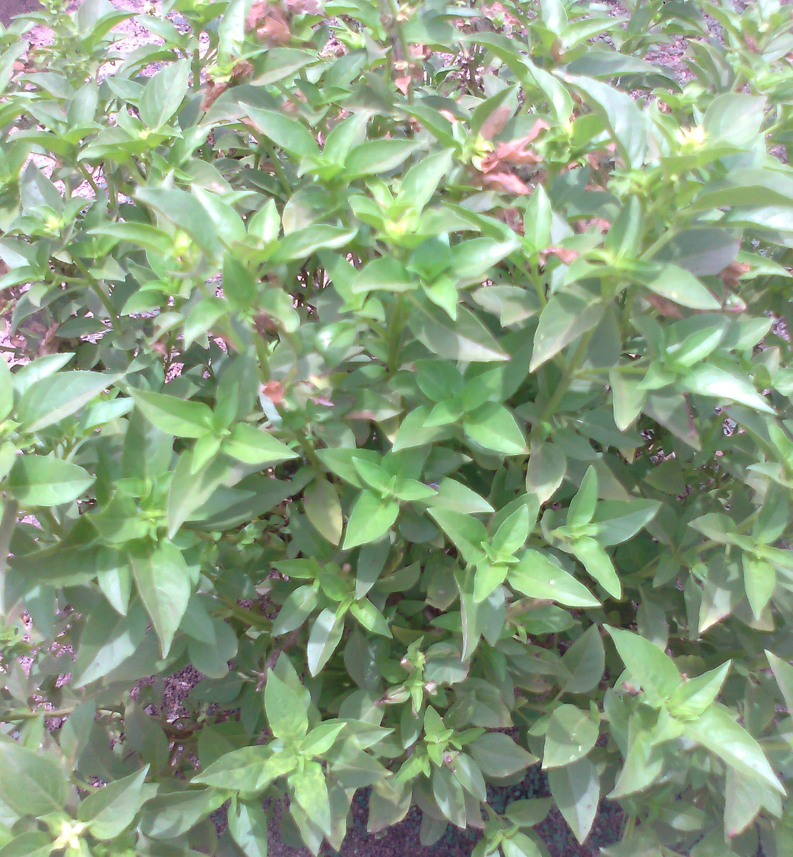
1: Vernonia amygdalina (Bitter leaf) Fig 2: Ocimum gratissimum (Scent leaf)

RESULTS:
Antibacterial activities of aqueous leaf extracts of Ocimum gratissimum (decoction), Vernonia amygdalina (decoction) and combination of equal ratio by volume of Ocimum gratissimum and Vernonia amygdalina (concoction) showed a wide range of activity on moxifloxacin resistant E.coli isolated from various clinical and environmental sources (Tables 1, 2 and 3). The discs containing 25.0mg/ml of aqueous leaf extracts showed the highest Mean ± SD zones of inhibition against both clinical and environmental moxifloxacin resistant E coli, while the discs containing 6.25mg/ml showed the lowest inhibitory zones. The zones of inhibition increased with the increase in concentrations of the extracts and thus, exhibiting concentration dependent activity.
The concoction of equal ratio by volume of the aqueous leaf extracts of Ocimum gratissimum and Vernonia amygdalina exert a much higher activities on moxifloxacin resistant E. coli obtained from both clinical and environmental samples with the highest zone of inhibition (15.3 ±2.0mm) observed in moxifloxacin resistant E.coli isolated from urine samples and the lowest inhibitory zone was found in moxifloxacin resistant E. coli obtained from soil having the values of 7.4±0.1mm. The concoction of Ocimum gratissimum and Vernonia amygdalina on E coli was synergistic. In the case of Ocimum gratissimum (decoction), highest inhibitory zone was obtained in moxifloxacin resistant E. coli isolated from soil with values of 14.0±0.9mm while the lowest inhibitory zone was obtained in moxifloxacin resistant E. coli from stool samples having value of 6.3±0.5 mm. The highest activities of leaf extract of Vernonia amygdalina was obtained on moxifloxacin resistant E coli isolated from sewage with the value of 13.8±0.5mm while lowest activities was obtained in moxifloxacin resistant E coli isolated from stool with the value of 6.4±2.0mm. Overall, the data indicated that concoction of aqueous leaf extracts of Ocimum gratissimum and Vernonia amygdalina exhibited strong antibacterial activity against moxifloxacin resistant E .coli compared to decoction of each of aqueous leaf extracts. However, there were significant differences in the values (zones of inhibition) obtained when the aqueous leaf extracts of Ocimum gratissimum; Vernonia amygdalina and concoction of Ocimum gratissimum and Vernonia amygdalina were tested with moxifloxacin resistant E. coli when compared with the values obtained with iminipen (Tables 1, 2 and 3). The data presented in Table 4 are the minimum inhibitory concentrations (MIC) and minimum bacteriocidal concentrations (MBC) values of the aqueous leaf extracts against moxifloxacin resistant E coli. In overall, concoctions of Ocimum gratissimum and Vernonia amygdalina had the lowest MIC and MBC, followed by decoction of Vernonia amygdalina and decoction of Ocimum gratissimum.
The pH values of the aqueous leaf extracts of three different concentrations (6.25mg/ml, 12.5mg/ml and 25.0 mg/ml) of Ocimum gratissimum (decoction) were 7.9±1.0, 7.1±0.4 and 6.7±1.0, respectively. The pH values of the aqueous leaf extracts of three different concentrations of Vernonia amygdalina (decoction) ranged from 6.4±1.0 to 7.6±0.1, while the pH values of the aqueous leaf extracts of three different concentrations of Ocimum gratissimum and Vernonia amygdalina (concoction) ranged from 6.0±1.0 to 6.7±0.1 (Fig.3). Figs 4, 5 and 6 showed the (Activity Index) which is the mean inhibition zone of sample divided by the mean inhibition zone of the standard drug. The phytochemical analysis of the aqueous leaf extracts of Ocimum gratissimum and Vernonia amygdalina revealed the presence of phyto-constituents such as alkaloids, saponins, tannins flavonoids, phlobatanins, anthraquinones, terpenes, deoxy-sugar and cardiac glycosides (Table 5).

Table 1: Antibacterial activity of Ocimum gratissimum (decoction) on Moxifloxacin Resistant E. coli
Bacterial  spp.  Codes | Sample Source |  | Mean ± SD zones of inhibition of Ocimum gratissimum (Decoction) |  |  | Iminipen | Water
Bacterial  spp.  Codes | Sample Source |  | 6.25mg/ml | 12.5 mg/ml | 25.0 mg/ml | Iminipen | Water
EC01 | Soil |  | NZ | 7.8±0.1ª | 11.2±1.2^{b} | 16.0±0.7^{b} | NZ
EC02 | Soil |  | 7.2±1.1ª | 10.1±1.4^{b} | 14.0±0.9^{c} | 21.2±1.7^{d} | NZ
EC03 | Sewage |  | 8.1±0.9^{b} | 12.0±0.7^{c} | 12.3±0.9^{b} | 20.0±2.6^{c} | NZ
EC04 | Urine |  | NZ | 6.6±0.4ª | 9.0±1.0ª | 14.2±1.0ª | NZ
EC05 | Stool |  | 6.3±0.5ª | 9.6±0.4^{b} | 13.5±2.0^{c} | 18.5±1.8^{c} | NZ
EC06 | Stool |  | 6.8±0.5ª | 10.1±1.5^{b} | 10.8±0.5ª | 16.5±1.5^{b} | NZ
EC07 | Sewage |  | 8.0±1.0 ^{b} | 10.5±1.5^{b} | 12.8±1.2^{b} | 21.3±2.7^{d} | NZ
EC08 | Urine |  | 8.9±0.2 ^{b} | 12.1±1.3^{c} | 13.5±3.0^{c} | 19.3±1.3^{c} | NZ
EC09 | Wound |  | NZ | 7.5±1.4ª | 10.1±1.5ª | 16.0±1.5^{b} | NZ
EC10 | Wound |  | 10.2±1.1^{c} | 12.0±2.2^{c} | 13.4±1.2^{c} | 20.3±5.5^{c} | NZ
_{P}H Values | --- |  | 7.9±1.0 | 7.1±0.4 | 6.7±1.0 | ND | ND
Each inhibitory zone includes 6 mm diameter of the disc.
NZ: No zone of inhibition observed; SD: Standard Deviation; ND: Not Determined
Each value represents the mean of three experiments and standard deviation. Means within the column followed by the same letter do not differ significantly as determined by Duncan’s multiple range test (P<0.05) among the treatment)

Table 2: Antibacterial activity of Vernonia amygdalina (decoction) on Moxifloxacin Resistant Escherichia coli
Bacterial  spp.  Codes | Sample Source | Mean ± SD zones of inhibition of Vernonia amygdalina (Decoction) |  |  |  | Iminipen |  | Water
Bacterial  spp.  Codes | Sample Source | 6.25mg/ml | 12.5mg/ml | 25.0mg/ml |  | Iminipen |  | Water
EC01 | Soil | NZ | 7.8±1.2ª | 9.5±2.0ª |  | 16.0±1.5^{b} |  | NZ
EC02 | Soil | 7.2±2.0ª | 10.8±0.2^{b} | 11.8±1.0^{b} |  | 21.2±1.3^{d} |  | NZ
EC03 | Sewage | 9.2 ±1.0^{b} | 10.0±1.0^{b} | 13.8±0.5^{c} |  | 20.0±1.5^{c} |  | NZ
EC04 | Urine | NZ | 8.5±1.1ª | 11.1±1.0^{b} |  | 14.2±1.0ª |  | NZ
EC05 | Stool | 8.2±0.7^{b} | 8.2±2.0ª | 9.8±1.5ª |  | 18.5±1.8^{c} |  | NZ
EC06 | Stool | 6.4±2.0ª | 10.4±0.5^{b} | 12.0±1.0^{b} |  | 16.5±1.5^{b} |  | NZ
EC07 | Sewage | 8.7±1.0^{b} | 9.9 ±1.0^{b} | 13.3±0.2^{c} |  | 21.3±2.7^{d} |  | NZ
EC08 | Urine | 7.9±1.0^{b} | 11.3±2.2^{c} | 11.4±1.0^{b} |  | 19.3±3.3^{c} |  | NZ
EC09 | Wound | NZ | 10.3±0.2^{b} | 12.2±1.0^{b} |  | 16.0±1.5^{b} |  | NZ
EC10 | Wound | 10.1±0.5^{c} | 11.5±0.5^{c} | 13.0±0.5^{c} |  | 20.3±1.1^{c} |  | NZ
_{P}H Values | --- | 7.6±0.1 | 6.9±0.4 | 6.4±1.0 |  | ND |  | ND
Each inhibitory zone includes 6 mm diameter of the disc.
NZ: No zone of inhibition observed; SD: Standard Deviation; ND: Not Determined
Each value represents the mean of three experiments and standard deviation. Means within the column followed by the same letter do not differ significantly as determined by Duncan’s Multiple Range Test (P<0.05) among the treatment)

Table 3: Antibacterial activity of Ocimum gratissimum and Vernonia amygdalina (concoction) on Moxifloxacin Resistant E.coli
Bacterial  spp.  (Codes) | Sample Source |  | Mean ± SD zones of inhibition of O. gratissimum+ V. amygdalina  (Concoction) |  |  | Iminipen |  | Water
Bacterial  spp.  (Codes) | Sample Source |  | 6.25mg/ml | 12.5 mg/ml | 25.0mg/ml | Iminipen |  | Water
EC01 | Soil |  | 7.6±1.0ª | 8.0±0.8ª | 11.5±0.5ª | 16.0±2.5^{b} |  | NZ
EC02 | Soil |  | 7.4±0.1ª | 11.2±0.4^{b} | 14.8±1.2^{b} | 21.2±0.3^{d} |  | NZ
EC03 | Sewage |  | 9.8±0.4^{b} | 12.0±1.1^{c} | 14.3±1.0^{b} | 20.0±1.5^{d} |  | NZ
EC04 | Urine |  | NZ | 9.3±0.5ª | 12.0±1.5ª | 14.2±1.0ª |  | NZ
EC05 | Stool |  | 8.5±0.5ª | 10.0±0.2^{b} | 15.0±0.5^{c} | 18.5±1.8^{c} |  | NZ
EC06 | Stool |  | 8.2±2.1ª | 10.8±0.5^{b} | 13.6±1.0^{b} | 16.5±1.5^{b} |  | NZ
EC07 | Sewage |  | 8.8±0.2ª | 11.0±0.1^{b} | 14.6±0.5^{b} | 21.3±0.7^{d} |  | NZ
EC08 | Urine |  | 8.0±0.5ª | 12.8±0.5^{c} | 15.3±2.0^{c} | 19.3±3.3^{c} |  | NZ
EC09 | Wound |  | NZ | 10.9±0.4^{b} | 13.6±0.2^{b} | 16.0±1.5^{b} |  | NZ
EC10 | Wound |  | 10.8±0.2^{b} | 12.6±0.5^{c} | 14.0±0.1^{b} | 20.3±2.5^{d} |  | NZ
_{P}H Values | --- |  | 6.7±0.1 | 6.4±0.4 | 6.0±1.0 | ND |  | ND
Each inhibitory zone includes 6 mm diameter of the disc.
NZ: No zone of inhibition observed; SD: Standard Deviation; ND: Not Determined
Each value represents the mean of three experiments and standard deviation. Means within the column followed by the same letter do not differ significantly as determined by Duncan’s multiple range test (P<0.05) among the treatment)

Table 4: Minimum Inhibitory Concentration (MIC) and Minimum Bacteriocidal Concentration (MBC) of Aqueous Leaf Extracts against Moxifloxacin Resistant E. coli
Bacterial spp.  Codes | Sample Source | O. gratissimum  MIC MBC  (Mg/ml) (Mg/ml) | V. amygdalina  MIC MBC  (Mg/ml) (Mg/ml) | O. gratissimum + V. amygdalina  MIC MBC  (Mg/ml) (Mg/ml)
EC01 | Soil | 10.0 25.0 | 10.0 30.0 | 5.0 15.0
EC02 | Soil | 5.0 20.0 | 5.0 15.0 | 5.0 15.0
EC03 | Sewage | 5.0 20.0 | 5.0 25.0 | 5.0 15.0
EC04 | Urine | 10.0 30.0 | 10.0 25.0 | 10.0 20.0
EC05 | Stool | 5.0 25.0 | 5.0 20.0 | 5.0 15.0
EC06 | Stool | 5.0 20.0 | 5.0 25.0 | 5.0 15.0
EC07 | Sewage | 5.0 20.0 | 5.0 20.0 | 5.0 20.0
EC08 | Urine | 5.0 25.0 | 5.0 20.0 | 5.0 15.0
EC09 | Wound | 10.0 25.0 | 10.0 25.0 | 10.0 20.0
EC10 | Wound | 5.0 25.0 | 5.0 20.0 | 5.0 15.0

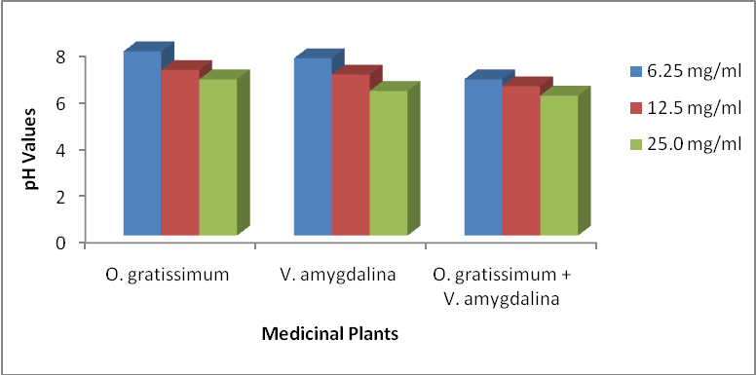
Fig 3: pH values of different graded concentrations of the extracts
Table 5: Phytochemical Analysis of Aqueous Leaf Extracts of Ocimum gratissimum and Vernonia amygdalina

Phytochemical Constituents | Ocimum gratissimum | Vernonia | amygdalina
Saponins | +++ |  | +
Tannins | + |  | ++
Phlobatanins | + |  | -
Cardiac glycoside | ++ |  | +
Anthraquinones, | + |  | +
Flavonoids, | + |  | ++
Terpenes | + |  | +
Deoxy-sugar | - |  | +
Alkaloids | ++ |  | +++
Keys: - = Not detected; + = Present in small concentration; ++ = Present in moderately high concentration; + + + = Present in high concentrations

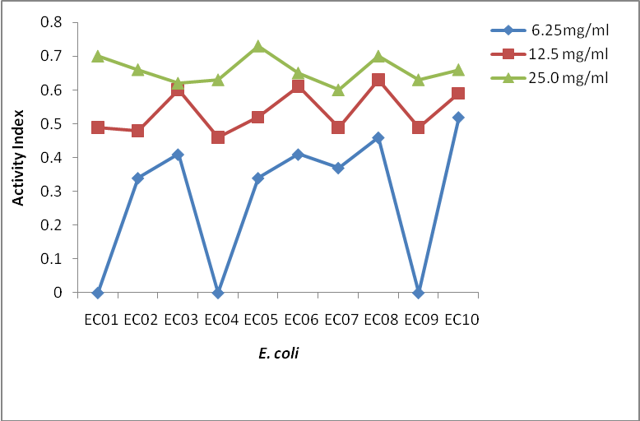
Figure 4: Activities Index (A.I) from Ocimum gratissimum (decoction) and Iminipen

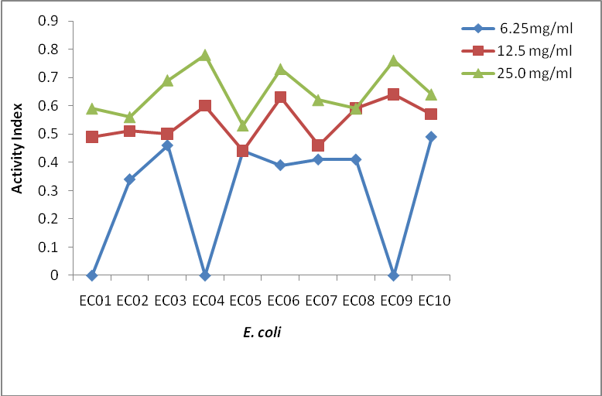
Figure 5: Activities Index (A.I) from Vernonia amygdalina (decoction) and Iminipen

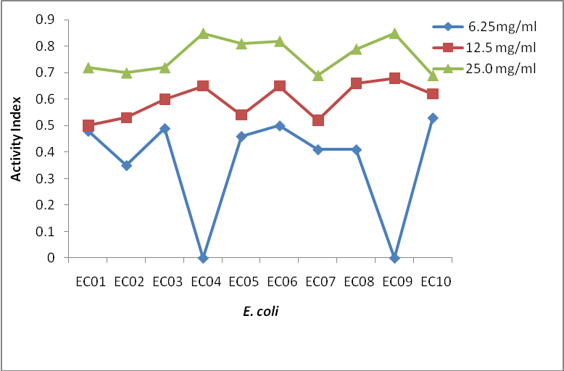
Figure 6: Activities Index (A.I) from Ocimum gratissimum and Vernonia amygdalina concoction and Iminipen

DISCUSSION:
Medicinal plants are important for pharmacological research and drug development because they contain undiscovered biodynamic compounds with unrealized potential for the use in modern drugs. Antibiotic resistance had become a global concern and increase in prevalence of antibiotic- resistant pathogens in hospital, homes and environment has necessitated the deliberate search for alternative treatments to combat further spread of antibiotic resistant-pathogens (Westh et al., 2004). The sensitivity of the moxifloxacin resistant Escherichia coli to V. amygdalina may be due to the presence of active saponins and essential oils (Desta, 1993). The susceptibility of E. coli to the aqueous leaf extract of V. amygdalina is in agreement with the findings of Scalbert (1991) that demonstrated the antimicrobial activity of some medicinal plants against bacteria by using the extract of V. amygdalina as one of the samples. The results of our investigation clearly demonstrated that aqueous leaf extracts of both Ocimum gratissimum and Vernonia amygdalina possess measurable in-vitro antibacterial activities on moxifloxacin resistant E. coli. The results in this research showed the bacteriostatic and bacteriocidal activities of V. amygdalina (decoction), Ocimum gratissimum (decoction) and concoction of V. amygdalina and Ocimum gratissimum. The bacteriostatic activity of V. amygdalina (decoction) in study agrees with the results of Aina and Uko (1990). The above findings pointed out that the higher the concentrations of the extracts, the higher the E coli sensitivities to the extracts as showed by the increased size of the bacterial growth inhibition zones and this is in conformity with Eyob et al. (2008), Okigbo et al. (2009) and Jagtap et al. (2009). Therefore, the higher the concentrations of the antibacterial agents in the red ginger extracts, the larger the diameter of the bacterial growth inhibition zones obtained was evident. Conclusively, the antibacterial activities of these extracts provide justification for the chemotherapeutic utilization of these herbs. Study of in-vivo anti-microbial activity and experiments involving activity guided fractionation are under way and the study is also aimed at extensive investigation, isolation and purification of active phytoconstituents with broad spectrum of antimicrobial activity.

Correspondence to: Akinjogunla Olajide Joseph,
Department of Microbiology,
University of Uyo, Uyo, Akwa
Ibom State, Nigeria.
E–mail: papajyde2000@yahoo.com

REFERENCES
- Abdulrahma F. Studies on natural products. The moracease in African traditional medicine and management of psychiatry in Borno State. M.Sc. Thesis, University of Maiduguri, Maiduguri (1992).pp 89-95.
- Abosi AO, Raseroka BH. In vivo antimalarial activity of Vernonia amygdalina. British Journal. Of Biomedical Science. (2003). 60: 89-91.
- Aguiyi JC, Obi CI, Gang SS, Igweh AC. Hypoglycaemic activity of Ocimum gratissimum in rats. Fitoterapia (2000). 71, 444-446.
- Aina JO, Uko EE. Assessment of antibacterial activity of some traditional medicinal plants on some food borne pathogens. Journal of Ethnopharmacology (1990): 13: 211 – 216
- Akah PA, Okafor CI. Hypoglycemic effect of Vernonia amygdalina (Del) in experimental rabbits. Plant Med. Res (1992). 1: 6-10.
- Akinjogunla OJ, Adegoke AA, Udokang IP, Adebayo-Tayo BC. Antimicrobial potential of Nymphaea lotus (Nymphaeaceae) against wound pathogens. Journal of Medicinal Plants Research. 2009. 3(3):138-141.
- Akinjogunla OJ, Etok CA, Oshoma CE. Preliminary phytochemistry and in-vitro antibacterial efficacy of Hydro-Ethanolic leaf extracts of Psidium guajava on common urinary tract Bacterial Pathogens. Bioresearch Bulletin (2011). .5: 329-336.
- Akinjogunla OJ, Yah SC, Eghafona NO, Ogbemudia FO. Antibacterial activity of leave extracts of Nymphaea lotus (Nymphaeaceae) on Methicillin Resistant Staphylococcus aureus (MRSA) and Vancomycin Resistant Staphylococcus aureus (VRSA) Isolated from clinical samples. Annals of Biological Research. 2010 .1(2):174-184.
- Akinyemi KO, Mendie UE, Smith ST, Oyefolu AO, Coker AO Screening of some medical plants for anti-salmonella activity. J Herb Pharmocother. (2004). 5(1): 45-60.
- Bosch CH, Borus DJ, Siemonsma JS. Vegetables of Tropical Africa. Conclusions and Recommendations Based on PROTA 2: ‘Vegetables’. PROTA Foundation, Wageningen, Netherlands. (2005). 10 modules, 68pp.
- Desta B. Ethiopian traditional herbs Part II. Antimicrobial activity of 63 medicinal plants. Journal of Ethnopharmacology (1993). 39: 263-276.
- Effraim ID, Salami HA, Osewa TS. The effect of aqueous leaf extract of Ocimum gratissimum on haematological and biochemical parameters in rabbits African Journal of Biomedical Research (2000). 175-179.
- Eyob S, Appelgren M, Rohloff J, Tsegaye A, Messele G. Traditional medicinal uses and essential oil composition of leaves and rhizomes of korarima (Aframomum corrorima (Braun) P.C.M. Jansen) from southern Ethiopia. South African Journal of Botany. (2008). 74: 181-185
- Gill LS. Ethnomedical Uses of Plants in Nigeria. Uniben Press, Benin City, Nigeria. (1992). p. 243.
- Hamowia AM, Saffaf AM.. Pharmacological studies on Vernonia amygdalina (Del) and Tithonia diversifolia (Gray). Vet. Med. Giza (1994). 2: 91-97.
- Igile GO, Oleszyek W, Burda S, Jurzysta N. Nutritional assessment of Vernonia amygdalina leaves in growing mice. Journal of Agriculture and Food Chemistry. (1995). 43: 2126- 2166.
- Ilori M, Sheteolu AO, Omonigbehin EA, Adeneye AA. Antibacterial activity of Ocimum gratissimum (Lamiaceae). Journal of Diarhoeal Diseases and Research. (1996).14: 283-285
- Izevbigie EB, Bryant JL, Walker A. A novel natural inhibitor of extracellular signal related kinases and human breast cancer cell growth. Experimental Biol. Med (Maywood). (2004) 229: 163-169.
- Jagtap SD, Deokule SS, Pawar PK, Harsulkar AM. Traditional Ethnomedicinal Knowledge Confined to the Pawra Tribe of Satpura Hills, Maharashtra, India. Ethnobotanical Leaflets, (2009) 13: 98-115.
- Lexa GM, Josphat CM, Francis NW, Miriam GK, Anne W, Thairu M, Titus KM. Antimicrobial activity of essential oils of ocimum gratissimum l. from different populations of Kenya African Journal of Traditional and Complimentary Medicines (2008). 5 (2): 187 – 193
- Lopez P, Sanchez K, Batlle R, Nerin C. Solid and vapour phase anti-microbial activities of six essential oils susceptibility of selected food borne bacterial and fungal strains. Journal of Agriculture, Food and Chemistry (2005). 53(17): 6939-6946.
- Martino PD, Gagniere H, Berry H, Bret L. Antibiotic resistance and virulence properties of Pseudomonas aeruginosa strains from mechanically ventilated patient with pneumonia in intensive care unit: Comparison with imipenem-resistant extra-respiratory tract isolates from uninfected patients. Microbiological Infection. 2002.4:613-620. Mayhew S, Penny A. Macmillan Tropical and Subtropical Foods. Macmillan Publishers, London, (1988). p.107.
- Nair R, Kalariya T, Sumitra C. Antibacterial activity of some selected Indian medicinal flora. Turkish Journal of Biology (2005) 29: 41 – 47.
- National Committee for Clinical Laboratory Standards (2004). Methods for determining Bacterial Activity of Antimicrobial Agents, Wayne, Pa.
- Nwinyi OC, Chinedu NS, Ajani OO, Ikpo CO, Ogunniran, KO. Antibacterial effects of extracts of Ocimum gratissimum and Piper guineense on Escherichia coli and Staphylococcus aureus. African Journal of Food Science (2009) .3(3); 77-81.
- Nwosu MO, Okafor JI. Preliminary studies of the antifungal activities of some medicinal plants against Basidiobolus and some other pathogenic fungi. Mycoses. (1995). 38: 191- 195.
- Oboh FOJ, Masodje HI. Nutritional and Antimicrobial Properties of Vernonia amygdalina Leaves. International Journal of Biomedical and Health Sciences. 2009.5(2) 51-56
- Okigbo RN, Mbajaka C, Njoku CO. Antimicrobial potential of (UDA) Xylopia aethopica and Ocimum gratissimum on some pathogens of man. Int J. Mol. Med. Ad. Sci. Pakistan (2005b). 1 (4): 392-394.
- Okigbo RN, Ogbonnanya, OU. Antifungal effects of two tropical plants extracts Ocimum gratissimum and Afromaomum melegueta on post harvest yam Discorea spp rot. African Journal of Biotechnology. (2006). 5 (9): 727-731.
- Onajobi FD, Smooth muscle contracting lipid soluble principles in chromatographic fractions of Ocimum gratissimum. Journal of Ethnopharmacology (1986). 18, 3-11.
- Pravi CT. Medicinal plants: Traditional knowledge. I.K. International Pvt. Ltd. New Delhi. 2006. 216pp.
- Preethi RM, Devanathan V V, Loganathan M. Antimicrobial and antioxidant efficacy of some medicinal plants against food borne pathogens. Advance in Biological Research. 2010, 4 122-125
- Raskin L, Ribnicky DM, Komarnytsky S, Llin N, Poulev A, Borisjuk N, Brinker A, Moreno DA, Ripoll C, Yakoby N, O’Neal JM, Cornwell T, Pastor I, Fridlender B.. Plants and human health in the twenty first century. Trends in Biotechnology (2002). 20(12): 522- 531.
- Scalbert A. Antimicrobial properties of tannin. Phytochemistry. (1991). 30:3875-3883.
- Sofowora A. Medicinal Plants and Traditional Medicine in Africa. (2nd Edn). Spectrum Books Limited, Ibadan, Nigeria. 1993.1-153.
- Trease GE, Evans WC. Pharmacology 11th Ed. Bailliere Tindall Ltd, London. (1989) pp 60-75. Westh H, Zinn CS, Rosahi VT. An international multicenter study of antimicrobial consumption and resistance in Staphylococcus aureus isolates from 15 hospitals in 14 countries. Microbial Drug Resistance. (2004). 10: 169 –179.
- World Health Organization. Traditional medicine. Media centre: 2008.http://www.who.int / media centre/factsheet/fs/34/en/.

27/5/2011

