Induction of Apoptosis, Necrosis and differentiation in hepG2 cell line (Comparison between natural and Synthetic products)

Wafaa A.Ahmed¹ ; Farid A. Abu Bedair¹ ; Abd El Hameed O.M² and Nasser E.A.³

¹ Department of Cancer Biology, National Cancer Institute, Cairo University, Cairo, Egypt.
² Clinical Biochemistry – Biomedical Engineering Department- High Institute of Engineering el-Shorouk-Academy .
³ Toxicology & Microanalysis unit, Faculty Science, Suez Canal University.
drwafaaeg@hotmail.com

Abstract: Hepatocellular carcinoma (HCC), one of the most common malignancies worldwide, is highly resistant to standard therapy. Hepatocellular carcinoma (HCC), which are the most health-threatening conditions drawing considerable attention from medical professionals and scientists. While liver surgery is not suitable in many of the HCC cases, patients are mostly given palliative support cares or transarterial chemoembolization or systemic chemotherapies. However, HCC is well known to be a highly chemoresistant tumor, and the response rate is <10–20%. To this end, alternative medicines are being actively sought from other sources with hopes to halt the disease's progression or even eliminate the tumors. In this work, we discuss our findings and trial studies of some semisynthetic and natural compounds on human HCC cell line. The effect of Vit. E, Corn Oil, t-BHQ and HMBA) against Hep-G2 cells was assessed using MTT assay to investigate cytotoxcity and cell proliferation .Flow cytometeric analysis was used for measurement apoptosis, nicrosis and cell cycle analysis. The results revealed that the treatment of Hep-G2 cells with Vit. E, corn oil, HMBA and TBH dramatically inhibited the cell growth in a dose dependent manner, with IC₅₀ values of 4.48 , 3.97, 3.35 mM and 350.02 µM, respectively. Flow cytometric analysis was performed. The growing cells were treated with IC₅₀ value of different investigated compounds for different intervals (6 and 12 hrs). The untreated cells showed the expected pattern for continuously growing cells, whereas the cells treated with HMBA and TBH for 12 hrs showed a progressive accumulation in the S phase and G2/M phase of the cell cycle correlating with decreased number of cells in the G0/G1 phase. Meanwhile, Vit. E and Corn oil treated cell showed a progressive accumulation in the Go/G1 phase. The treatment of HMBA showed highest induction of apoptosis followed by TBH, vit. E and the lowest induction of apoptosis was corn oil. It is concluded that the cytotoxicity of semisynthetic compounds (HMBA & TBH) has direct effect on the liver cells represented by the effects on the cell cycle and apoptotic mechanism while natural compounds (vit. E & corn oil) has less effect by the two mechanisms than other tested compounds but still has cytotoxic effect.
[Wafaa A.Ahmed ; Farid A. Abu Bedair ; Abd El Hameed O.M and Nasser E.A. Induction of Apoptosis, Necrosis and differentiation in hepG2 cell line (Comparison between natural and Synthetic products). Nature and Science 2011;9(7):62-73]. (ISSN:1545-0740). http://www.sciencepub.net.

Keywords: Apoptosis; Necrosis; Hepatocellular carcinoma; malignancies; chemoembolization.

1. Introduction
HCC is a major problem worldwide because of its high prevalence and treatment outcomes have generally remained poor (Huynh et al., 2002). Despite the high mortality and frequency of this cancer, surgical resection is an available option for only a small proportion of patients because metastases are often present when the cancer is discovered. Chemotherapy plays an important role in the treatment of cancer, but it is limited to a significant extent by its toxicities, significant resistance to available chemotherapeutic agents and side effects, including myelosuppression, neutropenia and thrombocytopenia (Chau et al., 2006).
As it is difficult to give sufficient doses due to poor liver function and low sensitivity for anticancer agents. Since prognosis and survival of patients with HCC is still very poor, novel strategies and agents, which have greater targeting on HCC but lower toxicity for normal liver cells, are seen as a direction of enormous potential. The development of malignancies can be considered as the result of change of the normal process of cell differentiation. The induction of terminal differentiation in tumor cells represents a possible therapeutic strategy with less toxicity (Mukhtar and Ahmad, 1999). Common cancer treatment techniques, such as chemotherapy, take advantage of apoptosis, to eliminate malignant cells within tumors (Fadeel et al., 2004).
Although this approach is effective on a wide variety of tumors, it not highly selective and thus cause its adverse effects on healthy tissue. An improved strategy for cancer treatment would be to use small molecules to selectively differentiate cancerous cells into normal cells (Richon et al., 1998). Differentiating therapy using cyto-differentiating agents represents a novel approach for cancer treatment. One possible way to increase the efficacy of anticancer drugs and to decrease toxicities or side effects is to develop traditional medicines, especially from medicinal plants (Greenwald et al., 2002; Johnson et al., 2007; Li et al., 2007; Dai et al., 2008). This is particularly evident in the treatment of cancers, in which more than 60% of drugs are of natural origin (Norikura et al., 2008).
Hence a new medicinal plant with anticancer activities could be a valuable substance in cancer treatment. The history and biological action (i.e., anticancer) of vit. E as will as the antiangiogenic effects of T3 and its mechanisms reported by several researches. Tadeusz et al. (2005). Vit. E describes a number of compounds that differ in chemical structure and biological activity. Naturally occurring Vit. E consists of a mixture of eight compounds that differ by the methylation patterns of the chromanol ring (α-, β-, γ-, and δ-tocopherol) and the presence or absence of double bonds of the phytyl side chain (α-, β-, γ-, and δ-tocotrienol). The role of these molecules as lipophilic antioxidants in vitro and in vivo is widely accepted. In addition, the non antioxidant properties of Vit.E family members have also been investigated (Aziz et al., 2002).
The Vit. E molecule can be divided into three different domains. The functional domain (I) arises from the substitution pattern at position C6 of the chromanol ring. This position determines whether the molecule behaves as redox active or redox silent.
The well documented antioxidant properties of the four tocopherol isomers resulted in their application in cancer clinical trials (Pham and Plakogiannis, 2005). The second, signaling domain (II), exhibits activities that are independent of the antioxidant nature of tocopherols and are given by the methylation pattern of the aromatic ring. (Kunisaki et al., 1995 and Tasinato et al., 1995). The lipophilic side chain of Vit. E isomers distinguishes between tocopherols with saturated isoprenyl units and tocotrienols with unsaturated isoprenyl units.
The hydrophobic domain (III) determines whether the molecule can bind to lipoproteins and membranes or be degraded by phase I enzymes (Birringer et al., 2002; Neuzil and Massa, 2005). Redox Silent Tocopherol Derivatives: Modifications of the Functional Domain. Mitocans induce apoptosis by initiating the mitochondrial (intrinsic) pathway. It has been reported that α-TOS-induced apoptosis was more pronounced in cancer cells with reduced antioxidant capacity (Kogure et al., 2002).
Agents that induce malignant cells to generate differentiated progeny might prevent the progression of cancers (Marks et al., 1996). Hexamethylene bisacetamide (HMBA), a low molecular weight synthetic compound, induces terminal differentiation and apoptosis in transformed cells in culture ( Richon et al., 1997 and Siegel et al., 1998)). Induced differentiation of transformed cells by hybrid polar compounds, such as hexamethylene bisacetamide (HMBA), is regularly associated with a loss of proliferative capacity (Marks et al., 1996). This is generally associated with cell cycle arrest in G₁ (Richon et al., 1998).
In some cell lineages, inducer mediated loss of proliferation reflects programmed cell death (Andreeff et al., 1992; Richon et al., 1997 and Siegel et al., 1998). t-butyl-hydroquinone (tBHQ), is well known phenolic antioxidants used in food preservatives, strongly activated c-Jun N-terminal kinase-1 (JNK1) and/or extracellular signal regulated protein kinase-2 (ERK2) in a dose and time dependent fashion. At relatively high concentrations, tBHQ stimulated proteolytic activity of ICE/Ced3 cysteine proteases, and caused apoptosis.
Further increase in concentrations lead to rapid cell death predominantly occurred via necrosis, t -Butylhydroquinone is used as an antioxidant in cosmetic products such as lipsticks, eye shadows, perfumes, blushers, and skin care preparations at concentrations ranging from 0.1% to 1.0%; the chemical is also used at concentrations up to 0.02% in oils, fats, and meat products to prevent rancidity, and as a polymerization inhibitor for various polyunsaturated polyesters (Okubo et al., 2003).

2. Materials and Methods:

1. Tested compounds:
Vit. E, Corn oil, N-Hexamethylen bisacetamide (HMBA) and t–Butyl hydroquinone (TBH) which were purchased from Sigma Chemical Co. (St Louis, MO).

2. Cell culture:
Hep-G2, a human hepatocellular carcinoma cell line was obtained from National Cancer Institute of Cairo University. Cells were cultured in RPMI-1640 medium (RPMI-1640, Sigma–Aldrich, St Louis, USA). The medium was supplemented with antibiotic- antimycotic (100 U/ml penicillin and 2 mg/ml streptomycin) and 10% fetal bovine serum (FBS, Sigma, USA). The cells were subcultivated after trypsination (Trypsin-EDTA, Cambrex BioScience Verviers, Belgium) once or twice per week and resuspended in complete medium in a 1:5 split ratio. Cell line was maintained as monolayer in 75 cm² cell culture flasks with filter screw caps (TPP, Trasadingen, Switzerland) at 37 °C in a humidified 5% CO₂ incubator. Tested compounds were dissolved in DMSO (99.9%). In all the cellular experiments, results were compared with DMSO treated cells. The data was represented as mean ±S.D.

3. Cell treatment:
Cells were treated with vit.E at concentration range from 0.65ug/dl to 5ug/dl, corn oil at concentration range from 0.65ug/dl to 5ug/dl, t-BH at concentration range from 12.50 to 200.00 µg/ml and with HMBA at concentration range from 0.65 to 5.00 ug/ml. The percentage of viable cells was determined by trypan blue exclusion.

4. MTT cytotoxic assay:
Anti-proliferative activity against liver tumor cell line was estimated by the 3-[4,5-dimethyl-2-thiazolyl]-2,5-diphenyl-2H-tetrazolium bromide (MTT) assay, which is based on the cleavage of the tetrazolium salt by mitochondrial dehydrogenises in viable cells . Cells were treated for 24 hrs with various concentrations of Vit. E, Corn oil, HMBA and TBH before submitted to the MTT assay. The relative cell viability was expressed as the mean percentage of viable cells comparing to DMSO-treated cells, and the half maximal growth inhibitory concentration (IC₅₀) was calculated by the trend line equation.

5. Flow cytometric cell cycle analysis:
Hep-G2 cells (5x10⁵ cells/well) were plated in 6 well microplate. Then collected after treatment with IC₅₀ concentration of Vit.E, Corn oil, HMBA and TBH for 6h, washed two times with PBS, resuspended in 300µl of PBS, and fixed with 4 ml of ice cold 70% ethanol. When ready to stain with propidium iodide (PI), cells were centrifuged; the ethanol was removed and washed once in PBS. The cell pellets were then resuspended in 1ml of PI/Triton X-100 staining solution (0.1% Triton X-100 in PBS, 0.2 mg/ml RNase A and 10 mg/ml PI) and incubated for 30 min at room temperature. The stained cells were analyzed using a MoFlo flow cytometer (DakoCytomation, Glostrup, Denmark).

6. Flow cytometric Apoptosis/Necrosis analysis:
Annexin V is a protein that binds to phosphatidylserine (PS) residues, which are exposed on the cell surface of apoptotic, but not normal cells. In living cells, the distribution of the PS group in the plasma membrane is asymmetrical, such that the groups are directed toward the inside of the cell. During apoptosis, this asymmetry is lost, and the PS groups are exposed to the exterior of the cell membrane. The binding of PS with annexin V is therefore an established biochemical marker of apoptosis.
Loss of phospholipids asymmetry and exposure of PS in the outer leaflet of the cell membrane of Hep-G2 cells was assayed using fluorescence isothiocyanate (FITC) conjugated Annexin V and Propidium iodide (PI) double staining using Apoptest Kit (DakoCytomation, Denmark). PI can be used to assess plasma membrane integrity and cell viability, where it is excluded from cells with intact plasma membranes. Hep-G2 cells (5×10⁵) growing on 6-cm culture dishes were treated with IC₅₀ concentration of Vit. E., Corn oil , HMBA and TBH for 6 and 12h, then collected by trypsinization, washed with PBS, spooled with floating cells and submitted to the kit procedure as manufacturer instructions. The sample was submitted to flow cytometric analysis using MoFlo sorter.

3. Results:
Using MTT assay, we studied the possible anti-proliferative effect of Vit. E, Corn oil (Fig.1A ), HMBA (Fig. 1B) and TBH (Fig. 1c) on the growth of our tumor cell line after incubation for 24 h. The treatment of Hep-G2 cells with Vit. E, corn oil, HMBA and TBH dramatically inhibited the cell growth in a dose dependent manner, with IC₅₀ values of 4.48, 3.97, 3.35 mM and 350.02 µM, respectively.
Cell cycle checkpoints can be targeted for cancer therapy either by activating checkpoint mediated apoptosis or by exploiting chemical sensitivity because of loss of checkpoint function . To investigate further the nature of growth nhibition by Vit. E, corn oil, HMBA and TBH in Hep-G2 cells, flow cytometric analysis was performed. The growing cells were treated with IC₅₀ value of Vit. E (4.48mM) ,Corn oil(3.79mM) HMBA (3.35 mM) and TBH (3.5 mM) for different intervals (6 and 12 h), and then subjected to flow cytometric analysis after staining their DNA. The distribution of cells in different phases of the cycle is illustrated in Fig. 2.
The untreated cells showed the expected pattern for continuously growing cells, whereas the cells treated with HMBA and TBH for 12 h showed a progressive accumulation in the S phase and G₂/M phase of the cell cycle correlating with decreased number of cells in the G₀/G₁ phase. Meanwhile Vit. E and Corn oil treated cell showed a progressive accumulation in the Go/G1 phase , the cell cycle chick point with a marked decreased number of cells that inter S phase.

A
B
D

C

Figure (1): The cytotoxicity of Vit. E (A), Corn Oil (B) t-BH (C)and HMBA (d) against Hep-G2 cells was assessed using MTT assay. The data are represented as the mean ± S.D. of the percentage of control (DMSO- treated cells).

Vit E |  | Corn oil |  | HMBA |  | t-BH
Conc.mM/dl | O.D | Conc mM/dl | O.D | Conc mM/dl | O.D | Conc.uM/dl | O.D
5.00 | 137.11 | 5.00 | 128.58 | 5.00 | 40.54 | 200.00 | 72.92
2.50 | 132.96 | 2.50 | 127.20 | 2.50 | 52.60 | 100.00 | 79.58
1.25 | 131.96 | 1.25 | 126.00 | 1.25 | 64.95 | 50.00 | 85.86
0.65 | 130.05 | 0.65 | 119.60 | 0.65 | 66.98 | 12.50 | 101.07
IC50 | 4.48 | IC50 | 3.79 | IC50 | 3.35 | IC50 (µM) | 350.02
The unit conc. For IC₅₀ mM/ml

This disturbance of the cell cycle phases aroused our interest to investigate the HMBA and TBH modulation of the necrosis and apoptosis ratio. Using a dual flow cytometry that investigate both of the apoptosis via tracing the presence of annexin-V protein and the necrosis via binding to PI (Fig. 3). The results of the analysis demonstrated that treatment with HMBA induced apoptosis ratio from 1.47 (control) to 7.63 after 6 hrs and from 1. 85 (control) to 63.44 after 12 hrs, while treatment with TBH induced apoptosis ratio from 1.47 (control) to 1.2 after 6 hrs and from 1. 85 (control) to 13.52 after12 hrs. The growth inhibition of Hep-G2 cells, S-phase and G₂/M arrest and the induction of apoptosis ratio are suggesting that the apoptosis is associated to the block of DNA replication and/or mitosis.

Figure (2): Results of cell cycle: Hep-G2 cells were treated with the IC₅₀ of Vit. E (4.48mM), corn oil (3.97mM), HMBA (3.35 mM) and t-BH (3.50. mM) for different intervals 6 and 12 hrs. The percentages of the cell populations were presented as G₀/G₁ phase (blue bar), S-phase (red bar) and G₂/M phase (yellow bar). Values are means ±S.D., n ₌ 3.
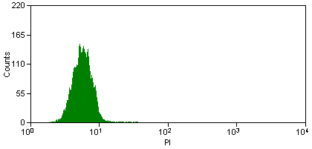
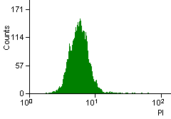
Control 12hrs.
Control 6 hrs

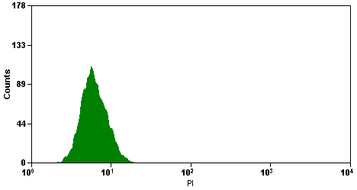
DMSO 12h.
DMSO 6 h.

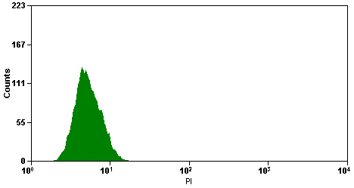
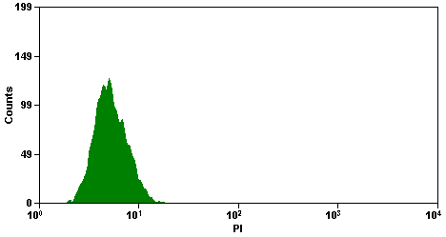
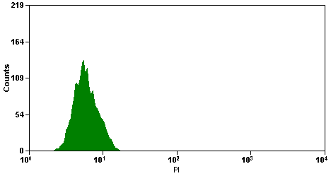
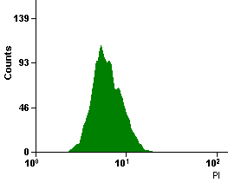
Corn oil 6h.
Corn oil 12 h.
DMSO 12h.
DMSO 6 h.
Vit. E 6 h.
Vit E 12 h.

HMBA 6 h.

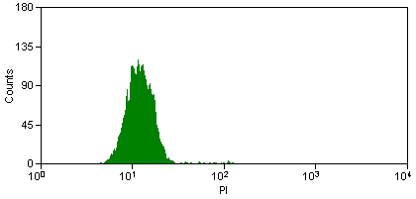
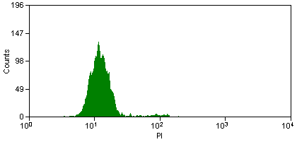
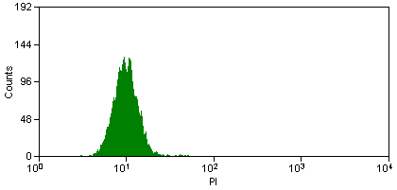
HMBA 12 h.
t-BH 6h

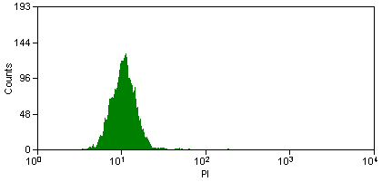
t-BH 12h

Figure of cell cycle analysis
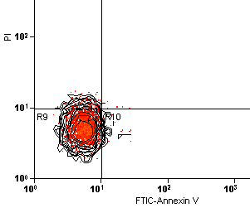
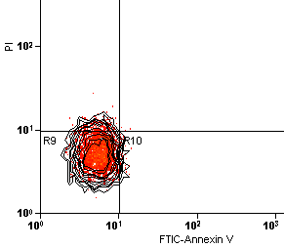
Representative figure for the results of Apoptosis /necrosis analysis
Corn oil 12 h.
Corn oil 6 h

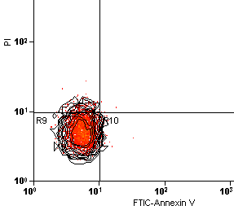
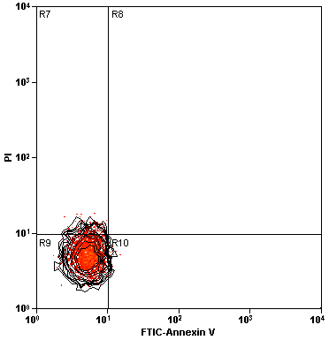
Control 6 h.
Control 12 h.

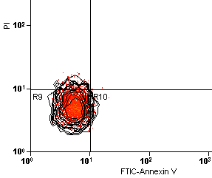
DMSO 6 h
DMSO 12 h.

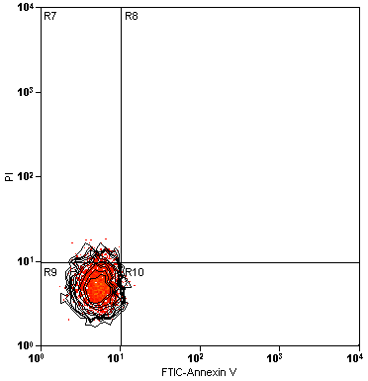
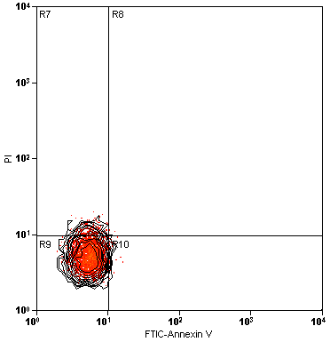
Corn oil 12 h.
Corn oil 6 h
t-BH 12 h.
t-BH 6 h.

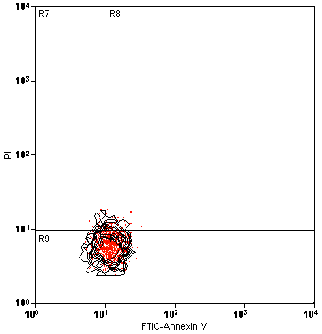
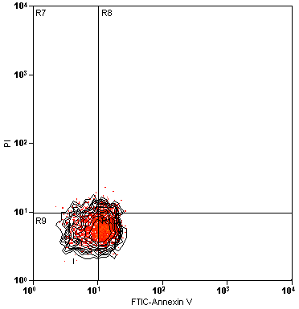
HMBA 6.h.
HMBA 12 h.

Figure 3. Analysis of apoptosis and necrosis (annexin V-FITC/PI): A (control),B (DMSO treatment), C (HMBA treatment) and D (TBH treatment). The percentages of the cell populations (E). Values are mean ±S.D., n= 3.

The results of Apoptosis /necrosis analysis In the flow cytometry representative

 | R1 | R2 | R3 | R4
Control 6h | 5.19 ± 1.4 | 0.17 ± 0.33 | 93.17 ± 1.56 | 1.47 ± 0.75
Control 12h | 5.69 ± 1.54 | 0.1 ± 0.02 | 92.63 ± 1.61 | 1.58 ± 0.09
Corn oil 6h | 5.67 ± 0.63 | 0.0 ± 0.0 | 93.13 ± 1.56 | 1.2 ± 0.08
Corn oil 12h | 6.63 ± 1.63 | 0.0 ± 0.0 | 92.17 ± 1.54 | 1.2 ± 0.07
DMSO 6h | 6.05 ± 0.93 | 0.13 ± 0.05 | 92.35 ± 1.57 | 1.47 ± 0.56
DMSO 12h | 6.27 ± 1.13 | 0.26 ± 0.037 | 91.97 ± 1.63 | 1.5 ± 0.69
Vit E 6h | 5.93 ± 0.55 | 0.19 ± 0.011 | 92.35 ± 1.57 | 1.53 ± 0.5
Vit E 12h | 5.27 ± 0.54 | 0.19 ± 0.02 | 90.57 ± 1.64 | 3.97 ± 0.49
TBH 6h | 6.13 ± 0.94 | 0.2 ± 0.01 | 92.47 ± 1.62 | 1.2 ± 0.04
TBH 12h | 5.85 ± 1.1 | 0.0 ± 0.0 | 80.63 ± 1.6 | 13.52 ± 1.87
HMBA 6 | 6.47 ± 1.53 | 0.07 ± 0.02 | 85.83 ± 1.59 | 7.63 ± 1.22
HMBA 12h | 2.29 ± 1.27 | 7.83 ± 0.07 | 26.44 ± 1.64 | 63.44 ± 3.59

Results of Apoptosis /necrosis analysis

In the flow cytometry representative figures: R1 upper left quadrant (necrotic cells), R2 upper right quadrant (apoptotic cells with damaged membranes), R3 lower left quadrant (healthy cells), R4 lower right quadrant (apoptotic cells)

Results of cell cycle analysis

 | G0/G1 | S | G2/M
Control 6h | 96.1 ± 5.4 | 3.7 ±0.51 | 0.2 ±0.01
Control 12h | 95.2 ± 4.8 | 3.4 ±0.42 | 1.4 ±0.03
Corn oil 6h | 95.4 ± 5.1 | 4.1 ±0.44 | 0.5 ±0.04
Corn oil 12h | 95.6 ± 5.2 | 3.8 ±0.39 | 0.6 ±0.05
DMSO 6h | 95.8 ± 4.6 | 3.9 ±0.29 | 0.3 ±0.02
DMSO 12h | 96.1 ± 5.0 | 3.6 ±0.34 | 0.3 ±0.03
Vit E 6h | 96.8 ± 6.1 | 3.0 ±0.41 | 0.2 ±0.02
Vit E 12h | 95.1 ± 5.5 | 3.2 ±0.29 | 1.7 ±0.34
TBH 6h | 64.6 ± 4.8 | 21.5 ±2.8 | 13.9 ±1.4
TBH 12h | 51.1 ± 3.9 | 24.8 ±2.1 | 24.1 ±2.6
HMBA 6 | 44.2 ± 4.0 | 45.1 ±5.2 | 10.7 ±0.9
HMBA 12h | 32.5 ± 3.9 | 58.3 ±4.9 | 9.2 ±1.4

4. Discussion:
Apoptosis and necrosis are two different forms of cell death, which are distinguished by well defined morphological and biochemical features. Necrosis is characterized by cell swelling, disruption, and rapid disintegration of the cell membrane, leading to the release of the cellular content, which may result in an inflammatory response (Fiers et al., 1999) and lysis of intracellular organelles. Apoptosis on the other hand is a tightly regulated process controlled by a hierarchical set of molecules. During apoptosis the cells undergo nuclear and cytoplasmic shrinkage, the chromatin is condensed and partitioned into multiple fragments, and the cells are finally broken into multiple membrane surrounded bodies (apoptotic bodies) (Fiers et al., 1999). Also, agents that induce malignant cells to generate differentiated progeny might prevent the progression of cancers (Aziz et al., 2002).
Cell cycle checkpoints can be targeted for cancer therapy either by activating checkpoint mediated apoptosis or by exploiting chemical sensitivity because of loss of checkpoint function (El-Deiry et al., 1993). Cel cycle analysis for the treated cell suggest that HMBA and TBH appears to affect processes that are essential to allow cells to progress through the S phase and G₂/M phase of the cell cycle, presumably by perturbation of the cell progression into the G₁ phase.
In the present study, the kinetic induction of apoptosis in Vit. E, Corn oil, HMBA and TBH treated Hep-G2 cells were triggered by a coincident disturbance in the cell cycle phases. Apoptosis was associated with an accumulation of cells in S phase, which suggested a mechanistic modulation in the apoptosis factors. There are several possible speculated mechanisms that may explain the shifted mode of Vit. E, Corn oil, HMBA and TBH treated Hep-G2 to apoptosis.
This study show dramatic inhibition of cell growth in a dose dependent manner showing IC₅₀ values for Vit. E, corn oil, HMBA and TBH of 4.48, 3.97, 3.35 µM and 350.02 µM, respectively. The nature of growth inhibition by each of them in Hep-G2 cells, as illustrated by flow cytometric analysis clarified that the cells treated with HMBA and TBH for 12 h showed a progressive accumulation in S phase and G₂/M phase. Meanwhile, Vit E and Corn oil treated cell showed a progressive accumulation in the Go/G1 phase; the cell cycle chickpoint with a marked decreased number of cells that inter S phase. This result support previous study by (Yu et al., 2002) which emphasized that Vit. E analog results in inhibition of cell proliferation which involves a G0/G1 cell cycle block, mediated in part by mitogen activated protein kinases MEK1 and ERK1 and up-regulation of the key cell cycle regulatory protein p21 (waf1/cip1).
Apoptosis or necroses study support that disturbance in cell cycle analysis showing a clear shift on this ratio from control to all treated cell. The ratio of apoptotic cell was increased on treated cell than that of control which repot 1.4&1.58 after 6 & 12 h. respectively, while HMBA showed the great shift, or highest ratio (7.6 & 63.4. followed by t-BH 1.2 & 13.5, while Vit. E showed the smallest ratio but steel higher than control 1.5 & 3.9. Vit. E treated cell showed shift on induction to apoptosis from 1.5 in control to 3.97 after 12 h. This behavior is similar to its effect on human melanoma cell by (Fermond et al., 2010) who emphasized that d-δ-Tochotrienol induce dose dependent suppression of cell proliferation coincident with cell cycle mediated arrest in G1 phase which was accompanied by reduced expression of cycling dependent kinase 4. Also this study clarified that these arrest was accompanied with induced caspase activation and apoptosis. All of these emphasized an activating checkpoint mediated apoptosis by vit. E on a time and dose dependent manner.
Also the cell cycle arrest on Go/G1 phase reflect a picture of suicide cell death, which is proved in our study by the level of annexin V the established biochemical marker of apoptosis, where vit. E showed decrease ratio of necrotic cell than that of control and DMSO, this is agree with many several study done on Analogs of Vit. E, epitomized by α-tocopheryl succinate (α-TOS), and clarified that Vit. E present one group of mitocans ( Dong et al., 2006; Ralph et al., 2006; Wang et al., 2006 and Neuzil et al., 2007). α-TOS selectively kills malignant cells at levels at which it exerts no toxicity (or minimal toxicity) to normal cells or tissues ( Weber et al., 2002). It also overrides mutations leading to loss of tumor suppressor genes (Weber et al., 2002). Proved the anticancer effect of vit. E through its apoptotic effect on cancerous cell only, sparing normal cell
This role of vit. E as a mitocan, that induce cell apoptosis through effects on the mitochondrial pathway (the intrinsic) pathway of apoptosis, dose not depends on the antioxidant potency of vit. E so it is not affect directly the DNA as the case on t-BH according to (Li et al., 2002). This study provide evidence that the bioactivation of tBHQ results in the formation of paraquinone, semiquinone anion radical, and reactive oxygen species. The reactive oxygen species may be involved in oxidative DNA damage and hence may contribute to the carcinogenicity of BHA (Li et al., 2002).
Over the recent years, it has been demonstrated that vit. E and its analog regulate biological processes including cell proliferation, differentiation and apoptosis. Also it has been found to modulate cellular functions at many levels which are deregulated during carcinogenesis. In many investigations, analog of vit. E has shown cytotoxic activity against several cancer cell lines such as, breast cancer (Kline et al., 2004), prostate cancer (Israel et al., 2000), melanoma cell line (Fernades et al., 2010), ovarian cancer (Anderson et al., 2004).
Furthermore, it is proved that, Vit. E analogs inhibit a diverse range of tumors in experimental animals. Vit. E derivative inhibits the growth of human breast cancers in culture by induction of DNA synthesis arrest, cellular differentiation and apoptosis (Kline et al., 2001 and You et al., 2002). Inhibition of cell proliferation involves a G0/G1 cell cycle block, mediated in part by mitogen activated protein kinases MEK1 and ERK1 and up-regulation of the key cell cycle regulatory protein p21 (waf1/cip1) (Yu et al., 2002).

5. Conclusion:
Using MTT assay, Hep-G2 cells exhibited increased inhibition of proliferation at micro molar concentrations of Vit. E, Corn oil, HMBA and t-BH at 6, and 12 hrs post treatment. Flow cytometry analysis showed that these materials are a potent inducer of apoptotsis in vitro and cell cycle analysis revealed an increase in S phase population. In total, the results indicate that Vit. E is a strong inhibitor of Hep-G2 cell proliferation and a potent inducer of in vitro apoptotic cell death. Further studies are required to evaluate the in vitro effects of Vit. E in cell derived from HCC patients.

References:
- Anderson, K., Simmons-Menchaca, M., Lawson, K. A., Atkinson, J., Sanders, B. G. & Kline, K. (2004): Differential response of human ovarian cancer cells to induction of apoptosis by vitamin E succinate and vitamin E analogue, α-TEA. Cancer Res., 64:4263-4269.
- Andreeff, M., Stone, R., Michaeli, J., Young, C. W., Tong, W., Sogoloff, H., Ervin, T., Kufe, D., Rifkind, R. A. & Marks, P. A. (1992): Hexamethylene bisacetamide in myelodysplastic syndrome and acute myelogenous leukemia: a phase II clinical trial with a differentiation-inducing agent. .Blood, 80: 2604-2609
- Aziz K and Wu G Y, (2002): Cancer screening: A practical guide for physician. Totowa N J; Human press.
- Birringer M, Pfluger P, Kluth D, Landes N, and Brigelius-Flohe R (2002) Identities and differences in the metabolism of tocotrienols and tocopherols in HepG2 cells. J Nutr 132: 3113–3118.
- Chau GY, Lui WY, Tsay SH, Chao Y, King KL, Wu CW. (2006):Postresectional adjuvant intraportal chemotherapy in patients with hepatocellular carcinoma: a case-control study. Ann Surg Oncol.;13:1329-1337.
- Dai ZJ, Wang XJ, Li ZF, Ji ZZ, Ren HT, Tang W, Liu XX, Kang HF, Guan HT, Song LQ. (2008):Scutellaria barbate extract induces apoptosis of hepatoma H22 cells via the mitochondrial pathway involving caspase-3. World J Gastroenterol.;14:7321-7328.
- Dong LF, Wang XF, Zhao Y, Tomasetti M, Wu K, and Neuzil J. (2006): Vitamin E analogues as anti-cancer agents: the role of modulation of apoptosis signalling pathways. Cancer Therapy, 4: 35–46.
- Fadeel B, Orrenius S and Pervaiz (2004): Common cancer treatment techniques. FASAB J; 18: 1.
- Fernandes NV, Guntipalli PK, Mo H (2010): d-δ-Tocotrienol-mediated cell cycle arrest and apoptosis in human melanoma cells. Anticancer Res.; 12:4937-44.
- Fiers W, Beyaert R, Declercq W and Vandenabeele P. (1999): Oncogene; 18: 7719-7730.
- Greenwald P. (2002): Cancer chemoprevention. BMJ.; 324:714-718.
- Huynh H, Chow P K, Ooi L L and So K C. (2002): A possible role for insulin-like growth factor-binding protein 3 autocrine/paracrine loops in controlling hepatocellular carcinoma cell proliferation. Cell Growth differ; 13 (3): 115-122.
- Israel K, Yu W, Sanders BG and Kline K. (2000): Vitamin E succinate induces apoptosis in human prostate cancer cells: Role for Fas in vitamin E succinate-triggered apoptosis. Nutr Cancer, 36: 90-100.
- Johnson IT. (2007): Phytochemicals and cancer. Proc Nutr Soc.; 66:207-215.
- Kline K, Weiping Yu and Bob G. Sanders (2004): Vitamin E and Breast Cancer J. Nutr., vol. 134(12): 3458S-3462S
- Kline, K., Yu, W. & Sanders, B. G. (2001): Vitamin E: mechanisms of action as tumor cell growth inhibitors. J. Nutr., 131:161S-163S.
- Kogure K, Hama S, Manabe S, Tokumura A, and Fukuzawa K (2002): High cytotoxicity of α-tocopheryl hemisuccinate to cancer cells is due to failure of their anti-oxidative defense systems. Cancer Lett., 86: 151–156.
- Kunisaki M, Bursell SE, Clermont AC, Ishii H, Ballas LM, Jirousek MR, Umeda F, Nawata H, and King GL (1995): Vitamin E prevents diabetes-induced abnormal retinal blood flow via the diacylglycerol-protein kinase C pathway. Am J Physiol., 269: E239–E246.
- Li WY, Chiu LC, Lam WS, Wong WY, Chan YT, Ho YP, Wong EY, Wong YS, Ooi VE. (2007): Ethyl acetate extract of Chinese medicinal herb Sarcandra glabra induces growth inhibition on human leukemic HL-60 cells, associated with cell cycle arrest and up-regulation of pro-apoptotic Bax/Bcl-2 ratio. Oncol Rep., 17:425-431.
- Li Y, Seacat A, Kuppusamy P, Zweier JL, Yager JD, and Trush MA (2002): Copper redox-dependent activation of 2-tert-butyl (1,4)hydroquinone: formation of reactive oxygen species and induction of oxidative DNA damage in isolated DNA and cultured rat hepatocytes. Mutat Res., 518: 123–133.
- Marks, P. A., Richon, V. M. & Rifkind, R. A. (1996) Inducing differentiation of transformed cells with hybrid polar compounds: a cell cycle-dependent process.. Int. J. Hematol., 63: 1-17.
- Mukhtar H and Ahmad N. (1999): Cancer chemoprevention: future holds in multiple agents. Toxicology and applied pharmacology; 158: (3): 207–210.
- Neuzil J · Jeffrey C. Dyason · Ruth Freeman, Lan-Feng Dong · Lubomir Prochazka ·Xiu-Fang Wang · Immo Scheffler · Stephen J. Ralph. (2007): Mitocans as anti-cancer agents targeting mitochondria: lessons from studies with vitamin E analogues, inhibitors of complex IIJ Bioenerg Biomembr. 39:65–72 DOI 10.1007/s10863-006-9060-z
- Neuzil J, Wang XF, Dong LF, Low P, and Ralph SJ (2006): Molecular mechanism of `mitocan'-induced apoptosis in cancer cells epitomizes the multiple roles of reactive oxygen species and Bcl-2 family proteins. FEBS Lett., 80: 5125–5129.
- Norikura T, Kojima-Yuasa A, Shimizu M, Huang X, Xu S, Kametani S, Rho SN, Kennedy DO, Matsui-Yuasa I. (2008): Mechanism of growth inhibitory effect of Blumea balsamifera extract in hepatocellular carcinoma. Biosci Biotechnol Biochem., 72:1183-1189.
- Okubo T, Yokoyama Y, Kano K, Kano I.(2003 ): Cell death induced by the phenolic antioxidant tert-butylhydroquinone and its metabolite tert-butylquinone in human monocytic leukemia U937 cells. Food Chem Toxicol., 41(5):679-88
- Pham DQ and Plakogiannis R. (2005) :Vitamin E supplementation in cardiovascular disease and cancer prevention: part 1. Ann Pharmacother ., 39: 1870–1878.
- Ralph SJ, Dong LF, Low P, Lawen A, and Neuzil J. (2006) :Mitocans: mitochondria-targeted anti-cancer drugs as improved therapies and related patents. Recent Pat Anticancer Drug Discov., 1: 305–326.
- Richon V M, Emiliani S, Verdin E, Webb Y, Breslow R, Rifkind R A and Marks P A, (1998): Improvement strategy of cancer treatment. Proc Natl Acad Sc: USA; 95: 3003.
- Richon VM, Russo P, Venta-Perez G, Cordon-Cardo C, Rifkind RA, Marks PA. (1997): Two cytodifferentiation agent-induced pathways, differentiation and apoptosis, are distinguished by the expression of human papillomavirus 16 E7 in human bladder carcinoma cells. Cancer Res., 57:2789)
- Siegel, D. S., Zhang, X., Feinman, R., Teitz, T., Zelenetz, A., Richon, V. M., Rifkind, R. A., Marks, P. A. & Michaeli, J. (1998): HMBA induced programmed cell death (apoptosis) and down regulates Bcl-2 expression in human myeloma cells. Proc. Natl. Acad. Sci. USA 95: 162-166.
- Tasinato A, Boscoboinik D, Bartoli GM, Maroni P, and Azzi A (1995): d-α-Tocopherol inhibition of vascular smooth muscle cell proliferation occurs at physiological concentrations, correlates with protein kinase C inhibition, and is independent of its antioxidant properties. Proc Natl Acad Sci USA, 92: 12190–12194
- Wang XF, Dong LF, Zhao Y, Tomasetti M, Wu K, and Neuzil J (2006): Vitamin E analogues as anti-cancer agents: lessons from studies with α-tocopheryl succinate. Mol Nutr Food Res., 50: 675–685.
- Weber T, Lu M, Andera L, Lahm H, Gellert N, Fariss MW, Korinek V, Sattler W, Ucker DS, Terman A, et al. (2002): Vitamin E succinate is a potent novel antineoplastic agent with high tumor selectivity and cooperativity with tumor necrosis factor-related apoptosis-inducing ligand (TRAIL, Apo2L) in vivo. Clin Cancer Res., 8: 863–869.
- You, H., Yu, W., Munoz-Medellin, D., Brown, P. H., Sanders, B. G. & Kline, K. (2002): Role of extracellular signal-regulated kinase pathway in RRR-α-tocopheryl succinate-induced differentiation of human MDA-MB-435 breast cancer cells. Mol. Carcinog., 4:228-236.
- Yu W, Liao QY, Hantash FM, Sanders BG and Kline K. (2001): Activation of extracellular signal-regulated kinase and c-Jun- NH(2)-terminal kinase but not p38 mitogen-activated protein kinases is required for RRR-·-tocopheryl succinate-induced apoptosis of human breast cancer cells. Cancer Res., 61: 6569- 6576.
- Yu, W., Sanders, B. G. & Kline, K. (2002): RRR-α-tocopheryl succinate-induction of DNA synthesis arrest of human MDA-MB-435 cells involves TGF-ß independent activation of p21 (Waf1/Cip1). Nutr. Cancer, 43:227-236
- Yu, W., Sanders, B. G. & Kline, K. (2003): RRR-α-tocopheryl succinate-induced apoptosis of human breast cancer cells involves Bax translocation to mitochondria. Cancer Res., 63:2483-2491.

5/22/2011

