Streptomyces anulatus a Tellurium Tolerant Actinomycete Some modes of Tolerance

El-Meleigy , M . A.¹; Mohamed, H. F.²; Mohamadein, M. M.³ and Salem, M. S.²

¹Biology Dept., Faculty of Education, Shaqraa University, K.S.A.
² Botany and Microbiology Dept., Faculty of Science, Al-Azhar University, Cairo , Egypt.
³Medical Laboratory Science Dept., College of Applied Medical Sciences, Alkharj University, K.S.A.
mereamsalah@yahoo.com

Abstract: Tellurium-tolerant actinomycete was isolated from the soil sample collected from the Egyptian contaminated sites in Hellwan City beside cement factory using starch nitrate agar medium supplemented with 1000 ppm of sodium tellurite. Identification depending on its morphological ,physiological and biochemical characterization , chemical analysis of the cell wall, cultural characteristics using the recommended media of the international Streptomyces project (for actinomycetes ) and with help of 16S rRNA sequencing, which revealed that it is Streptomyces anulatus strain MG 001 (GenBank accession number GU569951.1), Identities = 98 % , Gaps = 1 % . It is highly tellurite tolerance up to 0.6 % (w/v). Fractionation of protein on Sephadex gel G25 revealed the presence of low and high molecular weight proteins. Fraction number 7 showed maximum tellurium and protein content at the same time for all investigated protein fractions. Amino acid analysis of low molecular weight protein containing fraction number 7 showed the presence of proline, methionine and histidine representing Te-protein. Scanning electron microscopy was used to study the morphological feature compared to control and reveal the most common feature of mycelium fragmentation when Streptomyces anulatus was exposed to a tellurite-containing medium (1000 ppm). Scanning electron microscopy energy dispersive x-ray microanalysis (SEM-EDX) technique for the detection of the element uptake demonstrate the percentage of tellurium accumulated in microbial culture (4.430 %) compared to control culture (tellurite free).
[El-Meleigy, M . A; Mohamed, H. F.; Mokhtar, M. M. and Salem, M. S. Streptomyces anulatus a Tellurium Tolerant Actinomycete Some modes of Tolerance]. Nature and Science 2011;9(7):141-153]. (ISSN: 1545-0740). http://www.sciencepub.net. doi:10.7537/marsnsj090711.17

Key words: Heavy metals-tolerant actinomycetes, Streptomyces sp., Morphological, Biochemical Identification and partial 16S rRNA gene sequencing, SEM-EDX.

1. Introduction
The metalloid tellurium (Te), a group 16 element related to oxygen and sulfur, possesses chemically stable oxidation states of +VI (tellurate), +IV (tellurite), 0 (elemental tellurium), and _II (telluride), with most Te occurring as tellurate in the hydrosphere and as tellurides of gold and silver in the lithosphere(Yurkov and Csotonyi, 2003). While oxidized Te is toxic to most microorganisms at concentrations as low as 1 µg/ml (Taylor, 1999), aerobic reduction allows some species to resist K₂TeO₃ concentrations as high as 2,500 to 5,000 µg/ml (Yurkov et al., 1996; Pearion and Jablonski, 1999; Rathgeber et al., 2002; Yurkov and Csotonyi, 2003).
Industrial waste discharge sites can contain elevated concentrations of Te (Bagnall, 1975). Bacterial resistance to tellurite is poorly understood but is thought to be associated with tellurite reduction and precipitation of metallic tellurium (Silver, 1996, Rathgeber et al., 2002 and Lloyd, 2003).It has been suggested that tellurite entering cells can be reduced by membrane-associated nitrate reductases (Avazeri et al., 1997 and Sabaty et al., 2001). Once inside the cell, glutathione and other thiol-carrying molecules are the main mediators of tellurite reduction (Turner et al., 1999 and Turner et al., 2001). Other mechanisms, including cysteine-metabolizing enzymes and methyl transferases, may be important resistance mechanisms against tellurite toxicity (Taylor, 1999 and Basnayake et al., 2001).
Klonowska et al., 2005 studied Shewanella oneidensis MR-1 that reduces selenite and tellurite preferentially either aerobically or anaerobically. The liquid cultures of S. oneidensis MR-1 grown in the presence of Se (IV) or Te(IV) turned red or black respectively, proving the ability of this bacterium to reduce these oxyanions to their elemental forms.
Streptomyces are a group of aerobic high % G+C Gram positive bacteria that undergo complex differentiation to form filamentous mycelium, aerial hyphae and spores. In addition, they produce a broad range of secondary metabolites including antibiotics, antiparasitic agents, herbicides, anti-cancer drugs and various enzymes of industrial importance. Two Streptomyces species had their complete genome sequences published, namely the model organism Streptomyces coelicolor (% G+C = 72.1) and avermictin producer Streptomyces avermitilis (%G+C = 70.7) (Bentley et al., 2002 and Ikeda et al., 2003). Identification of aerobic actinomycetes by conventional biochemical assays requires expertise and time, and newer species such as Nocardia nova can be difficult to separate with accuracy from other related species (Wallace et al., 1991). Since these bacteria are slowly growing, 2 to 4 weeks is required for genus level identification and an additional 4 weeks or more is required for species-level identification. Alternative methods of identification, including high-performance liquid chromatography (HPLC) and molecular techniques have been applied to this group of bacteria (Butler et al., 1987). DNA amplification followed by PCR-restriction endonuclease analysis (PRA) of the 65 hsp gene has proven to be a more effective method of rapid identification (Steingrube et al., 1995). 16S rRNA gene sequence analysis lacks widespread use beyond the large and reference laboratories because of technical and cost considerations. Thus, a future challenge is to translate information from 16S rRNA gene sequencing into convenient biochemical testing schemes, making the accuracy of the genotypic identification available to the smaller and routine clinical microbiology laboratories (Clarridge, 2004).
Metallothioneins are cysteine-rich, low molecular weight (3500.14 KDa) peptides that chelate metal ions by thiolate coordination. MTs have received their designation from their prominent metal and sulfur content which, varying with the metal species present, together may contribute to over 20% of their weight (Mir et al., 2004). MTs are implicated in a variety of physiological processes, including maintaining homeostasis of essential metals, metal detoxification, scavenging free radicals, and regulating cell growth and proliferation (Palmiter, 1998; Vasak and Hasler, 2000).
Thiol compounds, including reduced glutathione (Y-glutamyl cysteinyl glycine) (GSH), phytochelatins (PCs) and metallothioneins (MTs), are essential components of heavy metal detoxification, in this respect Cd has been extensively studied (Courbot et al., 2004).
The siderophore of Pseudomonas stutzeri KC, pyridine-2,6-bis(thiocarboxylic acid) (pdtc), is shown to detoxify selenium and tellurium oxyanions in bacterial cultures. A mechanism for pdtc’s detoxification of tellurite and selenite is proposed. The mechanism is based upon determination using mass spectrometry and energy dispersive X-ray spectrometry of the chemical structures of compounds formed during initial reactions of tellurite and selenite with pdtc. Electron microscopy studies showed both extracellular precipitation and internal deposition of these metalloids by bacterial cells. The precipitates formed with synthetic pdtc were similar to those formed in pdtc-producing cultures of P. stutzeri KC (Zawadzka et al., 2006).
Here we report, the high tolerance of Streptomyces anulatus towards tellurite through the fractionation of protein content and determination of tellurium bounded protein using atomic absorption spectrophotometer and amino acid analysis of low molecular weight metallo-protien to exhibit the ability of this isolate to detoxify and tolerate such element , in addition to studying its effect on morphological feature using scanning electron microscopy (SEM) , also its accumulation using scanning electron microscopy energy dispersive x-ray microanalysis (SEM-EDX) technique was carried out.

2. Material and Methods
Organism, media, and culture conditions
Telleuro-tolerant strain of Streptomyces anulatus was used, originally isolated from contaminated sites in Hellwan City and identified by morphological , physiological and biochemical characterization , with help of 16S rRNA analysis. Culture was isolated and maintained on a defined medium sulfur free (Starch-nitrate agar medium), modified from that of Tadashi, 1975. The medium contained the following(g/l) : soluble starch 20.0; KNO₃ 2.0; K₂HPO₄ 1.0 ; KCl 0.5; CaCO₃ 2.0; agar 20 and tap water up to 1000 ml . The pH of the medium was adjusted at pH 7 – 7.4 before sterilization. Sodium tellurite was filter sterilized or sterilized by diethyl ether. The concentration was adjusted at 1000 ppm by the addition of equivalent volume of metal stock solution to the medium just before solidification. Direct spreading of soil technique was used in the isolation of heavy telleuro-tolerant actinomycete. For Scanning Electron Microscopy energy dispersive x-ray microanalysis (SEM-EDX) and Scanning Electron Microscopy examination, medium with the same condition of isolation was used except the control plate (heavy metal free). Starch nitrate broth medium supplemented with 0.1% (w/v) sodium tellurite and inoculated with the isolate under study, incubated at 30 ⁰C for 5 days and used for fractionation of protein.
Morphological examination of the actinomycete isolate was done by cover slip technique according to Kawato and Shinobu (1959). The mycelium structure, and arrangement of spores on the mycelium were examined using light microscopy under oil immersion (1,00 x). Since a single method could not identify all actinomycete isolates to the species level; therefore, a combination of methods was necessary. Biochemical tests and physiological criteria such as the capability to degrade the organic compounds such as casein, xanthine,pectin and starch as substrates, the utilization of different carbon and nitrogen sources , growth at 45°C at 3 days as well as growth in (%w/v): 7 NaCl, 0.1 Phenol , 0.01 Sodium Azid and 0.001 Potassium tellurite were studied in order to reach a possible classification to the species level .In addition to Cell Hydrolysis for Diaminopimelic Acid (DAP) ,detection and hydrolysis of cells for sugar analysis which carried out according to Becker et al. (1964) and Lechevalier et al.(1968) .

Media for production of melanin pigment
Peptone yeast extract-iron agar medium contains (g/l) : bacto-peptone 15.0; protease peptone (Difco) 5.0 ; ferric ammonium citrate 0.5 ; K₂HPO₄ 1.0 ; sodium thiosulphate 0.08 ; bacto-yeast extract 1.0 ; agar 20 and distilled water up to 1000 ml . The pH value was adjusted at 7-7.2 before autoclaving, Tyrosine agar medium contains (g/l) :glycerol 15 ; L-tyrosine (Difco) 0.5 ; L-asparagine (Difco) 1.0; K₂HPO₄ (anhydrous basis) 0.5 ; MgSO₄.7H₂O 0.5 ; NaCl 0.5 ; FeSO₄.7H₂O 0.01 ; trace salt solution 1.0 ml ; agar 20.0 and distilled water up to 1000 ml. The pH value was adjusted at 7-7.4.

Gel filtration fractionation of cell free extract of Streptomyces anulatus cultivated on sodium tellurite containing media.
The harvested mycelia were filtered, washed with distilled water several times, then ground with an approximately equal weight of clean cold sand in a cold mortar and extracted with 70 % (v/v) ethyl alcohol. The obtained slurry was centrifuged at 6.000 r.p.m. for 20 minutes. The supernatant was concentrated to approx. 2.0 ml, under vacuum using rotary evaporator at 40 ⁰C. Column (2.5×30 cm) was packed with Sephadex G₂₅ fine, washed with distilled water for 2 hours to allow settlement of the beds. The void volume and the uniformity of packing were determined using Blue Dextran 2000 and bromophenol blue. The concentrated extract was applied into the column and allowed to pass into the gel by running the column. phosphate buffer pH 7 was then added without disturbing the gel surface , 50 fractions were collected each of 5.0 ml .Tellurium content using atomic absorption spectrophotometer as well as protein content of each fraction were determined.

Atomic Absorption Spectrophotometer
The module (GBC932AA) was used at Regional Center for Mycology and Biotechnology (RCMB), Al-Azhar University.

Protein determination:
Protein was determined by the method of Lowry et al. (1951) using bovine serum albumin as a standard protein, the color was read at 750 nm using spectrophotometer Speko II.

Determination of amino acids composition by amino acid analyzer:
The application of amino acid hydrolysis was carried out according to (Block et al, 1958). Samples of amino were injected to the amino acid analyzer (Eppendorf-LC 3000). The peak area and percentage of each amino acid were calculated by computer using software AXXIOX CHROMATOGRAPHY-727.At Regional Center for Mycology and Biotechnology (RCMB), Al-Azhar University.

Scanning Electron Microscopy (SEM)
Specimens were coated with gold using an SPI Module TM Sputter Gold Coater. Coated specimens of each treatment were examined using high–vacuum mode of the computerized scanning electron microscope JEOL JSM-5500LV at Regional Center for Mycology and Biotechnology (RCMB), Al-Azhar University, Cairo, Egypt.

Scanning electron microscopy energy dispersive x-ray microanalysis (SEM-EDX) technique
After good growth, a block of the isolate under study was spread on a carbon holder and left to dry to be examined by scanning electron microscope energy dispersive x-ray microanalysis (SEM-EDX) to detect the percentage of the present elements with respect to one another. The analysis was carried out using X-ray detector (INCAxsight, Oxford Instruments) of the scanning electron microscope JEOL JSM-5500LV at Regional Center for Mycology and Biotechnology (RCMB) , Al-Azhar University, Cairo, Egypt. Window Integral was the mode of analysis (the given percentage represent the average of five measurements).

16S rDNA extraction (Sambrook et al., 1989), amplification, and sequencing
The genomic DNA of the isolate under study was isolated according to Sambrook et al., 1989. Cells were collected from overnight starch-nitrate broth cultures by centrifugation and resuspended in MLTEN buffer. Twenty five µl of 10 mg/ml of lysozyme was added and the tubes were incubated at 37⁰C for 30 min , followed by the addition of 75 µl of 10 % stock DNA solution (SDS) and the tubes were inverted gently several times till complete lysis. Three of 20 mg/ml of protienase k was added and the tubes were incubated at 37⁰C for one hour. After incubation 100 µl of 5 M NaCl was added and 800 µl of phenol/ chloroform: isoamyl alchol (24:1) was added and the tubes were inverted several times and centrifuged for 10 min. The upper phase was transferred to afresh tube and extracted once with chloroform. The upper phase was again transferred to a fresh tube and 0.7 volume of isopropanol was added and mixed gently and centrifuged for 10 min. The supernatant was removed carefully and the pellet was washed with 1ml of 70% ethanol. The pellet was collected by centrifugation for 5 min. The DNA was dried and dissolved in 100 µl TE buffer and stored at -20 ⁰C. The 16S rRNA gene was amplified by polymerase chain reaction (PCR) using eubacterial universal primers. That were F27 with the sequence 5-AGAGTTTGATCMTGGCTCAG-3 and R1492 with the sequence 5-TACGGGYTACCTTGTTACGACTT-3.The PCR mixture consisted of 30 picomoles of each primer, 10µg of chromosomal DNA, 200 µl dNTPs and 2.5 units of Taq polymerase in 50 µl of polymerase buffer. The PCR was carried out for 30 cycles of 94 ⁰C for 1 min, 55⁰C for 1 min and 27⁰C for 2 min. After completion, PCR product was purified using PCR purification kit (Qiagen, Germany). DNA sequences were obtained using an ABI PRISM 3700 DNA sequencer and ABI PRISM Big Dye Terminator Cycle Sequencing.

DNA sequence similarities and phylogenetic analysis.
Sequence data was analyzed in the GenBank database by using the BLAST program available on the National Center for Biotechnology Information website (www.ncbi.nlm.nih.gov).The unknown sequence was compared to all of the sequences in the database to assess the DNA similarities (Altschul et al., 1990).The GenBank entry with the highest score from the search with the BLAST program was downloaded.

3. Results
Streptomyces anulatus was isolated at 1000 ppm of sodium tellurite containing medium and able to tolerate high concentration of such element up to 0.6 % (w/v). Colonies attained black coloration as well as growth medium by addition of tellurite to the culturing medium .Such black precipitation in the external environment as a result of the reduction of tellurite to elemental tellurium indicated the powerful reducing agents produced by the studied isolate. Microscopic analysis revealed that, the isolate was straight to flexuous (Rectiflexibiles) aerial mycelium (Plate, 1 ) , and therefore this isolate was expected to belong to Streptomyces or related genera in addition to cell wall analysis that contains LL-diaminopimelic acid (LL-DAP) and sugar pattern not detected. Based on morphological, physiological and biochemical characters , and according to the recommended international Key’s viz. (Williams, 1989; and Hensyl, 1994) , the studied isolate was identified as Streptomyces anulatus, it had straight to flexuous (Rectiflexibiles) spore chains with smooth spore surface , color of spore mass belong to white series, there is no diffusible pigment, melanin pigment is not produced, hydrolysis of pectin and xanthin ,nitrate reduction and H₂S production were positive, grow at 45⁰C, grow in the presence of % (w/v) : 0.01 sodium azide, 0.001 potassium tellurite, 0.1 phenol and in presence of 7 NaCl, it utilizes L- Cysteine, L- Valine, L- phenylalanine, meso-Inositol, Mannitol and Rhamnose, table (1) show the comparative study between the isolate , to reference strains of Streptomyces anulatus, 16S rDNA sequencing was performed for this isolate as a confirmed identification tool .The extracted DNA sample from this isolate was amplified by PCR using 16S rRNA eubacterial universal primer. The PCR product was sequenced directly and 534 bp sequence of the isolate was successfully determined using an ABI PRISM 3700 DNA sequncer. The obtianed sequence was compared to all of the sequences in Gene bank by using Basic Local Alignment Search Tool (BLAST).The isolate was found to be similar to Streptomyces anulatus strain MG 001 (GenBank accession number GU569951.1), Identities = 98 % , Gaps = 1 %

Fractionation of the cell free extracts of Streptomyces anulatus grown at 0.1 % (w/v) ppm sodium tellurite concentration.
Streptomyces anulatus was cultivated in starch nitrate liquid medium containing 0.1% sodium tellurite. The cell free extract was concentrated and then proteins were fractionated on sephadex G₂₅ to several fractions. Out of fifty fractions were taken. Tellurium concentration in each fraction was determined using atomic absorption spectrophotometer. Table (2) and Fig. (1) have demonstrated the fractionation pattern of Streptomyces anulatus . Narrow range of protein containing fractions (12 fractions) is obtained by Streptomyces anulatus, nine of them containing tellurium ion. The detected fractions contains high level of tellurium as well, where fraction No. 7 contained highest amount of tellurium and protein at the same time 36.545 ppm Te/5ml and 1700 µg protein /5ml respectively .

Amino acid composition of telleuro-protein and telleuro-thionein in fractions No. 5,6,7,9 and 11 of Streptomyces anulatus fractionated on Sephadex G₂₅ fine.
Fractions No. 5, 6, 7, 9 and 11 were undergoing to acid hydrolysis for detection of their amino acid composition. Fractions No. 9 and 11 contained very low molecular weight protein, while fractions No. 6 and 7 are possibly metallothionein (low molecular weight protein) , while fractions No.5 considered high molecular weight proteins. Those fractions contained extremely high level of tellurium. Histidine, methionine and proline recorded the highest values in all fractions under study. Also glutamic acid and glycine showed a relatively high amount in fractions No. 6 and 11 where isoleucine and aspartic acid represented their maximum activity in fractions No.6 and 9 respectively (Table, 3 and Fig, 2).

Electron microscope studies concerning tellurite effects at 1000 ppm on morphemical characteristics of Streptomyces anulatus .
Streptomyces anulatus was allowed to grow on starch nitrate agar medium containing 1000 ppm of sodium tellurite beside control plate (heavy metal free). Starch nitrate agar medium support Streptomyces anulatus growth in absence of melal giving straight to flexuous (Rectiflexibiles) long chains of smooth large spores, Plate ( 2 a ) . Fragmentation of substrate and aerial mycelium was of a common feature exhibited by micrograph, Plate (2 b).

Scanning electron microscopy energy dispersive x-ray microanalysis (SEM-EDX) to tellurium detectable percentage in Streptomyces anulatus
Tellurite exposed actinomycetal cells showed a peak for the presence of tellurium representing 4.430 % fig., 4. While detectable quantities of transition metal were not present, in contrast to control culture (Table, 4 and Fig. 3).

4. Discussion:
Tellurium is highly toxic metalloid from group 16 of the periodic table. Tellurium is a relatively rare element found in nature in the form of metal tellurides (e.g., Pb, Cu, Ag, Au, and Sb). Industrial waste discharge sites can contain elevated concentrations of Te (Bagnall, 1975).
Microbial resistance to the inorganic oxyanion tellurite (TeO₃²⁻) is a widespread phenomenon. In most environments sampled to date, tellurite-resistant organisms comprise ~10% of the total culturable microbial population (Taylor, 1999 and Rathgeber et al., 2002).
Streptomyces anulatus was able to tolerate sodium tellurite at high concentration up to 0.6 %w/v). Such high resistance to tellurium was higher than that obtained by different strains .Where, the MICs of potassium tellurite determined for pyridine-2, 6-bis (thiocarboxylic acid) pdtc-producing strain KC and pdtc-negative Mutant strain CTN1 of Pseudomonas stutzeri were 0.1 and 0.075 mM, respectively (Zawadzka et al., 2006). The MIC for bacteria lacking resistance determinants is in the order of 1 to 2 µg /ml for TeO₃ ²⁻ . The microbial growth of studied isolate in sodium tellurite containing medium, black coloration of growth as well as precipitation in the external environment was noticed. Similarly, when pdtc was mixed with a tellurite solution, an orange precipitate formed which gradually changed to black, the color of elemental tellurium (Zawadzka et al., 2006). Also Klonowska et al., 2005 studied Shewanella oneidensis MR-1 that reduces selenite and tellurite preferentially either aerobically or anaerobically. The liquid cultures of S. oneidensis MR-1 grown in the presence of Se (IV) or Te (IV) turned red or black respectively, proving the ability of this bacterium to reduce these oxyanions to their elemental forms.
The traditional identification of bacteria on the basis of phenotypic characteristics is generally not as accurate as identification based on genotypic methods. Comparison of the bacterial 16S rRNA gene sequence has emerged as a preferred genetic technique (Clarridge, 2004), Although the 16S rRNA gene is generally used as a framework for modern bacterial classification, it often shows limited variation for the discrimination of closely related taxa (Fox et al., 1992; Stackebrandt and Swiderski, 2002). For these reasons we evaluated partial 16S rRNA gene sequences and compared the result of identification to the profiles obtained by morphological, physiological and biochemical analysis In accordance , evaluated partial 16S rRNA gene sequences and compared them to the profiles obtained by biochemical analysis, HPLC, fatty acid analysis, drug susceptibility testing, and PRA of the 65 hsp Telenti sequence for identification of isolates of the aerobic actinomycetes were carried out (Patel et al., 2004). PCR fingerprinting was used to identify our isolate at the subspecies level. PCR is a relatively rapid DNA fingerprinting technique that is known to discriminate bacterial isolates at the intraspecific level and potentially up to the strain level (Versalovic et al., 1994).

Table ( 1 ) : A comparative study of the identification properties of the isolate , in relation to the reference strains Streptomyces anulatus
Characteristic | Isolate | Streptomyces anulatus
Morphological Characteristics
Motility | - | -
Spore mass white | + | ±
Spore mass red | - | -
Spore mass gray | - | -
Spore chain Rectiflexibiles | + | +
Spore surface smooth | + | +
Diffusible pigment produced | - | -
Mycelial pigment red –orange | - | -
Diffusible pigment yellow-brown | - | -
Substrate mycelium-yellow- brown | + | +
Melanin pigment on  1-Peptone yeast extract-iron agar medium (ISP-6) | - | ±
2- Tyrosine agar medium (ISP-7) | - | ±
Pectin hydrolysis | + | +
Nitrate reduction | + | ±
H₂S production | + | +
Degradation of Xanthin | + | +
Growth at 45°C | + | -
Growth at NaCl 7% ( w/v) | + | ±
Growth inhibitor (% w/v)  Phenol (0.1)  Sodium Azid (0.01)  Potassium tellurite (0.001) | +  +  + | +  ±  ±
Utilization of
L- Cysteine | + | ±
L- Valine | + | ±
L- phenylalanine | + | ±
Sucrose | - | ±
Meso-Inositol | + | ±
Mannitol | + | +
Rhamnose | + | +
Symbols: ±, 11-89% of strains are positive.
+, 90 % or more of strains are positive.
- , 10 % or less of strains are positive

Table (2): Gel filtration fractionation of cell free extract of Streptomyces anulatus , cultivated on sodium tellurite containing medium .
Fraction No. | µg protein /5ml | ppm Te/5ml | Te/protein Ratio
1  2  3  4  5  6  7  8  9  10  11  12  13  14  15  16-50 | 0.0  0.0  0.0  300  300  550  1700  1300  900  800  810  430  330  212  190  0.0 | 0.0  0.0  0.0  11.315  23.895  25.515  36.545  19.495  21.28  6.845  9.76  2.015  0.0  0.0  0.0  0.0 | 0.0  0.0  0.0  0.0377  0.0795  0.0463  0.02149  0.01499  0.02364  0.00855  0.01204  0.00468  0.0  0.0  0.0  0.0

Table (3): Amino acid composition of telleuro-protein and telleuro-thionein in fractions No. 5, 6, 7, 9 and 11 of Streptomyces anulatus fractionated on sephadex G₂₅ fine.
Fraction  No.  Amino  acid | Fraction No.5 | Fraction No.6 | Fraction No.7 |  | Fraction No.9 | Fraction No.11
Fraction  No.  Amino  acid | Conc. µg/ml | Conc. µg/ml | Conc. µg/ml |  | Conc. µg/ml | Conc. µg/ml
Aspartic acid | 14.8 | 20.31 | 36 |  | 39.3 | 32
Threonine | 4.8 | 10.11 | 9 |  | 13.4 | 12.8
Serine | 6.1 | 11.1 | 10.4 |  | 12 | 14
Glutamic acid | 2.3 | 32.8 | 28 |  | 32 | 40.8
Proline | 32.7 | 50.08 | 39 |  | 45 | 61.7
Glycine | 23.5 | 43.06 | 25 |  | 26 | 50
Alanine | 5.6 | 12 | 12.5 |  | 18.6 | 33
Valine | 7.9 | 11 | 9.6 |  | 23 | 22
Methionine | 30 | 73.2 | 37.2 |  | 63 | 63
Isoleucine | 22.6 | 47.2 | 34 |  | 29 | 30
Lucine | 10.1 | 21 | 19 |  | 22.4 | 17.5
Tyrosine | 4.5 | 4.2 | 6.1 |  | 4.9 | 0.98
Phenylalanine | 12.2 | 19.4 | 15.09 |  | 16.8 | 1.7
Histidine | 143.9 | 120 | 53 |  | 72.9 | 47
Lysine | 0.8 | 1.6 | 9 |  | 28.5 | 2.6
Ammonia | 1768.15 | 89.34 | 167 |  | 194.7 | 350.9
Arginine | 15.7 | 18 | 4.33 | 22.9 |  | 19.7

Table (4): Percentage of elements detected in Streptomyces anulatus cells growing on 1000 ppm sodium tellurite.
Tests  Elements | Percentage(%)of elements detected by Streptomyces anulatus at condition of
Tests  Elements | Control | Tellurium
Na  Mg  P  S  Cl  K  Ca  Zn  Co  Hg  Cr  Se  Te | 9.200  7.380  33.877  1.063  3.543  3.700  37.757  5.610  -  -  -  -  - | 17.405  7.385  29.200  0.230  5.820  4.275  24.010  7.255  -  -  -  -  4.430

Control = sodium tellurite free culture

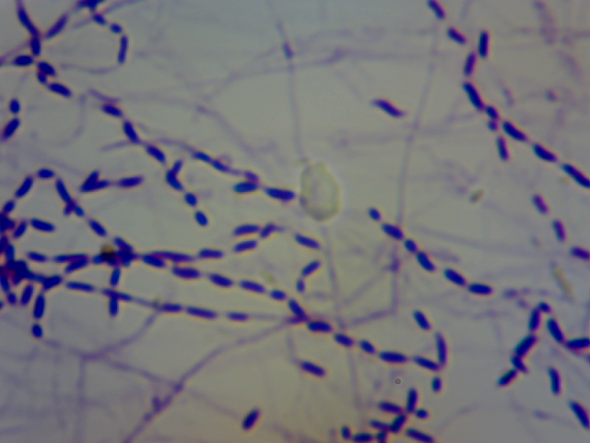
Plate (1). A photograph of the actinomycete isolate grown on starch-nitrate agar medium showing spore chain straight to flexuous (X 100).

Fig. ( 1 ): Protein and tellurium contents of different protein fractions extracted from Streptomyces anulatus, fractionated on a column( 2.5×30 cm) packed with Sephadex G₂₅ fine.

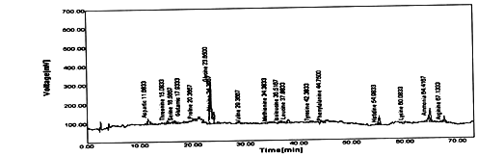
Fraction No. 5
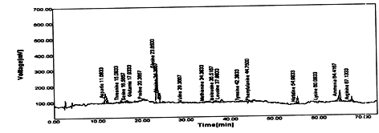
Fraction No. 6
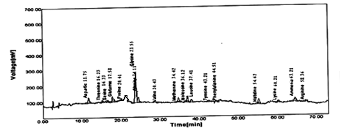
Fraction No. 7
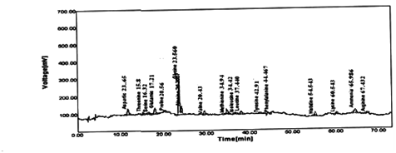
Fraction No. 9
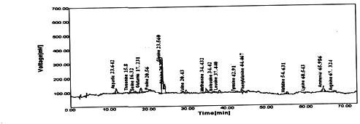
Fraction No.11
Fig.( 2) : Chromatogam of amino acid composition for tellurium containing protein fractions extracted from Streptomyces anulatus and fractionated on Sephadex G₂₅ fine .

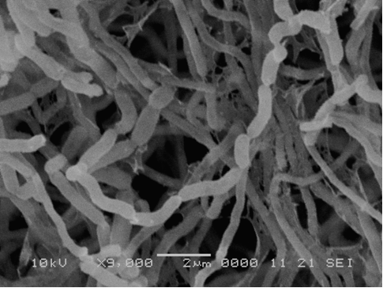
Plate (2a): Scanning electron micrograph of Streptomyces anulatus grown on starch nitrate agar medium without heavy metal . Bar= 2um and X 9000.

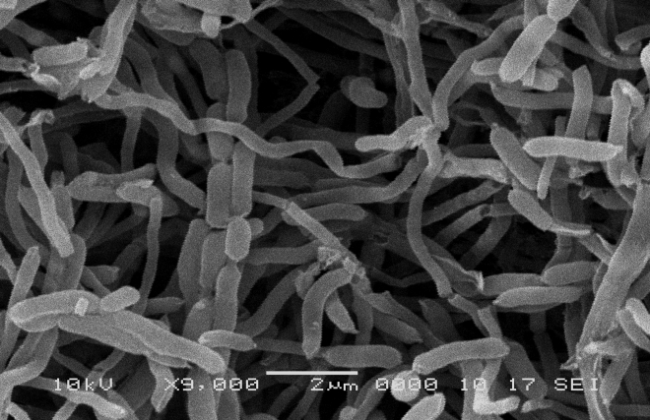
Plate (2b) :Scanning electron micrograph of Streptomyces anulatus grown on starch nitrate agar medium containing 1000 ppm sodium tellurite. Bar= 2um and X 9000.
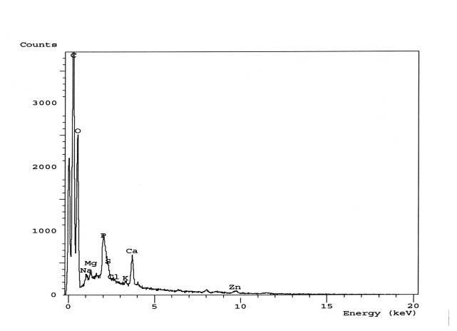

Fig. (3): X-ray spectrum of Streptomyces anulatus control culture (without heavy metal) using SEM-EDX.

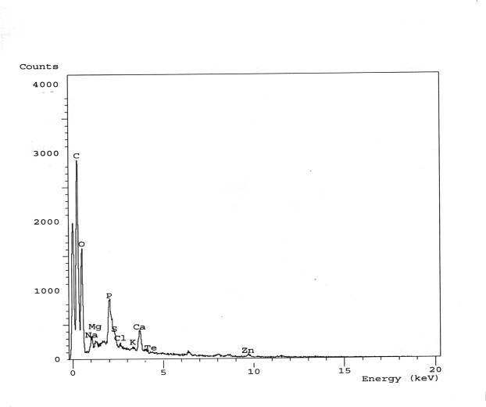

Fig. (4): X-ray spectrum of Streptomyces anulatus culture containing 1000 ppm sodium tellurite using SEM-EDX.

As expected from morphological studies and cell hydrolysis for diaminopimelic acid (DAP), the isolate was identified as members of Streptomyces. Depending on morphological, physiological and biochemical analysis, the isolate was identified as Streptomyces anulatus. 16S rDNA sequence analysis of the representative isolate allowed a confirmed species identification. The studied isolate had 534 bp 16S rRNA sequences and this sequence match with Streptomyces anulatus strain MG 001 (GenBank accession number GU569951.1), Identities = 98 % , Gaps = 1 % in Gene bank database and therefore , the 16S rRNA gene confirmed the phenotypic . Similarly, Patel et al., 2004 investigated the utility of 500-bp 16S rRNA gene sequencing for identifying clinically significant species of aerobic actinomycetes. The partial sequence of the 16S rRNA of Streptomyces albus isolate was aligned and compared with all eubacterial 16S rRNA gene sequences available in the GenBank and EMBL databases by multisequence analysis ( Altschul et al., 1997), giving the maximum identity (99%) with 16S rDNA sequences from Streptomyces albus subsp. albus type strain DSM (AJ621602). Our results indicate that sequencing of the 534 bp 16S rRNA gene provides enough information for the sub species-level identification for the isolated actinomycete.
In conclusion about the fractionation pattern of protein resulted by Streptomyces anulatus, we can said about its ability to regulate tellurite incorporation within the isolate, this can be explained by the detection of narrow range of protein. So, this may reflect the high tolerance potency of Streptomyces anulatus to tellurium toxicity. It is also in agreement with the previously mentioned, as this isolate can tolerate sodium tellurite up to 0.6 % (w/v). Such high level of tellurium can be explained as tellurium resembles sulphur atom and consequently displaced its position in sulphur containing amino acid. We can conclude that, the ability of Streptomyces anulatus to synthesize low molecular weight proteins (metallo-thionine) of high tellurium content is the common feature. Such biosynthesis of this protein type plays an important role via a mechanism of channeling the elements to avoid the incorporation of such heavy metal into other important cellular protein e.g. enzymes and can be considered a part of heavy metal detoxification and metabolism. At the same time, detection of Te-induced low molecular weight peptides in the fraction of maximum Te content considers a role of microbial detoxification.
Fractions No, 5, 6, 7, 9 and 11 were undergoing to acid hydrolysis for detection of their amino acid composition. Histidine, methionine and proline recorded the highest value in all fractions under study. Similar results was recorded by Zahran, 2010 , where Penicillium purpurogenum and Aspergillus niger were cultivated at pH1 in presence of 80 µg potassium chromate and demonstrate the incorporation of chromium into both high and low molecular weight proteins . In case of Penicillium purpurogenum only eleven protein fractions contained considerable amounts of chromium ions. Fractions No. 7-9 contained high molecular weight metalloproteins (chromium proteins), fractions No. 10 – 12 contained metallothionins, while the other fractions No. 13 – 17 contained very low molecular weight proteins or peptides (chromium chelatins). The fragmentation of substrate and aerial mycelium formed in microbial culture of Streptomyces anulatus after the addition of tellurite was examined by using SEM. Similar observations were noticed where metamorphosis of fungi under stress conditions was studied. Many metamorphoses in morphological structures under stress conditions were observed under salt and osmotic stress (Helmy, 2005 and El-Hosainy, 2009), under anaerobic stress (Ashoor , 2008 ), and under heavy metal stress (Osman, 2006) .Under alkaline stress, El-Meleigy et al., 2010a recorded that, no changed were observed in A .flavus width of conidia, conidiophores or length of vesicles, while conidial number was reduced sharply by increasing pH value. No secondary strigmata were observed at pH 10. Electron micrographs of Arthrobotrys oligospora grown at pH 10.5 showed wrinkled conidiophores, reduction in conidiation was observed at this pH value. SEM-EDS analysis indicated the presence of tellurium in association with cells.Similar results were obtained by Klonowska et al., 2005 ;Zawadzka et al., 2006 and Baesman et al., 2007).
Conclusively, in this study, both intracellular bioaccumulation and extracellular biosorption had contributed to the high resistance of Streptomyces anulatus to Te. These results suggest that this isolate can be used in biotreatment as a Te-trapper.

References:
- Altschul, S. F., Gish,W., Miller, W., Myers, E.W., and Lipman, D.J. ,1990. Basic local alignment search tool. J. Mol. Biol. 215:403–410.
- Altschul, X., Stephen,F., Thomas, L., Madden, X., Alejandro, A., Schäffer, X., Zhang, J., Zhang, Z., Miller, W., and Lipman, D.J., 1997 . Gapped BLAST and PSI-BLAST: a new generation of protein database search programs. Nucleic Acids Res. 25:3389-3402.
- Ashoor, M.S., 2008. Occurance of anaerobic fungi in nature and their speciation . PhD. Thesis, Botany and Microbiology Department, Faculty of Science (Girls), Al – Azhar University, Cairo, Egypt.
- Avazeri, C.; Turner, R. J.; Pommier, J.; Weiner, J. H. ; Giordano, G. and Verme´glio, A.,1997. Tellurite reductase activity of nitrate reductase is responsible for the basal resistance of Escherichia coli to tellurite. Microbiology .143:1181–1189.
- Baesman,S.M.; Bullen, T.D.; Dewald, J.; Zhang, D.; Curran, S.; Islam, F. S.; Beveridge, T.J. and Oremland, R.S.,2007. Formation of Tellurium Nanocrystals during Anaerobic Growth of Bacteria That Use Te Oxyanions as Respiratory Electron Acceptors. Applied and Environmental Microbiology. 73: 2135-2143
- Bagnall, K. W.,1975. Selenium, tellurium, and polonium, p. 935–1008. In M. Schmidt, W. Siebert, and K. W. Bagnall (ed.), The chemistry of sulfur, selenium, tellurium, and polonium. Pergamon Press, New York, N.Y.
- Basnayake, R. S.; Bius, J. H.; Akpolat, O. M. and Chasteen, T. G.,2001. Production of dimethyl telluride and elemental tellurium by bacteria amended with tellurite or tellurate. Appl. Organometal. Chem., 15:499–510.
- Becker, B.; Lechevalier, M.P.; Gordon, R.E. and Lechevalier, H.A.,1964. Rapid differentiation between Nocardia and Streptomyces by paper chromatography of whole cell hydrolysates. Appl. Microbiol . Biol ., 12: 421- 423 .
- Bentley, S.D.; Chater, K.F.;Cerdeno-Tarraga, A,M.; Challis, G.L.; Thomson, N.R.; James, K.D.; Harris, D.E.; Quail, M.A.; Kieser, H.; Harper, D.; Bateman, A.;Brown, S.; Chandra, G.; Chen ,C.W.; Collins, M.;Cronin, A.;Fraser, A.; Goble, A.; Hidalgo, J.; Hornsby, T.; Howarth, S.;Huang, C.H.; Kieser, T.; Larke, L.; Murphy, L.; Oliver, K.; O’Neil, S.;Rabbinowitsch, E.; Rajandream, M.A.; Rutherford, K.; Rutter, S.; Seeger, K.; Saunders, D.; Sharp, S.; Squares, R.; Squares, S.; Taylor, K.; Warren, T.; Wietzorrek, A.; Woodward ,J.; Barrell, B.G.; Parkhill, J. and Hopwood, D.A., 2002.Complete genome sequence of the model actinomycete Streptomyces coelicolor A32. Nature. 417:141–147.
- Block, R.J.; Durrum, E.L. and Zweig, B.,1958. Manual of paper chromatography and paper electrophoresis, 2nd ed. Academic press . INC. Publishers, New York).
- Butler, W. R., Kilburn, J. O., and Kubica, G. P., 1987. High-performance liquid chromatography analysis of mycolic acids as an aid in laboratory identification of Rhodococcus and Nocardia species. J. Clin. Microbiol. 25: 2126–2131.
- Clarridge, J. E.,2004. Impact of 16S rRNA Gene Sequence Analysis for Identification of Bacteria on Clinical Microbiology and Infectious Diseases . Clin Microbiol Rev., 17: 840–862.
- Courbot, M.; Diez, L.; Ruotolo, R.; Chalot, M. and Leroy, P.,2004. Cadmium-responsive thiols in the ectomycorrhizal fungus Paxillus involutus. Appl. Environ. Microbiol. 70: 7413.7417.
- El-Hosainy, A.M., 2009. Fungal adaptation to salt stress. Msc. Thesis, Botany and Microbiology Department, Faculty of Science (Girls), Al – Azhar University, Cairo, Egypt.
- El-Meleigy, M.A.; Ahmed, S.A.; Hoseiny, E. N. and Sabry, S.M.,2010. Responses of some filamentous fungi to alkaline stress, Isolation , Identification , Morphological Features and Ultrastructure of some alkalophilic Fungi. Egypt. J. Biotechnol ., 35: 13-33.
- Fox, G. E., Wisotzkey, J. D., and Jurtshuk, P.,1992. How close is close—16S ribosomal RNA sequence identity may not be sufficient to guarantee species identity. Int. J. Syst. Bacteriol., 42:166-170.
- Helmy, E.A.M.,2005. Fungal Ultrastructure Stability Against Stress Conditions. Msc. Thesis, Botany and Microbiology Department, Faculty of Science (Girls), Al – Azhar University, Cairo, Egypt.
- Hensyl, W.R., 1994. Bergey’s Manual of systematic bacteriology 9th , Baltimore, Philadeiphia, Hong Kong, London, Munich, Sydney, Tokyo.
- Ikeda ,H., Ishikawa, J., Hanamoto, A., Shinose, M., Kikuchi, H., Shiba, T., Sakaki, Y., Hattori, M., Omura, S.,2003. Complete genome sequence comparative analysis of the industrial microorganism Streptomyces avermitilis. Nat Biotechnol ., 21:526–531.
- Kawato, M. and Shinobu, R.,1959. A streptomyces heraricolor nov.sp. Supplement: A simple technique for the microscopical observation. Mem . Osaka Univ. Lib. Exts. Edu. 8:14.
- Klonowska, A.; Heulin, T. and Vermeglio, A., 2005. Selenite and Tellurite Reduction by Shewanella oneidensis. Applied and environmental microbiology, 71: 5607–5609.
- Lechevalier, M.P.; Lecheyalier, H.A. and Holbert, P.F.,1968. Sporichthya, in novo aqurre de Streptomycetaceae Ann. Inst. Pasteur, 114: 277-286.
- Lloyd, J. R.,2003. Microbial reduction of metals and radionuclides. FEMS Microbiol. Rev., 27:411–425.
- Lowry, O. H.; Rosebrough, N.J.; Furr, A.L. and Randall, R.J.,1951. Protein measurement with folin phenol reagents, J.Biol.chem., 193: 265-27.
- Mir, G.; Domenech, J.; Huguet, G.; Guo, W.; Goldsbrough, P. ; Atrian , S. and Molinas, M.,2004. A plant type 2 metallothionein(MT) from cork tissue responds to oxidative stress. J. Exp. Bot., 55: 2483.2493.
- Osman, N.H., 2006. Influence of microorganisms on some ions of sea water . Msc. Thesis, Botany and Microbiology Department, Faculty of Science (Girls), Al – Azhar University, Cairo, Egypt.
- Palmiter, R.D.,1998. The elusive function of metallothioneins. Proc. Natl. Acad. Sci. 95: 8428-8430.
- Patel, J.B., Wallace, R.J., Brown-Elliott, B.A., Taylor, T., Imperatrice, C., Leonard, D.G., Wilson, R.W., Mann, L., Jost, K.C., and Nachamkin1, I. ,2004. Sequence-Based Identification of Aerobic Actinomycetes. JOURNAL OF CLINICAL MICROBIOLOGY. 42: 2530–2540.
- Pearion, C. T. and Jablonski, P. E.,1999. High level, intrinsic resistance of Natronococcus occultus to potassium tellurite. FEMS Microbiol. Lett., 174: 19–23.
- Rathgeber, C.; Yurkova, N. ; Stackebrandt, E.; Beatty, J. T. and Yurkov, V., 2002. Isolation of tellurite- and selenite-resistant bacteria from hydrothermal vents of the Juan de Fuca Ridge in the Pacific Ocean. Appl. Environ. Microbiol., 68:4613–4622.
- Sambrook, J., Fritsch,E.F., and Maniatis, T.,1989. Molecular cloning: a laboratory manual, 2nd ed. Cold Spring Harbor Laboratory Press, Cold Spring Harbor, N.Y.
- Sabaty, M.; Avaze´ri, C.; Pignol, D. and Verme´glio, A., 2001. Characterization of the reduction of selenate and tellurite by nitrate reductases. Appl. Environ. Microbiol., 67:5122–5126.
- Silver, S. (1996) :Bacterial resistances to toxic metal ions: a review. Gene179:9–19.
- Stackebrandt, E., and Swiderski, J., 2002. From phylogeny to systematics: the dissection of the genus Bacillus. In Bacillus. In R. Berkeley, M. Heyndrickx, N. A. Logan, and P. De Vos (ed.), Applications and systematics of Bacillus and relatives. Blackwell Publishing, Oxford, United Kingdom.
- Steingrube, V. A., Brown, B. A., Gibson, J. L., Wilson, R. W., Brown, J., Blacklock, Z., Jost, K., Locke, S., Ulrich, R. F., and Wallace, R. J. ,1995. DNA amplification and restriction endonuclease analysis for differentiation of 12 species and taxa of Nocardia, including recognition of four new taxa within the Nocardia asteroides complex. J. Clin. Microbiol., 33:3096–3101.
- Tadashi, A., 1975. Culture media for actinomycetes. The society for actinomycetes. Japan National Agricultural Lib., 1 :31.
- Taylor, D. E., 1999. Bacterial tellurite resistance. Trends Microbiol., 7:111–115.
- Turner, R. J.; Weiner, J. H. and Taylor, D. E.,1999. Tellurite-mediated thiol oxidation in Escherichia coli. Microbiology, 145:2549–2557.
- Turner, R. J.; Aharonowitz, Y.; Weiner, J. H. and Taylor, D. E.,2001. Glutathione is a target in tellurite toxicity and is protected by tellurite resistance determinants in Escherichia coli. Can. J. Microbiol., 47:33–40.
- Vasak, M. and Hasler, D.W.,2000. Metallothioneins: New functional and structural insights. Curr. Opin. Chem. Biol., 4: 177.183.
- Versalovic, J., Schneider, M., De Bruijn, F. J., and Lupski, J. R., 1994. Genomic fingerprinting of bacteria using repetitive sequence-based polymerase chain reaction. Methods Mol. Cell. Biol., 5:25-40.
- Wallace, R. J., Jr., Brown, B. A., Tsukamura, M., Brown, J. M. , and Onyi, G. O.,1991. Clinical and laboratory features of Nocardia nova. J. Clin. Microbiol., 29:2407–2411.
- Williams, S.T.(Ed),1989. Bergeyۥ s Manual of Systematic bacteriology vol.4, Baltimore, Hong Kong, London, Sydney.
- Yurkov, V. V. and Csotonyi, J.T., 2003. Aerobic anoxygenic phototrophs and heavy metalloid reducers from extreme environments. Recent Res. Dev. Bacteriol., 1:247–300.
- Yurkov, V.; Jappe, J. and Vermeglio, A.,1996. Tellurite resistance and reduction by obligately aerobic photosynthetic bacteria. Appl. Environ. Microbiol., 62:4195–4198.
- Zahran, M.O., 2010. Tolerance of some fungi to acidic stress. Msc. Thesis, Botany and Microbiology Department, Faculty of Science (Girls), Al – Azhar University, Cairo, Egypt.
- Zawadzka, A. M.; Crawford, R.L. and Paszczynsk, A.J., 2006. Pyridine-2,6-Bis(Thiocarboxylic Acid) Produced by Pseudomonas stutzeri KC Reduces and Precipitates Selenium and Tellurium Oxyanions. Applied and Environmental Microbiology, 72:3119-3129.

6/11/2011

