Application of sugarcane straw anion exchanger for nitrate removal

Masoomeh Farasati¹, Saeed Boroomand nasab^{1, *}, Hadi Moazed¹, Nemaat Jafarzadeh², Jahangir Abedi kupaee³

- Water Sciences Engineering Faculty. Shahid Chamran University, Ahvaz, Iran.
- Environmental Technology Research Center, Ahvaz Jundi Shahpur University of Medical Sciences, Ahvaz, Iran.
- Agricultural Faculty, Isfahan Industry University, Isfahan, Iran.
farasati_1362@yahoo.com, boroomandsaeed@yahoo.com, hmoazed955@yahoo.com, N_Jaafarzadeh@yahoo.com, kupaee@yahoo.com

Abstract: The effect of sugarcane straw-AE of micrometer and nanometer particle sizes on nitrate removal by batch and column experiments has been investigated. The effects of operating conditions such as pH, adsorbent dosage, initial anion concentration, the coexisting ions and desorption experiments were examined. The results showed that the optimum pH=6 and the equilibrium time was 3h and 2h for micrometer-(µm) and nanometer-(nm) sized sugarcane straw-AE, respectively. The effect of initial concentration of NO₃⁻ ions with varying solution NO₃⁻ concentrations 5, 15, 50, 80, and 120 mg/L at optimum pH and time was investigated. With increasing initial NO₃⁻ concentration, R% from 78% to 60% and 87% to 80% decreased for micrometer and nanometer sized sugarcane straw-AE, respectively. With the increase of adsorbent dose from 0.1 to 0.5 g, for micrometer and nanometer sized sugarcane straw-AE, the R% increased from 43% to 69% and 52% to 71% respectively, but remained almost unchanged when adsorbent dosage ranged from 0.5 to 1g. Adsorption isotherm of nitrate ions onto sugarcane straw–AE fitted Langmuir isotherm model well. Adsorption kinetics of nitrate ions could be most successfully described by the pseudo-second order model. In column experiment, q_{e} for micrometer and nanometer sized sugarcane straw-AE obtained 3.84, 11.57, 24.54 mg/g and 6.99, 12.7, 17.28

mg/g, respectively. This study indicated that sugarcane straw-AE could be used for the removal of nitrate ions in water treatment.
[Masoomeh Farasati, Saeed Boroomand nasab, Hadi Moazed, Nemaat Jafarzadeh, Jahangir Abedi kupaee. Application of sugarcane straw anion exchanger for nitrate removal. Nature and Science 2011;9(7):158-168]. (ISSN: 1545-0740). http://www.sciencepub.net

Key word: Sugarcane straw, nitrate removal, nanometer particle size, anion exchange

1. Introduction
Nitrate pollution in surface and ground water has become a gradually more important problem for all over the world. An increased nitrate concentration supplies presents a potential health hazard such as blue baby. Several methods for nitrate removal from wastewater are denitrification, selective ion exchange and ammonia stripping (Fernandez-Olmo et al., 2007; Uygur and Karg, 2004). Ion exchange is a very feasible process for treatment of underground and surface water, primarily due to its ease of application (Malekian, 2011). Recently, numerous attempts have been made in finding economical and effective ion exchangers produced from agricultural by-products. So, several materials such as sugarcane bagasse (Orlando et al., 2003) and peanut hull (Gong et al., 2005) could be modified into anion exchangers and utilized for this purpose. Cross linking agricultural by-products with epichlorohydrin is the most common method used in the preparation of agricultural by-products based anion exchangers (Ozturk and EnnilKose, 2008). In this work, anion exchangers based on aminated intermediate (epoxypropyl triethylammonium chloride, ETC) is prepared (Xing et al., 2010), then micrometer and nanometer sized sugarcane straw- AE on nitrate removal investigated.
The objectives were in this study (1) determination of optimum condition nitrate removal (2) determination of the effect of particle size on NO₃⁻ removal and (3) determination of NO₃⁻ removal by sugarcane straw-AE and identification of an empirical model that best describes this ion-exchange process.

2. Experimental
2.1. Sugarcane straw sample
The Sugarcane straw used in this study originated from Khuzestan province, Iran. Total elemental analysis was performed by edax analysis showed that the Sugarcane straw had the following chemical composition (in %): Mg=3.64, Na=0.9, Si=11.74, S=8.72, Cl=7.06, Ca=2.33, Zn=71.6 and K=2.65 (Figure 1). The particle size of Sugarcane straw was between 120 and 300 micrometer. To obtain nano-sized organic particles, the sugarcane straw was ground in a jet mill. Particle size was then determined using a particle size analyzer (Malvern Zetasizer 3000, UK). The reported size was about 327.5 nm (Figure 2). The iodine number corresponding to the produced adsorbent was determined according to the procedure established by the Standard Test Method (ASTM standard D4607-94, 2002). The iodine numbers for micrometer and nanometer-sized Sugarcane straw were 417 and 602 mg/g.

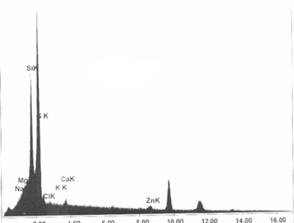
Figure 1. Edax analysis of sugarcane straw particles

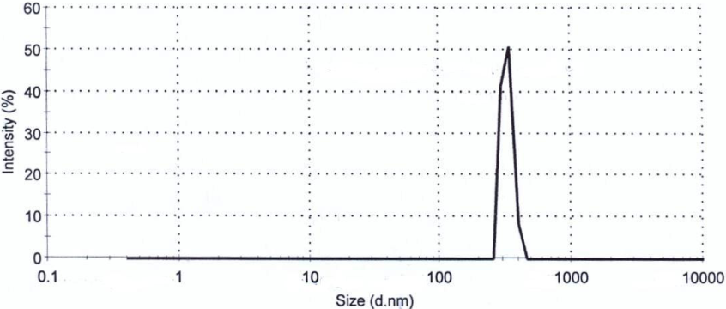
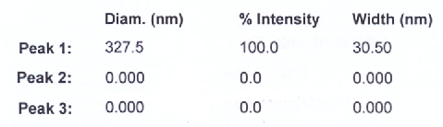
Figure 2. The particle size distribution of nano-sized sugarcane straw

2.2. Preparation of modified Sugarcane straw- anion exchanger (Sugarcane straw-AE)
In this study, preparation of anion exchangers based on aminated intermediate (epoxypropyl triethylammonium chloride, ETC) was conducted, which comprises first preparation of ETC by reaction of epichlorohydrin with triethylamine, then introduction of ETC into the agricultural by-products in the presence of a catalyst. The synthesis process for sugarcane straw-AE is divided into two steps: At first aminated intermediate was synthesized. An aliquot of 78 ml (1 mol) of epichlorohydrin was reacted with 152 ml (1.1 mol) of triethylamine in 150 ml of 50/50 (v/v) % methanol solution at 55 °C. After stirred for 5h, the produced intermediate was used in the second step. In the second synthesis process, 5g of Sugarcane straw were reacted with 35ml of intermediate and 5ml of pyridine in a 250 ml three-neck round bottom flask for 3h at 55 °C (Xing et al., 2010). The product was washed with distilled water to remove the residual chemicals, dried at 60 °C for 12h then used in all the sorption experiments (Xing et al., 2010). Total nitrogen content of the final product was determined using a Perker-Elmer Elemental analyzer CHNS/O. Table 1 displays the elemental changes of carbon, hydrogen and nitrogen Sugarcane straw–AE in comparison with Sugarcane straw. The significant increase in nitrogen content (0.67–3.61%) of Sugarcane straw–AE indicates the reactions between Sugarcane straw and aminated intermediate and quite a number of aminated groups have been introduced into the Sugarcane straw–AE. Similar result was observed in the previous work of Xing for the preparation of anion exchangers from wheat straw which have the nitrogen content in the range of 0.35%-3.57% and Gao for the preparation of anion exchangers from coin, rice hull, pure alkaline lignin and sugarcane bagasse, which have the nitrogen contents in the range of 3.6%–5.8% (Gao et al., 2009; Xing et al., 2010). The calculated total exchange capacity (TEC) was based on the nitrogen content incorporated into the final products according to the equation (Laszlo, 1996):
$\text{TEC}({\text{meqg}}^{−1})=\frac{N\text{\%}}{1\text{.}4}$ (1)

Table 1. Elemental change in sugarcane straw and sugarcane straw-AE
adsorbent | C% | H% | N% | TEC
Sugarcane straw | 28.33 | 3.78 | 0.67 | 0.48
Sugarcane straw -AE | 34.9 | 5.25 | 3.61 | 2.58

2.3. Chemicals
The 15mg/L of nitrate stock solutions were prepared by dissolving required weighed quantities (24.46mg) of KNO₃ in distilled water. All solutions for sorption and analysis were prepared by appropriate dilution of the freshly prepared stock solution. Sugarcane straw-AE by product represents a potential alternative as an anion exchanger because of its particular properties such as its chemical stability and high reactivity, resulting from the presence of reactive aminated groups in polymer chains. For each 30ml centrifuge tube, 0.3g sugarcane straw-AE and 30ml of working solution was mixed for 3h at 120 rpm. The mixtures were then centrifuged and filtered using filter paper to separate the water from the absorbent, and then the NO₃⁻ was analyzed by a UV-Vis spectrophotometer (Hach model, DR5000). All samples were prepared in triplicate. The NO₃⁻ exchanged on sugarcane straw- AE was calculated using the equation:

$q_{e}=\frac{C_{i}−C_{e}}{m}×V$ (2)

Where q_{e} is the NO₃⁻ exchanged on sugarcane straw-AE (mg/g), m is the adsorbent mass (g), C₀ and C_{e} are the initial and equilibrium concentrations of NO₃⁻ in solution (mg/L), respectively, and V is the volume of the solution (L). The removal efficiency was evaluated according to:

$R=\frac{C_{i}−C_{e}}{C_{i}}×\text{100}$ (3)

Where R is the nitrate removal efficiency expressed in %.

2.3.1. Effect of pH
The pH of the KNO₃ solutions (15 mg/L NO₃⁻) were adjusted to different values between 2 and 10 and regulated by using H₂SO₄ or NaOH (0.1N). 0.3g of dried adsorbent was added to solution. After adsorption, the pH value providing the maximum nitrate removal was determined.

2.3.2. Effect of contact time
In kinetic studies, 30 ml KNO₃ solution and 0.3g adsorbent was agitated. The mixtures were shaken at 120 rpm. Batch experiments were repeated for different periods between 10 to 210 minutes until reaching the adsorption equilibrium.

2.3.3. Effect of adsorbent dosage
Adsorption of 15mg/L of NO₃⁻ solution by different adsorbent doses (0.1–1.0g) for adsorbent was carried out at the optimum pH and equilibrium time.

2.3.4. Effect of initial concentration
The effect of initial concentration on the adsorption of NO₃⁻ ions by adsorbent with varying solution concentrations (5, 15, 50, 80, and 120 mg/L) at optimum pH, time and adsorbent dosage was investigated.

2.4. Equilibrium adsorption isotherm
Equilibrium adsorption data were analyzed using different isotherm models to understand the adsorbate–adsorbent interaction. To characterize the exchange equilibrium of NO₃⁻ ions by Sugarcane straw-AE, the Freundlich, Langmuir, Redlich–Peterson, and Langmuir–Freundlich models were used as follows (Malekian et al., 2011):

Freundlich[ equation: $q_{e}={\text{KC}}_{e^{1/n}}$ (4)

Langmuir equation: $q_{e}=\frac{{\text{bq}}_{m}C_{e}}{(1+{\text{bC}}_{e})}$ (5)
Redlich_Peterson equation:
$q_{e}=\frac{{\text{aC}}_{e}}{(1+{\text{bC}}_{e^{n}})}$ (6)
Langmuir_Freundlich equation:
$q_{e}=\frac{{\text{bq}}_{m}C_{e^{1/n}}}{(1+{\text{bC}}_{e^{1n}})}$ (7)

Where q_{e} is the nitrate exchanged at equilibrium (mgNO₃⁻/g) and C_{e} is the nitrate equilibrium concentration in solution (mgNo₃⁻/L). The other parameters represent different isotherm constants that can be determined by regression of the experimental isotherm data. It has been reported that nonlinear regression analysis method is a better method of obtaining the parameters involved in three parameter isotherms (Kumar and Sivanesan, 2006). Therefore, the ion-exchange isotherms were examined by a non-linear curve fitting analysis method, using Data-fit software (http://www.oakdaleengr.com/datafit.htm).
Previous studies have shown that commonly used correlation measures such as the correlation coefficient (R) and coefficient of determination (R²) are often unsuitable or confusing when used to compare model estimated and measured data. Difference measures such as the Root mean square error (RMSE), however, contain insightful information. In this work, the goodness of fit between experimental and model-estimated data was evaluated using R² and the RMSE as follows:

$\text{RMSE}=\sqrt{\frac{\sum_{i=1}^{n}{{\left(q_{e}−q_{c}\right)}^{2}}}{n}}$ (8)

Where q_{e} and q_{c} are the measured and model estimated amounts of NO₃⁻ exchanged, respectively, and n is the number of measurements. A lower RMSE value and higher R² value are regard to show goodness of agreement between measured and estimated NO₃⁻ exchanged data.

2.5. Kinetic study
The rate of adsorption of nitrate was studied at different time intervals that were as long as 210 min using different initial concentrations 5, 15, 50, 80 and 120 mg/L at optimum pH.
The modeling of the kinetics of adsorption of No₃⁻ on sugarcane straw-AE was investigated by three common models, Eqs. (9)– (12), as described in the later part (Shirvani et al., 2007):

Pseudo first _ orderequation:
$q_{t}=q_{e}(1−e^{−k_{1}t})$ (9)
Pseudo second _ order equation:
$q_{t}=\frac{q_{e^{2}}k_{2}t}{1+q_{e}k_{2}t}$ (10)
Powerequation:$q_{t}={\text{at}}^{b}$ (11)
Elovich equation:
$q_{t}=\left(\frac{1}{β}\right)\text{ln}\left(\text{αβ}\right)+\left(\frac{1}{β}\right)\text{ln}t$ (12)

Where q_{t} is the amount of nitrate removed at time t (mgNO₃⁻/g), q_{e} is the amount of nitrate removed at equilibrium (mgNO₃⁻/g), and k₁, k₂, α, β, a, and b are constants.

2.6. Effect of coexisting ions
Coexisting ions such as phosphate (1.5mg/L), nitrate (87mg/L), sulphate (14mg/L), chloride (70mg/L) and bicarbonate (366mg/L) were present in well water. The effect of present ions in well water on nitrate removal by sugarcane straw-AE was investigated

2.7. Desorption studies
After adsorption experiments, after separate the solution from the absorbent, desorption studies of the adsorbed nitrate were carried out by shaking the spent modified sugarcane straw-AE in 30 ml of 0.1 mol/L HCl for a period of 3h. After time passed, the sorbent was filtered and desorbed nitrate concentration was analyzed by UV-Vis spectrophotometer (Hach model, DR5000). The percentage of desorbed (D) nitrate anion was calculated as:

$\text{Desorption}(\text{\%})=\frac{\text{desorbedamountofsolute}}{\text{absorbedamountofsolute}}×\text{100}$ (13)

2.8. Column experiment
Sorption in a continuous-flow system was done in a fixed bed column reactor (2.8 cm i.d., 35 cm column length). Top and bottom of bed of sorbent was filter (40 micron diameter). The column consisted of sugarcane straw-AE. The feed water used was making water, spiked with KNO₃⁻, having an initial concentration of 15, 50 and 120 mg/L nitrate. Once the column was saturated with water, there was no visual evidence for air pockets remaining inside the column. The water was pumped upwards into the column using a peristaltic pump at 0.98 L/hr flow rate. Samples were collected from the exit of the column at different time intervals 30 minutes and analyzed for nitrate.

3. Results and discussion
3.1. Adsorption studies
3.1.1. Effect of initial pH
Figure 3 shows the variation in the amount adsorbed as a function of initial pH for nitrate anion. With pH of the solution varying from 2 to 10, R% and q_{e} of micrometer sized sugarcane straw-AE increased up to maximum of 56% to 69% and 1.12 to 1.38 mg/g reached at pH= 6, respectively. For nanometer sized sugarcane straw-AE, R% and q_{e} increased up to maximum of 45% to 90% and 0.9 to 1.57 mg/g reached at pH= 6, respectively which the adsorbent are positively charged, also enhancement of nitrate adsorption by sugarcane straw-AE as a result of increased electrostatic interactions between sugarcane straw negatively charged nitrate group and positively charged aminated group. Then for pH>6 adsorption performances reaching a constant. Thus, the optimal pH of nitrate removal is 6.0. The adsorption dependence on pH showing ion exchange mechanism (Ulmanu et al., 2008).

3.1.2. Effect of contact time
Figure 4 shows the variation in the amount adsorbed as a function of time for nitrate anion. With varying time from 10 to 210 minutes, R% and q_{e} of micrometer sized sugarcane straw-AE increased up to maximum of 27% to 75% and 0.405 to 1.125 mg/g reached at 3h respectively, and for nanometer sized sugarcane straw-AE, R% and q_{e} increased up to maximum of 35% to 82% and 0.525 to 1.23 mg/g reached at 2h respectively.

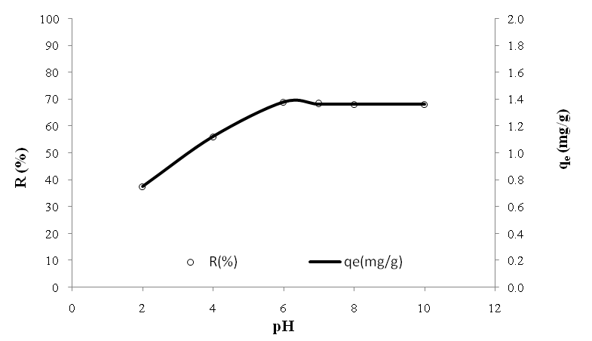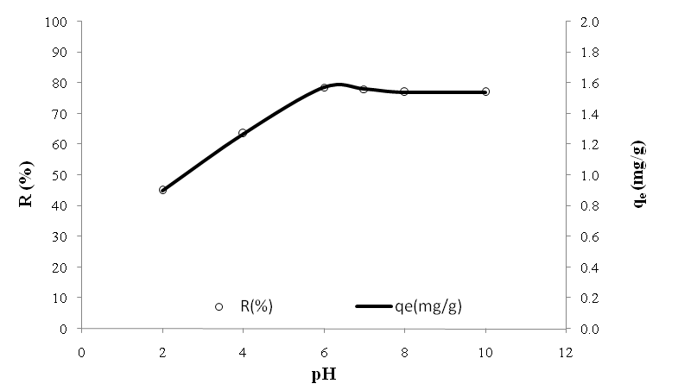
(a)
(b)

Figure 3. Effect of pH on the adsorption of NO₃⁻ ion by sugarcane straw-AE (a) micrometer-sized (b) nanometer-sized adsorbent (anion initial concentration: 15mg/L, adsorbent loading: 0.3g, adsorption time: 3h).

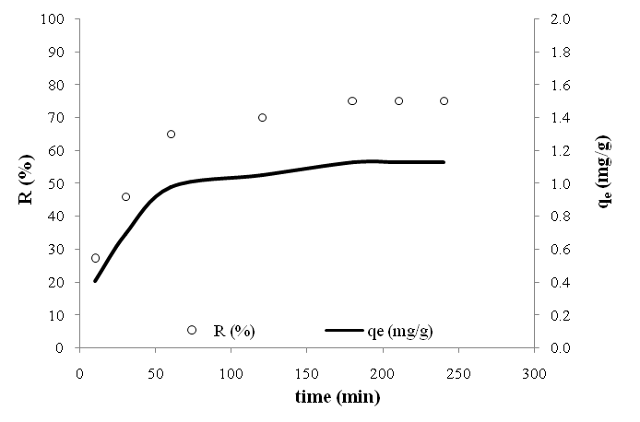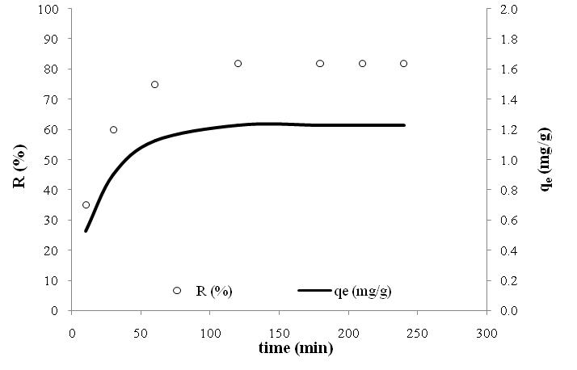
(a)
(b)
Figure 4. Effect of contact time on the adsorption of NO₃⁻ ion by sugarcane straw-AE adsorbent (a) micrometer-sized (b) nanometer-sized (anion initial concentration: 15mg/L, adsorbent loading: 0.3g, pH=6).

3.1.3. Effect of adsorbent dosage
For micrometer and nanometer-sized sugarcane straw-AE, with an increase in the adsorbent dosage from 0.1 to 0.5 g, the R% increased from 43% to 69% and 52% to 71% which reached maximum 69% and 71% at 0.5g adsorbent respectively, but remained almost unchanged when adsorbent dosage ranged from 0.5 to 1 g (Figure 5). In general, increase in adsorbent dosage, increased the percent removal and adsorption capacity of nitrate, which is due to the increase in adsorbent surface area and more adsorption sites. A result that is supported by the findings of Tehrani-Bagha et al., 2011. At adsorbent dosage >0.5g, the extra NO₃⁻ ion removal becomes very low. Thus, increased adsorbent dosage did not enhance the removal percentage of NO₃⁻ ion (Tehrani-Bagha et al., 2011).

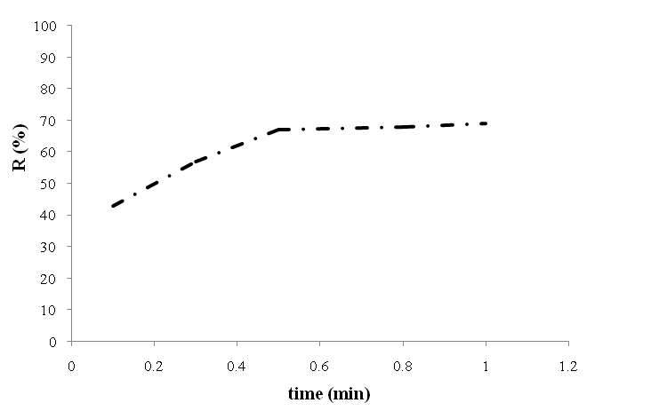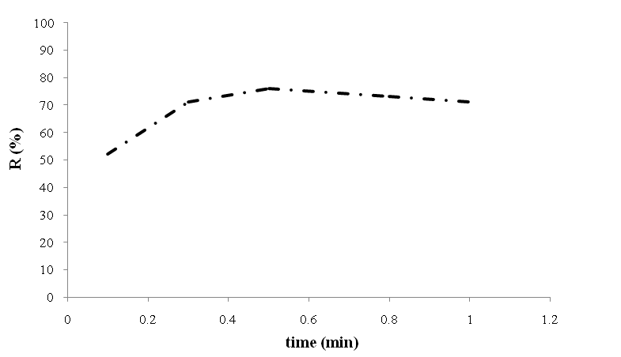
(a)
(b)

Figure 5. Effect of adsorbent dosage on removal of nitrate by sugarcane straw -AE (a) micrometer-sized (b) nanometer-sized (anion initial concentration 15mg/ L, pH=6)

3.1.4. Effect of initial concentration
The effect of initial concentration on the adsorption of NO₃⁻ ions by sugarcane straw-AE with varying solution concentrations 5, 15, 50, 80, and 120 mg/L using 0.5g adsorbent dose was investigated (Figure 6). With increasing concentration of solution, for micrometer and nanometer-sized sugarcane straw-AE, q_{e} from 0.39 to 7.24 mg/g and 0.43 to 8.44 mg/g increased respectively, while R% from 78% to 60% and 87% to 80% decreased respectively. At low initial solution concentration, the surface area and the availability of adsorption sites were relatively high, and the NO₃⁻ ions were easily adsorbed and removed. The initial high rate of nitrate uptake is probably due to the greater availability of binding sites near the surface of the sugarcane straw-AE adsorbent. At higher initial solution concentration, the total available adsorption sites are limited, thus resulting in a decrease in percentage removal of NO₃⁻ ions. The increased q_{e} at higher initial concentration can be attributed to enhanced driving force.

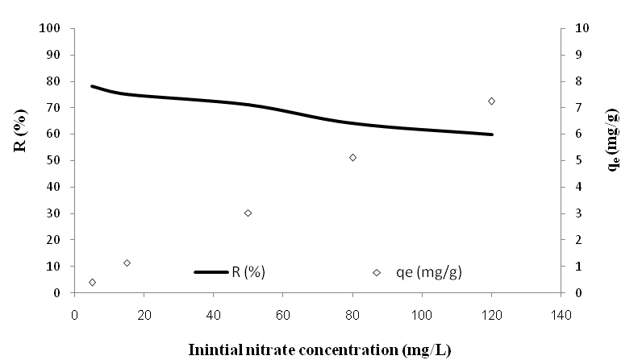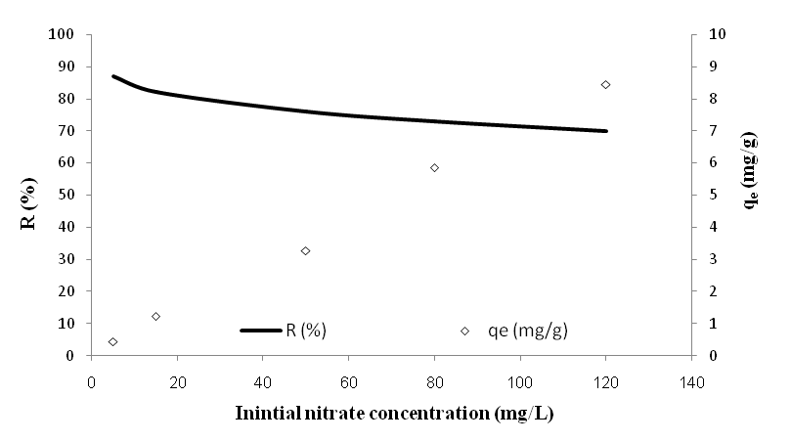
(a)
(b)

Figure 6. Effect of initial concentration on the removal and adsorption of NO₃⁻ ions by sugarcane straw-AE (a) micrometer-sized (b) nanometer-sized (adsorbent loading 0.5 g, pH=6)

3.2. Nitrate exchange isotherms
Ion-exchange isotherms characterize the equilibrium relationship between the amounts of exchanged ion by sugarcane straw-AE and its equilibrium concentration in the solution (19). In this work, the ion exchange isotherm data obtained for micrometer and nanometer sized sugarcane straw-AE were fitted to the Freundlich, Langmuir, Redlich–Peterson, and Langmuir–Freundlich models. The resulting exchange isotherms as well as experimental data are shown in Figure 7. The estimated model parameters, including R² and the RMSE, for the different models are presented in Table 2, which indicates that the experimental data of NO₃⁻ exchange could be well fitted by all four models. It was also made clear that the three-parameter models (Langmuir–Freundlich) provided better fitting in terms of R² and RMSE for all treatments compared to two-parameter isotherms (Freundlich and Langmuir), a result that is supported by the findings of Malekian et al., 2011. In practice, however, two-parameter equations are more extensively used than three parameter equations due to the difficulty of analyze three parameters isotherm. For two-parameter isotherms, the Langmuir model provided a more conforming to the experimental data compared with the Freundlich model (Table 2).

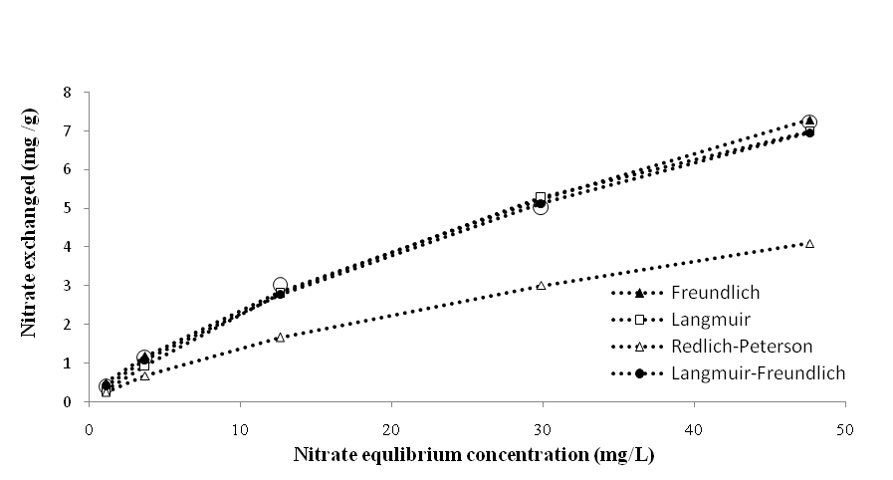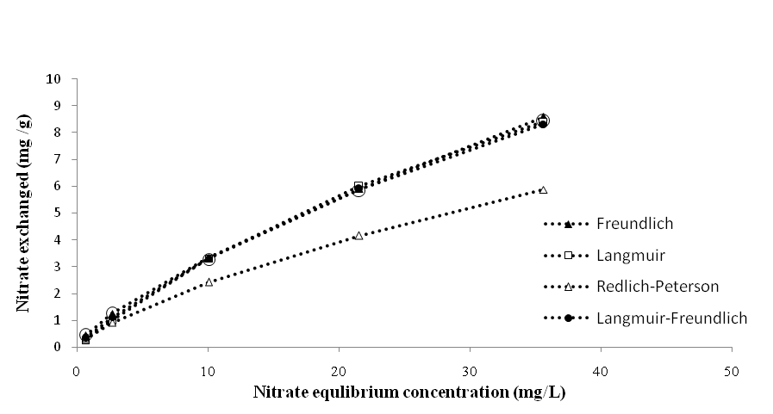
(a)
(b)

Figure 7. NO₃⁻ exchange isotherms by Sugarcane straw- AE (a) micrometer-sized (b) nanometer-sized

Table 2. Isotherm constants and statistical comparison values for NO₃⁻ exchange from solutions on micrometer and nanometer- sized sugarcane straw-AE
Model | Micrometer-sizes | Nanometer-sizes
Fruendlich
k | 0.47 | 0.59
1/n | 0.71 | 0.75
R² | 0.98 | 0.978
RMSE | 0.244 | 0.369
Langmuir
q_{m}(mg/g) | 15.17 | 21.56
b (L/mg) | 0.018 | 0.018
R² | 0.994 | 0.987
RMSE | 0.214 | 0.351
Redlich-Peterson
a | 0.412 | 0.788
b | 0.7 | 0.9
n | 0.436 | 0.401
R² | 0.997 | 0.999
RMSE | 1.779 | 1.43
Longmuir - Fruendlich
q_{m}(mg/ g) | 30 | 32
b(Lm/g) | 0.013 | 0.015
1/n | 0.81 | 0.88
R² | 0.997 | 0.999
RMSE | 0.174 | 0.091

The dimensionless parameter or separation factor, R_{L}, based on the more analysis of the Langmuir equation can be given by (Saltali et al., 2007):

$R_{L}=\frac{1}{1+{\text{bC}}_{0}}$ (14)

Where C₀ (mg/L) is the initial concentration of exchangeable ion and b is the Langmuir constant. The R_{L} parameter is considered as more valid indicator of exchange.
There are four possibilities for the R_{L} value: (i) for favorable exchange, 0<R_{L} <1, (ii) for unfavorable exchange, R_{L}>1, (iii) for linear exchange, R_{L}=1, and (iv) for irreversible exchange, R_{L}=0 (16). Figure 8 illustrates the variation of R_{L} with initial concentration of the No₃⁻ ion for all treatments. As can be seen from the fig.8, the R_{L} parameters are to be found between 0 and 1 which indicates that the removal of NO₃⁻ ions by sugarcane straw-AE is suitable. The R_{L} value obtained also demonstrate that sugarcane straw-AE is a potential ion-exchanger for NO₃⁻ ion removal from aqueous solutions, which is supported by several previous studies (Malekian et al., 2011; Saltali et al., 2007). Figure 8 also shows that the R_{L} value approaches zero as the C₀ value is increased, which indicates that the exchange of NO₃⁻ ion onto sugarcane straw- AE is less favorable at high concentrations of NO₃⁻ (Saltali et al., 2007).
Another parameter, q_{m}, used in either the Langmuir or Langmuir–Freundlich equations, represents the NO₃⁻ ion-exchange capacity (Lei et al., 2008) and is presented in Table 2 for micrometer and nanometer-sized sugarcane straw- AE. It is believed that q_{m} obtained from the Langmuir–Freundlich equation can be more reasonable than from the Langmuir equation (Lei et al., 2008). The comparison of q_{m} for micrometer and nanometer-sizes Sugarcane straw- AE suggests that the maximum NO₃⁻ exchange increases with decreasing particle size (Table 2), a result that is consistent with Malekian et al., 2011. The maximum NO₃⁻ exchange capacity by the sugarcane straw at equilibrium was 30 and 32 mgNO₃⁻/g for micrometer and nanometer-sized sugarcane straw-AE, respectively (Table 2). The 1/n constant for the Freundlich isotherm ranges from 0 to 1 and is a measure of exchange intensity or surface heterogeneity, with a value of 1/n smaller than 1 describing a favorable removal conditions (Raji and Anirudhan., 1998). In this study, the value of 1/n (Freundlich constant) for sugarcane straw-AE was between 0.81 and 0.88 (Table 2), which suggests that the exchange conditions were actually favorable.

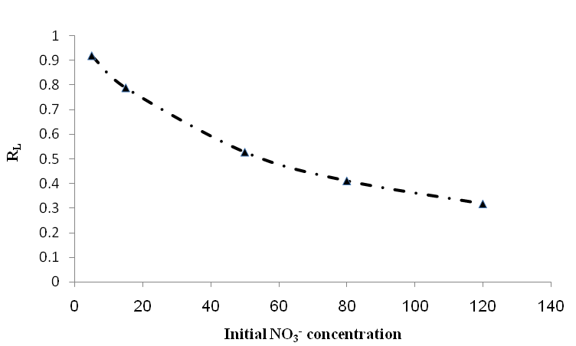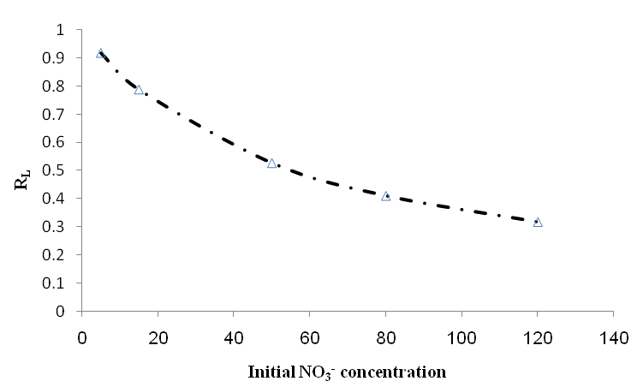
(a)
(b)

Figure 8. Variation of separation factor (R_{L}) as a function of initial NO₃⁻ concentration for sugarcane straw-AE of microimeter-sized (a) and nanometer- sized (b)

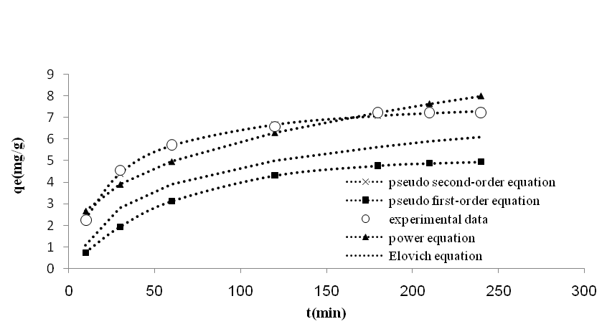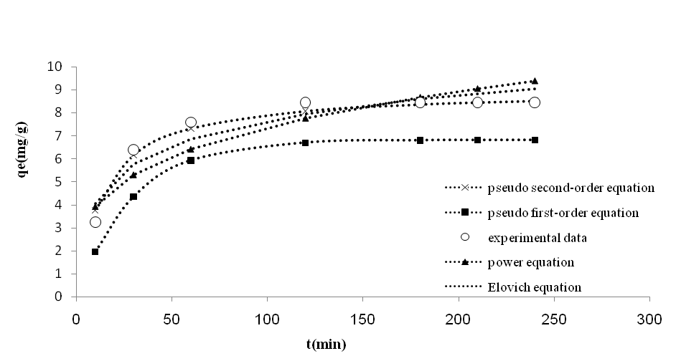
(a)
(b)

Figure 9. The fitting of kinetic models for NO₃⁻on sugarcane straw for 120 mg/L initial concentration (a) micrometer-sized (b) nanometer- sized

Table 3. Kinetic models parameters for the adsorption of NO₃⁻ on sugarcane straw and 120 mg/L initial NO₃⁻concentration (Co: mg/L; q_{e}: mg/g; k₁: min⁻¹; k₂: g/mg min, α: mg/g min and β: g/mg)
Model | Micrometer-sized | Nanometer-sized
Pseudo first _ order equation
q_{exp} | 7.24 | 8.439
k₁ | 0.016 | 0.034
q_{e} | 5.05 | 6.82
R² | 0.97 | 0.98
RMSE | 2.34 | 2.904
Pseudo second_ order equation
K₂ | 0.005 | 0.008
q_{e} | 8.06 | 9
R² | 0.99 | 0.99
RMSE | 0.097 | 0.285
Power function
a | 1.2 | 2.09
b | 0.342 | 0.274
R² | 0.94 | 0.84
RMSE | 2.3 | 0.752
Elovich equation
$$\frac{1}{β}\text{ln}(\text{αβ})$$ | -1.52 | 0.44
$$\frac{1}{β}$$ | 1.569 | 1.568
R² | 0.97 | 0.9
RMSE | 1.52 | 0.555

3.3. Kinetic study
The fittings of the experimental kinetic results to the four models are shown in Figure 9 and the estimated parameters values are presented in Table 3. It can be seen for micrometer and nanometer-sized sugarcane straw, the R² values for pseudo-second-order model gives the best fit R² :0.99, 0.99 and RMSE:0.097, 285 but its predicted q_{e} values 8.06 , 9 mg/g are overestimated as compared to the experimentally observed values (7.24mg/g). In pseudo-first-order, predicted q_{e} values 5.05, 6.82 mg/g were lower than experimentally observed values (7.24mg/g). However, q_{e} values estimated from the pseudo-second-order model are an extrapolation outside the time period that was experimentally investigated, the fact still remains that the model accurately predicts the adsorption kinetics throughout the period of experiments. The higher RMSE values obtained for the pseudo first-order were 2.34 and 2.904 respectively. Therefore, the pseudo-second-order model could be used for the prediction of the kinetics of adsorption of NO₃⁻ on sugarcane straw-AE.
The Power function model satisfactorily describes the NO₃⁻ removed by micrometer and nanometer-sized sugarcane straw-AE with RMSE: 2.3, 0.752, R²: 0.94, 0.84, respectively (Table 3).
The elovich model describes the NO₃⁻ removed by micrometer- sizes and nanometer-sizes sugarcane straw with RMSE: 1.52, 0.555 and R²: 0.97, 0.9, respectively (Table 3). The results showed that the pseudo-first-order rate expression was not valid in the present systems studied (Table 3). The calculated and experimental equilibrium uptake value fit well to pseudo-second-order rate model which indicates that the pseudo second order reaction is better than pseudo-first-order reaction. Among micrometer and nanometer–sized sugarcane straw, nanometer particle size was fine, spherical, high surface area, has high activity and adsorb ion quickly which same result obtained by Rahmani et al., 2010 (Rahmani et al., 2010). It was found that the fitting to pseudo-second-order model gave the highest values of determination coefficients (R²), lowest RMSE and predicted q_{e} more accurately than the other models investigated. Therefore, pseudo-second-order model could be used for the prediction of the kinetics of adsorption of NO₃⁻ on the adsorbent (Ozturk and Ennil Kose., 2008).

3.4. Effect of coexisting ions
Figure 10 shows the influence of coexisting ions on the adsorption of studied ion. The experiments were conducted with mixtures containing nitrate, sulphate, phosphate, chloride and bicarbonate. Presence of high concentrations of bicarbonate (366mg/L) and chloride (70mg/L) has obvious effect on the studied nitrate ion adsorption under reported conditions. The same result obtained by Samatya et al., 2006 (Samatya et al., 2008). Initial concentration of SO₄⁻², and Po₄-³ ions were less than No₃⁻ ion. Therefore the presence of SO₄⁻² and Po₄⁻³ ions did not disturb the adsorption significantly. The R% for NO₃⁻, Cl⁻ and HCO₃⁻ ions for micrometer-sizes and nanometer-sizes sugarcane straw-AE obtained 59.01%, 8.57%, 56.28% and 62.49%, 21.43%, 72.68%, respectively. The results showed that interactions between nitrate ions and other ions on sugarcane straw-AE are hindered in the presence of chloride and bicarbonate ions (bicarbonate especially).

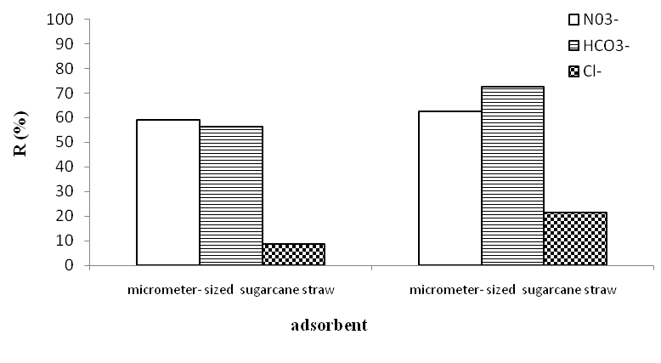
Figure 10.The effect of coexisting ions on nitrate removal by sugarcane straw-AE

3.5. Desorption
The results relating to desorption of NO₃⁻ by HCl are shown in table 4. The results showed that HCl demonstrate the high desorption capacities; this indicate that, the reverse of the reactions with Cl⁻ from the HCl solution displacing NO₃⁻ ion onto sugarcane straw–AE adsorbent.

Table 4: Desorption parameters of desorption solvent
Adsorbent | Adsorbed nitrate (mg/L) | Desorbed nitrate  (mg/L) | Desorption efficiency  (%)
micrometer-sized sugarcane straw | 11.3 | 7.16 | 63.36
Nanometer-sized sugarcane straw | 12.3 | 9.12 | 74.15

4. Result of column experiment
Figure 11 shows the variation in the equilibrium nitrate concentration as a function of time on micrometer and nanometer-sized sugarcane straw-AE.

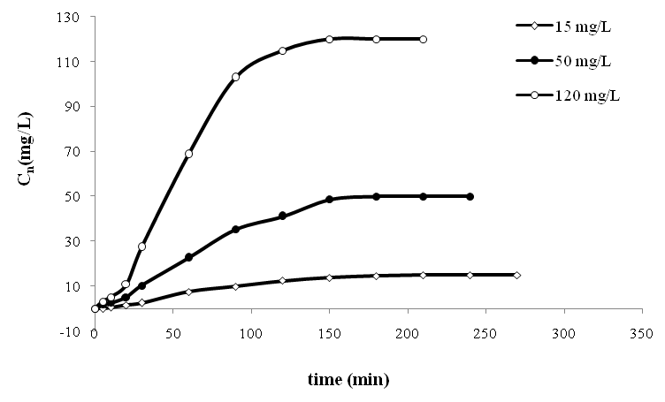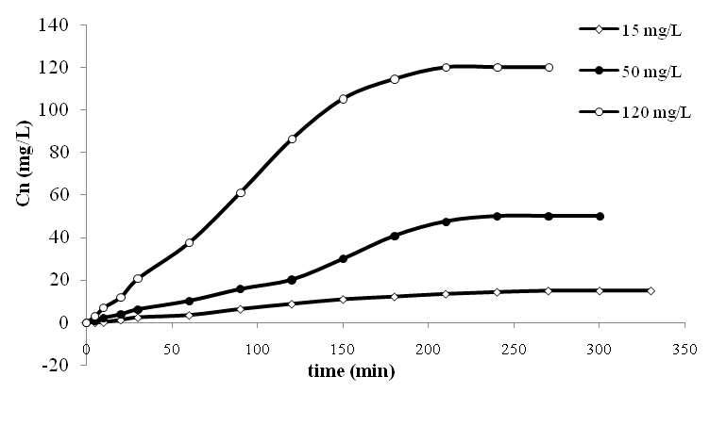
(a)
(b)
Figure 11. The change of equilibrium nitrate concentration with time on sugarcane straw-AE (a) micrometer-sized (b) nanometer-sized (flow rate: 0.98L/h, initial concentration of nitrate: 15, 50 and 120 mg/L, pH=6)

For micrometer-sized with flow rate of 0.98 L/hr, exhaustion time and adsorption capacity (q_{e}) obtained at 180, 150, 120 min and 3.84, 11.57, 24.54mg/g for 15, 50 and 120 mg/L initial nitrate concentration, respectively. For nanometer-sized sugarcane straw-AE, exhaustion time obtained at 240, 210, 180 min and 6.99, 12.7, 17.28 mg/g for 15, 50 and 120 mg/L initial nitrate concentration respectively (Figure 11). As indicated in Figure 11 at higher initial concentration of nitrate, a relatively higher uptake value was observed for nitrate sorption on sugarcane straw-AE. A higher q_{e} is observed at higher concentrations in column test for nitrate removal that attribute to the concentration gradient which will enhance the adsorption process. Similar results were reported in the work of Xing for the nitrate and phosphate removal by WS-AE and Han’s work for methylene blue adsorption onto natural zeolite in fixed-bed column (Han et al., 2007; Xing et al., 2010). The exhaustion time decreased with increasing initial concentration of nitrate. This behavior due to with increasing initial concentration, sites of adsorbent filled quickly.

5. Conclusion
In this study, the examined experimental parameters, such as pH, adsorbent dosage, initial NO₃⁻ concentration, coexisting ions and sugarcane straw particle size, influenced the removal of NO₃⁻ion by sugarcane straw–AE. The nitrate removal was optimal at pH= 6, and 180, 120 minutes equilibrium time in batch experiments for micrometer and nanometer-sized sugarcane straw-AE. Higher initial nitrate concentrations led to lower removal percentages but higher adsorption capacity. As the adsorbent dose increased, the removal of nitrate increased, while the adsorption capacity decreased. The NO₃⁻ ion exchange capacity of sugarcane straw–AE increased with decreasing particle size, and the NO₃⁻ ion exchange data was fitted to the Freundlich, Langmuir, Redlich–Peterson, and Langmuir–Freundlich models. Adsorption kinetics of nitrate ions onto sugarcane straw-AE could be most successfully described by the pseudo-second order kinetic model. The exhaustion time and total adsorbed nitrate quantity increased with increasing initial nitrate concentration of the solute in the adsorption column. Based on the results, it can be concluded that sugarcane straw–AE is a suitable anion-exchanger for NO₃⁻ removal and it can be recommended for use in wastewater treatment and agriculture purposes as it represents a sustainable and affordable ion exchange material. Because of develop high capacity and selective of nanoparticles for nitrate removal, nanometer-sized sugarcane straw-AE had higher ability of nitrate adsorption than micrometer-sized sugarcane straw-AE.

Acknowledgements
We would like to thank Assistant Professor Morteza Seyedian, Agricultural Faculty, Gonbad Kavoos University, Gonbad, Iran for his valuable help.

Correspondence to: Saeed Boroomand nasab
Water Sciences Engineering Faculty. Shahid Chamran University, Ahvaz, Iran.
Telephone: +989161183014
Email: boroomandsaeed@yahoo.com

References
[1] ASTM Book of Standards. Test method for Determination of Iodine Number of Activated Carbon. D4607-94 (Reapproved 1999). West Conshohocken.Volume 15.01. 2002; 846-854.
[2] Fernandez-Olmo, I. Fernandez, J.L. and Irabien, A. Purification of dilute hydrofluoric acid by commercial ion exchange resins. Sep. Purif. Technol. 2007; 56:118–125.
[3] Gao, B.Y. Xu, X. Wang, Y. Yue, Q.Y. and Xu, X.M. Preparation and characteristics of quaternary amino anion exchanger from wheat residue. J. Hazard. Mater. 2009; 165: 461–468.
[4] Gong, R.M. Ding, Y. and Li, M. Utilization of powdered peanut hull as biosorbent for removal of anionic dyes from aqueous solution. Dyes Pigment 2005; 64: 187–192.
[5] Han, R.P. Wang, Y. Zou, W.H. Wang, Y.F. and Shi, J. Comparison of linear and Nonlinear analysis in estimating the Thomas model parameters for methylene blue adsorption onto natural zeolite in fixed-bed column. J. Hazard. Mater. 2007; 145: 331–335.
[6] http://www.oakdaleengr.com/datafit.htm
[7] Kumar, K.V. and Sivanesan, S. Pseudo second order kinetic models for safranin onto rice husk: comparison of linear and non-linear regression analysis. Process Biochem. 2006; 41: 1198–1202.
[8] Laszlo, J.A. Preparing an ion exchange resin from sugarcane bagasse to remove reactive dye from wastewater. Textile Chemist and Colorist 1996; 28: 13–17.
[9] Lei, L.C. Li, X.J. Zhang, X.W. Ammonium removal from aqueous solutions using Microwave-treated natural Chinese zeolite. Sep. Purif. Technol. 2008; 58: 359–366.
[10] Malekian, R. Abedi-Koupai, J. Eslamian, S.S. Mousavi, F. Abbaspour, K. and Afyuni, M. Ion-exchange process for ammonium removal and release using natural Iranian zeolite. Applied Clay Science 2011; 51: 323–329.
[11] Mishra, P.C. Patel, R.K. Use of agricultural waste for the removal of nitrate-nitrogen from aqueous medium J. Environmental Management 2009; 90: 519-522.
[12] Orlando, U.S. Okuda, T. and Nishijima, W. Chemical properties of anion Exchangers prepared from waste natural materials. React. Funct. Polym. 2003; 55: 311–318.
[13] Ozturk, N. and Ennil Kose, T. A kinetic study of nitrite adsorption onto sepiolite and powdered activated carbon. Desalination 2008; 223: 174–179.
[14] Rahmani, A. Zavvar Mousavi, H. Fazli, M. Effect of nanostructure alumina on adsorption of heavy metals. Desalination. 2010; 253: 94–100.
[15] Raji, C. Anirudhan, T.S. Batch Cr (VI) removal by polyacrylamide-grafted Sawdust: kinetics and thermodynamics. Water Res. 1998; 32: 3772–3780.
[16] Ramesh, A. Devi, B. A. Hasegawa, H. Maki, T. and Ueda, K. Nanometer-sized alumina coated with chromotropic acid as solid phase metal extractant from environmental samples and determination by inductively coupled plasma atomic emission spectrometry. Microchemical Journal 2007; 86:124–130.
[17] Saltali, K. Sari, A. Aydin, M. Removal of ammonium ion from aqueous solution by natural Turkish (YIldIzeli) zeolite for environmental quality. J. Hazard. Mater. 2007; 141:258–263.
[18] Samatya, S. Kabay, N. ksel, U. Yu. erref Arda, Mu. Yu ksel, M. Removal of nitrate from aqueous solution by nitrate selective ion exchange resins. Reactive & Functional Polymers 2006; 66: 1206–1214.
[19] Sarioglu, M. Removal of ammonium from municipal wastewater using natural Turkish (Dogantepe) zeolite. Sep. Purif. Technol. 2005; 41:1–11.
[20] Shirvani, M. Shariatmadari, H. Kalbasi, M. Kinetics of cadmium desorption from fibrous silicate clay minerals: Influence of organic ligands and aging. Appl. Clay Sci. 2007; 37:175–184.
[21] Tehrani-Bagha, A.R. Nikkar, H. Mahmoodi, N.M. Markazi, M. Menger, F.M. The sorption of cationic dyes onto kaolin: Kinetic, isotherm and thermodynamic studies. Desalination 2011; 266: 274–280.
[22] Ulmanu, M. Anger, I. Fernández, Y. Castrillón, L. Maranon, E. Batch Chromium (VI), Cadmium (II) and Lead (II) Removal from Aqueous Solutions by Horticultural Peat. Water Air Soil Pollut 2008; 194:209–216. DOI 10.1007/s11270-008-9709-9.
[23] Uygur, A. and Karg, F. Biological nutrient removal from pre-treated landfill leachate in a sequencing batch reactor. J. Environ. Manage. 2004; 71: 9–14.
[24] Xing, X. Gao, B. Yue, Q. and Zhong, Q.Q. Preparation of agricultural by-product based anion exchanger and its utilization for nitrate and phosphate removal. Bioresource Technology 2010; 101: 8558–8564.

19/3/2011

