Comparative Study among the Germination and Propagation of Different Capsicum Annuum Cultivars using Tissue Culture Techniques

Omar M. Akram¹, Mona Gaafar², Gehan Safwat^{*1,2} and Ayman Diab^{1,3}

¹ Faculty of Biotechnology, October University for Modern Sciences and Arts, Egypt
² Horticulture Research Institute, Agriculture Research Centre, Egypt
³ Agricultural Genetic Engineering Research Institute, Egypt
*gehan.safwat@hotmail.co.uk

Abstract: Morphogenetic potential of seed and explants culturing of three capsicum annuum L. (pepper) genotypes (Gedion, Moaz, and Mohand) were studied to evaluate different plant regeneration protocols and develop a reliable system for plant propagation. An efficient procedure of in vitro plant regeneration through seed and direct shoot bud induction was tested from different explants of capsicum annuum L. Several methods of media preparation with combinations of growth regulators were used, and 2 combinations were found ideal for seed propagation with 7 mg/l 2,4-D or 5 mg/l IBA respectively. Additionally, it was indicated that seed dormancy can effect its propagation also the positioning of the seed or explants onto the media. Propagated seeds demonstrated shoot and root elongation. Regeneration of the explants did not show satisfactory results because most of the explants did not develop into normal shoots but instead developed into calli after 15 days of culture. HPLC Analysis of cultivars demonstrated that fructose suger percentage was higher in the three different types of pepper, followed by sucrose then glucose. Also the HPLC analysis drew out that media supplemented with 7mg/l 2,4-D generally had the highest effect of capsaicinoid sugar content in the following order i.e. cultivar Mohand was showed high significant in sugar content of capsaicinoid followed by Gedion and Moaz. Application of DPPH method illustrated that extracts obtained from Moaz leaves characterized the most proactive antioxidant (vitamin C) properties than Gedion and Mohand. A were noticed. The results of these studies indicated that antioxidant activities of the extract prepared from pepper leaves depended mainly on phenolic compounds.
[Omar M. Akram, Mona Gaafar, Gehan Safwat and Ayman Diab. Comparative Study among the Germination and Propagation of Different Capsicum Annuum Cultivars using Tissue Culture Techniques]. Nature and Science 2011;9(7):183-189]. (ISSN: 1545-0740). http://www.sciencepub.net.

Key words: Capsicum Annuum L., micropropagation.

1. Introduction
The genus Capsicum includes five domesticated cultivars and twenty six wild species. Capsicum annuum L. (pepper) is the most extensively cultivated species of Capsicum and represents an important economic vegetable and spice crop worldwide. The species includes both mild and pungent fruit types. Seeds are commonly utilized for multiplication and production in the conventional plant breeding systems. The propagation through seeds is further restricted by short span of viability, low germination rate, high risk of infection by various diseases. In addition, some of the limiting factors for the production of pepper are; high sensitivity to many pathogens and pests, including fungi, bacteria, viruses and extreme climatic conditions, particularly temperature extremes. In accordance to (Morrison, et al., 1986), to facilitate and improve the propagation of the commercial cultivars of these species and to meet the increasing demand of crop and overcome the plants lack of natural vegetative propagation, tissue culture methods provide a better way for the asexual multiplication of pepper plants.
Plant tissue culture comprises a set of in vitro techniques, methods and strategies that are part of the group of technologies called plant biotechnology. Tissue culture aspects of the pepper plant have been well studied (Phillips and Hustenberger, 1985; Agrawal et al., 1988; Harini and Sita, 1993; Hyde and Phillips, 1996; Christopher and Rajam, 1996; Hussain et al., 1999). numerous tissue culture techniques for micropropagation of pepper have been reported from seeds and different explants, including shoot tip (Christopher and Rajam, 1994), leaf , stem, root and embryo (Agrawal et al., 1989) and induced somatic embryogenesis (Arous et al., 2001). Nevertheless, it is inappropriate to establish in vitro conditions set for a specific cultivar to be applicable for the propagation of another cultivar. Consequently, it is essential to determine a reliable regeneration system for pepper propagation, especially for genotypes developed for commercial purposes. In this study we compared and evaluated the protocols for shoot, callus ad whole plant regeneration from seed and segment explants of different pepper genotypes germinated in green houses and throughout different tissue culture techniques by applying different measurements of growth regulators.

2. Materials and Methods
These experiments were carried out in the tissue culture laboratory of the Faculty of biotechnology, October University for Modern Sciences and Arts, 6th of October Governorate.

Plant materials
Seeds of Three Capsicum annuum L. (pepper) genotypes Gideon, Moaz,and Mohand were obtained from Horticulture Research Institute, Agriculture Research Centre, Egypt.
The explants were derived from 30 days old in vivo germinated seedlings cultured in the greenhouse of Horticulture Research Institute, Agriculture Research Centre, Egypt.

Callus induction and shoot differentiation
Seeds and Explants (shoot tip and stem) were surface sterilized by soaking in 70% (v/v) ethanol for 2 min, and then were immersed in 20% (v/v) bleach for 10 min and finally rinsed three times with sterile distilled water in a laminar flow hood to insure the absence of contaminants. Sterilized seeds and Explants were germinated in 150 and 250 ml glass jars. Media were containing 4.4 g/l MS (Murashige and Skoog, 1962) basal medium, 30g/l sucrose, and 9 g/l agar supplemented With various concentrations of auxins such as 2,4-D (2,4.dichlorophenoxyacetic acid) (5.0-7.0 mg/l), IBA (indol-3-3butyric acid) (3.0-5.0 mg/l), and cytokinin BAP (6-benzyl aminopurine) at the concentration of (3.0 mg/l) either alone or in combinations and subculture at every four weeks to same medium. Prior to medium sterilization, pH was adjusted to 5.7 in all media with 1M NaOH or 1M HCL. Media were autoclaved for 15 min. at 121 oC and a pressure of 1.05 Kg/cm2. All cultures were incubated in a growth chamber at temperature of 25±2 oC provided with light using white fluorescent lamps. At the end of the experiment the data in every treatment were calculated. Data were taken as the average of each cultivated plant; shoot length, root length, fresh weight, and callogensis were measured.. The frequency of the regenerated micro plants was presented in percentage both to the total number of explants and to the number of obtained direct embryoids from the respective genotypes. statistical analysis was obtained with the statistical package SAS.
Chemical analysis;
The chemical parameters included concentration of soluble sugars i.e fractious, sucrose, glucose and capsicinoids of different pepper cultivars was measured using HPLC (Lope-Hernandez et al, 1996; Jung et al, 2006). Protein content was determined according to the methods of AOAC (1983) and amino acids content was determined using amino acid analyzer according to the method of Moore et al (1985). Data were analyzed by variance (ANOVA) followed by Duncan’s multiple range test.

Antioxidant activity
Pepper extracts was measured as scavenging free radical potential in methanolic solutions of DPPH (1,1-diphenyl-2-picrylhydrazyl), as described by Burda and Oleszek (2001). The analysis was conducted for ethanolic extracts obtained from lyophilizd pepper leafs. The antiradical activity was calculated as percentage of DPPH decoloration compared to the control. Ascorbic acid content in fresh pepper leafs was determined by tillmans method (PN-A-04019 1998) and in ethanolic extracts by the same method with modification of roe (1967). The absorbance of these solutions were measured at λ=520 nm. Vitamin C concentration was calculated on standard solutions of L-ascorbic acid. Statistical significance of data was determined by the analysis of variance with LSD method (Steel and Torrie, 1980).

Determination of protein content
One gram of callus (FW) from the treatments of differentconcentrations of La3+ after cultured for 30 days was ground using a glass rod in mortar at an ice bath. The extraction was carried out
with 5 ml of Tris-HCl buffer at pH 8.0. Extract was centrifuged (5,000 g, 15 min) at 4°C and the residue was extracted again withthe same method. The combined supernatant was used forquantification determination. Soluble protein content was determined according to Bradford (1976). Bovine serum albuminwas used as the control. Peroxidase (POD) was extracted and determined with the method described by Wakamatsu and Takahama (1993). The determination was done at 25, 30 and 35 days after culture and triplicate samples were analyzed at each

Quantitative estimation of phenolic compounds:
For the estimation of total phenolics, from main to successive subcultures, method of Bray & Thorpe (1964) was used. One gram of callus was taken and boiled in methanol for 5 minutes. The boiled calli were homogenized in pestle mortar with methanol. The mixture was filtered and debris were washed with 80% acidified methanol. Two ml of H₂O was added. The extract was concentrated to aqueous volume by evaporation in a rotary evaporator under reduced pressure at 40ºC. The aqueous extract was centrifuged at 6,000 rpm to remove chlorophyll and fine debris.

3. Results and Discussion
Several Systems for regeneration of Capsicum has been reported (Agrawal et al., 1989; Arroyo and Revilla, 191; Christopher and Rajam, 1994; Ezura et al., 1993; Gunay and Rao, 1978; Philips and Hubstenberger,, 1985; Ramirez-Malagon and Ochoa-Alejo, 1996; Szasz et al., 1995). Therefore, Effects of explants source on in vitro propagation were evaluated in terms of regeneration. The results showed significant differences among the two sources of explants. The explants from shoot tip gave the best result with respect to direct regeneration parameters (Table 1). The most coactive response on the bases of percentage of explants that formed callus was obtained from the shoot tip but none of the emergent buds developed into shoots and all showed callogenesis. Moreover, the effect of growth regulators on shooting and rooting of in vitro induced shoot buds from shoot tip explants after six weeks of cultivation are shown in Table (2) (Figure 1).

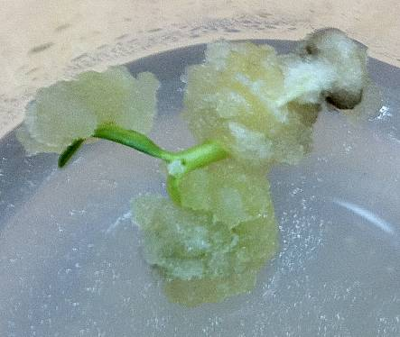
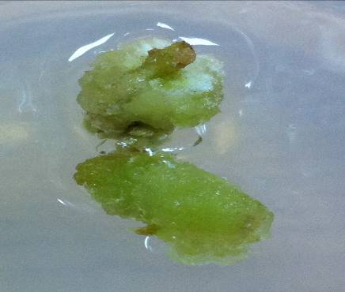

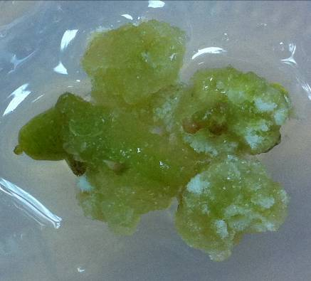

Fig. 1: Bud formation from different types of explants. (a) Tip explants from ‘Gedion’ showed shoots grown around the surface of the formed callus, (b) Tip explants from ‘Moaz’ showed regeneration but none of the emergent buds developed into a shoot and all experienced callogenesis and (c) Tip explants from ‘Mohand’ developed all into callus.

Table (1) Effect of growth regulators and explants on callogenesis, number of roots and shoots per explant in treatments with the best combination of growth regulators of the different of Capsicum annuum L. varieties. (A: Gedion, B: Moaz, C: Mohand)
Media |  | Shoot Tip |  |  |  |  |  |  |  |  |  | Stem
 |  | Number of Shoots per Plant |  |  |  | Number of roots per Plant |  |  | Callogensis  (%) |  |  | Number of Shoots per Plant |  |  | Number of roots per Plant |  |  | Callogensis  (%)
 |  | A |  | B | C | A | B | C | A | B | C | A | B | C | A | B | C | A | B | C
Medium 1 |  |  | 6.2±1.1 | 5.2±1.4 | 4.2±1.2 | 36±3.1 | 39±2.7 | 33±2.7 | 15 | 16 | 8 | 1.2±1.1 | 1.6±1.4 | 1.2±0.23 | - | - | - | 85 | 72 | 68
Medium 2 |  |  | -- | --- | --- | 32±2.5 | 41±2.7 | 45±1.4 | 3 | 4 | 3 | 1.3±0.9 | 1.5±0.8 | 1.3±1.1 | - | - | - | 59 | 48 | 52
Medium 3 |  |  | 4.2±0.45 | 7.3±0.65 | 5.1±1.3 | 35±2.4 | 42±3.7 | 43±2.0 | - | - | - | 1.4±1.2 | 1.2±0.9 | 1.2±0.28 | - | - | - | 73 | 57 | 58

Table (2) Effect of auxins and cytokines on rooting and shooting of in vitro induced shoot buds from shoot-tip explants of Capsicum annuum L. cvs.[Gedion, Moaz and Mohand (A, B, C)] Respectively, after six weeks of culture. Media 1 containing 7 mg/l 2, 4-D, media 2 containing 5 mg/l 2,4-D + 3. mg/l BA, and media 3 containing 5 mg/l IBA.

Auxins  (mg/l) |  |  | Cytokines  (mg/l) |  | Rooting  (%) |  |  | Shooting  (%) |  |  | Root Length  (cm)  Mean ± S.E |  |  | Shoot Length  (cm)  Mean± S.E |  |  | Plant Fresh Weight  (mg)  Mean ± S.E
IAA | IBA | NAA | 2,4-D | BA
 |  |  |  |  | A | B | C | A | B | C | A | B | C | A | B | C | A | B | C
2 | - | - | - | - | 80 | 70 | 100 | 0 | 0 | 0 | 9.5±0.31 | 8.5±0.27 | 12±0.24 | 0 | 0 | 0 | 0.3±0.12 | 0.4±0.11 | 0.3±0.17
- | 5 | - | - | - | 100 | 90 | 90 | 0 | 0 | 0 | 12.2±0.2 | 11.7±0.24 | 11±0.23 | 0 | 0 | 0 | 0.4±0.12 | 0.5±0.12 | 0.6±0.12
 | 3 | - | - | 2 | 100 | 100 | 100 | 100 | 100 | 100 | 11.2±0.3 | 11.8±0.25 | 11.7±0.2 | 2.5±0.31 | 2.5±0.31 | 2.5±0.31 | 1.5±0.2 | 1.8±0.22 | 1.7±0.2
= | - | 2 | - | 2 | 60 | 70 | 80 | 80 | 100 | 100 | 6.2±0.18 | 7.3±0.2 | 8.4±0.22 | 2.0±0.27 | 2.3±0.28 | 2.3±0.28 | 0.5±0.21 | 0.7±0.16 | 0.6±0.16
- | - | - | 5 | - | 0 | 0 | 0 | 40 | 40 | 35 | 0 | 0 | 0 | 1.5±0.12 | 1.7±0.13 | 1.3±0.11 | 0.3±0.09 | 0.28±0.1 | 0.26±0.1
2 | - | - | 5 | - | 80 | 100 | 100 | 50 | 55 | 50 | 10.2±0.3 | 9.7±0.31 | 11±0.23 | 1.7±0.20 | 1.7±0.13 | 1.3±0.11 | 0.5±0.09 | 0.6±0.09 | 0.5±0.09
- | 3 | - | 5 | - | 80 | 80 | 80 | 55 | 50 | 50 | 9.2±0.2 | 9.7±0.29 | 9.3±0.32 | 1.6±0.12 | 1.4±0.13 | 1.3±0.11 | 0.6±0.3 | 0.6±0.32 | 0.5±0.30
- | - | 3 | - | 5 | 100 | 80 | 100 | 100 | 100 | 100 | 13.2±0.4 | 8.7±0.28 | 11.8±0.2 | 2.8±0.2 | 3.8±0.27 | 3.4±0.26 | 1.9±0.21 | 1.8±0.22 | 1.7±0.2
- | - | 2 | - | 3 | 70 | 70 | 80 | 80 | 85 | 85 | 11.6±0.2 | 10.72±0.3 | 11.8±0.3 | 2.4±0.12 | 1.9±0.13 | 2.3±0.11 | 0.9±0.17 | 0.8±0.17 | 1.3±0.17
- | - | - | - | 3 | 0 | 0 | 0 | 100 | 100 | 100 | 0 | 0 | 0 | 2.8±0.31 | 3.8±0.27 | 3.4±0.26 | 0.7±0.16 | 0.4±0.11 | 0.6±0.14

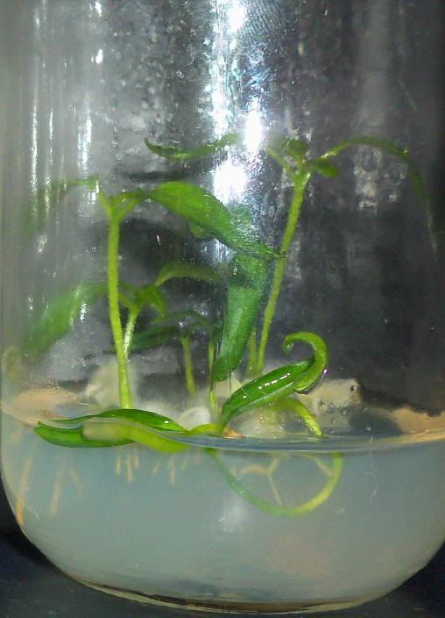
Fig. 2: Shoot and root elongation of ‘Gedion’ were witnessed

Sugar content of the three pepper cultivars were analyzed in Table (3) and the data obtained pointed out that none of them were influenced by different growth regulators. Fructose was the major sugar in the three types of pepper, followed by sucrose.

Media |  | Soluble sugar content (mg/g D.W)
 |  | Glucose |  |  | Fructose |  |  | Sucrose
 |  | A | B | C | A | B | C | A | B | C
Medium (1) |  | 24.2 | 26.9 | 25.9 | 58.4 | 59.8 | 60.06 | 34 | 33.6 | 36.9
Medium (2) |  | 19.9 | 17.8 | 18.8 | 52.9 | 54.4 | 56.9 | 30.8 | 33.3 | 32.7
Medium (3) |  | 22.1 | 23.8 | 25 | 61.6 | 64 | 72.1 | 37.7 | 39.07 | 37.5
Table (3) Soluble sugars contents of pepper leaves

The analysis of capsaicinoid content demonstrated in Figure (3) drew out that media(1) had the highest effect of the capsaicinoid content and Mohaned showed the most elevated content of capsaicinoid followed by Gedion.
The activities of antioxidant extracts determined by DPPH method elucidated in Figure (4) was found that extracts obtained from Moaz leaves characterized the higher antioxidant properties than from hot fruit where the higher concentrations of vitamin C, E and provitamin A were noticed. The results of these studies indicated that antioxidant activities of the extract prepared from pepper leaves depended mainly on the phenolic compounds
Figure 5 shows the effects of different concentration of growth regalatours on the soluble protein content of callus at three cultivars., the soluble protein content decreased markedly at high concentration treatments of (Benzyl Adenine )BA. These results are similar to the early published report which also showed a dose-dependent effect (Wan et al., 2004 “).A decreased trend of the soluble protein content was observed when the culture was containing 2,4- D and it could be the reason of phenol ration that effect the protein.
Figure 6 shows that Moaz has the highest level of phenol content followed by Gadion then Mohaned. This study, restricted callus maintenance and growth remained the major obstacle to trigger the desired differentiation response. One major reason identified for poor callus maintenance was the initiation of browning and necrosis of callus tissues at various levels of growth and differentiation. Generally the browning and necrosis activities are correlated with the accumulation of excessive phenolics. Interference of phenolics with the process of growth and differentiation is a common phenomenon. So present study was undertaken to determine the precise role of phenolic compound and to develop a possible link between browning and accumulation of phenolics.

Fig. 3: Capsaicinoid content from three pepper cultivars

Fig. 4: Antioxidant activity of ethanolic extracts from three cultivars of pepper samples

Fig. 5: Protein content of callus of three cultivars of pepper samples

Fig6: Phenolic compound content from three pepper cultivars

Conclusion
Based on the data acquired from our study; was remarkable to show how to reach the maximum regeneration of plant with adequate concentrations of growth regulatorsand. Furthermore, we have developed a promising method for an effective plant regeneration system from seeds and explants using 2,4-D and IBA. This study could be useful as an effective was to induce callusogenesis in genotypes of Capsicum annuum L. Moreover, this protocol might aid in providing a possible system towards genetic improvement of the crop.

Acknowledgment
This study was supported by the Faculty of Biotechnology, October University for Modern Sciences and Arts (MSA), 6th of October Governorate, Egypt. The authors hereby would like to thank Professor Khayri Abdel-Hamid (the university president) and Professor Nawal El-Degwi (the head of board of trust committee) for their role played in making the university a very professional campus and also thank Mrs. Amal Mohamed El-shierf for her technical support.

Corresponding author
Gehan Safwat
Horticulture Research Institute, Agriculture Research Centre, Egypt
gehan.safwat@hotmail.co.uk

5. References:
Agrawal, S., Chandra, N., and Kothari S.L., 1988. Shoot –tip culture of pepper for micropropagation. Curr. Sci., 57: 1347-1349
Agrawal, S., Chandra N., and Kothari S.L., 1988. Plant regeneration in tissue culture of pepper (capsicum annuum L. cv. Mathania). Plant cell tissue organ culture, 16: 47-55.
Andrzej, B., Szczytt, K.N., and Magdalena, J. 2002. Plant regeneration from sweet pepper (capsicum annuum L.) hypocotyls explants. Acta Physiol, Plantarum, 24:257-264.
AOAC. 1984. Official Method of Analysis of the Association of Official Analytical Chemists, Sidny Williams. Ed. 14th Ed. Association of Official Analutical Chemists, Inc. Arlington, Virginia, U.S.A
Arous, S,. Boussaid, M., and Marrakchi M., 2001. Plant regeneration from zygotic embryo hypocotyls of Tunisian chilli (capsicum annuum L.). J, Applied Hortic., 3:17-22.
Arroyo, R., and Revilla, M.A., 1991, In vitro plant regeneration from cotyledon and hypocotyl segments in two bell pepper cultivars. Plant Cell Rep., 10, 414-416.
Bray, H.G. and W.V. Thorp. 1954. Analysis of phenolic compounds of interest in metabolism. In:
Methods of Biochemical Analysis (Ed.): David Glich, 1: 27-52.
Burda S., Oleszek, W., 2001. Antioxidant and antiradical activities of flavonoids. J. Agric. Food Chem. 49, 2774-2779.
Christopher, T., and. Rajam M.V, 1994. In vitro clonal propagation of capsicum spp. Plant Cell Tissus Organ Culture, 38:25-29.
Christopher, T., and. Rajam M.V, 1996. Effect of genotype explants and medium on Iin vitroI regeneration of red pepper. Plant cell tissue Organ Culture, 46: 245-250.
Ezura, H., Nishimiya, S., and Kasumi, M., 1993. Efficient regeneration of plants independent of exogenous growth regulators in bell pepper (Capsicum annuum L.). Plant Cell Rep., 12, 676-680.
Gunay, A.L., and Rao P.S., 1978, In vitro plant regeneration from hypocotyl and cotyledon explants of red pepper (Capsicum). Plant Sci. Letts., 11, 365-372.
Harini, I. and Sita, G.L., 1993. Direct somatic embryogenesis and plant regeneration from immature embryos of chili (capsicum annuum L.). Plant Sci., 89: 107-112.
Hussain, S., Jain, A., and Kothari S.L, 1999. Phenylacetic acid improves bud elongation and in vitro plant regeneration efficiency in (capsicum annum L.). Plant Cell Report, 19: 64-68.
Hyde, C. L., and Philips G.C., 1996. Silver nitrate promotes shoot development and plant generation of chili pepper (capsicum annuum L.). via organogenesis. In vitro Cell Dev. Biol. Plants, 32: 72-80.
Jung JW, Cho MC, and Cho YS., 2006. Fruit quality of once-over harvest pepper (capsicum annuum. L.) Cultivar ‘Saengryeg No 211’ and ‘Saengryeg No 213’. Kor. J.Hort.Sci. Technol.24(2):205-206.
Lope-Hernandez J., Oruna-Concha MJ, Simal-Lozana J, Vazquez-Balnoco ME and Gonzalez-Castro MJ. 1996. Chemical composition of pardon pepper (capsicum annuum. L.) grown in Galicia. Food Chem. 57:557-559.
Moore, S.; Spackman, D. H., and Stein. W. H. 1958. Chromatography of amino acid on sulfonated polystyrene resins. Anal. Chem. 30 (7): 1185-1190.
Morrison, R,A., Koning, R.E., and Evans, D.A. 1986.Handbook of Plant Cell Culture. Pepper, In: D.A. Evans, W. R. Sharp and P. V. Ammirato (eds.). Macmillan, New York. Vol.4. p. 552-573.
Philips, G.C., and Hubstenberger, J.F., 1985. Organogenesis in pepper tissue cultures. Plant Cell Tissues Organ Culture, 4: 261-269.
PN-A-04019, 1998. Produkty spożywcze – Oznaczanie zawartości witaminy C [Food products – Determination of vitamin C content; in Polish].
Pottino, B. G. ,1981. Methods in plant tissue culture. Maryland : Dept. of Hort., Agric. College. 8-29 pp.
Radwan, S. S. 1978. Coupling of two dimention thin layer chromatography with gas chromatography for the quantitative analysis of lipids classes and their constituent fayyy acids. J. Chromatog. Sci. 16: 538-542.
Ramirez-Malagon, R., and Ochoa-Alejo, N., 1996, An improved and reliable chilli pepper (Capsicum annuum L.) plant regeneration method. Plant Cell Rep., 16, 226-231.
Roe J., 1967. Ascorbic acid. The Vitamins 7, 27-35.
Steel, R. G. D., and Torrie, J. H. 1980. Principles and procedures of statistics. A biometrical approach. 2nd ed. McGraw-Hill Kogakusha, Ltd., pp. 633.
Szasz, A., Nervo, G., and Fari, M., 1995, Screening for in vitro shoot forming capacity of seedling explants in bell pepper (Capsicum annuum L.) genotypes and efficient plant regeneration using thidiazuron. Plant Cell Rep., 14, 666-669.
Thomas, W., and Dutcher, R. A. 1924. Picric acid method for carbohydrate J. Amer. Chem. Sci. 46: 162-166.

6/2/2011

