Numerical analysis of the geomembrane behavior in the earth dams

Hamidreza Ahmadaghaei¹ , Mohammad Azadi²

1,2 Civil Engineering department,damavand branch,islamic Azad University,Damavand,iran
Corresponding author: h_ahmadaghaei@yahoo.com

Abstract:The use of geomembranes as Tatrava surface can be considered as valuable and affordable solution compared to other techniques for sealing of earth dams. In one Of the earth dams in Iran ( Sar Chesmeh Copper mine dam), the geomembrane is used to increase the height of the dam. In this study, using by software modeling to try to achieve the optimum thickness for geomembranes used in The shell was added to the old dam, based on analysis of Seepage and slope stability downstream slope of dam, So using by obtained thickness of the geomembrane, the smallest leak can cause, and Downstream slope of dam can maintain its consistency and economic aspects are also considered for implementation. To achieve this purpose, Geomembranes with different thickness in the respective place, Considered as a model and determine the optimal thickness of the geomembrane By comparing the results from the analysis of leakage. Then downstream slope dam stability will examine. [Hamidreza Ahmadaghaei , Mohammad Azadi. Numerical analysis of the geomembrane behavior in the earth dams. Nature and Science 2011;9(8):98-101]. (ISSN: 1545-0740). http://www.sciencepub.net.

Keywords: Geomembrane, Earth dams, Numerical analysis, Sealing.

1 – Introduction
Geomembrane is made of polymer plastic or rubber membranes that have very low permeability. Polymeric materials which are mainly used in the manufacture of geomembranes is a thermoplastic polymer. The most important application of geomembranes, confront with leakage phenomenon or infiltration water or other liquids and gases, toxic and hazardous in their care sites [1]. According to the International Committee Geosynthetic (IGS: Society Geosynthetics International), geomembrane which are used to in civil engineering are panels, relatively impermeable and the polymer in contact with soil, rock or other geotechnical material [2]. Between the geomembrane and other Geosynthetic (geotextile, a geogrid, etc.), there are important differences. Geomembranes They are designed so that have a low permeability as possible. In other words, the geomembrane to restrict fluid flow, while other Geosynthetic cause flow of liquid or conduct of it[3]. Geomembrane types include: 1) polymer geomembrane 2) and Bituminous geomembrane. Polymeric geomembranes include thermo plastic (EIA - PVC), the crystalline thermoplastic (VLDPE - LLDPE - HDPE), Thermoplastic Alastvmtrhay (CPE - CSPE) [4]. Geomembranes are used in earth dams, the core of earth dams, to increase of dam height, Walls of water and to repair leaking dams [5].

2 - Sar Cheshmeh Copper Mine Tailings Dam
Sar cheshmeh Copper Mine is located 60 kilometers from city of Rafsanjan. It is used for recovery operations of the copper and water . Therefore, the required water is supplied from the wells, Salt rivers, Return water and in the output in mining, the amount of weaskest water flow is 1000 liters per second. that, Firstly it must be maintained and control in place to prevent environmental pollution, And secondly, after separating the dry material through sedimentation, water returned to the factory and it is used again. The sediment retention dam about 21 km downstream of the mine site In order to collect the weaskest water plant was launched and was operating. The primary Sediment retention dam was kind of gravel dams with copper core and have been Height of 70 meters of river bottom. In terms of specifications, such as the dam has a width of 10m in the crest, geomembrane is used Because of the low width clay core in the primary sediment retention dam (about 3 meters). Consequently, The initial stage of sediment retention dam Consisting of gravel with a clay core height of 70 m, has been changed to The gravel dam with a mixture of clay and geomembrane sealing system and with a height of 110 meters, And a total of 37,000 square meters of PVC geomembrane is used [6].

3- Analysis of the leak in the Sar cheshmeh Copper dam
The GeoStudio software is used to analysis of the Leak in the mentioned dam. GeoStudio software is including geotechnical software Based on finite elements (Finite Elements). Through its, can be examine analyzes such as the stress - strain, leakage, flow, Slope stability and Dynamic Analysis. This software includes parts SIGMA / W for the analysis of the stress - strain, SEEP / W for the analysis of the flow and Leakage, SLOPE / W for the analysis of the slope stability, QUAKE / W for the dynamic analysis and other application areas. In this section, using the SEEP / W will be analysis of the Leakage in the sar cheshmeh cooper dam [7]. sar cheshmeh cooper dam is shown in Figure 1. Also the geotechnical parameters and leakage barrier material is presented in Table 1.

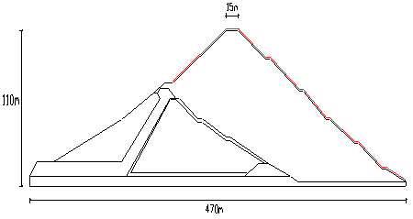

Figure 1 - section of the Sar Cheshmeh Copper dam

Table 1 - geotechnical parameters and leakage of the barrier materials

Material properties | Specific gravity (KN/m³) | Drained angle of internal friction | Cohesion Drained  (KPa) | Shear Modulus  (MPa) | Bulk Modulus  (MPa) | horizontal permeability  (cm/s)
upstream gravel | 20 | 47 | - | 80 | 170 | 10⁻¹
clay core | 19 | 22 | 20 | 10 | 90 | 10⁻⁶
downstream weir | 20 | 47 | - | 86 | 115 | 10⁻²
the shell was added | 22.5 | 44 | - | 86 | 115 | 10⁻³
geomembrane | - | - | - | - | - | 10⁻¹²
The andesite Foundation | 22.5 | - | - | 700 | 2600 | 5×10⁻⁶

For modeling in the GeoStudio software, Must first the Forming regions dam level introduce to software. To this, must be the coordinates of points forming a regional entere in the software environment. then constituent materials each area are introduced. With these steps, the model of sar cheshmeh cooper dam in GeoStudio environment are shown in Figure 2.

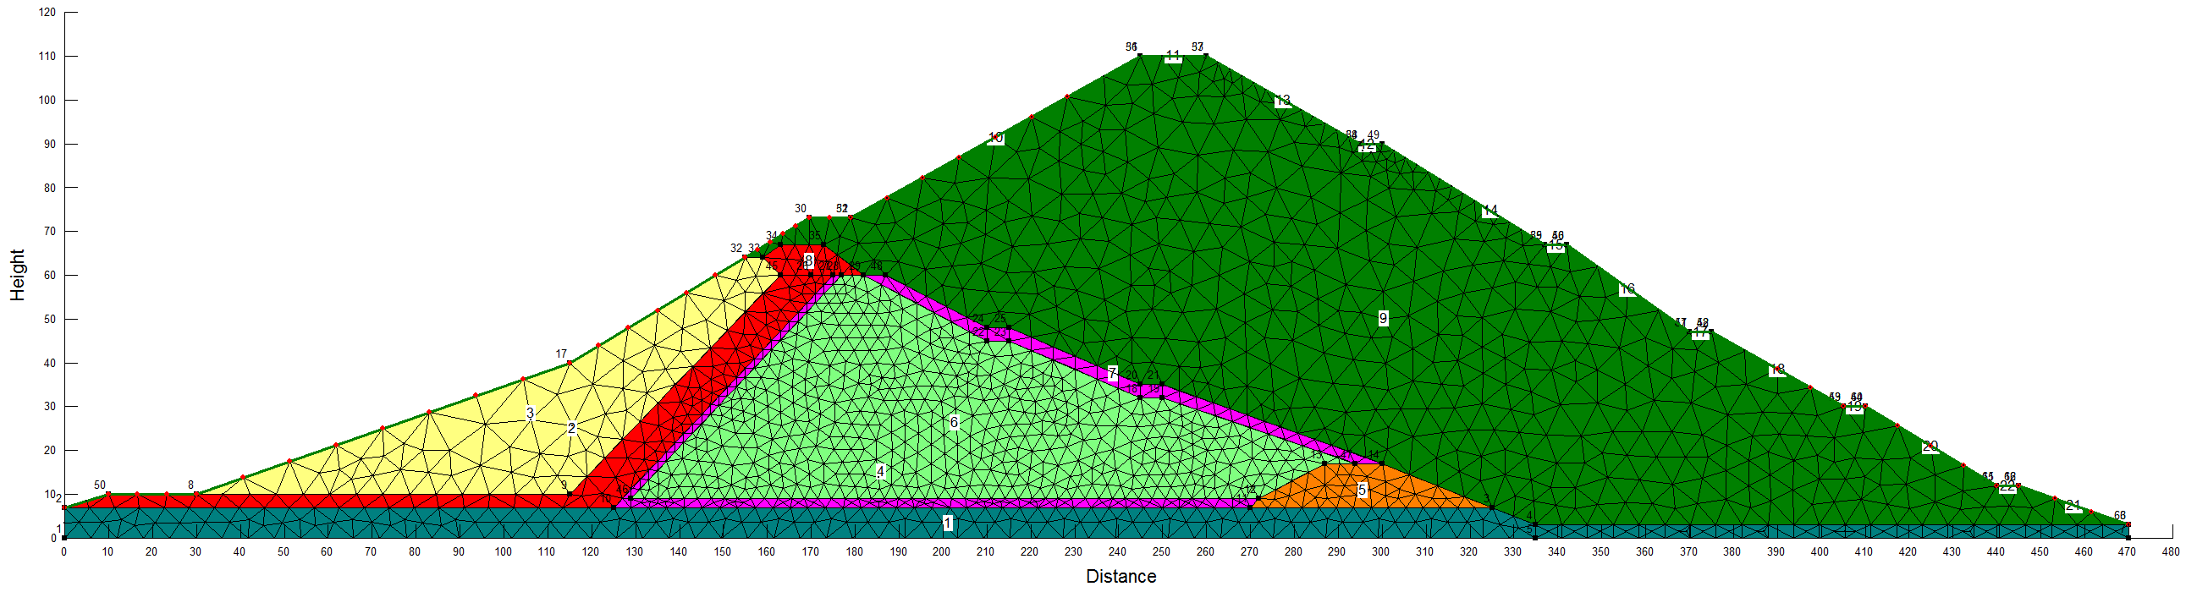
Figure 2 - cross of the modeling at the Dam Copper in the GeoStudio software

To find the optimal thickness of geomembranes used in dam, Geomembranes with different thickness is needed to become a model As shown in Figure 1. In this study, from 1 to 4 mm thick for the geomembrane, is examined. In the first, one model built without geomembrane in the software. And the total amount of leakage from the dam foundation is determined. Then in other four models, geomembrane with mensioned thickness in the shell has been added to the old dam is model. And the total leakage rate for each model separately obtained. By comparing the obtained values, ​​can be reached to optimal thickness of the geomembrane based on analysis of leakage.

Table 2 - The total amount of leakage in different modes

thickness of geomembrane (mm) |  | 1 | 2 | 3 |  |  | 4 |  | 0  (no geomembrane)
The total amount of leakage in different modes (m³/s) | 8.2843×10⁻³ |  | 3.3876×10⁻³ |  | 1.0135×10⁻³ | 0.2278×10⁻³ |  | 13.5082×10⁻³

According to Table 2, the percentage reduction of total leakage for different thickness of geomembrane, In comparison with the case without a geomembrane is given in Table 3.

Table 3 - Percent reduction in leakage for different thickness of geomembrane than Without the geomembrane
thickness of geomembrane (mm) | 1 | 2 | 3 | 4
Leakage reduction than the case without a geomembrane  (%) | 38.67 | 74.92 | 92.49 | 98.31

According to Table 3, we can say Optimum thickness for geomembranes used in dam-old added to the shell, is 3mm. Because leakage rate In comparison with the case without a geomembrane decreases 92.49 percent. also the amount of leakage reduction for the case without a geomembrane for the thickness less than 3mm is Somewhat lower than that would provide dam stability. About thickness 4 mm, although the amount of leakage is reduced by 98.31% compared with no geomembrane. But by consider the economic aspect, the thickness of 4mm is not acceptable. After selecting a thickness of 3mm for geomembranes used in the shell was added to the old dam, check dam downstream slope stability are addressed in two modes. One case is when do not use the geomembrane and the latter is when the geomembrane thickness 3mm to be used. To check the stability of the dam downstream slope from SLOPE / W section, GeoStudio software is used. For this purpose, the stable flow is considered. In Figure 3 slip surfaces in the downstream of the dam when is not used the geomembrane is displayed. And In Figure 4 slip surfaces in the downstream of the dam when the geomembrane thickness 3mm to be used is displayed.

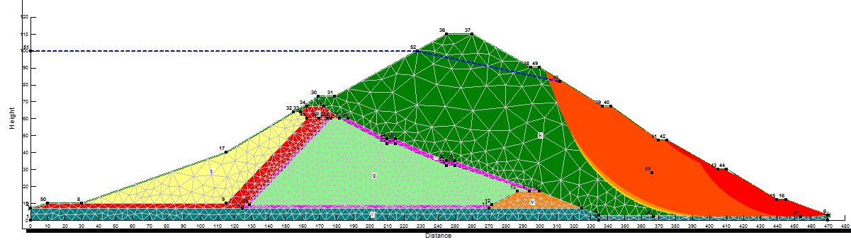
Figure 3 - The slip surfaces related to Without the geomembrane

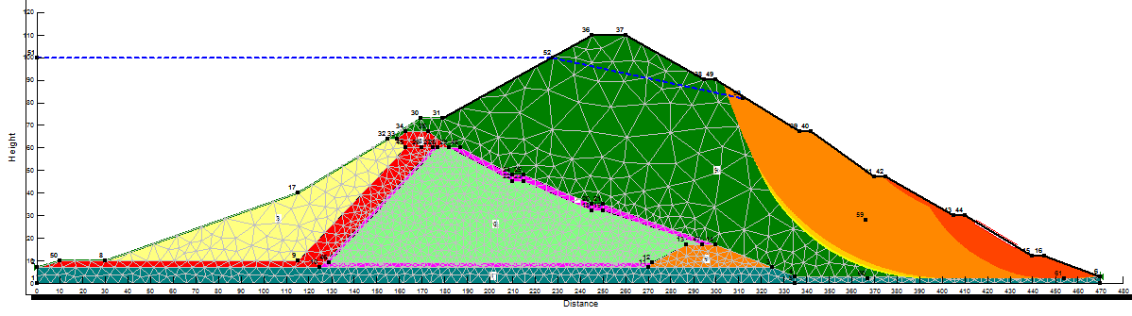
Figure 4 - the Slip surfaces associated with the use of geomembranes with a thickness of 3mm

It should be noted that the red color shown in Figures 3 and 4, Shows the critical mode of the slip. And farther away from the red, we can reduce the risk of slip. Obtained Coefficient of confidence is obtained in the case without the geomembrane by 0.68 and in the 3mm thickness of the geomembrane by the 1.604. That means when is not used the geomembrane, the lower dam would be unstable, when the geomembrane thickness 3mm to be used, stability of the Dam will provide.

Conclusion
Impermeable geomembrane used as cover in the dams is a new method. Similar dams used in the lower elevations of the dam with height Copper is very limited. Similar application of that in dams with lower hieght than Sar cheshmeh Copper dam, With increase of the height is very limited. In the Sar cheshmeh Copper dam due to dam construction, its sealing to prevent destructive leakage Is of considerable importance. Becouse of the low width of the clay core in the old dam to increase the height of the dam must be used geomembrane for the sealing barrier. Due to the high cost of the geomembrane implementing, geomembrane thickness used will impact significantly on project costs. So, the geomembrane must be used with required minimal thickness . According to Table 3, we can say optimized for geomembranes used in shell thickness was added to the old dam, is 3mm, because the bypass flow rate of the case without geomembrane, 92 percent is decreased. also the amount of leakage reduction for the case without a geomembrane for the thickness less than 3mm is Somewhat lower than that would provide dam stability. About thickness 4 mm, although the amount of leakage is reduced by 98% compared with no geomembrane, But by consider the economic aspect, the thickness of 4mm is not acceptable. Obtained Coefficient of confidence is obtained in the case without the geomembrane by 0.68 and in the 3mm thickness of the geomembrane by the 1.604. That means when is not used the geomembrane, the lower dam would be unstable, when the geomembrane thickness 3mm to be used , stability of the Dam will provide.

References
[1] W.R.Morrison. “Watertight geomembranes for dams” ICOLD Bulletin, 1991.
[2] L.O.Timblin. “Geomembrane sealing system for dams” , ICOLD Bulletin , 2005.
[3] O.Artieres, K.Oberreiter and F.Aschauer. “ Geosynthetics systems for earth dam- 35 years of experience”.
[4] A. M. Scuero. “ The new ICOLD Bulletin on impervious Geomembranes for dams”. ICOLD Bulletin , 2006.
[5] “Basement membrane (geomembrane) ”, translated by Dr Reza Nurzad and Majid Hajiri Azar.
[6] “Report about how to increase height of Sar Cheshmeh dam”, Sad Afzar company.

[7] “Static and dynamic analysis of earth dams by using GeoStudio”, written by AmirReza Amin Javaheri and Ehsan Pak Niyat.

7/2/2011

