Variations of VacA nucleotide and domain sequences of Helicobacter pylori coccoid forms isolated from a patient in Makkah City, Saudi Arabia

*¹Rajaa M. Milyani and ²Osama E. El-Sayed

¹Department of Biological Sciences, Faculty of Science, King Abdulaziz University, Jeddah, Saudi Arabia.
²National Research Centre, Genetics and Cytology Department Cairo, Egypt.

*Corresponding author:helicobacter2011@hotmail.com

ABSTRACT
Helicobacter pylori strain Makkah 7 was originally isolated from gastric biopsy of a patient complaining of chronic gastritis in Makkah City, Saudi Arabia. The resulted identified colonies were transferred to Cryovile containing thioglycolate broth with 15% glycerol and stored at -40°C for ten years. Storage under such conditions induced the transformation of the strain to coccoid forms. PCR amplification of Makkah 7 (accession no. HQ622108) revealed the 750 bp fragment that represented the VacA gene. Sequence alignment of VacA gene was performed and total number of 235 nucleotide positional differences with base-pair substitutions was identified compared with GenBank strains of H. pylori. Translation of the VacA sequence induced a putative signal polypeptide of 199 amino acids with a molecular weight of 140 kDa and 8.79 isoelectric point. The amino acid sequence comparison revealed that the predicted protein is a vacuolating cytotoxin A autotransporter domain (accession no. ADU05468). Amino acids alignment of Makkah 7 compared with 100 H. pylori strains obtained from GenBank revealed mutations in different positions. Phylogenetic analyses based on both VacA gene and its peptide domain sequences showed that Makkah 7 formed a phylogenetically distinct and a unique group. These findings emphasize the large variations in coccoid forms of H. pylori Makkah 7 strain which may influence its pathogenicity and characteristics.[Rajaa M. Milyani. Variations in Vac A nucleotides and peptides domain of Helicobacter pylori coccoid forms isolated from a patient suffering from gastritis in Makkah City, Saudi Arabia. Nature and Science 2011;9(8):122-137]. (ISSN: 1545-0740). http://www.sciencepub.net.

key words: Accession HQ877021, Helicobacter pylori, coccoid forms, amino acids, VacA gene, sequence variations.

1.Introduction

Helicobacter pylori (H. Pylori) is spiral-shaped Gram-negative bacteria that are highly motile, micro-aerophylic and liable to transform into coccoid forms that are metabolically active but uncultivable when exposed to unfavorable conditions, Bode et al. (1993);Azevedo, et al. (2007).
Since the discovery of H. Pylori by Warren and Marshall (1983) as the aetiological agent of type B gastritis, a large accumulated data have been established –yet- with many unresolved problems. Although H. Pylori is an important human pathogen that causes peptic ulcer, duodenal ulcer, gastric adenocarcinoma and mucosa-associated lymphoid tissue lymphoma in addition to their possible role in cardiovascular disease (Aceti, et al. (2004); Zhao, et al. (2007) the mode of transmission, successful therapy and the efficacy of vaccines to prevent H. Pylori infection is still not clear and far away from our understanding. Coccoid forms of H. Pylori are still a mystery to many scholars, though their role in pathogenisity has been documented Chan et al.,( 1994); Saito et al.,( 2003);Azevedo et al.,( 2007); Milyani(2011). Many researchers were attracted to the coccoid phase of the bacterium, started serious and important investigations - mostly up to the molecular levels – hoping to reveal the unknown so they can resolve the different troublesome problems that patients, physicians, pharmacologists and scientists face.
Several H. Pylori virulence factors in both spiral and coccoid forms have been identified and established in playing a role in its pathogenicity and the most important determinants are VacA and cagA genes,Xiang et al., (1995);She(2001);Falush et al. (2003). VacA encoded by the VacA gene, is known to be a key pathogenicity factor of H. pylori which infects the gastric mucosa of more than half of the human population worldwide (Blaser and Atherton 2004). VacA is a cytotoxin of the gastric epithelial cell layer and a potent immune-regulatory toxin inducing apoptosis in epithelial cells (Gebert et al. (2004). Furthermore, H. Pylori VacA sequences are well-characterized markers of H. pylori virulence, and have been identified as a strong marker of H. pylori-associated disease Chung et al. (2010). In addition, Blaser and Atherton (2004) recorded that the VacA gene, present as a single copy in the genomes of many H. pylori tested, and is highly polymorphic. On the other hand, Yamaoka (2009) stated that there are two types of cagA: the East Asian type and the Western type. Moreover, Gangwer et al. (2010) reported that phylogenetic reconstructions of VacA allowed the subdivision of VacA sequences into three main groups with distinct geographic distributions. They postulated that the divergence of the three groups is principally due to positively-selected peptide domain sequence changes.
The aim of the present study was to determine and analyze the sequence of VacA gene and its polypeptide domain in a new H. pylori coccoid form isolated from a male patient suffering from chronic gastritis in Makkah Almokarama City, Saudi Arabia

2.MATERIALS AND METHODS

2.1.Materials:

2.1.1.Clinical specimen and bacterial isolate
Helicobacter pylori was isolated from a gastric biopsy of a male patient complaining of chronic gastritis, the clinical specimen was provided by the Gastroenterology department at Al-Noor Specialist Hospital at Makah almokarrama City, Saudi Arabia.
2.1.2. Design specific primer for VacA gene
The VacA gene was detected using two primers: VacA -F
(5′ GCCAATTCAATGGCAATTCT 3′) and VacA -R: (5′ CGCTTGATTGGACAGATTGA 3′) procured from Bioron GmbH (Germany). The two primers were designed from the very similar sequences within the consensus gene regions of NCBI GenBank.

2.2.Methods:

2.2.1.Culture and Identification
Gastric biopsy was cultured on Blood and Chocolate agar using the rubbing technique and the plates were incubated under micro-aerophylic conditions at 37°C for five days ,Milyani and Barhameen, (2004). Identification was by morphological studies, urease, catalase and oxidase tests in addition to motility, Lee and Megraud, (1996). The colonies were sub-cultured on three blood agar plates and after five days incubation, the harvested colonies were transferred to a Cryovile filled with 0.5 ml Thioglycolate broth with 15% glycerol and stored at - 40°C as stock culture for further studies. Ten years later, a 10 µl diameter sterile disposable loop (Sara Med. Saudi Arabia) was dipped in the stock culture and a loopfull was streaked on both Blood and Chocolate agar and incubated under the appropriate conditions as mentioned above ,Milyani (2011).

2.2.2.DNA extraction and PCR amplification of VacA gene H. pylori coccoid forms
Total DNA was extracted using the Wizard® SV kit (Promega, Madison, USA). PCR-amplification reaction was used in a final volume of 25 µl containing 10X PCR buffer (10 mM Tris-HCl, 50 mM MgCl₂, 2 mM dNTPs, 10 mM of each forward and reverse primers, 50 ng of template DNA and 5 U of Taq polymerase (promega, USA). Reactions were performed in a thermocycler (biometra, gmbh, Germany) and PCR was performed as one cycle of 94°C for 3 min (de-naturation), 40 cycles of 94°C for 30 sec, 49°C for 1 min and 72°C for 1 min (annealing) and with a final extension of 5 min at 72°C. PCR amplified product was analyzed using 1.2% agarose gel electrophoresis in 1X TBE buffer by staining with 0.8 μg/μl ethidium bromide and visualized under UV light. The size of the VacA fragment of 750 bp was estimated based on a 50 bp DNA ladder (Bioron, Germany).

2.2.3.VacA gene purification, sequencing and analysis
PCR product of 750 bp was purified with the QIA quick PCR Purification Kit (Qiagen GmbH, Germany) according to the manufacturer’s instructions. DNA was eluted in 20 µl of sterile water. The VacA fragment was sequenced on an Applied Biosystems automatic sequencer (ABI PRISM® 1200 DNA Sequencer, Bioron GmbH, Germany).

2.2.4.Nucleotide sequence accession number
The GenBank accession number for the partial nucleotide sequences of Vac A gene from H. pylori isolate; Makkah 7 is HQ622108.

2.2.5.Vacuolating cytotoxin polypeptide domain accession number
The GenBank accession number for the putative conserved domain of vacuolating cytotoxin (Vac A) is ADU05468.

2.2.6.Sequence alignment of H. pylori VacA gene
Sequence was compared with sequences of representatives of the most related H. pylori strains deposited in GenBank and sequencing-genome databases by using the BLAST search (http://www.ncbi.nlm.nih.gov/blast). Highly conserved residues have a black background, whereas partially conserved residues are shown with a gray shaded background. Numbering at the end of each line refers to the position in the alignment.

2.2.7.Phylogenetic data analysis
Genetic distances were obtained using Kimura's two-parameter model (Kimura 1980). A phylogenetic tree and dendrogram were constructed using multiple alignment of the VacA from H. pylori isolates and strains by the neighbour-joining method (Saitou and Nei, 1987) with the Geneious Pro 4.5.4 program.
3.RESULTS
3.1.Culture and identification
Culture of gastric biopsy revealed typical morphology of H. pylori colonies, proven by positive urease, catalase and oxidase tests. Gram stain also showed Gram negative S-shaped bacteria, in addition, to the well recognized motility of H. pylori. However, culturing from the stock culture after ten years gave undetectable viable counts, and examining a drop from the stock

culture - using phase contrast microscope showed coccoid forms indicating complete transformation of the culture to coccoid.

3.2.PCR amplification and sequence analysis of Vac A gene of H. pylori coccoid forms isolate PCR amplifications of H. pylori isolate (Makkah-7) revealed the fragment with expected size of 750 bp that represented the VacA gene (Fig. 1).

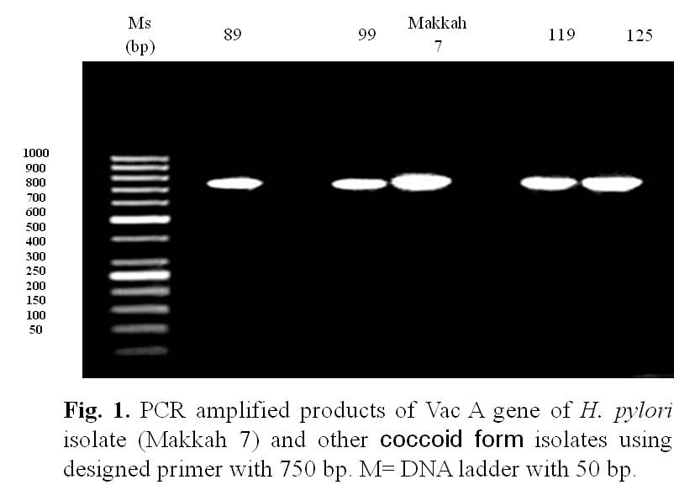

The 750 bp fragment of Vac A gene of H. pylori strain Makkah 7 was delivered to GenBank/NCBI database according to the expected size of the designed primer pair and to the appearance on the agarose gel electrophoresis (Fig. 1). However, the size of the fragment was finally reduced by the GenBank and submitted as 599 bp. This reduction in fragment size normally occurs when extraction of the fragments is from genomic DNA and not from sub-cloning experiment.
A 599 bp nucleotide sequence of the partial Vac A gene from isolate Makkah 7 (HQ622108) was aligned and compared in the GenBank using the BLAST search. A total of 87 Vac A gene partial sequences from different accessions of H. pylori included different isolates and strains were identified (Table 1). Sequence Blast alignment showed that the homology of Vac A coccoid isolate (HQ622108) and the reported accession sequences was 85 to 95% maximum.
Sequence alignments of the Vac A gene of
isolate Makkah-7 (HQ622108) compared with H. pylori GenBank strains and isolates revealed positional differences in nucleotide sequences and base-pair substitutions between the isolate and several isolates and strains (Fig. 2).
The accession HQ622108 with a fragment size 599 bp (isolate Makkah-7) revealed a total number of 235 nucleotide positional differences with base-pair substitutions. The highest number (29) with
positional differences with base-pair substitutions was obtained from Guanine (G) that changed to (A) and from Adenine (A) to Thymine (T), followed by Thymine (T) to Adenine (A) with 27 positional differences. In contrary, the lowest number with 7 positional differences was detected in Guanine (G) that changed to cytosine (C), followed by 11 from (C) to (G) and (T) to (G).
The alignment sequence of 599 bp was divided into parts according to the starting number of nucleotides and each part included 100 bp. The highest number of positional differences (45) was from 3200 to 3300, followed by the range from 3001 to 3100 with 43, then by the range from 2900 to 3000 with 42 positional differences. In the first part with a range of 2800 to 2900, Guanine (G) was changed in adenine (A) in 7 positional differences, followed by (A) changed to (G) and (T) to (A) in 6 positional differences. Adenine (A) was changed to cytosine (C) and (G) changed to (A) in 6 positional differences as shown in Table (2).

Table 1. Blast search of VacA gene sequence identity between the H. pylori isolate (Makkah-7) and

GenBank sequences.

Accession | Strain | % |  | Accession | Strain | % |  | Accession | Strain | % |  | Accession | Strain | %
AB190966 | F92 | 93 |  | AF049649 | F69 | 89 |  | AF195018 | 1939 | 85 |  | AY663830 | 249a3 | 93
AB190965 | F80 | 93 |  | AF049629 | F47 | 89 |  | AF195017 | 184 | 93
AJ418360 | NQ1701 | 93 |  | AF049626 | F42 | 89 |  | AF195010 | 55 | 89 |  | CP002076 | Cuz20 | 91
AB190973 | OK130 | 90 |  | AF049647 | F64 | 90 |  |  |  |  |  | CP002073 | SJM180 | 93
AB190964 | F32 | 89 |  | AF049624 | F34 | 90 |  | AF361702 | CHN5038c | 90 |  | CP002071 | Sat464 | 92
AB190958 | F13 | 89 |  | AF049631 | F52 | 90 |  | AF361701 | CHN4611a | 89
AB190961 | F17 | 89 |  | AF049648 | F68 | 92 |  | AF361700 | CHN3554a | 89 |  | GQ331981 | DL2 | 89
AB190969 | OK109 | 89 |  | AF049641 | F33 | 92 |  |  |  |  |  | GQ331982 | L7 | 90
AB190968 | OK107 | 90 |  | AF049646 | F62 | 92 |  | AJ418362 | LSU1014-6 | 86 |  | GQ331976 | PG227 | 89
AB190986 | OK204 | 90 |  | AF049619 | F20 | 92 |  | AJ418361 | LSU1014-1 | 86 |  | GQ331983 | L8 | 90
AB190975 | OK144 | 90 |  | AF049620 | F21 | 90 |  | AJ418358 | NQ1624 | 94 |  | GQ331977 | MZ1 | 89
AB190983 | OK185 | 90 |  | AF049621 | F28 | 89 |  | AJ438933 | HP-HJM 24 | 93 |  | GQ331984 | L1 | 90
AB190980 | OK179 | 91 |  | AF049634 | F57 | 90 |  | AJ438923 | HP-HJM 14 | 93 |  | GQ331974 | PG218 | 90
AB190979 | OK160 | 90 |  | AF049639 | F87 | 89 |  |  |  |  |  | GQ331980 | DL1 | 85
AB190974 | OK139 | 90 |  | AF049627 | F44 | 89 |  | AJ438930 | HP-HJM 21 | 92
AB190981 | OK180 | 88 |  | AF049632 | F55 | 89 |  | AJ438921 | HP-HJM 12 | 92 |  | FM991728 | B38 | 93
AB190982 | OK181 | 88 |  | AF049637 | F67 | 95 |  | AJ438926 | HP-HJM 17 | 86 |  | FN598874 | B8 | 95
AB190962 | F18 | 90 |  | AF049645 | F61 | 89
AB190960 | F16 | 90 |  |  |  |  |  | AE001439 | J99 | 91 |  | HM047646 | K47 | 92
AB190977 | OK158 | 90 |  | AF071095 | F37 | 93
AB190972 | OK129 | 90 |  | AF071096 | F71 | 90 |  | AM997176 | G27 | 85 |  | U95971 | 95-54 (J128) | 93
AB190988 | OK210 | 90 |  |  |  |  |  |  |  |  |  | U07145 | NCTC 11638 | 93
AB190987 | OK205 | 91 |  | AF191641 | AFN1156 | 92 |  | AY232454 | Iran Hel-155 | 90
AB190984 | OK187 | 93 |  | AF191642 | AFN4124 | 92
AB190976 | OK155 | 93 |  |  |  |  |  | AY848858 | MDC1 | 94
 |  |  |  | AF191645 | AFNG114 | 92 |  | AY663831 | 249a5 | 93
AF049622 | F29 | 85 |  | AF191643 | AFN4769 | 92 |  | AY765346 | MV008-P | 95

3.3.Phylogenetic analysis of VacA gene of Makkah-7
The phylogenetic tree represented the relationship between coccoid form H. pylori isolate (HQ622108) and all described H. pylori related strains obtained from GenBank based on the VacA gene as shown in Fig. (3). The dendrogram divided all GenBank strains into two clusters; one contained the H. pylori isolate (HQ622108) and the second cluster comprised all GenBank strains. The Makkah-7 isolate formed a phylogenetically distinct cluster separate from all other species.
3.4.Polymorphisms in vacuolating cytotoxin A domain
Translation of the 599-nucleotide long of the
VacA sequence induced a putative signal polypeptide of 199 amino acids with a molecular weight of about 140 kDa and 8.79. iso-electric point. of An amino acid sequence comparison using BLASTP (http://www.ncbi.nlm.nih.gov/BLAST) revealed that the predicted protein is a vacuolating cytotoxin A (VacA) putative conserved domain as shown in Table (3). Moreover, amino acids alignment of vacuolating cytotoxin A of isolate Makkah 7 (ADU05468) compared with 100 obtained GenBank H. pylori strains and isolates revealed mutations in different positions (Table 4 and Fig. 4).

Table 2. Positional differences and base pair substitutions in nucleotide sequences between Makkah-7 H. pylori isolate and numerous strains based on VacA gene similarity.

Exist in Makkah-7 as: | Nucleotide  sequence range | A | A | A | C | C | C | G | G | G | T | T | T
Changed in NCBI to: | Nucleotide  sequence range | C | G | T | A | G | T | A | T | C | A | C | G
Changes in nucleotide  positions: | 2800-2900 | 2863 | 2808 | 2828 | 2815 | 2802 | 2804 | 2811 | 2829 |  | 2816 | 2810 | 2825
Changes in nucleotide  positions: | 2800-2900 | 2900 | 2809 | 2849 | 2845 |  |  | 2820 | 2858 |  | 2817 | 2831 | 2853
Changes in nucleotide  positions: | 2800-2900 |  | 2846 |  | 2848 |  |  | 2842 |  |  | 2836 | 2832 | 2862
Changes in nucleotide  positions: | 2800-2900 |  | 2861 |  | 2895 |  |  | 2868 |  |  | 2837 | 2850 | 2879
Changes in nucleotide  positions: | 2800-2900 |  | 2867 |  |  |  |  | 2871 |  |  | 2859 | 2890 | 2891
Changes in nucleotide  positions: | 2800-2900 |  | 2892 |  |  |  |  | 2872 |  |  | 2874
Changes in nucleotide  positions: | 2800-2900 |  |  |  |  |  |  | 2887
Changes in nucleotide  positions: | T=41 | 2 | 6 | 2 | 4 | 1 | 1 | 7 | 2 | 0 | 6 | 5 | 5
Changes in nucleotide  positions: | 2900-3000 | 2932 | 2923 | 2933 | 2906 |  | 2939 | 2901 | 2918 | 2915 | 2982 | 2924 | 2952
Changes in nucleotide  positions: | 2900-3000 | 2959 | 2990 | 2972 | 2929 |  | 2957 | 2917 | 2919 | 2938 | 2985 | 2927
Changes in nucleotide  positions: | 2900-3000 | 2960 |  | 2997 | 2936 |  |  | 2928 | 2920 |  | 2986 | 2974
Changes in nucleotide  positions: | 2900-3000 | 2978 |  | 2998 | 2955 |  |  | 2965 | 2967 |  | 2988 | 2980
Changes in nucleotide  positions: | 2900-3000 | 2982 |  |  | 2963 |  |  | 2969 |  |  | 2989 | 2983
Changes in nucleotide  positions: | 2900-3000 | 2994 |  |  |  |  |  | 2979
Changes in nucleotide  positions: | T=42 | 6 | 2 | 4 | 5 | 0 | 2 | 6 | 4 | 2 | 5 | 5 | 1
Changes in nucleotide  positions: | 3000-3100 | 3028 |  | 3030 | 3003 | 3024 | 3002 | 3015 | 3013 | 3008 | 3007 | 3051 | 3063
Changes in nucleotide  positions: | 3000-3100 | 3034 |  | 3047 | 3059 | 3060 | 3011 | 3042 | 3031 | 3010 | 3022 | 3072 | 3064
Changes in nucleotide  positions: | 3000-3100 | 3039 |  | 3067 |  | 3084 | 3026 | 3055 | 3035 | 3012 | 3069 | 3086
Changes in nucleotide  positions: | 3000-3100 | 3075 |  | 3082 |  |  | 3029 | 3073 | 3065 | 3046 | 3070
Changes in nucleotide  positions: | 3000-3100 |  |  |  |  |  | 3061 | 3076 |  |  | 3079
Changes in nucleotide  positions: | 3000-3100 |  |  |  |  |  | 3080 | 3087
Changes in nucleotide  positions: | T=43 | 4 | 0 | 4 | 2 | 3 | 6 | 6 | 4 | 4 | 5 | 3 | 2
Changes in nucleotide  positions: | 3100-3200 | 3116 | 3118 | 3103 | 3145 |  | 3183 |  | 3108 |  |  | 3117
Changes in nucleotide  positions: | 3100-3200 | 3156 | 3147 | 3149 | 3195 |  | 3184 |  | 3109 |  |  | 3198
Changes in nucleotide  positions: | 3100-3200 |  | 3162 | 3151 |  |  | 3191 |  | 3120
Changes in nucleotide  positions: | 3100-3200 |  | 3192 | 3152 |  |  | 3199
Changes in nucleotide  positions: | 3100-3200 |  |  | 3172
Changes in nucleotide  positions: | 3100-3200 |  |  | 3178
Changes in nucleotide  positions: | 3100-3200 |  |  | 3179
Changes in nucleotide  positions: | 3100-3200 |  |  | 3187
Changes in nucleotide  positions: | T=25 | 2 | 4 | 8 | 2 | 0 | 4 | 0 | 3 | 0 | 0 | 2 | 0
Changes in nucleotide  positions: | 3200-3300 | 3214 | 3270 | 3233 | 3218 | 3217 | 3209 | 3201 | 3226 | 3274 | 3252 | 3205 | 3204
Changes in nucleotide  positions: | 3200-3300 | 3215 |  | 3245 | 3273 | 3238 | 3227 | 3206 | 3230 |  | 3260 | 3251 | 3240
Changes in nucleotide  positions: | 3200-3300 | 3220 |  |  | 3284 | 3294 | 3234 | 3244 |  |  | 3265 | 3272
Changes in nucleotide  positions: | 3200-3300 | 3239 |  |  | 3289 |  | 3266 | 3286 |  |  | 3279 | 3278
Changes in nucleotide  positions: | 3200-3300 | 3241 |  |  |  |  | 3300 |  |  |  | 3285 | 3280
Changes in nucleotide  positions: | 3200-3300 | 3287 |  |  |  |  |  |  |  |  | 3291 | 3290
Changes in nucleotide  positions: | 3200-3300 | 3295 |  |  |  |  |  |  |  |  | 3293
Changes in nucleotide  positions: | 3200-3300 | 3296
Changes in nucleotide  positions: | T=45 | 8 | 1 | 2 | 4 | 3 | 5 | 4 | 2 | 1 | 7 | 6 | 2
Changes in nucleotide  positions: | 3300-3400 | 3346 | 3303 | 3301 | 3343 | 3305 | 3337 | 3307 |  |  | 3323 | 3317 | 3364
Changes in nucleotide  positions: | 3300-3400 | 3377 | 3311 | 3341 |  | 3332 | 3330 | 3310 |  |  | 3356 | 3371
Changes in nucleotide  positions: | 3300-3400 |  | 3369 | 3354 |  | 3338 | 3331 | 3312 |  |  | 3372 | 3379
Changes in nucleotide  positions: | 3300-3400 |  |  | 3365 |  | 3345 | 3344 | 3333 |  |  | 3395
Changes in nucleotide  positions: | 3300-3400 |  |  | 3367 |  |  | 3349 | 3357
Changes in nucleotide  positions: | 3300-3400 |  |  | 3370 |  |  | 3366 | 3394
Changes in nucleotide  positions: | 3300-3400 |  |  | 3376
Changes in nucleotide  positions: | 3300-3400 |  |  | 3380
Changes in nucleotide  positions: | 3300-3400 |  |  | 3399
Changes in nucleotide  positions: | T=39 | 2 | 3 | 9 | 1 | 4 | 6 | 6 | 0 | 0 | 4 | 3 | 1
Changes in nucleotide  positions: | Total=235 | 24 | 16 | 29 | 18 | 11 | 24 | 29 | 15 | 7 | 27 | 24 | 11

Fig. 2. Sequence alignment of 599 bp of VacA gene in H. pylori isolate (Makkah-7) compared with other isolates and strains existed in NCBI GenBank. Conserved nucleotides between my isolates and other sequences are boxed in black. Putative conserved between the different isolates with no identity with isolates are boxed in grey. The yellow box referred to the identity of all accessions except my isolates. Dashes correspond to gaps introduced to optimize the alignments

 | 2801 2900
Makkah7 | GCCCATCAAT GATCCTTGCG TGGGTAGAAA TTCTGTTAAT TGCACATCAT TTTTAGGGTA ATTATGAGAA GGTACAGGTA TCATTAGAAT GACTCACAAA
AB190976 | GGCTATCGGC AATCAAAGCA TGGTGAATAA CCCTGAAAAT TACAAGTATC TTGTAGGTAA GGCATGGAAA AATACAGGGA TCAATAAAAC GGCTAACAAC
AB190979 | GGCTATCGGC AATCAAAGCA TGGTGAATAA CCCTGAAAAT TACAAGTATC TTGAAGGTAA GGCATGGAAA AATACAGGGA TCAATAAAAC GGCTAACAAC
AF191641 | GGCTATTGGC AATCAAAGCA TGGTGAATAA CCCTGAAAGT TACAAATATC TTGAAGGTAA GGCATGGAAA AACACAGGGA TCAATAAAAC GGCTAACAAC
GQ331980 | GGCTATCGGC AATCAAAGCA TGGTGAATAA CCCTGACAAT TACAAGTATC TTATCGGTAA GGCATGGAAA AATATAGGGA TCAGCAAAAC GGCTAACAGC
AF361700 | GGCTATCGGC GATCAAGCCA TGGTGAATAA CCCTGAAAAT TACAAGTATC TTATTGGTAA GGCATGGAAA AATATAGGCA TCAGTAAAAC GGCTAATGGC
AY663831 | GGCTATCGGC AATCAAAGCA TGGTGAATAA CCCTGACAGC TACAAGTATC TTGAAGGTAA GGCATGGAAA AATACAGGGA TCAATAAAAC GGCTAACAAC
AY663830 | GGCTATCGGC AATCAAAGCA TGGTGAATAA CCCTGACAGC TACAAGTATC TTGAAGGTAA GGCATGGAAA AATACAGGGA TCAATAAAAC GGCTAACAAC
AF195018 | GGCTATCGGC AATCAAAGCA TGGTGAATAA CCCTGAAAAT TACAAGTATC TTGAAGGTAA GGCATGGAAA AATACAGGGA TTAATAAAAC GGCTAACAAC
AF195010 | GGCTATCGGC AATCAAAGCA TGGTGAATAA CCCTGAAAGT TACAAGTATC TTGTAGGTAA GGCATGGAAA AATACAGGAA TTAGTAAAAC GGCTGACAAC
AF195017 | GGCTATCGGC GATCAAGCCA TGGTGAATAA CCCTGACAAT TACAAGTATC TTATTGGTAA GGCATGGAAA AATATAGGGA TCAGCAAAAC GGCTAATGGC
AY232454 | GGCTATCGGC AATCAAAGCA TGGTGAATAA CCCTGACAAT TACAAATATC TTATCGGTAA GGCATGGAAA AATATAGGGA TCAGCAAAAC GGCTAACGGC
 | 2901 3000
Makkah7 | GCCACCATCG CTGTGAGGGG TGATAATGCT TAAGCCCGCA CTGAGAATGG TGGCCACAAA TCCAATGTGC CAATATTAGT CTTTTTATTA GCGAGTAATG
AB190976 | ACCACAATCG CTGTCAATTT TGGCAACAAT TCTGCACCTA CTGAGAATGG TGGCAATACC ACAAATTTAC CTACAAACAC CACTAACAAG GCGCGTTTTG
AB190979 | ACCACAATCG CTGTTAACTT TGGCAACAAT TCTGCACCTA CTGAGAATGG TGGCAATACC ACAAATTTAC CTACAAACAC CACTAACAAG GCGCGTTTTG
AF191641 | ACCACAATCG CTGTTAATTT TGGCAATAAT TCTACGCCTA CTAGTTCTGA GAGCAATACC ACCAACTTAC CCACCAACAC CACCAATAAC GCGCGTTTCG
GQ331980 | TCTAAAATTT CGGTGCATTA TTTAGGCAAT TCTACGCCTA CTGAGAATGG TGGCAATACC ACAAATTTAC CTACAAACAC CACTAACAAT GCGCGTTCTG
AF361700 | TCTAAAATCT CTGTGCGTTA TTTAGGCAAT GCTACACCTG CTGAGAATGG TGGCAATACC ACAAATTTAC CCACAAACAC CACTAACAAC GCGCGTTTCG
AY663831 | ACCACAATCG CTGTTAATTT TGGCAACAAT TCTGCACCTA CTGAGAATGG TGGCAATACC ACAGATTTAC CCACCAACAC CACTAACAAC GCGCGTTTCG
AY663830 | ACCACAATCG CTGTTAATTT TGGCAACAAT TCTGCACCTA CTGAGAATGG TGGCAATACC ACAGATTTAC CCACCAACAC CACTAACAAC GCGCGTTTCG
AF195018 | ACCACAATCG CTGTTAATGT TGGCAATAAT TCTGCACCTA CTGAGAATGA TGGCAATACC ACAAATTTAC CCACAAACAC CACTAACAAT GCGCGTTTCG
AF195010 | ACCACAATCG CTGTTAATGT TGGCAACAAT TCTACGCCTA CTAGTTCTGA AAGCAATACC ACAAACTTAC CCACAAACAC CACTAACAAC GCGCGTTTCG
AF195017 | TCTAAAATCT CTGTGCGTTA TTTAGGTAAT GCTACACCTG CTGAGAATGG TGACAATACC ACAAATTTAC CCACAAACGC CACTAAAAAT GCGCGTTTCG
AY232454 | TCTAAAATTT CGGTGCATTA TTTAGGCAAT TCTACGCCTA CTGAGAAGGG TGGCAATACC ACAGATTTAC CCACCAACAC CACTAACAAT GCGCGTTCTG
 | 3001 3100
Makkah7 | CCCGCTTGAG CGGCGTAAAG ATCCCCCACA GCGAGCATTA TGGCGGAAAT TCTAGTTTCC CCTTGAACTT TTGAAGTGTC TATCGTGCCA TTGAAAGCGT
AB190976 | CTAGCTACGC TCTCATAAAG AACGCTCCTT TCGCTCGTTA TAGCGCTACT CCTAATTTAG TCGCTATCAA TCAGCATGAT TTTGGCACCA TTGAAAGCGT
AB190979 | CTAGCTACGC TCTCATAAAG AACGCTCCTT TCGCTCATTA TAGCGCTACT CCTAATTTAG TCGCTATCAA TCAGCATGAT TTTGGCACCA TTGAAAGCGT
AF191641 | CTAGCTACGC CCTCATAAAG AACGCTCCTT TCGCTCATTA CAGCGCCACT CCTAATTTAG TCGCTATCAA TCAGCATGAT TTTGGCACCA TTGAGAGCGT
GQ331980 | CCAACAACGC CCTTGCGCAA AACGCTCCTT TCGCTCAACC TAGCGCCACT CCTAATTTAG TCGCTATCAA TCAGCATGAT TTTGGCACCA TTGAAAGCGT
AF361700 | CTCGCTACGC TCTCATAAAG AACGCTCCTT TCGCTCATTA TAGCGCCACT CCTAATTTAG TCGCTATCAA TAAGCATAAC TTTGGCACCA TTGAAAGCGT
AY663831 | CTAGCTACGC TCTCATAAAG AACGCTCCTT TCGCGCATTA TAGCGCCACT CCTAATTTAG TCGCTATCAA TCAGCATGAT TTTGGCACCA TTGAAAGCGT
AY663830 | CTAGCTACGC TCTCATAAAG AACGCTCCTT TCGCGCATTA TAGCGCCACT CCTAATTTAG TCGCTATCAA TCAGCATGAT TTTGGCACCA TTGAAAGCGT
AF195018 | CTCGCTACGC TCTCATAAAG AACGCTCCTT TCGCGCATTA TAGCGCCACT CCTAATTTAG TCGCTATCAA TCAGCATGAT TTTGGCACCA TTGAAAGCGT
AF195010 | CTCGCTACGC TCTCATAAAG AACGCTCCTT TCGCGCATTA TAGCGCCACT CCTAATTTAG TCGCTATCAA TCAGCATGAT TTTGGCACCA TTGAAAGCGT
AF195017 | CTCGCTATGC ACTCATAAAG AACGTTCCTT TCGCGCATTA TAGCGCCACT CCTAATTTAG TCGCTATCAA TCAGCATGAT TTTGGCACCA TTGAAAGCGT
AY232454 | CCAACAACGC CCTTGCACAA AACGCTCCTT TCGCGCATTA TAGCGCCACT CCTAATTTAG TCGCTATCAA TCAGCATGAT TTTGGCACCA TTGAAAGCGT

Continue (Fig. 2)
 | 3101 3200
Makkah7 | GTATGAAGGG GCTAAATACG CTAGTGATAT TGACCCACAT ATTGCAAACT CAGGCGGCCC ATCCAGGGAT CACTTACTTA CCCCATAGAT CAATCGCTCT
AB190976 | GTTTGAATTG GCTAACCGCT CTAGTGATAT TGACACGCTT TATGCCAACT CAGGCGGCAC AGGCAGGGAT CTCTTACAAA CCTTATTGAT TGATAGCCAT
AB190979 | GTTTGAATTG GCTAACCGCT CTAGTGATAT TGACACGCTT TATGCCAACT CAGGCGGCAC AGGCAGGGAT CTCTTACAAA CCTTATTGAT TGATAGCCAT
AF191641 | GTTTGAATTG GCTGATCGCT CTAAGGATAT TGACACGCTT TATACTCATT CAGGCGTGCA AGGCAGGGAT CTCTTGCAAA CCTTATTGAT TGATAGCCAT
GQ331980 | GTTTGAATTG GCTAACCGCT CTAGTGATAT TGACACGCTT TATGCTAACT CAGGCGCTCA AGGCAGGGAT CTCTTACAAA CCTTATTGAT TGATAGCCAT
AF361700 | GTTTGAATTG GCTAACCGCT CTGAGGATAT TGACACGCTT TATGCTCACT CAGGCGCGCA AGGCAGGGAT CTCTTACAAA CCTTATTGAT TGATAGCCAT
AY663831 | GTTTGAATTG GCTGATCGCT CTAAAGATAT TGACACGCTT TATACTCATT CAGGCGCGCA AGGCAGGGAT CTCTTACAAA CCTTATTGAT TGATAGCCAT
AY663830 | GTTTGAATTG GCTGATCGCT CTAAAGATAT TGACACGCTT TATACTCATT CAGGCGCGCA AGGCAGGGAT CTCTTACAAA CCTTATTGAT TGATAGCCAT
AF195018 | GTTTGAATTG GCTGATCGCT CTAAAGATAT TGACACGCTT TATACTCATT CAGGCGCGCA AGGCAGGGAT CTCTTACAAA CCTTATTGAT TGATAGCCAT
AF195010 | GTTTGAATTG GCTGATCGCT CTAAAGATAT TGACACGCTT TATACTCATT CAGGCGCGCA AGGCAGGGAT CTCTTACAAA CCTTATTGAT TGATAGCCAT
AF195017 | GTTTGAATTG GCTGATCGCT CTAAAGATAT TGACACGCTT TATACTCATT CAGGCGCGCA AGGCAGGGAT CTCTTACAAA CCTTATTGAT TGATAGCCAT
AY232454 | GTTTGAATTG GCTGATCGCT CTAAAGATAT TGACACGCTT TATACTCATT CAGGCGCGCA AGGCAGGGAT CTCTTACAAA CCTTATTGAT TGATAGCCAT
 | 3201 3300
Makkah7 | GATTTGAGCT ATGAAACCAA AATGAGCGAG GCACCAACAT AAAGAGAAAT TACCAAGCAT TTGATCACGA CTCGTGATTT TTTCTGAACT TTTCAAAGTC
AB190976 | AATGCGGGTT ATGCCAGAAC AATGATTGAT GCTACAAGCG CTAATGAAAT CACCAAGCAA TTGAATACGG CCACTACCAC TTTAAACAAC ATAGCCAGTT
AB190979 | AATGCGGGTT ATGCCAGAAC AATGATTGAT GCTACAAGCG CTAATGAAAT CACCAAGCAA TTGAATACGG CCACTACCAC TTTAAACAAC ATAGCCAGTT
AF191641 | GATGCGGGTT ATGCCAGAAC CATGATTGAC GCTACAAATA CGAGTGAGAT CGCTCAAAGC TTGAATGCGG CCACTGACGC TTTAAACAAC GTAGCCAGTT
GQ331980 | GATGCGGGTT ATGCCAGAAC CATGATTGAT GCGACAAGCG CTAATGAAAT CACCAAGCAA TTGAATACGG CCACTACCAC TTTAAACAAC ATAGCCAGTT
AF361700 | AATGCAGGTT ATGCCAGAAC AATGATTGAT GCTACAAGCG CTAATGAAAT CACCAAGCAA TTGAATACGG CCACTGACGC TTTAAACAAC ATAGCCAGTT
AY663831 | AATGCAGGTT ATGCCAGAAC AATGATTGAT GCTACAAGCG CTAATGAAAT CACCAAGCAA TTGAATACGG CCACTGACGC TTTAAACAAC ATAGCCAGTT
AY663830 | AATGCAGGTT ATGCCAGAAC AATGATTGAT GCTACAAGCG CTAATGAAAT CACCAAGCAA TTGAATACGG CCACTGACGC TTTAAACAAC ATAGCCAGTT
AF195018 | AATGCAGGTT ATGCCAGAAC AATGATTGAT GCTACAAGCG CTAATGAAAT CACCAAGCAA TTGAATACGG CCACTGACGC TTTAAACAAC ATAGCCAGTT
AF195010 | AATGCAGGTT ATGCCAGAAC AATGATTGAT GCTACAAGCG CTAATGAAAT CACCAAGCAA TTGAATACGG CCACTGACGC TTTAAACAAC ATAGCCAGTT
AF195017 | AATGCAGGTT ATGCCAGAAC AATGATTGAT GCTACAAGCG CTAATGAAAT CACCAAGCAA TTGAATACGG CCACTGACGC TTTAAACAAC ATAGCCAGTT
AY232454 | AATGCAGGTT ATGCCAGAAC AATGATTGAT GCTACAAGCG CTAATGAAAT CACCAAGCAA TTGAATACGG CCACTGACGC TTTAAACAAC ATAGCCAGTT
 | 3301 3400
Makkah7 | AAAACCGTAG AGCAAGTGGC TTTCAAACTC CCGGCTCCAG AACCCACACG ATTATTGATT CTCTACAAAA TTATCAATTA AGATAGGCAC AGCGTCAAAA
AB190976 | TAGAGCATAA GACAAGCGGC TTACAAACTT TGAGTTTGAG TAATGCGATG ATTTTAAATT CTCGTTTAGT CAATCTCTCT AGA-AGGCAC AGCAACCATA
AB190979 | TAGAGCATAA GACAAGCGGC TTACAAACTT TGAGTTTGAG CAATGCGATG ATTTTAAATT CTCGTTTAGT CAATCTCTCT AGA-AGGCAC AGCAACCATA
AF191641 | TAGAGCATAA AACCAGCGGC TTACAAACTT TGAGCTTGAG CAATGCGATG ATTTTAAATT CTCGTTTAGT CAATCTCTCC AGG-AAGCAC AGCAACCATA
GQ331980 | TAGAGCATAA GACAAGCGGC TTACAAACTT TGAGCTTGAG TAATGCGATG ATTTTAAATT CTCGTTTAGT CAATCTCTCC AGG-AGGCAC AGCAACCATA
AF361700 | TGGAGCATAA GACAAGTGGC TTACAAACTT TGAGCTTGAG CAATGCGATG ATTTTAAATT CTCGTTTAGT CAATCTCTCC AGA-AGGCAC AGCAACAATA
AY663831 | TGGAGCATAA GACAAGTGGC TTACAAACTT TGAGCTTGAG CAATGCGATG ATTTTAAATT CTCGTTTAGT CAATCTCTCC AGA-AGGCAC AGCAACAATA
AY663830 | TGGAGCATAA GACAAGTGGC TTACAAACTT TGAGCTTGAG CAATGCGATG ATTTTAAATT CTCGTTTAGT CAATCTCTCC AGA-AGGCAC AGCAACAATA
AF195018 | TGGAGCATAA GACAAGTGGC TTACAAACTT TGAGCTTGAG CAATGCGATG ATTTTAAATT CTCGTTTAGT CAATCTCTCC AGA-AGGCAC AGCAACAATA
AF195010 | TGGAGCATAA GACAAGTGGC TTACAAACTT TGAGCTTGAG CAATGCGATG ATTTTAAATT CTCGTTTAGT CAATCTCTCC AGA-AGGCAC AGCAACAATA
AF195017 | TGGAGCATAA GACAAGTGGC TTACAAACTT TGAGCTTGAG CAATGCGATG ATTTTAAATT CTCGTTTAGT CAATCTCTCC AGA-AGGCAC AGCAACAATA
AY232454 | TGGAGCATAA GACAAGTGGC TTACAAACTT TGAGCTTGAG CAATGCGATG ATTTTAAATT CTCGTTTAGT CAATCTCTCC AGA-AGGCAC AGCAACAATA

Continue (Fig. 2)

 | 3401 3500
Makkah7 | TTCACTCGTT CGTGGTGCGG TTAGCCCACC TA
AB190976 | TTGACTCGTT CGCTCAACGC TTA-CAAGCT TTAAAAGGCC AAAGATTCGC TTCTTTAGAA AGCGCGGCAG AAGTGTTGTA TCAATTTGCC CCCAAATATG
AB190979 | TTGACTCGTT CGCTCAACGC TTA-CAAGCT TTAAAAGGCC AAAGATTCGC TTCTTTAGAA AGCGCGGCAG AAGTGTTGTA TCAATTTGCC CCCAAATATG
AF191641 | TTAACTCGTT CGCTCAACGC TTA-CAAGCT TTAAAAGGCC AAAGATTCGC TTCCTTAGAG AGCGCGGCAG AAGTGTTGTA TCAATTCGCC CCTAAATATG
GQ331980 | TTGACTCGTT CGCTAAGCGC TTA-CAAGCT TTAAAAGATC AAAGATTCGC TTCTTTAGAA AGCGCGGCAG AAGTGTTGTA TCAATTTGCC CCTAAATATG
AF361700 | TTGACTCATT CGCCAGACGC TTG-CAAGCT TTAAAAGACC AAAGATTCGC TTCTTTAGAA AGCGCAGCAG AAGTGTTGTA TCAATTTGCC CCTAAATATG
AY663831 | TTGACTCATT CGCCAGACGC TTG-CAAGCT TTAAAAGACC AAAGATTCGC TTCTTTAGAA AGCGCAGCAG AAGTGTTGTA TCAATTTGCC CCTAAATATG
AY663830 | TTGACTCATT CGCCAGACGC TTG-CAAGCT TTAAAAGACC AAAGATTCGC TTCTTTAGAA AGCGCAGCAG AAGTGTTGTA TCAATTTGCC CCTAAATATG
AF195018 | TTGACTCATT CGCCAGACGC TTG-CAAGCT TTAAAAGACC AAAGATTCGC TTCTTTAGAA AGCGCAGCAG AAGTGTTGTA TCAATTTGCC CCTAAATATG
AF195010 | TTGACTCATT CGCCAGACGC TTG-CAAGCT TTAAAAGACC AAAGATTCGC TTCTTTAGAA AGCGCAGCAG AAGTGTTGTA TCAATTTGCC CCTAAATATG
AF195017 | TTGACTCATT CGCCAGACGC TTG-CAAGCT TTAAAAGACC AAAGATTCGC TTCTTTAGAA AGCGCAGCAG AAGTGTTGTA TCAATTTGCC CCTAAATATG
AY232454 | TTGACTCATT CGCCAGACGC TTG-CAAGCT TTAAAAGACC AAAGATTCGC TTCTTTAGAA AGCGCAGCAG AAGTGTTGTA TCAATTTGCC CCTAAATATG

Table 3. Vaculating cytotoxin A (VacA) putative conserved domains of Makkah-7 H. pylori isolate.

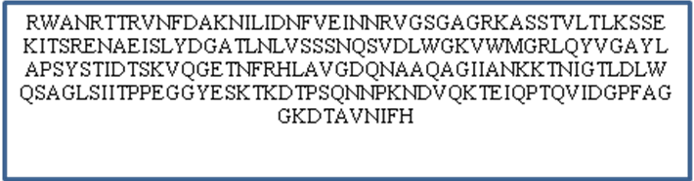

Fig. 3. Phylogenetic relationships between coccoid form H. pylori isolate (Makkah-7) and other GenBank related strains based on VacA gene.

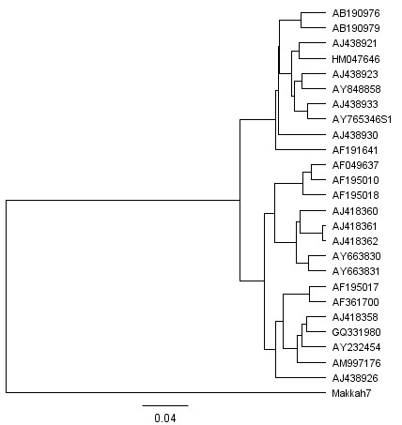

Table 4. BLASTP search of vacuolating cytotoxin A putative domains of Makkah-7 H. pylori isolate (ADU05468) and GenBank protein sequences.

AAC77451 |  | AAK56858 |  | ADH10184 |  | BAD51795 |  | CAD27667
 |  | AAK56860 |  | ADH10179 |  | BAD51773 |  | CAD27674
AAG28443 |  | AAK56857 |  | ADH10176 |  | BAD51781 |  | CAD27690
 |  | AAK56856 |  | ADH10182 |  | BAD51774 |  | CAD27669
AAD04264 |  |  |  | ADH10178 |  | BAD51770 |  | CAD27678
AAD04268 |  | AAF26509 |  | ADH10183 |  | BAD51786 |  | CAD27688
AAD04270 |  | AAF26502 |  |  |  | BAD51784 |  | CAD27685
AAD04269 |  | AAF26510 |  | ADO04098 |  | BAD51780 |  | CAD27676
AAD04277 |  | AAF26501 |  | ADO05607 |  | BAD51772
AAD04280 |  | AAF26508 |  |  |  | BAD51789 |  | NP_223537
AAD04285 |  | AAF86763 |  | ADP02391 |  | BAD51778
AAD04275 |  |  |  | ADP02390 |  | BAD51785 |  | Q48247
AAD04266 |  | AAL83504 |  |  |  | BAD51797 |  | Q48253
AAD04283 |  | AAL83503 |  | ADU80120 |  | BAJ56545
AAD04262 |  |  |  | ADU81729 |  | BAD51796 |  | ZP_03438412
AAD04265 |  | AAX49347 |  | ADU41215 |  | BAD51793 |  | ZP_03239901
AAD04272 |  |  |  | ADU83300 |  | BAD51792 |  | ZP_03440112
AAD04288 |  | ACX98036 |  | ADU05468 |  | BAD51794
AAD04279 |  |  |  |  |  | BAD51790 |  | YP_003057599
AAD04289 |  | ADK63280 |  | BAJ59976 |  | BAD51791 |  | YP_001910400
AAD04281 |  | ADK63300 |  |  |  | BAD51783 |  | YP_002266461
AAD04276 |  | ADK63323 |  | BAD51798 |  | BAD51777
AAD04261 |  |  |  | BAD51768 |  | BAD51771
AAD04267 |  | ADI34974 |  | BAD51782 |  | BAD51779

Fig. 4. Sequence alignment of vacuolating cytotoxin A putative domain in Makkah-7 isolate (ADU05468) compared with other isolates and strains in NCBI GenBank.

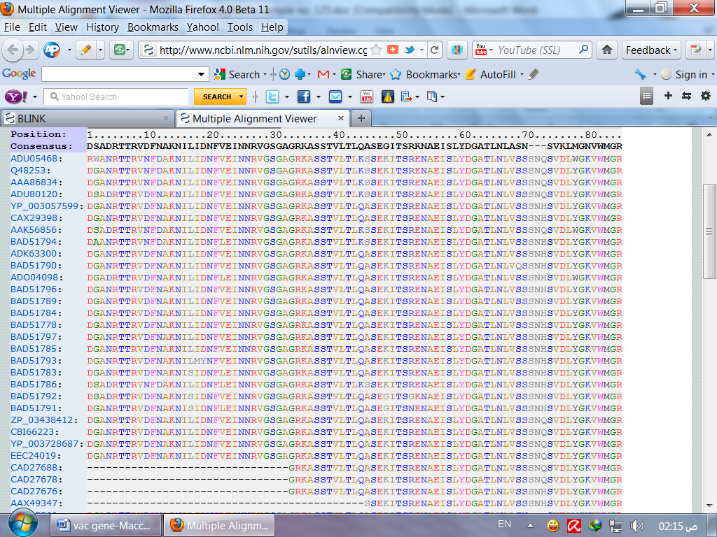

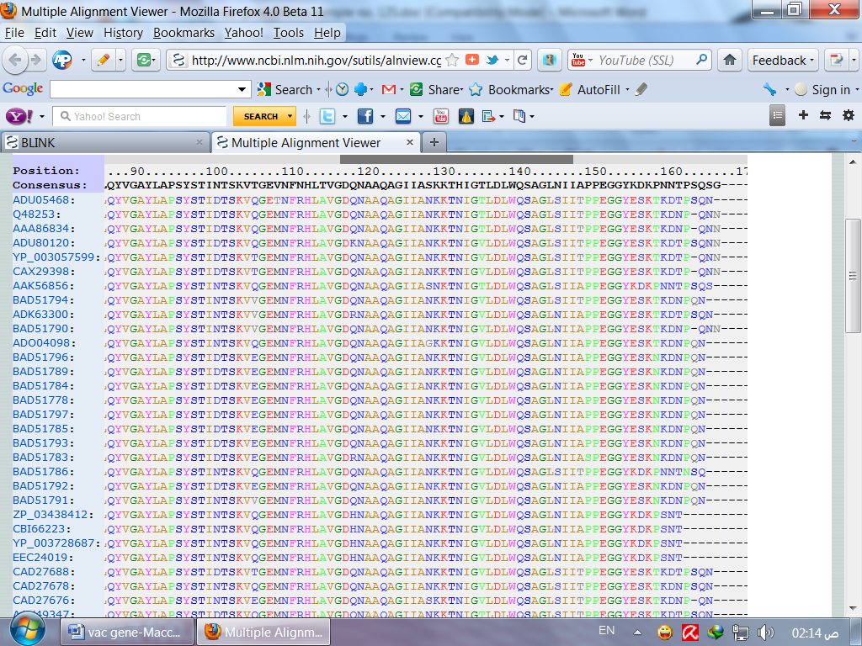

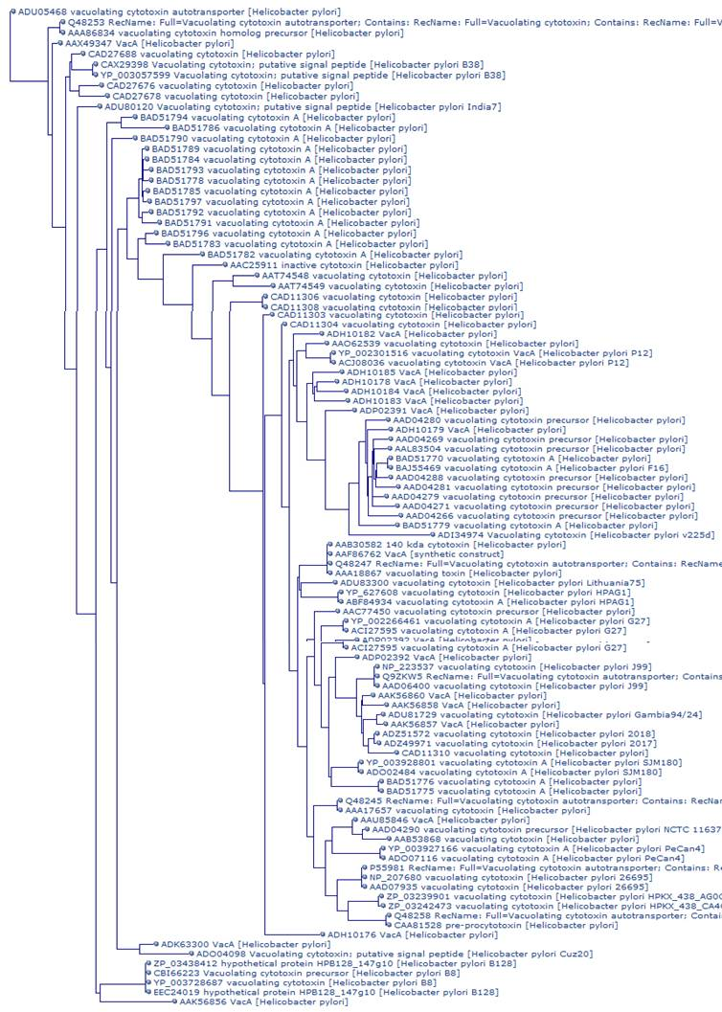
Fig. 5. Phylogenetic relationships between coccoid form H. pylori isolate (Makkah-7) and other GenBank related strains based on VacA protein sequence (ADU05468).

Total of 33 amino acids of Makkah-7 have changed to other GenBank H. pylori amino acids at different positions (Table 5). On the other hand, the highest numbers of amino acids (9) that changed to Asparagine (Asn) were as follows: Alanine (Ala) changed to Asn at positions 12, 101 and 161; Lysine (Lys) to Asn at 80 and 160; Serine (Ser) to Asn at 70 and 146; Phenylalanine (Phe) to Asn at 233 and Arginine (Arg) to Asn at 112. Moreover, Asn changed to Aspartic acid (Asp) at positions 4 and 10; (Arg to Asp) at 1; (Ser to Asp) at 157. Other amino acids were uniquely changed to individual GenBank amino acids, such as Lys to Glycine (Gly) at 48, Asn to Histidine (His) at 133, Tryptophan (Trp) to Methionine (Met) at 78. The VacA protein (ADU05468) and VacA nucleotide trees of Makka-7 revealed the same distinctive group that is distant from other GenBank strains (Fig. 5).

Table 5. Positional differences in translated protein sequences of vacuolating cytotoxin A putative peptide domain between Makkah-7 H. pylori isolate and numerous strains.
G=Glycine (Gly), M=Methionine (Met), H =Histidine (His)

 |  | Signal | Present in the GenBank accessions as:
 |  | Signal | A | D | E | G | H | I | K | M | N | P | Q | S | T | V
Present in  Makka-7 as: | Alanine (Ala) | A |  |  |  |  |  |  |  |  |  |  |  |  |  | 229 | 1
Present in  Makka-7 as: | Aspartic acid (Asp) | D |  |  |  |  |  |  | 76 |  | 12 |  |  | 206 |  |  | 3
Present in  Makka-7 as: | Aspartic acid (Asp) | D |  |  |  |  |  |  |  |  | 101 |  |  |  |  |  | 1
Present in  Makka-7 as: | Aspartic acid (Asp) | D |  |  |  |  |  |  |  |  | 161 |  |  |  |  |  | 1
Present in  Makka-7 as: | Glutamic acid (Glu) | E |  |  |  |  |  |  | 53 |  |  |  |  |  |  |  | 1
Present in  Makka-7 as: | Glutamic acid (Glu) | E |  |  |  |  |  |  | 156 |  |  |  |  |  |  |  | 1
Present in  Makka-7 as: | Phenylalanine (Phe) | F |  |  |  |  |  |  |  |  | 233 |  |  |  |  |  | 1
Present in  Makka-7 as: | Lysine (Lys) | K |  |  |  | 48 |  |  |  |  | 80 | 204 | 44 |  |  |  | 4
Present in  Makka-7 as: | Lysine (Lys) | K |  |  |  |  |  |  |  |  | 160 |  |  |  |  |  | 1
Present in  Makka-7 as: | Asparagine (Asn) | N |  | 4 |  |  | 133 |  |  |  |  |  |  | 129 |  |  | 3
Present in  Makka-7 as: | Asparagine (Asn) | N |  | 10 |  |  |  |  |  |  |  |  |  | 166 |  |  | 2
Present in  Makka-7 as: | Glutamine (Gln) | Q |  |  |  |  |  |  |  |  |  |  |  |  | 106 |  | 1
Present in  Makka-7 as: | Arginine (Arg) | R |  | 1 |  |  |  |  |  |  | 112 |  |  |  |  |  | 2
Present in  Makka-7 as: | Serine (Ser) | S | 45 | 157 |  |  |  |  |  |  | 70 |  |  |  |  |  | 3
Present in  Makka-7 as: | Serine (Ser) | S |  |  |  |  |  |  |  |  | 146 |  |  |  |  |  | 1
Present in  Makka-7 as: | Threonine (Thr) | T | 149 |  |  |  |  |  |  |  |  | 159 |  |  |  | 109 | 3
Present in  Makka-7 as: | Tryptophan (Trp) | W |  |  |  |  |  |  |  | 78 |  |  |  | 2 |  |  | 2
Present in  Makka-7 as: | Valine (Val) | V | 68 |  |  |  |  |  |  |  |  |  |  |  | 207 |  | 2
Present in  Makka-7 as: | Total |  | 3 | 4 | 0 | 1 | 1 | 0 | 3 | 1 | 9 | 2 | 1 | 4 | 2 | 2 | 33

4.DISCUSSION

Preservation of H. pylori in gastric biopsies or culture is usually carried out by keeping the harvested colonies or biopsy in Brain heart Infusion glycerol and freeze at -70 to -80°C, or in liquid nitrogen at -196°C. The recovery rate using these methods is 80-90% after six years, while routine freezing is not successful (Lee and Megraud 1996). However, unexpectedly Milyani and Barhameen (2004) found that 13 gastric biopsies gave positive growth of H. pylori after freezing at -20°C for 15 days. At the present study, the prolonged storage (ten years) of H. pylori under -40°C in thioglycolate broth + 15% glycerol rendered the spiral forms to transform into coccoid forms, this is in accordance with Catrenich and Maki (1991); Reynolds and Penn (1994); Milyani (2011) who managed to induce coccoid forms under extended incubation. Although, others also induced coccoid forms by subjecting fresh cultures to antibiotics, harsh environment or keeping H. pylori in sterile tap water outdoor at 35-45°C for 24 hours and weeks (Bode, et al. 1993; Andersen and Wadstrom, 2001; Nilsson, et al., 2002; Milyani unpublished data).
The results obtained at the present work confirmed that the coccoid forms of H. pylori strain under study (Makkah 7 accession no.HQ622108) is VacA positive with variations in VacA gene and peptide domain sequences. Our findings agree with She et al., (2001); Wang and Wang (2004) who reported that their data indicate that coccoid H. pylori contains UreA, UreB, hpaA, VacA, and Cage genes and contains complete VacA gene, and could synthesize its protein, which may be a potential pathogen. On the other hand, Argent, et al., (2008) stated that most strains of H. pylori possess both CagA and VacA virulence factors which down regulate each other’s effects on epithelial cells. Interestingly, many researchers recorded that their patients were colonized by multiple strains of H. pylori. (Kim, et al,. (2009);Ben Mansour, et al., (2010) and surprisingly, the results from biopsy samples produced different results when compared with those obtained from H. pylori isolates, especially for VacA s1, and IceA. Nevertheless, the present results show that VacA H. pylori Makkah 7 strain is distinct from other isolates based on VacA gene and peptide domain and according to the phylogenetic studies (Fig. 3 and 5). This distinction has been also recorded when other H. pylori were isolated from the same city (Makkah) based on 16S rRNA analysis namely Milyani 1, Milyani 2 and Milyani 3 with accession numbers HQ877021, HQ877022 and HQ877023 respectively (Milyani 2011). In contrast, Kumar et al., (2010) according to their phylogenetic analysis postulated that the Indian strains of H. pylori show close homology to those from Taiwan and/or Brazil and that genetic diversity among H. pylori isolates is widely prevalent regardless of the region from which they are isolated.
The present study revealed positional alternations in 33 amino acids among 199 amino acids of vaculating cytotoxin domain. However, such mutations may not actually influence the production of vaculating cytotoxin by Makkka 7 strain (ADU05468). This has been evidently obtained from Table (4) that represented the alignment of 100 accession of vacA domain with 100% similarity. On the other hand, Ivie, et al., (2008) and Genisset, et al., (2006) managed to introduce a small deletion mutation in both aspartic acids 346 and glycine 347 into the H. pylori chromosomal VacA gene. Similar to wild-type VacA, the VacA mutant was proteolytically processed, secreted, and bound to eukaryotic cells, but VacA 346-347 did not cause cell vacuolation or membrane depolarization.
The present findings provide additional information on VacA nucleotide and peptide domain isolated from Makkah City that is entirely different from other isolated H. pylori. These results also, emphasize the paramount importance of studying H. pylori isolates from Saudi population to develop a global understanding of gastric diseases. The factors influencing variations of Makkah 7 H. pylori strain are still to be elucidated and indeed these variations may be incriminated in pathogenicity and other characteristics (Milyani 2011). Coccoid forms of H. pylori and their virulence genes should not be underestimated and vigorous research and further studies should be carried out since many established date have shown their pathogenicity and their possible role in transmission and in therapeutic failure.

5.REFERENCES

Aceti A, Are R, Sabino G, Fenu L,Pasquazzi C, Quaranta G., Zechini B and Terrosu P. (2004).
Helicobacter pylori active infection in patients withacute coronary heart disease. Journal of Infection. 49: 8-12.

Andersen L.P. and Wadstrom T. (2001).
Basic bacteriology and culture, p. 27-38. In H. L. T. Mobley, G. L. Mendz, and S. L. Hazell (ed.), Helicobacter pylori: physiology and genetics. ASM Press, Washington, DC.

Argent R.H., Thomas R.J., Letley D.P., Rittig M.G., Hardie K.M. and Atherton J.C. (2008).
Functional association between the Helicobacter pylori virulence factors VacA and CagA. Journal of Medical Microbiology. 57: 145-150.

Azevedo N.F., Almeida C., Cequeira L., Dias S., Keevil C.W. and Vieira M.J. (2007). Coccoid forms of Helicobacter pylori as a morphological manifestation of cell adaptation to environment. Applied and Environmental Microbiology 73 (10): 3423-3427.

K., Fendri C., Zribi M., Masmoudi A., Labbene M., Fillali A., Ben Mami N., Najjar T., Meherzi A., Sfar T. and Burucoa C. (2010).
Prevalence of Helicobacter pylori VacA, cagA, iceA and oipA genotypes in Tunisian patients. Ann Clin Microbiol Antimicrob. 19: 9-10.

Blaser M.J. and Atherton J.C. (2004). Helicobacter pylori persistence: biology and disease. J Clin Invest 113: 321-333

Bode G., Mauch F. and Malfertheiner P. (1993). The coccoid forms of Helicobacter pylori. Criteria for their viability. Epidemiol Infect. 111: 483-490.

Chan, W. Y., Hui, P. K., Leung, K. M., Chow, J., Kwok, F. and Ng, C. S. (1994).
Coccoid forms of Helicobacter pylori in the human stomach. American Journal of
Clinical Pathology 102: 503-507.

Chung C., Olivares A., Torres E, Yilmaz O., Cohen H. and Perez-Perez G. (2010). Diversity of VacA intermediate region among Helicobacter pylori strains from several regions of the world. J Clin Microbiol 48: 690-696

Falush D., Wirth T., Linz B., Pritchard J.K., Stephens M., Kidd M., Blaser M.J., Graham D.Y., Vacher S., Perez-Perez G.I., Yamaoka Y., Megraud F., Otto K., Reichard U., Katzowitsch E., Wang X., Achtman M. and Suerbaum S. (2003). Traces of human migrations in Helicobacter pylori populations. Science 299: 1582-1585

Gangwer KA, Shaffer CL, Suerbaum S, Lacy DB, Cover TL, Bordenstein SR. (2010). Molecular evolution of the Helicobacter pylori vacuolating toxin gene VacA. Bacteriol. 192 (23):6126-35.

Gebert B., Fischer W. and Haas R. (2004).
The Helicobacter pylori vacuolating cytotoxin: from cellular vacuolation to immunosuppressive activities. Rev Physiol Biochem Pharmacol 152: 205-220

Genisset C, Galeotti CL, Lupetti P, Mercati D, Skibinski DA, Barone S, Battistutta R, de Bernard M, Telford JL. (2006). A Helicobacter pylori vacuolating toxin mutant that fails to oligomerize has a dominant negative phenotype. Infect Immun. 74:1786–1794. doi: 10.1128/IAI.74.3.1786-1794.2006.

Ivie SE, McClain MS. (2008). Torres VJ, Algood HM, Lacy DB, Yang R, Blanke SR, Cover TL.
Helicobacter pylori VacA subdomain required for intracellular toxin activity and assembly of functional oligomeric complexes. Infect Immun.76:2843–2851.

Kim Y.S., Kim N., Kim J.M., Kim M.S., Park J.H., Lee M.K., Lee D.H., Kim J.S., Jung H.C. and Song I.S. (2009).
Helicobacter pylori genotyping findings from multiple cultured isolates and mucosal biopsy specimens: strain diversities of Helicobacter pylori isolates in individual hosts. Eur J Gastroenterol Hepatol 21: 522-528

Kimura M. (1980).
A simple method for estimating evolutionary rates of base substitutions through comparative studies of nucleotide sequences. J. Mol. Evol. 16: 111-120.

Kumar S., Kumar A. and Dixit V.K. (2010). Genetic diversity in strains of Helicobacter pylori from India and their relatedness to strains from other parts of the world. Infect Genet Evol. 15

Lee A. and Megraud F. (1996).
Helicobacter pylori: techniques for clinical diagnosis and basic research.W.B. Saunders Compony Ltd, London.

Milyani, R. M. ( 2011).
Cytopathic effect of coccoid forms of Helicobacter pylori in Albino rats and Swiss mice. Journal of American Science; 7(6): 1087-1092.

Milyani R.M. and Barhameen A.A. (2004). Incidence of Helicobacter pylori infection assessed by four different methods in Makkah city (Saudi Arabia). Egyptian Journal of Biomededical Science 14: 113-127.

Milyani, R. M. ( 2011).
Nucleotide variations of 16S rRNA gene of VacA positive Helicobacter pylori strains isolated from human Gastric Biopsies in Saudi Arabia. Journal of American Science; 7(6): 136-145.

Nilsson H.O., Blom J., Abu-Al-Soud W., Ljungh A.A., Andersen L.P. and Wadstrom, T. (2002).
Effect of cold starvation, acid stress, and nutrients on metabolic activity of Helicobacter pylori. Applied and Environmental Microbiology. 68:11-19.

Reynolds D.J. and Penn, C.W. (1994). Characteristic of Helicobacter pylori growth in a defined medium and determination of its amino acid requirements. Microbiology 140: 2649-2656.

Saito N., konishi K., Sato F., Kato M., Takeda H., Sugiyama T. and Asaka M. (2003). Plural transformation-processes from spiral to coccoid Helicobacter pylori and its viability. Journal of Infection. 46: 49-55.

Saitou N. and Nei M. (1987).
The neighbor-joining method: a new method for reconstructing phylogenetic trees. Mol. Biol. Evol. 4: 406-425.

She F.F., Su D.H., Lin J.Y. and Zhou L.Y. (2001).

Virulence and potential pathogenicity of coccoid Helicobacter pylori induced by antibiotics. World J Gastroenterol. 7(2): 254-258.

Wang X.F. and Wang K.X. (2004).
Cloning and expression of VacA gene fragment of Helicobacter pylori with coccoid form. J Chin Med Assoc. 67(11): 549-556.

Warren JR and Marshall BJ (1983). .Unidentified curved bacilli on gastric epithelium in active chronic gastritis. Lancet. 1: 1273-1275.

Xiang Z., Censini S., Bayeli P.F., Telford J.L., Figura N., Rappuoli R. and Covacci A. (1995).
Analysis of expression of cagA and VacA virulence factors in 43 strains of Helicobacter pylori reveals that clinical isolates can be divided into two major types and that cagA is not necessary for expression of the vacuolating cytotoxin. Infect. Immun. 63: 94-98

Yamaoka Y. (2009).

Helicobacter pylori typing as a tool for tracking human migration. Clin Microbiol Infect 15: 829-834

Zhao, Y., Yokota, K., Ayada, K., Yamamoto, Y., Okada, T., Shen, L. and Oguma, K. (2007). Helicobacter pylori heat-shock protein 60 induces interleukin-8 via a Toll-like receptor (TLR)2 and mitogen-activated protein (MAP) kinase pathway in human monocytes. Journal of Medical Microbiology. (56): 154-164.

7/7/2011

