Kohlrabi (Brassica caulorapa L): A Potent Anticancer Vegetable Processed in Baked Biscuits

^{*1} Esmat A Hassan, ²Ahmad Hussein, and ¹El-Awadi M. E.

¹Botant Department, ²Department of Food Technology National Research Centre, Dokki, 12311.Giza, Egypt
Esmat_hassan@yahoo.com

Abstract: Nutritive constituents of protein , fat ,crude fiber , total phenols and phenolic acids were detected in two kohlrabi cultivars .Total phenols per a baked biscuit unit fortified with kohlrabi stem flour were calculated after baking . The results revealed that total phenols were higher in the leaves as compared to stems in both kohlrabi cultivars. Salicylic acid represented the maximum fraction detected in the green skin kohlrabi stems (56.1mg/100gm ) , reaching ca. double fold value of that existed in the red one (28.5mg/100g) on dry weight base. Maximum recovery of total phenols were 83.4 mg and 52.0 mg per one biscuit unit ( of ca.22 and 18 g ) at 15% and 8% levels of the added green and red kohlrabi stems in the blend respectively. Slight changes were recorded in the final baking characteristics due to kohlrabi stem flour addition. An enriched nutritive value and a prolonged shelf-life of the baked biscuit product were observed. This could be due to the bioactive antioxidants existed in such a vegetable .It is herein suggested to encourage baked products fortified with kohlrabi stem flour to be included in a dietary system in cancer care avoidance and /or prevention regime particularly in case of children.
[Esmat A Hassan, Ahmad Hussein, and El-Awadi M. E. Kohlrabi (Brassica caulorapa L): A Potent Anticancer vegetable Processed in Baked Biscuits. Nature and Science 2011;9(8):149-157]. (ISSN: 1545-0740). http://www.sciencepub.net.

Key words: Cancer, biscuits, kohlrabi, phenols, nutritive value.

1. Introduction:
Kholrabi plant (Brassica caulorapa var. gongylodes L.) with an edible turnip-like swollen stem is a cool-weather plant. It is botanically classified in the division Magnoliophyta, Class Mangoliopsida, order Capparales, family Cruciferae. It is grown more in Europe where some varieties are used as fodder. Its flavor is more delicate than that of other Brassica plants
Phenolic compounds are the most widely existing phytochemicals with significant morphological and physiological importance in plant kingdom ( Aberoumand and Deokule , 2008 ).
Various research results reported the antioxidant activity of phenolic compounds extracted and fractionated from different plant sources (Mustafa et.al., 2010 ; Yao et.al., 2010) .Phenolic compounds of the Brassica vegetables are considered of great significance for human health for their potential protective actions against cancer and heart diseases ( Cartea et. al., 2010 ). In this respect Herr and Buchler (2010) reported that dietary constituents of Brassica family plants are considered of cancer-preventive effects.
In the present study, in addition to determining the nutritional value (Hooda and Jood 2005), we focused on tracing and estimation of the phenolic substances in tissues of two kohlrabi plant cultivars planted under non-chemical conditions .We also tried to process a dry snack baked product of biscuits fortified by kohlrabi stems (Hassanen 1998 ).

2. Material and Methods:
Material:
1- Plant Material – cultivation and harvest:
Kohlrabi seeds were obtained from Japan Takii and Co. LTD (Kyoto, Japan).
Two cultivars were employed in the present study, i.e. Delikatess weisser with green outer skin and Veinna purple with red one (Fig. 1 & 2).
Seeds were sown in foam trays on August 2010. The seedlings were transplanted at age of 35 days to the field in the Experimental Station of The National Research Centre located in Nubaria region –Alexandria Governorate. The plants were subjected to the standard agricultural practices of irrigation, organic fertilization and pest control during the growth season.
The experiment was conducted of 4 replicate plots of 5 rows .Each row was prepared with 3 meters long and 75 cm. in width. Kohlrabi plants were harvested 40 days after transplanting. Leaves and stems were separated and each was prepared for the processing and analyses.

1 | 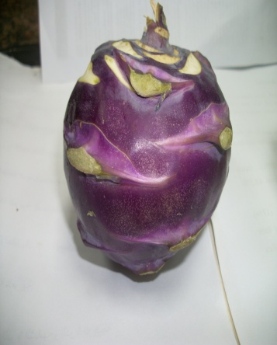  2
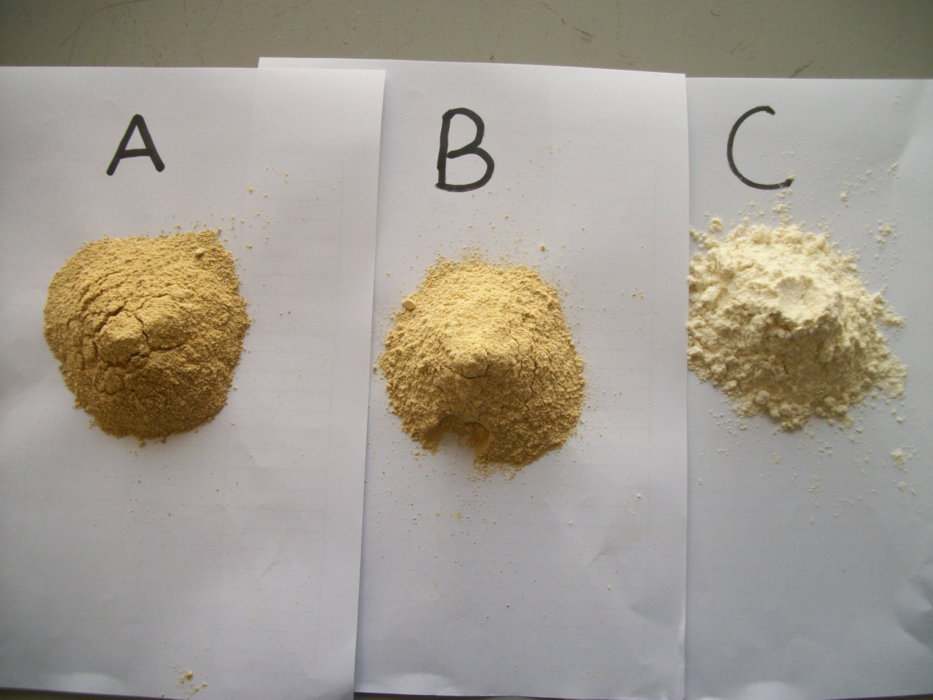  3 | 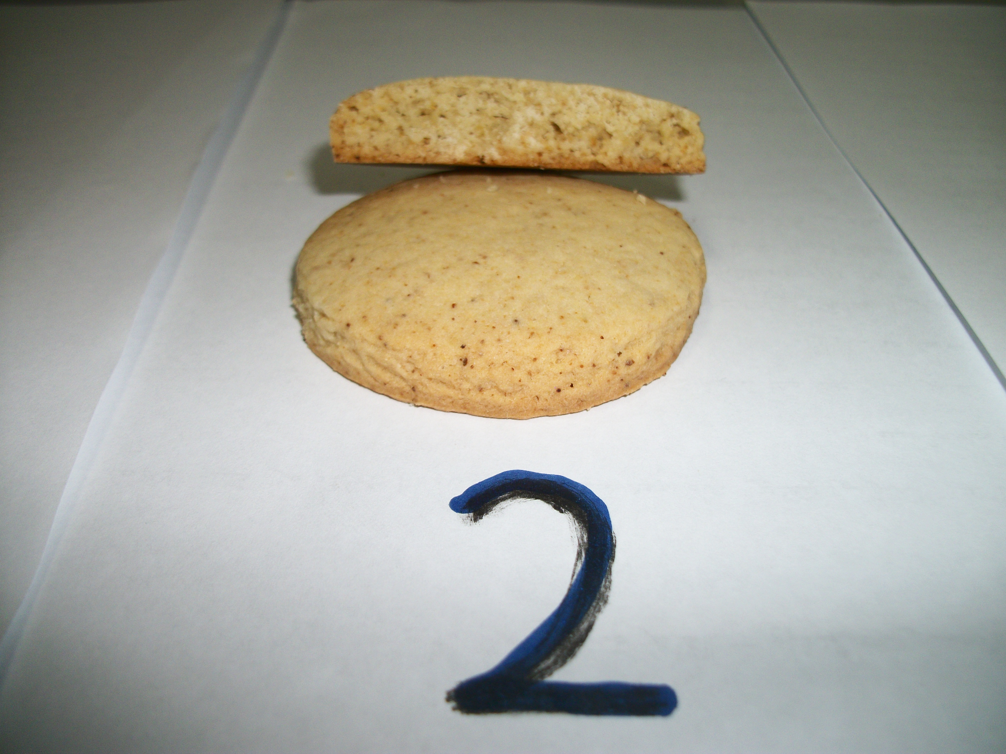  4

Figure (1):
(1) Kohlrabi cv. Delikatess weisser, (2) Veinna purple kohlrabi cultivar
(3 A): red kohlrabi flour blend, (3B): Green blend (3C): Plain wheat flour).
(4) Baked biscuits fortified by kohlrabi stem flour.

2-Material used in processing and baking the Biscuits:
Wheat flour (72% extraction) was purchased from the North Cairo Flour Mills Company, Egypt.
Sucrose, shortening, baking powder, salt, eggs and vanilla were purchased from the local market, Cairo, Egypt.
Kohlrabi stem flour was prepared from the stems of the ripe plant.

Methods:
- Preparation of kohlrabi plant stems in powdered flour:

Kohlrabi plant stems were washed before peeling , sliced (8 ± 0.3 mm), treated with sodium metabisulifate (0.5%) and citric acid (0.125%) and then dried in a thermostatically controlled oven with air fan at 40°C for 12 hour (Singh et al. 2008). The slices were milled using mixer and a Laboratorial disc mill (Quadrumat Junior flour mill, Model Type No: 279002, ©Brabender ® OHG, (Germany). The grinded material was passed through a 20 mesh/inch sieve and then stored in airtight containers and kept at 3-4 º C until required.
2- Preparation of flour blend mixtures:
Wheat flour (WF) of 72% extraction was well blended with either the green kohlrabi cultivar “ Delikasseetes weisser stem material or with the red one “Veinna” purple in a blender to produce individual mixtures containing 0, 5,10 and15% from the former and 4,8 and 12 % from the latter replacement levels to employ in biscuit processing as shown in table (1). All blends were stored in airtight containers and kept at 3-4 º C until required.

3- Rheological properties
Rheological properties of the two types of the dough amended separately with the green and the red kohlrabi stem flour, were evaluated using farinograph according to AACC (2000); methods No. 54-10 and 54-21, respectively.

4- Preparation and organoleptic evaluation of biscuits
Biscuits were prepared by mixing 100 g of wheat flour (72% extraction) and kohlrabi stem flour blends, in addition to other needed component ( Table 1) according to AACC [2000] following procedures No.(10-50D) .Shortening, sugar and salt were creamed in a Hobart mixer for 2 min to which a mixed flour blend containing baking powder was added and then mixed for further 2 min. Using a wooden rolling pin , the dough was sheeted on an aluminum platform to a uniform thickness of 1 mm. Circular sheeted dough of 4.0 cm in diameter was cut and baked at 210ºC for 12-15 min. After removal from the oven, the biscuits were allowed to cool for 5 min on the biscuits` sheet and were then transferred from the sheet to racks and cooled additionally for 30 min before being bagged in polyethylene and held at room temperature for evaluation.
Organoleptic characteristics of the processed baked biscuits were evaluated with some modifications, according to Hussein et al. (2008) by 15 trained panelists. The examined characteristics were color (10), odor (10), taste (10), texture (10), appearance (10), and overall acceptability (10).

5- Physical characteristics of the baked biscuits.
Diameter, volume, weight and height of baked biscuit units were measured by Boclase (HL 474938, STECO, Germany) according to the standard methods of the A.A.C.C. (2000).The spread ratio Diameter / height were calculated.

6- Color determinations.
Objective evaluation of raw materials and surface color of the baked biscuits was measured. Hunter a, b and L parameters were measured by a color difference meter using a spectro- colorimeter (Tristimulus Color Machine) with the CIE lab color scale (Hunter, Lab Scan XE - Reston VA, USA) in the reflection mode. The instrument was standardized each time with white tile of Hunter Lab Color Standard (LX No.16379): X= 72.26, Y= 81.94 and Z= 88.14 (L= 92.46; a= -0.86; b= -0.16) (Sapers & Douglas, 1987).The Hue, saturation and Δ E were calculated according to the method of (Palou et al., 1999) as follows:
Hue = tan-1 [b/a] (1) saturation = [a² + b²]^{1/2} (2) Δ E = (Δ L² + Δ a² + Δ b²)^{1/2}(3)

7. Chemical analysis

7.1. Moisture, ash, protein and fat were determined according to the methods No. 925.10, 923.03, 920.87 and 920.85 respectively as described by the AOAC [2000].

7. 2. Lipid autooxidation
The acid (AV) and peroxide (PV) values and thiobarbutric acid number (TBA) were the parameters used for the assessment of lipid auto-oxidation. These three parameters were determined in the oil extracted from the samples (Habib & Brown 1956) .The extracted oil was kept in a tightly closed dark bottle in a deep freezer at (–20°C) for subsequent analysis. The acid and peroxide values were determined according to the methods of the AOAC (1990).

Thiobarbutric acid number was estimated following the method described by Pearson (1976).

7.3. Analyses of phenolic contents
Estimation of total phenolic contents were carried out in mature red and green kohlrabi stems and leaves of plants harvested 40 days after transplanting , as described by ( Snell and Snell 1953). High performance liquid chromatography (HPLC) was used in the identification of phenolic acids. For matching, 0.1 g of each authentic phenolic acid was dissolved in 80% absolute ethanol. A mixture of these acids as 1ml from each was prepared. Single phenolic acids and their mixture were then filtered through 0.2 micron-filter membrane and degassed via ultrasonic water bath according to the methods described by Christian (1990).

Table 1: Composition of mixture blends of processed biscuits.
Ingredients | Basic formula  (Control) | Modified Biscuits
Ingredients | Basic formula  (Control) | A | B | C | D | E | F
Wheat flour 72% | 100 | 95 | 90 | 85 | 96 | 92 | 88
Kholrabi-green | - | 5 | 10 | 15 | - | - | -
Kholrabi-red | - | - | - | - | 4 | 8 | 12
Sucrose | 35 | 35 | 35 | 35 | 35 | 35 | 35
Fat | 28 | 28 | 28 | 28 | 28 | 28 | 28
Baking powder | 1.1 | 1.1 | 1.1 | 1.1 | 1.1 | 1.1 | 1.1
Salt | 1.0 | 1.0 | 1.0 | 1.0 | 1.0 | 1.0 | 1.0
Eggs | 30 | 30 | 30 | 30 | 30 | 30 | 30
Vanilla | 1.0 | 1.0 | 1.0 | 1.0 | 1.0 | 1.0 | 1.0

8. Statistical analysis
The results of organoleptic evaluations were evaluated by an analysis of variance and least significant difference (LSD) was calculated according to McClave & Benson [1991].
3. Results and Discussion
1. Phenolic contents in red and green skin kohlrabi cultivars:
Over 70 % of anticancer compounds are either natural products, or natural product-derived substances. Chemoprevention by edible phytochemicals (Karikas 2010), such as polyphenolic substances from plants (Namasyvayam 2011) can be considered as inexpensive, readily applicable, and accessible approach to cancer control and management. In this respect, food sources and bioavelability of polyphenols were previously discussed ( Manach et. al., 2004) .
Results obtained in the present study (Table 2) proved the existence of phenol substances in kohlrabi plant. It was generally at higher levels in the leaves than in the stems in both the red (14.3 mg/g dw) as well as in the green (15.5mg/g dw) of the kohlrabi cultivars. The total phenolic contents of stems were 12.3mg/g dw in the green cultivar " Delikatess weisser " and 11.6 mg/g dw in that of the purple one "Veinna purple ".This could be considerably higher as compared to the lower amounts recorded by Aberoumand and Deokule (2008) in other eight edible plant species which ranged from 87 to 586 mg/100g dw. From the same table, salicylic acid represented the maximum fraction detected in the stems of green skin kohlrabi (56.0mg/100g dw ) reaching ca. double fold value of 28.5 mg/100g dw found in the red one . The least fraction was Gallic acid with a proximal value of 5.7 and 6.2 mg/100 gm in the red and the green stems respectively. Other phenolic acids` values ranged between 28.7mg/100g dry weight in the green skin kholrabi stem as Para-benzoic acid, and 9.4 mg/100g dry weight as syringic acid in the red cultivar. These differences may be due to the complexity of phenolic compounds existed in different vegetables and fruits and / or to the methods of extraction and analysis (Bravo 1998). We herein had estimated the total phenols colorimetrically according to the method described by Snell and Snell (1953) .The HPLC method ( Christian 1990 ) was applied in detecting the individual phenolic acids ; while Abaroumand and Doukule (2008 ) adopted the method of Singleton and Rossi (1965 ) in their analysis of total phenols in methanolic extracts of different plant spieces. Regarding such differences, Tomas-Barberan and Espin (2001) and Rapisarda (1999) reported that phenolic contents of plant foods depend on a number of intrinsic (genus, species and cultivars) and extrinsic (agronomic, environmental, handling and storage) factors. This may implicate the variation in phenolic contents observed between the two kohlrabi cultivars as shown herein in Table (2). In addition such variability was recorded in the levels of the analyzed individual phenolic acids. As an example the protocatuic, salicylic, syringic and vanillic acid levels proximate double fold values in the green kohlrabi stems` of the cultivar "Delikatess weisser" as compared to that recorded in the red one "Veinna purple".

2. Recovery of total phenolic substances in the baked biscuit amended with different levels of two kohlrabi cultivar stems.
The recovery of the total contents of phenolic substances in the baked biscuit depended on the percentage of the kohlrabi material added to the flour before baking (Table 3). More over, the addition of the green kohlrabi cultivar " Delikatess weisser " to the flour before baking resulted in higher recovery of the total phenolic components in the processed biscuit units than that obtained with the red one" Veinna purple". However, one biscuit unit amended with 10 and 15 % of the green kohlrabi " Delikatess weisser " contained the highest quantity of phenolic substances,i.e. 71.5 and 83.4 mg. per one biscuit unit respectively . Corresponding values were 51.4 and 52.0 in those amended with the red cultivar “Veinna purple”. The least phenolic recovery was recorded in the biscuits amended with the red kohlrabi at 3% level as compared with the control of 35.0 mg per one unit.

Table 2: Total phenolic contents (mg/g dw) in red “Veinna purple” and in green "Delikatess weisser" kohlrabi ; and phenolic acids estimated as mg/100 g dry weight of stems.
 | Red |  | Green
 | Stem | Leaves | Stem | Leaves
Phenolic acids
Gallic
Protocateceuc
Parabenzoic
Salycilic
Syringic
Vanilic
 | 5.7 | - | 6.2 | -
 | 8.8 | - | 18.8 | -
 | 21.6 | - | 28.7 | -
 | 28.5 | - | 56.1 | -
 | 9.4 | - | 19.6 | -
 | 10.8 | - | 21.5 | -
Total Phenolic contents | 11.6 | 14.3 | 12.3 | 15.5

Table 3: Recovery of total phenolic contents as mg / gm dry weight in the baked biscuit product in relation to percentage of kohlrabi stem powder added to the flour before baking.
Percentage of Kohlrabi added | Total phenol in baked biscuit | Av. w (g)of baked biscuits Unit | Recovery of  Phenolic substance mg. per 1 unit
Control | 1.7 | 20.4 | 35.0
Red 3% | 1.7 | 21.1 | 35.8
6% | 2.5 | 20.8 | 51.5
8% | 3.0 | 18.1 | 52.0
Green 5% | 2.5 | 20.0 | 49.3
10% | 2.4 | 21.2 | 71.5
15% | 4.1 | 22.1 | 83.4

3. The effect of kohlrabi plant material added to the blend on different characteristics of the processed biscuits.
3.1. Chemical composition of wheat flour and kohlrabi raw materials:
Data presented in Table 4. indicate that the moisture and carbohydrate contents of of peeled green kohlrabi cultivar " Delikatess weisser " and of the red one“ Veinna purple “ cultivar were lower than that of wheat flour ( 72%)
On the contrary, the peeled kohlrabi stems were noticeably higher in protein, crude fiber and ash in both the cultivars in comparison to wheat flour.

Table 4: Values of the compositions of the raw materials used in biscuit processing before baking on dry weight basis.
Samples | Moisture | Protein | Fat | Crude Fiber | Ash | Total Carbohydrate
Wheat flour (72%) | 13.33± 0.02 | 12.00± 0.05 | 1.22± 0.02 | 0.86±0.02 | 0.75±0.01 | 85.17± 0.03
Kohlrabi –green | 8.16± 0.01 | 18.16± 0.03 | 1.03± 0.03 | 10.65±0.12 | 6.01±0.05 | 64.15±0.03
Kohlrabi- Red | 9.12± 0.01 | 24.95± 0.01 | 1.22± 0.01 | 12 .3±0.28 | 5.8±0.08 | 55.73± 0.06
Each value is the average of three determinations ± SD

3.2. The effect of adding green and red kohlrabi stems to wheat flour on farinograph parameters:
The present results revealed that increasing either the green or the red content in the blend from 0% to 15% in the former and from 0% to 12% in the latter resulted in the elevation of water absorption from 59% to 63.5% and 62% respectively ( Table 5). The Arrival time, Dough development time and Weakening were increased. The increase in the dough development time is probably due to the increase in protein and fiber content in the blends which slowed the rate of hydration and development of gluten. From the same table, Mixing tolerance index values increased in respect to increasing the kohlrabi material in the blend to reach its maximum of 100 BU at 12 % percentage of red kohlrabi as compared to 40 BU in the control (Table 5).This may be due to the dilution of gluten protein with the fiber content as previously reported (Chen et al., 1988; Sudha et al., 2007; Doxastakis et al., 2002). Similar observations were obtained with raw and germinated legume and mushroom blends which were found to retain more water due to their considerable amounts of fibers, sugars and high protein contents (Eissa et al., 2007). Water absorption capacity is referred to the high number of hydroxyl groups which exist in the fiber structure and allow more water interactions through hydrogen bonding (Rosell et al., 2001).

Table 5: Farinograph parameters of dough prepared from different blends formula.
Samples | Water absorption (%) | Arrival time (min) | Dough development time(min) | Stability time (min) | Weakening  (BU) | Mixing tolerance index (BU)
Control | 59 | 1.1 | 2.0 | 7.0 | 90 | 40
G- 5 % | 61 | 1.0 | 2.25 | 6.0 | 120 | 55
10 | 62.5 | 1.2 | 2.50 | 5.5 | 140 | 70
15 | 63.5 | 1.5 | 3.0 | 5.0 | 160 | 85
R-4% | 59.5 | 1.5 | 2.5 | 6.5 | 110 | 60
8 | 61 | 1.8 | 3.0 | 6.0 | 120 | 80
12 | 62 | 2.0 | 3.5 | 6.0 | 120 | 100
G= green peeled stems of kohlrabi plant. R = Red

3.3. Color characteristics:
The observed slight changes in color may be referred to colored pigment existed in the kohlrabi material which developed in the produced biscuits during processing.. The changes appeared to depend on kohlrabi percentage in the blends (Table 6). These are presented as Hunter values of whiteness (L), redness (a) and Yellow (b) measured for raw materials and crust colors. All fortified samples had slightly lower L values for crust than the control and therefore a slightly darker crumb color. All biscuits incorporated with either the green or with the red kohlrabi peeled stem flour had lower crust L values than the control, i.e. indicating darker color (Table 6). Also , decreases in the values of whiteness (L) and hue angle , while redness (a), Yellow (b), saturation and Δ E slightly had increased in all fortified samples. These results are in harmony with those obtained by (Ahmed 1999) and (Kenny et al. 2000).

Table 6: Color characteristics of biscuits processed from different blend formulas
ΔE | Hue | Saturation | a/b | B | A | L | Samples
- | 88.14 | 9.55 | 0.032 | 9.55 | 0.31 | 87.83 | Wheat flour
- | 82.94 | 17.74 | 0.124 | 17.61 | 2.18 | 73.42 | Green
- | 85.26 | 16.59 | 0.083 | 16.54 | 1.37 | 80.08 | Red
- | 78.74 | 23.00 | 0.199 | 22.56 | 4.49 | 73.74 | Control
7.46 | 75.37 | 22.79 | 0.261 | 22.06 | 5.76 | 66.41 | Green 5%
11.15 | 72.68 | 23.19 | 0.322 | 22.08 | 7.11 | 62.91 | 10%
13.77 | 68.35 | 24.09 | 0.397 | 22.40 | 8.89 | 60.69 | 15 %
7.65 | 68.72 | 24.88 | 0.389 | 23.19 | 9.03 | 67.61 | Red 4%
9.21 | 72.35 | 24.74 | 0.318 | 23.58 | 7.50 | 65.17 | 8%
12.53 | 68.90 | 25.75 | 0.385 | 24.03 | 9.27 | 63.39 | 12%
L= lightness (100= white; 0= black), a= redness (+100) to green (-80)
b= yellowness (70) to blue (-80), Δ E = (Δ L² + Δ a² + Δ b²)^{1/2}

3.3. Influence of green and red kohlrabi stem flour on the physical characteristics of the baked biscuits product:
Changes in height, diameter and spread ratio, were observed in respect to elevating the percentage of added kohlrabi flour in the blend formula (Table 7).The changes in diameter and height are reflected in spread ratio which decreased consistently from 4.66 to 4.00 with the addition of the green stem material, 4.38 to 3.65 with the red flour at 5–15% and 4-12% levels, respectively. Cookies having higher spread ratios are considered most desirable (Kirssel & Prentice, 1979). Other observations revealed that the thickness of supplemented biscuits increased, whereas diameter and spread ratio decreased in correspondence to increasing the levels of rice bran-fenugreek blends, fenugreek flour and other different bran blends (Sharma & Chauhan, 2002; Hooda & Jood, 2005; Sudha et al., 2007). The reduced spread ratios of the kohlrabi-fortified biscuits can be attributed to the fact that composite flours apparently may form aggregates possessing increased numbers of hydrophilic sites available for competing for the limited free water in cookie dough (McWatters, 1978; Hooda & Jood, 2005). Rapid partitioning of free water of these hydrophilic sites occurs during dough mixing and increases dough viscosity, thereby limiting cookie spread and top grain formation during baking.

Table 7: Physical characteristics of biscuits prepared from different blend formulas.
Samples | Diameter  (cm) | Height(cm) | Spread ratio (diam. /ht.) | Weight (g) | Volume  (cc) | Specific volume (cc/g)
Control | 5.4 | 1.1 | 4.91 | 22.15 | 75 | 3.39
G -5% | 5.6 | 1.2 | 4.66 | 21.59 | 79 | 3.66
10% | 5.8 | 1.4 | 4.14 | 21.23 | 82 | 3.86
15% | 6.0 | 1.5 | 4.00 | 20.02 | 85 | 4.25
R- 4% | 5.7 | 1.3 | 4.38 | 21.99 | 80 | 3.64
8% | 5.9 | 1.5 | 3.93 | 21.88 | 85 | 3.88
12% | 6.2 | 1.7 | 3.65 | 21.50 | 90 | 4.18
G = with green skin kohlrabi R = with red skin kohlrabi

3.4. Sensory characteristics of the baked biscuits fortified by different percentages of kohlrabi stem flour:
Changes occurred in the sensory scores for color, flavor, taste, texture, appearance and overall acceptability of the produced biscuit are shown to coincide with increasing the level of kohlrabi flour in the blend formula (Table 8). These were coincided with the increase in the level / percentage of the kohlrabi plant material included in the blend before baking.
The change in color and the bitter taste could be due to components existed in the raw kohlrabi material.
Biscuits made from blends containing a level of 5% of the green and 4% of the red kohlrabi plant stem flours did not differ significantly (p<0.05) in comparison to the control of plain flour biscuit. At 15% and 12 % levels of substitution, the flavor and color acceptability was rated as poor (Table 8).
These results can be compared to those previously obtained with mixture supplements of rice bran-fenugreek blend flours (Sharma & Chauhan, 2002) and fenugreeks blend with wheat flour (Hooda & Jood, 2005).
It is however, concluded that the green kohlrabi cultivar “ Deilekatess weisser “ and the red one “ Veinna purple” stem flour could be incorporated up to 10% in the blend formula for the former and up to 8% for the latter without affecting the sensory quality of the baked biscuits. Eventually, biscuits prepared with either the green or with the red kohlrabi plant stem flour at any level of addition showed significant scores for color, flavor, taste, texture and appearance with highest acceptability.

Table 8: Statistical evaluation of sensory properties of biscuits prepared from different blend formulas.
Samples | Color  (10) | Flavor  (10) | Taste  (10) | Texture  (10) | Appearance  (10) | Overall acceptability  (10)
Control | 9.45ª±0.79 | 9.0ª±0.85 | 9.08ª±0.79 | 9.5ª±0.85 | 9.16ª±0.83 | 9.25ª±0.71
G- 5% | 8.25^{b}±0.75 | 8.5^{ab}±0.52 | 8.33^{ab}±1.07 | 8.5^{ab}±0.52 | 9.0ª±0.52 | 8.92^{ab}±0.79
10% | 7.5^{bcd}±0.86 | 7.5^{cd}±0.52 | 8.25^{bc}±0.92 | 8.0^{bc}±0.74 | 8.5^{ab}±0.85 | 8.5b^{c}±0.55
15% | 7.41^{cd}±0.92 | 6.5e±0.51 | 7.5^{cd}±0.86 | 8.0^{bc}±0.85 | 8.0^{b}±0.88 | 8.0^{cd}±0.65
R- 4% | 8.0^{bc}±0.85 | 8.5^{ab}±0.59 | 8.5^{ab}±0.52 | 8.5^{ab}±0.52 | 9.0ª±0.82 | 9.0^{ab}±0.72
8% | 7.0^{d}±0.85 | 8.0^{bc}±0.65 | 8.0b^{cd}±0.65 | 8.0^{bc}±0.85 | 8.5^{ab}±0.76 | 8.2^{cd}±0.85
12% | 6.0e±0.0.82 | 7.0de±0.75 | 7.25^{d}±0.97 | 7.5^{c}±0.96 | 8.0^{b}±0.85 | 7.75^{d}±0.56
LSD at 0.05 | 0.718 | 0.57 | 0.78 | 0.68 | 0.72 | 0.70
G = With green skin kohlrabi R = With red kohlrabi

3.5. Chemical composition of biscuits fortified with green “Delikatess weisser” and red “Veinna purple” Kholrabi plant stem flour:
Kohlrabi stem flour is shown to be a good source for crude protein, crude fibers, and total ash (Table 9).
Therefore, the addition of kohlrabi stem in the blend to wheat flour had enriched the nutritive value of the biscuit product by increasing protein, ash and fiber contents. In other investigations , the nutritive value of baked products were elevated via the addition of germinated fenugreek flour to wheat flour in bread manufacture ( Sharma & Chauhan 2000). Later results obtained by Eissa et al .(2007) ; Hooda & Jood (2003) revealed that biscuits prepared from blends of wheat-raw and germinated fenugreek flours possessed higher protein content .

Table 9: Composition of different blends prepared for biscuits` processing (On dry weight basis).
Samples | Moisture | Protein | Fat | Crude fiber | Ash | Total  Carbohydrate
Control | 3.6 | 9.5 | 28.5 | 1.2 | 1.66 | 59.14
G- 5% | 3.9 | 9.9 | 28.5 | 1.7 | 1.86 | 58.04
10% | 4.1 | 10.2 | 28.5 | 2.2 | 2.06 | 57.04
15% | 4.4 | 10.5 | 28.5 | 2.7 | 2.32 | 55.98
R- 4% | 3.8 | 10.2 | 28.5 | 1.9 | 1.81 | 57.59
8% | 4.2 | 10.8 | 28.5 | 2.6 | 2.02 | 56.08
12% | 4.5 | 11.4 | 28.5 | 3.2 | 2.24 | 54.66
G= with green kohlrabi R= with red kholrabi

3.6. Chemical quality attributes; shelf-life storage:
The presence of antioxidants is required to avoid rancidity development and to prolong the shelf- life of baked products.
Herein , the acid value (AV) increased gradually up to the end of the storage time in all samples , i.e. in plain control as well as in the biscuits amended with different percentages of kohlrabi stem flour ( Table 10 ). While, acid value (AV) of the biscuits (control) increased from 0.65 mg KOH/1 g oil to 1.80 mg KOH/1 g oil, the fortified biscuits had lower ones at the end of the storage period. In this respect, similar findings were reported by Lean and Mohamed (1999) and Mahmoud (1999). From the same table, peroxide value (PV) of the biscuit prepared with kohlrabi flour increased from 3.0 at (0-time) to 14.9 and 11.0 mequ peroxide/1 kg oil (at the end of storage period). These results are in agreement with those obtained by Hassanen (1998) and Mahmoud (1999). In addition, thiobarbutric acid (TBA) was elevated from 0.01 to 0.092 mg and 0.082 mg malonaldehyd/1 kg oil at the end of storage period in biscuits amended with either the green skin or with the red kohlrabi flour respectively (Table 10).

Table 10: Effect of storage period on the chemical attributes of the stored biscuit.
Samples | Time of storage (days)
Samples | zero |  |  | 60 |  |  | 120 |  |  | 180
Samples | AV | PV | TBA | AV | PV | TBA | AV | PV | TBA | AV | PV | TBA
Control | 0.65 | 3.0 | 0.01 | 1.12 | 9.5 | 0.03 | 1.50 | 14.8 | 0.092 | 1.80 | 19.6 | 0.125
G-5% | 0.65 | 3.0 | 0.01 | 1.07 | 8.6 | 0.025 | 1.25 | 10.2 | 0.065 | 1.50 | 15.5 | 0.096
10% | 0.65 | 3.0 | 0.01 | 1.05 | 8.4 | 0.022 | 1.21 | 9.8 | 0.063 | 1.47 | 15.2 | 0.093
15% | 0.65 | 3.0 | 0.01 | 1.05 | 8.1 | 0.020 | 1.18 | 9.7 | 0.060 | 1.45 | 14.9 | 0.092
R- 4% | 0.65 | 3.0 | 0.01 | 1.01 | 7.8 | 0.022 | 1.15 | 9.5 | 0.062 | 1.40 | 11.5 | 0.090
8% | 0.65 | 3.0 | 0.01 | 0.95 | 7.5 | 0.018 | 1.12 | 9.2 | 0.060 | 1.35 | 11.3 | 0.086
12% | 0.65 | 3.0 | 0.01 | 0.90 | 7.3 | 0.015 | 1.10 | 8.8 | 0.056 | 1.30 | 11.0 | 0.082

AV: acid value (mg KOH = FFA/1 g oil); PV: peroxide value (m equ peroxide/1 kg oil); TBA: thiobarbutric acid (mg malonaldehyd/1 kg oil). G = with green kohlrabi R = with red kohlrabi

Conclusion:
From the present results and literature, the existence of considerable amount of phenolic substances in the Brassica kohlrabi plant is supporting its potential role as antioxidant / anti-carcinogenic agent. In addition to good acceptability, the dry baked biscuits fortified with either the green or the red skin cultivars had enriched the nutritive value and prolonged the shelf-life of the product. We are here recommending the use of such a product in cancer avoidance program via a dietary system application in schools of children. Investigations are needed on clinical level to accomplish such a recommendation.

Corresponding author
Esmat A Hassan
Botant Department, National Research Centre, Dokki, 12311.Giza, Egypt
esmat_hassan@yahoo.com

References:
A.A.C.C.( 2000). Approved Method of the AACC. 10th ed., American Association of Cereal Chemists, INC. St., Paul, Minnesota, USA.
Aberoumand A. and S. S. Deokle. (2008) Comparison of Phenolic Compounds of Some Edible Plants of Iran and India. Pakistan Journal of Nutrition.7 (4): 582-585.
Ahmed Z.S. (1999). Effect of hydrocolloids in Egyptian balady bread. II. Baking quality. J. Agric. Sci. Mansoura Univ., 24, 3535–3544.
AOAC (1990): Official Methods of Analyses of the Association of Official Analytical Chemists 15th Ed. Arlington.
AOAC. (2000). Official Methods of Analysis of AOAC International. (17th ed.) by Horwitz, W. Suite 500, 481 North Fredric avenue Gaithersburg, Maryland, USA. 2877-2417
Bravo L. (1998).Polyphenols: Chemistry, dietary sources, metabolism and nutritional significance, Nut. Rev. 56: 317-333.
Cartea M.E., Francisco M., Soengas P. and Velasco P. (2010).Phenolic compounds in Brassica vegetables Molecules .16(1):251-280.
Chen, H., Rubenthaler, G. L., & Schanus, E. G. (1988). Effect of apple fibre and cellulose on the physical properties of wheat flour. Journal of Food Science, 53, 304–305.
Christian G. (1990): Tips and Tricks. Alden Press Oxford, England, pp608
Doxastakis G., Zafiriadis I., Irakli M., Marlani H., Tananaki C, (2002). Lupine, Soya and triticale addition to wheat flour doughs and their effect on rheological properties. Food Chem., 77, 219–227.
Eissa H. A. , Hussein A.S. and Mostafa B.E. (2007). Rheological properties and quality evaluation of Egyptian balady bread and biscuits supplemented with flours of ungerminated and germinated legume seeds or mushroom. Pol. J. Food & Nutr. Sci., 57(4): 487–496.
Habib A.T., Brown H.D. (1956): Factors influencing the color of potato chips. Food Technology, 12:332–336.
Hassanen M.H. (1998): Utilization of some spices and their volatile oils as flavoring and preservative agents in biscuit. [M. Sc. Thesis.] Faculty of Agriculture, Cairo University, Egypt.
Herr I. and M. W. Buchler. (2010). Dietary constituents of broccoli and other cruciferous vegetables: implications for prevention and therapy of cancer.Cancer Treat Rev.36 (5):377-383.
Hooda, S. & Jood, S. (2003). Effect of soaking and germination on nutrient and antinutrient contents of fenugreek. J.Food Biochem., 27: 165-176
Hooda S. and Jood S., (2005). Organoleptic and nutritional evaluation of wheat biscuits supplemented with untreated and treated fenugreek flour. Food Chem., 90: 427–435.
Hussein A.M.S; Saleh Zeinab. A.; Badawy I. H. and El-Shobaki F. A.(2008). Rheological and sensory evaluation of some snacks modified to improve their nutritive and health value. J. Agric. Sci. Mansoura Univ., 33(1): 321-330.
Hussein, A. M. S ; Helmy, I. M. F.& Mostafa, B. E.(2006). Effect of barley and some of their functional ingredients on quality of pan bread. Minufiya Journal Agriculture, Research, 31, 877-897.
Kenny S., Karina W., Catherine S., Elke A., (2000).Incorporation of dairy ingredients into wheat bread: effects on dough rheology and bread quality. Eur. Food Res. Technol., 210: 391– 396.
Karikas G A. (2010). Anticancer and chemopreventing natural product: biochemical and therapeutic aspects. J BUO. 15(4) : 627-638.
Kirssel L., Prentice M., (1979). Protein and fibre enrichment of cookie flour with brewer’s spent grains. Cereal Chem., 50: 261– 265.
Lean L.P., Mohamed S. (1999): Antioxidative and antimycotic effects of turmeric, lemon-grass, betel leaves, clove, black pepper leaves and garcinia atrivirdis on butter cakes. Journal Science Food Agriculture, 79: 1817–1822.
Mahmoud B.S. (1999): Application of cardamom, cinnamon and clove spices and their volatile oils in preservation and flavoring of cookies. [M. Sc. Thesis.] Faculty of Agriculture, Cairo University, Egypt.
Manach C, Scalbert A, Morand C, Remesy C and L Jimenez. ( 2004). Polyphenols : Food sources and bioavelability. Am. J.Clin. Nutr. 79: 727-747.
McClave, J. T. and Benson, P. G.(1991). Statistical for business and economics. Max Well Macmillan International editions. Dellen Publishing Co. USA. P , 272-295.
McWatters K., (1978). Cookie baking properties of defatted peanut, soybean and field pea flours in baking powder biscuits. Cereal Chem., 55: 853–863. –
Mustafa R A., Abdul Hamid A., Mohamed S.and F A Bakar. (2010). Total phenolic compounds, flavonoids, and radical scavenging activity of 21 selected tropical plants. J.Food Sci. 75(1): C28-35.
Namasivayam N. (2011). Chemoprevention in experimental animals. Ann. NY Acad. Sci. 1215 (1): 60-71.
Palou E., Lopez-Malo A., Barbosa-Canovas G., Chanes-Welti J., Swanson W., (1999) Polyphenoloxidase and colour of blanched and high hydrostatic pressure treated banana puree. J. Food Sci., 64: 42–45.
Pearson, P. (1976).The chemical analysis of food 7th Ed. Haney, Kony, Churcbill Livingstons Xii, 575 p.488-495.
Rapisarda (1999). Antioxidant effectiveness as influenced by phenolic contents of fresh orange juices .J.Agric. Food Chem. 47: 4718 -4723.
Rosell, C., Rojas J., Benedito B., (2001). Influence of hydrocolloids on dough rheology and bread quality. Food Hydrocoll., 15: 75–81.
Sapers G., Douglas F., (1987). Measurement of enzymatic browning at cut surfaces and in juice of raw apple and pear fruits. J. Food Sci., 52: 1258–1262, 1285.
Sharma, H. & Chauhan, G.(2000). Physicochemical and rheological quality characteristics of fenugreek (Triwnella foenum graecum L.) supplemented with wheat flour. Int. J. Food Sci. Technol., 37: 87-90.
Sharma H. and Chauhan G., (2002). Effects of stabilized rice bran-fenugreek blends on the quality of breads and cookies. J. Food Sci. Technol., 39: 225–233.
Singh S., Riar C.S.& Saxena, D.C. (2008). Effect of incorporating sweet potato flour to wheat flour on the quality characteristics of cookies. African Journal of Food Science, 2, 065-072.
Singleton and Rossi (1965). Analysis of total phenols and other oxidation substrates and antioxidants by means of the Folin-Ciocalteu reagent. Methods in Enzymology , pp : 152-178.
Snell F. and C. Snell (1953). Colorimetric methods. Vol. III. Organic, D.Van Nostrand Company Inc., London, 606 pp.
Sudha, M., Vetrimani R., Leelavathi K. (2007). Influence of fibre from different cereals on the rheological characteristics of wheat flour dough and on biscuit quality. Food Chem., 100: 1365– 1370.
Tomas-Barberan F and J C. Espin (2001). Phenolic compounds and related enzymes as determinants of quality of fruits and vegetables. J. Sci. Food and Agric., 81: 853-876.
Yao Y, Sang W., Zhou M., and G. Ren. (2010).Phenolic composition and antioxidant activities of 11 celery cultivars.J.Food Sci.75 (1):C9-13.

7/7/2011

