Biology of the Hairy Mangrove Crab, Sersema Huzardii (Decapoda: Graspidae) from a Tropical Estuarine Lagoon.

Aderonke Omolara Lawal-Are* and Hilary Nwankwo

Department of Marine Sciences, University of Lagos, Akoka, Lagos –Nigeria.
*Corresponding author: aolawalare@gmail.com

ABSTRACT: The size composition, growth pattern, food habits, reproductive biology and feedstuff preferences of the mangrove crab, Sesarma huzardii in a tropical estuarine lagoon were investigated. The carapace length ranged from 1.5cm to 4.7cm and weight from 4.5g to 27.8g. The crab exhibited negative allometric growth. The condition factor ranged between 3.6 and 13.5 and decreased with size. The crabs fed mainly on diatoms, algae, higher plants and insect parts. The sex ratio was 1: 0.6 (male/female) which was significantly different from the expected 1:1 ratio. The fecundity ranged between 1.2 and 3.5 million eggs. The average fecundity was 2.5million eggs. Egg diameter ranged from 0.21 to 0.33mm with a mean diameter of 0.24mm. The crab had the highest gain in weight when fed with white mangrove leaves and least with animal food.
[Aderonke Omolara Lawal-Are and Hilary Nwankwo. Biology of the Hairy Mangrove Crab, Sersema Huzardii (Decapoda: Graspidae) from a Tropical Estuarine Lagoon. Nature and Science 2011;9(8):158-164]. (ISSN: 1545-0740). http://www.sciencepub.net.

Keywords: Mangrove crab, growth, feeding habits, reproductive biology

INTRODUCTION
Crabs occur commonly in West Africa and are a major food items caught in the marine, coastal and lagoon fishery. Their distribution has been documented by FAO (1992). The biology and ecology of the economically important crabs have been documented by Kwei (1978), Okafor (1988), Anetekhai et. al. (1994), Chindah et. al. (2000), Lawal-Are and Kusemiju (2000), Akin-Oriola et. al. (2005), Lawal-Are (2009, 2010).
The mangrove crabs (Sesarmidae) are the dominant species of crabs in the mangrove swamps. They live beneath drift and high-tide mark in the estuaries and lagoons (Cannicci et. al., 1995). They are amphibious in habit and can be found round inter-tidal areas with moist/wet muddier regions of the mangrove (Gillikin, 2004). Mangrove ecosystems fringe tropical and sub-tropical coastlines throughout the world and function as nurseries for a wide variety of vertebrate and invertebrate marine species (Olafasson et. al., 2002).
The mangrove crab inhabited a large area of mangrove swamps in Lagos Lagoon, a tropical estuarine lagoon. Such areas have however been subjected to reclamation for housing and road construction and deforestation for domestic firewood leading to diminishing of available space for these crabs.
While the mangrove crab does not constitute a food item for the coastal communities, it has played ecological role in the mangrove ecosystem where it has helped to clean up the mangrove areas by its feeding habits on the fallen leaves (Dahdouh-Guebas et. al., 1999; Olafsson et. al., 2002).
The aim of this study is to provide baseline data on the biology of the hairy mangrove crab (Sersama huzardii) in the Lagos Lagoon mangrove swamps with particular emphasis on the size composition, growth pattern, food habits, reproductive biology and feedstuff preferences.

MATERIALS AND METHODS
The Lagos Lagoon is located between latitudes 6º 26'N and 6º 39'N and longitude 3º 29'E and 3º 50'E (Fig. 1). The study was carried out between February and July 2006 and covered both the the dry and rainy seasons. Specimens of mangrove crabs were collected from University of Lagos (Yaba) lagoon front and two other stations where the mangrove swamps/forests are still preserved (Fig. 1.).
The crabs were collected with hand and hand net on weekly basis at each station between 1000 and 1200 hrs. The crabs were immediately preserved in an ice-chest with ice-blocks and later transferred into a deep freezer (-20⁰C) in the laboratory prior to analysis. A total of 600 crabs were studied.
Sex was determined using the method described by Kwei (1978).
The carapace length (CL) of the crab was measured from the edge of the frontal region to the tip of the carapace backwall using a 0.05cm precision Venier caliper, while the carapace width (CW) was measured from the tip of the 4th dorsal spine from left to right. The total weight of the crab was taken to the nearest tenth of a gram on a Sartorius top loading balance (Model 1106).
The carapace-length/weight relationship was expressed by

Log W = Log a + b Log L … (Parsons, 1988)
where W = weight of crab in g, L = carapace length in cm, a = regression constant and b = regression co-efficient.
The condition factor (K) of the crab was determined using the formula:
100W
K =………….. (Bannister, 1976).
L^{b}
where W = weight of the crab in g, L = carapace length in cm, b = regression co-efficient.

For the food analysis, the cardiac stomach of each specimen was dissected out and the contents examined under a binocular microscope. The food analysis was by the numerical and the frequency of occurrence methods (Kwei, 1978, Hyslop, 1980).
Fecundity was estimated by the gravimetric method (Bagenal, 1978; Kwei, 1978). The egg diameter was measured using a calibrated eye piece micrometer.
For the feed experiment, the mangrove crabs were fed feedstuffs in aquarium tanks. The feedstuffs included Tilapia, fluted pumpkins (Telferia sp), mangrove grass (Paspalum sp), red mangrove leaves (Rhizophora sp), hermit crab (Clibanarius sp), white mangrove leaves (Avicennia sp), green amaranth (Amaranthus sp), water leaf (Talinum sp), while in the control tank the crabs were fed with mixture of the eight feedstuffs. The crabs were fed 5% of their body weight. The experiment lasted 12 weeks.

RESULTS
Size composition and growth pattern
A total of 600 crabs were obtained from the mangrove swamps. The carapace length ranged from 1.5cm to 4.7cm (carapace width 1.0cm – 4.5cm) and weight from 4.5g to 27.8g. The size frequency distribution is given in Fig.2. The crabs exhibited a unimodal size distribution and were of the same age-group in the first year of life.
The length/weight relationship of S. huzardii showed no linear relationship between the length and the weight of the crabs (Fig.3.). The length/weight relationship values for the male, female and combined sexes were given as follows:

For Male:
Log W= Log 0.6327 + 1.0069 Log L (n = 384, r = 0.3063)
For Female
Log W = Log 0.5826 + 1.0768 Log L (n = 216, r = 0.3460)

For combined sexes
Log W = Log 0.6125 + 1.0430 Log L (n = 600, r = 0.3249)

The values of b, the regression coefficient were 1.0069, 1.0768 and 1.0431 for the males, females and combined sexes which showed that the mangrove crabs exhibited a very low negative allometric growth.
The correlation coefficient (r) was 0.3063 for the males, 0.3460 for females and 0.3460 for combined sexes which showed a very low correlation between the carapace length and weight in S. huzardii
The condition factor (K) which indicated the state or overall well-being of the crab is given in Table 1. The K- values ranged between 3.6 and 13.5 and decreased with increase in size of the crabs.

Food Habits
600 specimens of S. huzardii were examined for food and feeding habits. 56 (18.7%) of the crabs had empty stomachs. The summary of the stomach contents is given in Table 2. The stomach contents consisted mainly of plant materials, algae, diatoms, insect parts and unidentified mass. The plant materials formed the most important food item occurring in 96.3% of the mangrove crabs examined. Diatoms and algae occurred in 86.4% and 90.4% of the stomachs.

Reproductive Biology
Sex ratio
Of the 600 crabs obtained from the mangrove swamps, 382 were males and 218 were females giving a sex ratio of 1:0:6. A chi-square (ﻼ²) test indicated that this ratio was significantly (P<0.05) different from the expected 1:1 ratio.

Fecundity
Egg counts were made on the only ten mature female crabs (1.6 - 3.0cm carapace length, 17.2 32.2g weight) obtained during the study. The fecund females were obtained only during the month of February. The fecundity ranged from 1.2 to 3.5million eggs. The average fecundity was 2.5 million eggs.
The egg diameter ranged from 0.21 to 0.33mm. The average egg diameter was 0.24mm.

Feeding Experiment
A summary of the feedstuff experiment is given Table 3. The best growth in term of weight gained was obtained in the crabs fed with white mangrove leaves (97.9%) followed by mangrove grass (84.6%) and red mangrove leaves (37.1%). The least performance was obtained from tilapia (-21.3%) and hermit crab (10.0%).
In the control tank containing a mixture of all the feedstuffs, the crabs showed preference for the leaves compared to the animal food.

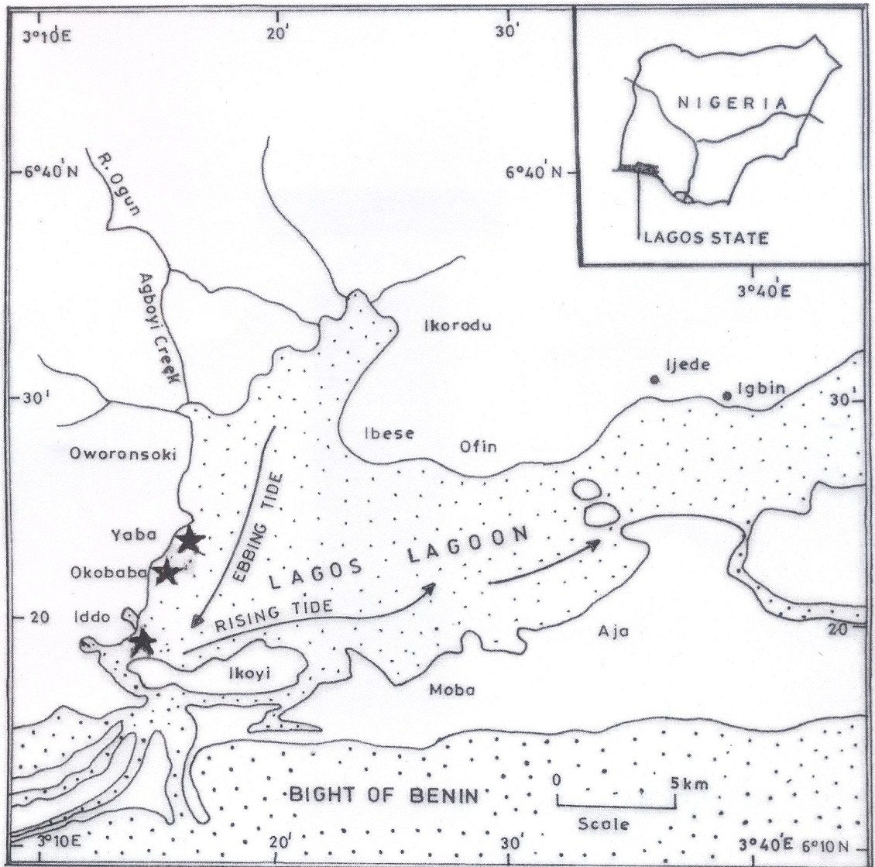

Figure 1: Lagos Lagoon showing sampling sites.

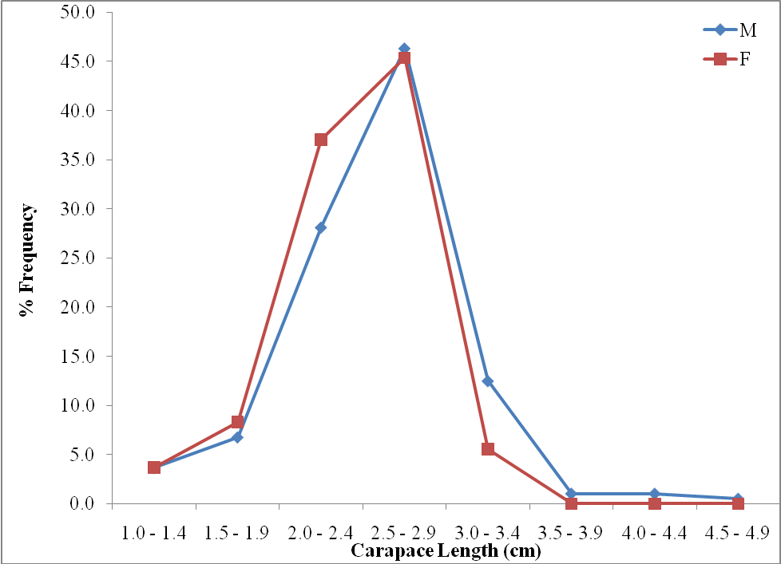

Figure 2. Carapace length frequency distribution of Sesarma huzardii from Lagos Lagoon mangrove swamps.

Table 1. Condition factor (K) by sex and size of Sesarma huzardii from mangrove swamps of Lagos Lagoon.
Carapace Length  (cm) | Male |  |  |  | Female |  |  |  | Combined Sex
Carapace Length  (cm) | N | CL | WT | K | N | CL | WT | K | N | CL | WT | K
1.0 - 1.4 | 14 | 1.1 | 1.8 | 13.5 | 8 | 1.1 | 1.7 | 12.8 | 22 | 1.1 | 1.8 | 13.1
1.5 - 1.9 | 26 | 1.7 | 5.4 | 11.0 | 18 | 1.6 | 5.1 | 12.5 | 44 | 1.7 | 5.3 | 11.7
2.0 - 2.4 | 108 | 2.2 | 10.9 | 10.2 | 80 | 2.1 | 10.6 | 11.4 | 188 | 2.2 | 10.8 | 10.8
2.5 - 2.9 | 178 | 2.6 | 16.4 | 9.3 | 98 | 2.6 | 15.1 | 8.6 | 276 | 2.6 | 15.8 | 9.0
3.0 - 3.4 | 48 | 3.0 | 18.9 | 7.0 | 12 | 3.0 | 17.3 | 6.4 | 60 | 3.0 | 18.1 | 6.7
3.5 - 3.9 | 4 | 3.5 | 24.6 | 5.7 | - | - | - | - | 4 | 3.5 | 24.6 | 5.7
4.0 - 4.4 | 4 | 4.0 | 28.5 | 4.5 | - | - | - | - | 4 | 4.0 | 28.5 | 4.5
4.5 - 4.9 | 2 | 4.5 | 32.8 | 3.6 | - | - | - | - | 2 | 4.5 | 32.8 | 3.6

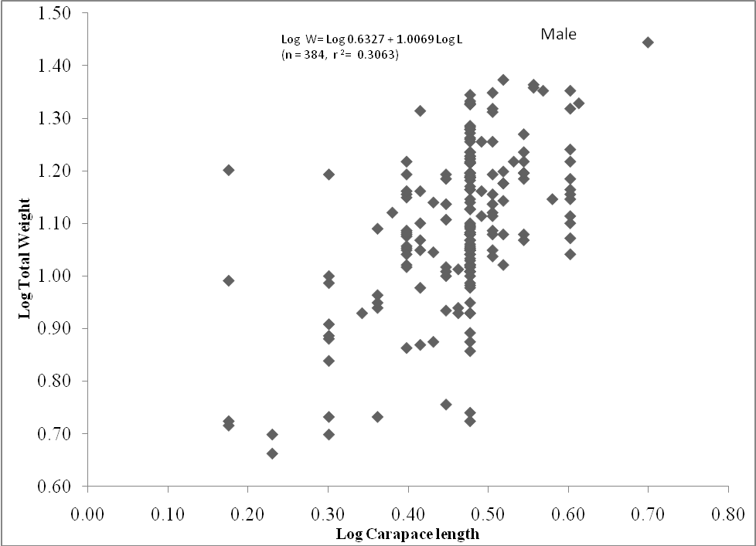

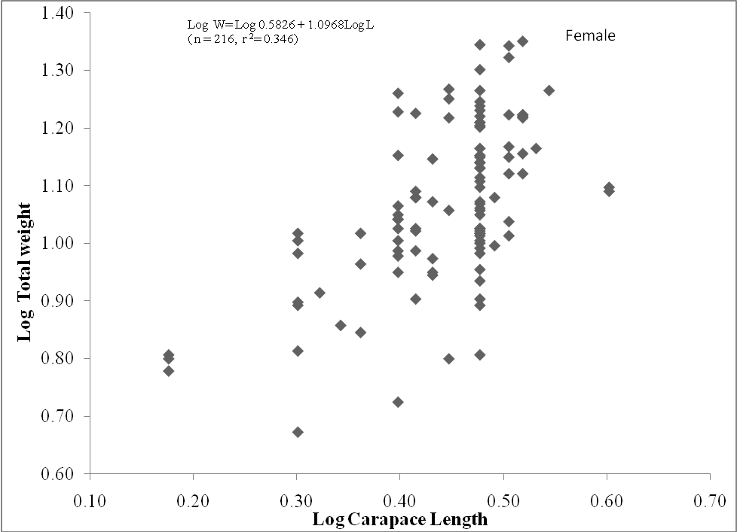

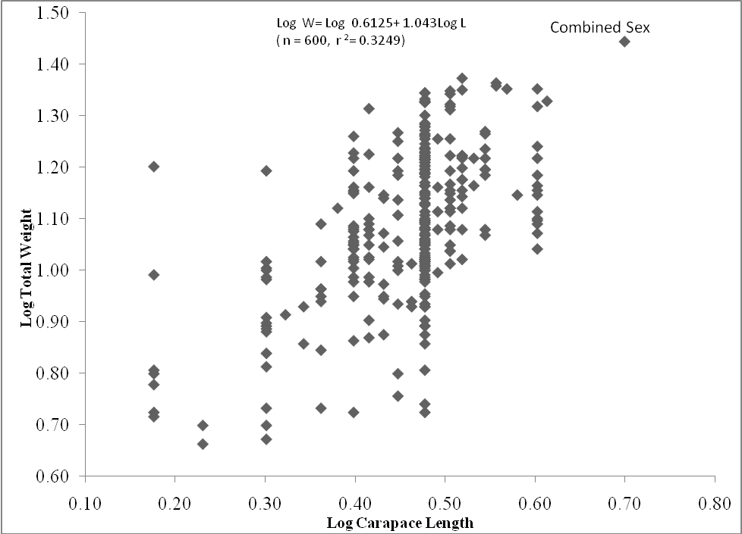

Figure 3. Log length / Log weight relationship of Sesarma huzardii from mangrove swamps of Lagos Lagoon.

Table 2. Summary of the stomach contents of Sesarma huzardii from the mangrove swamps of Lagos Lagoon.
Stomach Contents | Numerical Method |  | Occurrence Method
Stomach Contents | Number | % | Number | %
Algae | 9369 | 45.8 | 492 | 90.4
Diatoms | 10995 | 53.7 | 470 | 86.4
Insect parts | 104 | 0.5 | 90 | 16.5
Plant materials | - | - | 520 | 96.3
Unidentified mass | - | - | 484 | 89.0

Table 3. Growth Performance of Sesarma huzardii fed on different feedstuffs.
 | Tilapia | Fluted pumpkin | Mangrove grass | Red mangrove leaves | Hermit crab | White mangrove leaves | Green vegetable | Water leaf
No of crabs stocked | 20 | 20 | 20 | 20 | 20 | 20 | 20 | 20
Mortality | 6 | 2 | 0 | 0 | 2 | 0 | 2 | 3
Mean initial weight (g) | 15.5 | 13.6 | 9.1 | 7 | 8 | 4.8 | 13.2 | 16.8
Mean final weight (g) | 12.2 | 16.3 | 16.8 | 9.6 | 8.8 | 9.5 | 17 | 21
Mean increase in weight (g) | -3.3 | 2.7 | 7.7 | 2.6 | 0.8 | 4.7 | 3.8 | 4.2
% Weight gained | -21.3 | 19.9 | 84.6 | 37.1 | 10.0 | 97.9 | 28.8 | 25.0

DISCUSSION
The mangrove crab, S. huzardii examined in this study had carapace length of 1.5cm to 4.7cm and showed a unimodal size distribution. Unimodal size frequency was reported by Kwei (1978) for C. latimanus in two Ghanaian lagoons while Lawal-Are and Kusemiju (2000) documented it for C. amnicola in Badagry Lagoon. According to Kwei these results indicated that there was only one predominant generation of crabs sampled and the specimens belonged to the same year class in this case, in their first year of life.
S. huzardii from the mangrove swamps exhibited a highly negative allometric growth with b (correlation coefficient) values ranging between 1.0069 and 1.0768. Allometric growth in brachyuran crabs has been reported by Neville (1976), Hartnoll (1978), Oyenekan (1995), Lawal-Are and Kusemiju (2000).
The correlation coefficient (r) in the crabs (0.3063 for males, 0.3460 for females) was very low indicating that there was no linear relationship between length and weight in S. huzardii. This is contrary to very high correlation between length and weight reported by Kwei (1978) and Lawal-Are and Kusemiju (2000) for Callinectes sp.
The condition factor (K) for the mangrove crabs ranged from 3.1 to 18.8 and varied in relation to size of the crabs. Lawal-are and Kusemiju (2000) reported values of 5.67 to 9.97 for the blue crab, Callinectes amnicola in the adjacent Badagry Lagoon.
The crabs showed a carnivorous feeding habit as their stomach contents consisted of diatoms, algae, plant materials and insect parts. These were items commonly found in the mangrove swamps inhabited by the crab with the diatoms and algae coming in with the tidal water. Warner (1977) reported that crabs were opportunistic carnivore and this type of feeding was common in Carcinus sp, Cancer pagurus and C. sapidus. Lawal-Are (2009) reported that C. amnicola from the Lagos Lagoon was an opportunistic omnivore feeding mainly on fishes, crustaceans, molluscs, annelids and occasionally on plant materials.
The males were significantly more numerous than females. This differed from the nearly 1:1 ratio obtained for C. amnicola in the Lagos Lagoon by Lawal-Are (2010). Fecundity in S. huzardii was very high (1.2-3.5 million eggs). High fecundity has been reported in crab species. Kwei (1978) reported 1.9-2.8 million eggs in C. latimanus while Guillory et. al. (1996) documented mean fecundity of 3.2 million eggs for C. sapidus. According to Shields et. al. (1990), variations in fecundity may be caused by several ecological factors including habitat and biological constraints.
The egg diameter of S. huzardii ranged from 0.22 to 0.33mm with a mean of 0.24mm. This result is similar to Lawal-Are (2010) who obtained egg diameter of 0.25 to 0.35mm with a mean of 0,25mm for C. amnicola in the Lagos Lagoon.
In the feeding experiment, the crabs fed on white mangrove leaves and mangrove grass had the highest weight gain of 97.9% and 84.6% respectively. While these mangrove crabs may not be a food item for the coastal communities, they definitely help in keeping the mangrove ecosystem clean by feeding on the fallen and dead leaves. Olafsson et. al. (2002) reported that in Kenya East Africa mangrove decapod crab, Neosarmatium meinerti in the high intertidal Avicennia marina zone consumed on average 67% of the leaves placed on them within two hours while in the high zone, the crabs consumed appropriately twice the daily litter fall. The authors confirmed earlier studies indicating that N. meinerti may sweep mangrove forest floors clean of leaf litter.

REFERENCES
- Akin – Oriola, G., Anetekhai, M. and Olowonirejuaro, K. (2005). Morphometric and Meristic Studies in Two Crabs: Cardiosoma armatum and Callinectes pallidus. Turkish Journal of Fisheries and Aquatic Sciences 5: 85-89.
- Anetekhai, M., Owodeinde, F.G and Ogbe, F.G.(1994). Meristic and morphometric features, age and growth pattern in Cardiosoma armatum (Herklots) from Lagos Lagoon, Nigeria. Nigeria Journal of Science, 19(1): 12-18.
- Bagenal, T.B. (1978). Aspect of fish fecundity. In S.D. Gerking, (Ed.), Method of Assessment of Ecology of Freshwater Fish Production, Blackwell Scientific Publications, Blackwell, Oxford; 75-101.
- Bannister, J.V. (1976). The length – weight relationship, condition factor and gut contents of the Dolphin fish, Coryphaena hippurus (L) in the Mediterranean. Journal of Fish Biology, 9: 335-338.
- Cannicci, S., Dahdouh – Guebas F., Anyaona, D. and Vannini, M. (1995). Homing in the mangrove swimming crab, Thalamita crenata (Decapoda; Portunidae), Ethnology, 100: 424-452.
- Chindah, A.C., Tawari, C.C., Ifechukwude, K.A (2000). The food and feeding habits of the swimming crab, Callinectes amnicola (Portunidae) of the New Calabar River, Nigeria. Journal of Applied Science and Enviromental Management, 4: 51-57.
- Dahdouh – Guebas, F., Giuggioli, M., Oluoch, A., Vannini, M. and Cannicci, S. (1999). Feeding habits of non-ocypodid crabs from two mangrove forests in Kenya. Bulletin Marine Science, 64(2): 291-297.
- FAO (1992). Field guide to the commercial marine resources of the Gulf of Guinea. Food and Agricultural Organization of United Nations, Rome (Italy), 268pp
- Gillikin, D.P. (2004). Osmoregulatory ability of Chiromantes ortmanni (Crosnier, 1965) subjected to dilute and hypersaline seawater. Crustaceana, 77(1): 67 -74.
- Guillory, V., Prejean, E., Bourgeois, M., Burdon, J. and Merrell, J. (1996). A biological and fisheries profile of the blue crab, Callinectes sapidus. L.A. Department of Wildlife and Fisheries Management Plan Series, 8(1), 210pp.
- Hartnoll, R.G. (1978). The determination of relative growth in crustaceans. Crustaceana, 34 (3): 281-293.
- Hyslop, E.J. (1980). Stomach contents analysis and a review of the methods and their application. Journal of Fish Biology, 17: 411-429.
- Kwei, E.A. (1978). Size composition, growth and sexual maturity of Callinectes latimanus (Rath) in two Ghanaian lagoons. Zoological Journal of the Linnaean Society, 64 (2): 151-175.
- Lawal-Are, A.O. 2009. Food and feeding habits of the blue crabs, Callinectes amnicola (De Rocheburne) from three different interconnecting lagoons in South-West, Nigeria. European Journal of Scientific Research, 32 (1): 89-95.
- Lawal – Are, A.O. (2010). Reproductive Biology of the Blue Crab, Callinectes amnicola (De Rocheburne) in the Lagos Lagoon, Nigeria. Turkish Journal of Fisheries and Aquatic Sciences, 10: 1-7.
- Lawal – Are, A.O. and Kusemiju, K. (2000). Size composition, growth pattern and feeding habits of the blue crab, Callinectes amnicola (De Rocheburne) in the Badagry Lagoon, Nigeria. Journal of Scientific Research and Development, 5: 169-176.
- Neville, A.C. (1976). Animal asymmetry, Studies Biology, 67: 1-60.
- Okafor, F.C. (1988). The ecology of Sudanonautes africanus (Crustacea ; Decapoda) in south eastern Nigeria. Tropical Ecology, 29: 89-97.
- Olafsson, E., Buchmayer, S. and Skov., M.W. (2002). The East African decapod crab, Neosarmatium meinerti (de Man) sweeps mangrove floors clean of leaf litter. Ambio, 31 (7 – 8): 569-573.
- Oyenekan, J.A. (1995). Growth patterns in three brachyuran crabs in Lagos, Nigeria. Archie Hydrobiologia, 134(4): 533-546.
- Parsons, R. (1988). Statistical analysis – a decision – making approach. Second edition. Harper and Row Publishers, New York. 791pp
- Shields, J.D., Okazaki, R.K. and Kurts, A.M. (1990). Fecundity and the reproductive potential of the yellow rock crab, Cancer anthonyi. Fishery Bulletin, US, 89: 299-305.
- Warner, G.F. (1977). The Biology of Crabs. Paul Elek (Scientific Books) Ltd, London, 202pp.

7/8/2011

