Fate of cobalt and nickel in B. firmus and B. subtilis

El-Meleigy, M.A.¹; Abed, N.N.² and Sari, I. P. ²

¹Department of Biology Faculty of Education Shaqra University, Saudi Arabia
²Botany and Microbiology Department, Faculty of Science Al-Azhar University, Cairo, Egypt
elmeleigymagda@yahoo.com; nermin.abed@yahoo.com; ira_puspita_sari@yahoo.com

Abstract: Two bacterial isolates were isolated from Helwan city soil obtained from cement industry region, they tolerated high levels of cobalt and nickel. They identified as B. firmus and B. subtilis, the MIC for cobalt and nickel was 0.06 % (w/v). Proteins of metal tolerant bacterial isolates B. firmus and B.subtilis were fractionated and separated by using gel filtration on column of Sephadex G25. Different high and low molecular weight metaloproteins, metalothioneine and phytochelatins were obtained. Acid hydrolysates of those proteins revealed the presence of variable amounts of amino acids as methionine, glycine and high amounts of proline. Cells walls and membranes were thickened in presence of metal ions in the two tested bacteria. Endospore formation increased to overcome the dangerous effect of the metal ions. The endospores appeared with very thick spore wall and high dense intercellular due to Ni²⁺ precipitation and endospores became asymmetry ellipsoidal with high dark dense material due to Co²⁺ precipitation. Presence of Co²⁺ and Ni²⁺ ions in the cultivation medium metamorphosed cells and affected all cell constituents. Energy dispersive X-ray microanalysis (SEM-EDX) for B. firmus and B. subtilis at different concentrations of CoCl₂ and NiCl₂ (respectively) reveal the presence and absence of some essential and heavy metals ions.
[El-Meleigy, M.A.; Abed, N.N. and Sari, I. P. Fate of cobalt and nickel in B. firmus and B. subtilis]. Nature and Science 2011;9(8):175-]. (ISSN: 1545-0740). http://www.sciencepub.net.

Keywords: Heavy metals, cobalt, nickel, bacterial tolerance, metaloproteins, metalothioneine, chelators and x-ray microanalysis (SEM-EDX).

1. Introduction
Heavy metals influence the microbial population by affecting their growth, morphology, biochemical activities and ultimately resulting in decreased biomass and diversity (Roane and Pepper, 1999 and 2000). Heavy metals can damage the cell membranes, alter enzymes specificity, disrupt cellular functions and damage the structure of the DNA. Toxicity of these heavy metals occurs through the displacement of essential metals from their native binding sites or through ligand interactions (Bruins et al., 2000). Also, toxicity can occur as a result of alterations in the conformational structure of the nucleic acids and proteins and interference with oxidative phosphorylation and osmotic balance (Poole and Gadd, 1989, Bruins et al., 2000)).
Microorganisms may directly reduce many highly toxic metals (e.g., Cr, Hg, U) via detoxification pathways. Microbial reduction of certain metals to a lower redox state may result in reduced mobility and toxicity (Gadd, 2008). There are five basic mechanisms that convey an increased level of cellular resistance to metals: (1) efflux of the toxic metal out of the cell; (2) enzymatic conversion; (3) intra-or extracellular sequestration; (4) exclusion by a permeability barrier; and (5) reduction in sensitivity of cellular targets (Dopson et al., 2003).
The majority of heavy metals (density > 5) exhibit toxicity to all kinds of living being including bacteria at relative low concentrations (Bruins et al., 2000). Bacteria utilize different strategies to adapt to varying environmental situations including exposures to high concentrations of heavy metals. One of the strategies that bacteria adapt to cope with stress conditions is the change in morphology. Such changes were observed in phototrophic bacteria on exposure to metalloid oxyanions (Nepple et al., 1999) and in Pseudomonas putida and Enterobacter sp, in presence of toxic organic compounds (Neumann et al., 2005). Conditional lethality of cell shape mutations in Salmonella typhimurium (Costa and Anton, 1999) as another sample.
Many bacteria adapt to environmental stress through morphological changes, especially exposure to toxic heavy metals. Morphological alterations were induced when the bacterial cells were incubated with sub-inhibitory concentrations of some heavy metals (e.g., Cd, Cu, Ni and Zn). Loosely packed coccobacillus type normal cells formed characteristics chains of coccidal lenticular shape with constrictions at the junctions between them in presence of Cd or Ni. Cu induced transformation of cells to becoming round-shaped, while Zn turned the cells filamentous and aggregated (Chakravarty et al., 2007). Metal ion homeostasis is regulated principally by metalloregulatory proteins that control metal ion uptake, storage and efflux genes. Charles et al.(2005) have used transcriptional profiling to survey Bacillus subtilis for genes that are rapidly induced by exposure to high levels of metal ions including Ag(I), Cd(II), Cu(II), Ni(II) and Zn(II) and the metalloid As(V).
There is a preliminary evidence for the presence of the metalothionein like cadmium binding proteins in E.coli (Khazaeli and Mitra, 1981) whereas a metalothioneine like protein was purified from Pseudomonas putida (Higham et al., 1984). Metalothioneins, that have been reported in bacteria, cyanobacteria, algae, fungi and yeast is another mechanism involved in intracellular accumulation (Olafson, 1984). Metalothioneins are generally reported as small cysteine rich polypeptide that can bind essential metals such as Cu and Zn as well as non-essential metal like Cd and the function is metal detoxification (Butt and Ecker, 1987). Metalothioneins are cysteine-rich, low molecular weight (3500.14 KDa) peptides that chelate metal ions by thiolate coordination. MTs have received their designation from their prominent metal and sulfur content which, varying with the metal species present, together may contribute to over 20% of their weight (Mir et al., 2004). MTs are implicated in a variety of physiological processes, including maintaining homeostasis of essential metals, metal detoxification, scavenging free radicals, and regulating cell growth and proliferation (Palmiter, 1998; Vasak and Hasler, 2000).
Phytochelatins (PCs) are a family of small cysteine-rich peptides capable of binding heavy metal ions via their SH group. Their general structure is [GluCys]n-gly (n = 2 to 11). PCs are enzymatically synthesized by phytochelatin synthase from glutathione and have been found in some fungi( Cu-thionein Zn-thionein (Hartmann et al., 1979, Razak, 1989), Cd Chelators and Cu-thionein and chelators (El Meleigy, 1992), algae, and all plant species examined so far. This enzyme is activated by a broad range of heavy metals, including Cd, Ag, Pb, and Cu. PCs are with molecular masses which may vary, but which, according to the current literature, hardly seem to exceed 2 kDa in lower fungi (Collin-Hansen et al., 2007).
This search aims at isolation, identification and study the effect of nickel and cobalt on bacteria isolated from contaminated site, also study the fate of these metals in bacterial cells.

2. Material and Methods
Soil sample
A soil sample used for isolation of metal tolerant bacteria was obtained from zone beside cement factory at Hellwan, Egypt. The soil sample was tending to be alkaline and sandy texture. This soil contains high amounts of vanadium, iron, manganese, strontium and zinc. Moderate amounts of other heavy metals such as copper, cadmium, cobalt, nickel, molybdenum, chromium, aluminum and tellurium were also detected. Selenium was not detected.

Media used in isolation of bacteria
Nutrient agar (NA) medium incorporated with heavy metals 0.05% (w/v) of Co²⁺ as (CoCl₂) and Ni²⁺ as (NiCl₂) was used for isolation of metal tolerant bacteria. The medium was autoclaved at 1.5 atm for 15 minutes. Heavy metals were prepared separately and add to the medium after autoclaving and before bacterial cultivation.

Identification
Identification was only done for isolates which had highest minimum inhibitory concentration of Cobalt and Nickel. Identification included morphological studies, physiological and biochemical characteristics. Identification methods were based on Bergey’s Manual of Systematic Bacteriology (Williams, 1989 and Hensyl, 1994).

Determination of dry weight
Cells were harvested by filtration using pre-weighed filter papers, washing carefully with distilled water three times for medium removing, and then dried at 60-70 ºC to a constant weight. All the following measurements were made in triplicate and the results are expressed on an oven-dry weight basis.

Determination of Minimum Inhibitory Concentration of isolates
Minimum Inhibitory Concentration (MICs) of isolates grown on heavy metals incorporated media, against respective heavy metal was determined by gradually increasing the concentration of heavy metal. Nutrient broth liquid media supplement with different Ni²⁺ (NiCl₂) or Co²⁺ (CoCl₂) concentrations: 0; 0.005; 0.01; 0.02; 0.03; 0.04; 0.05 and 0.06% g /L (w/v). The initial pH value of the medium was adjusted at pH 7. Media of 100 ml were allotted among Erlenmeyer flasks of 250 ml capacity. Dry weights were determined.

Preparation of cell- free extracts
The harvested cells from 2 L liquid media (divided by 20 flasks each containing of 100 ml) were ground with an approximately equal volume of clean cold sand in a cold mortar and extracted with phosphate buffer solution (pH 7.1). The obtained slurry was centrifuged at 4000 rpm for 20 min. The supernatant was decanted and used for biochemical analysis.
Fractionation of protein on column of Sephadex G₂₅
Column (2.5×30 cm) was packed with Sephadex G₂₅ fine, washed with distilled water for 2 hours to allow settlement of the beds. The void volume and the uniformity of packing were determined using Blue Dextran 2000 and bromophenol blue. The concentrated extract was applied into the column and allowed to pass into the gel by running the column. Phosphate buffer pH 7 was then added without disturbing the gel surface, 50 fractions were collected each of 5.0 ml.

Determination of Protein
Determination of protein was carried out according to the method of Lowry et al. (1951).

Determination of Cobalt and Nickel
Determination of cobalt and nickel was carried out according to the methods used in American Society for Testing and Materials (2002).

Determination of amino acids composition by amino acid analyzer
Total amino acids were determined after acid hydrolysis of samples according to the method of Block et al. (1958).Samples of amino acids were injected to the amino acid analyzer (Eppendorf-LC 3000). The peak area and percentage of each amino acid were calculated by computer using software Axiom Chromatography-727, at Regional Center for Mycology and Biotechnology, Al Azhar University, Cairo Egypt.

Microanalysis by X-ray examination
Nutrient agar medium supplemented with different concentrations of Ni²⁺ (NiCl₂) and Co²⁺ (CoCl₂) separately were used from colony of isolates incubated at 30 ± 2ºC for 48 hours. In this study, the concentrations used were 0; 0.005; 0.02; 0.03; 0.05 and 0.06 % (w/v) CoCl₂ or NiCl₂. Microanalysis by X-ray used for detecting elemental composition in the isolate cell. Samples were examined under X-ray microanalyzer (Module Oxford 6587 INCA x-sight) attached to JEOL JSM-5500 LV scanning electron microscopy at 20 KV after gold coating using SPI- Module sputter coater. All methods were done at Regional Center for Mycology and Biotechnology, Al Azhar University, Cairo Egypt.

Microscopic studies
Light microscopy
Morphological features of the isolated bacteria were identified by using Gram stain slides under Olympus light microscopy made from control cultures as well as from the cultures grown at different concentrations of CoCl₂ and NiCl₂.

Electron microscopy studies
The two bacterial isolates were inoculated on nutrient broth medium supplemented with CoCl₂ or NiCl₂ at 0.02% (w/v) and the same medium free of metals. Specimens of each bacterial isolate were examined using a JEOL 1010 Transmission Electron Microscope at 80 KV at Regional Center for Mycology and Biotechnology, Al Azhar University, Cairo Egypt.

Statistical analysis
Statistical analysis was carried out using one way Analysis of Variance (ANOVA) with post test if P<0.05 and using software GraphPad InStat 3.06 Guide.

3. Results and Discussion
Two bacterial isolates were isolated on nutrient agar medium amended with 0.05 (w/v) g/L CoCl₂, named C1 and C2. Whereas three bacterial isolates were isolated on medium amended with 0.05 (w/v)g/L NiCl₂, they named N1, N2 and N3 by using soil spreading technique. Brookes and McGrath (1984) decided that, bacteria consists only a half content of microbial biomass in soil contaminated by heavy metals compared to uncontaminated soils.

Morphological characteristics of cobalt and nickel tolerant bacteria isolated from Hellwan city soil sample.
The shape of all bacterial colonies was circular and the colony surface was Shiny, smooth, also the colony texture was moist unless N3 was viscous. Colonies of C1 and N1 were cream in color while C2, N2 and N3 were had white color. N2 and N3 had flat colonies while N1 was convex. Elevation of C1 colony was umbionate while C2 had raised colony (Table 1). The colony margin was entire for all isolates unless N2 was undulate. The diameter of a representative colony was measured. The biggest size was N3 and smallest was N1. About 3 mm of size for C1 and C2.

Effect of different concentrations of cobalt chloride and nickel chloride on growth of metals tolerant bacterial isolates cultivated on nutrient agar medium
Heavy growth was obtained on cobalt free medium while by increasing cobalt concentration the bacterial growth was decreased. No growth was recorded at 0.07 % (w/v) by the two cobalt isolates (Table 2) and the three nickel isolates (Table 3). The five bacterial isolates had gradually grew till no growth on nutrient agar with heavy metal above 0.06%. No growth perhaps caused by the toxic effect of heavy metals. The toxic effect of nickel on bacterial cells like Pseudomonas tabica has a wide range of manifestations including inhibition of cell division, decreased viability and extensive plasmolysis etc (Sigee and Rabaee, 1986). Toxic effects of nickel have also been demonstrated in Escherichia coli and in marine bacteria (Cobet and Jones, 1971) in which nickel affect the DNA replication, transcription, and translation of the cells (Blundell and Wild, 1969; Webb, 1970; Guba and Mookerjee, 1979).

Determination of minimum inhibitory concentration (MIC) of bacterial isolates
MICs of the all bacterial isolates were 0.06 % CoCl₂ (w/v) for cobalt tolerant bacteria (Table 4) and 0.06 % NiCl₂ (w/v) nickel tolerant bacteria (Table 5). Increasing nickel concentration to 0.07 % (w/v) inhibited completely the bacterial growth. Mergeay et al. (1985) tested the MICs of several different metal ions for Escherichia coli on agar medium, showed that cobalt and nickel have the same value of MIC, 1 mM. Minimal inhibitory concentrations refer to the smallest concentration necessary to inhibit growth; thus, lower MIC values indicate more toxic metals and higher MICs indicate less toxicity. Gadd (1993 and 2008) reported that the toxic effect of metals depends on metal species and concentration, the organism and psycho-chemical factors of the environment. Metal such as Fe, Mn, Cu, Ni, Co and Zn are required for growth of many microorganisms, these same metals are toxic when present in the cytosol at elevated levels (Finney and O’Halloran, 2003). Nickel (commonly Ni (II)) is used in a few biologically important reactions, for example to form complexes with polypeptide chains (Cerruti et al., 1998). Many heavy metals are essentially required for microbial growth and functions. Trace elements such as manganese, nickel, iron, copper, zinc and molybdenum are required in very low concentrations as microelements (Doelman, 1986; Hughes and Poole, 1989a).

Identification of most tolerant bacterial isolates C2 and N3.
Identification of bacterial isolates was don on the basis of their physiological and biochemical characteristics (Table 6). Based on Bergey’s Manual of Systematic Bacteriology (Williams, 1989 and Hensyl, 1994) C2 isolate was Bacillus firmus and N3 isolate was Bacillus subtilis. Bacillus subtilis as one of nickel resistant isolates was isolated from industrial effluent exactly from the point of junction into main stream (Raihan, 2001). Grant and Long (1981) also reported that soils under stress (extremes of water activity, temperature, pH, etc.) generally have more Bacillus spp.Bacillus has been reported one of some genus as efficient chromium and nickel reducers (Gopalan and Veeramani, 1994; Yan and Viraraghavan, 2003). Many active transport systems in bacteria is specific, however, a few are known to transport metals with no known biological function, such as the manganese transport system in B. subtilis (Hughes and Poole, 1989b; McEldowney et al., 1994).

Fractionation of cell – free extract proteins of metal tolerant bacterial isolates B.firmus and B.subtilis using gel filtration on column of Sephadex G25.
Proteins in cell- free extracts of metal tolerant bacterial isolates B.firmus and B.subtilis were fractionated using gel filtration on a column of Sephadex G25 to separate different high and low molecular weights (Tables 7&8 , Figs. 1&2) metalloproteins and phytochelatins Proteins of B. firmus were fractionated among 50 fractions, out of them 46 fractions had cobalt protein materials. High percent of Co/protein was appeared in fraction No.10 followed by fraction No.9, those fractions containing high molecular weight proteins (metalloproteins). While fraction No. 22 represents a metallothionein fraction, which had high percent of Co/proteins .Low molecular weight peptides were appeared in fractions No. 41 ,22 and 43. Fractions No. 41 and 43 represented peptide model of very low molecular weight peptides, while fraction No. 22 represented a metallothionein fraction ,so, they were rich in sulphur containing amino acids ( may sulphur atom replacing by Co²⁺ atom in these compounds). Proteins of B.subtilis were fractionated in 52 fractions, out of them 34 fractions containing Ni ²⁺. Fraction No.12 represents a high molecular weight proteins conjugated with high amount of Ni ²⁺ and have high percentage of Ni/protein, while fractions No.32 and 33 represented metalothionein fractions with very high percentage of Ni/protein. Phytochelatins (Ni ²⁺ peptides) were represented in fractions No. 50, 51 and 52. All those fractions were subjected to analysis by amino acid analyzer to determine their content of amino acids.
All fractions are rich in methionine ( 26.6 , 4.93, 2.57 , 3.7 , 4.35 , 2.73, 5.33 , 5.07 , 5.33 and 3.63 (µg /ml) ) for fractions No.(12 ,17 , 20 ,23,27 , 32 , 33 ,50 , 51 and 52 ( respectively) ). Fraction No.12 and fraction No.23 which represented metaloproteins and metalothioneine (respectively). Variable amounts of all amino acids are present in each fraction especially proline (Tables 9&10).
The highest relative nickel content of protein fractions were located at fractions number 33 but some fractions also had high relative nickel content of protein which spread in a wide range from fraction 12 to 52. While fraction number 12 showed the peak value of ppm nickel. Fraction 12 and 33 was possibly metalothioneine. It showed that nickel relatively moderate MW and will replace sulphur atoms in the sulphur protein amino acid of moderate to low MW proteins. The synthesized low molecular weight protein of nickel content will be considered as nickelthionein as it has been mentioned for tellurothionein (El-Meleigy, 1987), Cu-thionein Zn-thionein (Hartmann et al., 1979), Cu-thionein (El-Meleigy, 1992) and this results also in agreement with the findings of Kagi and Vallee (1960) that metallothioneins are low molecular weight proteins, chemically unusual proteins. They have received their designation because of their extreme metal and sulphur content. Goulding et al. (1995) also reported that metalothioneine are ubiquitous low molecular weight proteins characterized by high cystein content and affinity for binding heavy metals. Possibly cobalt or nickel replaced sulphur atoms or absorbed onto the protein, such as happened in tellurium that reported by El -Meleigy (1987). It is possible that the detected metaloproteins contains high content of both extreme metal content and cobalt or nickel-protein amino acids. Such protein of relatively high cobalt or nickel content is probably one of non enzymic protein or more likely a metalothionein. Margoshes and Vallee (1957) reported that the detection of metaloproteins was associated with the presence of toxic metal in the environment. Metalothioneine was initially isolated as a cadmium containing metaloproteins. El-Meleigy (1987) reported that according to the principals of gel filtration on Sephadex G100, the detected tellurium is either incorporated into protein replacing sulphur atoms or just bound to protein molecule. She also reported that generally, the detection of such high level of tellurium may reflect the ability of the fungus to chelate tellurium either via its incorporation into non enzymic proteins; metalothionein or by its bound into protein molecules.
Proline plays important roles in osmoregulation (Ahmad and Hellebust, 1988; Laliberte and Hellebust, 1989), protection of enzymes (Paleg et al., 1984; Laliberte and Hellebust, 1989; Nikolopoulos and Manetas, 1991), stabilization of the machinery of protein synthesis (Kadpal and Rao, 1985), and scavenging of free radicals (Smirnoff and Cumbes, 1989). It also acts as an effective singlet oxygen quencher (Alia et al., 2001). Choudhary et al.(2006) reported increase in proline upon subjected of Spirulina platensis-S5 to heavy metals stress.

Electron microscopy studies on B.firmus and B. subtilis at different concentrations of CoCl₂ and NiCl2 (respectively).
Scanning and transmission electron microscopy were used to study the effect of different concentrations of metals used on metal ions in cells , cell measuring and cell structures of B.firmus and B. subtilis. Detection of metals present in bacterial cells was made using elemental analysis by scanning electron microscopy/energy dispersive X-ray microanalysis (SEM-EDX).
Sulpher not detected in bacterial cells cultivated at different concentrations of metals used .Also Co²⁺ ions and Ni ²⁺ ions not detected in cells cultivated at medium free of cobalt and nickel .By increasing cobalt concentration Cu²⁺ and Zn²⁺ released from the cells of B.firmus. As the concentration of cobalt increased some ions eliminated from the cells .Carbon and nitrogen concentrations were not changed in cells cultivated in cobalt free or containing medium (Table 11). Silicon increased in treated cells than in control ones while, sodium and magnesium were decreased dramatically. Again our results confirmed each other, that, Co²⁺ ions may replace sulpher, copper and zinc ions in treated cells.
B. subtilis cells cultivated at different concentrations of nickel had the same concentrations of carbon and oxygen to some extent compared with cells cultivated on nickel free medium. Sodium and magnesium decreased sharply in treated cells while silicon increased dramatically. It is known that silicon ions eliminate sodium ions in solutions (Table 12). Copper and zinc ions were decreased in treated cells than control and copper ions eliminated from cells cultivated at high Ni ²⁺ concentrations. Calcium also decreased by increasing Ni²⁺ concentration which indicated that it may replaced by silicon in bacterial cells.
The presence of Co²⁺ and Ni²⁺ ions in the cultivation medium metamorphosed cells and affect all cells constituents .Metal ions, especially Ca²⁺, maintain the lipopolysaccharide assembly on the surface of E. coli-a gram-negative bacterium (Kotra et al., 1999). Ion of Ca²⁺ plays many important roles in cellular metabolism and function after binding with a variety of proteins (Kuroki et al., 1989; da Silva and Reinach, 1991; Skelton et al., 1994; Ikura, 1996; Pidcock and Moore, 2001). As the divalent metal cations (Cd²⁺, Cu²⁺, Ni²⁺, Zn²⁺) are structurally similar Ca²⁺ (Huheey et al., 1993). It may be proposed that they replace Ca²⁺ from the binding sites because of their similar ligand, as the fact that higher amount of Ca²⁺ was found in the culture filtrate of Acidocella sp. GS19hrs treated (Chakravarty et al., 2007).
The cell wall of B. subtilis, as one type of Gram positive bacteria, has been well characterized and it has metal sequestering properties (Mc Lean et al., 2002). Cells length were decreased by (35% and 33.4 %) for B.firmus and B. subtilis (respectively) than cells cultivated in metal free medium ,also cells width of B.firmus were decreased by (9.25 %) than cells cultivated in metal free medium, while width of cells of B. subtilis were increased in nickel containing medium than nickel free medium by 13.49 %. Cells walls and membranes thickenings were increased in presence of metal ions in the two tested bacteria (Table 13). The thickening of the cell wall increased to be 2.79 and 1.27 fold, also membranes thickening increased by 1.27 and 1.07 fold than that of control of B.firmus and B. subtilis(respectively).
Raihan (2001) reported dense particles of cadmium salt were observed intracellularly in treated cells. Bacillus species produced large, floret and mucoid colonies in absence of nickel salt but in presence of nickel colonial size was significantly reduce. Microscopic analysis of the isolates showed differences in cellular size when grown in presence of cadmium and nickel salt. Pseudomonas aeruginosa cells appeared as small short rods, whereas B. subtilis (CMG57) produced more spores in presence of nickel salt as compared to those grown in absence of salt. By electron microscopy (negative staining), P. aeruginosa cells appeared as short thin rods in the presence of cadmium salt whereas they became coccobacilli in the absence of salt.
Examination of ultrathin sections of B. firmus cultivated on CoCl₂ free medium (Fig. 3a) appeared rod shaped vegetative cells capable of producing endospores, which are ellipsoidal and located in the center or sub terminal of the cell. Cell wall was a rigid structure surrounded the body of the cell with about the same thickness of each cell. The light-covered innermost membrane is the cytoplasmic membrane which surrounded by the darker-appearing cell wall and consisted of nucleoid and intracellular membrane systems such as mesosome. Cytoplasm was the dark dense part and the nucleoid was the light dense part in the cell.
Examination of ultrathin sections of B. firmus (Fig 3b) cultivated on 0.02% (w/v)CoCl₂ medium, showed: high dark dense cytoplasm due to Co²⁺ precipitation ; partially emptied (evacuated) with very thick cell wall; changing in the morphology of vegetative cells .The cell width became larger than before (Table 13). Vegetative cells lyses .Spores morphology also distorted and became much more smaller, endospore in the vegetative cell with high dark dense cytoplasm due to Co²⁺ precipitation; and changing the morphology of endospore which become asymmetry ellipsoidal .Some cells of Bacillus firmus showed dividing but the cell partially emptied with thick cell wall and the membrane cell wrinkled such that caused by plasmolysis.
Examination of ultrathin section of B. subtilis (Fig 4a) cultivated on NiCl₂ free medium appeared rod shaped vegetative cells capable of producing endospore which are ellipsoidal and located in the center of the cell or terminally. Some vegetative cells showed elongation phase to cell division. Dividing cells of B. subtilis showing formation of septum and prominent mesosomes associated with a newly forming cross wall. High dense cytoplasm due to Ni²⁺ precipitation and change of cell morphology was appeared by some vegetative cells. Cell wall became thickening, endospore formation increased to overcome the dangerous effect of the metal ions. While most of cells were in the endospore phase. The endospores appeared with very thick spore cell wall and intercellular high dense cytoplasm due to Ni²⁺ precipitation (Fig 4b).
Chakravarty et al.( 2007) studied bacterial cells in presence of some metal ions they reported, cells were mostly aggregated and in elongated form. In presence of Zn or Cu, blistering was also seen. When grown with Cd or Ni, the strain formed characteristic chains of coccidal lenticular cells with constrictions at the junctions between cells. In Cd²⁺ stressed cells, this filamentous appearance was measured having an average length of 6-7 µm, whereas an average length of 3.0-5.0 µm was found in case of Ni. And 3.0-3.5 µm in Zn supplemented medium. In this filamentous appearance, cells were also present in aggregated form though the number of log chains (three cells or more) decreased. While in presence of Cu, the rod shape was lost and the strain was observed as a mixed population of spherical and elongated cells in packed aggregation as well as in individual form. Uniform electron dense area on the surface of the cell was seen. There were some sticky appearance as evident from their overlapping nature with each other. Some cells showed even rougher surface structure and blister-like protrusions. In all cases, EDX (Energy Dispersive X-ray) spectra gave the evidence of metal deposition on the cell surface (Chakravarty et al., 2007).

Table (1): Colonial morphology of cobalt and nickel tolerant bacteria isolated from Hellwan city soil sample cultivated on nutrient agar medium amended with0.05 g/L (w/v) CoCl₂ or NiCl₂
Isolate No | Form | Size | Surface | Texture | Color | Elevation | Margin
C1 | Circular | 3 mm | Shiny, smooth | Moist | Cream | Umbionate | Entire
C2 | Circular | 3 mm | Shiny, smooth | Moist | White | Raised | Entire
N1 | Circular | 1-2 mm | Shiny, smooth | Moist | Cream | Convex | Entire
N2 | Circular | 2-3 mm | Shiny, smooth | Moist | White | Flat | Undulate
N3 | Circular | 4 mm | Shiny, smooth | Viscous | White | Flat | Entire

Table (2): Effect of different concentrations of cobalt chloride on growth of cobalt tolerant bacterial isolates cultivated on nutrient agar medium
Concentration of CoCl₂  (%) | Growth of isolates
Concentration of CoCl₂  (%) | C1 |  |  |  | C2
Concentration of CoCl₂  (%) | Time (Days)
Concentration of CoCl₂  (%) | 1st | 2nd | 3rd | 4th | 1st | 2nd | 3rd | 4th
0 | +++ | +++ | +++ | +++ | +++ | +++ | +++ | +++
0.01 | ++ | ++ | ++ | ++ | + | ++ | ++ | ++
0.02 | + | + | ++ | ++ | + | ++ | ++ | ++
0.03 | - | - | + | + | - | + | + | ++
0.04 | - | - | + | + | - | - | + | ++
0.05 | - | - | +/- | + | - | - | +/- | +
0.06 | - | - | - | +/- | - | - | +/- | +/-
0.07 | - | - | - | - | - | - | - | -
0.08 | - | - | - | - | - | - | - | -
0.09 | - | - | - | - | - | - | - | -
0.1 | - | - | - | - | - | - | - | -
+++ : heavy growth ++ : moderate growth + : low growth _ : no growth

Table (3): Effect of different concentrations of nickel chloride on growth of nickel tolerant bacterial isolates cultivated on nutrient agar medium
Concentration of NiCl₂ (%) | Growth of isolates
Concentration of NiCl₂ (%) | N1 |  |  |  | N2 |  |  |  | N3
Concentration of NiCl₂ (%) | Time (Days)
Concentration of NiCl₂ (%) | 1st | 2nd | 3rd | 4th | 1st | 2nd | 3rd | 4th | 1st | 2nd | 3rd | 4th
0 | +++ | +++ | +++ | +++ | +++ | +++ | +++ | +++ | +++ | +++ | +++ | +++
0.01 | ++ | ++ | +++ | +++ | ++ | +++ | +++ | +++ | ++ | ++ | ++ | ++
0.02 | - | + | ++ | ++ | - | + | ++ | ++ | + | ++ | ++ | ++
0.03 | - | + | ++ | ++ | - | - | + | + | - | +/- | + | +
0.04 | - | - | +/- | + | - | - | +/- | + | - | - | +/- | +
0.05 | - | - | +/- | + | - | - | +/- | + | - | - | +/- | +
0.06 | - | - | - | +/- | - | - | - | +/- | - | - | +/- | +/-
0.07 | - | - | - | - | - | - | - | - | - | - | - | -
0.08 | - | - | - | - | - | - | - | - | - | - | - | -
0.09 | - | - | - | - | - | - | - | - | - | - | - | -
0.1 | - | - | - | - | - | - | - | - | - | - | - | -
+++ : heavy growth ++ : moderate growth + : low growth _ : no growth

Table (4): Determination of minimum inhibitory concentration (MIC) of cobalt tolerant bacterial isolates
CoCl₂ Conc. % | C1  (mean Dry Wt.mg/100 ml medium ± SE) | C2  (mean Dry Wt.mg/100 ml medium ± SE)
Co free medium | 186 ± 0.0145 | 210 ± 0.0029
0,005 | 146 ± 0.0033 | 220 ± 0.0000
0,01 | 180 ± 0.0116 | 220 ± 0.0058
0,02 | 154 ± 0.0067 | 254 ± 0.0033
0,03 | 150 ± 0.0029 | 190 ± 0.0029
0,04 | 140 ± 0.0000 | 180± 0.0058
0,05 | 140 ± 0.0058 | 170 ± 0.0029
0,06 | 120 ± 0.0000 | 110 ± 0.0087 ***
*** Extremely significant vs 0 %

Table (5):Determination of minimum inhibitory concentration (MIC) of nickel tolerant bacterial isolates
NiCl₂ Conc.% | N₁ (mean Dry Wt.mg/100 ml medium ± SE | N₂ (mean Dry Wt.mg/100 ml medium ± SE | N₃ (mean Dry Wt.mg/100 ml medium ± SE
0 | 226 ± 0.012 | 186 ± 0,006 | 220 ± 0,009
0,005 | 106 ± 0.003 *** | 126 ± 0,003 | 186 ± 0,003
0,01 | 146 ± 0.003 | 180 ± 0,012 | 194 ± 0,009
0,02 | 180 ± 0.012 | 140 ± 0,000 | 260 ± 0,006
0,03 | 200 ± 0.012 | 120 ± 0,006 | 154 ± 0,003 *
0,04 | 146 ± 0.003 | 120 ± 0,006 | 146 ± 0,003 **
0,05 | 140 ± 0.000 * | 100 ± 0,012 | 140 ± 0,006 **
0,06 | 86 ± 0.003 *** | 80 ± 0,006 | 140 ± 0,006 **
*** Extremely significant ** very significant * significant

Table (6): Physiological and biochemical characteristics of the bacterial isolates C2 and N3
No | Test | C2 isolate | N3 isolate
1 | Gram staining | + | +
2 | Production of urease | - | -
3 | Motility | + | -
4 | Methyl Red | - | -
5 | Voges Proskauer | - | -
6 | Nitrate utilization | + | +
7 | H₂S production | - | -
8 | Gelatin liquefication | - | +
9 | Citrate utilization | + | -
10 | Indole Production | - | -
11 | Carbon Utilization
 | No carbon | + | -
 | Glucose | +++ | +
 | D-galaktose | +++ | +/-
 | Dextrin | +++ | +
 | mannitol | ++ | ++
 | D-fruktose | ++ | ++
 | L-sorpose | + | -
 | CMC | + | -
 | Lactose | +++ | +
 | Sucrose | ++ | +
 | Inositol | ++ | -
 | Cellobiose | + | +/-
 | D-xylase | ++ | -
 | D-ribose | +++ | -
 | maltose | +++ | +
12 | Nitrogen Utilization
 | DL-phenylalanine | + | -
 | L-asparagina | +++ (dark yellow) | +++
 | D-alanin | +++ (yellow) | +++
 | Cystein | ++ | +
 | L-tryptophan | ++ | -
 | L leucine | ++ | +
 | L-methionine | + | -
 | L-arginine | ++ | ++
 | D-L valin | ++ | +
13 | Various NaCl conc.
 | control | +++ | +++
 | 1% | ++ | +++
 | 2% | ++ | ++
 | 3% | ++ | -
 | 4% | ++ | -
 | 5% | +/- | -
 | 7% | - | -
 | 10% | - | -
 | 15% | - | -
 | 20% | - | -
14 | Temperature (ºC)
 | 20 | - | -
 | 30-32 | ++ | ++
 | 35 | ++ | +
 | 41-43 | +++ | _
 | 45 | +++ | _

Table (7): Fractionation of cell – free extract proteins of cobalt tolerant bacterial isolate B.firmus, cultivated on 0.02 % (w/v) CoCl₂ and fractionated on column (35 x 2.5 cm) of Sephadex G25
Fraction  No. | Protein (mg/5mL) | Cobalt (ppm) | Co/  protein% | Fraction  No. | Protein (mg/5mL) | Cobalt (ppm) | Co/  protein%
1 | 0,095 | <0,08 | 0,842 | 26 | 0,580 | <0,08 | 0,138
2 | 0,190 | <0,08 | 0,421 | 27 | 0,454 | <0,08 | 0,176
3 | 1,782 | <0,08 | 0,045 | 28 | 0,527 | <0,08 | 0,152
4 | 0,222 | <0,08 | 0,360 | 29 | 0,422 | <0,08 | 0,190
5 | 0,886 | <0,08 | 0,090 | 30 | 0,401 | <0,08 | 0,200
6 | 1,561 | <0,08 | 0,051 | 31 | 0,411 | <0,08 | 0,195
7 | 0,770 | <0,08 | 0,104 | 32 | 0,338 | <0,08 | 0,237
8 | 0,770 | 0,70 | 0,909 | 33 | 0,612 | <0,08 | 0,131
9 | 0,802 | 2,00 | 2,494 | 34 | 0,675 | <0,08 | 0,119
10 | 0,633 | 1,67 | 2,638 | 35 | 0,496 | <0,08 | 0,161
11 | 0,527 | 0,65 | 1,233 | 36 | 0,580 | <0,08 | 0,138
12 | 0,548 | <0,08 | 0,146 | 37 | 0,485 | <0,08 | 0,165
13 | 0,148 | <0,08 | 0,541 | 38 | 0,538 | <0,08 | 0,149
14 | 0,548 | <0,08 | 0,146 | 39 | 0,211 | <0,08 | 0,379
15 | 0,211 | <0,08 | 0,379 | 40 | 0,232 | <0,08 | 0,345
16 | 0,190 | <0,08 | 0,421 | 41 | 0,222 | <0,08 | 0,360
17 | 0,285 | <0,08 | 0,281 | 42 | 0,454 | <0,08 | 0,176
18 | 0,253 | <0,08 | 0,316 | 43 | 0,179 | <0,08 | 0,447
19 | 0,264 | <0,08 | 0,303 | 44 | 0,243 | <0,08 | 0,329
20 | 0,264 | <0,08 | 0,303 | 45 | 0,190 | <0,08 | 0,421
21 | 0,981 | <0,08 | 0,082 | 46 | 0,306 | <0,08 | 0,261
22 | 0,074 | <0,08 | 1,081 | 47 | 0 | 0 | 0
23 | 0,243 | <0,08 | 0,329 | 48 | 0 | 0 | 0
24 | 0,327 | <0,08 | 0,245 | 49 | 0 | 0 | 0
25 | 0,443 | <0,08 | 0,181 | 50 | 0 | 0 | 0

Table (8): Fractionation of cell – free extract proteins of cobalttolerant bacterial isolate B. subtilis, cultivated on 0.02% (w/v) NiCl₂ and fractionated on column (35 x 2.5 cm) of Sephadex G25
Fraction  No. | protein (mg/5mL) | nickel (ppm) | Ni/  protein | Fraction  No. | protein (mg/5mL) | nickel (ppm) | Ni/  protein
1 | 0,116 | 0 | 0 | 27 | 0,137 | 0,41 | 2,993
2 | 0,127 | 0 | 0 | 28 | 0,390 | 0 | 0
3 | 0,127 | 0 | 0 | 29 | 0,106 | 0,15 | 1,415
4 | 0,200 | 0 | 0 | 30 | 0,106 | 0 | 0
5 | 0,106 | 0 | 0 | 31 | 0,148 | 0,09 | 0,608
6 | 0,306 | 0 | 0 | 32 | 0,116 | 0,56 | 4,828
7 | 0,285 | 0 | 0 | 33 | 0,074 | 0,47 | 6,351
8 | 0,443 | 0 | 0 | 34 | 0,084 | 0 | 0
9 | 0,770 | 0,51 | 0,662 | 35 | 0,127 | 0,17 | 1,339
10 | 0,770 | 0,07 | 0,091 | 36 | 0,095 | 0,11 | 1,158
11 | 0,970 | 1,32 | 1,361 | 37 | 0,169 | 0,19 | 1,124
12 | 0,348 | 1,42 | 4,081 | 38 | 0,200 | 0 | 0
13 | 1,013 | 0,71 | 0,701 | 39 | 0,200 | 0,21 | 1,050
14 | 1,266 | 0,78 | 0,616 | 40 | 0,348 | 0 | 0
15 | 0,559 | 0,43 | 0,769 | 41 | 0,274 | 0,21 | 0,766
16 | 0,538 | 0 | 0 | 42 | 0,264 | 0 | 0
17 | 0,285 | 0,57 | 2,000 | 43 | 0,200 | 0 | 0
18 | 0,243 | 0,40 | 1,646 | 44 | 0,253 | 0,27 | 1,067
19 | 0,327 | 0,23 | 0,703 | 45 | 0,422 | 0,20 | 0,474
20 | 0,243 | 0,59 | 2,428 | 46 | 0,243 | 0,18 | 0,741
21 | 0,222 | 0,31 | 1,396 | 47 | 0,306 | 0,13 | 0,425
22 | 0,264 | 0,19 | 0,720 | 48 | 0,475 | 0,17 | 0,358
23 | 0,063 | 0,16 | 2,540 | 49 | 0,432 | 0,11 | 0,255
24 | 0,084 | 0 | 0 | 50 | 0,380 | 0,76 | 2,000
25 | 0,074 | 0 | 0 | 51 | 0,264 | 0,52 | 1,970
26 | 0,106 | 0,25 | 2,359 | 52 | 0,169 | 0,49 | 2,899

Table (9): Amino acids composition of high percentage of Co/protein fractions No. 9, 10, 11, 22, 41 and 43 of B. firmus
Amino Acid | Fraction No. Conc. Of amino acids (µg /ml)
 | 9 | 10 | 11 | 22 | 41 | 43
Aspartic | 4.398 | 3.893 | 2.401 | 2.539 | 5.878 | 6.563
Threonin | 4.846 | 5.881 | 4.609 | 1.184 | 6.032 | 4.517
Serine | 5.435 | 6.447 | 1.543 | 0.734 | 4.380 | 3.581
Glutamic | 0.039 | 1.421 | 0.183 | 0.037 | 0.136 | 0.394
Proline | 0.943 | 1.890 | 0.452 | 0.069 | 1.027 | 3.161
Glycine | 3.880 | 6.069 | 3.119 | 1.127 | 4.908 | 0.412
Alanine | 2.006 | 1.501 | 1.676 | 0.911 | 2.967 | 2.380
Valine | 0.274 | 0.248 | 0.106 | 0.060 | 0.154 | 1.561
Methionine | 1.407 | 0.115 | 0.072 | 2.311 | 7.781 | 2.220
Isoleucine | 0.465 | 0.793 | 2.709 | 0.274 | 1.367 | 2.474
Leucine | 1.612 | 0.598 | 0.128 | 0.071 | 1.711 | 0.891
Tyrosine | 0.591 | 0.221 | 0.477 | 0.061 | 0.544 | 3.103
Phenylalanine | 1.457 | 0.395 | 0.370 | 0.049 | 0.518 | 3.764
Histidine | 0.939 | 2.342 | 0.773 | 2.306 | 1.437 | 3.991
Lysine | 1.640 | 1.012 | 4.013 | 4.518 | 4.641 | 5.174
Arginine | 2.370 | 0.993 | 1.139 | 45.489 | 2.319 | 11.014

Table (10): Amino acids composition of high percentage nickel/ protein fractions No. 12, 17, 20, 23, 27, 32, 33, 50, 51 and 52 of B.subtilis
Amino acid | Fraction No. Conc. Of amino acids (µg /ml)
Amino acid | 12 | 17 | 20 | 23 | 27 | 32 | 33 | 50 | 51 | 52
Aspartic | 0.51 | 1.4 | 2.9 | 3.2 | 3.2 | 1.6 | 2.5 | 0.18 | 1.4 | 2.3
Threonin | 0.38 | 0.65 | 1.6 | 3.7 | 1.5 | 0.58 | 0.26 | 0.43 | 0.17 | 1.1
Serine | 0.14 | 0.22 | 2.3 | 3.8 | 2.5 | 0.19 | 0.09 | 0.77 | 0.13 | 1.8
Glutamic | 3.29 | 0.34 | 0.04 | 0.56 | 0.36 | 0.07 | 0.60 | 0.11 | 0.11 | 0.2
Proline | 0.52 | 1.2 | 0.83 | 0.06 | 0.52 | 0.19 | 1.4 | 1.6 | 1.6 | 1.8
Glycine | 1.79 | 0.70 | 0.18 | 2.2 | 1.9 | 0.44 | 1.8 | 0.37 | 0.89 | 2.7
Alanine | 1.40 | 1.8 | 0.07 | 1.7 | 0.31 | 0.04 | 0.25 | 0.32 | 0.29 | 0.60
Valine | 0.12 | 0.72 | 0.45 | 0.71 | 0.50 | 0.07 | 0.83 | 0.37 | 0.40 | 0.94
Methionine | 26.6 | 4.93 | 2.57 | 3.7 | 4.35 | 2.73 | 5.33 | 5.07 | 5.33 | 3.63
Isoleucine | 0.292 | 2.27 | 0.78 | 3.2 | 1.20 | 0.67 | 0.30 | 0.76 | 1.04 | 1.49
Leucine | 1.46 | 3.02 | 0.59 | 1.3 | 0.98 | 0.26 | 0.33 | 1.01 | 1.73 | 0.77
Tyrosine | 1.12 | 0.08 | 0.56 | 1.7 | 2.05 | 0.08 | 0.96 | 0.51 | 1.04 | 0.26
Phenylalanine | 1.84 | 0.38 | 1.64 | 0.87 | 1.82 | 0.06 | 1.62 | 0.58 | 0.28 | 0.99
Histidine | 2.04 | 2.81 | 1.38 | 0.72 | 2.69 | 3.59 | 0.86 | 0.23 | 5.01 | 3.38
Lysine | 3.67 | 1.98 | 1.13 | 1.35 | 3.02 | 1.69 | 2.19 | 3.26 | 2.71 | 1.92
Arginine | 1.59 | 1.27 | 1.02 | 5.47 | 2.10 | 0.77 | 1.48 | 1.95 | 2.77 | 0.91

Table (11): Elemental analysis by scanning electron microscopy/ energy dispersive X-ray microanalysis (SEM-EDX) of B. firmus cells at different concentrations of CoCl₂
Concentration of Co²⁺ (%) | 0 | 0.005 | 0.02 | 0.03 | 0.05 | 0.06
Element | % of Element ( Mean ± SD )
C | 43.860 ± 1.655 | 47.193 ± 0.911 | 45.537 ± 0.999 | 47.473 ± 1.085 | 48.760 ± 0.933 | 47.027 ± 1.376
O | 46.550 ± 3.249 | 51.840 ± 0.732 | 50.237 ± 1.772 | 51.757 ± 1.137 | 49.720 ± 1.952 | 51.413 ± 0.525
Na | 1.567 ± 0.337 | 0.390 ± 0.213 | 0.713 ± 0.110 | 0.517 ± 0.006 | 0.740 ± 0.311 | 0.633 ± 0.196
Mg | 0.920 ± 0.195 | 0.163 ± 0.045 | 0.410 ± 0.035 | 0.187 ± 0.040 | 0.290 ± 0.113 | 0.283 ± 0.144
Si | 0.193 ± 0.061 | 0.520 ± 0.085 | 0.283 ± 0.075 | 0.497 ± 0.058 | 0.585 ± 0.078 | 0.433 ± 0.167
P | 1.550 ± 0.550 | 1.473 ± 0.032 | 0.037 ± 0.110 | 1.493 ± 0.029 | 1.585 ± 0.106 | 0.973 ± 0.930
S | 0.583 ± 0.176 | N.D | N.D | N.D | N.D | N.D
Cl | 0.237 ± 0.117 | 0.193 ± 0.015 | 0.220 ± 0.069 | 0.203 ± 0.012 | 0.250 ± 0.057 | 0.200 ± 0.017
K | 0.180 ± 0.082 | 0.103 ± 0.051 | 0.153 ± 0.058 | 0.070 ± 0.017 | 0.165 ± 0.148 | 0.080 ± 0.035
Ca | 3.293 ± 0.668 | 0.810 ± 0.125 | 1.223 ± 0.318 | 0.730 ± 0.035 | 1.015 ± 0.431 | 0.830 ± 0.208
Co | N.D | 0.007 ± 0.071 | 0.047 ± 0.092 | 0.057 ± 0.023 | 0.060 ± 0.014 | 0.083 ± 0.023
Cu | 0.477 ± 0.471 | 0.290 ± 0.217 | 0.617 ± 0.254 | N.D | N.D | N.D
Zn | 0.587 ± 0.333 | 0.030 ± 0.131 | 0.523 ± 0.127 | N.D | N.D | N.D
N.D: not detected

Table (12): Elemental analysis by scanning electron microscopy/energy dispersive X-ray microanalysis (SEM-EDX) of B.subtilis cells at different concentrations of NiCl₂
Concentration of Ni²⁺ (%) | 0 | 0.005 | 0.02 | 0.03 | 0.05 | 0.06
Element | % of Element ( Mean ± SD )
C | 43.730 ± 4.226 | 44.830 ± 0.485 | 54.390 ± 1.264 | 47.503 ± 7.228 | 42.227 ± 4.013 | 50.163 ± 1.876
O | 35.613 ± 3.562 | 51.530 ± 0.762 | 40.690 ± 1.230 | 46.197 ± 5.999 | 55.250 ± 4.365 | 48.023 ± 1.155
Na | 2.117 ± 0.144 | 1.150 ± 0.087 | 1.113 ± 0.040 | 1.433 ± 0.237 | 1.007 ± 0.133 | 0.620 ± 0.173
Mg | 0.973 ± 0.040 | 0.313 ± 0.029 | 0.547 ± 0.058 | 0.707 ± 0.196 | 0.237 ± 0.064 | 0.280 ± 0.121
Si | 0.137 ± 0.046 | 0.477 ± 0.167 | 0.537 ± 0.110 | 0.563 ± 0.133 | 0.520 ± 0.225 | 0.640 ± 0.017
P | 3.143 ± 0.958 | 1.293 ± 0.439 | 0.143 ± 0.231 | 0.237 ± 0.150 | 0.610 ± 0.121 | 1.573 ± 0.219
S | 1.6 ±0.5 | N.D | N.D | N.D | N.D | N.D
K | 0.257 ± 0.133 | 0.397 ± 0.098 | 0.123 ± 0.040 | 0.170 ± 0.000 | 0.083 ± 0.006 | 0.237 ± 0.075
Ca | 9.780 ± 4.711 | 1.280 ± 0.242 | 1.250 ± 0.121 | 2.310 ± 0.797 | 0.610 ± 0.069 | 1.170 ± 0.294
Ni | N.D | 0.090 ± 0.087 | 0.117 ± 0.023 | 0.123 ± 0.029 | 0.157 ± 0.040 | 0.303 ± 0.081
Cu | 0.867 ± 0.497 | 0.777 ± 0.323 | 0.797 ± 0.115 | 0.697 ± 0.202 | 0.243 ± 0.058 | N.D
Zn | 1.797 ± 1.051 | 0.460 ± 0.087 | 0.573 ± 0.092 | 0.547 ± 0.115 | 0.267 ± 0.040 | 0.143 ± 0.185
N.D: not detected

Table (13): Effect of cobalt and nickel ions on measuring of cellconstituents of B. firmus and B. subtilis cultivated on 0.02% (w/v) CoCl₂ and NiCl₂ (respectively)
Cell  constituents | B. firmus |  | B. subtilis
Cell  constituents | Cobalt free medium | Cobalt containing medium | Nickel free medium | Nickel containing medium
Cell Length (nm) | 2494.8 ± 464.5 | 1623.4 ± 512.7 | 2404.0 ± 548.8 | 1600.8 ± 566.7
Cell Width (nm) | 860.4 ± 117.6 | 780.8 ± 37.6 | 614.5 ± 80.0 | 697.4 ± 147.8
Cell Wall thickness (nm) | 31.4 ± 9.4 | 87.7 ± 56.5 | 34.5 ± 6.7 | 44.0 ± 37.2
Cell Membrane thickness (nm) | 18.5 ± 6.0 | 23.5 ± 5.8 | 16.6 ± 2.7 | 17.9 ± 7.0
Result was presented as mean ± SD

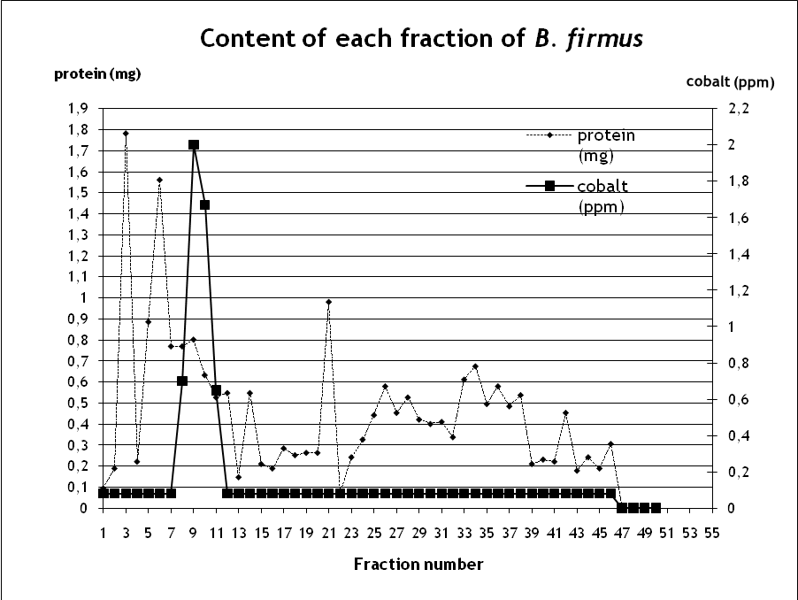

Fig. (1): Fractionation of cell – free extract proteins of cobalt tolerant bacterial isolate B.firmus, cultivated on 0.02% (w/v) CoCl₂ and fractionated on a column (35 x 2.5 cm) of Sephadex G25

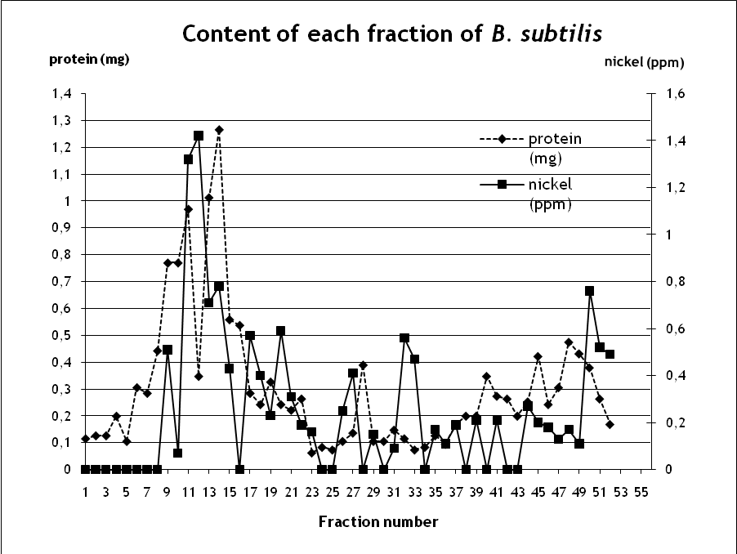

Fig. (2): Fractionation of cell – free extract proteins of nickel tolerant bacterial isolate B.subtilis, cultivated on 0.02 % (w/v) NiCl₂ and fractionated on a column (35 x 2.5 cm) of Sephadex G25

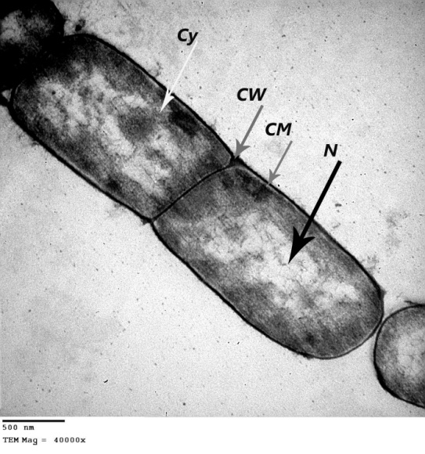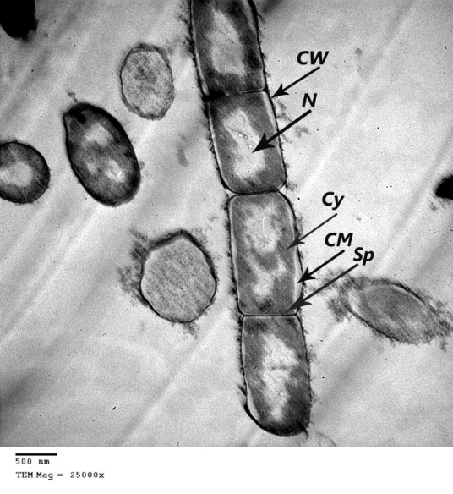
A B
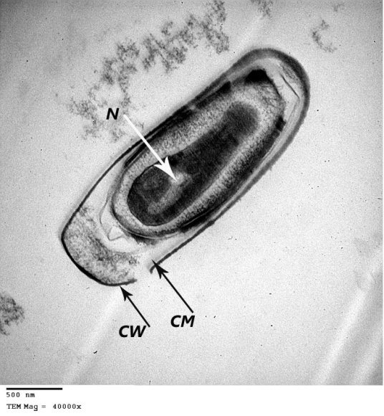
C
Fig. (3a): TEM Microphotograph of Bacillus firmus cells grown on nutrient agar medium free of CoCl_{2:} A and B, LS (longitudinal section) of vegetative cells; C, LS of endospore. CW, cell wall; CM, cell membrane; Cy, cytoplasm; N, nucleoid; Sp, septum. ( A.B= x50000; C,D= x30.000 and Bar= 500nm )

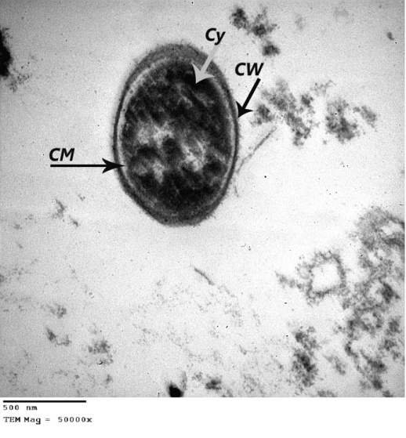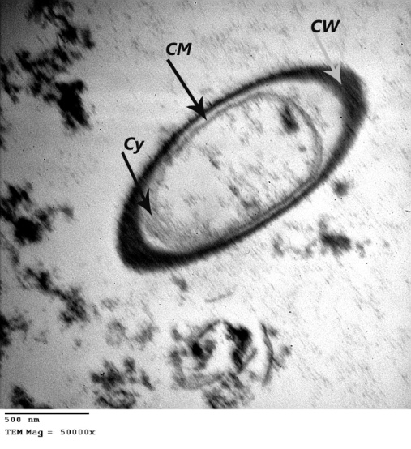
A B
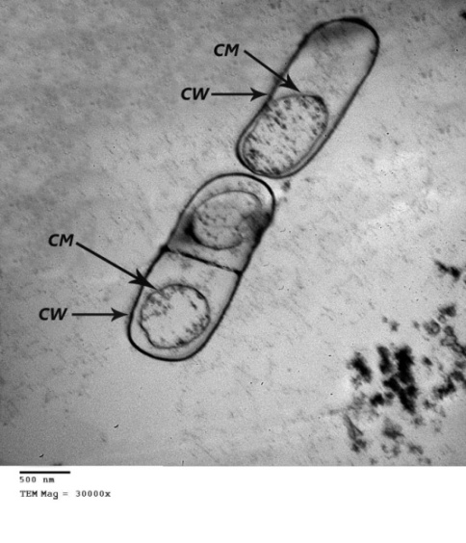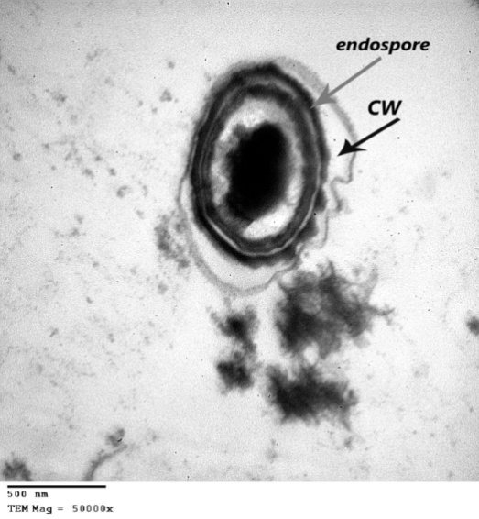
C D
Fig. (3b): TEM Microphotograph of Bacillus firmus cells grown on 0.02% of CoCl_{2:} A, TS of vegetative cell ,B and C, LS of vegetative cells and D, TS of vegetative cell obtained endospore; CW, cell wall; CM, cell membrane; Cy, cytoplasm. ( A.B= x50000; C,D= x30.000 and Bar= 500nm )

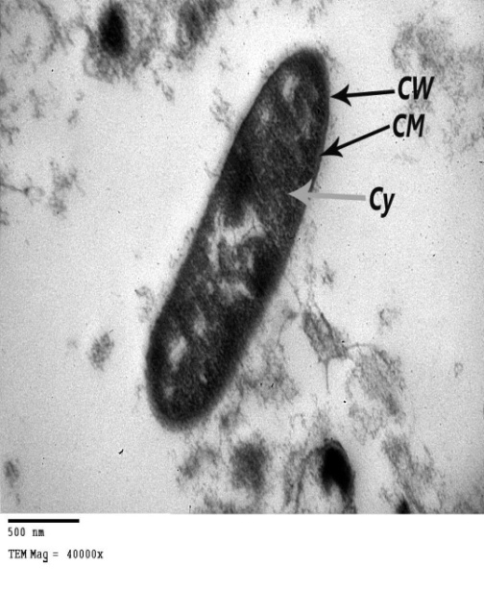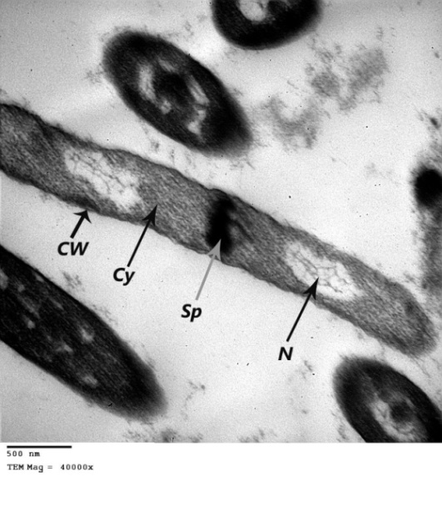
A B
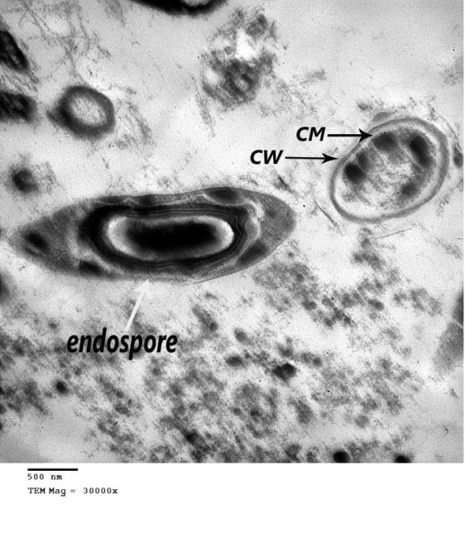
C
Fig. (4a): TEM Microphotograph of Bacillus subtilis cells grown on medium free of NiCl_{2:} A and B, LS (longitudinal section) of vegetative cells; C, LS of endospore. CW, cell wall; CM, cell membrane; Cy, cytoplasm; N, nucleoid; Sp, septum. (A,B= x40000; C,D= x30000 and Bar= 500nm )
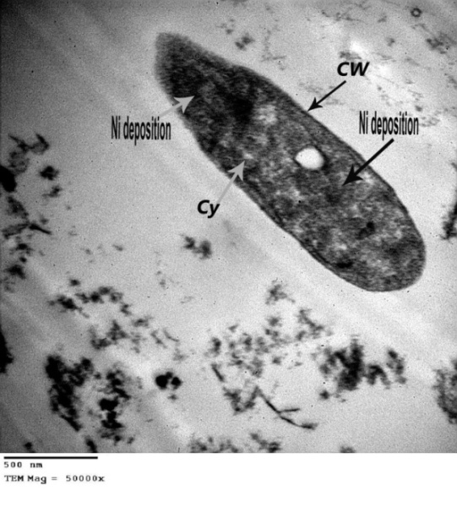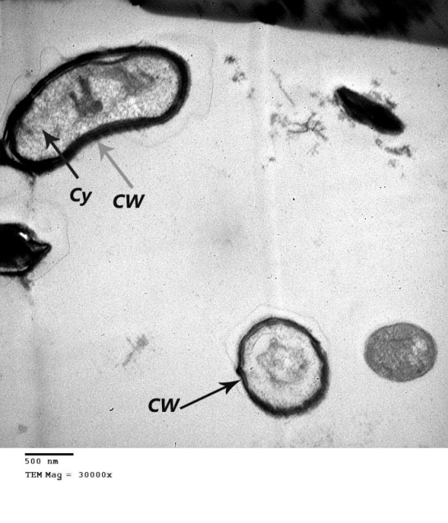
A B
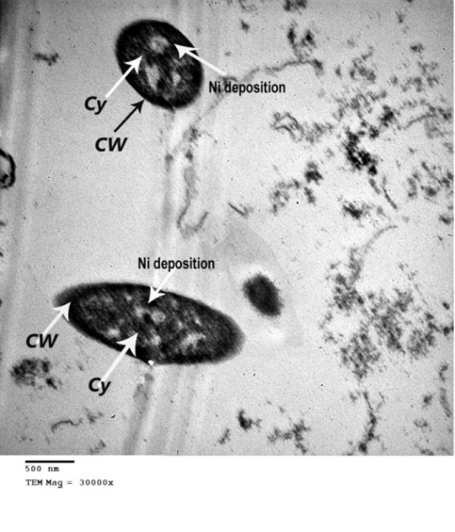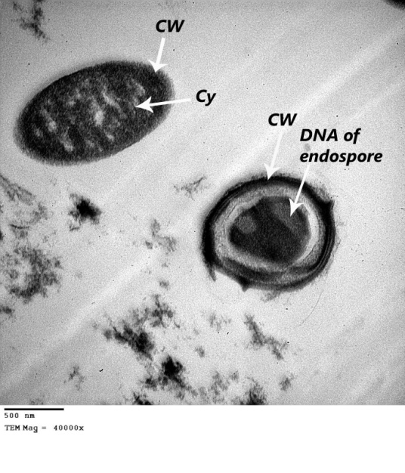
C D
Fig. (4b): TEM Microphotograph of Bacillus subtilis cells grown on 0.02% NiCl₂: A, B and C, LS (longitudinal section) of vegetative cell; D, LS of cell and TS (transactional section) of endospore. CW, cell wall; CM, cell membrane; Cy, cytoplasm.

Conclusion
The presence of nickel and cobalt in the culture medium of B.firmus and B. subtilis resulted in, production of metalothioneine, metaloproteins and metal chelators. Increase of sporulation and metamorphosed cells. Sequestration of metals inside cells displacement of some essential metals from cells and thickening of cell wall and shortening of cells. Future study must be concentrate on gens which affected in the presence of these metal ions in bacterial cells leading to these changes.

Corresponding Author
Sari, I. P
Botany and Microbiology Department, Faculty of Science Al-Azhar University, Cairo, Egypt
ira_puspita_sari@yahoo.com

References
Ahmad, I. and Hellebust, A. (1988): The relationship between inorganic nitrogen metabolism and proline accumulation in osmoregulatory responses of two euryhaline microalgae. Plant Physiol., 88: 348–354
Alia, P.; Mohanty, P. and Matysik, J. (2001): Effect of proline on the production of singlet oxygen. Amino Acid, 21: 195–200
American Society for Testing and Materials (2002). Annual Book of ASTM Standards. Vol. 11
Block, R.J.; Durrum, E.L. and Zweig, B. (1958): A manual of paper chromatography and paper electrophoresis. 2nd ed. Academic Press, INC Publishers. New York. 218p
Blundell, M.R. and Wild, D.G. (1969): Ribosome precursors accumulated by E. coli during incubation with cobalt chloride. Biochem. Jr. 115: 213-223
Brookes, P.C. and Mcgrath, S.P. (1984): Effect of metal toxicity on the size of the soil microbial biomass. J. Soil Sci., 35: 219- 220
Bruins, M.R.; Kapil, S. and Oehme, F.W (2000): Microbial resistance to metals in the environment. Ecotoxicology and Environmental Safety. 45:198-20
Butt, T.R. and Ecker, D.J. (1987): Yeast metallothionein and applications in biotechnology. Microbiol. Rev., 51: 351-364
Cerruti, C.; Curutchet, G. and Donati, E. (1998): Bio-dissolution of spent nickel-cadmium batteries using Thiobacillus ferrooxidans. J. Biotechnol., 62: 209-219
Chakravarty, R.; Manna, S.; Ghosh, A.K. and Baerjee, P.C. (2007): Morphological changes in an Acidocella strain in response to heavy metal stress. Research Journal of Microbiology, 2: 742-748
Charles, M.M.; Gaballa, A.; Hui, M.; Ye, R.W. and Helmann, J.D. (2005): Genetic and physiological responses in Bacillus subtilis to metal ion stress. Mol Microbiol., 57: 27-40
Choudhary, M.; Jetley, U.K.; Khan, M.A.; Zutshi, S. and Fatma, T. (2006): Effect of heavy metal stress on proline, malondialdehyde, and superoxide dismutase activity in the cyanobacterium Spirulina platensis-S5. Ecotoxicology and Environmental Safety. 66: 204-209
Cobet, A.B. and Jones, G.E. (1971): The effect of nickel on a marine bacterium: fine structure of Arthrobacter marinus. J. Gen. Microbiol., 66: 185-196
Collin-Hansen, C.; Pedersen, A.S.; Andersen, R.A. and Steinnes, E. (2007): First report of phytochelatins in a mushroom: induction of phytochelatins by metal exposure in Boletus edulis. Mycologia., 99: 161-174
Costa, C.S. and Anton, D.N. (1999): Conditional lethality of cell shape mutations of Salmonella typhimurium: rodA and mre mutants are lethal on solid but not in liquid medium. Curr. Microbiol., 38: 137-142
Da Silva, A.C.R. and Reinach, F.C. (1991): Calcium binding induces conformational changes in muscle regulatory proteins. Trends Biochem. Sci., 16: 53-57
Doelman, P. (1986): Resistance to soil microbial communities to heavy metal. FEMS. Symp., 33: 369-384
Dopson, M.; Baker-Austin, C.; Koppineedi, P.R. and Bond, P.L. (2003): Growth in sulfidic mineral environments: metal resistance mechanisms in acidophilic micro-organisms. Microbiology, 149: 1959-1970
El Meleigy, M.A. (1987): Microbiological and biochemical studies on some tellurotolerant fungi. Thesis submitted for the degree of Ph.D. Department of Botany, Faculty of Science for Girls, Al-Azhar University
El Meleigy, M.A. (1992): Copper organo-chelators in Aspergillus fumigatus and Penicillium chrysogenum. Biol Trace Elem Res., 34: 177-183
Finney, L.A. and O’Halloran, T.V. (2003): Transition metal speciation in the cell: Insights from the chemistry of metal ion receptors. Science, 300 (5621): 931-936
Gadd, G.M. (1993): Interaction of fungi with toxic metals. New Phytologist., 124: 25-60
Gadd, G.M. (2008): Bacterial and fungal geomicrobiology: a problem with communities. Geobiology, 6: 278-284
Gopalan, R. and Veeramani, H. (1994): Studies on microbial chromate reduction by Pseudomonas sp. In aerobic continous suspended growth cultures. Biotech. Bioeng., 43: 471-476
Goulding, H.; Jasani, B.; Pereira, H.; Reid, A.; Galea, M.; Bell, J.A.; Elston, C.W.; Robertson, J.F.; Blamey, R.W.; Nicholson, R.A.; Schmid, K.W. and Ellis, I.O. (1995): Metallothionein expression in human breast cancer. British Journal of Cancer, 72: 968-972
Grant, W.D. and Long, P.E. (1981): Environmental Microbiology. Tertiary level biology. Blackie and Son. Glasgow and London
Guba, C. and Mookerjee, A. (1979): Effect of nickel on macromolecular synthesis in Escherichia coli K-12. The Nucleus, 22: 45-47
Hartmann, H.J.; Rupp, H. and Weser, V. (1979): Oxidation-reduction reactions of copper-thiolate centres in Cu-thionein. Biochim Biophys Acta, 578: 462-475
Hensyl, W.R. (1994): Bergey’s Manual of systematic bacteriology 9th, Baltimore, Philadeiphia, Hong Kong, London, Munich, Sydney, Tokyo
Higham, D.P.; Sadler, P.J. and Scawen, M.D. (1984): Cadmium resistance in Pseudomonas putida; growth and uptake of cadmium. J. Gen. Microbiol., 131: 2539-2544
Hughes, M.N. and Poole, R. K. (1989a): Metal mimicry and metal limitation in studies of metal-microbe interactions. (eds: Poole, R.K., Gadd, G.M.) Metal-Microbe Interactions. IRL Press, Oxford. 1-17p
Hughes, M.N. and Poole, R. K. (1989b): Metals and microorganisms. Chapman and Hall. London
Huheey, J.E.; Keiter, E.A. and Keiter, R.L. (1993): Inorganic Chemistry: Principles of structure and reactivity. 4th edition. Harper Collins College Publishers, New York. 577-622p
Ikura, M. (1996): Calcium binding and conformational response in EF-hand proteins. Trends Biochem. Sci., 21: 14-17
Kadpal, R.P. and Rao, N.A. (1985): Alteration in the biosynthesis of proteins and nucleic acid in finger millet (Eleucine coracana) seedling during water stress and the effect of proline on protein biosynthesis. Plant Sci., 40: 73–79
Kagi, J.H.R. and Vallee, B.L. (1960):Metalothioneins : a cadmium and zinc containing protein from Equine Renal Cortex, J. Biol. Chem.,235: 3460-3465
Khazaeli, M.B. and Mitra, R.S. (1981): Cadmium binding competant in E. coli during accommodation to levels of this ion. Appl. Environ. Microbiol., 41: 46-50
Kotra, L.P.; Golemi, D.; Amro, N.A.; Liu, G.Y. and Mobashery, S. (1999): Dynamics of the lipopolysaccharide assembly on the surface of E. coli. J. Am. Chem. Soc., 121: 8707-8711
Kuroki, R.; Taniyama, Y.; Seko, C.; Nakamura, H.; Kikuchi, M. and Ikehara, M. (1989): Design and creation of a Ca²⁺ binding site in human lysozyme to enhance structural stability. Proc. Natl. Acad. Sci., 86: 6903-6907
Laliberte, G. and Hellebust, J.A. (1989): Regulation of proline content of Chlorella autopica in response to change in salinity. Can. J. Bot., 67: 1959–1965.
Lowry, O.H.; Rosebrough, N.J.; Farr, A.L. and Randall, R.J. (1951): Protein measurement with the folin-phenol reagents. J. Biol. Chem., 193: 265-275
Margoshes, M. and Vallee, B.L. (1957): A cadmium protein from equine kidney cortex. J. am. Chem. Soc. 79: 4813-4814
McEldowney, S.; Hardman, D.J. and Waite, S. (1994): Pollution Ecology and Biotreatment. Longman, Singapore Publishers (Pte) Ltd., Singapore. 272p.
McLean, J.S.; Lee, J.U. and Beveridge, T.J. (2002): Microbial influence on metal mobility and application for: Fundamentals of soil particle microorganism interaction. John Willey and Sons. 229p
Mergeay, M.; Nies, D.; Schlegel, H.G.; Gerits, J.; Charles, P. and Van Gijsegem, F. (1985): Alcaligenes eutrophus CH34 is a facultative chemolothotroph with plasmid-bound resistance to heavy metals. J. Bacteriol., 162 (1): 328-349
Mir, G.; Domenech, J.; Huguet, G.; Guo, W.; Goldsbrough, P.; Atrian, S. and Molinas, M. (2004): A plant type 2 metallothionein (MT) from cork tissue responds to oxidative stress. J. Exp. Bot., 55: 2483-2493
Nepple, B.B.; Flynn, I. and Bachofen, R. (1999): Morphological changes in phototrophic bacteria induced by metalloid oxyanions. Microbial. Res., 154: 191-198
Neumann, G.; Veeranagouda, Y.; Karegoudar, T.B.; Sahin, O.; Mausezahl, I.; Kabelitz, N.; Kappelmeyer, U. and Heipieper, H.J. (2005): Cells of Pseudomonas putida and Enterobacter sp. adapt to toxic organic compounds by increasing their size. Extremophiles, 9: 163-168
Nikolopoulos, D. and Manetas (1991): Compatible solutes and in vitro stability of Salsola soda enzyme: proline incompability. Phytochemistry, 30: 411–413
Olafson, R.W. (1984): Prokaryotic metallothionein. Int. J. Pest. Res., 24: 303-308
Paleg, L.G.; Steward, G.R. and Bradbeer, J.W. (1984): Proline and glycine betaine influence proline salvation. Plant Physiol., 75: 974–978
Palmiter, R.D. (1998): The elusive function of metallothioneins. Proc. Natl. Acad. Sci., 95: 8428-8430
Pidcock, E. and Moore, G.R. (2001): Structural characteristics of protein binding sites for calcium and lanthanide ions. J. Biol. Inorg. Chem., 6: 479-489
Poole, R.K. and Gadd, G.M. (1989): Metals: Microbe interactions. IRL Press. Oxford. 1-37p
Raihan, S. (2001): Studies on Mechanism of Bacterial Resistance to Cadmium and Nickel. Thesis submitted for the degree of Ph.D in genetics. Department of Genetic University of Karachi. Pakistan
Razak, A.A. (1989): Incorporation of cadmium into proteins in a cadmium tolerant fungi. Biol. Trace Elem. Res., 3: 277-285
Roane, T.M. and Pepper, I.L. (1999): Microorganisms and Metal Pollutants”.in Environmental Microbiology Maier, R., M, Gerba, C.P., Pepper, I.A.(Eds.),. Academic press, San Diago, California, London. 403p
Roane, T.M. and Pepper, I.L. (2000): Microbial responses to environmentally toxic cadmium. Microbial Ecology, 38:358-364
Sigee, D.C. and Rabaee, R.H.A. (1986): Nickel toxicity in Pseudomonas tabaci: Single cell and bulk sample analysis of bacteria cultured at high cation levels. Protoplasma., 130: 171-185
Skelton, N.J.; Kordel, J.; Akke, M.; Forsen, S. and Chazin, W.J. (1994): Signal transduction versus buffering activity in Ca²⁺ binding proteins. Nat. Struct. Biol., 1: 239-245
Smirnoff, N. and Cumbes, Q.J. (1989): Hydroxyl radical scavenging activity of compatible solute. Phytochemistry, 28:1057–1060
Vasak, M. and Hasler, D.W. (2000): Metallothioneins: New functional and structural insights. Curr. Opin. Chem. Biol., 4: 177-183
Venekemp, J.H. (1989): Regulation of cytosolic acidity in plants under condition of drought. Plant Physiol., 76: 112–117
Webb, M. (1970): The mechanism of acquired resistance to Co²⁺ and Ni²⁺ and G-ve bacteria. Biochem. Biophys. Acta, 222: 440-446
Williams, S.T. (Ed.) (1989): Bergey’s manual of systematic bacteriology. Baltimore, Hongkong, London, Sydney. Vol. 4
Yan, G. and Viraraghavan, T. (2003): Heavy metal removal from aqueous solution by fungus Mucor rouxii. Water Res., 37: 4486-4496.

7/8/2011

