Evaluation of Compost Fortified with Trichoderma Spp. Isolates as Biological Agents against Broomrape of Chamomile Herbs

Lobna S. Nawar¹ and Ahmed F. Sahab^{*2}

¹Biology Dep., Fac. of Science, King Abd El-Aziz Univ., Jeddah, Saudi Arabia.
²Plant Pathology Dept., NRC, Dokki, Cairo, Egypt
*ahmedsahab2002@yahoo.co.uk

Abstract: Several diseased broomrape samples were collected from different fields of tomato, broad bean and chamomile cultivation located in Egypt. One hundred and seventy seven fungal isolates were recorded on PDA medium from diseased orobanche samples mainly, Alternaria alternate, Aspergillus spp., Cephalosporium spp., Fusarium oxysporum, Fusarium spp., Penicillium spp. and Trichoderma spp. Pathogenicity test showed that Chaetomium sp., F. oxysoprum , F. solani, R. solani, Sclerotium rolfsii and T. harzianum attacked living tissues of Orobanche. ramose segments causing black lesion, soft rot and complete deterioration within 7 days (100%).
The average number of bacteria in the rhizosphere of chamomile plants of infested soil with orobanche seeds was lower than that the corresponding figures of the control (untreated plants), as the average count was decreased from 605.2 to 597.9 cfu x 10⁴ colonies / 1g (1.19%) respectively. The same trend was also observed in the rhisosphere of chamomile plants taken from the root infested with orobanche seeds and applied with compost + T. viride (18.81%), followed by plant guard treatment (7.26%). However, the infestation of soil with orobnanche seeds alone increased the average of total fungal community in the rhisosphere of chamomile from 49.6 to 61.6 cfu x 10³ colonies /g (24.20%). Also, the application of soil with compost + T. viride , compost + T. hammatum and/ or plant guard reduced the total fungi, as the averages numbers in the rhizosphere of these treatments reduced the average from 61.6 cfu x 10³ colonies /g in the control to 24.3, 43.3 and 17.7 cfu x 10³ colonies /g respectively. One the other hand, opposite trends was observed when soil was applied with compost + T. harzianum.The application of chamomile plants with compost fortified with T. harzianum disappeared or reduced the average percentage occurrence of Alternaria, Fusarium , Phycomycetes and synchetrium spp. by 67.16%, 27.62, 11.04, 100.0 and 13.83% respectively. Whereas, the same treatment stimulated the growth of Trichoderma spp. and sterile fungal spp. by 12.14 and 3.04 folds respectively. Application of T. harzianum and plant guard resulted in a reduction of number of orobanche shoots from 9 to 1 (88.9%) in comparison with the control, however the other two species of Trichoderma (T. viride and T. hamatum) were also effective in reducing the orobanche shoot numbers from 9 in the control to 3 (66.7%).
[Lobna S. Nawar and Ahmed F. Sahab. Evaluation of Compost Fortified with Trichoderma Spp. Isolates as Biological Agents against Broomrape of Chamomile Herbs]. Nature and Science 2011;9(8):229-236]. (ISSN: 1545-0740). http://www.sciencepub.net.

Keywords: Orobanche ramose, rhizosphere microorganisms, mycoherbicides, biological control

1. Introduction
Chamomile plant (Camomilla reculata) is grown in Egypt for many centuries and is used for medical and industrial purposes. This plant is subjected to attack with Orobanche ramosa that cause tremendous damage during growth stages (Hassan et al., 2004). The parasitic broomrapes (Orobanche spp.) is a wide spread weeds on average halving yields on Ca. 4% of the world's leading to yield losses of up to 10% in the host plant (Sauerborn, 1991). Vouzounis (2006) reported that Orobanche ramosa attacks cabbages, potato, tomato, melon, watermelon and other crops. The total infested area of the above mentioned crops in Cyprus was estimated at 10 ha, which corresponds to 10% of the total cultivated area.
As these plants attack to crop roots, they cannot be controlled mechanically, except by removal of their flower stalks (Amsellem et al., 2001). The use of biotechnologically derived herbicide-resistant crops may somewhat alleviate this problem with Orobanche spp. (Surov et al., 1997).
Several mycoherbicidal organisms have been isolated (Link et al., 1992; Thomas et al., 1999; Amsellem et al., 2001; Sauerborn et al., 2007; Goussous et al., 2009). Among the several microorganisms reported the isolate of Fusarium oxysporum var. orthoceras which gave some control of O. cernua (Bedi and Donchev, 1991) and O. cumana on sunflowers (Thomas et al., 1999). In addition, two very promising isolates of F. arthrosporioides and F. oxysporum were isolated in Israel and were found to be pathogenic to O. crenata and O. ramose on most vegetable crops (Amsellem et al., 2001). In Jordan, Hameed et al. (2001) isolated several pathogenic fungi from several orobanche species mainly Fusarium spp., Alternaria alternate, Rhizoctonia spp., Dendrophora spp., Chaetomium spp. and found that Fusarium spp. and Alternaria alternate are the most common and attacked healthy living tissue of orobanche spikes. These fungi caused lesions of black soft rot resulting in a complete deterioration within 5-7 days. In the same direction Stover and Kroshchel (2005) conclude that Ulocladium botrytis has only a limited potential as a biocontrol agent against Orobanche spp. In Egypt, Abdel-Kader et al (1996, 1998) evaluated the pathogenicity of some soilborne fungi, isolated from rhizosphere of different host plant on O. crenata under laboratory and greenhouse conditions. They reported that isolates of Alternaria , Fusarium and Trichoderma spp. could be attack and colonize tissues of O. crenata juveniles in different degrees. In further studies, Abdel-Kader and Elmougy (2002) demonstrated that application of mycoherbicides, Trichoderma harzianum and T. viride as plant spray and soil drench may be useful for controlling Orobanche crenata in pea field.
Considering the seriousness of broomrape problem in Egypt, the current study was initiated to explore the effect of compost fortified with the indigenous antagonistic Trichoderma spp. isolates on rhizosphere microflora in the root region of chamomile plants infested with orobanche seeds and efficacy controlling proomrape weed in this plant. Another aim for this study is to isolate pathogenic fungi and to evaluate their pathogenicity potencial against orobanche segments in-vitro.

2. Material and Methods:
1- Plant materials:
Diseased broomrape plants were collected from fields of tomato, broad bean and chamomile cultivation located in Cairo and Giza provinces during 2009. These samples consisted of orobanche plants showing disease symptoms such as wilting, soft rot, complete blight of the stem and /or black flora parts, but were growing in association with healthy host plant that exhibited no apparent signs symptoms of any soft infection.

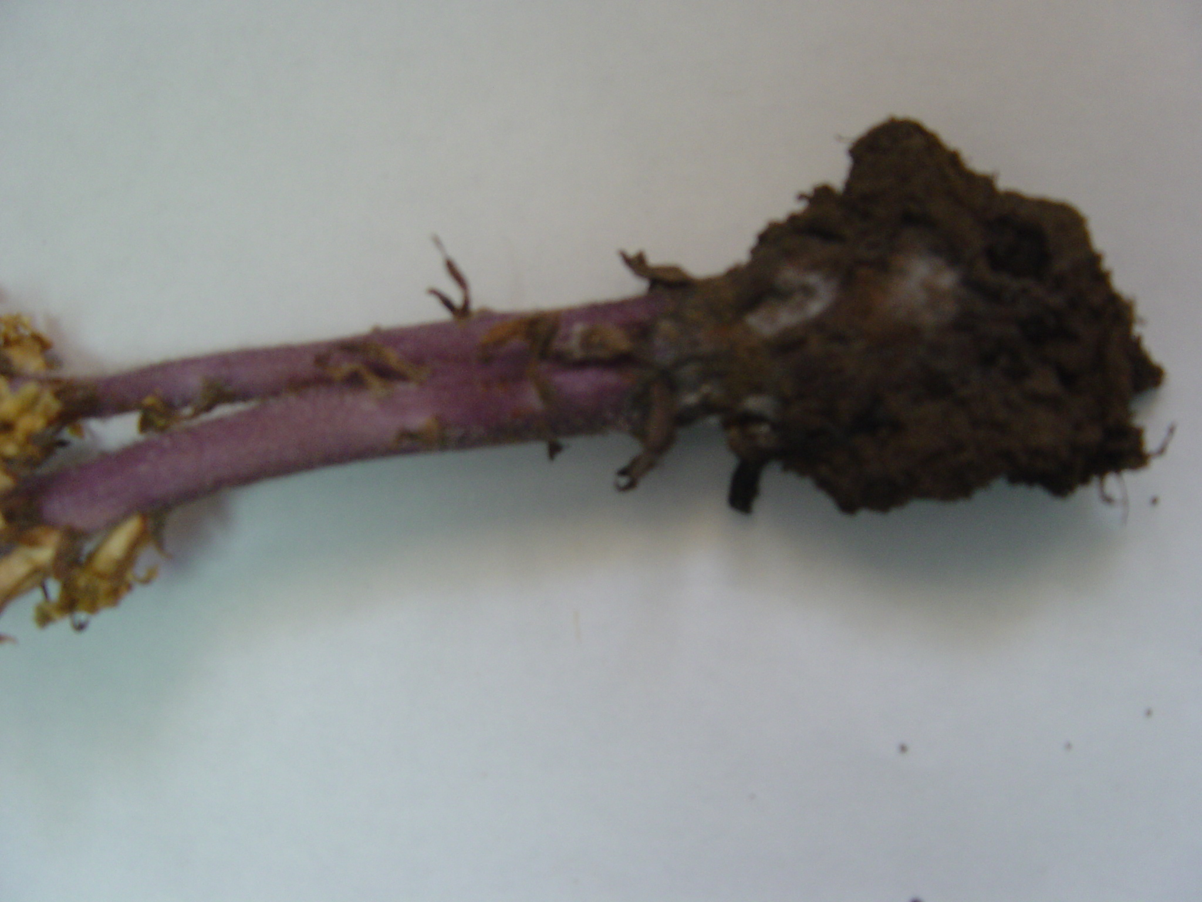
Fig. (1): Diseased Orobanche sp. plant at the stage of development where collections for putative pathogens were performed

2- Isolation and identification of potential pathogens:
Orobanche stems showing wilted or discolored parts were used for potential pathogen isolation (Fig. 1). This was performed according to common isolation procedure as described by Johnston and Booth (1983) and Sinclair and Dhingra (1995). About 3-5 mm pieces of diseased stems were surface sterilized with 2.5% sodium hypochlorite solution for 3 min., rinsed several times with sterilized water and blotted aseptically. Small pieces were then placed on plates of PDA medium and incubated at 28ºC ± 2. The fungal growth was purified using hyphal tip technique and the recovered isolates were identified to the generic or species based on culturable and morphological characteristics using the identification key's and observations described by Gilman, (1957); Nelson et al.,( 1983) and Barnett and Hunter,(1986).

3- Antagonistic agents;
T. harzianum, T. viride and T. hamatum were kindly obtained from plant pathology Dept., NRC, Dokki, Egypt. The fungus was received on agar plate as sporulated culture. Conidiophores from this plate were harvested from fungal cultures that were produced on PDA medium plus 4% yeast extract (PDAY) and incubated for 10-15 days at 25ºC ± 2. Conidial inoculums were taken from pure fungal cultures with no more than two serial passages from original culture. The surface of the culture was gently brushed in the presence of 20ml sterilized water in order to free spores. The concentration of the spore suspension was adjusted to 1x10⁸ conodia/ml³ using a haemacytometer.

4- Plant guard biofertilizer:
Commercial liquid materials contain spores of T. harzianum was also used to test its effect on the growth of chamomile plant and orobanche number.

5- Compost (farmyard manure):
One year old farmyard manure produced by NRC farm, Cairo, Egypt was used.

6- Pot experiment: Pot experiment was carried out to explore the effect of compost fortified with the antagonistic agents in controlling proomrape weed in chamomile plant. Uniform and healthy chamomile transplants were planted on sand/clay soil (1/1,v/v) was uniformly mixed with compost fortified with the antagonistic isolates of Trichoderma at a rate of 1% (w/w), divided into six groups in plastic pots (25-cm-diameter) and watered after inoculation with Orobanche ramosa seeds (60 mg to give 1000 seeds).
The following treatments were used.
- Untreated soil (control).
- Soil inoculated with orobanche seeds only
- Soil infested with orobanche seeds + T. harzianum
- "" "" "" "" "" + T. viride
- "" "" "" "" "" + T. hamatum
- "" "" "" "" "" + plant guard (at rate of 1%)
Five chamomile seedlings were sown in each pot and four replicates were used for each treatment. At the end of the experiment, the number of orobanche shoots emerged above the soil surface was determined.
Rhizosphere samples of chamomile plants were taken from each treatment at intervals of 15, 30, 60, and 90 days of plant growth. Serial dilutions method adapted by Louw and Webely (1959) was used for counting as cfu/g dry soil. Soil extract agar medium and dilutions of 1/10⁵ to 1/10⁷ were used for bacteria and incubated at 32ºC± 2 for 3 days (Mahmoud et al., 1964). While, Martin"s medium was used for fungi at dilutions of 1/10³-1/10⁵ and incubated at 27ºC± 2 for 5-7 days (Allen, 1961). Colonies appeared on plates used for counting total fungi were picked and subjected to preliminary identification as described before in the isolation trails.

3. Results and Discussions
1-Isolation, identification and frequency occurrence of the isolated fungi:
One hundred and seventy seven fungal isolates were recorded from diseased orobanche samples. Based on similarity in microscopic features, these selected isolates were divided into seven genera (Table, 1).

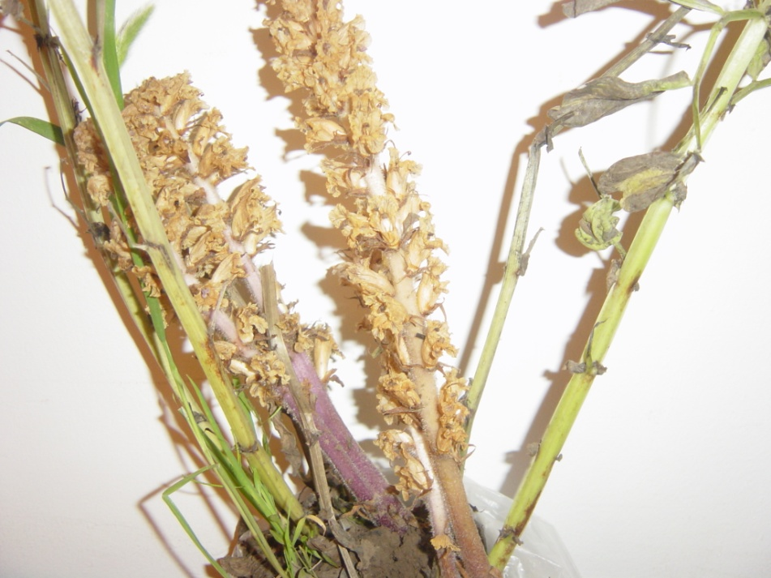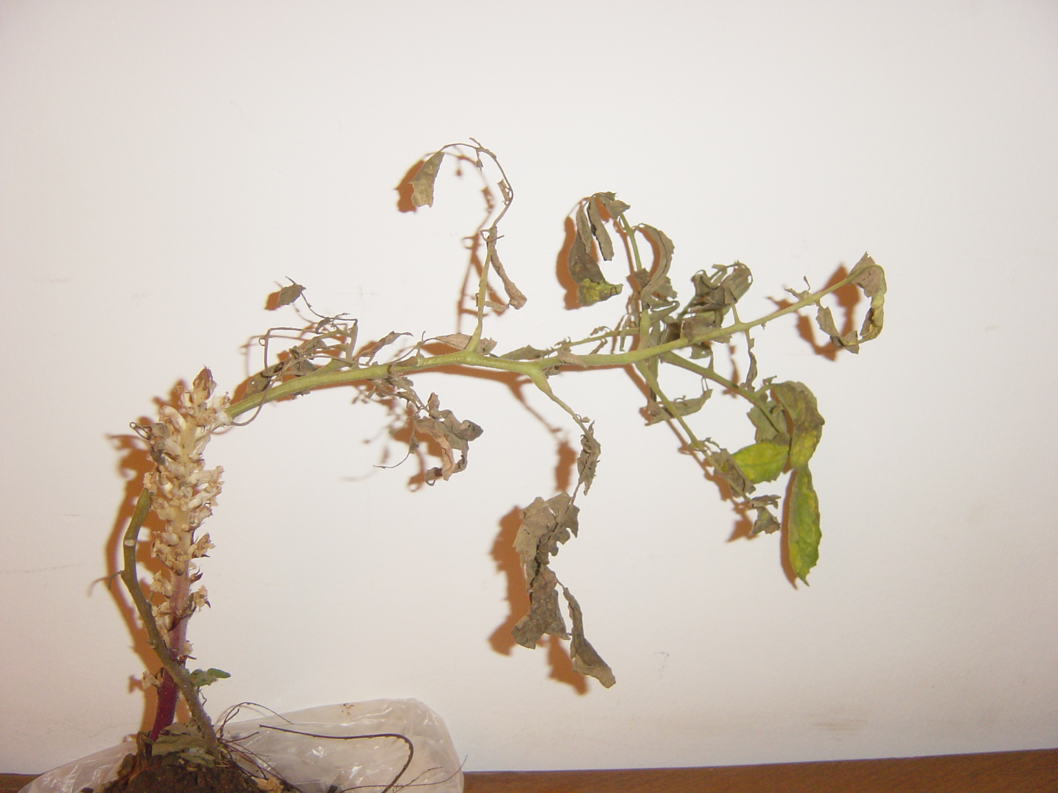
(1) (2)
Figs. (2) Chamomile plant infected with Orobanche ramose at (1) vegetative stage and at (2)maturity stage.

Table (1): Incidence of fungi associated with stems of Orobanche spp.showing disease symptoms.
Isolated  fungi | No./100  segments | %  occurrence
Alternaria alternata | 33 | 18.64
Aspergillus spp. | 27 | 15.25
Cephalosporium spp. | 3 | 1.69
Fusarium oxysporum | 30 | 16.95
Fusarium spp. | 32 | 18.08
Penicillium spp. | 12 | 6.78
Rhizoctonia solani | 22 | 12.43
Trichoderma spp. | 18 | 10.17
Total | 177

The representative isolates were identified as, Alternaria alternata, Aspergillus spp., Cephalosporium spp., Fusarium oxysporum, Fusarium spp., Penicillium spp. and Trichoderma spp. These fungi were previously isolated from diseased Orobanche spp. in Egypt by Abd-El-Kader et al. (1996, 1998) and in Jordan by Hameed et al. (2001). Moreover, Alternaria alternata (18.64%), F. oxysporum (16.95%) and Fusarium spp. (18.08%) showed the highest occurrence percentage followed by Aspergillus spp. (15.25%), Trichoderma spp. (10.17%) and R. solani (12.43%). However, Cephalosporium spp., and Penicillium spp. showed the lowest percentage of occurrence and recorded. 1.69% and 6.78% respectively.

2- Pathogenicity on orobanche plants in - vitro:
The isolated fungi were evaluated for their ability to infect Orobanche ramosa stem segments under laboratory conditions. The results indicated that fungal isolates varied in their pathogenicity on orobanche (Table 2). Fungal isolates of Chaetomium sp., F. oxysoprum , F. solani, R. solani, Sclerotium rolfsii and T. harzianum attacked living tissues of O. ramose segments causing black lesion, soft rot and complete deterioration within 7 days. This may indicate the potential of these fungi to cut down on the inoculums of this parazite. Meanwhile, Alternaria altarnata, A. niger and Macrophomina phaseolina caused moderate disease incidence (50-75%) which may be due to the fact that these fungi attacked the deteriorated tissues.
No damage was produced by species of A. flavus, Cephalosporium and Penicillium spp. and considered to be secondary invaders. The parasitism could be attributed to defence mechanisms of orobanche or genetic variations of fungal isolates. In a similar study using 44 isolates of different fungi, only 9 isolates belonging to Fusarium and Sclerotium spp. were found to produce sever rotten to broomrape tissues (Al-Menofi, 1986) suggesting that these useful for future biological control infestations.

Table (2): Pathogenicity and disease rating of different isolated fungi on healthy stem segments of Orobanche ramose after 3 and 7days of inoculation
Isolated fungi | Fungal growth |  | Disease incidence |  | Disease severity
 | Day 3 | Day 7 | Day 3 | Day 7 | Day 3 | Day 7
Alternaria alternata | 0 | 50 | + | + | 2 | 3
Aspergillus flavus | 0 | 0 | - | - | - | -
A. niger | 0 | 50 | + | + | 1 | 2
Cephalosporium sp. | 0 | 0 | - | - | - | -
Chaetomium sp | 0 | 100 | + | + | - | 4
Fusarium oxysporum | + | 100 | + | + | - | 4
F. solani | + | 100 | + | + | 3 | 4
Macrophomina phaseolina | + | 50 | + | + | 1 | 2
Penicillium sp. | 0 | 0 | - | - | - | -
Rhizoctonia solani | + | 100 | + | + | 2 | 4
Sclerotium rolfsii | + | 100 | + | + | 3 | 4
Trichoderma harzianum | + | 100 | + | + | 2 | 4
Control | 0 | 0 | 0 | 0 | 0 | 0
- Each is a mean of 4 replicates
- Fungal growth, according to index: 0= No growth, + = moderate growth to 100%
- Disease incidence: according to index: 0= No growth, += 100% complete colonization
- Diseases severity was determined on linear scale from 0 to 4 according to 0 =Healthy segment, 1=10% deterioration 2 =50% deterioration, 3 =75% deterioration, 4=100% complete deterioration.

3- Rhizospheric studies:
3-1 Total bacterial count:
The microbial analysis of chamomile rhizosphere showed that the number of bacteria in 1g dw of the control rhizosphere soil ranged from 260.2 to 1250.0 x10⁴ colonies with an average of 605.2 x10⁴, and those of the orobanche infested soil from 256.0 to 977.8x 10⁴ colonies with an average of 597.9 x10⁴ (Table 3).

Table (3): Effect of compost fortified with Trichoderma spp. on the total bacteria and total fungal counts in the rhizosphere of chamomile plants infested with Orobanche ramosa seeds during different period of plant growth.
 | Fungal count ( No.X 10³/g dry soil) |  |  |  |  | Bacterial count ( No.X 10⁴/g dry soil)
Time of sampling (days) | 15 | 30 | 60 | 90 | Mean | 15 | 30 | 60 | 90 | mean
Untreated soil (control ,1) | 20.2 | 29.9 | 37.4 | 110.8 | 49.6 | 387.9 | 1250.0 | 522.5 | 260.2 | 605.2
Infested soil with  Or. (control, 2) | 6.2 | 50.7 | 72.2 | 117.2 | 61.6 | 256.4 | 536.2 | 977.8 | 364.9 | 597.9
Or.+ T. harzianum | 45.4 | 266.5 | 391.5 | 404.7 | 277.0 | 401.9 | 4526.6 | 6014.2 | 6700.5 | 5335.3
Or. + T. viride | 18.3 | 20.1 | 21.2 | 37.5 | 24.3 | 180.6 | 428.3 | 725.0 | 631.3 | 491.3
Or. + T. hamatum | 27.9 | 29.8 | 48.2 | 67.1 | 43.3 | 302.0 | 585.6 | 1218.3 | 384.6 | 622.6
Or. + Plant guard | 7.4 | 9.9 | 29.9 | 33.4 | 17.7 | 230.5 | 378.2 | 455.6 | 1404.5 | 601.2

Moreover, counts of total bacterial flora in the rhizosphere of healthy plants (control, 1) increased and reached its peak after one month from transplanting then decreased and after two months in the other treatments. This may be due to the presence of antibacterial substances in the root exudates of chamomile at the beginning of cultivation, except plant guard treatment the maximum count was found at 90 days old plants. Data also showed that the average number of bacteria in infested soil with orobanche seeds was lower than that the corresponding figure of the control (untreated plants), as the average count was decreased from 605.2 to 597.9 cfu x 10⁴ colonies / 1g (1.19%). The same trend of decrease was also observed in the rhisosphere taken from the root infested with orobanche seeds and applied with T. viride (18.81%), followed by plant guard treatment (7.26%). On the other hand, inoculation of orobanche infested soil with T. harzianum or T. hamatum increased the total bacterial counts from 597. 9 to 5335.3 cfu/g (8.92 folds) and to 622.6 cfu/g (1.04 folds) respectively.

3-2- Total fungal counts:
Data presented in Table (3) also showed that the total fungal count in the rhizosphere of chamomile plants cultivated in infested soil with orobanche seeds or untreated control was increased as the plant grew up and reached its maximum at 90 days old plant. The decomposable root debris and root exudates that supply fungi with sources of nutrients can facilitate the damae of roots by increasing the activity of saprophytic fungi. The infestation of soil with orobnanche seeds alone increased the average of total fungal community in the rhisosphere of chamomile from 49.6 to 61.6 cfu x 10³ colonies /g ( 24.20%). The current data also showed that the total number of fungi in the rhizosphere of chamomile cultivated in infested soil with orobanche seed alone was inhibited at the early stage of plant growth (i.e.,15 days) than that of the comparable healthy one. Application with T. viride , T. hammatum and/ or plant guard decreased the total fungi, as the averages numbers in the rhizosphere of these treatments reduced this average from 61.6 cfu x 10³ colonies /g in the control to 24.3, 43.3 and 17.7 cfu x 10³ colonies /g for the treated plants respectively. In this regard, inoculation of orobanche infested soil with plant guard was the most inhibitory to rhizospheric fungi reducing their number to 71.3 % than encountered in the control 2 ( plants infested with orobanche seed only), followed by plants applied with T. viride ( 60.57%) and T. hamatum (29.77%).
On the other hand, the total fungal counts in the rhizosphere of chamomile plants cultivated in orbanche infested soil and inoculated wih T. harzianum showed opposite trend as the average number of total fungi was increased from 61.6 to 277.0 cfu x 10³ colonies /g (4.49 folds). This finding confirm the previous finding of Papavizas (1982) who reported that soil treatment technique enables the introduced fungus to establish high population in the plant rhizosphere.

4- Frequency occurrence of different fungi in the rhizosphere :
Data in Table (4) recorded, the quantitative and qualitative differences in frequent occurrence of fungal genera between different treatments. Ten genera were isolated from the rhizosphere of chamomile plants of non infested soil (control,1). Alternaria spp. (24.35%) followed by Aspergillus spp. (22.15%) were the most frequently isolated fungi. While, in the rhizosphere of chamomile plants infested with only orobanche seeds (control, 2) the densities of Fusarium , Phycomycetes, Synchytrium and Alternaria were increased by 3.33, 2.28, 1.74 and 1.01 folds respectively than that of comparable healthy one. Reversibly, genus Aspergillus , Mucor, Penicillium and Sterile mycelium fungi were absent or decreased by 22.34%, 100.0% , 71.23% and 63.58% respectively.

Table (4): The percentage occurrence of fungi in the rhizosphere of chamomile plants cultivated in soil infested with Orobanche ramosa seeds and inoculated with different isolates of Trichoderma isolates during plant growth.
Fungal genera | Plant stage | Uninfes-ted  Control, 1 | Soil infested with orobanche seeds
Fungal genera | Plant stage | Uninfes-ted  Control, 1 | Contr. (2) | + T. .har. | + T.  viride | + T. ham. | + pl. guard
Fungal genera | Seedling | 40.0 | 31.3 | 0.0 | 20.0 | 0.0 | 12.5
Alternaria | Maturity | 8.7 | 18.2 | 11.8 | 12.5 | 3.9 | 6.2
 | Av. | 24.35 | 24.75 | 5.90 | 16.25 | 1095 | 9.35
 | Seedling | 40.0 | 31.3 | 20.6 | 10.0 | 21.7 | 12.5
Aspergillus | Maturity | 4.3 | 3.1 | 4.3 | 12.5 | 17.3 | 27.2
 | Av. | 22.15 | 17.20 | 12.45 | 11.25 | 19.50 | 19.85
 | Seedling | 0.0 | 18.6 | 14.5 | 10.0 | 4.3 | 12.5
Fusarium | Maturity | 17.4 | 30.3 | 29.0 | 31.3 | 19.2 | 18.2
 | Av. | 7.35 | 24.45 | 21.75 | 20.65 | 11.75 | 15.35
 | Seedling | 20.0 | 0.0 | 0.0 | 10.0 | 0.0 | 12.5
Gliocladium | Maturity | 0.0 | 0.0 | 0.0 | 0.0 | 0.0 | 0.0
 | Av. | 10.0 | 0.0 | 0.0 | 5.0 | 0.0 | 6.35
 | Seedling | 0.0 | 0.0 | 0.0 | 0.0 | 0.0 | 0.0
Mucor | Maturity | 4.3 | 0.0 | 0.0 | 0.0 | 0.0 | 0.0
 | Av. | 2.65 | 0.0 | 0.0 | 0.0 | 0.0 | 0.0
 | Seedling | 0.0 | 6.3 | 0.0 | 0.0 | 8.6 | 0.0
Penicillium | Maturity | 21.9 | 0.0 | 0.0 | 0.0 | 3.9 | 0.0
 | Av. | 10.95 | 3.15 | 0.0 | 0.0 | 6.25 | 0.0
 | Seedling | 0.0 | 0.0 | 0.0 | 0.0 | 0.0 | 0.0
Phycomycetes | Maturity | 4.3 | 12.1 | 0.0 | 0.0 | 3.9 | 0.0
 | Av. | 2.65 | 6.05 | 0.0 | 0.0 | 1.95 | 0.0
 | Seedling | 0.0 | 6.3 | 20.6 | 10.0 | 27.0 | 18.7
Synchytrium | Maturity | 21.6 | 31.3 | 11.8 | 25.0 | 28.8 | 36.4
 | Av. | 10.80 | 18.80 | 16.20 | 17.5 | 27.90 | 27.55
 | Seedling | 0.0 | 6.3 | 35.1 | 40.0 | 38.4 | 18.7
Trichoderma | Maturity | 0.0 | 0.0 | 43.1 | 12.5 | 17.3 | 12.5
 | Av. | 0.0 | 3.15 | 39.10 | 26.25 | 27.85 | 15.60
 | Seedling | 0.0 | 0.0 | 9.2 | 0.0 | 0.0 | 12.5
Sterile mycelium | Maturity | 17.3 | 6.3 | 0.0 | 6.2 | 5.8 | 0.0
 | Av. | 8.65 | 3.15 | 9.60 | 3.10 | 2.90 | 6.25

It is clear from these data that application of chamomile plants with compost fortified with T harzianum disappeared or reduced the average percentage occurrence of Alternaria, Fusarium , Phycomycetes and Synchetrium spp. by 67.16%, 27.62, 11.04, 100.0 and 13.83% respectively compared with control (2). Whereas, the same treatment stimulated the growth of Trichoderma spp. and isolates of sterile fungi by 12.14 and 3.04 folds respectively.
Generally, the same trends were also observed when the plants treated with compost fortified with T. viride, T. hamatum and plant guard. The present investigation revealed the presence of some fungi in the rhizosphere of chamomile plant treated with compost fortified with Trichoderma spp. which could attack and colonize tissues of orobanche in different degree in-vivo

Greenhouse experiment:
The results of the greenhouse experiment showed that compost fortified with Trichoderma spp. as mycoherbicide resulted in reduction in number of orobanche shoots emerged above soil. Application of T. harzianum and plant guard resulted in a reduction of the number of orobanche shoots from 9 to 1 (88.9%) in comparison with the control, however the other two species of Trichoderma (T. viride and T. hamatum) were also effective in reducing the orobanche shoot numbers from 9 in the control to 3 (66.7% reduce). The reduction in number of orobanche shoots emerged above soil provided further evidence that compost fortified with the mycoherbicides tested attacked O. ramose of chamomile and was able to reduce its intensity than in untreated control. Similar results were also obtained by Abdel-Kader and El-Mougy (2009), who reported that T. harzianum (T₁ and T₃) and T. viride (T₃) have a potential for development as mycoherbicides for control of O. crenata on pea plants.

Table 5: Effect of compost fortified with Trichoderma spp. on orobanche infection as indicated by the number of shoots emerged above the soil surface cultivated with chamomile seedlings infested with orobanche seeds.
Treatment | No. of  Oorobanche shoots | No. of  chamomile plants | Orobanche shoot reduction %
Untreated soil (control ,1) | 0 | 5 | -
Infested soil with Or. (control, 2) | 9 | 5 | 0.0
Or..+ T. harzianum | 1 | 5 | 88.9
Or. + T. viride | 3 | 5 | 66.7
Or. + T. hamatum | 3 | 5 | 66.9
Or. + Plant guard | 1 | 5 | 88.9
- Fungal inoculums was incorporated into the soil at time of transplanting
** Each is a mean of 3 replicates.

Corresponding author
Ahmed F. Sahab
Plant Pathology Dept., NRC, Dokki, Cairo, Egypt
ahmedsahab2002@yahoo.co.uk

References
Abdel-Kader MM; Diab MM; Ismail BR; Hassan EA and Arafat KH. In-vitro test of different isolates of fungal genera for their pathogenicity against Orobanche spp. In advances in parasitic plant research (MT Moreno, JI Cubero, D Berner, D Joel, IJ Musselman, C Parker, eds). Proc. 6th international Parasitic Weed Symposium . 1996; Cordoba, Spain.
Abdel-Kader MM, Ismail B.R., Diab M.M., Hassan E.A. 1998. Preliminary evaluation of some soilborne fungi parasitizing Orobanche crenata in greenhouse. p. 127–132. In: Proc.
6th Mediteranean Symposium EWRS, Montpellier, France, May 13-15
Abdel-Kader MM and El-Mougy NS. Evaluation of different approaches of Mycoherbicidal application for controlling orobanche crenata in pea field. Egyp.J. of Phytopathol. 2002; 29: 69-82.
Abdel-Kader MM and El-Mougy NS. Prospects of mycoherbicides for control of broomrapes (Orobanche spp.) in Egypt. J. Plant Prot. Res. 2009; 49(1): 63-75.
Allen ON. Experiments in soil bacteriology. Burgess Pub,1961; Co. USA:147 pp.
Amsellem Z, Kleifeld Y, Kereny Z, Hornok L, Goldwasser y and Gressel J. Isolation, identification and activity of mycoherbicidal pathogens from juvenile broomrape plants. Biological control 2001; 21: 274-284.
Barnett HL and Hunter BB. Illustrated genera of fungi. 1986; 3ed.Burgess Co. Minneapolis, Minnesota, USA.
Bedi, J.S. and Donchev. N.. Results on mycoherbicides control of sunflower broomrape (Orobanche cumana Wall.) under glasshouse and field conditions. In Ransom, J.K., Musselman, L.J., Worsham, A.D. & Parker, C. eds. Proc. 5th Int. Symp. on Parasitic Weeds. CIMMYT, Nairobi, Kenya. 1991; 76-82.
Al-Menoufi OA.. Studies on Orobanche spp. 2- Fungi associated with Orobanche crenata Forsk. Alexandria J. Agric. Res. 1986; 31(2): 297-310
Gilman JC. A manual of soil fungi. 1957; Second Ed. The Iowa State Univ. Press, Ames, Iowa, USA, 450 pp.
Goussous SJ, Hameed KM and Saadoun I. Isolation and evaluation of indigenous fungal and bacterial isolates as potential bioagents against broomrape 9Orobanche cernua) in Jordan. Plant pathol. J. 2009; 8(3): 98-105.
Hameed KM, Saadoun IM and Al-Shyeb Z. Potential biological control of Orobanche by fungi isolated from diseased specimens in Jordan. Plant Pathol. J. 2001; 17(4): 189-195.
Hassn EA; El-Akkad SS: Mostafa SM and El-Awadi M. Histochemical aspects of penetration and vascular connection of broomrape haustoria in the host root and possible implication of phenylpropanoids. Int. J. Agric and Biol. 2004; 6(3): 430- 434.
Johnston, A and Booth C. Plant Pathologist’s Pocket Book. 1983; 2nd Edn., Surrey, Commonwealth Agricultural Bureaux, UK., ISBN: 0851985173.
Linke KH; Scheibel C Saxena MC and Sauerborn J. Fungi occurring on Orobanche spp. and their preliminary evaluation for Orobanche control. Trop. Pest Manage. 1992; 238: 127-130.
Low H A and Webely D W. The bacteriology of root region of the cat plant grown under controlled pot culture conditions. J. Appl. Bacteriology.1957; 22 : 216-226.
Mahmoud S A Z; Abou El-Fadl M and El-Mofty M. Studies on the rhizosphere microflora of a desert plants. Folia Microbiologica.1964; 3: 85
Nemat Alla MM, Shabana Ym, Serag MS, Hassan NM and El-Hawary NM. Granular mycoherbicides formulation of Fusarium oxysporum for mitigate oxidative stress growth reduction in host species. Res. J. Bot. 2007; 2(4): 165-175.
Nilson PE, Toussoun TA, Marasas WFO. Fusarium species. Am. Illustrated Manual for identification. Pennsylvania State Univ., 1983); Press Park and London: 193 pp.. Acesso em 01 de abril de 2009.
Papavizas GC. Survival of Trichoderma harzianum in soil and in pea and bean rhizosphere. Phytopath. 1982; 72: 121-125
Sarem H and Okhhovvat SM. Biological control of Orobanche aegyptiaca by Fusarium oxysporum f.sp. orobanchein in northwest Iran. Common Agric. Appl. Biol. Sci.. J. 2008; 73(4): 931-938.
Sauerborn J. The economic importance of the phytoparasites Orobanche and Striga. In Proceedings,5 th International symposium in parasitic Weeds,1991; pp : 137-143.
Sauerborn J. Muller-Stover D and Hershenhorn J. The role of biological control in managing parasitic weeds. Crop Prot. 2007; 26: 246-254.
Sinclair JB and Dhingra OD.. Basic Plant Pathology Methods. 1995; 2nd Ed, CRC Press, USA., ISBN: 0873716388.
Surov T; Aviv D; Aly R; Joel DM; Gldman-Guez T and Gressel J. Generation of transgenic asulam-resistant potatoes to facilitate eradication of parasitic broomrapes (Oronanche spp.) with the sul gene as the selectable marker. Theor. Appl. Genet. 1997; 96: 132-137.
Stover DM and Kroschel J. The potential of Ulocladium botrytis for biological control of Orobanche spp. Biol. Control 2005; 33(3): 301-306.
Thomas H; Sauerbom J; Stover DM and Kroschel J. Fungi of orobanche aegyptiaca in Nepal with potential as biological control agents. Biocontrol Sci. and Tech.1999; 9(3): 379-381.
Vouzounis N. Severity and control management of parasitic weeds in Cyprus. Workshop Parasitic Plant Management in Sustainable Agriculture. 2006; ITQB, Oeiras-Lishbon, Portugal: 58-64.
Zermane N, Souissi T, Kroschel J and Sikora R. Biocontrol of broomrape (Orobanche crenata Forsk. And Orobanche foetida Poir.) by Pseudomonas fluorescens isolate bf 7-9 from the faba bean rhizosphere. Biocontrol Sci. Tech. 2007; 17(5): 483-497.

7/1/2011

