A Comparative Study on Boiling Heat Transfer Enhancement for Some Metallic Alloys Used in Nuclear Applications

A.H.Khalifa, M.M.El-Fawal* and A.A.Gadalla

National Center for Nuclear Safety and Radiation Control, Atomic Energy Authority, Nasr City-P.O. Box 7551,Cairo,Egypt,
*mohamed_Elfawal@hotmail.com

Abstract: In the present study, saturated nucleate pool boiling in aqueous surfactant solutions from horizontal tubes has been investigated. Sodium Dodecyl Sulfate (SDS) with different concentrations is the test surfactant. A pool boiling test rig has been designed and constructed to carry out heat transfer experiments using three testing tubes with different materials which have wide range of applications in nuclear industry. Brass, aluminum and stainless steel which have wide range of applications in nuclear industry, were selected to be the test tube materials. Effects of wall heat flux, wall superheat and concentration of aqueous surfactant solutions on the nucleate boiling heat transfer coefficient are the major studied parameters. A detailed analysis of the experimental data showed remarkable enhancement in the heat transfer coefficient for all testing concentrations of SDS using the three test tube materials. It was found that aluminum alloy 6061 tube heater material exhibits the best heat transfer coefficient enhancement with respect to other investigated materials. The three parametric distribution function N(r) for the size of the stable vapor bubbles in active nucleation sites are deduced for the three test tubes using different test concentrations of aqueous surfactant solutions. A trial is made to correlate the size distribution function’s constants (Nmax /A, rst and m) with the concentration of the aqueous surfactant solutions. Attention is directed to correlate the experimental results of wall heat flux, wall superheat and active nucleation site density; to get a helpful tool for predicting the thermal performance of nucleate pool boiling in aqueous surfactant solutions. Good agreement is found between the present experimental data and the available published data.
[A. H. Khalifa, M. M. El-Fawal and A. A. Gadalla, A Comparative Study on Boiling Heat Transfer Enhancement for Some Metallic Alloys Used in Nuclear Applications]. Nature and Science 2011; 9(8): 244-254]. (ISSN: 1545-0740). http://www.sciencepub.net.

Key Words: Boiling heat transfer / Surfactants / Enhancing heat transfer coefficient

1. Introduction
In boiling heat transfer, it is usually desirable to transfer the largest possible heat flux with the smallest possible temperature difference between the heating surface and the boiling liquid. Various means have been developed with this aim in mind, including the use of additives to modify the liquid properties. The process of nucleate boiling is the total sum of the processes of bubble initiation, growth and departure. Though these individual processes have been studied much, recent literature reviews provide large amounts of information on how surfactants affect pool boiling.
The study of surfactant solutions in the pool boiling shows a significant enhancement of the boiling mechanism. The role of surface-active solutes was explored by Morgan et al. [1], for 0.1±1.0% aqueous solutions of a commercial surfactant. They found that the boiling curves of the heat flux (q) vs. temperature difference (Δt). were shifted the average surface temperature of the heater, and the saturation temperature of the solution (t_{sat}) laterally in varying degrees, such that heat transfer was higher than that for pure water, (q is the heat flux, Δt = t_{s} - t_{sat} is the super- heat, t_{s} is. This is an important fact because, if proved to be applicable under industrial boiling conditions, it may lead to a considerable increase in the power level of all boilers without any increase in size or operating temperature. One interesting field of application of boiling and evaporation is in desalination of seawater, which is becoming essential in some arid regions. It was shown by Sephton [2] in 1974 that addition of small amounts of surfactants to seawater can substantially enhance the boiling process, and reduce the price of the desalinated water to an acceptable level. At that time, the research was discontinued because the environmental impact of surfactants was not known.
Since the concentrations are usually low, addition of the surfactant to water causes no significant change in the saturation temperature and the majority of other physical properties, except for the surface tension and, in some cases, the viscosity. There have been a large number of studies to determine the boiling enhancement mechanism caused by addition of surfactants to water. Frost and Kippenhan [3] investigated boiling of water with varying concentrations of surfactant ``Ultra Wet 60L''. They found an increase in heat transfer and concluded that it resulted from the reduced surface tension. Heat transfer in nucleate pool boiling of dilute aqueous polymer solutions was measured by Kotch, aphakdee and Williams [4] and compared their results with pure water. Photographs showed distinct differences in bubble size and dynamics between polymeric and non-polymeric liquids.
Gannett and Williams [5] concluded that surface tension was irrelevant in explaining the enhancement effect, and reported that viscosity could be a generally successful correlating parameter. Nucleate boiling curves for aqueous solutions of drag-reducing polymers have been measured experimentally by Shah and Darby [6] and by Paul and Abdel-Khalik [7]. The explanation of observed changes in the boiling curves was based only on how the polymer additives changed the solution viscosity. Polymer type, concentration and molecular weight were important only insofar as they affect the solution viscosity. Yang and Maa [8] studied pool boiling of dilute surfactant solutions. The surfactants used in this study were sodium lauryl benzene sulfonate and sodium dodecyl sulfate (SDS). Since all experiments were carried out under very low concentrations, it was concluded that these additives had no notable influence over the physical properties of the boiling liquid, except surface tension, which was significantly reduced. This study showed that the surface tension of the boiling liquid had significant influence on the boiling heat transfer coefficient.
Pool boiling experiments were carried out by Tzan and Yang [9], for relatively wide ranges of surfactant concentration and heat fluxes. The results verify again that a small amount of surface-active additive makes the nucleate boiling heat transfer coefficient of water considerably higher. It was also found that there is an optimum additive concentration for highest heat flux. Beyond this optimum point, further increase in the concentration of the additive lowers the boiling heat transfer coefficient. Wu et al. [10] reported experimental data on the effect of surfactants on nucleate boiling heat transfer in water with nine additives. Anionic, cationic, and non-ionic surfactants were studied at concentration up to 400 ppm (parts per million). The enhancement of heat transfer was related to the depression of static surface tension.
Boiling heat transfer coefficients were measured by Ammerman and You [11] for an electrically heated platinum wire immersed in saturated water, and in water mixed with three different concentrations of SDS (an anionic surfactant). Their results showed that addition of an anionic surfactant to water caused an increase in the convection component and a corresponding reduction in the latent heat component of the heat flux in the fully developed boiling region. The enhancement of heat transfer at boiling of water, which is caused by the addition of an anionic surfactant, appears to be influenced by this relative change in these heat flux components. The comprehensive reviews on the heat transfer in nucleate pool boiling of aqueous surfactants and polymeric solutions have been published by Kandlikar and Alves [12] and by Wasekar and Manglik [13]. It is shown that surfactant additives at low concentrations can enhance the nucleate boiling heat transfer significantly.
Initial test results obtained by Elghanam and others [14] indicated that aqueous solutions of SDS surfactant are the best corrosion inhibitor. Also they found that for equal q and at any aqueous solution concentration, SDS gives the highest values of heat transfer coefficient (h), compared with SLES and Triton X-100. They attributed that to the physical properties of the aqueous SDS solutions which cause a depression of surface tension which is considered as the main reason for leading to enhance the nucleation characteristics to greater extent rather than SLES and Triton X-100 aqueous solutions. Therefore in this work, tests were performed only with SDS surfactant which gives the highest enhancement of heat transfer. The objective of the present study is to determine how the nucleate boiling is affected by the addition of SDS to water, and to generalize the data of the heat transfer enhancement for different concentration of surfactants. Saturated pool boiling on a heated surface and on a heated tube of different materials used for nuclear applications was investigated. Also a trial was made to correlate the size distribution function’s constants [(Maximum number of active nucleation sites (N_{max} /A), minimum radius of active nucleation sites (r_{st}) and size distribution function exponent (m)] with the concentration of the aqueous surfactant solutions. Based on the obtained results, the wall heat flux, wall superheat and active nucleation site density have been correlated with the test tube material and concentration of aqueous surfactant solutions.

2. Experimental Investigations
2.1 Test Rig
To achieve the aforementioned requirements, a test rig has been designed and constructed in which nucleate pool boiling of aqueous surfactant solutions is admitted on the electrically heated horizontal testing tubes of different metallic alloys (brass alloy C 444000, Aluminum alloy 6016 and stainless steel 316L). Details and main components of the test rig are given in Ref. [14]. Figure1.shows a schematic line diagram of the experimental test rig, which consists of the following:

a) Boiling and Condensation Vessel
It consists of two stainless steel hollow cylinders of different diameters connected by semi conical shape eight. The upper cylinder is used for condensation while the lower is used for evaporation part. It is provided with two glass windows perpendicular to each other. These two glass windows are used for visual observation of bubble formation at the test tube surface and for photographic recordings of the boiling process.

b) Heated Test Tubes
The heated test section consists of a horizontal tube made from stainless steel provided with 1 kW copper tube electrical heater. The two ends of the test tube with the heater are encapsulated by stainless steel casings and the outer surface of the test tube is treated mechanically by using very fine sand paper (4000 grit).

c) Condenser Cooling Water Circuit
The use of the cooling water circuit aims to achieve two purposes. The first is to release the latent heat of condensation of the ascending vapor. The second is to maintain constant saturation temperature of the aqueous solution by accurately adjusting the heat removed by the cooling water passing through the condenser coil to the heat produced at the test tube boiling surface. This is accomplished by continuous control of the temperature difference between the bulk temperature of the test aqueous solution and the inlet cooling water temperature.

d) Measuring Instrumentation.
The temperature of the test tube boiling surface is measured by four calibrated copper -constantan thermocouples embedded through four longitudinal grooves.

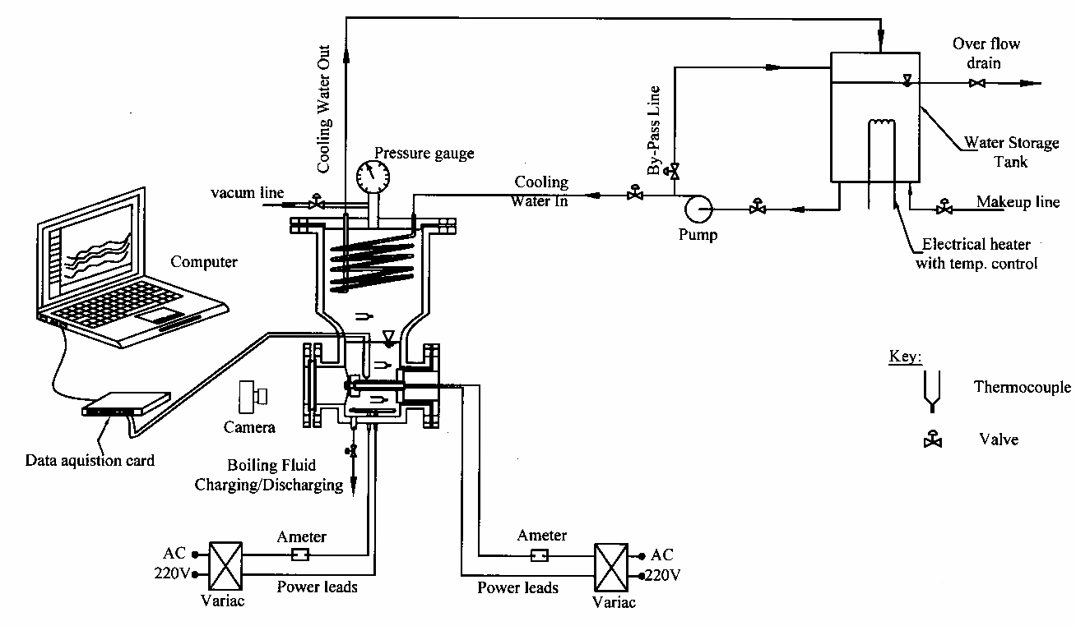

Figure 1: Schematic line diagram of the experimental test.

2.2 Experimental Procedure

Prior to performing the experiments, the test section components are cleaned routinely before and after each test run with a sequence of operations involving washing with alcohol, rinsed with distilled water several times and dried by a supply of hot dry air. Then, the system is evacuated to a pressure of about 15 mm Hg. If no leak is detected over a 24 h interval, the vessel is charged with one of the investigated working fluid (either distilled water or predetermined concentrations of aqueous surfactant solutions) to a level of 120 mm above the top of the test tube surface. The pool is thoroughly degassed before each boiling test run for a test fluid, to remove dissolved non-condensable gases by heating it first to the saturation temperature corresponding to the atmospheric pressure through the auxiliary heater, and later boiling it at a heat flux of about 112 kW/m² for at least half hour while constantly maintaining it at the saturation temperature, T_{sat}. The power supplied to the test tube cartridge heater is gradually and slowly reduced to zero. The test pool is kept close to the saturation temperature with the auxiliary heater for about forty minutes; then it is switched off to minimize convective effects.
Boiling test runs are started by boiling pure distilled water (baseline experiment). After that, distilled water is replaced by the aqueous surfactant solutions 200, 500, 1000 and 1500 ppm by weight. The experiments of aqueous surfactant solutions are conducted under the same conditions of baseline experiment. The changeover from one aqueous surfactant solution to the other must be precede by a reliable cleaning protocol for ensuring that there are no remaining remnants of the earlier sample inside the boiling condensation vessel. This is achieved by three-cycle operation of cleaning/rinsing with distilled water, acetone, and ethanol, and vacuum drying. Furthermore, baseline experiment is carried out after each aqueous surfactant solution experiment.
Initial test results indicated that aqueous solutions of SDS surfactant is the best corrosion inhibitor [15] and for equal q and at any aqueous solution concentration, it introduces the highest values of h, compared with SLES and Triton X-100 [14]. This is due to the physical properties of the aqueous SDS solutions which cause a depression of surface tension which considered as the main reasone which leads to enhance the nucleation characteristics to greater extent rather than SLES and Triton X-100 aqueous solutions, in addition to the ionic nature of each surfactant, and its chemistry. Therefore the tests were performed with SDS surfactant only which gives the highest enhancement of heat transfer.
Aqueous solutions of SDS with different concentrations are prepared by dissolving weighed samples in distilled water. The boiling curve for pure distilled water is first established. Then the water data provide the baseline reference for the surfactant solution results. For each run the boiling experiments are then carried out by varying the voltage drop in a stepwise manner. For each voltage drop, the corresponding current is recorded and then the dissipated wall heat flux is calculated. For each heat flux, the heater surface average temperature T_{avg} and the pool temperature (T_{sat}) are recorded and in turn excess temperature ΔT = (T_{avg} - T_{sat}) is determined. Constant saturation temperature of the test fluid is maintained by matching the rate of heat added at the test tube surface to be equal to the rate of heat rejected at the condenser

2.3 Theoretical investigations
The heat transfer coefficients h and h*, nucleate site density N/A and critical site radius for nucleation have been calculated using traditional equations given by Stephan, Wu and others [16-20]. N/A and r_{c} are calculated for different ∆T and representation of N/A as a function of r_{c}, gives the cumulative size distribution function N(r) for the different aqueous solutions. It is found that the interpolation lines for the relation (N/A) with r_{c} can be expressed by the exponential function with a power term as:
In ($\frac{N}{A}$) = In ($\frac{N_{\text{max}}}{A}$). $[1−(\frac{r_{c}}{r_{\text{st}}})^{m}]$ (1)
Where, N_{max} is the maximum value of N (at r_{c}= 0), r_{st} is the maximum value of r_{c} which corresponds to the nucleation beginning (N =1), and m is an exponent. The values of N_{max}, r_{st} and m are experimentally determined and they depend mainly on the boiling fluid concentration. Correlations are made to correlate the size distribution function constants (m, r_{st} and N_{max} /A) using obtained heat transfer measurements for different aqueous solution concentration.
3. Results and Discussion
Pure distilled water and aqueous surfactant solutions of SDS, having different concentrations (measured as the wppm additive content) are prepared by dissolving weighed samples in distilled water. These solutions are used as the boiling fluids. The concentrations of the test surfactant solutions are 200, 500, 1000, and 1500 ppm.

3.1 Effect of Aqueous Surfactant Solution on Pool Boiling Data.
3.1.1 Pure distilled water
The boiling data for pure distilled water is first established, to provide the baseline reference for the surfactant solution results. The pool boiling data of the three test tube materials S1, S2 and S3, using pure distilled water is shown in Fig. 2. It can be seen from Fig. 2 that for a given tube material the increase in wall heat flux q increases the heat transfer coefficient h. This is true for the three test materials. This is attributed to the fact that increasing q increases the number of nucleation sites which promotes h. Also, for a given q, aluminum tube, S2 introduces the highest h. This is related to the largest number of nucleation sites activated from it, due to its better thermal conductivity.

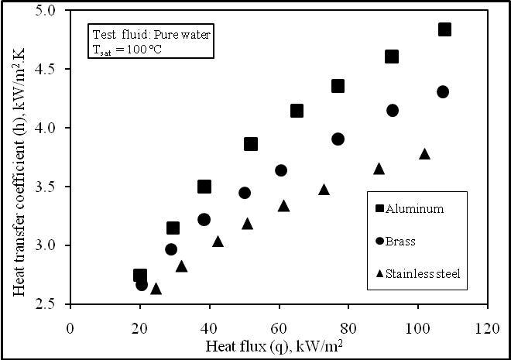

Fig. 2 Effect of heat flux on heat transfer coefficient for pure distilled water for different test tube materials.

3.1.2 Effect of SDS aqueous surfactant solution on heat transfer enhancement factor h of different materials
Figure 3 shows the comparative results of the variation of h with q for different concentrations of SDS aqueous surfactants solutions. The comparison is made for the three testing tubes S1, S2 and S3. It could be realized from Fig. 3 that any increase in q causes a corresponding increase in h. This could be attributed to the agitation effect resulted from the mobility of the vapor bubbles emitted form the tube wall nucleation sites which travel through the liquid pool. The increase in q activates greater number of nucleation sites. Also, it could be noticed that for any level of q, any increase in the concentration of aqueous surfactant solution causes appreciable increase in h. An explanation for the observed enhancement in h could be given by considering the role of dynamic surface tension and subsequent modification of bubble dynamics.
With the nucleation of a vapor bubble and during its subsequent growth, diffusion of surfactant molecules, and their adsorption behavior rates at the interface govern the extent of dynamic surface tension. The dynamic surface tension is appreciably lower than solvent's surface tension, which helps promoting large number of active nucleation sites. Lower values of dynamic surface tension also allow departure of smaller-sized bubbles because of the reduction in surface tension force at the heated tube wall that counters the bouncy force trying to pull the bubble away from the tube wall. The bubble growth time will consequently expect to be reduced, and leads to an increase in bubble departure frequency. Also, it is indicated that results for test tubes S1, S2 and S3 have the same trend with different slopes and absolute values.

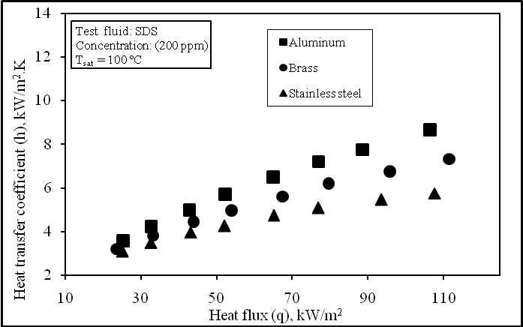
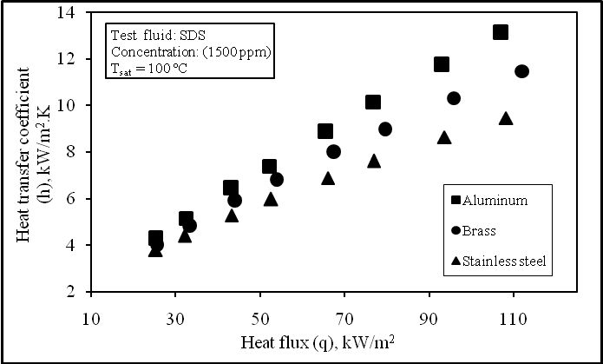

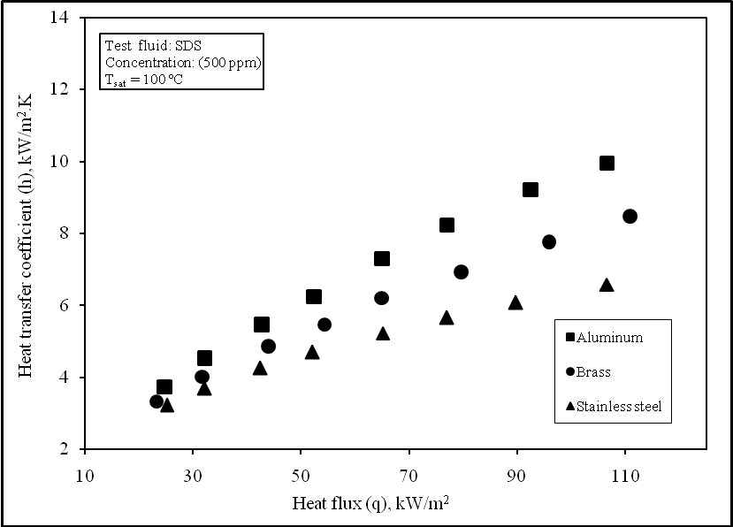
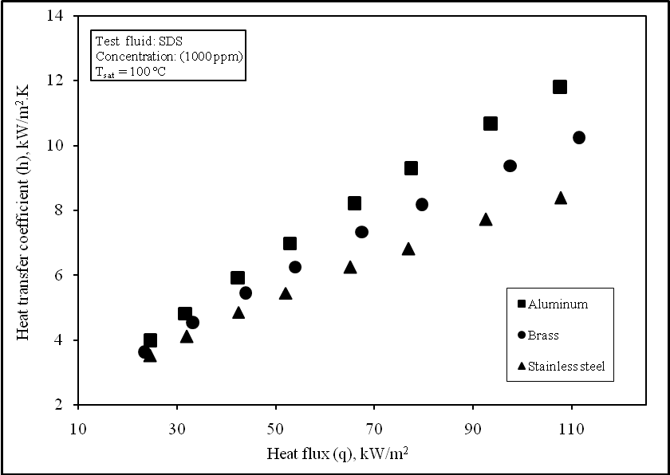

Fig. 3 Effect of heat flux on heat transfer coefficient for different concentrations of SDS aqueous surfactants solutions.

3.1.3 Effect of heat flux aqueous surfactant solution on heat transfer enhancement factor h٭ of different materials
The enhancement in pool boiling heat transfer coefficient (h٭), as a result of employing SDS aqueous surfactant solutions is shown in Fig. 4. In this figure h٭ is represented as a function of tube wall heat flux, q for the three test tubes S1, S2 and S3. The Figure shows that for a given q, as the concentration of surfactant in its aqueous solution, increases the enhancement in nucleate boiling heat transfer process represented by h٭increases. Also, it should be emphasized that for a given concentration of aqueous surfactant solution, increasing q, increases the magnitude of h ٭increases with the increase of q, which is related to the definition of the enhancement in the pool boiling heat transfer coefficient, h٭ as
h٭=h_{sur}/h_{w}=(q_{sur}/∆T_{sur})/(q_{w}/∆T_{w})=∆T_{w}/∆T_{sur} (2)
where the subscripts (sur.) and (w) refere to experiments with surfactant and pure water respectively. Also, with increasing q, more nucleation sites are activated and therefore more active cavities for initiating bubbles, there by increasing the nucleation site density as well as the bubble frequency. Also, from Eq.2 increasing the heat flux, q decreases ∆T_{sur}. This, in turn is reflected on the degree of enhancement. This may be due to the fact that during nucleate boiling, the surfactant molecules diffuse towards the growing bubble interface from the adjacent sub-layer. The surfactant concentration in this sub-layer would tend to be very close to the bulk concentration. This concurs with literature in the sense that the dynamic surface tension at the interface directly proportional to the bubble dynamics during boiling.

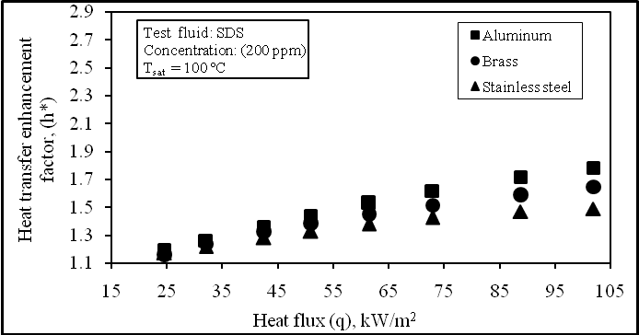
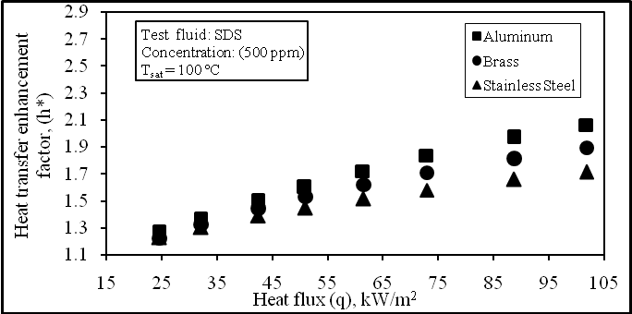

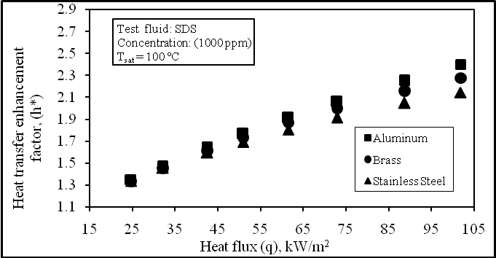
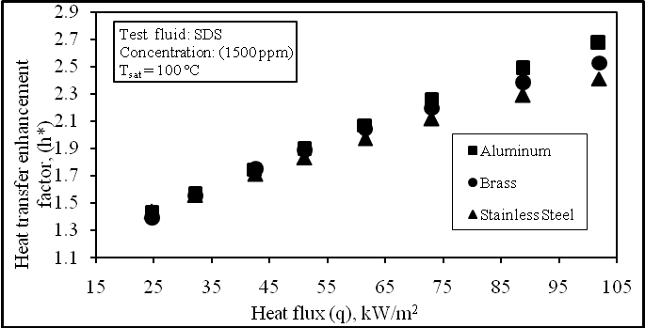

Fig. 4 Effect of heat flux aqueous surfactant solution on heat transfer enhancement factor h٭of different materials.

3.1.4 Effect of surfactant concentration on heat transfer enhancement factor h٭
Figures 5 and 6 show the effect of increasing the wall heat flux on the variation of h and h٭ with the SDS aqueous solution concentration, C for different heat flux. It is indicated that for a given q, increasing the concentration of the surfactant, increases both h and h٭. This is true for all the test tubes.
Also the test results showed that the enhancement heat transfer coefficient increases by about 156%, 156 % and 160% over that for pure water at q equals 32.1kW/m² at the highest SDS concentration, with stainless steel, brass and aluminum respectively. At q equals 61.4 kW/m² the increases are 198 % , 205 % and 207 % . At q equals 101.9 kW/m², the respective values are 241 %, 253 % and 267 %. The influence of test tube material on the size distribution function of the active nucleation sites for different concentrations of SDS aqueous surfactants solutions is shown in Fig.7. It indicates that aluminum test tube gives the highest N/A for any given value of r_{c}.

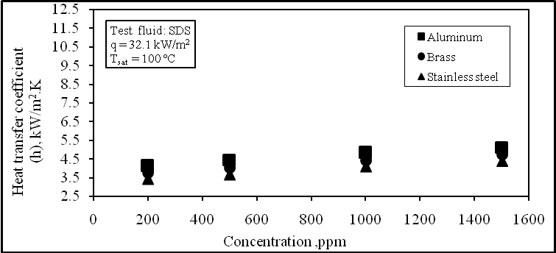
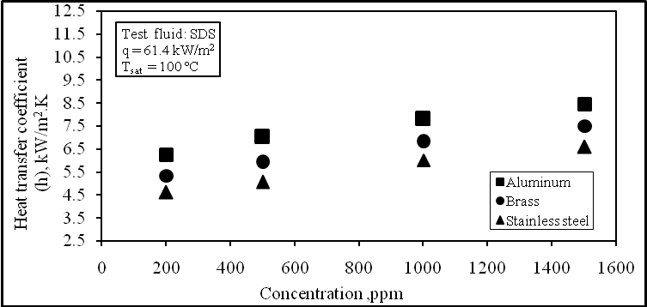

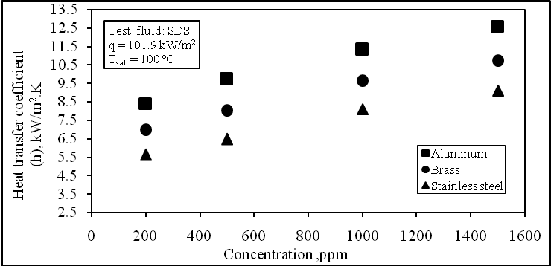

Fig. 5 Effect of surfactant concentration on heat transfer coefficient h for different heat flux

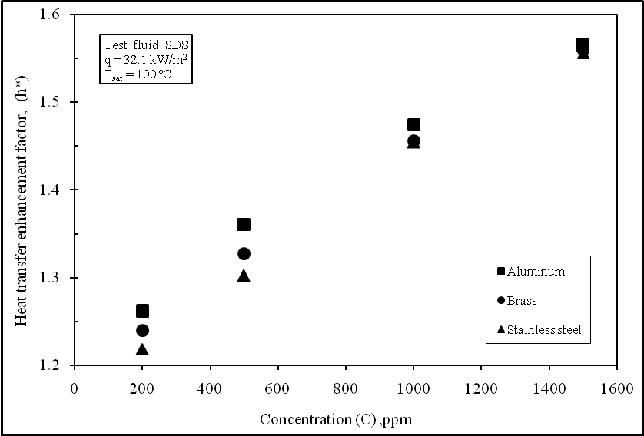
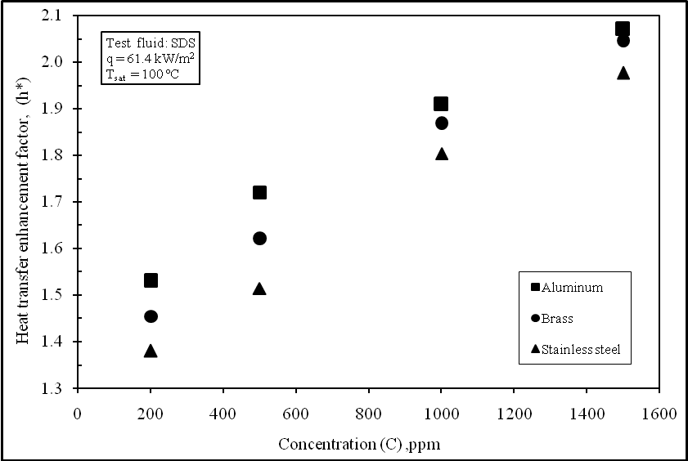

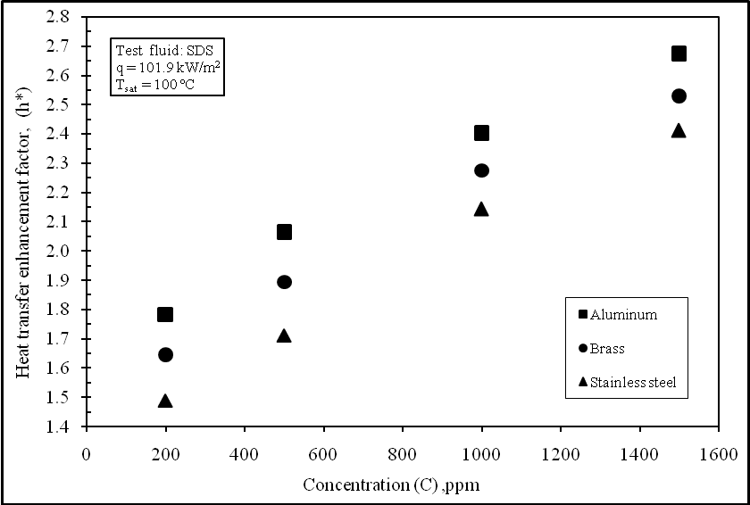

Fig. 6 Effect of surfactant concentration on heat transfer enhancement factor h for different heat flux
٭
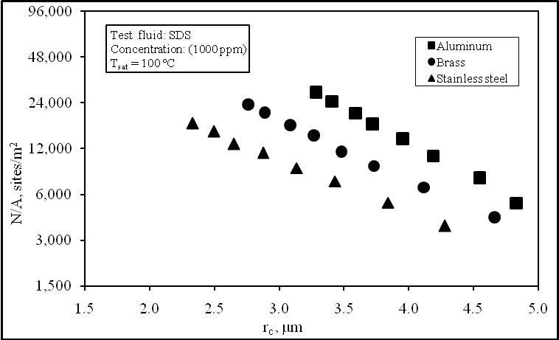
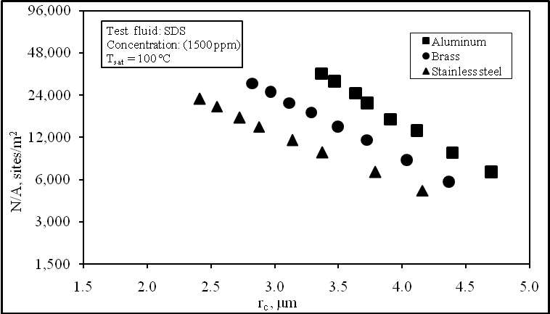

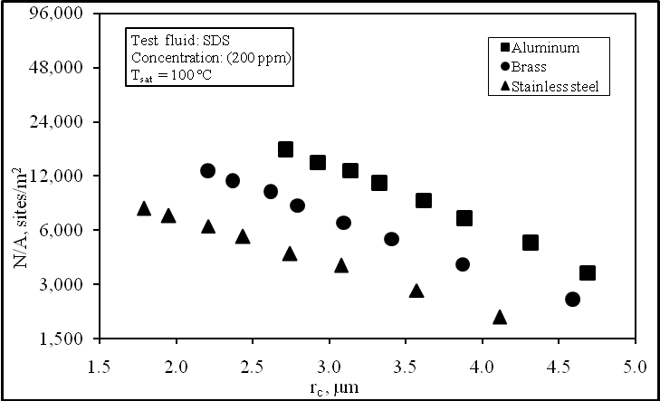
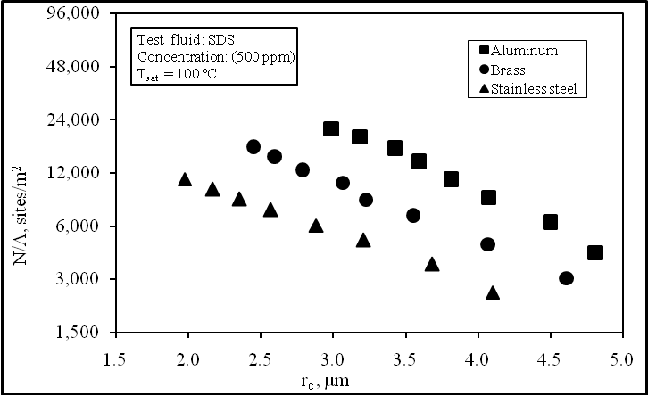

Fig. 7 Effect of size distribution functions for different concentrations of SDS aqueous surfactants solutions.

3.1.5 Effect of aqueous surfactant solution type and its concentration on the size distribution function's constants
Figure 8 depicts the relation between the exponent m, deduced from the three-parametric distribution functions calculated from the heat transfer
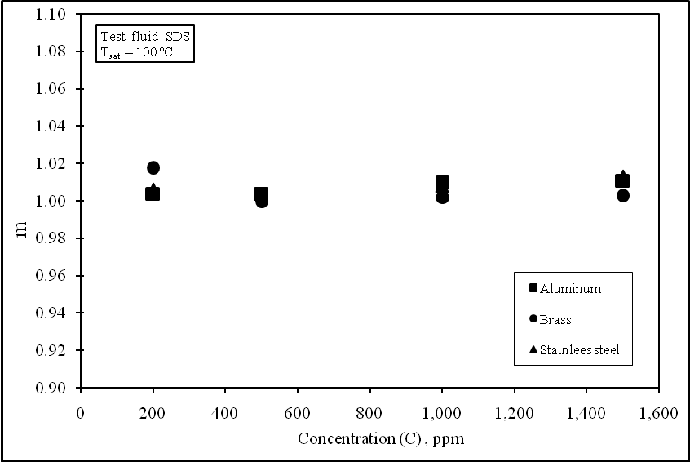
measurements of the three tested boiling surfaces and the concentration, C. It seems that the exponent m of the present results is not affected by the concentration and the material of the test tubes. It could be concluded that the exponent m may be considered as a constant equal to unity.

Fig. 8 The variation of size distribution function exponent m with concentration for the three tested tubes

Fig. 9 shows the effect of test tube material on the variation of r_{st} with concentration. From the Figure it could be noticed that for any given concentration; r_{st} value for aluminum tube is the highest. This fact ensures that aluminum tube introduces higher N/A and h*.

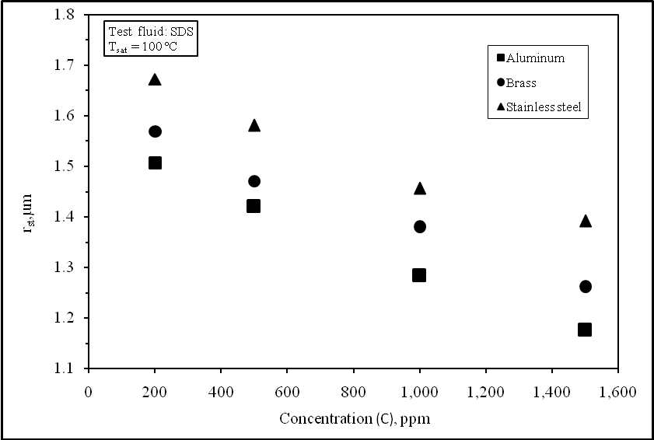

Fig. 9 Effect of surfactant concentration on the variation of r_{st} for the three test tube materials

In addition, Fig.10 shows the variation of the constant N_{max}/A with C using aqueous SDS solution. A comparison is made between the three test tube materials. It is clear that for any given concentration; N_{max}/A value for aluminum test tube is the highest. This fact agrees with the data of Fig. 3.

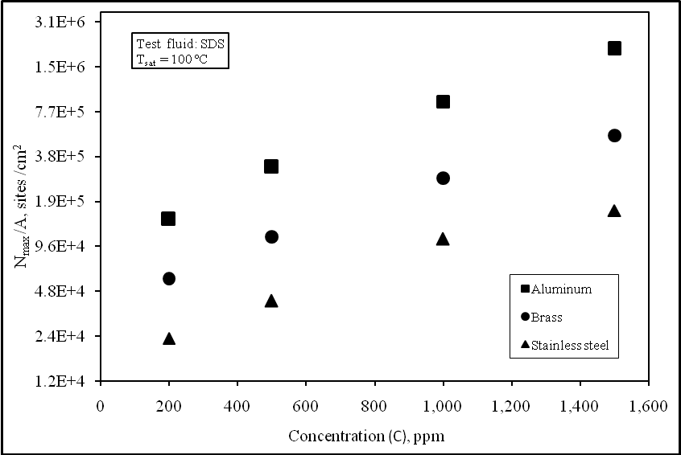

Fig. 10 Effect of surfactant concentration on the constant N_{max}/A for the three test tube materials

Figs.11 shows the variation of the constant N_{max}/A with r_{st} for pure water and SDS solutions for the three different testing tubes respectively. It is clear that N_{max}/A increase with the decrease of r_{st} , also the aluminum test tube gives the highest value of N_{max}/A.

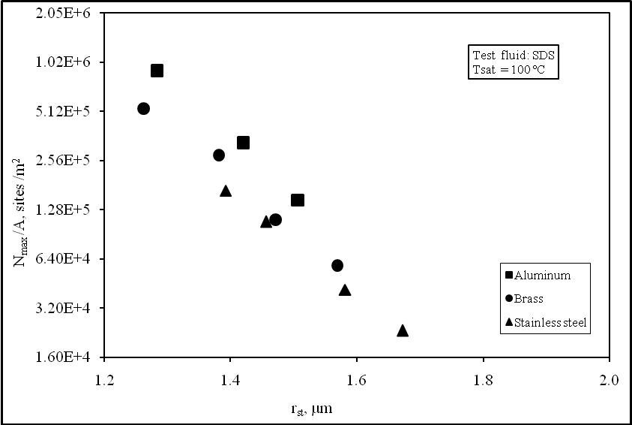
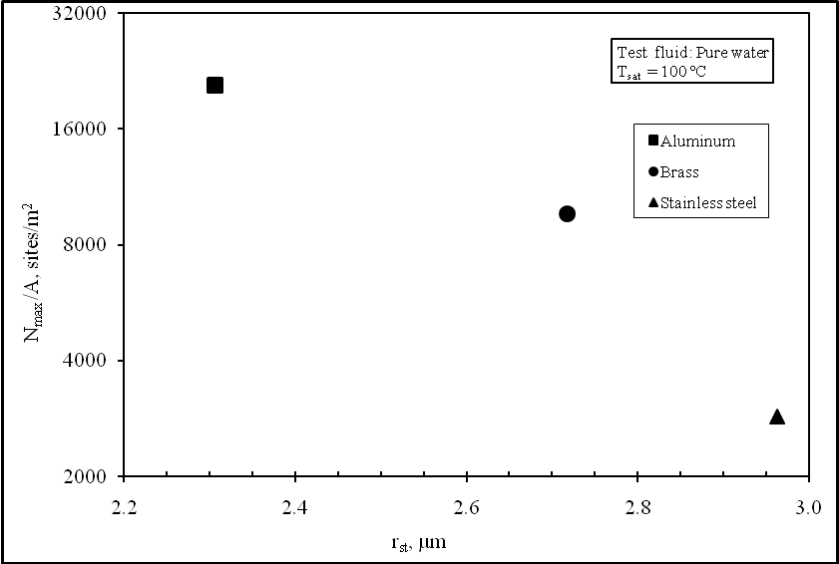

a. pure water SDS solutions .b
Fig. 11 Variation of the constant N_{max}/A with r_{st} for pure water and SDS solutions for the three different testing tubes

Fig. 12 depicts the relation between the active nucleation sites density N/A of the three tested boiling surfaces as a function of the heat flux q. It is noted from the present results that the active nucleation sites density N/A increases with the increase of the heat flux q. This is could be attributed to the agitation effect resulted from the mobility of the vapor bubbles emitted form the tube wall nucleation sites which travel through the liquid pool. The increase in q activates greater number of nucleation sites. On the other hand, the results of N/A showed a similar trend for the different aqueous surfactant solutions and the behavior is similar for the three tested boiling surfaces S1, S2 and S3. Also the results show that, aluminum testing material gives the highest value of N/A.

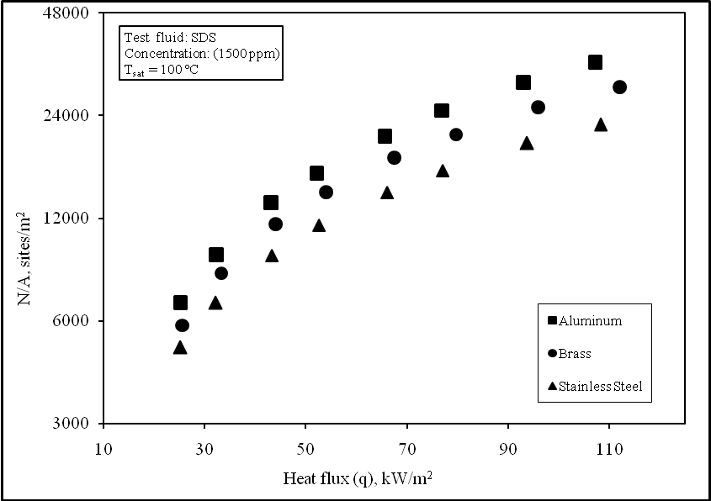
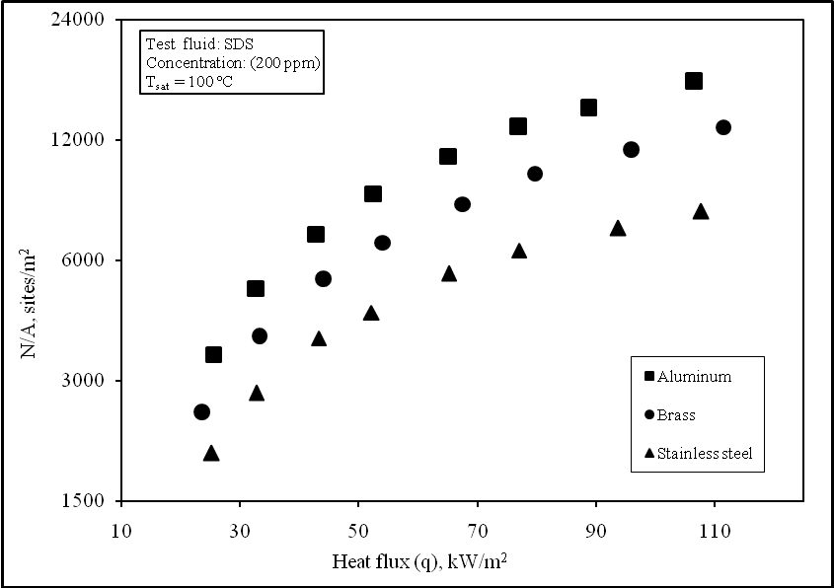

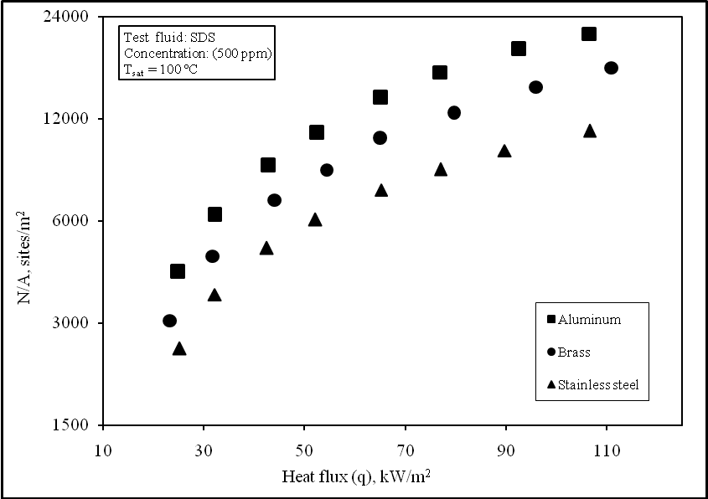
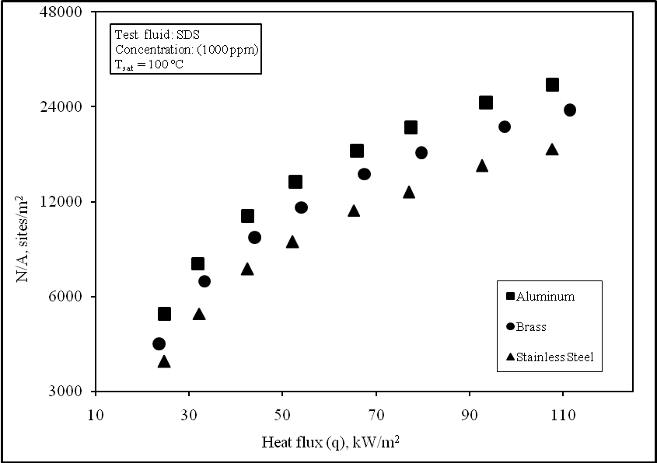

Fig. 12 Effect of heat flux on heat transfer coefficient for different concentrations of SDS aqueous surfactants solutions

3.2 Correlation of the Wall Heat Flux with ΔT and N/A.
The obtained experimental results show that, ΔT and the nucleation site density are affected by wall heat flux, q and concentration of aqueous surfactant solution. The nucleation site density, ΔT and q are found to be correlated by the equation [2 and 22]:
q = c. ΔTª.(N/A)^{b} (3)
Where a lies somewhere between 1.0 and 1.8, while ‘b’ is between 0.3 and 0.5. Fig.13 depicts the relation between the constants (a, b and c) of Eq. 3 for the three tested tubes as a function of the concentration.

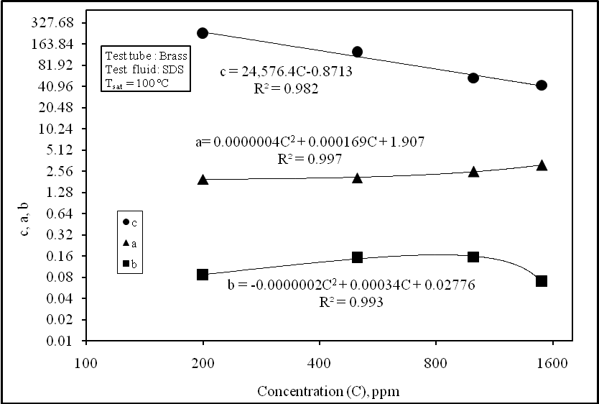
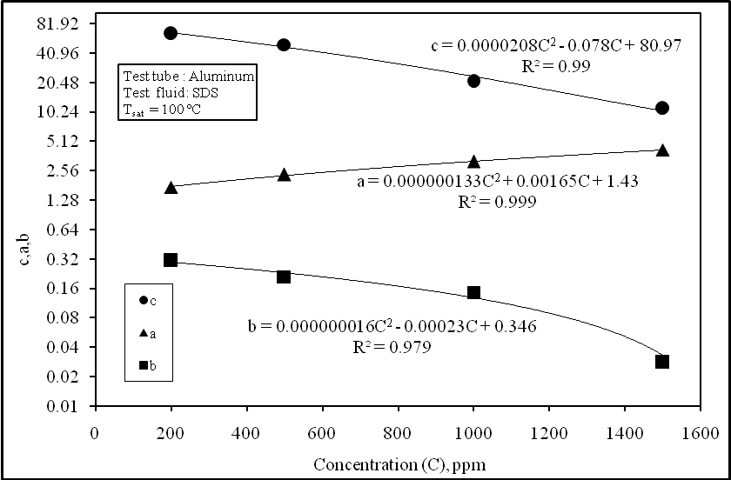

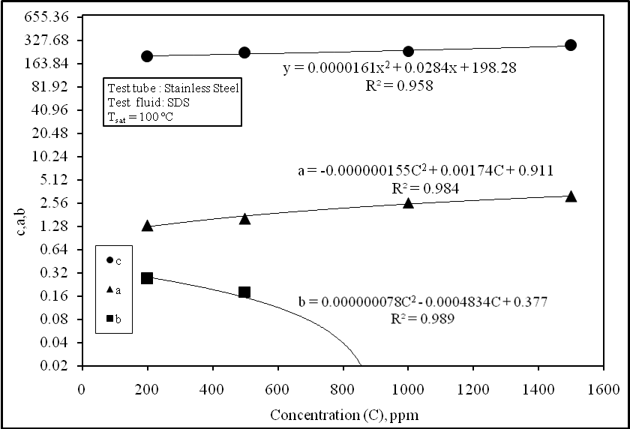

Fig. 13 Relation between the three constants (a, b and c) with concentration of SDS for the three testing tubes.

Based on the obtained experimental results, the constants of the Eq. 3 are given by the following equations:
i With aluminum
a = 0.000000133 C² + 0.00165 C + 1.43
b = 0.000000016 C² - 0. 00023 C +0.346
c = 0.0000208 C² - 0. 078 C + 80.97
ii With brass:
a = 0.0000004 C² + 0.000169 C + 1.907
b = - 0.0000002 C² + 0.00034 C + 0.02776
c = 24,576.4C ^{-0.8713}
iii With stainless steel:
a = -0.000000155 C² + 0.00174 C + 0.911
b = 0.000000078 C² - 0.0004834 C + 0.377
c = 0.0000161 C² + 0.0284 C + 198.28

3.3 Verification of the new correlation (Eq.3) with the present experimental data
Figure 14 shows a comparison between the obtained experimental values of the nucleation site density as function of heat flux with the corresponding ones calculated using the present correlation. Good agreement is noticed between the correlation and the experimental results, which means that the correlation could be give good representation for the relation between the heat flux, (q), nucleation site density (N/A), ΔT and surfactant concentration (C).

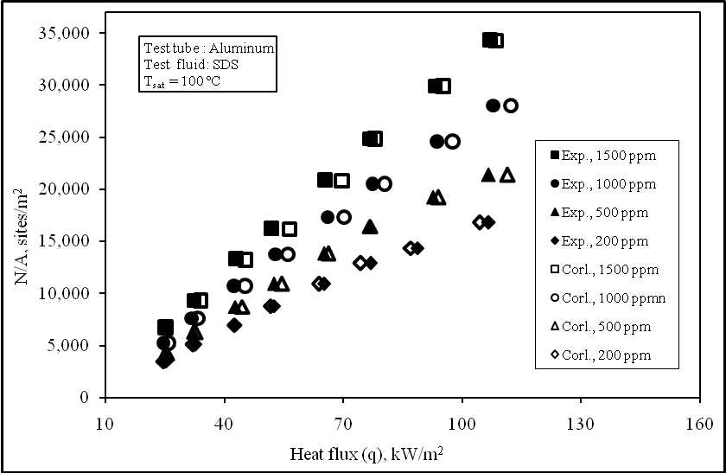
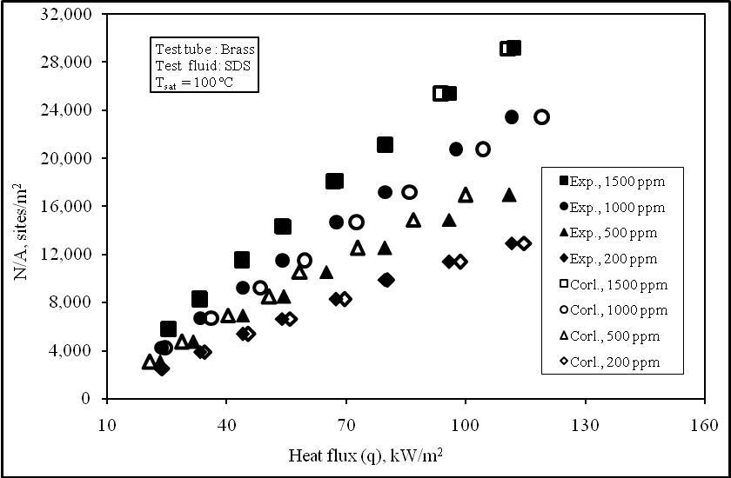

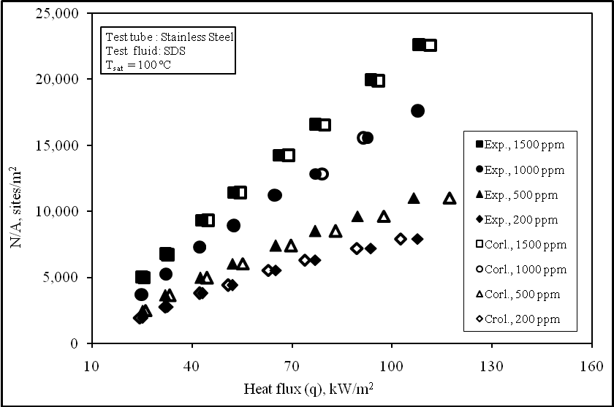

Fig 14 Verification of the present correlation with the experimental results for the three testing tube materials

4. Conclusions
The main objective of this study is to investigate the effect of wall heat flux and concentration of aqueous surfactant SDS solutions on the pool boiling heat transfer coefficient and active nucleation site. Saturated nucleate pool boiling experiments are performed on horizontal tubes of different materials (brass, aluminum and stainless steel), using pure distilled water and aqueous surfactant SDS solutions at different concentrations (200, 500, 1000, and 1500 ppm). The results showed that for a given aqueous

solution concentration, the nucleate pool boiling heat transfer coefficient and the active nucleation site density increase with increasing the wall heat flux. Also for a given wall heat flux, increasing the concentration of aqueous surfactant solution enhances both nucleate pool boiling heat transfer coefficient and active nucleation site density. Also, by comparison, it was found that the aluminum alloy 6061 tube heater material exhibits the best heat transfer coefficient enhancement with respect to other investigated materials.
The size distribution function constants (N_{max}/A, r_{st}, and m) deduced from the measurements show a defined trend with the different concentrations of the aqueous surfactant solution. With increasing surfactant concentration the constant (r_{st}) is decreased, N_{max}/A increases while the exponent (m) remains constant. For all heat transfer measurements the obtained results showed that the addition of SDS surfactants improve the heat transfer coefficient in percentages of 240 % at max. aqueous surfactant concentration with aluminum tube. Based on the present results, the wall heat flux, wall superheat and active heat flux, wall superheat and active nucleation site density are correlated versus the test tube material and concentration of aqueous surfactant solutions. It was found that the obtained calculated values using the investigated correlations are in good agreement with the corresponding experimental ones.

Corresponding author
M.M. El-Fawal
National Center for Nuclear Safety and Radiation Control, Atomic Energy Authority, Nasr City-P.O. Box 7551,Cairo,Egypt,
mohamed_Elfawal@hotmail.com

References
[1] A.I. Morgan, L.A. Bromley, C.R. Wilke, "Effect of Surface Tension on Heat Transfer in Boiling", Ind. Eng. Chem. 41 (1949), pp 2767- 2771.
[2] H. Sephton, US Patent No. 3846254, 1974.
[3] W. Frost, C.J. Kippenhan, "Bubble Growth and Heat Transfer Mechanisms in the Forced Convection Boiling of Water Containing a Surface Active Agent", Int. J. Heat Mass Transfer 10 (1967), pp 931- 949.
[4] P.Kotchaphakdee, M.C.Williams, "Enhancement of Nucleate Pool Boiling with Polymeric Additives", Int. J. Heat Mass Transfer 13 (1970), pp 835- 848.
[5] H.J. Gannet Jr., M.C. Williams, "Pool Boiling in Dilute non Aqueous Polymer Solutions", Int. J. Heat Mass Transfer 14 (1971), pp 1001- 1005.
[6] B.H. Shah, R. Darby, "The Effect of Surfactant on Evaporative Heat Transfer in Vertical Film Flow", Int. J.Heat Mass Transfer 16 (1973), pp 1889- 1903.
[7] D.D. Paul, S.I. Abdel-Khalik, "Nucleate Boiling in Drag- Reducing Polymer Solutions", Journal of Rheology 27(1983), pp 59-76.
[8] Y.M. Yang, J.R. Maa, "Pool Boiling of Dilute Surfactant Solutions", Journal of Heat Transfer 105 (1983), pp 190- 192.
[9] Y.L. Tzanand, Y.M. Yang, "Experimental Study of Surfactant Effects on Pool Boiling Heat Transfer", Journal of Heat Transfer 112 (1990), pp 207- 212.
[10] W.T. Wu, Y.M. Yang, J.R. Maa, "Enhancement of Nucleate Boiling Heat Transfer and Depression of Surface Tension by Surfactant Additives", Journal of Heat Transfer 117 (1995), pp 526- 529.
[11] C.N. Ammerman, S.M. You,"Determination of the Boiling Enhancement Mechanism Caused by Surfactant Addition to Water", Journal of Heat Transfer 118 (1996), pp 429- 435.
[12] S.G. Kandlikar, L. Alves, "Effects of Surface Tension and Binary Diffusion on Pool Boiling of Dilute Solutions: an Experimental Assessment", Journal of Heat Transfer 121 (1999), pp 488- 493.
[13] V.M. Wasekar, R.M. Manglik, "A Review of Enhanced Heat Transfer in Nucleate Pool Boiling of Aqueous Surfactant and Polymeric Solutions, Enhanced Heat Transfer" 6 (1999), pp 135-150.
[14] R.I.Elghanam, et al,"Experimental Study of Nucleate Boiling Heat Transfer Enhancement by Using Surfactant" Under Publication.
[15] R.F.Godec and V.Dolec, "An Effect of Sodium Dodecyl Sulfate on the Corrosion of Copper in Sulphuric Acid Media,"Faculty of Chemical Engineering, University of Maribor, Smetanova 7, Maribor, Slovenia, (2000).
[16] K.Stephan, "Beitrag Zur Thermodynamik des Wärmeöergargs Beim Sieden", Abhandl. Deutscher Kältetechnischer Verein, No. 18, C.F. Müller – Verlay Karlsruhe, 19.(1964)
[17] W.T.Wu, Y.M.Yang, J.R. Maa,"Nucleate Pool Boiling Enhancement by Means of Surfactant Additives, "Exp. Therm. Fluid Sci. 18 pp 195-209 (1998).
[18] D.Gorenflo, "Heat Transfer at Nucleate Boiling and One-Phase Free Convection in a Wide Pressure Range, "Abhandl. D. Deutschen Kältetchn Vereins, Nr. 22 C.F. Müller – Verlag, Karlsruhe.(1977)
[19] M.H.Sakr, "Effect of Surface Roughness on Pool Boiling Heat Transfer of R-12" M.SC. Thesis, Zagzig Univ., Banha Branch, Shubra Fac. Of Eng.,Cairo, Egypt, (1984)
[20] P. W. McFadden, and P. Grassmann,"The Relation Between Bubble Frequency and Diameter During Nucleate Pool Boiling", Int. J. H.M.T. 5, pp.169-179 (1962).
[21] C.L.Tien, "Hydrodynamic Model for Nucleate Pool Boiling," Int. J. Heat Mass Transfer, Vol. 5, pp. 533-546, (1962).
[22] N.Zuber, "Nucleate Boiling, the Region of Isolated Bubbles and the Similarity with the Natural Convection," Int. J. Heat Mass Transfer, Vol. 6, pp. 53-78, (1963).

