Canibalism Among Cultured African Catfishes (Heterbranchus Longifillis And Clarias Gariepinus)

SOLOMON, R. J. AND UDOJI, F. C.

Department Of Biological Sciences, Faculty Of Science,
University Of Abuja, Federal Capital Teritory - Nigeria

Abstract:A two month experiment was conducted to check cannibalism among cultured African catfishes, using Heterobranchus longifilis and Clarias gariepinus. There were three treatments (A, B and C) each 22.4 x 10cm³ which were situated in the botanical garden of the department of Biological Science, University of Abuja. Water quality parameters (Temperature, pH, Dissolved Oxygen, Ammonia and Nitrate) were recorded throughout the study period and found within suitable ranges throughout the length of study. Three stocking densities were used namely Heterobranchus longifilis and Clarias gariepinus (8:8, 16:16, 24:24) fishes/m². The fishes were fed multi coppen with 45% protein, fat 12%, calcium 2.2% phosphorus 1.2%, ash 8.5%. The result of the study showed that the fish in treatment ‘C’ stocked at the rate of 24:24 (Heterobranchus longifilis and Clarias gariepinus) significantly showed increase in rate of cannibalism. Treatment ‘A’ had significant increase in growth and this was attributed to the fact that they had more space, food and less competition.
[SOLOMON, R. J; UDOJI, F. C. Canibalism Among Cultured African Catfishes (Heterbranchus Longifillis And Clarias Gariepinus). Nature and Science 2011;9(9):1-13]. (ISSN: 1545-0740). http://www.sciencepub.net.

Keyword: Canibalism, Cultured, African Catfishes, Heterbranchus Longifillis , Clarias Gariepinus.

Introduction
Little is known about the behaviors of fish under culture conditions like other animals, fish often defend their food and territory (Ruane, 2000). These activities find their origin in the need to balance the need to eat and not to be eaten (Thorpe and Cho, 1995). In fish, activities, such as aggression, cannibalism result in skin lesions and fin damage and in extreme cases lethal. This in turn increases their susceptibility to diseases and weakens the fishes making them more liable to cannibalism or death as a consequence of their wounds (Kaiser et al., 1995). Aggressive activities also cause a lot of energy which otherwise could be used for growth (Hecht and ilys, 1997). Thus aggression can result in stock losses, reduced food conversion efficiency and slower growth.
Cannibalism is the act of one individual of a species consuming all or part of another individual of the same specie as food (Boeuf and le Bail, 1995). Cannibalism is common ecological interaction in the animal kingdom and has been recorded for more than 1500 species (Mason and Mendi, 1997).
Cannibalism does not occur only as a result of extreme food shortages or artificial conditions, but only occurs under natural conditions in a variety of species (Laurel, 1975).
Cannibalism seems to be especially prevalent in aquatic communities in which up to approximately 90% in the organism engage in cannibalism at some point of their life cycle (Nwosu and Holzlomer, 2000).

Types Of Cannibalism Sexual Cannibalism
This is a special case of cannibalism in which female organism kills and consume a co-specie male before, during or after copulation (Appelbaum and Kalmer, 2000).

Size-structure Cannibalism
This type of cannibalism entails situation in which large individuals consume similar co-specie. This type is more common, in wild variety of taxa (Ruane, 2002).

Infanticide Cannibalism
This type of cannibalism is situation whereby adults eat the young of their own specie (sometimes even their own immediate offspring). Examples include chimpanzees where groups or adult males have been observed to attack and co-specie infants (Helfman, 1993).

Intrauterine Cannibalism
This is a behavior in some carnivorous specie in which embryos are created at impregnation but only one or two are born. The larger or stronger ones consume their less-developed sibling as a source of nutrients (Limberly, 2002).

Factors Causing Cannibalism In The Culture Of
Catfishes
Many factors appear to cause cannibalism in culture of catfishes. These factors generally seem to fall within two primary categories:
- Genetic and behavioral factors
- Environmental factors (Olayemi. 2006).
Within the genetic category the main cause of cannibalism is size variation within a cohort, caused by genetic differences which dictate individual growth rate. Size variation is also a primary cause of agonistic behavior which in turn can have the same end effect as cannibalism.
Size variation is currently however viewed as both a cause and effect of cannibalism (Barton et al., 2002). The behavioral category of causative factors is obviously intimately linked to the genome.
It has been concluded by various research workers that social dominance is one of the causes of size variation (Barton et al., 2002) which in turn results in hierarchical territoriality and behavioral pattern. Thus, a larger initial size and a genetically related propensity towards higher relative aggression would lead to a cannibalistic response. Several environmental factors, particularly when these are limiting have been found to influence the behavioral pattern of African catfish larvae and juveniles, thereby affecting the rate and extent of cannibalism. These include the availability of alternative prey, availability of food, feeding frequency, density, light, refuge, size variation, feed distribution (Reddy et al., 1995)

Food Availability
Environmental conditions if limiting to a large extent govern the behavior of the fish. It has been demonstrated that contribution and territorial aggression as was as other behavior patterns can be controlled by simply altering food availability (Broom, 1998).
In general the relationship between the rate of cannibalism and food availability is an inverse one (Limberly, 2002). Of interest in early juvenile African cat fish is that as food availability starts to decline territoriality appears to increase. This or probably a strategy whereby the fittest individual optimize limited food resources (Helfman, 1993).
However when food availability decreases to below threshold level, energy is redirected into cannibalistic activity (Kaiser et al., 1995). The likelihood that an inadequate supply of food may initially induce cannibalism in a population of equal size, larvae, or early juveniles has serious consequences. It may impact a beneficial spurt of growth of the attacker which promotes further predation upon smaller fishes (Clap et al., 1997) Cannibalistic individuals may become solely reliant on cannibalism and never learn to accept inert food. Overall it is clear that cannibalism cannot be eliminated by adequate feeding but its rate can certainly be reduced (Barnet et al., 1997).

Effect of Density
In general, cannibalism appears to be density dependent. Interesting observation have however been made for African catfish. As is the case for species, territoriality and the rate of cannibalism increases with increasing density which can be attributed to increase competition for space and consequence of social dominance and hierarchy (Barton et al., 1988)At a particular thresh hold level territoriality, aggression and rate of cannibalism decreases. In other words cannibalism in African catfish is density dependent.

Effect of Live and Dry Feed
Cannibalistic and territorial aggression in early juvenile African catfish can be significantly suppressed by feeding live food as opposed to formulated dry food. The reduction in trans-specific aggression might simply be a redirection of aggressive feeding behavior towards another actively swimming food source (Downing et al., 1999).

Effect of Light
Larvae and early juvenile African catfish are negatively photo tactic and generally nocturnal and exhibit strong refuge seeking behavior under high light intensity. Experimental work has shown that early juveniles under satiation feeding condition are reared under continual light display reduced browsing and swimming activity and exhibit increasing level of cannibalistic and territorial aggression (Clap et al., 1997).

Effect of Turbidity/Refuge:
Increased turbidity level significantly reduced the incidence of territorial aggression and rate of cannibalism (Den Ouden et al., 1997) The cues for this reduction are probably identical under conditions of high refuge availability and low light conditions (Duncan, I. 2002) This would imply that conditions of increased light intensity and reduced refuge availability would result in increased level of territoriality and rate of cannibalism. A decrease in browsing activity and thus feeding activity which would lead to growth rate. This has been shown experimentally and turbid waters therefore simulate low light conditions and refuge availability resulting in reduced levels of aggression and cannibalism (Brambel 1995)

Size Variation
Amongst the very many causative factors of cannibalism, size variation is both a cause and effect of cannibalism. Some of the major causes of cannibalism include high stocking or population density, feeding practices and size distribution. Hence two types of cannibalism have been recognized in the culture of African catfish larvae and early juvenile. They are:
- Type one: Tail first (Hossain et al., 1998)
- Type Two: head first (Hossain et al., 1998)
Type two is preceded by type one and is linked to the relationship between predator mouth width and prey head width which is linked to the increased variation in growth over time.

General Description Of Experimental Fish
Clarias gariepinus and Heterobranchus longifilis were used because they meet the fundamental conditions for aquaculture namely:
- They adapt to tropical climate conditions and are indigenous to Nigeria.
- They are resistant to diseases.
- They have fast growth rate.
- They reach maturity stage fast which make them good candidates for commercial purposes and a rich means of revenue for those who culture them for this purpose.
- They do well and thrive on cheap diet.

Clarias and Heterobranchus are prominent fresh water, omnivorous species which has ubiquitous distribution in freshwater such as rivers, streams, dams, and in Nigeria (Atanda, 2007).
They are also known as the “walking catfish” and are widely distributed throughout Southeast Asia, Africa, and the Middle East; though some are cultured in the European countries (Brummet, 2000). The Clarias gariepinus and Heterobranchus longifilis possess sharp tooth. These species has been cultured at various levels such as earthened ponds, re-circulatory and flow through water systems.
The level of productivity is largely influenced by the nutritional regime being employed which ranges from organic fertilization to nutritionally complete prepared diet (van weed et al., 1999). It has been recognized that African catfishes Clarias gariepinus and Heterobranchus longifilis were one of the most suitable species for aquaculture in Africa (Haiser et al., 1997).
The African catfishes are quite resistant to diseases. They do not require high water quality and they tolerate high concentration of ammonia and nitrate in water. Low concentration of oxygen can also be tolerated as African catfish can utilize atmospheric oxygen as well as dissolved oxygen in water because they possess well developed organs used for breathing (Kebus et al., 1992).

Natural Geographical Distribution
C. gariepinus and the H. longifilis are generally considered to be the most important catfish species for aquaculture. They have almost Pan African distribution ranging from the Nile to West Africa, from Algeria to southern Africa and also occur in Asia.

Literature Review
The catfishes Clarias gariepinus and Heterobranchus longifilis are generally considered as the most important tropical catfishes, species for aquaculture. They have almost pan African distribution ranging the Nile to West Africa to South Africa. They also occur in Asia.
A 90 days experiment was conducted in man-lake Ayame using H. longifilis (Iwama et al) which started with fish of 0.8 ±0.5 initial fish /m³ were tested during this experiment. The results showed that unlike final mean weight (WF) and mean daily weight gain (m.dwg) weight variation coefficient (CV), cannibalism rate (Cr), mortality and survival rate (Sr) were density dependent; best results of survival, cannibalism and mortality(68.0 ±15%,18.0± 2.2% and 14.0± 1.5%respectively) were recorded at the lowest density (50fish/m³). In another experiment (Ellis et al., 2002) that began with fish of 13.4± 0.5g as initial weight and lasted for 270 days, the stocking densities tested were 6,12,25,50 and 100 fish/m³.
Results in this experiment showed that all the parameter (Mr, cr, st, final cr and after were recorded at the lowest stocking densities 6 and 12 fish/m³).
Another experiment (Kebus et al., 1992) carried out to check the rate of cannibalism among group of juvenile H .longifilis (19-48 days old) was 66.5% nocturnal and its impact under modified day length was proportional to the duration of the dark phase. Shallow depth and high population density decreased the intensity of cannibalism whereas low density and deeper environment had opposite effect. The maintenance (R maint) and maximum(R max) daily food ratio of cannibals feeding on life prey were modeled as maint = 3.899 Wc 0.327 Cr =0.999, d.f=5 where wc was the body weight of cannibal (g). the latter model indicated that the impact of the cannibal on a population decreased by a 20% margin each time the cannibal doubled its body weight, and suggested that the cannibalism among vundu would become insignificant for cannibal heavier than 30g.
The significant of these findings is discussed within the contexts of vundu aquaculture and of general conceptual models of the dynamics of cannibalism among fishes.
Another experiment Haylor, 1993 carried in attempt to check the cannibalism and yield of Clarias gariepinus, small fingerlings (average weight=3g) of the type usually, used by African hatcheries were stocked together with tilapia (Oreochromis niloticus) brood fish at a ratio 1g of fingering to 3.64±0.39g of brood fish. Holding ponds were so prepared that persisting leaks did not cause water level drops of more than 2cm/night and water temperature, pH and transparency averaged 27.3ºC, 65 and 20.8cm respectively.
Results showed that C. gariepinus fingerlings stocked with tilapia brood fish preyed on tilapia recruits and thus grow faster, survived better and withstood higher densities than those ponds without tilapia. Availability of tilapia recruits significantly enhanced C. gariepinus fingerling survival (P< 0.05), final average weight (P<0.03) and number harvested /m² /66 days.
A more recent study, (Barton and Morgan, 2002) conducted a 15 week experiment to evaluate the frequency of cannibalism in catfishes of genius Orange-spotted Epinephelus coioides in order to obtain information to reduce Clarias gariepinus and Heterobranchus longifilis mortality and therefore improve the seed production and culture of the species. In the study cannibalism was classified into three (3) types:
- Prey nipped in the head or body
- Prey swallowed whole, head first and
- Predator suffocated to death with the prey in its mouth.
As size-grading as widely known to minimize fish cannibalism, experiments were conducted on 30m² , 40m² ,50m ² per liter stocking density of fish. In the results of groups cannibalism was more prevalent in the 50m² group 40mm groups. Size grading demonstrated a tendency to minimize mortality in >40 m² groups whereas there was no effect in fish of the 50mm group. These results suggests that dominant juvenile group attack subordinates regardless of their size difference and size grade the technique is therefore ineffective in reducing cannibalism in the 50cm².

Temperature
Water temperature changes with depth of the water and season of the year. The surface water is likely to be warmer than the deeper water. As temperature changes affects the amount of oxygen which dissolve in the water. Change in the temperature will also affect the pH and salinity of the water. High fluctuation in the temperature greatly affects the biological activities of the fish maximum temperature rangers for aquatic life is considered to be 20-33⁰c (Robert et al 1997).

Potential Hydrogen
Although this depends on the specie to be cultured, but in all case a pH of range of 7.0-9.0 has been identified as procedure and suitable for fish farming. Fish in fresh water stir well in alkaline base environment, regular test to control the acidity or alkalinity of the culture water should be observed to avert dissociation of weak acids and bases in the culture water which promote toxicity of chemical compounds in the culture water (Ndukwe 2006). The water pH levels can make the effects of these substances worse, or less harmful, depending on the effects of acidity or alkanity on the particular chemical. As a general rule the following pH values can be used to see if these are water pollution.
pH 5-7 – Normal (If there is limestone in the area)
pH 7-8.5 – Normal (IF there is limestone in the area)
pH 8.5-9 and 4-5 – May be polluted
pH <4 or >9 – Pollution problem (Jensen., 1999).

Disolved Oxygen
Oxygen influence the feeding habits of fish, its energy contents and by extension, its growth the availability of oxygen in sufficient amounts in culture water will promote the water quality by oxidizing poisonous gases like hydrogen sulfur, nitrate, ammonia etc. into non toxic forms (Ndukwe 2006). The level of oxygen fluctuates naturally during the day and might from season to season. The fall of oxygen in the waterway is one of the first signs of pollution. For fish to be able to live there must be enough oxygen for them to use. The level of dissolved oxygen greater than 100% should not be less than 45milligrams of oxygen per liter (called 60% saturation) if it falls below 4.5mg/h, then the fish will probably die (Akinwole et al., 2006).
If oxygen concentration is low, the stable water should be pumped out and fresh water let in using water control structures (Dunham et al., 2006).

Ammonia
Ammonia is extremely toxic and even at low levels possesses a threat to fish health. Ammonia is produced as normal part of metabolism, such is the toxicity that most animals immediately convert it to a less harmful substance usually urea. Fish shortens this process and continually excrete metabolic ammonia directly into the surrounding water through special cells in the gills. Therefore in the confines of aquaria and ponds, levels can rise rapidly to dangerous levels. At low levels (<0.1mg/L NH₃) acts as a strong irritant to the gills prolonged exposure. At higher levels (70.1mg/l NH₃) even relatively short exposure can lead to skin, eye and gills damage (Edwards 2000).

Chemistry Of Ammonia
When dissolved in water, normal ammonia (NH₃) reacts to from ionized species called Ammonium.
NH₃ + H₂O NH₄ + OH⁻
Ammonia NH₃ is highly toxic, where as the ammonium ion is less toxic. At any point in time there will be both ammonia molecules ammonium ions present the quantity of both amounts and ammonium for each species is dependent on both PH and temperature. As a thumb rule it as best to aim for a zero level of total ammonia at all time in normal circumstance any reading above 0.1mg/L TAN should be considered as unacceptable.

Nitrate
Elevated level is common when people set up new Treatments or ponds. Nitrate level only increase in pressure of nitrifying bacteria which are slow flowers. Until nitrifiers are well established nitrate levels may be significantly low and acceptable to fish health. Also nitrate levels are influence by level of ammonia in the water.
In the water, nitrifying bacteria also process ammonia to nitrate (Vijai et al., 2002). Furthermore nitrate are converted to nitrate which is usually considered as harmless at levels less than 50mg/L safe level of nitrate in water for aquatic life is 0.06mg/L (Robert et al 1997).
National Guidance and standard for water quality by the federal Ministry of Environment prescribe the following as standard for water quality for aquatic life mg/L.

Types of Physiochemical Parameters
Parameter | Permissible Limit Standard
pH | 6.0-9.0
Temperature | 20-33⁰C
Dissolved 0xygen | 6.8
Ammonia (Total) | 2.2-1.37- PH dependent
Nitrate | 0.06
(Duncan, 2002))

Africa catfish (Clarias gariepinus of initial body weight 34.8±4.8g and vundu catfish (Heterobranchus longifilis of initial body weight 39.1 ±8.2g fingerlings were stocked at densities of 4,6,8 m³ in traditional fish ponds constructed in the flood plain of the Queme River. For 70day’s from March to June 2005. Fish were feed twice a day with 34% crude protein feed formulated with locally available ingredients.

Materials And Methods.
An eight week long experiment to check cannibalism among cultured African catfishes Clarias gariepinus and Heterobranchus longifilis. The experiment was carried out in the Botanical Garden of the Biological Department of the University of Abuja.

Site Description And Aquarium Preparation
The garden is located in the southwest corner of the aquaria used were positioned under a shed with aluminium roofing close to the larger ponds of the garden. Three aquaria of size 22.4cm were used with three stocking densities of 8 fish/m^{2,} 16 fish/m² and 24 fish/m² for each aquarium designated as treatment A, B and C respectively. Treatment A was used as the control experiment. Water level in the aquaria was maintained at 0.6m (60cm). The top of the aquaria were covered with nets to prevent the juvenile from jumping out of the aquarium. Aerating machines were not used and this leads to frequent change in the aquarium which was done manually.

Aquarium Management
Initial weights of the juveniles was measured using automated top loading balance (Ohaus E400 and Ohaus precision plus) and length was measured beginning from the snout to the end of the tail prior to introduction of juvenile into the aquarium. Fishes used are of the same age group (weight 3.5-8.5g and length 3.5-8.0cm). Experimental fish were fed multi-pelleted fed.
Experimental fish were fed 4% of the body weight in the morning 8:00am and the evening 6:00pm. Fish weight and length were measured at weekly intervals for each treatment.

Physiochemical Parameters
A number of physiochemical parameters were monitored and measured daily for the first week of the experiment to determine the maximum number of period of accumulation to toxic levels and subsequent at 2 days interval to misappropriate of water quality. The water quality parameters were analysed to check for parameters such as temperature. Dissolved oxygen both surface water temperature and atmospheric temperature was read to the nearest ºC with the aid of digital thermometer. Dissolved oxygen was determined once a week by filtration with 0.1 (sodium hydroxide and aside modification of wrinkle method American public Health Association 1916). pH was determined with combo strip kit.

Feeding And Measurement
Multi-coppens feed for aquaculture which originated from Holland, with composition of protein 45%, fat 12%,calcium 2.2%, phosphorus 1.2%, Ash 8.5%,fish 2.5%. All the fishes in treatment A, B and C were fed 4% body weight. The juvenile were fed twice daily i.e. morning (7:00am-9:00am) and evening (6:00pm-8:00pm).

Aquaria And Treatement
Three plastic basins each having a capacity of 70 litres was used in the experiment. There were 3 treatments with varying body namely: treatment A (control), treatment B, treatment C. All fishes were fed 4% (BW) with the stocking density of 8:8, 16:16, 24:24 respectively for treatment A, B, C.
The juvenile stocked together in an aquarium were of the same length and weight. This was done to minimize the rate of cannibalism (Haiser et al., 1995).
The fishes were acclimatized for 7 days before the commencement of the experiment. No aerator was used therefore leading to frequent change of water. After the acclimation period, the fishes were randomly stocked and their initial gross total length and initial gross total weight of individual fish recorded the aquaria was covered with mosquito net to prevent juveniles from jumping out and also to prevent intrusion of foreign bodies such as insects, lizards etc.

Treatment A - Poly culture of Heterobrachus longilfilis and Clarias gariepinus (8:8)
Treatment B - Poly culture of heterobrachus longilfilis and Clarias gariepinus (16:16)
Treatment C - Poly culture of heterobrachus longilfilis and Clarias gariepinus (24:24)

Field Evaluation Parameters
1) Weight gain: calculated as the different between the initial and final mean weight value
2) Mean Growth Rate (MGR)
MGR=W₂-W₁x100
0.5 (W₁W₂)
Where W₁=initial weight
W₂= final weight
t= time
- Length gain = initial length – finial length
L1-L2

4. Survival/Mortality Rate

= x 100

Results

Table 1: Physiochemical Parameters for Treatment A
Stocking Density 8 Fish/cm³ | Week One | Week Two | Week Three | Week Four | Week Five | Week Six | Week Seven | Week Eight
Water Temperature ⁰C | 27 | 26 | 27 | 27 | 26 | 27 | 27 | 26
Dissolved oxygen mg/l | 6.83 | 6.62 | 6.4 | 6.24 | 6.12 | 6.1 | 6 | 5.96
pH | 8 | 7.2 | 7.7 | 7.9 | 8.0 | 8.3 | 8.5 | 8.4
Ammonia mg/L | 0.01 | 0.23 | 0.29 | 0.35 | 0.4 | 0.49 | 0.54 | 1
Nitric mg/l | 0.001 | 0.01 | 0.01 | 0.02 | 0.02 | 0.02 | 0.02 | 0.03

Table 2: Physiochemical Parameters for Treatment B.
Stocking Density 16 Fish/cm³ | Week One | Week Two | Week Three | Week Four | Week Five | Week Six | Week Seven | Week Eight
Water temperature ⁰C | 27 | 26 | 27 | 27 | 26 | 27 | 27 | 26
Dissolved oxygen mg/l | 6.83 | 6.4 | 6.23 | 5.96 | 5.67 | 5.34 | 5.04 | 5.03
pH | 8 | 7.4 | 7.9 | 7.9 | 8.1 | 8.3 | 8.5 | 8.4
Ammonia mg/L | 0.01 | 0.38 | 0.46 | 0.59 | 0.68 | 0.74 | 0.9 | 1.4
Nitric mg/l | 0.001 | 0.01 | 0.02 | 0.02 | 0.03 | 0.03 | 0.04 | 0.05
Table 3: Physiochemical Parameters for Treatment C.
Water temperature ⁰C | 27 | 26 | 27 | 27 | 26 | 27 | 27 | 26
Dissolved oxygen mg/l | 6.83 | 6.22 | 5.38 | 4.8 | 4.3 | 4.11 | 3.86 | 3.88
pH | 8.0 | 7.5 | 7.6 | 7.8 | 8.1 | 8.4 | 8.6 | 8.5
Ammonia mg/L | 0.01 | 0.43 | 0.54 | 0.68 | 1.02 | 1.42 | 1.83 | 2.11
Nitric mg/l | 0.001 | 0.02 | 0.02 | 0.03 | 0.04 | 0.04 | 0.04 | 0.06

Table 4: The weight gain of Clarias gariepinus and Heterobranchus longifilis for Treatment A. (8:8)
 | Weight gain of Juveniles (%) | Treatment A 8:8
Weeks | Clarias gariepinus | Heterobranchus Longifilis
1 | 2.60±0.01 | 1.70±0.01
2 | 4.00±0.03 | 3.30±0.01
3 | 9.30±0.01 | 4.80±0.02
4 | 14.30±0.01 | 5.80±0.01
5 | 26.30±0.01 | 8.10±0.02
6 | 31.30±0.02 | 13.20±0.01
7 | 41.40±0.01 | 12.00±0.01
8 | 46.20±0.01 | 10.20±0.03

Table 5: The Length increment of Clarias garinepinus and Heterobranchus longifilis for Treatment A (8:8).
Weeks | Clarias garinepinus | Heterobranchus longifilis
1 | 0.50±0.1 | 0.3±0.1
2 | 0.70±0.2 | 0.5±0.1
3 | 1.30±0.1 | 0.7±0.3
4 | 1.60±0.2 | 1.10±0.2
5 | 2.00±0.1 | 1.20±0.1
6 | 2.20±0.3 | 1.20±0.2
7 | 2.50±0.3 | 1.30±0.1
8 | 3.10±0.1 | 1.50±0.0.2

Table 6: The Weight gain of Clarias gariepinus and Heterobranchus longifilis for Treatment B (16:16)
Weeks | Clarias | Heteorbranchus
1 | 2.80±0.1 | 1.60±0.1
2 | 4.30±0.2 | 2.30±0.1
3 | 8.70±0.1 | 3.10±0.3
4 | 12.70±0.2 | 4.50±0.2
5 | 27.60±0.1 | 1.30±0.1
6 | 33.30±0.3 | 2.20±0.2
7 | 42.60±0.3 | 5.70±0.1
8 | 46.90±0.1 | 6.60±0.0.2

Table 7: The Length increment of Clarias gariepinus and Heterobranchus longifilis for Treatment B (16:16)
Weeks | Clarias | Heterobranchus
1 | 0.50±0.1 | 0.40±0.1
2 | 0.80±0.1 | 0.50±0.1
3 | 1.20±0.1 | 0.60±0.2
4 | 1.30±0.1 | 0.90±0.2
5 | 1.80±0.2 | 1.20±0.2
6 | 2.10±0.1 | 1.30±0.2
7 | 2.40±0.2 | 1.50±0.1
8 | 2.90±0.2 | 1.80±0.1

Table 8: The Weight gain of Clarias gariepinus and Heterobranchus longifilis for Treatment C (24:24.)
Weights gain of Juvenile %
Weeks | Clarias | Heterobranchus
1 | 2.40±0.1 | 1.30±0.1
2 | 4.0±0.1 | 2.20±0.1
3 | 8.30±0.2 | 2.90±0.1
4 | 12.000.1 | 4.20±0.2
5 | 30.30±0.1 | 5.20±0.2
6 | 35.10±0.1 | 6.20±0.2
7 | 42.50±0.2 | 7.10±0.1
8 | 47.70±0.1 | 21.80±0.1

Table 9: The Length increment of Clarias gariepinus and Heterobranchus Longifilis for Treatment C (24:24.)
Weeks | Clarias | Heterobranchus
1 | 0.6±0.1 | 0.6±0.1
2 | 0.9±0.1 | 0.70±0.1
3 | 1.4±0.2 | 0.90±0.1
4 | 1.7±0.1 | 1.20±0.2
5 | 2.1±0.1 | 1.30±0.2
6 | 2.5±0.1 | 1.50±0.1
7 | 2.7±0.2 | 1.70±0.2
8 | 5.40±0.2 | 1.90±0.1

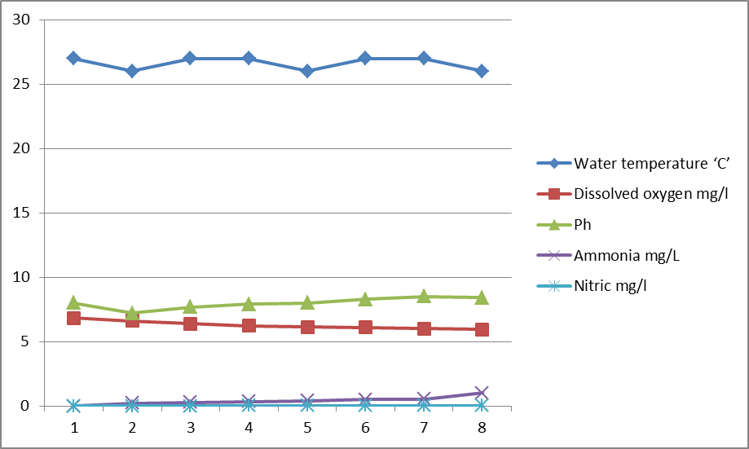

Figure 1: Physiochemical parameters for Treatment A

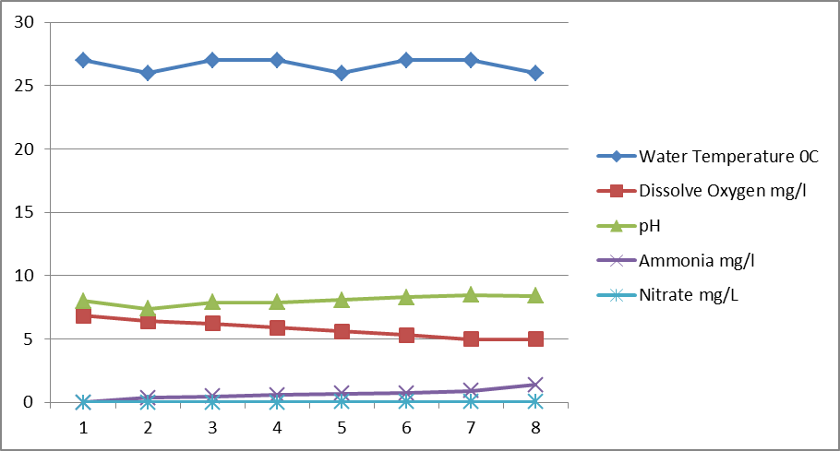

Figure2: Physiochemical Parameters for treatment B

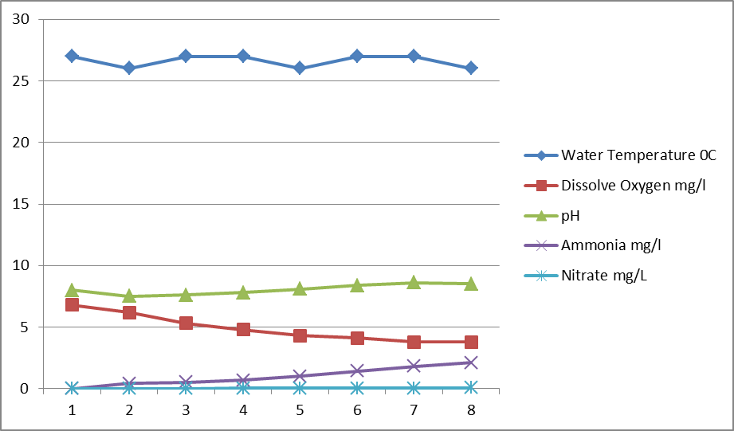

Figure 3: Physiochemical Parameters for treatment C

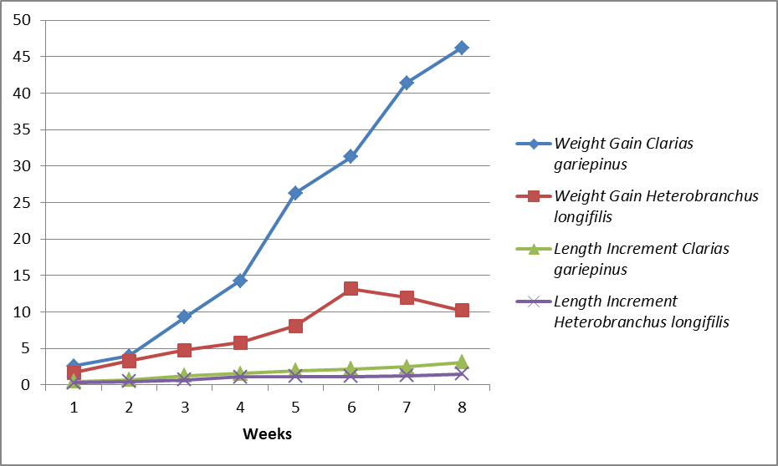

Figure 4: Weight gain and Length Increment of Clarias gariepinus and Heterobranchus longifilis Treatmnent A

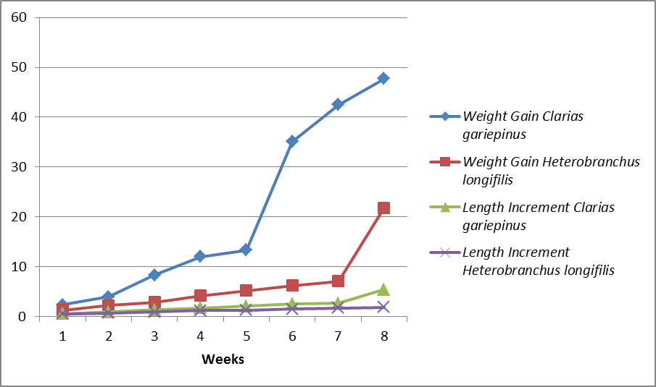

Figure 5: Weight gain and Length Increment of Clarias gariepinus and Heterobranchus longifilis Treatment B

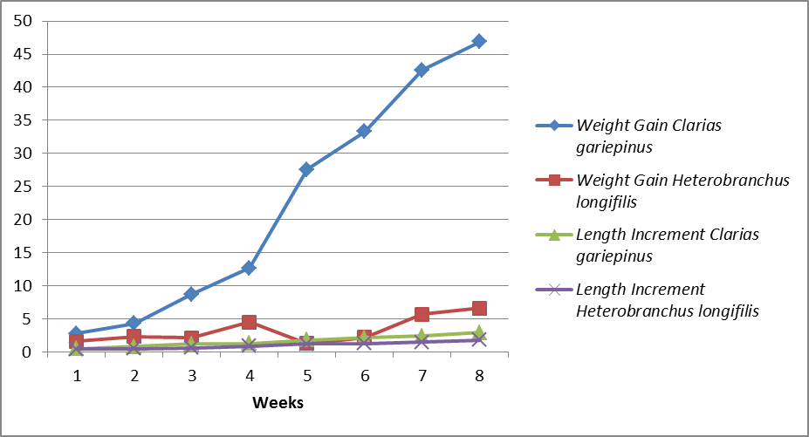

Figure 6: Weight gain and Length Increment of Clarias gariepinus and Heterobranchus longifilis Treatment B

Discussion
Adverse concentration of water quality parameter especially oxygen and ammonia are noticeable through out the study period, apart from serving as likely stressors some of this concentration could have been direct causes of death.

Water Temperature
Water temperature recorded during the experimental period ranged from 26 degrees to 28 degrees. The temperature readings in all the rearing Treatments were within the same range for the three treatments and this shows that the reading were within tolerable range for the culture of catfishes as recommended by Barton et al., (2002).

Hydrogen Ion Concentration (Ph)
The hydrogen ion concentration recorded during the study period for the three treatment range between 7.2-8.6 with Treatment A (control) having the lowest pH value of 7.2 while Treatment C had the highest value of 8.6 and thus attributed to the difference in stocking densities. This result shows that concentration of pH in all the three Treatments were alkaline in were within tolerable range (6.0-9.0) for the culture of catfish (Barnet et al., 1997).

Nitrate
Throughout the period of study the nitrate level never reached significant level that could affect the fishes health or growth. Their readings ranged between 0.01mg/l and 0.06mg/l for Treatment A having the lowest value of 0.01mg/l while the highest value occurred in Treatment C. High nitrates levels are dependent on nitrifying bacteria which are slow at growth. Nitrate levels greater than 0.06mg/l are considered toxic for the culturing of catfishes as recommended by federal ministry of environment, (2006).

Ammonia
Ammonia concentration throughout the study period for the three Treatments were at 0.23mg/l to 2.11mg/l. the highest level was recorded in Treatment C (2.11mg/l) while the lowest was obtained in Treatment A (0.23mg/l). although the concentration were within range hence this results agree with the guidelines from Eding et al., (2001) which states that values less that 8.8mg/l are considered tolerable for the culturing of catfishes (Clarias gariepinus and Heterobranchus Longifilis).

Cannibalism At Different Stocking Densities
Survival rates at different stocking densities (8:8, 16:16, 24:24) i.e. Treatment A, B and C were observed and recorded weekly. The survival rate in Treatment C showed that it had the highest cannibalism rate with Clarias gariepinus having the highest number of survivals of 24 numbers and Heterobranchus longifilis having 14 numbers out of the 48 that was initially stocked. Also Treatment B had Clarias gariepinus emerging with higher number of survivals with 16 and Heterobranchus with 9 numbers out of 24 that were initially stocked. Treatment A had 8 Clarias gariepinus and 2 Heterobranchus longifilis. The survival rate was high in treatment A and this was attributed to the fact that fishes in Treatment A had more space, supplementary food and as such reduce competition among the fishes in the aquarium. The mean weight gain of Clarias in Treatment C (31.10± 1.78g) and Heterobranchus with (3.50± 1.16g) shows that the Clarias gariepinus are more cannibalistic.
Duncan (2002) among others has demonstrated that survival decreases as stocking increases. . The highest mortalities recorded in Treatment C
was attributed to handling stress and overcrowding hence fishes in Treatment C were most probably under stress than those in Treatment A and B. The rate of cannibalism in different Treatments were statistically analyzed using the student t-test. The analyses showed a significant difference between the weight of Clarias specie and Heterobranchus specie (t calculated = 28.27, t calculated = 2.26), but the analyses did not show any significant difference between the length of Clarias specie and Heterobranchus specie. (t calculated = 1.5, t tabulated = 2.36) for Treatment A. in Treatment B there was significant difference between the weight of Clarias specie and Heterobranchus specie (t calculated = 42.16, t tabulated = 2.36) there was no significant difference in their length i.e.(t-calculated=1.76,t-tabulated=2.36)in Treatment B. in Treatment C there was also significant difference between the Clarias specie and Heterobranchus specie i.e. (t-calculated=12.95,t-tabulated=2.36) but there was no significant difference in their length i.e. (t-calculated=1.84,t-tabulated=2.36) in Treatment.
All those were attributed to the fact that Clarias gariepinus eats and feeds faster than Heterobranchus specie.

Conclusion
Brummet et al., reports that when the amount of fish stocks exceeds the carrying capacity of the water supply, quality and the condition of the fish deteriorates and mortality increases due to rapid growth of protozoa and bacterial diseases and parasites. Findings in the study further proof the hardy nature of African catfish (Clarias gariepinus and Heterobranchus longifilis) in terms of ability to withstand water quality, stress at higher stocking densities. The pond Clarias gariepinus and Heterobranchus longifilis in Nigeria has good potential foe economic success. Also from the studies, its shows that Clarias is more cannibalistic than Heterobranchus longifilis.

Recommendations
From the study so far, I there for suggest some practical hints to reduce larval and early juvenile cannibalism in culture of African catfishes (Clarias gariepinus and Heterobranchus longifilis).
- Feed to satiation
- Optimal feeding frequency
- Distribute inert food evenly over water surface
- Supplement with live food
- Food particle size must be optimized
- Rare larvae under low life condition
- Optimal stocking density
- Regularly grade fish by siz9
- Remove obvious cannibals.

References
- Almazan Rueda. P., Schrama. J.W and Verreth, J.A.J. Submitted. (2000) Behavioural responses under different feeding methods and light regimes for the African catfish (Clarias gariepinus) juveniles.
- Appelbaum, S and Kamler, E., (2000). Survival, growth, metabolism and behavior of Clarias gariepinus (Burchell 1822) early stages under different light conditions. Aquaculture Engineering 22, 269-289.
- Appelbaum, S and McGeer, J., (1998). Effect of diet and light regime on growth and survival of African catfish (Clarias gariepinus) larvae and early juveniles. Aquaculture Nutrition 4, 157-164.
- Barnett, J.L and Newman, E.A., (1997). Review of welfare research in the laying hen and he research and management implications for the Australian egg industry. Australian Journal of Agricultural Research 48, 385-402..
- Barton, B.A, Morgan, J.D and Vijayan, M.M (2002). Physiological and condition-related indicators of environmental stress in fish. In: Biological indicators of Aquatic Ecosystem Health. Adams S.M. ed. American Fisheries Society, Bethesda, M.D. pp. 111-148.
- Boeuf, G and Falcon, J. (2001). Photoperiod and growth in fish growth. Aquaculture 177, 129-152.
- Boeuf, G. and Le Bail, P.Y. (1999). Does light have an influence on fish growth. Aquaculture 177, 1-4.
- Boujard, T. Moreau and Luquet, P. (1991). Entrainment for the circadian rhythm of food demand by infradian cycles of light-dark alternation in Hoplostenum littorale (Teleostei). Aquatic Living Resources 4, 221-225.
- Bracke, M.B.M. Metz, J.H.M., Spruijt, B.M and Schouten, W.G.P. (2002). decision support system for overall welfare assessment in pregnant sows B: validation by expert opinion. Journal of Animal Science 80, 1835-1845.
- Brambell, F.W (1995). Report of the technical committee to enquire into the welfare of animals kept under intensive livestock husbandry systems.
- Britz, P.J and Pienaar, A.G (1992). Laboratory experiments on the effect of light and cover on the behavior and growth of African catfish, Clarias gariepinus (Pisces: Claridae). Journal of Zoology 227,43-62.
- Broom, D.M (1998). Fish welfare and the public perception on farmed fish. In: report Aquavision 98.
- Brummet, R.E. (2000). Indigenous Species for Aquaculture Development in Africa. Beeever Press, Nigeria. PP 5-8.
- Carmichael, G.J., Tomasso, J.R., Simco., B.A and Davis, K.B (1984). confinement and water quality induced.
- Clap, D.F, Bhagwat, Y and Wahl, D.H (1997). The effect of thermal stress on walleye fry and fingerling mortality. North American Journal of Fisheries Management 17, 429-437.
- Deacon, N and Hecht, T (1996).The effect of temperature and photoperiod on the growth of juvenile spotted grunter Pomadasys commersonnii (Pisces: Haemulidae) South African Journal of Marine science 17, 55-60.
- Den Ouden, M., Nijsing, J.T., Dijkhuizen, A.A and Huirne R.B.M, (1997). Economic optimization of pork production marketing chains: I. Model input on animal welfare and costs. Livestock Production Science 48, 23-37.
- Diana, J.S and Fast, A.W (1989). The effects of water exchange rate and density on yield of the walking catfish, Clarias fuscus. Aquaculture 78, 267-276.
- Downing, G and Litvak, M.K (1999). The effect of photoperiod, Treatment colour and light intensity on growth of larval haddock. Aquaculture International 7, 369-382.
- Duncan, I.J.H., (2002). Poultry welfare: Science or subjectivity? British Poultry Science 43, 643-652.
- Duncan, I.J.H and Fraser, D (1997). Understanding animal welfare pp 123-132.
- Ellis, T., North, B., Scoot, A.P., Bromage, N.R. Porter, M and Gadd, D
- ( 2002). The relationship between stocking density and welfare in farmed rainbow trout. Journal of Fish Biology 61, 493-531.
- FAO, (2002). The state of world fisheries and aquaculture (SOFIA). FAO Rome, Italy. Pp 54-67 .
- Geverink, N.A., Schouten and Wiegant, V.M ( 2003). Individual differences in behaviour, physiology and pathology in breeding filts housed in groups or stalls. Applied Animal. 54, 342-453.
- Haiser, H., Weyl, O and Hecht, T (1995). The effect of stocking density on growth, survival and agonistic behavior of African catfish. Aquaculture ; 3, 217-225.
- Haylor, G.S. (1992). Controlled hatchery production of Clarias gariepinus (Burchell): Growth and survival of larvae at high stocking density. Aquaculture and Fisheries Management 23, 303-314
- Haylor, G.S (1993). Controlled hatchery production of Clarias gariepinus growth and survival of fry at high stocking density. Aquaculture 22, 405-422.
- Hecht T and Uys, W (1997). Effect fo density on the feeding and aggressive behavior in juvenile African catfish, Clarias gariepinus. South African Journal of Science 93, 537-541.
- Hossain, M.A.R., Batty, R.S., Haylor G.S. and Beveridege, M.C.M (1999). Diel rhythms of feeding activity in African catfish, Clarias gariepinus (Burchell 1822). Aquaculture Research 30, 901-905.
- Hossain, M.A.R., Beveridge, M.C.M and Haylor, G.S (1998). The effects of density, light and shelter on the growth and survival of African catfish (Clarias gariepinus Burchell, 1822). Fingerlings. Aquaculture Research 30. 901-905.
- Hossain. M., Batty, R.S . Haylor, G., Beveridge, M. 1999. Diet rhythms of feeding activity in African catfish Clarias geriepinus . Aquaculture Research 30. 901-905.
- Hughes. CAB International UK. 127-141.
- Iwama, G.K., Vijayan, M.M., Forsyth, R.B and Ackerman, P.A (1999). Heat shock proteins and physiological stress in fish. American Zoologist 39, 901-909.
- Jensen, P. (2002). The study of animal behavior and its implications. In the Ethnology of Domestic Animals. P. Jensen ed. Pp. 3-11.
- Kaiser. H., Weyl., O and Hecht. T. (1995b). The effect of stocking density on growth, survival and agonistic behaviour of African catfish. Aquaculture international 3, 217-225.
- Kebus, M.J., Collins, M.T., Brownfield, M.S., Amundson, C.H., Kayes, T.B. and Mailson, J.A. (1992). Effects of rearing density on the stress response and growth of rainbow trout. Journal of Aquatic Animal Health 4, 1-6.
- Khwuanjai Hengsawat, Ward, F.J. and Pornchai Jaruratjamom, (1997). The effect of stocking density on yield, growth and mortality of African catfish (Clarias gariepinus Burchell 1822) cultured in cages. Aquaculture 152, 67-76.
- Kieffer, J.D., Currie, S. and Tufts, B. (1994). Effects of environmental temperature on the metabolic and acid-base responses of rainbow trout to exhaustive exercise. Journal of Experimental Biology 194, 299-317.
- Limbery, P. (2002). In too deep. The welfare of intensively farmed fish. Petersfield, Hampshire: A compassion in world farming report.
- Mason, G.J. (1991). Stereotypes: a critical review. Animal Behaviour 41, 1015-1037.
- Mench, J.A.and Mason, G.J. (1997). Behaviour. In: Animal welfare. Edited by M.C. Appledy and B.O.
- Nwosu, F.M. and Holzlohner, S. (2000). Effect of light periodicity and intensity on the growth and survival of Heterobranchus longifilis Val. 1840 (Teleostei: Clariidae) larvae after 14 days of rearing. Aquaculture 16. 231-243.
- Nwosu, F.M. and Holzlohner, S. (2000). Effect of light periodicity and intensity on the growth and survival of Heterobranchus longifilis Val. 1840 (Teleostei: Clariidae) larvae after 14 days of rearing. Journal of Applied lchthyology 16, 24-26.
- Olayemi, J.K (2006). Food Security in Nigeria. The report of a Research study on Nigeria 4 (16): 32-38.
- Pickering A.D.and Stewart, A. (1984). Acclimation of the interregnal tissue of the brown trout, Salmo truta L., to chronic crowding stess. Journal of Fish Biology 24, 731-740.
- Pickering, A.D.and Pottinger, T.G. (1987). Poor water quality suppresses the cortisol response of salmonid fish to handling and confinement. Journal of fish biology 30, 363-374.
- Reddy, P.K., Vijayan, M.M., Leatherland, J.F.and Moon, T.W. (1995). Modify hormonal responses to handling stressors and cortisol treatment in fed and fasted rainbow trout. Journal of Fish Biology 46, 341-359.
- Rivera-Rio, L. (1998). Effect of variation in photoperiod and light intensity on oxygen consumption, lactate concentration and behavior in crayfish, Procambarus clarkia and Procambarus digueti. Comparative Biochemistry and Physiology A 119, 263-269
- Robert, S, Rushen, J. and Farmer, C. (1997). Both energy content and bulk of food affect stereotypic behavior, heart rate and feeding motivation of female pigs. Applied Animal Behavior Science 54, 161-171
- Rotlant, J. and Tort, L. (1997). Cortisol and glucose responses after acute stress by net handling in the spa rid.
- Ruane, N.M. (2002). Stress and stress disorders in a teleost fish, the common carp Cyprinus carpio L. phD thesis Wageningen University. 160p.
- Ruane, N.M. (2002). Stress and stress disorders in a teleost fish, the common carp Cyprinus carpio 32,3-6.
- Ruane, N.M., Husiman, E.A. and Komen, J. (2001). Plasma cortisol and metabolite level profiles in two isogenic strains of common carp during confinement. Journal Fish Biology 59, 1-12. 84.
- Schouten W.G.P.and Wiepkema P.R. (1991). Coping styles of tethered sows. Behavioral Processes 25, 125-132.
- Siddiqui, A.Q., Alnajada, A.R. and Alhinty, H.M. (1993). Effects of density on growth, survival and yield of the African catfish, Clarias gariepinus (Burchell) in Saudi Arabia. Journal of Aquaculture in the Tropics 8, 213-219.
- Siddiqui, A.Q., Alnajada, A.R. and ALhinty, H.M. (1993). Effects of density on growth, survival and yield of African catfish, Clarias gariepinus (Burchell) in Saudi Arabia. Journal of Aquaculture in the Tropics 8, 213-219
- Stickney, R.R. and Andrews, J.W. (1971). The influence of photoperiod on growth and food conversion of Channel catfish. The Progressive Fish Culturist 33, 204-206
- Treatment, M. (2000). Selective breeding for stress response in common carp (Cyprinus carpio L.) using androgenesis 185 p.
- Thorpe, J.E. and Cho, Y.C. (1995). Minimising waste through bioenergetically and behaviourally based feeding strategies. Water Science and Technology 31, 29-40.
- Van weed, J.H., Khalaf H.A, and Aaron. (1999). Balance trails for African catfish fed with treated soyabean meal. Journal of Aquaculture Nutrition 3 (5) 135-143
- Vijayan, M.M., Ballantyne, J.S. and Leatherland, J.F. (1990). High stocking density alters the energy metabolism of brook charr, Salvelinus fontinalis. Aquaculture 88, 371-381.
- Vijayan, M.M. and Moon, T.W. (1992). Acute handling stress alters hepatic glycogen metabolism in food derived 4,123-127
- Wendelaar Bonga., A.E., (1997). The stress response in fish. Physiological reviews 77,591-625.
www.wikipedia.org

6/28/2011

