Numerical Analysis of Geomembrane Behavior in Increasing of Soil Dam’s Height

Hamidreza Ahmadaghaei¹ , Mohammad Azadi²

¹Department of Civil Engineering, Central Tehran Branch, Islamic Azad University, Tehran, Iran
²Department of Civil Engineering, Qazvin Branch, Islamic Azad University, Qazvin, Iran
Corresponding author: h_ahmadaghaei@yahoo.com

Abstract: Geomembranes can be used with current production technology for increasing of dams crest height. Sake increasing useless dam height of copper mine of Sar cheshmeh that is one of present soil dams in Iran is used Geomembranes. In this research, at first optimize using type and thickness of Geomembrane is noticed in this dam and the way of getting base on leakage and resistance analysis of dam downside slope and then with using of SIGMA/W program from GeoStudio software is applied to evaluate Geomembrane behavior in addition crust to old dam and research be done about sufficiency and insufficiency against enter forces that this evaluation is done base on stress- strain analysis.
[Hamidreza Ahmadaghaei, Mohammad Azadi. Numerical Analysis of Geomembrane Behavior in Increasing of Soil Dam’s Height. Nature and Science 2011; 9(9): 49-52]. (ISSN: 1545-0740). http://www.sciencepub.net.

Key words: Geomembrane, Numeral Analysis, Height increasing, Soil dams, Sealing.

1- Introduction
Geomembrane is made by enough continues and polymeric thin sheets but it can be made by geotextiles with asphalt and or elastometer sprays and or composite of Bituminous multilayer. Main aim is using of Geomembranes, supply an ant leakage with low permeability that even it can save its sealing characteristics under strains [1]. In generally Geomembranes is divided in two groups: polymeric Geomembranes and Bituminous Geomembranes [2]. Polymeric Geomembranes is produced to four shapes: without stability, multilayer, cover support and stiffer support [3]. Bituminous Geomembranes is produced with geotextiles that cover with hot and metal in factory. Geotextiles has support and base role for making [4]. Geomembrane can be used in increasing soil dam’s height as sealing wall and or for decreasing free level of water [5].

2 - Sar Cheshmeh Copper Mine Tailings Dam
Sar cheshmeh Copper Mine is located 60 kilometers from city of Rafsanjan. It is used for recovery operations of the copper and water . Therefore, the required water is supplied from the wells, Salt rivers,

Return water and in the output in mining, the amount of weaskest water flow is 1000 liters per second. that, Firstly it must be maintained and control in place to prevent environmental pollution, And secondly, after separating the dry material through sedimentation, water returned to the factory and it is used again. The sediment retention dam about 21 km downstream of the mine site In order to collect the weaskest water plant was launched and was operating. The primary Sediment retention dam was kind of gravel dams with copper core and have been Height of 70 meters of river bottom. In terms of specifications, such as the dam has a width of 10m in the crest, Geomembrane is used Because of the low width clay core in the primary sediment retention dam (about 3 meters). Consequently, The initial stage of sediment retention dam Consisting of gravel with a clay core height of 70 m, has been changed to The gravel dam with a mixture of clay and Geomembrane sealing system and with a height of 110 meters, And a total of 37,000 square meters of PVC Geomembrane is used [6,7].

3- The way of calculation of Geomembrane optimized width
Calculation of Geomembrane optimize width is done base on slope stability and leakage analysis. For this aim is used GeoSttudio software. The GeoStudio software is used to analysis of the Leak in the mentioned dam. GeoStudio software is including geotechnical software Based on finite elements (Finite Elements). Through its, can be examine analyzes such as the stress - strain, leakage, flow, Slope stability and Dynamic Analysis. This software includes parts SIGMA / W for the analysis of the stress - strain, SEEP / W for the analysis of the flow and Leakage, SLOPE / W for the analysis of the slope stability, QUAKE / W for the dynamic analysis and other application areas. In this section, using the SEEP / W will be analysis of the Leakage in the sar cheshmeh cooper dam [7]. sar cheshmeh cooper dam is shown in Figure 1. Also the geotechnical parameters and leakage barrier material is presented in Table 1[6,7].

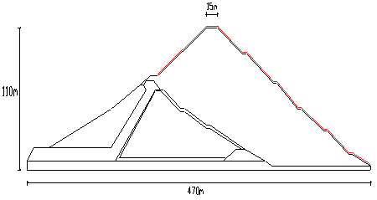
Figure 1 - section of the Sar Cheshmeh Copper dam [6,7]

Table 1 - geotechnical parameters and leakage of the barrier materials [6,7]

Material properties | Specific gravity (KN/m³) | Drained angle of internal friction | Cohesion Drained  (KPa) | Shear Modulus  (MPa) | Bulk Modulus  (MPa) | horizontal permeability  (cm/s)
upstream gravel | 20 | 47 | - | 80 | 170 | 10⁻¹
clay core | 19 | 22 | 20 | 10 | 90 | 10⁻⁶
downstream weir | 20 | 47 | - | 86 | 115 | 10⁻²
the shell was added | 22.5 | 44 | - | 86 | 115 | 10⁻³
geomembrane | - | - | - | - | - | 10⁻¹²
The andesite Foundation | 22.5 | - | - | 700 | 2600 | 5×10⁻⁶

Axial standard test results on Geomembrane cover show antiseptic values like delivery stress 1700 Pa, rapture stress in 3500 Pa tension and rapture strain 10% [8]. For finding useful and optimized width of Geomembrane in dam, it is necessary that Geomembrane with different widths are modeled like figure 1. After modeling and leakage analysis is chosen 3 mm width as optimized value for used Geomembrane in addition crust to old dam with using of SEEP/W program and stable analysis with SLOPE/W program [9]. In this research is noticed to evaluation if sufficiency and insufficiency Geomembrane that they are used with 3 mm width against enter forces. So SIGMA/W program is used. Also, some parameters like maximum and minimum of total stress and effective stress in horizontal and vertical dimension, pressure of hole water, maximum and minimum of strains rate and transfer in horizontal and vertical dimension in dam is calculated with this program. Modeling section of dam in SIGMA/W program is shown in Figure 3.
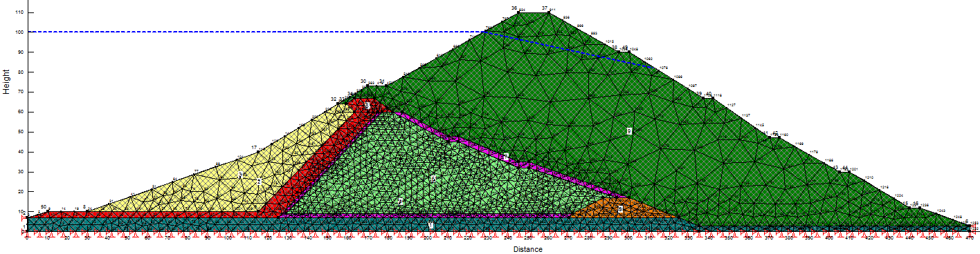
Figure 2 - cross of the modeling at the Dam Copper in the SIGMA/W program

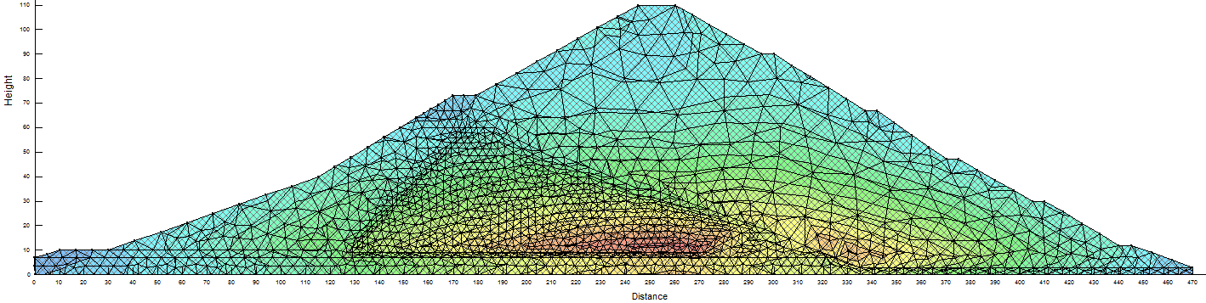
Fig 3- meter of horizontal total stress

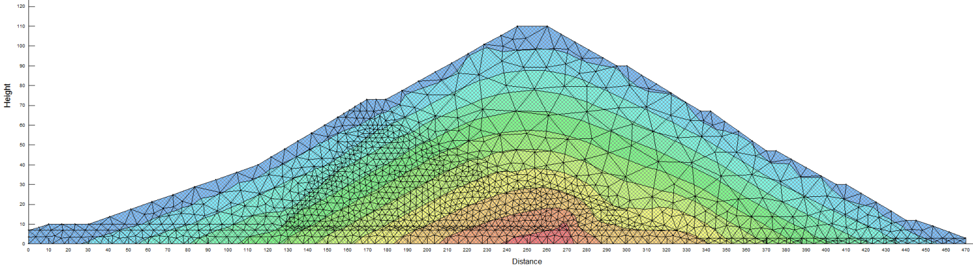
Fig 4 - meter of vertical total stress

This section is capable for review from SEEP/W program. After modeling (or model review from SEEP/W) and explain about continues points is done analysis function that get results is presented in Table 2.

Table2- results from SIGMA/W program
Minimum values of parameters | Maximum values of parameters | parameters
18.49 Pa | 882.59 Pa | Horizontal total stress
12.06 Pa | 2107.4 Pa | Vertical total stress
-938.299 Pa | 209.49 Pa | Horizontal effective stress
-855.27Pa | 1274.01Pa | Vertical effective stress
-26.33 Pa | 981.41 Pa | Pressure of hole water
-3.48 m | 3.55m | Horizontal transfer
2.14 m | 0 | Vertical transfer
3.26% | 0.067% | Horizontal strain
0.037% | 0.54% | Vertical strain

In minimum values for stress part, negative sign is demonstrated tensile stress. In fact, these values are maximum rate of tensile stress but on numeric aspect because of negative sign are introduced as minimum values with software. Also negative sign about transfer values is with meaning motion in opposite way of axial for horizontal transfer and motion in opposite way of Y axial for vertical transfer. Results of SIGMA/W program is shown in figure 3-9 as graphical.

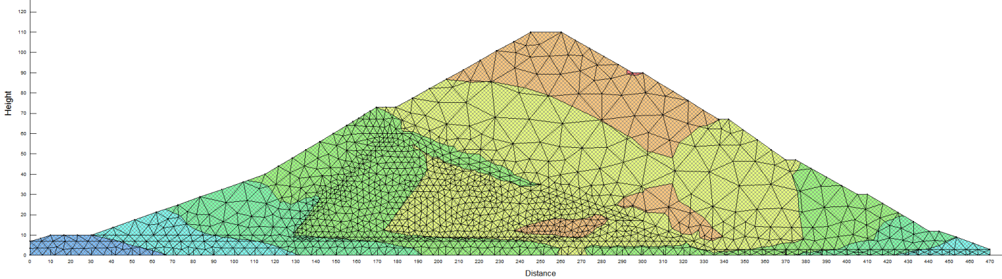

Fig 5 - meter of horizontal effective stress

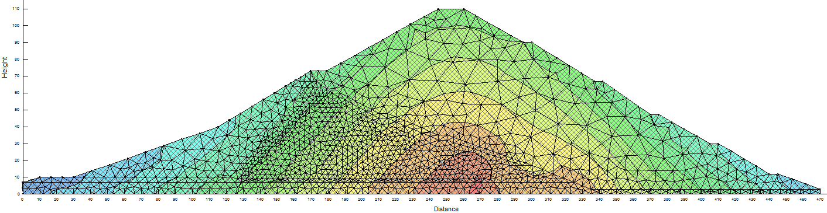

Fig 6 - meter of vertical effective stress

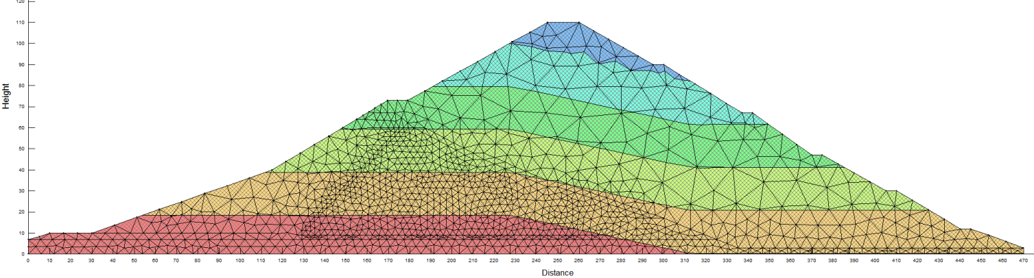
Fig 7 - meter of Pressure of hole water

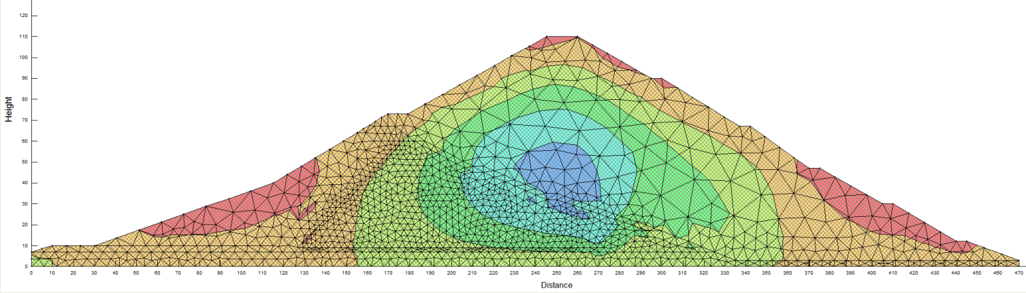
Fig 8 - meter of horizontal strain

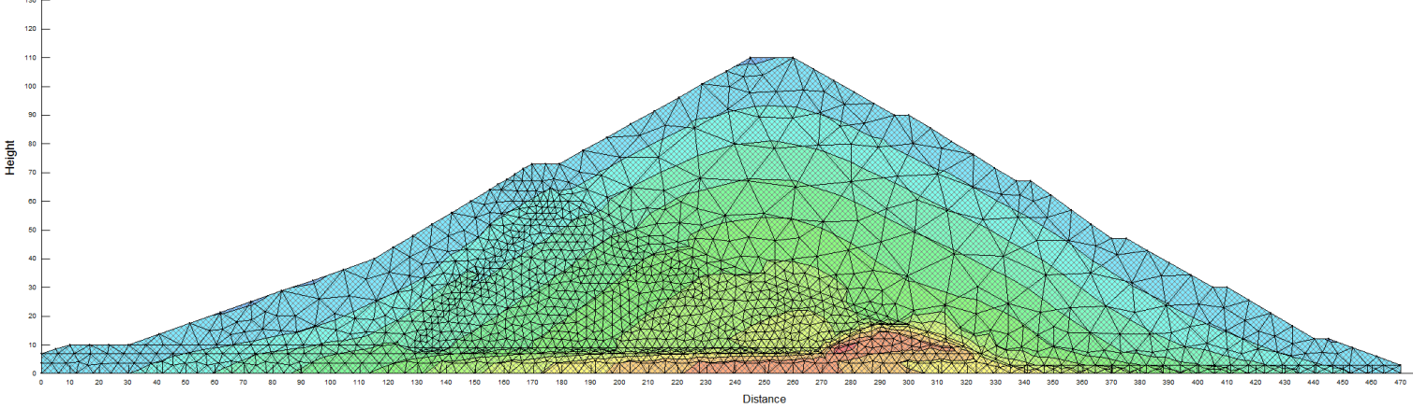
Fig 9 - meter of vertical strain

Conclusion
With notice to figures 3-7 have seen that regions that are used Geomembrane cover in their surface are illustrated stress in acceptable range dominantly blue and green. In figure 7 that is meter of hole water pressure, have been seen that in upside of dam from base floor to approximately height 18 m from upside base, hole water pressure have maximum value. Best way for decreasing water leankage in this area will be use of Geomembrane to decrease until range rate that is happen maximum hole water pressure. With notice to tension meter, maximum of produce tension is 938.299 Pa and is tensional in a range that is used Geomembrane And with notice to tension rate and rapture tension in tensional for using Geomembrane is 1700 Pa and 3500 Pa respectively. So using Geomembrane against enter tension show enough resistance. Also maximum rate of produce strain in Geomembrane is 3.26% and with notice to Geomembrane rapture strain is 10%, so produce strains in geomembrain is located in acceptable range too.

References
[1] O.Artieres , K.Oberreiter and F.Aschauer. “ Geosynthetics systems for earth dam- 35 years of experience”.
[2] A. M. Scuero. “ The new ICOLD Bulletin on impervious Geomembranes for dams”. ICOLD Bulletin , 2006.
[3] W.R.Morrison. “Watertight geomembranes for dams” ICOLD Bulletin, 1991.
[4] Robert M. Koerner. “ Lifetime prediction of polymeric Geomembrane used in new dam construction and dam rehabilitation” , 2005.
[5] “Basement membrane (geomembrane) ”, translated by Dr Reza Nurzad and Majid Hajiri Azar.
[6] “Report about how to increase height of Sar Cheshmeh dam”, Sad Afzar company.

[7] Hamidreza Ahmadaghaei , Mohammad Azadi. “Numerical analysis of the geomembrane behavior in the earth dams”, 2011.
[8] H. Perrier. “Tensile Test on Geomembranes” , 1998.
[9] “Static and dynamic analysis of earth dams by using GeoStudio”, written by AmirReza Amin Javaheri and Ehsan Pak Niyat .

7/11/2011

