Growth response of Chlorella vulgaris to acetate carbon and nitrogen forms

¹El-Sayed, A. B.; ¹Abdel-Maguid, A. A. and ²Hoballah, E.M.
¹Fertilization Technology Department, National Research Centre, Dokki-Cairo, Egypt
²Agricultural Microbiology Department, National Research Centre, Dokki, Cairo, Egypt
*bokhair@msn.com

Abstract: Growth of the green alga Chlorella vulgaris was performed on BG-II nutrient solution containing 17.6mM N from urea or sodium nitrate instead of N source. Acetic acid supports the heterotrophic growth of the examined alga. The investigated growth parameters were dry weight, chlorophyll and carotene. It was found that growth dry weight was markedly increased as growth medium was supported by urea nitrogen rather than nitrate nitrogen in free carbon media. Enrichment of nitrate growth media by organic carbon as acetic acid resulted in a moderate increase in growth dry weight as compared with urea growth culture. Chlorophyll were reduced due to acetate addition to nitrate grown cultures. Growth characteristics represented the same pattern and the lowest biomass doubling time of dry weight was about 9.8 hrs with urea nitrogen enriched cultures. Concerning chlorophyll, similar trend was slightly observed, however the effect was obviously higher with chlorophyll. On the contrary, carotene accumulation was increased due to acetate supplementation rather than the initial increase in control; however urea culture represented the maximum. Consequently, growth kinetics followed the same response. Urea provides alga by a sufficient carbon amount beside the same nitrogen quantity of nitrate source. [El-Sayed, A. B.; Abdel-Maguid, A. A. and Hoballah, E.M. Growth response of Chlorella vulgaris to acetate carbon and nitrogen forms. Nature and Science 2011; 9(9): 53-58]. (ISSN: 1545-0740). http://www.sciencepub.net.
Key words: Chlorella vulgaris, nitrate, urea, acetate carbon, dry weight, chlorophyll, carotene

Introduction

Photosynthesis is the key tune making solar energy available in useable forms for all organic life. Photosynthetic organisms including plants, algae and some photosynthetic bacteria are able to use such energy to combine water with carbon dioxide to create life biomass. It has long been recognized that a significant portion of the inorganic carbon fixed in actively growing photosynthetic algae is released as dissolved organic carbon (DOC) (Bertilsson and Jones 2002). Maximum releasing of total fixed carbon as extracellular dissolved organic carbon is closely depending on the nutrients availability that increased by nutrient limitation (Andersson & Zeutschel, 1970; Mague et al., 1980; Fogg, 1983; Lancelot 1983, Obernosterer & Herndl, 1995; Malinsky-Rushansky and Legrand, 1996 and Moran & Estrada, 2002). Although, most microalgae are photoautotrophs, some microalgae can use organic carbon substances as the sources of energy and carbon for cell growth. Mixotrophy is growth in which organic carbon is assimilated in the light simultaneously with carbon dioxide fixation.
Different hypothesis were early recognized concerning the action of different organic sources on algal growth. The ability of microalgae to use organic carbon as an energy source is important because it can minimize the inhibitory effects of seasonal and diurnal light limitation on growth in outdoor cultures. A considerable number of algae, for example Chlamydomonas (Lalibertè and de la Noüe 1993), Spirulina (Marquez et al., 1993), Chlorella (Endo et al., 1977), Galdieria (Gross and Schnarrenberger, 1995), Scenedesmus (Abeliovich and Weisman 1978), and Micractinium (Bouarab et al., 2004); can grow mixotrophically and heterotrophically in the presence of organic matter such as carbohydrates and acetate. Spirulina platensis grows faster and achieved a higher biomass concentration with the need for less light in mixotrophic culture than in photoautotrophic culture (Vonshak et al., 2000). Miao and Wu (2006) reported that heterotrophic growth of Chlorella protothecoides resulted in a high level of lipid accumulation in cells. Belcher (1968) examined the respiration of a non-axenic strain of Botrycoccus braunii in the presence of organic substrates, including monosaccharides, disaccharides, sugars, alcohols, or carboxylic acids, for 4 hrs under dark conditions. Oxygen consumption was increased significantly in the presence of these organic substrates such as glucose, mannose, acetic acid, ethanol, glycerol, and mannitol.
It is possible that bacterial contamination presents in the algal cultures had an effect on respiration rate. Also, it is unknown if this alga can grow for long periods of time in the dark. On the contrary, Weetall (1985) reported that Botrycoccus braunii did not grow heterotrophically in the dark, but growth was enhanced by the addition of carbon compounds including glucose, mannose, fructose, galactose, sucrose, lactic acid, or hydrolyzed cheese under light conditions. Assimilation of inorganic carbon and acetate by Botrycoccus braunii was also confirmed by Tenaud et al. (1989); who recognized that Botrycoccus has the capacity to utilize organic substrates to enhance growth in the light. The current work was achieved to eliminate the effect of acetate carbon against two nitrogen sources; i.e, sodium nitrate and ammonical nitrogen supported as urea.
2. Materials and Methods
Alga and nutrient solution
The green alga Chlorella vulgaris was grown with BG-II nutrient solution containing 1.5 g.l⁻¹ of NaNO₃ as a nitrogen source (Stainer et al., 1971). Urea (0.53g.l⁻¹) was used instead of sodium nitrate on equivalent weight basis (17.6mM N) as a nitrogen (46.5%N) and organic carbon source (49.5% CO). On the other series, acetic acid enriched the nitrate cultures by the same initial amount of urea carbon (0.25 ml.l⁻¹ of 96% analytical grade acetic acid).
Growth conditions
Growth was performed within high light transparent poly ethylene tubes (150cm length, 5cm diameter and 100µ in thickness) containing 2.5 L of the algal broth. Aeration was continuously provided from compressed air from the tube end, while one side white light bank supports the illumination to be 200 µ.E (El-Sayed and El-Fouly, 2005).
Growth measurements
The investigated parameters were dry weight, chlorophyll (a&b) and total carotene. Dry weight was measured by filtering a defined volume of the algal slurry (5-10 ml) over pre-weighted dried membrane filter (0.45 µm). Filters were dried at 105ºC for 30 minutes, kept over anhydrous calcium chloride till room temperature and then re-weighted. The difference between weights monitored the net dry weight of the grown alga within defined sampling time. Chlorophyll was extracted from the pre-centrifuged algal bulk by 95% DMSO (Burnison, 1980). Chlorophyll absorbance was measured at 649 & 665 nm and concentration was calculated (mg.l⁻¹) by Wellburn (1994). To recover carotene, saponification was performed by 5% KOH / 30% MeOH and the residual was re-extracted by DMSO after the addition of 5 drops of concentrated acetic acid (Boussiba et al., 1992). Carotene absorbance was measured at 468nm and concentration was calculated (mg.l⁻¹) according to Davies (1976) as: Total carotene (mg.l⁻¹) = 4.6 x A468. Growth analyses; including growth rate (µ); doubling time (g); degree of multiplication (n) and percentage increase (y%) were performed using the methods adopted by Pirt (1973).
3. Results and Discussion
Dry weight
Growth determined as dry weight was markedly increased with cultures that supported by urea as a nitrogen source comparing with nitrate supplementation under the same nitrogen content (17.6mMN). When data were subjected towards nitrate utilization as a nitrogen source, growth was reduced as compared with that used urea; however nitrate is preferably utilized by the most green algae including Chlorella (Fig.1). Supplying growth media by super optimal concentrations of urea as N source and phosphoric acid as P source enhanced vegetative growth. This might be led to increase some nutrients solubility or decrease pH values to near acidic reaction. Here, urea also acted as a complementary source of carbon (El-Sayed. et al., 2010).
The high initial carbon content of urea (49.5% CO) with high solubility rate to form carbonic acid might be enhanced the vegetative growth of algae. Furthermore, the cleavage of urea molecule led to the fast utilization of ammonical nitrogen part by the used alga. Urea degradation as a nitrogen source involved in two specific enzymatic systems (urease and urea amydolayase); which absent in algal metabolic matrix. The degradation might be achieved by bacteria; or due to the media reaction mainly acid reaction, light, aeration and/or hydrolysis by extracellular algal excretions.
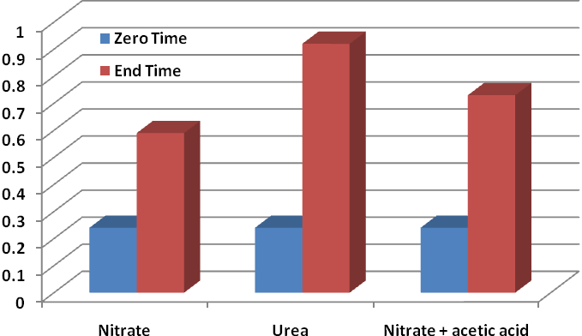

Dry weight (g.l⁻¹)

Nitrogen / carbon source

Fig. 1. Dry weight (g.l⁻¹) of Chlorella vulgaris under two nitrogen forms with organic carbon

The decline degree among the three examined treatments could be arranged in the order of 34.4% (urea/nitrate); 18.9% (urea/nitrate plus acetic) and 19.2% (nitrate plus acetate/ nitrate); which showed that urea capable to enhance the vegetative growth of Chlorella vulgaris when it used in a media free carbon.

Chlorophyll
Chlorophyll content was more affected by nitrogen source as compared with those data of dry weight accumulation. In addition, chlorophyll b was found to be more sensitive to such conditions, which resulted in inhibitory effect, especially when nitrate cultures were supported by acetic acid (Fig. 2). Thus, it could be suggested that acetate; however stimulate the vegetative growth; it reduce the rate of chlorophyll accumulation due to their absence function by fixing acetate on lipid form. The increment rates for chlorophyll a were found to be 11.44, 26.52 and 17.03% for urea/nitrate, urea/nitrate + acetic and nitrate / nitrate+acetic; respectively. As for chlorophyll b, organic carbon sources decreased the cell photosynthetic pigment contents and chlorophyll a to b ratio with a higher carotenoid to chlorophyll a ratio. This in harmony with Bertilsson et al. (2005); who reported that organic carbon sources reduced the photosynthesis efficiency, and the enhanced the biomass of Prochlorococcus tricornutum implied that organic carbon sources had more pronounced effects on respiration than on photosynthesis.
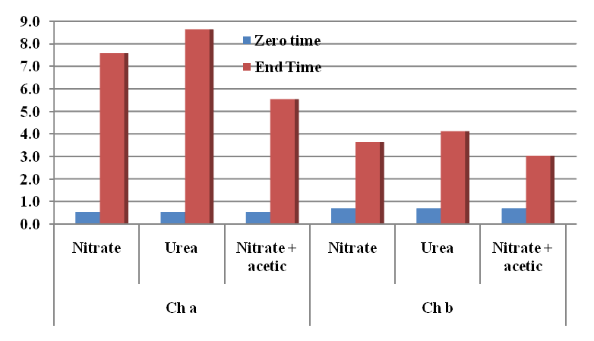

Chlorophyll (mg.l⁻¹)

Nitrogen / carbon source

Fig. 2. Chlorophyll a&b (mg.l⁻¹) of Chlorella vulgaris under two nitrogen forms with organic carbon

Belcher (1968) reported that 10 mM of acetate increased oxygen consumption by Botrycoccus braunii; however Weetall (1985) showed that sodium acetate had no effect on the growth of Botrycoccus braunii. In addition, Tenaud et al. (1989) reported that 5 mM acetate did not affect growth, but significantly increased respiration and inhibited photosynthesis. Addition of more than 10 mM sodium acetate to the cultures, increased chlorophyll fluorescence intensity, while it decreased with 20 mM acetate. However, in the presence of glucose under both light and dark culture conditions, the ratios of chlorophyll to dry weight were lower than those under autotrophic culture. The decline in chlorophyll contents might be caused by the inhibition of chloroplast development due to the presence of glucose or a relative increase in the level of other substances other than chlorophyll (Tanoi et al., 2011). Marquez et al. (1993) added that chlorophyll-a contents of Spirulina platensis cells under heterotrophic conditions was lower than under auto or mixotrophic conditions. So, it might be concluded that the balance between light intensity and the level of organic carbon is important and may determine the cellular content of chlorophyll.
Carotene
In comparison with chlorophyll data, maximum carotene content were obtained with urea grown cultures and acetate enhanced carotene content in nitrate cultures (Fig. 3). In this respect, low concentration of acetate was most likely assimilated by Botrycoccus braunii into both respiration and growth, however high concentration of acetate inhibited photosynthesis and growth (Tanoi et al., 2011). The effect of urea and acetate on algal growth media was early confirmed. Acetate enhanced the biosynthesis of carotene on the expense of chlorophyll. Such effect markedly obvious under severe stress conditions including salt stress, nitrogen deficiency and acetate trophic (El-Sayed, 2005 and El-Sayed, 2010).
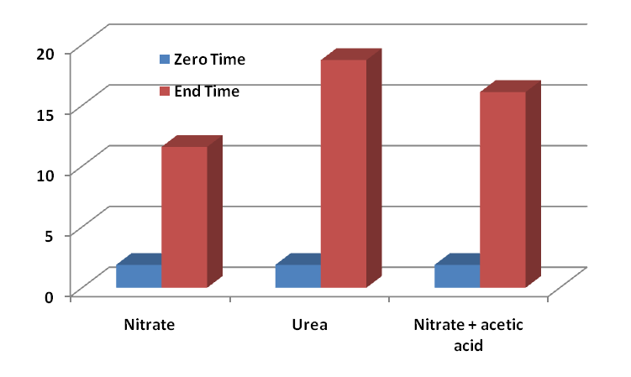

Carotene (mg.l⁻¹)

Nitrogen / carbon source

Fig. 3. Total carotene (mg.l⁻¹) of Chlorella vulgaris under two nitrogen forms with organic carbon

Growth analysis
Growth characteristics were markedly varied as growth was affected by both nitrogen form and trophic mode. Growth rate (µ) of cultures fed by urea as a source of ammonical nitrogen and organic carbon surpasses other cultures including nitrate free carbon or in the presence of acetic acid as a carbon source. Accordingly, doubling time was sharply decreased to be 9.8 hrs with urea treatment as compared with nitrate cultures that represented 14.6 hrs of dry weight doubling time. The net percentage increase also represented the same pattern (Table 1). The effect of citrate and other like-wastes on algal growth was considerably studied as a carbon source (Ruiz-Marin et al., 2010 and El-Sayed, 2010). The main effect on growth enhancement could be attributed to the initial content of some macro and micro-nutrients especially carbon and nitrogen.
Growth rate under different nitrogen sources was considerably surpasses when cultures were fed by urea (both in dry weight or chlorophyll a). Acetate addition caused an extra increase in growth rate only for dry weight of nitrate culture. On the other hand, acetate reduced chlorophyll (a&b) and carotene-growth rate for such culture that grown with nitrate (Table 1). The opposite effect on carotene might be attributed to the absence of Fe ion that enhances Fenton reaction and carotene accumulation. Consequently, other growth parameters showed the same pattern of the recorded growth rate. Moreover, data indicated that urea could replace nitrate as a nitrogen source and also supports growth media by a sufficient amount of carbon that might quickly utilize by the same time of nitrogen utilization.

Table 1. Growth characteristics of Chlorella vulgaris grown under two nitrogen forms with organic carbon.
N.S | µ | g | n | Y%
Dry weight
N | 0.047 | 14.6 |  | 145.8
  1.296927
U | 0.071 | 9.8 | 1.937474 | 283.3
N + ac | 0.059 | 11.8 | 1.603931 | 204.2
Chlorophyll a
N | 0.1396 | 4.96 | 3.824
  1418.4
U | 0.1464 | 4.73 | 4.013 | 1617.1
N + ac | 0.1231 | 5.63 | 3.372 | 1036.5
Chlorophyll b
N | 0.087 | 7.99 | 2.378
  520.3
U | 0.093 | 7.43 | 2.555 | 588.5
N + ac | 0.077 | 8.99 | 2.113 | 433.0
Carotene
N | 0.095 | 7.26 | 2.67 | 613.8
U | 0.096 | 5.74 | 3.31 | 991.5
N + ac | 0.091 | 6.14 | 3.09 | 852.4
NS= Nitrogen source
N= Nitrate U= Urea N+ac = Nitrate + acetic acid

The growth rate in mixotrophic conditions is approximately the same as the sum of the growth rate in the photoautotrophic and heterotrophic cultures (Endo et al., 1977, Ogawa and Aiba, 1981 and Marquez et al., 1993). On the other hand, organic carbon metabolism may exert an opposite influence on photosynthesis. Glucose can reduce the apparent affinity in CO₂ fixation (Lalucat et al., 1984, and Martinez & Orus, 1991). Glucose can also depress photosynthetic O₂ evolution (Der-Vartanian et al., 1981, and Oesterhelt et al., 2007).
Many studies of photosynthesis have been carried out with acetate grown Chlamydomonas reinhardtii cells. Increasing concentration of acetate reduced the photosynthetic CO₂ fixation and the net O₂ evolution, without effects on respiration and PS II efficiency (Heifetz et al., 2000). Acetate can also reduce carbonic anhydrase (CA) activity (Fett and Coleman, 1994). Kindle (1987) and Goldschmidt-Clermont (1986) showed that acetate can inhibit the light-harvesting chlorophyll a/b binding gene cab11-1 mRNA abundance and expression of rbcS encoding RuBPCase. In the unicellular green alga Chlorogonium elongatum, acetate inhibited the synthesis of RuBPCase and its mRNAs (Steinbiß and Zetsche, 1986). Moreover, acetate also repressed the activities of rbcL and rbcScah-1 encoding Rubisco, and psbA encoding protein D1 (Kroymann et al., 1995).
Some studies also suggested that glycerol assimilation by Pyrenomonas salina resulted in a reduction of photosynthetic components associated with light-harvesting. The cell phycoerythrin content, phycoerythrin to chlorophyll ratio, degree of thylakoid packing, number of thylakoids.cell−1, and PS II particle size were also reduced (Lewitus et al., 1991). In Cyanothece sp., glycerol addition in the light produced slight differences in the pigment content and ultrastructure (Schneegurt et al., 1997). Berman and Chava (1999) recognized that urea may also act as readily source of CO₂ required for photosynthetic organisms.

Growth metabolites ratios
The effect of acetate carbon with nitrate on some growth metabolites ratios including chlorophyll a/b and chlorophyll/carotene ratios were shown in Fig.4.
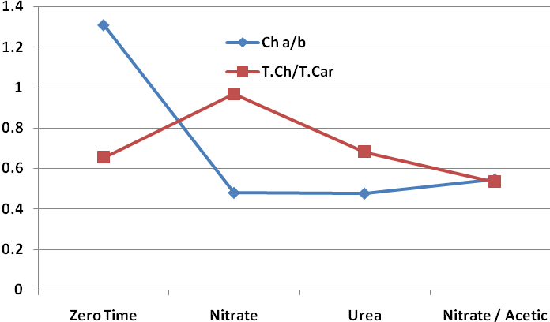
Ratio

Nitrogen / carbon source

Fig.4. Chlorophyll (a/b) and chlorophyll/carotene ratios of Chlorella vulgaris under two nitrogen forms with organic carbon.

At the early stage of cultivation, control culture at zero time represented the higher ratio of chlorophyll. Growth prolongation resulted in marked decreases on such ratio. The lowest decrease was observed with culture that received nitrate nitrogen in the presence of acetate carbon meaning that acetate affected chlorophyll contents by increasing chlorophyll b against chlorophyll a.
Conclusion
Nitrate was recognized as the prefer nitrogen source for many algal species. Urea seems to be the most effective nitrogen source for providing alga by a sufficient carbon amount beside the same nitrogen quantity of nitrate source.
Corresponding author
El-Sayed, A. B. Fertilization Technology Department, National Research Centre, Dokki-Cairo, Egypt
bokhair@msn.com
References
- Abeliovich, A. and Weisman, D. (1978). Role of heterotrophic nutrition in growth of the alga Scenedesmus obliquus in high-rate oxidation ponds. Appl. Environ. Microbiol.; 35:32–37.
- Anderson, G.C. and Zeutschel, R.P. (1970). Release of dissolved organic matter by marine phytoplankton in coastal and offshore areas of the northern Pacific Ocean. Limnol. Oceanogr.; 15: 402-407.
- Belcher, J.H. (1968). Note on the physiology of Botryococcus braunii Kützing. Arch. Mikrobiol.; 61:335 346.
- Berman, T. and Chava, S. (1999). Algal growth on organic compounds as nitrogen sources. Journal of Planktonic Research; 21 (8); 1423-1437.
- Bertilsson, S. and Jones, J.B. (2002). Supply of Dissolved Organic Matter to Aquatic Ecosystems: Autochthonous Sources, In: Findlay S.E.G. and Sinsabaugh, R.L. (eds), Aquatic Ecosystems: Interactivity of Dissolved Organic Matter, Academic Press, New York: 3-24.
- Bertilsson, S.; Berglund, O.; Pullin, M. J. and Chisholm, S.W. (2005). Release of dissolved organic matter by Prochlorococcus. VIE ET MILIEU, 55 (3-4) : 225-231.
- Bouarab, L.; Dauta, D. and Loudiki, M. (2004). Heterotropic and mixotropic growth of Micractinium pusillum fresenius in the presence of acetate and glucose: effect of light and acetate gradient concentration. Water Res.; 38:2706–2712.
- Boussiba, S.; Fan, L. and Vonshak, A. (1992). Enhancement and determination of astaxanthin accumulation in green alga Haematococcus pluvialis. Methods in Enzymology, 213, Carotenoids Part A, Lester Packer (ed.); Academic Press: 386-371.
- Burnison, K. (1980). Modified dimethyl sulfoxide (DMSO) extraction for chlorophyll analysis of phytoplankton. Can. J.Fish. Aquat. Sci.; 37:729-733.
- Davis, H. (1976). Carotenoids. In Chemistry and Biochemistry of Plant Pigments.2nd Eddition, vol.2. (Ed); Goodwin. T. W. pp.38-165. Academic Press.
- Der-Vartanian, D.; Espardellier, F.J. and Astier, C. (1981). Contributions of respiratory and photosynthetic pathways of a facultative photoautotrophic cyanobacterium, Aphanocapsa 6714. Plant Physiol 68:974–978.
- El-Sayed, A. B. (2005). Screening and growth characterizations of the green life stock of drill water from Jeddah. III- Enhancement of secondary carotenoids by oxidative stress in relation to medium composition. N. Egypt. J. Microbial. Vol.10, 232-241.
- El-Sayed, A. B. (2010). Carotenoids accumulation in the green alga Scenedesmus sp. incubated with industrial citrate waste and different inductions stress. Nature and Science 2010; 8(10):34-40.
- El-Sayed, A. B, El-Fouly, M.M. and Abou El-Nour, E. A. (2010). Immobilized-microalga Scenedesmus sp. for biological desalination of Red Sea water: I. Effect on growth metabolites. Nature and Science; 8(9):69-76.
- El-Sayed, A. B. and El-Fouly, M. M. (2005). Recovery of outdoor mass culture bleached Scenedesmus sp. Pakistan Journal of Biological Sciences, 8(3): 470-474.
- Endo, H.; Sanasawa, H. and Nakazima, K. (1977). Studies on Chlorella regularis, heterotrophic fast-growing strain. Mixotrophic growth in relation to light intensity and acetate condition. Plant Cell Physiol.; 18:199–205.
- Fett, J.P. and Coleman, J.R. (1994). Regulation of periplasmic carbonic anhydrase expression in Chlamydomonas reinhardtii by acetate and pH. Plant Physiol.; 106:103–108.
- Fogg, G.E. (1983). The ecological significance of extracellular products of phytoplankton photosynthesis. Botanica Marina, 26: 3-14.
- Goldschmidt-Clermont, M. (1986). The two genes for the small subunit of RuBp carboxylase/oxygenase are closely linked in Chlamydomonas reinhardtii. Plant Mol. Biol.; 6:13–21.
- Gross, W. and Schnarrenberger, C. (1995). Heterotrophic growth of 2 strains of the acido-thermophilic red alga Galdieria sulphuraria. Plant Cell Physiol.; 36:633–638
- Heifetz PB, Foster B, Osmond CB, Giles LG, Boynton JE (2000). Effects of acetate on facultative autotrophy in Chlamydomonas reinhardtii assessed by photosynthetic measurements and stable isotope analyses. Plant Physiol.; 122:1439–1445.
- Kindle, K.L. (1987). Expression of a gene for a light harvesting chlorophyll a/b-binding protein in Chlamydomonas reinhardtii: Effect of light and acetate. Plant Mol. Biol.; 9:547–563.
- Kroymann, J.; Schneider, W. and Zetsche, K. (1995). Opposite regulation of the copy number and the expression of plastid and mitochondrial genes by light and acetate in the green flagellate Chlorogonium. Plant Physiol.; 108:1641–1646.
- Lalibertè G. and de la Noüe, J. (1993). Auto, hetero and mixotrophic growth of Chlamydomonas humicola (Chlorophyceae) on acetate. J. Phycol.; 29:612–620.
- Lalucat, J.; Imperial, J. and Pares, R. (1984). Utilization of light for the assimilation of organic matter in Chlorella sp. VJ79. Biotechnol. Bioeng.; 26:677–681.
- Lancelot, C. (1983). Factors affecting phytoplankton extracellular release in the Southern Bight of the North Sea. Mar. Ecol. Progr.; Ser. 12: 115-121.
- Lewitus, A.J.; Caron, D.A. and Miller, K.R. (1991). Effects of light and glycerol on the organization of the photosynthetic apparatus in the facultative heterotroph Pyrenomonas salina (Cryptophyceae). J. Phycol.; 27:578–587.
- Mague, T.H.; Friberg, E.; Hughes, D.J. and Morris, I. (1980). Extracellular release of carbon by marine phytoplankton: a physiological approach. Limnol Oceanogr.; 25: 262-279.
- Malinsky-Rushansky, N.Z. and Legrand, C. (1996). Excretion of dissolved organic carbon by phytoplankton of different sizes and subsequent bacterial uptake. Mar. Ecol. Progr. Ser.; 132:249-255.
- Marquez, F.J.; Sasaki, K.; Kakizono, T.; Nishio, N. and Nagai, S. (1993). Growth characteristics of Spirulina platensis in mixotrophic and heterotrophic conditions. J. Ferment. Bioeng.; 76:408–410.
- Martinez, F. and Orus, M.I. (1991). Interactions between glucose and inorganic carbon metabolism in Chlorella vulgaris strain UAM101. Plant Physiol.; 95:1150–1155.
- Miao, X. and Wu, Q. (2006). Biodiesel production from heterotrophic microalgal oil. Biores. Technol.; 97:841–846.
- Morán, X.A.G. and Estrada, M. (2002). Phytoplankton DOC and POC production in the Bransfield and Gerlache straits as derived from kinetic experiments of ¹⁴C incorporation. Deep Sea Research II, 49: 769-786.
- Obernosterer, I. and Herndl, G.J. (1995). Phytoplankton extracellular release and bacterial growth: dependence on the inorganic N: P ratio. Mar. Ecol. Progr. Ser.; 116: 247-257.
- Oesterhelt, C.; Schmälzlin, E.; Schmitt, J.M. and Lokstein, H. (2007). Regulation of photosynthesis in the unicellular acidophilic red alga Galdieria sulphuraria. Plant J.; 51:500–511
- Ogawa, T. Aiba, S. (1981). Bioenergetic analysis of mixotrophic growth in Chlorella vulgaris and Scenedesmus acutus. Biotechnol. Bioeng.; 23:1121–1132.
- Pirt, S.J. (Ed.); (1973). Principle of Microbe and Cell Cultivation. Blackwell Sientific Publication, pp: 4-7.
- Ruiz-Marin, A.; Mendoza-Espinosa, L.G. and Stephenson, T. (2010). Growth and nutrient removal in free and immobilized green algae in batch and semi-continuous cultures treating real wastewater. Bioresource Technology, 101: 58–64.
- Schneegurt, M. A.; Sherman, D. M. and Sherman, L. A. (1997). Growth, physiology, and ultrastructure of a diazotrophic Cyanothece sp. Strain ATCC 51142 in mixotrophic and chemoheterotrophic cultures. J. Phycol.; 33:632–642.
- Stainer. R.Y.; Kunisawa, R.; Mandel, M. and Cohin-Bazire, G. (1971). Purification and properties of unicellular blue-green algae (order Chrococcales). Bacteriol Rev.; 35:171-205.
- Steinbiß, H.J. and Zetsche, K. (1986). Light and metabolite regulation of the synthesis of ribulose1,5-bisphosphatecarboxylase/oxygen-ase and the corresponding mRNAs in the unicellular alga Chlorogonium. Planta, 167:575–581.
- Tanoi, T.; Kawachi, M. and Watanabe, M, M. (2011). Effects of carbon source on growth and morphology of Botryococcus braunii. J. Appl. Phycol.; 23:25–33.
- Tenaud, M.; Ohmori, M. and Miyachi, S. (1989). Inorganic carbon and acetate assimilation in Botryococcus braunii (Chlorophyta). J. Phycol.; 25:662–667.
- Vonshak, A.; Cheung, S.M. and Chen, F. (2000). Mixotrophic growth modifies the response of Spirulina (Arthrospira) platensis (Cyanobacteria) cells to light. J. Phycol.; 36:675–679.
- Weetall, H.H. (1985). Studies on the nutritional requirements of the oil producing alga Botryococcus braunii. Appl. Biochem. Biotech.; 11:377–391.
- Wellburn, A.R. (1994). The spectral determination of chlorophyll a and b, as well total carotenoids, using various solvents with spectrophotometers of different resolution. J. Plant Physiol.; 144:307–313.

7/20/2011

