Nature and Science, 2011;9(9)
http://www.sciencepub.net/nature
The Physical Properties of Ube (Dacryodes edulis) at Different Stages of Fruit Development
Ngozika1Onuegbu¹, Uchenna Nwosuagwu¹, Ngozi Kabuo¹, Justina Nwosu¹ and Ngozi Ihediohanma¹,
1. Department of Food Science and Technology
Federal University of Technology, Owerri, Nigeria.
P.M.B 7276, Owerri.
tobuz2000@yahoo.com, uchehez@hotmail.com.
Abstract: Industrial processing is the major reason for the promotion of ube (Dacryodes edulis) since it is a
multipurpose fruit tree. However no commercial products has been made from it due to lack of information on the properties of the fruit. The fruit flesh is greatly appreciated by local people who eat it after boiling or roasting. This study examined the physical properties of ube (African pear) during fruit development. The results showed that the development of the fruit differed significantly (p <0.05) on all the physical properties. These properties did not differ significantly at the 17th to 21st week after fruit set except in the colour indicating ripening. Thus establishing the fact the fruit has reached optimum maturity and ready for harvest. The fruit width showed two different measurements from the opposite sides due to the rectangular/oblong shape instead of the perfect circle previously thought by some earlier researchers. The fruits
with larger pulp/seed ratios had smaller seed weight in relation to fruit-size since a larger air space was enclosed
between the fruit pulp and the seed.
[Ngozika Onuegbu, Uchenna Nwosuagwu, Ngozi Kabuo, Justina Nwosu and Ngozi Ihediohanma. The Physical
Properties of Ube (Dacryodes edulis) at Different Stages of Fruit Development. Nature and Science
2011;9(9):71-75]. (ISSN: 1545-0740). http://www.sciencepub.net.
Keywords: Fruit, African pear, physical property.
1.0 Introduction
African pear (Dacryodes edulis) which belongs to
the family of Burseraceae, is known as Safou in French,
ube in Ibo, elemi (Yoruba), eben (Efik) and orumu
(Benin) (Kengue et al., 2002; Nwokeji et al., 2005).
They grow in a wide variety of climate, soil type and
are widely distributed in Africa. They are found in
Cabinda,Cameroon,Congo(Brazzaville),Congo(Kinshasa, Gabon, Ghana, Equitorial, Guinea, Nigeria and Sao Tome, (Onana,2008). In south-east Nigeria, the trees are grown
around homesteads and flowering takes place from
January to April. The major fruiting season is between
May and October (Emebiri and Nwufo, 1990; Kengue
and Nyagatchou, 1990). In both rural and urban areas
of Cameroon, the fruits are boiled or roasted and then
eaten with cassava or maize (Kengue, 1995; Tchatat,
1996).

Fruits are ellipsoidal and their size varies
approximately from 4 to 9cm long and from 2 to 5cm
wide (Omoti and Okiy, 1987). As a percentage of dry
matter, the pulp contains 31.9% oil, 25.9% proteins and
17.9% fibre (Omoti and Okiy, 1987; Ajiwe et al.,
1997).They could be an important source of pulp oil,
seed oil and even whole fruit oil (Awono et al., 2002).
The ube oil should take their place in the food industry,
the pharmaceutical and the cosmetics industry (soap,
perfume, creams) as well as in other branches of
industry where fat raw materials are needed. The cake
remaining after the production of pulp oil may be
useful in the food industry (bakery, baby foods).
71
Information on the consumption and composition of
ube is far from complete. As the fruit becomes more
popular and is increasingly commercialized, such
information is indispensable for proper valorization of
the fruit. Also, because of the high perishability of the
ube fruit, high percentages of fruit losses are incurred
annually.
For the fact that ube like most other indigenous
African tropical fruit trees species (TFTS) has a
multipurpose value and industrial potentials, the study
is to provide information useful to food processors and
agriculturist in optimizing the economic and nutritional
potentials of the fruit. It will also provide information
necessary in the classification of the fruit and also data
necessary in determining the appropriate harvesting
period of the fruit; The research will also provide the
information necessary in equipment design for ube
processing.
Therefore, the objective of this study is to determine
the changes that take place on the physical properties
of the fruit during development.
2.0 Materials and Methods
The ube fruits were obtained from three different
trees labeled 1, 2 and 3 which were located in
Umuahia, Abia state, Nigeria.
2.1 Sample Collection and Preparation
Forty fruits (40) fruits were collected randomly
from each fruit tree at bi-weekly intervals starting from
the fifth week after fruit set until senescence. The

Nature and Science, 2011;9(9)
http://www.sciencepub.net/nature
collected fruits were cleaned with a moist soft cotton-
wool then subjected to the physical determinations.
2.2 Physical Characteristics.
The physical characteristics which were studied in
triplicates include; fruit length, width, pulp thickness
which were measured with venier calipers (Silou,
1996). Also, fruit weight, pulp weight, seed weight
were determined with electronic mettler balance while
fruit density, volume by Silou (1996) as well as the
percentage pulp, percentage seed, pulp/seed ratios by
calculation (Omoti and Okiy, 1987). Also, the colour
changes of the fruit were observed by visual
evaluation. Different codes were allocated to the fruits
based on their colours. The highest code being six
(bluish-black) and the lowest, one for pink.
2.2.1 Mass of the entire fruit and the Mass of pulp:
Using an electronic mettler balance, the entire fruit
was weighed to obtain the total mass (Mt). After
withdrawal of the seed, the pulp was weighed to obtain
pulp mass (Mp). (Here pulp means exo-, meso-and
endocarp). Also, volume of the fruit was measured by
water displacement in a measuring cylinder (Silou,
1996).
2.3 Statistical Analysis
The analysis of variance (ANOVA) of the data
obtained from the study and separation of means using
Least significant difference Test (LSD) were computed
using statistical package for social sciences (SPSS)
version 13. Significant difference was judged at
p<0.05.The observed colour changes during the fruit
development were given codes and represented
graphically.
3.0 Results and Discussions
3.1 Changes observed in the physical properties of
ube fruit during development and ripening.
The fruit length increased significantly (p<0.05)
from the fifth week till the ninth week and remained
steady till harvest maturity (Table 1.0). The slight
changes within the 11th to 21st week showed the period
of slow structural development within the fruit. The
fruit length values ranged from 5.13cm to 5.43cm at
the (17th – 21st week) which corresponded with the
period of the bluish black colour development in the
fruit (figure 1) which indicates ripening. Similar results
at this period were reported by other researchers
(Omoti and Okiy, 1987; Kengue, 2001; Onuegbu and
Ihediohanma 2008; Waruhiu et al., 2004 and Anegbeh
et al., 2005). In contrast, these values were lower than
the values (5.52- 8.17cm; 5.7- 6.1cm) reported by the
authors (Fonteh et al., 2005 and Kinkela et al., 2006.
.The variations could be attributed to the differences
climatic conditions and the variety of the fruit (Askar et
al., 1972).
The width significantly increased (p<0.05) from the
5th week to the 7th week after fruit set and had only
slight changes at the (9th- 21st week) as the fruit
developed to harvest maturity (Table 1.0).
The fruit width measurement revealed two different
values from adjacent sides due to the
rectangular/oblong shape of the fruit instead of the
perfect circle previously reported by some earlier
researchers (Omoti and Okiy, 1987). Width A and B
had values of 0.48- 3.01cm and 0.42- 2.82cm
respectively.The trend was virtually consistent
indicating width A as the wider side and width B as the
smaller side. Onuegbu and Ihediohanma (2008)
reported a similar trend. This observation could be
relevant in equipment design for industrial utilization
of the fruit. The width A and B values (2.91- 3.01cm
and 2.84- 2.82cm) at the (17th -21st week) respectively,
agreed with those reported by the several researchers
(Kengue, 2001; Onuegbu and Ihediohanma 2008;
Waruhiu et al., 2004 and Anegbeh et al., 2005). In
contrast, they were lower than the values (3.4- 3.9cm
reported by the authors (Kinkela et al., 2006). The
stage of development at the time of harvest and the
geographical growth conditions of the fruit may have
resulted to the differences.
The fruit weight rapidly increased from the 5th to 9th
week (5.77g to18.66g). This indicates the period of the
fruit cell development with accumulation of cell
(nutrient) constituents (Bezard et al., 1991). However
only slight changes were observed within the (13th – 21st
week) as the fruit approached full maturity and harvest,
with values ranging from 22.60g to 24.75g (Table 1.0).
These results agree with those reported by previous
researchers, (Onuegbu and Ihediohanma 2008;
Waruhiu et al., 2004 and Anegbeh et al., 2005).
However, they were lower than the range of values
(37.4- 48.8g and 53.28- 95.82g) reported by other
authors (Mbofung et al., 2002 and Fonteh et al., 2005).
The variation could be attributed to differences in
growth condition of the fruits (Kengue, 2001 and
Waruhiu et al., 2004). The fruit volume differed
significantly (p<0.05) from the 5th to the 11th week with
values ranging from 4.33 to 21.11ml but only had
slight changes within the (11th- 21st week) of the fruit
development with values ranging from 24.44ml to
27.67ml. These agreed with the already observed
trend in the fruit.
Pulp weight rapidly increased from the 5th week to
the 9th week but showed only slight changes within the (11th-
21st week) as the fruit approached maturity (Table 1.0).
The results ranged from 5.48g to 17.70g. The cell
development with the accumulation of nutrients may
have contributed to it. The pulp weight values of
72

Nature and Science, 2011;9(9)
17.42- 17.70g were recorded at the 17th- 21st week as
shown on Table1. This agrees with results reported by
previous authors (Onuegbu and Ihediohanma, 2008;
Waruhiu et al., 2004 and Anegbeh et al., 2005).
Kapseu and Tcheingang (1991); Mbofung et al. (2002)
and Fonteh et al. (2005) reported a higher values (25.5-
65.71g). The growing conditions of the
fruits and the state of development at the time
of harvest might have influence these
http://www.sciencepub.net/nature
variations (Waruhiu et al., 2004). The seed weight on
the other hand gradually increased from 0.22 to 7.00g
from the 5th week to the 21st week. The seed weight
values (5.28- 7.00g) at the (17th- 21st week)
respectively was observed during the same period of
significant external colour change (bluish-black) as in
figure1. This agreed with the obsevations reported by earlier
researchers (Onuegbu and Ihediohanma, 2008;
Anegbeh et al., 2005).
Table 1. Physical properties of ube fruit at different stages of development
Single fruit
wt (g)
Fruit density (g/cm3)
1.36ª
1.15^{b}
0.96^{c}
0.86^{cd}
0.81^{d}
0.89^{cd}
0.95^{cd}
0.89^{cd}
0.94^{cd}
Light yellow and
slight violet
Single fruit
vol (ml)
Wk 5
Wk 7
Wk 9
Wk 11
Wk 13
Wk 15
Wk 17
Wk 19
Wk 21
2.16^{c}
3.66^{b}
5.05ª
4.96ª
5.24ª
5.29ª
5.13ª
5.43ª
5.43ª
0.48e
0.92^{d}
2.42^{c}
2.57^{c}
2.82^{b}
3.00^{ab}
2.91^{ab}
3.04ª
3.01ª
0.42e
0.86^{d}
2.37^{c}
2.52^{c}
2.77^{b}
2.93^{ab}
2.84^{ab}
2.99a
2.82^{ab}
5.77e
9.68e
15.87^{d}
18.22cd
18.86^{bcd}
22.60^{abc}
22.70^{abc}
23.43^{ab}
24.75ª
4.33^{c}
8.56c
17.22b
21.11^{ab}
24.44ª
27.56ª
27.00ª
27.72ª
27.67ª
5.48^{d}
9.02c
13.72b
14.98^{ab}
16.46^{ab}
16.98ª
17.42ª
17.10ª
17.70ª
0.22^{d}
0.52^{cd}
2.11^{bc}
3.21^{b}
3.45^{b}
5.56ª
5.28ª
6.30ª
7.00ª
95.47ª
92.22^{ab}
86.47^{bc}
84.56^{c}
85.30c
77.07de
81.25^{cd}
74.90e
72.86e
3.74^{d}
5.22^{d}
13.1^{6c}
15.09^{c}
14.44^{c}
22.59^{ab}
18.82^{bc}
24.78^{ab}
27.12ª
32.02a
26.08^{abc}
11.47cd
16.05^{bcd}
28.1^{6ab}
6.48^{d}
15.17^{bcd}
12.55^{bcd}
6.69^{d}
0.14^{f}
0.27e
0.46ª
0.36^{d}
0.45^{ab}
0.40^{bcd}
0.43^{abc}
0.37^{cd}
0.38^{cd}
abc* Means with similar superscripts in the same column are not significantly different (p>0.05)
7
Bluish black Bluish black
6
5
Colour changes
4
Slight yellow and
bluish black
Mixed bluish
black
and yellow
3
Pink/light yellow
2
Pink/light yellow
Pink
1
Pink
Pink
0
Wk5
Wk7
Wk9
Wk11
Wk13
Wk15
Wk17
Wk19
Wk21
Developmental period (weeks)
Figure 1. Colour changes observed during the fruit Development of ube.
73
Pulp thickness (cm)
Fruit length (cm)
Pulp/ Seed
ratio
Pulp
wt Mp
(g)
Width
A (cm)
Width
B (cm)
Develo-
pment
Stage
(week)
Seed
wt (g)
% Seed
% pulp
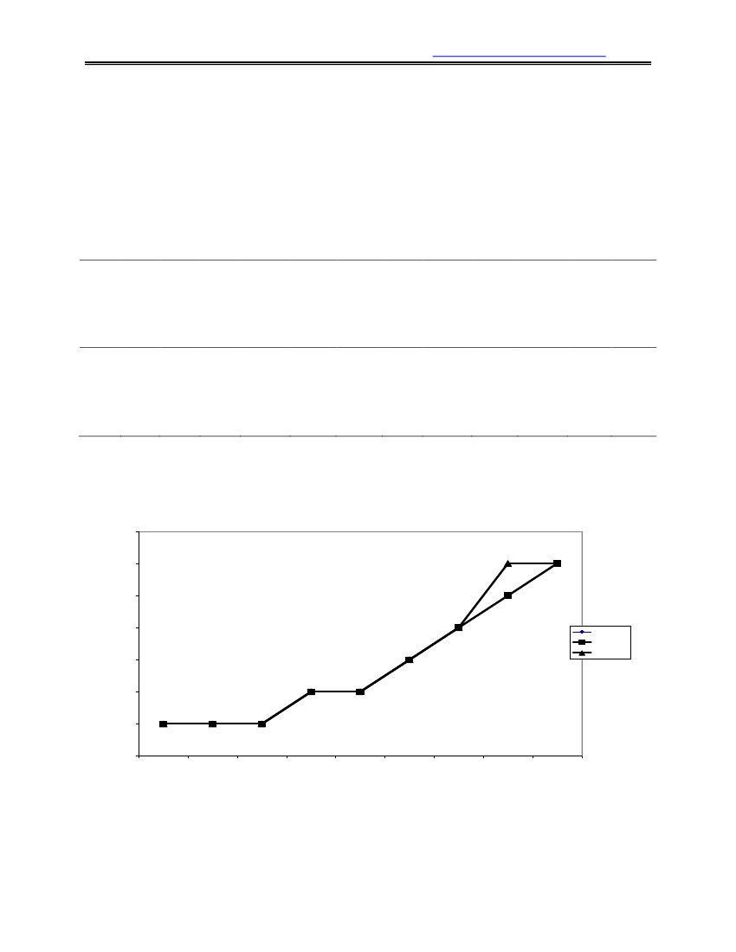
g
Nature and Science, 2011;9(9)
http://www.sciencepub.net/nature
The percentage pulp decreased while the percentage
seed increased significantly (p<0.05) with the fruit
development. The mean values decreased from 95.4 to72.86% for percentage pulp and increasd from 3.74 - 27.12% for percentage seed were from the 5th week to the 21st week.. It is important to note that certain fruits from Tree 3 had virtually little or no seed and this could contribute to the high values of the percentage pulp. The results were similar to the observations made by the researchers as a normal occurrence among some ube fruit varieties. (Onuegbu and Ihediohanma, 2008; Fonteh et al., 2005).
The pulp/seed ratio also decreased from the fifth
week value of 32.03 to 6.69 at the 21st week. The
values (15.17- 6.69) at the (17th- 21st week) are similar
to the observations made by Anegbeh et al. (2005).
These values suggest that the pulp increased faster at
the early stages of fruit development, while the seed
increased more towards the end of the developmental
period. The pulp thickness increased from the fifth
week after fruit set till harvest maturity with values
ranged from 0.14 to 0.38cm. The pulp is the edible
portion of the fruit. Therefore its weight, thickness and
proportion in the fruit are of utmost importance to the
consumer as well as the fruit processor. Fruits with
thicker pulps are usually preferred.
The fruit density also varied with the fruit
development (1.36- 0.94g/ml) from the 5th week to the
21st week, as shown in Table 1.0. It was observed that
mature fruits with larger pulp/seed ratios had smaller
seed weight in relation to fruit size. Usually a larger air
space was enclosed between the fruit pulp and the seed.
This resulted to the low density values for such fruits
and they floated on water. This explains why some of
the fruits may float on water while others did not.
The fruit colour changed from pink to bluish-black as
shown in figure1. This colour change in the fruit is
gradual starting (around the 15thweek) from
the part of the fruit closest to the fruit stalk and slowly
covering the whole fruit at the 19th to 21st week. This
also agreed with observations reported by
Onuegbu and Ihediohanma (2008).

4.0 Conclusion
The results of this study showed that the fruit
development had an effect on the physical properties of
the African pear fruits. The results point to the fact that
the fruit matures at the 17th -21st week after fruit set.
This period could be regarded as the physiological
mature stage of the fruits that would present the
optimum values of the properties. This information is of help the harvesters in order to reduce the collection of unripe fruits or over-ripe fruits that dropped naturally due to senescence, which may result to contamination, pest and disease attacks. The results will therefore enable famers and processors to predict the appropriate time of harvest foroptimum utilization of the fruit.
74
Acknowledgment
The authors thank Ikpeama, Ahamefula and
Nkwoala, Chiaka Charles all of the National Root
Crops Research Institute, Umudike in Abia state,
Nigeria for their technical assistance.
Correspondence to:
Onuegbu,N.C.
Department of Food Science and Technology
Federal University of Technology
Owerri, Nigeria
Phone:2348032789429
Email: tobuz2000@yahoo.com
References
[1]Ajiwe,V.I.E., Okeke, C.A., Nnabuike, B;
Ogunleye, G.A and Elebo, E. Application of
oilsextracted from African star apple
(Chrysophyllum africanum), horse eye bean
(Mucunasloanei) and African pear
(Dacryodes edulis) seeds. Bioresource
Technology 1997:59 (2-3): 259- 261.
[2]Anegbeh, P.O; Ukafor, V; Usoro, C;
Tchoundjeu, Z; Leakey, R.R.B and
Schreckenberg,KDomesticationof
Dacryodes edulis: Phenotypic variation of
fruit traits from 100 trees in south-east
Nigeria. New forests 2005 29 (2):149-160.
<www.icraf.org/ar2005/other_01.asp>Accesse
d 27th October, 2007.
[3]Askar, A; Rubach, K and Schormuller, J. The
importance of amino- acids in frui behaviour
of amino acid during ripening of bananas.
Gordian 1972:73, 12-16.
[4]Awono, A; Ndoye, O; Schreckenberg, K;
Tabuna, H; Isseri, F and Temple, L Production
and marketing of Safou (Dacryodes edulis) in
Cameroon and internationally: Market
development issues. Forest, Trees and
livelihoods 2002:12 (1/2): 125- 147.
[5]Bezard, J; Silou, T; Sempore, G and
Kiakouama, S. Study of Dacryodes edulis-
Variationof the Composition of the
glyceridic fraction for Safou Pulp (pear tree)
during ripening. Revue francaise de Corps
Gras1991:38 (7- 8): 233-241.
[6]Emebiri, L.C. and Nwufo, M.I. Effects of
fruits types and storage treatment on the
biodeterioration of African pear (Dacryodes
edulis) (G. Don) H.J. Lam). International
Biodeterioration 1990 :26(1):43-50.
[7]Fonteh, F.A; Niba, T.A and Tchoumboue, J.
Some physico-chemical properties of the
African pear and Black olive from different
agro-ecological zones of Cameroon. Fruits

Nature and Science, 2011;9(9)
http://www.sciencepub.net/nature
[8]
[9]
[10]
[11]
[12]
2005:60(2):107-113
Kengue, J. Le Safoutier (Dacryodes edulis
(G.Don) H.J. Lam). Le flamboyant
1995 :33:4-7.
Kengue, JSafou extension manual
international centre for underutilized crops,
Academic Publishers Southampton, UK.
2001:55.
Kengue, J; Tchuenguem Fohouo, F.N and
Adewusi, H.G. Towards the Improvement of
Safou (Dacryodes edulis), Population and
Reproductive Biology. Forests, Trees and
Livelihoods 2002:12:73-84.
Kinkela, T; Niamayoua, R.K; Mampouya, D
and Silou, T. Variations in morphologica
characteristics, lipid content and chemical
composition of Safou (Dacryodes edulis
(G.Don)H.J Lam) according to Fruit
distribution: A case study. African J.of
Biotechnology2006:5(12):1233-1238<
http://www.bioline.org.br> Accessed 20th
August, 2007.
Mbofung, C.M.F; Silou, T and Mouragadia, I.
ChemicalcharacterizationofSafou
(Dacryodes edulis) and evaluation of its
potential as Ingredient in nutritious biscuits.
Forests, Trees and livelihood 2002:12:105-
117.
[13]
[14]
[15]
[16]
[17]
[18]
Nwokeji, E.M; Nwufo, M.I; Ibe, A.E and
Ogbedeh, K.O. Investigation on the Uses and
Fungal diseases of African pear (Dacryodes
edulis, G.Don H.J. Lam) in Imo state, Nigeria.
Nig. J. of plant Protection 2005:22: 9-16.
Omoti, U and Okiy, D.A. Characteristics and
composition of the pulp oil and cake of the
African pear (Dacryodes edulis). J. Sci/.food
Agric.1987:38(1):805-809.<http://www3.interscience.wiley.com/jour
nal> Accessed 12th April, 2006.
Onana, J. M.. A Synoptic revision of
Dacryodes(Burseraceae) in Africa, with a new
species from Central Africa. Kew Bulletin
2008:63:385-400
Onuegbu, N.C and Ihediohanma, N.C. Some
proximate Analysis of African pear
(Dacryodes edulis). Jn, Appl. Sci. Environ.
Manage. (JASEM) 2008:12(1)83-85 (ISSN
1119-8362)
Silou, T (1996). Le safoutier (Dacryodes
edulis) Un arbre mal connu. Fruits 51 (1): 47-
59.
Waruhiu, A.N; Kengue, J; Atangana, A.R;
Tchoundjeu, Z and Leakey, R.R.B .
DomesticationofDacryodesedulis:
Phenotypic variation of fruit traits in 200 trees
in Cameroon. J. food, Agriculture and
Environment 2004 :2 (1): 340-346.
7/16/2011
75


