The social class relationship of the married women in Kerman and using contraceptive devices and methods for the control of the birth rate

Rahmatollah Dadvar¹ , Asiye Khoramaki ², Maryam Habibi Fathabadi³

¹(PH.D. student of university sains Malaysia (USM) & academy member, Islamic Azad University, Baft branch –Kerman ,Iran);
² (women studies M.S.from Islamic Azad University- Baft branch – Kerman ,Iran)
³ (women studies M.S.from Islamic Azad University- Baft branch and teacher ofBaft education –Kerman , Iran)
Email: Rdadvar7@yahoo.com

Abstract: The establishment of a balance between the daily increasing numbers of humans and their needs on one side and the existing resources on the other side is a difficult challenge for many developing countries including Iran. It seems that in order to free from the mentioned difficulties resulting from the irregular growth of population, the exact implementation of family control programs (using contraceptive devices and methods) is the only logic solution. Since the women are the main pillar of the family control plans, the present research also deals with the relation of the social class of the 15-49 years old married women in Kerman and using the contraceptive devices. In this research, survey research methodology has been used. Due to the broadness of the statistical society, through sample taking, first the daily number of the women referring to all health centers in Kerman (15-49 year old married women) was collected. They were 440 individuals in a day. Then using Cochran formula, 160 cases were considered for a further study. The necessary data was collected through questionnaires made by the author and data was collected. In this study, the women were classified in three classes of low, middle and high based on the data collected from the questionnaires. The findings of the study showed that there is a significant relation between the social class of women and using the contraceptive devices. Also based on these findings, there is a significant relation among variables such as level of education, knowledge, family income and tendency to use preventive devices and using these devices. There is no significant relation among variables such as the age of women, place of birth, family, number of children, gender of the children and duration of marriage and that of contraceptive devices to control the birth rate.
[Rahmatollah Dadvar, Asiye Khoramaki, Maryam Habibi Fathabadi. The social class relationship of the married women in Kerman and using contraceptive devices and methods for the control of the birth rate. Nature and Science 2011; 9(9):115-119] (ISSN:1545-0740). http://www.sciencepub.net.

Key terms: Social Class, Contraceptive Devices (for birth control), Women

1. Introduction:
The population of the world is increasing daily. The impact of this increase in the past ages has been so low due to the influence of threatening factors of human health. Almost, all regions in the world had a similar situation as far as population is concerned. After the industrial revolution in the Europe, due to the reduction of death tolls, the population growth went up. The increase of population along with the expansion of industrial system has brought about many changes in the humans socio-economic life. The experience of increase of population in the developing countries started a little bit later. The higher number of population and its faster growth in these countries as compared with the developed countries gave rise to the global explosion of the population. Despite the general reduction of population growth in the world in recent years, due to slowness of this reduction and slight rate in developing countries, it is expected that the share of these countries of the world population to be increased considerably (Mahmoodian, 2007-:22).
Studies have shown that the complexity of the population problem is due to the deep roots of religious beliefs and other visions and performance which are in favor of having large families (such as preferring a son), the problems which stand against the pregnancy prevention. So the issue of family control is in origin a social change problem and the technology of prevention of pregnancy is not an instrument to remove this problem. What is more important is to reinforce that group of social changes which have impact on fertilization such as: increase of the age of marriage, improvement of women conditions, supplying educational opportunities and employment of women, insurance for the old age, obligatory education of children and speeding up the economic changes in order to increase the per capita income (Barbarian, 2003: 90-91).
Fertilization irrespective from the population issues like some of the life features can be an effective factor in creating class and social distance among humans. Also it is a phenomenon which can not be considered only as a natural reality under the influence of the relation between two genders or the outcome of an instinctive demand and finally an inevitable issue. But it should be accepted that fertilization is the result of the action and behavior of humans which if they intend, they can reduce, increase or even not have it (Ahrari, 2003: 17).
For sure, the spread of family control (birth rate) plans is an effective factor to reduce fertilization. But accepting the family control plans in its broad scale depends on the socio-economic conditions, population policies, people's culture and so on. The industrial countries, being placed in specific conditions, i.e. the fast cultural changes, having the technologic factors under control, women employment, women contribution in decisions related to matrimonial affairs, the number of children, etc. have a low level of fertilization. Whereas in developing countries or so-called the Third World Countries, the lack of pregnancy preventive devices at an ideal level, the existence of customs and the dominancy of traditions and as likes have a higher level of population growth as compared with the industrial and developed countries (Helm Seresht, 2006: 51).
So, concerning the fact that Iran is a part of the developing countries and due to the important role of the women in birth control, and that most of the prevention methods are related to women and they are pioneer to received family control services from the health centers, so paying attention to this issue is important that what is the relation between the socio-economic conditions, family, culture, education, employment and income of women and this issue. With regard to the importance of this issue, this research is pursuing to find out whether or not there is a relation between the social classes of women and using the contraceptive devices?
The necessity and importance of the research
With regard to the fact that fertilization is the main factor of population growth and their high level of fertilization have unfavorable impacts on mothers’ health, so the expansion and spread of family control and birth control has not only reduced fertilization but also play an effective role in improving the health condition and social welfare level of the society.
Fertilization for many women means the emergence of grave difficulties, because it damages the mother’s health. The family control plan by interfering in the women fertilization cycle help them reduce the number, distance and time of pregnancy and disease affliction. This will increase the mother’s health (Barbarian, 2004-P. 95). Concerning the fact that half of the potential forces of this country are women, this fact also appears that the lack of birth control and lack of family control plans will bring about considerable damages on economic structure and the capabilities to produce goods and services (Amani, P. 1998: 91).
The above research and study is important because it can give awareness on family control plans in preventing the irregular growth of the population and its unfavorable socio-economic impacts. Knowing the rate of awareness and performance of different walks of life in particular the different age group of women is vital in any kind of education or planning for the purpose of population control. In other words, any kind of education and planning to make a change in the behavior, attitude and belief of those receiving the preventive tools of pregnancy is in need of further understanding of different groups of women in different levels of the society. The above research, directly deals with the factors such as: income, education, and job and their relation with using the contraceptive devices. The results of this research and similar ones will help with the socio-economic developments and responsible control of the family with its plentitude interests for the household members. Moreover, it helps with the planners of health and family control in policy making.
The main goal is to learn the relationship between the women social class and using contraceptive devices and methods.
2.Hypotheses:
- There is a significant relation between the women social class and using the preventive family control devices (contraceptives)
- There is a significant relations between women education and using the family control preventive devices
- There is a significant relation between the family income and using the pregnancy preventive devices.
- There is a relation between the rate of knowledge and family control instruments and using the contraceptive devices and methods.
- There is a relationship between the women tendency to using the contraceptive devices and their use
3.Theoretical framework:
The theoretical framework of this research is the views of Carl Marx, Max Webber and William James.
4.Karl Marx’s View:
For Marx, the class is a group of people who are in a common relation with the production instruments, the instruments by which they supply their livelihood. In the present industrial societies, factories, offices, machineries, wealth or needed capital to buy them finds a greater importance. The concept of class in the view of Marx orients us to the objective economic inequalities made in the society (Gidenes, 2004: 223-225). This theory is used to find out the social class of individuals based on the rate of income.
5.Max Webber’s View:
According to Webber, the class divisions is resulting from not only control or lack of control of production tools, but also from the economic differences which do not have any direct links with assets. These kinds of sources in particular include skills, degrees and conditions which have impact on various types of professions which people can have. For example, the individuals which have managerial or professional jobs have a higher income as compared with the blue collar individuals and have a better job condition.
The conditions which they have such as: academic degrees, diplomas and skills they have acquired, makes them more marketable compared with those in lack of them (ibid). This theory is used to find out the social class of individuals based on the rate of education.
6.William James’ View:
According to James, the mental awareness of human is a changing and dynamic issue. This dynamism orients it to make a selection among external affairs. That is to say to accept some of them and to reject some others or do not care some at all (Tavasoli, 2003: 270). This theory is used for the awareness of women of the family control instruments.
7.Research methodology:
In this research, survey method has been used.
8.Research tools:
In addition to questionnaire, the tools to collect data are using different books.
9.Method of data analysis:
In order to extract data, after the completion of data collection and their classification and coding stage, the data were analyzed by using SPSS 16 software, and Chi-Square test and V Cramer.
10.Statistical community:
According to the 2006 census, the population of Kerman was 677650 people of which 596976 people were living in cities. The total women population of Kerman is 292276 people and 183101 ones out of these women are in the age group of 15-49 which is the statistical community of the present study,
11.Sample and its volume:
In this research, the quota sampling method has been used. According to the formula of Cochran, the sample volume is 158 people and to ease the job, 2 people have been added to it, so the sample volume was considered equal to 160 people.
Assumption 1: There is a significant relation between the women social class and using the family control instruments.
Table No. 1:
Sig | Cramer V | df | 2χ
0.006 | 0.25 | 2 | 10.34

The histogram of the frequency distribution of using contraceptive devices and the women's social class
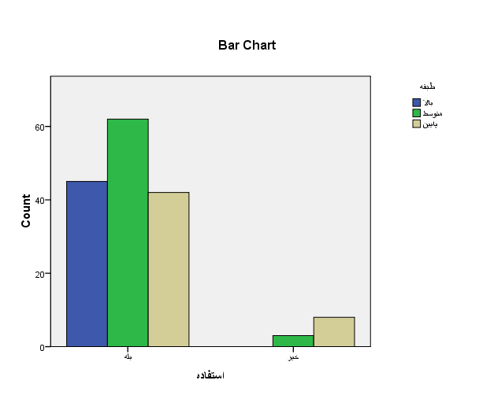
Assumption 2: There is a relation between the level of women education and using the contraceptive devices

Table No. 2:
Sig | Cramer V | df | 2χ
0.00 | 0.51 | 5 | 41.72

The histogram of the frequency distribution of the use of pregnancy preventive devices (contraceptive devices).
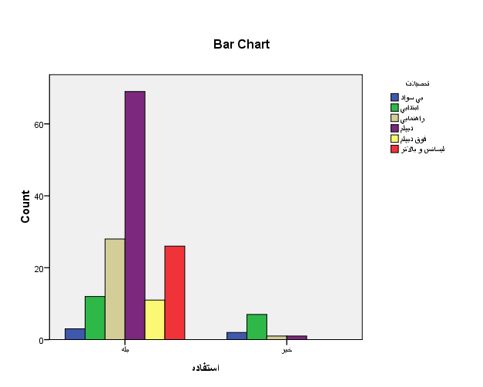
Assumption 3: there is a relation between the family income and use of contraceptive devices

Table No. 3:
Sig | Cramer V | df | 2χ
0.000 | 0.54 | 4 | 46.67
Table 4:
Sig | Cramer V | df | 2χ
0.003 | 0.32 | 4 | 16.368
The histogram of the frequency distribution of family income and the use of contraceptive devices

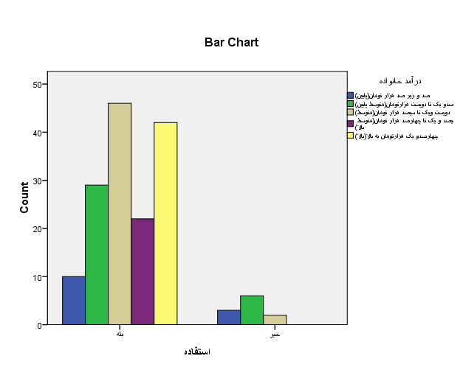

Assumption 4: There is a relationship between the rate of knowledge on contraceptive devices and the use of these devices

Table No. 5:
Sig | Cramer V | df | 2χ
0.000 | 0.32 | 2 | 16.62
The histogram of the frequency distribution of awareness and knowledge of contraceptive methods and devices and using them
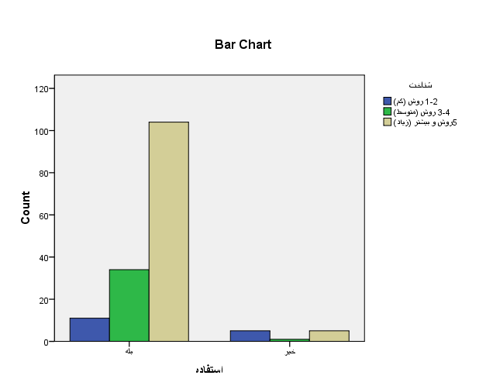

Assumption 5: There is a relation between the tendency of women in using the contraceptive devices and methods and their use

The histogram of the frequency distribution of women tendency to use the contraceptive devices and using these devices
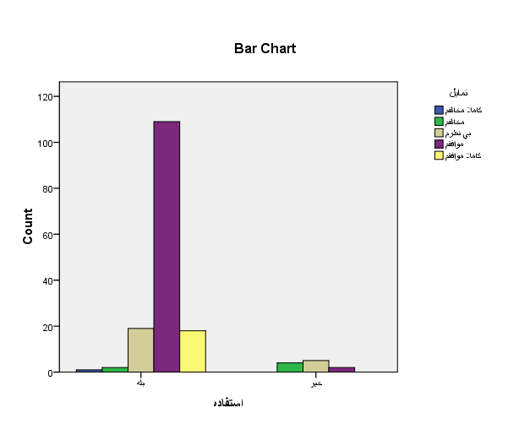
12. Results:
In the present research, the purpose is to learn the relation between the social class of the women and the use of family control instruments. The social class has been considered as an independent variable (forecasting) and use of the contraceptive methods and devices as a dependent variable (standard). The findings of the research show:
About 93/1 percent of the respondent women were using contraceptive devices and methods. Only 6/9 percent of the women were not using the contraceptive devices due to different reasons. Of the total respondents, based on the data extracted from the questionnaires, 28/1 percent of the women belonged to high social class, 40/6 percent to average social class and 31/3 percent to low social class.
Concerning the first assumption (hypothesis): (There is a relation between the women social class and use of contraceptive devices). Among the women respondents, 100 percent of the women of high class, 95/4 percent of the women with an average class and 84 percent of the low social class women were using contraceptive devices. According to the obtained Sig. (0/006), our main assumption that there is a relation between the women social class and the use of contraceptive devices, it was at the level of more than 99 percent significance and the intensity of the relation based on Cramer V was equal to 0/25. This assumption is confirmable based on the view of Webber and the view of Lin Stein.
Analysis of the second assumption (There is a relation between the women academic level and use of the contraceptive devices). It is observed that this assumption is significant at the level more than 99 percent (Sig=0/00). The intensity of the relation based on Cramer V is equal to 0/51 and based on the view of Weber is confirmable.
Concerning the third assumption (There is a relation between the family income and the use of contraceptive devices and methods). The assumption is significant at the level more than 99 percent (0/003) and the intensity of the relation based on Cramer V is equal to (0/003). It is in conformity with the fertilization economy view made by Lin Stein which states with the increase of the family income, the number of children is reduced.
The analysis of the fourth assumption: (There is a relation between the rate of awareness of contraceptive devices and methods and use of them). It was displayed that this assumption is confirmed at the level of more than 99 percent (Sig=0/00). This assumption based on the view of William James which states: "The human mental awareness is a changing and dynamic issue. This dynamism makes human to have a selection and accept some and deny some other or do not pay attention to some other at all" is confirmable.
Concerning the fifth assumption:
(There is a relation between the women’s tendency to use the contraceptive devices and methods and using them). According to our assumption, concerning the meaningfulness, there is a tendency to use it at the level of 99 percent (Sig=0/00) and the intensity of relation based on Cramer V is equal to 0/54. This assumption is in conformity with the theory of analysis of cost and benefit which the more the benefit of the outcome of an action is, the individual will have more incentive to do that.
13. Suggestions:
- Presenting free of charge services of contraceptive methods and devices in pharmacies and public places in addition to the health centers
- Publicizing the contraceptive methods and devices in mass media such as radio, T.V. and giving awareness on the benefits and damages
- Holding classes on contraceptive methods to control birth in places which people gather mostly such as mosques
- Including a course on family birth control in a very simple form in the adult literacy training programs and also in the last years of high schools in particular for the girls who mostly marry after graduation from high schools
- Further absorption of health staff in middle class areas and low class areas, presenting training and transferring these training through them to the women in their inhabiting places. Considering awards for those linking staff who are successful in spreading the contraceptive methods programs in their districts
- Encouraging women who lives in the low areas of the society to study and upgrade their level of education
- Paying attention to the role of women and their vital share in the socio-economic development in particular on prevention of pregnancy
- Making efforts to create equal opportunities for men and women either in education or employment
14. References
- Ahrary, Khadijeh, Ale Taha, Population and Family Control, Nevisandeh Press, Arak , 2003
- Amani, Mahdi, Demography Foundations, SAMT, First edition, Tehran , 1998
- Barbarian, Akbar, Population and Family Control, Noore Danesh, Second edition, Tehran , 2003
- Tavasoli, Gholamabas, Sociology Theories, SAMT, Ninth edition, Tehran , 2001
- Helm Seresht, Parivash, Del Pisheh, Esmaeel, Population and Family Control, Payame Noor, First Revised Edition, Tehran, 2006
- Khaki, Gholamreza, Research Methodology in Management with an Attitude to Thesis Writing, Derayat, First edition, Tehran , 1999
- Rafipour,Faramarz,Excavations and Assumptions, Enteshar, Fourteenth Edition, Tehran ,2004
- Gidenz, Anthony, Sociology, Translated by Manoochehr Saboori, Nei Publications, Tehran , 1994
- Mahmoodian, Hossein et al, Knowledge of the Family, SAMT, Eighth Edition, Tehran , 1998
- Ritzer, Jorge, Sociology Theories in Contemporary Ages, Translated by Mohsen Salasi, Elmi Publication, Third edition, Tehran , 1998
- The Results of Census 2006, Iranian Statistical Center, (www.amar.org.ir)
12. Lebenstein, Harvey “ The economic theory of fertility in the evolution of population theory edited by johannes overboeek,1977,pp :157.

7/7/2011

