Extraction of Chromium (Vi) with 4-Adipoyl and 4-Sebacoyl Derivatives of Bis (1-Phenyl-3-Methylpyrazolone-5) in Acid Medium and the Effect of Butanol

Kalagbor A. Ihesinachi¹, Uzoukwu B. Augustus² and Chukwu U. John²

1. Department of Science Laboratory Technology, Rivers State Polytechnic, Bori,
P.M.B. 20, Nigeria. Email: ksinachi@yahoo.com
2. Department of Pure and Industrial Chemistry, University of Port Harcourt,
P.M.B 5323, Choba, Nigeria. Email: uzoukwupob331@yahoo.co.uk; lydiuche@yahoo.com

Abstract: Solvent extraction of chromium (VI) ions from concentrations of various mineral acids (HCl, H₂SO₄ and HNO₃) have been carried out using chloroform solution of 4-adipoylbis(1-phenyl-3-methylpyrazolone-5), H₂Adp and 4-sebacoylbis(1-phenyl-3-methylpyrazolone-5), H₂SP in the presence and absence of butanol (BuOH) as synergist. Cr(VI) was quantitatively extracted from all three mineral acids using 0.01M solutions of H₂Adp/chloroform and H₂SP/chloroform. Optimal % extraction of 62%, at 0.5M acid concentration was obtained for HCl and 66% at 1.0M for H₂SO₄. While 82% at 3.0M acid concentration was obtained for HNO₃ from chloroform solution of H₂Adp in the absence of BuOH. Similarly, H₂SP/chloroform solution gave optimal % extraction of 50%, 70% and 90% at 0.5M, 2.0M and 5.0M acid concentrations for HCl, H₂SO₄ and HNO₃ respectively, for the extraction of Cr(VI) in the absence of BuOH. In the presence of BuOH, synergism was more pronounced for extraction of Cr (VI) from HNO₃ and HCl solutions into organic solutions of H₂Adp and H₂SP respectively. However, optimum extraction was better in HNO₃ followed by H₂SO₄ and least in HCl acidic medium for extraction of Cr(VI) into organic solutions of 0.01M H₂Adp/chloroform and 0.01M H₂SP/chloroform in both the absence and presence of BuOH. Mechanism of the extraction systems showed that extraction using the ligand H₂SP first involves an acidification process followed by the extraction species as ion pair complexes. Hence, the extracted species were: CrO₂(Adp) and H₄CrO₄²⁺(SP)^{2–} with an average log K_{ex} of 4.70.
[Kalagbor A. Ihesinachi, Uzoukwu B. Augustus and Chukwu U. John. Extraction of Chromium (Vi) with 4-Adipoyl and 4-Sebacoyl Derivatives of Bis (1-Phenyl-3-Methylpyrazolone-5) in Acid Medium and the Effect of Butanol. Nature and Science 2011; 9(9):147-153] (ISSN:1545-0740). http://www.sciencepub.net.

Keywords: Chromium (VI), Chloroform, Butanol, 4-adipoylbis(1-phenyl-3-methylpyrazolone-5), 4-sebacoylbis(1-phenyl-3-methylpyrazolone-5).

1.0 Introduction
1-phenyl-3-methyl-4-acylpyrazolone-5 and some of its derivatives have been widely reported in the extraction studies of many transition metals from different organic medium [1-5]. However, not so much has been reported on the bis derivative of this ligand [6-8]. The 4-adipoylbis(1-phenyl-3-methylpyrazolone-5), (H₂Adp) and 4-sebacoylbis(1-phenyl-3-methylpyrazolone-5), (H₂SP) were synthesized for the first time and characterized by Okafor and Uzoukwu, [9]. They have been found to exhibit the ability of effectively trapping toxic metals such as Fe, Cd, Cu, Ni, Mn, U, V and W from water. This is the main reason for their proposed use in organic solutions as extractants [10-13]. Like the 4-acylpyrazolones, they are β diketones and are efficient extractants forming stable complexes with some group I, II and transition metals [9].
The object of this present work is to study the extraction of chromium (VI) with 4-adipoyl and 4-sebacoyl derivatives of bis(1-phenyl-3-methylpyrazolone-5), (H₂Adp and H₂SP) in three different acid medium (HCl, H₂SO₄ and HNO₃). In a related study, kalagbor et al [14] reported the extraction of molybdenum (VI) with 4-adipoyl and 4-sebacoyl derivatives of bis(1-phenyl-3-methylpyrazolone-5) in acid medium. Furthermore, synergism has been demonstrated by several authors [15-18] in the extraction studies of 4-acylpyrazolone-5 to improve the efficiency of the ligand. Hence the present work equally aims at demonstrating synergism between these bis-ligand derivatives and butanol in the extraction of Chromium (VI) from concentrations of various mineral acids into chloroform solutions of 4-adipoylbis(1-phenyl-3-methylpyrazolone-5), and 4-sebacoylbis(1-phenyl-3-methylpyrazolone-5).

2.0 Experimental
2.1 Preparation of Stock Solutions
Fresh solutions of the organic extraction reagents, 4-adipoylbis(1-phenyl-3-methylpyrazolones-5) H₂Adp and 4-sebacoyl(1-phenyl-3-methylpyrazolones-5) H₂SP were prepared as when required. Appropriate weights of the ligands (H₂Adp and H₂SP) were dissolved in CHCl₃ to give a 0.01M concentration of the working organic reagent. These solutions (H₂Adp and H₂SP) were stable for at least one month.
Stock solution (100mg/L) of the metal ion Cr(VI) was prepared in 0.001M HCl solution by dissolving appropriate weights of potassium chromate.
2.2 Extraction procedures
A 0.1cm³ sample of the 100mg/L solution of Cr (VI) was pipetted into various sets of extraction bottles. A solution of an acid was added to each of the extraction bottles containing the metal ion followed by the addition of deionized water to adjust the volume of the aqueous solution in the bottles to 1cm³ such that the final dilution gave a range of concentrations from 0.001M to 5M of the acid.
An equal volume (1cm³) of 0.01M solution of H₂Adp/CHCl₃ was added to each of the extraction bottles as the organic phase. The two phases were mechanically shaken for 30 minutes (which had previously been determined as the equilibration time) and allowed to separate, and the unextracted metal ions in the aqueous phase (aqueous raffinate) determined. Extractions with solutions of H₂SP / CHCl₃ were also carried out using the above method.

2.3 Extraction in the presence of a Synergist
Butanol was added as the synergist. The extractants (H₂Adp and H₂SP) were prepared using a CHCl₃ / BuOH mixture in the ratio of 4: 1. The resultant solution was a 0.01M standard solution of the extractants. The standard solutions were used for all levels of investigation.

2.4 Determination of the Metal Ion
The Cr (VI) ions present in the aqueous raffinate were determined using diphenylcarbazide (DPC) [19-20]. A 0.5cm³ volume of the Cr (VI) extraction raffinate was taken and introduced into 5cm³ sample bottles. A 0.5cm³ volume of 10M H₂SO₄ was added followed by 1cm³ of DPC forming a violet complex. The solution mixture was made up to 5cm³ with deionized water. The absorbance of the complex was read at 540nm and the amount of Cr (VI) in the aqueous solution after extraction was determined by comparing the absorbance of the solution with that of a standard calibration curve.
The amount of metal extracted into the organic phase was obtained as the difference between the initial amount of metal ion concentration in the aqueous phase before extraction and the amount left in the aqueous phase after the extraction process, and is expressed as:
D = [ML_{n}]_{(org)}
[M^{n+}]_{(aq)}
where [ML_{n}]_{org} is the metal chelate concentration in the organic phase.
[M^{n+}]_{aq} is the metal ion concentration in the aqueous phase

3.0 Results and Discussion
3.1 Extraction of the Metal Species
Kalagbor et al [14] in a similar study with Mo(VI) ions had established the relationship between the metal ions and ligands in line with earlier works by Uzoukwu [21-22]. Thus the extraction of the metals species (M²⁺) can be represented as follows.
aM²⁺ + (b + c) HL_{(o)} M_{a}L_{b}(HL)_{C(o)} + bH⁺ …… (1)
Where HL is the 4-acylbispyrazolone

[M_{a}L_{b}(HL)_{C}]_{(o)}[H⁺]^{(b)}
K_{ex1} = [M²⁺]ª [HL]_{(o)}^{(b + c)} .… (2)

Where K_{ex1} is the extraction constant. Hence the distribution ratio D is given by:

log D₁ = logK_{ex1} + (a - 1) log[M²⁺] + (b + c) log[HL]_{o} – (b) log[H⁺] …………… (3)

In the presence of a solvating agent such as butanol (BuOH), the distribution ration becomes:

log D₂ = logK_{ex2} + (a - 1) log[M²⁺] + (b + c) log [HL]_{(o)} + d log [BuOH]_{(o)} – (b) log[H⁺] .............(4)

Where M_{a}L_{b}(HL)_{c(o)} and M_{a}L_{b}(HL)_{c}(BuOH)_{d(o)} represents the extractable metal complexes in the absence and presence of butanol respectively.

Determination of the values of a, b, c, and d for interactions between the ligand and one mole of metal in the equations can be done through evaluation of the partial derivatives of the equations by the method of slope analysis as follows:
d [log D] = b (5)
d [log [H⁺]

d [log D] = b + c (6)
d [log [HL]_{o}

d [log D] = d (7)
d [log [BuOH]_{(o)}]

d [log D] = a – 1 (8)
d [log [M²⁺] ]

If an acid is involved as a solvating agent in the extraction of the metal, the expected ion pair complex that would be extracted can be described by the following equation as proposed by previous authors [1 & 23].
aM²⁺ + (b+c)H₂L_{(o)} + eHA_{(o)} (H⁺)_{e}M_{a}L_{b}(HL)_{c(o)}.xA_{(o)}⁻ +(b)H⁺ …….(9)
[(H⁺)_{e}M_{a}L_{b}(HL)_{c(o)}.xA_{(o)}⁻]_{(o)} (H⁺)^{(b)}
K_{ex3}= [M²⁺]ª [H₂L]_{(o)}^{b+c}[HA]^{e} ..… (10)

log D₃ = logK_{ex3} + (a-1)log[M²⁺] + (b+c)log[H₂L]_{(o)} + elog[HA] + (b) logH⁺ ……(11)

Determination of the value of e in the equations can be done through evaluation of the partial derivative of the equation by the method of slope analysis as follows:

d[log D₃] = e
d[log[HA]] ……… (12)

3.2 Effect of Some Mineral Acids on the Extraction Cr(VI)
The effect of some mineral acids (HCl, H₂SO₄, and HNO₃) on the extraction of the metal ion was studied at various acid concentrations, using the ligands (H₂Adp and H₂SP) in chloroform. This has been presented as % extraction versus acid concentration (M) in Figs. 1 and 2 and as log D versus log species concentration in Figs. 3 – 8.

3.3 Effect of Acids on the Metal Ion Extraction in the Presence and Absence of BuOH
The effect of the three mineral acids HCl, H₂SO₄, and HNO₃ on the extraction of Cr(VI) in the presence and absence of BuOH as a synergist is presented in Figs. 1 and 2 for both ligands H₂Adp and H₂SP respectively. Fig 1 represents plots of % extraction of Cr(VI) against acid concentrations (M) using H₂Adp in chloroform. Results from the plots show that the extraction of Cr(VI) tends to be on the increase with increase in acid concentration. For HCl solutions, the % extraction increased from 32% (at 0.001M) to 62% (at 0.5M) into chloroform solution of the ligand H₂Adp. In the case of HNO₃, a much more remarkable increase in % extraction was observed even in the absence of a synergist. The extraction was observed to change remarkably from less than 1% at 0.001M HNO₃ acid to 82% extraction at 3M HNO₃ acid concentration.
A similar profile was observed with the metal extraction (Cr(VI)) from H₂SO₄ concentrations. In this case the extraction increased slightly from 52% at 0.001M and to 66% at 1M H₂SO₄ concentrations.
Generally, optimal % extractions of 62%, 65% and 82% were observed at acid concentrations of 0.5M, 1.0M and 3.0M for HCl, H₂SO₄ and HNO₃ respectively for the extraction of Cr(VI) in the absence of BuOH into 0.01M H₂Adp in chloroform. This suggests that extraction of Cr(VI) is best favored in HNO₃ acid concentration of 3.0M using the ligand H₂Adp in chloroform.
In the presence of BuOH, synergism was observed in the extraction of Cr(VI) from solutions of all the three acids as presented in Fig. 1.Unlike extraction in the absence of BuOH, optimal % extraction of 90% was recorded at 5.0M acid concentrations for both HNO₃ and H₂SO₄ solutions whereas for HCl solutions optimal % extraction was at 1.0M acid concentration. Furthermore, BuOH synergism was more pronounced for the extraction of Cr(VI) from HNO₃ solutions than for the other acids because at 0.001M concentrations of the acid, the % extraction increased from less than 1% to 76% extraction.

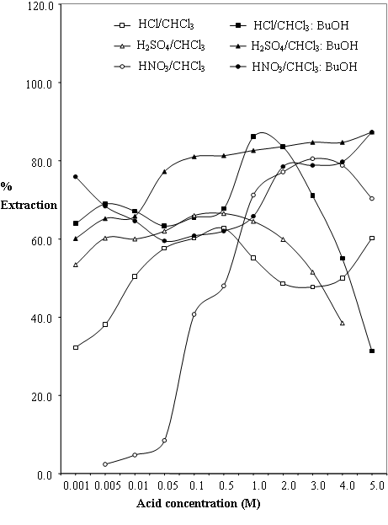
Fig 1: Variation of % Extraction of Cr(VI) with acid concentrations for H₂Adp.

Plots of Cr(VI) against acid concentrations (M) using H₂SP in chloroform in the presence and absence of BuOH is presented in Fig. 2. Results from the plot shows a similar extraction pattern in which the % extraction of Cr(VI) was increasing with increase in acid concentration. It also shows that the extraction of Cr(VI) was enhanced by the presence of BuOH as synergist in the organic phase with the exception of HNO₃ concentrations. In this case, however, it is the extraction from HCl solution that shows a remarkable increase from less than 2% extraction at 0.001M HCl concentration to 50% at 0.5M HCl concentration. This is contrast to extractions of same metal (Cr(VI) into H₂Adp in chloroform in which the synergistic effect was more pronounced for HNO₃ HCl. However, overall extraction using 0.01M H₂SP/Chloroform was best in HNO₃ solutions similar to extractions using 0.01M H₂Adp/Chloroform ligand.
Optimal % extraction of 50%, 70% and 90% at 0.5M, 2.0M and 5.0M acid concentrations were recorded for HCl, H₂SO₄ and HNO₃ respectively, for extraction of Cr(VI) into H₂SP in chloroform in the absence of BuOH. There is a striking similarity in the effect of BuOH on both ligands in the extraction of Cr (VI). For H₂SO₄ concentrations of 0.01M to 0.5M, the addition of BuOH was found to have enhanced the % extraction from 50% to 81%. A sharp drop to 64% was observed at 2.0M H₂SO₄ concentration, thereafter the drop continues gradually to 12% extraction of Cr (VI) recorded at 5.0M H₂SO₄ concentration.
Hence, BuOH synergism was more pronounced for extraction of Cr (VI) from HNO₃ and HCl solutions into organic solutions of H₂Adp and H₂SP respectively. Also, Optimum extraction was better in HNO₃ followed by H₂SO₄ and least in HCl acidic medium for extraction of Cr(VI) into organic solutions of H₂Adp and H₂SP in chloroform.

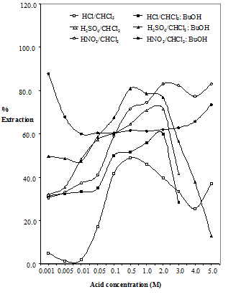
Fig 2: Variation of % Extraction of Cr(VI) with Acid Concentration for H₂SP

3.3 Mechanism of Extraction of Cr (VI)
Figure 3 shows the extraction of Cr (VI) as a plot of log D versus log [Acid]. Within the range of acid studied, slopes of zero was obtained for all the three acids (HCl, H₂SO₄ and HNO₃) which is an indication of the non-involvement of the acid as an ion pair or adduct complex species in the extraction process. Similar results have been obtained for the extraction of Mo(VI) from same acids into organic solutions of H₂Adp and H₂SP [14].
Figure 4 presents a plot of log D against log [Cr] for the three acid conditions for which a slope of zero was obtained. Substituting this value into equation 8 above and solving, we obtain a solution of 1 (one). This is an indication of the involvement of 1 mole of Cr(VI) in the extraction process because log D is independent of the metal ion concentration. That shows that adduct complex species were not formed, hence c = o in equation (1).
Figure 5 shows the plot of log D versus log [H₂Adp] for Cr(VI) for the three acids studied. The result gave slopes approximately equal to 1 for extractions from H₂SO₄ and HNO₃ acid solutions.
From equation (6), b + c = 1
since c = o that implies that:
b = 1
This is therefore an indication of the involvement of 1 mole of ligand in the extraction process. The extraction process based on CrO₂²⁺ species can be written as:
CrO₂²⁺ + H₂L_{(o)} CrO₂(L)_{(o)} + 2H⁺ …… (13)

logD₁ = log K_{ex} + log[CrO₂²⁺] + log[H₂L] + pH……(14)
(pH ≅ 0) where L = Adp
The values of log K_{ex} were found to be 4.50 and 4.90 as presented in Table 1.
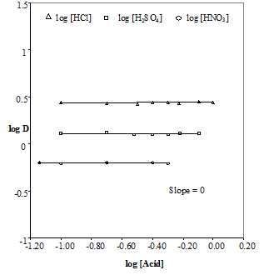
Figure 3: Plot of log D Vs log [Acid] for Cr(VI) with H₂Adp
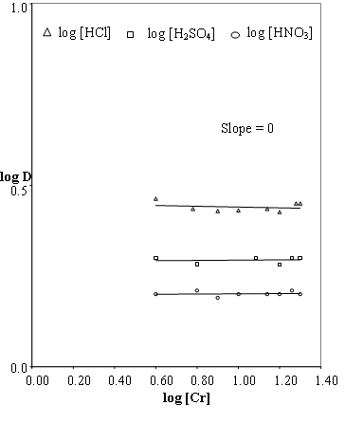
Figure 4: Plots of log D Vs log [Cr] with H₂Adp
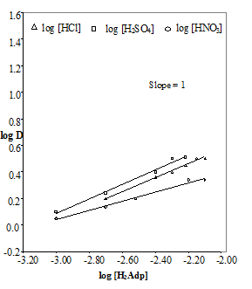
Figure 5: Plot of log D Vs log [H₂Adp] for Cr(VI) with H₂Adp.

However, in figures 6, 7 and 8 involving the H₂SP ligand, figure 6 recorded a slope of 1, an indication that there may be an ion pair complex species involving HCl. Solving equation (12) gives a value of e = 1.

Figure 7 simply shows that log D is independent of log [Cr] which is taken as an indication of the involvement of 1 mole of chromium in the extraction process. Thus if that is the case that means that the Cr (VI) species involved in the extraction process is definitely not the CrO₂²⁺ species used in equation (14). Figure 8 also recorded a slope of 1 indicating that 1 mole of the H₂SP ligand is involved in the extraction of chromium, when solved following the sequence of argument presented above. Therefore, the extraction of Cr(VI) involving this ligand in the presence of these acids can be written first as an acidification process [24 - 25] followed by the extraction of species as ion pair complexes as shown:
CrO₄^{2–} + H⁺ HCrO₄– …………… (15)
HCrO₄ – + H₂SP_{(o)} + H⁺ H₄CrO₄²⁺SP^{2–}_{(o)} …… (16)
[ H₄CrO₄²⁺SP^{2–} ]_{(o)}
K_{ex} = ………… (17) [ HCrO₄– ] [H₂SP]_{(o)} [H⁺]

log K_{ex} = log D + log [H₂SP] – log [H⁺] …… (18)
log D = log K_{ex} + log [H₂SP] + log [H⁺] ..…… (19)

The calculated log K_{ex} was found to be 4.70 and is presented in Table 1. Evidence of the acidification process involving CrO₄^{2–} ion has been previously reported [24 - 25].
Thus the extracted complexes are shown in table 1.0 below.
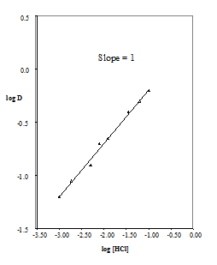
Fig 6: Plot of log D Vs log [HCl] for Cr(VI) in H₂SP
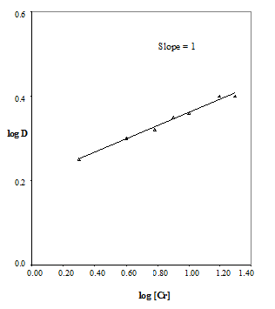
Fig 7: Plot of log D Vs log [Cr] in H₂SP

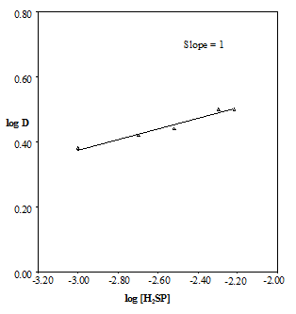
Fig 8: Plot of log D Vs log [H₂SP] for Cr(VI)

Table 1: Data on extraction of the metals with H₂Adp and H₂SP at room temperature.
Metal | Acid | Ligand | log K_{ex} | Extracted Specie
Cr(VI) | H₂SO₄ | H₂Adp | 4.90 | CrO₂(Adp)
 | HNO₃ | H₂Adp | 4.52 | CrO₂(Adp)
Cr(VI) | HCl | H₂SP | 4.70 | H₄CrO₄²⁺(SP)^{2–}

4.0 Conclusion
Liquid – liquid extraction of chromium (VI) ions from concentrations of various mineral acids (HCl, H₂SO₄ and HNO₃) using chloroform solution of the ligand 4-adipoylbis(1-phenyl-3-methylpyrazolone-5), H₂Adp in the absence of butanol (BuOH) gave optimal % extraction of 62%, at 0.5M acid concentration for HCl and 66% at 1.0M for H₂SO₄. While 82% at 3.0M acid concentration was equally obtained for HNO₃. Extractions using chloroform solution of 4-sebacoylbis(1-phenyl-3-methylpyrazolone-5), H₂SP in the absence of butanol (BuOH) gave optimal % extraction of 50%, 70% and 90% at 0.5M, 2.0M and 5.0M acid concentrations for HCl, H₂SO₄ and HNO₃ respectively, for the extraction of Cr(VI).
In the presence of BuOH, synergism was more pronounced for extraction of Cr (VI) from HNO₃ and HCl solutions into chloroform solutions of H₂Adp and H₂SP respectively. However, optimum extraction was better in HNO₃ media followed by H₂SO₄ and least in HCl acidic media for extraction of Cr(VI) into organic solutions of 0.01M H₂Adp/chloroform and 0.01M H₂SP/chloroform in both the absence and presence of BuOH.
Mechanism of the extraction systems showed that extraction using the ligand H₂SP/chloroform involved only one(1) mole of the ligand. Also, the interaction first involved an acidification process followed by the extraction species as ion pair complexes and thus its extracted specie was H₄CrO₄²⁺(SP)^{2–}. This behavior was however not observed for extraction using the ligand H₂Adp/chloroform, here, the interaction involved two(2) moles of the ligand and does not involve acidification first. Hence, its extracted specie was CrO₂(Adp). Finally, the calculated average log K_{ex} value was 4.70.

Correspondence to:
Ihesinachi A. Kalagbor
Department of Science Laboratory Technology, Rivers State Polytechnic, Bori,
P.M.B. 20, Bori, Nigeria.
Telephone: +234 803 3098983
E-mail: ksinachi@yahoo.com

References
- Okafor, E. C., Uzoukwu, B. A. “Extraction of Fe(III) and U(IV) with 1-phenyl-3-methyl-4-acylpyrazolones-5 from aqueous solutions of different acids and complexing agents. Separation of Fe(III) from U(IV)”. Radiochimica Acta. 1990; 51: 167-172.
- Uzoukwu BA, Mbonu JI. “Effect of chloride ion in a buffer medium on the liquid-liquid extraction of Cu(II) and Ni(II) using 1-phenyl-3-methyl-4-trichloroacetyl-pyrazolone-5. Solvent Extract Ion Exchange”. 2005; 23(6): 759 -71.
- Okafor, E. C., Adiukwu, P. U., Uzoukwu, B. A. “Synthesis and characterization of 4-iso-butyrl and 4-iso-valeroyl derivatives of 1-phenyl-3-methyl pyrazolone-5 and their U(VI), Th(IV), La(III), Fe(III), Pb(II) and Ca(II) complexes”. Synth. React. Inorg Met – Org Chem. 1993; 23(1): 97-111
- Chukwu UJ, Uzoukwu BA. “Effect of chloride ion in a buffer medium on the liquid-liquid extraction of Co²⁺ using 1-phenyl-3-methyl-4-trichloroacetyl-pyrazolone-5”. Sci Afr J 2008; 7(1): 42-50.
- Uzoukwu, B. A. and Adiukwu P. U.”Synthesis and Spectoscopic studies of 4-Phenylacetyl-3-methyl-1-phenyl-Pyrazolone-5 and its Thrium (VI), Lanthanuim (III) and Lead (II) complexes”. Spectrochemica Acta, 1995; 51A, 2589 – 2590
- Uzoukwu, B. A., Gloe K. and Duddeck, H. “Metal (II) complexes of 4- acylbis (pyrazolone-5): synthesis and Spectroscopic”. Synth. React Inorg. Met. Org. Chem. 1998ª; 28 (2), 207
- Uzoukwu, B. A., Gloe K. and Duddeck, H. “Extraction of Uranium(VI) and Vanaduim (V) with 4-adipoyl and 4-sebacoyl derivatives of bis(1-phenyl-3-methyl-pyrazolone-5) and effect of decanol on the distribution behaviour of these metal ions”. Solv. Extr. and Ion exch. 1998^{b}; 16 (3), 751.
- Uzoukwu, B.A., Gloe K. and Adiukwu P. U. “Molybdenum (VI), Uranim (VI) and Vanadium (V) complexes of 4-acylbis (1-phenyl-3-methylpyrazolone-5): synthesis and Spectroscopic Characterization”. Synth. Act. Inorg. And Metal – Org. Chem, 2000; 30, 433
- Okafor, E. C. and Uzoukwu, B. A. “Introducing a new bis (B-disketone): synthesis, UV-visible, IR, ¹H and ^{B}CNMR Spectral studies of 4-sebacoyl-bis(1-phenyl-3-mettylpyrazolone-5)and its U(VI), Fe(III) and Ca(II) complexes”. Synth, React Inorg. Met. Org. Chem. 1991;. 21 825
- Uzoukwu, B. A. and Adiukwu P. U. (1995).Synthesis and Spectoscopic studies of 4-Phenylacetyl-3-methyl-1-phenyl-Pyrazolone-5 and its Thrium (VI), Lanthanuim (III) and Lead (II) complexes. Spectrochemica Acta, 51A, 2589 – 2590
- Bukowsky H., Uhlemann, E. Gloe, K. and Muhl P. (1992). Heterocyclic Tantomerism VII: X-Ray structures of Two Crystalline Tautomers of 4-Cinnamoyl-1,3-dimethylpyrazol-5-one. Anal. Chim. Acta 257, 105 – 268.
- Uzoukwu, B. A., Adiukwu, P. U., Al-Juaid S. S, Hitchcock P. B. and Smith J. D (1996). Inorganica Chimica Acta, 250, 173 – 176
- Uzoukwu, B. A. and Okafor, E. C. (1990). Extraction of Fe(III) and U(IV) with 1-phenyl-3-methyl-4-acylpyrazolones-5 from aqueous solution of different acids and complexing agents. Radiochim Acta 51, 167
- Kalagbor, A. I, Uzoukwu, B. A and Chukwu, U. J. “Extraction of Molybdenum (VI) With 4-Adipoyl and 4-Sebacoyl Derivatives of Bis (1-Phenyl-3-Methylpyrazolone-5) In Acid Media.” Nature and Science 2011; 9(3):37-42.
- Chukwu U. J., Uzoukwu, B. A. “Synergistic extraction of Zn²⁺ from aqueous buffer medium of chloride ions into 1- phenyl -3- methyl -4- Trichloro Acetyl Pyrazolone - 5 in Benzene and Hexane". Recent Patents on Materials Science. 2010; 3(2): 146-150.
- Atanassova, M., Dukov, I. L. “Synergistic solvent extraction of trivalent lanthanoids with mixtures of 1-phenyl-3-methyl-4-benzoyl-5-pyrazolone and crown ethers”. Acta Chim. Slov. 2006; 53: 457–463.
- Barkat D, Derriche Z, Tayeb A. Synergistic solvent extraction of zinc(II) and cadmium(II) from sulfate medium by a mixture of 1-phenyl - 3 - methyl - 4 - benzoyl pyrazol - 5 - one and methyl -isobutyl ketone. Turk J Chem 2001; 25: 381-9.
- Atanassova M, Dukov IL. Synergistic solvent extraction and separation of trivalent lanthanide metals with mixtures of 4-benzoyl-3-methyl-1-phenyl-2-pyrazolin-5-one and aliquat 336. Separ Purif Technol 2004; 40(2): 171-6.
- Jeffrey G. H., Bassett, J., Mendham, J. and Denny, R. C. eds. (1998). Vogels Textbook of Quantitative Chemical Analysis, 5th ed.
- Allen, S.E. Grinshaw H.M., Parkinson, J.A. and Quarmby C. (1974). Chemical Analysis of Ecological Materials. Blackwell Scientific Publication, Oxford, 179 – 314
- Uzoukwu, B. A. (1998). A monograph presented at the conference on SEPARATORA “Kinetics of solvent extraction of metals from aqueous medium by 4-acylpyrazolones” held at Bydgoszcz, Poland organized by the Polish Chemical Society
- Uzoukwu, B. A., Gloe K. and Duddeck, H. (1998a). Metal (II) complexes of 4- acylbis (pyrazolone-5): synthesis and Spectroscopic. Synth. React Inorg. Met. Org. Chem. 28 (2), 207
- Zolotov Yu. A. and Gavrilova, L. G. (1969) Zh. Neorg. Khim, 14, 2137
- Ouejhani, A., Dachraoni, M, Lallere, G. and Fauvarque (2003) Hexavalent Chromium Recovery by Liquid-Liquid Extraction with Tributylphosphate from acidic chloride Media. Anal. Sc. 19, 1499 - 1504.
- Cotton FA, Willikinson G. Advanced Inorganic Chemistry, A Comprehensive Text. 3rd ed. Mohinder Singh Sejwal: New Delhi 1985; 893-912.

23/08/11

