Antifungal Activity of a Common Himalayan Foliose Lichen Parmotrema tinctorum ( Despr. ex Nyl.) Hale.

Priti Tiwari ^{1, 2*}, Himanshu Rai^{2**}, D.K.Upreti², Suman Trivedi¹, Preeti Shukla²

¹Motilal Vigyan Mahavidyalaya, Barkatullah University Bhopal (M.P.) 462003
²Lichenology Laboratory, National Botanical Research Institute, CSIR, Lucknow, Uttar Pradesh-226001, India
* prititiwari.kv@gmail.com, **himanshurai08@yahoo.com

Abstract: In-vitro antifungal activity of acetone, methanol and chloroform extracts of Parmotrema tinctorum (Despr.ex.Nyl.) Hale. was investigated against ten plant pathogenic fungi viz. Aspergillus niger, Aspergillus flavus, Aspergillus fumigatus, Alternaria alternata, Fusarium oxysporum, Fusarium solani, Fusarium roseum, Ustilago spp., Albugo candida and Penicillium citrinum , with reference to commercially available synthetic antifungal drug Ketoconazole (positive control) using disk diffusion assay. Methanol extract was most effective against all investigated fungi followed by acetone and chloroform extract. Principal component analysis (PCA) concluded that though Ketoconazole was effective against five of the investigated fungi, the extracts of Parmotrema tinctorum were more effective against rest of the five broad spectrum plant pathogenic fungi (Aspergillus fumigatus,Fusarium solani, Fusarium roseum, Penicillium citrinum and Ustilago spp.).
[Priti Tiwari, Himanshu Rai, D.K.Upreti, Suman Trivedi, Preeti Shukla. Antifungal Activity of a Common Himalayan Foliose Lichen Parmotrema tinctorum ( Despr. ex Nyl.) Hale. Nature and Science 2011; 9(9):167-171] (ISSN:1545-0740). http://www.sciencepub.net.

Key Words: Parmotrema tinctorum, Principal component analysis, Himalayan lichen, lichen extract, antifungal activity, secondary metabolites.

1. Introduction
Lichens have been used widely in traditional medicines in various parts of the world (Richardson 1991; Perry et al. 1999). Lichens produce exclusive characteristic secondary metabolites that are unique with respect to those of higher plants (Hale 1983; Lawrey 1986). Lichen substances are extracellular products of relatively low molecular weight crystallized on the hyphal cell walls, they are usually insoluble in water and can be extracted into organic solvents (Ötzürk et al., 1999). Lichen metabolites have shown to have manifold biological and pharmaceutical activity such as antimicrobial, antiviral, cytotoxic, antitumor, allergic, plant growth inhibitory, antiherbivore, ecological roles and enzyme inhibitory (Dülger et al. 1997, 1998; Huneck 1999; Ozturk 1999; Aslan et al. 2001; Perry et al. 1999; Manojlovic et al. 2002)
In India Parmeloid lichens are extensively used in traditional medicine to treat several diseases and disorders e.g. headache, skin diseases, urinary trouble, boils, vomiting, diarrhea, dysentery, heart trouble, cough, fever, leprosy and as blood purifier (Chandra and Singh, 1971; Kumar and Upreti 2001). Antibiotic and antifungal activity screenings of Indian lichens have been initiated recently (Shahi et al. 2001; Balaji & Hariharan 2007; Sati & Joshi 2011). Lichen screening against plant pathogenic fungi is still an unexplored field.
Parmelioid lichens, which constitute major biomass of lichens in the Himalayan forest, can be used for screening as antifungal agents. Thus, the present investigation was undertaken to evaluate in-vitro antifungal activity of common Himalayan Parmelioid lichen Parmotrema tinctorum, against ten plant pathogenic fungi.

2. Materials and Methods

2.1Collection and identification of lichen sample

The lichen sample of Parmotrema tinctorum were collected from bark in Pithoragarh district of Uttarakhand state in north western Himalaya, India. The identification was done morpho-anatomically using a Labomed TM stereomicroscope and Leica TM DM 500 optical microscope and chemically with the help of thin-layer chromatography (Elix et al. 1993; Orange et al. 2001). Identification was done using relevant key and monographs (Divakar & Upreti 2005; Awasthi 2007) .The voucher specimens were deposited at the lichen herbarium (LWG), National Botanical Research Institute (NBRI), Lucknow, India.

2.2 Extraction from lichen sample

Lichen samples were sorted, cleaned of substratum and dried for extraction. Three different solvent systems i.e. acetone, methanol and chloroform were used for extraction.

Lichen substances were extracted using Soxhlet extractor (Soxhlet 1879; Harwood & Moody 1989) in selected solvents (acetone, methanol and chloroform) equipped with a reflux condenser and further recovered through gentle removal of solvents from lichen samples by gentle evaporation using rotary evaporator (Büchi Rotavapor R-200 TM). The solvent extraction was carried out at the specific boiling temperature of the solvents (acetone-56ºC, methanol-65ºC and chloroform-61.2ºC) for 48h for complete extraction of secondary compounds.

Table 1. Antifungal activity of Acetone, Methanol and Chloroform extracts of Parmotrema tinctorum.

Plant Pathogenic Fungi | Diameter of inhibition zone (mm)*
Plant Pathogenic Fungi | Acetone | Methanol | Chloroform | Ketoconazole
Aspergillus flavus | 12.6±0.3 | 11.3±1.7 | 8.0±0.5 | 20.0±0.3
Aspergillus niger | 14.7±0.3 | 19.0±0.6 | 0.0±0.0 | 22.6±0.3
Alternaria alternata | 8.3±1.2 | 08.7±0.3 | 0.0±0.0 | 21.0±1.3
Aspergillus fumigatus | 12.0±0.5 | 18.7±0.8 | 19.6±0.3 | 10.0±1.2
Fusarium solani | 10.3±0.3 | 17.6±0.3 | 0.0±0.0 | 0.0±0.0
Fusarium roseum | 14.0±1.5 | 18.0±0.5 | 0.0±0.0 | 0.0±0.0
Fusarium oxysporum | 15.6±0.3 | 17.6±0.3 | 6.3±0.5 | 20.0±0.3
Penicillium citrinum | 14.3±0.6 | 24.3±1.2 | 0.0±0.0 | 11.0±0.7
Ustilago sp. | 28.3±0.8 | 33.0±1.5 | 14.7±0.3 | 11.0±0.3
Albugo candida | 13.0±0.6 | 18.3±1.2 | 10.0±0.6 | 20.0±0.6
*values are in Arithmetic mean± Standard error

2.3 Microorganisms and media:

Ten plant pathogenic fungal strains were procured from the mycological collection maintained by the Mycological Laboratory, department of microbiology at Kanpur University. The fungi used as test organisms were: Aspergillus niger, Aspergillus flavus, Aspergillus fumigatus, Alternaria alternata, Fusarium oxysporum, Fusarium solani, Fusarium roseum, Ustilago spp., Albugo candida and Penicillium citrinum. Fungal cultures were maintained on Potato Dextrose agar (PDA).

2.4 Determination of antimicrobial activity:

The antimicrobial activity of lichen extracts against test fungi was determined employing disk diffusion method (Bauer et al 1966; Larkin 1982; National Committee for Clinical Laboratory Standards, 1993). Fungal strains were inoculated onto potato dextrose agar plate (10⁸ spores/ml).

Test solutions of lichen substances were prepared by dissolving recovered substances in 10 ml of their respective solvents. Experimental diffusion discs were prepared by loading five milliliters of lichen extract, 1 ml in each load on filter paper disks (6 mm in diameter), allowing the solvent to evaporate between each loading and leaving the lichen extracts on disk without the solvent. All the three lichen extracts (i.e. acetone, methanol and chloroform) were loaded in this manner. Loaded discs were planted on test plant pathogenic culture plate in triplicate. Commercially available synthetic antifungal drug Ketoconazole was used as positive control. The plates were incubated for 5 days at 20º to25ºC. Growth was evaluated visually by comparing a particular plate with the control plates. The antimicrobial activity was evaluated by measuring the inhibition zone diameter (in millimeter) observed (National Committee for Clincal Laboratory Standards Nccls Document, 1997).

2.4 Data analysis:
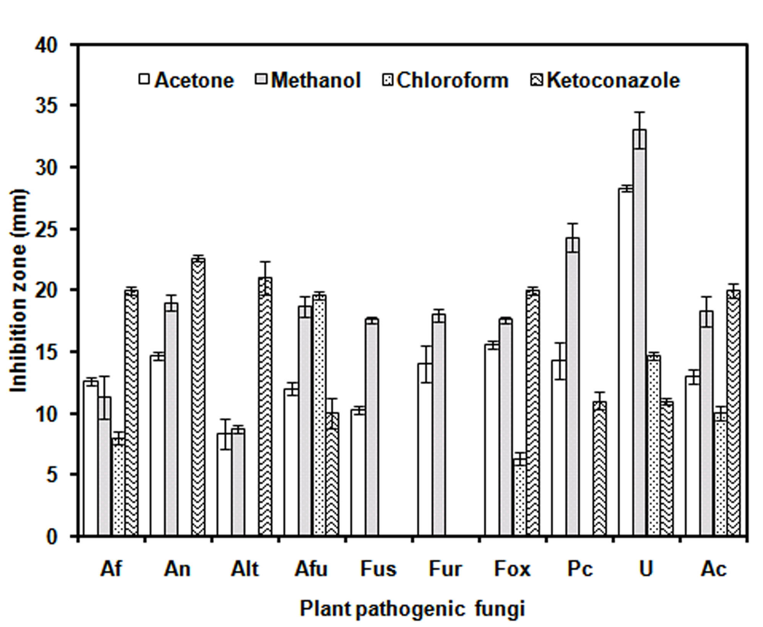
Figure 1. Comparative antifungal activity of Acetone, Methanol, and Chloroform extracts of Parmotrema tinctorum against selected plant pathogenic fungi (Af=Aspergillus flavus , An= Aspergillus niger, Alt=Alternaria alternata , Afu= Aspergillus fumigates, Fus= Fusarium solani, Fur =Fusarium roseum , Fox =Fusarium oxysporum , Pc= Penicillium citrinum , U=Ustilago sp., Ac=Albugo candida)
Indirect gradient ordination method, principal component analysis (PCA) was used to summarise the effect of three solvent extracts of Parmotrema tinctorum on test plant pathogenic fungi with reference to positive control Ketoconazole (Gauch 1982; ter Braak and Prentice 1988). PCA was done on the basis of inhibition zone (mm) produced test fungi colonies, utilizing correlation matrix in the data set, using multivar option in PAST 2.07 (Hammer 2001; Hall 2005).

3. Results:

Methanol extract exhibited highest antifungal activity against all the ten tested fungi followed by acetone extract and Ketoconazole (Table1, Figure 1). The chloroform extract was least active among the three extracts (Table1, Figure 1). All the three test extracts were found effective against five of the broad spectrum plant pathogenic fungi- Aspergillus flavus, A.fumigatus, Fusarium oxysporum, Ustilago spp and Albugo candida.

3.1 Differential activity of the extracts:
Disc diffusion assay of different solvent extracts of Parmotrema tinctorum showed that acetone and methanol extracts were active against all the test plant pathogenic fungi, while chloroform extract and Ketoconzole exhibited activity against five out of ten pathogenic fungi (Table1, Figure 1).
Ketoconazole and Chloroform extract of Parmotrema tinctorum were found ineffective against Fusarium solani and Fusarium roseum while acetone and methanol extracts were effective against the two (Table 1, Figure1). Chloroform extract was also found ineffective against Aspergillus niger, Alternaria alternata and Penicillium citrinum (Table 1, Figure1).
The overall antifungal activities of acetone and methanol extracts were better than Ketoconazole whereas chloroform extract was comparatively less effective than the other two. All the three solvents extracts were active against Ustilago spp. and exhibited zones of inhibition greater than that of Ketoconazole (Table1, Figure.1).

3.2 Principal component analysis (PCA):

PCA analysis required four components (axis) to account for 100% variance in the data set. The first two components (axis) of PCA explained 81.38 % of variance, and each of the two axis explained 53.67% and 27.72 % variance respectively. The PCA biplot (Figure 3) shows that though positive control Ketoconazole was more effective against five of the ten test fungi i.e. Alternaria alternata, Aspergillus flavus, Aspergillus niger, Fusarium oxysporum and Albugo candida lichen extracts were more effective against rest of the five test fungi i.e. chloroform extract against Aspergillus fumigatus, acetone extract against Ustilago spp. and methanol extract against Penicillium citrinum, Fusarium roseum and Fusarium oxysporum.

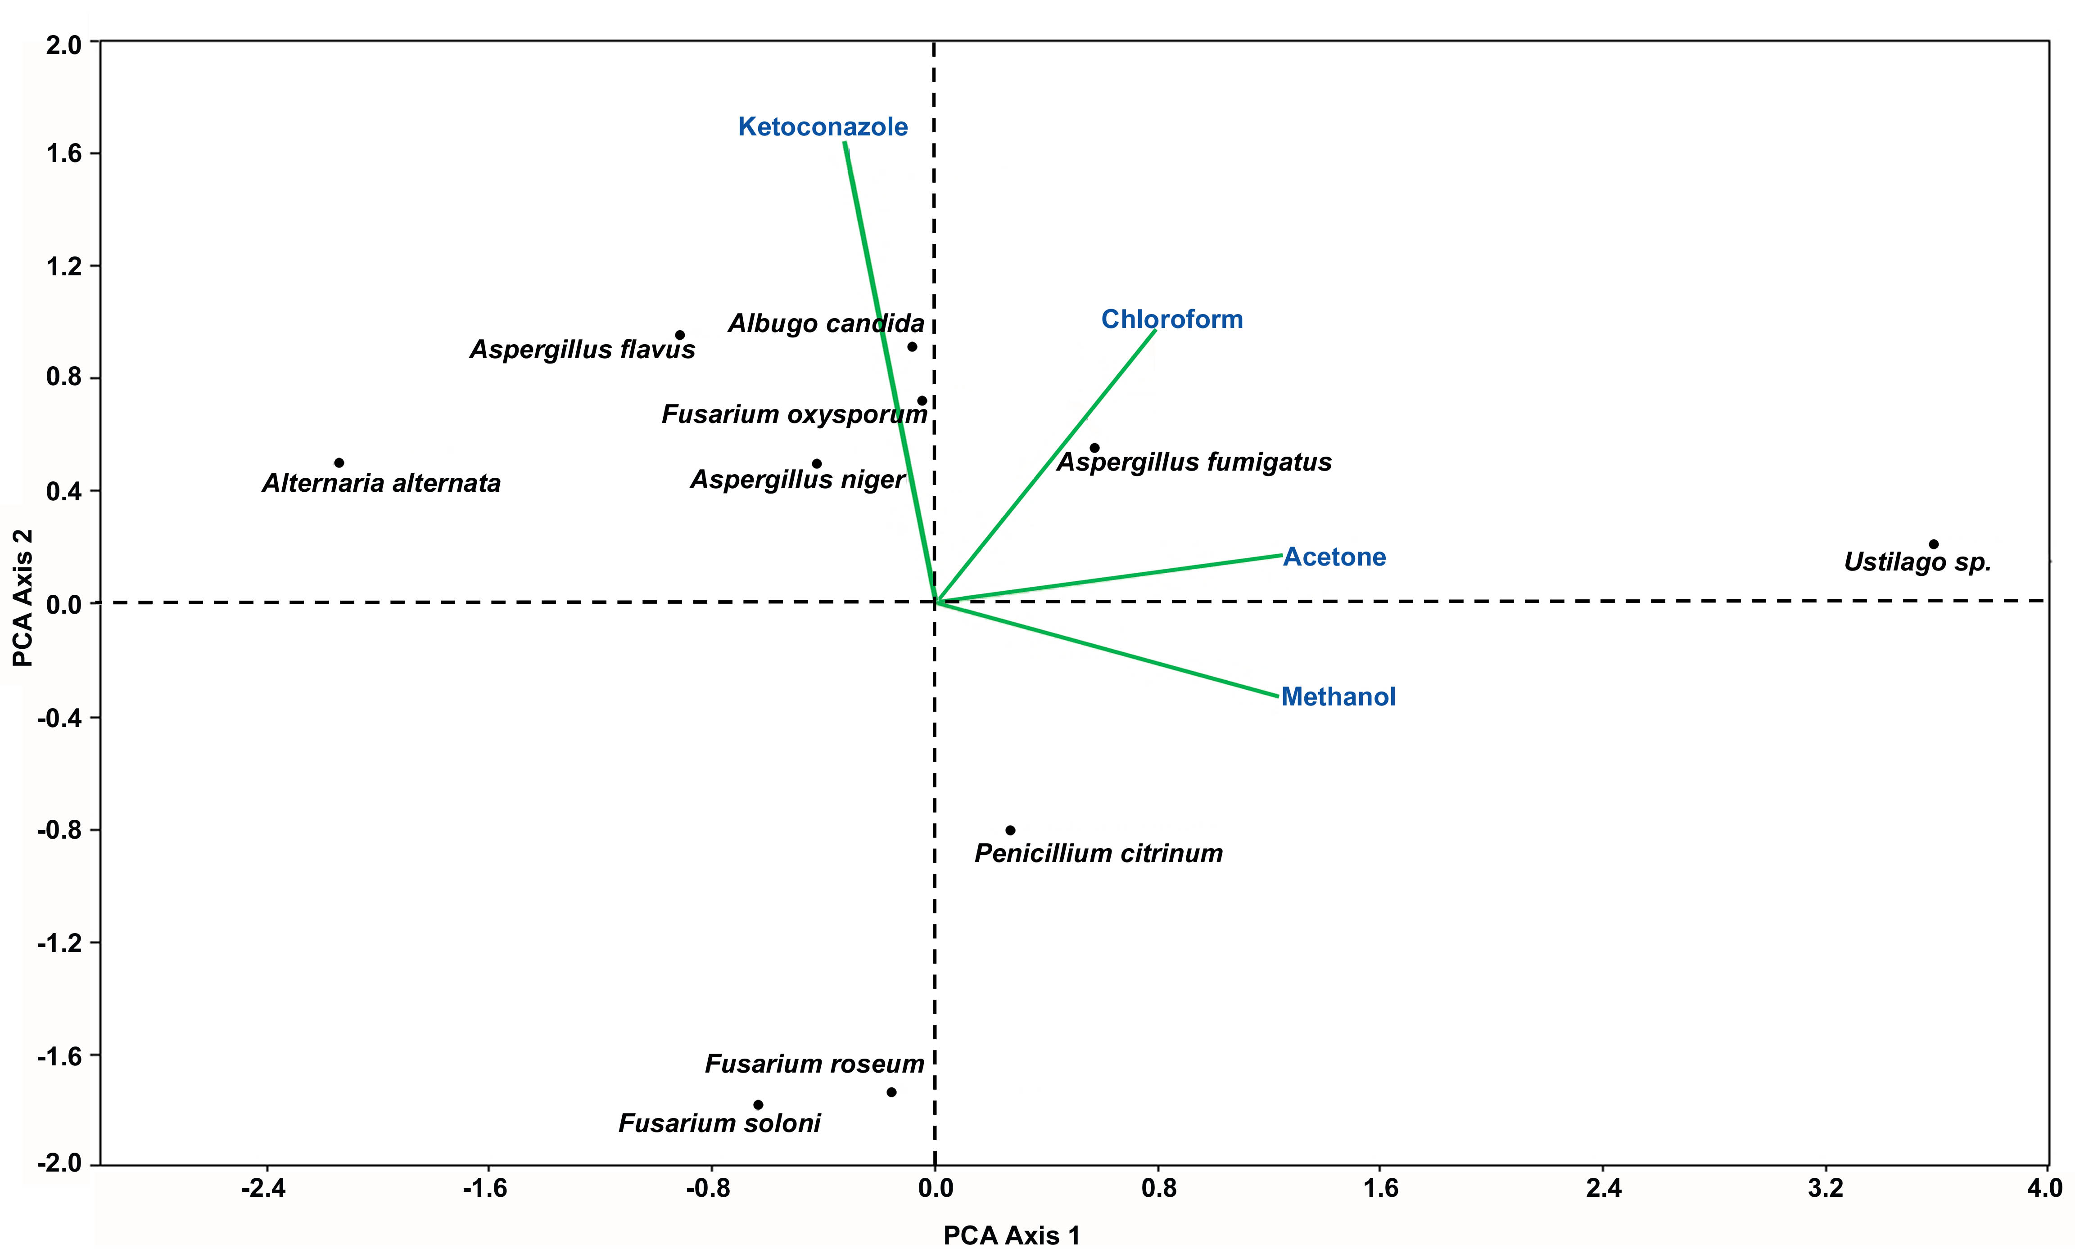

Figure 3: PCA biplot depicting effect of extracts of Parmotrema tinctorum against all investigated plant

4. Discussion:

Lichen substances as bioactive compounds are gaining edge over traditionally known chemicals due to their improved effectiveness over synthetic compounds (Huneck1999). Extracts of lichen thalli proved to have strong antifungal activity against various plant pathogenic fungi (Gulluce et al.2006 ; Halama and Van Haluwin 2004).

In present study the comparative better effectiveness of methanol and acetone extract of Parmotrema tinctorum against some well known plant pathogenic fungi, can be attributed to lichen substances like lecanoric and orsellinic acid, known for their antifungal properties (Gomes et al. 2002; Ranković 2008, 2010)

5. Conclusion:

The selective antifungal effect of acetone and methanol extracts over chloroform extracts can be attributed to differential solubility of constituent secondary metabolites in these extracts (Goel et.al.2011 , Halama and Haluwin 2004 ).

The better performance of lichenic extracts against broad spectrum plant pathogenic fungi (i.e. Fusarium roseum, Fusarium solani, Ustilago and Penicillium citrinum) suggests their superior potentials as antifungal substances.

Acknowledgement:
Authors are thankful to the Director, National Botanical Research Institute (CSIR), Lucknow for providing necessary laboratory facilities.

Correspondence to:

Himanshu Rai
C/O Dr. D.K.Upreti
Lichenology Laboratory,
Plant Biodiversity and Conservation Division,
National Botanical Research Institute, CSIR
Rana Pratap Marg, Lucknow, Uttar Pradesh,
India-226001
Email: himanshurai08@yahoo.com

References:
- Awasthi D D. A Compendium of the Macrolichens from India, Nepal and Sri Lanka. - Bishen Singh Mahendra Pal Singh, Dehra-Dun, India 2007;pp 580.
- Balaji P, Hariharan GN. In vitro antimicrobial activity of Parmotrema praesorediosum thallus extracts. Research Journal of Botany 2007; 2(1): 54-59.
- Bauer AW, Kirby WMM, Scherris JKC, Turck M. Antibiotic susceptibility testing by a standardized single disc method. Am. J.Clin. Pathol. 1966; 45: 493-496.
- Chandra S, Singh A. A lichen crude drug (charila) from India. Journal of research in Indian Medicine 1971; 6:209-206.
- Divakar PK, Upreti DK. Parmelioid Lichens in India: A Revisionary Study. Bishen Singh Mahendra Pal Singh. Dehradun. 2005; pp 488.
- Dülger B, Gucin F, Aslan A. Antimicrobial activity of the lichen Cetraria islandica (L.). Ach. Turk. J. Biol. 1998, 22: 111-18.
- Dülger B, Gucin F, Kara A, Aslan A. Antimicrobial activity of the lichen Usnea florida(L.) Wigg. Turk. J.Biol 1997; 21: 103-108.
- Elix J A, Ernst-Russel J L. A catalogue of standardized thin layer crhomatographic data and biosynthetic relationships for lichen substances. 2nd ed., Australian National University, Canberra. 1993.
- Gauch HGJr. Multivariate analysis in community structure. Cambridge University Press, (1982); Cambridge.
- Goel M, Dureja P, Rani A, Uniyal P L, Laatsch H. “Isolation, characterization and antifungal activity of major constituents of the Himalayan lichen Parmelia reticulata Tayl. Journal of Agriculture and Food Chemistry 2011; 59 :2299-2307.
- Gomes A T ,Honda N K, Roese F M ,Muzzi R M ,Marques M R. Bioactive derivatives obtained from lecanoric acid, a constituent of the lichen Parmotrema tinctorum (Nyl.) Hale (Parmeliaceae). Revista Brasileira de Farmacognosia 2002; 12 : 74-75.
- Gulluce M, Aslan A, Sokmen M, Sahin F, Adiguzel A, Agar G, Sokmen A. Screening the antioxidant and antimicrobial properties of the lichens Parmelia saxatilis, Platismatia glauca, Ramalina pollinaria, Ramalina polymorpha and Umbilicaria nylanderiana. Phytomedicine 2006; 13:515 - 521.
- Halama P ,Van Haluwin C. Antifungal activity of lichen extracts and lichenic acids. Bio Control 2004; 49:95-107.
- Hale M E. The biology of lichens. 3rd Edition. Edward Arnold Ltd. London. 1983
- Hall A. The plant community of Bergen swamp, NY, a rich minerotrophic mire. In: The environmental gradients and plant communities of Bergen swamp, N. Y., U.S.A 2005; https://ritdml.rit.edu/bitstream/handle/1850/1121/AHallThesis2005.pdf?sequence=8.[Cited 25August 2011].
- Hammer Ø, Harper DAT, Ryan DP. PAST: Paleontological statistics software package for education and data analysis. Palaentologia Electonica 2001; 4(1): 1-9 http://palaeo-electronica.org/2001_1/past/past.pdf [Cited 25 August 2011].
- Harwood LM, Moody CJ. Experimental organic chemistry: Principles and Practice (Illustrated edition ed.) 1989; pp. 122–125. ISBN 978-0632020171.
- Hostettmann K, Wolfender JL, Rodriguez S Rapid detections and subsequent isolation of bioactive constituents of crude plant extracts. Planta Med 1987; 63:2–10.
- Huneck S. The Significance of Lichens and Their Metabolites. Naturwissenschaften 1999; 86: 559–570.
- Kumar K ,Upreti D K. Parmelia sp.(lichens) in ancient medicinal plant lore of India. Economic Botany 2001; 55:458-459.
- Lawrey J D. Biological role of lichen substance. The Bryologist 1986; 89: 111-122.
- Manojlovic NT, Solujic S, Sukdolak S. Antimicrobial activity of an extract and anthraquinones from Caloplaca schaereri. Lichenologist 2002; 34(1): 83-85
- National Committee For Clincal Laboratory Standards. Nccls Document 1997; M26-P Villanova.
- National Committee for Clinical Laboratory Standards (1993) Approved Standard M2- A5. Performance Standards for Antimicrobial Disk Susceptibility Tests. National Committee for Clinical Laboratory standards, Villanova, Pennsylvania.
- Orange A, James P W, White F J. Microchemical Methods for the identification of Lichen Products. British Lichen Society 2001.
- Ozturk S, Guvenc S, Arikan N, Yilmaz O. Effect of usnic acid on mitotic index in root tips of Allium cepa L. Lagascalia 1999 ; 21:47-52.
- Perry NB, Benn MH, Brennan NJ, Burgess EJ, Ellis G, Gallowey DJ, Lorimer SD, Tangney RS. Antimicrobial, Antiviral and Cytotoxic activity of New Zeland Lichens. Lichenologist 1999; 31: 627-636
- Ranković B, Mišić M, Sukdolak S. Antimicrobial activity of extracts of the lichens Cladonia furcata, Parmelia caperata, Parmelia pertusa, Hypogymnia physodes and Umbilicaria polyphylla. Biologia 2010; 64(1): 53-58.
- Ranković B, Mišić M, Sukdolak S. The antimicrobial activity of substances derived from the lichens Physcia aipolia , Umbilicaria polyphylla, Parmelia caperata and Hypogymnia physodes. World Journal of Microbiology and Biotechnology 2008; 24(7): 1239-1242.
- Richardson D H S. Lichens and man. In: Hawksworth DL, ed., Frontiers in Mycology 1991; 187-210.
- Sati SC, Joshi S. Antibacterial Activity of the Himalayan Lichen Parmotrema nilgherrense. BMRJ. 2011; 1(2): 26-32.
- Shahi SK, Shukla AC, Dikshit A, Upreti DK. Broad spectrum antifungal properties of the lichen Heterodermia leucomela. Lichenologist 2001; 33: 177-179.
- Soxhlet F. Die gewichtsanalytische Bestimmung des Milchfettes, Polytechnisches J. (Dingler's) 1879; 232: 461-465.
- ter Braak CJF, Prentice IC. A theory of gradient analysis. Advances in Ecological Research 1988; 18: 271-313.

8/25/2011

