Comparative Evaluation of Foot and Mouth Disease Vaccines Used in Egypt

Saad, MA.^{*1} and Wafaa Deghaidy²

¹Central lab for Evaluation of Veterinary Biologics, Abbasia, Cairo
²Vet. Serum and Vaccine Research Institute, Abbasia, Cairo
*saad940@yahoo.com

Abstract: Once vaccine formulation, bottling conditions, and labels fulfill the requirements of national or international standards, safety and potency tests must be performed under the responsibility of an independent control Authority. In our study we evaluate four commercial FMD vaccine Batches (two oil and two gel), Two of this vaccine prepared from the local Egyptian O and A FMD strain and the other two prepared from a range of A and O antigens used in combinations that are specifically targeted for a particular territory. The four vaccine batches tested were safe. The first oil vaccine batch gave 80% protection for FMD strain A and O. The second gel gave 80% protection for FMD strain A and O, The third gel vaccine batch gave 100% protection for FMD strain A and O, while the fourth oil vaccine batch gave protection 100% for FMD strain A and 80% for FMD strain O. All the vaccine batches are evaluated with the Egyptian FMD strain A and O .the SNT titer for calves sera with batch one were 1.59 log10, 1.68 log10 for FMD strain A and O, respectively, while the SNT titer for calves sera vaccinated with batch 2 were 1.78 log10, 1.77 log10 for FMD strain A and O, respectively, while the SNT titer for calves sera vaccinated with batch 3 were 1.94 log10, 1.95 log10 for FMD strain A and O respectively, while the SNT titer for calves sera vaccinated with batch 4 were 1.92 log10, 1.83 log10 for FMD strain A and O, respectively.
[Saad, MA. and Wafaa Deghaidy. Comparative Evaluation of Foot and Mouth Disease Vaccines Used in Egypt]. Nature and Science 2011; 9(10):85-89]. (ISSN: 1545-0740). http://www.sciencepub.net. 11

Keywords: Comparative Evaluation; Foot; Mouth Disease; Vaccine; Egypt

Introduction
Foot-and Mouth Disease (FMD) is a serious viral disease principally affecting cattle, sheep, goats, pigs, buffalo and deer. The disease exists in 7 serotypes which are clinically indistinguishable but antigenically distinct. FMD has extreme communicability and can spread rapidly through livestock populations and across continents (Cox et al., 2007). The natural route of infection is via the upper respiratory tract or through injection of the virus. Initial virus replication usually occurs in the pharyngeal epithelium resulting in primary vesicles, fever and viraemia can occur within 1-2 days resulting in virus excretion from the respiratory tract, faeces, urine, saliva, milk and semen, virus entering the blood disseminates to various predilection sites such as the mouse, nose, hooves and also sometimes udder and teats any which secondary vesicles occur and from which further virus is released (Barnett et al., 2004).
The disease has very serious consequences including: adverse animal welfare effects due to the formation of acutely painful vesicular lesions of the mouth, feet and udder and fatalities in immature livestock (Burrous, 1996). FMD has both direct and indirect economic effects. These include: loss of productivity of meat and milk, mortalities, loss of national trading status and markets for live animals and animal products; interference with agriculture and tourism and the costs of applying control measures. These can encompass movement standstill orders, slaughter and disposal of animals, cleaning and disinfection, compensation and vaccination. To be have a potent vaccine we must be apply a restricted quality control measures of the product must be carried out whatever the process control results are. As for others inactivated virus vaccine FMD vaccine has the same mean quality criteria which should be considered before release of the vaccine in the field those criteria are according to OIE(2010):
1- Physical and chemical specifications.
2- Sterility and safety test.
3- Potency test.

2. Material and Methods
1- Virulent FMD viruses:
Local isolate of foot and mouse disease virus type O1 /3/93 EGYPT and Type A EGY /06. These viruses have been identified by the Animal Virus Research Institute, Pirbright, UK. The viruses were used for challenge test.

2- Calves:
Fifty six native cattle calves of 6-8 months old with 200 – 250 kg body weight were used. These calves were clinically healthy and free from antibodies against foot and mouth disease virus type O1 /93 EGYPT and type A EGY/06 tested by serum neutralization test (SNT).

3-Maintenance medium:
Minimum essential medium (MEM)with Hank's salt ,L-glutamine and without sodium bicarbonate was obtained from GIBCO BRL,UK .It was used as maintenance medium after the addition of 1-2% horse serum and the pH adjusted to 7.2-7.4.

4-BHK₂₁ Cell line
The cell line BHK ₂₁ Clone ₁₈ was received from the Animal Virus Research Institute at PirBright, U.K these cells were used in SNT.

5-Four commercial vaccine batches:
A-Batch one: bivalent oil FMD vaccine prepared from O Manisa and A 22 IRAQ.
B- Batch two: bivalent gel FMD vaccine prepared from O Manisa and A Iran 2005 and A Saudi 95.
C- Batch three: bivalent gel FMD vaccine prepared from type O1 /3/93 EGYPT and Type A EGY /06.
D- Batch Four: bivalent oil FMD vaccine prepared from O type O1 /3/93 EGYPT and Type A EGY /06.

Experimental Design:
The present study was designed to include the following criteria:
1-Safety test :- each vaccine batch from the evaluated four vaccine batches are inoculated in two calves by inoculate one dose of each vaccine batch intardermolingually and four days later four X of each vaccine dose were inoculated S/C . the inoculated calves were observed for ten days (OIE 2010).
2-Potency test: - each vaccine batch from the evaluated four vaccine batches were inoculated into ten calves by the recommended dose (as the manufactured labeled) S/C. 7,14 and 21 days post vaccination all calves are bled and serasamples collected ( SNT were done ). at 21 post vaccination all vaccinated calves ( and 4 control calves are inoculated in evaluation of each 2 vaccines ) are challenged with the virulent FMD type O1 /3/93 EGYPT and Type A EGY /06 viruses with titer of (10⁴ log 10 cattle ID₅₀) (OIE 2010) .

3. Results and Discussion:
Foot and mouth disease virus (FMDV) exists as seven different serotypes and infection or vaccination with one serotype does not protect against the others (Brooksby 1982, Cartwright et al., 1982 ).In addition , many antigenic stains have been recognized within serotypes (Rweyemamu and Hingley, 1984 , Alonso et al., 1993 ) and some of these differences may be important in relation to cross protection therefore , serological tests are routinely used as part of the process for selecting the most appropriate vaccine strain for protection against a given field isolate (Kitching et al., 1988 and Paton et al., 2005 ) .The mechanisms of the immune protection elicited by vaccination are not fully understood (Mccullough et al., 1992 and Dunn et al., 1998 )and relatively few published reports confirming the predictive value of serological vaccine matching tests (Aggarwai et al., 2002 Mattion et al., 2004,Barteling and Swan, 2006 , , Brehm et al., 2008 ) are available .Tables (1) and (2) illustrate the safety test of the evaluated vaccine in calves, where there was no FMD lesions or raise in temperature except there is a small ball like swelling appear in calves inoculated with batch one and subside within five days post inoculation which not affect the results of safety test so all four batches considered to be safe .Tables (3) and (4) illustrate the potency test of the evaluated four FMD vaccine where batch one and two induced 80% protection (one calf from each vaccinated group showed generalized FMD lesions in the challenge test) and average S.N.T (1.58,1.68,1.78 and 1.77) against Egyptian A and O strain although these two batches prepared from the two subtypes A and O strains other than the local Egyptian strains showing satisfactory results when evaluated and challenged by the Egyptian strain and this due to their high antigenic content The obtained benefits is that increasing the antigen payload beyond the threshold for maximum homologous strain protection so as to improve protection in the field against other strains . that gave them the efficacy to be potent and these results supported by (Cox et al., 2007 and Singanallur et al., 2011 ) .on the other hand batch (3) and (4) gave 100% and 80% protection respectively (one calf from one vaccinated group gave generalized FMD lesions in the challenge test with O strain as seen in photo from 1 to 4 ) and S.N.T (1.83log10 and 1.92 log10 ) against Egyptian A and O strains , respectively these results illustrate that these two batches provide more efficacy , high protection % and higher S.N.T than batch one and two due to there are prepared from the local Egyptian strain.FMD vaccine is considered potent if it induced not less than 75% protection and S.N.T 1.5log10 (OIE 2010 and Barnett,etal 2004 ). In conclusion the four evaluated bivalent A and O FMD vaccines batches are given satisfactory results in the manner of safety and potency test by the evaluation with the local A and O Egyptian strains, also batch three and four gave better results than the other two batches. Farther studies needed in the manner of the application of r value for the vicinal and failed strains on all these vaccines.

Tables (1, 2): Safety test of four evaluated bivalent FMD vaccine batches.
Table 1:
Days post inoculation | Batch one  ** C1 C2 |  |  |  | Batch two  C1 C2
Days post inoculation | Temp. Cº | Site of Inc. | Temp Cº. | Site of Inc. | Temp | Site of Inc. | Temp. Cº | Site of Inc.
*Pre | 38.2 | *****- | 38.5 | - | 38.3 | - | 38.3 | -
1 | 38.5 | - | 38.6 | - | 38.3 | - | 38.3 | -
2 | 38.3 | - | 38.4 | - | 38.4 | - | 38.4 | -
3 | 38.4 | - | 38.5 | - | 38.2 | - | 38.5 | -
4 | 38.3 | - | 38.4 | - | 38.3 | - | 38.3 | -
5 | 38.6 | - | 38.8 | - | 38.4 | - | 38.5 | -
6 | 38.6 | ****S | 38.7 | S | 38.4 | - | 38.5 | -
7 | 38.4 | S | 38.5 | S | 38.3 | - | 38.4 | -
8 | 38.3 | S | 38.5 | S | 38.3 | - | 38.3 | -
9 | 38.2 | S | 38.4 | S | 38.2 | - | 38.2 | -
10 | 38.3 | - | 38.5 | S | 38.3 | - | 38.3 | -
11 | 38.3 | - | 38.4 | - | 38.3 | - | 38.3 | -
12 | 38.3 | - | 38.3 | - | 38.2 | - | 38.2 | -

Table (2)
Days post inoculation | Batch Three  C1 C2 |  |  |  | Batch four  C1 C2
Days post inoculation | Temp. Cº | Site of Inc. | Temp. Cº | Site of Inc. | Temp | Site of Inc. | Temp. Cº | Site of Inc.
Pre | 38.6 | - | 38.3 | - | 38.4 | - | 38.3 | -
1 | 38.6 | - | 38.3 | - | 38.4 | - | 38.3 | -
2 | 38.7 | - | 38.4 | - | 38.5 | - | 38.4 | -
3 | 38.6 | - | 38.4 | - | 38.4 | - | 38.3 | -
4 | 38.6 | - | 38.3 | - | 38.5 | - | 38.6 | -
5 | 38.8 | - | 38.3 | - | 38.4 | - | 38.6 | -
6 | 38.8 | - | 38.5 | - | 38.6 | - | 38.5 | -
7 | 38.7 | - | 38.5 | - | 38.6 | - | 38.4 | -
8 | 38.7 | - | 38.4 | - | 38.5 | - | 38.3 | -
9 | 38.6 | - | 38.2 | - | 38.5 | - | 38.4 | -
10 | 38.6 | - | 38.3 | - | 38.4 | - | 38.3 | -
11 | 38.5 | - | 38.3 | - | 38.4 | - | 38.3 | -
12 | 38.6 | - | 38.2 | - | 38.3 | - | 38.2 | -
*PRE : Temp before animal inoculation **C1: calves .**** S :swelling at site of inoculation . *****- no swelling at site of inoculation.

Table(3): Results of S.N.T and challenge test of evaluated four FMD vaccine batches by O strain
Number of calves | Batch one |  |  |  |  |  |  |  |  |  |  |  | Batch two
Number of calves | S.N.T |  |  |  |  |  |  |  | Challenge test |  |  |  | S.N.T |  |  |  |  | Challenge test
Number of calves | 0 day |  | 7 day |  | 14 day |  | 21 day |  | Tongue |  | Feet |  | 0 day | 7 day | 14 day | 21 day |  | Tongue |  | Feet
C1 | 0.0 |  | 0.9 |  | 1.2 |  | 1.65 |  | + |  | - |  | 0.0 | 0.9 | 1.35 | 1.65 |  | + |  | -
C2 | 0.0 |  | 1.05 |  | 1.35 |  | 1.8 |  | - |  | - |  | 0.3 | 1.05 | 1.5 | 1.8 |  | - |  | -
C3 | 0.0 |  | 1.05 |  | 1.5 |  | 1.95 |  | - |  | - |  | 0.3 | 1.05 | 1.5 | 1.95 |  | - |  | -
C4 | 0.0 |  | 0.75 |  | 0.9 |  | 1.2 |  | + |  | + |  | 0.0 | 1.05 | 1.65 | 2.1 |  | - |  | -
C5 | 0.0 |  | 0.9 |  | 1.35 |  | 1.8 |  | - |  | - |  | 0.0 | 0.9 | 1.2 | 1.35 |  | + |  | +
Control1 | 0.0 |  | 0.0 |  | 0.0 |  | 0.0 |  | + |  | + |  | 0.0 | 0.0 | 0.0 | 0.0 |  | + |  | +
Control2 | 0.0 |  | 0.0 |  | 0.0 |  | 0.0 |  | + |  | + |  | 0.0 | 0.0 | 0.0 | 0.0 |  | + |  | +
Protection percent |  |  |  |  | 80% |  |  |  |  |  |  |  | 80%
Days post inoculation | Batch three |  |  |  |  |  |  |  |  |  |  | Batch four
Days post inoculation | S.N.T |  |  |  |  |  |  | Challenge test |  |  |  | S.N.T |  |  |  |  | Challenge test
Days post inoculation | 0 day | 7 day |  | 14 day |  | 21 day |  | Tongue |  | Feet |  | 0 day |  | 7 day | 14 day | 21 day | Tongue |  | Feet
C1 | 0.0 | 0.75 |  | 1.2 |  | 1.8 |  | - |  | - |  | 0.0 |  | 0.9 | 1.5 | 1.95 | - |  | -
C2 | 0.0 | 0.9 |  | 1.2 |  | 1.95 |  | - |  | - |  | 0.3 |  | 1.05 | 1.65 | 2.1 | - |  | -
C3 | 0.0 | 1.05 |  | 1.35 |  | 1.8 |  | - |  | - |  | 0.3 |  | 1.05 | 1.5 | 1.8 | - |  | -
C4 | 0.3 | 0.9 |  | 1.35 |  | 2.1 |  | - |  | - |  | 0.0 |  | 0.6 | 0.9 | 1.05 | + |  | +
C5 | 0.0 | 1.05 |  | 1.5 |  | 2.1 |  | - |  | - |  | 0.0 |  | 1.05 | 1.65 | 2.25 | - |  | -
Control1 | 0.0 | 0.0 |  | 0.0 |  | 0.0 |  | + |  | + |  | 0.0 |  | 0.0 | 0.0 | 0.0 | + |  | +
Control2 | 0.0 | 0.0 |  | 0.0 |  | 0.0 |  | + |  | + |  | 0.0 |  | 0.0 | 0.0 | 0.0 | + |  | +
Protection percent |  |  |  | 100% |  |  |  |  |  |  |  | 80%

Table(4): Results of S.N.T and challenge test of evaluated Four FMD vaccine batches by A strain
Number of calves | Batch one |  |  |  |  |  |  |  |  |  |  | Batch two
Number of calves | S.N.T |  |  |  |  |  |  |  | Challenge test |  |  | S.N.T |  |  |  |  | Challenge test
Number of calves | 0 day |  | 7 day |  | 14 day |  | 21 day |  | Tongue |  | Feet | 0 day | 7 day | 14 day | 21 day |  | Tongue |  | Feet
C1 | 0.0 |  | 0.75 |  | 1.2 |  | 1.65 |  | + |  | - | 0.0 | 0.75 | 1.2 | 1.65 |  | + |  | -
C2 | 0.0 |  | 0.9 |  | 1.35 |  | 1.65 |  | + |  | - | 0.3 | 0.9 | 1.35 | 1.8 |  | - |  | -
C3 | 0.0 |  | 1.05 |  | 1.5 |  | 1.8 |  | - |  | - | 0.3 | 1.05 | 1.5 | 1.95 |  | - |  | -
C4 | 0.0 |  | 0.6 |  | 0.9 |  | 1.05 |  | + |  | + | 0.0 | 1.05 | 1.5 | 2.1 |  | - |  | -
C5 | 0.0 |  | 0.9 |  | 1.35 |  | 1.8 |  | - |  | - | 0.0 | 0.6 | 0.9 | 1.35 |  | + |  | +
Control1 | 0.0 |  | 0.0 |  | 0.0 |  | 0.0 |  | + |  | + | 0.0 | 0.0 | 0.0 | 0.0 |  | + |  | +
Control2 | 0.0 |  | 0.0 |  | 0.0 |  | 0.0 |  | + |  | + | 0.0 | 0.0 | 0.0 | 0.0 |  | + |  | +
Protection percent |  |  |  |  | 80% |  |  |  |  |  |  | 80%
Days post inoculation | Batch three |  |  |  |  |  |  |  |  |  |  | Batch four
Days post inoculation | S.N.T |  |  |  |  |  |  | Challenge test |  |  |  | S.N.T |  |  |  | Challenge test
Days post inoculation | 0 day | 7 day |  | 14 day |  | 21 day |  | Tongue |  | Feet |  | 0 day | 7 day | 14 day | 21 day | Tongue |  | Feet
C1 | 0.0 | 0.75 |  | 1.35 |  | 1.8 |  | - |  | - |  | 0.0 | 0.75 | 1.35 | 1.95 | - |  | -
C2 | 0.0 | 0.9 |  | 1.5 |  | 1.95 |  | - |  | - |  | 0.3 | 1.05 | 1.65 | 2.1 | - |  | -
C3 | 0.0 | 0.9 |  | 1.35 |  | 1.8 |  | - |  | - |  | 0.3 | 1.05 | 1.35 | 1.8 | - |  | -
C4 | 0.3 | 0.75 |  | 1.35 |  | 2.1 |  | - |  | - |  | 0.0 | 0.75 | 1.2 | 1.65 | + |  | -
C5 | 0.0 | 1.05 |  | 1.65 |  | 2.1 |  | - |  | - |  | 0.0 | 0.9 | 1.35 | 2.1 | - |  | -
Control1 | 0.0 | 0.0 |  | 0.0 |  | 0.0 |  | + |  | + |  | 0.0 | 0.0 | 0.0 | 0.0 | + |  | +
Control2 | 0.0 | 0.0 |  | 0.0 |  | 0.0 |  | + |  | + |  | 0.0 | 0.0 | 0.0 | 0.0 | + |  | +
Protection percent |  |  |  | 100% |  |  |  |  |  |  |  | 100%

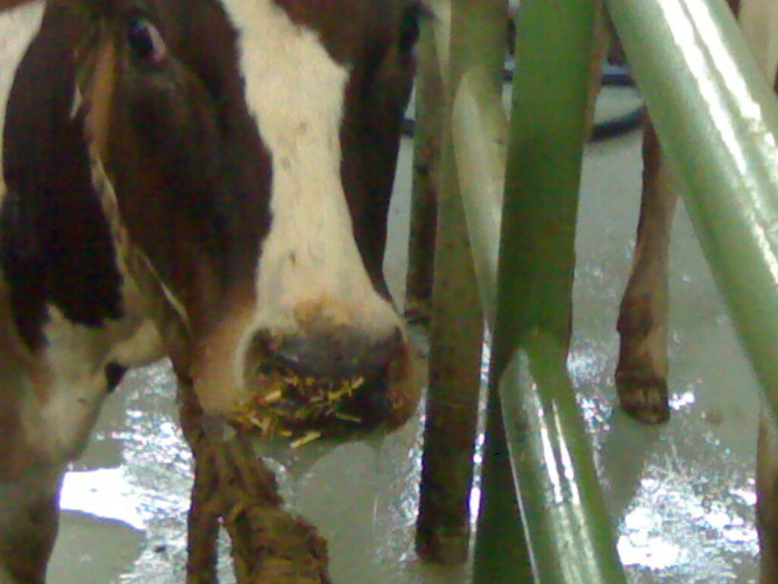
Photo 1: Illustrate salivation of control animal.

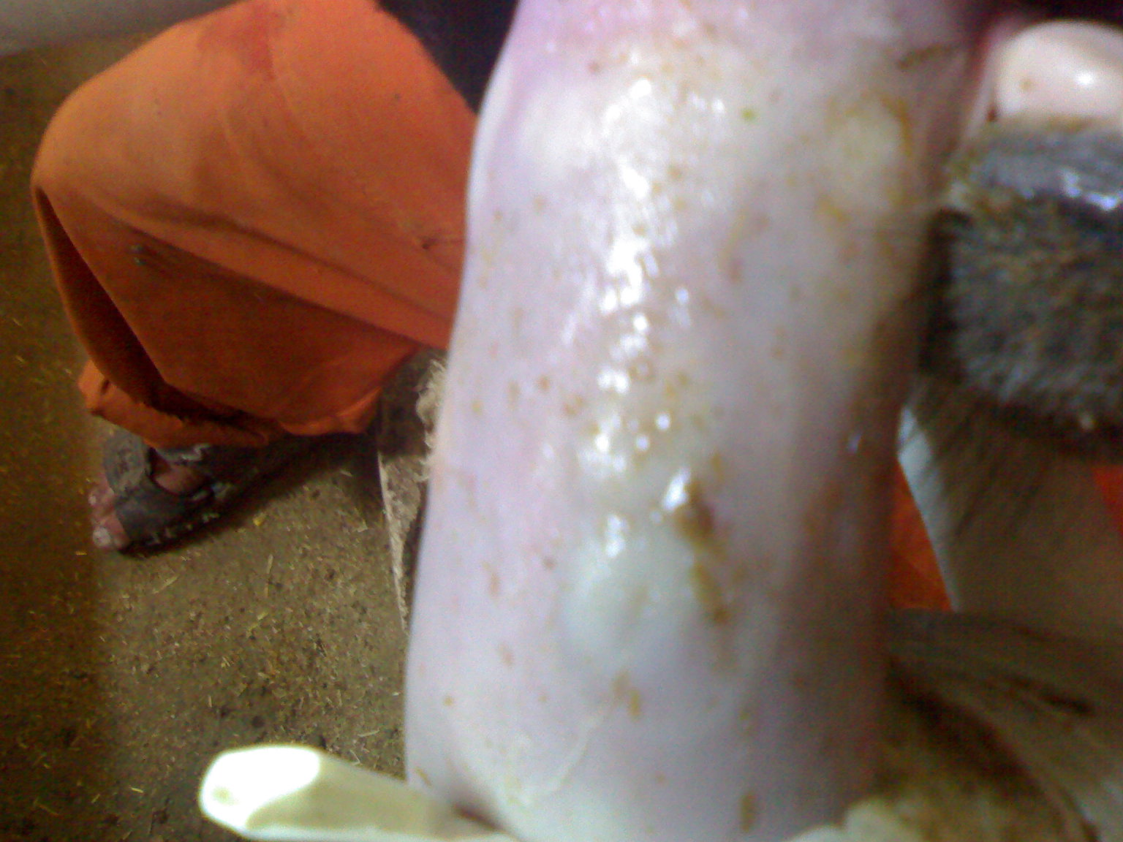
Photo 2: show vesicles formed in the tongue of inoculated control cattle after 72 hours.
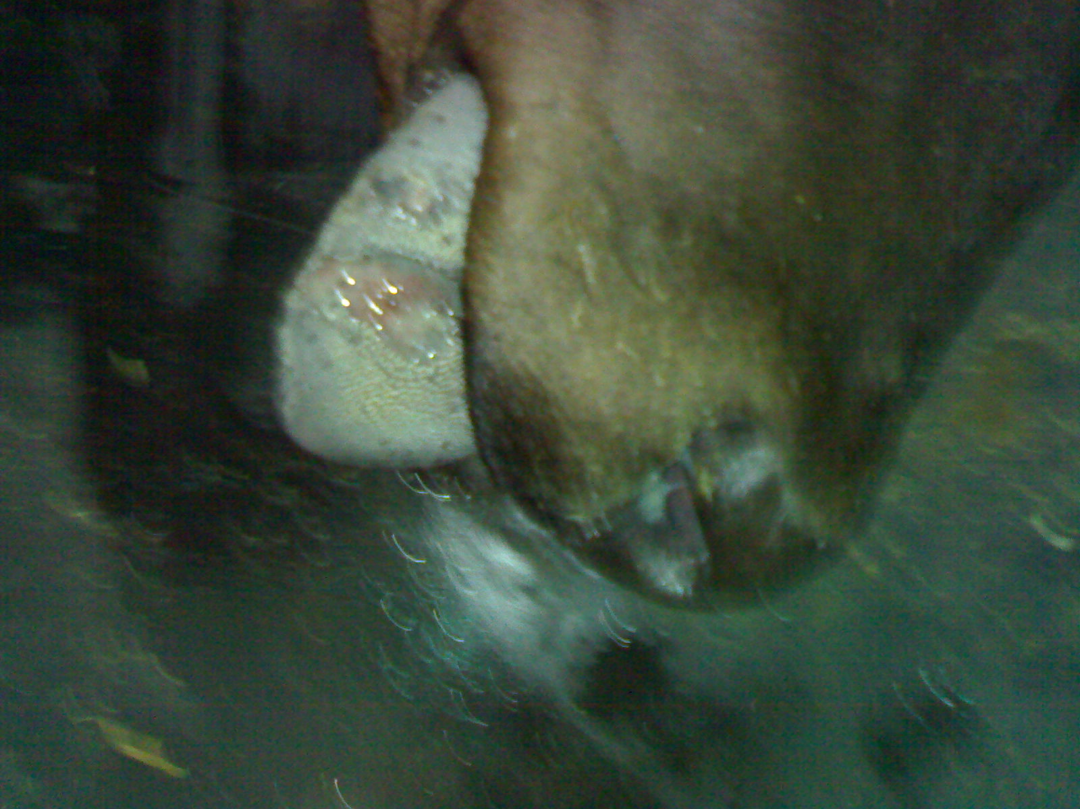
Photo 3: shows ulcer formation in the tongue of inoculated control cattle.
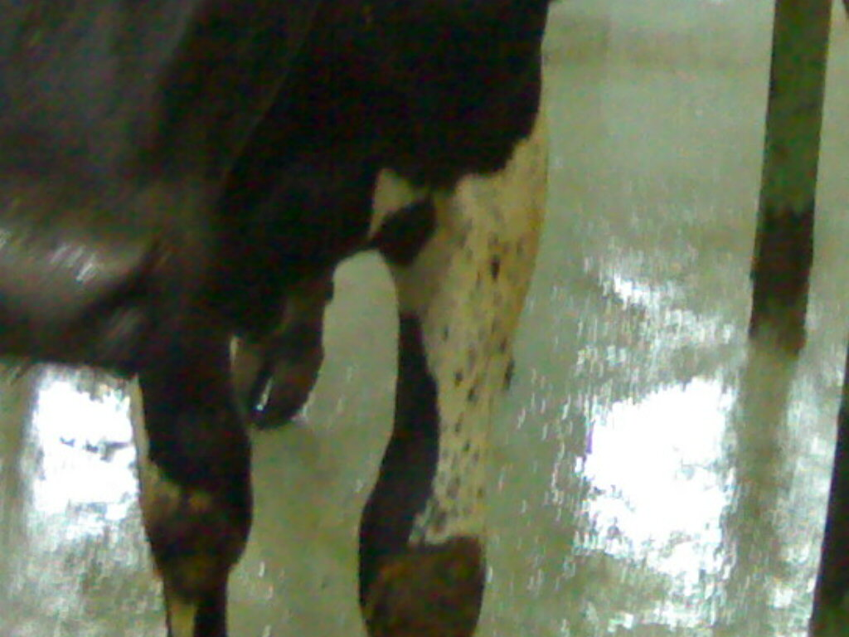
Photo 4: Illustrate infected leg of inoculated control cattle

Corresponding author
Saad, MA
Central lab for Evaluation of Veterinary Biologics, Abbasia, Cairo
saad940@yahoo.com

References
Aggarwal N,Zhang Z,Cox S, Statham R,Alexandersen S, Kitching RP, et al.(2002). Experimental studies with foot and mouth disease virus, Strain O, responsible for the 2001 epidemic in the united kingdom .Vaccine, 20:2508-15.
Alonso A,Gomes MPD, Ramalho AK, Allende R,Barahona H,Sondahl M, et al. (1993). characterization of foot and mouth disease virus by monoclonal antibodies viral Immunol.; 6:219-28
Barnett, P.V.; Keel, P.; Reid, S.; Armstrong, R.M.; Statham, R.J.; Voyce, C.; Aggarwal, N. and Cox, S.J. (2004): Evidence that high potency of foot and mouth disease vaccine inhibits local virus replication and prevents the carrier state in sheep Vaccine, 22: 1221-1232.
Burrous, R. (1996): The spictally assay of foot and mouth disease virus in pigs. J. Hyg. Comb., 64: 75.
Brooksby JB. (1982). Portraits of viruses: Foot and mouth disease virus .Intervirology, 18:1-23
Barteling SJ.Swam H. (2006). The potent aqueous and double oil emulsion foot and mouth disease type O vaccines from European vaccine banks probably protect against all other O strains .Report of the European Commission for the control of foot and mouth disease In:Session of the Research Group of the standing technical Committee, Appendix 13:90-4.
Brehm KE, Kumar N, Thulke H-H, Haas B. (2008). High potency vaccines induce protection against heterologous challenge with foot and mouth disease Virus .Vaccine; 26:1681-7.
Cox, S.J.; Satya Parida; Voyce, C.; Reid, M.S.; Hamblin, A.P.; Hutchinas, G.; Paton, D.J. and Barnett, V.P. (2007): Further evaluation of higher potency vaccines for early protection of cattle against FMDV direct contact challenge. Vaccine, 25:7687 -7695.
Cartwright B,Chapman WG,Sharpe RT (1982). Stimulation of heterotypic antigens of foot and mouth disease virus antibodies in vaccinated cattle .Res Vet Sci.; 32:338-42
Dunn Cs,Samuel AR,Pullen LA, Anderson J (1998). The biological relevance of virus neutralization sites for virulence and vaccine protection in the guinea pig model of foot and mouth disease; vaccine 51-61.
Kitching RP,Rendle R,ferris NP. (1988). Rapid correlation between field isolates and vaccine strains of foot and mouth disease virus. Vaccine; 6:403-8
McCullough KC,De Simone F,Brocchi E, Capucci L,Crowther JR, Kihm U. (1992). Protective immune response against foot and mouse disease. J Virol.; 66:1835-40
Mattion N,Konig G,Seki C,Smitsaart E,Maradei E,Robiolo B, et al . (2004). Re introduction of foot and mouth disease in Argentina: characterization of the isolates and development of tools for the control and eradication of the disease. Vaccine, 22:4149-62.
OIE (2010): Manual of diagnostic tests and vaccine terrestrial animals. 5th Edition 2008 Part 2 Chapter 2 .11.
Paton DJ,Valarcher JF, Bergman l, Mathlo OG, Zakharov VM, Palma EL, et al. (2005). Selection of foot and mouth disease vaccine strains – a review. Rev Sci tech OIE; 24:981-93
Rweyemamu MM, Hingley PJ. (1984). Foot and mouth disease virus strain differentiation: analysis of the serological data .J Biol Stand.; 12:225-9.
Singanallur Balasubramanian Nagendrakumar, Villuppanoor Alwar Srinivasan, Muthukrishnan Madhanmohan, Shanmugam Yuvaraj, Satya Parida, Antonelle Di Nardo, Jacquelyn Horsington, David James Paton (2004). Evaluation of cross protection between O Manisa Campos in cattle vaccinated with foot and mouth disease virus vaccine incorporating different payloads of inactivated O Manisa antigen , vaccine 29 (2911):1906-1912.

8/29/2011

