Preparation and Evaluation of Master Seed for infectious bronchitis vaccine from local variant isolate

Susan, S. El-Mahdy¹; Y. A., Soliman¹ and M. M. El-Hady².

¹Central Lab. for Evaluation of Vet. Biologics, Abassia, Cairo Egypt. (CLEVB)
²Vet. Collage, Cairo University. Cairo Egypt
prof.s.elmahdy@gmail.com

Abstract: Preparation and Evaluation of Master seed prepared from Local variant infectious bronchitis virus (IBV) isolated from different poultry farms in Egypt and identified as IS/1494/06 nephropathogenic strain are very important point for vaccine production for controlling of infectious brobchitis(IB) disease in Egypt. Master seed of the virus (MSV) contained 10⁴ EID50 per dose per bird free from bacterial; fungal; mycoplasma ; extraneous viral contamination ; Safe and potent. Polymerase chain reaction (PCR) genotyping methods used for determining the relation between MSV and other IB variant strains (IB-88 and IB 4-91). The molecular basis of antigenic variation has been investigated in showed a distinct dissimilarity with either CR-88 ( 27.83%) or IB4-91(9.3%) .
[Susan, S. El-Mahdy; Y. A., Soliman and M. M. El-Hady Preparation and Evaluation of Master Seed for infectious bronchitis vaccine from local variant isolate] Nature and Science 2011; 9(10):145-151]. (ISSN: 1545-0740). http://www.sciencepub.net. 19

Key Words: Master seed of the virus (MSV); local variant infectious bronchitis virus (IBV)

1. Introduction
Infectious bronchitis virus (IBV) is a Coronaviruses (Family Coronaviridae) belong to the order Nidovirales and contain a positive - stranded RNA genome that ranges from 27 to 31 Kb in size (Cavanagh, 1997). IBV is one member of the family coronaviridae which infect a wide range of hosts and this family have been classified into three groups on the basis of antigenicity, genome organization and sequence similarity (Lai and Cavanagh, 1997) Morever; IBV was placed in group (3) (Cavanagh, 2005).
IBV is one of the most important respiratory disease in chickens of all ages and characterized by severe loss of production and egg quality in mature hens. Some strains cause nephritis in young birds and infectious bronchitis is occasionally reported to be associated with enteritis. (Gorgyo et al; 1984).
It is an economically important disease for the poultry industry, and vaccination strategies are essential. It is well established that the main problem. In the control of infectious bronchitis is the ability of the virus to generate antigenic variants, due to mutation or sometimes recombination of the spike (S1) gene (Gelb et al., 2005). The S1 spike protein is responsible for cell attachment and for a large component of immunity and is important in virus neutralization, which has been used traditionally to determine serotyping of IBVs (Cavanagh et al., 1997). Small changes in the amino acid sequences of the spike protein can result in the generation of new antigenic types, which may be quite different from existing vaccine types (Adzhar et al., 1997) and may require a homologous vaccine.
In Egypt; IB infection was first recognized during 1950s by Ahmed, (1954) from birds showing respiratory signs and confirmed by Eissa et al., (1963). Many studies were done on the isolation of IBV from chickens suffering for respiratory or renal problem (Ahmed 1964; Amin and Moustagger 1977; Sheble et al., 1986; Bastami et al., 1987; El-Kady 1989; Eid 1994; El-Sisi and Eid 2000; and Sediek 2005) which isolate five isolates were serologically related to D274 variant strain.
Another studies were done to detect the level of antibodies against IB (Ahmed et al 1968; Salama 1976; Moustafa 1977; Ismail et al., 1980; Davelaar 1985; Awad 1988; El Zanaty and Sokkar 1988 Shahata et al., 1988; Taha et al., 1991; Mahmoud 1993; and shihata et al; 2003)
In Egypt, as is other countries IB has occurred frequently in vaccinated and non-vaccinated flocks and has caused severe economic losses in recent years. Susan et al., (2010) isolated and characterized of Nephro pathogenic strain of IB which related to the IS/1494/06 variant strain; So that our study was planed for preparation and evaluation of Master seed for IBV from this local variant isolate.

2. Materials and Methods:
Viral Strain:
Infectious bronchitis virus (IBV): It was supplied by isolation and characterization of variant strain which related to the IS/1494/06 nephropathic IBV strain from Egyptian farms at 2010 (Susan et al., 2010).

Living IBV vaccine:
Two variant infectious bronchitis vaccine used for comparison with master seed from local variant IBV; Nobilis IB 4-91 Batch No. (A0 86cj01) and Galivac IB 88(CR 88121) Batch No L377064. and two clasical IB vaccine; H120 Marial Batch No L365500 and Intervet Ma 5 Batch No. 10604C JO I.

Experimental Hosts:
a- Specific pathogen free (SPF) embryonating chicken eggs (ECE): were obtained from the SPF production farm, Koum Oshein, El-Fayoum, Egypt. Eggs were kept in the egg incubator at 37 °C with humidity 40-60% used for propagation according to Allan et al., ( 1973) and quality control of master seed of IB Local variant strain at (9-10) days old and at 18- day old for studying the potency test. The method for in-ovo-inculation were carried out according to wakenell et al (1995).
b- Experimental mice: swiss male mice were obtained from Central Lab. for Evaluation of Veterinary Biologics (CLEVB), used for studying the Safety of Master seed of IB vaccine for mammalian species. (Ecotoxicity test).
c- One day old SPF chicks: chicks free from MDA (Maternal driving antibodies)against IBV obtained from SPF Poultry farm at Koum Oshein El-Fayoum, Egypt were used for studying the safety test of the tested Master seed virus.
All birds were reared in cages and kept in a strict isolated mosquito proof room. The room was previously cleaned thoroughly disinfected and provided with clean water and food.

Tissue cultures and cell culture media: (Lennelte, 1964)
Primary chicken embryo fibroblast cell (CEF) was obtained from (CLEVB); Which prepared as described by Schat and Purchase (1989). Trypsin-versin solution prepared according to Lennelte (1964); Hank's balanced salt solution (HBSS) prepared according to Hank and wallance (1949); Minimun Essential Medium (MEM) was prepared according to the manufacturer’s instructions; and Bovin serum was mycoplasma free and virus screened "Gibco Limited, Scotland, and UK". The method used for inculation in the microtitre plates was done according to Rossiter and Jessett (1982).
Tissue culture used for detection of extraneous agents in prepared master seed (Avian Lymphoid Leukosis) according to 9 CFR Ch. 1 (1-1-09 Edition) 11.30 (2009).

Enzyme Linked Immuno-Sorbent Assay (ELISA): (Snyder et al., 1986)
ELISA Kit was obtained from Symbiotic corporation 11011 VIA Forntera San Digo, CA 92127, U.S. ; Leukosis ELISA Kit with Batch No. FS 5254 and Infactious Bronchitis Kit with Batch No FS 5175.

Polymerase Chain reaction (PCR): (Council of Europe, 1999)
PCR used for test of extraneous agents in Master seed according to Council of Europe (1999)and for detect of Identity of Master seed and relation with IB Vaccine from other variant strains (IB 4-91 and IB-CR 88121) by using DNA Star analysis; RNA extraction Kit using Bioflux simply total RNA extraction Kit Cat # BSC 52 S1 ). DNA extraction Kit using Bioflux Mega Bio virus DNA purification kit cat # BSC 12 S14. Amplification by using BIOER Reverse transcription polymerase chain reaction (RT–PCR) kit one step cat # BSBO 7 MI for (classical strain of infectious bronchitis, IBD, TRT and Avian Influenza) as extraneous RNA agents in Master IB variant strain seed. Amplification by using Ferments DreamTaq green PCR Master Mix Cat # K 1084 for (ILT, DH, Fowl Pox and Marek's disease virus) as extraneous DNA agents in Master IB Variant Strain Seed. The amplicone was subjected to sequencing

Haemaulutmation test (HA):
It carried out according to the standard procedure described by Majujabe and Hitchner (1977) to detect of extraneous haemagglutinating agents in prepared Master seed according to 9 CFR Ch. 1. (1-1-09) Edition 113 -3 3 (2009).

3. Results:
Preparation of Master IB Local variant strain seed:
IB variant strain was propagated in 9-10 day old SPF egg after is diluted in physiological saline; the inoculation by the intra-allantoic route into each SPF embryonated egg. The SPF eggs are reincubated at 37°C until 72h. The virus growth is optimum ( fig 1) , The allontoic fluid is collected under aseptic conditions and reinoculated for five passage in SPF eggs. The harvest of the 5th passage is stored at temperature lower than or equal to - 80°C in small vials for complete the quality control tests of master seed.

Quality Control of Master Seed (MSV):
1- Bacterial and fungal sterility:
The results of MSV is free from bacterial and fungal contamination.
2. Mycoplasmic sterility:
The results of MSV are free from mycoplasmes.
3. Identity:
Polymerase chain Reaction (PCR) by using primer specific to infectious bronchitis virus (Fig 2 - 4).

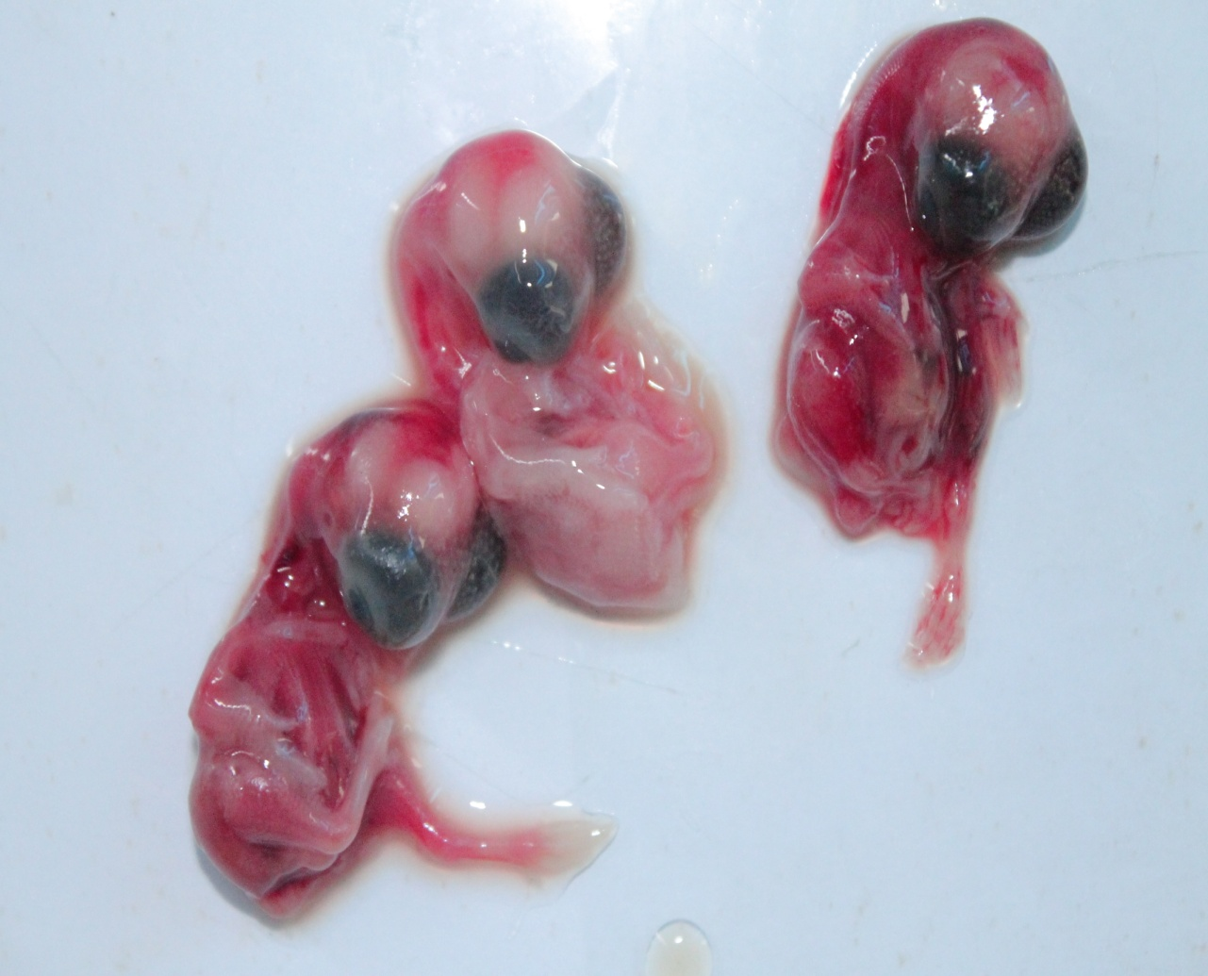
Fig 1: the embryos inoculated with the variant IB locally isolated strain, showing stunted growth as well as curling.

4. Purity tests:
The MSV does not contain any extraneous agent either haemagglutinating agent inoculation of 9 – 10 day old embryonated SPF eggs; primary culture of chicken embryofibroblasts (Test for avian leucosis virus) or by using PCR test for on other extraneous viral agents.
5. Titration:
The infectious bronchitis Master seed growing SPF embryonated eggs (9-10) days old. The infectivity criteria are the mortality and delayed growth the embryos. Dilutions of the MSV to be titrated are inoculated into SPF embryonated eggs. The infective titer is expressed in 50 percent egg infective doses (EID₅₀). The titer is such that one dose of MSV contains at least 4.0 log 10 EID₅₀/ dose.
6. Safety:
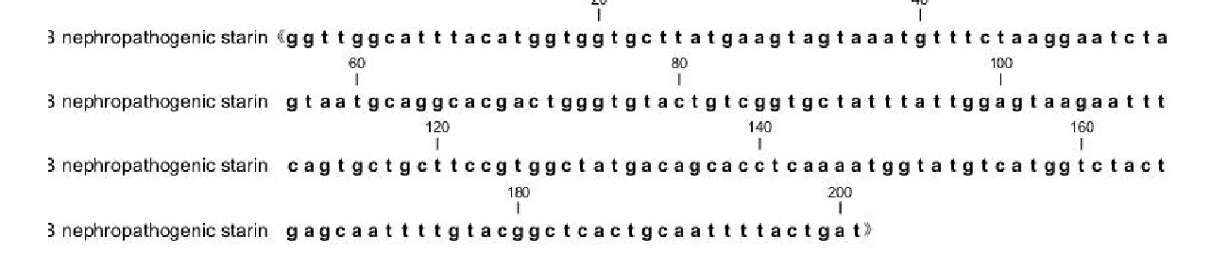
The Master seed virus proved to be safe after the ocular route administration of 2 weeks old SPF chicks free from maternal antibodies against IBV with a 10 X dose and observed for 21 days.
None of the chickens shows any serious signs or dies for reasons attributable to MSV.
Results of safety test in mammalian species (Ecotoxicity lest) gave no evidence for abdominal toxicity in Swiss mice inoculated intra peritoneal with 10 X dose of MSV.
7. Potency test:
This experiment was designed to study the potency effect of in ovo-inoculation of MSV in compare with variant strain (Nobilis IB 4-91 vaccine and Galivac IB88 (CR 88121) vaccine) and classical (H 120 and Ma 5).
The immune response of hatched chicks are determined at three weeks old chicks by using ELISA test and the results in table (1).

Fig (2): The PCR amplification of the spik gene from the IB varient of the locally isolated strain.

Fig (3): The nucleotide sequence of the spike protein of the IB variant local isolate ( upper ) and the phylogentic tree in comparison with the CR 88 and IB 4-99 ( lo

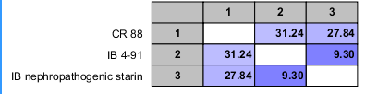
Fig (4): The percent identity of the IB nephropathogenic strain ( local isolate ) and the CR88 and IB4-91

Table (1): Antibody response to MSV compared with variant (IB4-91 and IB 88) and classical (IB H 120 and IB Ma 5) as monitored by ELISA after in ovo Vaccination.
Groups | Number of samples | Type of Virus | GMT of ELISA
GI | 20 | Master seed of local local variant ( MSV) strain | 10053.2
G2 | 20 | Nobilis IB 4-91 | 9067.6
G3 | 20 | Galivac IB 88 (CR 88121) | 4210.1
G4 | 20 | Marial IB H 120 | 4374.9
G5 | 20 | Intervet IB Ma 5 | 4803.7
G6 | 20 | Central unvaccinated  negative group | 156
GMT: Geometric mean titer N.B: Titer of control positive serum is equal or more than 3000.
Significant difference at P ≤ 0.05

4. Discussion:
Infectious bronchitis disease (IB), caused by infectious bronchitis virus (IBV). It is an acute and highly contagious disease in chickens. The disease is characterized by respiratory signs in young chickens, while in layers respiratory distress, decrease in egg production, and loss of internal and shell quality of eggs are reported. Some strains of the virus cause severe kidney damage, urolithiasis and may be associated with high mortality; this strain reported as variant strain and act as a major health problem affecting the chicken industry in most countries of the world (Liu. and Kong 2004).
Through the use of attenuated live as well as inactivated virus vaccines, economic losses due to this disease have been significantly reduced (Cavanagh and Nagi 2003).
Vaccinal strains are selected to represent the antigenic spectrum of isolates in a particular country or region. The Massachusetts (H120) or Ma5 and other vaccines of the Massachusetts serotypes are used widely around the world; also different variant IB vaccinal strains used for many years on poultry farms as UK 793 B (Nobilis IB 4-91 and CR 88) Capua et al., (1999) and Farsang et al., (2002).
However in Egypt IBV variants may continue to circulate among vaccinated and non – vaccinated flocks and cause severe economic problems (Susan et al., 2010).
The aims of the study were to prepared and evaluate the Master seed of nephropathogenic strain of IB related to the IS /1494/06 variant strain which isolated and characterized from different Egyptian farms in different government.
Locally preparation of master seed was carried on SPF eggs (9-10 )days; the allantoic fluid is collected after 72h post inoculation and store at - 80 C as described in Clarke et al., 1972 ; Jackwood et al., 1992 ; 9CFR (2009) and OIE (2010).
The result of titration was judged according to the parameters of code of Federal Regulation USA "Part 133. 331-9 CFR. 1 (2009) in which IBV titers must be not less than 10^{3.5} EID₅₀ / dose. So the prepared Master seed of IB Variant strain was Satisfactory with 10^{4.0} EID₅₀/dose. The results of MSV is free from bacterial fungal and Mycoplasma which judged according to parameters of European pharmacopoeia (1998) in which the Master Seed must be serial and free from any contamination. The MSV does not contain any extraneous agent either haemagglutinating agent; avian leucosis virus or any another extraneous, viral agents when use SPF inoculation, tissue calture; ELISA test or PCR. this results was judged according to 9CFR (2009) , Europian pharmacopeia (1989 and 1998) , British pharmacopeia (1990) and GRIMV (1992)
PCR used for detect of identity of MSV as described in OIE (2010) and the genotyping methods used for determining the relation between IB virus from other variant strain (IB 4-91 and IB-CR 88121) in fig (2-4) the nucleotide sequence of the spike protein of IB variant local isolate and the phylogentic tree in comparison with the CR88 and IB 4-91. The identity percent of the IB nephropathogenic local strain and the CR 88 and IB 4-91 gave distinct dissimilarity with 27.83% and 9.3% respectively.
MSV considered to be safe ( according to the requirements of OIE 2010) if inoculation 10 X dose in one day old SPF chick and gaves no serious signs or deathes during the opservation period ( 21 days post inoculation ) . our results for ecotoxicity test according to European pharmacopeia ( 1997)
In studying of potency effect of the master seed in comparison with other variant vaccinal strains and classiacal one in ovo vaccination gave GMT 10053.2 , 9067.6 . 4210.1, 4374.9, 4803.7 and 156; in comparison with unvaccinated negative control when using ELISA test. The ELISA technique is a sensitive serological method and gives earlier reactions and higher antibody titers than other tests according to Mockett and Darbyshire (1981).
MS considered potent according to parameters of 9 CFR 2009 , OIE 2010 and Wakenell et al., 1995 , Zwaagstra et al., 1992 , Mockett and Darbyshire 1981.
the similarity percentages showed a distinct differences between the locally isolated IB variant from those used in the vaccination of chicken in Egypt which explains why the variant still pathogenic in vaccinated chicken.
In conclusion the master seed prepearde from local isolate virus strain isolated from chicken suffered from severe renal lesions in Egypt farms and identified as nephropathogeneic svarient infectious bronchitis virus related to IS /1494/06 nephropathogenic strain gave good point to be used in vaccinal production to controlling the infectious bronchitis problem in Egypt.

Corresponding author
Susan, S. El-Mahdy
Central Lab. for Evaluation of Vet. Biologics, Abassia, Cairo Egypt. (CLEVB)
prof.s.elmahdy@gmail.com

References:
Adzhar, A., k.; Gough, R.E.., Haydon, D., Shaw, K., Britton, P. and Cavanagh, D. (1997) : Moleculer analysis of the 793/B scrotype of infectious bronchitis virus in Great Britain. A vian pathol. 26, 625-640.
Ahmed A.A.S., El-Sisi, M.A.; Abbasi, K.H.; Saber, M. and Reda, I.M. (1968): Further studies on respiratory infections of poultry in Egypt. J. Vet. Sci., UAR, 5:85-104
Ahmed, A.A.S. (1964): Infektiose Bronchitis des huhmes in Agypten. Berl. Munchen Tieraerzl, Wschr, 77:481-484
Ahmed, H.N. (1954): Incidence and treatment of some infectious viral respiratory diseases of poultry in Egypt. D.V.M. Thesis, Cairo Univ.
Allan, W.H. : Lancast6er, J. E. and Toth (1973): The production and use of Newcastle disease vaccine. Food and Ag1: culture organization. ROME, Italy, 1115.
Amin, A.A. and Moustagger, M. (1977): a preliminary report on an avian infectious bronchitis virus strain associated with nephritis nephrosis syndrome in chickens. J, Egypt. Vet. Med. Ass., 32 : 71-77.
Awad, M.M.M. (1988): Some studies on infectious bronchitis in chickens in Egypt. M.V.SC. thesis, fac. Vet.Med.Assiut Univ.
Bastami, M.A.; Amer, M.M. and Hamouda, A.S. (1987): Viral nephritis induced by an isolant related to Iinfectious Bronchitis virus. I. Isolation and identification of the isolant. Assiut Vet Med. J., 19 (37): 173
British pharmacopoeia (1990) (UK) MAL 74 and 79 tisting of virus purity.
Capua, 1., Minta, Z. Karpinska, E., Mawditt, K., Britton, P., Cavan agh, D. and Gough, R. E (1999) Co- Circulation of four types of infectious bronchitis virus (793/B, 624/1, B 1648 and Massachusetts) Avian Pathology, 28, 587 – 592.
Cavanagh, D, and Nagi, S. (2003): infectious bronchitis. Disease of poultry, 11th edn (pp. 101-119). Ames: Iowa state university press.
Cavanagh, D. (1997): Nidovirales: a new order compnising coronauiridac and Arteriviridae. Arch virol 142, 629 – 633
Cavanagh, D. (2005): Corona viruses in poultry and other birds. A vian pathology, 34, 439-448
Cavanagh, D., Ellis, M.M. and Cook, J.K.A. (1997): Relationship between sequence variation in the SI spike protein of infectious bronchitis virus and the extent of cross- protection in vivo. Avian pathology, 26, 63-74.
Clarke J.K., McFerran J.B and Gay F.W.(1972): Use of allantonic cells for the detection of avian infectious bronchitis virus. Arch. Gesamte virusforsch., 36, 62-70.
Code of American Federal Regulation (2009): (9CFR).
Published by office of the federal register national archives records service, Animals and animal products.
Council of Europe (1999). 2.6.3 Avian uiral vaccines: Tests for extraneous Agents in seed lots pharmeuropa 11, 188-191.
Davelaar, FG (1985): An update on infectious bronchitis second European Hubbard Synposium. June 24-29, 1985.
Eid, Amal, A.M. (1994): Studies on some avian viruses with a special reference to a heat resistant Newcastle disease virus. Ph.D Thesis. Poultry Dis Fac. Vet. Med, Zagazig Unit, Zagazig. Egypt.
Eissa, Y.M.; Zaher, A. and Nafai, E. (1963): Studies on respiratory diseases. Isolation of Infectious Bronchitis virus, J. Arab. Vet. Med. Ass., 23: 381.
El- Kady, M.F. (1989): Studies on the epidemiology and means of control of infectious bronchitis virus in chicken in Egypt. Ph.D. Thesis, Poult. Dis., Fac. Vet. Med., Cairo Univ.
El- Sisi, M.A. and Eid, Amal, A.M. (2000): Infectious bronchitis virus and infectious bursal disease, concurrent infection among broilers in Egypt. Zagazig, Vet. J., 28: 150-153.
El- Zanaty, K. and Sokkar, I. (1988): Measurement of antibodies to infectious bronchitis virus by agar get precipitation and Enzyme-Linked immunosorbent assay tests. Assuit. Vet. Med. J., 20(40) : 174-178.
European pharmacopaeia, 2nd adition (1989): V2.1.3.5. using ELISA test for testing viral purity.
European Pharmacopaeia (1997): Studing safety test (Control test technique) Monographs 0442, 0450 and 1068.
European Pharmacopaeia, 3 rd edition supplement (1998):
2.6.1 (Bacterial and fungal sterility) 2.6.5 Test for extraneous virus using cell culture 2.6.7 Mycoplasmas, culture method
Farsang, A., Ros, C., Renstrom, L.H.M., Cloudia Baule, Soos, T. and Belak. S. (2002) Molecular epizootiology of infectious bronchitis virusin Sweden indicating the involvement of a vaccine strain. Avian Pathology, 31, 229-236.
Gelb. J., Weisman, Y., Ladman, B. S. & Meir, R. (2005):
Gene characteristics and efficacy of vaccination against infectious bronchitis virus field isolates from the United States and Israel (1996 to 2000) Avian pathology, 34, 194-203.
Gorgyo, M; Umemura, T. and Itakura C. (1984): Concurrence of Nephrosis- nephritis due to infectious Bronchitis virus and infectious bursal disease in Broilder chickens Avian Pathology, 13, 191-200.
GRIMV (1992): General Requirements for the production and control of inactivated mammalian bacterial and viral vaccines for veterinary use: Master seed virus 7 BIM 2a 23-32.
Hank, J. H. and Wallance, R. R. (1949): Relation of Oxygen and temperature in the preservation of tissue by refrigeration. Prope. Sec. Exptl. Bio., Med., 71: 196-200.
Ismail, A.; El-Taher, A.M.; Salama, A.A. and El-Mogazy, R.E. (1980): Seroepidemiological studies for the demonstration of precipitins against ND, IB and CELO in chickens. J. Egypt. Vet. Med. Assoc., 40 (1): 113-118.
Jackwood M.W. Kwon H.M. & Hilt D.A. (1992). Infecious bronchitis virus detection in allantoic fluid using the polymerase chain reaction and a DNA probe. Avian Dis., 36, 403-409.
Lai, M.M. and Cavanagh, D. (1997): The molecular biology of corona viruses. Advances in virus research 48 : 1 – 100.
Lennelte, E.. H. (1964): Diagnosis procedure for viral and rickettsial disease. An public Hulth. Ass Inc., 3rd Brodway.
Liu, S. and Kong, X. (2004). Anew genotype of nephropathogenic infectious bronchitis virus circulating in vaccinated and non- vaccinated flocks in china Avian pathology, 33 (3) 321-327.
Mahmoud, A.R. (1993): Viruses associated with Coryza infection in chickens. M.V.Sc. Thesis (poultry Dis). Fac. Vet. Med. Zag. Univ. Egypt.
Majujabe, K. A. and Hitchner S.B. (1977): Antibody response to strain combination of Newcastle Disease Virus As Measured by Haemagglutination inhibition Test. Avian Disease, 21, 576 – 584.
Mockett A.P.A. & Darbyshire J.H. (1981). Comparative Studies with an enzyme-linked immunosorbent assay (ELISA) for antibodies to avian infectious bronchitis virus. Avian Pathol., 10, 1-10.
Mostafa, A. (1977): Studies on IBV infecion in chicken flocks. M.V.Sc. Thesis, Fac. Vet. Med., Cairo Univ.
OIE (2010): Manual of Diagnostic Tests and Vaccines for Terrestrial Animals.
Rossiter; P.B. and Jessett; D.M. (1982): Microtiter technique for the assay of rinderpest virus and neutralizing antibody. Res. Vet. Sci.; 32: 253-256
Salama, A.B.El-R. (1976): Indcidence of Infectious Bronchitis in chickens in Sharkia province M.V.Sc. Thesis, Fac. Vet. Med., Zagazig Univ.
Schat, K.A. and Purchase, H.G. (1989): Cell culture methods. In:American Assoc. Avian Pathol., 3rd Ed., PP. 167-175.
Sediek, M.M. (2005): Studies on infectious bronchitis in chickens. M.V.Sc, thesis, poultry Dis, Fac. Vet. Med. Alex Univ. Egypt.
Shahata, M.; Ibrahim, A.; Saif-EL Din, M., Gabr, N.; El-Demerdash, M. and Khafagy, A. 1988: Serological screening of chickens flocks for infectious bronchitis antibodies. Proc. 3rd Sc. Cong Fac. Vet. Med. Assuit. Univ. pp: 311-315
Sheble, A.; Sabry, M.Z.; Davelaar, F.G.; Burger, A.G.; Khafagy, A.K.; Moustafa, F.; Moustafa, M.M. and Henna, M. (1986): Present status of Infectious Bronchitis in Egypt. J. Egypt. Vet. Ass., 46 (4): 393-411.
Shihata, A.B.; EID, Amal, A.M.; Abdein, Hanan; M.F.; and El-Said,Maha, A, (2003) Studies on some etiological agent accompanying respiratory swollen head and stunted growth problems in chicken broilers. 1. serological investigation of Haemophilus paragallinarum (HPG) and infectious bronchitis (IB), Reo and Adeno virus in chicken broilers. Beni-Suef. Vet. Med. J., 13(1) : 453-465.
Snyder, D.B.; Marguardt, W.W.; Mallinion, E.T.; Russetcohen, E.; Svage, P.K. and Allen, D.C. (1986): Rapid serological profiling by enzyme linked immunosorbent assay. Avian Dis., 30:139-148.
Susan, S. El – Mahdy; El – Hady, M.M. and Soliman, Y. A. (2010): Isolation and characterization of Nephropalhogenic strain of infectious Bronchitis virus in Egypt; Journal of American Science 6 (9)669-674.
Taha, M.M.; Moustafa, M.M.A.; Soliman, S.M.; Attia, S.A. and Hatem, M.E. (1991): Effect of both Mycoplasma gallisepticum (MG) and IB classical and variant stains on the egg production of the broiler breeder flocks. Vet. Med. J., 39 (1): 169-179.
Wakenell P.S., Sharma J.M. & Slocombe R.F. (1995). Embryo vaccination of chickens with infectious bronchitis virus: histologic and utlrastructural lesion response and immunologic response to vaccination. Avian Dis., 39, 752-765.
Zwaagstra K.A., Van Der Zeust B.A.M. & Kusters J.G. (1992). Rapid detection and identification of Avian bronchitis virus. J. Clin. Microbiol., 30, 79-84..

9/25/2011

