Application of FT-IR Spectroscopy for Rapid and Simultaneous Quality Determination of Some Fruit Products

Gamal F. Mohamed¹, Mohamed S. Shaheen² Safaa K.H. Khalil³ , Ahmed M.S. Hussein¹ and Mohie M. Kamil^{*1}

¹Food Science and Technology Dept., ²Flavor and Aromatic Dept., ³Spectroscopy Dept., National Research Center,
Dokki, Cairo, Egypt
*ResearchTeamMMK@yahoo.com

Abstract: Detection of adulteration is a technical problem. In our work, we have demonstrated the capability of FT-IR spectroscopy as a simple, rapid and accurate method for simultaneously determining sugars, pectin and organic acid contents (citric acid) in some natural and synthetic fruit products. FT-IR technique used to detect the adulterants added such as glucose syrup, synthetic flavor and pigment (allura red & sunset yellow) in jams (strawberry & apricot), apricot sheet and juices (orange, apple and strawberry). The authenticity of strawberry jam was identified by several spectral bands assigned to fructose as deformation OCH, COH and CCH detected at 1425-1414 cm⁻¹. While, spectral peaks due to the presence of glucose, sucrose, citric acid, pectin and allura red pigment were identified at 1029-1045 cm⁻¹, 1058-1061cm⁻¹, 1351-1378 cm⁻¹, (700 - 705 and 917 - 927 cm⁻¹) and 631 - 633cm⁻¹, respectively in synthetic strawberry jam. Also, spectral band of fructose in fruity apricot jam was detected at (1414-1416 cm⁻¹); and spectral band of synthetic pigment (sunset yellow) were detected at (770-762 cm⁻¹) in synthetic apricot jam. Apricot sheet could be replaced with carrots as a cheap food material. Adulterated apricot sheet (100% Carrot) was identified with presence of a certain peak at 1089 cm⁻¹, which disappeared in 100% apricot sheet. Also, in carrot-adulterated apricot sheet the intensity of the peaks were higher than those of unadulterated one at the same concentration. FT- IR spectra of synthetic strawberry, orange and apple juices were dominated by specific peaks that attributed to corresponding synthetic pigments at (1637 - 1644 cm⁻¹), (1419 - 1421 cm⁻¹) and (1053 - 1056 cm⁻¹), respectively. The synthetic juices characterized with specific spectral bands of stretching C=O ester of aldehydic and ketonic groups in synthetic flavor at (1726-1731 cm⁻¹) and stretching CO of sucrose at (996-963 cm⁻¹), while these functional groups disappeared in natural juices. Results concerning the prediction of other quality traits using reference analyses were discussed. The obtained results indicated that, FT-IR technique could be easily adapted to detect any adulterants added in jam and juice products.
[Gamal F. Mohamed, Ahmed M.S. Hussein, Mohamed S. Shaheen and Safaa K.H. Khalil and Mohie M. Kamil Application of FT-IR Spectroscopy for Rapid and Simultaneous Quality Determination of Some Fruit Products]. Nature and Science 2011; 9(11):21-31]. (ISSN: 1545-0740). http://www.sciencepub.net.

Keywords: Adulteration – Authenticity - FT-IR spectroscopy – Jam – Juice - Apricot sheet

Introduction
Authenticity is an important food quality criterion. Regulatory bodies and food processor increasingly demand rapid methods for confirming food authenticity. In recent years, the soft drinks and jams industry have received great attention because of their biological activities and sensory qualities, and have become very important agricultural product in the world (Gurdeniz et al, 2007). The products of food industries such as jams and juices have grown in Egypt within the last decade, so that quality control demands using fast and easy technique to evaluate the quality control attributes and discover any adulterants added such as synthetic flavors and colorants become essential.
The adulteration of food products is of primary importance for consumers, food processors and industries. From the legislative point of view, the quality standards were established through the requirement of quality labels that specify the chemical composition of each product (Gallardo et al, 2009). The adulteration frequently involves the replacement of high cost ingredients with cheaper substitutes. Jams and soft drinks are frequently subjected to be adulterated with other synthetic flavors and colorants of lower commercial value (Flores et al, 2007). Although the adulteration is done for economic reasons, the action can affect the chemical composition and quality parameters of food (Christy et al, 2004).
Several analytical techniques have been developed for detection and quantification of adulteration and authentication of food products, such as mass spectrometry using new type of ion source, direct analysis in real time (Vaclavik et al, 2009), nuclear magnetic resonance (NMR) spectroscopy (Jafari et al, 2009), infrared spectroscopy (Lerma-Garcia et al, 2010), Raman spectroscopy (Heise et al, 2005), fluorescence (Poulli et al, 2007), gas chromatography (Jafari et al., 2009), high performance liquid chromatography (Flores et al, 2006) and differential scanning calorimetry (Chiavaro et al., 2009).
Some of these methods are time consuming, expensive, generally destructive of the sample material, and require a high degree of technical knowledge when interpreting the data. Optical spectroscopy techniques have the potential to replace or at least complement some of the classical laboratory methods. In many cases, they allow for a reliable analysis in quality control during production where speed and simplicity of analysis are crucial advantages. FT-IR spectroscopy has shown to be useful for a range of adulteration problems in food sector such as in strawberry purees (Kemsley et al, 1996), jam (Defernez et al., 1995) and extra virgin olive oil (Lai et al, 1994). Apricot and strawberry fruit quality is a multicomponent concept, defined by physical, physiological and biochemical attributes such as firmness, skin and flesh color, ethylene production, respiration rate, sugars, organic acids, pigments, phenolic compounds and volatiles (Guillot et al., 2006).
Most instrumental techniques currently required for measuring these parameters are long, expensive and involve a considerable amount of manual work. Therefore, there is a demand for new and rapid analytical methods for assessing quality attributes. Recently, Fourier transform mid-infrared (FT-IR) spectroscopy has become a well-accepted method for the determination of food constituents since it achieves high analysis speed and requires little or no sample preparation. FT-IR spectroscopy often coupled with chemometrics has been used to study different quality attributes in many food samples including fruits, vegetables or beverages e.g. epicuticular wax of apple (Veraverbeke et al, 2005), polymethoxylated flavone of orange oil residues (Manthey, 2006), vitamin C in powdered mixture and liquid (Yang & Irudayaraj, 2002). FT-IR spectroscopy has been widely used for must and wine analysis (Fernandez & Agosin, 2007). Moreover, it has become an alternative method for sugar analysis (Bellon-Maurel et al, 1995), in food such as mango juices (Duarte et al, 2002), soft drinks and fruit juices (Ramasami et al., 2004). More recently, this technique has been applied for the analysis of acids in fruits, and in particular apple and tomato (Beullens et al., 2006).
At present, FT-IR spectroscopy is often applied in the analysis of plant cell wall polysaccharides. It is a simple, fast and non-destructive method for investigation of fruit juices composition and monitoring the enzymes activity. This technique coupled with chemometrics has been used to study different quality attributes in many food samples including fruits, vegetables or beverages (Veraverbeke et al., 2005), olive pulp cell wall polysaccharides (Coimbra et al., 1999), must and wine analysis (Fernandez & Agosin, 2007). On the other hand, this technique has become an alternative method for the laborious sugar analysis (Bellon-Maurel et al, 1995), in food, e. g. soft drinks and fruit juices (Ramasami et al., 2004).
However, there is a few articles available related to the use of FT-IR spectroscopy for analysis of jams and juices adulterated with synthetic flavors and colorants. Therefore, in this research study, we adopted FT-IR spectroscopy to detect and evaluate the adulterants added to jams and juices during their processing.

2. Materials and Methods:
Fresh mature carrot, strawberry, apricot, orange and apple fruits were purchased from local market. Natural juices and jams of strawberry, apricot, apple and orange; and apricot sheet were prepared in Food Technology Lab., National Research Centre.
Strawberry, orange and apple synthetic flavors were obtained from Greatco Company for flavors and fragrances industries, 6th October City, Egypt.
To evaluate strawberry and apricot jam quality, three jam samples of each fruit were prepared using 100% sucrose, 50% sucrose + 50% glucose syrup and 100% glucose syrup. Synthetic jams were prepared by using synthetic flavors, pigment and pectin. Also, the authenticity of apricot sheet, carrot as a cheap food material was used as adulterant in apricot sheet, where sheets of 100% apricot (control) and their adulterated sheets of 50% or 100% carrot were prepared; and identified by FT-IR spectral data. Natural and synthetic strawberry, orange and apple Juices were prepared in Food Technology lab, National Research Center.

Determination of quality traits using reference analyses
Products were analyzed for Total Soluble Solids (TSS) using Digital Hand-held “Pocket” Refractometer, pH was measured by digital pH meter (Hanna, Italy) and viscosity was measured using Brookfield apparatus (spindle No. 2, speed 200 rpm and at 26.8°C). Color (L*, a*, b* and reflectance spectra) was measured using Hunter Lab. Instrument, standardized with white tile (LX No 16379).
The properties of the samples were identified using chemical and physical methods in parallel with FT-IR, where moisture, protein, carbohydrate and ash of fruits products were determined according to AOAC (1990). The spectra or fingerprints of the samples were obtained using FT-IR spectroscopy. The samples of FT-IR (FT-IR-6100 Jasco, Japan) were prepared by using potassium bromide disks.
All results were evaluated statistically using analysis of variance as reported by McClave and Benson (1991).

3. Results and Discussion:
To confirm the authenticity of strawberry jam, two type of adulterated jam (Photo 1) were processed at laboratory scale; the first one adulterated by replacing sucrose with glucose syrup (GS), and the second one adulterated by replacing strawberry fruits with synthetic strawberry flavor (SSF) and allura red pigment to produce adulterated jam. Also, natural and synthetic strawberry juices were evaluated.
Detection of adulteration is a technical problem. The first approach was carried out by comparing gross chemical constituents of strawberry, and either their natural or adulterated products as shown in Table (1). The obtained data showed that, there were no significant changes in gross chemical contents of adulterated strawberry jam in comparing with its natural products.

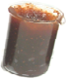  Glucose 100% | 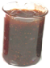  Sucrose 50% + Glucose 50% |  | 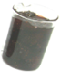  Sucrose 100%
Natural and adulterated (glucose syrup) strawberry jams
B = Sucrose + allura red  + flavor |  | 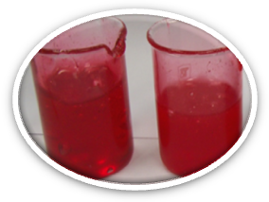  Synthetic strawberry Jams | A = Glucose + allura red  + flavor

Photo (1): Natural, adulterated and synthetic strawberry jams.

Table (1): Gross chemical composition of strawberry fruits and their natural or adulterated jams
Strawberry Jam | Moisture | Protein | Fat | Ash | Carbohydrate
Fresh fruits | 89.16 ± 1.04 | 0.79 ± 0.03 | 0.48 ± 0.015 | 0.5 ± 0.01 | 8.1 ± 0.15
Jam (100% sucrose) | 33.83 ± 0.76 | 0.3 ± 0.01 | 0.3 ± 0.01 | 0.2 ±0. 001 | 65.23 ± 0.75
Jam (100% Glucose) | 30.14 ± 1.03 | 0.29 ± 0.02 | 0.33 ± 0.001 | 0.22 ± 0.01 | 68.83 ± 0.65
Jam (Glucose 50% + sucrose) | 30.39 ± 0.69 | 0.32 ± 0.01 | 0.29 ± 0.001 | 0.21 ± 0.001 | 68.5 ± 0.5

In strawberry jam, the physical structure of the fruit is lost while the color intensity is varied, making visual identification difficult; while the color of synthetic jam was affected according to synthetic pigment (Photo 1). So, the color quality of natural strawberry jams were measured instrumentally by using Hunter color parameter and compared with its synthetic product as shown in Table (2).

Table (2): Hunter color parameters of strawberry and their natural and synthetic products.
Sample | L* | a* | b*
Strawberry fruit | 22.19ª ± 0.39 | 23.81^{b} ± 0.52 | 10.55^{b} ± 0.47
Natural Jam (100% Sucrose) | 6.86^{d} ± 0.28 | 10.49^{d} ± 0.19 | 7.06^{d} ± 0.12
Natural Jam (sucrose : Glucose 1:1) | 12.62^{b} ± 0.021 | 25ª ± 0.08 | 17.58ª ± 0.27
Natural Jam (100% Glucose) | 11.47^{c} ± 0.75 | 15.08^{c} ± 0.34 | 9.86^{c} ± 0.21
Synthetic Jam (100% Sucrose) | 7.39^{d} ± 0.46 | 9.2e ± 0.27 | 3.63e ± 0.04
Synthetic Jam (100% Glucose) | 2.21e ± 0.09 | 8.4e ± 0.85 | 3.55e ± 0.27
L S D at 5% level | 0.786 | 0.824 | 0.496

Natural strawberry jam has higher darkness, lower redness and yellowness than adulterated jam samples. These changes could be due to replacing sucrose with (GS) and effect of thermal treatment during jam concentration. Moreover, adulteration strawberry jam by replacing natural fruits with strawberry flavor and allurared pigment associated with decreasing in color parameters (L*, a* & b*).
On the other hand, confirmation of the authenticity of strawberry jam was identified by comparing the representative spectral data of adulterated and synthetic strawberry Jam with its natural product (Table, 3 and Figure 1). The fruity jams are characterized with their fructose content, where several spectral bands assigned to fructose as deformation OCH, COH and CCH that detected at 1425-1414 cm⁻¹ in natural jam and adulterated jam with a cheaper sweetener (glucose). The bands around 3390-1640 cm⁻¹ due to stretching (OH), (CH) asymmetric, stretching (C=O) and deformation (OH). Another spectral peaks identified due to the presence of glucose, sucrose, citric acid, pectin and allura red pigment at 1029-1045 cm⁻¹, 1058-1061cm⁻¹, 1351-1378 cm⁻¹, (700 - 705 and 917 - 927 cm⁻¹) and 631 - 633cm⁻¹, respectively (Guillot et al., 2006).
From the previous results it could be concluded that, the FT-IR bands of fructose in fruity jam and the bands of synthetic color (allura red) in synthetic jam could be used to detect the adulteration of strawberry jam. Also, replacing sucrose with a cheaper sweetener (glucose syrup) was detected. These results are in agreement with those of Defernez et al., (1995) and Kemsley et al, (1996).

Table (3): Representative FT-IR spectra (cm⁻¹) of natural, adulterated and synthetic strawberry Jam.
Assignment | Fresh Fruits | Natural Jam |  |  | Synthetic Jam  (Flavor + allura red)
Assignment | Fresh Fruits | Sucrose  (100%) | Adulterated by replacing sucrose with glucose
Assignment | Fresh Fruits | Sucrose  (100%) | Glucose  (50%) | Glucose  (100%) | Sucrose  (100%) | Glucose  (100%)
Stretching (OH) | 3380 | 3388 | 3386 | 3390 | 3388 | 3376
CH asymmetric )Stretching) | 2931 | 2931 | 2931 | 2930 | 2931 | 2929
Stretching (C=O) | 1730 | - - - | - - - | - - - | - - - | - - -
Deformation (OH) | 1622 | 1639 | 1640 | 1638 | 1640 | 1639
Deformation (OCH, COH, CCH) of fructose | 1415 | 1425 | 1414 | 1415 | - - - | - - -
Citric acid band | 1378 | - - - | 1365 | 1365 | 1351 | 1365
Citric acid band | 1239 | 1253 | 1295 | 1259 | 1254 | 1261
Stretching (C-O) of pectin | - - - | - - - | 1139 | 1147 | - - - | 1147
Stretching (CO, CC and CCO) of sucrose | - - - | 1060 | 1061 | - - - | 1058 | - - -
Vibrational (CO, CCC and vibrational asymmetric of pyranose ring) of glucose | 1045 | - - - | 1042 | 1030 | - - - | 1029
Rocking (CH3) of pectin | 927 | 918 | 927 | 925 | 917 | 926
Deformation (CH) of fructose | - - - | 818 | 824 | 818 | - - - | - - -

Apricot fruit is limited around the year and adulteration of its products is expected. So we are challenged in the near future to find a fast and easy specific analytical method to confirm the authenticity of apricot products. Hence, natural and synthetic apricot jam were made at laboratory scale as shown in Photo (2), and evaluated by FT-IR spectroscopy.
Photo (2) showed that, there was no observed difference in general appearance of natural apricot jam (100% sucrose) and its adulterated jam with replacing 50% or 100% (GS). Table (4) and Figure (2) show the assignments of spectral bands of the natural apricot, natural apricot jam and synthetic jam. In fruity and synthetic apricot jam the differences were detected as similar in fruity and synthetic strawberry jam. Moreover, there is a specific band at 770-762 cm⁻¹ for sunset yellow pigment in synthetic apricot jam. The natural β-carotene pigment and synthetic sunset yellow pigment were identified in fresh apricot fruit, natural apricot jam and synthetic apricot jam at 1630-1650 cm⁻¹ that attributed to Stretching (H-C=CH) of β-carotene and sunset yellow, respectively.
The obtained results suggest that, FT-IR spectroscopy could be used to differentiate between natural and synthetic apricot jam by using spectral band of synthetic pigment (sunset yellow at 770-762 cm⁻¹), and spectral band of fructose in fruity jam (1414-1416 cm⁻¹). Apricot sheet is one of the most important apricot products especially in Ramadan month; so, it may be replaced with carrots as a cheap food material. Photo (3) shows sheets of 100% apricot (control) and their adulterated sheets of 50% or 100% carrot.
The color quality of the studied apricot sheets were evaluated instrumentally by using Hunter color parameter (L*, a*, b* and uv-visible spectra analysis). Hunter color parameter (L*, a*, b*) as shown in Table (5) indicated that, the sheet (apricot: carrot 1:1) had the highest value of lightness (L*), redness (a*) and yellowness (b*), where they reached 33.05, 18.45 and 14.76, respectively, while the sheet of carrot 100% replacement ranked as the second of L*, a* and b*; and the sheet containing apricot 100% was ranked as a third.

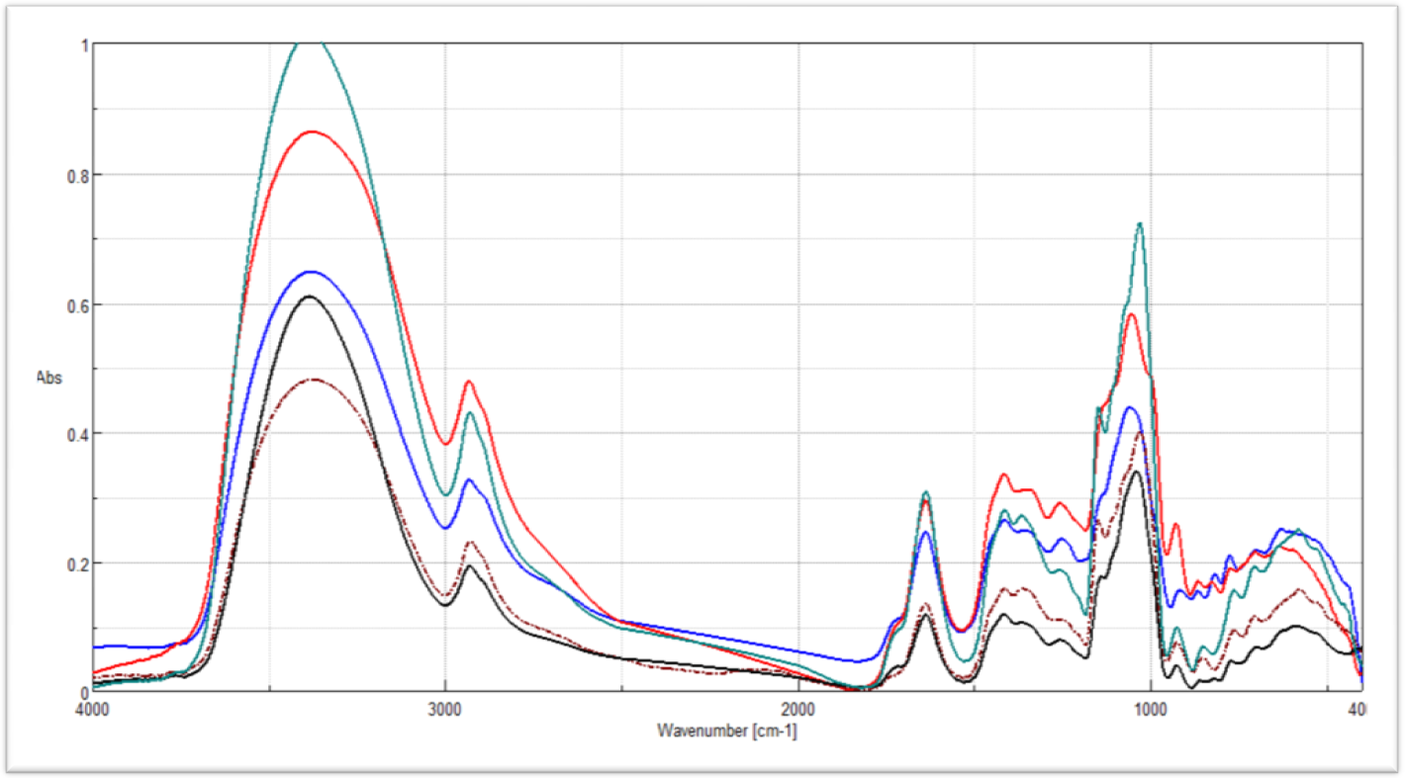
Synthetic strawberry jam (100% glucose)
Strawberry jam (50% sucrose + 50% glucose)
Strawberry jam (100% sucrose)

Synthetic strawberry jam (100% sucrose)

Strawberry jam (100% glucose)

Figure (1): FT-IR spectra (cm⁻¹) of natural, adulterated and synthetic strawberry Jam.
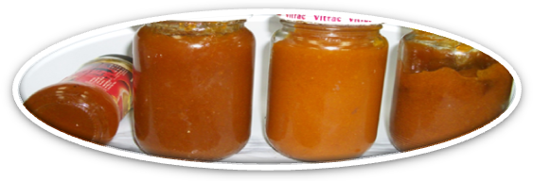
A = Synthetic B = Sucrose + Glucose (1:1) C = Glucose (100%) D = Sucrose (100%)
Photo (2): Apricot jam and its natural, adulterated and synthetic jam.

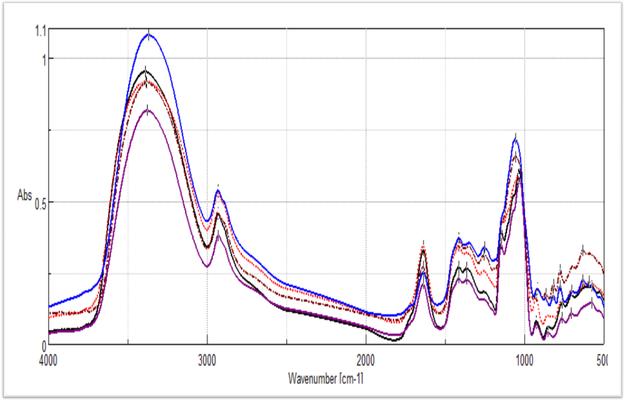
Synthetic apricot jam (100% glucose)
Apricot jam (100% sucrose)
Apricot jam (100% glucose)

Apricot jam (50% sucrose + 50% glucose)

Synthetic apricot jam (100% sucrose)

Figure (2): FT-IR spectra (cm⁻¹) of natural, adulterated and synthetic apricot Jam.

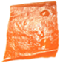  Carrot (100%) | 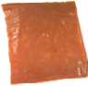  Apricot (50%) + Carrot (50%) | 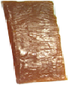  Apricot (100%)
Photo (3): Apricot sheet (100% Apricot) and its adulterated sheets with 50% or 100% carrot.

Table (5): Hunter color parameter of apricot sheet (100% apricot) and its adulterated sheet with 50% or 100% carrot.
Sample | L* | a* | b*
Apricot 100% | 23.82^{c} ± 0.4 | 13.23^{c} ± 0.37 | 11.18^{b} ± 0.33
Apricot: carrot (1:1) | 33.05ª ± 0.37 | 18.45ª ± 0.6 | 14.76ª ± 0.32
Carrot 100% | 30.5^{b} ± 0.9 | 14.67^{b} ± 0.58 | 14.23ª ± 0.25
L S D | 1.213 | 0.685 | 0.598

Table (4): FT-IR spectra (cm⁻¹) of apricot fruits and their natural and synthetic jams.
Assignment | Apricot Fruit | Natural Apricot Jam (citric + pectin) |  |  | Synthetic Apricot Jam  (citric + pectin + flavor + sunset pigment)
Assignment | Apricot Fruit | Sucrose (100%) | Sucrose : Glucose (1:1) | Glucose (100%) | Sucrose (100%) | Glucose (100%)
Stretching (OH) | 3371 | 3385 | 3382 | 3391 | 3371 | 3385
Stretching (CH) asymmetric | 2930 | 2930 | 2933 | 2930 | 2928 | 2931
Stretching (C=O) | 1718 | - - - - - | - - - - - | - - - - - | - - - - - | - - - - -
Stretching (H-C=CH) of β-carotene and sunset yellow | 1650 | 1639 | 1639 | 1630 | 1639 | 1638
Deformation (CH) | 1455 | - - - - - | - - - - - | - - - - - | - - - - - | - - - - -
Deformation (OCH, COH, CCH) of fructose | 1381 | 1415 | 1416 | 1414
Citric acid band | 1288 | 1364 | 1347 | 1365 | 1362 | - - - - -
Citric acid band | 1232 | 1257 | 1257 | 1258 | 1258 | 1261
Stretching (C-O) of pectin | 1136 | 1139 | - - - - - | 1147 | 1147 | - - - - -
Stretching (CO, CC and CCO) of sucrose | 1045 | 1058 | 1053 | - - - - - | 1052 | - - - - -
Vibrational (CO, CCC and vibrational asymmetric of pyranose ring) of glucose | - - - - - | 1040 | 1029 | 1030 | - - - - - | 1035
Rocking (CH3) of pectin | 926 | 925 | 927 | 926 | 926 | 927
Deformation (CH) of fructose | 837 | 820 | 825 | 827 | - - - - - | - - - - -
Sunset yellow pigment | - - - - - | - - - - - | - - - - - | - - - - - | 762 | 770

Visible spectroscopy was used to evaluate the spectra in apricot sheet (100% apricot) and its adulterated sheets (apricot + carrot 1:1 and 100% carrot). Spectra of β-carotene pigment showed two neighboring spectral bands at 450 and 475 nm. Natural apricot sheet (100% apricot) showed the same bands as found in standard β –carotene. The adulterated sheets of apricot plus carrot (1:1) and 100% carrot showed spectral band at (425, 450 and 475 nm); and a single broad band at 475 nm, respectively as illustrated in Figure (3).
The obtained results of Hunter color parameter and spectrophotometer show the need to develop other technique to detect and confirm the adulteration of apricot sheet. So, FT-IR was used to detect the variation between apricot sheet and its adulterated sheets of carrots.
Data reported in Table (6) and Fig (4) showed that, 100%carrot sheet was identified with specific peak at 1089 cm⁻¹, while 100% apricot sheet was characterized by a specific peak at 576 cm⁻¹, and 1374 cm⁻¹ was appeared in the adulterated sheet (50% carrot). The spectra of all samples were characterized with the following assignment, 3424-3428 cm⁻¹ (OH stretching), 2925 cm⁻¹ (CH stretching asymmetric and symmetric at 2858-2857cm⁻¹), 1743-1745cm⁻¹ (stretching C=O ester) of pectin, 1640-1647cm⁻¹ (vibrational CO bond), 1457-1449 cm⁻¹ (stretching CH), 1155-1162 cm⁻¹ (C-C stretching), 1042-1025 cm⁻¹ (vibrational CO of sucrose) and 707-721 cm⁻¹ (β-carotene), respectively. These assignments are in agreement with Bureau et al. (2009). Also, Figure (4) showed that, the peaks' intensities of carrot-adulterated sheet of apricot were the highest among 100% carrot and 50% carrot at the same concentrations.

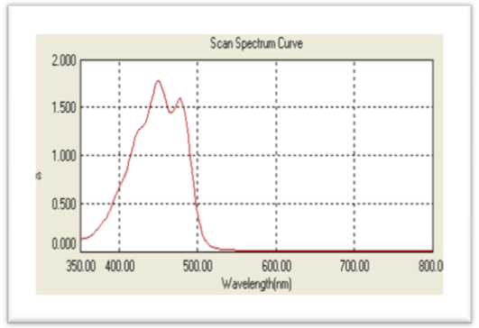  Standard β-carotene | 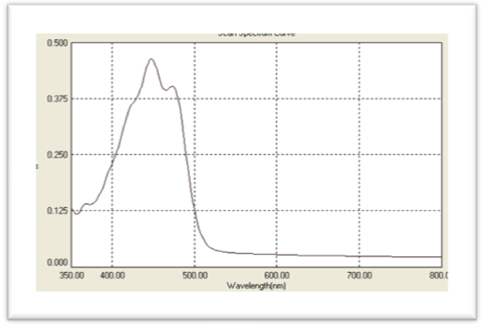  Apricot sheet (100% apricot)
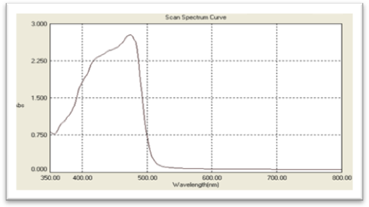  Adulterated sheet (100% carrot) | 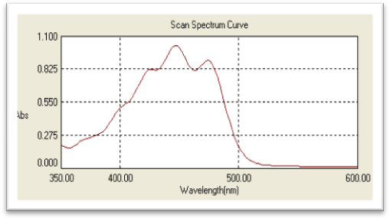  Adulterated sheet (apricot + carrot 1:1)

Figure (3): Reflectance of apricot sheet (100% apricot) and their adulterated sheets with 50% or 100% carrot.

Table (6): FT-IR assignment of apricot sheet (100% apricot), and its adulterated sheets (apricot + carrot 1:1 & 100% carrot).
Assignment | Apricot Sheet | Adulterated Apricot Sheet
Assignment | Apricot (100 %) | Carrot + Apricot (1:1) | Carrot (100 %)
Stretching O-H | 3425 | 3428 | 3424
Stretching C-H asymmetrical | 2925 | 2925 | 2925
Stretching C-H symmetrical of CH₃ | 2858 | 2857 | 2857
Stretching C=O ester of pectin | 1739 | 1745 | 1743
Stretching (H-C=CH) | 1647 | 1647 | 1640
Stretching CH | 1449 | 1457 | 1457
Stretching C-O-C ring | - - - | 1374 | - - -
Stretching C-H asymmetrical | 1155 | 1162 | 1155
C-C stretching of carbohydrates | - - - | - - - | 1089
Vibrational CO of sucrose | 1025 | 1030 | 1042
β-carotene | 707 | 721 | 711

Natural and synthetic strawberry, orange and apple juices were prepared at laboratory scale as shown in Photo (4). Table (7) showed that, natural strawberry juice characterized with its higher viscosity (101 cp) and lower TSS than synthetic juice, so that TSS does not reflected the authenticity of the strawberry juice.
Also, physical quality of natural orange, apple and strawberry juices were determined and compared with synthetic juices. Table (7) showed that, natural orange and apple juices was slightly affected with replacing fruits with synthetic flavor and color, where viscosity of natural and synthetic orange juice were 43.8 and 50.6 cp, respectively; also natural and synthetic apple juice were 18.6 and 18.5 cp, respectively. The same trend was observed in TSS and pH. This slight variation in physical properties indicated that we need another fast and easy method to identify the authenticity of orange and apple juices.
Color quality of natural and synthetic strawberry, orange and apple juices were evaluated separately. Table (8) showed that, all natural juices were characterized with its higher color parameter of lightness (L*), redness (a*) and yellowness (b*) than synthetic juices. This result could depend on juice dilution, type and concentration of synthetic pigment. So, the possibility of using FT-IR as a fast and easy technique to detect authenticity of some fruit juices was examined.

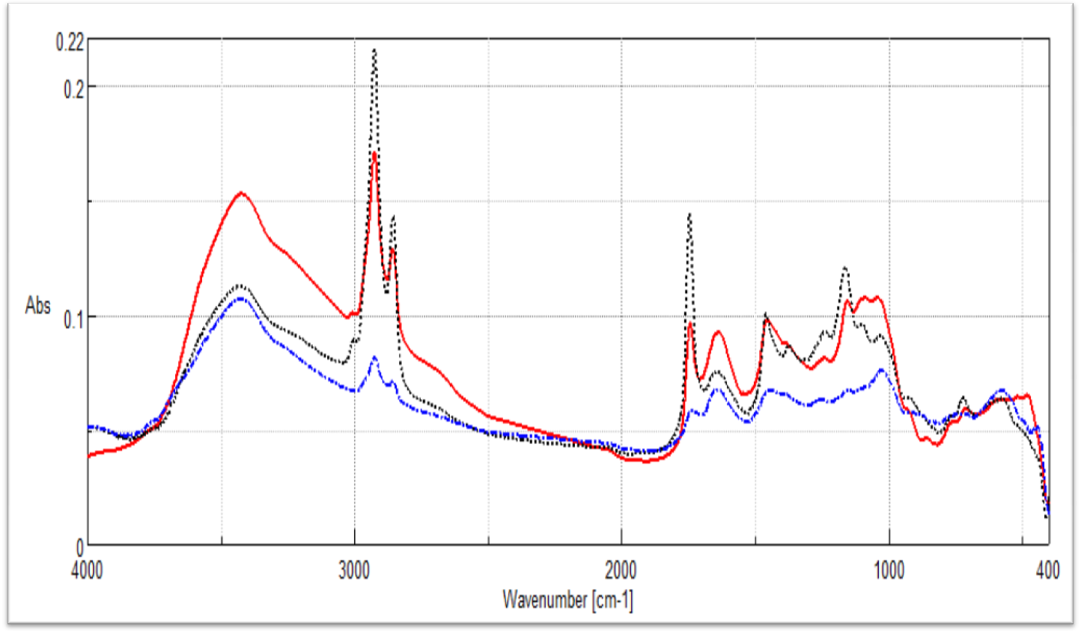

Adulterated sheet
(100% carrot)
Adulterated sheet (apricot + carrot)

Apricot sheet (100% apricot)

Figure (4): FT-IR spectra (cm⁻¹) of apricot sheet (100% apricot) and their adulterated sheets with 50% or 100% carrot.

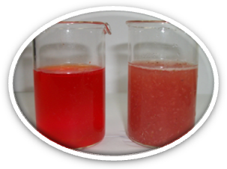  Synthetic Natural  Strawberry Juice | 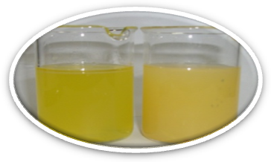  Synthetic Natural  Orange Juice | 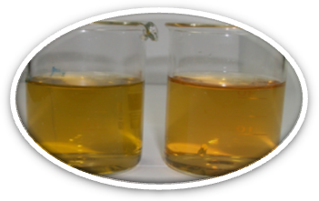  Synthetic Natural  Apple Juice
Photo (4): Natural and synthetic strawberry, orange and apple Juices.

Table (7). Physical properties of natural and synthetic strawberry, orange and apple juices.
Physical Parameter | Strawberry juice |  | Orange Juice |  | Apple Juice
Physical Parameter | Natural | Synthetic | Natural | Synthetic | Natural | Synthetic
pH | 3.67±0.17 | 2.13±0.01 | 3.47 ± 0.34 | 2.14 ± 0.01 | 3.63 ± 0.02 | 2.14 ± 0.06
TSS (Brix) | 12.1±0.05 | 15.87±0.29 | 13.55±1.22 | 17.87 ± 0.64 | 9.56 ± 0.19 | 13.6 ± 0.06
Viscosity (cp) | 101.00±1.00 | 20.07±0.81 | 43.8 ± 0.5 | 50.6 ± 0.3 | 18.6 ± 0.4 | 18.5 ± 0.1

Table (8): Hunter color parameters of natural and synthetic strawberry, orange and apple juices.
Sample | L* | a* | b*
Natural strawberry juice | 29.85ª ± 0.72 | 30.25ª ± 1.03 | 12.7^{b} ± 0.44
Synthetic strawberry juice | 9.31e ± 0.35 | 13.19e ± 0.38 | 4.8^{f} ± 0.21
Natural Orange Juice | 52.91ª ± 1.156 | 4.76^{c} ± 0.0404 | 45.72^{b} ± 1.91
Synthetic orange juice | 6.84e ± 0.0902 | 0.383^{d} ± 0.005 | 4.00e ± 0.623
Nature apple juice | 20.60ª ± 0.49 | 3.24ª ± 0.072 | 8.26ª ± 0.062
Synthetic apple juice | 6.03^{b} ± 0.252 | 0.56^{b} ± 0.0199 | 2.35^{b} ± 0.0551

Natural strawberry, apple and orange juices were evaluated by FT-IR spectral data as shown in Table (9). Stretching (OH), (CH) asymmetric, deformation (OH), deformation of (CH) functional groups in natural orange, apple and strawberry juices were identified in the region from 3441-1415 cm⁻¹. While, stretching (CO), (CC) and (CCO) of sugar and stretching C-OH ring were located at 1045-1058 cm⁻¹ and 924-930 cm⁻¹, respectively. These assignments are in agreement with Irudayaraj and Tewari (2003).

Table (9): Assignments of natural orange, apple and strawberry juices.
Assignments | Orange | Apple | Strawberry
Stretching (OH) | 3441 | 3421 | 3430
Stretching (CH) asymmetric | 2930 | 2938 | 2931
Deformation (OH) | 1632 | 1638 | 1622
Deformation (CH) of fructose | 1426 | 1424 | 1415
Stretching (CO, CC & CCO) of sugar | 1053 | 1058 | 1045
Rocking CH₃ of pectin | 930 | 924 | 927

FT- IR spectra of synthetic strawberry, orange and apple juices were dominated by specific peaks that were attributed to synthetic pigment at 1637 - 1644 cm⁻¹, 1419 - 1421 cm⁻¹ and 1053 - 1056 cm⁻¹ (Table 10). From the FT-IR results of natural and synthetic juices, we can conclude that, the synthetic juices can be characterized with specific bands of stretching C=O ester of aldehydic and ketonic groups in synthetic flavor which used in the manufacturing process of synthetic juices at 1726-1731 cm⁻¹ and stretching CO of sucrose at 996-963 cm⁻¹, while these functional groups disappeared in natural juices (Ramasami et al., 2004).

Table (10): Assignment of synthetic strawberry, orange and apple juice.
Assignment | Orange juice | Apple juice | Strawberry juice
Stretching O-H | 3378 | 3395 | 3401
Stretching C-H asymmetrical | 2932 | 2932 | 2932
Deformation OH | 1644 | 1644 | 1637
Stretching C=O ester | 1731 | 1726 | 1730
Stretching (COO⁻¹) of pectin | 1419 | 1421 | 1419
Vibrational CH3 deformation | - - - | - - - | 1384
Citric acid bands | 1248 | 1257 | 1262
Stretching C-O-C of glycosidic ring | 1133 | 1134 | 1139
Stretching CO of sucrose | 1055 | 1056 | 1053
Stretching CO ester of synthetic flavor | 997 | 996 | 663
Stretching C-OH | 929 | 928 | 926
Vibrational CH | 863 | 863 | 834
CH₂ group deformation | 593 | 594 | 605

In conclusion, the results of this work recommend FT-IR spectroscopy as a potential analytical rapid, economic and nondestructive tool to determine the quality attributes and to detect any adulterants, added in food industries, of some food products as jams and juices.

Acknowledgment
The present research is a part of project financed by the Science and Technology Development Fund (STDF), Egypt, Grant No 1062.

Corresponding author
Mohie M. Kamil, Food Science and Technology Department, National Research Center, Dokki, Cairo, Egypt. ResearchTeamMMK@yahoo.com
References:
AOAC (1990). Official Methods of Analysis of the Association of Official Analytical Chemists, 15th ed. Association of Official Analytical Chemists, Arlington, Virginia, USA.
Bellon-Maurel, V., Vallat, C., & Goffinet, D. (1995). Quantitative analysis of individual sugars during starch hydrolysis by FT-IR/ATR spectrometry. 1. Multivariate calibration study-repeatability and reproducibility. Applied Spectroscopy, 49, 556–562.
Beullens, K., Kirsanov, D., Irudayaraj, J., Rudnitskaya, A., Legin, A. and Nicolaï, B. (2006). The electronic tongue and ATR-FTIR for rapid detection of sugars and acids in tomatoes. Sensors and Actuators B, 116, 107–115.
Bureau S, Ruiz D, Reich M, Gouble B, Bertrand D, Audergon J, Renard C. (2009). Application of ATR-FTIR for a rapid and simultaneous determination of sugars and organic acids in apricot fruit. Food Chem 115(3):1133-40.
Chiavaro, E., Vittadini, E., Rodriguez-Estrada, M. T., Cerretani, L., Capelli, L., & Bendini, A. (2009). Differential scanning calorimetry detection of high oleic sunflower oil as an adulterant in extra-virgin olive oil. Journal of Food Lipids, 16, 227–244.
Christy, A. A., Kasemsumran, S., Du, Y. P., & Ozaki, Y. (2004). The detection and quantification of adulteration in olive oil by near-infrared spectroscopy and chemometrics. Analytical Sciences, 20, 935–940.
Coimbra, M.A., Barros, A., Rutledge, D.N., Delagadillo (1999). I. FT-IR spectroscopy as a tool for the analysis of olive pulp cell-wall polysaccharide extracts, Carbohydr. Res., 317, 145-154.
Defernez, M., Kemsley, E. K., & Wilson, R. H. (1995). The use of infrared spectroscopy and chemometrics for the authentication of fruit puree. Journal of Agriculture and Food Chemistry, 43, 109–113.
Duarte, I. F., Barros, A., Delgadillo, I., Almeida, C., & Gil, A. M. (2002). Application of FTIR spectroscopy for the quantification of sugars in mango juice as a function of ripening. Journal of Agriculture and Food Chemistry, 50, 3104–3111.
Fernandez, K., & Agosin, E. (2007). Quantitative analysis of red wine tannins using Fourier-Transform Mid-Infrared spectrometry. Journal of Agriculture and Food Chemistry, 55, 7294–7300.
Flores, G., Ruiz Del Castillo, M. L., Herraiz, M., & Blanch, G. P. (2006). Study of the adulteration of olive oil with hazelnut oil by on-line coupled high performance liquid chromatographic and gas chromatographic analysis of filbertone. Food Chemistry, 97, 742–749.
Flores, G., Ruiz Del Castillo, M. L., Blanch, G. P., & Herraiz, M. (2007). Detection of the adulteration of olive oils by solid phase microextraction and multidimensional gas chromatography. Food Chemistry, 97, 336–342.
Gallardo-Velazquez, T., Osorio-Revilla, G., Zuoiga-de Loa, M., & Rivera-Espinoza, Y. (2009). Application of FTIR–HATR spectroscopy and multivariate analysis to the quantification of adulterants in Mexican honeys. Food Research International, 42: 313–318.
Guillot S., Peytavi L., Bureau S., Boulanger R., Lepoutre J.P., Crouzet J., Schorr-Galindo S (2006). Aroma characterization of various apricot varieties using headspacesolid phase microextraction combined with gas chromatography mass spectrometry and gas chromatography-olfactometry. Food Chemistry, 96, 147–155.
Gurdeniz, G., Tokatli, F., & Ozen, B. (2007). Differentiation of mixtures of monovarietal olive oils by mid-infrared spectroscopy and chemometrics. European Journal of Lipid Science and Technology, 109, 1194–1202.
Heise, H. M., Damm, U., Lampen, P., Davies, A. N., & Mcintyre, P. S. (2005). Spectral variable selection for partial least squares calibration applied to authentication and quantification of extra virgin olive oils using Fourier transform Raman spectroscopy. Applied Spectroscopy, 59, 1286–1294.
Irudayaraj, J. and Tewari, J. (2003). Simultaneous Monitoring of Organic Acids and Sugars in Fresh and Processed Apple Juice by Fourier Transform Infrared–Attenuated Total Reflection Spectroscopy Appl. Spectrosc. 57, 1599-1604.
Kemsley,E. K., Holland, J. K., Defernez, M., and R. H. Wilson. Detection of Adulteration of Raspberry Purees Using Infrared Spectroscopy and Chemometrics, J. Agric. Food Chem., 1996, 44 (12), pp 3864–3870.
Lai, Y. W., Kemsley, E. K., & Wilson, R. H. (1994). Potential of Fourier transform infrared spectroscopy for the authentication of vegetable oils. Journal of Agricultural and Food Chemistry, 42, 1154–1159.
Jafari, M., Kadivar, M., & Keramat, J. (2009). Detection of adulteration in Iranian olive oils using instrumental (GC, NMR, DSC) methods. Journal of the American Oil Chemists’ Society, 86, 103–110.
Lerma-Garcia, M. J., Ramis-Ramos, G., Herrero-Martinez, J. M., & Simo-Alfonso, E. F. (2010). Authentication of extra virgin olive oils by Fourier transform infrared spectroscopy. Food Chemistry, 118, 78–83.
Manthey, J. A. (2006). Fourier transform infrared spectroscopic analysis of the polymethoxylated flavone content of orange oil residues. Journal of Agriculture and Food Chemistry, 54, 3215–3218.
McClave J.T. and Benson P.G. (1991). Statistics for Business and Economics. Max Well Macmillian International Editions. Dellen Publishing Co. USA., pp. 272-295.
Poulli, K. I., Mousdis, G. A., & Georgiou, C. A. (2007). Rapid synchronous fluorescence method for virgin olive oil adulteration assessment. Food Chemistry, 105, 369–375.
Ramasami, P., Jhaumeer-Laulloo, S., Rondeau, P., Cadet, F., Seepujak, H., & Seeruttun, A. (2004). Quantification of sugars in soft drinks and fruit juices by density, refractometry, infrared spectroscopy and statistical methods. South African Journal of Chemistry, 57, 24–27.
Vaclavik, L., Cajka, T., Hrbek, V., & Hajslova, J. (2009). Ambient mass spectrometry employing direct analysis in real time (DART) ion source for olive oil quality and authenticity assessment. Analytica Chimica Acta, 645, 56–63.
Veraverbeke, E. A., Lammertyn, J., Nicolaï, B. M., & Irudayaraj, J. (2005). Spectroscopic evaluation of the surface quality of apple. Journal of Agriculture and Food Chemistry, 53, 1046–1051
Yang, H., & Irudayaraj, J. (2002). Rapid determination of vitamin C by NIR, MIR and FT-Raman techniques. Journal of Pharmacy and Pharmacology, 54, 1247–1255.

10/10/2011

