FISHERIES, WILDLIFE AND VEGETATION OF AJIDO TOWN, BADAGRY, LAGOS.

*Akinnigbagbe Oluwatoyin Ruth¹, Akinnigbagbe Akintoye Edward¹, Aroriode Ojiyovwi Rebecca (Dr) ¹, Jegede Olusolape Margaret²

¹Nigerian Institute for Oceanography and Marine Research (NIOMR), Lagos, Nigeria.
² Rufus Giwa Polytechnic, Owo, Ondo State, Nigeria. toyinorims@yahoo.com

ABSTRACT: Fish species, wildlife and vegetation around Ajido town of Badagry, Nigeria were studied. The fish species caught during the period of investigation were properly identified and likewise the wildlife through visual survey, most especially the birds while, the rest that could not be monitored during period of visit were recorded using the analysis from questionnaire issued. The vegetation of this environment was also identified. Fisher folks and peoples’ record from the questionnaire, reported that most of the wild animals in their forest are no more because most of them have been hunted for. Therefore the rest of the animals moved for safety except the aquatic wetland birds that closely associated with water bodies due to their feeding, breeding, roosting behavior and other activities associated with the aquatic environment. The common species of the wetland birds found are herons, waterfowl, fish eagle and darters, the majority of which are piscivorous. The lagoon serves probably as a feeding ground for the juveniles of some fish species and it is reasonable to assume that the presence of suitable food also influence the occurrence and distribution of these species. The presence of Ethmalosa fimbriata that moves in school during the period of study in Badagry lagoon shows that they are more abundant during the rainy season which was the period of visit to the site. This study identified the various types of fishing gears used among the fisher folks in Ajido town; it described why they are used and how they are used among the fisher folks. The most preferred gear among the fisher folks in Ajido town, Badagry during the period of study is the nylon monofilament cast net with the mesh sizes ranges between 15 and 100mm, used by both boys, men and even the women because it does not have weight and can easily be handled by everyone. The natural vegetation of Ajido observed during the period of investigation that there are different species of mangrove vegetation typically around the wetland of the backshore areas of Ajido; this is characterized by an entangled dense growth of stems and aerial roots behind the stretch of palms. Close to the shore line, it was observed from the colouration of the leaves that some of these plants are affected by oil pollution due to the oil company that has pipe lines across the area.
[Akinnigbagbe Oluwatoyin Ruth, Akinnigbagbe Akintoye Edward, Aroriode Ojiyovwi Rebecca (Dr), Jegede Olusolape Margaret, Fisheries, Wildlife and Vegetation of Ajido town, Badagry, Lagos. Nature and Science 2011; 9(11):61-69]. (ISSN: 1545-0740). http://www.sciencepub.net.

Keywords: Fisher folks, wildlife, Vegetation, Species,Badagry, Lagoon

INTRODUCTION
Coastal environments are strongly influenced by upstream sources of pollution and freshwater inflow and are subject to an ever-growing coastal population. Sometimes, coastlines are intersected by an intricate network of creeks and rivers. Lagos State, the commercial hub of Nigeria is justifiably taunted as one of aquatic splendor, owing to her endowment with lagoons, creeks, deltaic distributaries, floodplains and mangrove swamps of which Badagry creek is a notable one. The Badagry creek runs across two national boundaries. It directly connects with Nigeria’s 960 km of coastline bordering the Atlantic Ocean in the Gulf of Guinea, a maritime area of 46,500 km² with depth of up to 50 m and an Exclusive Economic Zone of 210,900 km² (World Resources, 1990).
Wildlife is important to the economy both as a source of meat protein and as a basis for tourism and recreation. Although tourism and recreational interests have not attracted the desired awareness in terms of participation by the Nigerian populace, bush meat is a recognized trade at rural and urban centers. Wild animal meat is the main source of cheap protein for the majority of rural communities in Nigeria. Over eighty percent of the populations are rural dwellers who depend on bush meat, compared with urban dwellers that depend on abattoir supplies of cow and other ruminant meat. One can therefore appreciate the significant contribution of bush meat to the national economy and in reducing the protein deficiency of rural dwellers. Among fishing communities located along riverine and coastal areas, fish and non-fish aquatic vertebrates such as crocodiles, terrapins, hippopotamus and manatee are the main source of bush meat. These animals are also hunted for other products such as their skins for leather, their cartilaginous parts, feaces, skin and hoofs as aphrodisiacs and for traditional medicine.
The importance of fisheries cannot be over emphasized in that it is a good source of protein for the consumers which can also be gotten with a little effort most especially by the fisherfolks. Both wildlife and fisheries create a source of employment to the fisherfolks, hunters both male and the female most especially the youths in these environments.
Fishing gears are constructed, used, and amended by the fisherfolks examples of these fishing gears include the monofilament gillnet, multifilament fish gillnet, fishing traps, cast nets, trawl nets and many others which indicate that they are also employer of labour to the youths in the community and prevents them from being a nuisance around.
Wetland land vegetation is covered by viable plants, shrubs and crops which are very useful to humans. Examples of these are the palm tree, coconut tree, mango tree vegetables and so on out of which we get the palm oil, broom, palm carnel oil, fruits and vegetables that nourishes the body and provide some useful items that are used domestically. This wetland ecosystem structure (that is, the tangible items) yields benefits, which are of direct use value to humans.

MATERIALS AND METHODS
DESCRIPTION OF STUDY AREA
The Badagry Lagoon (Fig. 1), which is approximately 60 km long and 3 km wide, lies between longitudes 3°0′ and 3°45′ E and between latitudes 6°25′ and 6°30′ N. It is part of a continuous system of lagoons and creeks along the coast of Nigeria from the border with the Republic of Benin to the Niger delta. Its water depth ranges from 1 m to 3 m. The lagoon experiences two broad seasons: the dry season (December - May) and the wet season (June - November). Most of the year it is characterized by fresh and slightly brackish water. The lagoon is approximately equidistant from the entrances of Lagos and Cotonou harbours. As a result, it is influenced by tides and floods from the Lagos Lagoon and Cotonou harbour through Lake Nokue and Lake Porto-Novo (Anyanwu & Ezenwa, 1988). The Yewa River with its tributaries Isalu and Ijomo is the major river emptying into the lagoon. Creeks connected to the lagoon include Bawa and Doforo. Major weeds occurring in the lagoon yearly in December and January include the common water hyacinth Eichhornia crassipes and Cerotophyllum and Pistia sp. The lagoon is surrounded by large areas of swamps covered with vegetation among which the Raphia palm (Raphia sudanica), the African oil palm (Elaeis guineensis), and the coconut palm (Cocos nucifera) are dominant (FAO, 1969).

FIELD SURVEY
The approach used in studying the wildlife, fisheries and the vegetation of Afonriwo in Ajido was based on visual survey of the vegetation which was later proceeded to proper identification of the plants in the laboratory, visual survey of the wildlife was not perfect because most of the wildlife in this environment comes out only at night when human activities reduces to a minimal level in other to prevent themselves from being caught and more so because some possesses ‘’nautical sight’’ which can only be very active at night so it was accomplished by questionnaire method. Also boat was used as transportation means to the main station which helped to interview the fisher folks where they were fishing. A total of 20 fisher folks were interviewed to get accurate information about the study area.
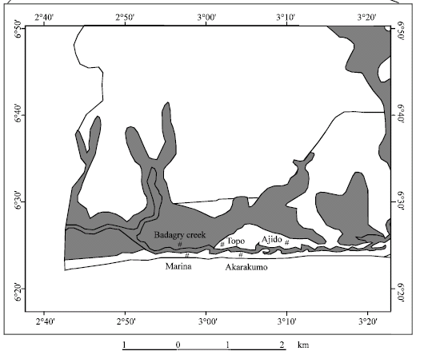

Figure 1: Map of Badagry showing the study area in red

WILDLIFE IN BADAGRY
Wetland wildlife are those vertebrate animals living, breeding and feeding in water, and those closely associated with water bodies due to their feeding, roosting behavior and other activities associated with the aquatic environment. It includes reptiles, amphibians, mammals, and birds they have a common feature of being good swimmers, adapted to aquatic life, piscivorous and/or feeding on organisms associated with water. The dentritus and nutrients from these wetlands form the food base of many marine and freshwater organisms of economic importance for example, the estuaries wetland form important spawning grounds for fish while both the estuaries and freshwater wetlands are important for wildlife.
The study site (Afonriwo, ASCON road) in Ajido town are covered by wild animals of which majority are wetland birds, about sixty-seven percent of the bird species of Nigeria are purely aquatic and they are sedentary, resident and indigenous to Nigeria. Amongst the aquatic birds are the common species of herons, waterfowl, fish eagle and darters, the majority of which are piscivorous (Fig. 2).
Frogs and toads are the most abundant amphibians found in the study area and these almost always associate with any available water, having a wider distribution during the rainy season and as one moves towards the coast the species diversity tends to increase. Some snakes feed on toads and frogs and are therefore also often associated with these habitats. These include the cobras, night and puff adder and water snakes. The diversity of snakes increases towards the forest zones. Fisherfolks in the study area reported that most of the wild animals in their forest are no more because most of them have been hunted for and therefore the rest of the animals moved for safety. Some years back wild animals like the monkey, squirrel, grasscutter and the rest were found by the hunters but recently they are no more except for the wetland birds.

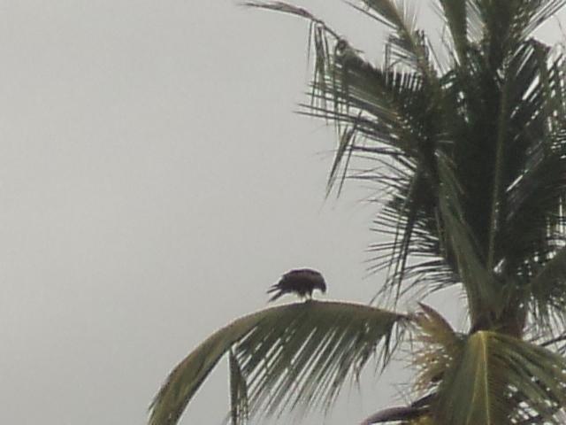
A

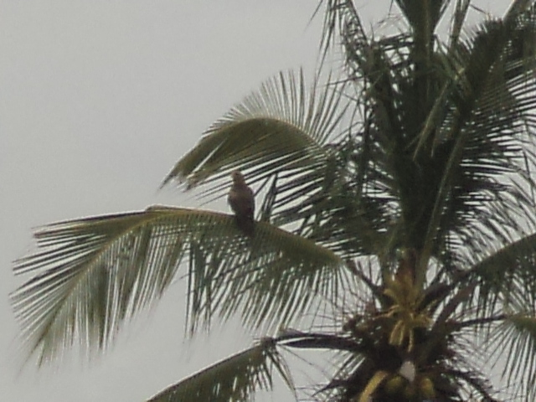
B

Figure 2A and B: Water eagle bird on one of the palms in Ajido town

The main reptiles that are reported to have been hunted for in the past decades by the hunters in the study area are the crocodiles and monitor lizards. In Nigeria, there are three crocodile species the Nile crocodile (Crocodilus niloticus), long snouted (C. cataphratus) and the West African Dwarf crocodile (Osteteolaemus tetrespis). The Nile crocodile is the commonest with a wide distribution in rivers, lakes, creeks and mangrove swamps. The long-snouted species has more of a riverine distribution throughout the West African Forest Rivers. The commonest lizard is the Nile monitor (Varanus niloticus). It is found in rivers with stony terrain. It often drops into water with a large splash from a basking point on top of stones and tree branches near water. Their distribution extends to the forest zones of the community. It has a broader head with fewer patterns on the skin and is hunted for its meat and leather. These have gone almost to the point of extinction in this area because of human activities.
The decline in aquatic fauna appears to be due to human population pressure and activities which include the efforts to increase crop hectarage, infrastructural developments such as dam construction, poaching and environmental pollution. While the biodiversity of aquatic fauna is not fully known their status is threatened due to habitat destruction, socio-cultural activities and lack of management of these animals for sustainable yields.
Of the total locally produced protein which includes beef from domestic animals, poultry, fish and bush meat from wild animals, bush meat contributes significantly to the national food budget of rural dwellers. The lack of information is also partly responsible for the non-recognition of this sector of the economy and the poor financial support being made for wildlife development in the annual national budget.

FISHERIES IN BADAGRY
Fishing is an act of catching fish, it is one of the oldest professions by which people feed themselves and their families and it is a year round activity.
The group of fishes that were found during the time of investigation was based on seasonal occurrence of the fish species. All the fish species were classified according to the season of their occurrence in the lagoon, they formed two broad groups (rainy and dry season). Besides there was a narrow group made up of a species occurring both in the rainy and the dry season. It was only the lesser African threadfin Galeoides decadactylus that represented this likely group.
Below comprises those fishes that occurred only in the rainy season when the salinity ranged from 1.4 to 2.0. These fishes were found during the rainy season from June to November. These include the following 20 species:
Ethmalosa fimbriata, Sardinella sp., Batanga lebretonis, Chloroscombrus latus, Clarotes laticeps, Bathygobious soporator, Chrysichthys auratus, Cynoglossus senegalensis, Brachydeuterus auritus, Chrysichthys, Drepane Africana, Caranx carangus nigrodigitatus, Eleotris vittata, Caranx sp., Chrysichthys walker, Elops lacerta, Chloroscombrus, Citharus linguatula, Clarias sp., Galeoides decadactylus.
The following species were reported by Fagade & Olaniyan (1974) as those found in the Lagos Lagoon when the water is brackish (salinity 0.5-28.0).

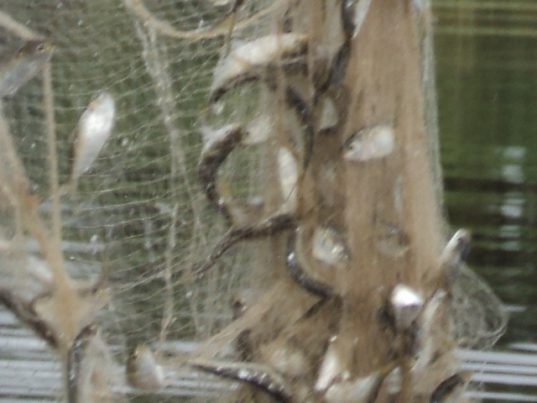
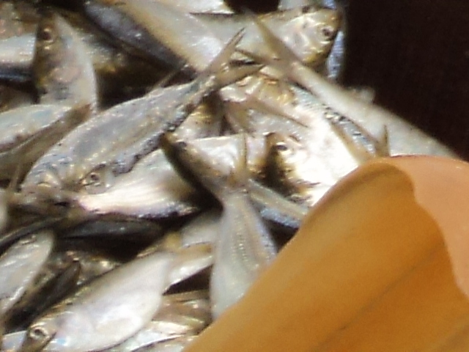
Figure 3A & B: Bonga shad fishes caught with cast net in Ajido lagoon

Caranx carangus, Chloroscombrus chrysurus, Drepane africana, and Galeoides decadactylus. Like other brackish-water species, only the immature stages occurred in the Badagry Lagoon. The sexually mature stages are found in the sea. The juvenile stages of many marine species are known to be able to live in water of reduced salinity (Fagade & Olaniyan, 1974). Some of the species found occurring throughout the year in the Lagos Lagoon by Fagade & Olaniyan (1974) were caught in the Badagry Lagoon at this low salinity. These species include Bathygobious soporator, Chrysichthys nigrodigitatus, Cynoglossus senegalensis, Elops lacerta, and Ethmalosa fimbriata, which were able to tolerate variations in salinity and other physical features. The big-eye grunt Brachydeuterus auritus, which is a marine species, was caught in the Badagry Lagoon in the wet season. Large specimens of the freshwater mud-catfish Clarias sp. were landed at the fish jetty during the wet months, which indicated that sexually mature species occurred in this lagoon.
The presence of large specimens of some fishes such as Ethmalosa fimbriata, Sardinella sp., Sphyraena barracuda, etc. indicated that some of the fishes are permanent residents in the Badagry Lagoon and some complete their life cycle in the lagoon. The lagoon serves probably as a feeding ground for the juveniles of those species and it is reasonable to assume that the presence of suitable food also influences the occurrence and distribution of all species. The presence of Ethmalosa fimbriata that moves in school during the period of study in Badagry lagoon shows that they are more abundant during the rainy season.

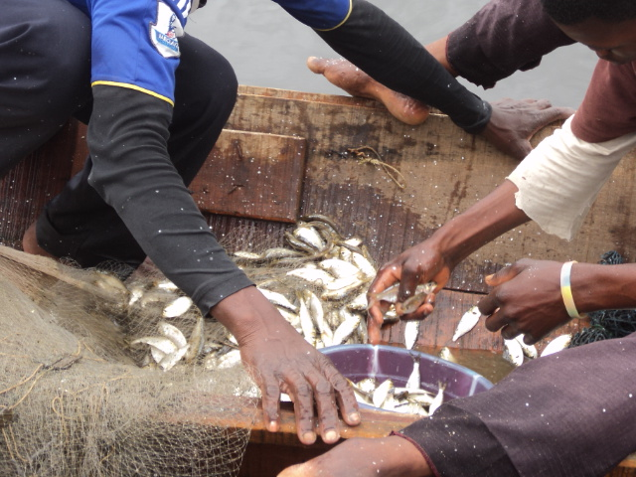

Fig 4: Abundance of Ethmalosa fimbriata species caught by the fishermen during the rainy season in Ajido town.

FISHING METHODS AND GEARS IN
AJIDO, BADAGRY LAGOON BRUSH
PARK (ACADJA)
The act of fishing involves the use of different fishing gears which include the trawl net, cast net, lift net and traps among others. Acadja is the fishing method used in Ajido town, the term “acadja” describes a family of installation of the fish parks type that is currently found in several of the West African coastal lagoons (Welcomme, 1972).These are made of various materials, such as weeds, palm fronds, tree branches as well as canes and are staked in rivers, estuaries, creeks or lagoons. The fences provide shelters for fish and this facilitate their congregation and capture, especially when they are left undisturbed for between 1-3 months. Fish are attracted to these objects for the shade, shelter, food and breeding grounds they provide (Solarin, 1998, Suresh, 2000; Emmanuel and Kusemiju, 2005).They are variously called Awa in Yoruba, Baban Chamba in Hausa and Acadja in Lagos. Across river fish fences (traps) are used in Lagos lagoon (Lagos State) especially in the dry season (February – May) when the currents are not very strong. The principle is to construct a fence across the river, leaving a small wide space (3-6 meters) to allow canoes to pass through. The fish are guided into various big chambers where they are periodically scooped out or collected with traps (Fig. 5). In some cases, large traps (3.2 m long and 1.13 m diameter in the entrance) are employed for harvesting. Oil lamps and kerosene lanterns are also hung close to the chamber for showing the location of the fences and also to assist in attracting fish at night. Net is used to cover the entire space and prevent the fishes from escaping in case of total harvesting. Acadja is used among the fisherfolks most especially the youths in Ajido town, it was reported to be very effective and catches all manner of fish species that swim across the barrier without allowing them to escape until they are being captured by the fishing traps.

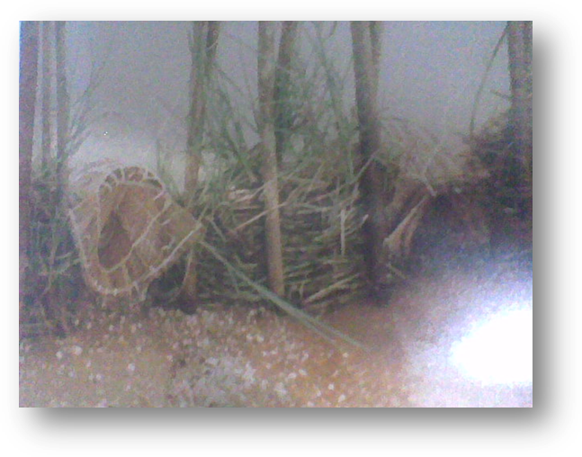
Figure 5: Fish traps set in the shallow lagoon and exposed at low tide in Ajido lagoon.

CASTNET
Castnets have been used for thousands of years and are used throughout the year among the fisherfolks of Ajido town. Fisherfolks reported that the castnet can be used by both boys, men and even the women among them because it does not have weight and can easily be handled by everyone. The catches of the castnet include Ethmalosa fimbriata, Sardinella sp., Pomadasys jubelini, Mugil sp., Caranx caranx and Selene dorsalis but the most available specie caught with the cast net during the time of study in Ajido town is the Ethmalosa fimbriata and this is because it is pelagic specie and the most abundant specie during the rainy season in their lagoon.
Castnets are conical falling nets with lead weight attached at regular intervals along the perimeter of the cone. The netting material can be nylon monofilament or multifilament with R 75-150tex twine thickness and mesh sizes varying between 12 and 100mm (Fig. 7). The most used among the fisherfolks in Ajido is the nylon monofilament with the mesh sizes ranges between 15 and 100mm. For each net used in Badagry lagoon, the height of the cone stretches between 4 to 7 meters.
In Ajido town, the cast net is used mostly by two or more fisherfolks on a boat (Fig. 6), the net is thrown on sighting a shoal of fish in such a way that it open unfolds to cover the greatest possible area of the water surface. Also the net is allowed to sink to the bottom of the water, trapping some of the fish species. The net is left in that position for a few minutes before it is gently but skillfully drawn towards the thrower by use of retrieving line into the boat (Fig. 8).
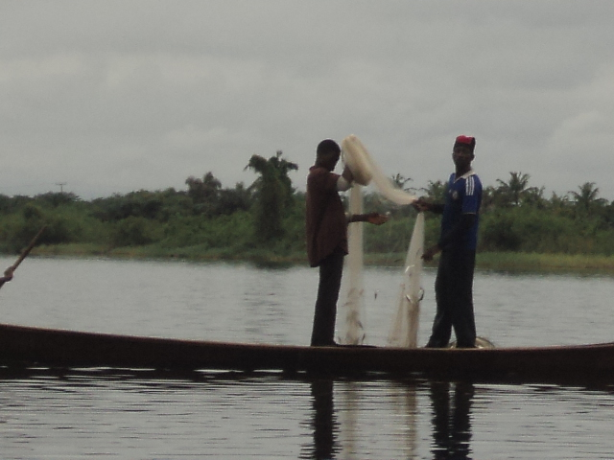

Figure 6: Cast net used by two fishermen
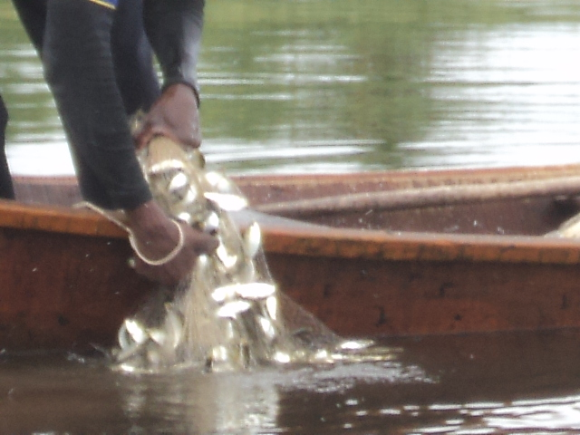

Figure7: Picture showing the mesh sizes of the cast net used in Ajido lagoon in Ajido lagoon.
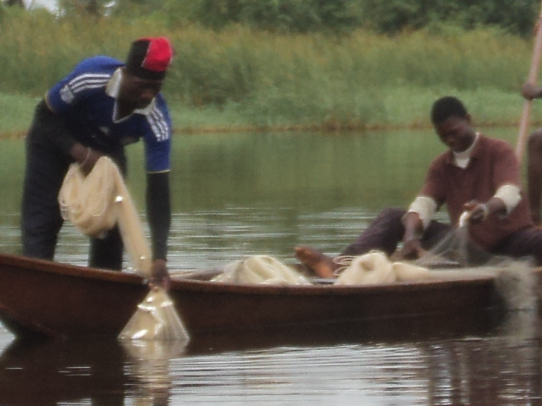

Figure 8: How the cast net is gently but skillfully

VEGETATION IN AJIDO, BADAGRY
Vegetation can simply be defined as the plant cover of the earth consisting of assemblages of plants. Together with physiography, it constitutes the most observable element of the landscape. Vegetation expresses and reflects environmental conditions, particularly climate. Nigeria has two broad belts of vegetation types these include the forest and savannah types. There is also the mountain vegetation of the isolated high plateau regions in the central and far eastern parts of the country.
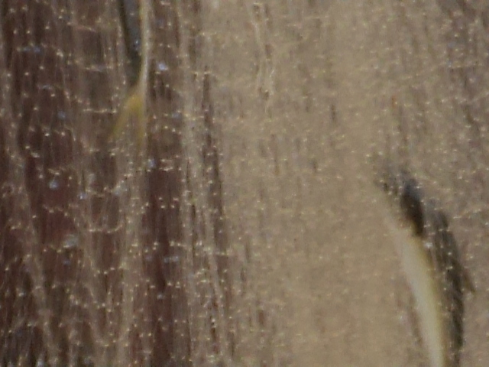

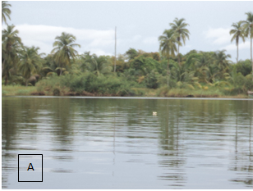

Figure 9: Fishermen trying to drawn towards the thrower by the fisherman retrieve the catches from the cast in Ajido lagoon net into the fishing boat
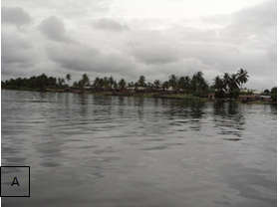

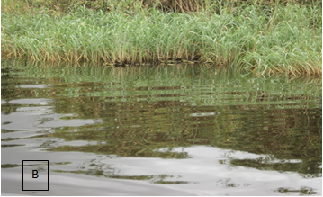

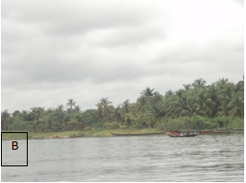
Figure 10A & B: The backshore areas of Ajido town covered by mangrove vegetation with dense growth of stems and aerial roots around the palms

However Ajido forests in Badagry has vegetation types or plant formations in which trees are the dominant species. Though it was observed during the period of investigation that there are different species of mangrove vegetation typically around the wetland of the backshore areas of Ajido, this is characterized by an entangled dense growth of stems and aerial roots behind the stretch of palms (Fig. 10A & B). The natural vegetation has changed due to human activities and habitations in parts of the area. Very close to the shore line, it was observed that some of the plants are affected which is clearly visible by the colouration of their leaves. Further investigation reveals the likely cause which is oil pollution that can easily be traced to the activities of the oil company that has their pipe lines across the area and few meters into the shore, the presence of oil film was noticed on the water (Fig. 11A & B).

Figure 11A & B: Presence of oil films and affected plants by oil pollution due to the activities of Oil Company close to the shore

DISCUSSION
The study area comprises the wetland ecosystem structures which include the plants, shrubs and crops which are very useful to humans. Examples of these are the palm tree, coconut tree, mango tree vegetables and so on out of which we get the palm oil, broom, palm canel oil, fruits and vegetables. These tangible items yield benefits, which are of direct use value to humans. The U.S. Fish and Wildlife Service defines wetlands as lands that are transitional between terrestrial and aquatic systems where the water table is usually at or near the surface or the land is covered by shallow water, and that have one or more of the following attributes: (1) At least periodically, the land supports predominantly hydrophytes; (2) the substrate is predominantly undrained hydric soil; and (3) the substrate is non-soil and is saturated with water or covered by shallow water at some time during the growing season of each year (Cowardin et al., 1979).
This study showed that both wildlife and fisheries create a source of employment to the fisher folks, hunters both male and the female most especially the youths in these environments. Wildlife is important to the economy both as a source of meat protein and as a basis for tourism and recreation, these agrees with Ajayi (1979) that a survey of West African countries revealed that the average consumption of bush meat in rural areas is between 20–90% of total animal protein intake, thus wildlife as a source of meat contributes significantly to the national food budget of rural dwellers.
Although fisher folks in the study area reported that some years back wild animals like the monkey, squirrel, grasscutter and the rest were found by the hunters but recently they are no more because most of them have been hunted for and therefore, the rest of the animals moved for safety except for the aquatic wetland birds that closely associated with water bodies due to their feeding, breeding, roosting behavior and other activities associated with the aquatic environment. These include the common species of herons, waterfowl, fish eagle and darters, the majority of which are piscivorous. Oluwande et.al., (1983) reported that there is need for review of information on wetland wildlife because the ever increasing population of the country, urbanization and the development of industry and infrastructure, and the increasing rate of pollution of aquatic systems make the urgency even more obvious and the review of their current status will allow the development of rational strategies for the sustainable utilization and management of the available wetland wildlife resources.
Wetland wildlife includes reptiles, amphibians, mammals, and birds they have a common feature of being good swimmers, adapted to aquatic life, piscivorous and/or feeding on organisms associated with water. The main reptiles that are reported to have been hunted for in the past decades by the hunters in the study area are the crocodiles and monitor lizards. This agrees with Ebin 1983 and Anon 1986 who stated that during the late 1960s most large bodies of water in Nigeria harboured crocodiles but now both crocodiles and monitor lizards are listed as threatened species in Nigeria and this is because both crocodiles and monitor lizards are hunted extensively, even to the point of extinction, for their meat and skins which are important foreign exchange earners. The high demand for crocodile skins, meat and body parts for traditional medicine certainly have contributed to the observed decline in their populations in Nigeria.
Fishing is an act of catching fish, it is one of the oldest professions by which people feed themselves and their families and it is a year round activity. The act of fishing involves the use of different fishing gears which include the trawl net, cast net, lift net, traps and many others some of which are made with fishing nets and that are used for fishing. Fridman and Carrothers (1986) reported that a fishing net or fishnet is a net that is used for fishing. Fishing nets are meshes usually formed by knotting a relatively thin thread. Modern nets are usually made of artificial polyamides like nylon, although nets of organic polyamides such as wool or silk thread were common until recently and are still used.
Fish aggregating device is peculiar to the fisherfolks at the study areas due to its environmental factors like the salinity which allows the growth of the macrophytes. The mechanism of fish aggregating started with the colonization of the shelter with plankton and other micro-organisms which in turn promoted the growth of a large number of small planktophagus animals and fishes which fed on them (Solarin 1998). The use of brush parks commonly known as “Acadja” has been tested at the sampled fishing community and was found effective among the fisher folks in attracting fishes. Dead and decayed plants found in water, supports a host of organic organisms. This agrees with Emmanuel (2009) who reported that aquatic macrophytes contribute to an increase in fish abundance when compared with areas or water bodies devoid of macrophytes. Killgore et al., (1989) in their study of fish in the Potomac River (Virginia, USA) found densities of 17,000 to 98,000 fish ha⁻¹ in areas with plants and the CPUE was two to seven times higher in areas with plants than without plant. They added that seasonal changes in density and species composition of aquatic plants cause a transition in the special and temporal distribution of fish.
The artisanal fishers in the study areas use the brush park which provides shelters for fish and facilitates their congregation and capture, especially when they are left undisturbed for between 1-3 months. Fish are attracted to these objects for the shade, shelter, food and breeding grounds they provide. Solarin (1998) reported on the use of brush park and other fish shelter in the Lagos lagoon were predominantly artificial reefs installed at the bottom. It was further reported that the floating weed acted more like the fish aggregating device (FAD) anchored or drifting at or near the water surface.
Castnets have been used for thousands of years and are used throughout the year among the fisherfolks of Ajido town. A good example of cast netting in antiquity is after His resurrection, Jesus tells his disciples to "'Throw your net on the right side of the boat and you will find some.' When they did, they were unable to haul the net in because of the large number of fish." (John 21:6 NIV), which shows that cast nets have been used for thousands of years.
Fisher folks reported that the castnet can be used by both boys, men and even the women among them because it does not have weight and can easily be handled by everyone these contrast with the believe that women only occasionally perform men’s fishing (Matthew, 1991). Castnets are conical falling nets with lead weight attached at regular intervals along the perimeter of the cone. Von Brandt (1984) reported that cast nets are small round nets with weights on the edges which are thrown by the fisher. Sizes vary up to about four metres in diameter. The net is thrown by hand in such a manner that it spreads out on the water and sinks. Fish are caught as the net is hauled back in.
It was observed that Ajido forests in Badagry have vegetation types or plant formations in which trees are the dominant species. Also there are different species of mangrove vegetation typically around the wetland of the backshore areas of Ajido; this is characterized by an entangled dense growth of stems and aerial roots behind the stretch of palms. Palms and coconut trees dominate the coastal zone vegetation, especially between Badagry beach and some kilometers east of Lagos and that the mangrove occupies an extensive zone with red soils and salt water. The Nigerian coastal zone is rich in natural resources. For example the timber from forest, oysters, shellfish, crabs from the mangroves, aqua cultural production especially fish of different species and minerals (oil and gas), sand, gravel and limestone are also solid minerals of the coastal zone. Ibe and Awosika (1988).
It was observed very close to the shore line that some of the plants are affected which is clearly visible by the colouration of their leaves due to oil pollution that can easily be traced to the activities of the oil company that has their pipe lines across the area and few meters into the shore, the presence of oil film was noticed on the water. These agrees with Ibe and Awosika (1988) who reported that Nigeria's coastal zone is being challenged and threatened by a lot of environmental problems such as soil and coastal erosion, pollution, population pressure, hypoxic waters and "dead zone", heated (thermal) waters, habitat loss, coastal hazards, marine/beach debris, oil spills, global climate change, over fishing, loss of biological diversity, invasion of non-indigenous/nuisance faunal species (water hyacinth), flooding etc. He also reported that good examples of the Nigeria coastal zones are the ever turbulent Lagos bar beach at Ahmadu Bello way Victoria Island and the seaward ends of the Niger delta at Okirika in Rivers State that are facing great coastal challenges in Nigeria. The annual menace of flooding of Victoria Island beach, which is often compounded by lack of drainage channels to drain excess water, has cost massive loss of land, contamination of coastal water resources, decimation of agricultural and recreational areas, loss of settlements, major roads like Ahmadu Bello Way, harbor and navigational structure

Correspondence to:
Akinnigbagbe Oluwatoyin Ruth
Fishing Technology Section,
Nigerian Institute for Oceanography,
P.M.B. 12729, Lagos, Nigeria.
Telephone: +234-(0)-8038216520
Email: toyinorims@yahoo.com

References
[1] Ajado, E. O. & Edokpayi, C. A. 2003. Comparative racial study of Clarias gariepinus (Burchell, 1822) from River Niger and Badagry Lagoon, Southwest Nigeria. Nig. J. Fish., 1, 41.48.
[2] Ajayi, S.S., 1979 Food and animal products from tropical forest: utilization of wildlife and by-product in West Africa. FAO Commission Consultancy Report, FAO, Rome.
[3] Anon., 1986 A National Conservation Strategy for Nigeria. NCF., 75pp.
[4] Anyanwu, A. J. & Ezenwa, B. I. O. 1988. Incidence of parasitic infection of pond raised Tilapia spp. and some cultivable fish species from three ecological areas of Lagos state. Nigeria Institute of Oceanography and Marine Research, Technical Paper No. 32.
[5] Breber, P. 1996. Can we use indicator species to define the quality of a lagoon? In EUCC .Management of Coastal Lagoons in Albania. Proceedings of International seminar held In Texas, May 29.June 7, 1994, pp. 147.150.
[6] Chukwu, L. O. & Kuton, M. P. 2001. The bio-ecology of the goby, Eleotris lebretonis (Steindachner) (Pisces: Eleotridae) from a eutrophic creek in southwestern Nigeria. J. Sci. Tech. & Environ., 1, 67.76.
[7] Cowardin, L.M., Carter V., Golet F.C. and LaRoe E.T. (1979): Classification of Wetlands and Deepwater Habitats of the United States. FWS/OBS-79/31. U.S. Fish and Wildlife Service: Washington, D.C.
[8] Dounas, K. & Koutsoubas, D. 1996. Environmental Impact Assessment: Oil Spill in the Navarino Gulf and Gialova Lagoon (Western Greece). Institute of Marine Biology of Crete.
[9] Ebin, C.O., 1983. An appraisal of the biotic and material resources of some game reserves and wildlife management in Nigeria. NCF, Lagos, 30pp.
[10] Emmanuel, B.E. (2009). The artisanal fishing gears, crafts technology and their efficiency in the Lekki lagoon, Nigeria. Ph.D Thesis. University of Lagos. 256pp.
[11] Emmanuel, B.E. and Kusemiju, K. (2005). Variations in castnet catch in a tropical brackish pond. Journal of Science Technology and Environmental. 5(1&2) 6-14.
[12] (Eyo, A. A. & Ajao, E. A., eds), pp. 215.220. Fisheries Society of Nigeria (FISON), Apapa.Lagos.
[13] Ezenwa, B. I. O & Kusemiju, K. 1985. Seasonal changes in the gonads of the catfish, Chrysichthys nigrodigitatus (Lacepede) in Badagry Lagoon, Nigeria. Biol. Afr., 2, 15.23.
[14] Fagade, S. O. & Olaniyan, C. I. O. 1974. Seasonal distribution of the fish fauna of the Lagos Lagoon. Bull. De I..I. F. A. N. T., Ser. A, 36(1), 244.252.
[15] FAO. 1969. Fisheries Survey in the Western and Mid-western Regions of Nigeria. FAO, Rome, SF74/NIR6.
[16] Fowler, H. W. 1936. The marine fishes of West Africa. Vol. I and II. Bull. Amer. Mus. Nat. Hist.,70.
[17] Fridman AL and Carrothers PJG (1986) ‘’Calculations for fishing gear designs’’ (FAO fishing manual), Fishing News Books. ISBN-13: 978-0852381410.
[18] Hill, M. B. & Webb, J. E. 1958. The topography and physical features of the Lagos harbour and Lagos Lagoon. Phil. Trans. R. Soc. Lond. B., 683, 307.419.

[19] Ibe,A.C. and Awosika, L.F. (1988). Sedimetology of beaches of Barrier Bar Complexes in Nigeria. NIOMR Tech. Paper No.28,18pp
[20] Killgore, K.J., Morgan II, R.P. and Rybicki, N.B. (1989). Distribution and abundance of fishes associated with submerged aquatic plants in the Potoma River. N. Amer. J. Fish. Manage. 9:101 – 111c
[21] Koutrakis, E. A., Tsiklikas, A. & Sinis, A. 2000b. Seasonal variation and fish fauna community distribution in the Porto-Lagos Lagoon. In Proceedings of Panhellenic Fisheries and Oceanography Symposium, Chios 23.26 May 2000, pp. 157.162.
[22] Koutrakis, E. T., Kokkinakis, A. K., Eleftheriadis, E. A. & Argyropoulou, M. D. 2000a. Seasonal changes in distribution and abundance of the fish fauna in the two estuarine systems of Strymonikos gulf (Macedonia, Greece). Belg. J. Zool., 130(1), 43.50.
[23] Lawal-Are, A. O. & Kusemiju, K. 2000. Size composition, growth pattern and feeding habits of the blue crab, Callinectes amnicola (De Rocheburne) in the Badagry Lagoon, Nigeria. J. Sci. Res. Dev., 5, 169.176
[24] Lawal-Are, A. O. 2001. Aspects of the biology of the lagoon crab, Callinectes amnicola (De Rocheburne) in Badagry, Lagos and Lekki Lagoons, Nigeria. In Proceedings of the 16th Annual Conference of Fisheries Society of Nigeria, Maiduguri, 4th.9th Nov., 2001
[25] Leveque, C., Paugy, D. & Teugel, G. G. 1991. Annotated checklist of the freshwater fishes of the Nilo-Sudan river basins in Africa. Rev. Hydrobiol. Trop., 24(2), 131.154.
[26] Mattew, E. (1991). Women and fishing in traditional Pacific island cultures. South Pacific Commission Fisheries Information Paper. 14:23pp.
[27] Olaniyan, C. I. O. 1957. The seasonal variation in plankton variation in Lagos harbour, Nigeria. Ph. D. Thesis, London University.
[28] Olaniyan, C. I. O. 1969. The seasonal variation in the hydrobiology and total [29]
[29] plankton of the lagoons of Southwest Nigeria. Nig. J. Sci., 3(2), 101.119.
[30] Olaosebikan, B. D. & Raji, A. 1998. Fieid Guide to Nigerian Freshwater Fishes. Federal College of Freshwater Fisheries Technology, New Bussa, Nigeria.
[31] Oluwande, P.A., Sridhar, M.C., Bammeke, A.O., & Olubadejo, A.O., 1983 Pollution levels in some Nigerian Rivers. Water Research, 17:947 – 963.
[32] Schneider, W. 1990. FAO Species Identification Sheets for Fishery Purposes. Field Guide to the Commercial Marine Resources of the Gulf of Guinea. FAO Regional Office for Africa,Rome.
[33] Solarin, B. B. & Kusemiju, K. 1991. Day and night variations in beach seine catches in Badagry creeks, Nigeria. J. West Afr. Fish., 5, 241.248.
[34] Solarin, B.B. (1998). The hydrobiology, fishes and fisheries of the Lagos lagoon, Nigeria. Ph.D Thesis. University of Lagos. 235pp.
[35] Suresh, V.R (2000). Floating Islands: a unique fish aggregating method. Naga, The ICLAM Quaterly. 23 (1): 11-13.
[36] Vitali, R. & Braghieri, L. 1981. Caratteristiche strutturali e dinamiche del popolamento ittico de medio Po nella zona di Caorso. Riv. Idrobiol., 20(1), 269.304.
[37] Welcomme, R.L (1972). An evaluation of the Acadja method of fishing practiced in the coastal lagoons of Dahomey (West Africa). J. Fish Biol. 4: 39-55.
[38] Williams, V. N. 1962. The seasonal distribution of the teleost fish fauna in Lagos harbor, creek and lagoon in relation to salt tolerance. M.Sc. thesis. University College, North Wales, Bangar.
[39] World Resources, 1990. Report by the World Resources Institute in Collaboration with UNEP and UNDP. Oxford University Press, New York, USA., pp: 383.

10/1/2011

