Neuroprotective Effects of Grape Seeds against Photo-Chemical Damage–Induced
Retinal Cell Death

Elawady A Ibrahim^{*1} and El-hansi N Mohmed²

¹Biophysics and Laser Science Unit, Research Institute of Ophthalmology, Giza, Egypt
²High institute of engineering in 15th May city
*amalawady@hotmail.com

Abstract: The aim of this study to investigate the influence of administration of grape seeds as an antioxidant on the blue light effects induced in retinal sensitivity. The a-& b-waves of rabbit electrorentinogram (ERG) were measured after different periods (2, 7, 14 and 21 days) of blue light exposure. The obtained results indicated that the blue light had an apparent effect on both a- & b-waves .That was in the form of a decrease in their amplitudes and increase in their implicit time. This effect increased for longer exposure period of blue light. However, the most striking feature in the ERG wave form variations appeared in case of the longest exposure time (21 days) where a negative ERG is recorded. This Type of ERG reflects the non-vitality of the retina due to the photo-chemical damage of blue light. After administration of grape seeds, there was a type of improvement in the ERG parameters towards control values but they were still lower than the control. However, no improvement appeared in the recorded negative ERG, and in this case the grape seed has no effects. It is concluded that long exposure to blue light affects the high order retinal neurons and this may be considered as a permanent effect. Accordingly, the grape seeds may have a neuroprotective effects that help in protecting the retinal neurons against photo - chemical damage which may induce retinal cell death. So, the administration of grape seeds can help in protecting the retina.
[Elawady A Ibrahim and El-hansi N Mohmed Neuroprotective Effects of Grape Seeds against Photo-Chemical Damage–Induced Retinal Cell Death] Nature and Science 2011; 9(11):83-89]. (ISSN: 1545-0740). http://www.sciencepub.net.

Key words: Blue light hazard; photo-oxidative; photo-chemical; ERG; negative ERG; antioxidant; grape seeds.

Introduction
People exposure to blue light (380-500 nm) has increased dramatically. Much of the world of commercial display and industry is lit with cool white fluorescent tubes which emit a strong spike of light in the blue and ultraviolet ranges. Indeed many homes and offices are lit with cool white fluorescent tubes. No doubts, more people are spending more time in front of Video Display Terminals (VDTs) which produce blue light (Elaine, 2000). It must not be ignored that the light of the sun, the arc associated with arc welding and plasma cutting, molten steel, iron and glass, the interior of furnaces, the arc or envelope of discharge lamps, the filament or envelope of incandescent lamps, and light-emitting diodes, all emit blue light.. While some people find blue light irritates their eyes or causes headache, most are able to ignore it. Scientists only now are beginning to investigate its long-term effects and offer some solutions for maintaining ocular health in the presence of blue light. Blue light is that light with wavelengths in the 500nm to 381nm range.
Roehlecke et al.(2011) reported that in vitro blue light irradiation of retinal explants made early ultra-structural changes, as well as damage that leads to cell death in photoreceptor cells. Also the results indicated that live retinal explants displayed an increase in reactive oxygen species production in photoreceptor cells after 30 min of blue light exposure. The effects of lifelong absence of xanthophylls followed by lutein (L) or zeaxanthin (Z) (which are found in the flavonoids) supplementation, combined with effects of n–3 fatty acid deficiency, on acute blue light photochemical damage was investigated by Felix et al. (2011). They reported that after long-term xanthophyll deficiency, L or Z supplementation protected the fovea from blue light damage, whereas adequate n–3 fatty acid levels reduced damage in the parafovea xanthophyll-free animals. Thomas et al. (2007) found that following blue light exposure, head tracking was significantly reduced. Superior colliculus recordings also revealed a significant decrease in the residual photoreceptor activity. Histological evaluation showed reduction of the rod population in the central area of the light-damaged retina. On the cellular level, 470–490-nm light induces oxidant injury in both the inner and outer segments of rod photo-receptors, an event requiring rhodopsin activation. Demontis et al. (2002) induced oxidative stress in isolated rod photo-receptors by bright 470- to 490-nm light. They concluded that prebleaching exposure to 520-nm light suppressed oxidative stress and membrane damage by subsequent application of bright 470- to 490-nm light, and the extent of suppression increased with prebleaching duration. Blue light may cause a photochemical injury to the retina, called photo retinitis or blue-light hazard (Okuno et al.2002). It was found that 350 nm light damaged the photoreceptor cells, whereas 441 nm light damaged the retinal pigment epithelium: RPE (Masuda and Watanabe, 2000). Grape seed extract contains a vast array of health-giving ingredients, such as protein, lipids, carbohydrates and polyphenols (which come mainly in the form of flavonoids, also known as bioflavonoids). The term flavonoid is used for a class of plant chemicals known for their activity as highly potent antioxidants, and therefore for their capability in protecting the body against oxidative and free radical damage. It was shown that the antioxidant power of polyphenols is 20 times more powerful than vitamin E, and 50 times greater than vitamin C. It is known that flavonoids may help to prevent or delay the progression of eye diseases. Observational and clinical trials support this. Rhone and Basu (2008). Nakayama et al., 2011 showed neuroprotective effects of flavonoids on hypoxia-, glutamate- or oxidative stress–induced retinal ganglion cells death .The presence of a specific sugar side chain (rutinoside) may enhance neuroprotective activity. Rhone and Basu (2008) showed that lutein and zeaxanthin and their association reduce risks of cataracts in healthy postmenopausal women and improving clinical features of Age-Related Macular (AMD) in patients. Domalapalli and Neeraj (2007) found that oxidative free radicals, whether induced by ischemia or elevation of IOP, result in apoptosis and death of retinal ganglion cells and progressive vision loss in glaucoma. They found that neuroprotection can be achieved through antioxidants; flavonoids and astrocyte cocultures. Hanneken et al. (2006) identified a selected group of flavonoids that protect retinal pigment epithelium cells from oxidative-stress–induced death with a high degree of potency and low toxicity. Chiou and Xu (2004) found that the flavonoid showed strong increase of ocular blood flow also produce marked positive effects on b-wave recovery after ischemic insult in the rat.
So, the aim of present work is to investigate whether the dietary intake of grape seeds can help as an antioxidant and a neuroprotective bioflavonoid to protect the retina from the hazards of exposure to blue light. This may help prevent or delay the progression of eye diseases.

2. Material and Methods
Thirty five, male, New Zealand, albino rabbits weighing 2.0 -2.5 Kg were used in this study. The rabbits were housed individually in separate cages under veterinary supervision. They were used in accordance with institutional guidelines and with the statement for use of animals in ophthalmic and vision research. The rabbits were fed with balanced diet and drink water ad libitum. Three rabbits were used as control, and the rest of rabbits were classified into two main groups I and II (n=16).
Group (I): Rabbits were divided into four subgroups that were exposed to blue lightat different periods of 2, 7, 14 and 21days.
Group (II): received a daily dose of 10 mg/kg body weight of grape seeds extract by the stomach tube two weeks before exposure to blue light with the same conditions as the above group. The supplementation of grape seeds extract continued daily during blue light exposure till decapitation.

Irradiation protocol
Exposure to blue light was carried out using a 60 watt 220 volt Sylvania lamp (made in Germany). The lamp is calibrated in National Institute of Standards. Rabbits were kept in a 12 hours dark/light cycles under controlled temperature and humidity.

Electrophysiological Study
The rabbits were dark adapted for 2 hours before the electrophysiological recording and anesthetized by intramuscular injection using ketamine hydrochloride. The ERG was recorded by using three Ag –Ag CL skin electrodes. The active electrode was placed near the margin of the lower eyelid, the reference electrode was placed on the forehead and the earth electrode was clipped to the earlobe. Fifty flashes were used with a flash energy of 0.2 joule and a flash frequency of 1 Hz i.e. one flash per second and background intensity of zero. The flashes were derived from a computerized system (EREV 99, Lace Eletronica, Italy).
Statistical Analysis
Statistical comparison was performed between exposed and unexposed eyes using the Student's t- test. The results were presented as the mean ± SD and studies were repeated at least four times independently. Differences were considered significant at P=0.05.

3. Results:
Typical records of control ERG is sown in Fig (1). The amplitude and implicit time of a- wave have mean values of 8.73 μV and 26.4 msec while those of the b-wave are 20.72 and 52.4 respectively.

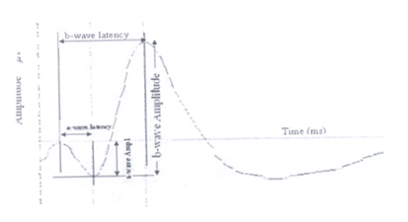
Fig. 1: ERG of selected Control samples

Figure 2 displays examples of the ERG records of treated eyes after 2 and 21 days from exposure to blue light with and without supplementation of the grape seed antioxidant extract. The obtained results are summarized in table (1). It lists the mean and standard deviation of the amplitude and implicit time of the a-and b-waves for the control and blue light treated eyes after different exposure periods. The results were obtained before (W/O) and after (W) administration of grape seeds.
The mean and standard deviation of the amplitudes of the a-and b- waves for the different exposure durations are shown in Figures 3 and 4, while the mean and standard deviation of their implicit times are shown in figures 5 and 6. It is clear from the figures that the ERG was strongly affected by exposure to blue light.
The results showed variations in the ERG waveform, amplitude and implicit time for all components It is noticed that by longer exposure of the eye to blue light, there is a significant decrease in amplitude of a- and b- waves and increase in their implicit time. For the shortest exposure period (2 days) the amplitudes of the a- and b-waves tended to be smaller than control group (p> 0.05) and their implicit time increased (p< 0.01). This trend was appeared in all groups. In case of the 14 days exposure period, the percentage difference-with respect to control of a- wave amplitude is 77% and implicit time was (-35%) (of the a- wave). Regarding the b-wave, the percentage difference was 58% for its amplitude and (-21%) of its implicit time. It is obvious that the a-wave was more affected than the b- wave. However, the most striking feature in the ERG wave form variations appeared at the longest exposure time (21 days) where a negative ERG is recorded. The percentage difference for amplitude was (-31%), (p<0.01) and implicit time was 1%, (p<0.001) for the a- wave. The behavior of the b-wave was found to follow another pattern where there was a significant reduction in its amplitude (p>0.05) and implicit time (p<0.01) and the percentage difference for both values were 75% & -31% respectively.In case of the negative ERG it is useful to calculate the (b/a) ratio to examine the vitality of the retina and in this work it was found to be 0.45. Administration of grape seeds improved the ERG parameters in different grades. The highly significant improvement appeared in case of the shortest exposure period to blue light (p<0.01) with respect to control. The implicit time of the a-&b-waves are presented in figures 5 and 6 .The improvement decreased with increased exposure period to blue light, except at the longest exposure period (21 days) where not any improvement appeared. The percentage difference of amplitude is -32%, p<0.01 & implicit time is 1.5%, p<0.01 for a-wave and regarding to b-wave, 73% is for its amplitude and -24 % is for its implicit time. Finally the b/a ratio is 0.49.It is noticed that the last group have the same results before and after administration of grape seeds. When compared this group to control one a significant result was found in a- and b- amplitude <0.01 & p <0.001 respectively and for their implicit time are p>0.05 &p<0.01.

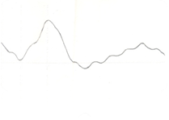 | 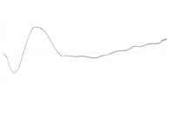
1
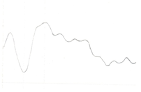 | 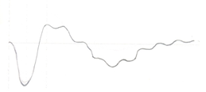
2

Figure 2: ERG records after 2 days (upper) and 21 days (lower) of (from) exposure to blue light without (1) and with (2) grape seeds administration

Table (1): lists the mean and standard deviation of the amplitude and implicit time of the a-and b-waves for the control and treated eyes after the different exposure periods

Time after exposure(days) | Amp of a-wave (µV) |  |  | Implicit time of a-wave (m sec) |  | Amp of b-wave (µV) |  | Implicit time of b-wave (m sec)
Time after exposure(days) | w/o |  | w | w/o | w | w/o | w | w/o | w
Control | 8.73 ±0.26 |  |  | 26.4 ±1.3 |  | 20.72 ± 0.62 |  | 52.4 ±2.1
2 | 7.37 ±0.3 | 9.39 ±0.23 |  | 29.59± 0.9 | 27.36 ±08 | 18.51 ±0.5 | 19.01±0.5 | 54.95 ±2.4 | 52.06 ± 1.9
7 | 5.37 ±0.19 | 7.38 ±0.11 |  | 32.41± 1.3 | 28.18±1,1 | 14.76 ±0.4 | 18.78±0,4 | 59.18 ±1.5 | 56.36 ±2.2
14 | 2.01 ±0.1 | 4.70 ±0.02 |  | 35.67 ±1.2 | 29.59±0,9 | 8.72 ±0.5 | 11.40±0.4 | 63.41± 1.9 | 59.18 ± 1.3
21 | 11.41 ±0.2 | 11.5 ±0.3 |  | 26.12 ±1,3 | 26.83±1.1 | 5.21 ±0.4 | 5.68 ±0.1 | 56.36± 2.2 | 56.13 ± 1.1

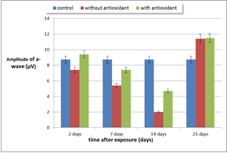

Fig. (3): Amplitude of a-wave (µV) of the control and blue light treated eyes after different periods, without and with grape seeds administration.

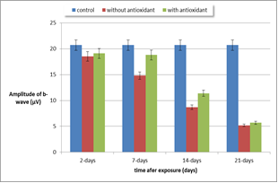
Fig. (4): Amplitude of b-wave (µV) of the control and blue light treated eyes after different periods without and with grape seeds administration.

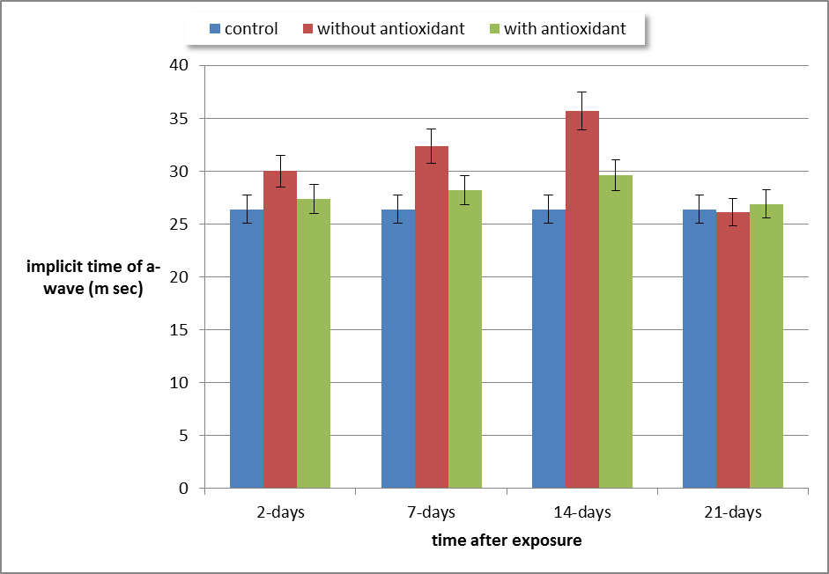
Fig. (5): implicit time of a-wave (m sec) before and after exposure to blue light at different periods without and with grape seeds administration.

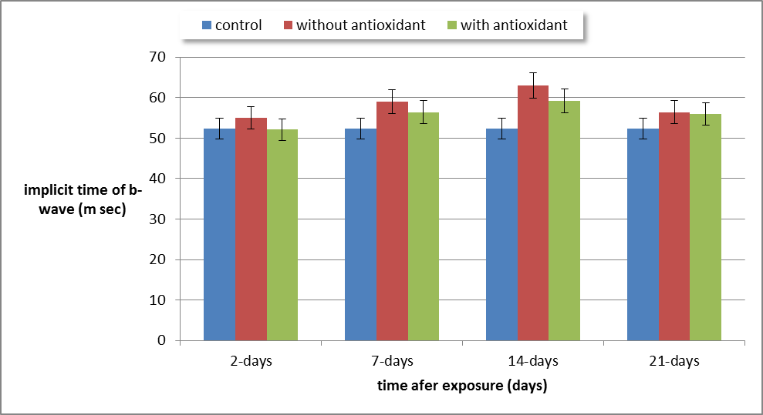
Fig. (6): implicit time of b-wave (m sec) before and after exposure to blue light at different periods without and with grape seeds administration.

4. Discussion
This study has been undertaken to ameliorate the photo-oxidative effect of blue light on retina. It is found that the exposure to blue light caused significant electrophysiological changes. The results showed, decrease of the amplitude of both a- and b- waves accompanied with increase in their implicit time .These effects were strongly exposure period dependant. However, this behavior was changed for the group exposed to the longest Period to blue light where a negative ERG appears. The above results agree with (Masuda and Watanabe, 2000) who found a reduction in a-, b-and c- waves of the ERG after exposure to blue light. Youssef et al., 2011 reported that photochemical damage is associated with both long-duration exposure times as well as Lower-wavelength (higher-energy) light exposure. In order to investigate the obtained results firstly it should explain the photochemical damage process. For a photochemical damage to occur;it is necessary that the light with short wave length must be transmitted to tissues with high oxygen content and then be absorbed by a chromophore ( Roberts, 2001 and Youssef et al. 2011).By applying the previously mentioned idea on retina and blue light, photochemical damage will occur. Photochemical damage is theorized to result from the generation of free radicals after the exposure. While the retina possesses inherent mechanisms to protect against such insult, it is thought that damage may occur once these protective mechanisms have been overcome (Dong et al., 2006, Dong et al., 2007, Lu et al., 2009). The chromophores are theorized to mediate the light-induced damage to the retina (Glickman, 2002, Wu et al., 2006). Light with wavelengths in the high-energy portion of the visible spectrum interacts with chromophore molecules contained within the retina. A chromophore is a region in a rhodopsin molecule in which the energy difference between two different molecular orbitals falls within the range of the visible spectrum. Visible light that hits the chromophore can thus be absorbed by exciting an electron from its ground state into an excited state. (Glickman, 2002, Rozanowska and Sarna, 2005, Wu et al., 2006).The generation of free radicals can occur in one of two ways. In the first mechanism of free radical generation, absorption of radiant energy causes excitation of electrons from the ‘ground state’ to the ‘excitation state’. However, the excitation state is unstable and because of this volatility the raised level of energy in the excitation state can be dissipated in one of several ways. While some atoms will simply release the quanta of energy that they previously absorbed and return the excited electron to the ground state, other interactions may lead to the formation of free radicals or reactive oxygen species. Free radicals form after the higher energy level of the excitation state is used to split the bond in another molecule either by direct electron exchange or direct hydrogen exchange. In the second mechanism, the absorption of radiant energy leads to the direct transfer of energy from the excited chromophore to oxygen, creating a singlet oxygen Species. Once generated, free radicals can attack many molecule types, thereby causing damage and rendering them inactive .Photoreceptors cells in which there is a large concentration of cell membranes are particularly vulnerable to free radicals; the attack of free radicals on polyunsaturated fatty acids results in lipid peroxidation that breaks down membranous structures. Lipid peroxidation is propagated as a chain reaction and Retinal light toxicity (Youssef et al., 2011). The a-wave reflects the photoreceptor activity. The b-wave is generated in the middle retinal layer in which the blood supply is provided mainly by the retinal circulation. Accordingly, the b-wave is believed to be a good indicator of the middle retina and retinal circulation (Kolb et al., 2011). So this explanation may give an intuitively idea about the deformation obtained in the ERG. The amplitude of the a-wave depends on the integrity of the photoreceptor and on absorption of quanta in the rhodopsin, while the b-wave amplitude depends on the a-wave, on retinal circulation, and on the functional integrity of the interactions between the a-and b- wave generators (Kolb et al., 2011). So the accumulation of free radicals after the longest exposure period to blue light may be the cause in the appearance of the negative ERG which reflect the non-vitality of the retina in the form of blocking the signal transmission from photoreceptors to second and higher order retinal neurons (Terasaki et al., 1997 , Vinberg et al., 2009). It is noticed from electrophysiological study, there is a type of improvement of ERG waves with supplementation of grape seeds but is still less than the control group. This improvement is reversely proportional with duration of exposure to blue light. The grape seeds extract is a rich bioflavonoid which is used for fighting free radicals, maintaining capillary health and strengthening the cell membranes. Also it has a positive influence on the permeability and tendency to hemorrhage of retinal vessels (Thomas, 1999) Flavonoids have multiple properties that are potentially of benefit for the prevention and treatment of ocular diseases, particularly those that involve the loss of nerve cells (Pamela and Hanneken, 2005).Additionally, the improvement may be due to the newly regenerated photoreceptors, which are continuously replenishing themselves (Kolb et al., 2011). The obtained results agree with Baudouin et al., 1999, Robredo et al., 2005 which showed that the antioxidant treatment could improve the progression of some retinal disorder. In case of the deformed shape of ERG is in the form of negative ERG is still found i.e. the changes are irreversible. Its b/a ratio is 0.45 before the administration of grape seeds and 0.49 after the administration. It is noticed that the ratio is less than 1 in both cases and that reflect a pathological state found as mentioned above.

Conclusion:
It is found that grape seeds can protect ERG from oxidative stress that occurs due to exposure to blue light with high levels of potency and low toxicity. These results have significant clinical potential because oxidative stress has been implicated in many types of ocular diseases, including glaucoma, diabetic retinopathy, and macular degeneration. Furthermore, it is a must to decrease the spending time in front of video display terminals (VDTs) as soon as possible.

Corresponding author
Elawady A Ibrahim
Biophysics and Laser Science Unit, Research Institute of Ophthalmology, Giza, Egypt
amalawady@hotmail.com

References
Baudouin, C. , P.Pisella, M. Ettaiche,M. Goldschild, F.Becquet, P.Gastaud and M. Droy- Lefaix (1999). Effects of EGb761 and superoxide dismutase in an experimental model of retinopathy generated by intravitreal production of superoxide anion radical. Arch. Clin. Exp.Ophthalmol., 237(1): 58-66.
Chiou, G.and X. Xu (2004). Effects of some natural flavonoids on retinal function recovery after ischemic insult in the rat. J .Ocul Pharmacol Ther., 20(2):107-13.
Demontis, G., B. Longoni and P., Marchiafava(2002). Molecular Steps Involved in Light-Induced Oxidative Damage to Retinal Rods. Invest. Ophthalmol. Vis. Sci., 43(7): 2421- 2427.
Domalapalli, M.and A. Neeraj (2007). Oxidative Stress in Glaucoma: A Burden of Evidence. Journal of Glaucoma., 16(3): 334-343.
Dong, A., Shen, J., M. Krause, H.Akiyama,F. Hackett, H .Lai et al.(2006). Superoxide dismutase 1 protects retinal Cells from oxidative damage. J Cell Physiol., 208(3): 516–526.
Dong, A.,J. Shen, M.Krause, F.Hackett, P.Campochiaro (2007). Increased expression of glial cell line-derived neurotrophic factor protects against oxidative damage-induced retinal degeneration. J Neurochem. 103(3): 1041–1052.
Elaine, K.(2000). The Effects of Blue Light on Ocular Health. Journal of Visual Impairment and Blindness., 6:399-411
Felix , B., E., Johnson, W., Schalch, et al. (2011). Nutritional Manipulation of Primate Retinas. V: Effects of Lutein, Zeaxanthin and n–3 Fatty Acids on Retinal Sensitivity to Blue Light Damage. Invest. Ophthalmol. Vis. Sci., 52(7) 3934-3942.
Glickman, R.(2002). Phototoxicity to the retina: mechanisms of damage. Int J Toxicol., 21(6): 473–490.
Hanneken, A., F. Lin, J. Johnson and P. Maher (2006). Flavonoids Protect Human Retinal Pigment Epithelial Cells from Oxidative-Stress–Induced Death. 4 Invest. Ophthalmol. Vis. Sci., 7(7): 3164-3177.
Kolb, H., R. Nelson, E. Fernandez and B. Jones (2011).Web vision. The organization of the retina and visual system. Copyright © web vision powered by word press. University of Utah Disclaimer Rhone, M.and A.Basu , 2008.Phytochemicals and age-related eye diseases. Nutr Rev. , 66(8):465-72.
Lu, L.,B. Oveson, Y. Jo, T.Lauer, S.Usui, K.Komeima et al. (2009). Increased expression of glutathione peroxidase 4 strongly protects retina from oxidative damage. Antioxid Redox Signal, 11(4): 715–724.
Masuda, K and I. Watanabe(2000). Short Wavelength Light-Induced Retinal Damage in Rats. Jpn J. Ophthalmol. , 44: 615–619.
Nakayama, M., A. Makoto, Y. Chen,M. Araie,K. Tomita,K. Yokotani and T. Iwashina(2011). Neuroprotective effects of flavonoids on hypoxia-, glutamate-, andoxidative stress–induced retinal ganglion cell death. Molecular Vision, 17:1784-1793.
Okuno, T., H. Saitoand and J. Ojima (2002). Evaluation of blue-light hazards from various light sources. Dev Ophthalmol.;35:104-12.
Pamela, M. and A. Hanneken(2005). Flavonoids Protect Retinal Ganglion Cells from Oxidative Stress–Induced Death. Invest. Ophthalmol. Vis. Sci., 46(12): 4796-4803.
Robredo P., D.Moya, J.Rodriguez,Gand Layana(2005). Vitamin C and E reduce retinal oxidative stress and nitric oxide metabolites and prevent ultrastructural alterations in porcine hypercholesterolemia. Invst Ophthalmol Vis Sci., 46(4): 1140-1146.
Roehlecke C, U. Schumann, M. Ader, L. Knels and H. Richard (2011). Influence of blue light on photoreceptors in a live retinal explants system. Molecular Vision. 17: 876–884.
Rozanowska, M.and T. Sarna(2005) .Light-induced damage to the retina: role of rhodopsin chromophore revisited. Photochem Photobiol ., 81(6): 1305–1330.
Terasaki, H.,Y.Miyake ,K.Mineo,and A.Tanikawa(1997). Focal macular electrorentinogram before and after drainage of macular dubretinal hemorrhage. American J. of ophth., 123-207.
Thomas, B. J., Magdalene, B. Robert, D. Samant, Q. Guanting ,N. Vyas, S.Arai and Z. Chen1 et al. (2007). Visual Functional Effects of Constant Blue Light in a Retinal Degenerate Rat Model. Photochemistry and Photobiology., 83: 759–765.
Thomas, G. (1999). Free radicals, antioxidants and eye diseases. Not as incurable as we once thought. The standard 2 (1):1-7.
Vinberg , F.,S. Strandman and A. Koskelainen (2009). Origin of the fast negative ERG component from isolated aspartate-treated mouse retinaJournal of Vision 9(12):9, 1–17.
Wu, J., S. Seregard and P.Algvere(2006). Photochemical damage of the retina. Surv Ophthalmol; 51(5): 461–481.
Youssef, P., N Sheibani and D. Albert (2011). Retinal light toxicity .Eye. 25: 1–14 Roberts, J. 2001. Ocular photo toxicity. Journal of Photochemistry and Photobiology B: Biology 64: 136–143.

10/3/2011

