Anti-mutagenic Effects of Fennel Plant (Foeniculum vulgare Mill) Seeds and Pure Anethole: An in vitro Test on Mice

^{1*}Esmat A. Hassan; ²Abdel Aziz K. B.; ¹M. E. El-Awadi and ²M. A. Hanan

¹Botany Department, ²Cell Biology Department, National Research Centre, Dokki, 12311, Cairo/Giza, Egypt
*esmat_hassan@yahoo.com

Abstract: In the present study Willbutrin (bupropion hydrochloride) was employed to induce mutagenic/ carcinogenic features in mice, i.e. undesirable cell division and DNA damage. The repair actions of fennel dry seeds and its extracted bioactive substance anethole supplied to Willbutrin-treated- mice in a dietary regime were investigated. Male Swiss albino mice (25-30gm) orally received Willbutrin dose (0.4 mg/day) for 14 consecutive days showed significant increases in number and types of abnormalities in chromosomes of both somatic and germ cells in comparison to control .In germ cells , this was coincided with several aberration symptoms detected in head and tail of sperms. Chromosome aberrations were significantly declined in wellbutrin-treated -mice group received dry fennel seed diet in comparison to both the untreated control as well as to the single treatment with the Willbutrin substance. In case of pure anethole chromosome aberrations were significantly reduced specially in bone marrow, i.e. somatic cells. It is herein concluded that whole fennel seeds can be introduced as an additive in daily diet to avoid / protect and/or inhibit the initiation and development of certain cancer cells in vivo. In this respect, precise experiments on clinical level need to be carried out.
[Esmat A. Hassan, Abdel Aziz K. B., M. E. El-Awadi, and M. R. Hanaa Anti-Mutagenic Effects of Fennel Plant (Foeniculum vulgare Mill) Seeds and Pure Anethole: An In vitro Test on Mice] Nature and Science 2011; 9(12): 21-26]. (ISSN: 1545-0740). http://www.sciencepub.net.

Key words: Anethole, antimutagenic, chromosomes, fennel, mice.

1. Introduction
Wellbutrin (bupropion hydrochloride- C13 H18 CINo Hcl) is reported as a carcinogenic agent inducing symptoms of undesirable cell division and DNA damage (Hanaa and Amal 2010 and Brambilla et al 2009). Productivity of fennel plant (Feoniculum vulgare Mill) and anethole content (chemical formula–Fig.1) levels were improved via certain physiological treatments (El-Awadi and Hassan 2010 and 2011). From several research results such a plant and its main bioactive constituent anethole is proved to possess a recovery and/or a protective function against different cancer cases` development (Choi and Hwang 2004, Lam et al 2002, Tanira et al 1996 and Al-Harbi et al 1995) . Abnormality changes in somatic chromosomes from bone marrow cells and in germ cells (spermatocytes) of mice in response to carcinogenic agents were previously described (Yosida and Amano 1965). On the other hand, healing effects of certain anti-carcinogenic substances (Preston and Brewey 1978; Wyrobek and Bruce 1978 and Abdel Aziz and Hassan 1994) were reported. We herein had employed Willbutrin to investigate the potential protective influence of fennel dry seeds and the extracted pure anethole received as daily oral diet supply against chromosome aberrations and cell damage in somatic and germ cells of mice.
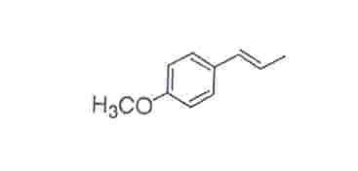
Fig. (1): Chemical formula of anethole (1-methoxy-4-(1-propenyl) benzene
2. Materials and Methods
I- Materials:
I.1. Tested substances
1-Water soluble Wellbutrin (buprotion hydrochloride; molecular formula: C13 H18 CINo Hcl ) is provided by GlaxoSmithKline (gsk), U.S.A.
2- Dry seeds of fennel plant ( Pheoniculum vulgare Mill ) ; grown under non-chemical conditions (Abd El-Rahman et al, 2010 ); supplied as a daily diet for animals, were obtained from the Department of Medicinal Plants in the National Research Centre.
3-Anethole (Fig.1) separated from the extract of the dry fennel seeds (El-Awadi and Hassan 2010) was given as amended daily dose for 14 consecutive days (0.2 mg / 30 gm mice body weight).

I.2. Animals and treatments:
Male Swiss albino mice aged 9-12 weeks of weight ranged from 25-30 gm, were obtained from a closed random bred colony at the National Research Centre–Egypt. Food and water were provided adlibitum. Animals were divided into 6 groups, 5 animals in each as follows: 1- Control, in which mice group received standard diet (Abdel Aziz and Abdel Rahem 2010). 2- Treated with wellbutrin drug (0.4 mg/ day). 3- Received dry fennel seeds as diet. 4- Received Anethole. 5- Dry fennel + wellbutrin. 6- Wellbutrin + Anethol.

II. Methods:
II.1. Oral administration of tested substances:
a-As described by Abdel Aziz and Abdel Rahem (2010 ) , the animals for 14 consecutive days were supplied with wellbutrin ( 0.4 mg/ day) to suit the small weight of albino mice (ca.30 gm) .
b-Wellbutrin was given to the mice as single treatment and in interaction either with dry fennel seeds or with pure anethole.
c-Two mice groups received single treatments with the former and the latter material as well.
d- The control group received normal diet.
e- Animals were sacrificed after 24 hours from the last diet treatment administration.

II.2. Detection of mutagenic features and repair action of the supplied dry fennel seeds and anethole:
To detect the anti-mutagenic activity of different material under test, i.e .fennel seeds and anethole against the clasto and mutagenic features exerted by the wellbutrin, the experimental steps were carried as follows:

1- For somatic cell chromosomes:
Forty animals were used as 35 for treatments and 5 as control.
Animals were killed by cervical dislocation after 24 h. from the last treatment.
Chromosomes from bone marrow cells were prepared according to the method of Yosida and Amano (1965) and changes in structure (100 metaphase spread from each animal) were examined under the microscope.

2- For germ cell chromosomes:
Testis were detached from the same animals to record the abnormalities occurred in spermatocytes (germ cells) using the methods of Preston and Brewey (1978).
Under the microscope, 100 metaphase spreads from each animal were examined and abnormalities were recorded.

3-For Sperm abnormalities:
For sperm shape analysis, the epididimus were excised and mined in about 8 ml of physiological saline solution, dispersed and filtered to exclude large tissue fragments. Smears were prepared after staining the sperms with Eosin Y (Aqueous), according to the methods previously reported (Farag et al 2002 and Hanaa et al 2008).- One thousand sperms from each animal were examined and all types of aberrations in both head and tail were recorded.

Microscopic examination
The prepared slides were examined using Nikon Optopho-2 (Nikon-Japan) microscope equipped with:
A xenophot long life 12v 1000w lamp (Osrama-Germany), neutral color balance (NCB) filter (for visible light) and CFE plan achro objective lens (Nikon-Japan).

Photomicrographs
Photomicrographs were prepared using photomicrographic attachment microflex FX-35Dx camera system (Nikon-Japan) and Kodak Gold100 ASA color print film (Hassan and El-Awadi, 2009).

Statistical analysis:
The data was subjected to statistical analysis using the t-test method of Murry (1982).

3. Results
a- Effect of single treatment with wellbutrin on somatic and germ cells of Swiss albino mice:
The data presented in Table (1) as means± standard error (SE) values indicated that wellbutrin caused significant increase in the number of cells with different abnormalities from 1.6±.02 recorded in the control group of mice to 12.6± 1.4 in somatic cells. The abnormalities were recorded after 14 days from treatment and represented by gaps, breaks, deletions, centric fusion, centromeric attenuation and the numerical types polyploidy and hypoploidy.
In a similar pattern the tested dose of wellbutrin was capable of inducing significant increase in the percentages of chromosomal aberrations in germ cells, i.e. the spermatocytes (Table 2). The maximum percentage of changes appeared after the mice received wellbutrin (0.4 mg/day) for 14 days .The mean value of abnormalities (2.8±.11) calculated for the control reached a significant high level of 13.6±1.39 as a result of wellbutrin administration to mice group under test. The types of aberration observed included gaps, fragments, deletion, x-y univalent, autosomal univalent and chain chromosomes.

b- Effect of adding fennel seeds and anethole with wellbutrin on somatic and germ cells of albino mice:
In the interaction treatments , the supplement of dry fennel seeds` daily diet to mice under test, resulted in reducing the mean aberration values recorded with wellbutrin dose from 12.6± 1.42 to 7.8±1.91 in somatic cells ( Table 1 ) . The corresponding value was 5.8±1.21 with the pure anethole administration.
In germ cells addition of dry fennel seeds with the wellbutrin caused a reduction in the mean value of aberration calculated in the control from 13.6 ±1.39 to 9.8±2.11 , while still at significant higher level in comparison to the control (1.6±0.01, Table 1) in somatic cells and 2.8±0.11 in germ cells (Table 2 ).

c-The effect of wellbutrin and its interaction with dry fennel seeds and anethole in the diet of albino mice on changes in sperm structure:
The abnormality changes recorded in sperms of the mice in response to wellbutrin (0.4 ml/day) given for 14 days are shown in Table 3. The aberrations were detected as amorphus head, big and Small heads, banana one in addition to that appeared with doubled head ( Fig . 2).Two types of tail aberrations were recorded as coild tail and double tail spears. In mice group received wellbutrin and dry fennel seeds together in the diet the value of sperm aberrations were declined from 74.8±3.3 to 55.0±1.9 (Table 3) as compared to that observed in the group received dry fennel seeds, i.e. 21 ± 1.91. These values reached considerably lower levels in the groups received either anethole alone (22.4±1.3) or when added with wellbutrin (37.0±1.14; Table 3).
The pure bioactive constituent anethole extracted from fennel seeds exerted a persistent significant recovery influence on chromosomal aberrations and sperm abnormalities resulted from the exposure to wellbutrin in mice. This was true in both the somatic and germ cells as well (Table 1,2 and 3).

Table (1): Chromosome aberration changes in response to the diet regime of wellbutrin, fennel dry seeds and pure anethole in mice somatic cells
Treatment | Number of Metaphase | Number/ type aberration |  |  |  |  |  |  | Mean ±SE
Treatment | Number of Metaphase | Gaps | brk. | delt. | C.F | C.A | polyp. | hypo. | Mean ±SE
Control | 5X10²  In each dose | 3 | 0 | 0 | 0 | 3 | 1 | 1 | 1.6±0.02
Single treatment | 5X10²  In each dose
Wellbutrin | 5X10²  In each dose | 13 | 14 | 12 | 9 | 9 | 3 | 3 | 12.6±1.4**
Dry fennel | 5X10²  In each dose | 3 | 1 | 0 | 0 | 2 | 1 | 0 | 1.4± 0.11
Anethol | 5X10²  In each dose | 3 | 0 | 0 | 0 | 0 | 1 | 0 | 0.8± 0.88
Interaction treatment  Wellbutrin + | 5X10²  In each dose
Fennel seeds | 5X10²  In each dose | 8 | 11 | 7 | 4 | 5 | 2 | 2 | 7.8±1.91**
Anethole | 5X10²  In each dose | 5 | 8 | 8 | 3 | 3 | 2 | 0 | 5.8±1.21*
brk.=breaks, delt.=deletion, polyp.= polyploidy, hypo.=hypoploidy , C.F= centric fusion, C.A.= centric attenuation.
* Significant at 0.05 ** Significant at 0.01

Table (2): Effect of wellbutrin dose and different types of fennel plant on mice germ cell
Dose | No. of metaphase | Number/ type aberration |  |  |  |  |  | Mean ± Se
Dose | No. of metaphase | Gaps | Fragment | Deletion | X-y univalent | Autosomal | Chain | Mean ± Se
Control | 5X102  In each dose | 2 | 6 | 0 | 2 | 4 | 0 | 2.8±0.11
Single treatment  Wellbutrin | 5X102  In each dose
Single treatment  Wellbutrin | 5X102  In each dose | 15 | 20 | 13 | 12 | 4 | 4 | 13.6±1.39**
Dry fennel | 5X102  In each dose | 2 | 5 | 0 | 2 | 1 | 0 | 2±0.91
Anethol | 5X102  In each dose | 0 | 6 | 0 | 0 | 0 | 0 | 1.2±1.11
Interaction treatment  Wellbutrin + | 5X102  In each dose
Fennel seeds | 5X102  In each dose | 10 | 15 | 11 | 8 | 3 | 2 | 9.8±2.11**
Anethole | 5X102  In each dose | 57 | 8 | 9 | 7 | 2 | 1 | 6.8±1.99*
* Significant at 0.05 ** Significant at 0.01

Table (3): Effect of wellbutrin drug and different types of fennel plant on mice sperms
Dose | No. of metaphase | No. of Sperm with |  |  |  |  |  |  |  | Mean ± Se
Dose | No. of metaphase | Amorphous | Banana | Big head | Small  head | Double  head | Coil tail | Double tail | Total | Mean ± Se
Control | 5X10²  In each dose | 40 | 27 | 26 | 14 | 4 | 10 | 10 | 131 | 22.2±2.2
Single treatment  Wellbutrin | 5X10²  In each dose
Single treatment  Wellbutrin | 5X10²  In each dose | 150 | 30 | 50 | 50 | 44 | 30 | 20 | 374 | 74.8±3.3**
Dry fennel | 5X10²  In each dose | 30 | 25 | 20 | 13 | 5 | 6 | 6 | 105 | 21 ±1.91
Anethol | 5X10²  In each dose | 30 | 25 | 20 | 14 | 4 | 9 | 10 | 112 | 22.4±1.3
Interaction treatment  Wellbutrin + | 5X10²  In each dose
Fennel seeds | 5X10²  In each dose | 100 | 20 | 30 | 40 | 40 | 25 | 20 | 275 | 55±1.9**
Anethole | 5X10²  In each dose | 70 | 10 | 20 | 25 | 20 | 20 | 20 | 185 | 37±1.4*
* Significant at 0.05 ** Significant at 0.01

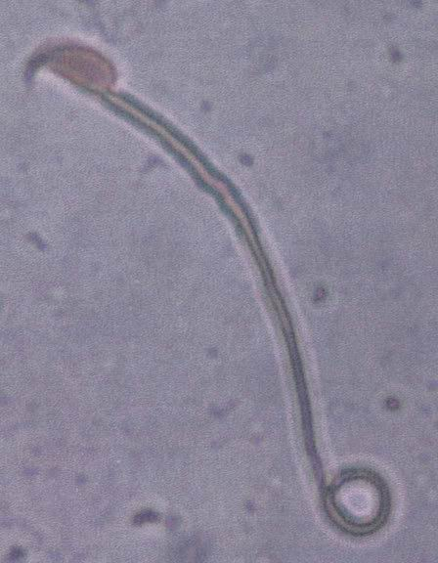  (f) | 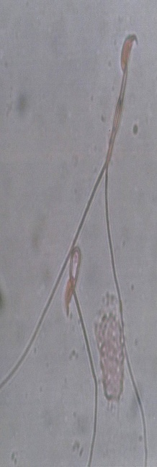  (e) | 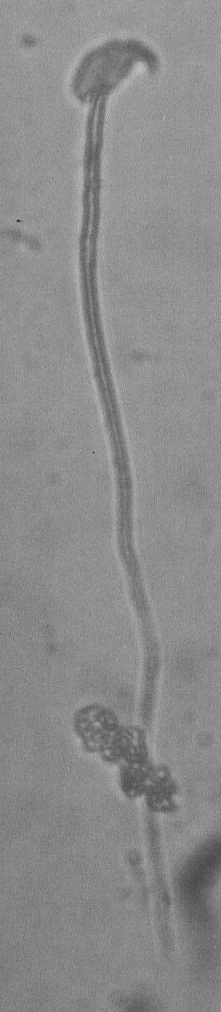  (d) | 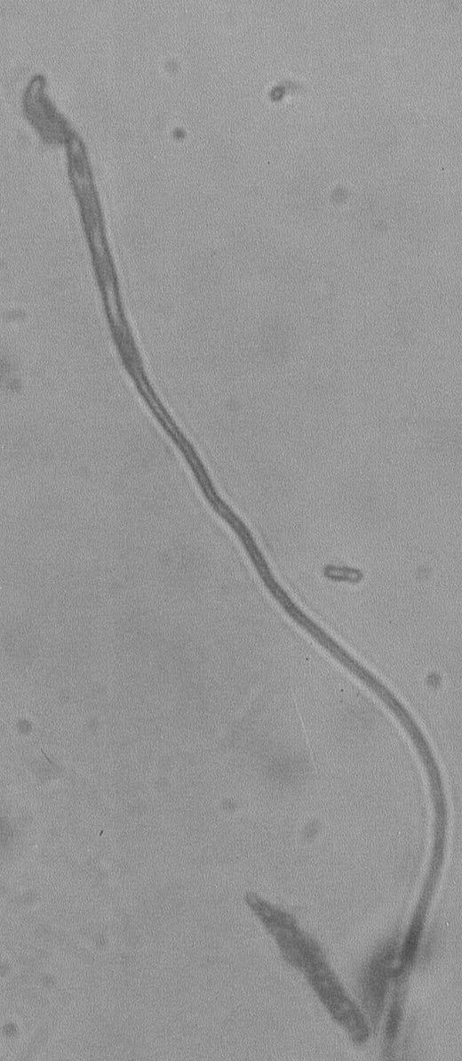  (c) | 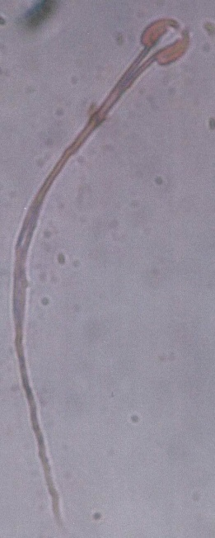  (b) | 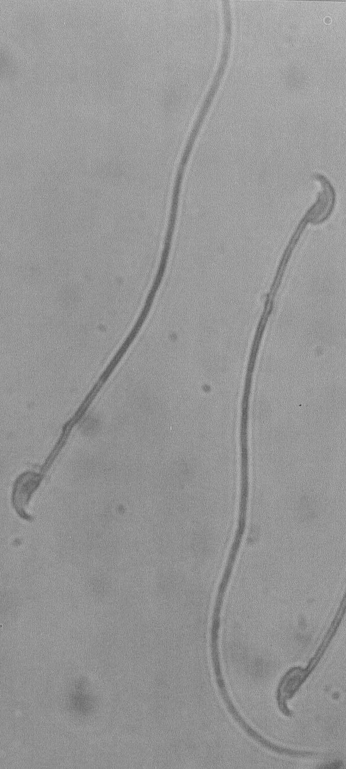  (a)
Fig 2: Abnormalities detected in sperms.
a: Normal b: Double head c: Banana head
d: Big large head e: Divided tail f: Coiled tail

4. Discussion:
In the present study on Swiss albino mice, wellbutrin drug showed different remarkable mutagenic effects. High frequent changed structural and numerical chromosomal aberrations in both somatic and germ cells were observed. The frequencies of sperm abnormalities were also increased. The pattern of change in the number of chromosome somatic cells showed as gap and breaking aberration symptoms reached its maximum of (13and 14 respectively ) with wellbutrin treatment (Table 1). These values were declined to the minimum of (5) in the interaction dietary regime with anethole followed by that in the dry fennel amended one (8). Whereas the calculated number of chromosome aberrations as deletion and centric fusion observed in response to wellbutrin, i.e. 12 and 9 respectively (Table 1) were declined to proximal quantities in both the interaction treatments. Similar trend could be noticed in germ cells and in the abnormalities of sperms recorded in mice groups under test (Table 2 and table 3). These structural changes were discussed before under different experimental conditions (Hanaa and Amal 2010, Jefferson et al 2006 and Abdel Aziz et al, 1993). Anti-mutagenic effects were detected against chlorpyrifos in male mice received lettuce leaves in a dietary regime (Abel Aziz et al, 2010). The observations herein revealed that, fennel plant either as dry seeds or its main bioactive constituent substance anethole had exerted considerable repair influence on different mutagenic symptoms caused by the wellbutrin drug in albino mice .In this connection anethole was reported as an anti-carcinogenic substance
(Lubet et al 1997 and Al-Harbi et al 1995).On the other hand, the present results indicated that germ cells were more sensitive to the wellbutrin than the somatic cells. Antioxidants had improved an immune status, scavenge of free radicals, reduce the production of DNA adducts and could be of effective means in preventing variety of diseases (Van Breda et al 2005 and Devaraj et al 2008). It could be herein suggested that the significant reduction in chromosomal aberrations in mice in response to fennel seed and anethole dietary regime may be due to minimizing the disturbance observed in DNA replication process (Patel et al 2007 and Aitken and Krausz 2000) which lead to reduction in sperm abnormalities as well ( Farag et al 2002). However, one may conclude that the protective anti-mutagenic action of fennel seed constituents against Willbutrin might be via a binding to mutagens in somatic and germ cells (Devaraj et al 2008).
From the present results, the repair action of pure anethole on chromosomal aberrations exceeded that of the dry seeds supplied in the dietary regime in the mice under test.This is in agreement with the findings reported on the anti-carcinogenic influence of such a substance observed in experiments on Swiss albino mice and rat (Lub et et al 1997 and Al-Harbi et al 1995)
It could be however concluded that a standard anethole quantity can be supplied as an amendment in a dietary regime for protection and/or cancer avoidance. In this respect, clinical studies and expertise research participants are needed to reach convenience results and precise recommendation.

Corresponding author
Esmat A. Hassan
Botany Department, National Research Centre, Dokki, 12311, Cairo/Giza, Egypt
esmat_hassan@yahoo.com

Reference
Abd El-Rahman H.A., Zaki M.F., El- Behairy U. A., and M.M. Abou El- Magd (2010). Effect of planting dates and productivity and head quality of some broccoli calrtivars under sandy soil conditions. Egypt. J. Appl. Sci, 25 : 52-56.
Abdel Aziz, K.B. and E. A. Hassan. 1994. Protective Function Of Thiola Against Butralin-Induced Damage Of Chromosomes In Mice. NRC Bulletin 19(4): 275-284.
Abdel Aziz K. B, El Makawy, A. I, Zain El-Abidin, A. and Darwish, A. M., (2010): Genotoxicity of chlorpyrifos and the antimutagenic role of lettuce leaves in male mice. Comunicata, Scientic 1 (2); 137-145.
Abdel Aziz K.B., El-Nahhas E. and S.A.Halim (1993). Tamaron –induced sperm shape abnormalities and chromosomal aberrations in mouce. J.Egypt. Germ. Soc. Zool. 12: 99-133.
Abdel Aziz, K. B. and H. M. Abdel Rahem (2010): Lambada, the pyrethroid insecticide as mutagenic agent in both somatic and germ cells. Journal of American Science, (6) 3: 1-10.
Aitken, R. J., Krausz, C. (2000): Oxidative stress, DNA damage and Y chromosome. Reproduction, 122: 497-506.
Al-Harbi, M.M.; S. Qureshi; M. Raza; M. M. Ahmed; A. B. Giangreco and A. H, Shah (1995): Influence of anethole treatment on the tumor Induced by Ehrlich ascites carcinoma cells in paw Swiss albino mice. European Journal Cancer Prev., 4: 307-318.
Brambilla G., Camottioli F. et al (2009): Genotoxic and carrinogenic effect of outipsychotics. Toxicology, 26 (3): 77-88.
Choi, E. M. and J. K. Hwang (2004): Antiinflammatory, analgestic and antioxidant activities of the fruit of Foeniculum vulgare. Fitoterapia .75 (6): 557-565.
Devaraj, S., Mathur, S., Basu, A., Aung, H. H., Vasu, V. T., Meyers, S., Jialal, I. (2008): A dose-response study on the effects of purified lycopene supplementation on biomarkers of oxidative stress. Journal of the American college of Nutrition 27: 267-273.
El-Awadi M.E and E.A. Hassan (2010): Physiological Responses of Fennel (Foeniculum Vulgare Mill) Plants to Some Growth Substances. The Effect of Certain Amino Acids and a Pyrimidine Derivative. Journal of American Science, 6(7): 102-125
El-Awadi M.E. and E .A. Hassan (2011): Improving Growth and Productivity of Fennel Plant Exposed to Pendimethalin Herbicide: Stress–Recovery Treatments. Nature and Science, 2011; 9 (2): 97-108.
Farag, I. M., Abdou, H. S. A., Ayesh, A. M., Osfr, M. M. H. (2002): Chromosomal and sperm studies on the mutagenic effect of overheated meat and the protective role of green tea and ginseng on rats. Al-Azhar Bull Sci 13: 105-120.
Hanaa, H. Y., Khalil, W. K. B., Elmakawy, A. I., Elmeeged, G. A., (2008): Androgenic profile and genotoxicity evaluation of testosterone propionate and novel synthesized heterocyclic steroids. Journal of Steroid Biochemistry&Molecular Biology 110: 284-294.
Hanaa, M. R. and Amal, A. F. (2010): Cytogenetic and biochemical effects of antidepression drug (Wallbutrin) on male mice. New York Science J. 3(6): 121-126.
Jefferson T. W. et al. (2006): The effect of bupropion in the Ames test. J. Clin. Psychiatry June, 67(6): 865-873.
Lam, S. C.; J.C. MaeAulay; Y. Le Riche; A. Dyachkova; M. Coldman; E. Guillaud; M. Hawk; O. Christen and A. F. Gazdar (2002): A randomized phase IIb trial of anethole dinitrothione in smokers with bronchial dysplasia. Journal of Natural Cancer Institute, 94: 1001-1009.
Lubet R. A. , Steele V.A., Eto I, Juliana M.M. Kellof G. J. and C. J. Grubbs (1997). Chemopreventive efficacy of anethole trithione, N-acetyl cysteine, miconazole and phenethylisothiocyanate in DMBA-induced rat mammary cancer model. Int. J. Cancer. 27: 95-101.
Murry R. (1982): Scham s Outline Series of Theory and Problems of Probability and Statistics. McGraw-Hill Book Company, Singapore.
Patel S., Bajpayee M., Parmar D. and S. Dhawan (2007). In vitro induction of cytotoxicity and DNA strand breaks in CHO cells exposed to cypermethrin , pendimethalin and dichlorvos. Toxocology In Vitro. 21 (8) 1409-1414.
Preston R.J. and Brewey J.G (1978): Analysis of chromosome aberrations in mammalian germ cells, in: A. Hoaender and F.J. de serres (Eds) Chemical mutagens, Vol. 5 plenum, New York. Pp. 127-150.
Tanira, M. O. M.; A. H. shah; A. Mohsin; A. M. Ageel and S. Quresehi (1996): pharmacological and toxicological investigations on Foeniculum Vulgare dried fruit extract in experimental animals. Phytother. Res., 10:33-36.
Van Breda, S. G., Van Agen, E., Van Sanden, S., Burzykowski, T., Kleinjans, J. C., Van Delft, J. H., (2005): Vegetables affect the expression of genes involved in carcinogenic and anti-carcinogenic processes in the lungs of female C57BI/6 mice. J Nutr. 135: 2546-2552.
Wyrobek, A. J., Gordon, L. A., Burhhart,, J. G., Francis, M. W., Kapp, R. W.; Letz, g. Malling, H. V., Topham,, J. C., whorton, M. D. (1983): An evaluation of human sperm as indicators of chemically induced alterations of spermatogenic function. Mutat Res 115: 73-148.
Yosida T. H. and K. Amano. (1965 ). Autosomal polymorphism in laboratory bred and wild rats , Rattus norvegicus , found in misima. Chromosoma, 16: 658-667.

11/12/2011

