Hydrochemistry of a Tropical harbor: Influence of Industrial and Municipal inputs

BALOGUN Kayode James¹*, LADIGBOLU Ismail Adejare² and OLAJI Ebenezer Dayo²

¹Department of Biological Oceanography, Nigerian Institute for Oceanography and Marine Research, P.M.B. 12729, Victoria Island, Lagos, Nigeria

²Department of Chemical Oceanography, Nigerian Institute for Oceanography and Marine Research, P.M.B. 12729, Victoria Island, Lagos, Nigeria
*Corresponding Author’s E-mail: kayjaybal@yahoo.com
ABSTRACT: In recent times, pollution hazards of coastal waters have increased due to human activities including sand mining and dredging, industrial effluent discharges, indiscriminate dumping of sewage and domestic waste, use of detergents and heavy metals. A study was carried out to assess the extent of pollution caused by industrial and municipal discharges in the Lagos Harbour. Composite samples were collected monthly from the Harbour at seven locations from June to November, 2009 (covering parts of the rainy and dry seasons) and analyzed for some pollution parameters and trace elements [(Temperature, pH, Conductivity, Turbidity, Salinity, Total Dissolved Solids, Dissolved Oxygen, Alkalinity, Organic matters (BOD, COD), Nutrients (NO₃, PO₄ and SiO₂) and Heavy metals (Cr, Pb, Cd, Cu and Fe)]. Surface water of the Harbour was characterized by fairy constant temperature with a range of ( 25.67 – 28.33ºC), alkaline pH (7.70 – 8.42mg/l), brackish salinity (7.00 – 22.47‰), low BOD₂₀⁵ values (0.80 – 3.33mg/l), total dissolved solids(6.00 – 19.00mg/l), moderate dissolved oxygen content (4.13 – 7.60mg/l) which fell below FEPA limit of 10mg/l, alkalinity (8.00 – 15.33mg/l), low Nitrate value (0.08 – 0.12mg/l), moderate Phosphate (0.57 – 1.60mg/l) and moderately high Silicate values (1.27 – 9.23mg/l). Moderate concentration of heavy metals salts such as Cr (0.03 – 0.60mg/l), Pb (0.22 – 0.61mg/l), Cd (nd – 0.02mg/l, Fe (0.67 – 1.41mg/l) and high Cu values (4.53 – 5.55mg/l). Correlation between Salinity and heavy metals measured in this study were negative except Iron. Considering the values recorded for the pollution indicators, the harbor appears to be polluted. The temporal variability in some of these parameters could be attributed to influx of freshwater during the rainy season.
[BALOGUN Kayode James, LADIGBOLU Ismail Adejare and OLAJI Ebenezer Dayo. Hydrochemistry of a Tropical harbor: Influence of Industrial and Municipal inputs. Nature and Science 2011; 9(12): 36-43]. (ISSN: 1545-0740). http://www.sciencepub.net.
Keywords: Pollution, Hydrochemistry, Harbour, Heavy metals
Introduction

Aquatic ecosystems have been suffering significant changes due to anthropogenic activities which eventually produce biodiversity losses as a direct consequence. Ajao (1996) identified sand mining, sand filling, industrial effluent discharge, oil wastes, domestic waste, sewage discharges among others as human related activities capable and presently destroying the sensitive coastal environment of Nigeria species. According to Ajao (1996) coastal waters can be contaminated from both natural and anthropogenic sources of pollution.
Pollution is a natural or induced change in the quality of water which renders it unusable or dangerous as regards food, human and animal health, industry, and agriculture, fishing, or leisure pursuits. Basically, pollution is induced by those human activities which cause pollutants to enter natural waters. The main cause of water pollution is the discharge of solid or liquid waste products containing pollutants on to the land surface, or into surface or coastal waters. Direct discharge of untreated domestic wastes such as kitchen wastes, faeces and urine into the Lagos lagoon systems threaten the aquatic ecosystem in many ways. These include causing an increase in the microbial load in these water bodies, nutrient enrichment, pollution of the soil and aquatic environments (Oyelola and Babatunde, 2008) as well as the availability of substratum for bacterial growth. It also causes a reduction in dissolved oxygen level, reduction in the distribution and diversity of organisms and reduction in transparency due to the presence of non-dissolved solids and eutrophication (Harold, 1997).
The concentrations of heavy metals in the water may be raised locally by discharges from many industrial processes, and in sediments they may become very high. They may be released into the water from sediments disturbed by dredging, or by changes in pH or redox potential. Careful monitoring of these metals is obviously essential in any area where toxic metal pollution of seafood’s is a possibility.
The Lagos Harbor, like many coastal Harbors, serves as a seaport, centre for recreational sailing and a sink for disposal of domestic and industrial wastes. A paucity of information exists on the extent of pollution of the harbor and hence its public health implication.

Materials And Methods
Study area:
The Lagos harbor (Fig 1) is located in Lagos state, Nigeria. The 2 km wide harbour receives inland waters from the Lagos Lagoon in the east, and from Badagry Creek in the west. The Harbour provides the only opening to the sea for the nine lagoons of South Western Nigeria and is where the most important seaport in Nigeria is situated. The Harbour is one of the three main segments of Lagos Lagoon Complex; other segments are: Metropolitan and the Epe Division Segments. Lagos Harbour host facilities for the loading and unloading of cargo and usually with installations for the refueling and repair of ships. Apart from oil depots sited along the shore of western parts of the Harbour coupled with the proliferation of urban and industrial establishments on the shore of eastern part of the Harbour, the Harbour is used as a route to transport goods but subsistence fishing takes place at some locations by artisanal fishermen.

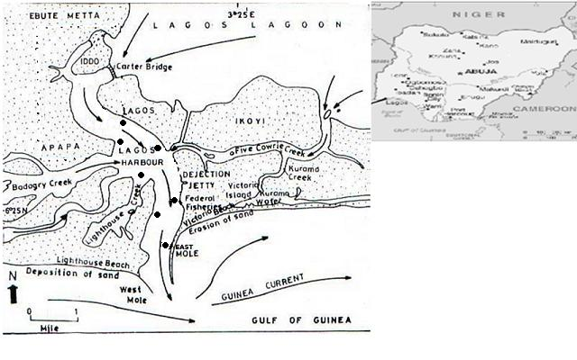
Figure 1: Map showing Lagos Harbour and sampling locations denoted by ●

Collection of Samples
Water samples were collected from the surface of Lagos Harbour with a 1dm³ water sampler and stored in 1litre screw-capped plastic containers and stored in a refrigerator at 4⁰C ± 1⁰C prior to analyses. Separate water samples were collected in 250ml dissolved oxygen bottles at each station and occasion for dissolved oxygen estimation using iodometric Winkler’s method (Stirling, 1999). Water samples were collected in amber glass bottle (300ml) with glass stoppers for Biological Oxygen Demand (BOD₅) determination. Composite samples were collected monthly from seven different locations along the harbour from June to November 2009. Surface water temperature was measured in situ using mercury-in-glass thermometers. pH, conductivity, salinity and turbidity were also analysed in situ using a multi-meter water checker (Horiba U-12).
Monthly rainfall data measured in mm were obtained from the NIMET marine office at the Nigerian Institute for Oceanography and Marine Research, Victoria- Island, Lagos. Water samples collected were preserved as recommended in both Torrent Laboratory Guide to sample Volume, Container, Preservation and Hold Time – Water/ Soil/Sediment and APHA (1989).

Chemical Analysis
In the Laboratory, Alkalinity of the water samples was determined by titrating dilute HCl against 50ml of the water sample using methyl orange as an indicator (APHA, 1989). Total Dissolved Solids (TDS) were determined gravimetrically by filtering a well – mixed water sample through a fibre filter paper into a weighted dish. The filtrate (in the dish) was evaporated to dryness to a constant weight. TDS was calculated with the following formula (APHA, 1989).

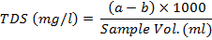
Where; a = Weight of dish (mg) + dried residue
b = Weight of dish (mg)

Chemical Oxygen Demand (COD) was determined by adding mercury sulphate, 5 ml concentrated sulphuric acid (H₂SO₄) to 5 ml of samples and 25 ml of potassium permanganate was added. The mixture was refluxed for 2hr and allowed to cool: the solution was titrated against ammonium sulphate solution using the ferroin as indicator (APHA, 1989).

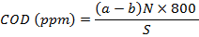
Where; N = Normality of ferrous ammonium sulphate
a - b = Volume (ml) of Ferrous ammonium sulphate used in titration of Blank (a) and of
Sample efficient (b)
S = Volume (ml) of sample water
COD = Chemical Oxygen Demand.

Biological Oxygen Demand (BOD₅²⁰) was carried out by measuring the amount of dissolved oxygen present in the samples before and after incubation in the dark at 20ºC for five days. The Biological Oxygen Demand in mg/litre is the difference in the dissolved oxygen values before and after incubation (APHA, 1989).
Nitrate – Nitrogen (No₃-N), Phosphate – Phosphorus (Po₄-P) and Silicate – Silicon (SiO-S) in the water sampled for each set of samples were measured in the laboratory with a portable datalogging spectrophotometer HACH DR/2010 after reduction with appropriate solutions. All reagents used for the analyses were of analytical grade and double distilled water was used in the preparation of all the solutions.
Heavy metal contents (Pb, Cr, Cu, Cd and Fe) in the water sampled for each set of samples were measured after samples had been digested using standard digestion procedure (APHA, 1989) with Atomic Absorption Spectrophotometer (AAS) by comparing their absorbance’s with those of standards (solutions of known metal concentration) using an Alpha-4 cathodeon AAS. For data quality, factory prepared AAS standard solutions were run as samples for accuracy check after every five measurements.

Data analysis
Mean and standard error values were obtained monthly for each of the physico-chemical parameters. The linear correlation analysis was carried out on the water parameters to verify if there is any significant relationship.

Results And Discussion

Hydrochemistry Indices
The monthly variation in Hydrochemistry indices measured in the Lagos Harbour between June and November, 2009 is shown in Table 1.
Surface water temperatures ranged from 25.7⁰C in August to 28.6⁰C in September. The uniformity of water temperature in this study may be linked to the regular tidal motions which ensured the complete mixing of the water. This observation is in line with earlier workers (Ajao 1990, Oyewo 1998, Fagade and Olaniyan 1994).
The pH values of the surface water of Lagos Harbour were alkaline in nature (between 7.70 and 8.42) throughout the sampling months. This stable pH may be linked to the buffer properties of sea water. Similar views have been reported by Onyema,et.al, 2009; Nwankwo, 1996; Ajao,1990; Nkwonji et.al., 2010 etc. Furthermore, the biological activity of the coastal zone ensures stable pH, a notable feature of the marine environment; whereby conditions are remarkably constant over certain areas.
Monthly rainfall volumes observed before and during this investigation as presented in figure 2 followed known bi-modal distributive patterns as earlier reported by several authors (Hill and Webb 1958; Chukwu 2002; Nwankwo et. al., 2003). This study revealed the strong link among the biological - abiotic factors and rainfall pattern in the Harbour. Salinity regimes in Lagos Lagoon Complex have been linked to rainfall pattern. Salinity recorded ranged between 7.0‰ in and 22.47‰. This variation in the salinity values observed in the study area could be attributed to the influx of water mainly due to rainfall as many workers (Olaniyan, 1969; Dublin-Green, 1990; Ajao ,1990; and Oyewo, 1998) reported that this has been major factor controlling the seasonal distribution of salinity in Lagos Lagoon and environs.

Table 1: Monthly variation in Hydrochemistry indices measured in the Lagos Harbour between June and November, 2009. Values are; Mean ± SE.
Parameters | June | July | August | September | October | November
General
variables
Water Temperature(⁰C) | 25.80 ± 0.58 | 26.50 ± 0.29 | 25.67 ± 0.33 | 28.33 ± 0.33 | 27.50 ± 0.58 | 26.83 ± 0.60
pH | 8.20 ± 0.12 | 8.10 ± 0.15 | 8.10 ± 0.06 | 8.07 ± 0.07 | 7.70 ± 0.12 | 8.42 ± 0.08
Conductivity (mS/cm) | 19.67 ± 1.34 | 39.33 ± 6.50 | 19.33 ± 1.20 | 18.67 ± 2.34 | 12.33 ± 0.88 | 31.60 ± 5.09
Turbidity (NTU) | 66.00 ± 12.35 | 53.33±11.58 | 64.67 ±31.75 | 11.33 ± 3.34 | 14.67 ± 6.67 | 15.43 ± 1.84
Salinity (‰) | 11.00 ± 0.58 | 19.67± 1.46 | 11.33± 0.67 | 11.33 ± 1.46 | 7.00 ± 0.58 | 22.47 ± 5.55
T.D.S (mg/l) | 10.67 ± 1.34 | 19.00 ± 3.22 | 9.00 ± 0.58 | 8.67 ± 1.20 | 6.00 ± 0.58 | 15.17 ± 2.46
Dissolved Oxygen (mg/l) | 4.20 ± 0.38 | 7.60 ± 0.23 | 4.13 ± 0.35 | 5.73 ± 0.48 | 6.53 ± 0.27 | 5.33 ± 0.35
Alkalinity (mg/l) | 14.67 ± 1.37 | 12.67 ± 1.77 | 15.33 ± 1.34 | 12.67 ± 1.34 | 8.00 ± 1.34 | 12.00 ± 1.16
Organic matter
BOD₅ (mg/l) | 2.70 ± 0.67 | 2.73 ± 0.64 | 1.07 ± 0.37 | 3.33 ± 0.74 | 2.33 ± 1.07 | 0.80 ± 0.23
COD (mg/l) | 11.30 ± 1.34 | 10.00 ± 1.16 | 6.10 ± 0.32 | 8.40 ± 0.50 | 7.23 ± 1.05 | 6.33 ± 0.88
Nutrients
Nitrate (mg/l) | 0.09 ± 0.01 | 0.11 ± 0.01 | 0.08 ± 0.01 | 0.11 ± 0.01 | 0.11 ± 0.01 | 0.12 ± 0.01
Phosphate (mg/l) | 0.97 ± 0.43 | 0.78 ± 0.33 | 1.46 ± 0.70 | 0.57 ± 0.03 | 1.47 ± 0.27 | 1.60 ± 0.12
Silicate (mg/l) | 3.13 ± 0.48 | 3.53 ± 0.55 | 1.27 ± 0.35 | 6.23 ± 0.51 | 9.23 ± 1.07 | 6.13 ± 0.75
Trace elements
Cr (mg/l) | 0.06 ± 0.01 | 0.04 ± 0.01 | 0.08 ± 0.02 | 0.03 ± 0.01 | 0.05 ± 0.02 | 0.60 ± 0.01
Pb (mg/l) | 0.22 ± 0.05 | 0.28 ± 0.05 | 0.45 ± 0.07 | 0.51 ± 0.13 | 0.61 ± 0.30 | 0.60 ± 0.23
Cd (mg/l) | Nd | Nd | 0.02 ± 0.00 | Nd | Nd | 0.01 ± 0.00
Cu (mg/l) | 5.32 ± 1.41 | 4.53 ± 0.31 | 5.36 ± 1.24 | 4.77 ± 1.33 | 5.55 ± 0.77 | 5.42 ± 0.85
Fe (mg/l) | 0.67 ± 0.19 | 0.68 ±0.14 | 1.31 ± 0.28 | 0.86 ± 0.30 | 1.03 ± 0.37 | 1.41 ± 0.23

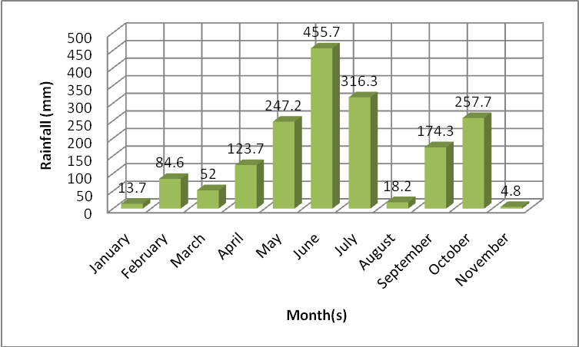
Figure 2: Monthly rainfall volumes observed before and during this investigation (January – November, 2009) (Source: NIMET marine office at the Nigerian Institute for Oceanography and Marine Research, Victoria- Island, Lagos, Nigeria.)

Conductivity and salinity have been reported as associated factors (Onyema and Nwankwo 2009). Conductivity values of the study sites increase with rise in salinity and TDS. Conductivity was between 12.33 and 39.33mS/cm while Total Dissolved Solids (TDS) ranged between 6.0 and 19.0 mg/l. In this study, there is positive correlation between conductivity and salinity (r= 0.92), consequently, conductivity and TDS showed a similar relationship (r = 0.74) Table 2. This finding is in line with the report of Hill and Webb (1958) that there is a close correlation between the salinity and other ecological factors in the Lagos Lagoon and Harbour and the rainfall of the regions draining into the Harbour.

Table 2: Pearson Correlation Co-efficient Matrix of General variables measured in Lagos Harbor (June – November, 2009).
 | Water Temp. (⁰C) | pH | Conductivity(mS/cm) | Turbidity(NTU) | Salinity(PSU) | Dissolved Oxygen(mg/l) | BOD₅(mg/l) | COD(mg/l) | Alkalinity(mg/l) | TDS(mg/l) | Rainfall(mm)
Water Temp.(⁰C) | 1
pH | -0.36 | 1
Conductivity(mS/cm) | -0.23 | 0.59 | 1
Turbidity(NTU) | -0.89 | 0.18 | 0.17 | 1
Salinity(PSU) | -0.16 | 0.76 | 0.92 | -0.03 | 1
Dissolved Oxygen(mg/l) | 0.48 | -0.38 | 0.45 | -0.37 | 0.26 | 1
BOD₅(mg/l) | 0.47 | -0.41 | -0.14 | -0.07 | -0.38 | 0.39 | 1
COD(mg/l) | -0.16 | 0.04 | 0.2 | 0.43 | -0.05 | 0.14 | 0.73 | 1
Alkalinity(mg/l) | -0.65 | 0.58 | 0.18 | 0.76 | 0.13 | -0.65 | -0.13 | 0.25 | 1
TDS(mg/l) | -0.52 | 0.64 | 0.74 | 0.5 | 0.64 | 0.06 | 0.06 | 0.66 | 0.42 | 1
Rainfall(mm) | -0.1 | -0.29 | -0.05 | 0.34 | -0.31 | 0.21 | 0.73 | 0.92 | -0.03 | 0.44 | 1

Turbidity values of between 11.33NTU in September and 64.67 NTU in August were high. Increased turbidity observed could be attributed to the release of suspended particles as a result of dredging and sand mining activities in the Harbour. Some authors (Nwankwo 1998; Chukwu and Nwankwo 2003; Edokpayi et. al., 2004; Saliu and Ekpo 2006) reported similar trend as transparency in the region. Lowest Mean value for Alkalinity recorded was 8.0mg/L in October and the highest value was 15.33mg/L in August.
The concentration of a nutrient in the water at any moment is the result of a balance between the rates of supply and consumption. According to Edokpayi, (1988), most tropical waters have low nutrient values a feature considered common for natural and polluted waters. Nitrate determination helps in the assessment of the character and degree of oxidation in surface waters and in biological processes (ISO, 1990). The low nitrate values (0.08 – 0.12mg/l) obtained in this study is characteristic to a fairly unpolluted coastal system. The phosphate is also of great importance as an essential nutrient in aquatic system. Phosphates are generally the limiting nutrient for plant growth, and excesses can lead to eutrophication. The high levels of Phosphates (0.57 – 1.60mg/l) recorded could be attributed to inputs of domestic and industrial effluents. Silica, in the form of dissolved silicate, is important only for the skeletons of diatoms which are usually an important component of the phytoplankton. High concentration of Silica (1.27 – 9.23mg/l) was recorded in this investigation. The concentration of Silica decrease as rainfall decreased but poorly correlated (r = 0.01) with rainfall and negatively correlated (r = -0.19) with salinity (Figure 3).

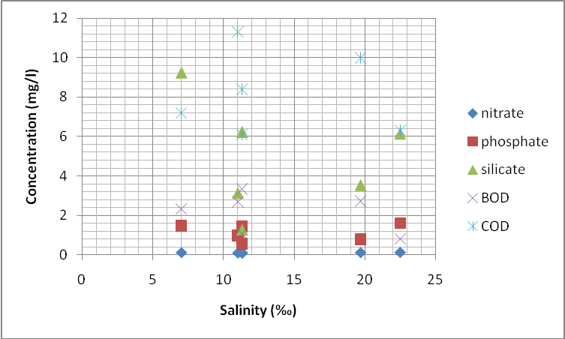
Figure 3: Correlation of Nutrients and Organic matter with Salinity in the Lagos Harbour

The concentration of Organic matter is measured by the BOD₅ and COD analyses. The value of BOD₅ is always lower than that of COD simply because many Organic substances cannot oxidize biologically but can be oxidized chemically. This principle was observed in this study as Biological Oxygen Demand and Chemical Oxygen Demand values were between 0.74 and 2.73mg/L and 6.10 and 11.30mg/L respectively. The low BOD₅ and moderate Dissolved Oxygen (4.13 – 7.60mg/l) recorded in this investigation is in contrast to Nwankwo 1998; Chukwu and Nwankwo 2003; Lawal- Are et. al., 2010 reports for the region.
Metals levels can be varied in concentration ranges depending on the type of waste discharged into such water bodies. Analysis revealed small variation in the concentration of all metals measured in different sampling points and months. The monthly mean range in variation of the heavy metals were notable Chromium (0.03 – 0.60mg/L), Lead (0.22 – 0.61mg/L), Cadmium (nd – 0.02mg/L), Copper (4.53 – 5.55mg/l) and Iron (0.67 – 1.41mg/l). High concentrations of these metals were observed at locations nearer to sewage disposal. Similar observation was reported by Fodeke (1975). These metals concentration fell below FEPA limit except Copper. The high Copper concentration in this study could be attributed to sand mining and dredging activities in the harbour as concentration of Copper is released into the water from sediment disturbed. Correlation between the metals and salinity revealed that only Iron correlated positively (r = 0.21) with salinity (Figure 4).

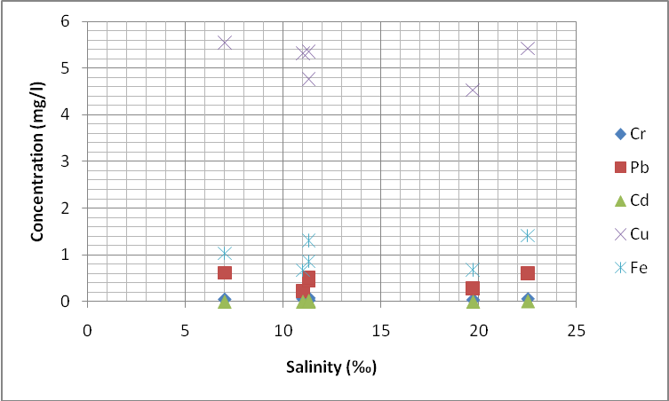
Fig 4: Correlation of dissolved metals with Salinity in the Lagos Harbour.

Conclusion
Considering the values recorded for the pollution indicators in this study, Lagos Harbour surface water is contaminated. Although level of pollution varies from one location to another but generally the Harbour appears to be polluted. The temporal variability in some of these parameters could be attributed to influx of freshwater during the rainy season. We therefore recommend that anthropogenic activities in the Harbour should be regulated. Though dredging is inevitable to maintain sufficient water depth in shipping channels and harbors, which are continually filled in by deposition, Sand mining could also be regulated. Adequate waste disposal facilities should be provided for inhabitants of Lagos metropolis to prevent/reduce indiscriminate dumping of sewage and domestic waste into the Harbour. Furthermore, Federal Environmental Protection Agency (FEPA) should ensure that industries treat their effluents adequately before disposal into the Harbour.
Acknowledgement
The authors are grateful to the Nigerian Institute for Oceanography and Marine Research, Nigeria, for the use of her facilities.

References
- Ajao E. A. (1990). The influence of domestic and industrial effluents on populations of sessile and benthic organisms in Lagos Lagoon. Ph.D Thesis, University of Lagos, p. 411.
- Ajao E. A. (1996). A review of the state of pollution of the Lagos Lagoon. Nigerian Institute for Oceanography & Marine Research Technical, Paper,; No. 106. 20pp.
- Ajibola VO, Funtua II, Unuaworho AE (2005). Pollution studies of some water bodies in lagos, Nigeria. Caspian J. Env. Sci., Vol. 3 No.1 pp. 49-5.
- American Public Health Association (APHA). (1989). Standard Methods for the examination of water and Waste Water 17th edn (L. S. Clesceri, A. E Greenberg and R. R Trusell eds). APHA. Am Water works Assoc, and water pollution .Control Fed, Washington Dc; pp. 881 – 885.
- Chukwu, L .O and Nwankwo, D. L (2003). The Impact of land based pollution on the Hydrochemistry and macrobenthic community of a tropical W/A Creek. In Diffuse poll. Conf. Dublin.
- Chukwu, L. O. (2002). Ecological effects of human induced stressors on coastal ecosystems in South Western Nigeria. Proceedings of the International Oceanographic Institute (IOI) Pacem in Maribus (PIM) Conference, held at the University of Western Cape, Cape Town, South Africa, 8 – 14 December, 2002.
- Dublin-Green CO (1990). Seasonal variations in some physico – chemicals parameters of the bonny estuary, Niger Delta. NIOMR. Techn. paper 591: 5.
- Edokpayi, C. A. (1988). Transport of particulate suspended matter in a perturbed stream in southern Nigeria. Trop. Freshwat. Biol., 1(1), 16–29.
- Federal Environmental Protection Agency (FEPA). Guidelines and Standards for Environmental Pollution Control in Nigeria, 1991.
- Harold, R. (1997): Environmental issues and the interaction of aquaculture with other compelling resource users. Proceedings of the Huntsmas Marine Science CENTRE Symposium Cold water aquaculture to the year 2000 Aquaculture Association of Canada Special Publication No 2: 1 – 13 [22] International Development
- Hill, W.B. and Webb, J.E. (1958). The ecology of Lagos lagoon II. The topography and physical features of Lagos Harbour and Lagos lagoon. Philosophical Transactions of the Royal Society of London. 241: 307-419.
- ISO. (1990). Water quality- determination of Nitrate Part 1: 2,6 – Dimethyl Phenol Spectrometric Method. Intl. Std. ISO 7980-1, Intl. Org. for Standardization, Geneva. 7-42.
- Nkwoji JA, Yakub A, Ajani GE, Balogun K.J, Renner K.O, Igbo JK, Ariyo AA, Bello BO. (2010). Seasonal variations in the water chemistry and benthic macro-invertebrates of a south western lagoon, lagos. Nigeria. Journal of American Science; 6(3): 85-92.
- Nwankwo, D. I. (1996). Phytoplankton diversity and succession in Lagos lagoon, Nigeria. Archiv fur Hydrobiologie 135 (4): 529-542.
- Nwankwo, D. I. (1998). The influence of saw-mill woodwastes on Diatom population at Okobaba Lagos, Nigeria. Journal of Botany. 11: 16-24.
- Olaniyan CIO. (1969)The seasonal Variations in the hydrography and total plankton of the Lagoons of Southwest Nigeria. Nig. J. Sci,; 3(2 :) 101-119.
- Onyema IC. (2009). The water chemistry, phytoplankton biomass, episammic and periphytic algae of a previously unstudied lagoon in Lagos: Apese lagoon. Reports and Opinion,.
- Oyelola, O. T. and Babatunde, A. I, 2008. Effect of Municipal Solid Waste on the Levels of Heavy Metals In Olusosun Dumpsite Soil, Lagos State, Nigeria Int. Jor. P. App. Scs., 2(1):17– 21.
- Oyewo EO. (1999). Industrial Sources and Distribution of Heavy Metals in Lagos Lagoon and Biological Effect on Estuarine Animals. Ph.D Thesis. University of Ibadan, 1998; pp 279.
- Saliu J. K and Epko M. P. (2006) Preliminary Chemical and Biological Assessment of Ogbe Creek, Lagos, Nigeria. W/A Journal of Appl. Ecol. Vol. 9
- Stirling HP. Chemical and biological methods of water analysis for aquaculture. Pisces press Ltd, Scotland. pp: 44 – 47.
- Tatah JFK and Ikenebomeh MJ. (1999). Influence of brewery effluent on heterotrophic counts and some physical parameters of Ikpoba Tropical River, Nigeria. Nig J Microbiol.; 13:55-58

11/12/2011

