Study on Troop Size and Troop Composition of Rhesus Monkey, Macaca mulatta (Zimmermann, 1758) in Saraswati Plantation Wildlife Sanctuary and Bir Sonty Reserve Forest, Kurukshetra, Haryana (India)

¹Girish Chopra, ²Ajay Kumar, ³Tarsem Kumar, ⁴Sanjeev Kamal Sharma and ⁵Anita Kadian

^{1,2,3,4} Department of Zoology, Kurukshetra University, Kurukshetra-136119, India
⁵Forensic Science laboratory, Madhuban, Karnal-132001, Haryana (India)
²e-mail - ajayindorakuk@yahoo.com

Abstract: Rhesus monkey (Macaca mulatta) is an old world monkey belongs to family- cercopithecidae. Rhesus monkey has a major role in biodiversity and in medical biological study such as surrogate mother, immunodeficiency disease, captive breeding, blood grouping and sequence of genome etc. (Zahn et al., 2007). The present study was carried out from February, 2008 to July, 2008 to record various troop size and troop composition of rhesus monkey in Saraswati Plantation Wildlife Sanctuary and Bir Sonty Reserve Forest, Kurukshetra, Haryana (India). Three troops (T-I, T-II, T-III) of rhesus monkey in Saraswati Plantation Wildlife Sanctuary and three troops (T-IV, T-V, T-VI) in Bir Sonty Reserve Forest were selected. The sighted individuals were categorized based on age-sex ratio viz., infants, juveniles, adult male and adult female followed by Singh (1981).The results indicated that the number of adults (males and females) remained constant during study period in all six selected troops of rhesus monkey. However, troop size swelled from 25 to 29 of troop-I, 35 to 38 of troop-II and 49 to 55 of troop-III. Similarly, in Bir Sonty Reserve Forest, troop size swelled from 45 to 49 of troop-IV, 48 to 54 of troop-V and 42 to 45 troop-V due to addition of newly born young ones during breeding period of rhesus monkey. The average age-sex ratio varied from a minimum of 2.40 in troop I to a maximum of 3.16 in troop II.
[Girish Chopra, ²Ajay Kumar, ³Tarsem Kumar, ⁴Sanjeev Kamal Sharma and ⁵Anita Kadian. Study on Troop Size and Troop Composition of Rhesus Monkey, Macaca mulatta (Zimmermann, 1758) in Saraswati Plantation Wildlife Sanctuary and Bir Sonty Reserve Forest, Kurukshetra, Haryana (India). Nature and Science 2011; 9(12): 44-49]. (ISSN: 1545-0740). http://www.sciencepub.net.
Keywords- Rhesus monkey, troop size and troop composition, Sanctuary.

- Introduction
Among mammals Primates, are the most complex creatures, which appeared on the planet Earth around 63 million years ago in Eocene period of Coenozoic era (Moody, 1962). Rhesus monkey, Macaca mulatta is an old world monkey and belongs to Order- Primates, Family- Cercopithecidae, Genus- Macaca and Species- mulatta (Wilson, 2007). Rhesus monkey is distributed ubiquitously throughout mainland Asia, from Afghanistan to India and Thailand to Southern China, Bangladesh, Bhutan, Nepal and Pakistan (Ferris et al., 1980; Groves, 2001; Smith and Mc Donough, 2005). In India, it is found in good numbers in peninsular region (Assam, Madhya Pradesh and West Bangal), North region (Jammu and Kashmir, Himachal Pradesh, Punjab, Haryana, Uttar Pradeh, Rajasthan, Gujrat) and central region (Orrisa, Bihar) (Seth et al., 2001). In Haryana, rhesus monkey is found in different habitats including villages, road side forest, towns, temples and near agricultural fields (Hunger, 2004). Rhesus macaques characterized by dusty brown in color with little to no fur on their reddish-pink faces. Male and female are sexually dimorphic. Male have more red color on rump than female resemble with their faces. Average body length for female 207.6 mm and for male 227.9 mm. and average weight for male is 7.70 kg and for female is 5.34 Kg. Infants are normally less than one year (period before weaning and may be extend if sibling is not born at 1 year of age). Juveniles are also more than one year and less than two years (period between weaning and menarche). They have a vulvar perinneal skin and spent much time in same sexes (Singh, 1981; Fooden, 2000; Singh and Sinha, 2004).

Materials and Methods
2.1 Study area
To study troop size and troop composition of Macaca mullatta, Saraswati Plantation Wildlife Sanctuary and Bir Sonty Reserve Forest were selected as study sites. Saraswati Plantation Wildlife Sanctuary (76° 27' -76° 33' E latitude and 29° 56'- 30° 01' N longitude) is located in between two districts (Kurukshetra and Kaithal) of Haryana (India) with an area of 11,003 acres. The climate of area is subtropical, semi arid type and contain alkali soil. The vegetation of the Saraswati Plantation Wildlife Sanctuary is categorized as “Sub–group 5B tropical deciduous forest” (Champion and Seth, 1968) (fig. 1a). Bir Sonty Reserve Forest (30° 0' E latitude and 77° 1' N longitude) is also located on Kurukshetra-Ladwa link road around 20 km. East of Kurukshetra University campus and spread over an area of 474.50 acres. It is an artificial forest and contains majority of the cultivated plants. The area has dark colored, alluvial soil rich in organic matter and having high water retention capacity (fig. 1a).
To study, troop size and troop composition of rhesus monkey Direct contact method (Barwer, 1971) was followed. Three troops of Macaca mulatta in Saraswati Plantation Wildlife Sanctuary (T-I, T-II, T-III) and in Bir Sonty Reserve Forest (T-IV, T-V, T-VI) were selected (fig.1b and 1c). Periodic fortnightly visits were conducted in each study site from February, 2008 to July, 2008. The individuals of selected troop were counted to record the troop size. The sighted troops of Macaca mulatta were categorized as infants, juveniles, adult male and adult female followed by Singh (1981). The collected data was later on statically analyzed.

3. Results
Periodic visits were conducted from February, 2008 to July, 2008 to record troop size and composition of rhesus monkey in Saraswati Plantation Wildlife Sanctuary and Bir Sonty Reserve Forest, Kurukshetra, Haryana (India). During periodic visits six troops of rhesus monkey of variable sizes were recorded. In these six troops the number of adults (males and females) remains constant throughout the year. However, variation was witnessed in number of Juveniles, to some extent, and in the number of infants, to a large extent (Fig. 2 and 3).
In Saraswati Plantation Wildlife Sanctuary, troop-I (T-I), troop-II (T-II) and troop-III (T-III) were located. T-I (troop-I) was residing near the rest house. In this troop, the number of adult male and adult female rhesus monkeys remained constant during the study time and the troop size swelled from 25 (5 adult male, 12 adult female, 4 juvenile and 4 infants) to 29 (5 adult male, 12 adult female, 4 juvenile and 8 infants) in six months of study due to addition of 4 newly born individuals early March to late April. Similarly, T-II (troop-II) was active near the entry gate of Saraswati Plantation Wildlife Sanctuary. This troop was composed by 35 rhesus monkeys of different age groups (6 adult males, 19 adult females, 6 juveniles and 4 infants) at the start of the study and the number swelled to 38 (6 adult male, 19 adult female, 6 juvenile and 7 infants) due to birth of 3 infants in the month April, 2008. T-III (troop-III) was located in the center of the Saraswati Plantation Wildlife Sanctuary having troop size 49 comprising of 10 adult males, 26 adult females, 9 juveniles and 4 infants. During study period, its troop size increased from 49 to 55 (10 adult male, 26 adult female, 10 juvenile and 9 infants) with the addition of 6 infants in early April to late July, 2008 (fig. 2 and 3).
Similarly, in Bir Sonty Reserve Forest, T-IV (troop-IV) was residing near the entrance gate of the forest. It had a troop size of 45 comprising of 8 adult males, 23 adult females, 10 juveniles and 4 infants. By the end of July, 2008 it is swelled up to 49 comprising of 8 adult males, 23 adult females, 10 juveniles and 8 infants due to addition of 4 newly inborn infants in month of April, 2008. T-V (Troop-V) was observed highly active near agricultural land of village Sonty. This troop was composed of 9 adult males, 24 adult females, 8 juveniles and 7 infants. The troop size also increased from 48 to 54 (9 adult male, 24 adult female, 10 juvenile and 11 infants) during study period due addition of 6 newly infants in late March to early May, 2008. Also, T-VI (troop-VI) was to be found in the center of the forest, near the water source and this troop restricted its activities within the forest area. Its troop size, was 42 comprising of 9 adult males, 22 adult females, 5 juveniles and 6 infants at the time of initiation of study. However, in the end of July, 2008 this troop swelled 45 comprising of 9 adult males, 22 adult females, 5 juveniles and 9 infants by the addition of 3 newly infants in the month of early April to late July, 2008 (fig. 2 and 3). All the six troops has different average sex ratio, i.e., 2.40 for T-I (troop-I), 3.16 for T-II (troop-II), 2.60 for T-III (troop-III), 2.87 for T-IV (troop-IV), 2.66 for T-V (troop-V) and 2.64 for T-VI (troop-VI). It varied from a minimum of 2.40 in troop I to a maximum of 3.16 in troop II (fig. 4).

- Discussion
Troop size refers to number of individuals in troops while troop composition refers to sex ratio category of Macaca mulatta in a particular troop (Singh, 1981). Parkash (1962), Jay and Lindberg (1965) and Mukharjee and Gupta (1965) observed that the troop size of Macaca mullatta in forest, semi forest and urban areas (Uttar Pradesh, India). In the present study, troops of Macaca mullatta were observed in the scrubby forest areas. Mukharjee (1969) was observed that the troop size of rhesus monkey, Macaca mulatta, i.e., 33 and 30 in two different villages in Uttar Pradesh. Troop size of rhesus monkey, Macaca mullatta increased from 6 to 98 in Chipara village of Uttar Pradesh (Lindberg, 1969). Seth and Seth (1983) presented data on troop size, troop composition and reproductive rates of free ranging rhesus monkey inhabiting in different habitats and suggested that there was a increases in troop size from 18 to 40.

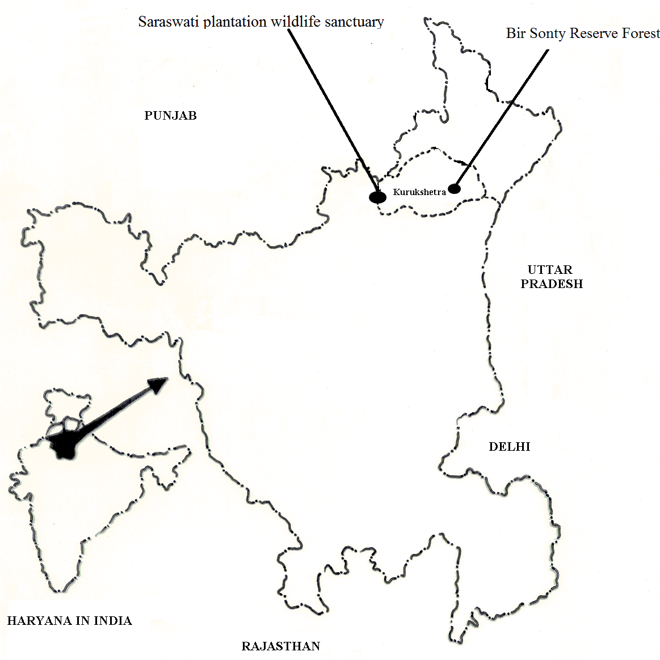
(a)

(b)

(c)

(b)
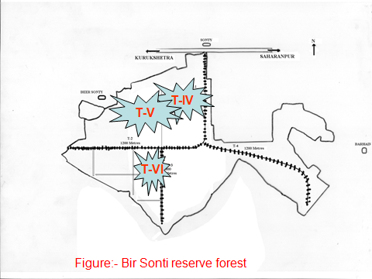
(c)
Fig. 1 (a) Map showing position of study sites, Selected three troops of rhesus monkey in (b) Saraswati Plantation Wildlife Sanctuary and (c) Bir Sonty Reserve Forest.

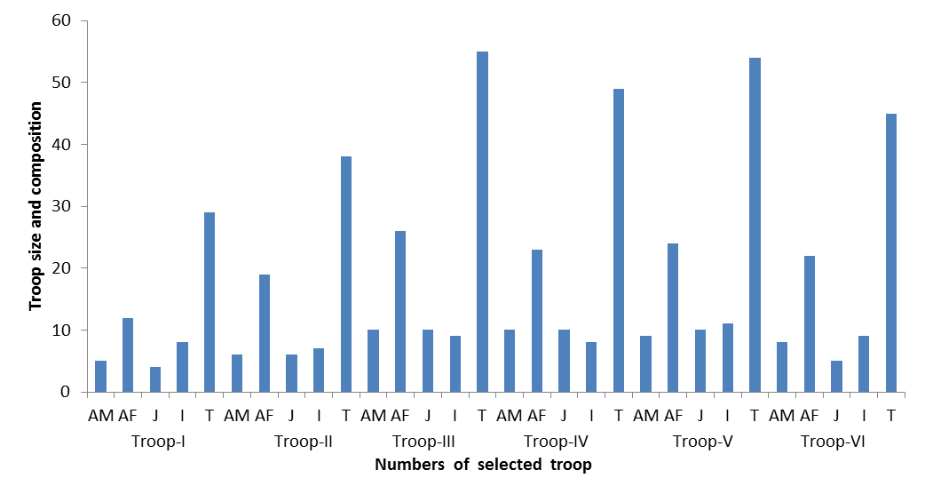
AM- Adult males, AF- Adult females, J- Juveniles, I- Infant, T-total

Fig. 2 Troop size and composition of rhesus monkey at initiation time of study periods in both study sites (Saraswati Plantation Wildlife Sanctuary and Bir Sonty Reserve Forest).

AM- Adult males, AF- 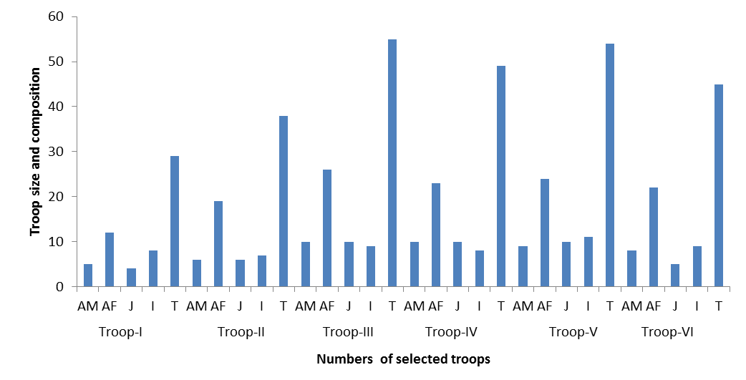Adult females, J- Juveniles, I- Infant, T-tota

Fig. 3 Troop size and composition of rhesus monkey at after completion of study period in both study sites (Saraswati Plantation Wildlife Sanctuary and Bir Sonty Reserve Forest).

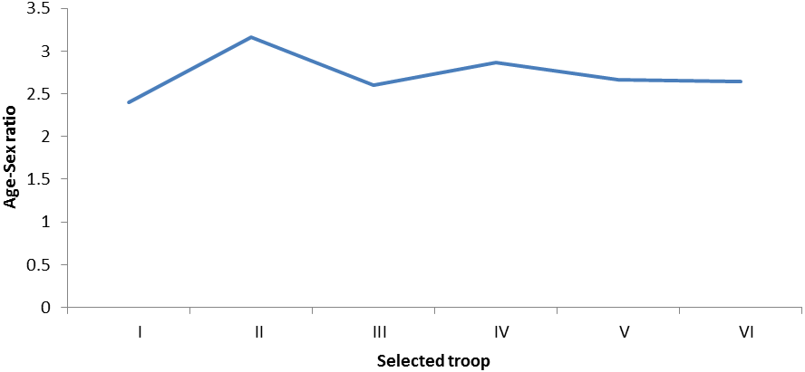
Fig. 4 Age- sex ratio of all selected rhesus monkeys troops in both study sites.

According to Seth et al. (1989) rhesus macaques live in troop of 8 to 180 individuals in diverse habitats such as temple, urban, village, village-cum-pond, pond, road sides, canal sides and in forests with human interactions. Ekwal et al. (2000) have also studied the rhesus monkeys troop in Varindaban (district Mathura, U.P.) and they observed 30 troops of rhesus macaques, comprising 1338 individuals and troop size varied from 14 to 142. In the present study, the troop size of Macaca mullatta varied from a minimum of 25 to a maximum of 49 in Saraswati Plantation Wildlife Sanctuary and from a minimum of 42 to a maximum of 48 in Bir Sonty Reserve Forest. These swelled in number due to addition of newly born individuals in the months of March to the end of July, 2008 and the troop size increased to minimum 29 to maximum 55 in Saraswati forest and minimum 45 to maximum 54 in the Bir Sonty Reserve Forest.
Southwick et al. (2001) observed that the rhesus monkey live in large, multi males and multi females groups and have average size of 10 to 80 individuals/troop. Troop size may be increased up to 100 in mountain areas, area of high human food provided and agriculture areas. Wolf (2002) also compared the troop size and ecology of two different troops of rhesus macaques in Jaipur (Rajasthan). He observed that there are 21 to 87 and 13 to 47 individuals in different troops. Kofard (1996) observed the troop composition of rhesus monkeys 96 males and 100 females in Cynosantigo colony. According to Seth and Seth (1989) rhesus macaques live in large, multi males and multi females troops with an average troop size of 8 to 180 individual regardless of habitat type. Troop may number in hundreds in mountain region and areas of high human food subsidization or agricultural habitats (Lindburg, 1971; Seth and Seth, 1989; Qu et al., 1993; Southwick et al., 1996; Kumar, 2007; Wilson, 2007). In present study troop size of rhesus monkey varied from 25 to 29 in troop-I, 35 to 38 in troop-II, 49 to 55 in troop-III in Saraswati Plantation Wildlife Sanctuary while it is varied from 45 to 49 in troop-IV, 48-54 in troop-V and 42 to 45 in troop VI in Bir Sonty Reserve Forest.
Troop composition is referred to as the number of individuals such as infants, juveniles, adolescents and adults species which is based on age and sex ratio. Santor et al. (2001) represented effect of percentage of sex ratio in troop composition in his stydy areas (Conginition, China). Bercovitch et al. (2003) also observed the troop composition in Sepkufe in north India and observed that during his study period the number of adult males and adult females were same while some change in infants, juveniles and adolescents. Koyama and Shekher (2005) observed that the percentage of adults, sub adults, juveniles and infants with the adults constituted about 58 % of the total population in hanuman langur (P. entellus), however in rhesus monkey (Macaca mulatta), the adults accounted for about 48.3% of the total population. In present study, in Saraswati Plantation Wildlife Sanctuary, in the troop composition number of male and female remained constant during the period of study. The troop composition varied from minimum 25 (5 adult male, 12 adult female, 4 juvenile and 4 infants) to 29 (5 adult male, 12 adult female, 4 juvenile and 8 infants) in troop-I to maximum 49 (10 adult males, 26 adult females, 9 juveniles and 4 infants) to maximum 55 (10 adult male, 26 adult female, 10 juvenile and 9 infants). Similarly, in Bir Sonty Reserve Forest, troop composition varied from minimum 42 (9 adult males, 22 adult females, 5 juveniles and 6 infants) to 45 (9 adult males, 22 adult females, 5 juveniles and 9 infants) of troop-VI to maximum 48 (9 adult males, 24 adult females, 8 juveniles and 7 infants) to 54 (9 adult male, 24 adult female, 10 juvenile and 11 infants) of troop-V.
Jiang et al. (2005) observed that there were about 115 monkeys in 5 natural troops in 1981 while the number of troops increased from 5 to 19 in 1984 and total population increased at rate of 115 to 930 individuals from 1984 to 2005 (approximately 1200 monkeys in 20 troops). The sex ratio of new born in any one year varied from 0.3 to 3.5 males to females. Kumar (2007) has also monitored 32 individuals of rhesus monkey in a troop comprising 5 adult males, 16 adult females, 4 sub adults and 7 juveniles with a female and male ratio of 3:1. In present study, male and female sex ratio varying from 2.40 to 3.16 in six studied rhesus macaques troops. The sex ratio of all the six studied troops varied from a minimum of 2.40 in troop I to a maximum of 3.16 in troop II in both study sites i.e., Saraswati Plantation Wildlife Sanctuary and Bir Sonty Reserve Forest.

Correspondence to:
Ajay Kumar
Department of Zoology, Kurukshetra University,
Kurukshetra-136119, (Haryana) India
Telephone: 01282-320043
Cellular phone: +91-9813077684
E-mail: ajayindorakuk@yahoo.com

References
[1] Barwer M. Daily activity pattern study of rhesus monkey Journal of Animal Behaviour 1971;72(4):165-169.
[2] Bercovitch FB, Widding A, Trifilov A, Kessler MJ, Berard JD, Schmidtke J, Nurnberg P, Krawczak, M. A longitudinal study of age specific body condition among rhesus monkey, Macaca mulatta Nature wissenschaften 2003; 90(4):309-312.
[3] Dagar JC, Singh G, Singh NT. Evalution of forest and fruit tree used for rehabilitation of semiarid alkali-sodic soil in India Journal of Arid land Research and Management 2001;15(2):115-133.
[4] Ferris SD, Sage RD, Page EM. Classification of living macaques in D.G. Lindburg, education the Macaca mulatta studies in ecology, behaviour and evolution Journal of Van- restern- reinhold, Newyork 1980:1-9.
[5] Fooden A. Successful mass translocation on commensal rhesus monkey (Macaca mulatta) in Varindaban, India 2000;6(1):87-93.
[6] Groves RW. How a developing brains gets itself properly wired for adaptive function. In E. to back, L.R. Aronsone and E. Shaw (Eds.) The biopsychology of development New York: Academic Press 2001;6(4):42-43.
[7] Haunger MD. Spontaneous number representation in semi free rhesus monkey, Macaca mulatta Proceed in royal society of London 2004;8(2):267,829-833.
[8] Jiang H, Liu Z, Zhag Y, Southwick C. Population ecology of rhesus monkey (Macaca mulatta) at Nanwal nature reserve Hainan, China American journal of primatology 2005; 25(7):207-217.
[9] Koford CB. Population changes in rhesus monkey: Cyno Santago. 1980-1984 Tulane. Stud. Zool. 1996;13:1-17.
[10] Koyama N, Shekar PB. Geographic distribution of rhesus monkey and bonnet monkeys in west central Asia J. Bomb. Nat. Soc. 2005;78(2):240-255
[11] Kumar S, Rathi RK, Chawla YK, Chakarbirth A. The incident of sporal hepatitis in North India monkey Preliminary state 2007;6(1):1-8.
[12] Lindburg DG. A field study of reproductive behavior of the rhesus monkey, Macaca mulatta. Ph. D. Thesis, University of Calfornia, Berkerly 1965:132.
[13] Lindburg DG. Rhesus monkeys- mating season mobility of adult males 1969;65(2):1176-1178.
[14] Lindburg DG. The rhesus monkey in north India: an ecological and behavioral study; in primate behavior, L.A. Rosenblum (ed.) New York, Academic press 1971;2(4):1-106.
[15] Mukharjee AK, Gupta S. Habits of rhesus macaque, Macaca mulatta 1965.
[16] Mukhergee RP. A Field study on the behavior of two road side groups of rhesus monkeys, Macaca mulatta ( Zimmermann, 1780) in northen Uttar Pradesh. J. Bomb. Nat.His. Soc. 1969;66(1):47-56.
[17] Parkash I. Group organization, sexual behavior and breeding activities of certain Indian monkey Japanese journals of ecology 1962;12(5):83-86.
[18] Qu W, Zhang Y, Manry D, Southwick CH. Rhesus monkeys (Macaca mulatta) in the Taihang Mountains, Jiyvan county, Henan, China Int. J. Primatol 1993;14(4):607-721.
[19] Santor lR, Sulkowski GM, Spaepen GM, Hauser MD. Object individual using property/kind information in rhesus monkey (Macaca mulatta) Conginition 2001;83(11):241-264.
[20] Seth PK, Pokwal NK. Behaviour and ecology of primates. J. Nat. His. Soci. 2001;14(3):172-180.
[21] Seth PK, Seth S. Habitat, resource, utilization, pattern and determinates of behaviour in rhesus monkeys J. Hum. Eco. 1989;11(1):1-21.
[22] Seth PK, Seth S, Shukla AK. Sociobiology of free ranging rhesus monkey. Prospective in primate Biology editions. P.K., Seth 1989:5(1);37-44.
[23] Seth PK, Vipin L, Seth S. Population dynamics of free ranging rhesus monkey in different ecological condition in India Am. Journal of Primatology 1983;5(9):61-67.
[24] Singh M, Sinha A. life history traits: ecological adaptation or phylogenetic relationship? In: Thierry, B., Singh, M., Kaumanns, W. editors. acaque societies: a model for the study of social organization.Cambridge(UK): Cambridge,University, Cambridghe 2004;8(9):80-83.
[25] Singh R. Study of behavioral pattern of age-sex classes during trastional period in free ranging rhesus monkey, Macaca mulatta. Ph. D. Thesis, University of Jaipur, Rajasthan 1981:12-192.
[26] Smith and Mc Donough. Habitat, resources, utilization, pattern and determinates of behaviour in rhesus monkey (Macaca mulatta) J. Hum. Eco. 2005;11(1):1-21.
[27] Southwick CH, Siddiqui ME, Gupta AK. Status, conservation and management of Primates in India ( Dehradun) 2001;1(8):81-91.
[28] Southwick CH, Zhay Y, Hiang H, Lu Z, Qu W. Population ecology of rhesus macaques in tropical and temperate habitat in China. In evolution of macaques society, Cambridge University press, Cambridge 1996:95-105.
[29] Wilson EO. Rhesus monkey (Macaca mulatta)- feeding behaviour and diet of rhesus monkey in Sivalik forest in north India. IUCN red list of threatened species 2007;1(8):1-11.
[30] Wolf, LD. Rhesus macaque: a compressive study of two sites, Jaipur in India and Silver springs, Florida. Cambridge (U.K.), Cambridge university Press 2002;9(4):310-330.

11/12/2011

