A high-throughput microtiter plate based method for the quantitative measurement of cyanogenesis (rate of formation of HCN)

Stephen Abban^{1,2*}, Line Thorsen¹, Leon Brimer²

- Department of Food Science, Faculty of Life Sciences, University of Copenhagen, Denmark
- Department of Veterinary Disease Biology, Faculty of Life Sciences, University of Copenhagen, Denmark
sabban@life.ku.dk, lbr@life.ku.dk

Abstract: Food crops containing cyanogenic glycosides abound in nature and form part of the basic staple for millions of people. Several attempts at devising analytical systems that can be used to measure the cyanogens breakdown rates for instance during detoxifying fermentations of food and feedstuff have been made, but with limited success. The present method is an improvement and modification of some previously developed systems for the quantitative determination of cyanogens. The new methods is a high throughput system allowing both screening of food samples for cyanogen presence and the determination of degrading activity respectively.

[Stephen Abban, Line Thorsen, Leon Brimer. A high-throughput microtiter plate based method for the quantitative measurement of cyanogenesis (rate of formation of HCN). Nature and Science 2011;9(12):64-68]. (ISSN: 1545-0740).

Key words: cyanogenesis, cyanogenic glycosides, quantification, screening, microtiter plate

1. Introduction
Cyanogenic glycosides (CG’s) are widely spread toxicants, known to be present in over 2650 plant species of which several are important to human and animal nutrition and health (Bak et al, 2006). Major food varieties that have these toxicants in significant amounts include cassava, lima beans, sorghum, apricots, almonds and plums. Their toxigenic potential stems from their ability to release hydrogen cyanide (HCN) on hydrolysis at processing or after consumption of the CG of the containing foods (Vetter, 2000).
Several authors have worked on systems to screen for and quantify cyanogenic glycosides in food and feedstuff, many based on the picrate reaction system which produces a colour reaction between picric acid and HCN in the presence of carbonates (Guignard, 1906; Bradbury, 2006; Drochioiu et al, 2008). Brimer et al. (1993) described a system for screening the ability of selected microbes to degrade amygdalin; this method was at best semi-quantitative. However, Brimer (1994) also described a method for quantitative solid-state detection of these cyanogens. Though this method works well, specific test racks need to be made for the test, and having full control of reaction proceedings is quiet cumbersome. It also limits the number or amounts of samples that can be examined at a time.
We describe here a system using microtiter plates, as for Brimer et al. (1993), but which employs temperature control and other steps to allow for both quantification of the amounts of cyanogens present in a sample, as well as the rates of breakdown by glycosidases. The method can also be used for screening the ability of microbes to breakdown cyanogens.

2. Materials and Methods

2.1 Material
Picrate reagent sheets for detecting evolution of HCN in cyanogenesis assay were made according to Brimer et al. (1993). Pre-coated ion-exchange sheets (Poly-ionex 25-SB-Ac, Machery-Nagel, Germany) were impregnated by immersion (plastic side up) in saturated picric acid aqueous solution, followed by blotting on absorbent paper and allowing to air-dry. The sheets were then immersed in 1M Na₂CO₃, followed by blotting and allowing to air dry. The sheets were then cut out into 12cm × 8cm pieces (dimensions of a 96-well microtitre plate), each piece wrapped in aluminium foil and stored in a cardboard-made container at 5ºC until ready to be used.
The following were also prepared for the cyanogenesis assays (Brimer et al, 1993): 2mM aqueous solution linamarin (Sigma, L-9131), 2mM aqueous solution amygdalin (Sigma, A-6005), Sørensen’s buffer (66mM, pH 6.0) (Gomori, 1955), 0.4M phosphoric acid solution (Fluka) and 1M sodium hydroxide solution. All chemicals not further described were of analytical grade.

  - Procedure
2.2.1 Standard curve for amygdalin (glycosidase breakdown)
The following solutions of amygdalin were prepared: 1.0, 0.5, 0.2, 0.1, and 0.05mM. These were placed in each second row of a microtitre plate in 20µl amounts. A volume of 180µl of Sørensen’s buffer was added to each reaction well, followed by addition of 20µl of 5g/l solution of β-glucosidase solution (Sigma G-0395, Sigma-Aldrich, USA) using a multichannel pipette. A picrate sheet was quickly placed on it, with appropriate weight and the setup was incubated at 30ºC overnight. The picrate sheet was then dried, wrapped in aluminium foil and stored at 5ºC in the dark until ready for analysis.
The reaction spots were scanned with a standard office scanner and analyzed densitometrically using the Quantiscan® software (Biosoft, UK), as by Brimer (1994). The spread results generated were imported into and analyzed with Microsoft Excel and plotted to obtain a standard curve relating spot intensity to amount of cyanogen originally present. It is assumed that the breakdown is complete since the β-glucosidase was in excess and maximum reaction time was allowed.

2.2.2 Quantifying the breakdown rates for a commercial enzyme and degrading microbes
The following solutions of β-glucosidase respectively, were prepared: 60mg/l, 20mg/l and 6.7mg/l. On each second row of a microtitre plate (on the shorter 8cm end), 20µl of the enzyme solution were placed in corresponding mapped wells (8 repetitions for each concentration). This was followed by addition of 180µl of Sørensen’s buffer. A multichannel pipette was used to quickly deliver 20µl of 2mM amygdalin solution into each of the test wells, the plate quickly covered with a picrate sheet and a timer started simultaneously. The set up with appropriate weight was then incubated at 30ºC. Negative control wells contained 200µl of buffer and 20µl of amygdalin solution.
Four such reaction plates were done with reactions being stopped after 10 minutes, 30 minutes, 1 hour and 2 hours, by removing from incubation and quickly placing the plate between 2 cooling element frozen at -80ºC overnight, for 5 minutes. A volume of 20µl 1M NaOH was added to each reaction well via use of a multichannel pipette after opening up the picrate sheet which had been hinged to the edge of the plate with adhesive tape (ensures sheet falls to the same position when reaction is continued). The plate was then placed on an orbital shaker with rotation at 100rev/min for 5 minutes to allow mixing of the base which further ceases the reaction by raising the pH of each well to 11. When the well contents had sufficiently thawed, 20µl of 0.4M of H₃PO₄ solution was added to each reacting well (brings pH back to about 6 and allows CN- to be converted to HCN) and the picrate sheets was immediately placed back on the plate. The set up was allowed to stand at room temperature overnight. The picrate sheets were then dried, wrapped in aluminium foil, and stored at 5ºC until ready for analysis.
Kinetics assays similar to that done above with commercial β-glucosidase replaced by cell suspension of Bacillus spp. strains containing 1µg wet weight of cell pellet per µl of Sørensen’s buffer were made. The strains were obtained from the freeze collection at the Department of Food Science, University of Copenhagen and treated as follow: strains were first grown on BHI agar overnight. Single colonies were inoculated into 15ml of BHI broth in a 50ml volumetric flask with metal capping and incubated in a water bath at 30ºC with aeration at 120 rpm (GFL 1083, GFL GmbH) for 24 hr. Ten ml of the resulting culture was centrifuged at 3900×g for 10 min at 5ºC, supernatant discarded and pellets washed twice with Sorensen’s buffer to obtain the wet pellets used.
The reaction spots from these assays were scanned and analysed densitometrically using the Quantiscan software (Biosoft, UK), followed by analysis as above.

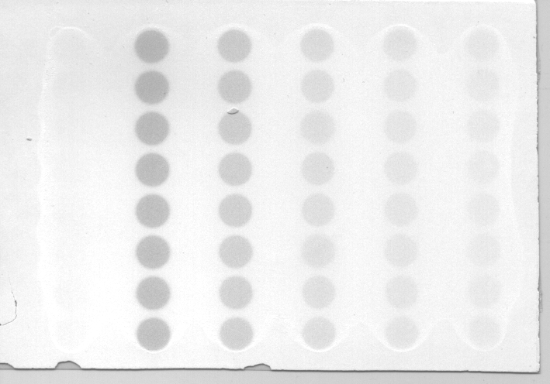
0.0 20.0 10.0 5.0 2.0 1.0
Figure 1: Image of picrate sheet used for standards analysis; indicated values are standard concentrations of amygdalin used (in nmol).

3. Results and Discussion
The Quantiscan analysis maps the lanes of spots and returns a net area, which is proportional to the intensity of the spot. Figure 1 is the gray scale image of a sheet used in quantifying the degradation of standard amounts of amygdalin. The increase in spot intensity with increase in cyanogen concentration is obvious. The corresponding standard curve, fitted to the average and deviations plot is shown in figure 2. This curve can thus be used to read-off or calculate the ‘amygdalin equivalent’ of cyanogens present in a sample within the limits of the curve. The curve was thus used for that purpose for the proceeding quantifications.

Figure 2: Plot of amounts of amygdalin used in standards versus the ‘net area’ scores from Quantiscan® analysis (n=8).

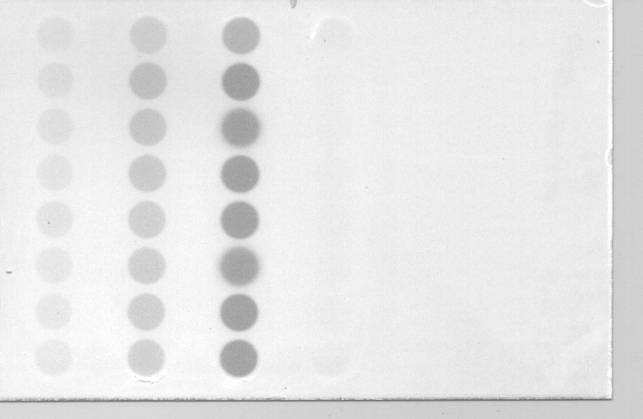
6.7 20.0 60.0 0.0
Figure 3: Image picrate sheet for kinetic analysis for reaction stopped after 1hour of incubation; indicated figures are concentrations of β-glucosidase solutions used (in mg/l).

C43 C45 C46 C13 F32 F21 NEG
Figure 4: Image of picrate sheet from kinetic reaction analysis for Bacillus strains after 3 hours incubation).

The gray scale images of one of the time points each for both the commercial β-glucosidase and the assayed Bacillus spp. are shown in figures 3 and 4 respectively.
For the same period of incubation, the effect of higher glucosidase concentration on breakdown is clear. The amounts of substrate broken down in the given time are read-off figure 2 using the net area scores from the spot analysis. The plot of this with time for the commercial enzyme (20mg/l concentration) is shown in figure 5. From the equation of the fitted line, the enzyme rate is 0.082nmol/min of amygdalin or 4.94nmol/hr, for the chosen experimental conditions.

Figure 5: Plot of calculated amount of amygdalin broken down per minute by the 20mg/l β-glucosidase experiment (n=8).

For the Bacillus assay, equimolar amount of linamarin (present in the cyanogenic food commodity cassava) were used as the cyanogen, as some of the strains were known from previous works (Abban et al, unpublished) to be substrate specific. The average net area from the Quantiscan analysis and corresponding amounts of cyanogen broken down for one time point (3 hour incubation; as in figure 4) are shown in table 1. Strain C13 had been shown from later screening (Abban et al, unpublished) to not have cyanogen degrading activity, so the results are consistent. Strains C45 and F32 are the most active at cyanogens breakdown for the given conditions.

Table 1: Calculated amounts of linamarin broken down by 10⁻³mg/µl (wet weight) cell suspension after 3 hours incubation
Microbial strain | C43 (n=3) | C45 (n=4) | C46 (n=4) | C13 (n=4) | F32 (n=4) | F21 (n=4)
Net area (Average) | 408.29 | 479.90 | 248.41 | 84.08 | 472.59 | 321.85
Standard deviation | 22.26 | 24.25 | 7.76 | 8.78 | 44.97 | 57.30
Amount of amygdalin equivalent broken down and reaction rates
Average amounts (nmol) | 3.61 | 6.29 | 0.09 | 2.45 | 6.45 | 5.09
Breakdown rates (nmol/hr) | 1.20 | 2.10 | 0.03 | 0.82 | 2.15 | 1.70

The information that can be obtained from this system can be very instructive. Cyanogen contents of large sets of samples of food or other materials can be determined within a short period, with some optimizations. The breakdown rates of cyanogens during various fermentations of cyanogenic crops such as cassava (Padonou et al, 2009; Amoa-Awua, Jakobsen, 1995) can also be followed. To this end the contributions of different microbial strains to the detoxification process of such crops in fermentation can be done more accurately at reasonable cost in short periods. This could also be the starting point for screening for microbes with the ability to produce such degrading enzymes, which can then be scaled up industrially (Schallmey et al, 2004).

Correspondence to:
Stephen Abban
Department of Food Science, Faculty of Life Sciences, University of Copenhagen, Rolighedsvej 30, 4th floor, DK-1958 Frederiksberg C, Denmark.
Telephone: +45 35 33 32 93
Fax: +45 35 33 32 14
Emails: sabban@life.ku.dk; lbr@life.ku.dk

References
- Amoa-Awua WKA. The dominating microflora and their role in the fermentation of ‘agbelima’ cassava dough. Ph.D thesis, University of Ghana, 2006.
- Amoa-Awua WKA, Jakobsen M. The role of Bacillus species in the fermentation of cassava. Journal of Applied Bacteriology, 1995; 79, 250–256.
- Bak S, Paquette SM, Morant M, Morant AV, Saito S, Bjarnholt N, Zagrobelny M, Jørgensen K, Osmani S, Simonsen HS, Perez RS, van Heeswijck TB, Jørgensen B, Møller BL. Cyanogenic glycosides: a case study for evolution and application of cytochromes P450. Phytochemistry Review, 2006; 5, 309–329.
- Bradbury JH. Simple wetting method to reduce cyanogen content of cassava flour. Journal of Food Composition and Analysis, 2006; 19(4), 388-393.
- Brimer L. Quantitative solid-state detection of cyanogens: from field test kits to semi-automated laboratory systems allowing kinetic measurements. Acta Horticulturae (Wageningen), 1994; 375, 105–116.
- Brimer L, Tuncel G, Nout MJR. Simple screening procedure for microorganisms to degrade amygdalin. Biotechnology Techniques, 1993; 7, 683–687.
- Drochioiu, G., Arsene, C., Murariu, M. & Oniscu, C. Analysis of cyanogens with resorcinol and picrate. Food and Chemical Toxicology, 2008; 46, 3540–3545.
- Guignard ML. Chemie Vegetale.-Le Haricot a acide cyanohydrique, Phaseolus lunatus L. Comptes Rendues hebdomadaires des Seances de l’Academie des Sciences, 1906; 142, 545-553.
- Gomori, G. Preparation of biological buffers. Methods of Enzymology, 1, 1955; 138-145.
- Padonou SW, Nielsen DS, Hounhouigan JD, Thorsen L, Nago MC, Jakobsen M. The microbiota of lafun, an African traditional cassava food product. International Journal of Food Microbiology, 2009; 133, 22-30.
- Schallmey M, Singh A, Ward OP. Developments in the use of Bacillus species in industrial production. Canadian Journal of Microbiology, 2004; 50, 1-17.
- Vetter J. Plant cyanogenic glycosides. Toxicon, 2000; 38, 11-36.

11/2/2011

