Dietary Items and Feeding Habits of Sompat Grunt Pomadasys jubelini (Cuvier, 1830)

Fatimat Adenike Adebiyi *

Department of Marine Science, Faculty of Science, University of Lagos, Akoka, Yaba, Lagos, Nigeria.

adebiyi_fatima@yahoo.com

Abstract: Investigation on dietary items and feeding habits of the sompat grunt Pomadasys jubelini off Lagos coast, Nigeria was carried out in order to identify the dietary items of P. jubelini and determine its feeding habits. The analysis of stomach content was done by numeric, occurrence and volumetric methods. The results showed that the dietary items of P. jubelini were molluscs, crustaceans, fish, annelids and algae. P. jubelini had molluscs and crustaceans as the main dietary items which accounted for 44.0% and 41.1% by number, 53.2% and 72.7% by occurrence and 32.0% and 48.6% by volume respectively. P. jubelini is a non-piscivorous predatory fish which feeds mainly on other macroscopic animals other than fish. This information will contribute to existing knowledge of the fish biology of P. jubelini with particular reference to feeding and will be useful for aquaculture and fishery management of P. jubelini.
[Fatimat Adenike Adebiyi. Dietary Items and Feeding Habits of Sompat Grunt Pomadasys jubelini (Cuvier, 1830 Nature and Science 2011;9(12):69-75]. (ISSN: 1545-0740). http://www.sciencepub.net

Key words: dietary items, feeding habits, Lagos coast, Pomadasys jubelini, sompat grunt, stomach content.

1. Introduction
Pomadasys jubelini is a common fish species in the Nigerian coastal waters. It belongs to the family Haemulidae and is among the economically important fish species for artisanal and trawl fisheries of the coast of Nigeria. It serves as source of food for man especially those living along the coast. It is a demersal fish species that inhabits sandy, muddy bottoms of coastal waters and can be found at depths below 100m. It is mostly found in tropical brackish or marine waters and can also be found in freshwaters (Roux, 1986; Roux, 1990; Schneider, 1990). P. jubelini is widely distributed in the Eastern Atlantic Ocean from Mauritania to Angola (Smith and Mc Kay, 1986).
Aside fisheries, information on dietary items and feeding habits of fish species is relevant for aquaculture. Feeding habits and food studies of fish emphasise the food habit and type of food which forms fish diet (Kume et al. (1999) and Hajisamaea et al. (2003) noted that information of feeding habit of a fish community is necessary for understanding the feeding ecology of the fish community. Trophic relationships in the aquatic ecosystem could be identified through information on natural feeding of fish (Abdel-Aziz and Gharib, 2007).
Generally, information on particular dietary items that fish consume and the feeding habit is known through the study of dietary items and feeding habits. Also, preference for dietary items when there is food competition among fish species in a fish community could be known in the aquatic ecosystem.
Dietary items and feeding habits of some fish species off the Lagos coast have been reported by some authors (Kusemiju et al., 1979). Information on dietary items and feeding habits of P. jubelini off Lagos coast is scarce. As a result of this paucity of information, the aim of this study was to fill this void in knowledge by investigating the dietary items and feeding habits of P. jubelini in Nigerian coastal water off the Lagos coast by identifying the dietary items and their abundance, as well as seasonal variation in dietary items during the study period. It is hoped that this study will enhance our knowledge of the trophic structure of fish community in the Nigerian coastal ecosystem and contribute valuable information which is necessary for successful fishery management and aquaculture of P. jubelini.

2. Materials and methods
2.1. Study area
The Lagos coast was the study area for this research. It is a narrow coastal shelf and lies between 14, 816km and 27,780km with a total area of 41,000km². The Nigerian coastline is between longitude 02° 53¹ to 08° 14¹E and latitude 06° 21¹ to 03° 55¹N, covering a distance of 85km and lies in between the Gulf of Guinea. It is a marine environment and salinity is a major limiting factor to the growth of some organisms in the Lagos coast. (FAO, 1969; Nwankwo and Onyema, 2003). Figure 1 shows the Lagos coast.

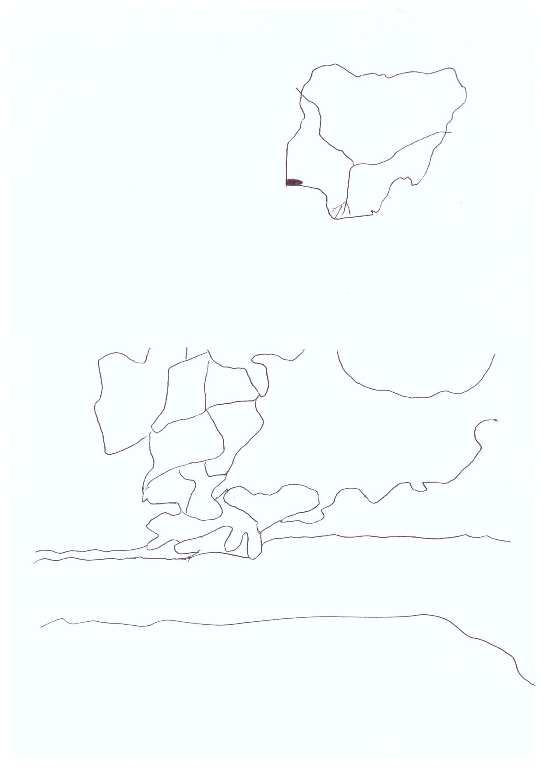
NIGERIA
LAGOS
STUDY AREA
LAGOS LAGOON
ATLANTIC OCEAN
BADAGRY CREEK
LAGOS HARBOUR
SURULERE
OSHODI -ISOLO HARBOUR
LAGOS
MAINLAND
VICTORIA ISLAND HARBOUR
ISLAND
LAGOS IKOYI
AJEGUNLE
MUSHIN
SHOMOLU
APAPA
N
SCALE: 1: 500,000

Figure 1. Map of Lagos showing the Lagos coast. Inset: Map of Nigeria showing the study area

2.2. Collection of specimens and sampling
Specimens of P. jubelini were purchased from fish mongers at the landing centre of trawlers fishing off the Lagos coast, at the jetty in Ijora Olopa, Lagos, Nigeria. The specimens were collected from January to September 2005. The fish was identified by using the FAO fish identification manual (FAO, 1981). Fifty samples were randomly selected each month, making a total of 450 samples collected during the study period. The samples were transported to the research laboratory and preserved in a deep freezer at -20°C until examination and analysis.

2.3. Morphometric measurements
The specimens were brought out of the deep freezer and allowed to thaw and the body length and weight were measured. Total and standard lengths were measured using a one-meter measuring board graduated in cm. The fish was wiped with a dry napkin before weighing and body weight was measured using a weighing balance (Sartorius model).

2.4. Stomach content analysis
After measurements were taken, each specimen was dissected and the stomach was removed. Fullness of stomach was determined as 0/4 for empty stomach, 1/4 for quarter full, 2/4 for half full, 3/4 for three-quarter full and 4/4 for full stomach. The stomach contents were emptied into a Petri dish containing little amount of water which loosen up the materials for easier identification and estimation of number of organisms which were made under a monocular microscope. The contents were identified to the species level where possible and analyzed by numerical, occurrence and volumetric methods according to Bagenal (1978).

2.5. Numerical method
The number of each type of food items in each stomach was counted and expressed as a percentage of the total number of all food items found in the stomach. This method shows the dietary items occurring in the largest number

2.6. Occurrence method
In this method, the number of stomach in which each food items occurred was counted and expressed as a percentage of the number of stomach containing food. This method provides information on the various types of food organism the fish fed upon.

2.7. Volumetric method
This method involved measurement of the volume of stomach and contents directly after dissection and the contents emptied into a Petri dish. The volume alone was measured to obtain the total volume of food items by subtraction. The volume of the different food items was then expressed as a percentage of the total volume of all food items. This method shows the bulk relationship of the different food items.

2.8. Determination of diet importance
The importance of dietary items was determined by using index of relative importance (IRI). This was calculated according to Cortes (1997) as follows:
IRI = (N + V) X O
Where IRI = Index of relative importance, N= percentage of a certain food organism, V= percentage of food volume, O = Percentage of frequency of occurrence of food.

3. Results
3.1. Food habits
3.1.1. Empty stomach
In P. jubelini 40 out of 450 (8.9%) specimens examined had empty stomach. The monthly percentage of empty stomach is illustrated in Figure 2. The percentage of empty stomach was high in April and August for B. auritus (24%).

3.1.2. Dietary items
The dietary items of P. jubelini are shown in Table 1. Analysis of stomach content of P. jubelini showed that molluscs accounted for 44.0% by number, 53.2% by occurrence and 32.0% by volume, while crustaceans accounted for 41.1% by number, 72.7% by occurrence and 48.6% by volume. Other food items were fishes which accounted for 7.3% by number, 22.7% by occurrence and 10.0% by volume. Annelids accounted for 0.4% by number, 8.3% by occurrence and 5.1% by volume. Algae accounted for 5.1% by number and 3.4% by occurrence. Detritus and unidentified mass accounted for 72.0% and 85.1% by occurrence, respectively. Sand grains were also present in the stomach of P. jubelini.

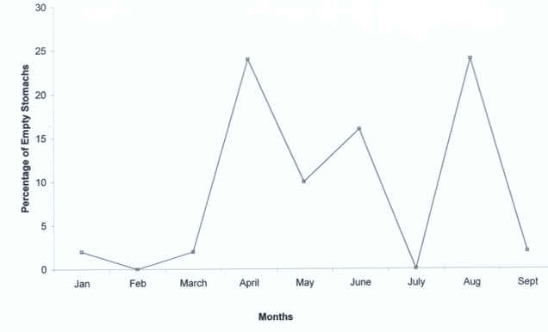

Figure 2. Monthly percentage of empty stomachs of Pomadasys jubelini off Lagos coast

3.1.3. Relative importance of dietary items
Table 2 shows the relative importance of dietary items of P. jubelini off the Lagos coast.

3.1.4. Seasonal variation in dietary items
The seasonal variation in dietary items was determined by the numerical monthly variation in food items of P. jubelini. The seasonal variation of dietary items of P. jubelini is illustrated in Figure 3. Molluscs and crustaceans were the most prominent dietary item, followed by fish and then algae in the dry and wet seasons. Annelid was the least prominent dietary item in both seasons.

4. Discussion
P. jubelini in the Lagos coast were feeding well. This was indicated by the relatively low percentage of empty stomach which was observed in this study. In this study, 40 out of 450 (8.9%) fish had empty stomach. A lower percentage (7%) of empty stomach was reported for P. jubelini by Ugwumba (1988). Although the sample size of fish used was lower than that used for this study.
The dietary items of P. jubelini showed that it is a non- piscivorous predatory fish. This is because molluscs and crustaceans formed the major diet, which is a characteristic of non-piscivorous feeders that feed mainly on other macroscopic animals apart from fish as their main dietary item.
The dietary items of P. jubelini that was found in this study were similar to those found in P. jubelini in Namibia by Bianchi et al. (1993). They reported that it fed on fish, benthic organism, crustaceans, molluscs and worms. Ugwumba (1988) reported that P. jubelini is a non-piscivorous predatory fish that fed mainly on molluscs and crustaceans. This was in conformity with the results obtained in this study.
P. jubelini from creeks in Aiyetoro in Ondo state and Ibeno in Cross river state, Nigeria fed mainly on white shrimp Nematopalaemon sp., penaeid prawn, hermit crab, and polychaete worm. Amphipod, green algae (Spirogyra sp.), gastropod shell and insect wings were present in the stomach of P. jubelini (Ugwumba, 1988). Similar dietary items were found in the stomach of P. jubelini examined in this study. However, amphipod, green algae and insect wings were not present. In this study, sand grains were found in the stomach of P. jubelini. Ugwumba (1988) also encountered sand grains in the stomach of P. jubelini.
According to Ugwumba and Kusemiju (1994), P. jubelini in Lekki lagoon, Nigeria fed on plant materials, invertebrates and fish. The dietary items were similar to those found P. jubelini in the Lagos coast. However, plant materials were not present in the stomach of P. jubelini in this study.
Dietary items of bastard grunt Pomadasys incisus were crustaceans, benthic and planktonic organism which included decapods (shrimp, lobsters and crabs), amphipods, bivalves, echinoderms, polychaetes and euphausiids (Fehri-Bedoui and Gharbi, 2008).

Table 1: Dietary items of Pomadasys jubelini off Lagos coast
Dietary items | Numerical method |  |  |  | Occurrence method |  |  |  | Volumetric method
 | Number |  | Percentage |  | Number |  | Percentage |  | Number |  | Percentage
Mollusca:  Aloidis trigona  Tympanotonus fuscatus  Bivalve shells  Crustacea:  Shrimp  Shrimp appendages  Hermit crab  Crab appendages  Copepod  Isopod  Fishes:  Fish  Fish flesh  Fish scale  Fish bone  Fish eggs  Annelida:  Nereis sp.  Algae:  Algal filaments  Sand grains  Detritus  Unidentified mass |  | 640  13  13,555  63  9739  76  3454  611  4  3  779  385  403  822  119  1634  -  -  - |  | 2.0  0.0  42.0  0.2  28.1  0.2  10.7  1.9  0.0  0.0  2.4  1.2  1.2  2.5  0.4  5.1  -  -  - |  | 37  9  172  40  121  42  79  14  2  3  24  20  36  10  34  14  37  295  349 |  | 9.0  2.2  42.0  9.8  29.5  10.2  19.3  3.4  0.5  0.7  5.9  4.9  8.8  2.4  8.3  3.4  9.0  72.0  85.1 |  | 37.8  7.0  124.2  52.7  82.3  44.5  61.6  8.2  2.0  1.8  14.9  10.8  21.0  4.9  27.2  -  17.3  -  - |  | 7.2  1.3  23.5  10.0  17.5  8.4  10.7  1.6  0.4  0.3  2.8  2.0  4.0  0.9  5.1  -  3.3  -  -

Table 2: Relative importance of dietary items of P. jubelini off the Lagos coast
Dietary items | Percentage number (%) | Percentage of occurrence (%) | Percentage volume (%) | IRI
Molluscs  Crustaceans  Fish  Annelids | 44.0  41.1  7.3  0.4 | 53.2  72.7  22.7  8.3 | 32.0  48.6  10.0  5.1 | 4043.20  6521.19  392.71  45.65

In this study, the dietary items of P. jubelini were also among those reported for Pomadasys incisus. However, P. jubelini did not feed on amphipods, echinoderms and euphausiids.
Investigations on the important dietary items revealed that molluscs and crustaceans were the main dietary items of importance. This inference was based on the result of the index of relative importance of dietary items of P. jubelini. In this study the dietary items that had no value for percentage number and percentage volume were not considered for evaluation of index of relative importance, this was to give a fair and unbiased result of the important dietary items.

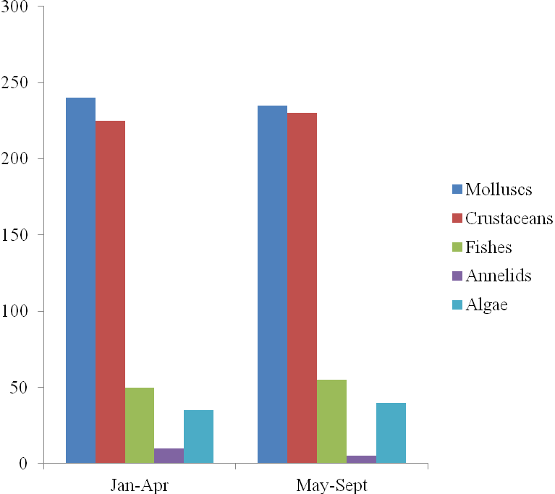
Percentage
number (%)
Months

Figure 3. Seasonal variation in dietary items of P. jubelini

Molluscs and crustaceans were the most prominent dietary item of P. jubelini followed by fish and algae in the dry season (January – April) and wet season (May – September). Annelids were the least prominent dietary item in both seasons. The prominence of dietary items was similar in both seasons, and this indicated that there was no variation in the dietary item and feeding habit of P. jubelini in the dry and wet season. It can be deduced that changes in season had no effect on the dietary items and feeding habit of P. jubelini in the Lagos coast. Further research is needed to study the effect of seasonal variation on the dietary items and feeding habit of P. jubelini.

5. Conclusion
P. jubelini is a non-piscivorous predatory fish that feeds on mollusc, crustaceans, fish, annelid, and algae. The important dietary items are molluscs and crustaceans. This study is significant for fish biology as well as fisheries management and aquaculture of P. jubelini.

Acknowledgements:
The academic assistance of Dr. Ugwumba, A. A. A during this study and the provision of laboratory facilities by the Department of Marine Science, University of Lagos used in this study are gratefully acknowledged.

Correspondence to:
Fatimat Adenike Adebiyi
Department of Aquaculture, Faculty of Agriculture, Universiti Putra Malaysia. 43400 UPM Serdang, Selangor, Malaysia.
Telephone: +60133325064
Fax: +60389464102
E-mail: adebiyi_fatima@yahoo.com

References
[1] Roux C. Pomadasyidae. In: Daget P, Gosse JP, Thys Van Den Audenaerde DFE, eds. Checklist of the freshwater fishes of Africa (CLOFFA). ISNB, Brussels: MRAC. 1986: 327-330.
[2] Roux C. Haemulidae. In: Quero JC, Hureau JC, Karrer C, Post A, Saldanha L, eds. Checklist of the fishes of the Eastern tropical Atlantic (CLOFETA). JNICT, Lisbon, SEI: Paris and UNESCO., 1990: 783-788.
[3] Schneider W. FAO species identification sheets for fishery purpose. Field guide to the commercial marine resources of the Gulf of Guinea. Rome: FAO.1990.
[4] Smith MM, Mc Kay RJ. Haemulidae. In: Smith MM, Heemstra PC, eds. Smiths’ sea fishes. USA: Springer-Verlag, 1986: 564-571.
[5] Kume G, Yamaguchi A, Taniuchi T. Feeding habits of the cardinal fish Apogon lineatus in Tokyo bay, Japan. Fisheries Science. 1999; 65: 1039-1048.
[6] Hajisamaea S, Choua LM, Ibrahim S. Feeding habits and trophic organisation of the fish community in shallow waters of an impacted tropical habitat. Estuarine and Coastal Shelf Science. 2003; 58: 89-98.
[7] Abdel-Aziz NE, Gharib SM. Food and feeding habits of round sardinella (Sardinella aurita) in El-Mex bay, Alexandria, Egypt. Egyptian Journal of Aquatic Research. 2007; 33: 202-221.
[8] Kusemiju K, Olaniyan CIO, Garba EO. Food habits and sex ratio of the big eye Brachydeuterus auritus (Valenciennes, 1831) off Lagos coast, Nigeria (Pisces, Pomadasyidae. Bulletin de l’institut Francais d’Afrique Noire. 1979; 41A: 863-874.
[9] FAO. Fisheries survey in the Western and Mid-Western Regions, Nigeria. Rome: FAO. (FAO/SF: 74 NIR 6). 1969.
[10] Nwankwo DI, Onyema IC. A checklist of planktonic algae off Lagos coast. Journal of Scientific Research and Development. 2003; 9: 75-82.
[11] FAO. Species identification sheets for fishing purpose, Eastern central Atlantic. Field guide to the commercial marine resources of the Gulf of Guinea. 1981; 3: 99-102.
[12] Bagenal TB. Methods of assessment of fish production in freshwater. Oxford: Blackwell scientific publication. 1978.
[13] Cortes E. A critical review of methods studying fish feeding based on analysis of stomach contents: Application to Elasmobranchs fishes. Canadian Journal of Fisheries and Aquatic Sciences. 1997; 54: 726-738.
[14] Ugwumba AAA. Food and feeding habits of juveniles of some culturable fish species in Nigeria. NIOMR Technical Paper. 1988; 31:1- 24
[15] Bianchi G, Carpenter KE, Roux JP, Molloy FJ, Boyer D, Boyer HJ. FAO species identification field guide for fishery purposes. The living marine resources of Namibia. Rome: FAO. 1993.
[16] Ugwumba AAA, Kusemiju K. The food and feeding habits of the non-cichlid fishes in the Lekki lagoon, Nigeria. Nigerian Journal of Science. 1994; 28: 351-368.
[17] Fehri-Bedoui R, Gharbi H. Sex ratio, reproduction and feeding habits of Pomadasys incisus (Haemulidae) in the Gulf of Tunis (Tunisia). Acta Adriatica. 2008; 49: 5-19.

11/10/2011

