Effects of nonsteriodal aromatase inhibitor in sex reversal of Nile Tilapia (Oreochromis niloticus)

Eleraky Wafaa, Refat Nahla*, Abd Ellatif Mohamed**, Tahia Ahmed*** and Khedr Nasser***

Nutrition and Clinical Nutrition Dept., Pathology Dept.*
** Animal Wealth Development Dep., Faculty of Veterinary Medicine, Zagazig University
*** Nutrition and Clinical Nutrition Dept, Faculty of Veterinary Medicine, Benha University

Abstract: In the present study, we investigate the efficacy of Fadrozole, a potent nonsteriodal aromatase inhibitor (AI) incorporated into the feed on sex reversal (Monosex population) of Nile tilapia (Oreochromis niloticus). Nile tilapia larvae were classified into eight groups, which fed diets contained different levels of Fadrozole (0, 50, 100, 200 mg/ kg) for 14 and 28 days, starting 7 days after hatching (dph). After 28 days, fries were transferred to tanks (80 liter). Fish were weight at 28 days and after 12 weeks. All growth parameters were calculated. Results of this study revealed that, groups treated with Fadrozole for 14 or 28 days recorded increases the proportion or percentage of males' production than control groups. While the groups fed high levels of Fadrozol (100 and 200 mg / kg) for 28 days produced the highest proportion (95% and 98%) of males' production than for 14 days. There were improvements in weight gain and feed conversion ratio with groups fed diets contained high levels of Fadrozole. The microscopical findings of Fadrozole treated tilapia revealed few numbers of true juvenile hermaphrodite larvae with both gonads. Chromatin nucleolar stages of oocytes were seen next to testicular tissue. The majority of tilapia was differentiated to testes which contained all spermatogenetic cells in the testicular lobules .Some tilapia showed ovary with chromatin nucleolar, perinucleolar and cortical alveoli formation stages of oocyte. The vitellogenic and ripe stages of oocyte were not detected. In conclusion, Fadrozol, nonsteriodal compound induces monosex population of Nile tilapia larvae through suppressing aromatase activity.
[Eleraky Wafaa, Refat Nahla, Abd Ellatif Mohamed, Tahia Ahmed and Khedr Nasser. Effects of nonsteriodal aromatase inhibitor in sex reversal of Nile Tilapia (Oreochromis niloticus). Nature and Science 2011; 9(12):145-150]. (ISSN: 1545-0740). http://www.sciencepub.net.

Key words: Aromatase, Tilapia, Sexual differentiation, Growth.

1. Introduction
All of the tilapia commonly grown for food fish is mouth-breeders. The main problem in tilapia culture is that females grow slower than males; early sexual maturation of females diverts energy from growth to reproduction, uncontrolled reproduction, overcrowding lead to stunt in tilapia growth making them unmarketable. Fish have a bisexual gonad (i.e., the pressure of ovarian and testicular tissues in gonad) in the male phase before they change to females (Lee et al. 2001). All male populations are desirable, because males demonstrate superior growth characteristics compared to females. Moreover, culture of monosex populations prevents reproduction and results in a uniform size. Fadrozole is a nonsteriodal aromatase inhibitor, which binds reversibly to the enzyme and has been shown to reduce estrogen biosynthesis in vivo and in vitro in mammals (Steele et al. 1987), in chicken (Elbrecht and Smith 1992) and in fish (Afonso et al. 1999). Fadrozole has also been shown to influence sex differentiation increasing male production in fish (Kitano et al. 2000). The objectives of this study were to investigate the effect of nonsteriodal aromatase inhibitor on sex reversal and growth performance of Nile tilapia (Oreochromis niloticus) Larvae.

2. Materials and Methods
For fry production, 224 breeding Nile tilapia with average body weight 250-300 gm were stocked in clean concrete ponds (3 X 1 X 1 m), each pond divided into two parts (one third part for fries collection and the other two third part for brood fish) by metal partition with nets of pores 5mm for migration of fries from brood fish. The fish were classified into four groups each group contained 56 fish at a ratio of one male to three females tilapia. The collected fry at 7 days post hatching were divided into eight duplicate groups (60 fry/group) and kept in glass aquaria (30 liter). The daily mean water temperature and dissolved oxygen concentration ( July - August 2011 ) were 27°C ± 2.3°C and 5.4± 0.6 mg/L respectively under constant aeration. For determine the effective different doses of AI Fadrozole (Novartis, summit, NJ), three concentrations (50, 100 and 200 mg/kg diet) were prepared, which mixed with the commercial diet (38.4% C. protein, fat 9.3%, 3233 ME (kcal/kg) and fed to fish larvae for 14 and 28 days, starting 7 days after hatching. After 28 days, fry were transferred to the grow out tanks (80 liter) under the same ecological condition. Fish were weight at 28 days and after 12 weeks. All growth parameters as body gain, specific growth rate (gm and %), feed intake and feed conversion ratio were calculated according to Jauncy and Ross, 1982. The total length will be measured and the condition factor was calculated according to Gjedrem and Gunnes (1978). For evaluation of the health conditions of the fishes during the experiments, escape, defensive, tail and ocular reflexes were regularly observed according to Lucky (1977).
For histological examination of gonads, ten fish from each group (after end the experiment) were randomly sampled and fish gonads were dissected and sexed through microscopic examination using the gonadal sqush method (Guerrero and Shelton, 1974). Sex ratios were determined by examination of in situ (40 x) and squash (100 x) preparations after aceto-iron hematoxylin (Wittman, 1962) Staining. Sex ratio data were analyzed using the chisquare test (Zar, 1984). The obtained data were statistically analyzed for variance ANOVA, LSD (Least significant difference) according to Snedecor and Cochran (1982).

3. Results and Discussion
The present study demonstrates that the aromatase inhibitor Fadrozole supplemented in the diet induces masculinization in Nile tilapia during sexual differentiation period. Nile tilapia ovarian differentiation occurred 23-26 days after hatching (Nakamura and Nagahama 1985).
Table (1) shows the percentage or proportion of males' production. Fish groups fed on AI (Fadrozole) for 28 days started at 7 dph showed high proportion or percentage of males' production than other groups fed Fadrozole for 14 day and control group. The percentages of male production were 35%, 66%, 80% and 84% in the control, 50, 100, 200 mg Fadrozole/kg diet for 14 day respectively. In fish groups treated with 100, 200 mg Fadrozole/kg diet for 28 day recorded the highest percentages of male production (95%, 98%) than other groups. These results revealed that AI (Fadrozol) may inhibit or retard ovarian cavity formation. These results were in agreement with Ze-xia GAO et al., 2010 and Afonso et al., 2001, who found that fish groups treated with Fadrozole (75, 100 mg/kg) increased significantly the males proportion. Fadrozole is a nonsteriodal aromatase inhibitor, which binds reversibly to the enzyme (Steele et al., 1987) and has been shown to reduce estrogens biosynthesis and increased males proportion in fish (Afonso et al., 1999). In the Nile tilapia, Kwon et al., (2000) reported that 500mg /kg AI diet administration from 7 to 37 dph induced 96% males and Afonso et al., 2001 reported 100% males were produced by 30 days of 75 and 100mg/kg AI diet treatment from 9 dph.
The male proportion increased when compared with control group even at the lowest diet dose (50 mg/kg). The most important factors to be considered for inducing sex reversal are the onset time of treatment, the duration, the drug and the dose used (Piferrer 2001). The results of macroscopic and microscopic examination of gonadal tissues correlated with histological analysis. The histological examination at the beginning of the experiment, the gonads of larvae were sexually undifferentiated.
Testes and ovaries in the control fish were structurally distinct. The majority of the testes were fully mature, containing spermatids and spermatozoa (Figs.1&2). Some of testes showed all spermatogenetic cells in tilapia testicular lobules. The microscopical observation in this study revealed different histological structure of each oocyte developmental stage (Fig.3). Chromatin nucleolar stage where the oocyte was small spherical cell containing a central nucleus with one to four nucleoli. Cytoplasm was thin layer and strongly basophilic. Perinucleolar stage with several nucleoli arranged along the inner side of nuclear membrane. Cortical alveoli formation stage which characterized by the appearance of clear vesicles (cortical alveoli) in the periphery of the oocyte cytoplasm. Vitellogenic (yolk) stage where the oocyte size increased besides small yolk granules were visible as a ring of deep eosinophilic in the cytoplasm. Ripe (mature) stage was characterized by the enlargement of both cortical alveoli and yolk granules. The oocyte size markedly increased with peripheral migration of the nucleus was observed. The microscopical findings of Fadrozole treated tilapia revealed few numbers of true juvenile hermaphrodite larvae with both gonads. Chromatin nucleolar stages of oocytes were seen next to testicular tissue (Fig.4). Ze-xia Gao et al. 2010 and Komatsu et al. 2006, reported that, a testis with some oocytes was observed in groups treated with aromatase inhibitor (50 mg/kg), giving it the appearance of having developed from an ovary. The majority of tilapia was differentiated to testes which contained all spermatogenetic cells in the testicular lobules (Fig.5).Some tilapia showed ovary with chromatin nucleolar, perinucleolar and cortical alveoli formation stages of oocyte (Fig.6).The vitellogenic and ripe stages of oocyte were not detected. The treated groups' male and female gonads showed the same pattern as in the control group. These results suggest that the AI inhibits or retards ovarian development in groups treated with high dose for 28 day. Also, Afonso et al., (2001) found similar intersex gonad in the Nile tilapia that received 50 mg/kg AI for 30 days and Komatsu et.al, (2006) recorded the same results with golden rabbit fish which fed 500mg/kg AI diet for 30 days.
Figures (7, 8) show the body weights and body length of fish in different groups at four and eight weeks of the experiment. The figures revealed increase in average body weight and no difference in average body length of fish groups fed Fadrazole for 14 and 28 days in compare with control group.
The results of body weight gains, body length gains, feed conversion rate and condition factor of fish in different groups at end of experiment are summarized in table (2). There were significant differences in body weight gains between different groups. The highest weight gains were recorded for groups fed diets contained 100 and 200 mg/kg Fadrozole for 14 0r 28 days, gps.2, 3 (11.63g , 12.15g) and gps.7,8 (13.54g, 14.26g). The high efficient feed utilization (low Value of feed conversion ratio) was observed with groups fed different levels of Fadrozole.
Our results indicate that the improvements in weight gain and feed conversion ratio were observed with groups fed diets contained high levels of Fadrozole. AI-Qutob and Nashashibi, 2009 found that, there are differences in male versus females growth rates in Oreochromis species, monosex production or even in complete female prevents reproduction and therefore feed energy could be diverted into growth instead of production of unwanted juvenile fish. From the same table, it was clear that, the higher condition factor and a good healthy fish were observed in group 7 (2.82) and group 8 (2.34), while the lowest value was recorded in group 1, 4 (1.67, 1, 74). These results were also supported by Gjedrem and Gunnes (1978) and Shimei et al., (2007), who,s reported that, the higher condition factor indicate the good nutritional state of fish. There was no difference in survival rate between fish groups fed different diets and the macro pathological examination did not reveal any pathological differences in the fish fed different diets. Concerning the evaluation of the health condition of the experimental fish, there were found that no changes in the normal behavior of the fish because the tested fish were able to respond positively to all tested reflexes especially the escape reflex, in which the fish during and at the end of the experiment were able to exhibit normal responses in fish pond. Lucky (1977) reported that sick fish do not react to external agitation and were not able to exhibit normal behavioural responses (lost of reflexes) and therefore can be easily caught by dip net or by hand be course sick fish are not energetic. There were no marked difference in the behavioural responses between the tested fish groups, which received diets contained diets with different levels of Fadrozole and fish of control groups.
The fish reacted rapidly to external agitation so they quickly submerge to greater depth, swim a way from the water Surface and in general their escape movements were energetic and their general healthy condition were good without any changes of the color of the tested fish. In conclusion, the present study demonstrated that inhibition of aromatase activity by AI- Fadrozole could influence sex differentiation in Nile tilapia.

Table (1): Effect of aromatase inhibitor Fadrazole in diet on sex ratios of Nile Tilapia larvae.
Feed for 14 days  start at 7 days (DPh) | groups | Treatment | No.  of Larvae | Male  % | Female  % | Undifferentiated.
Feed for 14 days  start at 7 days (DPh) | 1 | Control | 30 | 35 | 65 | 0
Feed for 14 days  start at 7 days (DPh) | 2 | 50mg (fed./kg) | 30 | 66 | 32 | 2
Feed for 14 days  start at 7 days (DPh) | 3 | 100mg (fed./kg) | 30 | 80 | 19 | 1
Feed for 14 days  start at 7 days (DPh) | 4 | 200mg (fed./kg) | 30 | 84 | 15 | 1
Feed for 28days  start at 7 days (DPh) | 5 | Control | 30 | 50 | 50 | 0
Feed for 28days  start at 7 days (DPh) | 6 | 50mg (fed./kg) | 30 | 68 | 31 | 1
Feed for 28days  start at 7 days (DPh) | 7 | 100mg (fed./kg) | 30 | 95 | 4 | 1
Feed for 28days  start at 7 days (DPh) | 8 | 200mg (fed./kg) | 30 | 98 | 2 | 0
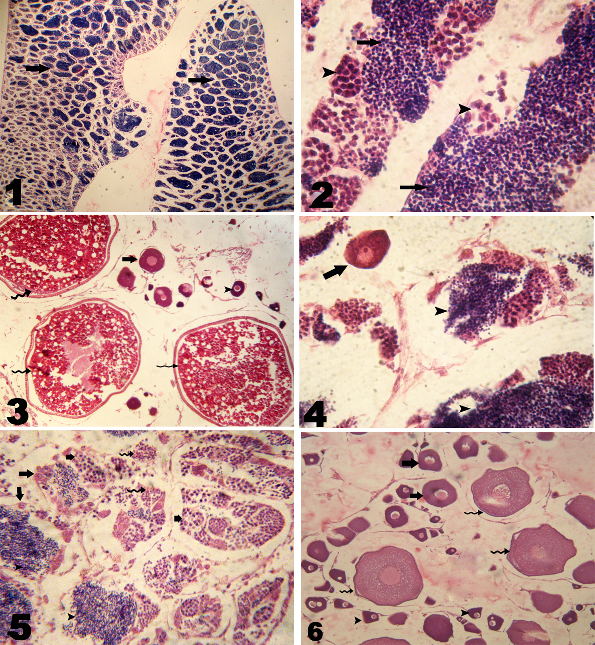
Figs. (1 - 6): Histological structures of the Nile-tilapia gonads:

1- Testis from the control group showing testicular lobules filling with free spermatozoa (arrow), H&Ex150.
  - Testis from the control group showing free spermatozoa (arrow) filling the lumen of all the lobules. Cysts with spermatids (arrowhead) are visible next to the lobules, H & Ex3000.
  - Ovary from the control group showing chromatin nucleolar stage of oocyte (arrowhead) perinucleolar stage of oocyte (arrow) and ripe stage of oocyte with migratory nucleus (zigzag arrow), H&E.x300.
  - Ovotestis from the Fadrozole treated group showing chromatin nucleolar stage of oocyte (arrow) next to testicular tissue (arrowhead), H&E.x3000.
  - Testis from the Fadrozole treated group showing all spermatogenetic cells in testicular lobules: spermatogonia (arrow), spermatocytes (short arrow), spermatids (zigzag arrow) and spermatozoa (arrowhead) released into the lobule lumen, H&E.x1200.
  - Ovary from the Fadrozole treated group showing chromatin nucleolar stage of oocyte (arrowhead) with a big nucleolus in nucleus and deeply basophilic cytoplasm, erinucleolar stage of oocyte (arrow) with several small nucleoli attached to nuclear membrane and cortical alveolar stage of oocyte (zigzag arrow) with perinucleoli attached to the nuclear membrane and cortical alveoli formed at the periphery of the oocyte, H&E.x300.

Table (2): Effect of aromatase inhibitor Fadrazole in diet on growth performance of Nile Tilapia larvae at the end of the experiment
Feed for 14 days | start at 7 days (DPh) | groups | Treatment | mean body  Weight after 12W | mean body  gain (gm) | SGR  %day -1 | DWG  g/day | Feed  intake | Feed  conv. rate | Length  gain (mm) | Cond.  factor | Survival rate%
Feed for 14 days | start at 7 days (DPh) | 1 | Control | 8.09 e  ±0.22 | 8.03e  ±0.22 | 9.561 | 0.096 | 16.43  ±0.09 | 2.05 ^{d}  ±0.07 | 6.38 | 1.66 | 86.7
Feed for 14 days | start at 7 days (DPh) | 2 | 50mg (fed./kg) | 9.47 ^{d}  ±0.165 | 9.40^{d}  ±0.17 | 11.19 | 0.112 | 15.66  ±0.26 | 1.67 ^{bc}  ±0.055 | 5.97 | 2.26 | 86.7
Feed for 14 days | start at 7 days (DPh) | 3 | 100mg (fed./kg) | 11.73 ^{b}  ±0.03 | 11.63^{b}  ±0.025 | 13.85 | 0.138 | 15.91  ±0.09 | 1.36 ^{d}  ±0.005 | 6.65 | 1.96 | 90.0
Feed for 14 days | start at 7 days (DPh) | 4 | 200mg (fed./kg) | 12.25 ^{b}  ±0.275 | 12.15^{b}  ±0.29 | 14.46 | 0.145 | 15.92  ±0.025 | 1.31 de  ±0.030 | 6.82 | 1.91 | 90.0
Feed for 28days | start at 7 days (DPh) | 5 | Control | 9.21 ^{d}  ±0.015 | 9.14^{d}  ±0.015 | 10.88 | 0.109 | 16.27  ±0.29 | 1.78 ^{b}  ±0.030 | 6.57 | 1.74 | 93.3
Feed for 28days | start at 7 days (DPh) | 6 | 50mg (fed./kg) | 10.69 ^{c}  ±0.285 | 10.61^{c}  ±0.285 | 12.64 | 0.126 | 16.11  ±0.011 | 1.52 ^{c}  ±0.050 | 6.75 | 1.71 | 90.0
Feed for 28days | start at 7 days (DPh) | 7 | 100mg (fed./kg) | 13.66 ª  ±0.205 | 13.54ª  ±0.21 | 16.12 | 0.161 | 15.76  ±0.55 | 1.16 e  ±0.055 | 6.05 | 2.82 | 93.3
Feed for 28days | start at 7 days (DPh) | 8 | 200mg (fed./kg) | 14.45 ª  ±0.470 | 14.26ª  ±0.475 | 16.98 | 0.17 | 15.86  ±0.14 | 1.11 ^{f}  ±0.025 | 6.61 | 2.34 | 93.3
^{abcd} Means within the same row with different superscripts are significantly different Mean± SE

Fig. (7): Effect of aromatase inhibitor Fadrazole in the diet on body weight development of Nile Tilapia larvae.

Fig. (8): Effect of aromatase inhibitor Fadrazole in the diet on body length development of Nile Tilapia larvae.

Acknowledgement
This study was done through the project, which was funded from the post graduate studies– sector, Zagazig University. The principal investigator Prof. Dr. Wafaa Eleraky expresses gratitude to this sector for their help and support.

References
- Afonso L.O.B., Smith J, Iwama G.K, Donaldson E.M. (1999): Effects of the aromatase inhibitor Fadrozole on plasma sex steroid secretion and ovulation rate in female coho salmon, oncorhynchus kisutch, close to final maturation. Gen
  - Comp Endocrinol 113:221- 229.
- Afonso L.O.B., Wassermann G.J. & Oloveira R.T.D.: (2001): sex reversal in Nile tilapia (Oreochromis niloticus) using a nonsteroidal aromatase inhibitor. Jornal of Experimental Zoology 290:177- 181.
- AI-Qutob A. Mutaz and Tharwat S. Nashashhibi (2009): The effects of cox- Inhibitors (Diclofenac and Ibuprofen) on growth rate, mortality sex reversal in Nile Tilapia (Oreochromis niloticus) International Journal of the Bioflux Society
- Elbrecht A, Smith R. (1992): Aromatase enzyme activity and sex determination in chickens. Science 255: 467- 470.
- Gjedrem, T. and Gunnes, K.( 1978 ): Comparison of growth rate in Atlantic salmon, Pink salmon, Artic char, Sea trout and Rainbow trout under Norwegian farming condition, Aqua., 13: 135- 141.
- Guerrero R. D. , and Shelton W. L. ( 1974 ) : An aceto-carmine squash technique for sexing juvenile fishes . Progressive Fish Culturist 36:56
- Jauncey, K. and Ross, B. (1982): A guide to Tilapia feeds and feeding. University of Stirling, Institute of Aqua culture, Stirling, Scotland.
- Kwon J.y., Haghpanah V., Kogson-hurtado I.M., McAndrew B.J. & Penman D.J. (2000): Masculization of grenetic female Nile tilapia (Oreochromis niloticus) by dietary andministration of an aromatase inhibitor during sexual differentiation Jornal of Experimental Zoology 287. 46- 53
- Kitano T, Kazufumi T, Nagahama H, Abd S-I. (2000): Aromatase inhibitor and 17α- methyltestosterone cause sexreversal from genetical females to phenotypic males and suppression of P450 aromatase gene expression in Japanese flounder (Paralichthys olivaceus). Mol Reporod Dev 56: 1- 5.
- Komatsu T., Nakamura S. and Nakamura M. (2006): Masculinization of female golden rabbitfish Siganus guttatus using an aromatase inhibitor treatment during sex differentiation . Comparative Biochemistry and Physiology part C 143, 402-409 .
- Lee Y.H, Du J.L, Yueh WS, Lin BY,Huang JD, Lee CY, Lee MF, Lau EL, Lee FY, Morrey C, Nagahama Y, Chang CF. (2001): The sex change in the prolarndrous black porgy, Acanthopogrus schlegeli: a review in gonadal development, estradiol, estrogen receptor, aromatase activity and gonadotropin . J Exp. Zool; 290: 715- 726.
- Lucky, M. (1977): Determining the health condition of fishes, in: Methods for the diagnosis of fish diseases in Amerind publishing Co. Ltd. Newdelhi Bombay, New York.
- Nakamura M, Nagahama Y. (1985): Steroid producing cells during ovarian differentiation of the tilapia, Sarotherodon niloticus. Dev Growth Differ 27:701-708.
- Piferrer E. (2001) : Endocrine sex control strategies for the feminization of teleost fish . Aquaculture197, 229-281 .
- Shimei l., kangsen M. and Beiping, T., 2007: Effects of exogenous enzyme supplementation in diets on growth and feed utilization in Tilapia, Oreochromis niloticus X O . aureus. Aquaculture research, Vol.38, P.1645-1653.
- Snedecor, G.W. and Cochran, W.G. (1982): Statistical methods. 8th Ed., Ames. Lowa State university.
- Steele R.E, Mellor L.B, Sawyer W.K, Wasary J.M, Browne L.J. ( 1987) . In vitro and in vivo studies demonstration potent and selective estrongen inhibition by the nonsteroidal aromatase inhibitor CGS 16949A. Steroids 50: 147- 161.
- Wittman, W. (1962): Aceto-iron hematoxylin for staining chromosomes in squashes of plant material. Stain Technology, 37: 27-30.
- Zar, J.H. 1984: Biostatistical analysis, second edition-prentice and hall Inc. Englewood Cliffs, New Jersey, pp. 62-65.
- Ze-Xia Gao , Ha-Ping Wang, Geoff Wallat, Hong Yao, Dean Rapp, Paul OBryant, Russ MacDonald and Wei-Min Wang (2010): Effects of nonsteroidal aromatase inhibitor on gonadal differentiation of blue sunfish Lepomis macrochirus. Aquaculture Research, 41, 1282-1289.

11/11/2011

