Synthesis of GMA / PVA Cast Membrane Reinforced with Alumina for Fuel Cell Applications

M.M. El-Toony

National center for radiation research and technology, Atomic energy authority, Egypt, Cairo, Egypt
toonyoptrade@yahoo.com

Abstract: This work aims to synthesis low cost new membrane applied for generation of environmentally friends energy via fuel cell. Different ratio of glycidyl methacrylate to polyvinyl alcohol were used for membranes casting. Reinforcement of the membranes was carried out by alumina powdered with ten percent of the mixture cast. Gamma irradiation doses were applied on the cast mixture for compatiblization and finally cross-linking. Chemical properties of the prepared membranes were discussed using FTIR while mechanical characteristics were reviewed by measuring their hardness. Thermal behaviors of the prepared membranes were studied using thermal gravimetric analysis, differential scanning calorimetry (DSC) and morphological structures were investigated via scan electron microscope (SEM). The membranes' water uptake were performed prior to evaluate their ion exchange capacities. The AC impedances were measured with different frequency values. The AC conductivities reached to 5.2 x 10⁻² simon/cm which confirmed the membranes usage in fuel cell applications. Raising up temperature to 80ºc increase the electrical conductivity to 9.6 x 10⁻² simon/cm which exceed that of Nafion by 62%. Chemical stability of the membranes assured their availability for such application.
[M.M. El-Toony Synthesis of GMA / PVA Cast Membrane Reinforced with Alumina for Fuel Cell Applications]. Nature and Science 2011; 9(12):160-172]. (ISSN: 1545-0740). http://www.sciencepub.net. 23

Key wards: GMA, PVA, cast, gamma irradiation, alumina, AC impedance, fuel cell.

Introduction
Proton exchange membranes (PEM) are key components in many electrochemical processes: electro dialysis, water treatment, energy storage in electrolysers and Redox systems and fuel cells (PEMFC) which have been recognized as promising new energy conversion technologies for clean power sources. Commercially available perfluorinated PEM, such as Nafion®, are commonly used due to their excellent chemical and oxidative resistance as well as high proton conductivity, in the range of 0.1 S cm⁻¹. However, their drawbacks are high cost and low operation temperature and have motivated researches on alternative proton conducting membranes to the perfluorinated membranes for high temperature PEMFC applications [1,2] As a standard membrane material, Nafion is widely applied for PEMFCs. But when it is operated under low humidity condition, the proton conductivity will decrease with reduced water content due to the shrinkage of the hydrated ionic clusters [3–12]. To enhance the water retention of Nafion® and related membranes under low humidity conditions, many previous works focused on incorporating some hygroscopic oxide particles into membrane matrix [13–15].
Polyvinyl alcohol (PVA) membranes have been studied [16–21] Because of the good film-forming property, chemical resistance property and low cost. Also, PVA was used to improve certain properties of other polymers or membranes [22–25]. It is a synthetic polymer with a planar zigzag structure [26] , which is water-soluble on account of its elevated polarity. PVA shows great potential for application in the production of biodegradable film,
Most researchers have selected inorganic materials by modification methods because the roles of inorganic materials are to improve the water retention in membrane, allowing an increase of fuel cell operation temperature in conjunction with low external humidification conditions as well as the reduction of methanol crossover [27,28]. Recently, Kim et al. [29] prepared a cross-linked PVA/SiO₂ hybrid polymer membrane containing sulfonic acid groups (sulfosuccinic acid, SSA) for acidic DMFC applications. It was found that the ionic conductivities and methanol permeabilities of PVA/SiO₂ hybrid polymer membrane were 10⁻³ to 10⁻² S cm⁻¹ and 10⁻⁸ to 10⁻⁷ cm² s⁻¹, respectively. Moreover, Kim et al. [30] also prepared and examined the organic–inorganic hybrid polymer membrane based on PVA / PAA / silica for DMFC. These hybrid polymer membranes also showed similar results for the ionic conductivity and methanol permeability. However, they did not present any DMFC electrochemical results [31–33]. Al₂O₃ phase was chosen in this work because it has a large specific surface area, well-defined pore size distribution, and stability in a wide temperature range [34]. It is also able to stabilize and disperse the active phase adequately [35]. An increase in the heating temperature generates transformation to the other transitional-phase aluminas such as ᵟ, θ and α-Al₂O₃ with changes in the pore structure to accommodate densification [36-38]. Alumina is typically used in the form of nano-particles providing with high surface area and activity, and excellent chemical stability. The addition of hydrophilic Al₂O₃ fillers into the polymer matrix reduces the crystallinity of the PVA polymer, therefore increasing the amorphous phases of PVA polymer matrix, resulting in an increase of its ionic conductivity. As we know, when Al₂O₃ filler used as a stiffener material added to the PVA matrix, the mechanical properties of the Q PVA/Al₂O₃ nanocomposite polymer membrane greatly enhance The thermal property, dimensional stability, and swelling ratio could also be improved.[39]
Glycidyl methacrylate (GMA) has a hydrolysable ester group that can be beneficially modified by polymer analogous reactions to get a wide range of functionalized polymers. It also has a reactive epoxy group, which, due to its efficient binding nature, acts as a ‘molecular anchor’ for active molecular species. The epoxide ring on opening generates new functional groups that find uses in ion exchange, chelate formation and as pseudo-affinity ligands [40,41].
The present work aims to synthesis low cast membranes efficiently used in fuel cell unit. GMA was mixed with different ratio to PVA and reinforced with alumina powdered. Different doses of gamma irradiation were used for crosslinking the cast mixture to prepare the membranes. Characterizations of membranes were such as FTIR, SEM, TGA, DSC, water uptake, ion exchange capacity and chemical stability were performed. Electrical conductivity measurements were carried out in the temperature range 25 to 80 ºC.

2. Experimental
2.1. Materials:
Commercial polyvinyl alcohol powdered was purchased from OPTCo, Egypt.
Reagent grade, glycidyl methacrylate of purity 99.9% was supplied by Aldrich, Germany, other chemicals such as solvents, alkali acids and….etc., were reagent grade. Alumina powdered micro-particles was produced by oxford, India.

2. 2. Preparation of grafted membrane:
To prepare the PVA solution, the polymer was first homogenized with distilled water for 30 min and then dissolved at 90ºC [42] with magnetic stirring for a further 30 min. These solutions were then mixed together adequately to obtain two concentrations of PVA (20 g PVA/ 100 g macromolecules) and homogenized until the temperature reached 90 and then to 55ºC, always with magnetic stirring. Casting was carried out using different ratio (10 %, 20%, 30%) of glycidyl methacrylate to be mixed with poly vinyl alcohol solution. The mixture was poured into glass petridish with10 cm dimension and irradiated with different doses (10 and 20 KGy) of gamma. Before carrying out the characterizations, the films were conditioned in desiccators with saturated solutions of silica gel at 25ºC for at least seven days, except for the samples for the TGA analysis which were conditioned. All the characterizations were made in an air-conditioned room (T = 25ºC) with a relative humidity between 55 and 65 %, always in triplicate.

Moisture content (MC)
Moisture content (MC) was determined according to a method described [43, 44]. Film samples were weighted (W_{o}) into glass dishes, dried in an air-circulating oven at 105ºC for 24 h and weighted again (W_{i}). Moisture content for each film was determined in quadruplicate by Eq. (1).
W_{o} -W_{i}
MC=---------------------- x 100 …….. Eq. A.1
W_{o}

Swelling ratio (S)
The swelling characteristics of the different specimens were studied in triplicate at different times. All the films were weighted (Wd) and immersed in 30 mL of deionized water for specific time intervals at room temperature. The samples were removed from the swelling medium, wiped with a piece of paper to absorb excess water on the surfaces and reweighted (Ws). The swelling ratios of the samples were calculated from Eq. (2).
Ws –Wd
S = --------------x100 ………… Eq. A.2
Wd

Ion Exchange Capacity:
Determination of Ion Exchange Capacity (IEC) The acidified membranes were dried under vacuum at 120 ºC for 24 h. Each membrane was weighed, and then stirred in an excess, known volume of 0.1 M NaOH for 12 h to ensure that the membrane was completely neutralized. Excess NaOH was then titrated using 0.01 M acetic acid and a phenyolphthalein indicator. IEC was then calculated based on the weight of the acidified membrane and the moles of NaOH consumed during neutralization of the membrane, determined by difference. IEC was determined in triplicate (three separate titrations) and reported as the average.
V_{NaOH} × 0.1
IEC_{experimental} = -------------------------……..(Eq. A.3)
m_{dry}
The equivalent weight (EW) was calculated from the following equation, which is reported as [45, 46]
1000
EW =---------------------- …….. (Eq.A.4)
IEC

2.4. Chemical stability
The chemical stability was characterized using a H₂O₂ aqueous solution [47]. For this purpose, the membrane with a size of 3 cm× 3 cm was immersed in the 3 % H₂O₂ aqueous solution at 60ºC. During the immersion, the membranes were intermittently taken out of the solution and weighed after wiping off the excess surface water. The durability time, which was defined as the lasting time till the weight loss get started in the H₂O₂. The hardness can be measured as a function of time (120 minutes) to evaluate the availability of the membranes.

2.5. Conductivity
Prior to conductivity measurements, the membranes were first transformed into protonic or acidic form. The proton conductivity of the membrane was measured with HIOKI LCR Hi-Tester, Model:3532, Japan by using a frequency range of 20 Hz– 1 MHz. The impedance studies were conducted using temperature ranges from ambient to 80 ºC. The resistance (R) was obtained from the intercept of the impedance curve with real axis at high frequency end. The ionic conductivity (σ) was calculated according to the following equation:
L
σ (Ω⁻¹ cm⁻¹) = ----------------------………. (Eq. A.5)
RA
where L is the thickness of the membrane sample, A or (πr2) the sample surface area and R the resistance.

2.6. Scientific Equipments:
2.6.1. FTIR characterization:
The functional groups of the casted membrane were studied using Mattson 1000, Pye-Unicam, England.

2.6.2. Scan Electron Microscope (SEM)
Investigation and magnification of the casted membrane surface was carried out by SEM, JEOL-JSM-5400, Japan.

2.6.3. Thermal gravimetric analysis
Shimadzu TGA -50, Japan, was used to characterize the thermal stability of the casted membrane.

2.6.4. Hardness tester
Samples of were cut for 3 x 3 cm for hardness test. The measurement was carried out according to (ASTM D 2240, 2000) by manual analogue instrument with pin produced termed Baxio, UK.The unit of hardness is expressed in (Shore A).

2. 7. Gamma irradiation
Gamma irradiation was carried out by ⁶⁰Co gamma rays with a cylinder irradiation chamber. All irradiations were performed at ambient temperature (about 45ºC at the chamber).

3. Results and Discussion
Theoretical approach
The idea of using an organic cation exchange membrane as a solid electrolyte in electrochemical cells was first described for a fuel cell by Grubb in 1959. At present the polymer electrolyte fuel cell (PEFC) is the most promising candidate system of all fuel cell systems in terms of the mode of operation and applications. As shown in Fig.A, a PEFC consists of two electrodes and a solid polymer membrane, which acts as an electrolyte. The polymer electrolyte membrane is sandwiched between two platinum porous electrodes such as carbon paper and mesh. Some single cell assemblies can be mechanically compressed across electrically conductive separators to fabricate electrochemical stacks. In general, PEFCs require humidified gases, hydrogen and oxygen (or air) as a fuel for their operation [48].
PEMFCs have a layered structure and therefore the water transport process in each individual component should be taken into account in relation to the overall management of water in PEMFCs. The electrochemical reaction at the anode is
H₂ = 2H⁺‏ ‏ + 2e (1)
whereas that at the cathode is
1/2 O₂ ‏ + 2H‏⁺ ‏ + 2e = H2O (2)
The overall reaction in the PEMFC is therefore
H2 ‏+ 1/2O₂ = H2O (3)
To model water transport in an operational single PEMFC, the thermal balance described by an energy equation for the electrochemical reaction should be considered, because the current density in the cell is not uniform, resulting in inhomogeneous heat release and the presence of temperature gradients. Such in homogeneities can be found in both the through-plane and in-plane directions. Nevertheless, to simplify the representation of water transport in each cell component of an operational PEMFC, in this section we will only consider equations for water transport under isothermal condition in the through-plane direction [49]

3.1. Membrane characterization
3.1.1. FTIR Characterizations:
Infrared spectral (IR) analysis is a powerful tool for identifying the nature of bonding and the presence of different functional groups in a sample by monitoring the vibrational energy levels, which are essentially the fingerprint of different molecules [50,51].

Figure 1A: Diagram represent the fuel cell

Figure 1B: 10 KGy gamma irradiation Figure 1C: 20KGy gamma irradiation
Figure 1: FTIR chart of Poly glycidyl methacrylayte/PVA cast membrane reinforced with alumina powdered.
a) 10 % PGMA, b) 20 % PGMA, c) 30 % PGMA, d) 10 % PGMA, e) 20 % PGMA, f) 30 % PGMA.

Evidence of blending and network formation has been provided by the characterization of the synthesized casted membrane. The IR spectra of the membranes, prepared by blending Glycidyl methacrylate, with partially hydrolyzed polyvinyl alcohol, are given in Fig. 1. The resulting hydrogen bonding between hydroxyl groups produces a wide hydroxyl stretch at 3323 cm⁻¹ have been seen in figure 1-a,b and c while it appear at 3345 cm⁻¹ for figure 1-d,e and f . The C-O stretch appears at 1120 cm⁻¹, is typical for secondary alcohols. The vibrational bands observed at 2958, 2360 and 1250 cm⁻¹ for figure 1-a,b and c and it appeared at 2944, 2360 and 1265 were ascribed to –CH3 asymmetric, symmetric stretching and symmetric bending vibrations of PVAc respectively. The vibrational peak at 944 cm⁻¹ was assigned to CH bending vibration and the peak at 579 cm⁻¹ for 10 KGy irradiated membranes while it was at 556 cm⁻¹ was assumed to be linked with CH3 (C–O) group. The C–H wagging modes of vibration were confirmed by the presence of band at 739 cm⁻¹ [52,53]. Disappearance of the peaks related to epoxy ring confirmed their opening. The intensity of 10 KGy irradiated membranes have less intensity which may due to higher water content.

3.1.2. 1.Thermal behavior
3.1.2. 1. Thermal gravimetric analysis (TGA)
Figure 2: TGA thermogram of Poly glycidyl methacrylayte/PVA blend membrane reinforced with alumina powdered.
a)20 Poly GMA in the cast membrane at 10 KGy.
b)10 Poly GMA in the cast membrane at 20 KGy,
c)20 Poly GMA in the cast membrane at 20 KGy.
d)30 Poly GMA in the cast membrane at 20 KGy.

As a result, the weights of the polymer specimens decreased. The determination of this loss in weight is the principle of different variant of thermogravimetric analysis (TGA). The temperature at which the polymers lose weight is called the thermal resistance of polymer [54-56]. Thermograms of the PGMA / PVA casted membranes at different irradiation doses were studied using thermogravimetric analysis. These thermograms are discussed for investigate the thermal stability of the membranes.
Figure 2-a has seen could be differentiated into four divisions. First division showed thermal stability reached to 137 ºC at which the loss of weight was 4.7 %. This result may be due to loss of water content through the membranes. Second division was ranged from 220 to 292 ºC at which loss of weight was decreased from 91 % to 82 %. After which the third division described fast loss of weight which reached to 34 % at the temperature range from 292 to 436.7 ºC. The fourth zone showed the thermograms tail at which the least value of weight was 29 % that was due to raising the temperature to 550 ºC.
Figure 2-c (20 % GMA of the casted membranes) has the same behavior as it has the same composition while it differed with irradiation dose (20 KGy). The of curve's tail reached to 33% instead of 29 % which represented with figure 2-a.
10 % GMA content of the casted membranes showed more or less thermal stability. The working temperature at which loss of weight reached to 4 % was 76 ºC. The second zone expressed convex curve between 76 and 208 ºC at which loss of weight reached to 77.7 %. The last division (curve's tail) illustrated decrease of the weight to 62 % by heating to 550 ºC.
Figure 2-d showed less thermal stability than 2-a and c this curve could be differentiated into 5 divisions. First of which described the working temperature of the casted membrane at which loss of weight was 5 % resulted as raising the temperature to 117 ºC. The second division showed slow weight loss to 91 % at the temperature range 117 to 170 ºC. side peak (convex curve) have been seen by raising temperature to 231 ºC at which weight decreased to 80 %. The fourth division showed slow loss of weight to 68 % which was due to increase the temperature to 304 ºC. the fifth division illustrated the curve's tail through which the loss of weight reached to 39% by raising the temperature to 540 ºC.
These results confirmed the usage 20 % PGMA / 80% PVA through the fuel cell applications as they have maximum thermal stability and wide range of working temperature.

3.1.2.2. Differential scanning calorimetry

Figure 3: DSC thermogram of Poly glycidyl methacrylayte/PVA blend membrane reinforced with alumina powdered.
a)20 Poly GMA in the cast membrane at 10 KGy.
b)10 Poly GMA in the cast membrane at 20 KGy,
c)20 Poly GMA in the cast membrane at 20 KGy.
d)30 Poly GMA in the cast membrane at 20 KGy.

DSC was employed to determine the thermal behaviour of the solid polymer electrolytes results of the differential scanning calorimetry (DSC) analyses partially confirmed the FTIR analyses. Normally, a highly cross linked polymer would be completely amorphous, i.e. the DSC thermograms of these types of material would not present endothermal events. Nevertheless, the thermograms of all the films produced in the present study were typical of partially crystalline materials [57], as also observed in the work of [42] for glutaraldehyde cross linked gelatin films. Classically, phase transitions are considered to be strongly dependent on the cross linking degree of the polymers [58]. However, no effect was observed on any of the phase properties, except for the glass transition temperature determined.
20 % of PGMA of the casted membranes showed nearly no difference in the thermograms behavior while using different doses 10 and 20 KGy gamma irradiation dose. 10 % PGMA ratio while using 20 KGy irradiation dose showed more or less regular curve which may due to less compatibility of PVA and GMA through the membrane. 30 % PGMA casted membrane showed more crystalline form due to deep Tc and wide range of the peak's bottom.
A possible explanation for the decrease of thermal stability was described by Neto et al. [59,60]. It might be the formation of intra crosslinking reactions between PVA chains with GMA, which by its turn interferes with previously existing attractive hydrogen bonds, in those regions where crosslinking occurred. As a consequence, the crosslinked PVA's structure weakened, reducing its thermal stability.
Morphological structure of the casted membranes have been illustrated in the figure 4. There are 2 factors affecting their surface structure: first of which is gamma irradiation have very important role for homogenization and complete crosslinking of the casted membranes. Figure 4-a showed porous network diffused through whitish spots. It suggested that PVA predominant than GMA shared through the membranes. Porous of the membranes have been obviously seen which attempt strongly passage of electrolytes and so high electrical conductivity. Figure 4-d showed nearly the same appearance while differed in some manners such as more regular distribution of whitish spots through the composite membranes. It attempts that more compatibility and better crosslinking. Figure 4-b and 4-e showed whitish color could be seen with nearly no white spots or any change in color. It may due to maximum homogenous pattern and approximately no differentiation between PVA and poly-GMA shared in synthesized membranes while figure 3-e showed more homogenous manner. This figure attempt 20 % GMA of the membranes is a magic ratio at which maximum compatibility have been attained.
Figure 4-c and 4-f showed more or less differentiation of the of the casted membranes into two plates, first of which its color is white while the second is darker (whitish). Pores, large channels and long threads have apparently seen. These observations attempted that; less compatibility of the synthesized membranes. Figure 4-f showed less homogenous structure than that of 4-c.
Figure 3-d,e and f showed thinner threads and network than that of 4-a, b and c which may due to less water content of the membranes matrix. These features conduct less water uptake for more exposing irradiation doses' casted membranes and more facilitation of electrolytes passage. These observations leading to higher electrical conductivities of 4-d,e and f than 4-a,b and c and recommend their usage in fuel cell applications.
There are no dots of any color have been seen which attempt alumina have corporate between the molecular spaces of the two shared polymers (Poly-GMA and PVA) or it may migrate into deeper surface of the membranes.

3.2. Hydrophilicity:
3.2.1.Moisture content
3.1.3. Morphological properties:
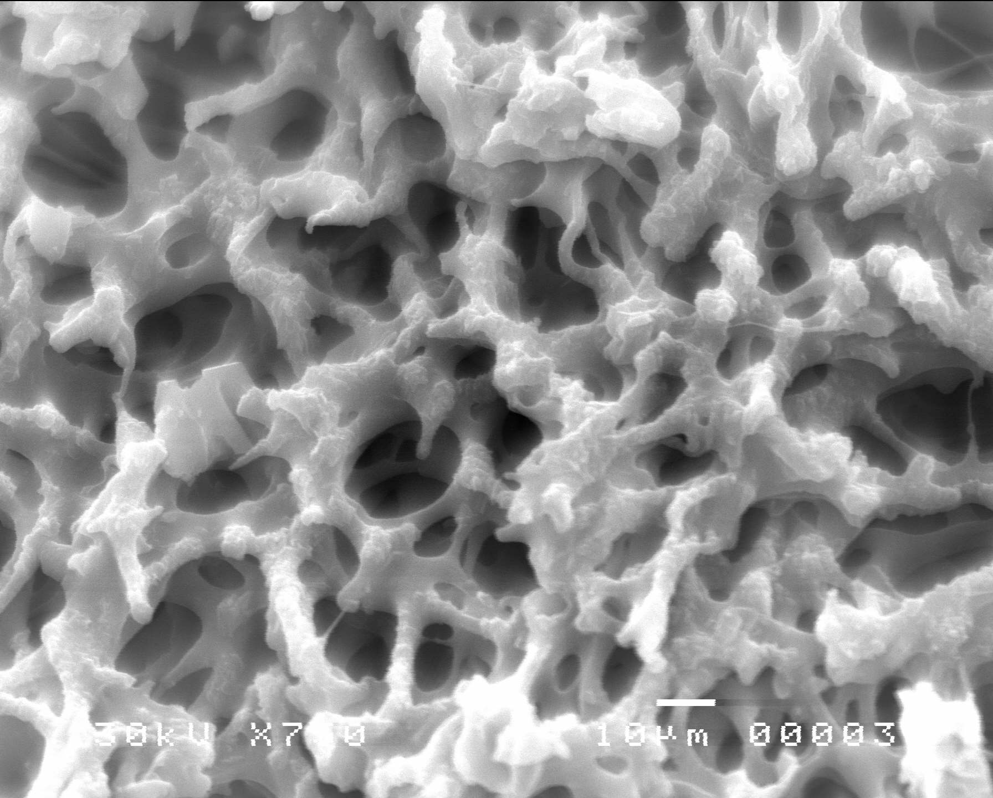
a)

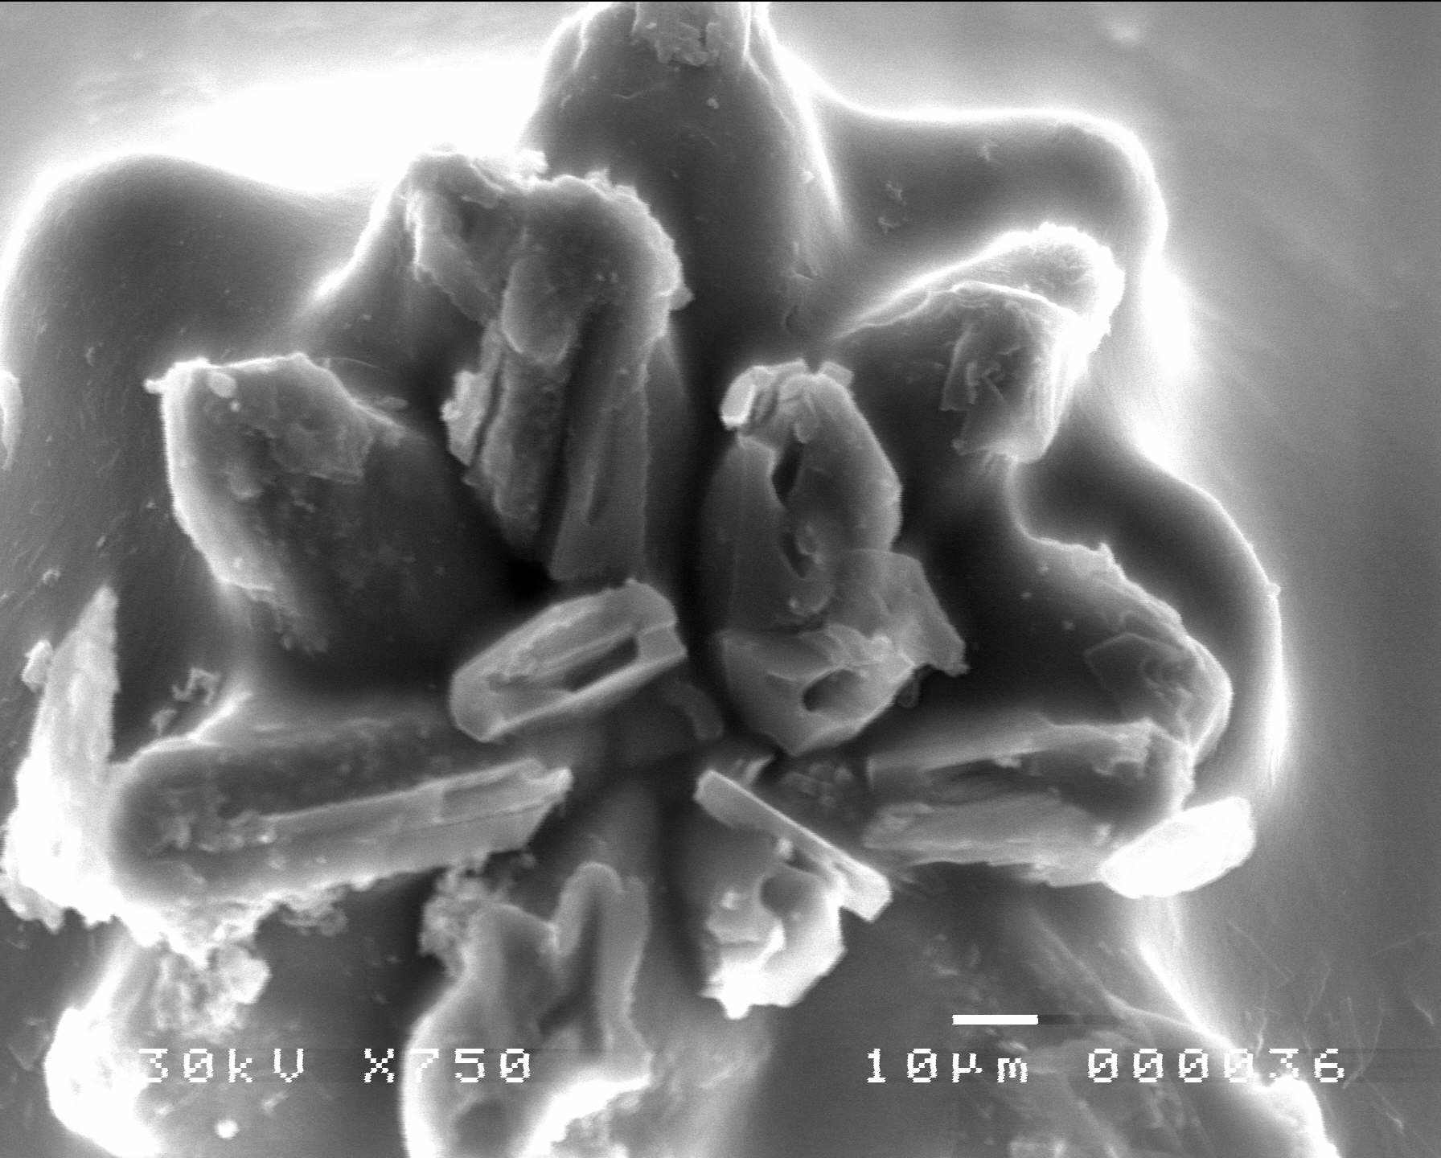
b)

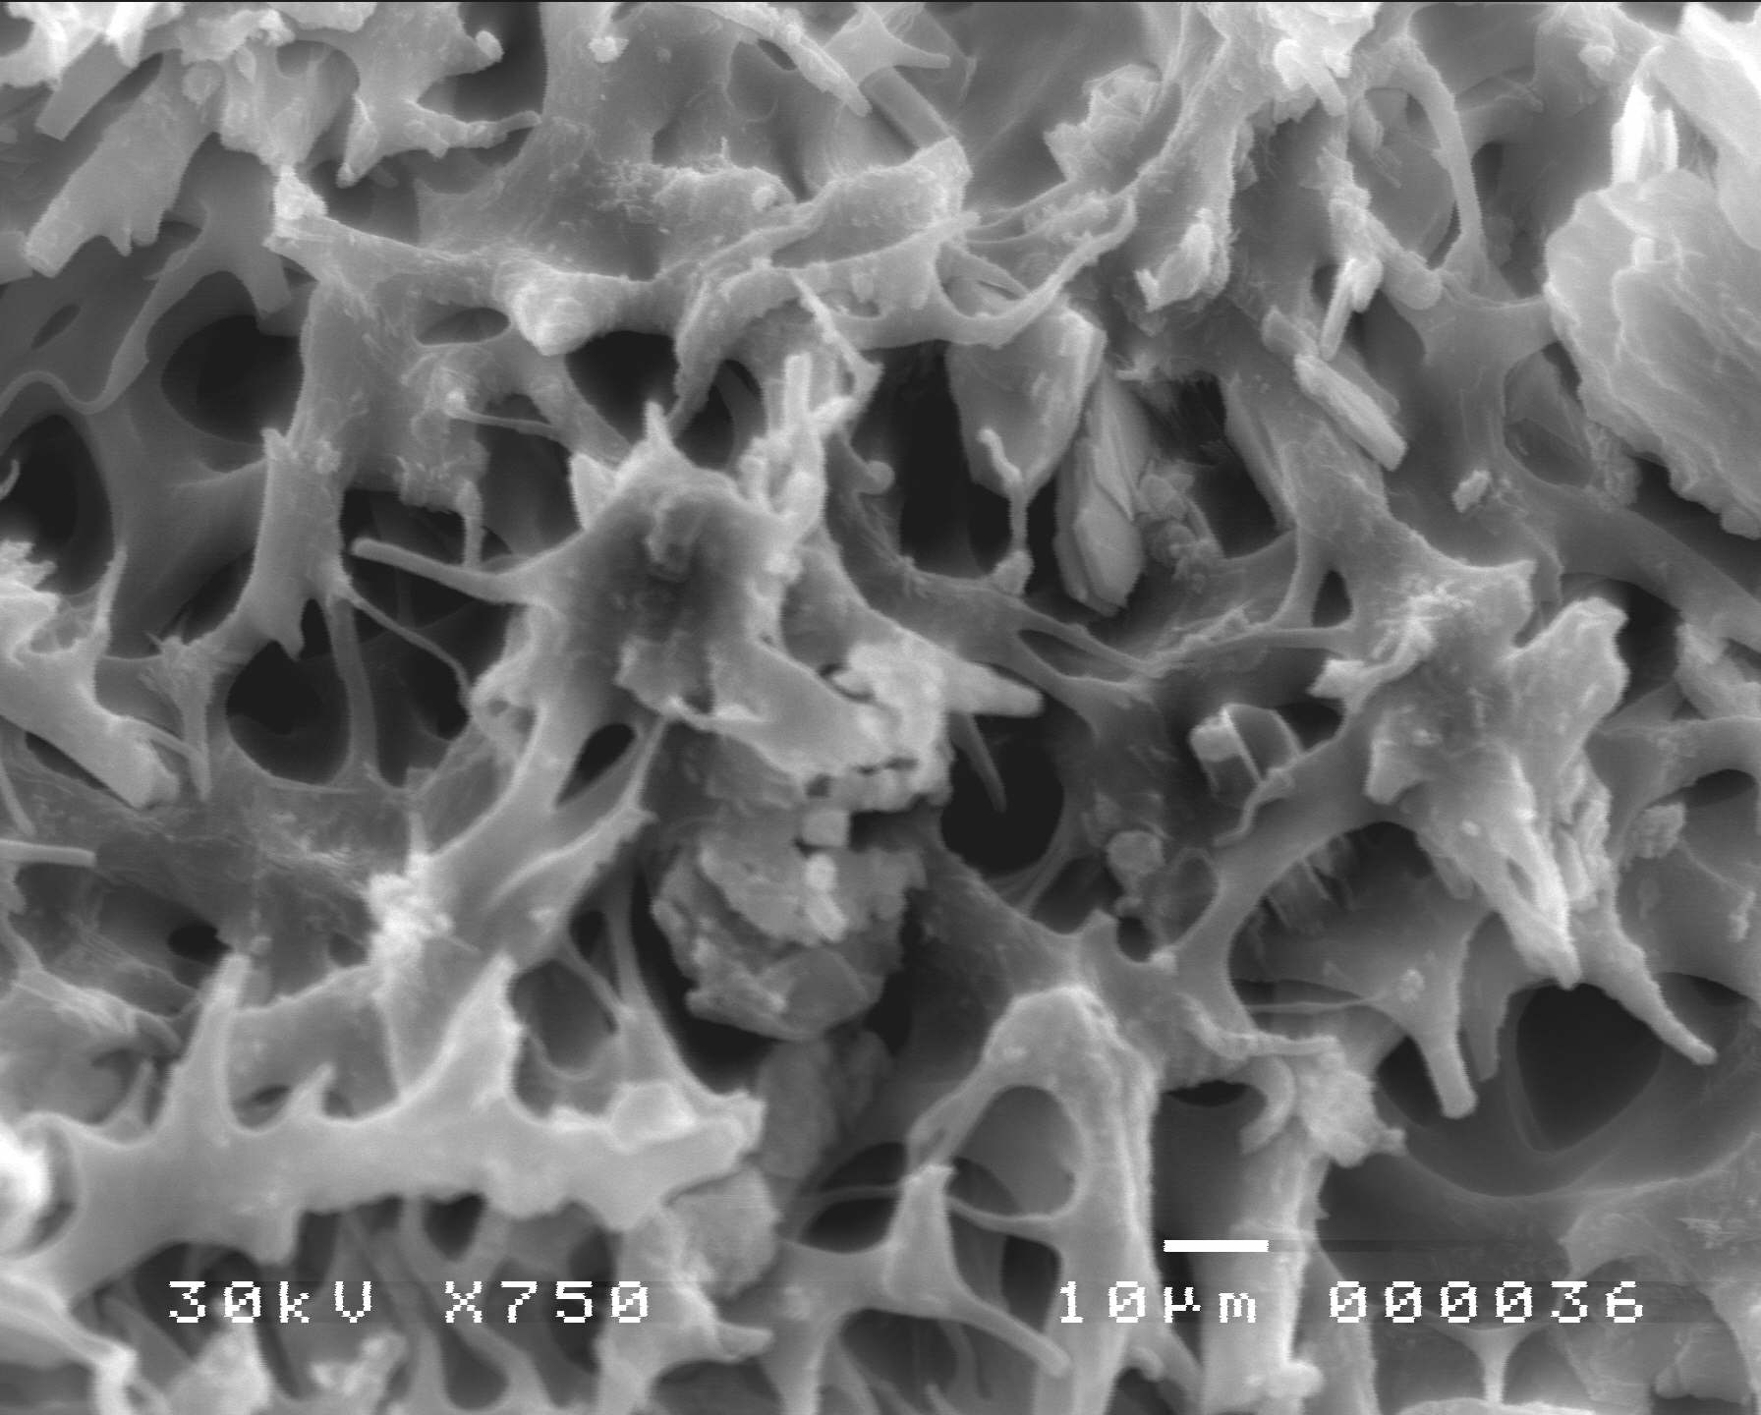
c)
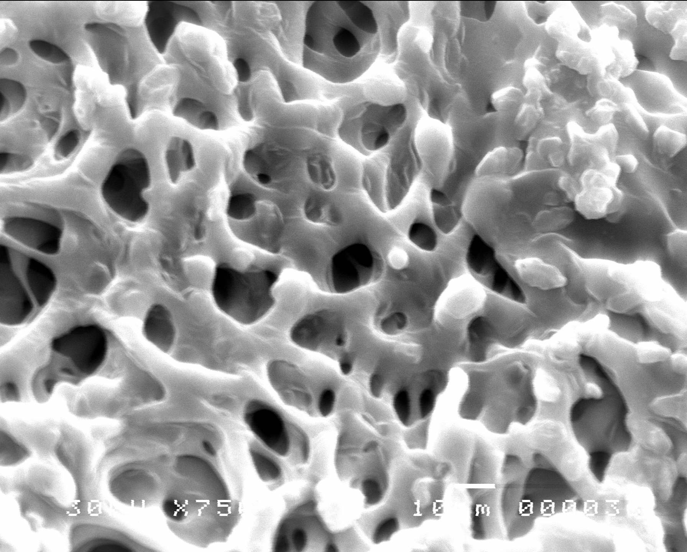
d)
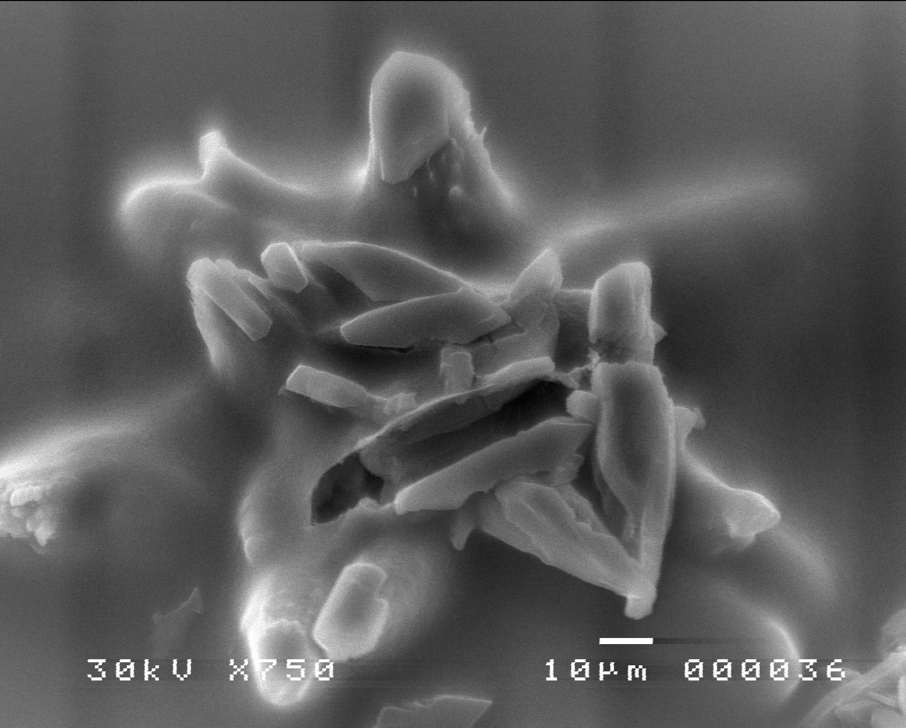
e)
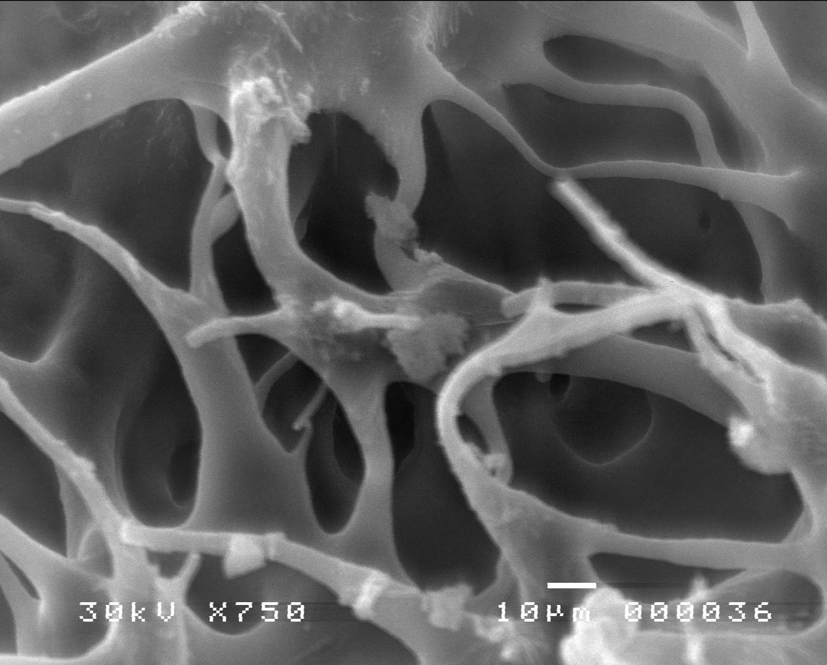
f)
Figure 4: Scan electron microscope of Poly glycidyl methacrylayte/PVA blend membrane reinforced with alumina powdered
a) 10 KGy and 10 % PGMA, b) 10 KGy and 20 % PGMA, c)10 KGy and 30 % PGMA, d) 20 KGy and 10 % PGMA, e) 20 KGy and 20 % PGMA, f) 20 KGy and 30 % PGMA.

Figure 5: Moisture content of Poly glycidyl methacrylayte/PVA blend membrane reinforced with alumina powdered.

The ratio of GMA content in the membrane influenced effectively on the moisture content of the films. However, the films produced with higher PVA showed higher values for moisture content (1.2 % for 10 KGy irradiation dose while it reduced to 0.9 % by exposing them to 10 KGy) as seen in figure 4. different values were observed by Silva et al, [61] working with films based on gelatin with PVA blends. However, these same authors observed that films of pure PVA were less hygroscopic than gelatin films.

3.2.2.Water Uptake
Water uptake is an important property for PEMs which needs to be seriously considered, because the loss of water is anticipated to bring two negative impacts on cell performance: decreased proton conductivity and degraded membrane-catalyst interface [62–65].

Figure 6: Water uptake of Poly glycidyl methacrylayte/PVA blend membrane reinforced with alumina powdered

It is one of the important characteristic properties for the casted membranes, which confirmed the successful incorporation of hydrophilic group inside the membrane. The water and methanol uptakes capabilities that in turn related to the membranes electrochemical properties were also determined. In this study, the swelling behavior for the casted membranes consist of ratio of the binary constituent ,and irradiation doses investigated in term water uptake and hydration number, i.e. the number of water molecules per opened ring of GMA. The percentage water uptake with different ratio of GMA in the membranes in Fig. 6. It can be seen that the sorption of water by phosphate group by the opened ring of GMA's membrane increases with the increase of GMA ratio till 20% while it reduced after which. The water uptake increase to 65 wt.% as the ratio of GMA increases to 20 % while it reduced to 38 % by raising its ratio to 35% at 20 KGy. The same behavior has attained by reduce the gamma irradiation dose to 10 KGy while the maximum water uptake was 58% and it reduced to 29% by decrease the GMA content to 35 % . The increase in water uptake for all membranes samples can be reasonably attributed to the increase in the hydrophilicity imparted to the membrane from the increases in the GMA yield besides the presence of hydroxyl group of PVA. Such behavior is due to the effect of the suppression of the swelling by the porous hydrophobic membrane matrix structure. The water uptakes of Nafion 117 membrane were found to be about 20 wt.% under the same condition which less than that of the casted membranes. Incorporation of alumina has very important role for controlling water and methanol passage through the prepared membrane.

3.2.3. Ion exchange capacity and porosity
Sample No. | Glycidyl methacrylate % |  | IEC (meq/g.) | Equivalent  Area
Sample No. | Irradiation dose |  | IEC (meq/g.) | Equivalent  Area
Sample No. | 10 KGy | 20 KGy | IEC (meq/g.) | Equivalent  Area
1- | 10 |  | 0.91 | 1099
2- | 20 |  | 1.06 | 943
3- | 30 |  | 0.77 | 1299
4- |  | 10 | 0.97 | 1033
5- |  | 20 | 1.12 | 893
6- |  | 30 | 0.89 | 1123

Table 1 listed the IEC values and the equivalent area of the casted membranes. The membranes showed the highest IEC value of 1.12 mmolg⁻¹ at 20 KGy irradiation dose compared with that exposed to 10 KGy of 1.06 mmolg⁻¹ while Nafion®/SiO2 of 0.87 mmolg⁻¹. The increased IEC value illustrated that a little more acid sites resulting from increasing the GMA ratio to 20 % while the value reduced by increasing their value to 30 %. Opening the GMA ring besides the hydroxyl group of PVA have very important role for increasing the IEC value. The enhanced acid property was expected to promote the membrane proton conductivity at various conditions [66–68]. On the contrary, alumina within membranes have nearly no effect on IEC due to the existence of non-proton-conductive Al₂O₃ particles. Obviously, this result was unfavorable to cell performance under wet condition.
According to previous report [69,70], the possibility of preparing membranes with tailored equivalent weight (EW) can be achieved through the implementation of radiation induced finally crosslinking. This is due to the fact that the variation in the EW can be obtained via varying the GMA ratio which in turn, reflected on the amount of mentioned functional groups anchored into the membrane matrix. A high IEC will result in a low EW of the membrane, while low GMA Ratio leads to high EW. Thus, the acquired EW values are in harmony with the aforementioned discussion that shows a decreasing trend with increasing grafting yield. Meanwhile, the corresponding EW value of Nafion 117 membrane is approximately to 1073 g/eq which is higher than the prepared membrane and so recommend their usage in the desired application.

3.3. Electrical characterization:
3.3.1. AC impedance of the membrane with no humidity
The previous results showed exposing 10 KGy irradiation dose for the cast each of IEC and water uptake have a larger value than that exposed to 20 KGy. On the contrary electrical conductivity have versus behavior. Ratio of GMA through the cast membrane versus electrical conductivity was illustrated in figure 7.

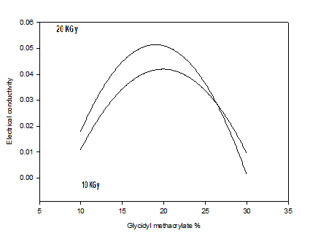
Figure 7: Electrical conductivity of Poly glycidyl methacrylayte/PVA blend membrane reinforced with alumina powdered

The ionic conductivity increases with increase the GMA ratio in the cast membrane. Membranes with values of 10 % GMA ratio and above record an ionic conductivity as high as 10⁻³ simon cm⁻¹. The threshold ionic conductivity value is given by the membrane with (GMA ratio ) of 20 %, viz., 5.2 ×10⁻² simon cm⁻¹. This ionic conductivity is comparable to that of a Nafion 117 membrane, which was found to be 5.3×10⁻² simon cm⁻¹ under the same experimental conditions. The dependence of the ionic conductivity of cast membranes on the GMA yield is probably caused by the increase in both function groups (Hydroxyl of PVA and opened ring in GMA) associated with the amount of the sorbed water. This indicates that the incorporation of more GMA conduct decrease of EC which may due to less compatibility of the GMA and PVA shared through the cast membrane. Since there is a relation between the water sorption and the ionic conductivity based on the concept of ionic domain percolation, the high-ionic conductivity demonstrated by these membranes at high GMA yields, i.e., Ratio about 20 % GMA suggests that the water swollen ionic domains in the membranes form a network structure. Irradiation dose has very important role on the membrane that affect severely on EC. Increasing the irradiation dose resulted in more compatibility while reduce the water content captured through the network matrix which may facilitate the ionic motion. These reasons conduct raising the EC value for the operation of proton exchange membrane fuel cells (PEMFCs) at high temperature and low relative humidity provides several advantages than lower temperature cells:
(i) Low CO catalyst poisoning.
(ii) Better water management.
(iii) High system efficiency.
(iv) Increase rates of reaction and diffusion.
Therefore, the development of PEM, which has high proton conductivity at high temperatures and low relative humidity, is great importance in high temperature PEMFC research and development. [71,72].

Figure 8: Effect of temperature on Electrical conductivity of Poly glycidyl methacrylayte/PVA blend membrane reinforced with alumina powdered

Proton hopping and vehicular diffusion are believed to be the predominant modes of proton conduction in the ionomer membranes [73,74]. An increase in temperature increases conductivity as it strongly affects both mechanisms: hopping as well as diffusion becomes faster. Notably, the conductivity also increases with the dilution of charge carriers (increasing water content of the samples). An increase in conductivity, when increasing water content of the membranes is caused by an increase in proton mobility. But in the PEMFC operating range (25 mhr–80◦C) conductivity increases only about 25% by temperature increase with 15◦C (25 to 40ºC). Increasing temperature with 20ºC from 40 to 60ºC and 60 to 80ºC resulted in increasing conductivity by 20%. Conductivity increases nearly by an order of magnitude with increasing water content. Therefore, water content and the related proton mobility are identified as the key parameters affecting membrane conductivity. At 100% RH and 80 ◦C, Nafion/silica membrane shows a proton conductivity of 9.6 x 10⁻² simon cm⁻¹, compared to 0.080 simon cm⁻¹ for recast Nafion 117. It has been reported that in the production of hybrid alumina-cast membranes, the presence of inorganic alumina domains could interfere with the structure of the ionic clusters and accordingly reduce the proton conductivity measured at high water activity. Nevertheless the presence of mesoporous alumina has not disrupted the proton transport pathway in the present study. The temperature-dependent conductivities of the prepared membranes were plotted at RH = 100 % (Fig. 8). The water present in the membranes might be acting as a well connected network for proton hopping. But the situation is different at nearly 30 % RH, i.e. when the water content of Nafion is diminished significantly. In this case the activation energy for Nafion increases to 19.3 kJ mol−1, indicating a change in the conductivity mechanism; but, for functionalized hybrid membranes, Ea does not change too much because water is effectively retained in these membranes, favoring vehicular diffusion of protons [75-77].

3.4. Membrane durability
Figure 9: Effect of time on durability of of Poly glycidyl methacrylayte/PVA blend membrane reinforced with alumina powdered

The membrane used in fuel cell acts as a carrier for proton transport and as a barrier to provide effective separation between the anode and cathode. The former requires the membrane to be as thin as possible, while the latter requires the membrane to be strong enough to avoid damage during the membrane electrode assembly (MEA) fabrication, and during the fuel cell operation. Especially in a DMFC, one side of the membrane is exposed to the liquid methanol solution, and the other side is exposed to the dry gas. Different swelling on the two sides will accelerate the degradation of the fuel cell membrane. In many cases, it is found that the degradation of the fuel cell is not only caused by the lower chemical stability, but by mechanical damage.
Evaluation of the mechanical properties were measured as a function time for 20% GMA ratio and 20 KGy irradiation dose. Hardness measurements showed decrease their value by increasing the heating time of with hydrogen peroxide. These results attempt the availability of the membrane and their durability through the 2 hours however; it noticed more applicability via the first 45 minutes at decrease the stability not exceed 27% from the original value.

Conclusion
The target of the work is to synthesis cheap membranes have high availability for using through the fuel cell unit. Mixing of Glycidyl methacrylate with different ratio of (10, 20 and 30 %) to PVA and 10 % alumina powdered for reinforcement the membranes. Different gamma irradiation doses (10 and 20 KGy) were used for achieving high compatibility and finally crosslinking. Characterizations of the membranes were performed chemically (FTIR), thermally (TGA and DSC) and morphologically (SEM). Water uptake and ion exchange capacity (IEC) measurement exceed the result attained by Nafion with 28% (for IEC). AC electrical conductivity was 5.2 x 10⁻² which is well comparable with that of Nafion (which was 5.3 x 10⁻²). Raising temperature to 80ºC conducted increase the conductivity by 64 % which is strongly recommend the membranes application into fuel cell unit.

Corresponding author
M.M. El-Toony
National center for radiation research and technology, Atomic energy authority, Egypt, Cairo, Egypt
toonyoptrade@yahoo.com

References
[1] Mabrouka,W L. Ogier, F. Matoussi, C. Sollogoubb, S. Vidal, M. Dachraoui, J.F. Fauvarque, Preparation of new proton exchange membranes using sulfonated poly (ether sulfone) modified by octylamine (SPESOS) Materials Chemistry and Physics 128, 456–463, 2011.
[2] Savadogo,O J. Power Sources 127,135, 2004.
[3Yang, CC Synthesis and characterization of the cross-linked PVA/TiO2 composite polymer membrane for alkaline DMFC, J. Membr. Sci. 288, 51–60, 2007.
[4] Yang, C.C. S.J. Chiu, W.C. Chien, Development of alkaline direct methanol fuel cells based on crosslinked PVA polymer membranes, J. Power Sources 162, 21–29, 2006.
[5] Wang, Y. L. Li, L. Hu, L. Zhuang, J. Lu, B. Xu, A feasibility analysis for alkaline membrane direct methanol fuel cell: thermodynamic disadvantages versus kinetic advantages, Electrochem. Commun. 5, 662–666,2003,.
[6] Baglio V., A.S. Arico, A.D. Blasi, V. Antonucci, P.L. Antonucci, S. Licoccia, E. Traversa, F.S. Fiory, Nafion–TiO₂ composite DMFC membranes: physico-chemical properties of the filler versus electrochemical performance, Electrochim. Acta 50, 1241–1246, 2005.
[6] ZawodzinskiT.A. Jr., T.E. Springer, F. Uribe, S. Gottesfeld, Solid State Ionics 60, 199, 1993.
[7] Yeo R. S., J. Electrochem. Soc. 130, 533, 1983,.
[8] HillR., M.W. Verbrugge, J. Electrochem. Soc. 137, 886, 1990.
[9] Bernardi D.M., J. Electrochem. Soc. 137, 3344, 1990.
[10] Cappadonia, M J.W. Erning, S.M. Saberi Niaki, U. Stimming, Solid State Ionics 77, 65, 1995.
[11] Zawodzins.ki TA. Jr., C. Derouin, S. Radzinski, R.J. Sherman, V.T. Smith, T.E. Springer, S. Gottesfeld, J. Electrochem. Soc. 140, 1041,1993.
[12] Fuller T.F., J. Newman, J. Electrochem. Soc. 139, 1332, 1992.
[13] Antonucci.PLA.S. Arico, P. Creti, E. Ramunni, V. Antonucci, Solid State Ionics 125 (1–4), 431, 1999.
[14] AdjemianK.T., S. Srinivasan, J. Benziger, A.B. Bocarsly, J. Power Sources 109, 356, 2002.
[15] WatanabeM, H. Uchida, Y. Seki, M. Emori, P. Stonehart, J. Electrochem. Soc. 143 (12), 3847, 1996.
[16] Lang K, S. Sourirajan, T. Matsuura, G. chowdhury, A study on the preparation of polyvinyl alcohol thin-film composite membranes and reverse osmosis testing, Desalination 104, 185–196, 1996.
[17] Tsai. C,E C.W. Lin, B.J. Hwang, A novel crosslinking strategy for preparing poly(vinyl alcohol)-based pronton-conducting membranes with high sulfonation, J. Power Sources 195, 2166–2173,2010.
[18] Bolto,B T. Tran, M. Hoang, Z. Xie, Crosslinked poly(vinyl alcohol) membranes, Prog. Polym. Sci. 34, 969–981,2009.
[19] ZhangW, Z.N. Zhang, X.P. Wang, Investigation on surface molecular conformations and pervaporation performance of the poly(vinyl alcohol) (PVA) membrane, J. Colloid Interface Sci. 333, 346–353, 2009 .
[20] Hyder,M.N R.Y.M. Huang, P. Chen, Effect of selective layer thickness on pervaporation of composite layer thickness on pervaporation of composite poly(vinyl alcohol)-poly(sulfone) membranes, J. Membr. Sci. 318, 387–396, 2008.
[21] Tang, X.M. Sun, Q.H. Li, J.H. Wu, J.M. Lin, Fabrication of a high-strength hydrogel with an interpenetrating network structure, Colloids Surf. A: Physicochem. Eng. Aspects 346, 91–98, 2009.
[22] Stoljkovic, R. Venkatesh, E. Klimov, V. Raman, J.H. Wendorff, A. Greiner, Poly (styrene-co-n-butyl acrylate) nanofibers with excellent stability against water by electrospinning from aqueous colloidal dispersions, Macromolecules 42, 6147–6151, 2009.
[23] Xu, C.Q. Yang, Y.L. Deng, Combination of bifunctional aldehydes and poly (vinyl alcohol) as the crosslinking systems to improve paper wet strength, J. Appl. Polym. Sci. 93, 1673–1680, 2004.
[24] Toutanji, B. Xu, J. Gilbert, T. Lavin, Properties of poly (vinyl alcohol) fiber reinforced high-performance organic aggregate cementitious material: converting brittle to plastic, Constr. Build. Mater. 24, 1–10, 2010.
[25] Pal, A. K.Banthia, & D. K. Majumdar, Preparation and characterization of poly(vinyl alcohol) egelatin hydrogel membranes for biomedical applications. AAPS PharmSciTech, 8(1), E1-E5, 2007.
[26] Priscila Alves, A.Rosemary Carvalho, C.F. Izabel Moraes, Carla G. Luciano, Ana Mônica Q.B. Bittante, Paulo J.A. Sobral, Development of films based on blends of gelatin and poly(vinyl alcohol) cross linked with glutaraldehyde, Food Hydrocolloids 25,1751-1757, 2011.
[27] Xu, P.K. Shen, X. Ji, R. Zeng, Y. Liu, Enhanced activity for ethanol electrooxidation on Pt–MgO/C catalysts, Electrochem. Commun. 7, 1305–1308, 2005.
[28] Baglio, A.S. Arico, A. Di Blasi, P.L. Antonucci, F. Nannetti, V. Tricoli, V. Antonucci, J. Appl. Electrochem. 35, 207–212, 2005.
[29] Yang , J.Y. Lee , J.Y. Jeong, Y. Na, W.J. Kim Cell performance of DMFC fabricated with H⁺-ETS-10/Nafion composite membrane, Microporous and Mesoporous Materials 143, 215–220, 2011.
[30] Kim, H.B. Park, J.W. Rhim, Y.M. Lee, Preparation and characterization of crosslinked PVA/SiO₂ hybrid membranes containing sulfonic acid groups for direct methanol fuel cell applications, J. Membr. Sci. 240, 37–48, 2004.
[31] Kim, H.B. Park, J.W. Rhim, Y.M. Lee, Proton conductivity and methanol transport behavior of cross-linked PVA/PAA/silica hybrid membranes, Solid State Ionics 176, 117–126, 2005.
[32] Guo, C. Hu, F. Pan, H. Wu, Z. Jiang, PVA–GPTMS/TEOS hybrid pervaporation membrane for dehydration of ethylene glycol aqueous solution, J. Membr. Sci. 281, 454–462, 2006.
[33] Chun-Chen Yang, Yingjeng James Li, Tzong-Horng Liou, Preparation of novel poly(vinyl alcohol)/SiO₂ nanocomposite membranes by a sol–gel process and their application on alkaline DMFCsDesalination 276, 366–372, 2011.
[34] Diaz, S. Ordَnez, A.Vega Coca J. Adsorption properties of a Pd/ γ -Al₂O₃ catalyst using inverse gas chromatography. Microporous Mesoporous Mater; 70(1–3):109–18, 2004.
[35] Cheong, WS Cho, JS Ha, CS Kim, DK Choi, DS Cheong. Structural evolution of alumina membrane prepared on an alumina support using a sol–gel method. J Alloys Compds; 290(1–2):304–9, 1999.
[36] Lambert, R.D. Gonzalez. Effect of binder addition on the properties of unsupported γ-Al₂O₃ membranes. Mater Lett; 38(2):145–9, 1999.
[37] Wu, Y. Zhang, L. Zhang. Effects of finely metallic palladium on microstructure and properties of nanocomposites produced by sol–gel technique. China Particuol; 2(1):19–24, 2004.
[38] Ahmad, N.N.N. Mustafa, Sol–gel synthesized of nanocomposite palladium–alumina ceramic membrane for H₂ permeability: Preparation and characterizationInternational Journal of Hydrogen Energy 32, 2010 – 2021, 2007.
[39] Chun-Chen Yang, Shwu-Jer Chiu, Wen-Chen Chien, Sheng-Shin Chiu, Quaternized poly(vinyl alcohol)/alumina composite polymer membranes for alkaline direct methanol fuel cells, Journal of Power Sources 195, 2212–2219, 2010.
[40] Kim, S.Kiyohara, S.Konishi, S.Tsuneda, K.Saito and T. Sugo. J. Membr. Sci. 117: 33, 1996.
[41] Ghanshyam S. Chauhan, Lalit Guleria and Rajeev Sharma, Synthesis, characterization and metal ion sorption studies of graft copolymers of cellulose with glycidyl methacrylate and some comonomers, Cellulose 12: 97–110, 2005.
[42] Chiellini, P.Cinelli, , E. G. Fernandes, E. S.Kenawy, & A. Lazzeri, Gelatinbased blends and composites. Morphological and thermal mechanical characterization. Biomacromolecules, 2(3), 806-811, 2001.
[43] Rhim, A. Gennadios, C.L. Weller, M.A. Hanna, Soy protein isolate–dialdehyde starch films. Ind. Crops Prod. 8 (3), 195–203, 1998.
[44] Agusin Gonzalez, Miriam Cristina Strumia, Cecilia Ines Alvarez Igarzabal, Cross-linked soy protein as material for biodegradable films: Synthesis, characterization and biodegradation, Journal of Food Engineering 106, 331–338, 2011.
[45] Nasef, Proton exchange membranes by radiation-induced graft copolymerization of styrene onto fluorinated polymers, Ph.D. Thesis, Universiti Teknologi Malaysia, 1999.
[46] Haibo Li, Nathan J. Kirk, Kenneth A. Mauritz, Robson F. Storey, Poly(arylene ether sulfone) multi-block copolymers bearing perfluoroalkyl sulfonic acid groups, Polymer 52, 3550-3559, 2011.
[47] Chen, M. Asano, Y. Maekawa, M. Yoshida, Suitability of some fluoropolymers used as base films for preparation of polymer electrolyte fuel cell membranes. J of Mem Sci 277: 249-257, 2006.
[48] Rikukawa, K. Sanui, Proton-conducting polymer electrolyte membranes based on hydrocarbon polymers, Prog. Polym. Sci. 25 (2000) 1463-1502.
[49] Shohji Tsushima, Shuichiro Hirai, In situ diagnostics for water transport in proton exchange membrane fuel cells, Progress in Energy and Combustion Science 37, 2011, 204-220.
[50] Rajendran, O. Mahendran, R. Kannan, Mater. Chem. Phys. 74, 52, 2002.
[51] Missan, P.P. Chu, S.S. Sekhon, J. Power Sources 158, 1472, 2006.
[52] Ulaganathan, S. Sundar Pethaiah, S. Rajendran Li-ion conduction in PVAc based polymer blend electrolytes for lithium battery applications Materials Chemistry and Physics 129, 471– 476, 2011.
[53] Li, G. Su, X. Wang, D. Gao, Solid State Ionics 176, 1903, 2005.
[54] Korshaki V.V., 1997.The chemical structure and thermal character of polymer, Keter press, 24, 2005.
[55] Wang, W. Yan, S.Hayaakawa, K. Tsuru and A. Osaka, Apatite deposition on thermally and anodically oxidized titanium surfaces in a simulated body fluid Biomaterials, 24: 4631-7, 2003.
[56] El-Toony, N.A. El-Kelesh, and H.I. Abdel-Shafy, Synthesis and Characterization of PVA/AAC Foam and their Application with Alum for Reduction of Turbidity, Calcium and Magnesium Ions, and Microbial Count in the Nile River, WATER 3, 68-78, 31, 2011.
[57] Sobral, F. C. Menegalli, M. D. Hubinger, & M. A. Roques, Mechanical, water vapor barrier and thermal properties of gelatin based edible films. Food Hydrocolloids, 15(4-6), 423-432, 2001.
[58] Billmeyer, Jr. Textbook of polymer science (3rd ed.). New York: Wiley Press, 1984.
[59] Neto, J.A. Giacometti, A.E. Job, F.C. Ferreira, J.L.C. Fonseca, M.R. Pereira, Carbohydr. Polym. 62, 97, 2005.
[60] Jen Ming Yang, Wen Yu Su, Preparation and characterization of chitosan hydrogel membrane for the permeation of 5-Fluorouracil Materials Science and Engineering C 31, 1002–1009, 2011.
[61] D.Silva, P. J. A. Sobral, R. A. Carvalho, P. V. A. Bergo, O. W. M. Taboada & A. M. Q. B. Habitante, Biodegradable films based on blends of gelatin and poly(vinyl alcohol): effect of PVA type or concentration on some physical properties of films. Journal of Polymers and the Environment, 16, 276-285, 2008.
[62] Adjemian, R. Dominey, L. Krishnan, H. Ota, P. Majsztrik, T. Zhang, J. Mann, B. Kirby, L. Gatto, M. Velo-Simpson, J. Leahy, S. Srinivasan, J.B. Benziger, A.B. Bocarsly, Chem. Mater. 18, 2238–2248, 2006.
[63] Thampan, N.H. Jalani, P. Choi, R. Datta, J. Electrochem. Soc. 152 (2) A316–A325, 2005.
[64] Kanamura, H. Morikawa, T. Umegaki, J. Electrochem. Soc. 150, A193, 2003.
[65] Cheng Bi, Huamin Zhang, Yu Zhang, Xiaobing Zhu, Yuanwei Ma, Hua Dai, Shaohua Xiao, Fabrication and investigation of SiO2 supported sulfated zirconia/Nafion® self-humidifying membrane for proton exchange membrane fuel cell applications, Journal of Power Sources 184, 197–203, 2008.
[66] Zhai, H. Zhang, J. Hu, B. Yi, J. Membr. Sci. 280, 148, 2006.
[67] Zhang, H. Zhang, Y. Zhai, X. Zhu, C. Bi, J. Power Sources 168, 323, 2007.
[68] Zhang, H. Zhang, X. Zhu, C. Bi, J. Phys. Chem. B 111, 6391, 2007.
[69] Nasef, N.A. Zubir, A.F. Ismail, K.Z. Dahlan, H. Saidi, New pore-filled polymer electrolyte membranes by electrons induced grafting, in: Proceedings of the International Symposium on Renewable Energy: Environment Protection and Energy Solution for Sustainable Development. Malaysian Institute of Energy and Malaysia Energy Center Kuala Lumpur September 14-17, 2003.
[70] Abdel-Hady, M.O. Abdel-Hamed, M.M. El-Toony and M.R. El-Sharkawy, Comparative Study between Sulfonation and Phosphoration for Commercial PTFE grafted with Styrene for Fuel Cell Application J Membra Sci Technol, 1:3, 2011.
[71] Yang, P. Costamagna, S. Srinivasan, J. Benziger, A.B. Bocarsly, J. Power Sources 103, 1, 2001.
[72] Boysen, T. Uda, C.R.I. Chisholm, S.M. Haile, Science 303, 68.
[73] Kreuer, Solid State Ionics 94 (1997) 55–62, 2004.
[74] Eikerling, A.A. Kornyshev, A.M. Kuznetsov, J. Ulstrup, S. Walbran, J. Phys. Chem. B 105, 3646–3662, 2001.
[75] Pereira, K. Valle, P. Belleville, A. Morin, S. Lambert, C. Sanchez, Chem. Mater. 20, 1710–1718, 2008.
[76] Kreuer, Chem. Mater. 8, 610–641, 1996.
[77] Jorphin Joseph, Chi-Yung Tseng, Bing-Joe Hwang, Phosphonic acid-grafted mesostructured silica/Nafion hybrid membranes for fuel cell applications, Journal of Power Sources 196, 7363– 7371, 2011.

11/13/2011

