Electrochemical techniques for measuring some trace heavy metals in Taps Water of Riyadh in Saudi Arabia

Sanaa Arab¹ and Asia Alshikh²

^{1.}Kingdom Of Saudi Arabia, Ministry of Higher Education, King Abdulaziz University, Deanship of Scientific Research, Girl’s College of Educational, Jeddah.^{2.}Kingdom Of Saudi Arabia, Ministry of Higher Education, Jizan University, Deanship of Scientific Research, Girl’s College of Educational .Jizan.
Ziadahmed1020@hotmail.com

Abstract: The estimation of Pb, Cd, Cu, Zn, Fe, Se concentration in the taps water of the capital Riyadh in Kingdom Of Saudi Arabia city was accomplished using electrochemical methods. Also, chemical, physical and bacteriological Parameters were studied. The obtained results were lower than the average range of these Parameters in the maximum concentration as they were allowed to be by The World Health Organization (WHO).
[Sanaa Arab and Asia Alshikh Electrochemical techniques for measuring some trace heavy metals in Taps Water of Riyadh in Saudi Arabia] Nature and Science 2011; 9(12):190-195]. (ISSN: 1545-0740). http://www.sciencepub.net. 26

Keywords: Tap water; electrochemical ; Saudi ; trace heavy elements.

1. Introduction
The essential role of water is supporting human life so, if contaminated, a wide variety of diseases and illnesses will occurred. The developed world water-related diseases are rare, due essentially to the presence of efficient water supply and wastewater disposal systems. However, in the developing world perhaps as many as 1.3 thousand million people are without safe water supply and almost 2 thousand million do not have adequate sanitation (PhD et al.,1998 and Volker et al., 2010).
Although the benefits of water fluoridation for dental health are widely accepted ( as safe water ), concerns remain about possible adverse effects, particularly effects on bone. Several investigators have suggested increased rates of hip fracture in places with high concentrations of fluoride in drinking water . The primary findings from this study have shown that fluoride content in hair is highly correlated with fluoride content in drinking water and dental fluorosis level, indicating that hair may be regarded as biomaterial of high informative potential in evaluating prolonged exposure to fluorides and to individuate children at risk of fluorosis regardless of the phase of teeth eruption. Available evidence on risk of hip and other bone fractures suggests no effect of fluoride in water It appears to be no link between water fluoridation and either cancer in general or any specific cancer type (Mandinic et al., 2010).
These findings indicate that ingestion of residual disinfectants via drinking water may pose a health risk in terms of in vivo generation of iodinated organics. Recent epidemiological studies have reported associations between the consumption of chlorinated drinking water and various types of human cancer; in addition, exposure to chlorine (Cl⁻) in drinking water has been reported to suppress certain immune functions in laboratory animals (French et al., 1998). Every household and every factory uses water, none of them is pure. One class of impurity that is of special interest is "hardness", this refers to the presence of dissolved ions, mainly of calcium Ca²⁺ and magnesium Mg²⁺ which are acquired through contact with rocks and sediments in the environment.
Researchers have studied water hardness and cardiovascular disease mortality. Such studies have been "epidemiological studies," which are statistical relationship studies (Tebbutt et al., 1983).

Potential Health Effects: Coliform bacteria may not cause disease, but can be indicators of pathogenic organisms that cause diseases. The latter could cause intestinal infections, dysentery, hepatitis, typhoid fever, cholera and other illnesses. However, these illnesses are not limited to disease-causing organisms in drinking water. Other factors not associated with drinking water may be the cause.
Intestinal infections and dysentery are generally considered minor health problems. They can, however, prove fatal to infants, the elderly, and those who are ill. Today typhoid, hepatitis and cholera are rarely encountered in the United States. Other bacteria also may be present in water. No specific sanitary significance or health standards have been indicated for non-pathogenic non- coliform bacteria (Dadswell, 1990, Roeder et al., 2010 and Corsaro et al.,, 2010).

2. Materials and Methods
Gathering samples:
Taps water samples were chosen from the Tap water of districts of Riyadh for one-year.
Eastern districts of Riyadh (Alfalah, Alrwdah, Alnasim, Alnazim, Alsali,Alqods, Alhamra, Grnata, Alnahdah, Alkhaleeg, Almoghrzat, AlJazeera, Alrwad, Alrabwa, Ashbilia, AlYarmuk, Gordoba,Rayan, Ashbiliah,Alshwhda).
western districts of Riyadh (Diriyah,Albadia,Dhrat Albadia, Irqa, Haiy Allaban,Swedi,Shubra, Aeryjae,
King Saud University)
The northern districts of Riyadh (Malqa, Alsahafa, Alnakheel,Alyasmine,Alnafil,Alezdhar,Qrnath, Almghrzat,Alwaha,Almursalat,Alwrood,Almorog,Alghadeer,Alrabea,Almohamedya,Alraed,Alagig,Alnakeel-Alghrbe, Alnakeel -Alshargi).
Southern district of Riyadh (Alshifa, Bader, Almarwa, Alfawwaz,Alhazm,Alazizia,Aldar Albida, Almansoura, Nammar, Aldirihmiah, Shubra, Alyamama, Almasanea, Bin Turki, Alswedi, Alshemissi, Alhayer, Al shalan.
Central districts of the city of Riyadh (Almuraba, Almargab, Batha, Deira, Alsalhia, Almalaz, Alfakhiriah.

The apparatus used in the study :
1- The concentration of trace elements were measured by Polargraph instrumental 746 VA trace analyzer with 747 VA stand or from Metrohm company .
WE Multi Mode Electrode (MME)
Mercury drop capillary for MME
AE Pt rod electrode
RE Ag/AgCl reference system c(KCl) = 3 mol/L
Electrolyte vessel filled with c(KCl) = 3 mol/L
The information storage is done by a computer, from Toshiba company 757 VA computracy joined with the device (Guzsvány et al., 2010, Gil and Ostapczuk, 1994).
2- Spectrophotometer company Hach Lange/LPV 42299 – 00001.

3. Results and Discussion
Riyadh city consider to be one of the fastest growing cities in the world. It's area was doubled in less than a century for more than a thousand times and over-developed urban area was (1000) km². Also population was increased to more than (200) doubled.
Saudi Arabia published a survey estimated that the population of the capital, Riyadh, Saudi Arabia reached at the end of last year about 4.9 million. The high organization of the development of the city of Riyadh in it's report of the urban indicators of the city stressed that «Riyadh's population attained the end of last year 1430 about 723. 878. 4, by annual growth rate reached 4 percent ». The report noted that the Saudi nationals in Riyadh make up 68 percent of the total population compared to 32 percent of the residents, while males represented 55 percent of the population of the city, compared with 45 percent of females. The indicators demonstrated the demo-graphics mark of the citizens by the increase in the proportion of young ages (less than 15 years) by 34 percent, while the average age for Saudi citizens 18 years old. The number of participants in water services in 1430e reached (299054m³) participants and the amount of water consumed annually in the city for the same year reached(406 338 110 m³) (organization the Water and Sanitation in Riyadh 1430e).
The study of the sources of drinking water shows that the city of Riyadh based on three main sources of water ; Desalination water in Jubail which constitute 65% of the water that feed the city of Riyadh. non-renewable deep wells water from the configuration of Almangoor and Alwasea.
Surface wells water in the Nsah and Hayer area with the deep wells water represent 35% of water of AlRiyadh.
Figure 1 shows districts of Riyadh, old districts of Riyadh ( Deira, Manfuha, Batha, Malaz)

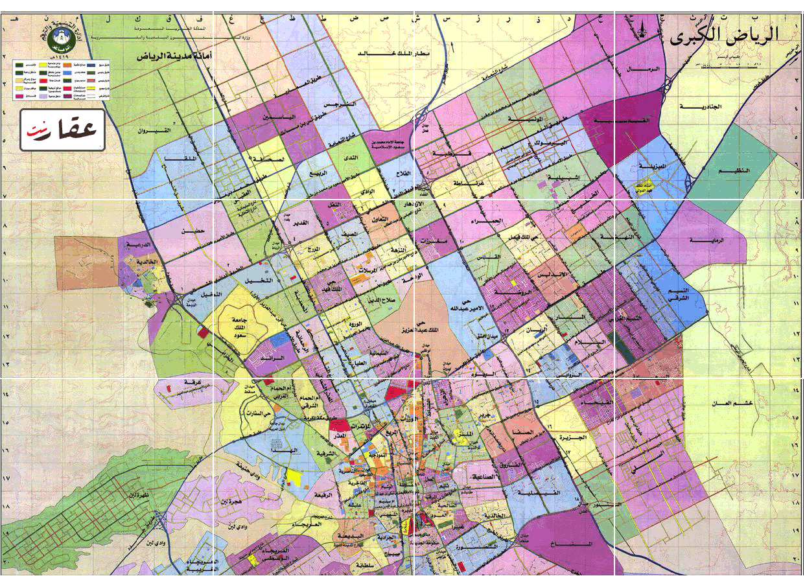

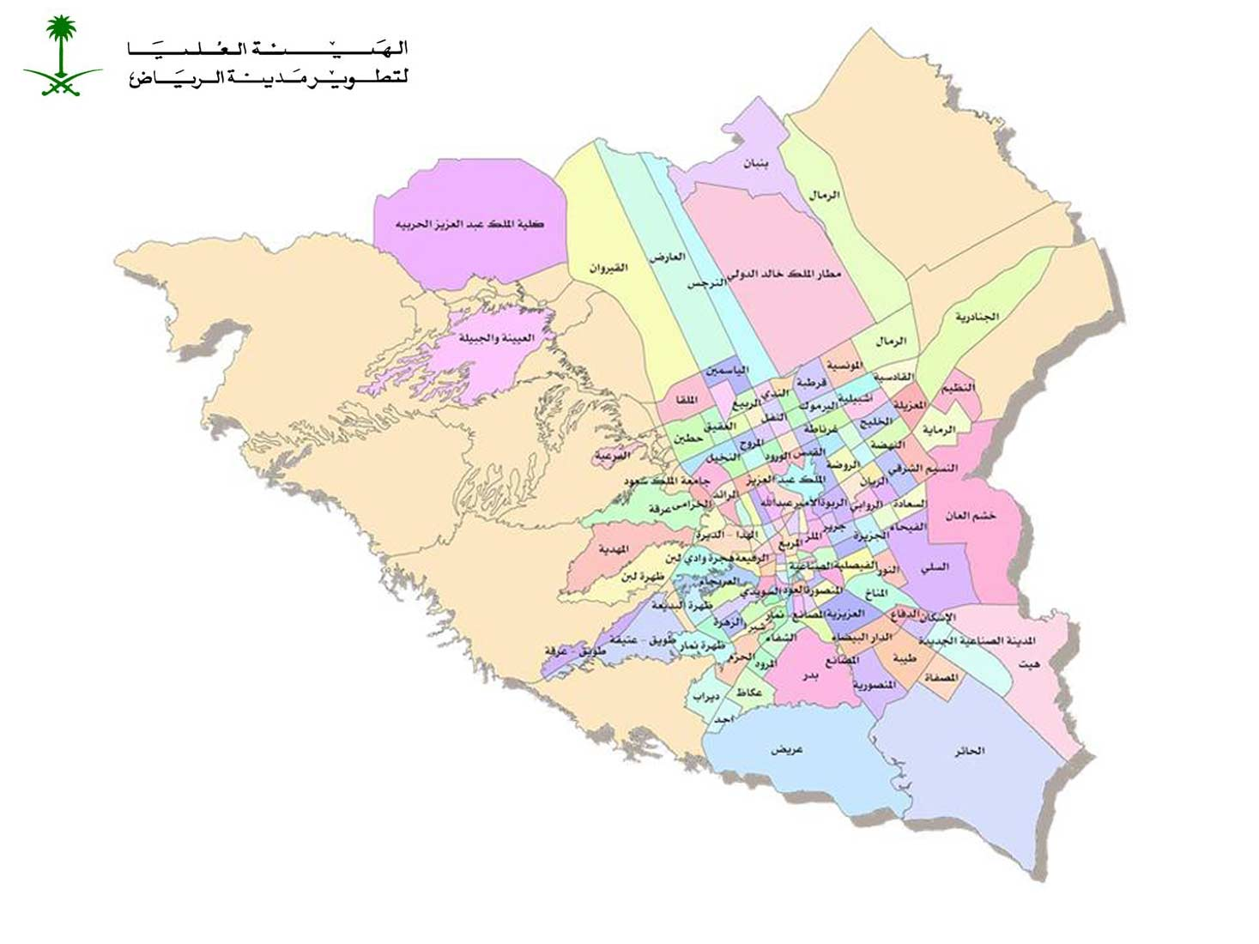

Figure 1. Districts of Riyadh

Table 1 shows the chemical Parameters of the Taps water which have been studied for the chosen districts of AlRiyadh city. They have been analyzed using SPSS program , at significant ( p<0.01).
Electrical Conductivity: Electrical conductivity (EC) estimates the amount of total dissolved salts (TDS), or the total amount of dissolved ions in the water. Table 1 shows high electrical conductivity and high total soluble solid salts of taps water in the east of AlRiyadh city, where it was 1100 µS/cm , and total soluble solid salts amounted to about (747 mg/l) while PH – Value was Neutral. Also table 1.shows low total alkalinity, it was (2 mg/l) in the west of AlRiyadh city. As it can be seen that ammonia is similar in all parts of AlRiyadh city, where it was (0.05 mg/l).

Table 1. The Chemical Parameters of the Taps water
for the chosen districts Al Riyadh city.
Chemical Parameter | districts Al Riyadh city  Mean ± S.D.
Chemical Parameter | North | South | East | West
Conductivity(25ºC)µS/cm | 1056±0.0022 | 1097±0.0012 | 1100±0.0014 | 1078±0.0016
PH - Value (25ºC) | 7.42±  0.0013 | 7.48±  0.0032 | 7.61±  0.0015 | 7.7±  0.0013
Total soluble solid salts | 718±  0.0023 | 744±  0.0031 | 747±  0.0012 | 730±  0.0012
Total alkalinity (mg/l) | 5±  0.0027 | 4±  0.0035 | 3±  0.0018 | 2±  0.0014
Ammonia  (mg/l) | 0.05±  0.0028 | 0.05±  0.0033 | 0.05±  0.0019 | 0.05±  0.0022

These "hardness ions" cause two major kinds of problems. The metal cations react with soaps, causing them to form an unsightly precipitate — the familiar "bathtub ring". More seriously, the calcium and magnesium carbonates tend to precipitate out as adherent solids on the surfaces of pipes and especially on the hot heat exchanger surfaces of boilers. The resulting scale buildup can impede water flow in pipes. In boilers, the deposits act as thermal insulation that impedes the flow of heat into the water; this not only reduces heating efficiency, but
allows the metal to overheat, which in pressurized systems can lead to catastrophic failure.
Physical Parameters: (Turbidity, color, smell) of taps water have been studied ,they are clear.

Figure 2.Shows that total hardness of taps water of the districts of Al Riyadh city was similar and it was about (25%) .

Types of water hardness:
Temporary hardness:
This refers to hardness whose effects can be removed by boiling the water in an open container. Such water have usually percolated though limestone formations and contain bicarbonate HCO₃– along with small amounts of carbonate CO₃^{2–} as the principal negative ions. Boiling the water promotes the reaction
2 HCO₃– → CO₃^{2–} + CO₂
by driving off the carbon dioxide gas. The CO₃^{2–} reacts with Ca²⁺ or Mg²⁺ ions, to form insoluble calcium and magnesium carbonates which precipitate out. By tying up the metal ions in this way, the amounts available to form soap scum are greatly reduced.

Permanent hardness:
Water contains other anions such as chloride or sulfate cannot be remediated by boiling, and are said to be "permanently" hard. The only practical treatment is to remove all the ions, Electrical Conductivity: Electrical conductivity (EC) estimates the amount of total dissolved salts (TDS), or the total amount of dissolved ions in the water .

Indications of Hard Water: Hard water interferes with almost every cleaning task from laundering and dishwashing to bathing and personal grooming. Clothes laundered in hard water may look dingy and feel harsh and scratchy. Dishes and glasses may be spotted when dry. Hard water may cause a film on glass shower doors, shower walls, bathtubs, sinks, faucets, etc. Hair washed in hard water may feel sticky and look dull. Water flow may be reduced by deposits in pipes.
Dealing with hard water problems in the home can be a nuisance. The amount of hardness minerals in water affects the amount of soap and detergent necessary for cleaning. Soap used in hard water combines with the minerals to form a sticky soap curd. Some synthetic detergents are less effective in hard water because the active ingredient is partially inactivated by hardness, even though it stays dissolved. Bathing with soap in hard water leaves a film of sticky soap curd on the skin. The film may prevent removal of soil and bacteria. Soap curd interferes with the return of skin to its normal, slightly acid condition, and may lead to irritation. Soap curd on hair may make it dull, lifeless and difficult to manage.
When doing laundry in hard water, soap curds lodge in fabric during washing to make fabric stiff and rough.
Incomplete soil removal from laundry causes graying of white fabric and the loss of brightness in colors. A sour odor can develop in clothes. Continuous laundering in hard water can shorten the life of clothes. In addition, soap curds can deposit on dishes, bathtubs and showers, and all water fixtures.
Hard water also contributes to inefficient and costly operation of water-using appliances. Heated hard water forms a scale of calcium and magnesium minerals that can contribute to the inefficient operation or failure of water-using appliances. Pipes can become clogged with scale that reduces water flow and ultimately requires pipe replacement.

Figure 3.Shows Mg hardness of taps water of districts of Al Riyadh city was similar and it was about (25%=114 mg/l) in the west and north while it was about (27%=119 mg/l) in the south and about (23%=106 mg/l) in the east of districts Al Riyadh.

Figure 4. shows Ca hardness of taps water of districts Al Riyadh city was similar. It was about (25%=207-213 mg/l) in the west and east while it was about (24%=204 mg/l) in the south and about (26%=218 mg/l) in the north of districts Al Riyadh.
Hard water is not a health hazard, but dealing with hard water in the home can be a nuisance. The hardness (calcium and magnesium concentration) of water can be approximated with a home-use water testing kit, or can be measured more accurately with a laboratory water test. Water hardness can be managed with packaged water softeners or with a mechanical ion exchange softening unit.

Figure 5. Cation of taps water in Al Riyadh city

Also it is clarified from Figure 5 that, the mean concentration of cation (trace elements) in Taps water of Al Riyadh districts is, as follows:
1. North Al Riyadh Taps water ,the highest mean concentration Pb element is found , that it reached to (0.008ppm) .
2. East Al Riyadh Taps water concerning Cd ; it was the lowest mean concentration within (0.0020ppm).
3. North Al Riyadh Taps water ; in that the highest mean concentration Cu was within (0.0012ppm) (Ellingsen et al., 2007) ,and it was highest in mean concentration Zn element within (0.0016ppm) in north Al Riyadh Tap water.
4. North Al Riyadh Taps water ,the highest mean concentration Se element is found ,that it reached to (0.0043ppm) ,also the highest mean concentration Fe element is found in South Al Riyadh Taps water ,that it reached (0.071ppm) (Chenoufi et al., 1997, Lasheen et al., 2008) .
Also it is clarified from Figure 5. that the highest concentration in all Taps water under the study is as follows : Fe element > Zn element > Pb element > Se element > Cu element > Cd element.
The obtained results were lower than the average range of these elements in the maximum concentration as they were allowed to be by The World Health Organization (WHO). Bacterial contamination of taps water can be a problem. A water test is the only way to evaluate whether bacteria is present in a water supply. Proper well location and construction are keys to avoiding bacterial contamination of tap water ( Loret and Greub, 2010, Jurzik et al., 2010). Table 2. shows bacteriological parameters ,it approved that no bacterial contamination is presented (E.coli bacteria and Fecal coliform). The total count of bacteria was about (5-7) of taps water in all studied districts in Al Riyadh.

Table 2. Bacteriological Parameters
Bacteriology | districts Alriyadh city  Mean ± S.D.
Bacteriology | North | South | East | West
Total count of bacteria | 7±  0.0021 | 6±  0.0011 | 5±  0.0013 | 6±  0.0022
E.coli bacteria | -ve | -ve | -ve | -ve
Fecal coliform | -ve | -ve | -ve | -ve

‘

Figure 6.Anions of taps water of districts AlRiyadh city

Figure 6 shows that the concentration of chloride (Cl) in taps water of districts Al Riyadh city was similar about (177.5 mg/l) in the north and the south while it was about (173.95 mg/l) in the west and the east of districts.
Also the Figure shows that the concentration of sulfate (SO₄) of taps water of districts was similar. The highest concentration was about (187.5 mg/l) in the north while the lowest concentration of sulfate (SO₄) was (167.5 mg/l) in the west of districts Al Riyadh. The highest concentration was found with nitrate noticed from the Figure is (7.4 mg/l) in taps water of the west, while the north has the lowest concentration of nitrate it reached (4.9 mg/l) in north. Also the study proved that the highest concentration of silicate reached (13.2 mg/l) in south and the lowest concentration of silica reached (11.6 mg/l) in the western taps water. While the concentration of florid was found in the northern taps water which reached (0.44 mg/l), in the southern taps water reached to (0.43 mg/l), in the western taps water reached to (0.38 mg/l), and finally in the eastern taps water reached to (0.28 mg/l).

Conclusion
The estimation of Pb, Cd, Cu, Zn, Fe, Se concentration in the taps water of the capital Riyadh in Kingdom Of Saudi Arabia city was accomplished using electrochemical methods. Also, chemical, physical and bacteriological Parameters were studied.
The obtained results shows high electrical conductivity and high total soluble solid salts of taps water in the east of Al Riyadh city, and total soluble solid salts amounted to about (747 mg/l) while PH – Value was Neutral. Also shows low total alkalinity, it was (2 mg/l) in the west of Al Riyadh city. As it can be seen that ammonia is similar in all parts of Al Riyadh city. Also the obtained results shows that total hardness, Mg hardness and Ca hardness of taps water of the districts of Al Riyadh city were similar. Also it is clarified from results that, the mean concentration of cation (trace elements) in Taps water of Al Riyadh districts is, as follows: North Al Riyadh Taps water ,the highest mean concentration Pb ,Cu, Zn, Se and Fe elements are found:
-East Al Riyadh Taps water concerning Cd; it was the lowest mean concentration.
Also it is clarified from results that the highest concentration in all Taps water under the study is as follows: Fe element > Zn element > Pb element > Se element > Cu element > Cd element. Also shows bacteriological parameters ,it approved that no bacterial contamination is presented (E.coli bacteria and Fecal coliform). The total count of bacteria was about (5-7) of taps water in all studied districts in Al Riyadh.
The obtained results were lower than the average range of these Parameters in the maximum concentration as they were allowed to be by The World Health Organization (WHO).

Corresponding Author:
Dr .Sana Taher Arab
Kingdom Of Saudi Arabia, Ministry of Higher Education, King Abdul-Aziz University, Deanship of Scientific Research, Girl’s College of Educational, Jeddah.

Dr.Asia Ali Alshaik
Kingdom Of Saudi Arabia, Ministry of Higher Education, Jizan University, Deanship of Scientific Research, Girl’s College of Educational, Jizan.
E-mail: Ziadahmed1020@hotmail.com

References
- PhD, SM, BSc, CEng, FICE, Tebbutt FTHY(1998). Water Quality and health Principles of Water Quality control (Fifth Edition) 1998; 51-62.
- Völker S, Schreiber C, Kistemann T. (2010). Drinking water quality in household supply infrastructure: A survey of the current situation in Germany. International Journal of Hygieneand Environmental Health; 213(3): 204- 209.
- Mandinic Z , Curcic M, Antonijevic B, Carevic M, Mandic J, Djukic-Cosic D, Lekic PC. (2010). Fluoride indrinking water and dental fluorosis Science of The Total Environment; 408(17) 3507-3512.
- French SA, Carey B. Copeland CB, Andrews DL, Wiliams WC, Riddle MM, Luebke RW(1998). Evaluation of the potential immunotoxicity of chlorinated drinkingwater in mice. Toxicology; 125(1)53-58.
- Tebbutt THY (1983). Relation ship Between Natural Water Quality And Healthy, Technical Document In Hydrology, Unisco, Paris,.
- Dadswell TV (1990). Microbiological Aspects of Water Quality & Health. J. Instant.Wat Envir. Management; 4-515.
- Roeder SR, Lenz J, Tarne P, Gebel J, Exner M, Szewzyk U (2010). Long-term effects of disinfectants on the community composition of drinking water biofilms. International Journal of Hygiene and Environmental Health, 213(3): 183-189 .
- Corsaro D, Pages GS, Catalan V, Loret JF, Greub G (2010). Biodiversity of amoebae and amoeba-associated bacteria in water treatment plants. International Journal of Hygiene and Environmental Health; 213(3) 158-166.
- Guzsvány V, Nakajima H, Soh N, Nakano K, Imato T (2010). Antimony-film electrode for the determination of trace metals by sequential-injection analysis/anodic stripping voltammetry .Analytica Chimica Acta; 658 (1):12-17.
- Gil EP, Ostapczuk P(1994). Potentiometric stripping determination of mercury(II), selenium(IV), copper(II) and lead(II) at a gold film electrode in water samples. Analytica Chimica Acta; 293 (1-2) 55-65.
- Ellingsen DG, Horn N, Aaseth J (2007). Copper. Handbook on the Toxicology of Metals (Third Edition); 529-546.
- Chenoufi N, Loréal O, Drénou B, Cariou S, Hubert N, Leroyer P, Brissot P, Lescoat G (1997). Iron may induce both DNA synthesis and repair in rat hepatocytes stimulated by EGF / pyruvate. Journal of Hepatology; 26(3) 650-658.

- Lasheen MR, Sharaby CM, El-Kholy NG,Elsherif IY, El-Wakeel ST(2008).. Factors influencing lead and iron release from some Egyptian drinking water pipes. Journal o Hazardous Materials;160(2-3)675-680.
- Loret JF, Greub G(2010).Free-living amoebae: Biological by-passes in water treatment. International Journal of Hygiene and Environmental Health; 213(3) 167-175.
- Jurzik L, Hamza IA, Puchert W, Überla K, Michael Wilhelm M (2010). Chemical and microbiological parameters as possible indicators for human enteric viruses in surface water. International Journal of Hygiene and Environmental Health; 213(3): 210-216.

