Determination Of Some Trace Heavy Metals In Tap Water Of South Saudi Arabia by Anodic Stripping Voltammetry Technique

Asia Alshikh

Girl’s College of Educational, Jazan, Ministry of Higher Education, Jazan University, Kingdom of Saudi Arabia
Ziadahmed1020@hotmail.com

Abstract: In this work, the direct determination of some trace heavy metals in the tap water were carried out by differential pulse anodic stripping voltammetry (DPASV) technique at Multi Mode Electrode (MME) ,mercury drop capillary for MME working electrode, using a differential pulse mode. The stripping current arising from the oxidation of metals were connected with the concentration the metals in the sample. The concentration of some trace heavy metals found in tap water sample were determined using acetate buffer (pH: 4.2). This value of elements in this study is between the limit values suggested by WHO, TSE and EPA , it is understood that the concentration of Zn(II), Cu(II), Pb(II) and Cd(II) in Tap water of Abu-Arish, Sabia, Jazan and Bani-Malik areas have no influence on the human health .
[Asia Alshikh. Determination Of Some Trace Heavy Metals In Tap Water Of South Saudi Arabia by Anodic Stripping Voltammetry Technique. Nature and Science 2012;10(1):124-129]. (ISSN: 1545-0740). http://www.sciencepub.net.

Key words: Tap water; DPASV; Saudi; Trace heavy metals.

1. Introduction
In Jazan area south Kingdom of Saudi Arabia illustrates that the average daily water consumption of citizens did not exceed 115 liter/day. A 17% decrease in water consumption in comparison to 1415h. A periodic chemical analysis was also undertaken (over the last three years) in the MOMRA1, Tahliyah and ICE laboratories to determine the purity of the water in their tanks. No biological or organic impurities were found. However in comparison, the public water networks and tanks that were tested contained chronic organic biologic impurities. This was considered due to the use of the impure clay and heavy materials used to line the tanks. These materials caused sediment and sludge to build up and as a consequence block and close the network tubes from working effectively and efficiently, causing an economical and health problem for the citizens and the municipality. The study illustrates that 92% weight of sediment and sludge has a united reaction susceptibility with HCL (3M) acid. This in turn means a build-up of CaCo^{3,} far exceeding the 2 micron molecule diameter normally encountered, This created a bigger qualitative surface inside the tanks and pipelines. The chemical structures were also analyzed using x-ray florescence spectrometry for non-organic complex molecules formed in the large vacuum voids. These structures may cause the growth of foci of a micro- biological nature and thus diminish the effects of the chlorine in the water and could cause a health problem (AL-bakri and Break, 2004). Water is the most important resource for humans. It can alter the water taste or cause scaling problems in forms 50 to 60% in weight of our body (Abed and Alwakeel., 2007). Knowledge of the concentration of free metals in tap water is essential to understand the role of nutrient and pollutant elements. Investigations of toxic heavy metals such as Pb, Cd, Cu, and Zn place special importance on environmental samples (Yilmaz et al., 2009). Toxic heavy metal ions in water pose potential dangers to the health of humans, even in trace amount. Sensitive analysis or in situ monitoring of trace heavy metal ions in water is very important. In the past decades, different instrumental analysis techniques have been used to analyze the trace heavy metals ions in water, these include AAS, ICP-AES, MPT (microwave plasma torch)-AES and ICP-MS (Rawat et al., 2003) Other analytical techniques, such as electrochemical analysis (Yantasee et al., 2008), fluorescence measurement (Ali et al., 2007) absorption measurement (Shtoyko et al., 2003) X-ray fluorescence technique(Sitko et al., 2006) and electrolyte cathode atmospheric glow discharge (ELCAD) have also been developed to analyze trace heavy metals in water (Mezei and Cserfalvi, 2007).
In this study, DPASV technique was used to determine of some heavy metals in Jazan area tap water samples. DPASV technique, rapid, simple, selective and inexpensive for qualitative and quantitative determinations of heavy metals, was successfully applied (Arab and Alshikh , 2010).

2. Materials and Methods
Samples collection:
Taps water samples were chosen from The areas, Abu-Arish, Sabia, Jazan and Bani-Malik. Before water sampling, all the glass bottles were cleaned and rinsed thoroughly with water to be analyzed. All reagents used were of analytical grade. Samples were unfiltered and the concentration of the different parameters could correspond to the total concentration of the tap water elements was used by the consumers.
The apparatus used in the study :
The concentration of trace elements were measured by Polargraph instrumental 746 VA trace analyzer with 747 VA stand or from Metrohm company (Herisau, Switzerland) with a three-electrode system consisting of a WE Multi Mode Electrode (MME) ,Mercury drop capillary for MME working electrode, a platinum wire auxiliary electrode and Ag/AgCl( NaCl/ 3M , Metrohm) reference electrode. After the experimental parameters were recorded, the sample in the voltametric cell was sprayed with nitrogen for 300s. All pH measurements were made with Model Metrohm 744 pH meter (Herisau, Switzerland) at ambient temperature of the laboratory (25-30 °C). The information storage is done by a computer, from Toshiba company 757 VA computracy joined with the device.

3. Results and Discussion
Jazan region is one of the administrative regions of the Kingdom of Saudi Arabia is located in southern Saudi Arabia on the southern border with the Republic of Yemen, overlooking the Red Sea, there is the port of Jazan third ports of the Kingdom in terms of capacity and features diverse environmental and climate and is the gateway state Actual Islands Knights and the effects of dating to 8000 before century (B.C.) (Fig. 1).

Figure 1. Area of Jazan.

I- Determination of Zinc (Zn) trace elements in Tap water sample:
In this study, the concentration of Zn trace element in Tap water was successfully determined by ASV technique. DPAS voltammograms of Zn element obtained from standard addition technique are given in Fig 2. The sensitivity was calibrated by standard additions to the sample and the initial metal concentrations were calculated by extrapolation Fig 3. (Used voltammetric apparatus on quantitative mode a automatically requires one sample to be added to the voltammetric cell and then two standards to be added and finally, the machine plots the value of the current- concentration. Therefore, there are only three plots on calibration curve). Consequently, linear calibration range was automatically obtained as being related to quantitative mode of the voltammetric unit.
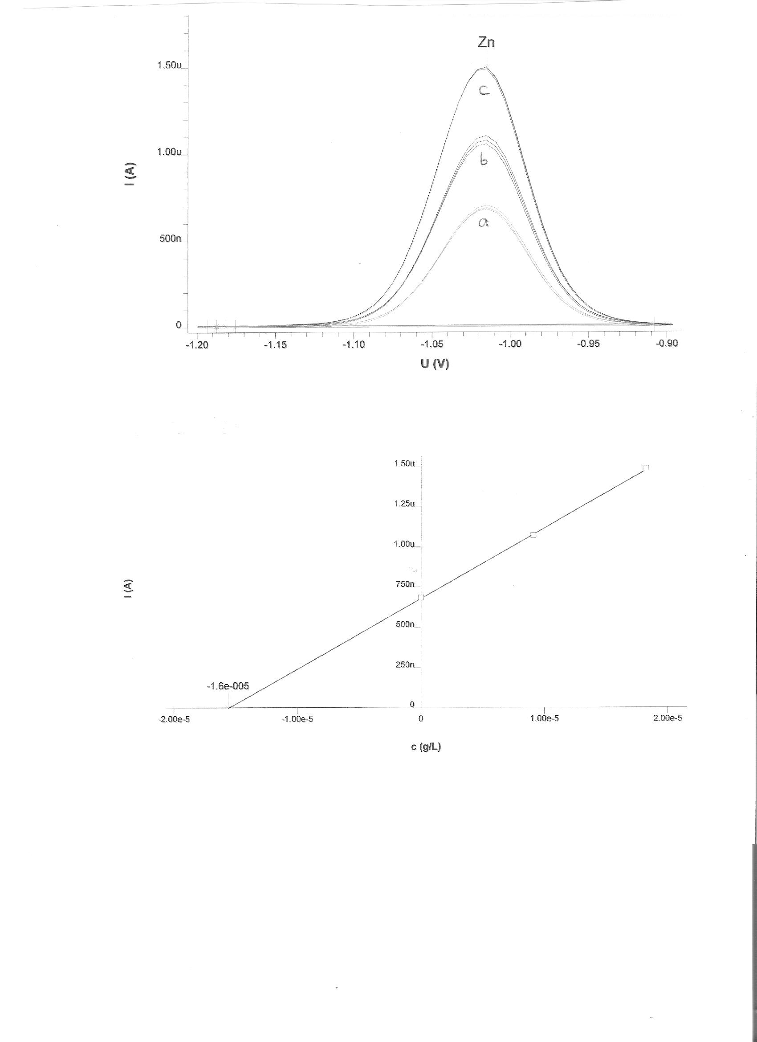
Figure 2. DPAS voltamograms of the Zn element obtained from standard addition technique a) 1 ml acetate buffer (pH = 4.2) + 10 ml Tap water b) a + 100 µl c) b + 100 µl standard solution of Zn (10 mg /l).
Figure 3. The calibration plot of Zn(II) element obtained from standard addition by DPASV technique.

As can be seen from the Fig. 3, the current of oxidation peak of Zinc element increased by the addition of the standard solution. A further increase in sensitivity of peak currents was achieved by increasing the deposition time to 300 s. In addition, to increase sensitivity, the optimum pH value in acetate buffer tampon was determined to be 4.2. Under these conditions, the concentration of Zn(II) element in Tap water was found to be between 0.013 - 0.016 mg/l.

Also the study in Figure 4. approved that the highest concentration of Zn element was found Sabia area Tap water which reached (0.016 mg/l) then Jazan area Tap water reached to (0.015 mg/l) , then Bani - Malik area Tap water reached to (0.014 mg/l) finally Abu-Arish area Tap water reached to (0.013 mg/l), finally. This value is between the limit values suggested by WHO, TSE and EPA , it is understood that the concentration of Zn(II) in Tap water have no influence on the human health . Also, the analysis has been determined without the interferences in the applied voltammetric method. The advantages of the proposed voltammetric method over the other known techniques were sample preparation, sensitivity, rapidity and cost.

II- Determination of Lead (Pb) trace elements in Tap water sample:
In this study, the concentration of Pb trace element in Tap water was successfully determined by ASV technique. DPAS voltammograms of Pb element obtained from standard addition technique are given in Fig 5. The sensitivity was calibrated by standard additions to the sample and the initial metal concentrations were calculated by extrapolation (Fig 6). (Used voltammetric apparatus on quantitative mode a automatically requires one sample to be added to the voltammetric cell and then two standards to be added and finally, the machine plots the value of the current- concentration. Therefore, there are only three plots on calibration curve). Consequently, linear calibration range was automatically obtained as being related to quantitative mode of the voltammetric unit.

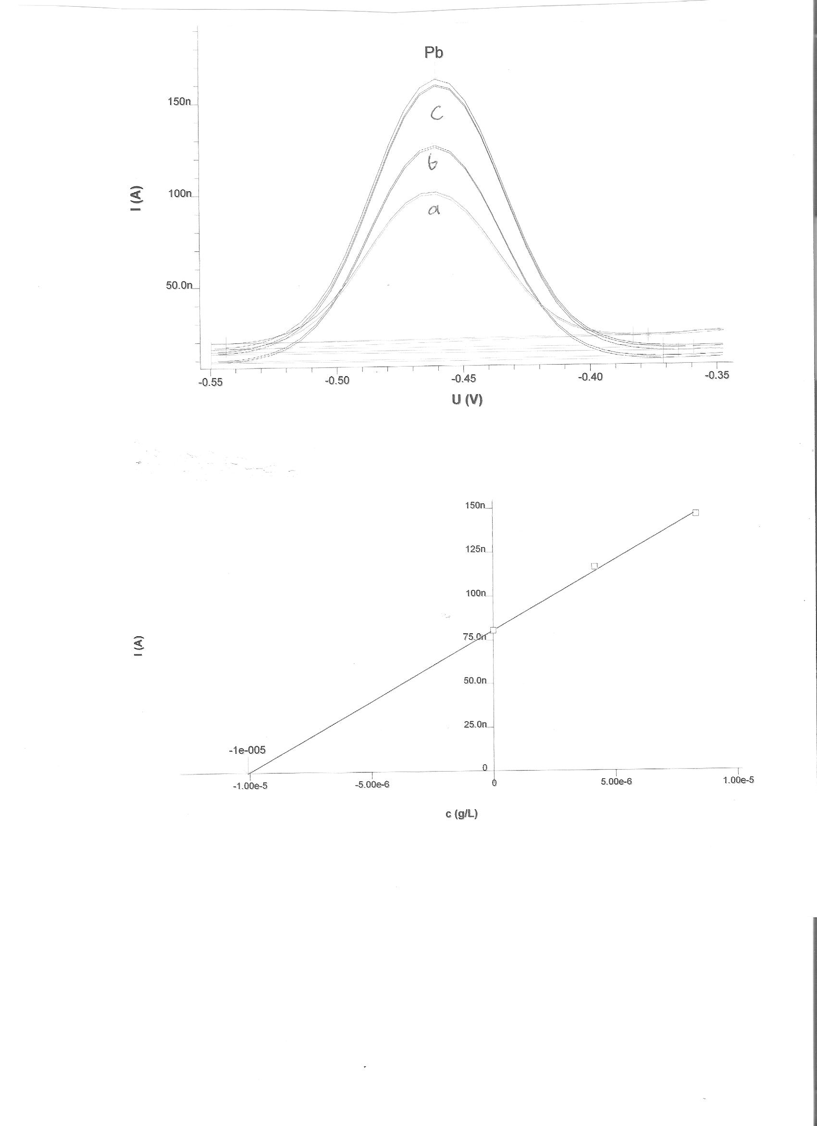
Figure 5. DPAS voltamograms of the Pb element obtained from standard addition technique a) 1 ml acetate buffer (pH = 4.2) + 10 ml Tap water b) a + 100 µl c) b + 100 µl standard solution of Pb (10 mg /l).

Figure 6. The calibration plot of Pb (II) element obtained from standard addition by DPASV technique.

As can be seen from the Fig. 5, the current of oxidation peak of Lead element increased by the addition of the standard solution. A further increase in sensitivity of peak currents was achieved by increasing the deposition time to 300 s. In addition , to increase sensitivity, the optimum pH value in acetate buffer tampon was determined to be 4.2. Under these conditions, the concentration of Pb(II) element in Tap water was found to be between 0.005 - 0.009 mg/l.

In Figure 7. the highest concentration was found with Pb element noticed is (0.009 mg/l) in Abu-Arish area Tap water , while Bani - Malik area Tap water has the lower concentration it reached (0.005 mg/l) the order is: Abu-Arish area Tap water > Sabia area Tap water > Jazan area Tap water > Bani-Malik area Tap water. This value is between the limit values suggested by WHO, TSE and EPA, it is understood that the concentration of Pb(II) in Tap water have no influence on the human health .

III- Determination of Copper (Cu) trace elements in Tap water sample: In this study, the concentration of Cu trace element in Tap water was successfully determined by ASV technique. DPAS voltammograms of Cu element obtained from standard addition technique are given in Fig 8. The sensitivity was calibrated by standard additions to the sample and the initial metal concentrations were calculated by extrapolation (Fig 9).
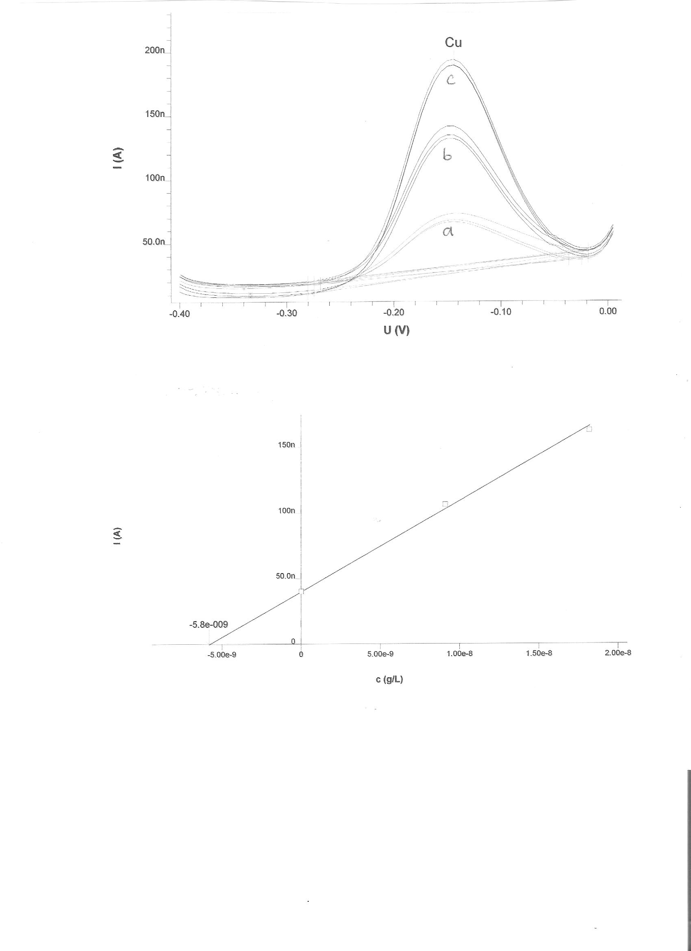
Figure 8. DPAS voltamograms of the Cu element obtained from standard addition technique a) 1 ml acetate buffer (pH=4.2)+10 ml Tap water b) a+100 µl c) b+100 µl standard solution of Cu (8 mg /l).

Figure 9. The calibration plot of Cu (II) element obtained from standard addition by DPASV technique.

As can be seen from the Fig. 9, the current of oxidation peak of Cu element increased by the addition of the standard solution. A further increase in sensitivity of peak currents was achieved by increasing the deposition time to 300 s. In addition , to increase sensitivity, the optimum pH value in acetate buffer tampon was determined to be 4.2. Under these conditions, the concentration of Cu(II) element in Tap water was found to be between 0.001 - 0.006 mg/l.
In Figure 10. Also the study showed that the highest concentration Cu element was in Sabia area Tap water (0.006 mg/l) then Jazan area Tap water where (0.005 mg/l), then Bani-Malik area Tap water (0.004 mg/l) then Abu-Arish area Tap water (0.001 mg/l). This value is between the limit values suggested by WHO, TSE and EPA, it is understood that the concentration of Cu(II) in Tap water have no influence on the human health .

IV- Determination of Cadmium (Cd) trace elements in Tap water sample:
In this study, the concentration of Cd trace element in Tap water was successfully determined by ASV technique. DPAS voltammograms of Cd element obtained from standard addition technique are given in Fig 11. The sensitivity was calibrated by standard additions to the sample and the initial metal concentrations were calculated by extrapolation (Fig.12). 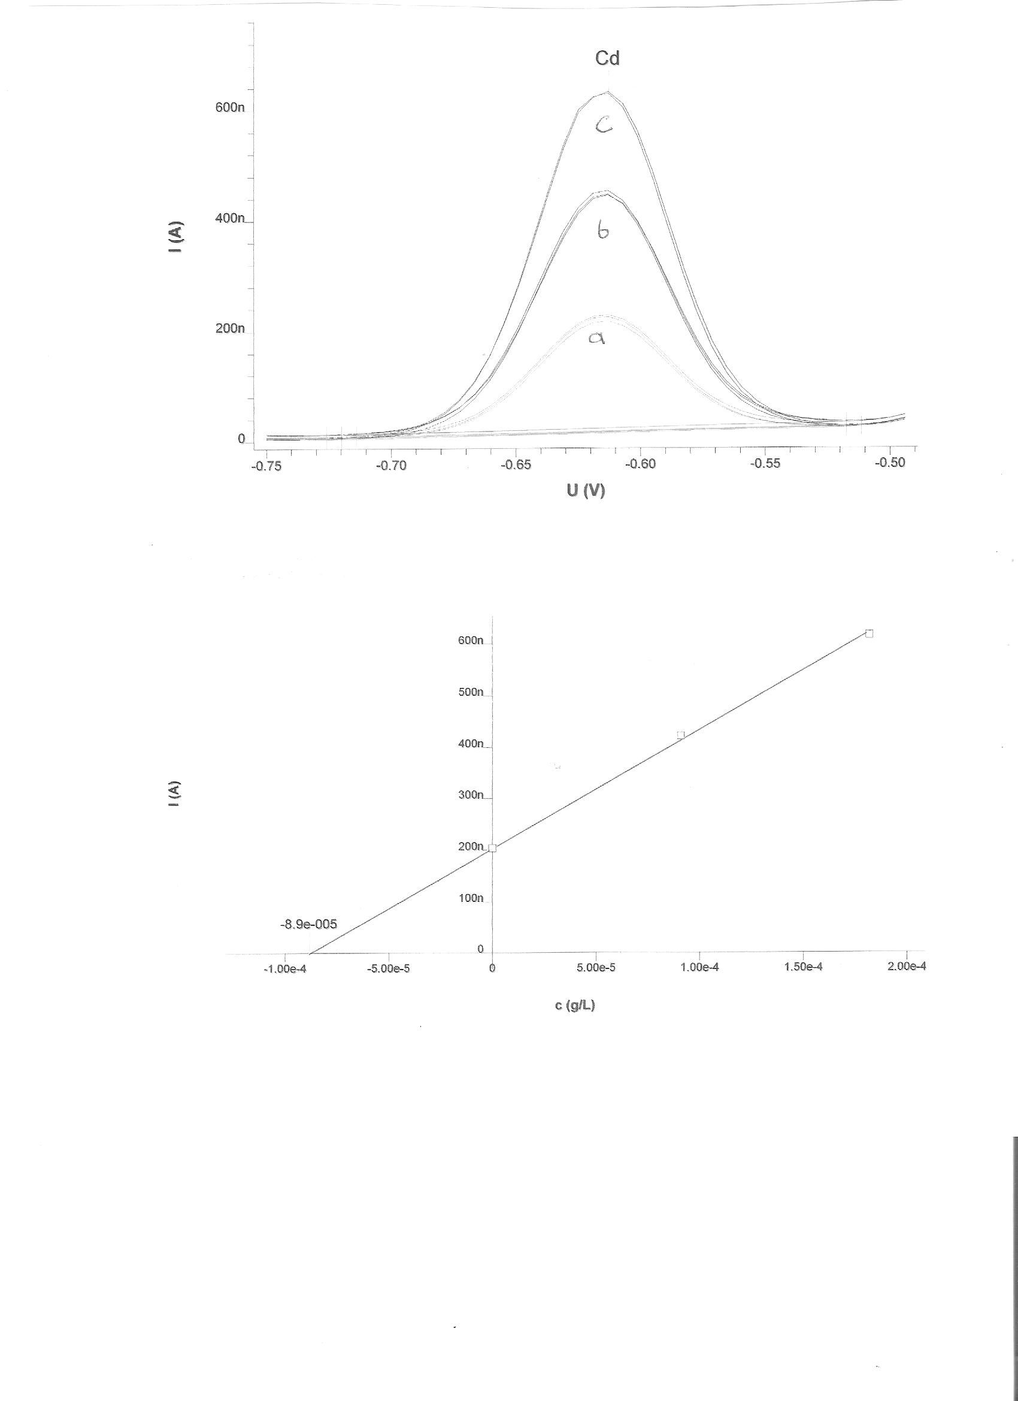
Figure 11. DPAS voltamograms of the Cd element obtained from standard addition technique a) 1 ml acetate buffer (pH = 4.2) + 10 ml Tap water b) a + 100µl c) b + 100µl standard solution of Cd(5mg /l).
Figure 12. The calibration plot of Cd (II) element obtained from standard addition by DPASV technique.

As can be seen from the Fig. 12, the current of oxidation peak of Cd element increased by the addition of the standard solution. A further increase in sensitivity of peak currents was achieved by increasing the deposition time to 300 s. In addition , to increase sensitivity, the optimum pH value in acetate buffer tampon was determined to be 4.2. Under these conditions, the concentration of Cd(II) element in Tap water was found to be between 0.001 - 0.003 mg/l.
In Figure 13. Also the study showed that the highest concentration Cd element was in Abu-Arish area Tap water (0.003 mg/l) then Jazan area Tap water where (0.002 mg/l), then Sabia area Tap water (0.00105 mg/l) then Bani-Malik area Tap water (0.001 mg/l). This value is between the limit values suggested by WHO, TSE and EPA, it is understood that the concentration of Cd(II) in Tap water have no influence on the human health .

Also the study clarified the differences between elements concentration, so that it can be seen in :
1. Jazan area Tap water, the highest concentration Zn element is found, that it reached to (0.015 mg/l) where the less concentration was Cd element , that it reached to (0.002 mg/l) . Pb element reached to (0.007 mg/l) , following that ,Cu element where it reached (0.005 ppm).
2. Abu-Arish area Tap water concerning Cu element, it was the lowest concentration within (0.001 mg/l) following that Cd element within (0.003 mg/l) after that Pb element within (0.009 mg/l) and the highest concentration was Zn element within (0.013 mg/l) .
3. Sabia area Tap water, in that the highest concentration Zn element was within (0.016 mg/l) , and it was lower in concentration Cd element within (0.00105 mg/l) , and Pb element concentration reached to (0.008 mg/l) while Cu element concentration reached to (0.006 mg/l).
4. Bani-Malik area Tap water concerning Pb element within (0.005 mg/l) and Cu element concentration reached to (0.004 mg/l) while the lowest concentration was in Cd element where it reached to (0.001 mg/l) and the highest concentration was Zn element within (0.014 mg/l).

Corresponding Author:
Dr.Asia Ali Alshaik
Kingdom Of Saudi Arabia, Ministry of Higher Education, Jizan University, Deanship of Scientific Research, Girl’s College of Educational, Jizan.
E-mail: Ziadahmed1020@hotmail.com

References
1. AL-bakri I and Break E(2004). Chemical pollution in Jizan water (facts, reasons, impact and treatment). Arab Gulf Journal of Scientific Research; 22(2):102-116.
2. Abed K and Alwakeel S(2007). Mineral and Microbial Contents of Bottled and Tap Water in Riyadh, Saudi Arabia. Middle - East Journal of Scientific Research; 2 (3-4):151-156.
3. Yilmaz S, Yagmur S, Saglikoglu G, Sadikoglu M. (2009). Direct Determination of Zn Heavy Metal in Tap Water of Canakkale (TURKEY) by Anodic Stripping Voltammetry Technique. Int. J. Electrochem. Sci. ; 4: 288 – 294.
4. Rawat M, Moturi MCZ , and Subramanian V(2003). Inventory compilation and distribution of heavy metals in wastewater from small-scale industrial areas of Delhi, India, J. Environ. Monit.;5: 906–912.
5. Yantasee W, Hongsirikarn K, Warner CL, Choi D, Sangvanich T, Toloczko MB, Warner MG, Fryxell GE, Addleman RS and Timchalk C(2008). Direct detection of Pb in urine and Cd, Pb, Cu, and Ag in natural waters using electrochemical sensors immobilized with DMSA functionalized magnetic nanoparticles. Analyst; 133: 348–355.
6. Ali EM, Zheng Y, Yu H and Ying JY (2007). Ultrasensitive Pb2+ detection by glutathione-capped quantum dots, Anal. Chem.;79: 9452–9458.
7. Shtoyko T, Maghasi AT, Richardson JN, Seliskar CJ and Heineman WR (2003). Spectroelectrochemical sensing based on attenuated total internal reflectance stripping voltammetry. 1.Determination of lead and cadmium, Anal. Chem.; 75: 4585–4590.
8.Sitko R, Zawisza B and Mzyk Z (2006). Chemofiltration of mercury water samples through zinc sulfide layer and determination by wave length dispersive X-ray fluorescence spectrometry, J. Anal. At. Spectrom. ; 21 : 13–18.
9. Mezei P and Cserfalvi T(2007). Electrolyte cathode atmospheric glow discharges for direct solution analysis, Appl. Spectrosc. Rev.; 42: 573–604.
10. Arab S and Alshikh A (2010). Voltammetry Determination Of Some Trace Elements In Tap Water Samples Of Jeddah Area In The Kingdom Of Saudi Arabia. Journal of American Science; 6( 10):1026-1032.

11/21/2011

