IMPROVEMENT OF RADIOACTIVE WASTE SOLIDIFICATION PROCESS USING MODIFIED BENTONITE MATERIALS

M. Abdel Geleel; N. S. Mahmoud

National Centre for Nuclear Safety and Radiation control, Atomic Energy Authority, Nasr City 11762, B.O Box 7551 Cairo, Egypt. mnnarmine@hotmail.com

Abstract: The solidification matrix is an important barrier for the safety of disposal site. Improvement of this matrix is done by incorporation of Na-bentonite and K-bentonite loaded by cobalt and cesium into ordinary Portland cement. To improve the compressive strength of the final solid block, bentonite was coated by acrylic acid and styrene. The compressive strength for Portland cement containing 25 wt. % K-bentonite was increased from 15 MPa to 27 and 36 MPa when coated by acrylic acid and styrene respectively. On the other hand, the compressive strength of Na-betonite was increased from 14 MPa to 24 and 33 MPa when coated by acrylic acid and styrene respectively. Mechanical, chemical and radiation stability has been carried out under different experimental conditions. The effect of radiation dose to solidified cemented waste form was investigated and the results show that at 1.5 Mrad the compressive strength increased to its maximum value 57 Mrad and 51.2 Mrad for K-bentonite and Na-bentonite, respectively. To assess the safety of radioactive waste-cement composition, the leaching of ⁶⁰Co and ¹³⁷Cs from a waste composite into a surrounding fluid has been studied using underground water as leachant. Leaching tests were carried out in accordance with a method recommended by the IAEA.
[M. Abdel Geleel; N. S. Mahmoud. IMPROVEMENT OF RADIOACTIVE WASTE SOLIDIFICATION PROCESS USING MODIFIED BENTONITE MATERIALS. Nature and Science 2012;10(1):158-164]. (ISSN: 1545-0740). http://www.sciencpub.net.

Key words: Disposal; Safety assessment; Radio active waste; Solidification process.

1. Introduction
Nuclear power plant is generating a nuclear waste stream of different salt concentration and composition. In order to prevent widespread dispersion of these radionuclides into the human environment, radioactive waste produced in nuclear facilities has been incorporated in several kinds of matrices; cement, bitumen or polymers⁽¹⁻³⁾. In The objectives of immobilization of radioactive waste are to convert the waste into forms which are
- Leaching resistant so that the release of radionuclides will be slow even though they may come into contact with flowing water;
- Mechanically, physically and chemically stable for handling, transport and disposal⁽⁴⁾.
The technique of immobilizing radioactive waste in cement has been used in the nuclear industry and at nuclear research centres for more than 40 years. Cement has many characteristics in its favour: it is readily available and widely used in civil engineering, the raw material is inexpensive and the processing equipment can be based on conventional technology. The resulting waste forms are strong, noncombustible and radiation resistant, have a high density (providing radiation shielding), have a reasonable chemical stability and have a moderate resistance to the release of radionuclides. Cement, as a porous material, its rate of dissolution varies as a function of phase chemistry and this dissolution exposes or enlarges pores; thus the leaching behavior must be related to pore structure and the composition of the pore solution. Although cement has several unfavorable characteristics as a solidifying material, i.e. low volume reduction and relatively high leachibility, it possesses many particle advantages: good mechanical characteristics, low cost, easy operation and radiation and thermal stability.
Polymeric encapsulation offers provide a number of advantages for treatment of contentious waste streams. Their superior mechanical properties allow for good waste loadings, allowing the number of packages to be reduced, while maintaining the integrity of the wasteforms. Their resistance to acids, alkalis, and organic solvents makes them highly durable, and they exhibit excellent radionuclide retention and leach resistance. Polymeric materials are also non aqueous systems so direct corrosion of the metals by water is minimised. Moreover, they provide a good barrier to moisture transport and they offer good radiation resistance.
Egypt, radioactive liquid wastes are immobilized in cement matrix Cesium and cobalt salts are massively present in low and medium radioactive liquid wastes generated from different uses of radioactive materials such as; nuclear power reactor, research reactor, and research labs. As a result of high reactive surface site density and high specific surface area, clay-sized mineral particles may retard the migration of these radionuclides in receiving sediments via adsorption and/or surface precipitation reactions. Also, the solidification behavior of cement may be either physical or chemical. Physically it may act as a barrier and chemically as a selective binder for these radionuclides. The latter aspect is believed to assume increasing importance at long ages.
The present work aims to profit from advantages of the two matrices and the characteristics of clay mineral to improve the solidification process as an important safety barrier of the disposal site.

2. Experiment
The cement used for incorporating bentonite loaded by Co-60 and Cs-137 radioactive waste was ordinary Portland cement (OPC) from National Cement Company at Helwan, Helwan, Egypt. Different matrices were prepared by mixing modified and activated clay with cement at a ratio ranging from 5 to 25 wt. % until homogenous paste is obtained. These mixture were prepared at water/cement ratio (w/c) 0.35 to determine the mechanical and chemical characteristics of these matrices. Specimens were cast in 5 cm diameter cylindrical polyethylene vials and 5 cm length. The vials were then capped to prevent evaporative water loss. Specimens were compression tested after curing for at least 60 days.

2.1. Compressive strength
Compressive strength testing was conducted as a measure of mechanical integrity. The compressive strength of ordinary Portland cement waste forms were tested in accordance with the ASTM method C 39-72, "Test for the compressive Strength of Cylindrial Concrete Specimens" (American Socity for Testing and Materials, C39-72 1975).

2.2 Leaching behavior
The leaching characteristics, which refer to the release of radionuclides from the solidified waste forms to aqueous environment, were reported using different percent of modified activated bentonite added to Ordinary Portland cement. Radioactive wastes containing Co-60 and Cs-137 were incorporated into different modified clay/cement ratios. Leaching experiments were carried out following Hesp's leaching test⁽⁵⁾.

(∑a _{n} /A_{o}) / (F/V) versus square root of the total leachant renewal period √ t_{n}

Where:
a _{n} = radioactivity leached during the leachant renewal period n.
A_{o} = radioactivity initially present in the specimen.
F = exposed surface area of the specimen (cm²).
V = volume of the specimen (cm³).
T _{n} = duration (days) of the leachant renewal period.
Samples were suspended in a way that the whole surface area was exposed to the leaching solution. Ground water as leachant was obtained from Abu-Zaable well No. 202, which is one of the nearest grounds well to the suggested disposal site. The chemical analysis of the ground water is shown in table 1 ⁽⁶⁾.

Table 1 Chemical analysis of ground water well No.202⁽⁶⁾.

TDS*  (mg/l) | pH | Soluble cations (ppm) |  |  | Soluble anions (ppm)
TDS*  (mg/l) | pH | K⁺ | Na⁺ | Mg⁺ | Ca⁺⁺ | Cl ⁻ | SO₄⁻ | HCO₃⁻
1.05 | 7.2 | 23 | 149 | 13 | 74 | 137 | 317 | 272
*Total Dissolves Salts

Compatibility between cement and activated bentonite
Compressive strength
Mechanical integrity of waste forms is an important consideration in the safe handling and transportation of radioactive waste prior to disposal. Waste form failure under load may result in cracking or friability leading to possible dispersion of activity. Waste form failure creates a larger effective surface area from which activity can be leached. Therefore, mechanical properties of waste forms are of concern within the disposal environment.

Curing time
The compressive strength data of the solidified waste form as a function of time at different weight percent of K-bentonite and Na-bentonite are represented in Fig. 1-3. These figure shows that the compressive strength depending on the weight percent K-and Na-bentonite added to OPC. The compressive strength decreases from 62.4 MPa to 13.1 MPa and from58.2 MPa to11.3 MPa by increasing the weight percent of K-and Na-bentonite from 5 wt.% to 25 wt.%, respectively. This result could be attributed to the increase in the alkali metal concentrations in the prepared mixture at the expense of aluminosilicates, which could affect the whole integrity of the pastes⁽⁸⁾. On the other hand, the compressive strength increases with increasing setting time till t reached to certain time (28 days) it levels off.

Fig. 3 Effect of bentonite weight percent incorporated onto Portland cement on the compressive strength.

Effect of bentonite weight percent
The effect of different weight percent of bentonite coated by acrylic acid and styrene on the compressive strength was examined and the obtained results are given in Figures 4,5. From these figures it is clear that the compressive strength increases from 51.5 MPa (5 wt.% K-bentonite without coating) to 71.7 and 94.2 MPa when it is coated by styrene and acrylic acid, respectively. On the other hand, when 5 wt.% Na-bentonite coated by styrene and acrylic acid the compressive strength increases from 40.2 MPa (5 wt.% Na-bentonite without coating) to 60.4 MPa and 75.1 MPa when it is coated with styrene and acrylicacid.

Fig. 4. Effect of weight percent on the compressive strength on K-bentonite coated by acrylic acid (AAc) and styrene (St.).

Fig. 5. Effect of weight percent on the compressive strength on Na-bentonite coated by acrylic acid (AAc) and styrene (St.).

Radiation dose
Ordinary Portland Cement is often used as a solidifying agent for radioactive wastes. One factor that needs to be assessed is the resistance of OPC to radiation that may be cause losses in mechanical strength. Gamma radiation from radioactive wastes is especially important because of its ability to deeply penetrate and degrade materials. The effect of gamma irradiation dose to the compressive strength of K-bentonite and Na-bentonte is represented in figure 6. The compressive strength increases from 49 MPa to 57 MPa (in case of K-bentonite) and from 43 MPa to 49.9 MPa (in case of Na-bentonite) with increasing the radiation dose from 1 to 1.5 Mrad then it is sharply decrease when exposed to irradiation dose more than 1.5 Mrad. This may be due to the deeply penetrate and degrade materials of OPC⁽⁹⁾.

Leaching test of Cs-137 and Co-60 radionuclides
When the cemented waste forms come in contact with water, the transfer of soluble materials from the waste to the surrounding water is caused by dissolution or chemical reaction with chemical components of water. In this study, the radionuclides chosen for the leach test are intended to represent the desorption (leaching) behavior of some of the typical radionuclides encountered in low-level solid waste forms. The variations of the cumulative leach fractions of ¹³⁷Cs and ⁶⁰Co radionuclides incorporated into potassium and sodium bentonite coated by acrylic acid and styrene and mixed with OPC are depicted in Fig.7-10. From these figures it is clear that; the leaching curves obtained have two distinct parts. The initial part shows a high leach rate and the second final part shows a low leach rate. The initially high release may be attributed to the surface activities which are easily washed when the sample comes in contact with leachant. On the other hand, the results showed that, the coating with acrylic acid and styrene decreased the leaching rate of both cesium and cobalt and this may be due to the acrylic acid and styrene are capable to reduce the volume of large pores and capillaries found in cement pastes⁽⁹⁾. The magnitude of the cumulative leach fraction is an index for the release of the nuclide for the cement matrix. In both studied cases have highest values of cumulative leach fraction than cobalt radionuclides. The cumulative leach fractions are in the following order:
K-Bentonite > K-Bentonite coated with styrene > K- Bentonite coated with acrylic acid

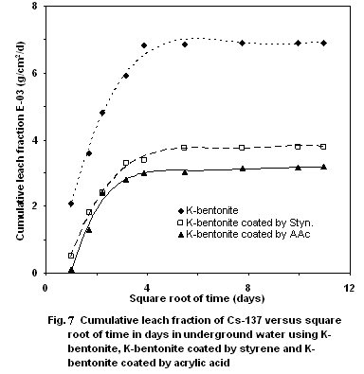

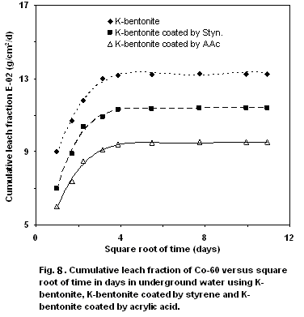

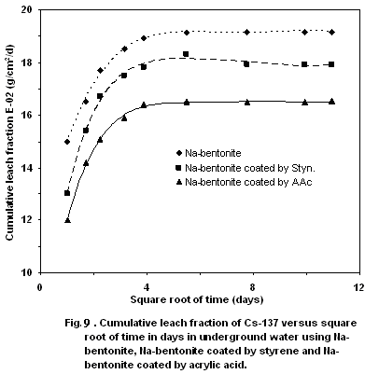

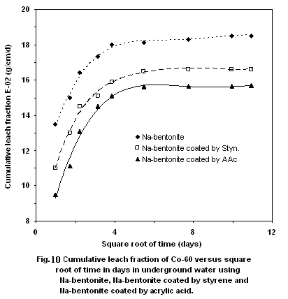

3. Conclusion
The fixation of cesium and cobalt radionuclides on natural and thermal bentonite coated by acrylic acid and styrene then immobilized into OPC was investigated. The results showed that the best waste isolation, without causing a loss in the mechanical strength, is obtained when the bentonite content in the cement is 10 wt.% and it is reached to 25 wt.% by coated with acrylic acid and styrene. The compressive strength for Portland cement containing 10 wt. % K-bentonite was 41 MPa while K-bentonite coated by acrylic acid and styrene was 63 and 82 MPa. While the compressive strength for Portland cement containing 10 wt. % Na-bentonite was 33 MPa while Na-bentonite coated by acrylic acid and styrene was 55.5 and 68 MPa. The leachability test shows that the coating with acrylic acid and styrene decreased the leaching rate of both cesium and cobalt and this may be due to the acrylic acid and styrene are capable to reduce the volume of large pores and capillaries found in cement pastes.

References
- Burns R. H.(1971) Solidification of low and intermediate level waste, Atomic Energy Rev. 9, 545,.
- Plecas I., Mihajlovic L.J., Kostadinovic A(1985). Optimization of concerete containers composition in radioactive waste technology, Radioactive waste management and fuel cycle. 6(2), 161,.
- Lu A. H(1978)., Modelling of radionuclide migration from a low level radioactive waste burial site, Health Physics, 34 (39), 39,
- Plecas I(2005), Leaching study on the process of solidification of radionuclide ⁶⁰Co in concrete; J. Environmental studies vol. 14, no. 5 699-701.
- Hespe E. D(1979), " Health safety and waste management" International Atomic Energy Agency, vol. 9 No.1 pp.195, Vienna
- El-Dakroury A. M.(2003),"Conditioning of radioactive liquid wastes using waste ceramic (sludge)" Al-Azhar University Engineering Journal (AUEJ), vol.6 No.4, pp82).
- Ezz El-Din M.R, Molukhia H. And Ramadan A(2001)., "Treatment of radioactive waste solutions using local clay minerals" , Arab Journal of Nuclear Science and Application, Vol. 34, No.2, pp.117-122).
- . El-KamashA.M. , M.R. El-Naggar, and M.I. El-Dessouky(2006), Immobilization of cesium and strontium radionuclides in zeolite-cement blends, Journal of Hazardous Materials B136, 310,.
- .Abdel Geleel M(2010)., New trend for incorporation of cobalt and cesium radionuclides in natural and thermal activated bentonite cement block, J. Nature and Science, vol 8 (10), pp. 311-316

12/12/2011

