Investigation on defensive enzymes activity of Brassica juncea genotypes during pathogenesis of Alternaria blight

Pankaj Singh Parihar, Om Prakash and H. Punetha*

Department of Biochemistry College of Basic Sciences and Humanities
Department of Chemistry College of Basic Sciences and Humanities
G.B. Pant University of Agriculture and Technology, Pantnagar 263145 (Uttarakhand) India.
punetha_hp@rediffmail.com, oporgchem@gmail.com

ABSTRACT: The investigation was carried out to know the biochemical basis of defense mechanism of seven Brassica juncea genotypes infected with Alternaria blight, under field conditions. Genotypes EC-399299, EC-399296, EC-399313 and PHR-2 showed lowest percent Disease Severity Index. The activity of PAL, PPO, Peroxidase and Catalase were recorded at 65DAS, 25DPI and 50DPI. Biochemical analysis of infected genotypes revealed an increase in PAL, PPO and peroxidase activity. EC-399299, EC-399296 and PHR-2 exhibited maximum increase in these parameters. Catalase activity was decreased, with the progresses of disease. The activity of PAL, PPO, peoxidase and catalase were used as parameter to identify the resistant genotype for breeding programmes. The finding revealed that EC-399299, EC-399296, EC-399313 and PHR-2 are comparatively more resistance against infection of Alternaria brassicae then other observed genotypes and suggested that PAL, PPO and peroxidase may play an important role in under taking the defense mechanisms of Brassica juncea genotypes against Alerternaria blight pathogenesis.
[Pankaj Singh Parihar, Om Prakash and H. Punetha. Investigation on defensive enzymes activity of Brassica juncea genotypes during pathogenesis of Alternaria blight. Nature and Science 2012;10(2):63-68]. (ISSN: 1545-0740). http://www.sciencepub.net. 11

Key Words: Brassica juncea, Alternaria blight, defensive enzymes

INTRODUCTION
Alternaria blight disease caused by Alternaria brassicae (Berk.) Sacc has been reported from all the continents of the world and is one the important devastating diseases of Indian mustard causing up to 47% yield losses “(Kolte, 1986)”. Average yield losses in the range of 32-57 per cent due to Alternaria blight have been reported “(Shrestha et al., 2005)”. In addition to the direct losses in yield, the disease adversely affects the seed quality by reducing seed size, seed discolouration and reduction in oil content “(Prasad & Lallu, 2006)”. The host-pathogen interaction induce signaling molecule in plants system, which lead to production of antimicrobial compound. Defensive enzymes are among the most influential and widely distributed products in the plants. PAL, PPO and peroxidase were reported in plants treated with various biotic and abiotic inducer “(Raghvendra et al., 2007)”. Phenylalanine ammonialyase (PAL) is the key enzyme catalyzing the biosynthesis of phenolics and lignin from the aromatic amino acid phenylalanine “(Cartea et al., 2010)”. Polyphenol oxidase (PPO) is allowed to leave the chloroplast thylakoid membrane and come in contact with the accumulated phenolic compounds. In the presence of oxygen, PPO oxidizes the phenolic compounds that are in the form of o-diphenol to a o-quinone(Raj et al., 2006). The plants peroxidases have been implicated in a variety of defense-related processes, including the hypersensitive response, lignification, cross-linking of phenolics and glycoprotein, suberization and phytoalexin production. Catalase is frequently used by cells to rapidly catalyze the decomposition of hydrogen peroxide into less reactive gaseous oxygen and water molecules thus avoiding cellular disintegration “(Bolwell and Wojtaszek, 1997)”. The present investigation focused on biochemical changes in susceptible and resistant cultivars of Brassica juncea during pathogenesis of Alternaria brassicae.

MATERIALS AND METHODS
The investigation was carried out at Crop Research Centre, G.B.P.U.A & T., Pantnagar during rabi season, 2010-2011. Seven genotypes of Brassica juncea namely EC-399313, EC-399312, EC-399296, EC-399299, 399302, PHR-2 and Varuna were used for the present investigation. For all biochemical analysis fresh leaf samples were used. The experiment was laid out in a randomized block design (RBD) with three replications.
Phenylalanine ammonia lyase (PAL) activity was measured as described by “(Lisker et al, 1983)”. Leaf material was homogenized in 25mM Tris-HCI buffer, pH 8.8 (w/v, 1:1) centrifuged at 8000 r.c.f for 30 min at 4°C. The reaction mixture contains 1 mL of enzyme extract, 0.5 mL substrate L-phenylalanine and 0.4 mL of 25mM Tris-HCL buffer (pH 8.8). After incubation of 2h at 40°C, activity was stopped by the addition of 0.06mL 5N HCL and the absorption was read at 290nm. The enzyme activity was expressed as µmol of trance –cinnamic acid /mg of protein/h. Polyphenol oxidase activity measured as described by “(Mayer et al, 1965)”. Leaf material was homogenized in 50mM sodium phosphate buffer, pH 6.8 (w/v, 1:1) centrifuged at10,000 r.c.f for 20 min at 4°C The reaction mixture contains l00µL of enzyme extract, 50µL of substrate 60mM catechol and 2mL of 50mM sodium phosphate buffer (pH 6.8). The absorption was read at 290nm enzyme activity was expressed as ∆OD at 420/mg of protein/ min. Peroxidase activity was measured as described by “(Hammerschmidt and Kuc, 1982)”. Leaf material was homogenized in 50mM sodium phosphate buffer, pH 6.8 (w/v, 1:1) centrifuged at 10,000 r.c.f for 20 min at 4°C The reaction mixture contains 0.5mL of enzyme extract, 1.5mL of substrate 0.05M pyrogallol and 0.5mL 1% hydrogen peroxide, absorption was read at 420nm was recorded at 30 seconds intervals for 2 minutes, Enzyme activity was expressed as ∆OD at 420/mg of protein/min. Catalase activity measured by the method of “(Beers and Sizer, 1952)”. Leaf material was homogenized in 0.1M phosphate buffer, pH 6.5 (w/v, 1:1) centrifuged at 15,000r.c.f for 30 min at 4°C.The reaction mixture contains 1.9 mL reagent grade water 1.0 mL of 0.059 M Hydrogen peroxide which was incubate for 4-5 minutes to achieve temperature equilibration and to establish blank rate, add 0.1 mL of diluted enzyme and record decrease in absorbance at 240 nm for 2-3 minutes. The difference in absorbance (∆A₂₄₀) was divided by the H₂O₂ molar extinction coefficient (36M⁻¹.cm⁻¹). Enzyme activity was expressed as µmol of H₂O₂/ mg of protein / min. Total soluble proteins was estimated by “(Bradford 1976)”.

RESULTS AND DISCUSSION
In present investigation it was observed that disease severity increased with the plant age and infection, in all the genotypes. The maximum disease severity was observed in Varuna which was 37.41% and 85.9% at 25 DPI and 50DPI respectively followed by EC-3399302, 85.59% and EC-399312, 80.8% at 50 DPI. No disease symptoms were observed at 65 DAS. Other genotypes were expressing a moderate level of tolerance against A. brassicae figure 1 and table 1. The observation supported by the previous research on different genotypes of mustard infected by A. brassicae, concluded that Varuna, EC-399302 and EC-399312 were susceptible, other genotypes were highly or moderately tolerant “(Patni et al., 2005)”.
Progressive increase of PAL activity recorded with increase in disease infection at 65DAS, 25DPI and 50 DPI shown in figure 2 and table 1. The lowest activity was observed in Varuna (7.32, 8.9 and 9.31 µmol of trans-cinnamic acid/mg protein/h) at 65DAS, 25DPI and 50 DPI respectively, whereas highest activity observed in EC-399299 (8.77, 10.77 and 12.6 µmol of trans-cinnamic acid/mg protein/h) at 65DAS, 25DPI and 50DPI respectively followed by EC-399296. Similar observations were recorded in previous research, during the plant development, cell differentiation, stress conditions such as irradiation, wounding, nutrient deficiencies, herbicide treatment and viral, fungal and insect attacks ” (Morelló et al., 2005)”. Logemann et al. (2000) reported that the increase in PAL activity has frequently been mentioned as a defense reaction of plants to pathogen attack. An increase in PAL activity results in increase in concentration of phenolic compounds, which are substrates for oxidative enzymes such as polyphenol oxidase and peroxidase. PAL catalyzed first reaction of phenylproponoid pathway, phenylalanine to t-cinannamic acid, which results accumulation of phenolics and other antimicrobial compounds “(Slatnar et al., 2010)”.
The highest activity of PPO was observed in EC-399299 (10.53, 12.56 and 13.10 ∆OD/mg of protein/min) at 65DAS, 25DPI and 50DPI respectively followed by EC-399296 whereas lowest was observed in Varuna, EC-399312 and EC-399302 throughout all stages. With the increase in infection and plant age, the PPO activity was increased in all genotypes as shown in figure 3 and table 1. In the present investigation PPO activity was observed to be higher in infected leaves as comparison to the healthy one and the resistant genotype expressed more PPO activity than the susceptible one. Niranjanraj et al. (2006) observed similar results that seedlings of resistant varieties had greater PPO activity than susceptible seedlings. Similarly the higher PPO activity was recorded in pearl millet tissues infected with DM fungus than healthy “(Shetty et al., 2001)”. Similar phenomenon has also been observed in pear fruits infected resistant cultivar with Erwinia amylovora pathogen “(Honty et al., 2005)”. The PPO induction upon infection was found in the pearl millet-Sclerospora graminicola and wheat-Alternaria triticina interactions increase in the activity level of polyphenol oxidase (PPO) was observed, this could be enhanced the oxidation of phenolic compounds into the more toxic forms, quinones, against pathogen “(Tyagi et al., 2000)”.
It was observed that Peroxidase activity was increased, as disease progressed. At 65DAS the lowest activity was observed in Varuna and EC-399312 which was 11.31 and 11.08 ∆OD at 420nm/mg of protein/min respectively. The lowest value was observed in Varuna which was11.84 and 13.80 (∆OD at 420nm/mg of protein/min) at 25DPI and 50DPI respectively whereas highest value were recorded for EC-399296 and EC-399299 throughout all stages of study as shown in figure 4 and table 1. Higher levels of peroxidase activity resulted exclusively from fungal infection as reported by Rosta’s et al. (2002) in Alternaria brassicae infected Chinese cabbage. The present investigation is in confirmatory with the investigation of Saharan et al. (2000), who reported increased peroxidase activity in response to Alternaria blight infection in both resistant and susceptible clusterbean varieties. Stout et al. (1999) observed that tomato plants inoculated with the pathogenic fungus Phytophthora infestans had increased peroxidase activities. Higher peroxidase activity was observed in diseased leaf as compared to healthy leaf was reported by Meena et al. (2008). Paranidharan et al. (2009) observed higher peroxidase activity in rice leaf sheaths infected with Rhizoctonia solani. Increases in peroxidase activity could be correlated with infection in plants, polymerization of cinnamyl alcohols to lignin is catabolised by Peroxidase lignification leading to disease resistance.
It has been observed that catalase activity was decreased, as disease progressed. The lowest activity was observed in EC-399296 which was 2.52, 1.63 and 1.36 µ mol of H₂O₂/ min/ mg of protein at 65DAS, 25DPI and 50 DPI, respectively, whereas highest in EC-399302 which was 2.81, 2.25 and 1.88 µ mol of H₂O₂/ min/ mg of protein at 65 DAS, 25DPI and 50DPI, respectively. Catalase activity was observed to be lesser in infected leaves as comparison to the healthy one and the resistant genotype expressed less catalase activity than the susceptible one figure 5 and table 1. Similar results were observed by Chandra et al. (2001) who reported that resistant cv. HHB 67 showed a significant drop in CAT activity. In case of cowpea against root rot caused by Rhizoctonia solani, resistant verity exhibited maximum decline in CAT activity. Khedr et al. (2003) observed that stress inhibited the activity of catalase. The catalase activity was lower in infected leaves as compared to healthy and very low in later stages of infection which account for maximum disease severity there by suggesting that catalase may not have significant role in disease resistance “(Mehdy 1994)”.
Based on above results it may be concluded that high activity of peroxidase, polyphenol oxidase, phenylalanine ammonia lyase and low catalse activity of the leaf sample of Brassica juncea appeared to be important biochemical constituents in imparting resistance to Alternaria leaf blight infection. Some genotypes show tolrance towards Alternaria leaf blight infection, having high PAL, PPO and peroxidase activity and lower catalase activity whereas susceptible are expressing reveres trend. Other genotypes which are in between the range would be regarded as moderately resistant expressing moderate level of enzymes under studied.

ACKNOWLEDGEMENT
Authors are thankful to ICAR for research grant under AICRP R & M scheme. We are also thankful to DES Pantnagar for providing research facility.

Corresponding author:
Dr. H. Punetha, J.R.O Department of Biochemistry, CBSH, GBPUA&T Pantnagar
Email: punetha_hp@rediffmail.com,
oporgchem@gmail.com
Fax: 05944-233473, 233310
(m): 09411300297

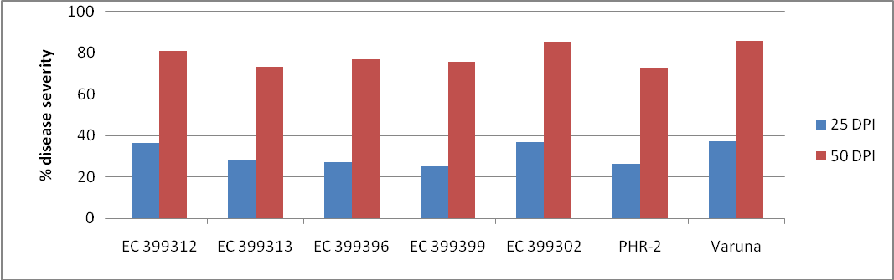
Figure 1: Percent disease severity of B. juncea genotypes infected with Alternaria blight

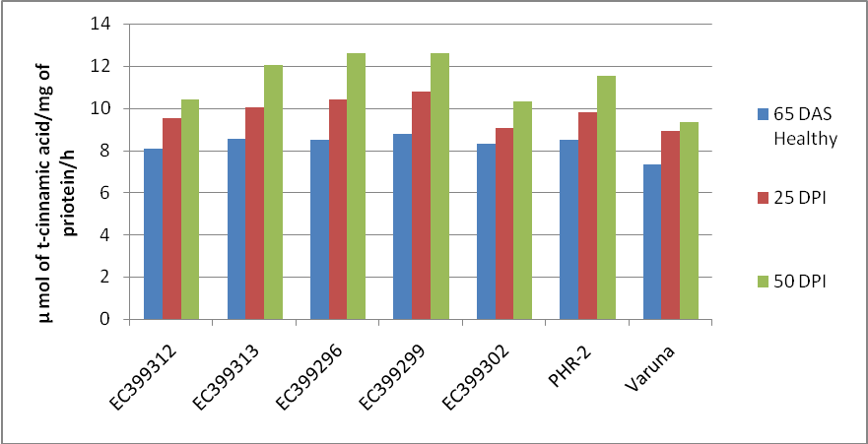
Figure 2: Activity of Phenylalanine ammonia lyase from B. juncea genotypes infected with Alternaria blight

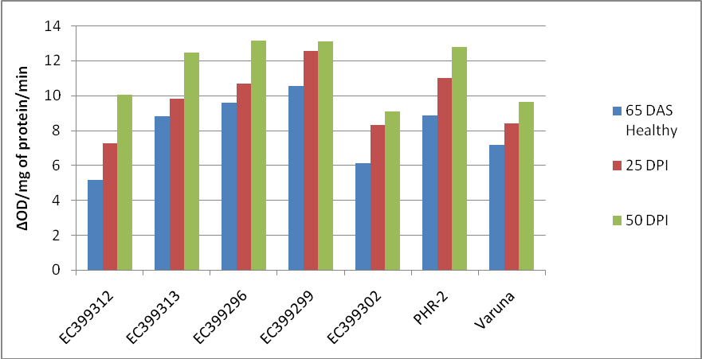Figure 3: Activity of Polyphenol Oxidase from B. juncea genotypes infected with Alternaria blight
DAS*=Day after sowing, DPI*=Day past infection

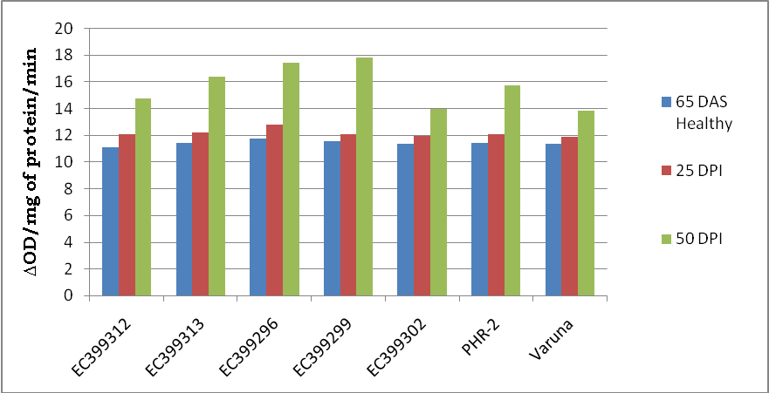
Figure 4: Activity of Peroxidase from B. juncea genotypes infected with Alternaria blight

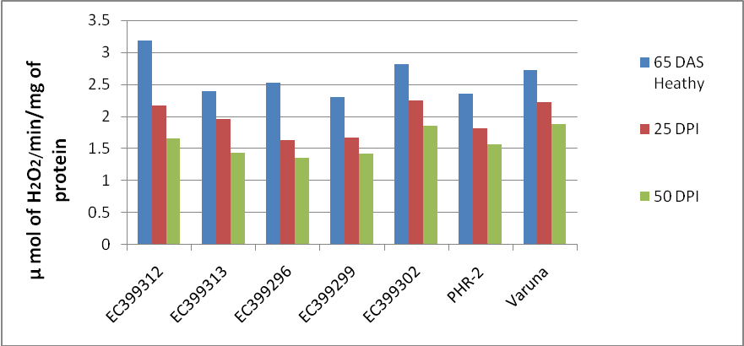
Figure 5: Activity of catalase from B. juncea genotypes infected with Alternaria blight
DAS*=Day after sowing, DPI*=Day past infection

Table 1: Percentage disease severity index, PAL, peroxidase, catalase, polyphenol oxidase activity estimated from various B. juncea genotypes infected with Alternaria blight
Parameters | Disease Severity Index  (%) |  |  | Peroxidase Activity (∆OD/mg of protein/min) |  |  | PAL Activity (µmol of trans-cinnamic acid/mg protein/h) |  |  | Polyphenol Oxidase Activity (∆OD/mg of protein/min) |  |  | Catalase Activity (µ mol of H₂O₂/ min/ mg of protein)
Stage  genotype | 65 DAS  Healthy | 25* DPI | 50* DPI | 65DAS  Healthy | 25* DPI | 50* DPI | 65 DAS  Healthy | 25* DPI | 50* DPI | 65DAS  Healthy | 25* DPI | 50* DPI | 65DAS  Healthy | 25* DPI | 50* DPI
EC-399312 | - | 36.31 | 80.81 | 11.08 | 12.02 | 14.72 | 8.09 | 9.51 | 10.42 | 5.15 | 7.24 | 10.04 | 3.18 | 2.17 | 1.66
EC-399313 | - | 28.26 | 73.39 | 11.38 | 12.16 | 16.32 | 8.55 | 10.04 | 12.05 | 8.80 | 9.80 | 12.46 | 2.39 | 1.96 | 1.43
EC-399296 | - | 27.05 | 76.9 | 11.75 | 12.80 | 17.41 | 8.48 | 10.43 | 12.6 | 9.59 | 10.67 | 13.10 | 2.52 | 1.63 | 1.36
EC-399299 | - | 25.2 | 75.66 | 11.56 | 12.07 | 17.77 | 8.77 | 10.77 | 12.6 | 10.53 | 12.56 | 13.11 | 2.30 | 1.67 | 1.42
EC-399302 | - | 36.79 | 85.59 | 11.31 | 11.95 | 13.97 | 8.30 | 9.07 | 10.33 | 6.10 | 8.30 | 9.09 | 2.81 | 1.25 | 1.86
PHR-2 | - | 26.28 | 72.87 | 11.43 | 12.06 | 15.72 | 8.48 | 9.82 | 11.54 | 8.83 | 11.00 | 12.75 | 2.35 | 1.81 | 1.56
Varuna | - | 37.41 | 85.9 | 11.31 | 11.84 | 13.80 | 7.32 | 8.90 | 9.31 | 7.15 | 8.40 | 9.62 | 2.73 | 2.22 | 1.88
Se.m | - | 1.45 | 0.69 | 0.02 | 0.109 | 0.039 | 0.062 | 0.125 | 0.206 | 0.21 | 0.23 | 0.13 | 0.03 | 0.02 | 0.02
CD (5%) | - | 4.48 | 2.13 | 0.063 | 0.338 | 0.122 | 0.192 | 0.385 | 0.63 | 0.65 | 0.73 | 0.42 | 0.11 | 0.071 | 0.06
DAS*=Day after sowing, DPI*=Day past infection

REFERENCES
- Beers, R.; and Sizer, I. (1952) A Spectrophotometric method for Measuring the breckdown of Hydrogen peroxide by Catalase. J. Biol. Chem. 195,133.
- Bolwell, G.P. and Wojtaszek, P. (1997). Mechanisms for the generation of reactive oxygen species in plant defence-a broad perspective. Physiol. Mol. Plant Pathol. 55: 347-366.
- Bradford, M.M. (1976). A rapid and sensitive method for identification of microgram quantities of protei utilizing the principle of protein-dye binding .Anals Biochem. 72: 248-254.
- Bray, H.G. and Thorpe W.V. (1954). Meth. Biochem. Anal . 1: 27-52.
- Cartea, E.M.; Francisco, M.; Soengas, P. and Velasco, P. (2010). Phenolic compounds in Brassica vegetables. Molecules, 6: 251-280.
- Chandra, A.; Anand, A.; Mandal, P.K. and Saxena, P. (2001). Influence of salicylic acid on protein content and catalase activity in relation to systemic acquired resistance in cowpea against root rot. Indian Phytopath. 54: 284-287.
- Hammerschmidt, R.; Nuckles, E.M. and Kuc, J. (1982). Association of enhanced peroxidase activity with induced systemic resistance of cucumber to Colletotrichum lagenarium. Plant Pathol. 20:73-82.
- Honty, K.K.; Hevesi, M.; Tóth, M. and Stefanovits, E.B. (2005). Some biochemical changes in pear fruit tissue induced by Erwinia amylovora, In: Proceedings of the 8th Hungarian Congress on Plant Physiology and the 6th Hungarian Conference on Photosynthesis. Acta Biologica Szegediensis. 49:127-129.
- Khedr, A.H.A.; Abbas, M.A.A.A.; Quick, W.P.; Abogadallah, G.M. (2003). Proleine induces the expression of salt-stress-responsive proteins and may improve the adaptation on Pancratium maritimum L. to salt-stress. J. Exp. Bot. 54:2553-2562.
- Kolte, S.J. (1986). Important diseases of rapeseed and mustard in India: Present research progress and future research needs. In Proc. IDRC, Canada, 3rd Oil Crops Network Workshop held in Addis Abada, Ethiopia, Oct. 6-10, 1986: pp. 91-106.
- Lisker, N.; Cohen, I.; Chalutz, E. and Fucus, Y. (1983). Fungal infections suppress ethylene-induced phenylalanine ammonia lyase activity in grape fruits. Physiol Plant Pathol. 22:331-338.
- Logemann, E.; Tavernaro, A.; Shulz, W.; Somssish, I.E. and Hahlbrock, K. (2000). UV light selectively co induces supply pathways from primary metabolism and flavonoid secondary product formation in parsley. Proc. Natl. Acad. Sci. USA 97:1903-1907.
- Mayer, A.M. and Harle, E. (1991). Phenoloxidases and their significance in fruit and vegetables. In Food Enzymology, (P.F. Fox, ed.) pp. 373-398, Elsevier Science Publishing, New York.
- Mayer, A.M.; Harel, E. and Shaul, R.B. (1965). Assay of catechol oxidase a critical comparison methods. Phytochemistry 5:783-789.
- Meena, R.K.; Patni, V. and Arora, D.K. (2008). Study on Phenolics and Their Oxidative Enzyme in Capsicum annuum L. infected with Geminivirus. Asian J. Exp. Sci. 22(3): 307-310.
- Mehdy, C. N. (1994). Active oxygen species in plants defense against pathogens. Plant Physiol. 105:467-472.
- Morelló, J.M.; Romero, M.P.; Ramo, T. and Motilva, M.J. (2005). Evaluation of L-Phenylalanine ammonia-lyase activity and phenolic profile in olive drupe (Olea europaea L.) Corresponding author: from fruit setting period to harvesting time. Plant Science, 168: 65–72.
- Niranjanraj, S. and Sarosh, B.R.S. (2006). Induction and accumulation of polyphenol oxidase activities as implicated in delopment of resistance against pearl millet downy mildew disease Funct Plant Biol. 33: 563-571.
- Paranidharan, V.; Palaniswami, A.; Vidhyasekaran, P. and Velazhahan, R. (2009). Induction of enzymatic scavengers of active oxygen species in rice in response to infection by Rhizoctonia solani. Acta Physiologiae Plantarum. 25(1): 91-96.
- Patni, C.S., Kolte, S.J. and Awasthi, R.P. (2005). Screening of Indian mustard [Brassica juncea (Linn) Czern and Coss] genotypes of Alternaria brassicae (Berk) sacc. isolates based on infection rate reducing resistance. J. Interacad. 9(4):498-507.
- Prasad, Rajendra and Lallu (2006). Management of Alternaria blight of mustard with combination of chemicals and botanicals. Ann. Pl. Protec. Sci. 14 (2): 400-403.
- Raghvendra VB, Lokesh S, Govindappa M, Vasanth KT (2007). Dravyaas,an organic agent for the management of seed borne fungi of sorghum and its role in the induction of defense enzymes. Pest. Biochem. Physiol. 89: 190-197.
- Raj, S.N.; Sarosh, B.R. and Shetty, H.S. (2006). Induction and accumulation of polyphenol oxidase activities as implicated in development of resistance against pearl millet downy mildew disease. Funct. Plant Biol. 33:563–571.
- Rosta´s, M.; Bennett, R. and Hilker, M. (2002). Comparative Physiological Responses in Chinese Cabbage Induced by Herbivory and Fungal Infection. J. Chem. Ecol. 28: 12.
- Saharan, G.S.; Joshi, U.N. and Saharan, M.S. (2000). Phenolic compounds and oxidative enzymes in healthy and Altermaria blight infected leaves of clusterbean. Acta Phytopathologica et Entomologica Hungarica. 34: 299-306.
- Shetty, H.S.; Vasanthi, N.S.; Sarosh, B.R. and Kini, K.R. (2001). Inheritance of downy mildew resistance, ß-1, 3-glucanases and peroxidases in pearl millet [Pennisetum glaucum (L.) R. Br.] crosses. Theor. Appl. Genet. 102: 1221-1226.
- Shrestha, S.K., Munk, L. and Mathur, S.B. (2005). Role of weather on Alternaria leaf blight disease and its effect on yield and yield component of mustard.Agric. Res. J., 6: 62-72.
- Slatnar, A.; Mikuli, P.M.; Halbwirth, H.; Stampar, F.; Stich, K. and Veberic, R. (2010). Enzyme activity of the phenylpropanoid pathway as a response to apple scab infection. Annals of Applied Biology, 156: 449–456.
- Stout, M.J; Fidantsef, A.L.; Duffey, S.S. and Bostock, R.M. (1999). Signal interactions in pathogen and insect attack: systemic plant-mediated interactions between pathogens and herbivores of the tomato, Lycopersicon esculentum. Physiol. Mol. Plant Path. 54:115–130.
- Tyagi, M.; Kayastha, A. and Sinha, M. (2000). B, the role of peroxidase and polyphenol oxidase isozymes in wheat resistance to Alternaria triticina. Biol. Plant. 43, 559-562.

1/2/2012

