Evaluation of Electromagnetic Field of Vertical Magnetic Dipole above Grid Screen

Adel A. S. Abo Seliem¹ and Fathia Alseroury²

¹Department of Mathematics, Faculty of Science,University of Kafr El-Sheikh, Egypt
² Department of Physics, Faculty of Science for Girls, King Abdul- Aziz University, Jeddah21412, KSA
adel_atta60@yahoo.com

Abstract: In this paper, the solution of describing the radiation field of V.E.D placed above a plane grid screen is presented. If is shown that both the solution and the related computational. Procedure can be substantially simplified using methods of virtual images and boundary conditions; the method requires the proper Fourier transform for theoretical formulation of the problem. The results can be used to calculate the parameters of electromagnetic screen involving metal grids are obtained.
[Adel A.S.Abo Seliem and Fathia Alseroury, Evaluation of Electromagnetic Field of Vertical Magnetic Dipole above Grid Screen. Nature and Science 2012;10(2):87-90]. (ISSN: 1545-0740). http://www.sciencepub.net. 15

Key words: Electromagnetic fields – Radiation – Vertical dipole.

1. Introduction
To calculate the radiation characteristics of antennas placed above grids screen, numerically methods are usually applied Wait[1]. Such methods are rather time consuming even for medium computing facilities Mahmoud[2] and Abo seliem [3] considered the same source radiating near two layered ground and finally De Hoop[4] and Kuester [5] studied the problem of line sources in half space . Historically, transient solution of this problem is found by applying a Fourier transform on the time variable .The boundary condition are satisfied by taking on expansion of spherical wave in the terms of cylindrical wave using Fourier- based transform, however these problems can be solving using methods of a boundary conditions and image which substantially simplify the computational procedure , this approach was successfully used Lindell [6] to calculate the fields of vertical and horizontal magnetic dipoles placed above metal grid.

2. Formulation of the problem
In fig [1], showing a vertical magnetic dipole of length l with dipole moment I placed at height h above the surface of plane grid (1) with square mesh. The mesh size $a≺λ$
Where $λ$ is radiation wavelength and $r_{0}≺λ$ and the contacts between wires are its determine field in the upper and lower half space introduce component of negative hertz vector satisfying the Holmholtz equation
$(∇^{2}+K^{2}){π∗}_{1}^{}(r)=\frac{i}{wμ_{0}}\text{IL}δ(r−z_{0}h),z≥0$ (1)
$(∇^{2}+K^{2}){π∗}_{\text{12}}^{}(r)=0,z≤0$ (2)

Where $K^{2}=w^{2}ε_{0}μ_{0}$ and $μ_{0}$ and $ε_{0}$ are the permeability and permeability of free space ,the coordinates of the observation point and $δ\left(r−z_{0}h)\right)$ is the Dirac delta
Appling the Fourier transform in x-y plane to equation (1) and(2) where

$F(ε,β,z,t)=\iint_{−∞}{F(x,y,z,t)e^{j(αx+βy)}}\text{dxdy},z≥0$ (3)
Then
$\frac{∂^{2}π_{1}^{}}{∂z^{2}}+γ^{2}π_{1}^{}=\frac{\text{iI}}{wμ_{0}}δ(z−h),z≥0$ (4)

$\frac{∂^{2}π_{2}^{}}{∂z^{2}}+γ^{2}π_{2}^{}=0,z≤0$ (5)
Where $γ^{2}=(K^{2}−α^{2}−β^{2})$ and $α$and$β$ are the variables of the Fourier transform and $\text{Im}γ≤0$, the screen of equations (4)and (5) coincides with that of equation describing a z- directed transmission line can be written as

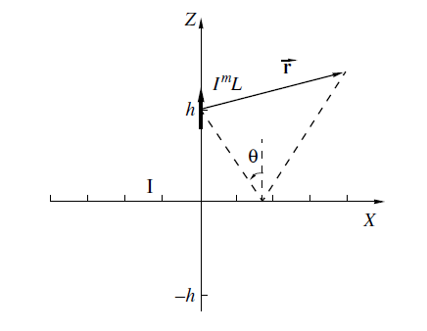

Fig. (1) Geometry of the problem

$π_{1}^{}={\text{Ae}}^{−jγz}−\frac{\text{IL}}{2γwμ_{0}}e^{−j\left|z−h\right|},z≥0$ (6)
$π_{2}^{}={\text{Ce}}^{jγz},z≤0$ (7)
The constants A and C are determined form the boundary conditions on the grid surface and taking into account that vectors E and H are related to the Hertz – vector via relationships
$∇×π=\frac{i}{wμ_{0}}E$, $∇(∇\text{.}π)=H−K^{2}π$ (8)
Applied boundary condition of the Fourier images $π$ as
$π_{1}=π_{2}$ at z=h (9)
$π_{1}=\frac{η}{wμ_{0}}K(\frac{∂π_{1}}{∂z}−\frac{∂π_{2}}{∂z})$ at z=h (10)
Where $η=\sqrt{\frac{μ_{0}}{ε_{0}}}$
We obtain

$A=−I\frac{L}{2γwμ_{0}}k(\frac{1}{k+2jγK}e^{−jγh})$ (11)

$C=I\frac{L}{2γwμ_{0}}k(\frac{2jγ}{k+2jγK}e^{−jγh})$ (12)
Now the Fourier images $π_{1}^{} \text{and}{ π}_{2}^{}$ can be written as

$π_{1}^{\text{/*}}=\frac{\text{IL}}{2γwμ_{0}}e^{−j\left|z−h\right|}+\frac{\text{IL}}{2wλμ_{0}}R(γ)e^{−jγ(z+h)},z≥0$ (13)

$π_{2}^{\text{/*}}=\frac{\text{IL}}{2γwμ_{0}}(1+R(γ))^{jγ(z−−h)},z≤0$ (14)
$R(γ)=\frac{k}{k+2jγK}\text{whereK}=\frac{a}{λ}\text{ln}\frac{a}{2πr_{0}}$ (15)

Note that the first and second terms in formula (13) describes be the incident and reflected wave respectively and is essentially the reflection coefficient .
We derive as expression for the Hertz vector corresponding to the grid current by considering some image similarly to the case of the perfectly conducting plane, assume that $R(γ)$ is the Laplace transform of function f(s) that is

$R(γ)=\int_{0}^{∞}{f(s)e^{−γ}\text{ds}}$ (16)
From relationships (15) and (16 ). It follows that

$f(s)=\frac{\text{jk}}{2K}e^{j\frac{k}{2K}s}$ (17)
Taking into account formula (15) and (16) we can write expression (13) in the form

$π_{1}^{\text{/*}}=\frac{\text{IL}}{2γwμ_{0}}e^{−j\left|z−h\right|}+\frac{\text{IL}}{2wλμ_{0}}\int_{0}^{∞}{\frac{\text{jk}}{2K}}e^{−jγs+j\frac{\text{ks}}{2K}}{\text{dse}}^{−jγ(z+d)}=π_{1}^{0\text{/*}}+π_{1}^{1\text{/*}}$ (18)

Where $π_{1}^{0\text{/*}}\text{and}π_{1}^{1\text{/*}}$ are the Fourier images of the Hertz vector corresponding to the dipole and grid current . In the physical case, the Hertz vector dipole field is determined by expressions
$π_{1}^{0∗(r)=\frac{\text{jIL}}{4πwμ_{0}}\frac{e^{−\text{jkd}}}{d}}$ (19)
Is free space Green s function $G(r−z_{0}h)=\frac{e^{−\text{jkd}}}{d}$, and
$π_{1}^{\text{/*}}(r)=−\frac{\text{IL}}{8πwλμ_{0}}\int_{0}^{∞}{\frac{k}{K}}e^{−jγs+j\frac{\text{ks}}{2K}}G(r−z(−h+\text{js})\text{ds}$ (20)

Where r is the position vector determining coordinate of the observation point (-h+js) are the coordinate of the simulating the effect grid surface . The equation (19) treated as the Hertz vector of a virtual source placed in the complex space

3. Described the integral
The integral appearing in the expression (19) converges , if calculating it for a given complex d, we have choose the branch with Im $d≺0$, consider two limiting case the grid is absent and the grid transforms to the perfectly conducting surface. If we assume that $\frac{r_{0}}{a}→0$ as a result of decreasing radius of a the grid wire , then, $K→0$ In this case we obtain form equation (19) that is $π_{1}^{\text{/*}}(r)→0$, the dipole is placed in free space and if $\frac{1}{2K}→0$, then performing partial integration formulation (19) , we obtain
$π_{1}^{\text{/*}}(r)=j\frac{\text{IL}}{4πwμ_{0}}G(r+\text{zh})$ (21)

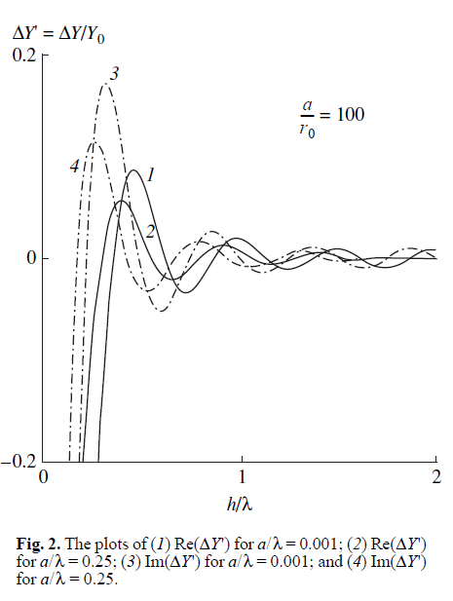

This expression corresponds to the Hertz vector of a magnetic dipole with opposite current placed at the mirror – symmetric point.
If the observation point is located at in the upper and the grid source, then passing to corresponding limits, we obtain a well – know relationships for the reflection coefficient of a plane TE wave from a grid with square mesh.

$R^{\text{TE}}=\frac{1}{1+2j\text{cos}θK}$ (22)

Using the above technique and the method of induced magneto motive forces, we can derive relationships for determination of the relation of input admittance of the magnetic dipole related to grid screen

$\frac{ΔY}{Y_{0}}=\frac{3}{8{Kπ}^{2}}e^{−j\frac{4π}{λ}K}\int_{0}^{∞}{{\left\{\frac{1}{(\frac{2h}{λ}−jτ)^{2}}+\frac{1}{(\frac{2h}{λ}−jτ)^{3}}\right\}}^{π(i/k−2)τ}dτ}$ (23)

Where $λ$ is the wavelength and $Y_{0}=\frac{2π}{3}\sqrt{\frac{ε_{0}}{μ_{0}}}(L/λ)$ is radiation conductance of magnetic dipole place in free space , finally , in Fig(2) presents the real and imaginary parts of the dipole input admittance of function of $h/λ$ for two of $a/λ$.
4. Conclusion
If should be noted that the obtained results can be used to calculated the parameters of grid electromagnetic screen designed for the problem of physical installation and objects.

Corresponding author
Adel A. S. Abo Seliem
Department of Mathematics, Faculty of Science,
University of Kafr El-Sheikh, Egypt
adel_atta60@yahoo.com

References
1-J.R.Wait, Antenna theory (McGraw- Hill, New York), (1969).
2-S.F.Mohamud, A.Z. Botros and J.R. Wait, Transient electromagnetic fields of vertical magnetic dipole on a two layer earth. Proc. IEEE, vol.62,1022-1029, July (1979).
3-A.A.S.Abo seliem, Transient electromagnetic field of vertical electric dipole above an atmospheric surface duct. Radio Science, vol.31 ,833- 840, July- august. (1996).
4-A.T.De Hoop, Pulsed electromagnetic radiation from a line source a two – media configuration. Radio Science vol.11,253-265 Marc.-April (1979) .
5-E.F.Kuester.,The transient electromagnetic field of a pulsed line source located above a depressively reflecting source. IEEE Trans. Antenna propagate vol. Ap-32 ,1154-1162 Nov. (1984).
6-I.V.Lidell.,Methods for electromagnetic field analysis 2nd ed, University press, Oxford, (1995).

1/12/2012

