Toxicological Implications of Aqueous Leaf Extract of Andrographis paniculata in Wistar Rat

Oyewo, Emmanuel Bukoye ^{1, *}, Akanji, Musbau Adewumi ², Iniaghe, Martin Onome³ and Fakunle, Ponle Bamidele ⁴

- Department of Biochemistry, Ladoke Akintola University of Technology, P. M. B. 4000, Ogbomoso, Nigeria.
- Department of Biochemistry, University of Ilorin, P. M. B. 1515, Ilorin, Nigeria.
- Department of Biochemistry, Ambrose Alli University, Ekpoma, Nigeria.
- Department of Anatomy, Ladoke Akintola University of Technology, P. M. B. 4000, Ogbomoso, Nigeria.
askafterbukoye@yahoo.com, akanjima@yahoo.com, iniaghe@yahoo.com, fakuns@yahoo.com

Abstract: The toxicological implications of long-term administration of aqueous leaf extract of Andrographis paniculata was investigated in male Wistar rats. Dry leaf powder was extracted with water and lyophilized. Forty male Wistar rats of average body weight of 130g were grouped into four (A-D), comprised of ten rats per group. Group A received distilled water (control), while doses of 250, 500 and 1000 mg/kg body weight of extract were administered once daily for 84 days to animals in groups B, C and D respectively. Significant reductions (p<0.05) were obtained at 1000 mg/kg body weight dose in ‘enzyme markers’ activities in tissues with corresponding significant increases (p<0.05) in the serum. Significant increases (p<0.05) were obtained in liver reduced GSH concentrations at 250 and 500 mg/kg body weight doses with significant reductions (p<0.05) in liver MDA concentrations at these doses. Dose dependent significant reductions (p<0.05) were observed in the sperm count and motility. Varied alterations in were exhibited in the photomicrographs of the organs studied, as toxicity increased with dose increase. The results from the study revealed that the various enzyme activities suggested disruption of the plasma membrane at high doses of the extract. The extract at 1000 mg/kg body weight dose induced chronic inflammatory responses in tissues, suggesting that the use of the aqueous leaf extract of A. paniculata is recommended at doses of not more than 250 mg/kg body weight and its long-term or habitual use calls for caution especially spermatogenesis.
[Oyewo, Emmanuel Bukoye, Akanji, Musbau Ademi, Iniaghe, Martin Onome and Fakunle, Ponle Bamidele. Toxicological Implications of Aqueous Leaf Extract of Andrographis paniculata in Wistar Rat. Nature and Science 2012;10(2):91-108]. (ISSN: 1545-0740). http://www.sciencepub.net. 16

Key words: Andrographis paniculata, Toxicological implications, Long-term administration, Chronic inflammatory responses, Spermatogenesis

1. Introduction
Medicinal plants have formed the basis of health care throughout the world since the earliest days of humanity and are still widely used with considerable importance in international trade (Ahmed et al., 2006). Medicinal plants can be described as plants in which one or more of its organ contain substances that can be used for therapeutic purpose, or are precursors for the synthesis of useful drugs (WHO, 1977). They can also be described as any plants or parts of plants that are used for its scent, flavor and therapeutic properties, medicinal products made of them are frequently taken to improve health as dietary supplement (Tapsell et al., 2006). Examples include food, spices, perfumery plants, microscopic plants (fungi), actinomycetes (antibiotic) etc. When plant materials are consumed, either as food or as concoctions, they elicit different actions based on the naturally occurring bioactive compound contained in them (Asakawa, 1990). Nigerian flora has already made and will continue to make a great contribution to the health care system in the country (Gbile and Adesina, 1987).
Andrographis paniculata (A. paniculata) is a herbaceous plant native to India and Sri Lanka. It is a member of the plant family, Acanthaceae and is known commonly as ‘King of Bitters’ or ‘bile of the earth’ (English) (Coon and Ernst, 2004). It is currently cultivated in the south-west geopolitical zone of Nigeria (sun.ars-grin.gov, 2008). Both the fresh and dried leaf extract of A. paniculata, as well as the fresh juice of the whole plant has been widely used in traditional regimes and folklore medicines for liver disorders, bowel complaints, colic pain, cases of general debility, and convalescence after fevers, a stomachic, anthelmintic, antiperistaltic, and antispasmodic, antibacterial and antimalaria (Borhanuddin et al., 1994; Kulinchencko et al., 2003; Coon and Ernst, 2004; Spasov et al., 2004; Abraham, 2006). Due to the vast reports on the alleged pharmaceutical capabilities of the leaf extract of A. paniculata, it is commonly consumed regularly alongside meals with the aim of prevention and/, or cure of infective and degenerative diseases (Oyewo et al., 2010). It is worthy of note that there is hardly a drug or chemical that will not cause an adverse reaction in someone, at sometime, and at some place. Thus, any organ or tissue can be the site of an adverse reaction particularly, organs and tissues related to adsorption, metabolism, storage and excretion of the chemical agent or drug (Irey, 1982). Therefore, there is the need for a scientific dissemination of the toxic implications or safety of A. paniculata, as herb is intrinsically toxic to the cell. This study was designed to provide information on the toxic implication of long-term administration of the aqueous leaf extract of A. paniculata in some tissues in Wistar rats.

2.0 Materials and method
2.1 Materials
2.1.1 Plant material
Fresh mature Andrographis paniculata plant sample was collected before sun rise in May, from Airport area, Ilorin, Nigeria. The plant was authenticated at the Forestry Research Institute of Nigeria (FRIN), Ibadan, Oyo State. A voucher specimen was deposited at the herbarium of the Institute with voucher number FHI 108453. The fresh leaf was rinsed thoroughly in distilled water and dried in the shade for 14 days. The dried leaf was ground to fine powder, using a domestic electric grinder and suspended in distilled water at room temperature. The filtrates were pulled together and filtered using Whatman No 1 filter paper. The supernatant was lyophilised using a freeze dryer and the yield of the aqueous leaf extract was 16.28% (^{w}/_{w}). The lyophilised extract was stored in the desiccator with pre-heated silica gel and kept in the dark till when needed.

2.1.2 Quantitative assay kits
Aspartate Transaminase (AST), Alanine Transaminase (ALT), Acid Phosphatase (ACP), Alkaline Phosphatase (ALP) and Lactate Dehydrogenase (LDH) were products of LABKIT, CHEMELEX, S.A. Pol. Canovelles – Barcelona, Spain. Reduced Glutathione assay kit was a product of BioAssay Systems, Hayward, USA.

2.1.3 Other reagents
All the chemicals and reagents used in the study were of analytical grade and were purchased from the Bristish Drug House (BDH) Poole England and Sigma Aldrich Chemical Co. Inc., Milwaukee, Wis., U.S.A.

2.1.4 Laboratory animals
Ten to twelve weeks old male Wistar rats of average body weight of 130 ± 6.0 g were obtained from the Animal Care Facility II, Ladoke Akintola University of Technology (LAUTECH), Osogbo, Osun State. The rats were fed with rat pellet (product of Bendel Feeds and Flour Mills Ltd, Ewu, Edo State, Nigeria).
2.2 Methods
2.2.1 Experimental animals and procedure
Forty male Wistar rats (weight 130 ± 6 g) were randomly grouped into four (A-D), comprising of ten rats per group. The rats were housed in cages made of wooden frames and metal netting, and were fed ad libitum with rat pellet and tap water with 12-hours light/dark cycle. The cages were cleaned every morning and disinfected at intervals of 3 days. The rats were allowed to acclimatize for 10 days before extract administration was commenced. Calculated amount of lyophilized aqueous leaf extracts of A. paniculata were constituted in distilled water to give doses of 250, 500 and 1000 mg/kg body weight and administered to the various groups as illustrated:
Group A: control, received 1.0 ml distilled water
Group B: received 250 mg/kg body weight of the extract
Group C: received 500 mg/kg body weight of the extract
Group D: received 1000 mg/kg body weight of the extract
Administration of aqueous leaf extract of A. wilkesiana was performed orally once daily between 8:30 am ± 30 minutes, using metal cannula attached to a 2 ml syringe. Administration lasted for 84 days, after which the rats were fasted for 12 hours and were sacrificed by anaesthesia using diethyl ether. Blood was collected by cardiac puncture and placed in bottles with no anticoagulant and the organs of interest were excised, cleansed of tissues, washed and the weights recorded.
This study was conducted in accordance with the National Institutes of Health’s Guide for the Care and Use of Laboratory Animals (1985), and the study was approved by the Ethical Committee of College of Medicine, Ladoke Akintola University of Technology, Ogbomoso, Nigeria.

2.2.2 Lactate dehydrogenase
The lactate dehydrogenase (LDH) activity was determined by pyruvate kinetic liquid reaction, according to the method described by Murray (1984^{b}) and Pesce (1984).

2.2.3 Aspartate transaminase
The activity of aspartate transaminase (AST) was determined by malate dehyrogenase (MDH)-NADH kinetic ultra - violet reaction, according to the method described by Murray (1984ª) and Tietz et al. (1995).

2.2.4 Alanine transaminase
The activity of alanine transaminase (ALT) was determined by lactate dehyrogenase (LDH)-NADH kinetic ultra-violet reaction, according to the method described by Murray (1984ª) and Young (1995).

2.2.5 Alkaline phosphatase
The activity of alkaline phosphatase (ALP) was determination by p-Nitrophenylphosphate kinetic reaction, according to the method described by Wenger et al. (1984) and Tietz et al. (1995).

2.2.6 Acid phosphatase
The activity of acid phosphatase (ACP) was determined by α-Naphtyphosphate kinetic reaction, according to the method described by Abbort et al. (1984) and Tietz et al. (1995). The serum and tissue homogenates were stabilized with 50 µl of acetic acid (R₄) per ml of sample.

2.2.7 Determination of liver reduced glutathione concentration
The levels of reduced glutathione (GSH) were determined using 5,5'-dithio-bis-2-nitrobenzoic acid (DTNB) enzymatic colorimetric reaction, according to the method described by Ellman (1959), as modified by Eyer and Podhradsky (1986) and Baker et al. (1990).

2.2.8 Determination of liver malondialdehyde concentration
The concentration of thiobarbituric acid reactive substances, malondialdehyde (MDA) was determined using the method of Slater and Sawyer (1971), modified by Fraga et al. (1981).

2.2.9 Semen analysis
The sperm count (Pant and Srivastava, 2003) and motility (Zemjanis, 1977) was determined, using new improved Neubeur’s Hemeocytometer counting chamber.

2.2.10 Histology
The histological studies were performed on liver, kidney, heart, spleen, small intestine and prostate gland following the procedure described by Krause (2001).

2.2.11 Statistical analysis
This research work used a completely randomised design (CRD) model. The results were expressed as mean of 6 replicates ± standard error of mean (SEM). Results were analyzed using Prism 3.00 software. Results were subjected to one way analysis of variance (ANOVA) to test the effect of each dose level on the parameter under investigation at 95% level of confidence. The Duncan Multiple Range Test (DMRT) was conducted for the pair-wise mean comparisons, to determine the significant treatment dose at 95% level of confidence. Values were considered statistically significant at (p<0.05) and denoted by different alphabets (Mahajan, 1997).

3.0 Results
3.1 Enzyme activities
3.1.1 Lactate dehydrogenase
There were significant increases (p<0.05) in LDH activity in the liver when rats were administered 250 and 500 mg/kg body weight (Table 1). In the small intestine, LDH activity was not significantly different (p>0.05) at 250 mg/kg body weight, but reduced significantly (p<0.05) at 500 and 1000 mg/kg body weight (Table 1). However, in the heart, significant increases (p<0.05) in enzyme activity were obtained at 250 and 500 mg/kg body weight, while the enzyme activity was significantly decreased (p<0.05) at 1000 mg/kg body weight (Table 1). Significant reduction (p<0.05) was obtained in serum LDH activity at 250 and 500 mg/kg body weight, while at 1000 mg/kg body weight, the activity increased significantly (p<0.05) (Table 1).

3.1.2 Aspartate transaminase
In the liver, AST activity was significantly increased (p<0.05) at 250 and 500 mg/kg body weight, but was not significantly different (p>0.05) at 1000 mg/kg body weight (Table 1). Significant decrease was observed in AST activity in the kidney (p<0.05) following the administration of the extract (Table 1). The trend obtained in AST activity in the heart of rats administered the extract was not consistent, in which significant increase was seen at 250 mg/kg body weight (p<0.05), but a significant decrease at 1000 mg/kg body weight (Table 1). Serum AST activity decreased significantly at 250 and 500 mg/kg body weight of extract, but significantly increased at 1000 mg/kg body weight (Table 1).

3.1.3 Alanine transaminase
Administration of various doses of aqueous leaf extract of A. paniculata to male rats resulted in significant reduction (p<0.05) in kidney enzyme activity at 500 and 1000 mg/kg body weight (Table 1), while significant increase and decrease (p<0.05) were obtained in the liver enzyme activity at 500 and 1000 mg/kg body weight respectively (Table 1). In the heart of male rats administered the extract, ALT activity increased significantly (p<0.05) at 250 and 500 mg/kg body weight only (Table 1), while significant reduction (p<0.05) were obtained in the activity of serum ALT at 250 and 500 mg/kg body weight only (Table 1).

3.1.4 Alkaline phosphatase
In the liver, significant increase (p<0.05) was obtained at 250 mg/kg body weight of extract, while at 1000 mg/kg body weight, enzyme activity decreased significantly (p<0.05) (Table 1). There were significant reductions (p<0.05) in ALP activity in the kidney when rats were administered 500 and 1000 mg/kg body weight of extract (Table 1). However, in the small intestine, only 1000 mg/kg body weight of extract resulted in significant reduction (p<0.05) in enzyme activity (Table 1). The trend obtained for serum ALP activity in rats showed significant decrease at 250 and 500 mg/kg body weight (p<0.05) and significant increase at 1000 mg/kg body weight (Table 1).

3.1.5 Acid phosphatase
Administration of various doses of the aqueous leaf extract of A. paniculata to rats resulted in significant reduction in the liver ACP activity (p<0.05) at 1000 mg/kg body weight (Table 1). In the spleen of rats, ACP activity was reduced significantly (p<0.05) at 500 and 1000 mg/kg body weight of extract (Table 1). The ACP activity in the prostate gland of rat was reduced significantly at all the doses administered (p<0.05) (Table 1), while total ACP and prostatic ACP activities in serum were increased significantly (p<0.05) dose dependently following long-term administration of aqueous extract of A. paniculata (Table 1).

3.2 Liver reduced glutathione and malondialdehyde
Significant increases (p<0.05) were obtained in liver reduced GSH concentrations and MDA at 250 and 500 mg/kg body weight, while no significant change was obtained at 1000 mg/kg body weight (p<0.05), following administration of aqueous leaf extract of A. paniculata to male rats (Table 2).

3.3 Sperm count and motility
Dose dependent significant reductions (p<0.05) were observed in sperm count and motility of the rats following the administration of the aqueous extract of A. paniculata (Table 2).

Table 1: Effects of long-term administration of aqueous leaf extract of A. paniculata on some enzymes activity in rat tissues
 |  | Extract doses (mg/kg body weight)
 | Control |  | 250 | 500 | 1000
LDH (U/L)  Liver  Small intestine  Heart  Serum | 121.40 ± 8.35ª  292.5 ± 19.54ª  220.33 ± 5.82ª  346.54 ± 14.77ª |  | 199.06 ± 6.15^{b}  286.25 ± 10.36ª  280.82 ± 6.74^{b}  312.80 ± 6.19^{b} | 152.29 ± 5.62^{c}  226.25 ± 12.50^{b}  239.95 ± 6.33^{c}  322.04 ± 7.97^{b} | 135.69 ± 3.21ª  172.5 ± 13.27^{c}  150.74 ± 8.01^{d}  379.28 ± 6.72^{c}
AST (U/L)  Liver  Kidney  Heart  Serum | 114.46 ± 3.07ª  202.01 ± 6.08ª  35.64 ± 2.10ª  40.43 ± 3.28ª |  | 142.24 ± 7.47^{b}  182.95 ± 4.96^{b}  41.31 ± 2.12^{b}  27.56 ± 1.91^{b} | 150.32 ± 3.40^{b}  173.15 ± 3.31^{b}  36.33 ± 3.21ª  28.36 ± 1.32^{b} | 82.41 ± 3.08^{c}  104.17 ± 4.96^{c}  19.88 ± 2.43^{c}  54.62 ± 3.13^{c}
ALT (U/L)  Liver  Kidney  Heart  Serum | 111.73 ± 4.21ª  106.61 ± 3.63ª  26.97 ± 2.14ª  41.09 ± 4.33ª |  | 122.84 ± 7.37ª  119.97 ± 2.72ª  49.66 ± 2.11^{b}  25.77 ± 1.52^{b} | 144.56 ± 3.40^{b}  81.67 ± 6.11^{b}  39.01 ± 3.07^{c}  29.66 ± 2.31^{b} | 89.23 ± 3.07^{c}  49.00 ± 2.72^{c}  21.89 ± 2.21ª  63.63 ± 4.35^{c}
ALP (U/L)  Liver  Kidney  Small intestine  Serum | 187.90 ± 6.02ª  199.09 ± 3.18ª  191.25 ± 12.31ª  139.21 ± 4.43ª |  | 213.00 ± 4.61^{b}  199.58 ± 6.93ª  177.5 ± 10.54ª  86.60 ± 4.24^{b} | 192.48 ± 5.93ª  161.295 ± 4.17^{b}  148.75 ± 12.50^{c}  106.66 ± 2.86^{c} | 151.03 ± 6.09^{c}  106.71 ± 6.26^{c}  103.75 ± 10.16^{d}  163.25 ± 8.20^{d}
ACP (U/L)  Liver  Spleen  Prostate  Serum Total  Serum prostatic | 131.28 ± 5.03ª  62.17 ± 4.17ª  139.33 ± 4.29ª  29.88 ± 1.91ª  10.21 ± 1.06ª |  | 125.02 ± 3.22ª  45.87 ± 5.09^{b}  115.85 ± 7.95^{b}  41.16 ±1.94^{b}  15.56 ± 0.98^{b} | 128.39 ± 4.95ª  37.65 ± 3.01^{c}  89.65 ± 4.09^{c}  52.71 ± 1.84^{c}  21.35 ± 0.86^{c} | 101.70 ± 3.42ª  20.5 ± 2.63^{c}  59.1 ± 6.41^{d}  69.20 ± 2.06^{d}  32.88 ± 0.99^{d}
Values are means ± SEM; n=6. *Values bearing different alphabets are significantly different (p<0.05).

3.4 Organ-Body weight index
The effect of the administration of the extract on the heart, kidney, liver, spleen and prostate gland is shown in Figure 1. Significant decrease (p<0.05) was obtained in kidney-body weight index at 1000 mg/kg body weight only, while a significant increase (p<0.05) was obtained in the spleen-body weight index. In the case of the prostate gland-body weight index, significant increases (p<0.05) were obtained in an almost dose dependent manner (Figure 1).

3.5 Histology
The results were classified as percentages of inflammation or compromise to the integrity of cells in the captured area of the organ, in which < 10% is non-significant, < 25% is mild, < 50% moderate and > 50% is severe. Long-term administration of the aqueous leaf extract of A. paniculata to male rats at 1000 mg/kg body weight resulted in mild hepatic hyperplasia, venous congestion and intracytoplasmic inclusions of the hepatocytes (Plate 4), compared to the control (Plate 1). The nephrons of rat administered the extract showed significant changes (moderate venous congestion) at 1000 mg/kg body weight of extract (Plate 8) compared to control (Plate 5). The photomicrographs of the heart revealed significant marked effects on the cardiac cells at 1000 mg/kg body weight of extract (Plate 12) compared to control (Plate 9).
Dose dependent significant changes were revealed in the spleen of rat administered the extract, represented by Plate 16, compared to control (Plate 13). The spleen showed significant congestion, which were hyperaemic in nature. The photomicrographs of the small intestine in rat following the long-term administration of the extract showed significant effects at 1000 mg/kg body weight of extract only (Plate 20) when compared to the control (Plate 17). The effect was seen as enlargement of the arteriole, lysis that affecting the villi, which affected the epithelial linings, causing tissue degeneration (Plate 20). However, the extract did not appear to have compromised the histoarchitexture of the small intestine as the muscles appeared normal. Significant tissue congestion and degeneration that were dose dependent were revealed in the photomicrograph of the prostate of rats administered extract, represented by Plate 24 when compared to the control (Plate 21). The overall observation showed that 1000 mg/kg body weight of the extract adversely affected the gross and the histoarchitecture of the heart, the spleen and the prostate (Plates 12, 16, and 24 respectively).

Table 2: Effect of long-term administration of aqueous leaf extract on liver reduced glutathione, malondialdehyde, sperm count and sperm motility in rats.
 |  | Extract doses (mg/kg body weight)
 | Control | 250 | 500 | 1000
Liver  GSH (µM)  MDA(nmole/mg protein) | 41.52 ± 3.98ª  3.99 ± 0.37ª | 60.21 ± 4.05^{b}  1.96 ± 0.18^{b} | 50.35 ± 3.01^{b}  2.18 ± 0.23^{b} | 37.00 ± 3.13ª  3.74 ± 0.58ª
Sperm  Count (10⁶cell/ml)  Motility(10⁶cell/ml) | 157.18 ± 3.87ª  15.1 ± 1.11ª | 102.24± 3.24^{b}  5.19 ± 0.49^{b} | 58.58 ± 3.55^{c}  2.7 ± 0.21^{c} | 40.5 ± 3.52^{d}  1.23 ± 0.04^{d}
Values are means ± SEM; n=6. *Values bearing different alphabets are significantly different (p<0.05).

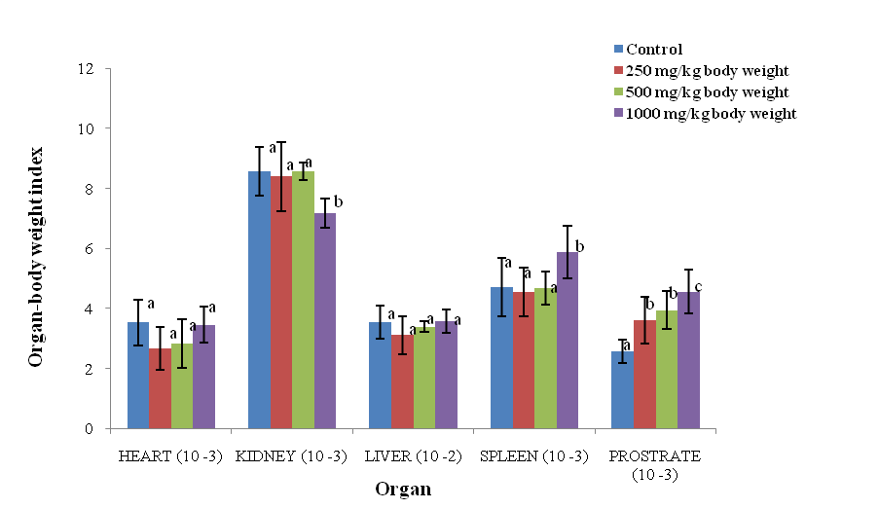
Values are means ± SEM; n=6. *Values bearing different alphabets are significantly different (p<0.05).

Figure 1: Effect of aqueous leaf extract on organ/body weight index.

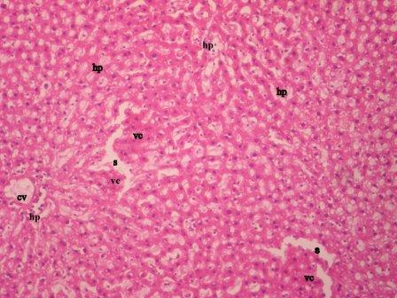  Plate 1: Photomicrograph of liver of male rat administered distilled water (Mag x 100; H & E). hp (hepatocytes), s (sinusoids), CV (central vein) and VC (venous congestion (non significant). A normal liver with non significant venous congestion.  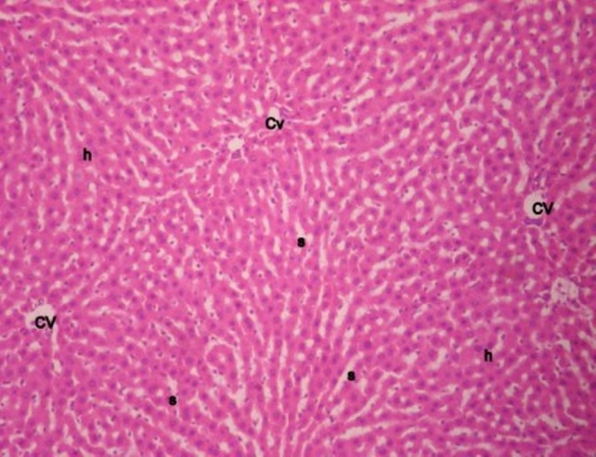  Plate 3: Photomicrograph of liver of rat administered 500 mg/kg body weight of A. paniculata (Mag x 100; H & E). HP (hepatocytes), S (sinusoids), CV (central vein) and VC (venous congestion (non significant). A normal liver. | 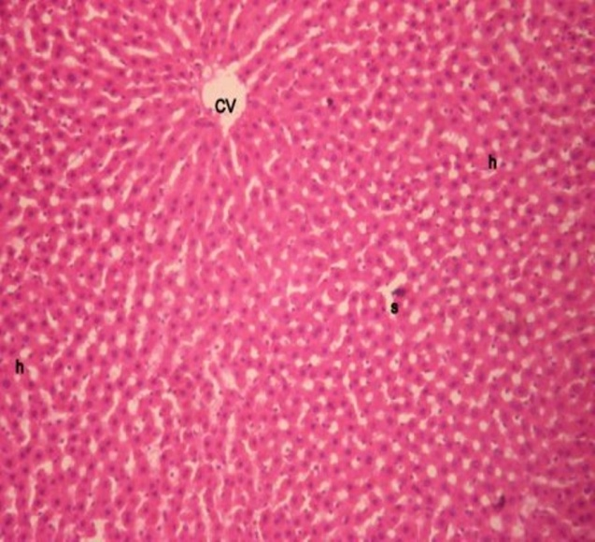  Plate 2: Photomicrograph of liver of rat administered 250 mg/kg body weight of A. paniculata (Mag x 100; H & E). HP (hepatocytes), S (sinusoids) and CV (central vein). A normal liver.  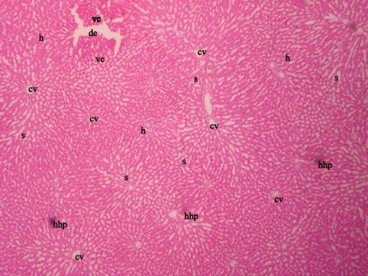  Plate 4: Photomicrograph of liver of rat administered 1000 mg/kg body weight of A. paniculata (Mag x 100; H & E). h (hepatocytes), s (sinusoids), cv (central vein), de (degeneration), vc (venous congestion)., hhp (hepatic hyperplasia) A moderately compromised liver with significant venous congestion.

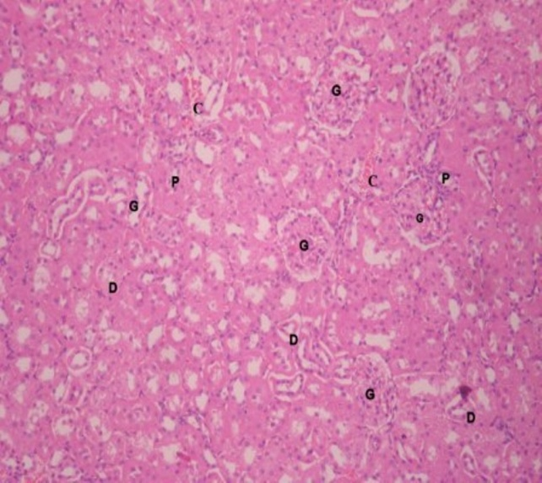  Plate 5: Photomicrograph of kidney of male rat administered distilled water (Mag x 100; H & E). G (Glomerulus), D (Distal convoluted tubule), P (proximal convoluted tubule) and C (Congestion (non significant) A normal kidney.  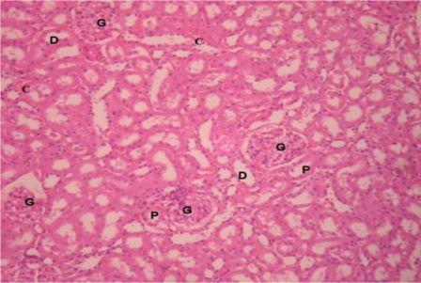  Plate 7: Photomicrograph of kidney of rat administered 500 mg/kg body weight of A. paniculata (Mag x 100; H & E). G (Glomerulus), D (Distal convoluted tubule), P (proximal convoluted tubule) and C (Congestion (mild). A normal kidney. | 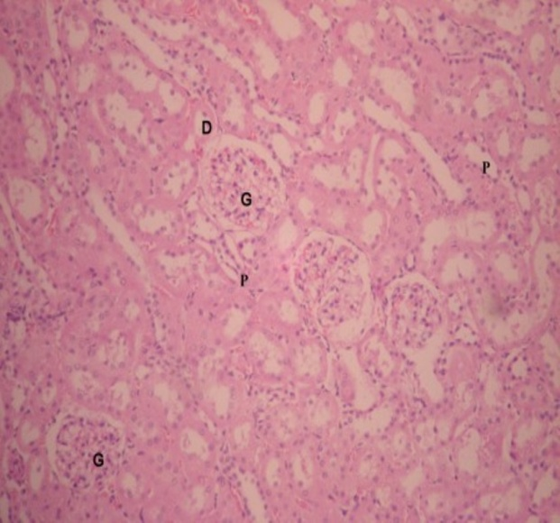  Plate 6: Photomicrograph of kidney of rat administered 250 mg/kg body weight of A. paniculata (Mag x 100; H & E). G (Glomerulus), D (Distal convoluted tubule) and P (proximal convoluted tubule). A normal kidney.  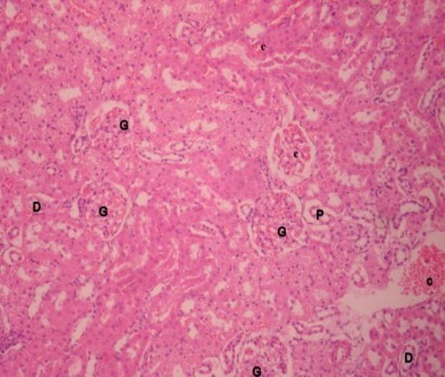  Plate 8: Photomicrograph of liver of rat administered 1000 mg/kg body weight of A. paniculata (Mag x 100; H & E). G (Glomerulus), D (Distal convoluted tubule), P (proximal convoluted tubule) and C (Congestion (moderate). A significantly compromised kidney.

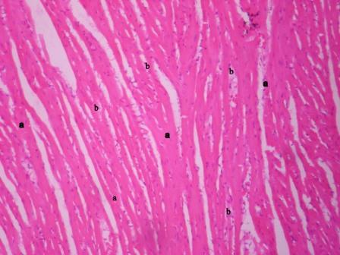  Plate 9: Photomicrograph of heart of male rat administered distilled water (Mag x 100; H & E). a (cardiac muscle fibre), b (nucleus) plh (pericardial lymphoid hyperplasia(non significantly)). A normal heart.  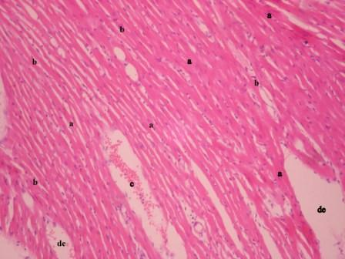  Plate 11: Photomicrograph of heart of rat administered 500 mg/kg body weight of A. paniculata (Mag x 100; H & E). a (cardiac muscle fibre), b (nucleus), c (congestion (mild)) and de (degeneration (mild)). A significantly compromised heart. | 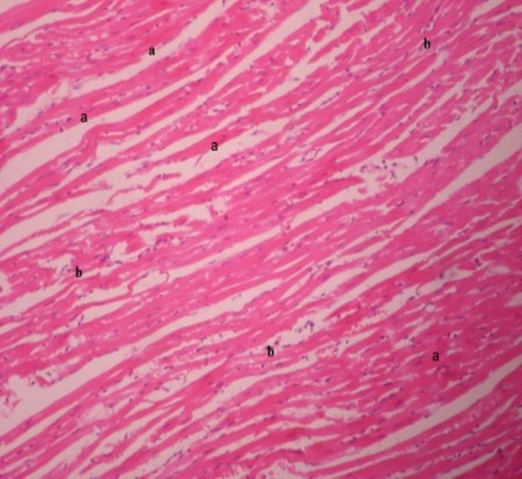  Plate 10: Photomicrograph of heart of rat administered 250 mg/kg body weight of A. paniculata (Mag x 100; H & E). a (cardiac muscle fibre) and b (nucleus). A normal heart.  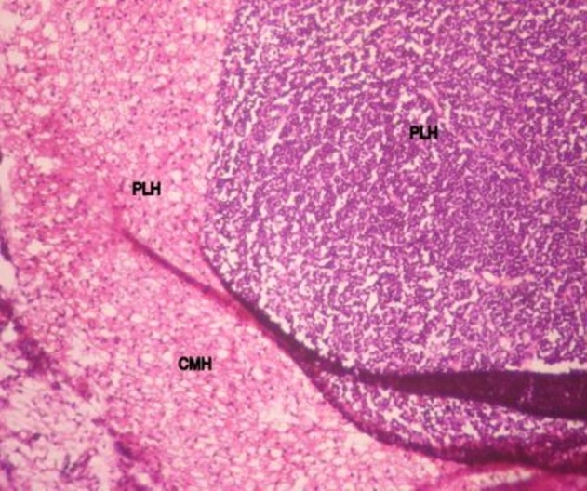  Plate 12: Photomicrograph of liver of rat administered 1000 mg/kg body weight of A. paniculata (Mag x 100; H & E). PLH (pericardial lymphoid hyperplasia (severe)), CMH (cardiac muscle hyperplasia (severe)) A significantly compromised heart.

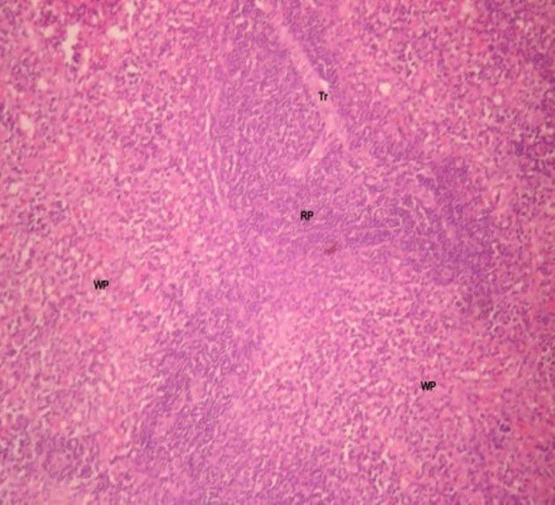  Plate 13: Photomicrograph of spleen of male rat administered distilled water (Mag x 100; H & E).  (RP (red pulp), WP (white pulp), Tr (trabecula) and spleenic congestion (non significant)). A non - significantly compromised spleen  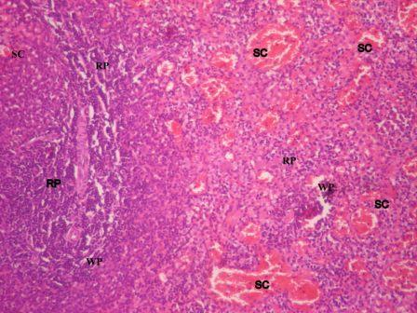  Plate 15: Photomicrograph of spleen of rat administered 500 mg/kg body weight of A. paniculata (Mag x 100; H & E). RP (red pulp), WP (white pulp) and SC (spleenic congestion (moderate).A significantly compromised spleen. | 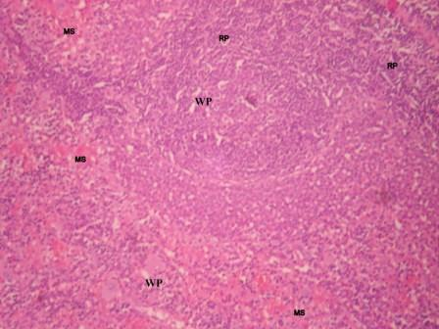  Plate 14: Photomicrograph of spleen of rat administered 250 mg/kg body weight of A. paniculata (Mag x 100; H & E). RP (red pulp), WP (white pulp) and MS (spleenic congestion (mild). A significantly compromised spleen  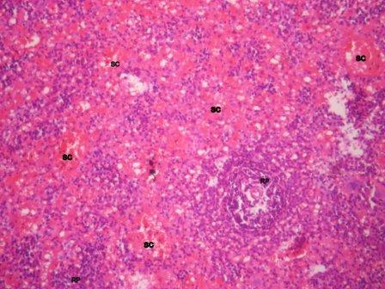  Plate 16: Photomicrograph of spleen of rat administered 1000 mg/kg body weight of A. paniculata (Mag x 100; H & E). RP (red pulp) and SC (spleenic congestion (severe). A significantly compromised spleen.

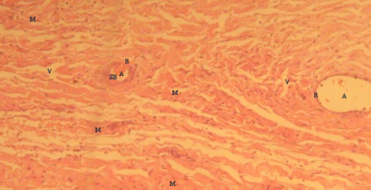  Plate 17: Photomicrograph of small intestine of male rat administered distilled water (Mag x 100; H & E). SB (submucosa), V (villi), A (arterioles) and M (muscles). A normal small intestine.  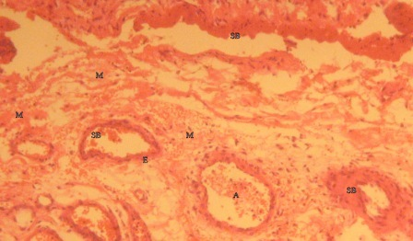  Plate 19: Photomicrograph of small intestine of rat administered 500 mg/kg body weight of A. paniculata (Mag x 100; H & E). SB (submucosa), V (villi), A (arterioles) and M (muscles). A normal small intestine. | 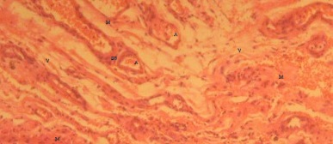  Plate 18: Photomicrograph of small intestine of rat administered 250 mg/kg body weight of A. paniculata (Mag x 100; H & E). SB (submucosa), V (villi), A (arterioles) and M (muscles). A normal small intestine.  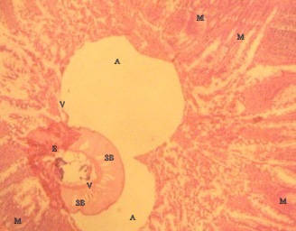  Plate 20: Photomicrograph of small intestine of rat administered 1000 mg/kg body weight of A. paniculata (Mag x 100; H & E). SB (submucosa), V (villi (significant lysis affecting the epithelia)), A (arterioles) and M (muscles). A significantly compromised small intestine.

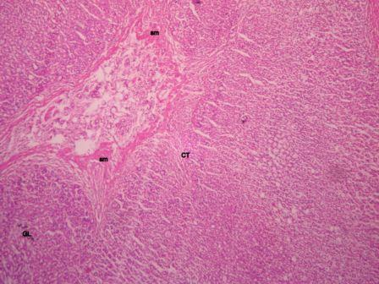  Plate 21: Photomicrograph of prostate of male rat administered distilled water (Mag x 100; H & E). CT (connective tissue), sm (smooth muscle) and GL (gland) A normal prostate.  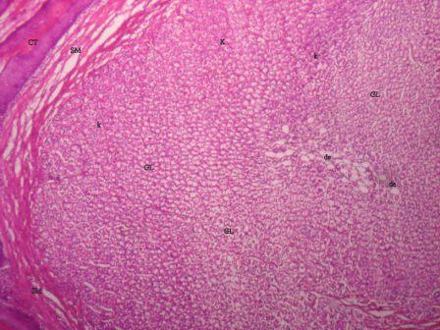  Plate 23: Photomicrograph of prostate of rat administered 500 mg/kg body weight of A. paniculata (Mag x 100; H & E). CT (connective tissue), GL (gland), K (congestion (moderate) and DE (degeneration (mild)). A significantly compromised prostate. | 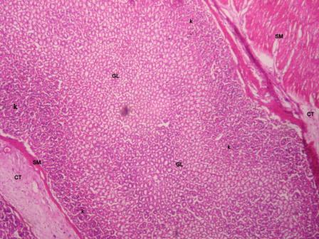  Plate 22: Photomicrograph of prostate of rat administered 250 mg/kg body weight of A. paniculata (Mag x 100; H & E). CT (connective tissue), GL (gland), SM (smooth muscle) and K (congestion (mild). A significantly compromised prostate.  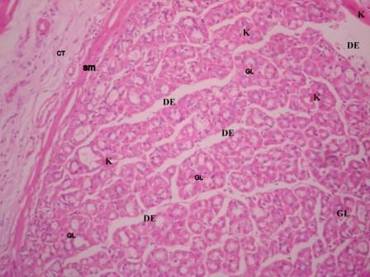  Plate 24: Photomicrograph of prostate of rat administered 1000 mg/kg body weight of A. paniculata (Mag x 100; H & E). CT (connective tissue), GL (gland), SM (smooth muscle), K (congestion (moderate) and DE (degeneration (severe)). A significantly compromised prostate.

4.0 Discussion
4.1 Enzyme activities
4.1.1 Alkaline phosphatase
The trends depicted in the kidney ALP activity (Table 1), suggested that the long-term administration of the aqueous leaf extract of A. paniculata did not confer protection on the kidney, but rather compromised the integrity of the organ at 500 and 1000 mg/kg body weight. However, in the small intestine, long-term administration of the extract may have caused derangement of the plasma membrane. This effect was significant at 1000 mg/kg body weight only (Table 1), which could be due to the levels of saponins in the aqueous leaf extract of A. paniculata as reported by Oyewo et al. (2010). High concentrations of saponins have been implicated in permeabilization of the gastrointestinal tract that could cause ‘autointoxication’ or “leaky gut’, due to marked disorder in the plasma membrane (Francis et al., 2002; Evers, 2008). The administration of the aqueous extract of A. paniculata had hepatoprotective capability at the 250 and 500 mg/kg body weight doses. This was evident with liver ALP activities presented (Table 1). Hepatoprotective capability diminished with increase in dose and at 1000 mg/kg body weight dose, hepatotoxicity is indicated.
The overall trend in ALP activities indicated that 1000 mg/kg body weight dose of the aqueous leaf extract of A. paniculata disrupted the integrity of plasma membrane in the kidney, liver and small intestine (Table 1) that lead to loss of membrane components (including ALP) into the serum (Malbica and Hart, 1971), inactivation of the enzyme in situ (Umezawa and Hooper, 1982), or inhibition of enzyme activity at the cellular/molecular level. Reduction in ALP activities could also result from disruption of the orderred lipid bilayer of membrane structure, leading to the release of detectable quantities of ALP out of the cell. This disruption hinders adequate transportation of required ions or molecules across cell membrane (Akanji et al., 1993). Thus, the reductions in ALP activity in tissues, as seen in this study, may have adversely affected other metabolic processes such as nuclear protein synthesis, nucleic acid and phospholipids metabolism, as well as in the cleavage of phosphate esters that involve this enzyme.
The trend presented in serum ALP activities (Table 1) support the reports made on the liver, small intestine and kidney ALP activities. The decrease in serum ALP activities at 250 and 500 mg/kg body weight doses suggest that the normal functions of the liver, bile ducts or gall bladder and the plasma membranes of kidney, liver and small intestine were not disrupted at these doses, while at 1000 mg/kg body weight, possibly disruption of plasma membrane of the liver, bile duct or gall bladder and/or small intestine. In addition, an increase in serum ALP activity is frequently associated with a variety of diseases, such as extrahepatic bile obstruction, intrahepatic cholestasis, infiltrative liver disease, sepsis, bone growth or loss, kidney failure and hepatitis (Li-Fern and Rajasoorya, 1999; Kim et al., 2004).

4.1.2 Lactate dehydrogenase
The administration of the aqueous leaf extract of A. paniculata indicated hepatoprotective capability at 250 and 500 mg/kg body weight doses. This was evident with liver LDH activities presented in the study (Table 1). However, hepatoprotective capability was observed to diminish with increase in dose. The pattern of LDH activities in the small intestine suggested that the muscle cells of the small intestine were disrupted at 1000 mg/kg body weight (Table 1). This submission is logical since LDH is in close proximity to the plasma membrane (Akanji and Yakubu, 2000). This is supported by the result of ALP activity in the liver and small intestine respectively (Table 1).
The long-term administration of the aqueous extract of A. paniculata caused derangement in the heart at 1000 mg/kg body weight dose, but cardio-protective capabilities at 250 and 500 mg/kg body weight doses, as presented in the heart LDH activities (Table 1). However, cardio-protective capability of the extract was shown to decrease with dose increase. The decreases in serum LDH activity at 250 and 500 mg/kg body weight doses are consistent with the suggested cardio- and hepato-protective capability of the aqueous extract. The high dose of 1000 mg/kg body weight strengthened the possibilities of tissue toxicity (Table 1). The death of cells in these tissues, cause the release of LDH into the blood stream. However, many conditions such as heart failure, muscle injury, hemolytic anaemia, blood flow deficiency (ischemia), stroke, leukaemia etc other than cell death could be responsible for the increase in serum LDH activity (Butt et al., 2002).

4.1.3 Aspartate transaminase
The results for kidney AST activity (Table 1), suggest that the administration of the aqueous leaf extract of A. paniculata protected the kidney at 250 mg/kg body weight, but rather compromised the integrity of the organ at 500 and 1000 mg/kg body weight. Administration of the aqueous extract presented evidence suggesting hepatoprotective capability of the extract at 250 and 500 mg/kg body weight doses. This submission was evident with liver AST activity presented (Table 1). However, hepatoprotective capability was observed to diminish with increase in dose. The administration of the aqueous leaf extract may have caused derangement in heart tissue at the 1000 mg/kg body weight dose, but cardio-protective effects at 250 and 500 mg/kg body weight doses, as presented (Table 1). However, cardio-protective effect of the extract was shown to decrease with dose increase. The presented decreases in serum AST activity at 250 and 500 mg/kg body weight doses (Table 1) suggest that the administration of the aqueous leaf extract did not cause marked disruption of any tissue membranes, thus, limiting possible leakage from the cytoplasm and mitochondria that results from tissues (liver, kidney and heart) damage and/ or disease (Gaze, 2007). Rather, the extract conferred protection to the organs at these doses. However, at 1000 mg/kg body weight dose of aqueous leaf extract, disruption of membrane(s) of any of the aforementioned organs may have occurred.

4.1.4 Alanine transaminase
The trend depicted for kidney ALT activity (Table 1), suggests that the administration of aqueous leaf extract of A. paniculata possibly compromised the integrity of the organ at 500 and 1000 mg/kg body weight doses. However, the administration of the extract elicited support for the hepatoprotective capability of the extract at 250 and 500 mg/kg body weight doses. This submission was evident with liver ALT activity presented (Table 1). Hepatoprotective capability diminished with increase in dose of the extract, with the high dose of 1000 mg/kg body weight eliciting hepatotoxicity as presented in AST activity in the liver (Table 1).
Administration of the aqueous leaf extract of A. paniculata caused possible derangement of the heart tissues at 1000 mg/kg body weight dose (Table 1). The presented decrease serum ALT activities (Table 1) at 250 and 500 mg/kg body weight doses of extract indicated that the administration extract did not cause tissue damage, so there was no possible leakage of the enzyme from the cytoplasm of cells (Nyblom et al, 2006). Rather, the extract may have conferred protection on the organs at these doses. However, 1000 mg/kg body weight dose possibly caused tissue damage in all of the aforementioned organs.
The overall trends in ALT activities of rat administered 1000 mg/kg body weight dose of the aqueous extract indicated possibly toxicity in the kidney, liver and heart. This was responsible for the elevation of ALT activity in the serum (Table 1). The leakage of aminotransferases into serum, therefore, would impair the biosynthesis of some crucial proteins in cells, and leads to organ failure and death. When the activities of aminotransferases are reduce markedly, critical proteins are not synthesised, and a variety of symptoms up to the dissolution of membranes may ensue (Davern and Scharschmidt, 2002).

4.1.5 Acid phosphatase
The administration of the aqueous leaf extract of A. paniculata provided evidence of the hepatoprotective capability of the extract at the 250 and 500 mg/kg body weight doses. This was evident with liver ACP activity presented (Table 1). Hepatoprotective capability diminished with increase in dose, with the 1000 mg/kg body weight dose eliciting suggested hepatotoxicity. However, the administration of the aqueous leaf extract at the various doses obviously compromised the prostate gland in rats (Table 1). The compromise could possibly be due to inflammation (prostatitis) and or, benign prostatic hyperplasia (cancer) as the compromise increased with dose. The presented dose dependent decrease in the spleen ACP activity in male rats following administration of the extract indicated overt signs of compromise to the organ (Table 1).
The dose dependent increases in serum total and prostatic ACP activities following the administration of the aqueous extract (Table 1) indicated that the extract definitely increased the activities of lysosomal enzymes in tissues such as the prostate gland, liver and spleen or possibly caused heart and kidney diseases (Bull et al., 2002; Taira et al., 2007). Increased serum prostatic ACP activity is a strong indicator of prostate gland inflammation or cancer, or prostate cancer that has metastasized to the bone (Nakanishi et al., 1998). Thus, the aqueous leaf extract of A. paniculata at the dose levels studied, possibly compromised the integrity of the prostate gland as presented in Table 1.
The overall result for the serum LDH and total ACP activities support the anaemic tendencies of the aqueous leaf extract of A. paniculata previously reported by Oyewo et al. (2011). Also, the possible risk of predispositions to biliary obstruction and hepatotoxicity following the administration of the leaf extract of A. paniculata at 1000 mg/kg body weight dose reported by Oyewo et al. (2011) were strengthened by results of serum ALT, AST and ALP activities (Table 1).

4.2 Oxidative stress indices
4.2.1 Liver reduced glutathione
The administration of the aqueous leaf extract of A. paniculata demonstrated a good means of recovery of reduced glutathione (GSH), in line with the presented increase in liver GSH levels at the 250 and 500 mg/kg body weight doses (Table 2). However, the dose of 1000 mg/kg body weight possibly promoted the generation of more pro-oxidants (Proctor, 1970; Cutler, 1984), or caused loss of organ function due to hepatocyte infiltrations, necrosis of chronic inflammation. GSH is the one of the most proactive endogenous antioxidants in the body, because it is involved in many detoxification processes (Becker, 1993). The levels of saponins and polyphenolic compounds reported by Oyewo et al. (2010) in the aqueous leaf extract, inferably suggest antioxidant properties and thus, the recovery of reduced GSH that could prevent the development of degenerative diseases caused by oxidative stress. The trend obtained in liver (GSH) following administration of the leaf extract is consistent with the reports of Anderson et al. (1997) and Xiang et al. (2001) that decrease in liver GSH concentration resulted in the increase in tissue inflammation and over-expression of IL-6 as previously reported by Oyewo et al. (2011).
The level of glutathione in the liver tightly regulates the concentration of uric acid in the blood and increase in GSH concentration in liver was reported to facilitate the excretion of uric acid in the blood, thereby reducing the risk of the formation of inflammatory responses, kidney stones and gout (Becker, 1993). There is increase in the demand for uric acid as an antioxidant (greater than 50% of total antioxidant pool in the body), when the concentration of GSH in the liver is low, in conditions such as oxidative stress, liver diseases and chronic inflammation (Beck, 1993; Xiang et al., 2001). Therefore, the administration of aqueous leaf extract of A. paniculata in rats at high doses probably resulted in inflammation in the liver, which decreased the recovery of GSH in the liver and stimulated the increase in uric acid concentrations in the serum reported previously by Oyewo et al. (2011), which could have induced inflammation in the joint, thereby acting as adjuvant that stimulated the immune system to produce IL -6 and TNF-α (Oyewo et al., 2011).

4.2.2 Malondialdehyde
The reduced MDA concentrations in the liver following administration of the aqueous leaf extract of A. paniculata at 250 and 500 mg/kg body weight doses (Table 2), supported the reported antioxidative property of the aqueous extract (Oyewo et al., 2010). However, the antioxidative property of the leaf extract decreased with increase in dose, while at 1000 mg/kg body weight dose, it had no remarkable antioxidative effects. The reductions in MDA concentrations in the liver at 250 and 500 mg/kg body weight doses suggest that the leaf extract at these doses reduced the induction or progression of oxidative stress, but at 1000 mg/kg body weight dose, pro-oxidants were probably generated as indicated in reduced glutathione concentrations in the liver (Table 2) and reported increase in serum uric acid concentrations (Oyewo et al., 2011), because elevated levels of strong reducing agents (uric acid) have been reported to act also as pro-oxidant (Proctor, 1970; Cutler, 1984).
The result obtained in the MDA concentrations in the liver is consistent with the trends reported in the liver GSH concentrations and serum uric acid concentrations, all indicating decrease in the endogenous antioxidant capability with increase in dose.

4.3 Sperm count and motility
Marked reductions in the sperm count and sperm motility of male rats following the administration of the aqueous leaf extract of A. paniculata (Table 2), suggest that the extract definitely interfered with spermatogenesis the rats. The reduced sperm count could possibly be due to androgen blocking and or, prevention of cytokinesis of the dividing spermatogenic cell lines (Akbarsha et al., 1990; Akbarsha and Murugaian, 2000). Therefore, aqueous extract of A. paniculata probably contained constituents that inactivated or killed sperm cells, thereby reducing the population of active sperm cells.

4.4 Organ-body weight index
The reduction in the kidney-body weight index and increase in the spleen-body weight index at 1000 mg/kg body weight dose might indicate possible loss of organs function (Figure 1). Reduction in kidney-body weight index may be due to tissue dehydration, while the enlarged spleen may be due to tissue inflammation, necrosis or cancer. The dose dependent increase in the prostate-body weight ratio indicated that the extract may induce inflammation or malignant cells formation in the prostate (Figure 1). Therefore, the increased prostate- and spleen-body weight ratios may be due the inflammation (possibly tissue damage) (Smith et al., 2001).

4.5 Histology
The photomicrographs of the liver revealed that the administration of the aqueous extract of A. paniculata adversely affected the hepatocytes at 1000 mg/kg body weight (Plate 4). This finding supports the result for liver glutathione and MDA concentrations (Table 2), the activities of LDH, AST, ALT, ALP and ACP in the liver (Table 1). The hyperplasia and venous congestion seen in the liver photomicrographs might cause biliary stricture (benign or malignant) as previously reported by Oyewo et al. (2011) in rats administered 1000 mg/kg body weight of aqueous leaf extract. This submission is strengthened by the presented serum ALT and ALP activities (Table 1), since a minor elevation in serum ALT activity is a good predictor of mortality from liver disease, especially when serum ALP activity is increased as well (Kim et al., 2004). Thus, the photomicrogragh of the liver confirms hepatotoxicty caused by the aqueous leaf extract of A. paniculata at 1000 mg/kg body weight dose.
The administration of the extract at 1000 mg/kg body weight dose compromised the integrity of the nephrons and may impair kidney functions, most especially tubular fluid re-absorption (Plate 8). The results for kidney ALP, AST and ALT activities (Table 1) confirmed possible nephro-toxicity following the administration of the aqueous leaf extract of A. paniculata. The significant compromise in the cardiac tissues as seen following the administration of the extract at 1000 mg/kg body weight doses (Plate 12) indicated that ingestion of the extract at high doses could lead to cardiac failure. This submission is supported by the reduction in activities of heart LDH, heart AST and heart ALT (Table 1). The observed compromise in the heart might be the cause of the partial paralysis (hemiplagia) reported at 1000 mg/kg body weight dose by Oyewo et al. (2011). This submission is in consonance with the previous reports of Oyewo et al. (2011), where over-expression of IL-6 and TNF-α were presented following the administration of aqueous leaf extract of A. paniculata. Szekanecz et al. (1994), Biasucci et al. (1996) and Dubiński and Zdrojewicz (2007) revealed that over-expression of IL-6 and TNF-α were directly implicated in high risk of predisposition to atherosclerosis, myocardial infarction and stroke, when other major risk factors like blood lipid, body mass index, diabetes, blood pressure, alcoholism etc were normal.
IL-6 and TNF-α regulate localized tissue uptake of LDL-C by inhibiting the expression of LDL-C receptors via SREBP. However, in chronic inflammatory conditions as reported earlier, IL-6 and TNF-α may be over-expressed, which increases the risk of oxidation of LDL-C, the subsequent uptake of oxidised LDL-C by macrophages in vascular endothelia cells and release of acute phase proteins such as fibrinogen, which are the hallmark of plague formation in heart tissues (Ford and Giles, 2000; Morrow and Ridker, 2000).
The long-term administration of the extract of A. paniculata revealed dose dependent toxicity to the spleen (Plate 16) and supported the reported decrease in the ACP activity in the spleen (Table 1). The increases in the spleen-body weight index (Figure 1) is indicative of inflammation in the spleen, caused possibly by high serum IL-6 and TNF-α levels (Oyewo et al., 2011). The spleen photomicrographs further strengthens the reported anaemic property, and possible autoimmune capability of the aqueous leaf extract of A. paniculata at 1000 mg/kg body weight doses reported by Oyewo et al. (2011). In addition, problems with spleen are often times reflected in heart diseases, as mortality due to ischaemic heart disease was increased in splenectomised subjects (Robinette and Fraumeni, 1977).
The photomicrographs of the small intestine (Plate 20) revealed possibility of autointoxication, which could inflame or perforate the intestine and thereby causing obstruction of blood supply to the intestine and ultimately leading to cell death. This submission is strengthened by results obtained for LDH and ALP activities in the small intestine (Table 1). The damage to the walls of the small intestine could be due to permeabilization by saponins in the aqueous leaf extract, which could cause lipid mal-absorption presented at 1000 mg/kg body weight as reported by Oyewo et al. (2010). The over-expression of IL-6 and TNF-α previously reported by Oyewo et al. (2011) following the long-term administration of the aqueous leaf extract of A. paniculata at 1000 mg/kg body weight could be the aftermath of autointoxication that resulted in chronic inflammation in tissues. The compromises seen in the photomicrographs of the prostate gland (Plate 24) following the administration of the aqueous leaf extract, strengthens the suggested inflammation or probable malignancy in the prostate as presented for prostate-body weight ratio (Figure 1), prostate ACP activities and serum prostatic ACP activities (Table 1).
The overall findings of the toxic implication of the aqueous leaf extract of A. paniculata on the organs studied showed that the 250 mg/kg body weight dose has protective effects on the heart and the liver with no remarkable effects on the kidney and small intestine, while 500 mg/kg body weight dose suggested protective effect on the liver only. All the organs presented tissue toxicities at 1000 mg/kg body weight dose of leaf extract. In addition, toxicities in the spleen and prostate following the administration of aqueous leaf extract of A. paniculata, are consistent with a dose dependent effects on the integrity of the organs.

5.0 Conclusion
The aqueous leaf extract of Andrographis paniculata presented tissue toxicities at high doses and thus, not recommended at dose more than 250 mg/kg body weight. In addition, long-term use of the aqueous leaf extract in male is discouraged due to the interference with spermatogenesis, sperm motility, spleen and prostate inflammation, even at 250 mg/kg body weight doses.

Acknowledgement:
We appreciate the academic contributions of Professor A. Adesokan of Biochemistry Department, LAUTECH, Ogbomoso, Oyo State, Nigeria and Dr. Musa Yakub, of Biochemistry Department, University of Ilorin, Kwara State, Nigeria.

Disclosure Statement:
“No competing financial interests exist".

Correspondence to:
Emmanuel Bukoye Oyewo,
Department of Biochemistry,
Faculty of Basic Medical Sciences,
Ladoke Akintola University of Technology,
P. M. B. 4000,
Ogbomoso, Oyo State.Nigeria

Cellular phone: +234-8035184135 / +234-057455184
Email: askafterbukoye@yahoo.com

References
[1] Abbort L, Kaplan A, Rubaltelli F, Hammerman
C, Vilei M, Leiter C, Abramov A. (1984). Acid
phosphatase. Clin Chem The C.V. Mosby Co. St Louis. Toronto. Princeton. Pp.112.
[2] Abraham N, Carty R, DuFour D, Pincus M.
Clinical enzymology. In: McPherson R, Pincus M,
eds. Henry’s Clinical Diagnosis and Management
by Laboratory Methods. 21st ed. Philadelphia, Pa:
Saunders Elsevier, 2006;720.
[3] Anderson JK, De Rosa SC, Hom DG, Jurma OP, Herzenberg LA. Glutathione deficiency is associated with impaired survival in HIV disease. Proc. Natl. Acad. Sci., 1997; 94: 1967-1972.
[4] Ahmed ZM, Goodyear R, Riazuddin S, Legan RK,
Lilley KS. The tip-link Antigen, a protein
associated with the transduction complex of
sensory hair cell is Protacadherin-15. J. Neurosci.,
2006; 26 (26): 7022-7034.
[5] Akanji MA, Olagoke OA, Oloyede OB. Effect of
chronic consumption of metabisulphite on the
integrity of rat cellular system. Toxicol., 1993; 81:
173-179.
[6] Akanji MA, Yakubu MT. α-Tocopherol protects
against metabisulphite-induced tissue damage in
rats. Nig. J. Biochem. Mol. Biol., 2000; 15(2):
179-183.
[7] Akbarsha MA, Manivannan B, Shahul H.
Antifertility effect of Andrographis paniculata
(Nees) in male albino rat. Indian J Exp Biol., 1990;
28: 421-426.
[8] Akbarsha MA, Murugaian P. Aspects of the male
reproductive toxicity/male antifertility property of
andrographolide in albino rats: effect on the testis
and the cauda epididymidal spermatozoa.
Phytother. Res., 2000; 14(6): 432-435.
[9] Asakawa Y. Biological active substance obtained
from bryophyte. In: proceedings of the
phytochemical society of Europe (H.D.
Zinemesster and R. Mue ed.) 1990; 250.
[10] Asakawa Y. Biological active substance obtained
from bryophyte. In: proceedings of the
phytochemical society of Europe (H.D.
Zinemesster and R. Mue ed.) 1990; 250.
[11] Baker MA, Cerniglia GJ, Zaman A.. Microtiter
plate assay for the measurement of glutathione and
glutathione disulfide in large numbers of biological
samples. Anal. Biochem., 1990; 190: 360-365.
[12] Becker BF. "Towards the physiological function of
uric acid". Free Radical Biology and Medicine,
1993; 14 (6): 615-631.
[13] Biasucci L, Vitelli A, Liuzzo G, Altamura S,
Caligiuri G, Monaco C, Rebuzzi A, Ciliberto G,
Maseri A.. Elevated levels of interleukin-6 in
unstable angina. Circulation, 1996; 94:874-877.
[14] Borhanuddin M, Shamsuzzoha M, Hussain AH.
Hypoglycaemic effects of Andrographis
paniculata Nees on non-diabetic rabbits.
Bangladesh Med. Res. Counc. Bull., 1994; 20(1):
24-26.
[15] Bull H, Murray PG, Thomas D, Fraser AM, Nelson
PN. Acid phosphatases. Molecular Pathology,
2002; 55 (2): 65-72.
[16] Butt AA, Michaels S, Greer D, Clark R, Kissinger
P, Martin DH. "Serum LDH level as a clue to the
diagnosis of histoplasmosis". AIDS Read, 2002;
12 (7): 317-21.
[17] Coon JT, Ernst ET. Andrographis paniculata in the
treatment of upper respiratory tract infections: a
systemic review of safety and efficacy. Planta
Medica., 2004; 70 (4): 293-298.
[18] Cutler RG. "Urate and ascorbate: their possible
roles as antioxidants in determining longevity of
mammalian species". Archives of Gerontology and
Geriatrics, 1984; 3 (4): 321-348.
[19] Davern TJ, Scharschmidt BF. Biochemical liver
tests. In: Feldman M, Friedman LS, Sleisenger MH, eds. Sleisenger & Fordtran's Gastrointestinal and liver disease: pathophysiology, diagnosis, management. 7th ed. Philadelphia: Saunders, 2002; 1227-1238.
[20] Dubiński A, Zdrojewicz Z. "The role of
interleukin-6 in development and progression of atherosclerosis" (in Polish). Pol. Merkur. Lekarski., 2007; 22 (130): 291-294.
[21] Ellman G.L. Tissue sulphydryl groups. Arch. Biochem. Biophys., 1959; 11: 70-77.
[22] Evers BM. Small intestine. In: Townsend CM, Beauchamp RD, Evers, B. M., Mattox, K. L., eds. Sabiston Textbook of Surgery. 18th ed. St. Louis, Mo: WB Saunders ,2008; chap 48.
[23] Eyer P, Podhradsky D. Evaluation of the micromethod for determination of glutathione using enzymatic cycling and Ellmanâ€™s reagent. Anal. Biochem., 1986; 153: 57-66.
[24] Ford ES, Giles WH. Serum C-reactive protein and
fibrinogen concentrations and self-reported angina pectoris and myocardial infarction: findings from National Health and Nutrition Examination Survey III. J. Clin. Epidemiol., 2000; 53: 95-102.
[25] Fraga CG, Leibovitz BE, Toppel AL. Lipid peroxidation measured as TBARS in tissue characterization and comparison with homogenates and microsomes. Free Radic. Biol. Med., 1981; 4: 155-161.
[26] Francis G, Kerem Z, Makkar HP, Becker K. Biological action of saponins in animal system: a review. Br. J. Nutr., 2002; 88(6): 587-605.
[27] Gaze DC. “The role of existing and novel cardiac biomarkers for cardioprotection”. Curr. Opin. Invest. Drugs, 2007; 8 (9): 711-717.
[28] Gbile ZO, Adesina SK. Nigeria flora and its pharmaceutical potentials. J. Ethnopharm., 1987; 19: 1-16.
[29] Irey NS. When is drug induced? In: pathology of drug induced and toxic disease. Robert, H. Ridell (ed), Churchhill Livingstone, 1982; 1-8.
[30] Kim HC, Nam CM, Jee SH, Han KH, Oh DK., Suh II. Normal serum aminotransferase concentration and risk of mortality from liver diseases: prospective cohort study. Br. Med. J., 2004; 328: 983-987.
[31] Kulichenko LL, Kireyeva LV, Malyshkina EN, Wikman GA. Randomized, controlled study of Kan Jang versus amantadine in the treatment of influenza in Volgograd. J.Herb.Pharmacother., 2003; 3(1): 77-93.
[32] Krause WJ. The art of examining and interpreting histologic preparations. A student handbook. Partheton Publishing Group, UK. 2001; 9-10.
[33] Li-Fern H, Rajasoorya C. "The elevated serum alkaline phosphatase--the chase that led to two endocrinopathies and one possible unifying diagnosis”. Eur. J. Endocrinol., 1999; 140 (2): 143-7.
[34] Mahajan BK. Significance of difference in means. In: Methods in Biostatistics for Medical and Research workers, 6th edition. New Delhi, JAYPEE Brothers Medical Publishers, 1997; 103 – 155.
[35] Malbica JO, Hart LG. Effect of adenosine triphosphatase (ATP) and some anti-inflammatory agents on purified lysosomal fraction having high acid phosphatase and labile glucuronidase activity. Biochem. Pharmacol., 1971; 20:2017-2026.
[36] Morrow DA, Ridker PM. C-reactive protein, inflammation, and coronary risk. Med. Clin. North Amer., 2000, 84: 149 - 161.
[37] Murray R. Aminotransferases. Kaplan, A., Rubaltelli, F. F., Hammerman, C. Clin. Chem. The C.V. Mosby Co. St Louis. Toronto. Princeton, 1984ª; 1112-119.
[38] Murray R. Lactate dehydrogenase. Kaplan, A., Rubaltelli, F. F., Hammerman, C. Clin. Chem. The C.V. Mosby Co. St Louis. Toronto. Princeton, 1984^{b} 1154-162.
[39] Nakanishi M, Yoh K, Uchida K. Improved method for measuring tartrate-resistant acid phosphatase activity in serum. Clin. Chem., 1998; 44: 221-225.
[40] National Institute of Health. Guide for the Care and Use of Laboratory Animals. 2nd ed., revised. DHEW Publication (NIH). Bethesda, Maryland: Office of Science and Health Reports, DRR/NIH. 1985.
[41] Nyblom H, Björnsson E, Simrén M, Aldenborg F, Almer S, Olsson R. "The AST / ALT ratio as an indicator of cirrhosis in patients with PBC". Liver Int., 2006; 26 (7): 840 – 846.
[42] Oyewo B, Akanji M, Onifade N. In vitro and In vivo Evaluation of the Antioxidant Properties of Aqueous Extract of Andrographis paniculata Leafs. Researcher. 2010; 2 (11): 42 - 51.
[43] Oyewo EB, Akanji MA. Immune Modulation Potentials of Aqueous Extract of Andrographis paniculata Leaves in Male Rat. Researcher. 2011;3 (1):48-57.
[44] Pant N, Srivastava SP. Testicular and spermatotoxic effects of quinalphos in rats. J. Appl. Toxicol., 2003; 23(4): 211-214.
[45] Pesce A. Lactate dehydrogenase. Kaplan, A. Clin Chem The C.V. Mosby Co. St Louis. Toronto. Princeton, 1984; 1124 - 1127, 438.
[49 Proctor P. "Similar functions of uric acid and ascorbate in man"? Nature, 1970; 228 (5274): 868-875.
[50] Robinette CD, Fraumeni JF. Splenectomy and subsequent mortality in veteran of the 1939-1945 war. Lancet , 1977; 16(2): 127-129.
[51] Slater TF, Sawyer BC. The stimulatory effects of carbon tetrachloride and other halogenoalkanes on peroxidative reactions in rats liver fractions in vitro. General features of the system used. Biochem. J., 1971; 123(5): 865-874.
[52] Smith P C, Hobisch A, Lin DL, Culig Z, Keller ET. "Interleukin-6 and prostate cancer progression". Cytokine Growth Factor Rev., 2001; 12 (1): 33-40.
[53] Spasov AA, Ostrovskij OV, Chernikov MV. Comparative controlled study of Andrographis paniculata fixed combination, Kan Jang and an Echinacea preparation as adjuvant, in the treatment of uncomplicated respiratory disease in children. Phytother. Res., 2004; 18 (1): 47-53.
[54] Szekanecz Z, Shah MR, Pearce WH, Koch AE. Human atherosclerotic abdominal aortic aneurysms produce interleukin (IL)-6 and interferon-gamma but not IL-2 and IL-4: the possible role for IL-6 and interferon-gamma in vascular inflammation. Agents Actions, 1994; 42: 159-162.
[55] Taira A, Merrick G, Wallner K, Dattoli M. "Reviving the acid phosphatase test for prostate cancer". Oncology (Williston Park, N.Y.), 2007, 21 (8): 1003-1110.
[56] Tapsell L, Hemphil I, Cobiac L, Patch C, Sullivan D, Igne K. Health benefits of herbs and spices: the past, The present and future. Med. J. Aust., 2006; 21: 514-524.
[57] Tietz NW, Pruden EL, Siggard-Andersen O. Clinical Guide to Laboratory Tests, 3rd edition,
W. B. Saunders. Company: Philadelphia. 1995.
[58] Umezawa H, Hooper IR. Amino-glycoside antibiotic. Sranger-Verlag Berlin, Hadeelberg. 1982; 51.
[59] Wenger C, Kaplan A, Rubaltelli FF, Hammerman C. Alkaline phosphatase. Clin. Chem. The C.V. Mosby Co. St Louis. Toronto. Princeton. 1984; 1094-1098.
[60] WHO (World Health Organization). Resolution, promotion and development of training and research in traditional medicine. WHO Document No. 30, 1977; 49.
[61] Young DS. Effects of drugs on Clinical Lab. Tests, 4th ed AACC Press, 1995.
[62] Zemjanis R. The effects of oestradiol cypionate (ECP) on spontaneous and oxytocin-stimulated postpartum myometrial activity in the cow. Vet. Med. Small. Anim. Clin., 1977; 72(2): 221-5

4/01/2012

