Maternal practice and its effect on Quality of Life of their Epileptic Children

Gamalat Mansy¹, Azza Elshehawy², Ebtisam El-sayed³, Nahed Morsy⁴ and Samia Hegazy³.

¹Pediatric Nursing Department, Faculty of Nursing, Alexandria University,
²Pediatrics Department, Faculty of Medicine, Tanta University
³Pediatric Nursing and ⁴Psychiatric and Mental Health Nursing Department, Faculty of Nursing, Tanta University
ebtisamelsayed@yahoo.com

Abstract: Epilepsy is the commonest serious neurological condition of childhood. It is a group of chronic disorders in which the indispensable feature is recurrence of seizure. Mothers' knowledge and skills about management of epilepsy is very important particularly management of epileptic fits. Educational intervention enables children and their families to cope effectively with epilepsy and improve their quality of life. The study aims to explore the effect of maternal practice on their epileptic children's quality of life. The study was conducted in the Pediatric Neurological unit and the pediatric outpatient clinic at Tanta University Hospital. A convenient sample of 50 epileptic children and their mothers were included in the study, their age ranged from 8-12 years. Four tools were used to collect the required data. Structured interview sheet to obtain the sociodemographic characteristics ,medical history of children and their families. Mothers practices questionnaire sheet to assess mothers' practices regarding care of epileptic children. Seizure severity scale to assess severity of epileptic fits and Ped's quality of life inventory version 4.0 TM to assess children quality of life. Results of the study revealed that, the educational program showed significant improvement of mothers' practices and improved children quality of life. further studies to assess the needs of the epileptic children and their families and measures to fulfill these needs was Recommended.
[Gamalat Mansy, Azza Elshehawy, Ebtisam El-sayed, Nahed Morsy; Samia Hegazy. Maternal practice and its effect on Quality of Life of their Epileptic Children. Nature and Science 2012;10(2):116-123]. (ISSN: 1545-0740). http://www.sciencepub.net. 18

Keywords: Epilepsy; childhood; children; life

1. Introduction
Childhood epilepsy is one of the most important and prevalent neurological conditions in developing years. Persons with childhood onset epilepsy are at a high risk of poor psychosocial outcomes even without experiencing co-morbidities. Children with epilepsy are at greater risk of having injuries of all sorts, including burns, falls, and drowning ⁽¹⁾. It is defined also as an abnormal electrical disturbance in one or more areas of the brain. The basic problem is thought to be an electrical disturbance in the nerve cells in one section of the brain, causing them to give off abnormal recurrent, uncontrolled electrical discharges that produce a seizure or convulsion⁽¹⁾.
The impact of epilepsy on an individual is a combination of physical consequences of the seizure, the effect on the social position, and the psychological outcome or both of them. Furthermore, not only the person with epilepsy but also the family and indirectly the community are affected. The physical hazards of epilepsy are frequently due to the unpredictability of the seizure which may occur without warning in potentially dangerous situations. Social exclusion can occur because of the negative attitude of others towards people with epilepsy, which can lead to isolation⁽²⁾.
There are many factors that may predispose a child to epilepsy as trauma to the head, or brain tumor, circulatory disorders and stroke, metabolic disorders such as hypoglycemia, hypocalcaemia or cerebral anoxia. Another suspected cause is some medications, alcohol toxicity and infection ^{(1).}
In developed countries the crude annual incidence of epilepsy in children is a round 60 / 100.000 child. The incidence varies markedly with age, and most studies report slightly higher rates in boys ⁽¹⁾. In the United States, epilepsy affects approximately 326,000 school-aged children; 45,000 new cases are diagnosed every year. Of these children 10%-20% may also have a diagnosis of intellectual disability or mental retardation ⁽³⁾.
Regarding the incidence of epilepsy in Egypt WHO (1998) reported that, the number of population suffering from epilepsy is 40.000 people about 10.000 of them suffering from severe activity limitation ⁽⁴⁾ . In Egypt, Mahmoud ⁽⁵⁾, Elmotayam, ⁽⁶⁾ reported that the prevalence of epilepsy among primary school children was 7.2/1000
It is important to encourage a healthy attitude toward the child to help the parents feel competent in their ability to meet their responsibilities towards their child. Education is the cornerstone to the management of children with any form of seizure disorder. Children and families will almost certainly have been extremely frightened. Initial reassurance should allay the fear that seizures are likely to be life threatening and/cause brain damage. However, it is wrong to trivialize what has occurred ⁽⁷⁾.
For these reasons this study was conducted to explore the effect of maternal practices on the quality of life of their epileptic children.

2. Material and Methods
Study design:
A quasi experimental design was used in the present study.
Settings:
The study was conducted at the Pediatric Neurological Unit and Outpatient Clinic of Tanta University Hospital.

Subjects:
A convenient sample of 50 mothers and their epileptic children are included in the study. Children's age ranged from 8-12 years.

Tools:
Four tools were used to obtain the required data:
I – Structured interview sheet to obtain the demographic data of the family and the epileptic children which includes: mothers age, level of education, occupation and income, Family medical history of epilepsy or any mental disorders
Children history which include age, sex, birth order, number of siblings, previous academic failure or success, last year achievement and absenteeism rate, Child's hobbies and leisure time activities, Child's Medical history which includes onset of epilepsy, duration, frequency of seizures, seizures triggers factors, and history of hospital admission.

II. Mothers practices questionnaire sheet to assess mother's practices in caring for their children before, during and after the attack and mothers practices in the management of side effects of antiepileptic drugs.
The scoring system was done concerning maternal practices regarding management of epileptic fits and side effects of antiepileptic drugs. Before the attack: precautions consists of eighteen items ,each item scored 1 grade . (The total score was18), care during the attack consists of sixteen items, (The total score was 16).After the attack: care consists of eight items (The total score was 8) . Emergency medical care include seven situations (total grade 7), and actions to manage side effects of anti epileptic drugs 1grade.
The total practice score was 50 .The grades for each step performed was assigned as follow:
Right action ( one grade)
Wrong action or not done ( zero grade)
The total score was considered satisfactory when the total grades were more than (50% to 100%).
Unsatisfactory when the total grades were less than (50%).

III- Seizure severity scale developed by Hans et al., ⁽⁸⁾. It was translated into Arabic , revised by five experts and used to assess seizures frequency, duration, level of consciousness, associated signs and symptoms and complains after the attacks.
The scoring system was done concerning the above items. Each question response was either always, 3grades), usually, 2grades), sometimes 1grade), or never, zero grade). The total score was 39. The seizure severity was categorized as
zero = no seizure
1-13 grades = mild seizure
14-26 grades= moderate seizure
27-39 grades= severe seizure

IV. Ped's quality of life inventory version 4.0TM ⁽⁹⁾ to assess epileptic children's quality of life. The scale comprised of parallel child self report and parent report formats. The scale consisted of two formats which has the same items. One format is answered by the child and the other one is answered by the mother. Both of them total score was 184 grades. Children's scale: It assessed the child's quality of life from the following domains: physical, emotional, social and school functioning by asking the child himself about any problem he may encountered in the last month.
Parents' scale: to assess the children quality of life by asking the mother about any problems the child faced in the last month from the following domains. Physical, emotional, social and school functioning domains.
Both formats were translated into Arabic and revised by 5 experts for content validity .The scoring system was done concerning the items of children's quality of life. It was divided into four items : physical functioning (32 grades), emotional functioning(20 grades), social functioning (20 grades), and school functioning (20 grades). Each question in the two formats scored as follow( 0, 1,2,3,4 grades). The question is scored (0) when the child or mother answered no problem, score (1) when the response was almost never a problem, scored (2) if the response was sometimes a problem, scored (3 ) if the response was often a problem, and finally scored (4) if the response was almost always a problem. Children's quality of life was categorized into three categories: Good when the total score was 0 to less than 62, fair when the total score was 62 to less than 124, Poor when the total score was > 124 up to 184.
Mothers and their children were interviewed either at the inpatient neurological unit or the out patient clinic. To collect data about both of them by using the first and second tools, the objective of the study was explained to them. During the initial interview, the history of epilepsy was taken and mothers' practices about epilepsy were explored.

Program implementation:
The program was carried out according to the client presence. The program consisted of 4 sessions:
First session: general information about epilepsy
The second session: first aids of epileptic fits
The third session: general knowledge about Anti Epileptic Drugs and management of its side effects
The fourth session: primary care of epileptic children
The action plan was done through structured interview with the mothers and their children. Mothers were divided into 5 groups each group consisted of 10 mothers with their children. If the mothers did not attend the session for any reason the content of the session were explained to them later or when they come for the next visit. Different teaching methods like discussion, demonstration or simulation were used during the program presentation according to the content of the session. Every session takes 45 minutes.
At the beginning of the initial interview, an orientation to the program and its objectives took place. The researcher started each session with summary for the previous one. An Arabic language with simple words was used to suit children and their mothers' level of understanding. At the end of each session mothers' and their children' questions were discussed. Evaluation of the program: The reassessment format was used to evaluate the program after implementation by interviewing mothers and their children. the evaluation of the program was based on:-Degree of acquired practices by mothers as indicated in the post test using tool (II). -Evaluation of seizure severity using tool (III). -The effect of the program on the child's quality of life as it was assessed using tool (IV).

3. Results
Table (1) presents biosocial data of mothers of epileptic children . It was found that, more than half of mothers' age (58%) ranged from 30-39 years with a mean of 30.58±0.50. Forty six percent were secondary school graduates ,where as 6% had primary school. Most of them (76%) were house wives.
Table (2) presents socio-demographic characteristics of the epileptic children. It was found that, the age of epileptic children ranged from 8-12 with a mean of 9.34±1.27 and 54% were boys. Two thirds of them were the first born child. Sixty eight percent were living in the rural area. Half of them (50%) were in the third year primary school and 46% had previous academic failure. Thirty eight percent missed from 1-5 days last month. Thirty two percent of the children had hobbies as computer 4%, watching T.V. 8% and playing football 20%.
Figure (1): illustrated the categories of mothers' practices regarding care provided to their epileptic children. It was found that, the majority of mothers ' practices (84%) were satisfactory immediately after the program, compared by none of them preprogram, and 76% three months later. There was statistical significant difference at 5%, (X² = 86.36, P= 0.0001).
Levels of Quality of life of epileptic children were illustrated in figure (2)and revealed that ,preprogram 18% of children's quality of life was fair and the majority of them (82%) had poor quality of life . However immediately after program, their quality of life was good(38%), 56% fair and only 6% was poor. After three months, children's quality of life was good(48%)and52% was fair. There was statistical significant difference at 5 %,( X²= 100.79, P= 0.0001).
Figure (3) Presents the severity of seizure. It was found that, significant improvement occurred immediately after program where 34% were free from seizure and after three months the percentage was increased to 52%, compared to none of them preprogram. As regards seizure severity the percentage of severe fits were nothing immediately and three 3 months after, compared to38% preprogram. There was statistical significant difference at 5 %,( X² = 145.54, P= 0.0001).
Table (3): shows the correlation between quality of life of the epileptic children and mothers' practice score and seizure severity scores. There was statistical significant correlation between mothers 'practices score and quality of life of epileptic children immediately and three months after the program, where r = .768, P=0.0001 and r= 476, P= 0.0001 respectively . As regards seizure severity, there was statistical significant correlation between seizure severity score and quality of life immediately and 3 months after program, where (r= .570, P= 0.0001, r =.494 P= 0.0001 respectively).

Table (1): biosocial data of mothers of epileptic children .
Variables | Mothers of epileptic children  (n=50)
Variables | n | %
Age (years):
20- | 21 | 42.0
30- | 29 | 58.0
40- | 0 | 0
Range | 20-40
Mean±SD | 30.58±0.50
Education level:
Illiterate | 7 | 14.0
Primary | 3 | 6.0
Preparatory | 11 | 22.0
Secondary | 23 | 46.0
Baccalaureate | 6 | 12.0
Job
House wife | 38 | 76.0
Employee | 12 | 24.0

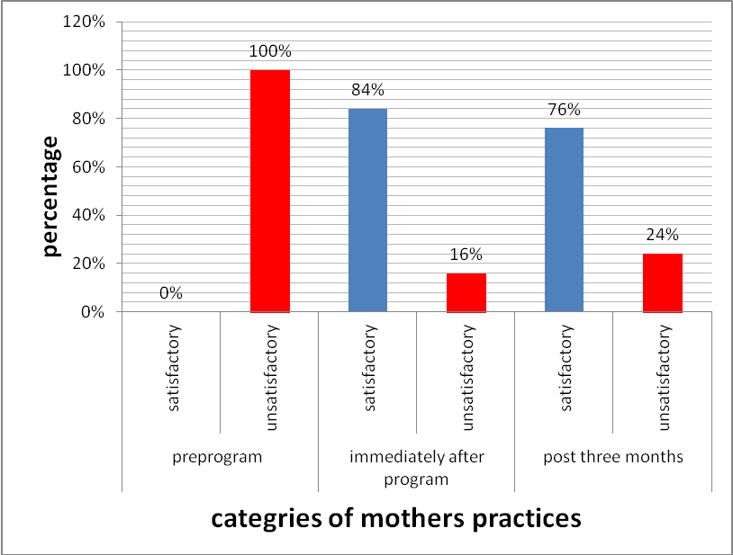

Figure (1): Categories of mothers' practices regarding care of the epileptic children.

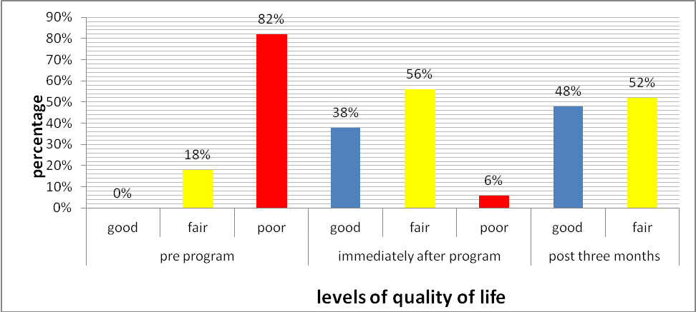

Figure (2): Levels of Quality of life (Ped's) of the studied epileptic children pre-program, immediate after program and post 3 months.

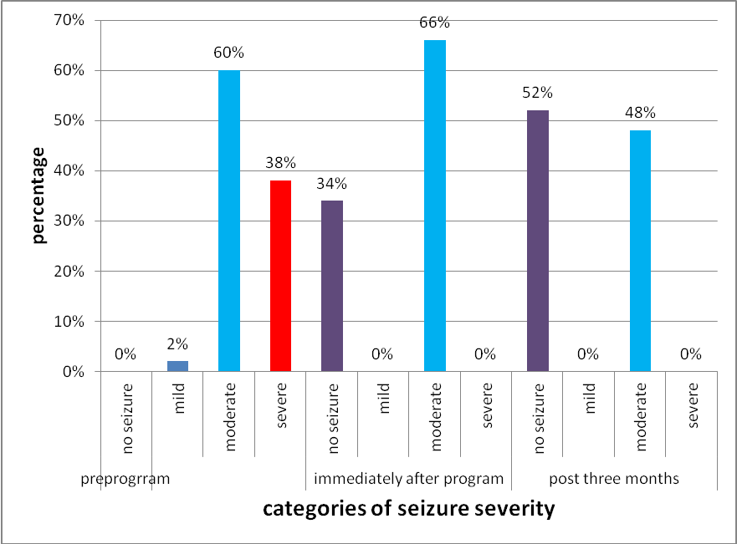

Figure (3): Seizure severity of the studied epileptic children pre-program, immediate after program and post 3 months.

Table (2): Socio-demographic characteristics of the epileptic children
Variables | The studied epileptic children  (n=50)
Variables | no = 50 | %
Age (years):
8- | 35 | 70.0
10-12 | 15 | 30.0
Range | 8-12
Mean±SD | 9.34±1.27
Sex:
Boys | 27 | 54.0
Girls | 23 | 46.0
Birth order:
First | 30 | 60.0
Second | 9 | 18.0
Third | 9 | 18.0
Fourth | 2 | 4.0
Residence:
Rural | 34 | 68.0
Urban | 16 | 32.0
cohabitants:
Mother only | 6 | 12.0
Both parents | 44 | 88.0
Education year: primary years
2nd | 5 | 10.0
3rd | 25 | 50.0
4th | 13 | 26.0
5th | 5 | 10.0
6th | 2 | 4.0
Previous academic failure:
Yes | 23 | 46.0
No | 27 | 54.0
Child absence from school:
Yes | 39 | 78.0
No | 11 | 22.0
Absenteeism days in the last month:
1- | 19 | 38.0
6-  11- | 10  0 | 20.0  0.0
>15 | 10 | 20.0
Types of children's hobbies:
Computer | 2 | 4.0
TV watching | 4 | 8.0
Play football  No hobbies | 10  43 | 20.0  68.0

Table (3): Correlation between maternal practices, severity of seizures and quality of life of epileptic children
Variables | Quality of life of the studied epileptic children  (n=50)
Variables | Preprogram  (n=50) | Immediate post-program  (n=50) | 3 months post-program  (n=50)
Variables | r  P | r  P | r  P
-Practice of epileptic children 'mothers | 0.087  0.548 | 0.768*  0.0001 | 0.476*  0.0001
-Severity of seizures of epileptic children | 0.120  0.408 | 0.570*  0.0001* | 0.494*  0.0001*

4. Discussions
Epilepsy is a common neurological disorder in children. It has a major impact on a child’s development.
Education about epilepsy involving the entire family structure help to alleviate some of the negative attitudes towards children with epilepsy ⁽¹⁾. Study was conducted with the aim of exploring the effect of maternal practice on the quality of life of their epileptic children.
Socio demographic status of epileptic children showed that most of epileptic children are living in rural areas and this is in agreement with El-Senosy et al.,⁽¹⁰⁾ and Mahmoud, ⁽⁵⁾ and Sander, ⁽¹¹⁾ who reported that, rural social habits like marriage of the relatives and home delivery increase the risk of developing epilepsy. It was found also that epilepsy was higher in children younger than 10 years. This may be explained as it is a time broaden field of activity to which increase the risk of exposure to infections and accidents affecting integrity of nervous system⁽¹⁾.
About half of epileptic children had impaired academic achievement. This could be due to learning and neuropsychological problems related to localization of the epileptic focus and intellectual deterioration in severe cases. In addition ,epileptic children may miss school days either because of the disease or visiting doctor or even hospitalization. This finding is in agreement with Bakier,⁽¹²⁾ who reported that, epilepsy affect academic achievement of epileptic children.
Key finding of the present study is significant improvement in mothers' practices regarding management of antiepileptic drugs. The majority of mothers mentioned that the optimum action to manage the epileptic fits is administration of prescribed AEDs compared to preprogram. The significant improvement may be due to increased mothers' awareness about the value of medication in the control of seizure and the dangers that may occur to their children if they neglect the administration of the medications effectively. These findings were in agreement with Besage,⁽¹³⁾ who stated that socio demographic criteria affect patient compliance to the treatment. In addition, there was significant improvement in mothers' practices regarding managing their epileptic children after the educational intervention. This improvement may be due to increased mothers' understanding about epilepsy nature and causes, seizure triggers and how to manage them, treatment aspects regarding dose, compliance to therapy, follow up and side effects and how to manage them⁽¹⁴⁾.
As regards mothers practices in managing epileptic fits. There was statistical significant differences between mothers' practices before, immediately after and three months post program. Where all mothers were able to provide care to their epileptic children during their fits. These findings were in agreement with Sidig, ⁽¹⁴⁾.
Regarding seizure severity scale, there was significant improvement immediately after program and continued after 3 months compared by preprogram. The improvement may be due to increased mothers' and children awareness about triggers that cause seizures and how to avoid them. In addition, increased their compliance to medication which in turn affects their seizure control. These findings were in agreement with Modi et al., ⁽¹⁵⁾ who mentioned that compliance to prescribed medication plan lead to good seizure control and vice versa.
The present study revealed that there was significant correlation between epileptic children's quality of life and improved children and mothers' practice immediately after educational program. The education intervention removes false believes which caused the child and family to be stigmatized from the disease. They got more information about treatment facilities and reassured that, epilepsy is a curable disease if treatment plan is followed correctly. These findings were in agreement with Pal et al.,^{(16),} who illustrated that, effective educational intervention with innovative use of existing community resources could improve the health related quality of life. In addition there was significant positive correlation between seizure severity scores and quality of life score. This correlation is due to the unpredictability of seizure, the probable associated events like incontinence, injury or even suffocation and death.. Seizure may also require special attention and precautions imposed on the child's and family life. These findings are in agreement with findings of Ronen et al.,⁽¹⁷⁾ and Rodenburg,⁽¹⁸⁾ who concluded that, seizure has moderate correlation with quality of life. Also frequent severe seizure reduces the health related quality of life. In addition Shakaishvii,⁽¹⁹⁾ reported also that high seizure frequency and long duration of epilepsy had a significant negative influence on heath related quality of life.
In Conclusion : The program had significantly improved maternal practices regarding the care provided to their children. There was positive correlation between quality of life of epileptic children and maternal practices and severity of their seizure.
The following recommendations are suggested:
- Develop patient education sessionss through mass media to reduce exposure to seizure triggers .
- Increase awareness of epileptic children's care givers about existing resources in Egypt that already address many of the questions parents may have about epilepsy, such as the Egyptian Society against Epilepsy.
- Community based programs about epilepsy should be conducted to all workers with epileptic children, at home, in the hospital at school and all over the community to increase awareness about epilepsy nature and eliminate the traumatic stigma of epilepsy.

Corresponding Author:
Ebtisam El-sayed
Pediatric Nursing, Faculty of Nursing, Tanta University, Tanta, Egypt

References
- Wong D(2007): Nursing Care of Infants and Children.8thed. London: Mosby Co., 1652-1675.
- World Development Report(1993): Investing in health. New York, Oxford University press for the World Bank,; 77-89.
- The World Health Report (2001): Mental Health: New understanding new hope. Geneva, World Health Organization 2001.
- World Health Organization, - Life in the 21st century: A vision for all. Geneva, 1998.
- Mahmoud N(2009): Prevalence of epilepsy in primary school children in El-Minia City, Egypt. Department of Neurology and Psychiatry. Egypt J. Neurol Psychiat. Neurosurg.; 46(1):33-39.
- El- Motayam AS(1992). Epidemiological study of Neurological diseases in young age. Thesis submitted in partial fulfillment of requirement of master degree in Neurology and Psychological medicine Faculty of Medicine. Zagazig University.
- Jane W, Ruth C(2006):. Child health nursing parenting with children. 1st ed. New Jersey: Pearson Prentice Hall,.1324-1365.
- Hans A, Willem F, Vermeulen J, et al. (1996): Parent completed scale for measuring seizure severity and severity of side effects of antiepileptic drugs in childhood epilepsy: development and psychometric analysis. Epilepsy Research , (24): 173-181
- Varni JW, Seid M, Rode GA. The Ped 's QL TM(1999): Measurement model for the pediatric quality of life inventory. Med Care.;37:126-139
- El-senosy M, El-belshawy W, et al. (2009): Infantile and childhood epilepsies in middle Delta: types, risk factors, and etiology. Egypt J. Neurol, psychiat, Neurosurgery; 46(1): 151-160.
- Sander JW(2003). The epidemiology of epilepsy: Curr Opin Neural Journal; 16(2):165-170.
- Babikir H, Yousif H(2009): Health Education and Counseling in Childhood Epilepsy. Sudanese J of Public Health.; 4(2):242-249.
- Besag F(2007): Epilepsy in Adolescence. In Sander JW et al. (eds) Epilepsy.from self to community. A practical guide to epilepsy.11th ed. International league Against epilepsy. (UK)Chapter and the national Society for epilepsy. London.
- Sidig A, Ibrahim G, Hussein A, Abdla A, Babikir A(2009). A study of knowledge, attitude, practice towards epilepsy among relative of epileptic patients in Khartoum state. Sudanese Journal of Public Health;4(4):393-398.
- Modi AC(2008): One Month adherence in children with new onset epilepsy white coat compliance does not occur . J Pediat.; 121(12):1616-25.
- Pal DK, Chaundhury G, Das T, Sengupta S(2002): Predictors of Parental adjustment to children's epilepsy in rural India. Child care health development; (28):295-300.
- Ronen GM, Streiner D L, Rosen baum P(2003): Canadian Pesiatric Epilepsy Network. Health related quality of life in children with epilepsy. Development and validation of self report and proxy measure Epilepsia,;44: 598-612.
- Rodenburg R, Meijer M, Dekovic M. (2005): Family factors and psychopathology in children with epilepsy: A literature review. J Epi and Beh; 6(4):488-503.
- Shakari shvili R, Djibuti M(2003): Influence of clinical & Demographic and Socioeconomic variables on Quality of life in patients with epilepsy findings from Georgan study Neuro. Neuro Surg Psych J; 74(5)570-573.

1/6/2012

