Study of the “Unculi” of Pseudocheneis sulcatus (McClelland) (Sisoridae) fish of Kumaun Himalaya.

S.C.Joshi ¹, Ila Bisht ² and S.K. Agarwal ²

¹ Department of Zoology, Surjmal Agarwal Private Kanya Mahavidyalaya, Kumaun University, Nainital, India.
²Department of Zoology, S.S.J. Campus, Almora Kumaun University, Nainital – 263 601, India.
Joshi.drsuresh301@gmail.com sureshjoshi2007@yahoo.com

Abstract: Different type of unculi in the general body epidermis, snout epidermis, lip epidermis, adhesive apparatus epidermis and paired fin epidermis of Pseudocheneis sulcatus (McClelland) (Sisoridae) have been characterized by using scanning electron microscopy techniques in an attempt to understand their functional significance in relation to friction. The epidermis is differentiated into rough and smooth P. sulcatus. The rough epidermis consists of the epithelial cells. The smooth epidermis in addition to these cells type also possesses mucous cells. The surface of rough epidermis and smooth epidermis of P. sulcatus are keratinized in nature, in the rough epidermis, the epithelial cell surfaces are modifying into epidermal growth the unculi. The present investigation shows that, P. sulcatus GBE, snout and lips are non-papilliated with uncular surface and the adhesive apparatus and fin epidermis are papilliated.
[S.C.Joshi, Ila Bisht and S.K. Agarwal. Study of the “Unculi” of Pseudocheneis sulcatus (McClelland) (Sisoridae) fish of Kumaun Himalaya. Nature and Science 2012;10(3):33-38]. (ISSN: 1545-0740). http://www.sciencepub.net. 5

Key word: Epidermal unculi, Kumaun Himalaya, Hill-stream fish, P. sulcatus and SEM.

1. Introduction: The aim of present investigation is to study surface morphology of adhesive structures of unculi located GBE, Snout, Lip, Adhesive apparatus and paired fins of mountain stream fishes, P. sulcatus (McClelland) (Sisoridae).

2. Materials and Methods: Live adult specimens of P. sulcatus (6-7 cm long) from east Ramganga River at Thal, Distt. Pithoragarh respectively water current was very fast having velocity 2.0 to 3.0 m/sec. (Bhatt & Pathak, 1991). Specimens were maintained in laboratory at 25 ± 2⁰C. The fish were cold anesthetized, following Mittal & Whitear (1978), for SEM preparation of GBE, Snout, Lip, Adhesive apparatus and paired fins. Tissue were excised and rinsed in 70 % ethanol and one change saline solution to remove debris and fixed on 3% Glutaraldehyde in 0.1M phosphate buffer, at p^{H} 7.4 for one night at 4ºc at Refrigerator. The tissue were washed in 2-3 changes in phosphate buffer and dehydrated in the graded series of ice cold Acetone ( 30%, 50%, 70%, 90%, and 100% approximate 20-30 min.) and critical point dried, using Critical Point Dryer (BIO-RAD England) with liquid carbon dioxide as the transitional fluid. Tissues were glued to stubs, using Conductive Silver Preparation (Eltecks, Corporation, India) Coated with gold using a sputter Coater (AGAR, B 1340, England) and examined in a Scanning Electron Microscope (Leo, 435, VP, England). The results were recorded using Kodak T-MAX 100 professional film (Kodak Ltd., England).

3. Result:
Pseudocheneis sulcatus (McClelland) (Sisoridae)

A. GENERAL BODY AND SNOUT EPIDERMIS: The skin of general body snout is scale less in P. sulcatus and the epidermis is both types keratinized and mucogenic. The rough epidermis of snout of P. sulcatus bears only epithelial cells. Surface of these epithelial cells are modifies into epidermal growth the unculi. These unculi are short and stumpy structures. In these fish, the epidermis of mid-dorsal part of snout possesses epidermal tubercles. These type of structures are absent in dorso-lateral part of general body and snout epidermis (Fig. 1, 2).

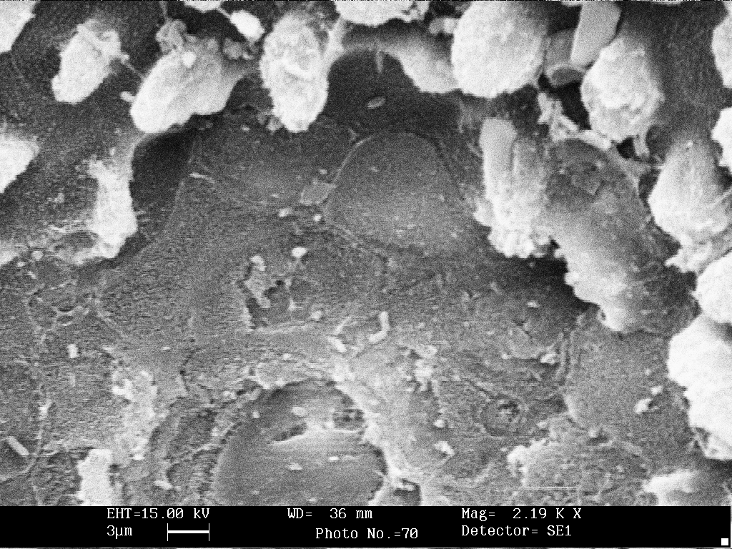
Figure 1: SEMPH of the General body epidermis of P. sulcatus showing unculi (Marked by arrows) (Scale bar- 3 µm).
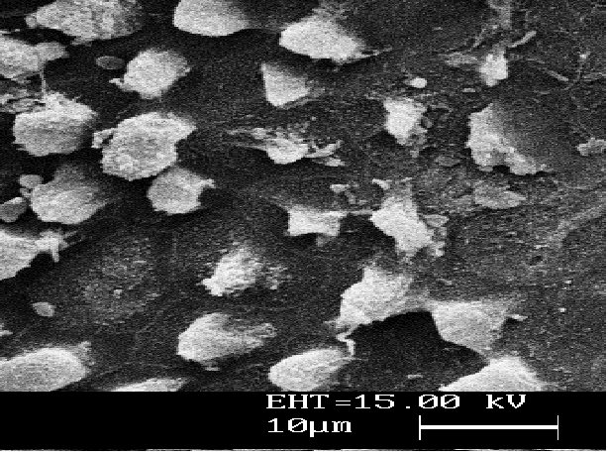
Figure 2: SEMPH of the snout epidermis of P. sulcatus showing unculi, the modified epidermal growth (Marked by arrows) (Scale bar- 10 µm).

B. LIP EPIDERMIS: In P. sulcatus, the epidermis of anterior and posterior lip is non-papillary but uncular. The uncular epidermis is outpused by well developed unculi, at the both side of the anterior and posterior lip (Fig. 3).
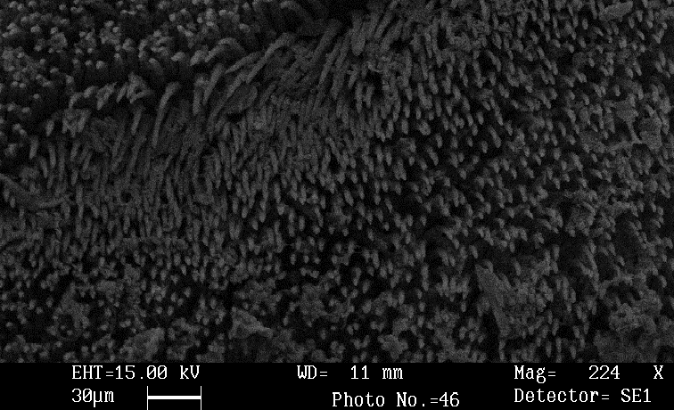
Figure 3: SEMPH of the lip epidermis of P. sulcatus showing unculi (Scale bar- 10 µm).
Surface from unculi are truly keratinized (Shah, 1989). The surface of the region is provided with an organized array of prominent, tall and conical with broad base projection/unculi separated by groove. (Length 0.5 µm) (Fig. 4).

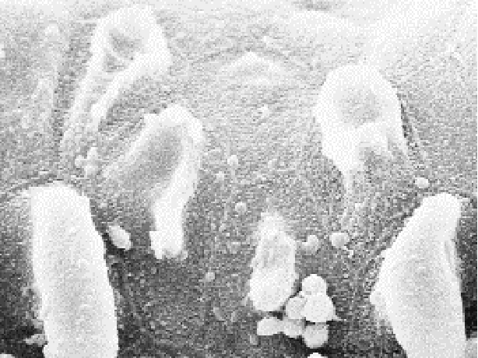
Figure 4: SEMPH of the lip epidermis of P. sulcatus showing unculi, broad base projection/unculi (Marked by arrows) (Scale bar- 3 µm).

C. ADHESIVE APPARATUS EPIDERMIS: P. sulcatus the adhesive apparatus is present in thoracic region, which lies between the base of pectoral fins and extend posterior for considerable distance and it has a prominent oval adhesive apparatus The prominent oval adhesive apparatus of P. sulcatus provides with 13-15 transversely arranged ridges (approximate width 32 m) P. sulcatus, the surfaces of ridges are provided with on organized of prominent large, conical unculi (Fig. 5).

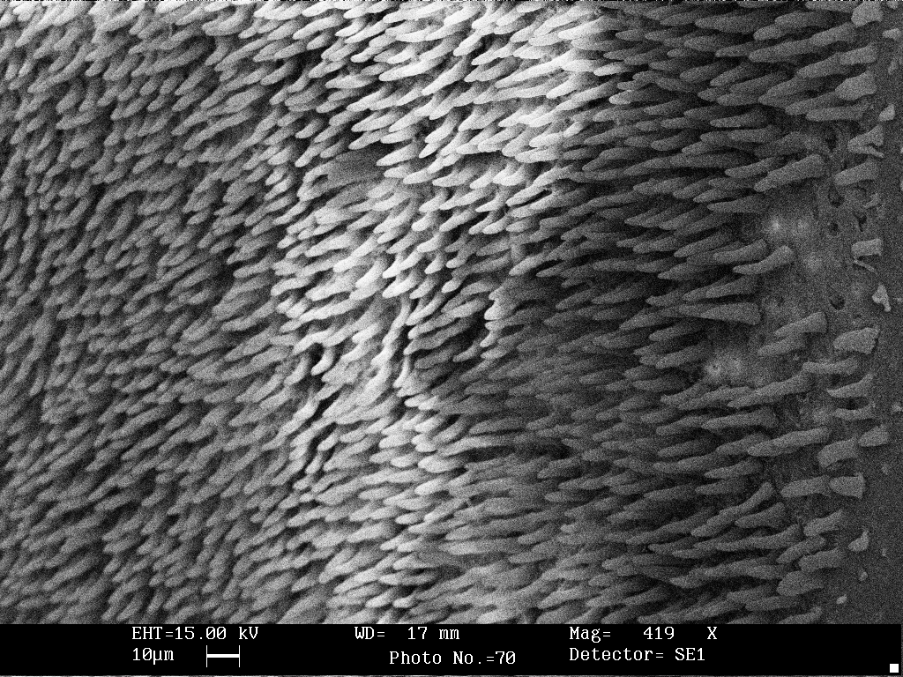
Figure 5: SEMPH of the adhesive apparatus epidermis of P. sulcatus showing unculi (Scale bar- 10 µm).

The base of unculi are possesses hexagonal epithelial cells indicating that these unculi are the modification of epithelial cells (Fig. 6).
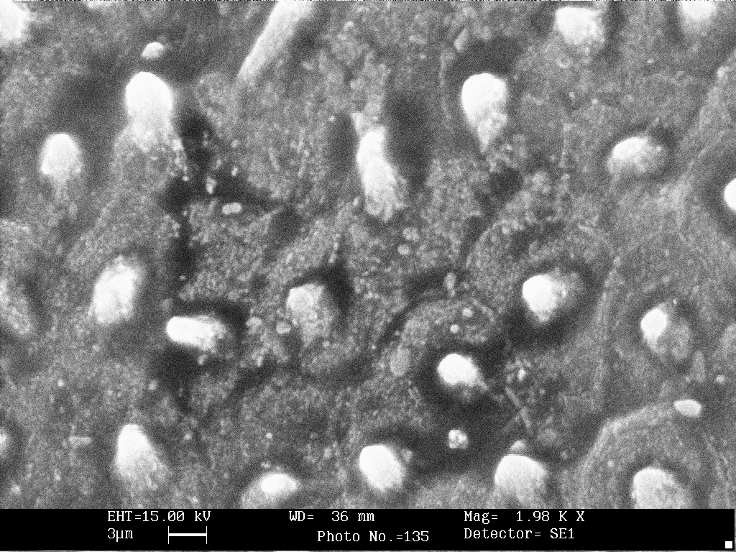
Figure 6: SEMPH of the snout epidermis of P. sulcatus showing The base of unculi are possesses hexagonal epithelial cells (Marked by arrows) (Scale bar- 3 µm).

D. PAIRED FINS EPIDERMIS: The paired fins of P. sulcatus are large, expanded and fan-shaped in appearance they are pushes outward and placed horizontally on the side of the body. The epidermis covering of paired fin of all three fishes is rough and keratinized.
The epidermis on ventral surface along the entire length of first ray of pectoral fin and pelvic fin and proximal part (approximate ¹/₁₀th part) of second ray of pectoral fin only, is rough and is provided with a large number of irregularly arranged transverse ridges separated by superficial grooves (Fig. 7).

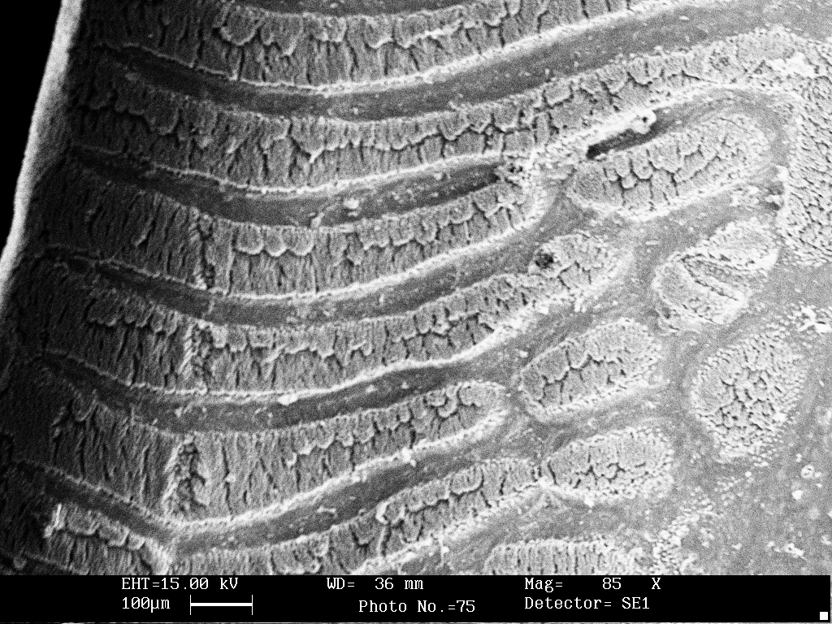
Figure 7: SEMPH of the Fin epidermis of P. sulcatus showing ridges separated by superficial grooves. (Marked by arrows) (Scale bar- 10 µm).

The epidermis on ventral surface covering the entire length of first anterior rays of pectoral and pelvic fins shows remarkable modification from the epidermis of rest of the parts of fins. In P. sulcatus, the epidermis of pectoral and pelvic fins is papillary with a large number of horny projections /unculi (Fig. 8).
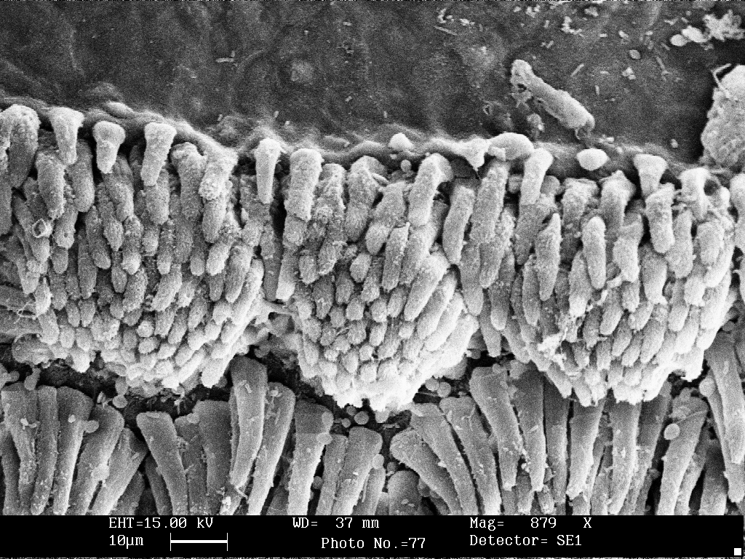
Figure 8: SEMPH of the Fin epidermis of P. sulcatus showing papilla. (Marked by arrows) (Scale bar- 10 µm).

P. sulcatus, these unculi are blunt with separated by groove (Fig. 9).
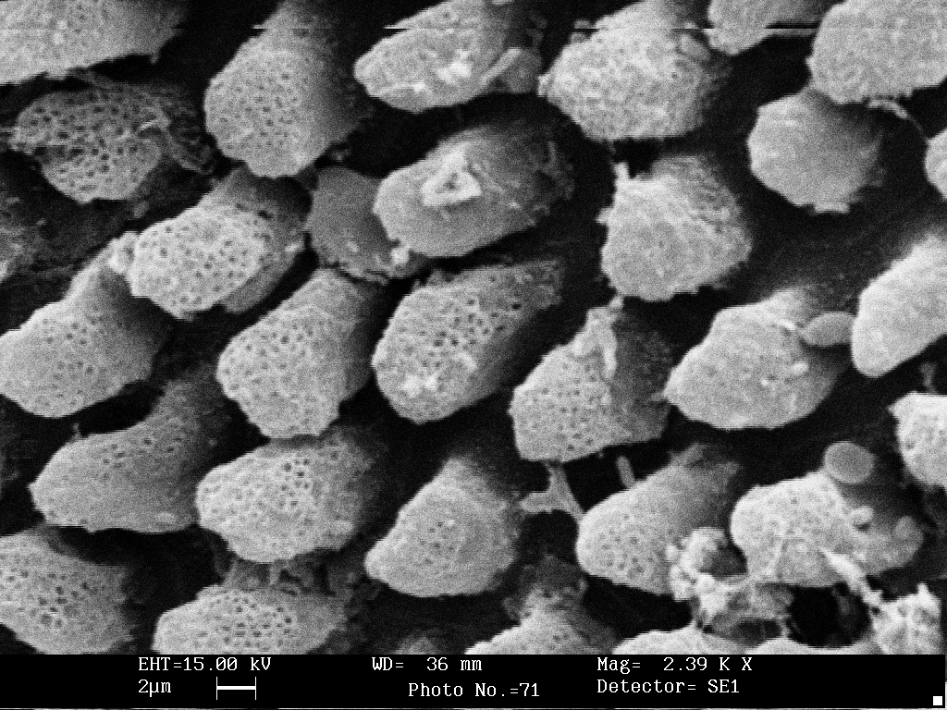
Figure 9: SEMPH of the Fin epidermis of P. sulcatus showing unculi are blunt with separated by groove. (Marked by arrows) (Scale bar- 2 µm).

These unculi are of uniform size shape and remain projected at the free surface. Each unculus represents a modified surface relief of compactly layer of epithelial cells (Fig. 10).
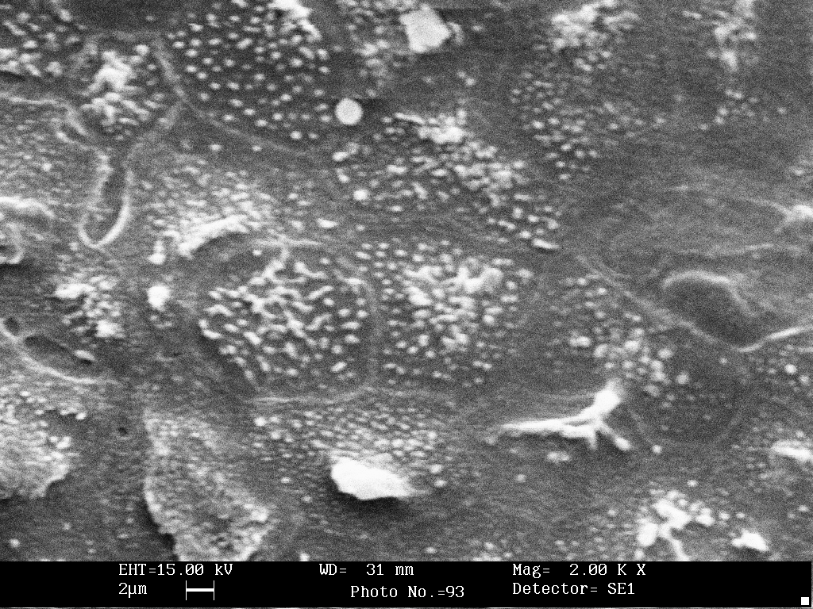
Figure 10: SEMPH of the Fin epidermis of P. sulcatus showing unculi modified layer of epithelial cells. (Marked by arrows) (Scale bar- 2 µm).

4. Conclusions
Fish have a wide range of protective skin adaptations, which enable them to occupy habitats ranging from rocky bottom surface to turbulent water. In the GBE and snout of P. sulcatus, the centrally ridged unculiferous regions were present, function primarily to provide mechanical protection, and also possibly provide protection against pathogens. The hook shaped curved unculi of the rough epidermis facilitate rasping or adhesion by increasing the roughness of the skin.
The present investigation shows that, P. sulcatus GBE, snout and lips are non-papilliated with uncular surface and the adhesive apparatus and fin epidermis are papilliated. There has been lot of confusion in the literature regarding the terminology used to describe the lips and the structures associated with them in different species of fishes. The anterior lip, described on this study has been stated as greatly enlarged rostral cap overlying the inconspicuous anterior lip or the anterior labial fold furthermore the posterior lip or the posterior labial fold (Saxena, 1959; Saxena & Chandy, 1966; Bose et. al, 1971; Ojha & Sing 1992; Sing et. al, 1994; Pinky et. al, 2002). studied the development of adhesive disc in Garra and stated that the true lips are only visible in the young states in the development of the fish and they are much reduced in the order. In the later case, they are covered by secondary folds, the anterior and the posterior labial folds, which have been termed the upper and lower lips respectively.
Lips and associated organs in several teleosts have been reported by various workers using different terms (Agarwal & Mittal, 1922 a.). In the present instance, we have followed Roberts (1982) in referring to these structures as unculi.
Shah (1989) has shown that these unculi in G. gotyla give strong reaction with the histochemical methods indicating their keratinized nature. Benjamin (1986) has also reported that the horny rasps of the upper and lower lips of Gyrinocheilus aymonier give strong reactions for keratin.
In P. sulcatus, the presence of unculi of different structures and differences in their form could be considered as adaptive modifications in the different environmental conditions.
These may be considered primarily as an adaptation to assist the fish in clinging to the substrate by engaging irregularities on the surfaces of the rocks or stones or by getting entangled with organic growth, e.g. algal felts or mats on the substratum. This may promote firm adhesion of the fish, even without the aid of suction, in the fast flowing current of hill-streams. According to Al-Hussaini (1949), Takahasi (1925) and Girgis (1952), the lips are thrust against the substratum by the contraction of cranial muscles. Hora (1922) also suggested that the so-called anterior labial fold in Garra species is fringed and tuberculate and helps the fish adhere to rocks. Similar spine-like projections observed on the adhesive apparatus of Glyptothorax species (Hora 1922), Glyptothorax telchitta (Bhatia, 1950), Glyptothorax pectinopterus (Lal et al., 1966; Sing at al, 1990) and in several hill-stream fishes (Saxena, 1956; Saxena & Chandy 1966) have been reported to serve as non-slipping frictional devices. Hora (1925) suggested that in species which inhabit rapid running streams, e.g. Garra kampi and Garra gotyla, the non-slipping, adhesive apparatus in the undersurface of paired fins is better developed than in species which live in lakes and comparatively still water, eg. Garra mullya and Garra gravelyi. The frictional devices of these fishes are more useful than a vacuum sucker. The strength of vacuum sucker is limited according to its area, while friction increases with the pressure and this increases with the rapidity of the current in hill-streams. Ojha & Singh (1992) suggested that the unculi at upper and lower lips in Garra lamta serve as food scrapers. This could, however, be considered as a secondary function of the unculi assisting the fish to scrap the food material from the substratum, in addition, to its primary role in promoting adherence of the fish to the substrate. Well developed polygonal unculi on both lips in P. sulcatus, may be considered as sharp cutting structures, an adaptation to browsing or scraping food materials, e.g. algal felts and mats grown in the substratum to which the fish remains attaches. Agarwal & Mittal (1922 a) reported, at the light microscopic level, similar structures on the ventral side of the upper lip in Labeo rohita and Cirrhina mrigala, and on the dorsal side of the lower lip in Labeo rohita. They suggested that these unculi may reinforce and provide additional strength and protection to the epithelia in these regions of lip protuberances, so that the lip can withstands various traumatic conditions, e.g. abrasion during their characteristic feeding behaviour. Girgis (1952) suggested that in Labeo horie a highly protrusible mouth with its horny edges allows the fish to secure a good grasp on algal filaments. Yashpal et al (2006) suggested, unculi are especially prominent feature of portions of the epidermis of cyprinidae (carps, loaches and their allies) and Siluroide (catfishes), Agarwal & Mittal (1922 a, b) and Pinky et al. (2004, 2008) in their studies on the lips of Gyrinochyeilus aymonieri, Labeo rohita, C. mrigala and G. lamta, respectively, reported that the unculi are keratinized. The outer rays of these fins (pectoral and pelvic fins) are ventrally and dorsally modified into structures that bear prominent ridges and grooves in P. sulcatus. Such structures regressively developed on dorsal side of paired fin. The expanded pectoral and pelvic fins are used for swimming against the strong water current. At rest, however, these fins are involves in adhesion (Hora 1930). The outer rays of these paired fins are generally employed for this purpose. This change seems to have been brought about for two reasons. First, it allows the ventral surface of the body to be firmly applied to rocks and second, to enable the fins to act as organs of attachment. The epidermis covering of the outer rays of these fins is an extension of the abdominal skin, and in order to achieve the function of adhesion, the epidermis has undergone remarkable modifications. The epidermis covering the ridges of the outer rays is characterized by the presence of spines, whereas the part that lines the grooves between the ridges is devoid of spines. These ultrastructural features allow us to speculate about the possible mechanism operative in the process of adhesion by the pectoral and pelvic fins in these teleost. It is likely that the outer rays of these fins work on the principle of suction for adhesion. When the fins are pressed against the substratum, a reduced pressure is created by the musculature attached to the ridges and grooves. The spiny projections might then assist in organic growth on the submerges rocks.

Acknowledgements: We wish to thank the Head of the Department of Anatomy, the officer-in-charge and the staff Electron Microscope Facility, All India Institute of Medical Sciences, New Delhi, for extending invaluable help in carrying out SEM studies.

Correspondence to:
Dr. Suresh Chandra Joshi (Associate Professor).
Department of zoology,
S.A.P.K.M. Kichha, Kumaun University, Nainital, (Uttarakhand) India.
joshi.drsuresh301@gmail.com
sureshjoshi2007@yahoo.com
Cellular Phone: 9720250733.
REFERENCES:
1. Agarwal N, Mittal AK. Structure modifications and histochemistry of the epithelia of lips and associated structure of a carp Labeo rohita. Eur. Arch. Biol. 1922a; 103: 169- 180.
2. Al-Hussaini AH. On the functional morphology of the alimentary tract of some fish in relation to differences in their feeding habits Anatomy and histology. Q. J. Microse. Sci. 1949; 90: 109-140.
3. Banjamin M. The oral sucker of Gyrinocheilus aymonieri (Teleostei: Cypriniformas). J. Zool. lond. 1986; 1 (B): 211-254.
4. Aslon R. Scanning electron microscopy of the fish gill. In. Munshi, J. S. D. and Dutta, H. M. (Eds.), fish morphology: Horizon of new research oxford and IBH Publication Co. Pvt. Ltd. New Delhi. India. Pp. 1945. 31-45.
5. Bhatia B. Adaptive modification in a hill stream catfish, Glyptothorax telchitta (Hamilton). Proc. Nat. Inst. Sci. Ind. 1950; 16: 271-285.
6. Bose S, Sen Roy RR, Sudhy TK.. Studies on the socalled adhesive disc of Discognathus (Garra) modestus (Day). Res. J. Ranch.Univ. 1971, 6-7: 156-159.
7. Girgis S. The bucco-pharyngeal feeding mechanism in the herbivorous bottom - feeding Cyprinoid, Labeo horie. (Cavies). J. Marphal. 1952, 90: 317-362.
8. Das D, Nag TC. Fine structure of the organ attachment of the teleost Garra gotyla gotyla (Ham.). Acta Zool. 2006, 86: 231-237.
9. Das D, Nag TC. Morphology of adhesive organ of the Snow trout Schizothorx richardsonii. (Gary, 1832). Italian Journal of Zoology. 2008,75(4): 361-370.
10. Hora SL. Indian Cyprinoid fishes belonging to the genus Gara. Res. Ind. Mus. 1921, 22: 635-648.
11. Hora SL. Structural modifications in the fish of mountain torrents. Res. Ind. Mus. 1922, 24: 31-61.
12. Lal MB, Bhatnagar AN, Uniyal JD. Adaptive modification of a Hill-stream fish, Glyptothoraxy pectinopterus (McClelland). Proc. Nat. Acad. Sci. Ind. 1966, 36: 109-116.
13. Mittal AK, Ueda T, Fujimari O, Yamada K. Histochemical analysis of glycoproteins in the epidermal mucous cells and succiform cells of an Indian Swamp eel Monopterus cuchia (Hamilton) (Synbranchiformes, Pisces). Acta. Histochem. Cytochem. 1994 b, 27: 193-204.
14. Ojha J, Singh SK. Functional morphology of the anchorage system and food scrapers of a hill-stream fish, Garra lamta (Ham) (Cyprinidae, Cypriniformes). J. Fish. Biol. 1992, 41: 159-161.
15. Pinky, Miltal S, Ojha J, Mittal AK.). Scanning electron microscopic study of the structures associated with lips of an Indian hill-stream fish Garra lamta (Cyprinidae, Cypriniformes). European Journal of Morphology. Vol. 2002, 40(3): 161-169.
16. Pinky, Mital S, Yashpal M, Ojha J, Mittal AK. Occurrence of keratinization in the structures associated with lips of a hill-stream fish Garra lamta (Hamilton) (Cyprinidae, Cypriniformes). J. Fish. Biol. 2004, 65: 1165-1172.
17. Pinky, Mittal S, Mittal AK. Glycoproteins in the epithelium of lips and associated structures of a hill-stream fish Garra gotyla (Cprinidae. Cypriniformes): A histochemical investigation. Anat. Histol. Embryol. 2008, 37: 101-113.
18. Saxena SC. (): Adhesive apparatus of a hill-stream Cyprinid fish Garra mullya (Sykes). Proc. Natn. Acad. Sci. India. 1959, 25(B): 205-214.
19. Saxena SC. Adaptive modifications of certain Indian hill-stream fishes. A thesis submitted to the University of Delhi. 1963.
20. Saxena SC, Chandy M. Adhesive apparatus in certain Indian hill-stream fishes. J. Zool. 1963, 148: 315-340.
21. Saxena SC, Chandy B. Adhesive apparatus in certain hill-stream fishes. J. Zool. London. 1966, 148: 315-340.
22. Singh N, Agarwal NK, Singh HR. SEM investigation on the adhesive apparatus of Garra gotyla gotyla (Family-Cyprinidae) from Garhwal Himalaya. In: Singh, H. R. Ed. Advances in fish biology and Fisheries. Vol. 1. Delhi, Hindustan Publicating Corporation. 1994, 281-291.
23. Singh SK, Mittal AK. (): A comparative study of the epidermis of the Common carp and the three Indian major corps. J. Fish. Biol. 1990, 36 (1): 9-19.
24. Wu HW, Liu CK. On the structure of the adhesive apparatus of Glyptosternum, sinensia, Shanghat. 1940, 11: 69-75.
25. Yashpal M, Kumari U, Mittal S, Mittal AK. Surface architecture of the mouth cavity of a carnivorous fish Rita rita (Hamilton, 1822) (Siluriformes: Bagridae). Belg. J. Zool. 2006, 136: 155-162.

1/2/2012.

