Changes in metabolites of Brassica juncea (Indian mustard) during progressive infection of Alternaria brassicae

PANKAJ SINGH PARIHAR*

Department of Biochemistry*, College of Basic Sciences and Humanities, G.B. Pant University of Agriculture and Technology. Pantnagar- 263145. India. ppjalajpari@gmail.com

ABSTRACT: Metabolites changes were studied in Brassica juncea genotypes infected with Alternaria brassicae causing black spot disease. The percentage disease severity was maximum in Varuna and EC-399302 as compared to EC-399313 and PHR-2 during progressive infection. The total phenols, o-dihydroxy phenols, flavanols, total soluble proteins contents were recorded at 65 DAS, 25 DPI and 50 SPI of seven genotypes of Indian mustard during Alternaria blight infection. The total phenols, o-dihydroxy phenols were accumulated maximally in EC-399296 and EC-399299 as compared to other genotypes. The phenolic contents tend to increase whereas flavanols contents decreased with increase in infection and plant age. Among all, EC-399296 and EC-399313 showed maximum increase in total soluble protein contents in all stages of Alternaria blight infection. These findings revealed that post infectional response of the metabolites under consideration in the susceptible genotype seems to be associated with its susceptible response and symptom expression.
[PANKAJ SINGH PARIHAR. Changes in metabolites of Brassica juncea (Indian mustard) during progressive infection of Alternaria brassicae. Nature and Science 2012;10(3):39-42]. (ISSN: 1545-0740). http://www.sciencepub.net. 6

Key words: Brassica juncea, Alternaria blight, metabolites.

Indian mustard (Brassica juncea) an important and predominant rabi oilseed crop of rapeseed mustard group in India, occupies 90% area of the total hectarage, sown under rapeseed-mustard. In India alone mustard is cultivated in around 6 million hectares and it is projected that by 2020, 41 % of total demand for oilseed will be met by mustard alone (Mondal et al., 2007). Indian mustard encoununters number of foliar diseases among them Alternaria blight is the most devasting causing yield loss of 35-38% (Kolte et al, 1987). In addition to the direct losses in yield, the disease adversely affects seed quality by reducing seed size, seed discolouration and reduction in oil content (Prasad & Lallu, 2006). The disease also reduces germinability, oil content and protein content of seeds. In the absence of resistant donor germplasm of mustard, plant breeding approaches for the development of novel resistant genotypesare still remain questionable.The most practical way to overcome this situation to understand the in built resistance in the plants. Plants challenged by fungal pathogen exhibit several biochemical defense responses which include accumulation of specific metabolites (Daayf et al., 2000). It is crucial to know the comprehensive metabolites changes during various stages of plant-pathogen interaction. Hence, the present study was carried out to know the changes in metabolites of Brassica juncea genotypes during infection of Alternaria brassicae.

MATERIALS AND METHODS
The investigation was carried out at Norman E. Borlaug Crop Research Centre, G.B.P.U.A & T., Pantnagar during rabi season, 2010-2011. Seven genotypes of Brassica juncea namely EC-399296, EC-399299, EC-399312, EC-399313, PHR-2, EC-399302 and Varuna were used for the present investigation. For all biochemical analysis, except for total soluble protein contents for which fresh leaf samples were used, leaves of all genotypes for various stages were oven dried and required amount of sample was taken from the dried leaf powder. The experiment was laid out in a randomized block design (RBD) with three replications. Critical differences were calculated at 5% probability level of significance.
Disease severity index was calculated by the disease assessment key given by Conn et al (1990). Biochemical characterization of the healthy and infected leaves was done at 65 DAS, 25 DPI and 50 DPI.The total phenols estimated by Bray and Thorpe (1954), o-dihydroxy phenols by Mahadevan and Sridhar (1986), flavanols by Swain and Hills (1959), total soluble proteins estimated by Bradford (1976).

RESULTS AND DISCUSSION
In present investigation no disease symptom was observed at 65 DAS and genotypes were in healthy stage. In Infected stage it was observed that EC-399313 and PHR-2 were least disease infected among all genotypes. The disease severity index increased from 28.26 (25 DPI) to 73.29% (50 DPI) and 26.28(25 DPI) to 72.87(50 DPI) for EC-399313 and PHR-2 respectively. The susceptible expression in relation to disease severity increased readily from 37.41 (25 DPI) to 85.9% (50 DPI), 36.79% (25 DPI) to 85.57 %( 50 DPI) for Varuna and EC-399302 respectively (Table-1:Fig. 1). Other genotypes were expressing a moderate level of tolerance against A. brassicae.
It was observed that the total phenol and o-dihydroxyphenol contents of all genotypes were gradually increased with the increase in percent disease infection (Table-1, Fig. 2 & 3). At healthy stage maximum phenol content was observed in EC-399299 (4.67 mg/g) and EC-399296 (4.55 mg/g) but with progress of infection EC-399313 and PHR-2 accumulating maximum phenol content in all stages of infection. At 25 DPI phenol content in EC-399313 was 6.03 mg/g and PHR-2 was 6.11 mg/g. In susceptible less phenol was accumulated as in the case of Varuna and EC-399312. Similarly o-dihydroxy phenol was observed to be maximum in EC-399296 (0.48 mg/g 50 DPI) followed by EC-399299 (0.47mg/g 50 DPI) as compared to Varuna (0.37mg/g 50 DPI) and EC-399302 (0.36 mg/g 50 DPI). The other genotypes were expressing moderate level of phenols. The increased phenolic contents might be attributed to defense mechanism as the suppression of phenolic compounds synthesis leads to disease susceptibility in transgenic tobacco (Chong et al., 2002). The increase in phenols in severely infected plant part could be attributed to the induced resistance for further invasion of pathogen. The role of o-dihydroxy phenol investigated as a resistance factor because they become highly reactive upon oxidation and may form substances toxic to pathogens or inactivates enzymes including hydrolytic enzymes produced by plant pathogenic fungi (Patil and Diamond, 1967). The accumulation of phenolic compounds in infected host tissues may be related to their release from glycosidic esters by the enzymatic activity of host or pathogen enhanced synthesis by host through the shikimic acid pathway or due to migration of phenols from non-infected tissues.
In healthy stage (65 DAS) maximum flavonol content was observed in EC-399302 (0.26mg/g) and Varuna (0.25 mg/g). Flavanols content decreased in infected leaves with the progress of infection and was more pronounced in EC-399302 and Varuna and least in the EC-399299 and EC-399296 and moderate in other genotypes (Table 1 & Fig. 4). These results are supported by the findings of Saharan et al., (2000), who reported that flavonols content was decreased with the plant age in cluster been infected with Alternaria blight. However less significant role of flavonols was reported in plant defense as compared to total phenols and ortho-dihydroxy phenols (Atwal et al., 2003).
The concentration of total soluble proteins content in healthy stage was maximum in EC-399296 (3.22 mg/g) and EC-399299 (3.18 mg/g) and least in EC-399312 (2.63 mg/g) and Varuna (2.21 mg/g) and moderate in other genotypes (Table-1 & Fig. 5). With increase in infection and plant age, the protein content was increased in all genotypes. The similar trend was observed where increase in protein content due to fungal infection in coconut and postulated that proliferation of microorganism synthesizes several enzyme proteins & some cause rearrangement of nutritional composition of substrate due to formation of several degrading products thereby increasing its protein content (Onifade and Agboola, 2003).The proteins have fungistatic effect through their involvement in metabolic reactions associated with disease resistance such as synthesis of specific proteins related to infection (Misra et al., 2008). Based on the present findings it may be concluded that high contents of phenols, o-dihydroxy phenols, flavonols and protein contents impart resistance development in EC-399299, EC-399296and PHR-2 against A. brassicae However low induction of the same metabolites in the susceptible genotypes (Varuna and EC-399302) seems to be associated with its susceptible response and symptom expression. The present investigation also enlighten that the genotypes, EC-399313, EC-399312 were expressing moderate level of tolerance against A.brassicae due to their intermediate expression of metabolites during progressive stages of infection. The present study further revealed that there is a relationship between plant metabolites and fungal infection which support their role in plant resistance that can be utilized in breeding program for incorporation of resistant traits in promising susceptible genotypes.

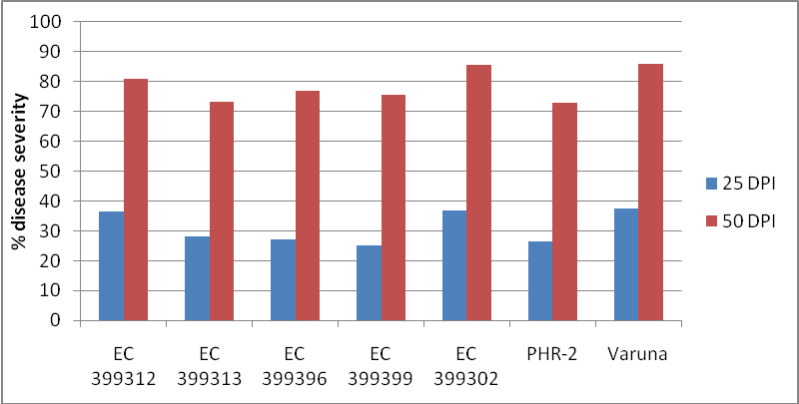

Fig. 1: Percent disease severity

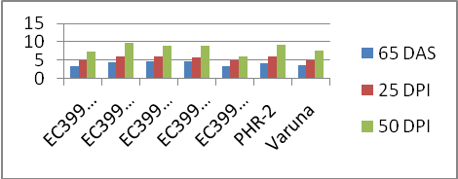

Fig. 2: Total phenols contents

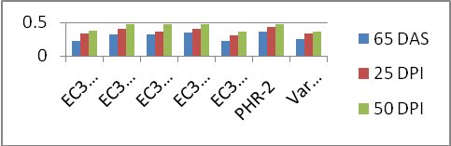

Fig.3: ortho dihydroxy phenol
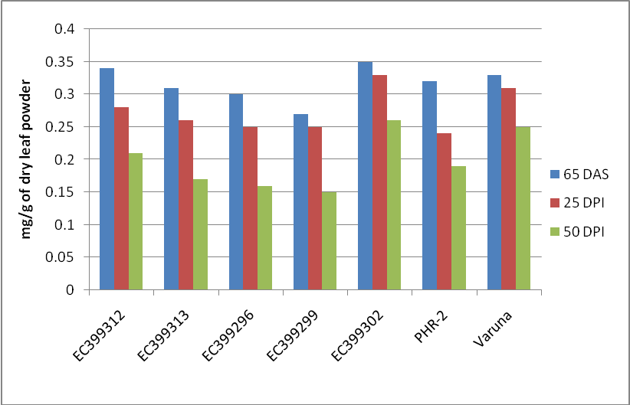

Fig. 4: Flavonols contents

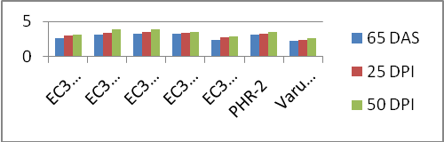

Fig.5: Total soluble protein

Table-(1) Total Phenols, O-dihydroxy phenols, Total Protein and Flavanols content, during infection of Alternaria blight
Parame-ters | Disease Severity Index (Per cent) |  |  | Total phenols ( mg/g of dry leaf powder) |  |  | O-Dihydroxy phenol (mg/g of dry leaf powder) |  |  | Flavanols content(mg/g dry leaf powder) |  |  | Total Protein content ( mg/g of fresh leaf )
Stage  geno  -type | 65 DAS  Healthy | 25 DPI | 50 DPI | 65 DAS  Healthy | 25 DPI | 50 DPI | 65 DAS  Healthy | 25 DPI | 50 DPI | 65 DAS  Healthy | 25 DPI | 50 DPI | 65 DAS  Healthy | 25 DPI | 50 DPI
EC -399312 | - | 36.31 | 80.81 | 3.26 | 4.95 | 7.45 | 0.23 | 0.33 | 0.38 | 0.34 | 0.28 | 0.21 | 2.63 | 2.92 | 3.16
EC- 399313 | - | 28.26 | 73.39 | 4.35 | 6.03 | 9.59 | 0.32 | 0.4 | 0.47 | 0.31 | 0.26 | 0.17 | 3.11 | 3.41 | 3.82
EC- 399296 | - | 27.05 | 76.9 | 4.55 | 5.91 | 8.82 | 0.32 | 0.37 | 0.48 | 0.30 | 0.25 | 0.16 | 3.22 | 3.46 | 3.83
EC- 399299 | - | 25.2 | 75.66 | 4.67 | 5.67 | 8.81 | 0.35 | 0.40 | 0.47 | 0.27 | 0.25 | 0.15 | 3.18 | 3.31 | 3.55
EC-  399302 | - | 36.79 | 85.59 | 3.43 | 4.89 | 6.08 | 0.23 | 0.31 | 0.36 | 0.35 | 0.33 | 0.26 | 2.37 | 2.69 | 2.87
PHR-2 | - | 26.28 | 72.87 | 4.11 | 6.11 | 9.11 | 0.37 | 0.43 | 0.46 | 0.32 | 0.24 | 0.19 | 3.05 | 3.27 | 3.45
Varuna | - | 37.41 | 85.9 | 3.50 | 5.02 | 7.47 | 0.25 | 0.33 | 0.37 | 0.33 | 0.31 | 0.25 | 2.21 | 2.36 | 2.58
Se.m ± | - | 1.45 | 0.69 | 0.017 | 0.018 | 0.024 | 0.110 | 0.008 | 0.013 | 0.002 | 0.003 | 0.008 | 0.011 | 0.008 | 0.008
CD (5%) | - | 4.48 | 2.13 | 0.054 | 0.057 | 0.075 | 0.030 | 0.020 | 0.040 | 0.007 | 0.010 | 0.025 | 0.034 | 0.026 | 0.026
DAS*= Day after sowing, DPI*= Day past infection.

ACKNOWLEDGEMENT
The financial support and research assistance provided under AICRPR & M is highly acknowledged.
Corresponding author: Pankaj singh parihar , Department of Biochemistry GBPUA & T Pantnagar Udhamsingh nagarUttarakhand-223145,India, Email:ppjalajpari@gmail.com, (m.no): 09456776387.

Corresponding author:
Pankaj Singh Parihar, Research scholar.
Email: ppjalajpari@gmail.com

RRFERENCES
- Atwal, A.K., Ramandeep Munshi, S.K. and Mann, A.P.S. (2003). Biochemical changes in relation to Alternaria leaf blight in Indian mustard. Plant Dis. Res, 19: 57-59.
- Bradford, M. M. (1976). A rapid and sensitive method for identification of microgram quantities of protein utilizing the principle of protein-dye binding. Anals. Biochem. 72: 248-254.
- Bray, H.G. and Thorpe W.V. (1954). Analysis of phenolic compounds of interest in metabolism. In: Glick D, ed. Methods of Biochemical Analysis. New York, USA: Interscience Publishers, Inc., 27–52.
- 4 Chong, J., Baltz, R., Schmitt, C., Beffa, R. and Saindrenan, P. (2002). Down regulation of pathogen-responsive tobacco UDP-Glc: phenylpropanoids glucosyltransferase reduces scopoletin glucoside accumulation, enhances oxidative stress, and weakness virus resistance. Plant Cell. 14: 1093-1107.
- Conn, K. L., Tewari, J. P. and Awasthi, R. P. (1990). A disease assessment key for Alternaria black spot in rapeseed and mustard. Can. Plant Dis. Survey 70: 19-22
- Daayf, F., Ongena, M., Boulanger, R., Hadrami, I. El, Belanger, R.R. (2000). Induction of phenolic compounds in two cultivars of cucumber by treatment of healthy and powdery mildew-infected plants with extracts of Reynoutria sachalinensis. J. Chem. Ecol. 26: 1579-1593.
- Kolte, S. J., Awasthi, R. P. and Vishwanath (1987). Assesment of yield losses due to Alternaria blight in rapeseed and mustard. Indian Phytopathol. 10: 209-211.
- Mahadevan, A. and Sridhar R. (1986). In: Methods in Physiological Plant Pathology (3rd edn.) Sivakami Publications, Chennai, 183p.
- Misra, Raj Shekhar, Sharma, Kamal, Mishra, Ajay Kumar and Sriram, S. (2008). Biochemical alterations induced in Taro in response to Phytophthora colocasiae infection. Adv. Natural Applied Sci. 2 (3): 112-121.
- Mondal, Kalyan K., Bhattacharya, R.C., Koundal, K.R. and Chatterjee, S.C. (2007). Transgenic Indian mustard (Brassica juncea) expressing tomato glucanase leads to arrested growth of Alternaria brassicae. Plant Cell Rep. 26: 247-252
- Onifade, A.K., Agboola, Y.A.J. (2003). Effect of fungal infection on proximate nutrient composition of coconut (Cocos nucifera Linn) fruit. Food, Agric. Environ. 1 (2): 141-142.
- Patil, S. S. and Dimond, A. E. (1967). Inhibition of Verticillium polygalacturonase by oxidation products of polyphenol. Phytopathol. 57: 492-496.
- Prasad, Rajendra and Lallu (2006). Management of Alternaria blight of mustard with combination of chemicals and botanicals. Ann. Pl. Protec. Sci. 14 (2): 400-403.
- Saharan, G.S.; Joshi, U.N. and Saharan, M.S. (2000). Phenolic compounds and oxidative enzymes in healthy and Altermaria blight infected leaves of clusterbean. Acta Phytopathologica et Entomologica Hungarica. 34: 299-306.
- Swain, T. and Hillis, W. E. (1959). The phenolic constituents of Prunus domestica. The quantitative analysis of phenolic constituents. J. Sci. Food Agric. 10: 63-68.

2/12/2012

