Quantum Chemical Calculations on Some Thiocarbamides as Corrosion Inhibitors for Brass in Acidic Media

Musa E. Mohamed ^{1,*}, Kamal K. Taha ²

^{1, 2} Department of Chemistry, College of Applied and Industrial Sciences,
University Of Bahri, Khartoum State, Khartoum, Sudan
*e-mail address: musaahimer5@hotmail.com
*Telephone number: 00249923023519 fax: 0011222142-249

Abstract: Quantum chemical calculations have been employed for the inhibition efficiency of some thiocarbamides namely thiocarbamides (TC), ethylenethiocarbamide (ETC) and thiobenzamide (TBA) for brass in HClO₄ by means of density functional theory (DFT) methods B3LYP/6-31G*, RHF/6-31G* and semi-empirical method (AM1) in gas phase, The calculated quantum chemical parameters correlated to the inhibition efficiency are, E_{HOMO}, E_{LUMO}, energy of the gap (ΔE), charge on the reactive center , dipole moments and global hardness. The order of inhibition efficiencies as follows: TBA> ETC> TC as can be obtained from experimental data.
[Musa E. Mohamed; Kamal K. Taha. Quantum Chemical Calculations on Some Thiocarbamides as Corrosion Inhibitors for Brass in Acidic Media. Nature and Science 2012; 10(3): 55-60]. (ISSN: 1545-0740). http://www.sciencepub.net. 9

Keywords: Thiocarbamides; Corrosion Inhibitors; Density Functional Theory Methods; Quantum Chemical Calculations.

1. Introduction
Corrosion of metals is one of the most important and challenging problems in industry. Therefore, the development of inhibiting films able to protect the underlying metal from corrosion has been the subject of numerous investigations [1,2]. The corrosion inhibition efficiency of organic compounds is related to their adsorption properties. Adsorption depends on the nature and the state of the metal surface, on the type of corrosive medium and on the chemical structure of the inhibitor [3]. Studies report that the adsorption of the organic inhibitors mainly depends on some physicochemical properties of the molecule, related to its functional groups, to the possible steric effects and electronic density of donor atoms; adsorption is supposed also to depend on the possible interaction of p-orbitals of the inhibitor with d-orbitals of the metal surface atoms [4].
The reaction mechanism includes the transfer of one pair of electrons from the organic compound, and the formation of the coordinate covalent bond with a metal or an alloy [5].
Experimental means are useful in explaining the inhibition mechanism but they are often expensive and time consuming. Advance in computer hardware and software and in theoretical chemistry have brought high-performance computing and graphical tools within the reach of many academic and industrial laboratories. Recently more corrosion publications contain substantial quantum chemical calculations [6]. Such calculations are usually used to explore the electronic properties of the inhibitors, the effect of the highest occupied molecular orbital (HOMO) and the lowest unoccupied molecular orbital (LUMO) energies, the difference between highest occupied molecular orbital and lowest unoccupied molecular orbital energies (E_{LUMO}-E_{HOMO}), charge on the reactive center, dipole moments, global hardness and total energies had to be investigated to achieve the appropriate correlation [7, 8].
Thiocarbamides are well-known for their corrosion inhibitor efficiency [9-12], especially on the transition metals mainly to the presence of sulphur atom, which has high electron density and can therefore easily bind to the metal surface. The presence of NH₂ group in thiocarbamides will further contribute to stronger binding and to the enhanced inhibition [11].
The inhibitive properties of three differentorganic compounds, namely Thiocarbamide (TC), ethylenethiocarbamide (ETC) and thiobenzamide (TBA) as corrosion inhibitors for brass in HClO₄ have been reported in previous experimental study [13], and their inhibition efficiency measured using weight loss method, Tafel and linear polarization, electrochemical impedance techniques. Results obtained showed that thiobenzamide (TBA) has the highest inhibition efficiency while thiocarbamide (TC) has the least inhibition efficiency [13].
The aim of this work is to extend these investigations in order to discuss the relationship between quantum chemical calculations and experimental inhibition efficiencies of these thiocarbamides by Am1, RHF/6-31G* and B3LYP/6-31G* from these data, by determining quantum chemical parameters such as the energies of the highest occupied molecular orbital (E_{HOMO}) and the energy of the lowest unoccupied molecular orbital (E_{LUMO}), the energy difference (ΔE) between E_{HOMO} and E_{LUMO}, charge on the reactive center , dipole moments and global hardness.

2. Method of calculations
Firstly theoretical calculations were carried out by using AM1 semi-empirical methods in MOPAC2007 program, implemented on an Intel Pentum (R) 1.86 GB personal computer. Initial estimates for the geometries of all the structures were obtained by molecular mechanics program (ACD11) for Widows, followed by full optimization of all geometrical variables (bond lengths, bond angles and dihedral angles), without any symmetry constraint, using AM1 semi-empirical methods in gas phase. The structures obtained from AM1 calculations were fully re-optimized by using Restricted Hartree Fock (RHF) and Density functional theory (DFT) methods to estimate the quantum chemical parameters. Calculations at the RHF and DFT level were performed with basic set 6-31G*. For this purpose the Gaussian 03 Quantum Chemistry Program with complete geometry optimization was used.

3. Results and Discussion
The chemical structures of the compounds under investigation are presented in figure 1. The optimized molecular structures of the studied molecules using B3LYP/6-31G* methods are shown in figure 2.

Thiocarbamide (TC) Ethylenethiocarbamide (ETC)

Thiobenzamide (TBA)

Figure 1. The structure of thiocarbamides derivatives

The calculated quantum chemical indices E_{HOMO}, E_{LUMO}, E_{L}-E_{H}, global hardness, total energies, dipole moment and inhibition efficiencies obtained from the experimental measurements are given in table 1, Mulliken atomic charges on nitrogen, sulphur and carbon atoms are shown in table 2. It has been proven that local electron densities or charges are important,
in many chemical reactions and physicochemical properties of compounds [14]. Inhibition action of organic molecules can be explained by the adsorption
on metal surface. Since the surface of the brass is positively charged in acidic solution [15], table 2
show that all nitrogen, sulphur and carbon atoms of phenyl ring of thiocarbamides derivatives carry the negative charges, this indicate that these atoms are the negative charge centers which could offer electrons to the brass surface to form a coordination type of bond.
Another important point to be considered in the energy level terms is gap between the HOMO and LUMO energies for the studies molecules (1-3). Cherry et al.[16] have used the concept of LUMO-HOMO energy gap in developing theoretical models which is capable of explaining the structure and conformation barriers in many molecular systems qualitatively. Low absolute values of the energy band gap (ΔE) gives good inhibition efficiencies, because the energy to remove an electron from the last occupied orbital will be low [6]. According to the data in table 1, there is a good correlation in LUMO- HOMO energy gap by these methods in gas phase, it can be seen that thiobenzamide (TBA) is best inhibitor and has smallest LUMO- HOMO gap i.e (7.895 eV), (10.611 eV) and (4.0114 eV) by AM1, RHF/ 6-31G* and B3LYP/6-31G* respectively, but the thiocarbamides (TC), which is least inhibitor and has highest LUMO- HOMO gap i.e (8.889 eV), (13.025 eV) and (5.7097 eV) by AM1, RHF/ 6-31G* and B3LYP/6-31G* respectively. Thus the difference between the LUMO- HOMO of the TBA and LUMO- HOMO of TC by B3LYP/6-31G* method is of 1.6983 eV caused an inhibition increase to 21.6%. As can be seen from table 1 for all methods of calculations, the inhibition effiencies increases as the E_{L}-E_{H} values decrease, which indicates the stability of formed complexes between thiocarbamides and brass in perchloric acid media, i.e the order of inhibition efficiencies as follows: TBA> ETC> TC as can be obtained from experimental data [13]. This indicates that the best correlations between experimental and calculated inhibition effiencies were obtained by using AM1, RHF/6-31G* and B3LYP/6-31G* in gas phase for thiocarbamides, correlations are almost in the same order. Correlation coefficients greater than 60% were well accepted in quantum chemical calculations of corrosion studies [17].

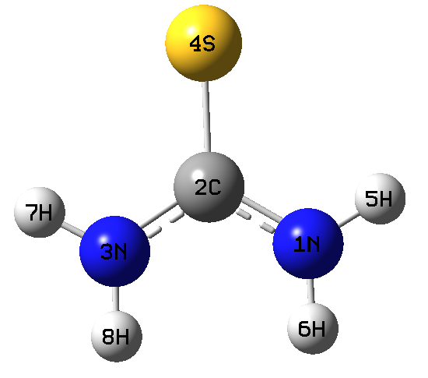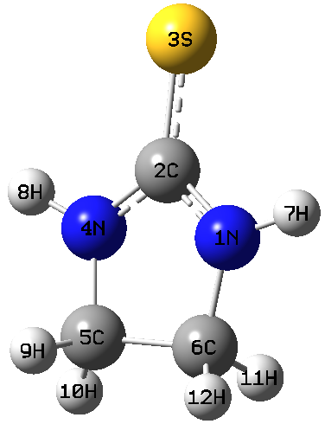
Thiocarbamide (TC) Ethylenethiocarbamide (ETC)
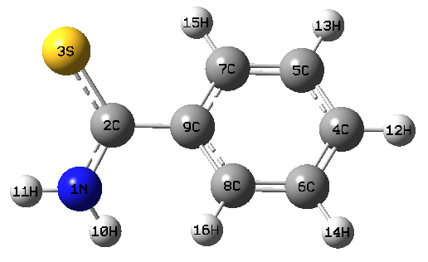
Thiobenzamide (TBA)

Figure 2. The optimized structure of thiocarbamides by B3LYP/6-31G*

High E_{HOMO} values indicate that the molecule has a tendency to donate electrons to appropriate acceptor molecules with low energy empty molecular orbital. Increasing values of the E_{HOMO} facilitate adsorption (and therefore inhibition) by influencing the transport process through the adsorbed layer, low LUMO energy indicates the ability of the molecules to accept electrons [6]. The results obtained by AM1 method in gas phase, (table 1) show that TBA has highest HOMO energy (E_{HOMO}= -8.483 eV) and lowest LUMO energy (E_{LUMO} = -0.588 eV) among these inhibitors. Whereas the TC has low E_{HOMO} and high E_{LU MO}. The same results can be shown by RHF/6-31G* and B3LYP/6-31G* methods in table 1. Figure 3 shows the shapes of highest occupied molecular orbital (HOMO) and the lowest unoccupied molecular orbital (LUMO) of the compounds under investigations. From these figures it can be concluded that the compounds adsorbed on the mild brass surface by using the thiocarbamides moiety which contains the heteroatom Nitrogen and Sulphur.

Table 1. AM1, RHF/6-31G* and B3LYP/6-31G* data for thiocarbamides (1-3)

Inhibitor | E_{LUMO}  (eV) | E_{HOMO}  (eV) | E_{L}-E_{H}  (eV) | Hardness  eV | Dipole  Moment  (D) | Total energy  eV | % Inhibition  in 0.1M HClO₄
AM1  1 TC  2 ETC  3 TBA  RHF/6-31G*  1 TC  2 ETC  3 TBA  B₃LYP/6-31G*  1 TC  2 ETC  3 TBA | 0.365  0.020  -0.588  4.5358  4.3549  2.1407  0.2571  0.0367  -1.6092 | -8.524  -8.601  -8.483  -8.4899  -8.4543  -8.4709  -5.4526  -5.4795  -5.6207 | 8.889  8.621  7.895  13.025  12.809  10.611  5.7097  5.5162  4.0114 | 4.444  4.310  3.947  6.512  6.404  5.305  2.854  2.758  2.005 | 5.6278  5.3593  4.6157  6.341  6.569  5.272  5.7546  5.7653  4.5941 | -791.649  -1074.63  -1393.31  -14874.1  -16966.7  -19622.6  -14917.6  -17024.1  -19698.2 | 71.6  84.2  93.2  71.6  84.2  93.2  71.6  84.2  93.2
% inhibition efficiencies are taken from reference [13]

Table 2. Mulliken atomic charges of thiocarbamides (1-3) by B3LYP/6-31G*
Molecule N1 N3 N4 S3 S4 C4 C5 C6 C7 C8
1 TC -0.7217 -0.7217 - - -0.3266 - - - - -
2 ETC -0.5562 - -0.5561 -0.3204 - - -0.1342 -0.1340 - -
3 TBA -0.6850 - - -0.2517 - -0.1193 -0.1328 -0.12 85 -0.1579 -0.1765

Quantum chemical calculation reveals that the substitution of primary amines NH₂ in TC by secondary amines in ETC, and change of structure from an open chain in TC to a cyclic in ETC results in a great increase of HOMO energy level (and a decrease of energy of the gap E_{LUMO}- E_{HOMO}) obviously. The same effect can be seen in substitution of NH₂ in TC by phenyl group in TBA. The increase of inhibition efficiency due to NH₂/C₆H₅ substitution should arise from the increase of HOMO level energy, low LUMO energy and low ΔE implying the ability of TBA to offer free electrons to the metal surface. The result of the high inhibition efficiency in TBA is is not surprising as C₆H₅ which is an phenyl group is an electron donor, which has π-orbital able to overlap with the metal d-orbital resulting in stronger adsorption with brass. TC has the lowest E_{HOMO} value, also the lowest inhibition efficiency. Thus, the order of inhibition efficiency is TBA > ETC > TC, as can be deduced above, which agreed with experimental ones.

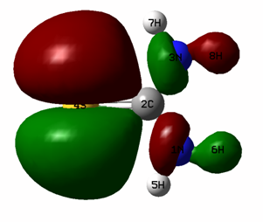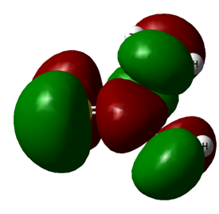
HOMO of TC LUMO of TC

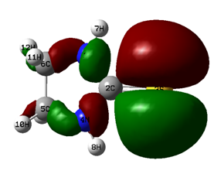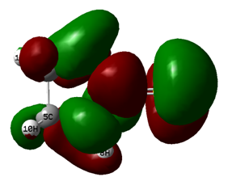
HOMO of ETC LUMO of ETC

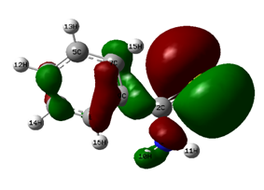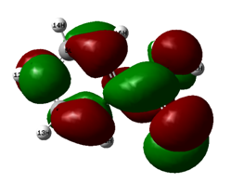
HOMO of TBA LUMO of TBA

Figure 3. Frontier molecular orbital diagrams of TC, ETC and TBA by the B3LYP/6-31G* model chemistry

Another property calculated for these molecules is the global hardness η, calculated as ∆E/2, which is parameter that gives important information about the reactive behavior of the molecule, and can be defined under the principle of chemical hardness and softness (HSAB).[18], as can be seen in table 1, the TBA exhibits the minimum hardness value, whereas the TC presents the maximum value of hardness this indicate that TBA is potential corrosion inhibitor over the other.
The dipole moment is another way to obtain data on the electronic distribution in a molecule and is one of the properties more used traditionally to discuss and to rationalize the structure and reactivity of many chemical systems [19], according to results in table 1, TBA has low value of dipole moment (4.6157 D) and TC has high value of diploe moment (5.6278 D) by AM1 methods, Which explain the higher inhibition efficiency of TBA than the other two inhibitors, i.e. the order of inhibition efficiencies as before: TBA> ETC> TC.

4. Conclusions
Through AM1 semi-empirical, RHF/6-31G* and B3LYP/6-31G* quantum chemical calculations a correlation between parameters related to structure of some thiocarbamides derivatives and their ability to inhibit the corrosion process could be established.
The inhibition efficiency of thiocarbamide and its derivatives obtained experimentally increase with the increased in E_{HOMO}, and decreased in E_{LUMO} and decreased in the energy of the gap (∆E). TBA has the highest inhibition efficiency because it had the highest HOMO energy and low (∆E) values, and it was most capable of offering electrons. TC has the lowest E_{HOMO} value, also the lowest inhibition efficiency. Thus, the order of inhibition efficiency is TBA > ETC > TC.
Comparison of theoretical and experimental data exhibit good correlation confirming the reliability of the method employed here.

Supplementary Information
Supplementary information (output results of semi-empirical calculations) is available free of charge, on correspondence to the author on request.

Correspondence to:
Musa E. Mohamed,
Department of Chemistry, College of Applied and Industrial Sciences, University of Bahri
Khartoum State, Khartoum, Sudan
Telephone number: 00249923023519
Fax: 0011222142-249
e-mail address: musaahimer5@hotmail.com

References
[1] Scendo, M. and Hepel, M.; J Electroanal Chem; 2008, 613,35–50
[2] Otmacic, H.; Stupnisek-Lisak, E.; Electrochim Acta, 2003, 48, 985–991
[3] Bentiss, F.; Lagrenee, M.; Traisnel, M. and Hornez, JC.; Corrosion Sci, 1999,41, 789–803
[4] Bentiss, F.; Traisnel, M. and Lagrenee, M.; J Appl Electrochem , 2001, 31, 41–48
[5] Quraishi, M. A.; Wajid Khan, M. A.; Ajmal, A. and Muralidharan, S., Br. Corr. J., 1997, 32, 72.
[6] Gece, G. Corros. Sci., 2008, 50, 2981.
[7] Bereket, G.; Ogretir,C. and Yurt, A.; J.Mol. Struct.(THEOCHEM) 2001, 571,139.
[8] Bereket, G.; Ogretir,C. and Hur, E.; J.Mol. Struct.(THEOCHEM) 2002, 578, 79.
[9] Jing Chi; Lin Shipeizhon; Yi Ping Wang and Hong Jun Chess, JPN, Kolcai Tokkyo Koho, JP, 11269674 Az; 1999, 16.
[10] Stoyanava, A.; Raicheva, S. and Sokolava, E. Int Symp Electrochem and Inhibitor Protection from Corrosion Albena, Bulgaria, 11-14 Oct. 1989
[11] Raicheva, S. N.; Aleksiev, B. V. and Sokolava, E. I. , Corr. Sci.; 1993, 34, 343.
[12] Juttner, K.; Electrochemical Acta, 1990, 35, 1501
[13] Taha, K. K.; Sheshadri, B.S.; Ahmed, M. F. and Muralidharan, V. S. Indian Journal of Chemical Technology, 2006, 13, 128-134
[14] Karelson, M. and Lobanov, V.S.; Chem. Rev.1996, 96, 1027
[15] Taha, K. K., Ph. D thesis, Corrosion Inhibition of Brass in perchloric acid, Banglore University, 2002.
[16] Cherry, W.; fpiotis, N. and Thatcher, W.; Acc. Chem. Res.; 1977, 16,167.
[17] Goliak,V. and Bedoglazov, S. Proceeding of seventh International Corrosion Symposium, Yildiz Teknik Uni Istanbul, 2000.
[18] Pearson, R.G.; J. Am. Chem. Soc.1963, 85, 3533.
[19] Kikuchi, O.; Quant. Struct-Act. Relat., 1987, 6, 179.

2/23/12

