Diversity of lichens along altitudinal and land use gradients in the Trans Himalayan cold desert of Ladakh
Jatinder Kumar¹, Roshni Khare², Himanshu Rai², D. K. Upreti^{2*}, A. Tayade¹, S. Hota¹, O. P. Chaurasia¹, R. B. Srivastava¹
¹ Defence Institute of High altitude Research (DIHAR), Defence Research & Development Organisation (DRDO), Leh – 901205, Jammu & Kashmir, India
² Lichenology Laboratory, CSIR National Botanical Research Institute (NBRI), Lucknow-226001,
Uttar Pradesh, India
*upretidk@rediffmail.com

Abstract: Lichen communities growing on rocks and soil forms a major constituent of biodiversity in high altitude Himalayan habitats. An intensive survey in different localities in three major sites in and around Leh in Ladakh region of Jammu and Kashmir state, India, revealed the occurrence of 38 species of lichens. The crustose growth form of lichens belonging to the family Physciaceae exhibited their dominance in the area. Apart from temperature and altitude, land use pattern also influenced the species composition up to a greater extant.
[Jatinder Kumar, Roshni Khare, Himanshu Rai, D. K. Upreti, A. Tayade, S. Hota, O. P. Chaurasia, R. B. Srivastava. Diversity of lichens along altitudinal and land use gradients in the Trans Himalayan cold desert of Ladakh. Nature and Science 2012;10(4):1-9]. (ISSN: 1545-0740). http://www.sciencepub.net/nature. 1

Keywords: Altitude, Crustose, Ladakh, Land use, Leh, Lichen

1. Introduction
Lichens, the mutualistic association of an alga (green and/or blue green) and fungus are the most successful symbiotic organisms in nature. The unique anatomical (absence of cuticle and root) and physiological (poikilohydry and absorbance of nutrient from general thallus surface) peculiarities allow lichens to grow in all sought of terrestrial domains. This unique association probably evolved as an adaptation to the varied microhabitats withstanding extreme microclimatic conditions unfavourable for the fungi and algae in isolation (Negi and Upreti 2000).
It is estimated that there are about 13,500 to 17000 (Hale 1974; Hawksworth and Hill 1984) lichen species throughout world. India is represented by 2303 lichen species (Singh and Sinha 2010) which represents 14% of world lichen population.
Himalayan habitats by virtue of their stressed climatology (i.e. higher environmental lapse rate, high wind velocity, high UV radiation, low atmospheric pressure and low precipitation of rain and high precipitation of snow), and delimiting nutrient and exposure regime, support relatively simple ecosystems, characterised by limited trophic levels and relatively very few plant growth forms and species (Rai et al 2010). Himalayan region of India are rich in lichen biodiversity which constitute a very important part of cryptogamic vegetation in alpine habitats (Upreti 1998).
Ladakh, the north most region of the Indian Himalayas, is characterized by mountainous topography, and subzero harsh climate. Rocks and soil are the most preferred habitats for lichens of the region (Negi and Upreti 2000).Except the enumeration of 21 species of lichens from Hemis National Park, by Negi & Upreti (2000) no records of lichens are available from this region, thus to explore systematically the lichen flora of the state extensive collection of lichens in the three major sites, in and around the Leh and Ladakh region was carried out and along with enumeration of lichen taxa of these sites their habitat preferences and distribution along altitude and land use types were studied.

2. Materials and Methods:
2.1. Study area:
The study was conducted in and around Leh (34°11′11″N 77°29′22″E to 34°02′49″N 77°55′50″E), in Ladakh region of Jammu & Kashmir state, India(Figure 1, Table 1). The region has a cold desert climate with long, harsh winters from October to early March, with minimum temperatures well below freezing for most of the winter. Average annual rainfall is only 90 mm. The temperature ranges from −28 °C in winter to 33 °C in summer.

2.2. Lichen sampling and identification:
Lichens were randomly sampled in the three localities (Figure 1, Table 1), from all the available sampling relevés. The major substratum of lichen occurrence was rock and soil. Rock inhabiting lichens (saxicolous) were the dominant habitat subset recorded.
The lichen samples collected were examined and identified in the Lichenology Laboratory of the National Botanical Research Institute, Lucknow, Uttar Pradesh, India. Lichens were identified to species using a stereomicroscope, light microscope (morpho-anatomically), and chemically with the help of spot tests, UV light and standardized thin-layer chromatography (Elix and Ernst-Russel 1993; Orange et al. 2001). Identification was done using relevant key and monographs (Awasthi 1991; Divakar & Upreti 2005; Awasthi 2007).The voucher specimens were deposited at the lichen herbarium (LWG), National Botanical Research Institute (NBRI), Lucknow, India.

Table 1: Sampling localities and their geomorphic and land use attributes.
Localities | Altitude (m) | Coordinates |  | Land use
DIHAR hill, Leh | 3530 | 34°08′08.86″N  77° 34′36.0″E |  | Native primary scrubland
Phyang | 3658 | 34°11′12.37″N  77°29′21.9″E | Monastry with associated agricultural and pastoral land
Chang la | 5189 | 34°02′36.05″N  77°56′26.6″E | Barren cold desert

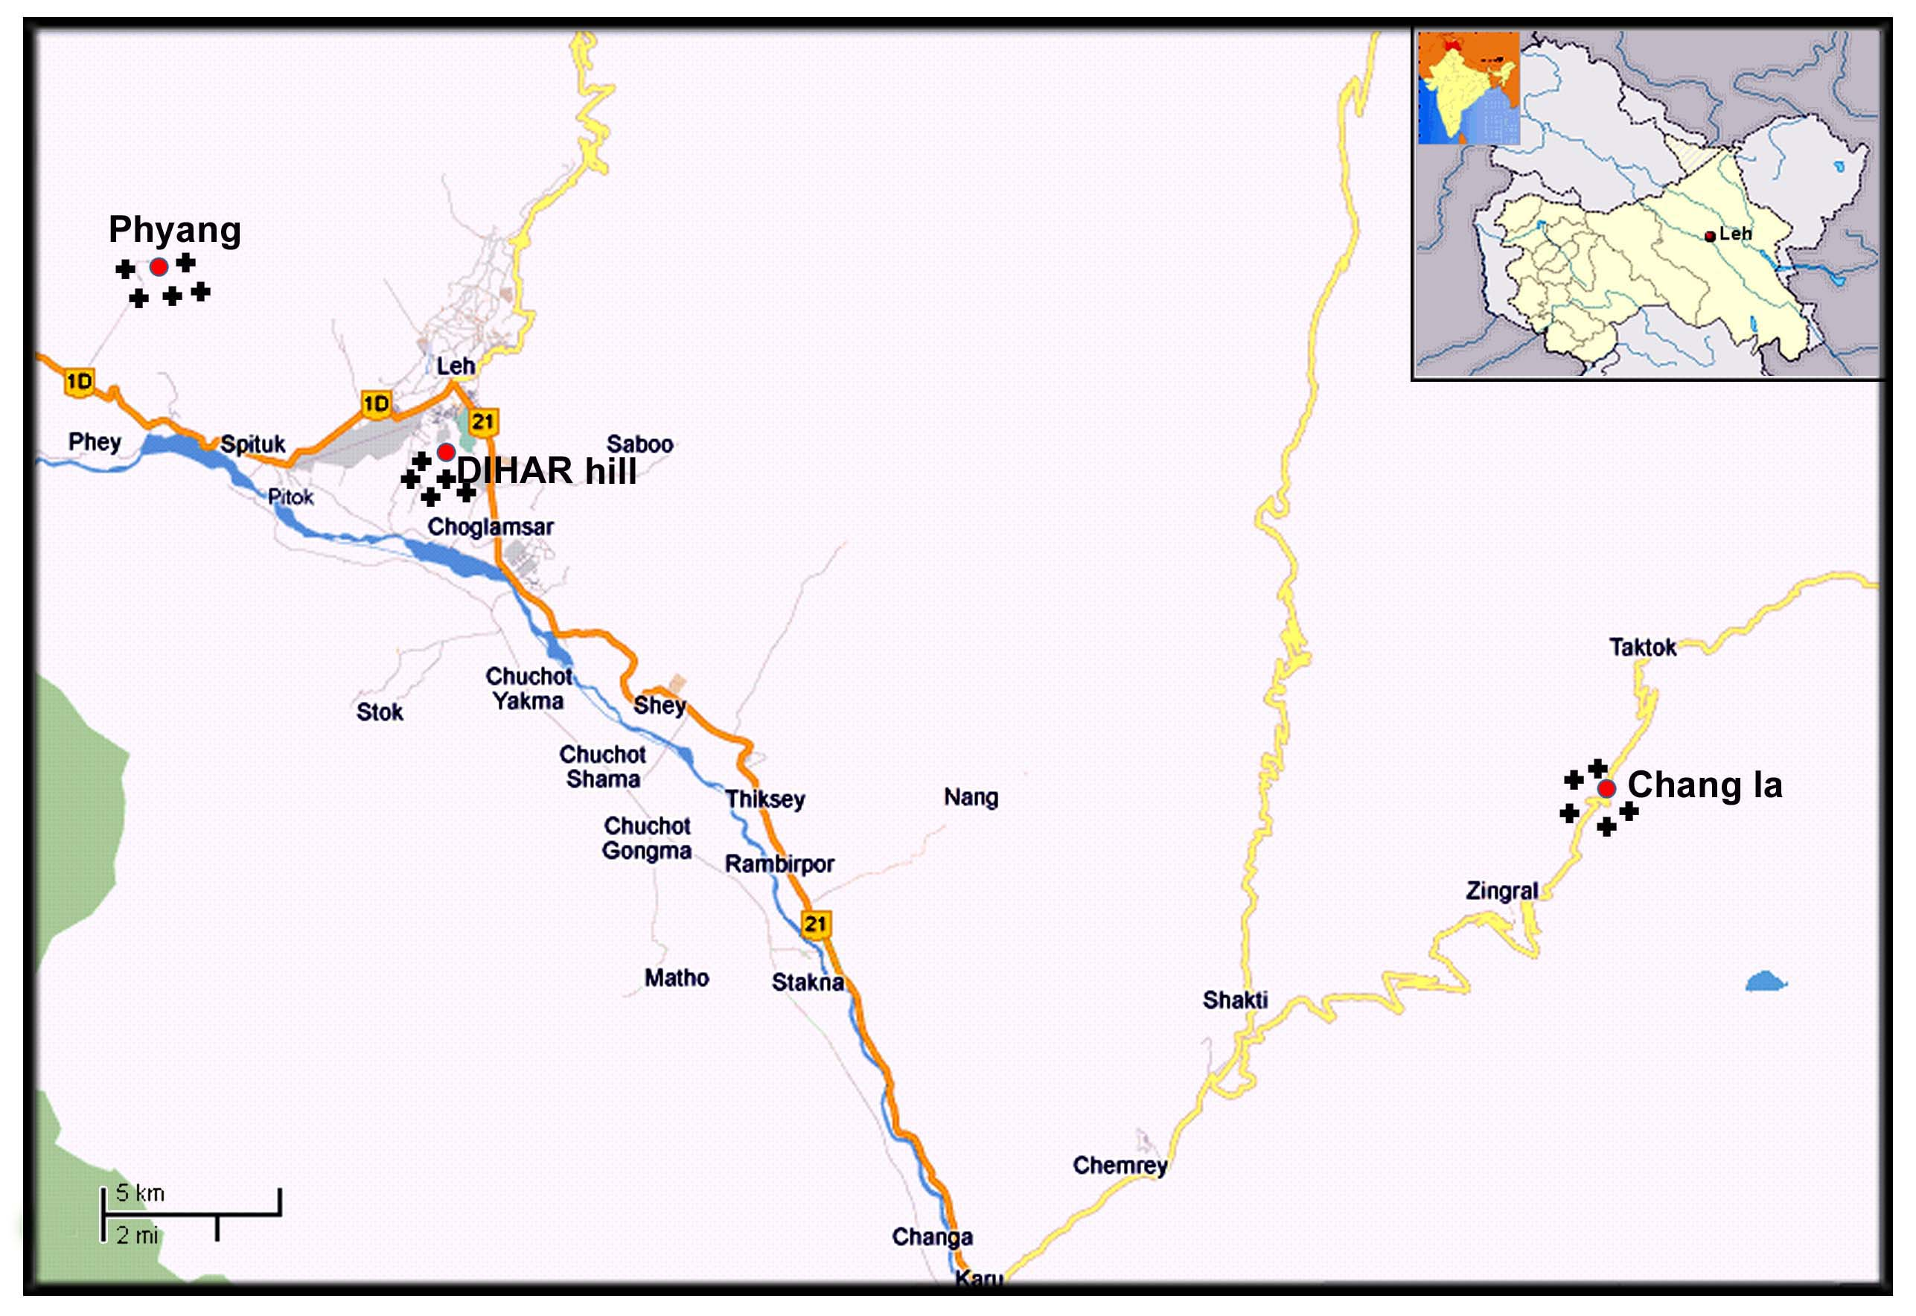
Figure1: Map of study area showing sampling localities.

3. Results:
3.1Lichen flora
The study revealed presence of 12 families with 20 genera and 38 species in the three studied locations. Physciaceae (5 species) was the dominant family followed by Acarosporaceae, Megasporaceae, Lecanoraceae, Parmeliaceae (4 species each); Teloschistaceae, Verrucariaceae (3 species each); Lecidiaceae, Rhizocarpaceae (2 species each) and Lichinaceae (1 species) (Table 2, Figure 3). Acarospora badiofusca and Peccania coralloides are the two new records for Ladakh(Table 2, Figure 3). Among the various growth forms crustose was the dominant growth form followed by foliose, squamulose and fruticose growth forms (Table 2). Among the substratum, lichens of the region preferred saxicolous (on rock) habitat with less preference for terricolous (on soil) habitat (Table 2). DIHAR hills in Leh harboured maximum lichen diversity among the three sites sampled, followed by Chang la area and Phyang (Figure 2). The decrease in lichen species diversity though was not linear, second order polynomial fits to the data (Figure 2).

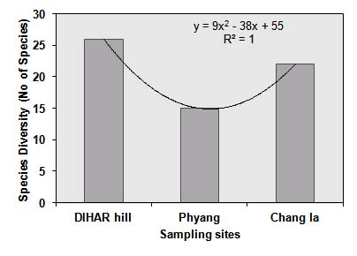
Figure 2: Comparative Lichen species diversity of the sampling sites.

Detailed taxonomic account of all the recorded lichen species is given below.

3.2Taxonomic description:
Acarospora fusca B. de Lesd.
Thallus saxicolous, squamulose, areolate, pale brown to dark brown; sqamules to 2.5 mm across. Apothecia 0.1- 0.2 (-0.5) mm diam.; spores colourless, small, simple, thin walled, subglobose, 3- 4.5 × 1.7 µm.

Specimens examined: Jammu and Kashmir, Leh district, DIHAR hill, alt. 3523m, on rocks, 12/06/2010, Jatinder Kumar 10-014306, 10-014307 (LWG); Chang la, alt.5334 m, on rocks, 05/07/2010, Jatinder kumar , 10-014313, 10-014317, 10-014323, 10-014330 (LWG); on rocks, 18/08/2010, Jatinder kumar 10-014382 (LWG).

Acarospora badiofusca (Nyl.) Th. Fr. Fig. 4A
Thallus wide spreading, areolate, areoles rather small, 0.5-1.5 mm wide, ± rounded, numerous, at times wavy, irregular, rarely imbricate, flat or ± convex, reddish brown, algal layer continuous. Apothecia 0.4-2 mm diam., mostly single, rarely 2- to 4- contiguous per areoles, rounded or gyrose-contorted, sessile, thalline exiple usually distinct, ± elevated, entire, concolorous with disc, hymenium 60-75(-90) µm tall, disc flat-convex, oftened roughened, usually red brown to brown black, always darker than thallus, paraphyses 2.5-3 µm
wide at base, 4-5µm at tips, asci 200 spored, spores 3-6 × 1.5-2.5 µm, ellipsoid.
Specimens examined: Jammu and Kashmir, Leh district, DIHAR hill, alt. 3523 m, on rocks, 18/08/2010, Jatinder kumar, 10-014389, 10-014391 (LWG); Chang la, alt. 5334 m, on rock, 05/07/2010, Jatinder kumar 10-014388, 10-014391 (LWG).

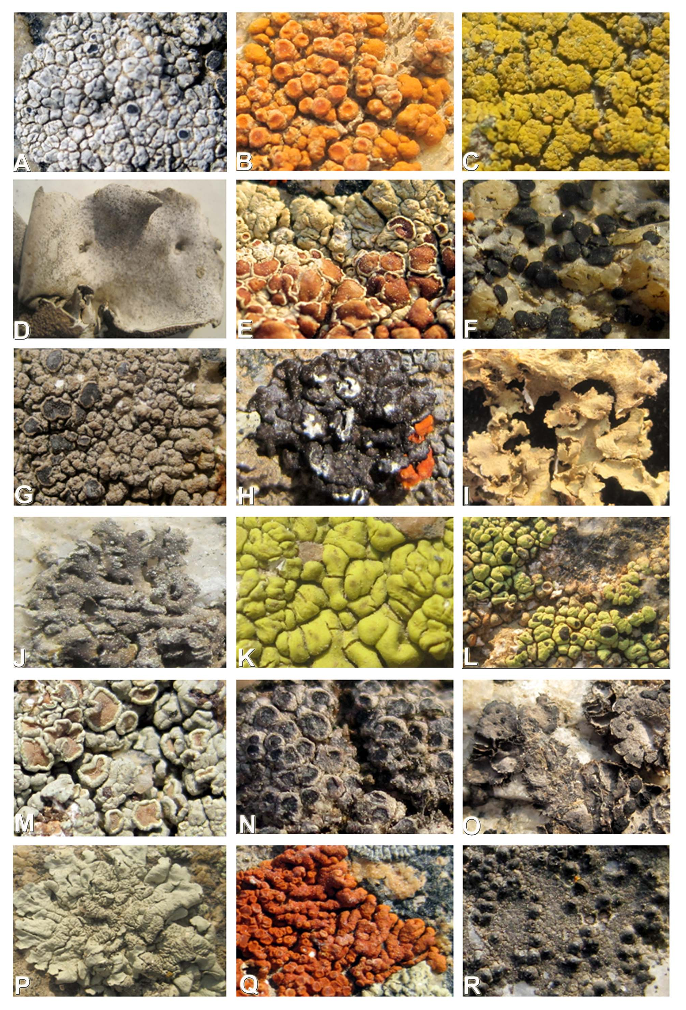

Figure 3.A. Aspicilia caesiocinerea (Nyl. ex Malbr.) Arnold B. Caloplaca saxicola (Hoffm.) Norden C. Candelariella aurella (Hoffm.) Zahlbr. D. Dermatocarpon vellereum Zschacke E. Lecanora muralis var. muralis (Schreb.) Rabenh. em. Poelt F. Lecidea plana (J. Lahn) Nyl. G. Lobothallia alphoplaca (Wahlenb. ex Ach.) Hafellner H. Melanelia disjuncta Essl. I. Nepromopsis nephromoides (Nyl.) Ahti & Randl. J. Physconia detersa (Naeg. Ex Hepp) Müll Arg. K. Pleopsidium flavum (Bell.) Korb. L. Rhizocarpon geographicum (L.) DC. M. Rhizoplaca chrysoleuca (Sm.) Zopf N. Rinodina turfacea (Wahlenb.) Körber O. Umbilicaria vellea (L.) Ach. em. Frey P. Xanthoparmelia mexicana (Gyeln.) Hale Q. Xanthoria elegans (Links.) Th. Fr. R. Verrucaria acrotella Ach.

Acarospora strigata (Nyl.) Jatt
Thallus saxicolous, areolate- squamulose, yellow; squamules pale on lower surface, pruinose, 1- 1.5 mm large. Apothecia scarce, 0.2- 0.5 mm diam.; ascospores
3- 4.5 × 2- 2.5 µm. Thallus K-, Pd-, C-, KC-. No chemical present.
Specimens examined: Jammu and Kashmir, Leh district, DIHAR hill, alt. 3526 m, on rocks, 18/08/2010, Jatinder kumar 10-014359, 10-014360, 10-014367, 10-014369, 10-01437 (LWG); Chang la, alt. 5350 m, on rock, 05/07/2010, Jatinder kumar 10-014334, 10-014332, 10-014392 (LWG).

Aspicilia caesiocinerea (Nyl. ex Malbr.) Arnold
Fig. 3A
Thallus saxicolous, crustose, grey or bluish- grey, cracked to warted- areolate. Apothecia 0.4- 1 mm in diam., epruinose, crater like to emergent; disc black; ascospores, 4- 6 (- 8) per ascus, broadly ellipsoid to globose, 14- 30 × 7- 16 µm.
Specimens examined: Jammu and Kashmir, Leh district, DIHAR hill, alt. 3526 m, on rock, 18/08/2010, Jatinder kumar 10-014370 (LWG); Chang la, alt. 5350 m, on rock, 05/07/2010, Jatinder kumar 10-014326, 10-014333, 10-014336, 10-014338, 10-014346 (LWG).

Aspicilia calcarea (L.) Körb.
Thallus saxicolous, crustose, chalky- white or greyish white forming ± circular patches, effuse, rimose- areolate,continuous. Apothecia greyish- pruinose, 0.3- 1 mm diam., ± immersed or flat; disc black, pruinose; ascospores, 4 per ascus, broadly ellipsoid to subglobose, 15- 30 × 10- 24 µm.
Specimen examined: Jammu and Kashmir, Leh district, Chang la, alt. 5351 m, on rock, 05/07/2010, Jatinder kumar 10-014342, 10-014348 (LWG).

Aspicilia maculata (H. Magn.) D. D. Awasthi
Thallus saxicolous, crustose, whitish- grey, continuous, irregular to rounded, sordid white granular- pruinose. Apothecia crater-like when young, surrounded by pruinose ring, 0.5- 1.2 mm in diam.; disc black, pruinose, depressed; ascospores 4- 6 per ascus, ellipsoid, 17- 28 × 10- 18 µm.
Specimen examined: Jammu and Kashmir, Leh district, Chang la, alt. 5350 m, 05/07/2010, Jatinder kumar 10-014325, 10-014342, 10-014393 (LWG).

Caloplaca saxicola (Hoffm.) Norden Fig. 3B
Thallus crustose, saxicolous, placodioid, 0.7-1.5 cm in diam., orange to deep orange, lobes finger like to broad. Apothecia numerous, scattered to clustered, 0.3-1.0 mm in diam., disc usually dark orange, spores polaribilocular, ellipsoid, 11.0-15.0 × 4.0-5.0 µm, isthmus 3.5-4.0 µm. Thallus, apothecial disc and epihymenium K+ purple, C-, Pd-. Parietin present.
Specimen examined: Jammu and Kashmir, Leh district, Chang la, alt. 5350 m, on rock, 05/07/2010, Jatinder kumar 10-014393 (LWG).

Caloplaca vanabilis (Pers.) Müll Arg
Thallus crustose, saxicolous, thin to thick, smooth to areolate to verruculose, dull grey to greyish-brown, prothallus a narrow black zone. Apothecia numerous, scattered to clustered, sessile to ± constricted at the base, round, 0.2-0.7 (-1.0) mm diam., disc brownish black to black, ascus 8 spored, spores polaribilocular, ellipsoid, (9-16) × (4-8) µm, isthmus 2-4 µm .Thallus and apothecial disc K- to K+ weak purple, C-, Pd-.
Specimen examined: Jammu and Kashmir, Leh district, DIHAR hill, alt. 3523 m, on rock, 12/06/2010, Jatinder kumar 10-014306 (LWG); on rock, 18/08/2010, Jatinder kumar, 10-014372 (LWG); Chang la, alt. 5350 m, on rock, 05/07/2010, Jatinder kumar 10-014344 (LWG).

Candelariella aurella (Hoffm.) Zahlbr. Fig. 3C
Thallus saxicolous, crustose, scattered, yellow to green- yellow, granular, prothallus thin, continuous, dark grey to black. Apothecia frequent 0.2- 1.2 mm diam., discrete, ± regularly dispersed, yellow; ascospores oblong- ellipsoid, 13- 21 × 5.5- 6.5 µm. Thallus K-, Pd-, C+ orange, KC-. Calycin, pulvinic dilactone and pulvinic acid present
Specimens examined: Jammu and Kashmir, Leh district, DIHAR hill, alt. 3523 m, on rocks, 18/08/2010, Jatinder kumar, 10-014377 (LWG); Chang la, alt. 5350 m, on soil, 05/07/2010, Jatinder kumar 10-014319 (LWG).

Candelariella nepalensis Poelt & Reddi
Thallus tericolous, squamulose, upto 4cm across, squamules 1-2(-5) mm wide, ± rosulate, apothecia orange to olive yellow, hymenium 90- 125 µm high, spores 9-13.5(-15) × 4.5-5.5(-7) µm.
Specimen examined: Jammu and Kashmir, Leh district, DIHAR hill, alt. 3525 m, on rocks, 12/06/2010, Jatinder kumar 10-014303 (LWG).

Dermatocarpon miniatum (L.) Mann.
Thallus saxicolous, foliose, umbilicate, upper side grey, lower side lacunose or wrinkled. Perithecia immersed in the thallus, with punctiform ostiole; ascospores 9- 12 × 5- 7 µm.
Specimen examined: Jammu and Kashmir, Leh district, Chang la, alt. 5351 m, on rock, 05/07/2010, Jatinder kumar 10-014313, 10-014327, 10-14329 (LWG).

Dermatocarpon vellereum Zschacke Fig. 3D
Thallus saxicolous, foliose, umbilicate, monophyllous, leathery, upper side light brownish to brownish red, white to dark pruinose, lower side black, with dense, thick, stumpy, coralloid rhizinomorphs. Perithecia pale red; ascospores ellipsoid, 9- 12 × (5-) 6- 9 µm.
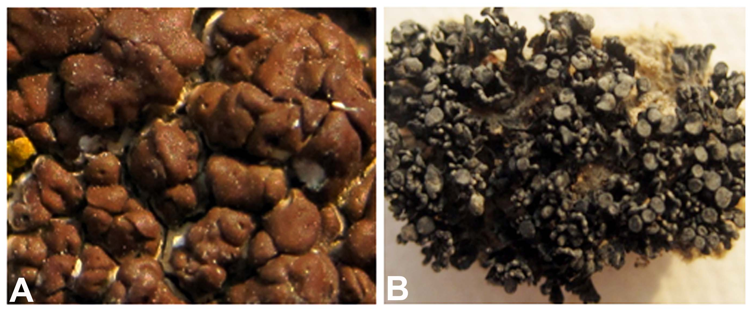
Specimen examined: Jammu and Kashmir, Leh district, DIHAR hill, alt. 3525 m, on rock, 18/08/2010, Jatinder Kumar, 10-014361 (LWG).

Lecanora frustulosa (Dick.) Ach.
Thallus placodioid, closely adpressed, , greenish yellow to yellow brown, margin pale or whitish above, 0.3-0.7 mm wide,1.0-3.8 mm long lower surface pale brown to black. Apothecia sessile, densely aggregate in centre of the thallus, 0.4-1.8mm diam., spores 8 per ascus, ellipsoidal, 9.0-16.0×4.5-7.0 um. Thallus and apothecial margin K-, C-,KC+ yellowish, PD-, usnic acid and zeorin present.
Specimens examined: Jammu and Kashmir, Leh district, Fyang, alt. 3657 m, on rocks, 19/06/2010, Jatinder kumar 10-014310 (LWG); Chang la, alt. 5351 m, on rock, 05/07/2010, Jatinder kumar 10-014315, 10-014349 (LWG); DIHAR hill, alt. 3525 m, on rock, 18/08/2010, Jatinder Kumar 10-014371, 10-014373, 10-014383 (LWG).

Lecanora muralis var. muralis (Schreb.) Rabenh. em. Poelt Fig. 3E
Thallus saxicolous, marginally lobate, foliose, centrally areolate with apothecia, pruinose, upper side yellowish green to grey. Apothecia dense, to 1.5 mm in diam., disc yellowish to reddish brown, epruinose, spores 9- 14 × 4- 7µm. Thallus K-, Pd-, C-, KC+ yellowish. Usnic acid, leucotylin and zeorin present.
Specimen examined: Jammu and Kashmir, Leh district, Chang la, alt. 3523 m, on rock, 05/07/2010, Jatinder kumar , 10-014318 (LWG).

Lecidea confluens (Weker) Ach.
Thallus irregularly, cracked-areolate whitish to grey, often unevenly rust coloured; medulla I+blue-violet prothallus often conspicuous, black. Apothecia (0.2-)0.5- 1.2(-1.8)mm diam., immersed to ± sessile, black, arising between the areoles and often compacted together with angular margins, spores (8-)10-15(-16) × (4.5-)5-8 µm, widely ellipsoid. Thallus and medulla Pd-, K-, KC-.
Specimens examined: Jammu and Kashmir, Leh district, DIHAR hill, alt. 5351 m, on rock, 18/08/2010, Jatinder Kumar 10-014368 (LWG).

Lecidea plana (J. Lahn) Nyl. Fig. 3F
Thallus pale grey, granular to cracked and irregularly areolate, prothallus indistinct. Apothecia 0.2 – 0.5 (-1.5) mm diam., sessile, disc flat to slightly convex, asci 30-40×8-14µm, lecidea type, spores (7-)8-11(-13) × (2.5-)3.5-5(-6) µm, ellipsoid.
Figure 4. A. Acarospora badiofusca (Nyl.) Th. Fr. B. Peccania coralloides (Massal.) Massal.

Specimen examined: Jammu and Kashmir, Leh district, Chang la, alt. 5350 m, on rock, 05/07/2010, Jatinder kumar 10-014387 (LWG).

Lobothallia alphoplaca (Wahlenb. ex Ach.) Hafellner Fig. 3G
Thallus, saxicolous, crustose, whitish- grey, verrucose areolate centrally, radiating laciniae marginally, hollow. Apothecia rounded, 0.5- 2.0 (-2.5) mm diam., disc plane to slightly convex, dark brown to brown black, margin whitish, smooth, ascospores 8 per ascus, 8- 12 × 4- 8 µm. Thallus K+ yellow then red, Pd+ yellow- orange, C-, KC-. Norstictic and salazininc acids present.
Specimens examined: Jammu and Kashmir, Leh district, DIHAR hill, alt. 3523 m, on rock, 12/06/2010, Jatinder kumar 10-014304, 10-014307 (LWG) ;on rock, 18/08/2010, Jatinder Kumar, 10-014362 (LWG).

Melanelia disjuncta Essl. Fig. 3H
Thallus appressed, lobes flat to slightly convex or concave, contiguous, upper surface usually dark olive brown, dark brown or blackish, pseudocyphellae small, submarginal, sorediate, lower surface, moderately rhizinate. Apothecia infrequent, sessile, margin sorediate, rugose, pseudocyphellate, spores ellipsoid, 9-12.5 × 5-7 µm. Perlatolic and stenosporic acid.
Specimens examined: Jammu and Kashmir, Leh district, DIHAR hill, alt. 3523 m, on rock, 18/08/2010, Jatinder Kumar 10-014380, 10-014362 (LWG); Chang la, alt. 5350 m, on rock, 05/07/2010, Jatinder kumar 10-014330, 10-014331, 10-014352 (LWG).

Nepromopsis nephromoides (Nyl.) Ahti & Randl.
Fig. 3I
Thallus corticolous, foliose, adnate, lobes rounded and convoluted, to 2 (-4) cm wide, upper side greenish grey to yellowish grey; lower side yellow- brown, lacunose- rugose, pseudocyphellae at level or depressed, rhizines short. Apothecia marginal on lower side, nephromoid, 7- 9 × 3- 5mm, spores 7- 9 × 3.5 µm.
Specimen examined: Jammu and Kashmir, Leh district, Chang la, alt. 5350 m, on soil, 05/07/2010, Jatinder kumar 10-014385 (LWG).

Peccania coralloides (Massal.) Massal. Fig. 4B
Thallus fruticose, dry black, lobes erect surface smooth, cylindrical, central hyphal strand compact, photobiont a cyanobacterium. Apothecia terminal, emerging long,
0.5-1 mm in diam., urceolate, disc concave to flat, black or dark brown, hymenium tainted, 100-120 µm high, IKI (+) blue, asci cylindrical clavate, 8 spored, from 50-70 x 15-22 µm, spores spherical or ellipsoidal, hyaline, 8-15x6-10µm.
Specimen examined: Jammu and Kashmir, Leh district, DIHAR hill, alt. 3523 m, on rock, 18/08/2010, Jatinder Kumar 10-014355 (LWG).

Table 2: Diversity attributes of lichens on rocks and soil from the three collection localities of Leh and adjacent area.
SNo. | Species Name | Families |  | Growth form* |  |  |  |  |  |  |  | Substratum** |  |  |  | Localities
SNo. | Species Name |  |  | Crustose |  | Squamulose |  | Foliose |  | Fruticose |  | Saxicolous |  | Terricolous |  | DIHAR  hill |  | Chang la |  | Phyang
1. | Acarospora fusca |  | Acarosporaceae |  | - |  | + |  | - |  | - |  | + |  | - |  | + |  | + |  | +
2. | Acarospora badiofusca † |  | Acarosporaceae |  | + |  | - |  | - |  | - |  | - |  | - |  | + |  | + |  | -
3. | Acarospora strigata |  | Acarosporaceae |  | + |  | - |  | - |  | - |  | + |  | - |  | + |  | + |  | -
4. | Aspicilia caesiocinerea |  | Megasporaceae |  | + |  | - |  | - |  | - |  | + |  | - |  | + |  | + |  | +
5. | Aspicilia calcaria |  | Megasporaceae |  | + |  | - |  | - |  | - |  | + |  | - |  | + |  | + |  | -
6. | Aspicilia maculata |  | Megasporaceae |  | + |  | - |  | - |  | - |  | + |  | - |  | + |  | - |  | -
7. | Caloplaca saxicola |  | Teloschistaceae |  | + |  | - |  | - |  | - |  | + |  | - |  | - |  | + |  | +
8. | Caloplaca vanabilis |  | Teloschistaceae |  | + |  | - |  | - |  | - |  | + |  | - |  | + |  | + |  | -
9. | Candelariella aurella |  | Candelariaceae |  | - |  | + |  | - |  | - |  | + |  | + |  | + |  | + |  | -
10. | Candelariella nepalensis |  | Candelariaceae |  | - |  | + |  | - |  | - |  | + |  | - |  | + |  | - |  | -
11. | Dermatocarpon miniatum |  | Verrucariaceae |  | - |  | - |  | + |  | - |  | + |  | - |  | - |  | + |  | +
12. | Dermatocarpon vellereum |  | Verrucariaceae |  | - |  | - |  | + |  | - |  | + |  | - |  | + |  | - |  | -
13. | Lecanora frustulosa |  | Lecanoraceae |  | + |  | - |  | - |  | - |  | + |  | - |  | + |  | + |  | +
14. | Lecanora muralis |  | Lecanoraceae |  | + |  | - |  | - |  | - |  | + |  | - |  | - |  | + |  | -
15. | Lecidea confluens |  | Lecidiaceae |  | + |  | - |  | - |  | - |  | + |  | - |  | + |  | - |  | +
16. | Lecidea plana |  | Lecidiaceae |  | + |  | - |  | - |  | - |  | + |  | - |  | - |  | + |  | +
17. | Lobothallina alphoplaca |  | Megasporaceae |  | + |  | - |  | - |  | - |  | + |  | - |  | - |  | - |  | +
18. | Melanelia disjuncta |  | Parmeliaceae |  | + |  | - |  | - |  | - |  | + |  | + |  | + |  | + |  | -
19. | Nephromopsis nephromoides |  | Parmeliaceae |  | + |  | - |  | - |  | - |  | - |  | - |  | + |  | - |  | -
20. | Peccania coralloides† |  | Lichinaceae |  | - |  | - |  | - |  | + |  | + |  | - |  | + |  | - |  | -
21. | Physconia muscigena |  | Physciaceae |  | - |  | - |  | + |  | - |  | + |  | + |  | + |  | + |  | -
22. | Physconia detersa |  | Physciaceae |  | - |  | - |  | + |  | - |  | + |  | - |  | + |  | - |  | -
23. | Physconia grisea |  | Physciaceae |  | - |  | - |  | + |  | - |  | + |  | - |  | + |  | - |  | -
24. | Pleopsidium flavum |  | Acarosporaceae |  | - |  | + |  | - |  | - |  | + |  | - |  | + |  | - |  | -
25. | Rhizocarpon geographicum |  | Rhizocarpaceae |  | + |  | - |  | - |  | - |  | + |  | - |  | + |  | - |  | +
26. | Rhizocarpon disporum |  | Rhizocarpaceae |  | + |  | - |  | - |  | - |  | + |  | - |  | + |  | + |  | -
27. | Rhizoplaca chrysoleuca |  | Lecanoraceae |  | + |  | - |  | - |  | - |  | + |  | - |  | + |  | + |  | +
28. | Rhizoplaca melanophthalma |  | Lecanoraceae |  | + |  | - |  | - |  | - |  | + |  | - |  | - |  | + |  | +
29. | Rinodina badiella |  | Physciaceae |  | + |  | - |  | - |  | - |  | + |  | - |  | + |  | - |  | -
30. | Rinodina trufacea |  | Physciaceae |  | + |  | - |  | - |  | - |  | - |  | + |  | - |  | + |  | +
31. | Umbilicaria vellea |  | Umbilicariaceae |  | - |  | - |  | + |  | - |  | + |  | - |  | - |  | + |  | +
32. | Umbilicaria virginis |  | Umbilicariaceae |  | - |  | - |  | + |  | - |  | + |  | - |  | - |  | + |  | -
33. | Xanthoparmelia mexicana |  | Parmeliaceae |  | + |  | - |  | - |  | - |  | + |  | + |  | - |  | - |  | -
34. | Xanthoparmelia stenophylla |  | Parmeliaceae |  | + |  | - |  | - |  | - |  | + |  | - |  | + |  | - |  | +
35. | Xanthoria elegans |  | Teloschistaceae |  | - |  | - |  | + |  | - |  | + |  | - |  | + |  | + |  | +
36. | Verrucaria acrotella | Verrucariaceae |  | + |  | - |  | - |  | - |  | + |  | - |  | + |  | + |  | -
 | *Cr= Crustose, Sq= Sqamulose, Fo= Foliose, Fr=Fruticose; **Sx=Saxicolous (on rock), Tr= Terricolous (on soil); † New records for the region.

Physconia muscigena (Ach.) Poelt.
Thallus tericolous or muscicolous, to 10 cm across, lobes 1-1.5 (apiucally 3) mm wide; upper side brownish, lacking isidia or soredia; lower side black; rihizines
squarrosely branched. Apothecia to 5 mm in diam., ascospores 23-32 (-35) × 12-16 µm.
Specimens examined: Jammu and Kashmir, Leh district, DIHAR hill, alt. 3523 m, on soil, 12/06/2010, Jatinder kumar s.n. (LWG); Chang la, alt. 5350 m, on soil, 05/07/2010, Jatinder kumar 10-014313 (LWG).

Physconia detersa (Naeg. Ex Hepp) Müll Arg. Fig. 3J
Thallus saxicolous or terricolous, to 6cm across; lobes to 3mm wide; upper side grey -brown, soralia marginal, bluish tinged; lower side black. Apothecia absent.
Specimen examined: Jammu and Kashmir, Leh district,, DIHAR hill, alt. 3523 m, on soil, 18/08/2010, Jatinder kumar 10-014374 (LWG).

Physconia grisea (Lam.) Poelt
Thallus saxicolous, to 5 cm across, lobes to 3 mm wide, upper side greyish brown, maculately pruinose, isidia laminal or marginal, becoming sorediate, rhizines simple, rarely branched at tips. Apothecia absent.
Specimen examined: Jammu and Kashmir, Leh district, DIHAR hill, alt. 3525 m, on soil, 18/08/2010, Jatinder kumar 10-014375 (LWG).

Pleopsidium flavum (Bell.) Korb. Fig. 3K
Thallus saxicolous, marginally lobate, yellow, effigurate, ± areolate, marginal lobes of thallus rough, subconvex, scabrid and 1.5- 2 mm long. Apothecia plane, solitary, to 0.1- 1.0 mm in diam., immersed in areolae, disc plane brown, margin thick, persistent, spores simple, hyaline, ellipsoid, 4- 5 × 1.7- 2 µm.
Specimen examined: Jammu and Kashmir, Leh district, DIHAR hill, alt. 3523 m, on rocks, 18/08/2010, Jatinder kumar 10-014379 (LWG).

Rhizocarpon geographicum (L.) DC. Fig. 3L
Thallus saxicolous, crustose, areolate, verrucose, greenish- yellow to yellow- green, strongly divided, 0.4- 1.5 mm across, UV+ yellow; areoles 0.4- 1.5 mm across. Apothecia 0.4- 1.2 mm diam., faintly greenish; ascospores muriform, 6- 10 loculed, 24- 40 × 11- 15 µm. Medulla I+ blue, K-, Pd+ yellow, C-; epithecium K+ reddish or greenish. Rhizocarpic, psoromic and ± gyrophoric acids present.
Specimen examined: Jammu and Kashmir, Leh district, DIHAR hill, alt. 3523 m, on rock, 18/08/2010, Jatinder Kumar 10-014368 (LWG).

Rhizocarpon disporum (Naeg ex Hepp) Müll. Arg.
Thallus crustose, areolate, ashy white, verrucose, verucae 0.2-0.7 mm wide, apothecia 0.5-1 mm wide, spores 36-70 × 14-30 µm.
Specimens examined: Jammu and Kashmir, Leh district, DIHAR hill, alt. 3523 m, on rock, 12/07/2010, Jatinder Kumar 10-014358 (LWG); on rocks, 18/08/2010, Jatinder Kumar 10-014374 (LWG); Chang la, alt. 5350 m, on rock, 05/07/2010, Jatinder kumar 10-014314, 10-14341 (LWG).

Rhizoplaca chrysoleuca (Sm.) Zopf Fig. 3M
Thallus saxicolous, foliose, umbilicate, monophyllous or polyphyllous, with thick lobes united by a stalk at centre; lower side brown at centre, bluish black in outer part. Apothecia to 5 mm in diam., disc orange- red to red, pruinose; ascospores 8.5- 12 × 3.5- 6 µm.Medulla K-, Pd+ yellowish. Placodialic acid present.
Specimens examined: Jammu and Kashmir, Leh district, DIHAR hill, alt. 3523 m, on rock, 18/08/2010, Jatinder Kumar 10-014363 (LWG); Chang la, alt. 5350 m, on rock, 05/07/2010, Jatinder kumar 10-014324, 10-014330, 10-014332, 10-014342 (LWG).

Rhizoplaca melanophthalma (DC) Leuck. & Poelt
Thallus saxicolous, peltate, monophyllous, up to 3 cm across, lobes round to crenate, lower side reddish brown. Apothecia to 3 mm in diam., sessile, disc bluish, brown to black, spores 9-11.5×5-5.5. Medulla P+ yellow, Placodialic acid and rarely psoromic acid present.
Specimens examined: Jammu and Kashmir, Leh district, Phyang, alt. 3657 m, on rocks, 19/06/2010, Jatinder kumar 10-014312 (LWG); Chang la, alt. 5350 m, on rock, 05/07/2010, Jatinder kumar 10-014316, 10-014322, 10-014330, 10-014337, 10-014349, 10-014351 (LWG).

Rinodina badiella (Nyl.) Th. Fr.
Thallus saxicolous, grey to brown, verruculose to areolate, apothecia up to 1 mm in diam., , sunken to sessile, spores pachysporia type, 1 septate, 16-21 ×9-13 µm.
Specimen examined: Jammu and Kashmir, Leh district, DIHAR hill, alt. 3523 m, on rock, 18/08/2010, Jatinder kumar 10-014376 (LWG).

Rinodina turfacea (Wahlenb.) Körber Fig. 3N
Thallus terricolous, ashy-white, granular, cortex I+ blue. Apothecia concave to plane, 1-1.5 mm in diam., disc brown-black, spores 26-35×11-14 µm with septum.
Specimen examined: Jammu and Kashmir, Leh district, Chang la, alt. 5350 m on soil, 05/07/2010, Jatinder kumar 10-014319 (LWG).

Umbilicaria virginis Schaer.
Thallus saxicolous, foliose, monophyllous, umbilicate, orbicular; upper side buff to yellowish brown, irregularly wrinkled, finely granulose, white pruinose, lower side ochraceous or pinkish red; rhizinomorphs cylindrical or flat, simple or branched, brownish. Apothecia numerous, to 4.5 mm in diam., spores colourless with a dark central band, ovoid to ellipsoid, 10- 17 × 6- 10 µm. Thallus K-, Pd-, C-, KC+ red. Gyrophoric acid present.
Specimen examined: Jammu and Kashmir, Leh district, Chang la, alt. 5350 m, on rock, 05/07/2010, Jatinder kumar 10-014350 (LWG).

Umbilicaria vellea (L.) Ach. em. Frey Fig. 3O
Thallus saxicolous, minophyllous, umbilicate, grey to blackish grey, smooth. Areolate, pruinose, lower side black, rhizomorphs dimorphic. Apothecia black, gyrose, spores simple, colourless 8.5-13×6.8-10 µm.
Specimens examined: Jammu and Kashmir, Leh district, Chang la, alt. 5350 m, on rock, 05/07/2010, Jatinder kumar 10-014326, 10-014328, 10-14329, 10-014337, 10-014341, 10-014347 (LWG).

Xanthoparmelia mexicana (Gyeln.) Hale Fig. 3P
Thallus saxicolous, foliose; lobes 1.5-3 mm wide, black rimmed; upper side yellow- green, isidiate; isidia subglobose to cylindrical, simple to coralloid branched, black tipped; lower side brownish, rhizinate; medulla white.
Specimen examined: Jammu and Kashmir, Leh district, DIHAR hill, alt. 3523 m, on rock, 12/02/2010, Jatinder Kumar, 10-014308 (LWG).

Xanthoparmelia stenophylla (Ach.) Ahti & Hawksw.
Thallus saxicolous, foliose, pulvinate, lobes sublinear, 1.2- 5 mm wide, brownish at apices, secondary lobules developing at centre, often erhizinate, upper side yellow- green, lacking isidia and soredia, lower side brownish, rhizinate.
Specimen examined: Jammu and Kashmir, Leh district, Chang la, alt. 5350 m, on rock, 05/07/2010, Jatinder kumar 10-014339 (LWG).

Xanthoria elegans (Links.) Th. Fr. Fig. 3Q
Thallus saxicolous, foliose, suborbicular, lobes radiating, compact, convex, nodulose with densely crowded apothecia in central part, upper side orange-red to reddish brown, lower side grey, medulla white, ± hollow. Apothecia up to 1 mm in diam., spores 12-16 (-18) × 6-8 (-10) µm with 4- 5µm thick transverse septum. Upper surface K+ purple, Pd-, C-, I-. Parietin, fallacinal, emodin, teloschistin and parietinic acid. Chemosyndrome A.
Specimens examined: Jammu and Kashmir, Leh district, DIHAR hill, alt. 3523 m, on rock, 12/06/2010, Jatinder kumar 10-014301, 10-014304, (LWG); Phyang, alt. 3657 m, on rocks, 19/06/2010, Jatinder kumar 10-014311 (LWG); Chang la, alt. 5350 m, on rock, 05/07/2010, Jatinder kumar 10-014313, 10-014320, 10-014322, 10-014329, 10-014340, 10-014340, 10-014341, 10-014345, 10-014348 (LWG).

Verrucaria acrotella Ach. Fig. 3R
Thallus saxicolous, crustose, dark brown to brown- black, epilithic. Ascocarps perithecia, subglobose, 0.1- 0.15 mm diam., immersed, peridium covered by involucrellum, ascospores simple, colourless, ellipsoid to ovoid, 11- 21 × 7- 10 µm.
Specimens examined: Jammu and Kashmir, Leh district, DIHAR hill, alt. 3523 m, on rock, 18/08/2010, Jatinder Kumar 10-014364 (LWG); Chang la, alt. 5350 m, on rock, 05/07/2010, Jatinder kumar 10-014329 (LWG).

4. Discussion:
The decrease in lichen diversity along increasing altitude (Figure 2) and their preference to saxicolous habitat can be attributed to the abiotic factors such as temperature, rainfall and substrate (Negi and Upreti 2000). Among the higher altitude sites the low lichen species turnout at Phyang (3658 m) than Chang la (5189 m) can be due to landuse with higher anthropogenic pressure in Phyang. The lichen species distribution in the three sites also validates this as DIHAR hills shared maximum species similarity with Chang la than Phyang (Figure 5). Higher anthropogenic activities in the form of agriculture and other human activities decrease the microhabitat types for most of the rock and soil inhabiting lichens which results in lower species turn out.

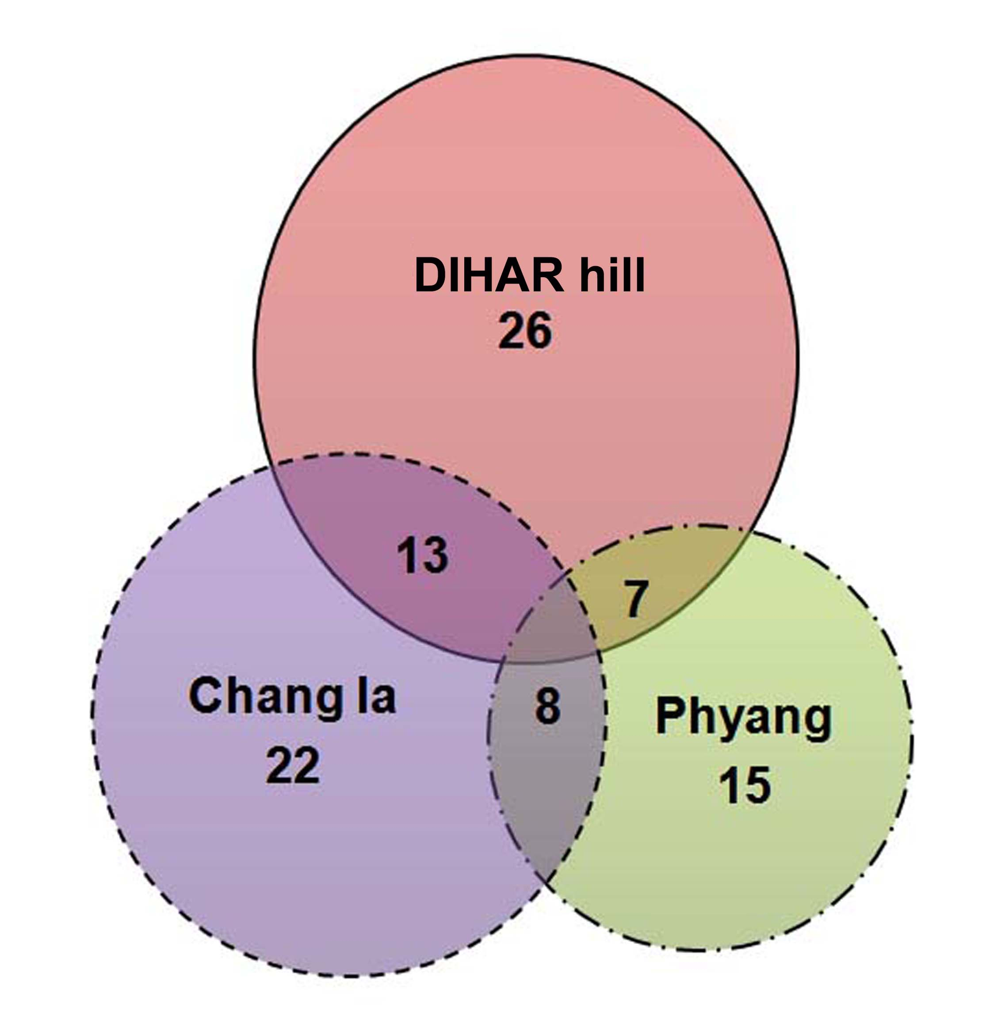
Figure 5: Venn diagram depicting the distribution of 36 lichens species in three sampling sites.

5. Conclusion:
Lichens are good indicators of habitat heterogeneity and anthropogenic pressures (Nag et al 2011; Rai et al 2011; Rai et al 2012). Current study reveals region specific distribution of lichens, which is very different from the lichen distribution in other Himalayan region (Negi and Upreti 2000). This disparity can be primarily attributed to the harsh climatic regime with low annual precipitation, subzero atmospheric temperatures through major part of the year, altitudinal extremes and scarce vegetational cover (Negi and Upreti 2000). Along with these primary factors, anthropogenic pressures in the form of land use patterns also influence the lichen communities of the area (Gilbert 1980; Ruoss 1999; Stoffer et al 2006; Rai et al 2011; Rai et al 2012). These findings though region specific can be extrapolated for periodic monitoring of the lichen communities in relation to ongoing changes of the local land use and thus can be instrumental in promoting lichen-friendly management regimes.

Acknowledgement:
Authors are thankful to the Director, CSIR-National Botanical Research Institute, Lucknow for providing necessary laboratory facilities. This research work is dedicated to Late Dr. D.D. Awasthi (28 Sept. 1922-21 Aug. 2011) pioneer Lichenologist, whose work laid foundation for systematic lichenological research in Indian subcontinent.

Correspondence to:
Dr. D.K.Upreti
Senior Principal Scientist,
Lichenology Laboratory,
Plant Biodiversity and Conservation Division,
National Botanical Research Institute, CSIR
Rana Pratap Marg, Lucknow, Uttar Pradesh,
India-226001
Email: upretidk@rediffmail.com

References:
- Awasthi DD, A Compendium of the Macrolichens from India, Nepal and Sri Lanka. - Bishen Singh Mahendra Pal Singh, Dehra-Dun, India 2007; pp 580.
- Awasthi DD, A key to the microlichens of India, Nepal and Sri Lanka, Biblioth. Lichenol. 1991; 40: 1-336.
- Divakar PK, Upreti DK, Parmelioid Lichens in India: A Revisionary Study. Bishen Singh Mahendra Pal Singh. Dehradun. 2005; pp 488.
- Gilbert OL, Effect of land use on terricolous lichens, Lichenologist 1980; 12(1): 117-124

Hale ME, The Biology of Lichens. 2nd edn. London:Edward Arnold, 1974; pp 303.

Hawksworth DL, Hill DJ, The Lichen-forming Fungi. Glasgow: Blackie, 1984, pp 158

Nag P, Rai H, Upreti DK, Nayaka S, Gupta R, Epiphytic lichens as indicator of land-use pattern and forest harvesting in a community forest in west Nepal. Botanica Orientalis-Journal of Plant Science, 2011; 8: 24-32

Negi HR and Upreti DK, Species diversity and relative abundance of lichens in Rumbak catchment of Hemis National Park in Ladakh, Current Science, 2000; 78(9): 1105-1112

Rai H, Khare R, Gupta RK, Upreti DK, Terricolous lichens as indicator of anthropogenic disturbances in a high altitude grassland in Garhwal (Western Himalaya), India. Botanica Orientalis – Journal of Plant Science 2011; 8: 16-23

Rai H, Upreti DK, Gupta RK, Diversity and distribution of terricolous lichens as indicator of habitat heterogeneity and grazing induced trampling in a temperate-alpine shrub and meadow, Biodiversity and Conservation 2012; 21:97–113

Ruoss E, How Agriculture Affects Lichen Vegetation in Central Switzerland, Lichenologist 1999; 31(1): 63-73

Singh KP, Sinha GP, Indian lichens: an annotated checklist. Govt. of India, Botanical Survey of India. Ministry of Environment and Forest, India, 2010; pp571.
- Stoffer S, Bergamini A, Aragón G, Carvalho P, Coppins B J, Davey S, Dietrich M, Farkas E, Kärkkäinen K, Keller C, Lökös L, Lommi S, Máguas C, Mitchell R, Pinho P, Rico V J, Truscott A-M, Wolseley P A,Watt A and Scheidegger C, Species richness of lichen functional groups in relation to land use intensity , The Lichenologist 2006; 38(4): 331–353

Upreti, D.K, Diversity of Lichens in India, In Perspectives in Environment (eds.Agarwal S.K., Kaushik J.P., Kaul K.K., and Jain A.K.),APH Publishing Corporation, New Delhi, 1998;pp71-79.

3/5/2012

