STUDY OF ROOSTING SITES OF BLUE PEAFOWL, Pavo cristatus LINNAEUS, 1758 IN DISTRICT KURUKSHETRA, HARYANA (INDIA)

GIRISH CHOPRA¹ and TARSEM KUMAR ²

Department of Zoology, Kurukshetra University, Kurukshetra-136119 (INDIA)
¹email - Tarsemkuk@gmail.com

Abstract: The present study on the roosting sites of blue peafowl Pavo cristatus Linnaeus, 1758 was carried out from August, 2009 to September, 2010 in three study areas, namely, Saraswati Plantation Wildlife Sanctuary (SPWS), Bir Sonti Reserve Forest (BSRF) and village Jhrouli Kalan and its agricultural lands (JKAL) in district Kurukshetra in the state of Haryana, India. Results revealed that blue peafowls mainly used tree species such as Kikar (Acacia nilotica), Shisham (Dalbergia sissoo), Safeda (Eucalyptus hybrid), Bargad (Ficus bengalensis), Pilkhan (Ficus rumphii), Jamun (Syzygium cumini), Beri (Zizyphus mauritiana), Teek (Tectona grandis), Nashpati (Pyrus pyrifolia), Nakh (Pyrus cummunis), Mango (Mangifera indica), Guava (Psidium guajava), Popular (Populus populous) for roosting activity during the day time as well as in the whole night in dense forest/scrubby forest/orchards of all the three study areas. Eucalyptus tree, being the dominating plant in SPWS and BSRF, was found to be used as roosting site by majority of peafowls, i.e., 31% in SPWS and 32% in BSRF. However, In JKAL, peafowl were seen roosting on Beri (Zizyphus mauritiana) for maximum 17% number of times.

[GIRISH CHOPRA and TARSEM KUMAR. STUDY OF ROOSTING SITES OF BLUE PEAFOWL, Pavo cristatus LINNAEUS, 1758 IN DISTRICT KURUKSHETRA, HARYANA (INDIA). Nature and Science 2012;10(4):49-55]. (ISSN: 1545-0740). http://www.sciencepub.net/nature. 8

Keywords: Blue peafowl, Habitat, Eucalyptus, Ziziphus

Introduction
Order Galliformes of class Aves includes more than 250 birds species including turkeys, grouse, chickens, quails and pheasants on worldwide basis (Crowe et al., 2006). These birds are commonly known as gamefowl or gamebirds, landfowl, gallinaceous birds or galliforms. The family Phasianidae, being one of the largest families of Galliformes, includes 38 genera and around 138 species including the largest sized peafowls (del Hoyo et al., 1992). Three species of peafowls are found in the world, i.e., Burmese peafowl from eastwards to Sumatra, African peafowl in Belgian Congo and Indian peafowl or blue peafowl in Indian subcontinent (Dharmakumarsinhji and Lavkumar, 1981).The blue peafowl, Pavo cristatus, commonly called as Mor or Myur, is the most common pheasant of India and is designated as national bird of India.
Pavo cristatus inhabits mostly in the semi arid conditions viz., Bhutan, Eastern China, India, Nepal, Pakistan and Sri Lanka (Dharmakumarsinhji and Lavkumar, 1981). In India, Pavo cristatus is distributed in the Gujarat, Haryana, Madhya Pradesh, Punjab, Rajasthan and Uttar Pradesh. It is protected throughout the country, especially under the Schedule-1 of the Indian wildlife protection Act, 1972 and its subsequent amendment and Appendix-1 of CITES (Dodia, 2011). In Haryana, Pavo cristatus is mainly distributed in Sultanpur National Park (Gurgaon), Kalesar National Park (Yamunanagar), Saraswati Plantation Wildlife Sanctuary (Kurukshetra) and in other districts such as Faridabad, Hisar, Jind and Mahendergarh. Studies related to its ecology and behaviour are lacking in this region. Therefore, present study was conducted on the roosting sites of common peafowl (Pavo cristatus) from August, 2009 to September, 2010 at Saraswati plantation wildlife sanctuary (SPWS), Bir Sonti reserve forest (BSRF) and Jhrouli Kalan and its agricultural lands (JKAL) in district Kurukshetra, Haryana (India).

Methodology

The present study on was carried out from August, 2009 to September, 2010 in district Kurukshetra in the state of Haryana, India. Three study areas, namely, Saraswati Plantation Wildlife Sanctuary (SPWS), Bir Sonti Reserve Forest (BSRF) and village Jhrouli Kalan and its agricultural lands (JKAL) in district Kurukshetra were selected (Fig. 1). Three transects each of variable lengths were marked in each study area. All the three selected study areas were visited at fortnightly intervals from 6:00 AM to 6:00 PM. Marked transects were traversed on foot at steady pace to identify substrata used by peafowls for roosting and other activities. The tree species used by peafowl for roosting in orchards, scrubby and dense forest regions of all the three study areas were recorded and identified. Monthly and seasonal records of trees species utilized for roosting activity by blue peafowl were maintained.
Results
In the present investigation, those sites were considered as the habitat of blue peafowl where they spent maximum time of the day and night for roosting. Blue peafowls used mainly Kikar (Acacia nilotica), Shisham (Dalbergia sissoo), Safeda (Eucalyptus hybrid), Bargad (Ficus bengalensis), Pilkhan (Ficus rumphii), Jamun (Syzygium cumini), Beri (Zizyphus mauritiana), Teek (Tectona grandis), Nashpati (Pyrus pyrifolia), Nakh (Pyrus cummunis), Mango (Mangifera indica), Guava (Psidium guajava), Popular (Populus populous) tree species for roosting activity during the day time as well as in the whole night in all the three study areas (Plate 1). In SPWS study area, 7 trees species, namely, Acacia nilotica, Dalbergia sissoo, Eucalyptus hybrid, Ficus bengalensis, Ficus rumphii, Syzygium cumini and Zizyphus mauritiana were used by the peafowls as their roosting sites in day as well as during night hours in all the seasons of year (Table 1). In BSRF study area also, blue peafowl were observed to use 7 trees species in all for roosting activity (Table 1). Acacia nilotica, Dalbergia sissoo, Eucalyptus hybrid, Ficus rumphii, Syzygium cumini, Zizyphus mauritiana were also used by peafowls for roosting in this study area. Besides these 6 trees, they also were found roosting during the day and night on Tectona grandis tree species (Table 1). In JKAL study area, Pavo cristatus was observed roosting on 11 tree species, namely, Kikar Acacia nilotica, Shisham Dalbergia sissoo, Safeda Eucalyptus hybrid, Jamun Syzygium cumini, Beri Zizyphus mauritiana, Teek Tectona grandis, Nashpati Pyrus pyrifolia, Nakh Pyrus cummunis, Mango Mangifera indica, Guava Psidium guajava and Popular Populus populous (Table 1).
Observations revealed variability in the preference of tree species as roosting sites by blue peafowls in all the three study areas. In SPWS, 31%, 19%, 14%, 14%, 9%, 8% and 5% peafowls were noticed roosting on Eucalyptus hybrid, Acacia nilotica, Dalbergia sissoo, Ficus bengalensis, Ficus rumphii, Zizyphus mauritiana and Syzygium cumini respectively (Fig. 2). Similarly in BSRF, 32%, 27%, 13%, 11%, 8%, 7% and 2% peafowls used Eucalyptus hybrid, Acacia nilotica, Tectona grandis, Zizyphus mauritiana, Dalbergia sissoo, Ficus rumphii and Syzygium cumini tree species respectively for roosting. In JKAL, 17%, 13%, 11%, 11%, 10%, 9%, 8%, 7%, 7%, 5% and 2% peafowl were observed on Beri (Zizyphus mauritiana), Safeda (Eucalyptus hybrid), Mango (Mangifera indica), Nashpati (Pyrus pyrifolia), Shisham (Dalbergia sissoo), Guava (Psidium guajava), Teek (Tectona grandis), Jamun (Syzygium cumini), Kikar (Acacia nilotica), Nakh (Pyrus cummunis) and Popular (Populus populous) tree species doing roosting activity (Fig. 2).
Discussion
Ali and Ripley (1983) have reported that large birds need tall trees and small birds need small trees for roosting. In the present study, peafowl, being the large bird, was found to prefer large trees for roosting. According to Bergmann (1980) and Johansgaurd (1986), blue peafowl (Pavo cristatus) has been observed on the tall trees for roosting, and nesting under dense bushes with open areas having feeding grounds. In the present study also, peafowls were observed on most dominant species of the trees in all the three selected study areas. Roosting of the peafowls was very closely related with the sunset but temperature had no relation with roosting (Navatheekannan 1984). In the present study, peafowl were observed roosting in their habitats during their inactive period (i.e., noon and in late evening hours) on dominant tree species. Similar results have also been reported by Ward and Zahavi (1973) in case of other birds species. Dodia (2011) has reported that among 14 trees species (Azadiracta indica, Ficus bengalensis, Eucalyptus, Cocos nucifera, Prosopsis juliflora, Mangifera indica, Ziziphus mauritina, Syzium cumini, Ficus teseila, Manikara haexandra, Terminalia catappa, Casuariana equisetafolia, Samanaea saman, Adansonnia digitate) peafowl roosted mainly on Azadiracta indica, Ficus bengalensis, Eucalyptus and Cocos nucifera in Gujarat state of India. In the present study also among 13 species of trees, namely, Acacia nilotica, Dalbergia sissoo, Eucalyptus hybrid, Ficus bengalensis, Ficus rumphii, Syzygium cumini, Zizyphus mauritiana, Tectona grandis, Pyrus pyrifolia, Pyrus cummunis, Mangifera indica, Psidium guajava, Populus populous tree species (Table 1), peafowl was sighted roosting mainly on Eucalyptus hybrid in SPWS and BSRF and Zizyphus mauritiana in JKAL study areas.
Eucalyptus tree being the dominating plant in SPWS and BSRF, was found to be used as roosting site by majority of peafowls, i.e., 31% in SPWS and 32% in BSRF. However, In JKAL, peafowl were seen roosting on Beri (Zizyphus mauritiana) for maximum number of times, i.e., 17% (Fig. 4.20). Besides Eucalyptus, in SPWS and BSRF and Ziziphus in JKAL, others trees were also preferred by variable number of peafowl for roosting activity. In SPWS, 19% peafowls were sighted using Kikar (Acacia nilotica) and 14% peafowls were observed to use Bargad (Ficus bengalensis) and Shisham (Dalbergia sisso) each. In BSRF, 27% peafowl were observed to use Kikar (Acacia nilotica) and 13% used Teek (Tectona grandis) for roosting. In the JKAL study area, 13% and 11% peafowls were recorded to use Safeda (Eucalyptus) and Nashpati (Pyrus pyrifolia) for roosting. Besides, other plants were used occasionally as roosting sites by peafowls in all the three study areas. Geist (1974b) and Jarman (1974) have correlated population size of peafowl with the availability of congenial habitat having feeding grounds. Physical structure and floristic properties of a plant community also affect the habitat types (Holmes and Robinson 1981; Weins and Rottenberry 1981; Collins 1983), but some bird species have plasticity with their habitat selection, which depend on the food availability, habitat choice and lack of competitors (Winkler and Leisler, 1985). In the present study too, variability in the vegetation provided adequate habitats for various behavioural activities such as roosting, feeding, nesting etc. in different seasons in all the three study areas.

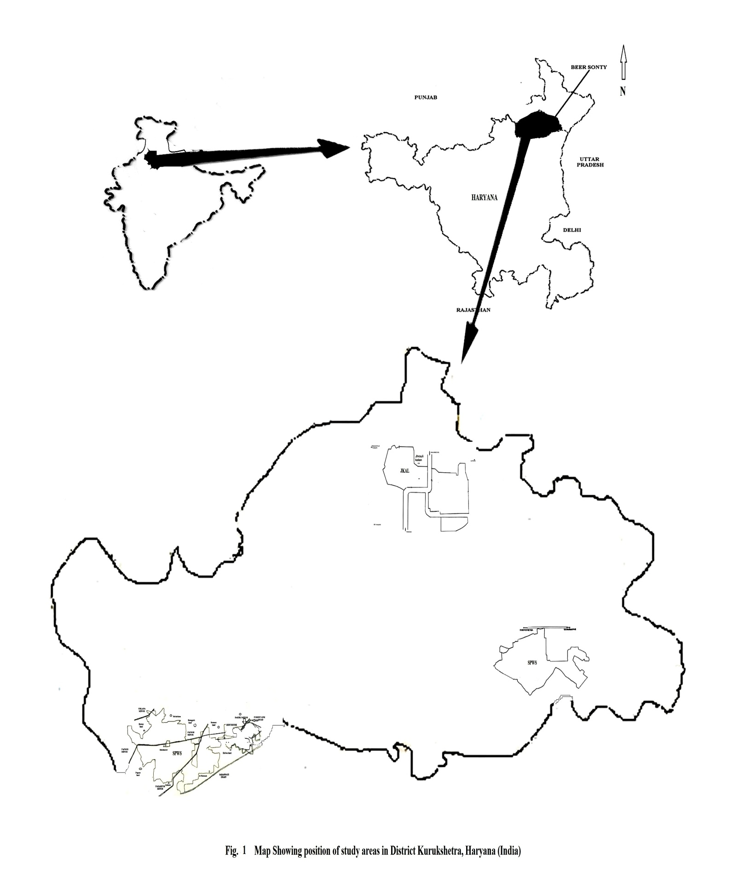

Table 1. Tree species used by peafowl for roosting at three study areas.

S No. | Tree species |  | SPWS | BSRF | JKAL
S No. | Common name | Scientific name | SPWS | BSRF | JKAL
1 | Kikar | Acacia nilotica | + | + | +
2 | Shisham | Dalbergia sissoo | + | + | +
3 | Safeda | Eucalyptus hybrid | + | + | +
4 | Bargad | Ficus bengalensis | + | - | -
5 | Pilkhan | Ficus rumphii | + | + | -
6 | Jamun | Syzygium cumini | + | + | +
7 | Beri | Zizyphus mauritiana | + | + | +
8 | Teek | Tectona grandis | - | + | +
9 | Nashpati | Pyrus pyrifolia | - | - | +
10 | Nakh | Pyrus cummunis | - | - | +
11 | Mango | Mangifera indica | - | - | +
12 | Guava | Psidium guajava | - | - | +
13 | Popular | Populus populus | - | - | +

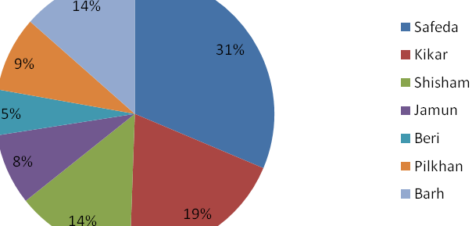
(a)
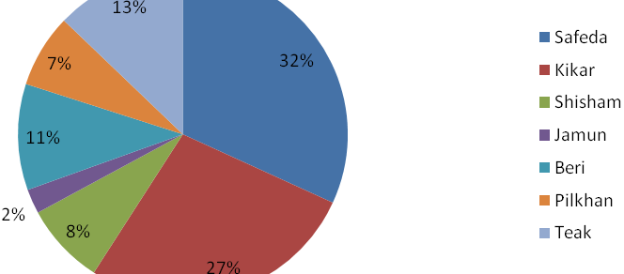
(b)
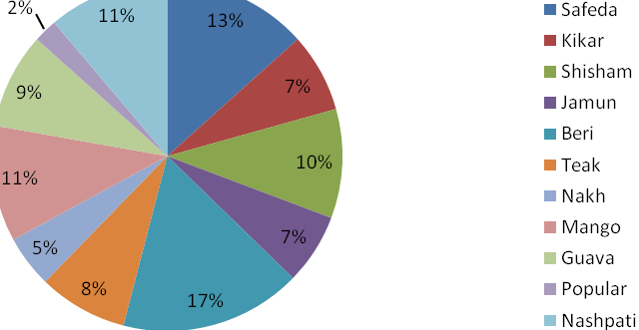
(c)
Fig. 2. Variation in percentage of peafowls sighted on different trees during study
period in (a) SPWS (b) BSRF (c) JKAL study areas.
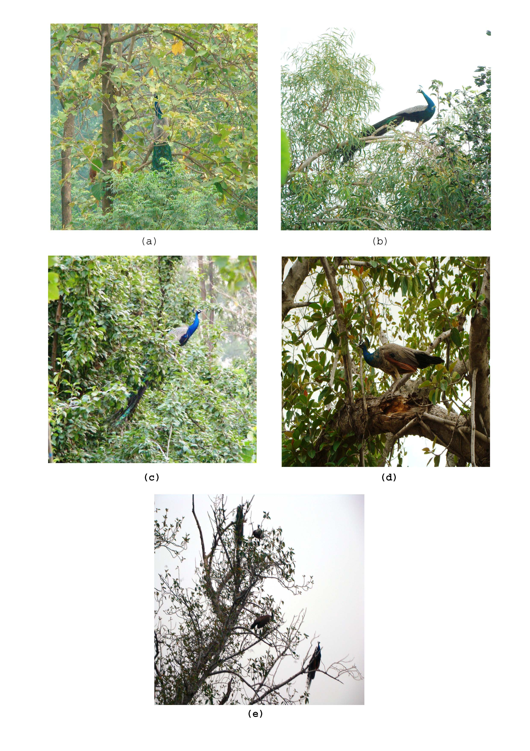 Plate 1. Roosting by peafowl at (a) Techtona tree (b) Eucalyptus tree (c) Pyrus tree (D) Ficus sp. tree and (e) night roosting by peafowls on Ficus sp. tree.

Corresponding Author:
Tarsem Kumar
Department of Zoology
Kurukshetra University, Kurukshetra
Haryana (India)-136119
References:
- Ali, S. and Ripley, S.D. (1983). Handbook of the Birds of India and Pakistan, Compact Edition, Oxford University Press, Mumbai.
- Bergmann, J. (1980). The peafowl of the world, Saiga Publ. Co. Ltd.
- Collins, S.L. (1983). Geographic variation in habitat structure for the wood warblers in Maine and in Minnesota, Oecologia (Berlin) 59: 246-252.
- Crowe, T.M., Bowie, R.C.K., Bloomer, P., Mandiwana, T., Hedderson, T., Randi, E., Pereira, S.L. and Wakeling, J. (2006). Phylogenetics and biogeography of, and character evolution in gamebirds (Aves: Galliformes), Effects of character exclusion, partitioning and missing data, Cladistics 22:495-532.
- del Hoyo, J., Elliot, A. and Sargatal,J. (1992) Handbook of the birds of the World, Vol-1 Barcelona, Lynx Edicion.
- Dharmakumarsinhji, R.S. and Lavkumar, K.S. (1981). Indian peafowl, Sixteen Indian birds, Publication division, Ministry of information and broadcasting, Government of India: 24-28.
- Dodia, P. P. (2011) Roost Tree Selection By The Common Indian Peafowl (Pavo cristastus) at Bhavnagar District, Gujarat (India), Life sciences Leaflets 11: 346-354.
- Geist, V. (1974b) On the relationships of social evolution ecology of Ungulates, Ani. Zool. 14: 205-220.
- Holmes, R. T. and Robinson, S. K. (1981). Tree species preference of foraging insectivorous birds in northern hardwood forest, Oecologia 48: 31-55.
- Jarman, P. J. (1974). The social organization of antelope in relation to their ecology, Behaviour 48: 215-267.
- Johnsgard, P. A. (1986). The Pheasants of the World, Oxford Univ. Press Oxford.
- Navaneethakanana, K. (1984). Activity patterns in a colony of peafowls (Pavo cristatus) in nature, J. BNHS 81: 387-393.
- Ward, P. and Zahavi, A. (1973). The importance of certain assemblages of birds as "information centers" for food finding, Ibis 115:517-534.
- Wiens, J. A. and Rotenberry, J. T. (1981). Habitat Associations and Community Structure of Birds, Shrubsteppe Environments, Ecological Monographs 51:21–42.
- Winkler, H. and Leisler, B. (1985). Morphological aspects of habitat selection in birds, In, Cody, M. L. (Eds.), Habitat selection in birds, Academic Press, New York: 415-434.

3/13/2012

