Environment friendly alkaline pulping of Albizia lebbeck from Sudan

Osman Taha Elzaki ¹, Tarig Osman Khider ^{2 *}, Safaa Hassan Omer ³ Suhair Kamal Shomeina ¹

¹Institute for Technological Research, National Centre for Research, P.O. Box 2404, Khartoum State, Sudan
^{2*} Departments of Pulp and Paper—College of Applied and Industrial Sciences, University of Bahri,
Khartoum State, Sudan, Telephone 00249922240925
email: tkhider@yahoo.com
³ Department of Forestry—College of Natural Resources and Environmental Studies, University of Bahri, Khartoum State, Sudan

Abstract: Albizia lebbeck stems, woody fibers resources from Khartoum state were cooked with alkaline sulphite-anthraquinone-AS-AQ and alkaline sulphite anthraquinone with addition of methanol-ASAM -an environment friendly process having high yield and strength properties. The present study aimed to investigate the suitability of A. lebbeck for pulping with AS-AQ and ASAM processes. AS-AQ applied with alkali charge 18.6-20% and two NaOH: Na₂SO₃ ratios mainly 60:40 and 70:30, it was indicted that the latter ratio had better results. The screened yields were 46.73-48.53%, viscosities 811-922 mlg⁻¹, Kappa numbers 17.92-20.96 and ISO brightness 25-30%. ASAM process gave good to excellent physical properties, screened yields 46.65-47.53%, low Kappa numbers 13.27-20.53, viscosities 946-991 mlg⁻¹ and ISO brightness 30.7-34.8%.
[Osman Taha Elzaki, Tarig Osman Khider *, Safaa Hassan Omer and Suhair Kamal Shomeina, Environment friendly alkaline pulping of Albizia lebbeck from Sudan. Nature and Science 2012;10(4):76-82]. (ISSN: 1545-0740) http://www.sciencepub.net/nature. 12.

Key words: Albizia lebbeck, Papermaking, Pulp strength properties, Alkaline sulphite with anthraquinone, ASAM process.

Introduction
Sudan is rich country with pulp and papermaking raw materials that include non-woody plants, agricultural residue, recycled papers, as well as hard wood species. Albizia lebbeck found in deciduous and semi-deciduous monsoon forests, and rainforests in its native habitat, and in a variety of situations in the humid and semi-arid tropics and subtropics, a multipurpose, fast growing tree species widely grown in the tropical region; it has been introduced to Sudan since sixties of last century and was basically used as an ornamental or shade tree [1 and 2]. A. lebbeck found in dense deciduous forests in tropical and sub-tropical countries of Asia, as Laos, Cambodia, Malaysia, Indonesia and Vietnam, Africa, and Australia [3]. A. lebbeck can attain a height of 30 m and a diameter of 1 m, more often it is 15-20 m tall with a diameter of 50 cm [4]. A. lebbeck can make an important contribution to plant and animal production from tropical pastures and could be of special value in areas with salinity problems [5 and 6]. A. lebbeck forms symbiotic relationship with Rhizobium and fix atmospheric nitrogen used for its growth and also for the enrichment of the rhizosphere [7].
The extract from A. lebbeck leaves shows sensitivity for both gram positive and gram negative bacteria with maximum against Escherichia coli [8]. The petroleum ether extracts of A. lebbeck leaves displayed the presence ten types of alkaloids with ten different Rf values with range from 0.02-0.85 [9]. Extract of A. lebbeck demonstrated that this plant has significant analgesic and anti-inflammatory properties [10]. The leaves are good fodder with much protein contents contains saponin, macrocyclic alkaloids, phenolic glycosides, and flavonids [11]. The extract of stem bark contain saponin and exhibited potent cytotoxic activity against human aqueous cell carcinoma [12], and effective drug in bronchial asthma [13].
Alkaline pulping processes were heavily investigated by researchers on different raw materials, SAS-AQ pulping process offers many advantages including high pulp yield, better mechanical strength properties comparable to Kraft pulp [14]. The ASAM process is environment friendly as no obnoxious smell is emitted after cooking [15]. In ASAM pulping the synergistic effect of AQ and methanol provided a far selective delignification [16]
Refiner mechanical pulp from A. lebbeck was yielded 50-60% with strength properties better than or equivalent to these conventional chemical pulps which have a yield of 40-45% [17]. The physical and anatomical properties of Albizia lebbeck wood have shown that, it could be a good material for pulp production without serious problems for liquor penetration [18].
As continuation of previous study in pulping of Albizia lebbeck with soda and soda-anthraquinone processes [18], the objective of the current work was to investigate the suitability of pulping of Albizia lebbeck stems with alkaline sulphite with anthraquinone (AS-AQ) and alkaline sulphite –anthraquinone with addition of methanol (ASAM) process.

Material and Methods
Five logs from five-year-old Albizia lebbeck trees, planted in Khartoum State were randomly selected, logged and collected according to TAPPI standards [18 and 19]. They were prepared and cross cut into logs then were transported to National Centre for Research, further were debarked and cut into discs of 2.5 cm thickness. The discs were chipped approximately to 2.5X2.5X0.25cm. The physical characteristics, fiber dimensions and chemical components were carried out and presented in previous study [18].
The chips were air dried under sun; the moisture content was determined 4-6%, kept in air tight polythene bags until used. The optimization of pulping conditions was done in small digester with 100 g oven dry weight [20 and 21]. The chemicals applied to alkaline sulphite with anthraquinone with and without addition of methanol were applied as (NaOH: Na₂SO₃) with two ratios (70:30 and 60:40) respectively [22-24]. The chemicals were added as Na₂O in percentage on oven dry wood, range between 18.6-20% for AS-AQ pulping and 16.3-20% for ASAM process. The amount of methanol added for ASAM cookings was 15% by volume of the white liquor. Keeping the rest of the pulping parameters constant for both processes, the dose of AQ was 0.1% on oven dry wood, white liquor to wood ratio was (4:1), maximum temperature 170 ⁰C, time to reach maximum temperature 90 min, time at maximum temperature 120 min. Pulping experiments were carried out in 7l electrically heated rotating digester and automatic time- temperature and pressure control [25 and 26]. The pulps produced were refined in the PFI mill in order to modify the fibre properties. Before beating treatment the pulps equivalent to 30 g oven dry were completely soaked in water at consistency of 1.5% and disintegrated for 10000 revolutions. The disintegrated pulp slurries were thickened to 10% consistency for refining in the PFI mill [19 and 27]. Hand-sheets were prepared using a Rapid-Kothen sheet forming machine and tested in accordance with TAPPI standards.

Results and discussion
Albizia lebbeck stems were cooked with alkaline sulphite with anthraquinone and ASAM processes. The amount of sodium sulphite charged had a considerable influence on the rate of cooking. The OH⁻ differs greatly from SO₃²⁻ and HSO₃²⁻ both in its chemical nature and in its effects on the course of reaction with lignin and carbohydrates [28]. The applied ratios as NaOH: NaSO₃ showed during cooking with ratio 70:30 the slight increase screened yield compared to 60:40 ratio at same amount alkali charge (18.6%), associated with decrease in rejects and hence the total yield (table 1).

Table 1:Pulping conditions and unbleached pulp evaluation for AS-AQ process from Central Sudan
Pulping conditions | AS-AQ1 | AS-AQ2 | AS-AQ3 | AS-AQ4
Active alkali as Na₂O on oven-dry base wood, (%) | 18.6 | 18.6 | 19.4 | 20
NaOH: Na₂SO₃ ratio | 60:40 | 70:30 | 60:40 | 70:30
White liquor to wood ratio | 4:1 | 4:1 | 4:1 | 4:1
AQ on oven dry-wood base, (%) | 0:1 | 0:1 | 0:1 | 0:1
Time to reach maximum temperature, (min) | 90 | 90 | 90 | 90
Pulping maximum temperature, (C⁰) | 170 | 170 | 170 | 170
Time at maximum temperature, (min) | 120 | 120 | 120 | 120
Total yield on oven- dry wood base, (%) | 50.02 | 48.84 | 49.53 | 47.23
Screened yield on oven- dry wood base, (%) | 46.73 | 47.44 | 48.53 | 46.47
Rejects, (%) | 3.29 | 1.40 | 1.00 | 0.76
Kappa number | 20.96 | 19.73 | 19.59 | 17.92
Viscosity, mlg⁻¹ | 811 | 899 | 903 | 922
ISO brightness, % | 27 | 25 | 29 | 30

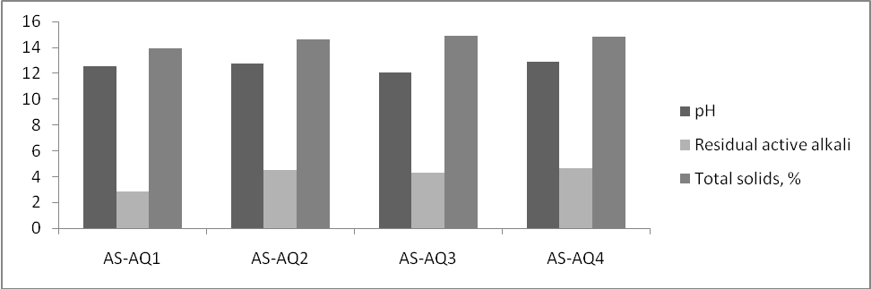
Figure1. Black liquor analysis of alkaline sulphite (AS-AQ) pulping.

The increase of sodium hydroxide ratio from 60:40 to 70:30 accelerated delignification, but beyond that the delignification rate becomes slow. This supported further by an increase viscosity (899 mlg⁻¹) compared to (811 mlg⁻¹) and slight decrease in kappa number, although there is slight decrease in ISO brightness. When comparing the physical properties of pulps for both ratios (60:40 and 70:30), and constant alkali charge (Figures 3-6), it was clear the suppository of the latter ratio.
When the alkali charge increased to 19.4% during the pulping with AS-AQ with constant ratio (60:40), the screened yield increased (48.53%), as well as viscosity (903 mlg⁻¹) and ISO brightness (29) associated with decrease in kappa number (19.59) and rejects (1%). However the physical properties of pulps indicated that an increase in alkali charge to ( 19.4%) improved in all aspects (Figures 3-6) when compared to alkali charge (18.6%) with the same ratio of (NaOH: Na₂SO₃). This demonstrated that the
delignification rate was improved when alkali charge was increased.
The application of higher alkali charge (20%) to AS-AQ cooking using ratio (70:30), gave highest viscosity (922 mlg⁻¹ and brightness 30) compared to other cooking with low bleachable kappa number (17.92). Although the slight decrease in screened yield and total yield with negligible amount of rejects the overall physical properties were the best compared to rest of AS-AQ cookings. It is attractive to produce pulp from Albizia lebbeck stems with AS-AQ process with alkali charge (20%) with ratio (70:30). Figure 1 demonstrated the black liquor analysis of alkaline sulphite with anthraquinone, thus the pH, total solids and residual active alkalis were increased with increasing in alkali charges applied, and higher (NaOH: Na₂SO_{3,} 70:30) positively correlated with chemical recovery

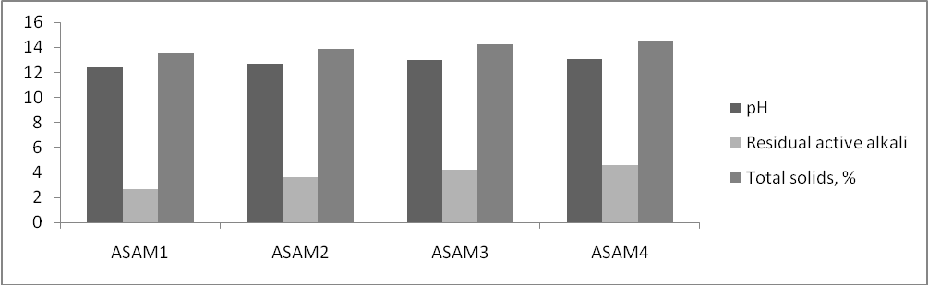
Figure2. Black liquor analysis of ASAM pulping.

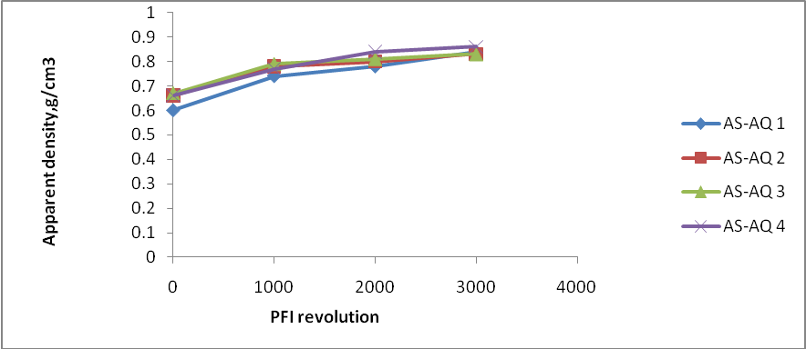
Figure 3. Apparent density vs. PFI revolution of unbleached AS-AQ pulps.

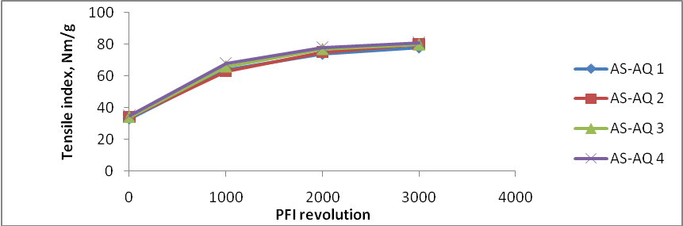
Figure 4. Tensile index vs. PFI revolution of unbleached AS-AQ pulps.

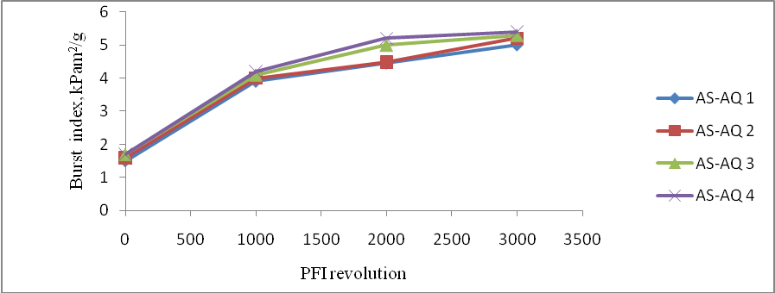
Figure 5. Tear index vs. PFI revolution of unbleached AS-AQ pulps

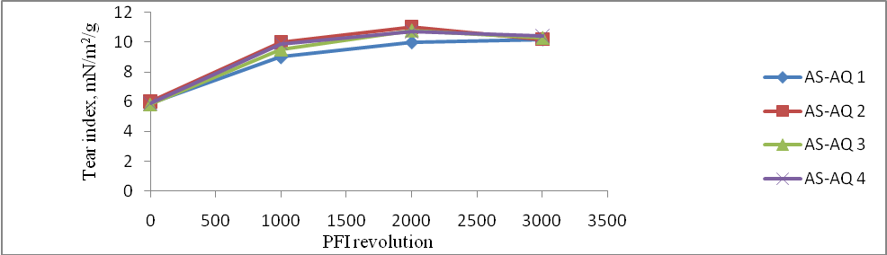
Figure 6. Burst index vs. PFI revolution of unbleached AS-AQ pulps.

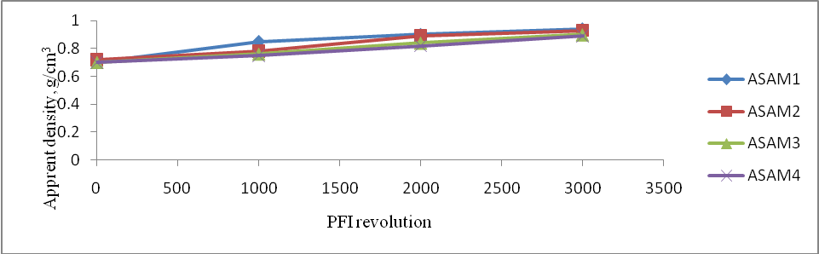
Figure 7. Apparent density vs. PFI revolution of unbleached ASAM pulps.

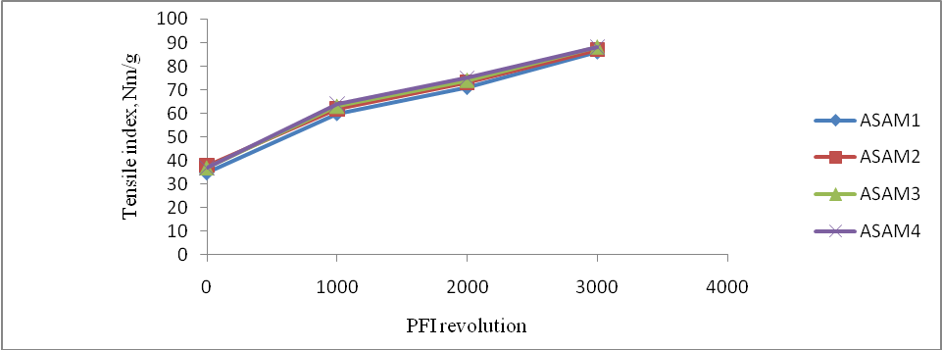
Figure 8. . Tensile index vs. PFI revolution of unbleached ASAM pulps.

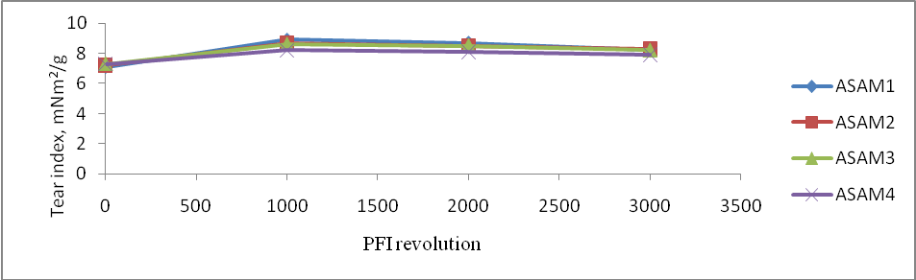
Figure 9. . Tear index vs. PFI revolution of unbleached ASAM pulps.

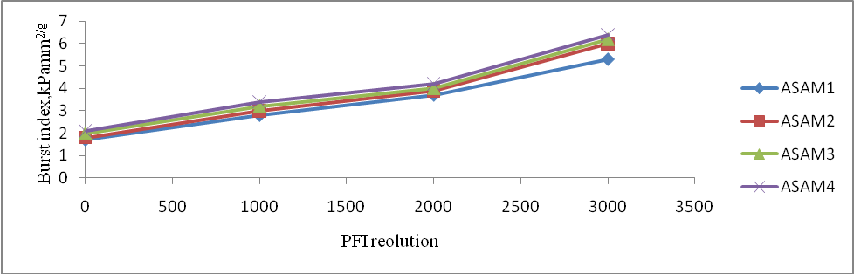
Figure 10. . Burst index vs. PFI revolution of unbleached ASAM pulps.

Table 2:Pulping conditions and unbleached pulp evaluation for ASAM process from Central Sudan
 | Pulping conditions | ASAM1 | ASAM2 | ASAM3 | ASAM4
 | Active alkali as Na₂O on oven-dry base wood, (%) | 16.3 | 18.6 | 19.4 | 20
 | NaOH: Na₂SO₃ ratio | 70:30 | 70:30 | 70:30 | 70:30
 | Methanol, volume/volume white liquor, (%) | 15 | 15 | 15 | 15
 | White liquor to wood ratio | 4:1 | 4:1 | 4:1 | 4:1
 | AQ on oven dry-wood base, (%) | 0.1 | 0.1 | 0.1 | 0.1
 | Time to reach maximum temperature, (min) | 90 | 90 | 90 | 90
 | Pulping maximum temperature, (C⁰) | 170 | 170 | 170 | 170
 | Time at maximum temperature, (min) | 120 | 120 | 120 | 120
 | Total yield on oven- dry wood base, (%) | 50.20 | 49.84 | 48.56 | 47.77
 | Screened yield on oven- dry wood base, (%) | 46.65 | 47.44 | 47.53 | 47.22
 | Rejects, (%) | 3.55 | 2.40 | 1.03 | 0.55
 | Kappa number | 20.53 | 17.23 | 15.44 | 13.27
 | Viscosity, mlg⁻¹ | 991 | 970 | 983 | 946
 | ISO brightness, % | 30.7 | 32.2 | 34.6 | 34.8

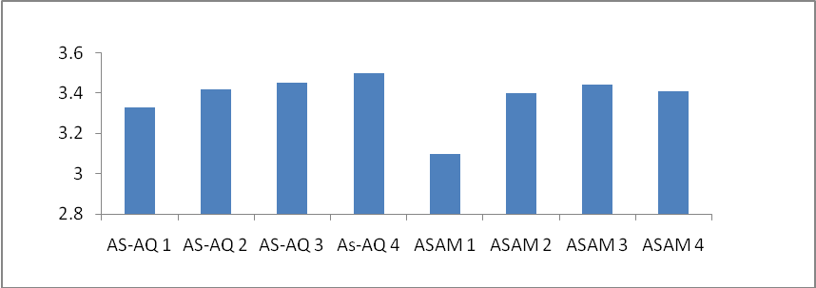
Figure 11. Fold Kohler (log) of unbleached AS-AQ and ASAM pulps at 3000 PFI revolution.

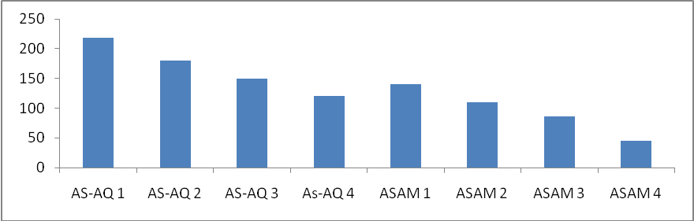
Figure 12. Porosity Bendsten, ml/ min of unbleached AS-AQ and ASAM pulps at 3000 PFI revolution.

As alkaline sulphite anthraquinone pulping, the ASAM process showed the same results when black liquor was analyzed.
The physical properties were reflected the superiority of ASAM process compared to AS-AQ process expect the tear index (Tables 1 and 2) and Figures (3-10). This supported further by higher screened yields, lower rejects, better ISO brightness and lower bleachable Kappa numbers at higher viscosities.
During pulping with ASAM process only one ratio was applied (70:30) due to its suitability with alkaline sulphite pulping of Albizia lebbeck. Addition of methanol to the white liquor improves the impregnation of the chemicals, acts as a buffer, prevents lignin from condensing and stabilizes carbohydrates [29]. The cooking conditions were fixed, thus methanol was added 15% by volume of white liquor, the amount of AQ was added 0.1% on oven dry wood and maximum temperature 170 ⁰C. The alkali charges were applied 16.3-20%. It was determined that with increase of alkali charge, the Kappa number reduced until it was reached bleachable Kappa number 13.27,indicating an easy, low cost bleaching chemicals applied, although this associated with reduction in viscosity and increase in ISO brightness. The screened yields were more or less similar with slight reduction when alkali charge of 16.3% applied. On the other hand the amount of rejects was decreased with increasing of alkali charge. Although the total yield of 16.3% alkali charge was the highest, which could be attributed to highest amount of rejects, it was preferable to apply alkali charge 19.4%, when an easy bleaching is required. The physical properties of ASAM pulps showed different pattern, thus the burst and tensile strengths were increased with increased alkali charge, but apparent density and tear strength showed decreased behavior (Figures 7-10). The fold Kohler for both AS-AQ was illustrated in (figure 11), reflected that fold increase with an increase of alkali charge applied, on the other hand pulps of ASAM were more compact compared to porous pulps of AS-AQ specially those cooked with low alkali charges (Figure 12).

Conclusion
During pulping of Albizia lebbeck with alkaline sulphite anthraquinone the application of ratio 70:30 as NaOH: NaSO₃ offers many advantages when compared to lower alkalinity ratio 60:40, screened yield, Kappa number, viscosity, rejects and physical properties of pulps. the addition of methanol as ASAM pulping has tendency to improve pulping process by increasing the delignification rate, thus Kappa number could reach bleachable standards 13.27 when chemical charged is increased and associates with increase in screened yield compared to AS-AQ pulping.
Albizia lebbeck stems could be easily pulped with ASAM resulting in high yields, low kappa numbers, high viscosities and good to excellent physical properties.

References
- Tropical Forages. 2005. Tropical Forage, an interactive selection tool, Albizia lebbeck Site http://www.tropicalforages.info
- Abdelgadir, S.A. 2009. Studies on genetic diversity, seedlings performance and rooting of cuttings of Albizia lebbeck (L.) wild. Trees grown in Khartoum state- Sudan. Thesis, Sudan University of Science and Technology.
- CTSP, FA, DANIDA. 2004. Cambodian Tree Species, Albizia lebbeck: 51-54.
- Al Amin, H. M. 1990. Trees and Shrubs of the Sudan. Ithaca Press, Exeter.
- Prinsen, J.H. 1986. Potential of Albizia lebbeck (Mimosaceae) as a tropical fodder tree, a review of literature. Tropical Grass Land, vol. 20 (2): 78-83.
- Lowry, J.B. 1989. Agronomy and forage quality of Albizia lebbeck. Tropical Grass Land, vol. 23(2): 84-91.
- Qadri, R. and Mahmood, A. 2005. Ultra- structural studies on root nodules of Albizia lebbeck (L.). Pakistan Journal of Botany, 37(4):815-821.
- Rahul, L. Pankaj, P. Sarwan, S.K. and Mahesh, J.K. 2010. Phytochemical screening and antimicrobial activity of Albizia lebbeck. Journal of Chemical and Pharmaceutical research, 2 (5): 476-484.
- Bobby, N., Wesely, EG., Johnsan, M. 2012. HPTLC profile studies on the alkaloids of Albizia lebbeck. Asian Pacific Journal of Tropical Biomedicine, 1-3:1-6.
- Saha, A and Ahmed, M. 2009. The analgesic and anti- inflammatory activities of the extract of Albizia lebbeck in animal model. Pakistan Journal of Pharmaceutical. Science ., Vol.22,(1): 74-77.
- Mishara, S.S. Gothecha, V.K. and Sharma, A. 2010. Albizia lebbeck: A short review. Journal of Herbal Medicine and Toxicology 4(2): 9-15.
- Jangwan, J.S. Dobhal, M. and Kumar, N. 2010. New cytotoxic saponin of Albizia lebbeck. Indian Journal of Chemistry, vol.(49B):123-126.
- Kumar, S. Bansal, P. Gupta, V. Sannd, R. and Rao, M. 2010. The clinical effect of Albizia lebbeck stem bark decoction on Bronchial Asthma. International Journal of Pharmaceutical Sciences and Drug Research 2(1): 48-50.
- Dutt, D. Upadhyaya, J.S. and Tugi, C.H. 2010. Studies on Hibiscus cannabinus, Hibiscus sabdariffa and Cannabinus sativa pulp to be a substitute for soft wood pulp- Part2: SAS-AQ and NSS-AQ delignification processes. BioResources 5(4): 2137-2152.
- Roy, A.K. and Chattapadhyay, S.N. 2011.Enviroment friendly pulping of Jute. IPPTA, vol. 23(2): 197-199.
- Khider, T.O. Omer, S. and Taha, O. 2012. Alkaline pulping of Typha domingensis from Sudan. World Applied Sciences Journal, 16(3):331-336.
- Kalara, K.K. 1990. Delignification of refiner mechanical pulp for Albizia lebbeck. Indian Forester, vol. 116(16): 811-821.
- Khider, T.O. Elzaki, O.T. Omer, S.H. 2011. Soda and Soda-anthraquinone pulping of Albizia lebbeck from Sudan. Suranaree Journal of Science and Technology, 18(3): in press.
- TAPP1, (2002). Standards and suggested methods. TAPPI, New York.
- Jahan, M. S. Sabina, R. and Rubinxat, A. 2008. Alkaline pulping and bleaching Acacia auriculiformis grown in Bangladesh. Turkey Journal of Agriculture and Forestry 32:331-347.
- Yang, S. Lu, L. and Ni, Y. 2006. Cloned poplar as a new fibre resource for the Chinese pulp and paper industry. Pulp and Paper Canada, 107(2): T34-T37.
- Qing, C. Zhu, H.X. Song, H. Yan, and Chai, X. S. 2006. Mass transfer mechanism of anthraquinone during alkaline wood pulping. 231st National Meeting of the American- Chemical-Society: 134-141.
- Kordsachia, O. Patt, R. 2004. Production of Spruce dissolving pulp with the prehydrolysis- alkaline sulfite process (PH-ASA). Lenzinger Berichte, 83:24-34.
- Fleming, B.I. Cascade, B. R. 1992. Alternative and emerging pulping technologies: Non-Kraft processes. International Symposium on Pollution Prevention in the Manufacture of Pulp. Pp10.
- Khider, T.O. Omer, S.H. and Elzaki, O.T. 2012. Pulping and totally chlorine free (TCF) bleaching of Acacia mellifera from Sudan. World Applied Sciences Journal, 16(9): 1256-1261.
- Shatalov, A.A. and Pereira, H. 2001. Arundo donax L. reed. New perspectives for pulping and bleaching-2. Organosolv delignification. TAPPI Journal, 84(11): 1-12.
- Kim, H. J. and Jo, B.M. 2000. Influence of refining of pulp fibres on the structure of sheet formation. Applied Chemistry, vol.4 (1).367-369.
- Dutt, D. Upadhyaya, J.S. and Tugi, C.H. 2010. Studies on Hibiscus cannabinus, Hibiscus sabdariffa and Cannabinus sativa pulp to be a substitute for soft wood pulp- Part1: AS-AQ delignification process. BioResources 5(4): 2123-2136.
- Patt R and Kordsachia O (1988) Anforderungen an neue zellstoffherstellungsverfahren. Wochenbl

3/22/2012

