Evaluation of protein preparations from bacteria using proteomics approaches: Application to an Antarctic bacterium Pseudomonas syringae

Ehab F. Abou-Eladab ^{1, 2*,} M Mohammed Idris², Medicharla V Jagannadham²

¹Mansoura University, Faculty of Specific Education-Damietta, 34517 New Damietta City, Damietta, Egypt
² Centre for Cellular and Molecular Biology, Uppal Road, Hyderabad 500007, India.
Email: ehab10f@gmail.com

Abstract: The proteins of Pseudomonas syringae pv. TomatoT1 were prepared using a protein preparation method with some modifications and applied the procedure to an Antarctic Pseudomonas syringae Lz4W and evaluate the results using proteomics methods. The preparation of proteins was studied using Pseudomonas syringae pv. tomato T1 as a model bacterium and separated the proteins on SDS-PAGE. Suitable method is applied for the preparation of proteins from Pseudomonas syringae Lz4W. The gel bands cut into small slices, in-gel digested with trypsin and the resulting peptide mixtures analyzed by proteomics analysis. Our results showed a total of 190 proteins were identified from supernatant and 326 proteins from pellet when bacteria grown at 22ºC by using Method A. Also Pseudomonas syringae pv. tomato T1 showed a total of 301 proteins grown at 28ºC by using Method B, whereas only 33 proteins were identified using MALDI. The proteomic approaches used in the present study are very useful to evaluate the efficiency of the protein preparation methods. This study highlights that the protein preparation method plays a critical role in proteomics studies of bacteria.
[Ehab F. Abou-Eladab, M Mohammed Idris, Medicharla V Jagannadham. Evaluation of protein preparations from bacteria using proteomics approaches: Application to an Antarctic bacterium Pseudomonas syringae Nature and Science 2012; 10(4): 102-114]. (ISSN: 1545-0740). http://www.sciencepub.net/nature. 16

Keywords: Proteins of Pseudomonas syringae

Abbreviations: TCA, trichloro acetic acid; DTT , dithiothreitol ; ACN, acetonitrile;1D, one-dimensional; 2D, two-dimensional; CID, collision induced dissociation; IEF, Iso Electric Focussing; ASB-14, Amidosulfobetaine.

1. Introduction
Pseudomonas syringae is a rod shaped Gram-negative bacterium with polar flagella. It is a plant pathogen which can infect a wide range of plant species. It is a member of the Pseudomonas genus, and based on 16S rRNA analysis, P. syringae has been placed in the P. syringae group [1]. Although it is a plant pathogen, it can also live as a saprotroph in the phyllosphere when conditions are not favorable for disease [2]. Some saprotrophic strains of P. syringae have been used as biocontrol agents against post-harvest rots [3]. Pseudomonas syringae Lz4W is an Antarctic psychrotrophic bacterium capable of growing at temperatures between 2 and 30°C with an optimum temperature of growth around 20°C. The isolation and identification of psychrotrophs of various genera from the soil samples of Antarctica have been reported earlier [4-8]. These bacteria were capable of growing near 0°C but were unable to grow above 30°C. They were adapted to the extreme environmental conditions of Antarctica. The mechanism of this cold adaptation is not known. P.syringae can cause water to freeze at temperatures of −1.8°C [7]. Shivaji et al, established ten cultures of Pseudomonas spp. from soil samples collected in around a lake in Antarctica. Based on their morphology, biochemical and physiological characteristics, they were identified as P. fluorescens, P. putida, and P. syringae and find the importance of trmE in rapid adaptation to growth at low temperatures [5, 9]. Our laboratory is working on identifying the molecular basis of cold adaptation. Earlier studies revealed that membranes, proteins and other molecules play an important role in cold adaptation [10-12]. In order to identify the proteins playing a possible role in cold adaptation, the proteins of the bacterium should be extracted effectively for their study. In view of the advantages of proteomic approaches over conventional protein identification and peptide sequencing, some initial attempts have been made for proteomics studies of Pseudomonas syringae Lz4W [13-14]. In the present study, total proteins preparation of Pseudomonas syringae pv. Tomato T1 whose genome sequence is known is optimized and analyzed by gel electrophoresis and applied this procedure to the psychrotrophic Pseudomonas syringae Lz4W whose genome sequence was unknown. The procedure used in this study can be applied to other psychrotrophic bacteria also. Using proteomics approaches the proteins were identified and evaluated the protein extraction and separation methods using proteomics approaches.

2. Material and Methods
2.1 Chemicals and reagents
All the chemicals required for culturing bacteria such as yeast extract, peptone and agar were purchased from Himedia (Mumbai, India). All the solvents used in this study were procured from Merck (Darmstadt, Germany). The chemicals for gel electrophoresis, acrylamide, bisacrylamide, TEMED, ammonium persulfate, SDS, Tris, glycine, urea, CHAPS, were all obtained from Bio-Rad (Hercules, CA, USA). Molecular weight markers obtained from takara biotechnology (Shiga, Japan), α-Cyano-4-hydroxy-cinnamic acid and trypsin of spectroscopic grade were obtained from Sigma Chemical Co. (St. Louis, MO, USA).

2.2 Bacterial growth and culture conditions
The Antarctic psychotropic bacterium P. syringae Lz4W was routinely grown in Antarctic bacterial medium, consisting of bacto peptone 0.5% w/v and yeast extract 0.2% w/v at 22⁰C [5]. This bacterium had the ability to grow between 0 and 30ºC with an optimum temperature of 22ºC. The strain was grown to optical density 1.0 at 595 nm and harvested. Pseudomonas syringae pv. tomato T1 was grown in Kings Medium, consisting of bacto peptone 2% w/v, 0.15% w/v K₂HPO₄, 0.15% w/v MgSO₄.7H₂O and 1% glycerol v/v at 28⁰C [15]. The strain was grown to optical density 1.0 at 595 nm and harvested.

2.3 Extraction protocols for preparation total protein from bacterial
Total protein were isolated from Psychrotrophic Pseudomonas syringae Lz4W or/and a mesophillic Pseudomonas syringae pv. tomato T1 using Method A, as described earlier [13] and Method B with modification.

Method A (Ultracentrifuge method)
The bacterial (Pseudomonas syringae Lz4W or/and Pseudomonas syringae pv. tomato T1) proteins were prepared as follow: the cells pellet collect by centrifuge at 8000 rpm for 10 min at 4ºC and washed by 50 mM Tris-HCl, pH 7.5. The cell pellet were treated with Lysozyme 2 g/ml in the lysis buffer (50 mM Tris, pH 7.5, 0.6M sucrose, 10 mM EDTA, 100 µg/ml RNase, 10 U/ml DNase I, 65 mM DTT and protease inhibitor, (1µg/ml Aprotinin, 1µg/ml Leupeptin, 1 µg/ml Pepstatin and 4 µg/ml PMSF) in ice for one hour and sonicated for 3 min in a Sonics Vibra cell VCX 500. The unbroken cells and cell debris were removed by centrifugation at 10000 rpm for 20 min in an Eppendorf centrifuge (5810R). The entire supernatant fraction was pelleted by ultracentrifugation at 50000 rpm for 1 h at 4oC in ultracentrifuge TL-100 (Beckman). The supernatant was used as cytoplasmic fraction of proteins. The pellet was solubilized with 2% Triton X-100 in the solubilisation buffer (7M urea, 2M thiourea, 4% CHAPS, 50 mM Tris, 5% glycerol , 65 mM DTT and 1% ASB-14) for 60 min at room temperature (25ºC). The soluble proteins were separated by SDS-PAGE. Protein concentrations were estimated by performing protein dye binding assay using Bio-Rad protein assay reagents and bovine serum albumin as standard.

Method B (Trichloroacetic acid/acetone precipitation)
Method B was used for comparing protocol preparation in method A. In method B the supernatant is precipitated by 10% tricholoroacetic acid/acetone at -20°C for 16 hour, collect the protein precipitation at 14000 rpm for 15 min and dry by speed vac. After drying, protein is dissolved in solubilisation buffer (7M urea, 2M thiourea, 4% CHAPS, 50 mM Tris, 5% glycerol, 65 mM DTT). The aliquots were stored in -20°C or -70°C until further use.

2.4 SDS-PAGE and in-gel digestion with trypsin
The proteins were separated on 1D gel for their analysis on LC –ESI MS/MS. About 100 μg of proteins of Pseudomonas syringae Lz4W or/and Pseudomonas syringae pv. tomato T1 was fractionated on a 12% SDS-PAGE gel according to the Laemmli protocol [16]. The gels were stained with Coomassie Brilliant Blue (R250) overnight. After de-staining the gel, it is washed with MilliQ water several times. Subsequently, each gel lane was sliced into several pieces and washed 3 times for 15 minutes each in 50% Acetonitrile (ACN) with 25 mM Ammonium Bicarbonate (ABC) to remove excess Coomassie stain. After the washings, the gel slices were treated with in 100% ACN for 15 minutes to dehydrate the gels. Excess ACN was removed and the gel slices were dried up using SpeedVac concentrator for 15-30 minutes. The dried gels were rehydrated and trypsinized with 40-50 μl cold Trypsin solution (20 μg/ml in 25 mM ABC) and incubated at 37°C for 16 hrs. The resultant peptides were extracted with 100 µl 5% TFA in 50% ACN for 30 minutes with gentle agitation at room temperature. The resultant peptides were collected and transferred to a second clean Eppendorf tube and dried on a speed vac concentrator to complete dryness and stored it at -70°C until use. Before loading on the LC MS system for mass spectral analysis, the samples were reconstituted in 10 μl of 5% ACN and 0.1% formic acid.

2.5 Two Dimensional Gel Electrophoresis
Total proteins (300-600 μg, Supernatant or pellet) from Antarctic psychotropic bacterium Pseudomonas syringae Lz4W or/and a mesophilic strain Pseudomonas syringae pv. tomato T1 were loaded on immobilized pH gradient (IPG) strip (11cms, pH 4 –7, Bio Rad, Hercules, CA) for IEF in the first dimension, followed by SDS-PAGE in 12% acryl amide in the second dimension. The IPG strips were rehydrated in the buffer (7M urea, 2M thiourea 4% CHAPS, 50 mM DTT, and 2% Bio-lyte carrier ampholytes pH 3–10, from Bio Rad and 0.002% bromophenol blue, from sigma) for 16 hours at room temperature in the presence of proteins. IEF was carried out in a Protein IEF cell (Bio Rad) cell using the appropriate tray with the initial voltage was set at 4000 Volts at 20 °C for a total of 40000 volt hours. After IEF, proteins on the IPG strips were reduced with DTT (2% w/v) for 15 min and then alkylated with iodoacetamide (2.5% w/v) for 15 min in equilibration buffer (6 M urea, 375 mM Tris-HCl, pH 8.8, 2% SDS and 20% glycerol). The second dimension separation was run using SDS PAGE. 12% acryl amide gel (11 cm ×11 cm, 1 mm thickness) was run at constant voltage 120 V and current set at 20 mA, using a dual vertical slab gel electrophoresis apparatus obtained from Broviga (Chennai, India). 25 mM tris-glycine buffer with 0.1% SDS, pH 8.3 was used as the running buffer. The 2D gels were run stained with coomassie blue and destain with methanol/acetic acid solution.

2.6 MALDI TOF MS/MS
The proteins separated on 2D gels were subjected to MALDI TOF/TOF analysis after tryptic digestion. Peptides were reconstituted in 8 µL 50% ACN with 0.1% TFA for mass fingerprinting before spotting peptides on the MALDI plate. The mass spectra of the trypsin-digested proteins were obtained with the help of 4800 MALDI TOF/TOF mass spectrometer from Applied Biosystems. Mass spectra were recorded in reflector mode. The matrix used was α-cyano-4-hydroxycinnamic acid (CHCA). The MS/MS spectra of individual peptides were recorded, with air as CID gas by using 1 keV energy. The peptides were selected based on their relative abundance. Proteins were identified using the GPS explorer software supplied by the manufacturer. This program uses MASCOT search tools for the identification of proteins using the National Center for Biotechnology Information (NCBI) database. MS/MS spectra were submitted for database searching of proteins from Pseudomonas sp. Using MS/MS data, several proteins could be identified. The sequences of the top-scoring peptides were selected. The protein hits with these sequences were identified. The peptide summary report essentially groups the peptide matches into protein hits and the protein score was derived by combining the ions scores for ranking the proteins. The highest-scoring proteins that contained one or more peptides were selected for identification. The MASCOT peptide score 33 was considered as significant (p<0.05). The precursor ion mass tolerance and the MS/MS fragment ion tolerances were set to 0.2 and 0.25 Da, respectively.
For protein identification, protein spots of interest from 2DE were excised, and digested with trypsin and desalted with C18 ZipTips (Millipore Corporation). Both MS and MS/MS analyses of the digested peptides were performed on a MALDI-TOF/TOF tandem MS (4800 Proteomics Analyzer, Applied Biosystems, Foster City, CA, USA) with internal mass calibration. Mass spectra (m/z 800–4,000) were acquired in the positive ion mode. GPS explorer software (v3.5, ABI) was used to generate the peak lists for the database search against the Pseudomonas NCBI-2008 using a local Mascot search engine (v2.2). Trypsin was selected as enzyme with 1 missed cleavage; carbamidomethyl-modified cysteine and oxidation of methionine were set as fixed and variable modifications respectively. Mass tolerance for precursor ions was 50 ppm and for fragment ions was 0.25Da. Proteins containing at least two peptides with confidence interval values no less than 95% were considered to be positively identified.

2.7 Image analysis
Images were acquired using (Bio-Rad) image analysis was carried out using PDQuest image analysis software (Bio-Rad). All images were taken under uniform settings major spots in different parts of the gel were used for fixing the coordinates. Gels were also normalized for small variations in staining or protein loads, using total optical density of the protein spots. Spots were identified based on their presence in bacteria with grown different temperature.

2.8 LC-MS/MS analysis
All LC-MS/MS experiments were carried out on an ESI- mass spectrometer with linear ion trap mass analyzer (LTQ-IT; Thermo Fischer, Waltham, MA, USA), equipped with Finnigan Surveyor MS Pump Plus. 10 μl of the sample (Pseudomonas syringae Lz4W or/and Pseudomonas syringae pv. tomato T1) was loaded with constant flow of 2 μl /min onto a reverse phase Micro LC column Bio Basic C18, (Thermo Fischer, and Waltham, MA, USA). Peptides were eluted on a gradient of 60 minutes for each gel slice starting with 100% water containing 0.1% fromaic acid (Sol. A) for the first 10 minutes in which 10 minutes were for retention of peptides in water. Acetonitrile gradient was set from 0-100% over the next 45 minutes followed by Sol. A wash for the last 5 minutes. Chromatographically separated peptides were sprayed through a 20 cm metal needle emitter and the mass spectrometer was operated in the data-dependent mode to acquire MS and MS/MS spectra switching automatically between MS and MS/MS modes. One full MS scan from 200 to 2000 m/z followed by 5 data-dependent MS/MS scans was recorded. The electro spray voltage was set at 4.0 kV, and capillary temperature at 200 0 C. The peptides were fragmented using Collision induced dissociation (CID) with normalized collision energy of 35%. Top 5 peptide precursor ions were selected for MS/MS analysis.

2.9 Sub cellular localization using PSORTb
All the membrane proteins of P. syringae Lz4W obtained using method A was listed in table 5. The protein redundancy was removed based on the protein name, accession number and sequence identity [13]. In all, a total of 516 (proteins supernatant 190 and pellet 326) were identified. The sub cellular localization of these proteins was predicted using the PSORTb version.3.0.2 Program (http://www.psort.org) by choosing gram-negative long format. The predictions made for each protein are shown in the Supplemental Table 2 and 3. The protein sequences were submitted in the FASTA format for all the predictions.

2.10 Gene Ontology
In order that biological meaning may be derived and testable hypotheses may be built from proteomics experiments, assignments of proteins identified by mass spectrometry or other techniques must be supplemented with additional notation, such as information on known protein functions, protein−protein interactions, or biological pathway associations. Here we present the Software Tool for Researching Annotations of Proteins (STRAP) automatically obtains gene ontology (GO) terms associated with proteins in a proteomics results ID list using the freely accessible UniProtKB and EBI GOA databases. GO-term association data in pie charts (biological process, cellular component, and molecular function) to aid in the interpretation of large data sets and differential analyses experiments. Furthermore, proteins of interest may be exported as a unique FASTA-formatted file to allow for customizable re-searching of mass spectrometry data, and gene names corresponding to the proteins in the lists. We incorporated UniProt and Gene Ontology keywords as statistical units of analysis, yielding quantitative information about changes in abundance for an entire functional category. This provides a consistent and quantitative method for formulating conclusions about cellular behavior, independent of network models or standard enrichment analyses [17].

2.11 Bioinformatic analysis.
The mass spectra obtained were searched against the protein sequences of the Pseudomonas syringae pv. Tomato T1 obtained from NCBI-2008 (5702 proteins). As the genome sequence of the Antarctic psychotropic bacterium P. syringae is not known, the sequences of the other Pseudomonas sp. Available at NCBI-2008 (159036 proteins) were used to identify the proteins using SEQUEST algorithm which is incorporated in the BioWorks Browser (Version 3.2 EF2, Thermoelectron Corp.). Enzyme specificity was set to full trypsin digestion with only one missed cleavage. Methionine oxidation was set as a variable modification and carboxyamidomethylation as fixed modification.. Peptide identifications were accepted if they passed the filter criteria set to deltaCN value as 0.100, Rsp as 5, Xcorr vs charge values as 1.90 (+1 charge), 2.20 (+2 charge) and 3.10 (+3 charge) and protein probability as 0.001. Protein identifications were accepted. The GO (gene ontological) biological process (BP), cellular component (CC) and molecular function (MF) of the identified proteins were analyzed using STRAP software program analysis [17].

RESULTS AND DISCUSSION
Optimizing protein preparation and separation methods using a Mesophillic P.syringae pv. tomato T. The major issue with bacterial extracts of protein is their high nucleic acid to protein ratio. DNA and RNA can interfere with focusing and in the presence of DNA can render the sample to viscous to work with effectively. Therefore, Bacterial cell treated with nucleases to prevent these problems. Also, protein in the sample must be fully denatured, reduced and solubilized for effective first dimension IEF separation. So, sample buffer for 2D electrophoresis must contain urea or a mixture of urea, thiourea and a reducing agent capable of reducing disulfide bond (e.g. DTT) and a neutral or zwitterionic detergent (e.g. CHAPS, Triton X-100). In some case SDS is used for rapidly solubilizing proteins. We have made some changes in a protein preparation protocol and evaluated its efficiency in extracting maximum number of proteins. The proteins of P.syringae pv. Tamato T was extracted using protocol A and B (Figure 1).
The proteins were separated on 1-D gel as shown in Figure2. For optimizing the protocol for protein preparation and separation on 1-D and 2-D gels, the effect of common contaminants such as small ionic compounds, polysaccharides, nucleic acid and lipids should be eliminated. High concentration of salts cause horizontal streaks and large polysaccharides needs to be removed by ultracentrifugation and also use enzymatic digestion protocols to remove Nucleic acids and lipids. While lipid make complexing of hydrophobic proteins and binding of detergent and nucleic acid bind to proteins through electrostatic interactions and leads to streaking in the gels, hence, the sample is treated with DNase/RNase, finally add protease inhibitors (Aprotinin, EDTA, Leupeptin, Pepstatin and PMSF) to minimize proteolysis of proteins. Then protocol is designed in this study to solve these problems using Pseudomonas syringae pv tomatoT1 whose genome sequence is known as control and applied it to improve separation of total protein from Pseudomonas syringae Lz4W whose genome sequence is not known and then compared the results. It is observed that more proteins were found and separated using method B (Lanes 7, 8 and 9 of Fig.2). Hence precipitation of proteins helped in removing non proteins contaminants and also helped protein separation in the gel.
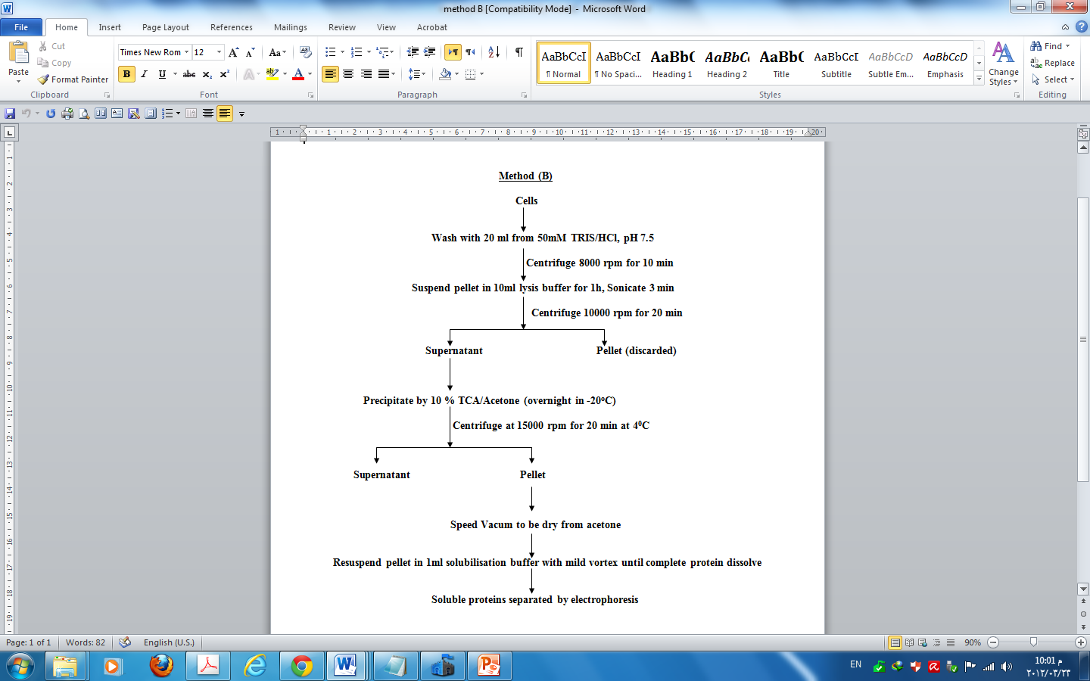

Figure 1: The protocols used for the preparation of proteins from mesophillic Pseudomonas syringae pv.tomato T1 and an Antarctic psychrotrophic bacterium Pseudomonas syringae Lz4W. The total protein extract obtained was precipitated using TCA/acetone (Mehtod B).
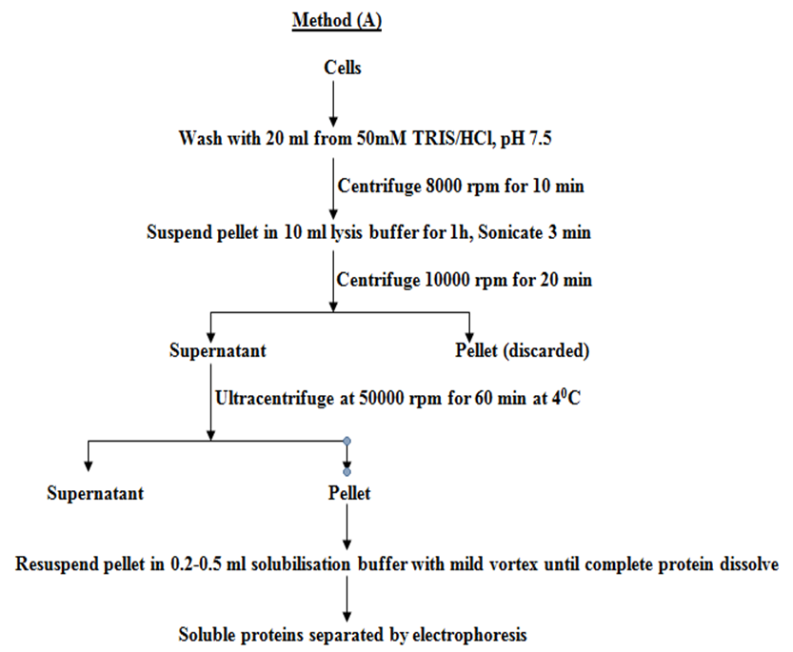

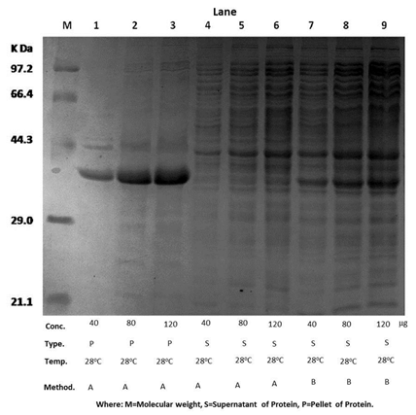

Figure 2: A representative gel picture of 1-D gel stained with coomasie blue. 12% SDS- PAGE of the proteins prepared from Pseudomonas syringae pv. tomato T1 . Lanes 1-3 shows different amounts of the proteins obtained from the pellet using method A, the soluble proteins were loaded at different amounts as shown in the lanes 4-6. Lanes 7-9 exhibits the proteins obtained from the precipitation (method B). The pellet proteins were solubilized in the solubilization buffer and the soluble proteins were loaded.
Comparison of protein profiles of the Psychrotrophic P.syringae and mesophillic P.syringae pv. tomato T1
The proteins prepared by both these methods were also separated by 2-D gels as described earlier [19-20]. It is observed that proteins prepared by method B could not be separated well on 2-D gels (data not shown). It is possible that proteins get aggregated during precipitation process and could not be solubilized after wards for the 2-D gel separations. Hence Method A was used for the preparation of proteins from the Antarctic bacterium P.syringae
Lz4W. The proteins were fractionated using method A for both the mesophillic Pseudomonas syringae pv Tomato T and Pseudomonas syringae Lz4W and separated the proteins on 1-D gel (Figure 3).
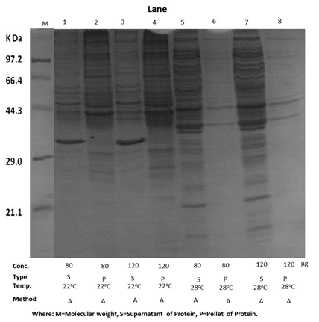

Figure 3: The proteins of both the bacteria were prepared using Method A and loaded on 12% SDS PAGE gel. The proteins obtained from the Antarctic psychrotrophic P.syringae Lz4W were shown in the lanes 1-4. Lanes 5-8 shows the proteins obtained from the mesopholic P.syringae pv.tomato T1. The proteins of the pellet were solubilized in the solubilization buffer and the soluble proteins were loaded. Different amount of proteins loaded on the gel were shown. The gel was stained with coomassie blue.

The proteins present in the supernatant and the pellet were separated after loading in different concentrations. Figure 3 shows that pellet obtained from mesophillic P.syringae contained less number of proteins as compared to the Antarctic bacterium P.syringae. Earlier studies demonstrated that the structure of the membranes varies in growth temperatures and also between a mesophile and a psychrotroph [21-23]. It is also possible that variations in protein contents between these bacterial species could be the reason for less number of proteins from the mesophile 2-D gels was run to evaluate the number of proteins.

Identification of proteins using LC coupled ESI MS/MS:
In order to compare the proteins present in these species, and also to evaluate the efficiency of the method used, the proteins prepared from each of the bacterial strain (mesophile and psychrotroph), were identified using proteomics approches. The gel bands were cut digested with trypsin and analyzed using LC coupled ESI mass spectrometry. The lanes of the gel (wells 3, 4 7and 8 of Fig 3) from Fig. 3 were cut, and each of them were analyzed separately. Approximately each lane was cut to 10 pieces and subjected to in-gel digestion and then analyzed the tryptic peptides extracted from these individual bands using mass spectrometry.
The proteins were identified using SEQUEST program supplied by the manufacturer. The proteins identified from the supernatant and pellet prepared from the mesophillic strain P.syringae pv Tomato T was combined together, removed the redundancy and showed in the supplemental Table S1. In the mesophillic strain Pseudomonas pv Tomato T 187 proteins were identified with more than one peptide and 114 proteins with single peptide (Table S1). A total of 301 proteins were identified.
Then, the proteins of the psychrotroph were also analyzed. This analysis identified 81 proteins with more than one peptide and 109 proteins with single peptide hits in the supernatant pseudomonas syringae Lz4W (suppl. Table S2). In the pellet 150 proteins were identified with more than one peptide and 176 proteins with single peptide hits (supplemental Table S3). The pellet contains 326 proteins (Table S2) and the supernatant contains 190 proteins (Table S3). From these results, it is clear that more proteins could be extracted and separated using Method A. Thus using proteomic approaches, it was demonstrated that more proteins could be prepared using Method A. This method is very useful for the extraction of proteins, particularly from the psychrotrophic strain of P.syringae Lz 4W. Some of the proteins identified in this study were shown to play an important role in cold adaptation [24, 25].

Protein separation on 2-D gels
Since two-dimensional gel electrophoresis (2-DE) is a powerful method to study protein expression, this technique, is also applied using the optimized total protein preparation methodologies to identify the number of proteins extracted from mesophillic and psychrotrophic bacterium. The proteins prepared using Method A were separated on 2-D gels. The proteins obtained in the supernatant and the pellet prepared by method A from the mesophillic P.syringae pv toamato were shown in the Figure 4.
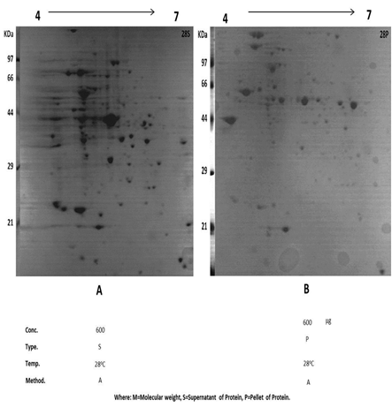

Figure 4: Two-dimensional gel pictures of the proteins prepared from the mesophillic P.syringae pv. tomato T1 were separated on a 12% SDS gel and stained with coomassie blue. Proteins were separated in the pI range 4-7. The soluble fraction was shown in 28S and the proteins solubilized from the pellet were shown in 28P.

It is clear from these results that the supernatant contains more proteins than the pellet. The pellet contains membrane proteins, and hydrophobic interactions among them might be main cause of their solubility and hence more proteins could not be detected. The proteins prepared by method B were also separated on gels. But very less number of bands could be identified (data not shown). During the protein precipitation process the proteins might aggregated and could not be solubilized and hence they could not even enter the gels. The proteins of Psychrptrophic P.syringae Lz 4W were prepared using Mehtod A as it was found to be a better method and separated the proteins on 2-D gels.
Figure 5 exhibits the proteins from P.syringae Lz4W. From these results it is clear that Pellet exhibited more proteins whereas the soluble fraction has few proteins. It appears that more membrane proteins or proteins with hydrophobic character could be extracted using the Method A. Thus, this method was found to be useful for the preparation of proteins from the Antarctic bacterium Pseudomonas syringae Lz 4W. Many proteins spots selected were cut from 2-DE gels and identified by matrix assisted laser desorption ionization time-of-flight mass spectrometry (MALDI-TOF MS) after trypsin digestion. We have identified 33 proteins from P. syringae Lz4W. Most of the proteins identified by MALDI TOF MS analysis were also found in the LC coupled ESI mass spectral studies. Thus by using different ionization methods, the proteins could be identified and confirmed and these procedures helped in evaluating the method for protein preparation.

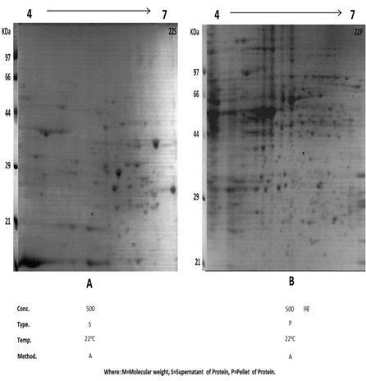

Figure 5: Two-dimensional gel pictures of the proteins prepared from the psychrotrophic P.syringae Lz4W were separated on a 12% SDS gel and stained with coomassie blue. Proteins were separated in the pI range 4-7. The soluble fraction was shown in 22S and the proteins solubilized from the pellet were shown in 22P.

Subcellular localization
The subcellular localization of the proteins identified from P. syringae Lz4W have been predicted using PSORTb V.3.0.2 as shown in Figure 6 and Table 1.

Table 1: Comparison of the Subcellular localization of proteins from P.syringae pv. tomato T and P.syringae Lz4W obtained from the supernatant and pellet using PSORTb.
No | Localization | Proteins of P.syringae pv tomato T | Proteins of P.syringae Lz4W obtained for the supernatant | Proteins of P.syringae Lz4W identified from the pellet
1 | Cytoplasmic [C] | 242 | 145 | 284
2 | Cytoplasmic membrane [CM] | 26 | 14 | 19
3 | Extracellular [E] | 0 | 0 | 2
4 | Outer membrane [OM] | 5 | 13 | 3
5 | Periplasmic [P] | 6 | 7 | 5
6 | Unknown [U] | 22 | 11 | 11
7 | Unknown (multiple localizations sites) [U(m)] | 0 | 0 | 2
8 | Total | 301 | 190 | 326
8 | Total | 301 | 516

It is clear from these results that out of total 429 proteins, 145 proteins are from cytoplasmic supernatant and 284 are from cytoplasmic pellet as predicted by the algorithm (Supplemental Tables 2 and 3). In addition there are 33 cytoplasmic membrane proteins, 16 outer membrane proteins and 12 periplasmic proteins. With multiple localization sites. It could also be possible that some these proteins are also part of membrane proteins. The location of 22 proteins could not be predicted, whereas 2 only proteins predicted unknown localization in contain multiple localization sites. It appears that method A preparation proteins has been shown to play an important role in cold adaptation were also identified.

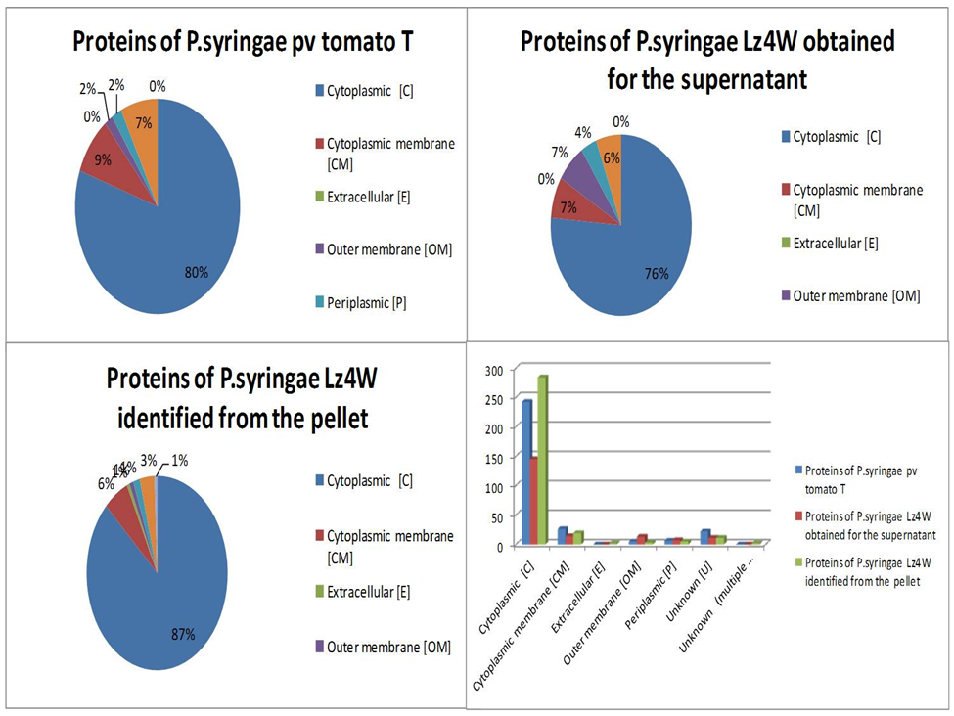
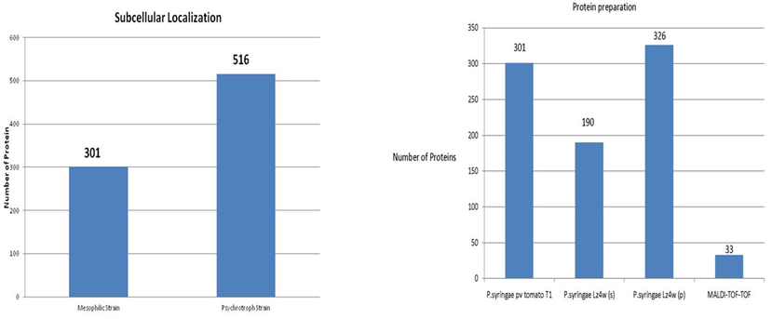

Figure 6: The sub cellular localization of the Proteins of P.syringae pv tomato T and P.syringae Lz4W, predicted by PSORTb.V.3. The number of proteins predicted in each subcellular location, C-ytoplasmic, CM-cytoplasmic membrane, E-extracellular, OM-outer membrane, P-periplasmic, U-unknown, U (M)-unknown location with multiple localization sites. Protein preparation by cell lysis followed by fractionation by ultra-centrifugation yielded more number of proteins as compared to the protein preparation by TCA/acetone precipitation. A mesophillic Pseudomonas syringae pv tomato T1 was used to optimize the method and applied the method to an Antarctic Psychrotroph Pseudomonas syringae Lz4W. 516 proteins were identified from P.syringae Lz 4W whereas 301 proteins were identified from P.syringae pv. tomato T1. Protein preparation method plays a crucial role in proteomics.

Gene Ontology
Using Gene Ontology, we classified three categories of GO as shown in Figure 7-9. Biological process refers to a biological objective to which the gene or gene product contributes. Molecular function is including specific binding to ligands or structures of a gene product and Cellular component refers to the place in the cell where a gene product is active Ontologies have long been used in an attempt to describe all entities within an area of reality and all relationships between those entities. Ontology comprises a set of well-defined terms with well-defined relationships. The structure itself reflects the current representation of biological knowledge as well as serving as a guide for organizing new data. Data can be annotated to varying levels depending on the amount and completeness of available information. This flexibility also allows users to narrow or widen the focus of queries. Ultimately, ontology can be a vital tool enabling researchers to turn data into knowledge [18].

Figure 7:
Biological process
Cellular process | 73
Localization | 8
Metabolic process | 8
Regulation | 5
Response to stimulus | 6

Cellular component
Cytoplasm | 48
Macromolecular complex | 15
Plasma membrane | 14
Ribosome | 2
Chromosome | 1
Other | 20

Molecular function
Catalytic activity | 49
Binding | 39
Structural molecule activity | 1
Antioxidant activity | 1
Other | 10

Figure 8:
Biological process
Cellular process | 77
Localization | 2
Metabolic process | 7
Regulation | 7
Response to stimulus | 4
Other | 3

Cellular component
Cytoplasm | 61
Macromolecular complex | 8
Plasma membrane | 4
Ribosome | 10
Chromosome | 3
Other | 9
Nucleus | 4
Mitochondria | 1

Molecular function
Catalytic activity | 50
Binding | 43
Antioxidant activity | 1
Other | 3
Structural molecule activity | 3

Figure 9:
Biological process
Cellular process | 65
Localization | 17
Regulation | 4
Response to stimulus | 9
Other | 5

Cellular component
Cytoplasm | 39
Macromolecular complex | 18
Plasma membrane | 14
Other intracellular organelles | 4
Other | 25

Molecular function
Catalytic activity | 28
Binding | 46
Antioxidant activity | 3
Other | 20
Structural molecule activity | 3

In this study, Figure 8 and 9 attempts are made to establish a procedure for total protein extraction from the culture pellet of P. syringae Lz4W using proteomic approach.
The earlier studies with membrane protein of P. syringae Lz4W were focused on identification of proteins from membrane preparation from an Antarctic bacterium Pseudomonas syringae, whose genome sequence is not available [13-14]. The method described in the present study aimed at preparing total proteins can be applied to other bacterial species as required often in proteomic applications.

Conclusions
In the present study, the efficiency of a method A to extract proteins from a mesophilic strain of Pseudomonas syringae pv. tomato T1 and an Antarctic psychrotrophic bacterium P. syringae Lz4W was evaluated using proteomics approaches. It is observed that TCA/ acetone precipitation methods are not suitable for preparation of proteins, particularly when they require to be separated on 2-Dgels. Moreover, we have identified several proteins which are associated with pathways involved in cold adaptation indicating a functional significance for these proteins in Pseudomonas syringae Lz4W.

Acknowledgements
This research work was supported by a grant from Department of Biotechnology (BT/PR7383/BRB/10/474/2006), New Delhi. Ehab Abou-Eladab worked at CCMB on a TWAS-CSIR postdoctoral fellowship. We thank Prof. Boris A Vinatzer from Virginia Tech, USA for providing the bacterial strain Pseudomonas syringae pv. tomato T.

Corresponding Author:
Dr. Ehab Fathy Aboueladab
Mansoura University-Branch Damietta
Faculty of Specific Education Damietta
34517 New Damietta City
Damietta, Egypt
E-mail: ehab10f@mans.edu.eg

References
- Anzai, et al.; Kim, H; Park, JY; Wakabayashi, H; Oyaizu, H. Phylogenetic affiliation of the Pseudomonads based on 16S rRNA sequence. Int J Syst Evol Microbiol, 2000; 50: 1563–89
- Hirano, S. S. and C. D. Upper. Population biology and epidemiology of Pseudomonas syringae. Ann Rev Phytopathology 1990; 28:155-177
- Hirano, S.S and Upper, C.D. Bacteria in the Leaf Ecosystem with Emphasis on Pseudomonas syringae a Pathogen, Ice Nucleus, and Epiphyte Microbiol and Mol Bio Rev, 2000; 64: 624-653
- Shivaji S, Rao NS, Saisree L, Sheth V, Reddy GSN, Bhargava PM. Isolation and identification of Micrococcus roseus and Planococcus sp. from Schirmacher Oasis, Antarctica. J Biosci, 1988; 13:409–414
- Shivaji S, Rao NS, Saisree L, Sheth V, Reddy GSN, Bhargava PM. Isolation and identification of Pseudomonas spp. From Schirmacher Oasis, Antarctica. Appl Environ Microbiol, 1989a; 55:767–770
- Shivaji S, Rao NS, Saisree L, Reddy GSN, Bhargava PM. Isolates of Arthrobacter from the soils of Schirmacher Oasis, Antarctica. Polar Biol, 1989b; 10:225–229
- Shivaji S, Ray MK, Seshu Kumar G, Reddy GSN, Saisree L, Wynn-Williams DD. Identification of Janthinobacterium lividum from the soils of the islands of Scotia Ridge and from Antarctic Peninsula Polar Biol, 1991;11:267–271
- Shivaji S, Ray MK, Saisree L, Jagannadham MV, Seshu Kumar G, Reddy GSN, Bhargava PM. Sphingobacterium antarcticus sp. nov. a psychrotrophic bacterium from the soils of Schirmacher Oasis, Antarctica. Int J Syst Bacteriol, 1992; 42:157–165
- Ashish K. Singh, Pavan Kumar Pindi, Smita Dube, V. R. Sundareswaran, and S. Shivaji. Importance of trmE for Growth of the Psychrophile Pseudomonas syringae at Low Temperatures. Appl. Envir. Microbiol, 2009; 75: 4419 - 4426.
- Ray, M.K., Kumar, G.S. and Shivaji, S. Phosphorylation of membrane proteins in response to low temperature in an Antarctic Pseudomonas syringae. Microbiol. 1994; 140:3217-3223
- Ray, M.K., Kumar, G.S., Janiyani, K., Kannan, K., Jagatap, P., Basu, M.K. and Shivaji. S. Adaptation to low temperature and regulation of gene expression in Antarctic psychrotrophic bacteria.J. Biosci. 1998; 23:423-435.
- Jagannadham, M.V., Rao, V.J and Shivaji, S. The major carotenoid pigment of a psychrotrophic Micrococcus reoseus: purification, structure and interaction of the pigment with synthetic membranes. J. Bacteriol. 1991; 173:7911-7917.
- M V Jagannadham. Identification of proteins from membrane preparation by a combination of MALDI TOF-TOF and IC-coupled linear ion trap MS analysis of an Antarctic bacterium Pseudomonas syringae Lz4W, a strain with unsequenced genome, Electrophoresis, 2008;29: 4341-4350
- Heramb M. Kulkarni, V. Ramesh, R. Srinivas and M.V. Jagannadham. Acetylating Tryptic Peptides Enhances b Ion Intensity in MALDI TOF/TOF: Implications in Peptide Sequencing and Identification of Proteins in an Antarctic Bacterium Pseudomonas Syringae, Proteomics Insights 2010; 3: 1–16
- Schaad, N. W. Laboratory Guide for the Identification of Plant Pathogenic Bacteria The American Phytopathological Society, 1980;St. Paul, MN. 72 pp. (p. 3)
- Laemmli. U.K. Cleavage of structural proteins during the assembly of the head of bacteriophage T4, Nature, 1970; 227: 680–685.
- Bhatia, V. N., Perlman, D. H., Costello, C. E., and McComb, M. E. Software tool for researching annotations of proteins: open-source protein annotation software with data visualization. Anal. Chem. 2009; 81, 9819–9823.
- Michael Ashburner et al .Gene Ontology: tool for the unification of biology,Nat Genet. 2000; 25(1): 25–29. doi:10.1038/75556.
- Jagannadham, M.V., Ehab, A.F and Kulakrni, H.M.The outer membrane proteins of an Antarctic bacterium Pseudomonas syringae Lz4W. 2011;doi:10.1074/mcp.M110.004549.
- Jagannadham, M.V. Membrane proteins of Antarctic bacterium Pseudomonas syringae. VDM Verlag. 2011; (ISBN: 978-3-639-33582-8)
- Kumar, G.S., Jagannadham, M.V and Ray, M.K. Low-temperature induced changes in composition and fluidity of lipopolysacchirides in the Antarctic psychroteophic bacterium Pseudomonas syringae. J.Bacteriol. 2002; 184: 6746-6749.
- Suutari, M., and Laakso, S. Microbial fatty acids and thermal adaptation. Crit. Rev. Micribiol. 1994; 20:285-328.
- Jagannadham, M.V., Chattopadhyay, M.K., Subbalakshmi, C., Vairamani, M., Narayanan, K., Rao, C.M and Shivaji, S. Carotenoids of an Antarctic psychrotolerant bacterium, Spingobacterium antarcticus and a mesophillic bacterium Spingobacterium multivorum. Arch. Micribiol. 2000; 173: 418-424.
- Chattopadhyay, M.K Mechanism of bacterial adaptation to low temperatures. J. Biosci 2006; 31: 157-165.
- Strocchi, M., Ferrer, M., Timmis, K.N and Golyshin, P.N. Low temperature-induced systems failure in Escherichia coli: Insights from rescue by cold adapted charepons. Proteomics 2006; 6: 193-206.

