Role of Biological Fluids in Crime Detection

¹Richa Mehta and ²Dr. S.S. Chandna

¹Senior Scientific Officer (Biology Division) ²Assistant Director (Serology Division)
Forensic Science Laboratory (Haryana) INDIA
richamehtaa@gmail.com

Abstract: All sorts of biological fluids have a severe impact in detection, determination, reconstruction and confirmation of heinous crime. Significance of blood, semen, sweat, saliva, urine etc. lies in the fact that these fluids come out of the body and show multi-direction spread. Moreover, each fluid has its own inherent and distinct features in functioning of body as well as after attaining mortality by the individual. However, individual qualities of blood in consonance of magnetic resonance both in male and female reveal unique parameter of attraction or passive repulsion. Magnetic properties prevalent in the liquid connective tissue also bind lipophilic substances to show more endogenous rhythmic activity to get synchronised with a friend but definitely rhythmic activity of high amplitude has been noticed towards a foe or an accused. Blood of an accused and that of a victim replenishes a severe flow but blood of the victim tries to desist the aggressiveness of the accused displayed by his body. Magnetic induction being displayed through biological fluids-blood and semen have further revolutionized the thinking of Forensic Biologists that why there is strong affinity between male and female. Magnetic devices have to be designed for examination of biological fluid to prove detective value to be followed and to be linked as an active ingredient in the true spirit of circumstantial evidences. Effective corroboration correlated with these vital clues i.e. body fluids enhance the specificity of real happenings of perpetuation of crime. Moreover, scientific sanctity sorted out in the performed experiments will be of immense use in prosecuting system. When true findings come in light, only then it becomes the legitimate issue being exercised in Honourable Courts to fairly dispose the cases.
[Richa Mehta and Dr. S.S. Chandna. Role of Biological Fluids in Crime Detection. Nature and Science 2012; 10(4): 115-119]. (ISSN: 1545-0740). http://www.sciencepub.net/nature. 17
Keywords: Body Fluids, Semen, Blood, Magnetic Resonance, Crime.

Introduction:
Blood plays a vital role in heinous crimes related to murder, accident, poisoning, drowning, suicide cases etc. Much work has been carried out on the role of blood as an oxygen and micronutrients carrier to various tissues, but certainly a little work has been done towards its role in crime detection and linking this vital clue for prosecution. Lack of attention is so cumbersome that inspite of demands for maintaining low temperature for further deterioration of blood enzymes have not been fulfilled till date.
Remedial measures are being adopted to streamline the analytical framework to be carried out in the laboratory. Special emphasis has been given with respect to earmarking acidity/ alkalinity of blood and serum components. Magnetic resonance has been duly highlighted in our recent findings which will corroborate the evidence to a larger extent. Important yardstick measure has to be adopted with regards to viscous nature of the blood .Though a large work has been done on various parameters of blood i.e. blood glucose, blood urea, serum alkaline phosphate, serum proteins etc. but pH and magnetic resonance of blood are our main concerns which will further cater to attention of investigating agencies to get benefit of analysis and further to mould the case for better prosecution.
Viscosity of the blood depends on-(1) Hematocrit (2) Composition of the plasma. Hematocrit is defined as percentage of the volume of the blood occupied by red cells and increased value of Hematocrit results in increased viscosity of blood due to polythemia and decreased value of hematocrit further lead to decreased viscosity due to anaemic conditions. While composition of the plasma depends upon the presence of plasma proteins such as immunoglobins and resistance of the cells to deformation. Increase in plasma proteins (immunoglobins) is associated with increased viscosity whist while increase in cells to deformation results in further increase in viscosity.
Unique feature of fetal hemoglobin is that it has less affinity for oxygen than adult haemoglobin as it has less affinity for 2,3 DPG than HbA. These conditions are only applicable under ideal conditions and normal body circulation. If a person is dependent upon drugs then values of hemoglobin etc. change to a larger extent as blood pH changes due to “Aspirin”. Aspirin has an anti plate action. A single dose of aspirin can inhibit the platelet cycloxygenase as the life of the platelet is 8-11 days. Platelets being non-nucleic have a little or no capacity for protein synthesis.

Table 1: ABO Blood group system (Discovered by Karl Landsteiner)

ABO Blood group system
Phenotype | Genotype | Antigens | Antibodies | Frequency (%)
O | OO | O | Anti-A, Anti-B | 46
A | AA or AO | A | Anti-B | 42
B | BB or BO | B | Anti-A | 9
AB | AB | AB | None | 3
Note: The agglutinogens of ABO system are also present in Saliva, sweat and semen but not in cerebrospinal fluid.

The examination of fresh sample of blood is done for solving cases pertaining to disputed maternity or paternity i.e. “In spite of a large number of blood grouping systems, a positive conclusive identity of a father cannot be established but a definite non identity that is the elimination or exclusion can be established”. Thus a conclusive evidence cannot be sought but a magnificent contribution can be made for establishing the proof of paternity by various blood group systems and their inheritance.

Medico legal aspects of Blood grouping:-
A blood group antigen cannot appear in a child unless present in one or the other parents. If a person is homozygous for a blood group factor, it must appear in the blood of all his children. If a child is homozygous for a blood group factor, the gene for the same must have been inherited by him from each of his parents. Blood group factor can be best defined as- Inherited human characteristic and therefore considered as most useful in identification problems as in paternity testing.An absolute identification can also be made by DNA testing. However, blood group characters are unique and peculiar to the person and remain unchanged throughout life. Therefore, blood group determination linked to medico legal problems can be applied for several purposes (1) Rh Hazards (2) Transfusion errors (3) Inheritance claims (4) Disputed paternity and maternity (5) To determine the possible source of blood stains in cases of murder, rape, accidental injuries including vehicular accidents etc.
Erythropoietin is a plasma protein that acts as a hormone. It is the major regulator of human erythropoiesis. As the level of 2, 3 DPG increases; oxygen dissociation curve shifts to right i.e. more oxygen will be available to the tissue and if 2, 3 DPG level falls, oxygen dissociation curve shifts to left i.e. haemoglobin has high affinity for oxygen and availability of oxygen to the tissue decreases. e.g. in blood transfusions, generally stored blood is involved i.e. in bank blood that is stored; 2, 3 DPG level falls, which shift oxygen dissociation curve to the left. Thus, the availability of stored blood to release oxygen in tissues is drastically reduced.

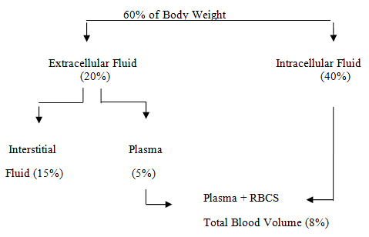

Figure 1: Total Blood Volume

The solvent used for blood stains is 10% solution of potassium cyanide and approximate age of blood stains can be determined by colour changes, rate of solubility in water and degree of fluorescence. Dark brown coloured blood stains on white cloth suggests that its age is more than 24 hours whist while vegetable stains can be differentiated from blood stains due to presence of tannin.

Table 2: Effect of Blood Loss on physiological processes changes
Blood Loss | <15% | 15-30% | 30-40% | >40%
Blood pressure | No Change | No Change | Reduced | Markedly reduced
Heart Rate | Slight Increase | 100-120 | >120 upto a week | >120,thready
Respiratory Rate (Breathe/min.) | Normal | Increased | >20 | 20-30
Note: Menstrual Blood loss has fibrinolysins.
Table 3: Summary of Blood Components
COMPONENT | COMPOSITION | SHELF LIFE
BLOOD AS A WHOLE  UNIT | (1) RBCs (2) Non-functional  WBCs & Platelets; plasma.900 ml  of total volume contains 400 ml of  RBC | CPDA-1:35 days  (at temp 1º to 6º c)
Packed RBCs | RBCs; some plasma; non-functional  WBCs and platelets (500 to 700ml total  volume contains 400 ml of RBC) | AS 1:42 Days  (1º-6º c)
Leukocytes-Reduced  RBCs | RBCs; Minimum plasma and non-fun-  tional WBCs and platelets (400ml total  volume contains 340 to 380ml of RBCs) | 24 hours (1º-6º c)
Platelets (Single unit  From WHOLE BLOOD) | Platelets, some Non-functional WBCs  few RBCs; plasma (50 to 70 ml) Total  volume contains 5.5 (10¹⁰ platelets). Level  of labile Clotting factors depend on storage  time. | 5 days (20º-24º c)
Fresh Frozen Plasma | Plasma, all coagulation factors (180-250 ml.  contains 0.7 to 1 unit/ml of prothrombin -  Factors V, VII, VIII, IX, XII and XIII and  500 ml. of fibrinogen) | Frozen 1 year  (<30ºc)

Table 4: Percentage of blood in various blood vessels

AOROTA | 2%
ARTERY | 8%
ARTERIOLE | 10%
CAPILLARY | 5%
VENULE, VEIN & VENA CAVAE | 54%

Material and Method
Samples of vaginal swabs, vaginal smear, menstrual blood and normal blood were collected from the different localities and the age group (13-40 years), irrespective of cast, community and creed. Their pH was measured by using pH strips.A graduated glass slab coined with the help of glass manufacturer ie Krishna glassware and allied services at Muradabad (UP),India having two cavities with the retaining capacity of 10 ml. blood impregnated liquid along with three magnetic strips that were placed equidistant from each other were used and the impact of solution running through the graduated capillaries was observed.
Results and discussion
Though small creatures were used as material for experimentation. During the past decades Indian desert gerbils were used in the Department of Zoology, University of Rajasthan, Jaipur and in HAU , Hisar small albino mice and Indian gerbils, Tatera indica Hurrianae were being used for haematological, toxicological, histopathological studies etc. Trials on human beings are made ,followed by satisfied with experimental trials on these small mammals. Results achieved from these animals have been found to be in consonance with that of human beings as blood of mammals bear striking resemblances.

.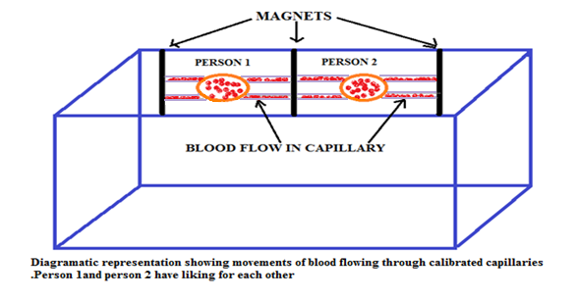
Figure 2: Magnetic effect in blood of two persons who have liking for each other

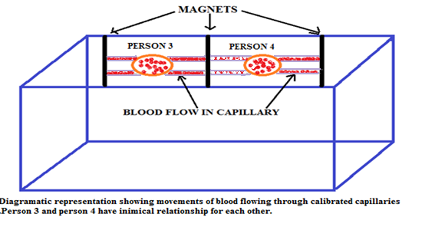
Figure 3: Magnetic effect in blood of two persons who have inimical relationship

Lipophilic substances tend to increase in person having liking for each other. Lipophilic substances being triggered by enzymes from posterior part of pituitary gland have enhanced interactions as well as activating haematin activity thus increasing the rate of synthesis of haemoglobin which emanates as per strong will of the person. However, the persons having an inimical stand have been found to be obsessed with secretion of fewer enzymes to further associated with curtailment of lipophilic substances thus deviating from the normal flow of haemoglobin in the blood. Therefore, intensive studies were carried out keeping in view the hazards of less erythropoietin in the bones of the persons which get more ossified thus reducing the lumen in which bone marrow exists and propagates. Activity of erythropoietin is related to production of erythrocytes which show magnetic power and raise the internal alarm when counteracted by the magnetic influence of other personalities. Therefore, a severe endogenous rhythmic activity is generated to maintain a reflex arc in proportion to magnetic waves resonating in the body fluids of victims or accused ones thus creating a formidable reaction. In Germany blood groups are being changed from one form to another for transfusion by enzymatic activity and strong lipophilic substances. Now time has come that blood groups of any kind will be transformed in to resembling blood group to be transfused in the injured persons or patients. Even experiments are going on to counter react the mechanism of Rhesus factor Rh+ or Rh- to create a normal degree of antigens and antibodies for likelihood. Similarly in Denmark, experiments are being performed in bovine fluids. Normal concentration of Sodium azide being miscible with body fluids has given an imperative luminescence.
- pH of menstrual blood is always less than 7 i.e. acidic in nature.
- Flow of blood obtained from assailant and victim was found to be deviating from the normal flow. For further establishing that Lypophilic substances were prevalent in the blood of women were found to be deviating from the normal mean.

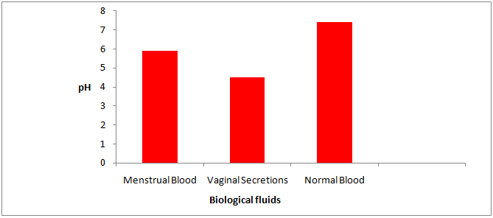
Figure 4: Bar Diagram reveals pH of various body fluids

Corresponding Author  Richa Mehta  Senior Scientific Officer (Biology Division) Forensic Science Laboratory Madhuban, Karnal- 132001, Haryana (India) Mobile no. +91-9896154747 |  | References:  - Kirk, P.L. Crime Investigation- blood individual factors Haemoglobin. Thornton, Johnl., edition.1914; 205.  - Devenport, H. E. Biochemist’s Handbook Haematin Compounds in Plants. 1971; 1033  - Collection and Examination of Significant Clue- Blood from the Crime Scene. Journal of American Science 2012;8(2):386-391]. (ISSN: 1545-1003)

