Biodegradation Of Rattan Wood And Maize Stovers By Pleurotus ostreatus

Adenipekun^{1*},C.O and Okunlade,O.A.²

¹Department of Botany, University of Ibadan, Ibadan, Oyo state, Nigeria.
²Department of Microbiology, University of Ibadan, Ibadan, Oyo state, Nigeria.
oyinpek@yahoo.com, yemioklad@yahoo.com

Abstract: Studies were carried out on the degradation of rattan wood and maize stovers using Pleurotus ostreatus in cultures incubated for 0-90days.The proximate composition, percentages of nitrogen, carbon and potassium, pH, loss of organic matter, loss of water, fibre content, organic matter digestibility, metabolisable energy and in-vitro gas digestibility were determined using the substrates degraded by P.ostreatus. In degraded rattan wood, crude protein increased significantly from 1.52% to 3.99% and on maize stovers 2.74% to 7.45%. Crude fibre decreased significantly from 46.05% to 20.13% for rattan wood and maize stovers from 33.25% to 15.66% after 90 days of incubation. In both substrates ether extract, ash and dry matter contents also decreased but moisture contents increased from 0-90days.Percentage of nitrogen, carbon and potassium increased with increase in incubation period. The pH decreased, the least value being 3.78. Loss of organic matter in the substrates decreased significantly as the period of incubation increased. There was also significant decrease in loss of water as the incubation period increased, the lowest being 37.25 in rattan wood. The fibre content and enzyme production decreased but the organic matter digestibility and metabolizable energy increased with increasing incubation period .Gas production for in-vitro gas digestibility increased at three hour intervals with highest volume being 28.00ml at 24hours for maize stovers.
[Adenipekun CO,Okunlade, O.A. Biodegradation of Rattan Wood and Maize Stovers by Pleurotus ostreatus. Nature and Science 2012;10(5):49-57]. (ISSN: 1545-0740). http://www.sciencepub.net/nature. 5

Key words: Biodegradation, Rattan wood, Maize Stovers, Pleurotus ostreatus

- Introduction
Biodegradation is the biological process involving chemical dissolution of materials resulting from the complex activities of living microorganisms such as bacteria and fungi (Diaz, 2008). The term often used in relation to ecology, waste management, biomedicine and the natural environments, is now commonly associated with environmental products that are capable of decomposing back into natural environment. Biodegradable matter is generally organic material originating from living organisms or other artificial materials that are similar enough to plant and animal matter to be put to use by microorganisms (Luzier, 1992). Organic material can be degraded aerobically or anaerobically.
In the opinion of Williams (2001), wood debris and by products of wood processing, pollute the environment even though the debris are materials suited for biodegradation. Maize stovers are the remnants of maize (Zea mays) plants left in a field after the harvest and made up stalk, leaf husk and cob following the harvest of cereal grain. Rattans are vine-like plants having slender stems with long internodes. When used in small-scale industries, rattan pieces constitute organic wastes. Rattan wood consists of fibres and other lignocellulosic materials comprising of three main polymeric constituents: cellulose, lignin and hemicelluloses (Higuchi, 1997).Lignin is the second most abundant renewable organic polymer on earth and is the major part of wood. As lignin and other lignocellulosics are renewable resources for the production of paper products, feeds, chemicals and fuels, there has been increasing research emphasis on the fungal degradation of lignin (Boominathna and Reddy, 1992).
Fukushima and Kirk (1995) identified that basidiomycetes such as Pleurotus spp lacked lignin peroxidases indicating that different enzymes are probably involved in the lignin biodegradation. As reported by Marzullo et al.(1995),enzyme secreted by Pleurotus ostreatus produced significant reduction in the molecular mass of soluble lignosulphates. Lignolytic fungi produce extracellular enzymes with low substrate specificity suitable for degradation of many different compounds notably organopollutants. The fungal biomass obtained after mycoremediation of crude oil and palm kernel sludge contaminated soils could be further exploited as spawn, fertilizer and fodder enrichment (Adenipekun and Lawal, 2011).
The available wastes such as maize stovers, corn cob and maize husk cereal straws are not able to meet nutritional requirements of ruminants. To dispose these wastes, they are usually burnt in heaps thereby releasing offensive odour and gases into the atmosphere. Some are even thrown in the rivers and streams thereby endangering aquatic lives.
The degradation of plant organic wastes using an edible fungus in a recycling technology may be adopted by farmers in developing countries. Therefore, the study was undertaken to investigate the potential of Pleurotus ostreatus in degradation of maize stovers and rattan wood. The study which aimed at ascertaining the in-vitro gas digestibility and the nutrient contents of the degraded substrates also determined the enzyme activities involved in the degradation.

- MATERIALS & METHODS
  - Cultivation and Incubation of fungus
The pure culture of Pleurotus ostreatus was obtained from Plant Physiology Laboratory of Department of Botany, University of Ibadan. Fresh cultures were obtained by repeated sub-culturing on Potato Dextrose Agar (PDA) and incubated.
The substrates used for this study were rattan wood and maize stovers. Pieces of rattan wood were collected from Bodija market, Ibadan, Nigeria and maize stovers from Agriculture farm, University of Ibadan. Freshly harvested rice straw obtained from International Institute of Tropical Agriculture (I.I.T.A) Ibadan, was sun-dried for two weeks to prevent decomposition then cut into 5metres size using guillotine. Wheat bran was obtained from Bodija market, Ibadan.
2.2 Digestibility Test
The method of Adenipekun and Fasidi (2005) was employed. Twenty five grammes (25g) of each of the dry wastes of the rattan wood and maize stovers were weighed into each conical flask and squeezed out after 75ml of distilled water was added. The flasks were covered with aluminium foil then sterilized at 121⁰C for 15 minutes and later inoculated with two 5mm agar diameter mycelia at the centre and covered immediately except for the controls which were not inoculated. The flasks were incubated at 30 ± 2⁰C and 100% relative humidity. The uninoculated controls were put in an oven at 100 ± 2⁰C for 48 hours to determine the initial dry weight of the substrates. The experiment was replicated four times and conical flasks were observed daily for sclerotium development. The conical flasks were harvested after 30, 60 and 90 days. 5g of the degraded substrates was aseptically weighed out for enzyme analysis and then placed in the oven for 48 hours at 100 ± 2⁰C to determine dry weights.
2.3 Nutrient Content Analysis
Crude fibre (CF), Neutral Detergent Fibre (NDF), Acid Detergent Fibre (ADF), Acid Detergent Lignin (ADL) Dietary Fibre (DF), Loss of organic matter (LOM), Loss of water(LOW) and pH were determined as described by Zadarazil and Brunnert (1982).The method of Association of Official Agricultural Chemists (A.O.A.C. 2003) was used to determine organic carbon, organic matter, percentage nitrogen, phosphorus, potassium and enzymes assay.
2.4 Enzyme Assay
Cellulase was assayed using 3,5-dinitrosalicyclic acid(DNSA) and the amount of reducing sugar formed was determined according to Denison and Koehn (1977),amylase according to method ofWilson(1971),peroxidase using method of Keilin and Hartee (1951) and lignase by the method of Berridge(1955).
2.5 Determination of in-vitro gas Production
The in-vitro gas production was determined following the procedure of Menke and Steingass (1988). A sensitive scale was used to measure out 200mg of the milled samples (rattan wood and maize stovers); these were placed into 120ml graduated syringes. Two replicates were prepared. Rumen fluid was obtained from two West African dwarf female goats and one West African dwarf male goat. The method for collection (Babayemi and Bamikole, 2006a) involved using suction tube from goats which were fed with concentrate feed (40% corn, 10% wheat offal, 10% palm kernel cake, 20% groundnut cake, 15 common salt, 3.75% oyster shell and 0.25% fish meal. Incubation procedure was carried out as reported by Menke and Steingass (1988) using 120ml calibrated syringes in triplicates at 39⁰C. 30ml of the inoculums containing rumen liquor and buffer (g/litre) of 9.8 NaHCO₃ + 2.77Na₂ HP0₄ + 0.57 KCL + 0.47 NaCl + 0.12g MgS0₄. 7H₂0 + 0.16g CaCl₂.2H₂0) 1:4 v/v) under continuous flushing with carbon dioxide (C0₂) was strained using cheese cloth and dispensed using another 50ml plastic calibrated syringe. The syringe was tapped and pushed upward by the piston in order to completely eliminate air in the inoculums. The silicon tube in the syringe was then tightened by a metal clip so as to prevent escape of the gas. Incubation was carried out at 39 ± 1⁰C and the volume of gas production was measured at 3,6,9,12,15,18,21 and 24h. At post incubation period, 4ml of Na0H (10M) was introduced to estimate methane production.
The post incubation parameters such as Metabolisable Energy (ME) and Organic Matter Digestibility (OMD %) were estimated MJ/KgDM according to the method described by Menke and Steingass (1988).
2.6. Experimental Design
The experimental design used was randomized factorial experiment which include one fungus Pleurotus ostreatus, the two substrates, rattan wood and maize stovers, incubated for 0,30,60 and 90 days. An ANOVA table was prepared using the Duncan’s multiple range test for the first series of experiment on lignin-degrading abilities of the white-rot fungus. Each treatment was replicated four times.
3. Results
3.1 Effects of Pleurotus ostreatus on Proximate composition of maize stovers and rattan wood.
Figure 1 shows the proximate composition (g/100gDM) of Pleurotus ostreatus on degraded rattan wood and maize stovers incubated for 0-90days. The crude protein contents of the fungal treated increased significantly throughout the incubation period, from 1.52% in the control to 3.99% in the rattan wood, and in maize stovers from 2.74% (control) to7.45%.The Crude Fibre(CF) decreased significantly compared to untreated substrates as the rate of incubation increased. Rattan wood treated with P. ostreatus decreased from 46.05% in the control to 20.13% after 90days; maize stovers treated with the fungus decreased significantly from 33.25% to 15.66%.Ether extract content, Ash and dry matter of the fungal treated substrates decreased with increasing rate of incubation. Ether extract content in rattan wood decreased from 0.25% in the control 0.13% and in maize stovers from 0.70% in the control to 0.14%. In the untreated substrate, the ash content of rattan wood decreased from 7.38% to 3.80% and in maize stovers from 4.88% to 2.16%. rattan wood decreased from 7.38% to 3.80% and in maize stovers from 4.88% to 2.16%. The dry matter decreased in treated rattan wood from 91.62% in the control to 81.22% and maize stovers from 91.39% (control) to 90.10%. Moisture content increased as the incubation period increased in rattan wood from 8.40% (control) to 9.79% and in maize stovers from 6.12% in the control to 9.65%.
3.2 Percentage of nitrogen, carbon and potassium on degraded substrates.
The percentages of nitrogen, carbon and potassium of the substrates are shown in figure 2 .With increasing incubation period, the percentage nitrogen of treated rattan wood increased from 0.24% in the control to 0.64% and in maize stovers from 0.44% in the control to 1.87%. Carbon content of rattan wood increased from 2.99% in the untreated substrates to 7.81% and in maize stovers from 5.80%(control) to 10.62%.The potassium content in treated rattan wood increased from 2.83% to 11.35% while that of maize stovers increased from 2.62% to 10.14%.
3.3 Effects of P.ostreatus on pH, Loss of organic matter and Loss of water on degraded rattan wood and maize stovers.
As shown in Figure 3, the pH decreased as the incubation period increased. The pH of rattan wood decreased from 5.48 to 3.78 and in maize stovers from 6.53 to 4.02 after 90 days incubation. The percentage loss of organic matter decreased with increase in incubation period. In rattan wood the decrease was from 29.25% in the control to 22.25% and in maize stovers from 40.00% in the control to 16.00%. There was also decrease in the percentage loss of water as the incubation increased. In rattan wood, the decrease was from 52.25% to 37.25% while that of maize stovers was from 50.00% to 39.00%.
3.4 Effects on P.ostreatus on degraded rattan wood and maize stovers in evaluating the NDF, ADF, ADL, Cellulose and Hemicelluloses content.
In Table 1, there was consistent decrease in the Neutral Detergent Fibre (NDF), Acid Detergent Fibre (ADF), Acid Detergent Lignin (ADL), cellulose and hemicelluloses. The NDF of the treated rattan wood decreased from 75.98% to 36.74%. ADF from 64.38% to 33.10%, ADL reduced from 55.27% to 25.30%; cellulose from 14.11% to 4.80% and the hemicelluloses from 11.60% to 3.64%.The NDF of maize showed reduction from 66.03% (control) to 22.28%, ADF of the maize stovers decreased from 55.66% to 23.43%; the ADL, cellulose content and hemicelluloses content of the maize stovers treated decreased from 43.31% to 14.65%; 13.60% to 4.17% and 8.11% to 2.85% respectively.
3.5 Effects of P.ostreatus on degraded rattan wood and maize stovers for enzymes production
Table 2 shows the production of amylase, cellulase, lignase and peroxidase by P. ostreatus for 0-90 days. There was decrease in enzyme production as the period of incubation increased. The amylase produced in treated rattan wood decreased from 0.21 unit/ml after 30 days to 0.14 unit/ml after 90 days; the cellulase decreased from 0.14 unit/ml after 30 days to 0.11unit/ml while lignase and peroxidase decreased from 0.36 unit/ml to 0.18 unit/ml and 0.41 unit/ml to 0.18 unit/ml after 90 days incubation. The amylase produced in maize stovers decreased from 0.21 unit/ml after 30 days to 0.10 unit/ml for 90 days of incubation while cellulase, lignase and peroxidase decreased from 0.19 unit/ml to 0.15 unit/ml; 0.20 unit/ml to 0.15 unit/ml and 0.16 unit/ml to 0.13 unit/ml after 90 days of incubation respectively.
3.6 Effects of P.ostreatus on degraded rattan wood and maize stovers in evaluating organic matter digestibility and metabolisable energy used.
As shown in Table 3, the organic matter and metabolisable energy increased as the incubation period increased. Treated rattan wood for organic matter increased from 5.16% in control to 13.47% and in maize stovers from 9.56% to 21.31% while metabolisable energy in rattan wood from 2.35 MJ/KGDM to 2.67MJ/KGDM and in maize stovers increased from 2.21MJ/KGDM to 2.65MJ/KGDM.
3.7 Effects of P.ostreatus on the degraded rattan wood and maize stovers for in-vitro gas production
Table 4 shows the in-vitro gas production of degraded rattan wood and maize stovers. It was observed that gas production increased at 3 hours interval for 24 hours and that the methane gas production increased with increasing incubation period. Treated rattan wood produced methane at 0,30,60 and 90 days with values 6.00ml, 8.00ml, 9.00ml and 13,00ml respectively while in maize stovers 6.00ml, 8.00ml, 9.00ml and 17.00ml of methane were produced at 0,30,60 and 90 days respectively. The highest volume of gas was produced at 90 days incubation.
- Discussion
White rot basidiomycetes are the most potent lignin degraders of all known microorganisms (Galhaup et al., 2002). In the present work, Pleurotus ostreatus degraded rattan wood and maize stovers. The crude protein in the treated substrates for both rattan wood and maize stovers was higher than the untreated substrates throughout the period of incubation. This is in line with Belewu and Belewu(2005) where it was observed that the addition of fungal protein during solubilization and degradation of rice husk increased the crude protein content .Jonathan et al (2010) also reported increase in fungal protein when maize stovers was treated with Pleurotus tuber-regium.
The decrease in fibre analysis of Pleurotus ostreatus on degraded rattan wood and maize stovers could be as a result of cellulosic enzymes secreted by cellulolytic fungi. As observed by Isikhuemhen and Nerud (1999) white-rot fungi have been known to produce extracellular lignin modifying enzymes, in which the best characterized enzymes, are laccase, lignin peroxidase and manganese peroxidases. Belewu and Belewu (2005) reported that degradation of banana leaves decreased in fibre contents or fractions due to the production of various enzymes during the vegetative and reproductive phases with lignocelluloses degrading properties.
Akinfemi et al. (2010) reported that hemicelluloses reduced when Pleurotus ostreatus was used during biodegradation of agricultural waste of sorghum stover because of energy availability.They also observed that it could be due to differences in Pleurotus species. The decrease in crude fibre fractions in the substrate might have been as a result of the fungal ability to produce extracellular enzymes capable of reducing the fibre contents.In another study, Akinfemi et al. (2009) were of the view that decrease in the value of detergent fibre (hemicelluloses, cellulose and lignin) and acid detergent fibre (lignin and cellulose) for fungal treated maize cobs could be as a result of extra cellular enzymes produced by Pleurotus ostreatus.
Karunanandaa and Varga (1996) concluded that lignifications of structural polysaccharides would not only inhibit ruminal microbial digestion of polysaccharide by forming 3-D matrix, but also that the presence of highly lignified tissue formed a barrier preventing accessibility of the otherwise highly digestible tissue to the action of hydrolytic enzymes of the rumen microorganisms. Increased digestibility was shown to be associated with the degradation of structural carbohydrates.
The decreasing crude fibre and crude fibre fractions could also be as a result of activities of celluloytic bacteria (Sallam et al.; 2007). During fungal growth, part of the cell wall is converted into soluble sugars to provide energy a phenomenon that could be responsible for decrease in a major fibre (cellulose and hemicelluloses components).The increase in percentages of nitrogen, carbon and potassium might be due to the fact that mushrooms contain appreciable amount of mineral elements. Isikhuemhen et al.(1996) reported that variation in mineral elements present in a mushroom may not be unconnected with the type of substrates used during duration of fermentation and the specie of fungus used. The change in pH value may be associated with the increase in amino nitrogen content and the presence of metabolic waste products within the substrates.This agrees with the finding of Jonathan et al .(2004) observing a change in pH during the growth of V. esculenta in submerged medium. The increase in amino nitrogen content may be due to hydrolysis of protein within the substrates.
The decrease in organic matter during the incubation period may be due to the release of carbon content released by the fungi during the period of degradation of the substrates. This agrees with the observation of Zadrazil (1985) who reported that under favourable conditions,some fungi can completely mineralize straw during 80-100days of fermentation.
Water is essential for supporting the metabolic activities of fungi, thereby enhancing the biodegradation process of the substrates. Tamara et al. (1996) observed the importance of water content in the solubilization of lignin at the vegetative phase and reproductive phase with lignocellulose degrading properties.This may explain the decrease in the loss of water with increase in the incubation period in the present study.
The depletion in enzymes production as the incubation period increased might be due to metabolic activities during the process of degradation where enzymes were being used up to aid the process. Kuforiji and Fasidi (2008) reported that higher activities of proteinase, cellulase, lipase and catalase were observed in the fruit bodies compared to the sclerotia. These enzymes were found to affect the shelf life, food nutrient and flavour of the mushroom.In a similar report,Rajarathman et al. (1998) stated that edible mushrooms are able to bioconvert a wide variety of lignocelluloses materials due to secretion of extracellular production with increasing incubation period. Incubation with Pleurotus ostreatus brought about an increase in metabolisable energy in treated substrates. This agrees with the report of Babayemi et al. (2004) that the enhanced crude protein softened crude fibre and crude fibre fractions most likely contributed to the best values observed for organic matter digestibility and metabolizable energy in Pleurotus tuber-regium and Lentinus subnudus.
The increase in organic matter digestibility and metabolisable energy could be as a result of increase in crude protein and it shows that microbes in the rumen and animals have high nutrient uptake(Chumpawadee et al.,2005).There are many factors that determine the amount of gas during fermentation depending on the nature and level of fibre (Babayemi et al., 2004) and potency of the rumen liquor used for incubation.The gas production is a function and mirror of degradable carbohydrates and therefore the amount of gas produced depends on nature of the carbohydrates. Methane gas production was observed to be high in treated substrates. Methane gas production has negative effects on the animals because it is energy loss to animal. However when it accumulates in the rumen it causes bloat (Babayemi, 2006). Therefore, a reduction in the methane gas production is saving energy for the animal.

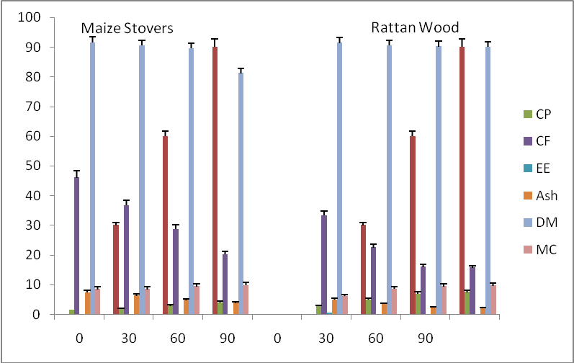

0 30 60 90 0 30 60 90

Days
Days

Figure 1: Effects of Pleurotus ostreatus on proximate composition (g/100gDM) of the degraded maize stovers and rattan wood.
Each value is a mean of 4 replicates

CP = Crude Protein, CF = Crude Fibre, EE = Ether Extract, DM = Dry Matter and MC = Moisture Content

Rattan wood
Maize stovers
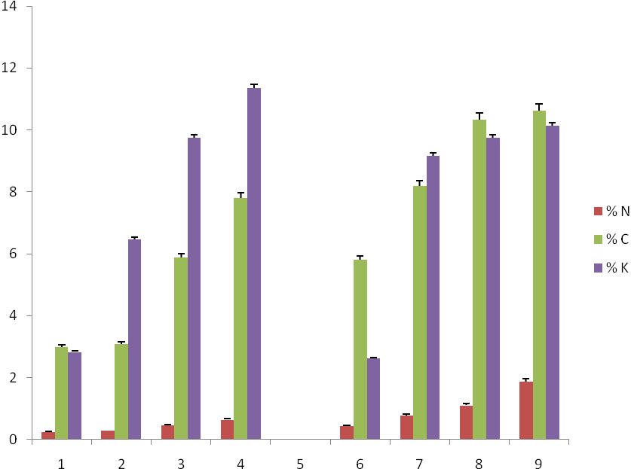
0 30 60 90 0 30 60 90

Days
Days

Figure 2: Effects of Pleurotus ostreatus on Nitrogen, Carbon and Potassium of degraded rattan wood and maize stovers.
Each value is a mean of 4 replicates. N= Nitrogen, C = carbon and K = Potassium.

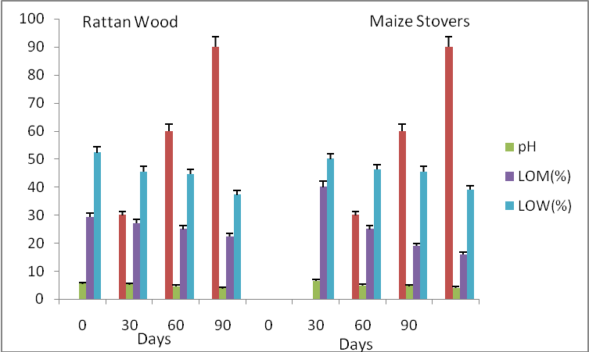
0 30 60 90 0 30 60 90

Figure 3: Effects of Pleurotus ostreatus on pH, Loss of Organic matter and loss of water on degraded rattan
wood and maize stovers.
LOM – Loss of organic matter.
LOW – Loss of water.

Table 1: Effects of P.ostreatus on degraded rattan wood and maize stovers in evaluating the NDF,ADF,ADL,Cellulose and Hemicelluloses content .
 | Substrate | Days | NDF | ADF | ADL | Cellulose | Hemicelluloses
 | Rattan wood | 0 | 75.98ª | 64.38ª | 55.27ª | 14.11^{b} | 11.60ª
 |  | 30 | 45.20^{b} | 55.73ª | 42.60^{b} | 13.13ª | 8.90^{cd}
 |  | 60 | 44.65^{b} | 40.60^{b} | 34.86^{c} | 5.74^{cd} | 5.05^{cd}
 |  | 90 | 36.74^{bc} | 33.10^{bc} | 25.30^{d} | 4.80^{bc} | 3.64^{cd}
 | Maize stovers | 0 | 66.03ª | 55.66ª | 43.31^{b} | 13.60ª | 8.11^{b}
 |  | 30 | 32.99^{bc} | 25.57^{cd} | 23.09 | 4.49^{d} | 5.42^{c}
 |  | 60 | 24.83^{c} | 20.33^{d} | 15.76e | 4.30^{d} | 4.49^{cd}
 |  | 90 | 22.28^{c} | 23.43^{d} | 14.65^{d} | 4.17^{d} | 2.85^{d}
Each value is a mean of 4 replicates.

Means with different superscripts in each column are significantly different at P ≤ 0.05 according to Duncan multiple range test.
N.D.F. = Neutral Detergent Fibre; A.D.F = Acid Detergent Fibre, ADL = Acid Detergent Lignin.

Table 2:Effects of P.ostreatus on degraded rattan wood and maize stovers for enzymes Production (Unit/ml)
 | Substrate | Days | Amylase | Cellulase | Lignase | Peroxidase
 | Rattan wood | 0 | 0.00 | 0.00 | 0.00 | 0.00
 |  | 30 | 0.21^{c} | 0.14^{c} | 0.36^{b} | 0.41^{c}
 |  | 60 | 0.17^{c} | 0.12^{c} | 0.25^{c} | 0.29
 |  | 90 | 0.14^{d} | 0.11 | 0.18^{d} | 0.18e
 | Maize stovers | 0 | 0.00 | 0.00 | 0.00 | 0.00
 |  | 30 | 0.21^{c} | 0.19^{c} | 0.20^{c} | 0.16e
 |  | 60 | 0.15^{c} | 0.16^{c} | 0.17^{c} | 0.15^{ef}
 |  | 90 | 0.10^{d} | 0.15^{d} | 0.15^{d} | 0.13^{f}
Each value is a mean of 4 replicates.

Means with different superscripts in each column are significantly different at P ≤ 0.05 according to Duncan’s multiple range test.

Table 3: Effects of P.ostreatus on degraded rattan wood and maize stovers in evaluating organic matter digestibility (%) and metabolizable energy used.
 | Substrate | Days | Organic matter | Metabolizable energy
 | Rattan wood | 0 | 5.16^{c} | 2.35^{d}
 |  | 30 | 5.33^{c} | 2.50^{c}
 |  | 60 | 10.12^{bc} | 2.56^{b}
 |  | 90 | 13.47^{ab} | 2.67ª
 | Maize stovers | 0 | 9.56^{bc} | 2.21e
 |  | 30 | 14.14^{ab} | 2.50^{c}
 |  | 60 | 20.39ª | 2.58^{b}
 |  | 90 | 21.31ª | 2.65ª
Each value is a mean of 4 replicates.
Means with different superscripts in each column are significantly different at P ≤ 0.05 according to Duncan’s multiple range test.

Table 4:Effects of P.ostreatus on degraded rattan wood and maize stovers for in-vitro gas production.
 | Substrate | Days | 3rd hr ml | Gas (ml) 6th | Gas ml 9th hr | Gas ml 12th hr | Gas ml 15th | Gas ml 18th | Gas ml 21st | Gas ml 24th | Gas methane gas
 | Rattan wood | 0 | - | 6.00 | 6.00 | 6.00 | 7.00 | 7.00 | 8.00 | 9.00 | 6.00
 |  | 30 | - | 6.00 | 7.00 | 7.00 | 9.00 | 10.00 | 11.00 | 11.00 | 8.00
 |  | 60 | - | 5.00 | 7.00 | 8.00 | 9.00 | 11.00 | 12.00 | 13.0 | 9.00
 |  | 90 | 3.00 | 8.00 | 11.00 | 14.00 | 19.00 | 21.00 | 21.00 | 22.00 | 13.00
 | Maize stovers | 0 | - | 6.00 | 8.00 | 12.00 | 12.00 | 14.00 | 16.00 | 17.00 | 6.00
 |  | 30 | - | 5.00 | 7.00 | 7.00 | 8.00 | 8.00 | 9.00 | 10.00 | 8.00
 |  | 60 | - | 5.00 | 8.00 | 9.00 | 10.00 | 10.00 | 11.00 | 12.00 | 9.00
 |  | 90 | 2.00 | 8.00 | 8.00 | 14.00 | 20.00 | 22.00 | 24.00 | 28.00 | 17.00
Each value is a mean of 4 replicates.

References
[1] Adenipekun, C. O. and Fasidi, I. O. Degradation of Selected agricultural wastes by Pleurotus tuber-regium (Fries) Singer and Lentinus subnudus (Berk) Nigerian edible mushroom. Advances in Food Science 2005; 27.2: 61-64.
[2] Adenipekun C.O, Lawal, Y. ..Mycoremediation of Crude oil and palm kernel sludge contaminated soils by Pleurotus pulmonarius Fries(Quelet).Nature and Science 2011,9(9).
[3] Akinfemi, A., Jonathan, S. G., Adu, O. A. Improving the Nutritive value of millet stovers using Biological treatment. Libyan agriculture Research Centre Journal International 2010.3: 195-201.
[4] Akinfemi, A., Adu, O. A., Adebiyi, O. A. Use of white-rot-fungi in upgrading maize straw and the resulting impact on chemical composition and invitro digestibility. Livestock research for Rural development 2009.Volume 21.10.
[5] AOAC. .Association of Official Analytical Chemist: Method of Analysis, Washington DC. 2003
[6] Babayemi, O. J. Anti Nutritional Factors, Nutritive value and in vitro gas production of Foliage and Fruit of Enterolobium cyclocarpun World Journal of Zoology.2006 1.2: 113-117.
[7] Babayemi, O. J., Bamikole, M. A. Effects of Tephrosia candida DC leaf and its mixture with guinea grass on invitro fermentation changes on feed for ruminants. Pakistan Journal of Nutrition2006a 5.1: 14-18.
[8] Babayemi. O. J., Demeyer, D., Fievez, V. Nutritive value and qualitative assessment of secondary compounds in seeds of eight tropical browse shrub and pulse legumes comm. Applied Biological Science 2004. 69.1: 103-110.
[9] Belewu, M. A., Belewu, K.Y. Cultivation of Mushrooms (Volvariella volvacea) on banana Leaves. African Journal of Biotechnology. 2005 4.12: 1401-1403.
[10] Berridge, N.J. Methods in Enzymology 1.Academic Press 1955. Pp 185-192.
[11] Boominathan, K., Reddy, C. A. Fungal degradation of lignin: Biotechnology applications P. 763-822 in D.K Arora R.P. Elander and K.G Mukerji (edited). Handbook of Applied Mycology1992. volume 4. New York: Marcel Dekker Inc.
[12] Chumpawadee, S., Sommart, K., Vongpralub, T., Pattarajinda, V.. Nutritional evaluation of non forage high fibrous tropical feeds for ruminant using Invitro gas production technique. Pakistan Journal of Nutrition 2005 4: 298-303.
[13] Denison,A.D and Koehn.Cellulase activity of Poronia oedipus.Mycologia.1977;69;592-603.
[14] Diaz, E. Microbial Biodegradation: Genomics and Molecular Biology (1st edn) Caister Academic Press. 2008.
[15] Fukushima, Y.and Kirk, T.K. .Lacasse component of the Ceriporiopsis subvermispora lignin degrading system.Applied Environmental Microbiology 1995.61: 872-876.
[16] Galphaup, C., Wagner, H., Hinterstoisser, B.,Haltrich, D.,. Increased production of laccase by the wood degrading basidiomycete Trametes pubescens. Enzyme Microbiology and technology 2002.
[17] Higuchi, T..Biochemistry and molecular biology of wood. Springer Verlag. 1997 London.http://www.utafoundation.org/p/L/Preston and Leng.htm.
[18] Isikhuemhen, O. S and Nerude, F. Preliminary Studies on Lignolytic Enzymes Produced by the tropical Fungus Pleurotus tuber-regium. Antonie Van Leeuwenhoek 1999. 75: 2457-260.
[19] Isikhuemhen, O. S, Zadrazil, F.and Fasidi, F. O. Cultivation of white rot fungi in solid state Fermentation. Journal of Science and Industrial Resource1996. 44: 388-393.
[20] Jonathan, S .G., Fasidi, I. O. Effect of carbon, nitrogen and mineral sources on growth of Psathyerella atroumbonata Pegler), a Nigerian edible mushroom. Food Chemistry 2001. 72: 479-483.
[21] Jonathan, S. G., Akinfemi, A.,Adenipekun CO.Biodegradation and in-vitro digestibility of maize husk treated with edible fungi (Pleurotus tuber-regium and Lentinus subnudus) from Nigeria. Electronic Journal of Environmental, Agriculture and Food Chemistry 2010.9(4): 742-750.
[22] Jonathan, S. G., Fasidi, I. O., Ajayi, E. J. Physicochemical studies of Volvariella esculenta (Mass) Singer, a Nigeria edible fungus. Food Chemistry 2004. 85: 339-342.
[23] Karunnanada, K. and Varga, G. A. Colonization of the straw by white-rot fungi (Cyathus sterioreus). Effect on ruminant Fermentation Pattern, Nitrogen Metabolism and Fiber utilization during Continuous Culture Animal Food Science technology 1996. 61:1-16.
[24] Keilin, D and Hartee, F.E.Purification of horse radish peroxidase and comparison of its properties with those of catalase and methaemoglobin. Biochem Journal 1951;49:88-104.
[25] Kuforiji, O. O.and Fasidi, I. O: Enzymes Activities of Pleurotus tuber-regium (Fries) Singer. Cultivated on selected agricultural wastes. Bioresource Technology 2008. 99: 4275-4278.
[26] Luzier, W. D. Materials Derived from Biomass/Biodegradable Materials. Proceedings of the National Academy of Sciences 1992 89.3 839-42.
[27] Marzullo, L., Cannion, R., Samnia, G., Veratyl alchol oxidase from Pleurotus ostreatus precipitate in lignin biodegradation and prevents polymerization of lacasse oxidized substrates. Journal of Biological Chemistry 1995 270:3823-3827.
[28] Menke, K. H., Steingass, H..Estimation of the energetic feed value from chemical analysis and in-vitro gas production using rumen fluid. Animal Resource Development 1988 28:7-55.
[29] Rajarathnam, S., Shashirekha, M., Bano, Z. Biodegradation and biosynthetic capacities of mushrooms. Present and future strategies. Critical mushrooms. Present and Future strategies. Critical Reviews in Biotechnology 1998: 18:91-236.
[30] Sallam, S. M. A., Nasser, M. E. A., El-Waziry, A. M., Bueno, I. C. S., Abdalla, A. L.. Use of an in-vitro gas production technique to evaluate some ruminant feedstuffs. Journal of Applied Sciences Resource 2007 3.1: 34-42.
[31] Tamara, V., Mika, K., Annele, H., . Lignin peroxidases, Manganese, peroxidases and other lignolytic enzymes produced by Phelebia radiate during solid state fermentation of wheat straw. Applied Environmental Microbiology 1996: 3515-3529.
[32] Williams, B., 2001. Biotechnology from A to Z. Second edition New York: Oxford Press: 2001 Pp.384-385.
[33] Wilson,M.A.Amylase synthesis and stability in crested wheat grass seeds at low water potentials-Plant physiology1971;48:541-546.
[34] Zadrazil, F., Brunnert, H., 1982. Solid State Fermentation of Lignocellulose containing plant residues with Sporotrichum pulverlentium. Nov. and Dichotimus squalens (Karsl) Reid. European Journal of Applied Microbiology and Biotechnology 1982: 16: 45-51.
[35] Zadrazil,F. Screening of Fungi For Lignin Decomposition and Conservation of Straws into Feeds.Angrew Botanik 1985; 69:433-452.

28/03/2012

