Characterization of Four Egyptian Crude Oils

I. A. Mohammad ¹, R. I. Abdallah ², A. Y. El-Naggar ^{2,3}, M. M. Mashaly ¹, A. A. Salem ²

¹ Department of Chemistry, Faculty of Science, Mansoura University (Damietta Branch), Egypt.
² Egyptian petroleum Research Institute, Nasr City, Cairo, Egypt. aynaggar361@yahoo.com
³ Department of Chemistry, Faculty of Science, Taif University, Kingdom Saudi Arabia.
Islam_kasim@yahoo.com

Abstract: Four Egyptian crude oils (Marine Shoukeir-22, Marine West Ashrafi, Arta-4 and Hana-3) of different API gravities ranging from 38.55 to 16.20 were fractionated into saturates, aromatics, resins and asphaltenes (SARA) through liquid column chromatography. Nickel (Ni) and Vanadium (V) contents were measured using atomic absorption spectroscopy. The physicochemical properties were studied for: (і) the four crude oils before fractionation and (іі) the technical fractions (gasoline, kerosene, gas oil, lubricating oil and vacuum residue over 370 ºC) of Shoukeir-22 and Hana-3. It was clear that the resins and asphaltenes increase for heavy crude oils (Arta-4 and Hana-3). All crude oils have high contents of the technical fractions except that the content of the vacuum residue was little in Shoukeir-22 crude oil. The gasoline fraction of Shoukeir-22 and Hana-3 can be used as a charge stoke for the production of aviation or motor gasoline. The kerosene fraction of Shoukeir-22 is shown to be more suitable as a fuel for motor jets and for illumination.
[I. A. Mohammad, R. I. Abdallah, A. Y. El-Naggar, M. M. Mashaly, A. A. Salem. Characterization of Four Egyptian Crude Oils. Nature and Science 2012;10(5):72-79]. (ISSN: 1545-0740). http://www.sciencepub.net/nature. 8

Keywords: Egyptian crude oils, Shoukeir-22, West Ashrafi, Arta-4 and Hana-3, physicochemical properties, hydrocarbons, Ni, V, and technical fractions.

1. Introduction
From a chemical standpoint, petroleum is an extremely complex mixture of hydrocarbon compounds, usually, with minor amounts of nitrogen-, oxygen-, and sulfur-containing compounds as well as trace amounts of metal-containing compounds like nickel and vanadium (porphyrins) ⁽¹⁻⁶⁾.
The crude oils have compounds belonging to different families (paraffins, naphthenes and aromatics, PNA) or polarities (saturates, aromatics, resins and asphaltenes, SARA) ⁽⁷⁾.
Also, Petroleum can be considered as being composed of a number of light and heavy components. At the conditions of the original oil in its reservoir, the light and heavy components are mutually soluble, one in the other. However, variations in temperature, pressure, or composition may alter this balance, and some of the species may segregate, forming another liquid or even a solid phase.
The aim of this work is to characterize the Egyptian crude oils Marine Shoukeir-22, Marine West Ashrafi, Arta-4 and Hana-3 whose fields lie in the Suez Gulf region. The characterization includes (і) the physicochemical properties; (іі) fractionation according to the hydrocarbon types and classes; (ііі) the content of nickel and vanadium; and, also, (іv) details on the technical fractions of Shoukeir-22 and Hana-3.

Experimental
Crude oil samples:
The study was carried out on Four Egyptian crude oil samples which are collected from the fields of Shoukeir-22, Ashrafi, Arta-4 and Hana-3 located in the region of the Gulf of Suez.

Physicochemical properties of the four crude oils:
The physicochemical characterizations of the four studied crude oils were carried out using the standard test methods of analysis ASTM ⁽⁸⁾, UOP ⁽⁹⁾ and IP ⁽¹⁰⁾ and the results are listed in (table 1).

Fractionation of the crude oils according to their hydrocarbon types and classes:
The four crude oils were fractionated based on their hydrocarbon types and classes into asphaltenes, maltenes, resins, saturates and aromatics (mono-, di-, and polycyclic aromatics). Asphaltenes were separated using the standard test method IP-143. Maltenes (which constitute deasphalted crude oils) were further separated into saturates, aromatics and resins using the technique of liquid chromatography, LC, on alumina column. Aromatics were further separated into mono-, di-, and polycyclic aromatics using LC on silica gel column ⁽¹¹⁾.

Crude oil distillation into technical fractions
The two crude oils Shoukeir-22 and Hana-3 were distillated to isolate their technical fractions. The fractions were gasoline (Initial-150 ºC), kerosene (150-250 ºC), gas oil (250-300 ºC), lubricating oil (300-370 ºC) and residue (over 370 ºC) according to (ASTM-D2892)⁽⁸⁾. The physicochemical properties of these fractions were studied according to standard test methods. The structural group analysis of the kerosene, gas oil and lubricating oil fractions has been carried out using the n-d-M method (ASTM D-3238)⁽⁸⁾.
Hydrocarbon types of gasoline and kerosene fractions were investigated using the standard test method (ASTM D-1319)⁽⁸⁾, while the residues (over 370 ºC) were fractionated into their hydrocarbon types by deasphalting followed by liquid column chromatography ⁽¹¹⁾.

Results and Discussion
The hydrocarbons are the principal constituents of petroleum crude oils and their physicochemical properties highly affect the general characteristics of the crude oils and their fractions. Accordingly, the results of the detailed analysis of the crude oils and their fractions enable the refiner to select the most economic oil or fraction.
On the other hand, the hydrocarbons are commonly viewed as an important guide in searching of the origin and migration of the crude oil, which is valuable to the exploration companies.

Physicochemical characteristics of the studied crude oils
The physicochemical characteristics of the four studied Egyptian crude oils are given in (Table 1) and represented in (Figure 1). The results indicate that the two marine crude oils Shoukeir-22 and West Ashrafi belong to the light crude oil types with API gravity of about 38.55 (sp.gr. 0.8321) and 34.76 (sp. gr. 0.8511) respectively, while Hana-3 is a medium crude oil type with API 24.91 (sp.gr. 0.9047) and Arta-4 is a heavy crude oil with API 16.20 (sp.gr. 0.9580).
The light crude oils, Shoukeir-22 and West Ashrafi, are characterized by: (і) low content of sulfur, asphaltenes and carbon residue which leads to low ash content; (іі) low value of viscosity, flash point and pour point which is compatible with the low wax content and (ііі) the high values of API gravity, leading to higher hydrogen contents and resulting in greater calorific values.
Comparing with the two marine crude oils (Shoukeir-22 and West Ashrafi), the medium crude oil, Hana-3, is characterized by: (і) relatively higher content of sulfur, asphaltenes and carbon residue leading to relatively higher ash content; (іі) a marked increase in viscosity and pour point with a moderate increase in wax content and (ііі) relatively lower hydrogen content as a result of the lower API gravity value leading to a decrease in its calorific value.
The heavy crude oil, Arta-4, shows the highest values of viscosity and sulfur content, consequently, high content of asphaltene, carbon residue and ash resulting in the lowest wax content of all the studied oils. It, also, has the lowest value of hydrogen content, which leads to lowest calorific value.
The nickel, Ni, and vanadium, V, contents of the four crude oils are shown in (Table 2) and (Figure 2). The results indicate that marine Shoukeir-22 crude oil has the lowest vanadium and nickel contents while Arta-4 has the highest respective contents. The Ni/V ratios of the four crude oils ranged from 0.41 to 0.61 (less than unity), reflecting the marine origin source rocks of the four crude oils ⁽¹²⁾.
Fig. 3 represents the results of the distillation of the four studied crude oils. The data of each crude oil are in good correlation with the API gravity value. The marine Shoukeir-22 crude oil with the highest API gravity (Table 1), shows the lowest initial boiling point (50 ºC) and the highest recovered volume (58 ml) while the crude oil Arta-4 with the lowest API gravity (Table 1), shows the highest initial boiling point (80 ºC) and the lowest recovered volume (43 ml).

Hydrocarbon Types Analysis:
The analysis of the four studied crude oils for their components has been carried out by deasphalting the residue boiling above 200 ºC through precipitation in normal heptane, then resolving the maltene by alumina column chromatography into saturates, aromatics and resins. The results are given in (Tables 3 and 4) and shown in (figures 4 and 5). The Shoukeir-22 crude oil has the highest content of saturates while Arta-4 crude oil has the lowest content. An increase in the content of aromatics (as total and type), resins and asphaltenes is clear in the direction of Shoukeir-22 (the lowest), West ashrafi, Hana-3 to Arta-4 (the highest).

Shoukeir-22 and Hana-3 Technical Fractions:
Each of the shoukeir-22 and Hana-3 crude oils has been distilled into five technical fractions, namely, gasoline, kerosene, gas oil, lubricating oil and vacuum residue. The fraction type, boiling point range and percentage in the oil are listed in (Table 5) and shown in (Figure 6).

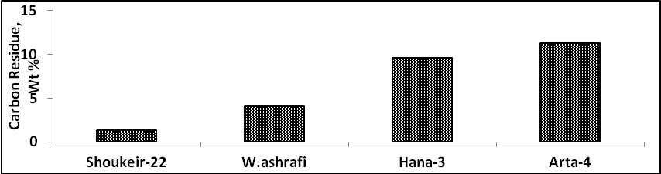
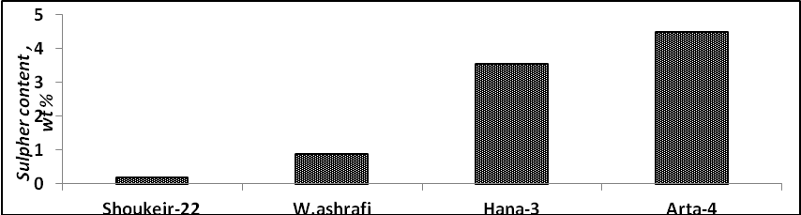
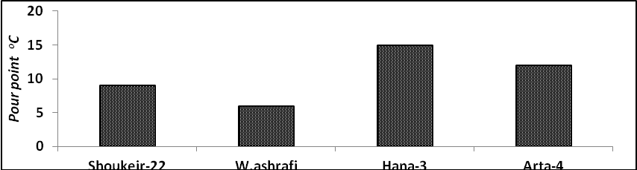
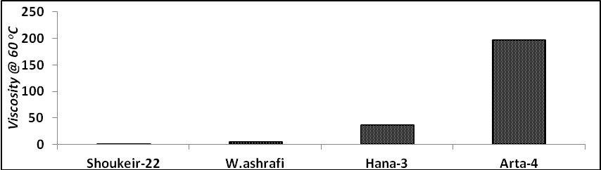
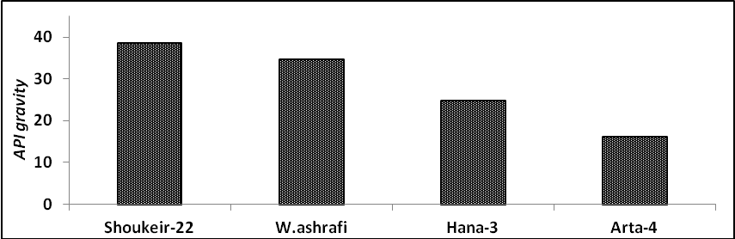
Fig. 1 Physicochemical characteristics of the four studied Crude Oils.

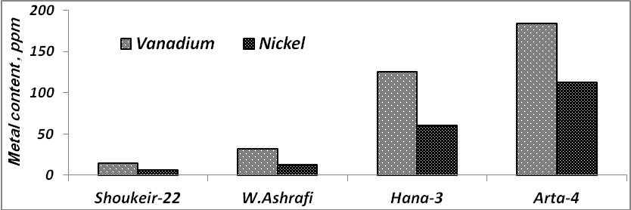
Fig. 2 Vanadium and Nickel contents of the four studied crude oils

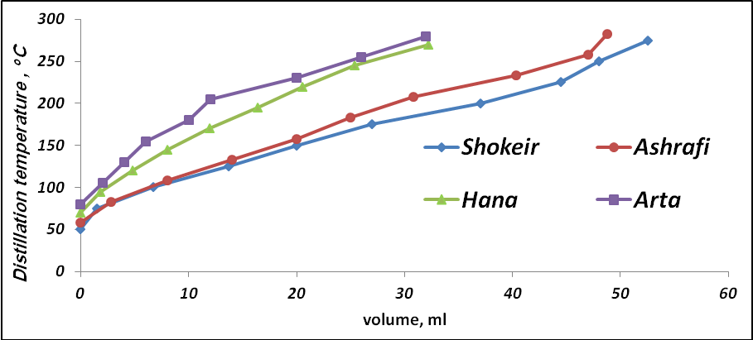
Fig. 3 ASTM D-86 of the four studied crude oils.

Table 1. Physicochemical Properties of the four Studied Crude Oils.
Experiment | Method | Shoukeir-22 | West Ashrafi | Hana-3 | Arta-4
Density, at 15.56 ºC  Specific Gravity  API gravity at 60 ºF | ASTMD-1298 | 0.83  0.83  38.55 | 0.85  0.85  34.76 | 0.90  0.90  24.91 | 0.96  0.96  16.20
Total acid number, mg KOH/ gm | ASTM D-2896 | 0.04 | 0.18 | 0.40 | 0.68
Kinematic viscosity, cSt, at 60 ºC | ASTM D-445 | 3.19 | 4.84 | 36.31 | 196.39*
Pour point, ºC | ASTM D-97 | 9 | 6 | 15 | 12
Hydrogen Sulfide, ppm | ASTM D-3227 | Nil | Nil | Nil | Nil
Mercapten , ppm | ASTM D-3227 | Nil | Nil | Nil | Nil
Residual Sulfur, ppm | ASTM D-3227 | 665.89 | 141.32 | 882.32 | 6050.60
Total Sulphur, wt % | ASTM D-4294 | 0.19 | 0.91 | 3.56 | 4.50
Nitrogen content, wt % | ASTM D-3228 | 0.05 | 0.10 | 0.26 | 0.34
Asphalten content, wt % | IP-143 | 0.36 | 1.73 | 6.82 | 10.28
Wax Content, wt % | UOP-64 | 9.96 | 3.75 | 4.69 | 2.58
BS& W, vol % | ASTM D-96 | 4 | 74 | 2 | 42
Ash content, wt % | ASTM D-482 | 0.00 | 0.02 | 0.03 | 0.95
Water content , vol % | ASTM D-95 | 4.75 | 65.00 | 3.00 | 54.00
Carbon residue, wt % | ASTM D-189 | 1.33 | 4.12 | 9.62 | 11.34
Copper corrosion | ASTM D-130 | 1a | 1a | 1a | 1a
Flash point, ºC | ASTM D-93 | -5 | -4 | 19 | 52
Salt content, ppm | ASTM D- 3230 | 9047.80 | 97090.95 | 512.71 | 71618.86
Calorific value KJ/Kg | ASTM D-240 | 45770.00 | 45222.00 | 42120.00 | 41720.00
Hydrogen % | Elemental analysis | 13.06 | 12.77 | 11.43 | 10.63
Oxygen % | Elemental analysis | 0.09 | 0.58 | 2.41 | 3.04
Carbon % | Elemental analysis | 86.60 | 85.62 | 82.31 | 80.55
* Kinematic viscosity at 80 ºC.

Table 2. Vanadium and Nickel contents of the four studied crude oils.
Crude oil | Vanadium, V, ppm | Nickel, Ni, ppm | Ni/V
Shoukeir-22 | 14.93 | 6.70 | 0.45
West Ashrafi | 32.39 | 13.21 | 0.41
Hana-3 | 125.70 | 60.29 | 0.48
Arta-4 | 183.97 | 113.05 | 0.61

The results reveals that the light Marine Shoukeir-22 crude oil has more weight percentages than Hana-3 crude oil with respect to the content of gasoline, kerosene, gas oil and lubricating oil, while the situation is reversed with respect to their contents of residue.
The physicochemical characteristics of the technical fractions of Shoukeir-22 and Hana-3 are given in (Tables 6 and 7), respectively. The gasoline fractions of Shoukeir-22 (Tables 6 and 8) and Hana-3 (Tables 7 and 8) crude oils exhibits low content of sulfur and aromatics with high calorific value respectively, and nil gum content, which indicate that these gasoline fractions can be used as a charge stock for the production of aviation or motor gasoline.
The kerosene fractions of the Shoukeir-22 crude oil showed low contents of sulfur (Table 6) and aromatics (Table 9) with low smoke point (Table 6), while the kerosene fractions of Hana-3 crude oil (Tables 7 and 9) showed, relatively, slight increase in the detected values of the respective above mentioned parameters. Thus, relatively, the Shoukeir-22 kerosene fraction is more suitable than that of Hana-3 to use as a motor jet fuel and in illumination without expensive refinery treatment.

Table 3. Hydrocarbon types of the four studied crude oils.
Hydrocarbon Type | Shoukeir-22 | West Ashrafi | Hana-3 | Arta-4
Saturates % | 54.44 | 42.37 | 32.15 | 13.71
Aromatics % | 32.67 | 43.30 | 45.52 | 56.83
Resins % | 12.53 | 12.61 | 15.51 | 19.19
Asphaltenes % | 0.36 | 1.72 | 6.82 | 10.28

Table 4. Aromatic types of the four studied crude oils.
Aromatic Type | Shoukeir-22 | West Ashrafi | Hana-3 | Arta-4
Monocyclic aromatics % | 15.092 | 15.303 | 15.575 | 24.122
Dicyclic aromatics % | 3.897 | 6.166 | 6.228 | 7.460
Polycyclic aromatics % | 13.682 | 21.827 | 23.712 | 25.243

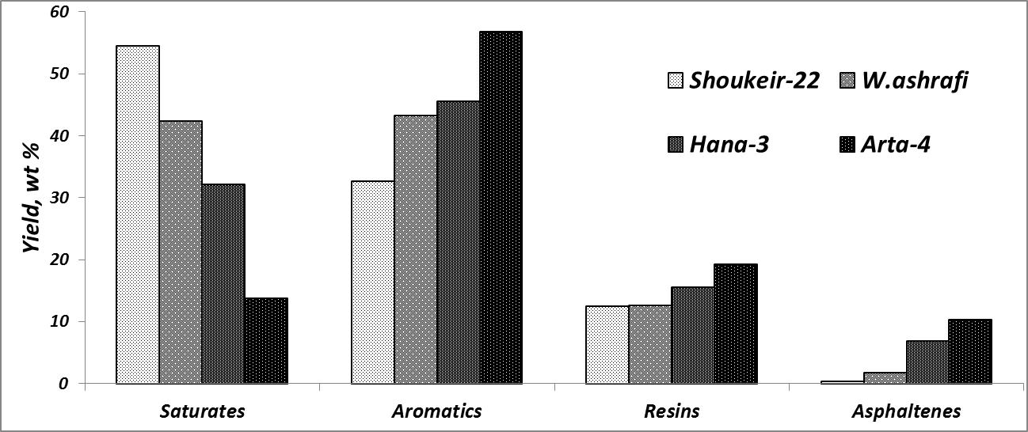
Fig. 4 Hydrocarbon types of the four studied crude oils.
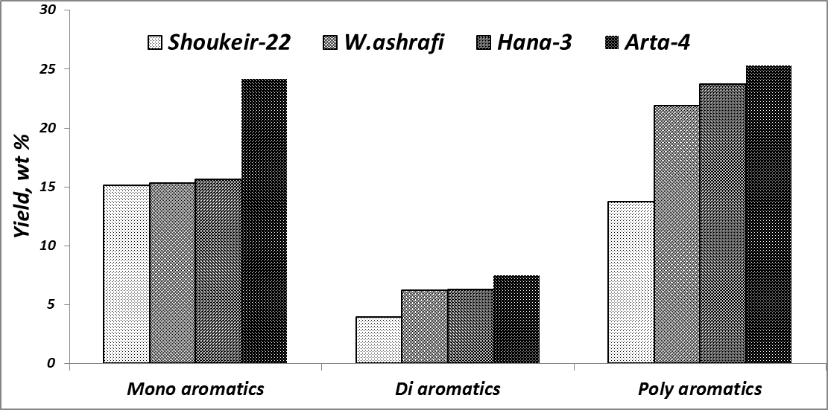
Fig. 5 Aromatic types of the four studied crude oils.

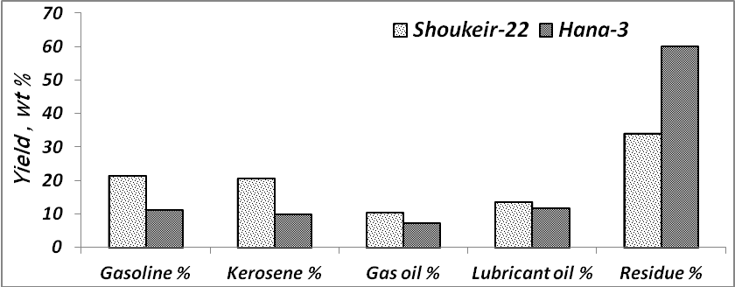
Figure. 6 Technical fractions of Shoukeir-22 and Hana-3 crude oils.

Table 5. Technical fraction of Shoukeir-22 and Hana-3.
Technical Fractions, b.p. range | Fraction percentage % in the oil
Technical Fractions, b.p. range | Shoukeir-22 | Hana-3
Gasoline (Int-150 ºC) | 21.47 | 11.13
Kerosene (150-250 ºC) | 20.59 | 9.80
Gas oil (250-300 ºC) | 10.30 | 7.14
Lubricating oil (300-370 ºC) | 13.61 | 11.79
Residue over 370 ºC | 34.03 | 60.13

The gas oil fractions of Shoukeir-22 (Table 6) and Hana-3 (Table 7) crude oils are both of low viscosity, free of carbon residue, high calorific value, with low and medium sulfur content, respectively. The results reveal that this fraction is suitable as a diesel fuel for high speed engine.
The vacuum residue of Shoukeir-22 (Table 6) has medium sulfur content and viscosity, with high carbon content, while Hana-3 vacuum residue (Table 7) is of high sulfur content, viscosity and carbon content. This indicates that vacuum residues can be used in the production of bright stocks after its deasphalting and deresining. They can, also, be used as a good furnace fuel after depression of the viscosity of Hana-3 residue either by mixing with a fraction of lower boiling point range or heating before atomizing to the burner.
The hydrocarbon types of the gasoline (Table 8) and kerosene (Table 9) fractions of both Shoukeir-22 and Hana-3 crude oils were carried out using FIA technique (ASTM-D1319)⁽⁸⁾, the results revealed that : (і) the saturates percentage in the Shoukeir-22 oil is more than in the Hana-3 oil, and (іі) reversely, the percentages of the olefins and aromatics in the Hana-3 crude oil are more than in the Shoukeir-22 oil.
The structural group analysis of the kerosene, gas oil and lubricating oil has been carried out using the n-d-M method (ASTM D-3238)⁽⁸⁾. For the Shoukeir-22 (Table 6) and Hana-3 (Table 7) crude oils, the results revealed that : (і) the Shoukeir-22 kerosene, gas oil and lubricating oil fractions (Table 6) contain percentage of paraffinic carbon (% C_{P}) respectively, (more than), (about the same) and (lesser than) the corresponding fractions in the Hana-3 oil (Table 7).
In the Shoukeir-22 crude oil (Table 6), The percentage of naphthenic carbon (%C_{N}) increases in the direction kerosene - gas oil – lubricating oil, while the Hana-3 crude oil (Table 7), the gas oil fraction has the highest value of (%C_{N}) with the kerosene and lubricating oil fractions having about the same lesser value. In the Shoukeir-22 (Table 6) and Hana-3 (Table 7) crude oils, the percentage of aromatic carbon (%C_{A}) and the percentage of total carbon ring structures (aromatic and naphthenic) (%C_{R}) are higher in the gas oil fraction than in each of the kerosene and lubricating oil fractions.
In the Shoukeir-22 (Table 6) and Hana-3 (Table 7) crude oils, the average number of aromatic rings per molecule (R_{A}) and the average number of naphthenic rings per molecule (R_{N}) increase in the direction of kerosene - gas oil – lubricating oil fractions.
The vacuum residues of shoukeir-22 and Hana-3 crude oils have been fractionated into there components, namely, saturates, mono-, di-, and polycyclic aromatics, resins and asphaltenes (Table 10) and (Fig. 7) ; The results (Table 10) of the Shoukeir-22 vacuum residue reveal that the saturates and ashaltenes have, sharply, the highest and lowest percentage, respectively, which is in agreement with a low sulfur content (Table 6). The situation is different for the Hana-3 vacuum residue, where the saturates and asphaltenes are of comparable medium concentrations. For comparison, the saturates in Shoukeir-22 are sharply more in than in Hana-3; in the opposite, the asphaltenes are sharply more in Hana-3 than in Shoukeir-22.

Table 6. Physicochemical characteristics of Shoukeir-22 Technical fractions.
Experiment | Method | Gasoline  Int-150 ºC | Kerosene  150-250 ºC | Gas oil  250-300 ºC | Lub oil  300-370 ºC | Residue  >370 ºC
Density at 60 ºF  Specific gravity  API | ASTM D1298 | 0.7210  0.7217  64.56 | 0.8043  0.8050  44.26 | 0.8432  0.8440  36.15 | 0.8597  0.8605  32.93 | 0.9072  0.9081  24.332
Viscosity at 40 ºC, cSt | ASTM D-445 | 0.55 | 1.23 | 3.13 | 6.80 | 37.90*
Sulfur content, wt % | ASTMD-4249 | 0.016 | 0.053 | 0.20 | 0.29 | 0.35
Carbon residue, wt % | ASTM D-198 | Nil | Nil | Nil | Nil | 9.2
Molecular weight | - | 96.34 | 144.07 | 170.89 | 216.266 | 407.196
Calorific value, Kj/kg | ASTM D-240 | 48596 | 46120 | 44965 | - | -
Gum content, wt % | ASTM D-381 | Nil | - | - | - | -
Smoke point, cm | ASTM D-1322 | - | 19 | - | - | -
Refractive index at 20 ºC | ASTM D-1218 | - | 1.4530 | 1.4730 | 1.4809 | -
Structural group analysis  Carbon distribution  % C_{A}  % C_{R}  % C_{N}  % C_{P}  Ring content analysis  R_{A}  R_{T}  R_{N} | ASTM D-3238 | - | 21.49  35.99  14.50  64.01  0.38  0.634  0.254 | 23.95  46.59  22.65  53.41  0.495  0.91  0.42 | 20.88  44.59  23.71  55.41  0.549  1.095  0.546 | -
* Kinematic viscosity at 80 ºC.

Table 7. Physicochemical characteristics of Hana-3 technical fractions.
Experiment | Method | Gasoline  Int-150 ºC | Kerosene  150-250 ºC | Gas oil  250-300 ºC | Lub oil  300-370 ºC | Residue  >370 ºC
Density at 60 ºF  Specific gravity  API | ASTM D1298 | 0.7234  0.7241  63.92 | 0.8090  0.8098  43.24 | 0.8482  0.8490  35.16 | 0.8715  0.8724  30.70 | 0.9643  0.9652  15.10
Viscosity at 40 ºC, cSt | ASTM D-445 | 0.60 | 1.44 | 3.17 | 7.12 | 478.72*
Sulfur content, wt % | ASTMD-4249 | 0.43 | 1.08 | 2.02 | 2.18 | 4.55
Carbon residue, wt % | ASTM D-198 | Nil | Nil | Nil | Nil | 12.2
Molecular weight | - | 104.21 | 152.09 | 191.07 | 246.01 | 472.82
Calorific value, Kj/kg | ASTM D-240 | 48157 | 45830 | 44653 | - | -
Gum content, wt % | ASTM D-381 | Nil | - | - | - | -
Smoke point, cm | ASTM D-1322 | - | 23 | - | - | -
Refractive index at 20 ºC | ASTM D-1218 | - | 1.4519 | 1.4719 | 1.4843 | -
Structural group analysis  Carbon distribution  % C_{A}  % C_{R}  % C_{N}  % C_{P}  Ring content analysis  R_{A}  R_{T}  R_{N} | ASTM D-3238 | - | 15.17  38.147  22.98  61.853  0.286  0.644  0.358 | 17.51  46.02  28.51  53.98  0.41  0.9  0.49 | 17.39  39.99  22.6  60.01  0.52  1.196  0.676 | -
* Kinematic viscosity at 80 ºC.

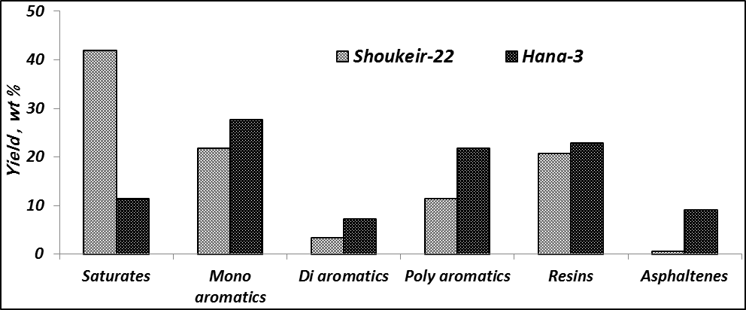
Fig. 7 Hydrocarbon types of vacuum residue for shoukeir-22 and Hana-3 crude oils.

Table 8. Hydrocarbon types of the gasoline fractions of shoukeir-22 and Hana-3
Gasoline components | Shoukeir-22 | Hana-3
Saturates % | 91.94 | 90.32
Olefins % | 7.23 | 8.73
Aromatics % | 0.81 | 0.95

Table 9. Hydrocarbon types of the kerosene fractions of shoukeir-22 and Hana-3
Kerosene components | Shoukeir-22 | Hana-3
Saturates % | 68.75 | 62.5
Olefins % | 30.36 | 36.14
Aromatics % | 0.89 | 1.36

Table 10. Hydrocarbon types of the residue >370 ºC fractions of shoukeir-22 and Hana-3
Vacuum Residue components | % in Shoukeir-22 | % in Hana-3
Saturates | 41.99 | 11.40
Mono-aromatics | 21.82 | 27.62
Di-aromatics | 3.43 | 7.23
Poly-aromatics | 11.48 | 21.78
Resins | 20.77 | 22.85
Asphaltenes | 0.52 | 9.10

Acknowledgements:
The authors express their gratitude to the management of the Gulf of Suez Petroleum Company (GUPCO), Agiba petroleum Company and Petrodara petroleum Company for providing crude oil samples. I express my deep gratitude to every one supporting me to carry out this work in Egyptian Petroleum Research Institute (EPRI).

Corresponding Author:
Islam Ahmed Mohammad
Faculty of Science (Department of Chemistry)
Mansoura University (Damietta Branch), Egypt.
E-mail: Islam_kasim@yahoo.com

References
- Bestougeff M. In Fundamental Aspects of Petroleum Geochemistry, 1967. Nagy B. and Colombo U. eds. Elsevier, Amsterdam. Chapter 3.
- Colombo U. In Fundamental Aspects of Petroleum Geochemistry, 1967. Nagy B. and Colombo U. eds. Elsevier, Amsterdam. Chapter 8.
- Hobson G. D. and Pohl W. Modern Petroleum Technology, 4 the dn, 1973. Applied Science Publishers, Barking, England.
- Thornton D. P. Jr. In Energy Technology Handbook, 1977. Considine D. M, Ed. McGraw-Hill, New York. pp.3–12.
- Considine D. M. and Considine G. D. Encyclopedia of Chemistry, 4th edn, 1984. Van Nostrand Rein-hold Co, New York.
- Speight J. G. Fuel Science and Technology Handbook, 1990. Marcel Dekker, New York.
- Altgelt K. H, Boduszynski M. M. Composition and Analysis of Heavy Petroleum Fractionsm 1994. Marcel Dekker: New York,.
- ASTM. “Annual Book of Standard Petroleum Products and Lubricants, 2003”, American Society for Testing and Material, Philadphia, USA.
- UOP. " Laboratory Test Methods for Petroleum and its Products", University Oil Products CO, 1985. Chicago, USA, UOP, 64.
- IP. "Standards Methods for Analysis and Testing of Petroleum and Related Products, 2002", the Institute of Petroleum, London.
- Zewen L, Ansong G, Alain G, Patrice C, Anna C and Yaxue Z. Saturated Hydrocarbons Occluded Inside Asphaltene structures And Their Geochemical Significance, as Exemplified By Two Venezualan Oils, 2006. "Organic Geochemistry", (1- 13).
- Barwise A. J. Role of nickel and vanadium in petroleum classification, 1990. J. Energy Fuels, 4(6): 647-652.

4/8/2012

