Caesarean section scar defects: clinical manifestations

Taiseer M M; Nahed E Allam and Hanaa Abd EL Hamid El Ebeissy

Department of Obstetrics and Gynaecology, Faculty of Medicine, Al-Azhar University, for Girls, Cairo, Egypt
Nahed16@ymail.com

Abstract: Objective: to find the correlation between the presence of CS scar defect diagnosed by TV US and the incidence of clinical manifestation of the patients. Patients & methods. Prospective cross sectional clinical study was done on 40 patients in the out- patient clinic of Alzhraa University Hospital from the period of February 2010 to September 2011. All the patients with history of at least one CS complained of any gynaecologic complains (IUB, chronic pelvic pain, dysmenorrhoea ,dysparunia or unexplained infertility) were subjected to TVUS .Uterine size, position, and scar defect parameters as depth, width, and thickness of overlying myometrium were recorded. Results: The mean age of the patients was 34.5±5.0 years,17 patients had undergone 3 C.S,15 had undergone 2 C.S & 8had undergone one C.S. 15% of patients had history of vaginal delivery. 22.5% of study group had undergone emergency C.S. most of them were complaining of post-menstrual spotting (60%), 27.5% were complaining of chronic pelvic pain and 12.5% with dysmenorrhoea.RVF uterus was diagnosed in 15% of patients. There was no statistical significant difference between emergency and elective C.S as regard defect parameters. In cases of RVF uteri there was statistical significant decrease in defect depth in comparison to AVF uteri, also myometrial thickness overlying scar was less in RVF uteri although it was not statistically significant. The myometrial thickness overlying the scar showed statistical significant difference in case of patients with history of vaginal delivery. Defect depth and myometrial thickness overlying the scar showed statistical significant difference in patients with postmenstrual spotting .Defect depth and width showed statistical significant increase in patients with history of 2 or more C.S. Conclusion : Factors that were associated with deficient scars: history of multiple Cesarean sections; uterine retroflexion; post-menstrual spotting,chronic pelvic pain and infertility. As the incidence of CS is increasing across the world, this disorder therefore warrants close attention.
[Taiseer M M, Nahed E Allam and Hanaa Abd El Hamid El Ebeissy. Caesarean section scar defects: clinical manifestations. Nat Sci 2012;10(7):11-17]. (ISSN: 1545-0740). http://www.sciencepub.net/nature. 3

Key words: Caesarean section scar defects ,retroverted uterus,post menstrual spotting ,transvaginal ultrasound

1. Introduction
Rates of CS are an issue of international health concern in both developed and developing countries. The worldwide incidence of caesarean section is 15% as mentioned in WHO reports at 2007, ranging from 3.5% in Africa to 29.2% in Latin America (1). Cesarean section is associated with long-term risks such as postoperative pelvic adhesions, uterine scar rupture, and placental complications (2). Attention has focused on strategies to reduce that incidence due to concern that higher CS rates do not confer additional health gain but may increase maternal risks, have implications for future pregnancy, associated a number of gynaecological disturbances (menstrual disorders, chronic pelvic pain, and infertility,…) and have economic implication on health services(3). Several studies assessed scar integrity during pregnancy, but the sonographic detection of uterine scars is easiest in the non-pregnant state (4). The presence of congested endometrial folds, polyps, lymphocytic infiltration & iatrogenic adenomyosis at the site of the scar proved by histopathological examination of hysterectomy specimens are suggested to be the potential causes of some gyaenecological disturbances (5). Since 2003, Fabres et al. reported that 82.6% women with a history of at least one CS experienced Abnormal uterine bleeding , and clinicians have become increasingly aware of the importance of this menstrual abnormality due to the increasing incidence of CS. And Menada et al .,(6) considered post caesarean section AUB a specific subtype of dysfunctional uterine bleeding (DUB). The question is :Is the defect seen at the site of previous scar diagnosed simply by trans-vaginal US of non pregnant uterus is correlated with the clinical manifestations of that patients ?, and whether the size of the defect & the thickness of overlying myometrium ,are responsible for more sever clinical manifestations?.
The aim of this study is to find the correlation between the presence of CS scar defect diagnosed by TVUS and the incidence of clinical manifestation of the patients.

2. Patients and Methods:
After local ethics committee approval and informed verbal patient consent, prospective cross section clinical study was done on 40 patients attended the out- patient clinic of Alzhraa University Hospital from the period of Feb., 2010 to Sep., 2011,after exclusion of 6 patients due to presence of uterine fibroid or endometrial polyp. All the patients with history of at least one CS complained of any gynaecologic complains (IUB, chronic pelvic pain, dysmenorrhoea, dysparunia or unexplained infertility) were subjected to TVUS. Medical &obstetric history was taken for each patient and review of the clinical symptoms, general and local examinations were done. Exclusion criteria were previous surgery on the uterus other than Cesarean section, any uterine gross pathology seen by TVUS, anticoagulants, exogenous hormones, or hematologic disorders should be excluded as possible causes of AUB.. Trans-vaginal ultrasound examination was done by the same operator with the woman with an empty bladder using the instrument Sonoace 8800 (Medison Digital GAIA) ultrasound machine with Doppler unit with transvaginal probe with a frequency 7.5MH. The uterus was examined in the longitudinal plane for ascertain the location of a Cesarean section scar and scar defects. Uterine anteflexion was diagnosed when the long axis of the uterine body was deviating anteriorly in relation to the long axis of the cervix, while posterior deviation was classified as retroflexion. The myometrial thickness adjacent to scar measured in the longitudinal section, scar defect described as depth, width, and thickness of overlying myometrium were recorded(Fig.1). Data were expressed as mean± SD, median (range) and number. Parametric data were analyzed using ANOVA and unpaired t tests, while non-parametric data analyzed using Kruskal-Wallis and Mann-Whitney U-tests. Chi-square test was used analyze incidence. A probability value (P) <0.05 was considered significant. (*= significant compared to other group).

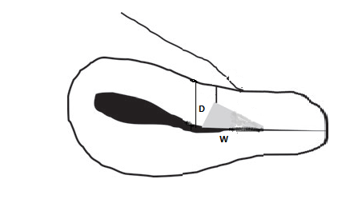

Figure (1)

3. Results:-
This study included 46 patients attended the outpatient clinic, complained of different gynaecological problems with history of at least one caesarean section, six of them were excluded due to uterine myoma or endometrial polyp within a period of twenty months . From the history the time elapsed from last C.S was at least six months. The mean age of the patient was 34 years(range 28-42ys)17 patients had undergone 3 C.S,15 had undergone 2 C.S& 8had undergone one C.S. 15% patients had history of vaginal delivery . 9(22.5%) of study group had undergone emergency C.S and 76.5%had undergone elective C.S(Table 1).
AS regard clinical characteristics of the study group, most of them were complaining of post-menstrual spotting& discharge (60%), 27.5% were complaining of chronic pelvic pain and 12.5% with 2^{ry} infertility (Table2). RVF uterus was diagnosed in 15% of patients. As regard defect measurement parameters, the mean width was 4.575mm, mean depth 4.295mm, the mean myometrial thickness overlying the scar was 1.314mm, the mean myometrial thickness adjacent to scar was 4.533 mm . There was no statistical significant difference between emergency and elective C.S as regard defect parameters (depth –width –myometrial thickness over the scar)(Table 3). In cases of RVF uteri there was statistical significant decrease in defect depth in comparison to AVF uteri(p =0.03 ) , also myometrial thickness overlying scar was less in RVF uteri it was statistically significant(p =0.01) (Table4), in patients with RVF uteri the most common complains were chronic pelvic pain ( 36.36%) and dysmenorrhea ( 40%).The myometrial thickness overlying the scar was more thicker in case of patients with history of vaginal delivery(p=0.003) (Table5).Defect depth and myometrial thickness overlying the scar showed statistical significant difference in patients with post-menstual spotting followed by patients with chronic pelvic pain (p =0.05,0.09, respectively) (Table6) . Defect depth showed statistical significant increase in patients with history of 2 or more C.S, the myometrial thickness adjacent to scar and myometrial thickness overlying the scar showed also statistical significant increase among patients had one versus those had two or more previous C.S(p = 0.02, 0.007,0.04,respectively) (Table 7). The ratio between the myometrial thickness adjacent to scar and overlying the scar was lowest in patients with previous one C.S .

Table (1) descriptive data of study group
Age(ys) | Range | 28.000 | 42.00
Age(ys) | Mean±SD | 34.5±5.0
 |  | N | %
History of abortion | No | 12 | 30
History of abortion | Yes | 28 | 70
PCS | 1 | 8 | 20.00
PCS | 2 | 15 | 37.50
PCS | 3 | 17 | 42.50
Type of CS | Elective | 31 | 77.50
Type of CS | Emergency | 9 | 22.50
Previous normal delivery | No | 34 | 85
Previous normal delivery | Yes | 6 | 15

Table (2) clinical characteristics of study group
 |  | N | %
Uterine position | RVF | 6 | 15.00
Uterine position | AVF | 34 | 85.00
Presenting symptoms | Chronic pelvic pain | 11 | 27.50
Presenting symptoms | Post menstrual spotting | 24 | 60.00
Presenting symptoms | 2ry infertility | 5 | 12.50
Defect width (mm) | Range | 2.200 | 5.900
Defect width (mm) | Mean±SD | 4.6±1.0
Defect depth (mm) | Range | 2.500 | 6.400
Defect depth (mm) | Mean±SD | 4.3± 1.5
Myometrial thickness adjacent scar (mm) | Range | 3.800 | 5.300
Myometrial thickness adjacent scar (mm) | Mean±SD | 4.5± 0.4
Myometrial thickness over scar (mm) | Range | 0.750 | 1.620
Myometrial thickness over scar (mm) | Mean±SD | 1.3± 0.3
Table (3):The defect parameters among types of C.S
 | Type of CS
 | elective |  |  | emergency |  |  | T-test
 | Mean | ± | SD | Mean | ± | SD | t | P-value
Defect width (mm) | 4.548 | ± | 1.075 | 4.667 | ± | 0.970 | -0.297 | 0.768
Defect depth (mm) | 4.490 | ± | 1.589 | 3.622 | ± | 1.337 | 1.489 | 0.145
Myometrial thickness adjacent scar (mm) | 4.497 | ± | 0.391 | 4.656 | ± | 0.485 | -1.016 | 0.316
Myometrial thickness over scar (mm) | 1.293 | ± | 0.289 | 1.384 | ± | 0.253 | -0.857 | 0.397

Table (4):The defect parameters among AVF&RVF uteri
 | Uterine position
 | RVF |  |  | AVF |  |  | T-test
 | Mean | ± | SD | Mean | ± | SD | t | P-value
Defect width (mm) | 4.667 | ± | 1.285 | 4.559 | ± | 1.014 | 0.231 | 0.818
Defect depth (mm) | 3.050 | ± | 0.138 | 4.315 | ± | 1.598 | -2.220 | 0.032*
Myometrial thickness (mm) | 4.350 | ± | 0.414 | 4.565 | ± | 0.410 | -1.180 | 0.245
Myometrial thickness over scar (mm) | 1.153 | ± | 0.305 | 1.342 | ± | 0.272 | -1.540 | 0.0132*

Table (5):The defect parameters among patients with previous vaginal delivery.
 | Previous vaginal delivery
 | No |  |  | Yes |  |  | T-test
 | Mean | ± | SD | Mean | ± | SD | t | P-value
Defect width (mm) | 4.606 | ± | 1.127 | 4.400 | ± | 0.179 | 0.442 | 0.661
Defect depth (mm) | 4.338 | ± | 1.559 | 4.050 | ± | 1.717 | 0.412 | 0.683
Myometrial thickness adjacent scar (mm) | 4.568 | ± | 0.405 | 4.333 | ± | 0.437 | 1.293 | 0.204
Myometrial thickness over scar (mm) | 1.015 | ± | 0.238 | 1.366 | ± | 0.342 | 3.121 | 0.003*

Table (6):The defect parameters in relation to presenting symptoms
 | Presenting symptoms
 | Chronic pelvic pain |  |  | Post-menstrual spotting |  |  | 2ry infertility |  |  | ANOVA
 | Mean | ± | SD | Mean | ± | SD | Mean | ± | SD | F | P-value
Defect width (mm) | 4.709 | ± | 1.080 | 4.642 | ± | 1.046 | 3.960 | ± | 0.896 | 1.014 | 0.373
Defect depth (mm) | 4.164 | ± | 1.624 | 4.654 | ± | 1.549 | 2.860 | ± | 0.230 | 3.073 | 0.058*
Myometrial thickness adjacent scar (mm) | 4.627 | ± | 0.400 | 4.538 | ± | 0.440 | 4.300 | ± | 0.235 | 1.089 | 0.347
Myometrial thickness over scar (mm) | 1.159 | ± | 0.323 | 1.375 | ± | 0.252 | 1.358 | ± | 0.235 | 2.469 | 0.099*
Table(7): Defect parameters and number of C.S.
 | PCS
 | 1 |  |  | 2 or more |  |  | T-test
 | Mean | ± | SD | Mean | ± | SD | t | P-value
Defect width (mm) | 4.950 | ± | 0.602 | 4.481 | ± | 1.112 | 1.144 | 0.260
Defect depth (mm) | 3.175 | ± | 1.331 | 4.575 | ± | 1.507 | -2.399 | 0.021
Myometrial thickness adjacent to scar (mm) | 4.591 | ± | 0.177 | 4.300 | ± | 0.436 | -2.926 | 0.007
Myometrial thickness overlying scar (mm) | 1.474 | ± | 0.219 | 1.273 | ± | 0.283 | 2.171 | 0.048

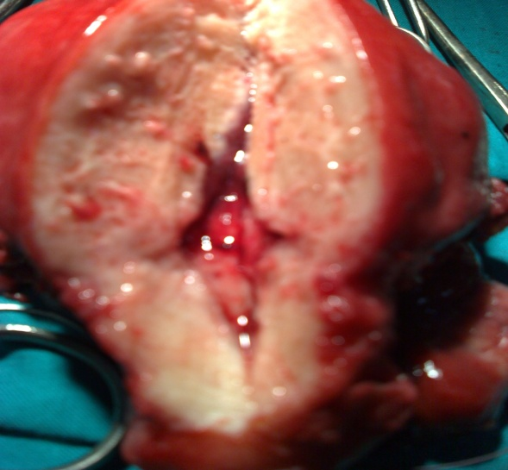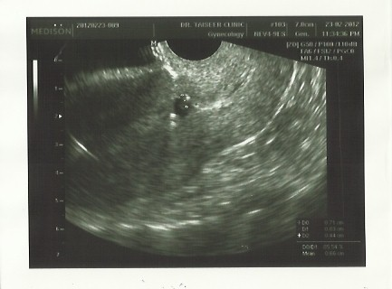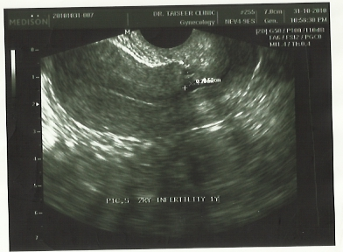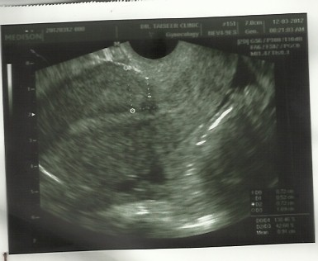

4. Discussion:-
In ultrasound studies of non-pregnant women, caesarean defects in the hysterotomy scar have been shown to be common(7–8) .The prevalence of such anatomic defect is unknown, but the reported incidence ranged from 19.4-25% as reported by Ofili-Yebovi et al. (9), and BIJ et al. (10). The clinical importance of scar defects possibly uterine rupture or placenta accreta in subsequent pregnancies . Fertility may be also affected because blood present in the cervical canal can change sperm transportation and impair embryonic implantation (11). Also the recess may be large enough to the point of allowing the gestational sac to implant on this site, and lead to the term ‘Cesarean scar pregnancy’ which often leads to serious maternal morbidity due to severe hemorrhage. There is also evidence that viable Cesarean scar pregnancies have the potential to develop into placenta previa or accreta at term(12,13). In this study RVF uterus was diagnosed in 15%of the study group,larger defects were more common in uteri in retroflexion than in anteflexion(width –depth-myometrial thickness overlying the scar) this in agreement with results reported by Ofili-Yebovi et al. (9), who explained that mechanical tension of the lower uterine segment in a retroflexed uterus might impair blood perfusion and oxygenation of the healing tissues, and that could affect wound healing negatively as tissue oxygenation is an important factor for wound healing.
This study found that 60% of study group were complaining of post-menstrual spotting . Statistical significant increase was found in mean defect depth in patients complained of post-menstrual spotting, followed by chronic pelvic pain, this finding supported by the hypothesis that scar defect act as a reservoir for some retained blood. Recent studies showed that large scar defect can be found in 82.6% of women with intermenstrual bleeding and prior history of abdominal delivery Fabres et al. (11), another explanation reported by Thurmond et al. (14). is a lack of coordinated muscular contractions occurs around the cesarean scar, allows menstrual blood to collect and then leach out after the main menstrual flow has ceased. This study failed to found significant difference between cases undergone emergency and elective CS as regard defect parameter. Of course there is an association between the degree of cervical dilatation (in particular dilatation >9 cm) at caesarean and uterine or utero-cervical lacerations and extensive blood loss causing surgical difficulties(15). Such difficulties could theoretically affect the healing process. Another possibility is that changes in the myometrium induced by labour (16) could affect healing negatively .But the results of studies uptill now are conflicting as regard factors affect the appearance of caesarean scars at ultrasound examination. The weak point in this study is that there was no written documentation about details of events of CS(emergency CS done at what stage ,at what cervical dilatation ,single or double layer ,by what suture material, with closure or non-closure of visceral peritoneum ?).
This study found that history of multiple Cesarean sections was associated with increased width and depth of the CSD as repeated trauma to a wound can disrupt the normal healing process. A histopathological study of hysterectomy specimens with Cesarean section scars proposed three possible mechanisms underlying the pathogenesis of this condition(5): the presence of a congested endometrial fold and small polyps in the scar recess are potential causes of menorrhagia and abnormal uterine bleeding, lymphocytic infiltration and distortion of the lower uterine segment could contribute to chronic pelvic pain and dyspareunia; iatrogenic adenomyosis confined to the scar could account for dysmenorrhea.In this study total abdominal hysterectomy was done for one patient complained of post menstrual spotting not responding to OC and after exclusion of endometrial pathology. Medical treatment with oral contraceptives (OC)was described in preliminary report of Tahra et al.(17), which result in a temporary improvement in symptoms ,and many patients discontinue therapy because of side effects .

5. Conclusion:-
In this study the factors that were associated with deficient scars: history of multiple Cesarean sections; uterine retroflexion; and post-menstrual spotting ,chronic pelvic pain and infertility . As the incidence of CS is increasing across the world, this disorder therefore warrants close attention. Further studies on large scale is needed , with special attention to CS events, suture material used &surgical techniques performed.

Reference:-
- Betran AP, Merialdi M, Lauer JA, et al. (2007): Rates of cesarean section: analysis of global, regional and national estimates. Paediatr Perinat Epidemiol;21:98-113.
- Gilliam M, Rosenberg D, Davis F.(2002): The likelihood of placenta praevia with greater number of Cesarean deliveries and higher parity. Obstet Gynecol; 99: 976–980.
- National Collaborating Centre for Women's and Children's Health. (2004): Caesarean Section: Clinical Guideline. London, United Kingdom: RCOG Press,.
- Armstrong V, Hansen W, Van Voorhis B, Syrop C. (2003): Detection of Cesarean scars by transvaginal ultrasound. Obstet Gynecol; 101: 61–65.
- Morris H. (1995): Surgical pathology of the lower uterine segment cesarean section scar: is the scar a source of clinical symptoms? Int J Gynecol Pathol.; 14: 16–20.
- Menada Valenzano M, Lijoi D, Mistrangelo E, Costantini S, Ragni N. (2006): Vaginal ultrasonographic and hysterosonographic evaluation of the low transverse incision after caesarean section: correlation with gynaecological symptoms. Gynecol Obstet Invest;61:216–22.
- Regnard C, Nosbusch M, Fellemans C, Benali N, van Rysselberghe M, Barlow P, et al. (2004): Cesarean section scar evaluation by saline contrast sonohysterography. Ultrasound Obstet Gynecol;23: 289–92.
- Vikhareva Osser O, Jokubkiene L, Valentin L. (2009): High prevalence of defects in Cesarean section scars at transvaginal ultrasound examination. Ultrasound Obstet Gynecol; 34:90–7.
- Ofili-Yebovi D, Ben-Nagi J, Sawyer E, Yazbek J, Lee C, Gonzalez J, et al. (2008): Deficient lower-segment Cesarean section scars: prevalence and risk factors. Ultrasound Obstet Gynecol.;31:72–7.
- Bij de Vaate AJ, Brölmann HA, van der Voet LF, van der Slikke JW, Veersema S, Huirne JA. (2011):Ultrasound evaluation of the Cesarean scar: relation between a niche and postmenstrual spotting.Ultrasound Obstet Gynecol; 37: 93–99
- Fabres C, Arriagada P, Fernandez C, Mackenna A, Zegers F, Fernandez E. (2005): Surgical treatment and follow-up of women with intermenstrual bleeding due to cesarean section scar defect. J Minim Invasive Gynecol;12:25–8.
- Jurkovic D, Hillaby K, Woelfer B, Lawrence A, Salim R, Elson C. (2003): First-trimester diagnosis and management of pregnancies implanted into the lower uterine segment Cesarean section scar. Ultrasound Obstet Gynecol.; 21: 220–227.
- Ben Nagi J, Ofili-Yebovi D, Marsh M, Jurkovic D (2005): First trimester Cesarean scar pregnancy evolving into placenta previa/accreta at term. J Ultrasound Med; 24: 1569–1573.
- Thurmond AS, Harvey WJ, Smith SS. (1999): Cesarean section scar as a cause of abnormal vaginal bleeding: diagnosis by sonohysterography. J Ultrasound Med.;18:13–16.
- Ha¨ ger RM, Daltveit AK, Hofoss D, Nilsen ST, Kolaas T, Øian P, et al. (2004): Complications of cesarean deliveries: rates and risk factors. Am J Obstet Gynecol; 190:428–34.
- Buhimschi CS, Buhimschi IA, Yu C, Wang H, Sharer DJ, Diamond MP, et al. (2006): The effect of dystocia and previous cesarean uterine scar on the tensile properties of the lower uterine segment. Am J Obstet Gynecol;194:873–83.
- Tahara M, Shimizu T, Shimoura H. (2006): Preliminary report of treatment with oral contraceptive pills for intermenstrual vaginal bleeding secondary to a cesarean section scar. Fertil Steril;86:477–9..

4/29/2012

