AVIAN BIODIVERSITY IN AND AROUND MAJOR WETLANDS OF “LOWER SHIVALIK FOOTHILLS” (INDIA)

Girish Chopra¹ and Sanjeev Kamal Sharma²

^{1,2}Depatrment of Zoology, Kurukshetra University, Kurukshetra-136119, India.
²e-mail: sharmaksanjeev_37@rediffmail.com

Abstract:The avifauna was studied in and around three major wetlands of “Lower Shivalik Foothills” in India, i.e., two lakes in the offshoots of Morni hills at Tikkar Tal, in district Panchkula (Haryana) and one lake at Shri Renuka ji in district Sirmour (Himachal Pradesh), from December 2009 to December 2010. A total of 88 bird species were observed which belonged to 17 orders and 32 families. Of the 88 bird species, 22 species were water birds and 66 were terrestrial species. Maximum, i.e., 35 (40%) species belonged to order Passeriformes. As many as 21 (24%) bird species were migratory. Of the 21 recorded migratory bird species, 13 (62%) were local migrants and 8 (38%) were winter visitors. Immigrations were mostly observed in the months of November and December, and the emigrations were recorded in late January and February months. Based on the frequency of their sightings during the field visits, 37 (42%) were designated as abundant, 30 (34%) common, 18 (21%) occasional and 3 (3%) as rare species.
[Girish Chopra and Sanjeev Kamal Sharma. Avian biodiversity in and around major wetlands of “lower shivalik foothills” (india). Nat Sci 2012;10(7):86-93]. (ISSN: 1545-0740). http://www.sciencepub.net/nature. 13

Key words: Wetlands, Migratory, Immigrations, Emigrations.

Introduction
Biodiversity is manifested at all levels of bio-organization i.e. from cell to ecosystem and refers to enumerable kinds of living organisms inhabiting terrestrial, marine and freshwater ecosystems (Ambasht et al., 1994). World’s avian diversity, in particular, has been reviewed by ornithologists from time to time (Ali, 1941; Parkes, 1975; Sibley and Munroe, 1993; Dickinson, 2004). Most recently, Lepage (2008) has recognized 10,000 species of varied forms descended from one another through the process of adaptation by natural selection globally. Indian avian fauna has also been studied extensively (Inskipp et al., 1999). However lower Shivalik foothills region in the north is relatively poorly explored (Gupta and Kumar, 2009). Although, lower Shivalik foothills is well afforested with both exotic and endemic plant species but fragmentation of the natural habitat and increased urbanization in the recent years has put pressure on the biodiversity in this region. Such human activities threaten the existence of many organisms by destroying their habitat or directly affecting their survival and reproductive success (Green and Hirons, 1991). Therefore, the present study was conducted in the three major wetlands located in the “Lower Shivalik Foothills” in India, from December 2009 to December 2010 not only to prepare a checklist of birds, but also to find out their migratory status, abundance, threats and conservational strategies.

Materials and Methods
The present study was conducted at three major wetlands, Lake I and Lake II (Tikkar Tal lakes) in the offshoots of Morni hills (in the state of Haryana) and Lake III (Renuka lake) at Shri Renuka ji (in the state of Himachal Pradesh) for one year from December, 2009 to December, 2010. Lake I (30° 39' N and 77° 04' E) and Lake II (30°39' N and 77°05' E) are located in district Panchkula (Haryana) covering an area of 0.13 km² and 0.30 km² respectively (Figure 1 a,b). The water level of these lakes more or less remains the same, because of the hidden channel under the hill connecting them. Lake III (30° 36' N and 77° 27' E), with an area of 0.82 km², is located at Sri Renuka ji in district Sirmour (Himachal Pradesh). It is the largest natural lake of the state (Figure 1 c). Of these three study sites, Lake II at Morni hills has been developed as a famous tourist/picnic spot and Lake III at Sri Renuka ji comes under wildlife protected area.
To study the avian fauna of all the three study sites, point count method (Blondel et al., 1981) was followed. During the present study, whole diurnal period was divided in the three phases, i.e., morning phase (6.00 AM-11.00 AM), noon phase (11.00 AM-3.00 PM) and evening phase (3.00 PM-6.00 PM). Birds were observed during their most active period, i.e., morning phase and evening phase. Field binocular was used for the best visualization of birds during the study. Sighted birds were photographed using Sony cyber shot DSC-H9 digital camera. They were subsequently identified from the photographs following Ali and Ripley (1983), Coomber (1991), Ali and Ripley (1996), Ali (1996), and Grimmet et al. (1999) and were classified in accordance with Grewal et al. (2002).
The birds sighted during the study were categorized as residents or R (birds that have been known to breed in the study area itself and encountered during each visit), and local migrant or LM (birds which were encountered many times during the study period and breeding in surrounding areas). On the basis of frequency of bird sighting in the field visits, the bird species were also categorized as: Abundant or A (sighted throughout the study area in good numbers during each visit with encounter rate 95% to 100%), Common or C (sighted throughout the study area during most of the visits with encounter rate 60% to 95%), Occasional or O (found in small number and with less frequency of sighting with encounter rate 20% to 60%) and Rare or R (frequency of sighting and numbers are very low with encounter rate less than 20%).

Results
In the present study, a total number of 88 bird species were identified in and around three major wetlands (Lake I and Lake II or Tikkar Tal lakes and Lake III or Renuka lake) during December, 2009 to December, 2010. Of these, 22 bird species were water birds and 66 were terrestrial bird species. The birds of the study area belonged to 17 orders, namely, Passeriformes, Ciconiformes, Falconiformes, Psittaciformes, Cuculiformes, Apodiformes, Upupiformes, Bucerotiformes, Charadriiformes, Coraciiformes, Gruiformes, Peleconiformes, Columbiformes, Piciformes, Podicipediformes, Galliformes and Anseriformes and 32 families, namely, Hirundinidae, Motacillidae, Nectarinidae, Sturnidae, Passeridae, Corvidae, Muscicapidae, Zosteropidae, Ardeidae, Accipitridae, Psittacidae, Cuculidae, Apodidae, Upupidae, Bucerotidae, Recurvirostridae, Charadridae, Alcedinidae, Picidae, Rallidae, Phalacrocoracidae, Laniidae, Oriolidae, Alaudidae, Ciconiidae, Columbidae, Meropidae, Coraciidae, Capitonidae, Podicipedae, Phasianidae and Anatidae (Table 1). The Present study revealed that maximum birds species, i.e., 35 (40%) belonged to the order Passeriformes, 8 (9%) birds species belonged to order Ciconiformes, 7 (8%) birds species belonged to order Ciconiformes followed by Cuculiiformes, Charadriiformes and Anseriformes each with 5 (6%) birds species, Galliformes with 4 (5%) bird species, Falconiformes, Gruiformes and Peleconiformes each with 3 (3%) bird species, Columbiiformes, Piciformes and Psittaciformes with 2 (2%) birds species and least number of bird species, i.e., 1 (2%) belonged to the orders Apodiformes, Upupiformes, Bucerotiformes, and Podicipediformes each (Figure 2). This is in accordance with the order wise distribution of 1300 bird species belonging to 17 orders and 78 families reported from India (Grimett et al., 1998). Out of total observed 88 bird species, maximum bird species i.e. 10 (9%) belong to family Muscicapidae, 7 (9%) belong to family Ardeidae, 6 (9%) belong to family Passeridae, 5 (9%) belong to family Cuculidae and Anatidae each, 4 (9%) belong to family Motacillidae, Charadridae, Sturnidae, Alcedindae and Phasianidae each, 3 (%) belong to family Corvidae, Accipitridae, Rallidae and Phalacrocoracidae each, 2(%) belong to Hirundinidae, Alaudidae, Psittacidae, Columbidae and Capitonidae each, followed by Laniidae, Nectariniidae, Ciconiidae, Apodidae, Zosteropidae, Upupidae, Bucerotidae, Recurvirostridae, Picidae, Meropoidae, Oriolidae, Coraciidae and Podicipedae with least number of bird species i.e. 1 ( %) (Figure 3).
In all, 32 families of birds were recorded from study area, out of which 11 families belong to order Passeriformes represented by 35 species, 4 families belong to order Coracciformes represented by 7 species, 2 families belong to order Ciconiformes and Charadriiformes each represented by 8 and 5 bird species respectively, and 1 family belong to each order Falconiformes (3 birds species), Psittaciformes (2 birds species), Cuculiformes (5 birds species), Apodiformes (1 birds species), Upupiformes (1 birds species), Bucerotiformes (1 birds species), Columbiformes (2 birds species), Piciformes (2 birds species), Gruiformes (3 birds species), Peleconiformes (3 birds species), Anseriformes (5 birds species), Podicipediformes (1 birds species) and Galliformes (4 birds species) as depicted (Figure 4). As far as resident or migrant status of birds is concerned, out of total 88 bird species recorded during the present study, 67 (76%) bird species were resident (recorded throughout the year) and 21 (24%) bird species were migratory (Figure 5). Based on the frequency of their sightings during the field visits, 37 (42 %) species were abundant, 30 (34 %) were common, 18 (21 %) were occasional and 3 (3 %) were rare (Figure 6). Out of 21 migratory bird species, 13 (62%) were local migrants and 8 (38%) were winter visitors (Figure 7).

Discussion
The diversity of birds in different regions varies with numerous factors like climate of the area (temperature, humidity, and rainfall), altitude, abundance of food material etc. and is maximum in places with favorable living conditions for birds. Laiolo (2003) correlated the bird diversity with the area having rich floral diversity as compared to other with a particular type of plant species in himalayan subalpine zone. In the present study, the study sites (wetlands) supported a large number of fishes, mollusks, amphibians and aquatic insects and their larvae which served as good food source for the resident as well as migratory birds.
In India, Grimett et al. (1998) have reported 1300 species of birds belonging to 78 families and 17 orders and made order wise distribution of these bird species. Similarly, in Haryana, a compressive checklist of 203 bird species was given by Yadav and Maleywar (1981). As far as lower Shivalik region is concerned, Mahabal (1996) carried out the study on avian fauna of three districts viz. Una, Hamirpur and Bilaspur of Himachal Pradesh which fall under Shivalik Himalayas and recorded 136 bird species belonging to 41 families. Also Gupta and Kumar (2009) recorded 130 avian species belonging to 16 orders and 35 families, in Morni hills of district Panchkula (Haryana). In the present study, as many as 88 species of birds belonging to 32 families and 17 orders were recorded from three major wetlands of lower Shivalik foothills and their surroundings. In all, 40% of the species in the study area belonged to order Passeriformes, 9% birds species to order Ciconiformes, 8% birds species to order Ciconiformes followed by orders Cuculiiformes, Charadriiformes and Anseriformes, each with 6% birds species and order Galliformes with 5% bird species, Falconiformes, Gruiformes and Peleconiformes each with 3% bird species, Columbiiformes, Piciformes and Psittaciformes with 2% birds species and least number of bird species, i.e., 2% belong to the orders Apodiformes, Upupiformes, Bucerotiformes, and Podicipediformes each (Fig. 2). Sauvjot et al. (1998) and Savard et al. (1999) have reported that birds are sensitive to the local landscape and change in vegetation pattern can change the population of birds in the area. The results of the present studies also support above cited observations. Price et al. (2003) compared the bird species diversity and differences in the species composition of Himachal Pradesh with that of Kashmir and found considerable variations in it along the Himalayas.
Seasonal changes in the composition of birds of lower Shivalik foothills are very evident. Most high altitude birds are known to migrate to lower altitudes during winter. A total of 149 species of waterfowls are known to migrate throughout the world, of which 62 are from Asia (Sonobe and Usui, 1993) and 41 from India (Ali and Ripley, 1978). In the present study, of the 88 bird species recorded from the study area, as many as 67 (76 %) bird species were resident i.e. recorded throughout the year and 21 (24%) species were migrants visiting the study area at one or the other time (Fig 5). Out of 21 migratory bird species, 8 (38%) were recorded as winter migrants (visiting the area during the winters only) and 13 (62%) as local migrants (visiting the area occasionally) (Fig. 7). The basic requirement of the migratory water birds at their wintering sites is adequate food supply and safety (Bharat Lakshmi, 2006). The studies on the local abundance status of three major wetlands revealed that avifauna of the study area can be placed into four abundance categories viz. Abundant (A) represented by 37 (42%) species, Common (C) represented by 30 (34%) species, Occasional (O) represented by 18 (21%) species and Rare (R) represented by 3 (3%) species (Fig 6). Occasional and rare species collectively counted for more than 24% of the total avian species in the study area. Thus, there is a need to take the steps to conserve the avifauna whose abundance status could otherwise degrade further.
According to Schaefer (1994), the diversity recorded in a human impacted area must not mislead one to those of large green parks and reserves in urban areas as they support high species diversity because these protected urban areas are the habitat fragments of highly diverse ecosystem. However, in the present study, direct human interventions were the most influencing factor on the composition and distribution of bird species in wetlands and their surroundings. Anthropogenic pressure at Lake-I and Lake-II (Tikkar Tal lakes) was a major factor that affected the habitat of water birds as these lakes are used to collect water for irrigation. Also, cattle grazing and bathing usually disturbed avifauna. Moreover, Lake-III (Renuka Lake) bears a lot of tourism pressure due to tourist activities such as swimming, boat riding and feeding the aquatic animals. If tourism is allowed to grow uncontrolled, adequate protection of wildlife and environment will be difficult, if not possible.

Table 1: A classified chart of various bird species in the study area.
Sr.No. | Common Name | Zoological Name | Status  Migration/Frequency
Order: PASSERIFORMES
Family: HIRUNDINIDAE: Swallows.
1. | Wire-tailed Swallow | Hirundo smithii | R A
2. | House Swallow | Hirundo tahitica | R A
LANIIDAE: Shrikes.
3. | Brown Shrike | Lanius cristatus | R A
ORIOLIDAE: Orioles.
4. | Eurasian Golden Oriole | Oriolus oriolus | LM O
MOTACILLIDAE: Pipits, Wagtails
5. | White Wagtail | Motacilla alba | R C
6. | Forest Wagtail | Dendronanthus indicus | R A
7. | Yellow Wagtail | Motacilla flava | R A
8. | White Browed Wagtail | Motacilla maderaspatensis | R C
NECTARINIIDAE: Sunbirds.
9. | Purple Sunbird | Nectarinia asiatica | R A
ALAUDIDAE: Larks.
10. | Indian Bush Lark | Mirafra erythroptera | R A
11. | Sand Lark | Calandrella raytal | R A
STURNIDAE: Starlings, Mynas.
12. | Asian Pied Starling | Sturnus contra | R O
13. | Brahminy Starling | Sturnus pagodarum | R C
14. | Common Myna | Acridotheres tristis | R A
15. | Bank Myna | Acridotheres ginginianus | R A
PASSERIDAE: House Sparrows, Weaver Birds.
16. | Red Vented Bulbul | Pycnonotus cafer | R A
17. | White-eared Bulbul | Pycnonotus leucotis | R C
18. | Scaly-breasted Munia | Lonchura punctulata | R C
19. | House sparrow | Passer domesticus | R C
20. | Baya Weaver | Ploceus philippinus | R C
21. | Crested Bunting | Melophus lathami | R C
CORVIDAE: Crows, Tree Pies.
22. | House Crow | Corvus splendus | R A
23. | Jungle Crow | Corvus macrorhynchos | R A
24. | Black Drongo | Dicrurus macrocercus | R A
MUSCICAPIDAE: Babblers, Flycatchers, Warblers, Thrushes, Chats.
25. | Common Babbler | Turdoides caudatus | R A
26. | Jungle Babbler | Turdoides striatus | R A
27. | Ashy Prinia | Prinia socialis | R A
28. | Jungle Prinia | Prinia sylvatica | R A
29. | Common Tailorbird | Orthotomous sutoris | R A
30. | Black Redstart | Phoenicurus ochruros | R O
31. | Plumbeous Water Redstart (♂, ♀) | Rhyacornis fuliginosa | R C
32. | Hodgsons Redstart | Phoenicurus hodgsoni | R C
33. | White-capped water Redstart | Chaimarrornis leucocephalus | R C
34. | Asian Paradise Flycatcher | Terpsiphone paradise | R O
ZOSTEROPIDAE: White Eyes.
35. | Oriental White Eye | Zosterops palpebrosus | R O
Order: CICONIFORMES
Family: ARDEIDAE: Herons, Egrets, Bitterns.
36. | Cattle Egret | Bubulcus ibis | R A
37. | Great Egret | Casmerodius albus | R C
38. | Intermediate egret | Mesophoyx intermedia | R C
39. | Little Egret | Egretta garzetta | R C
40. | Indian Pond Heron | Ardeola grayi | R C
41. | Purple Heron | Ardea purpurea | LM O
42. | Black crowned Night Heron | Nycticorax nycticorax | M O
CICONIIDAE: Storks
43. | Black-necked Stork | Ephippiorhynchus asiaticus | WM O
Order: FALCONIFORMES
Family: ACCIPITRIDAE: Hawks, Vultures
44. | Black- Shouldered Kite | Elanus caeruleus | R O
45. | Shikra | Accipiter badius | R C
46. | Himalayan Griffon | Gyps himalayensis | R C
Order: PSITTACIFORMES
Family: PSITTACIDAE: Parrots.
47. | Rose-ringed Parakeet | Psittacula krameri | R A
48. | Plum-headed Parakeet | Psittacula cyanocephala | R C
Order: CUCULIFORMES
Family: CUCULIDAE: Cuckoos.
49. | Asian Koel (♂♀) | Eudynamys scolopacea | R A
50. | Greater Coucal | Centropus sinensis
51. | Lesser Coucal
52. | Pied Cuckoo | Clamator jacobinus | R C
53. | Indian Cuckoo | Cuculus micropterus | R C
Order: APODIFORMES
Family: APODIDAE: Swifts.
54. | House Swift | Apus affinis | R C
Order: UPUPIFORMES
Family: UPUPIDAE: Hoppoes.
55. | Hoopoe | Upupa epos | R A
Order: BUCEROTIFORMES
Family: BUCEROTIDAE: Hornbills
56. | Indian Grey Hornbill | Ocyceros birostris | R A
Order: CHARADRIIFORMES
Family: RECURVIROSTRIDAE: Stilts, Avocets.
57. | Black-winged Stilt | Himantopus himantopus | LM O
CHARADRIDAE: Plovers, Curlew.
58. | Red-Wattled Lapwing | Vanellus indicus | R A
59. | Common Sandpiper | Actitis hypoleucos | LM O
60. | Marsh Sandpiper | Tringa stagnatilis | R O
61. | Yellow-Wattled Lapwing | Vanellus malabaricus | LM C
Order: COLUMBIFORMES
Family: COLUMBIDAE: Pigeons, Doves.
62. | Rock Pigeon | Columba livia | R A
63. | Spotted Dove | Streptopelia chinensis | R C
Order: CORACIIFORMES
Family: ALCEDINIDAE: Kingfishers.
64. | White-breasted Kingfisher | Halcyon smyrnensis | R A
65. | Common Kingfisher | Alcedo atthis
66. | Pied Kingfisher | Ceryle rudis | WM R
67. | Strok Billed Kingfisher | Halcyon capensis | R O
PICIDAE: Woodpeckers.
68. | Black Rumped Flameback | Dinopium benghalense | R C
MEROPIDAE: Bee-eaters.
69. | Green Bee-eater | Merops orientalis | R A
CORACIIDAEIDAE: Rollers.
70. | Indian Roller | Coracias benghalensis | R C
Order: PICIFORMES
Family: CAPITONIDAE: Barbets.
71. | Brown-headed Barbet | Megalaima zeylanica | R A
72. | Coppersmith Barbet | Megalaima haemacephala | R A
Order: GRUIFORMES
Family: RALLIDAE: Rails, Coots.
73. | Common Moorhen | Gallinula chloropus | R A
74. | White-breasted Water hen | Amaurornis phoenicurus | R A
75. | Common Coot | Fulica atra | M O
Order: PELECONIFORMES
Family: PHALACROCORACIDAE: Cormorants, Darter.
76. | Great cormorant | Phalacrocorax carbo | LM A
77. | Little cormorant | Phalacrocorax niger | LM O
78. | Indian Cormorant | Phalacrocorax fusicollis | LM O
Order: ANSERIFORMES
Family: ANATIDAE: Ducks, Geese.
79. | Common Teal | Anas crecca | M O
80. | Spot-billed Duck | Anas poecilorhyncha | M O
81. | Mallard | Anas platyrhynchos | M O
82. | Common Pochard | Aythya ferina | M C
83. | Garganey | Anas querquedula | M C
Order: PODICIPEDIFORMES
Family: PODICIPEDAE: Grebes.
84. | Little Grebe | Tachybaptus ruficollis | M C
Order: GALLIFORMES
Family: PHASIANIDAE: Pheasants, Quails.
85. | Grey Francolin | Francolinus francolinus | R A
86. | Jungle Bush Quail | Perdicula asiatica | R A
87. | Red Jungle Fowl | Gallus gallus | R C
88. | Indian Peafowl | Pavo cristatus | R A

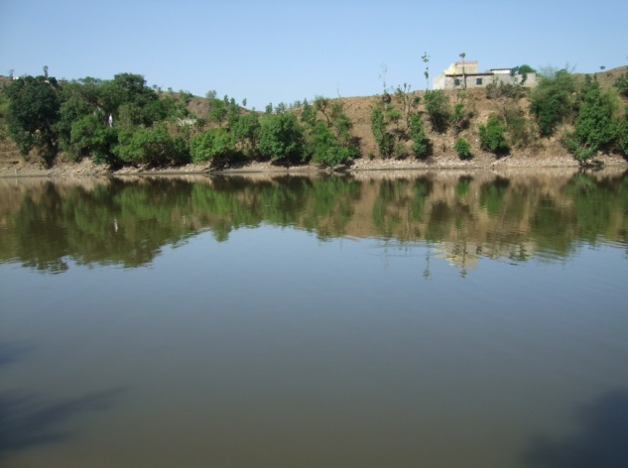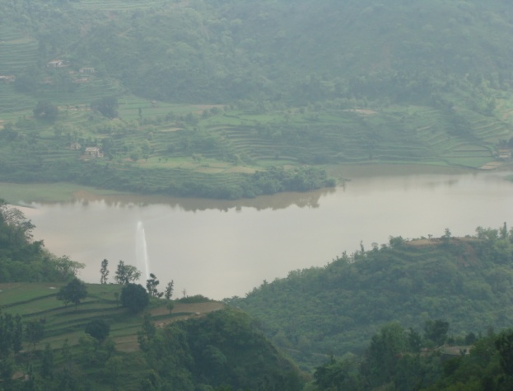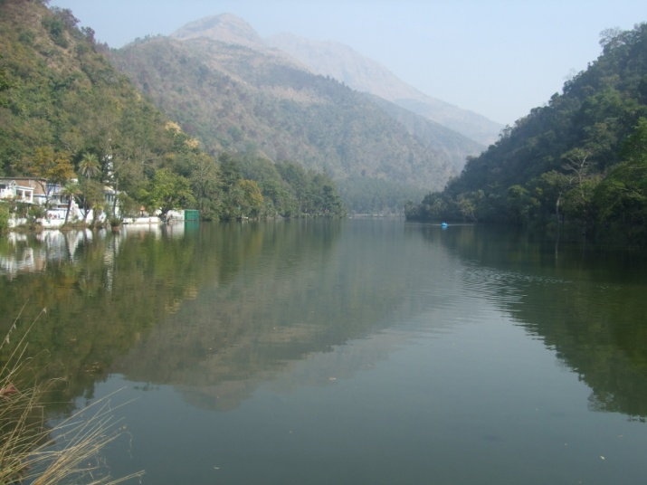
(a) (b) (c)

Figure 1: View of three lakes in the study site (a) Lake – I (b) Lake – II (c) Lake – III

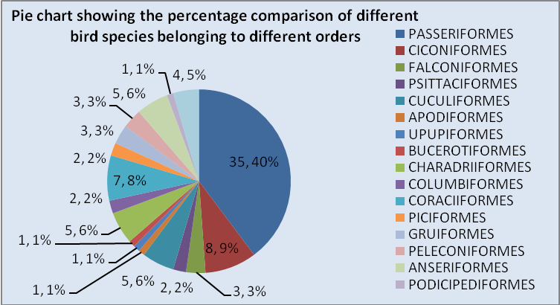
Figure 2: Comparison of number and percentage of bird species belonging to different avian orders.

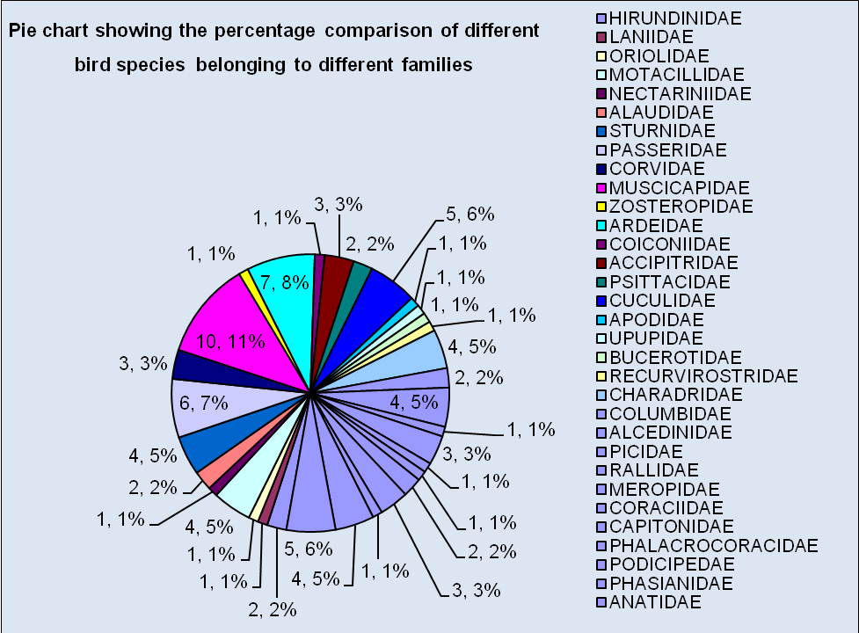
Figure 3: Comparison of number and percentage of bird species belonging to different avian families.
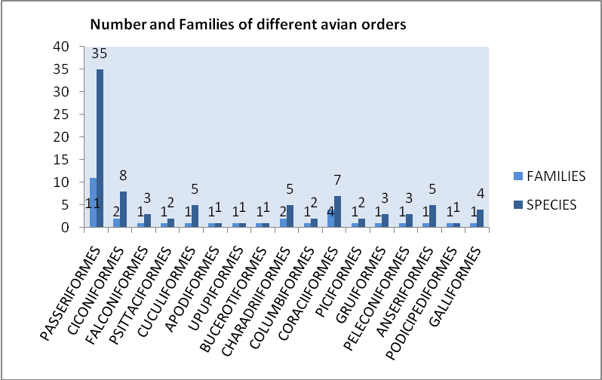
Figure 4: Bar chart showing number of families and species of different avian orders in study area.

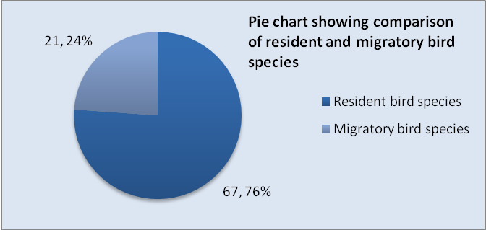
Figure 5: Comparison of number and percentage of migratory and resident bird species in the study sites.

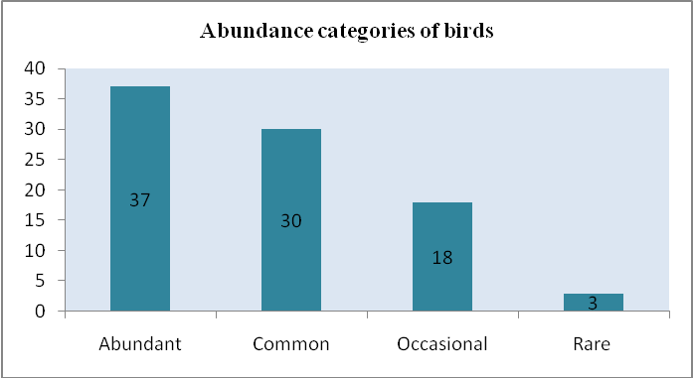
Figure 6: Bar diagram representing abundance category of bird species.

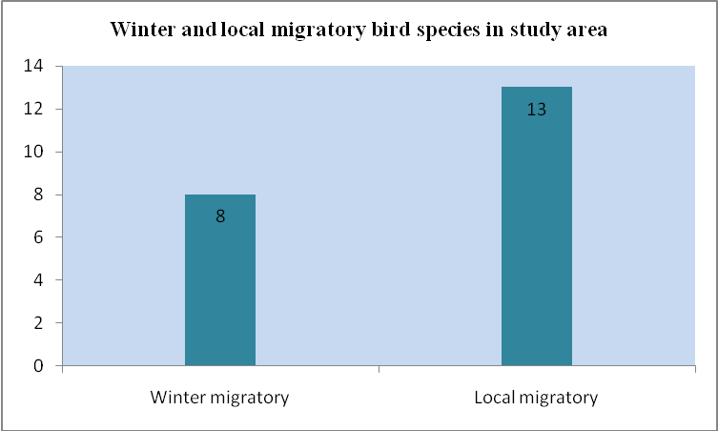
Figure 7: Bar diagram representing winter and local migratory bird species.

Corresponding Author:
Sanjeev Kamal Sharma
House No. 1, Air Force Enclave,
Vill. Himmatgarh, Dhakola,
Zirkpur, Punjab. 160104.
Email: sharmaksanjeev_37@rediffmail.com

REFERENCES
- Ali S. The Book of Indian Birds. Bombay Natural History Society, Bombay, 1941;175.
- Ali S. The Book of Indian Birds. Oxford University Press, New Delhi, 1996;140.
- Ali S, Ripley SD. Handbook of birds of India and Pakistan. Oxford University Press, Delhi, 1978;382.
- Ali S, Ripley SD. Handbook of birds of India and Pakistan. Oxford University Press Delhi, 1983;180.
- Ali S, Ripley SD. A Pictorial Guide to the Birds of the Indian Subcontinent. Oxford University Press, Mumbai, 1996;150.
- Ambasht RS, Srivastava AK, Ambasht NK. Conserving the bio diversity of India: An ecological approach. Indian Forester 1994;120(9):791-798.
- Bharatha Lakshmi B. Avifauna of Gosthani estuary near Vishakhapatnam, Andhra Pradesh. J.Nacton 2006;18(2):291-304.
- Blondel J, Ferry C, Frochot B. Point counts with unlimited distance, Stud. Avian Biology 1981;6:414-420.
- Coomber R. Birds of the World. Color Library Books Ltd, Italy, 1991.
- Dickinson EC. The Howard and Moore Complete Checklist of Birds of the World. Princeton university press, 2004; 12.
- Green RE, Hirons GMJ. The relevance of population studies to the conservation of threatened birds. Bird Population Studies, Oxford University Press, New York, 1991;594-621.
- Grewal B, Harvey V, Pfister O. A Photographic guide to Birds of India. Periplus Editions (HK) Ltd, Singapore, 2002.
- Grimmett R, Inskipp C, Inskipp T. Birds of the Indian Subcontinent. Oxford University Press, Delhi, 1998.
- Grimett R, Inskipp C, Inskipp T. Pocket guide to the birds of the Indian subcontinent. Oxford University Press, Delhi, 1999;384.
- Gupta RC, Kumar S. Determination of Avian Biodiversity in Morni Hills in District Panchkula, Haryana. Journal of Advanced Zoology 2009;30(1):44-52.
- Inskipp C, Inskipp T. Grimmet R. A Pocket Guide to the Birds of the Indian Subcontinent, 1999.
- Laiolo P. Diversity and structure of bird community overwintering in the Himalayan subalpine zone: Is conservation compatible with tourism? J. Biological Conservation 2003;115:251-262.
- Lepage D. Avibase-Bird Checklists of the World. http://avibase.bsc-oc.org/ checklist.jsp? 2008 [accessed 01 May 2008].
- Mahabal A. Bird survey in Shivalik Himalayas of Himachal Pradesh. PAVO 1996;34:7-16.
- Price T, Zee J, Jamdar N. Bird species diversity along Himalayas: a comparison of Himachal Pradesh with Kashmir. Bombay Natural History Society, Bombay 2003;100:394-409.
- Parks KC. Special review. Auk 1975;92:818-830.
- Sauvjot RM, Buechner M, Kamradt DA, Schonerwald CM. Patterns of human disturbances and response by small mammals and birds, in chaparral near urban development. Urban Ecosystem 1998;2:279-297.
- Savard LJ, Clergeau P, Mennechez G. Biodiversity concept and urban ecosystem 1998;48(3-4):131-142.
- Sonobe K, Usui S. A field Guide to the Water birds of Asia. Bird Society of Japan, Tokyo, 1993; 1-224.
- Schaefer V. Urban Biodiversity in Biodiversity. Environment Canada and Canadian Wildlife service, Vancouver, Canada, 1994;307-308.
- Sibley CG, Monroe BL. A supplement to distribution and taxonomy of birds of World. Yale University Press, New haven CT, 1993.
- Yadav JS, Maleyvar RP. The birds of Haryana: a few more spotting. Pavo 1981;19:51-55.

5/5/2012

